Oppositional Failures:
Two Fights Against McCarthy and Why They Fell Short

Authored By: Benjamin J. Congos

University of Wisconsin—Eau Claire

Capstone Submitted to Dr. Patricia Turner
Of the UWEC History Department

If all mankind, minus one, were of one opinion, it would be just as wrong for society to silence that one man as it would be for that one man to silence the world…for silencing expression is robbing mankind
--John Stuart Mill, On Liberty

Table of Contents
Abstract………………………………………………………………………………………………………………………. p. 3
Section One: Perspective ………………….…………………………………….…………………………………. p. 4
Secondary Literature………………………………………………………………………………………. p. 5
Section Two: The Washington Warrior……………………………………………………………………….. p. 13
Benton’s Motivation……………………………………………………………………………………….. p. 13
The Lawsuit…………………………………………………………………………………………………….. p. 15
The Bean Report……………………………………………………………………………………………… p. 18
Summary………………………………………………………………………………………………………… p. 22
Section Three: The Joe Must Go Club………………………….……………………………………………… p. 23
Join The Club…………………………………………………………………………………………………… p. 24
Gathering Support…………………………………………………………………………………………… p. 26
Know The Truth About Joe……………………………………………………………………………… p. 27
Summary………………………………………………………………………………………………………… p. 28
Section Four: Putting It All Together…………………………………………………………………………… p. 30
William Benton’s Shortcoming………………………………………………………………………... p. 30
The Club’s Shortcoming…………………………………………………………………………………… p. 32
The Common Problem…………………………………………………………………………………….. p. 34
Appendices…………………………………………………………………………………………………………………. p. 35
Bibliography……………………………………………………………………………………………………………….. p. 39

Abstract
In 1950 McCarthy began his hunt against communists in government, and helped add fear to an already paranoid anti-communist American society. Although many agreed with the notion that communists needed to be ousted from governmental posts, some did not agree with the methods McCarthy utilized and made certain that their distaste of McCarthyism became known. This paper offers a comparative analysis of the anti-McCarthy efforts of the Joe Must Go Club of Wisconsin with the efforts of Wisconsin Senator William Benton in order to find a common shortfall in their failure to stop the McCarthy movement. The evidence demonstrates that both movements failed because communication with constituents failed; both of these anti-McCarthy efforts assumed that to stop McCarthy was simply to make known how McCarthy’s intolerance was against the American Creed. However, because neither movement was able to personalize the issue to individuals, both movements stalled shy of motivating the larger public to stop McCarthy.

Section I: Perspective
When the Cold War began shortly following World War Two, a widespread fear of Communism began to terrorize most Americans. Common opinion was that communism was going to destroy the free world; this is exemplified by the local Eau Claire Leader-Telegram as it was overrun by letters to the editor explaining how communism and its sympathizers were the biggest enemy of America, and if they were to elect politicians it would be on the basis of eliminating the communist threat. Nearly all advertisements from politicians (both Republican and Democrat) were promising that they would stop the spread of communism from Russia and China more effectively than their opponents. One politician in particular ran his campaign vowing to be the strongest opponent of communism—and that was Senator Joseph McCarthy.
Senator Joseph McCarthy of the state of Wisconsin was in office from 1947 until his death in 1957. McCarthy began his quest against communism in Wheeling, West Virginia when during a speech he asserted that “I have in my hand 57 cases of individuals who would appear to be either card carrying members or certainly loyal to the Communist Party, but who nevertheless are still helping to shape our foreign policy.” These words are attributed to starting the second red scare in the United States, commonly known as McCarthyism.
During this era of McCarthyism, not many people were willing to argue that Communists needed to be ousted from government posts. However, many were outspoken against the methods with which McCarthy used in attempts to rid communist idealists from government. Wisconsin‘s own Leroy Gore had started the “Joe Must Go Club”, which quickly grew to thousands of members. In Washington D.C., Senator William Benton of Connecticut was one politician who was outspoken against McCarthy, and quickly became one of McCarthy’s biggest enemies.
The Joe Must Go Club and Senator Benton are the primary focus of this paper; by analyzing the two movements—one led by McCarthy’s constituents, another led by a colleague of McCarthy— it becomes evident that both movements failed because of a lack of communication with constituents. The assumption was made by both Benton and the Joe Must Go Club that to stop McCarthy was to widely publicize how McCarthyism was against American values. However, because neither movement was able to effectively communicate how McCarthyism was a problem for all individuals—and not just communists—both movements stopped shy of defeating Senator Joseph R. McCarthy and his crusade. The failure of McCarthy’s opposition was their inability to get constituents to look beyond their fears of communism and to recognize the more substantial issue that suppressing dissimilar viewpoints within a nation built upon a written constitution that asserts its citizens a right to a freedom of speech.
Secondary Literature
There are many books, articles, and textbook pages devoted to the subject of McCarthy and McCarthyism; however, because this paper focuses on two particular movements, the number of secondary sources becomes much smaller.
The first sources analyzed are in relation to anti-McCarthy movements in Wisconsin. An important article is that of David and Esther Thelen, and their writings on the ‘Joe Must Go’ movement. The Thelens state that Wisconsin was one of the last states to ratify a recall amendment to its constitution (in 1926)—but was the first state to attempt the recall of either a United States Representative or a United States Senator. The movement to recall McCarthy, the Thelens assert, started in a small town of “less than 2,000 inhabitants, and by a man who was anything but a reformer.”
Leroy Gore, an editor of a small newspaper (and surprisingly a staunch republican), began the movement against McCarthy. Gore held personal morality to a very high standard, and after McCarthy began persecuting possible communists, Gore felt that McCarthy was over-stepping his bounds and needed to be stopped. In March of 1954 Gore wrote an editorial in the Sauk-Prairie Star newspaper asserting his beliefs as to why McCarthy needed to be removed from office—and provided instructions on how the fill out the recall petition. Within a matter of days Gore received more signatures and letters than he himself could handle, and soon the ‘Joe Must Go’ movement was formed. The grass-roots ‘Joe Must Go Club’ began, and “for one dollar, delegates received a membership card in the Joe Must Go Club…” The initial members were from all over the state of Wisconsin, and after the adjournment of the first meeting these members went to their respective homes and started their own chapter of the ‘Joe Must Go Club’. The movement spread like a wildfire.
This article by David and Esther Thelen provides information asserting that the ‘Joe Must Go’ movement was inclusive of a wide variety of people with differing political views who could all agree that McCarthy needed to be recalled. The Thelens assert that letters written to Leroy Gore from out-of-state voters were two to one in favor of McCarthy—but Wisconsinites were seventy-five to one opposed to McCarthy. This simple fact helps my research in that there is clearly a difference in how Wisconsin felt about McCarthy compared to the rest of the nation.
A book by Michael O’Brien entitled McCarthy and McCarthyism in Wisconsin expands on the Thelen article, going beyond one singular movement and viewing several aspects of Wisconsin sentiment towards the Senator. O’Brien is quick to note that “While much of the nation after World War II succumbed to serious encroachments on civil liberties (the movement McCarthy symbolized), Wisconsin for the most part defeated legislative assaults on basic freedoms” which indicates that there was a difference in Wisconsin’s approach to McCarthyism compared to the rest of the nation.
Looking into the 1952 election in greater detail, O’Brien details how the numbers show that McCarthy was certainly not politically invincible as indicated by McCarthy’s total number of votes being significantly lower than many other Republicans that ran in 1952. O’Brien states that political and social scientists were noting how detrimental McCarthyism was to the Senator’s 1952 campaign—most of his support came from counties that were extremely supportive of the Republican ticket in general and thus not surprising that McCarthy won them. However, because McCarthy was significantly behind in the vote total compared to the rest of his party, it becomes obvious that his tactics in ousting communists from government was harming his image.
A very interesting point in O’Brien’s book is a direct disagreement with the Thelen article. Dave and Esther Thelen asserted that farmers and rural communities had voted against McCarthy because of a concern about the extreme butter surplus, however, O’Brien states that “In Wisconsin’s fourteen most rural counties, McCarthy’s vote was 3.1 percent higher than the average Republican total.” O’Brien states that farmers overwhelmingly supported McCarthy, which is a clear contradiction to Dave and Esther Thelen.
Michael O’Brien also focuses on the tactics used by the Democratic Party to fight McCarthy in the 1952 campaign. O’Brien discusses the increasing animosity that Wisconsinites felt towards McCarthy, and how this growing disgust began giving the Democratic Party hope for a victorious election in 1952. Interestingly enough, the disdain towards McCarthy was not for his battle against communist insurgents in government; rather, the anger stemmed from McCarthy’s tactics used when battling against communist insurgents in government. Wisconsinites believed that McCarthy’s behavior in the Senate was giving a poor image of Wisconsin to the rest of the country, and thus change was needed to restore Wisconsin’s good image. The biggest problem the Democrats faced, according to O’Brien, was organizing an effective campaign in an unorganized party. The Democratic Party could not garner support for one candidate in the primary election, thus could not endorse one candidate for a long period of time prior to the election—the Republicans, however, could.
What was interesting, though, is that the Republicans—though capable of polishing party support behind one candidate—were split between supporting McCarthy or somebody else in 1952. The Republican Party, according to O’Brien, was hoping that the Wisconsin Governor at the time—Walter Kohler, Jr.—would run in the primary and defeat McCarthy. O’Brien asserts that the notion of Kohler running for senate was what really kept the Democratic Party from finding a candidate—because Kohler held so much support from both sides of the political aisle that nobody would donate money to the Democratic Party if Kohler would potentially run for office. However, late in the primary campaign Kohler stated that he would not run for senate which gave the Republican Party a huge head-start over the Democrats in the 1952 campaign. Instead, Leonard Schmitt ran against McCarthy in the primary and lost by a large margin. McCarthy went on to win the general election over Thomas Fairchild, with pundits asserting that Wisconsinites were not voting for McCarthy, they were “voting against Stalin.”
The election year of 1952 was a dramatic one in Wisconsin, thus should be looked into further. “Wisconsin Labor and the Campaign of 1952” by David Oshinsky explores why McCarthy was so heavily supported by unions and labor organizations when it was the Democratic candidates that supported pro-labor reforms.
The argument made by Oshinsky as to why labor organizations and unions would have supported McCarthy stems from the fact that many unions located in Milwaukee contained a lot of Polish, Czechs, and Italians whom all supported McCarthy’s anti-communist campaign—no matter how it violated American principles. Concerning the Polish and Czech ethnicities it is easy to see why they would support McCarthy—both Poland and Czechoslovakia had been occupied by the U.S.S.R. Oshinsky believes that the Italians, however, supported McCarthy because the Senator was a devout catholic.
Union leaders, however, were extremely concerned over the idea of another six years of McCarthy in office. They began a strong movement involving nearly all the unions of the east coast of Wisconsin, lobbying and spreading support for Thomas Fairchild—McCarthy’s democratic opponent. The labor movement raised vast sums of money, most of it spent in support of democratic candidates. However, McCarthy still won the election and Oshinsky believes that it was due to Eisenhower. The major importance of this labor movement, according to Oshinsky, is that it shed light upon McCarthyism and how it violated American freedoms—which helped to feed the ‘Joe Must Go’ movement in 1954.
Another pertinent source on the McCarthy era is that of Robert Griffith and his paper “The General and the Senator: Republican politics and the 1952 Campaign in Wisconsin”. This article helps transition the focal point away from Wisconsin and towards Washington D.C. in that in this article Griffith addresses the Republican in-fighting between the Eisenhower and the McCarthy camps. The political scene in 1952 became a challenge for Eisenhower between denouncing McCarthyism and yet keeping voter support for the Republican side. This in-fighting made the campaign of 1952 so interesting and well researched.
Griffith asserts that Eisenhower denounced McCarthy and McCarthyism in private, but in the public scene Eisenhower needed to win Wisconsin which had voted for the democratic presidential nominee in three of the last four elections. Griffith states “Any attack on McCarthy by Eisenhower…would only embitter the already strained relations between the moderates and conservatives.” Wisconsin support was behind McCarthy at this time—so if Eisenhower was to win Wisconsin, Eisenhower needed to support McCarthy. This became a symbiotic relationship according Griffith, for Eisenhower needed McCarthy to win Wisconsin, but McCarthy also needed the national support for his campaign.
The first source pertaining to Washington’s perception of McCarthy that I will mention is that of Richard M. Fried called Men Against McCarthy. In this source, Fried analyzes McCarthy beginning with the famous “Wheeling Speech”. Fried does not look at McCarthy’s early life or how Wisconsin may have influenced his political life; rather, Fried focuses completely on McCarthy’s senate career.
What Fried finds is that the Republican’s were actually more fearful of what McCarthy was doing than the Democrats were. This is because McCarthy was damaging the Republican reputation, which would only benefit the Democratic Party in the next election. The issue here is that the Republican’s did not know what to do, and they ended up resorting to a policy of avoidance. The Republican Party was hoping that if they ignored McCarthy he would simply go away. Fried states that “Democrats had generally emulated the administration’s hands-off policy toward McCarthy. He was, the Democrats commonly asserted, a ‘Republican problem’ over which they had little control.”
The final source that will be addressed is The Politics of Fear by Robert Griffith. This book is different from his article that I looked into earlier, for Griffith mentions several opponents to McCarthy, both Republican and Democrat. Even though this source resembles closely that of the book by Richard Fried, there are several differences. Griffith, in contrast to Fried, asserts that criticism of McCarthy from the Republican side of the Senate was infrequent and indirect compared to some Democratic senators. Griffith states that “For the most part Republicans, liberal and conservative alike, were in no mood to chastise their party’s most controversial member.”
Griffith’s book is considered to be one of the premier sources concerning Joseph McCarthy. It was one of the first sources to look at McCarthy in a strictly historical sense, and is still one of the few. Politics of Fear is also groundbreaking in that it maintains an unbiased view of McCarthy, and rather looks at facts to conclude who McCarthy’s biggest enemies in Washington were, and what they did for McCarthy’s reputation.
These secondary sources are helpful in discovering what has been researched and written on the subject of McCarthy’s opponents, but this paper has a slightly different purpose in mind. This paper compares the goals of the Joe Must Go Club with the work Senator Benton did in opposing McCarthy’s actions utilizing primary sources from William Benton and the Joe Must Go Club.

Section II: The Washington Warrior
It can be argued that McCarthy’s biggest opponent on Capitol Hill was Senator William Benton of Connecticut. Although many politicians felt that McCarthy was in the wrong with his behavior against communists, it was Senator Benton that was truly outspoken against McCarthy’s actions. The animosity between McCarthy and Benton was solidified when in 1951 Benton filed a lawsuit against McCarthy with the belief that McCarthy’s fight would have been better handled within the Department of Justice. Even when Benton lost re-election in 1952, his fight did against McCarthyism did not end.

Benton’s Motivation
Senator Benton, although a senator from Connecticut, was born in Minneapolis, Minnesota and went to Shattuck Military Academy in Faribault, Minnesota. Benton continued his education at Yale University—graduating in 1921. Benton never lost his military work ethic, eventually founding his own advertising agency in New York and moving to Connecticut. From there, Benton became vice-president of the University of Chicago and soon following he became Assistant Secretary of State, becoming very active in the creation of the United Nations. Coinciding with his work at the University of Chicago and under the Secretary of State, Senator Benton was also publisher of the Encyclopedia Britannica. In 1949 Benton was appointed to the United States Senate in order to fill a vacancy left by resigning Senator Raymond Baldwin; in 1950 Benton won the seat via special election.
Benton kept his militaristic ideals of discipline and respect which gave him his courage to stand against McCarthyism. Benton’s passion, however, stems from his conversations with citizens from other nations. In a short essay, Benton asserts that he needed to assure Europeans time and time again that McCarthy could not destroy American values—Benton even had to object to many Europeans’ comparisons of McCarthy to Adolf Hitler. Benton states that “America has had a long and continuous history of constitutional government, and of free speech, free debate and free elections. Measured against the power and prestige of the American Constitution and the Bill of Rights, Senator McCarthy is a pygmy.”
Benton also states several reasons why he concluded that fighting McCarthyism was a moral imperative, stating that:
I fought [McCarthy] not because I denied the existence of a communist danger within the Government and within America. I fought him because he, for personal and partisan ends, sought to exploit this danger, and America’s mood of anxiety, with reckless and irresponsible charges; because by so doing he injured innocent people—non-communists—unjustly; because he has challenged our hard-won western doctrine of the presumption of innocence; because he is fomenting a dangerously simple interpretation of the forces at work in our twentieth century world; and because he can, if he goes unchallenged, use the ‘subversive’ label to frighten worthy but dissenting citizens into verbal conformity and thus weaken our hard-won right to freedom of expression—the very touchstone of our western creed.
Benton could no longer tolerate McCarthy stepping on the United States’ Constitution claiming it was for the safety of everyone against communism. Thus Benton started his fight against McCarthy.

The Lawsuit

When McCarthy began his rampant tirade against communism, Benton was one of the first to question the legality of McCarthy’s actions. Senator Benton began to send letters to the United States Attorney General Herbert Brownell, Jr. asking what legal precedent there was in the McCarthy situation. The Attorney General responded citing two Public Laws that the eighty-first congress had enacted.
The first law Brownell, Jr. makes reference to is Public Law 759, which states
Any person who advocates, or who is a member of an organization that advocates, the overthrow of the government of the United States by force or violence and accepts employment the salary or wages of which are paid from any appropriation or fund contained in this or any other act shall be guilty of a felony and, upon conviction, shall be fined not more than 1,000 dollars or imprisoned for not more than one year, or both; Provided further, that the above penalty clause shall be in addition to, and not in substitution for, any other provisions of existing law.

This law clearly asserted that anti-government groups may not accept any government wages or funds, and if caught doing so will receive penalties. This law by itself, however, would not justify McCarthy’s actions—which is why Attorney General Brownell, Jr. cites a second law, Public Law 831, which asserted that
Communist action organizations endeavor to carry out the objectives of the world Communist movement by the overthrow of existing governments by any available means, including force if necessary.

Public Law 831, with one short sentence, alienated all communist groups (although not communist sympathizers) as organizations that are a danger and a threat to the United States and its citizens. By coupling Public Law 831 with Public Law 759 one will see that members of Communist groups are not allowed to accept money from the government, either in wages, grants, or funds. For if communist party members are seen as enemies to the public, and enemies to the public cannot be employed by the government, this meant that communists could not be employed by the United States government.
Public Laws 759 and 831 grouped together actually placed Senator McCarthy, at least in the eyes of the law, in the right for his attempts of ousting communists from government. However, Senator Benton still wanted to file a lawsuit in hopes that McCarthy could be at least temporarily prevented of his outspoken behavior on the senate floor. Thus, Senator Benton filed a lawsuit against Joseph McCarthy on the grounds that if McCarthy had information about communists employed by the United States government, that McCarthy was required by law to turn the evidence in to the proper authorities, such as to the U.S. Department of Justice or the F.B.I. McCarthy responded to Benton’s lawsuit by sending Senator Benton a letter, outlining several points as to why McCarthy was in fact welcoming of this lawsuit.
When Senator Benton filed the lawsuit against McCarthy, Senator McCarthy actually wanted the hearing as soon as possible in order to hold the hearing before the 1952 elections. McCarthy’s letter to Senator Benton clearly stated why McCarthy wanted the hearing before November of 1952. McCarthy made five points in the letter explaining why he was so confident he would win the lawsuit:
- The Communist Party officially proclaimed….in the Daily Worker that one of its major tasks is to oust and smear Joseph McCarthy
- Political Affairs ordered all communists to “support the Benton Resolution.”
- “Unity Can Defeat McCarthyism”—a directive signed by Philip Frankfield (who had since been jailed). Tells fellow communists to remember that the main enemy is McCarthyism.
- Gus Hall (since been jailed) told the communist party to “yield second place to none in the fight to rid…McCarthyism.”
- All above objectives of the communist party have also been adopted by William Benton.

This letter from McCarthy to Benton was a clear statement that if the lawsuit were to be held before the November elections that McCarthy would simply show to the court (and thus the entire public) how Senator Benton was a communist sympathizer, and that he is actually helping the communist party to win. This is what made Joseph McCarthy so slippery—McCarthy had created the stigma that to oppose him would mean aiding the communist party; thus, not many wanted to stand against Senator Joseph McCarthy.
The irony that appears in the 1952 elections is that Senator William Benton lost his re-election bid for the senate. Senator Benton was one of the few outspoken politicians against Senator McCarthy, but did not last long in the Senate due to the Republican sweep in the 1952 elections. Communism was the issue in the early 1950’s; McCarthy himself stated in a television interview on the Longines Chronoscope that,
“In this fight against communism, it isn’t a democrat fight it isn’t a republican fight…it was not a vote for McCarthy, it was a vote on an issue, an all-important issue, the American people recognize that the one real issue, not the phony issue, is the issue of communism, and corruption, all tied up with the Korean war.”

McCarthy himself felt that people should not vote necessarily for McCarthy, but rather against Communism, which meant voting against McCarthy’s opponents. Thus it appears that the points McCarthy outlined in his letter to Benton was true with the average American voter. However, even though Senator Benton lost in the 1952 election, his fight against McCarthyism did not stop.

“The Bean Report”
Senator Benton, even when he lost his senate seat in 1952, continued his resistance against the ‘witch-hunting’ methods McCarthy used to apprehend communists. Benton continued to send letters to other senators pleading for them to do something in order to condemn McCarthy’s actions; however, in 1954 Benton began to focus a lot of effort in more widely publicizing what became known as the “Bean Report”.
The “Bean Report” is actually titled Influences in the 1954 Mid-Term Elections, and gets its nickname from the author—Louis H. Bean. Louis Bean was a Harvard graduate with a Masters degree in business administration with a career as an agricultural economist. However, in the late 1940’s Bean began to study political polling statistics (most famously correctly predicting President Truman to win the 1948 election when most pollsters asserted that Dewey would defeat Truman) and became widely recognized throughout the 1950’s. In 1954 Louis Bean had some findings concerning Senator McCarthy, findings that suggested McCarthy was a negative influence upon the Republican Party based off of the 1952 elections.
The Bean Report utilized voting statistics concerning McCarthy from both the 1946 and 1952 elections in order to show a large drop in McCarthy’s popularity. Bean also compared the aggregate number of votes for other leading Republican candidates and compared them to the aggregate number of votes McCarthy received—these numbers had a staggering disparity. Over one million Wisconsinites voted for Walter Kohler, who was the Republican candidate for governor. Compared to this, McCarthy received only 870 thousand votes—nearly a fifteen percent difference—showing disfavor of McCarthy within the Republican Party.
The next argument that the Bean Report asserted was disproving the idea that the Catholic support for McCarthy was a major reason as to why McCarthy pulled through with a victory. Bean did not believe this to be true. Bean stated that “There is no denying that [McCarthy] rates more favorably among Catholics than among Protestants and Jews but that does not mean that his influence can sway the vote of a Catholic community without setting up counter reactions in that community or in other parts of a state.” Bean compared counties with low populations of Catholics with that of higher Catholic populations and found a negligible difference. However, Beans also asserted that the greatest factor in voting outcomes came from population densities.
Louis Bean examined polls from the highest populated counties down through the lowest populated and found that the biggest population centers, like that of Milwaukee and Madison, showed the largest drop in the number of votes in support of McCarthy. Bean asserts that McCarthy found “…support in farming areas, in low income areas, among the less educated.” This bit of information coincides with a poll found in the Eau Claire Leader-Telegram, which showed the McCarthy received a higher number of votes in the country and small towns as compared to Eau Claire city itself.
The final, and the most significant point that Louis Bean asserted is that when McCarthy had campaigned in other states there was a noticeable difference in the polls—a difference that favored Democrats. In 1952 McCarthy campaigned in thirteen states (not including Wisconsin) in support of the Republican ticket, and Louis Bean found that in the twelve northern states McCarthy visited the Democratic candidate who was attacked by McCarthy actually fared better in the election than Democratic candidates seeking other posts. The report also asserted that this was not the case in fifteen other northern states where McCarthy did not campaign. Bean stated that “Our finding that in 1952 Democratic Senatorial candidates were not as a rule hurt by McCarthy’s charges against them but, possibly, even helped, on the average, by about five percentage points…” Bean argues that “as of April, 1954, McCarthy’s possible influence had fallen to the point where, if he influenced two persons to vote for a Republican Congressman or Senator, he would drive five others away, most likely into the Democratic column.”
These findings by Louis Bean were substantial for William Benton—these numbers showed that McCarthy was a burden on the Republican Party, meaning that the GOP should not support McCarthy. Benton now needed to publicize the Bean Report more widely, which is where problems arose.
The most severe issue concerning the Bean Report was that of money. If this report was to be published across the nation there were costs that needed to be covered. A letter written by Louis Bean to John Howe in December of 1954 exposes how important money was in this situation. Bean’s letter was short and to the point, stating
“Dear John,
In looking over our correspondences I find that in your note of May 4th you said you would try to secure for me $500 in addition to the $4,000 you turned over to Dewey Anderson for doing the elections study. I assume it has been secured by this time and I would appreciate receiving it.”

John Howe wrote a letter to Benton on May 7th stating that “At least $2,500 of the $4,000 represents a fee to Bean. He doesn’t seem to think this is enough.” Clearly, Howe promised Bean more money in May, but it was hard to find a satisfactory amount for Louis Bean. In corresponding letters between William Benton and John Howe showed attempts to raise money by mailing their most hardy supporters, but not much money came in and thus it was difficult for the Report to be publicized more widely.

Summary
Senator Benton, through both the lawsuit and the Bean Report, openly expressed his opposition to McCarthyism and proved Benton to be one of the most vigilant Senators against McCarthyism. However, neither route Benton went in order to fight McCarthyism included communicating Benton’s particular contention with it. Benton asserted that he felt it necessary to oppose McCarthyism because “[McCarthy] can, if he goes unchallenged, use the ‘subversive’ label to frighten worthy but dissenting citizens into verbal conformity and thus weaken our hard-won right to freedom of expression—the very touchstone of our western creed.” However, Benton did not work as hard to display this sentiment as he did with the lawsuit and the Bean Report—which may have hurt his overall battle against McCarthyism.

Section III: Joe Must Go

According to the National Conference of State Legislatures, there are currently eighteen states with recall processes for state officials—Wisconsin is one of those eighteen states ratifying their recall law in 1926. Wisconsin was the twelfth state to amend a recall process to its constitution, but it was the first state to actually attempt the recall of either a United States Representative or Senator.
How the Wisconsin recall law works is that:
- Before a petition for recall is raised, the elected official to whom the petition is concerned must have served at least one year in office after the most recent election.
- If this prerequisite is met, and a petition for recall is raised, the recall must be completed within sixty days.
- In this sixty day period, enough signatures must be acquired to represent at least twenty-five percent of those who voted in the last gubernatorial election.
- If the twenty-five percent mark is hit, then the officer being recalled must stand for re-election on the sixth Tuesday after the petition period has closed (unless if resigning).
- If the sixth Tuesday is a legal holiday, the re-election will be held on the following Tuesday.
- The person who receives the most votes is the new elected official and will finish out the term of the former officer before being placed for re-election.

All these legal requisites are found in the Wisconsin State Constitution under Article XIII in section twelve. To simplify the legal jargon: a petition can only be started after the already elected official has served at least one year of his or her term. The petition can only last sixty days and all signatures must be received strictly within those sixty days; and if enough signatures are obtained, the elected official is already registered and bid in the re-election process (unless the official decides to resign). The re-election will happen on a Tuesday between forty and fifty days later. What is interesting is that it does not matter which elected official is being recalled, the number of required signatures is based on how many people voted in the previous governor’s race. The number of signers must be at least twenty-five percent of the number of voters in the previous election for governor (i.e. if one million people voted for governor in the last election—250,000 signatures are required on the recall petition).
Wisconsin moved to recall Senator McCarthy in the spring of 1954, one year after McCarthy started his second term in the senate. It was in 1952 when the last vote for governor took place which was a presidential election year, which meant the voter turnout was particularly high. In the 1952 election there were over 1,656,000 people who voted in the gubernatorial race—which means that in less than two months the recall movement that had begun needed to obtain a little over 404,000 signatures from people who wanted McCarthy out of office.

“Join the Club”
Leroy Gore was the publisher for a small newspaper company called the Sauk-Prairie Star, based out of Sauk City, Wisconsin. Gore was born and raised in Iowa, was graduated from the University of Nebraska journalism school in 1928, and served his journalistic apprenticeship on small newspapers in Iowa and Nebraska. Gore worked for several Wisconsin newspapers, including Fort Atkinson and Clintonville, and owned the Spring Valley Wisconsin Sun before he came to Sauk City to begin a new weekly paper in 1952. In March of 1954, Gore used the Sauk-Prairie Star to start a movement that had never been done before—the recall of a United States Senator.
The reasons for Leroy Gore starting a recall movement are clearly (and comically) stated in his own book entitled Joe Must Go. Gore asserted that he could not say which part of McCarthyism he disliked most, but he could remember “the exact moment of my conversion to anti-mccarthyism”, it was with a conversation with a twelve-year-old daughter of a good friend:
“‘Is Mr. Truman really a traitor?’ the little girl wanted to know.
‘Of course not,’ I [(Gore)] assured her.
‘Why does Senator McCarthy say he’s a traitor?’ she persisted.
‘Politics,’ I explained learnedly. ‘Just politics.’
I was ready to quit the discussion, but the girl wasn’t.
‘What’s politics?’
‘Politics,’ I floundered, ‘is the method we use to run our government.’
The little girl looked horrified. ‘You mean we run our government with lies?’”
It was at this moment that Gore’s morality took over. Gore stated that he could not in good conscience allow McCarthy’s actions to continue, asserting that “Ultimately, I diagnosed my affliction as an acute and chronic attack of ingrown mccarthyism, a most severe ailment against which even the wonder drugs of this wonder age are powerless.” So in March of 1954, with Gore’s conscience no longer able to hold the heavy weight of watching McCarthyism continue, the group to be known as the “Joe Must Go Club” had been formed.

Gathering Support
In the first ever meeting of the Joe Must Go Club, Ivan Nestigen opened the conference with an introduction of Leroy Gore and why the Club was necessary, stating that
[Gore] has been swamped with letters, cards, telephone calls, requests for petitions to support his demand, and promises of aid from all over the state and from without the state…as a result this meeting was called today to determine if it is possible to give him the help which he so much needs.
Nestigen was the initial secretary of the first chapter of the Club in Sauk City; he had helped fundraise, record proceedings, and organize other chapters of the Club in other areas of the state.
Nestigen’s papers clearly demonstrate the amount of support that the Club had, both within and without the state of Wisconsin. Through financial records found in his collections it was clear that many around the nation were fed up with Joseph McCarthy—particularly California. By mid-April of 1954 over 5,000 dollars were received from the Los Angeles Daily news, and 1,700 received from the California Young Democrats. Less than one month later, over 8,000 dollars had been donated by the L.A. Daily News in order to help the recall movement.

“Know the Truth About Joe…”
When the Joe Must Go Club began circulating recall petitions they also circulated a pamphlet entitled “Hints and Suggestions For Workers in the Campaign to Recall Joseph McCarthy”, and this pamphlet clearly asserted what the Club was striving to do:
The Recall Movement to unseat Senator Joseph R. McCarthy is a spontaneous, grass roots crusade by the common people of Wisconsin against McCarthyism and all its evils. The recall of the state’s Junior Senator as the spear-head of this movement is imperative and inevitable.
The “Hints and Suggestions” pamphlet was given to most petition circulators, and not only asserted the goals of the Joe Must Go Club but also gave tips on how to increase the number of petition signers.
Most of the tips found in this pamphlet are basic and inclusive of such things as telling petition circulators to be personable, follow through and maintain good rapport with those who have signed the petition, and not to argue with people who refuse to sign the petition (for it was believed that it would be hard to change a person’s mind and would instead just upset the constituent). However, there was one part of the pamphlet that was particularly interesting, and it stated “Special Note: No Communist or Sympathizer may participate in this program”.
This ‘special note’ found in the pamphlet is particularly intriguing for the fact that over 400,000 signatures were necessary in order to place McCarthy under a special recall election, and yet the Club was willing to add a stipulation that would not allow people who would hold the most amount of animosity towards McCarthy to sign the petition. Since the Club needed as much help as it could get, it appears to be counter-intuitive to add a stipulation such as that one. Frank Cloak, however, did not believe this stipulation to be the biggest reason for the Club’s curtailing. Cloak believed that the Club failed to maintain rapport with constituents.
Frank Theodore (Ted) Cloak was a circulator of petitions for the Club in the Madison area; and Cloak states that
Perhaps our biggest mistake in the handling of this part of the organization was our failure to go out to see these people…and generally establish and maintain the kind of face-to-face contact so necessary in social action for a common purpose.
Cloak believed that the Club was not as personable as they should have been. The “Hints and Suggestions” pamphlet ended with a short quote stating “Know the Truth About Joe, and the Truth Shall Make You Free”. According to Cloak, the assumption that knowledge alone would be enough to garner over 400,000 signatures was a major flaw in achieving the Club’s goal.

Summary
The Joe Must Go Club had detailed organization, lots of members, and plenty of petitions to go around; however, the Club had fallen short of its goal of 404,000 signatures. The Club had underestimated how difficult it would be to convince voters that they had made a mistake in electing McCarthy in 1952. Another problem the Club faced was that it failed to build a rapport with constituents. The Club had recognized that it needed to be personable with all eligible voters, however was unable to achieve this.

Section IV: Putting it All Together
William Benton was a leader who stood against an intolerance that went against the United States’ basic principles; Benton was, in fact, one of the first few senators who did. The Joe Must Go Club was spread throughout Wisconsin, with strong support in the large urban centers, and provided a plethora of information to Wisconsin voters about McCarthy’s bigotry. Benton attempted to suppress McCarthy via the legal system and filed a lawsuit. The Joe Must Go Club attempted to completely oust McCarthy via public outcry against McCarthy’s actions. However McCarthy remained in office until his untimely death in 1957, which begs the question: with so much opposition to McCarthy, how did McCarthy persevere and remain in the U.S. Senate?

William Benton’s Shortcoming

Unfortunately for William Benton, his tenure in the senate did not last very long so he could not continue his fight against McCarthyism on Capitol Hill. Benton lost his re-election bid through a sweeping cross-country movement for citizens to vote for Eisenhower and Eisenhower’s fellow republicans—but this did not mean, however, that Benton discontinued his battle against McCarthy. Benton remained active in following the actions of McCarthy; he even helped to raise funds for the aforementioned Bean Report. However, Benton’s efforts played to McCarthy’s strong point—an attack on McCarthy meant to the general public that Benton was a communist sympathizer.
Benton was not a communist sympathizer. However, McCarthy was able to turn any debate on communism into an ultimatum—‘our side or their side’ type of debate. Benton was not a communist, nor did he support communism. Benton simply believed that McCarthy’s methods of fighting communists were an unjust way of fighting the communist agenda, which marked Benton as a communist sympathizer. Benton’s primary concern was that the illegality of communists in the State Department was best left handled by the Department of Justice and not by a strong-willed senator from Wisconsin. This point did not matter, however, for even President Eisenhower was not pleased with McCarthy’s methods yet McCarthy would not stop.
This becomes Benton’s biggest obstacle and one he was not able to overcome; for although he was not against ridding the government of communists, he was still arguing with McCarthy as it concerns communism—and McCarthy was able to use this point in order to ‘prove’ that Benton was a communist sympathizer. This is not to say, necessarily, that Benton failed because he was not good enough at presenting a viable argument against McCarthyism. Benton failed because the means to his goal was doomed for failure.
Communism at this time was not something that was simply easy to dislike. Communism at this time was a legitimate fear. This is because of the Iron Curtain, communism spreading into China and Korea, and the U.S.S.R.’s development of the atomic bomb coupled with its dislike of capitalism. These events shaped the Unites States’ public opinion into a non-negotiable anti-communist sentiment; as long as McCarthy could spin an argument into a ‘pro-communist’ argument, many citizens would be on the side of McCarthy. Thusly, if citizens were going to be on the side of McCarthy, most fellow politicians would be as well.
Benton’s primary failure in his opposition to McCarthy was due to a lack of communication to the average constituent. When a citizen would send a letter to Benton concerning the McCarthy issue Benton would respond with an ambiguous template letter—a letter sent in return to those who had written Benton that said the same thing word for word. Because this letter was written in such a fashion that it could be sent to everyone the letter did nothing of informational value, and demonstrated that Benton did not take the time to communicate with his constituents as effectively as he could have.
Benton also placed a lot of emphasis on the Bean Report; however, Benton did not appear able to do enough in helping spread the news about this analysis. It appears that Benton seemed to think that the Bean Report, when publicized, would quickly proliferate amongst Americans and demonstrate to the Republican Party that they need not support Joseph McCarthy. This did not happen, however, nor did Benton take much initiative in informing the general public about the Bean Report. Benton placed a lot of eggs in one basket as it concerns the Bean Report, and Benton did not do much to ensure his investment made a good return.

The Club’s Shortcoming
The Joe Must Go Club had given a valiant effort in stopping Senator McCarthy, but fell short of their goal. Even with plenty of contributors, both within and without the state of Wisconsin, the Club was unable to achieve the necessary amount of signatures to instigate a special election. Unlike the issue Benton had, the Club did not have to worry about being incorrectly labeled as a Communist-Sympathizing organization; yet the Club had a few major problems that were not seen at the time.
The first issue the club had was that it underestimated how difficult it would be to convince voters that they had made a mistake in electing McCarthy in 1952. The quote in the “Hints and Suggestions” pamphlet that stated “Know the Truth About Joe and the Truth Shall Make You Free” was taken too literally by the Club. Frank Cloak states that
Many of us felt that all we had to do was flood the state with petitions in answer to requests and we would somehow automatically go way over the top…it was not long before we realized this was faulty.
The Joe Must Go Club felt that as long as they had informed people about McCarthy’s intolerance towards freedom of expression that people would simply jump on board with the recall. What the club failed to do was inform people, specifically, why intolerance towards freedom of speech was a particularly bad thing for everybody. Communism in the 1950’s was something deeply feared by most people, and the Club needed to assert why McCarthy’s actions should be something even more feared than Communism. Instead the Club simply asserted that what McCarthy was doing on Capitol Hill was wrong, rather than asserting how harmful it could be to all citizens in the long run to oppress opinion.
A second problem the club faced was clearly stated by Frank Clark when he asserted that the Club failed to build a rapport with constituents. Although the Club recognized that it needed to be personable with all eligible voters in hopes that constituents who were on the fence about McCarthy would join their side, the Club could still not achieve this. Inclusive of the fact that the Club had a lot of members and support, the fact of the matter remains that so many signatures were required that it was asking the impossible for petition circulators to maintain contact with petition signers.

The Common Problem
William Benton and The Joe Must Go Club both failed on one particular aspect, one that may have been the most important, and that was communicating the true issue to the common voter. Both Benton and the Club believed that by simply showing that what McCarthy was doing was wrong that people would stop their support of McCarthyism. What Benton and the Club needed to do was show how McCarthy’s actions were of particular significance to every individual. The average constituent did not worry about McCarthy’s tactics because the average constituent was not a communist. Benton and the Club knew that there was a greater issue behind McCarthyism than just fighting Communism; they knew that the true issue was chastising people for their personal beliefs. Yet neither Benton nor the Club iterated this particular problem. Senator Benton focused on the improper behavior of McCarthy for he feared becoming misrecognized as a Communist Sympathizer. The Club also focused on McCarthy’s behavior, but for the reason that McCarthy was a Wisconsin representative on a national level.
The failure of McCarthy’s opposition was communicating with voters and not getting constituents to look beyond their fears of communism and recognize the severe issue of suppressing uncommon viewpoints in a nation with a written constitution that asserts its citizens a right to a freedom of speech.

Appendices
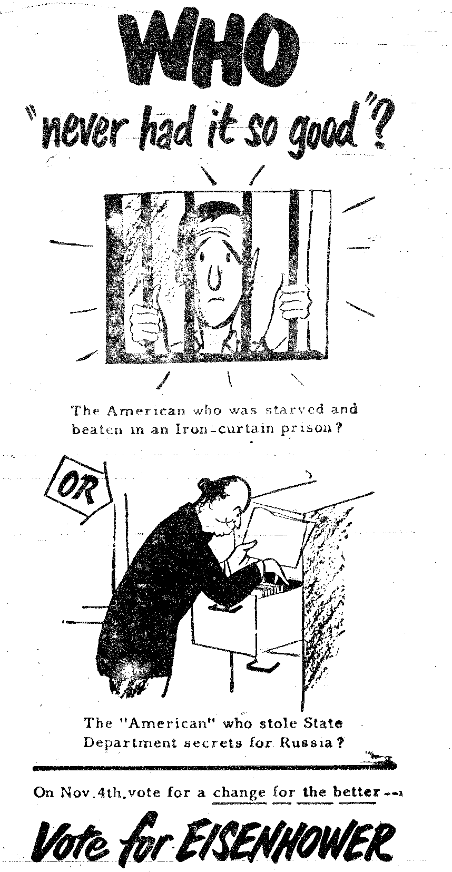
Eau Claire Leader-Telegram, November 2nd 1952

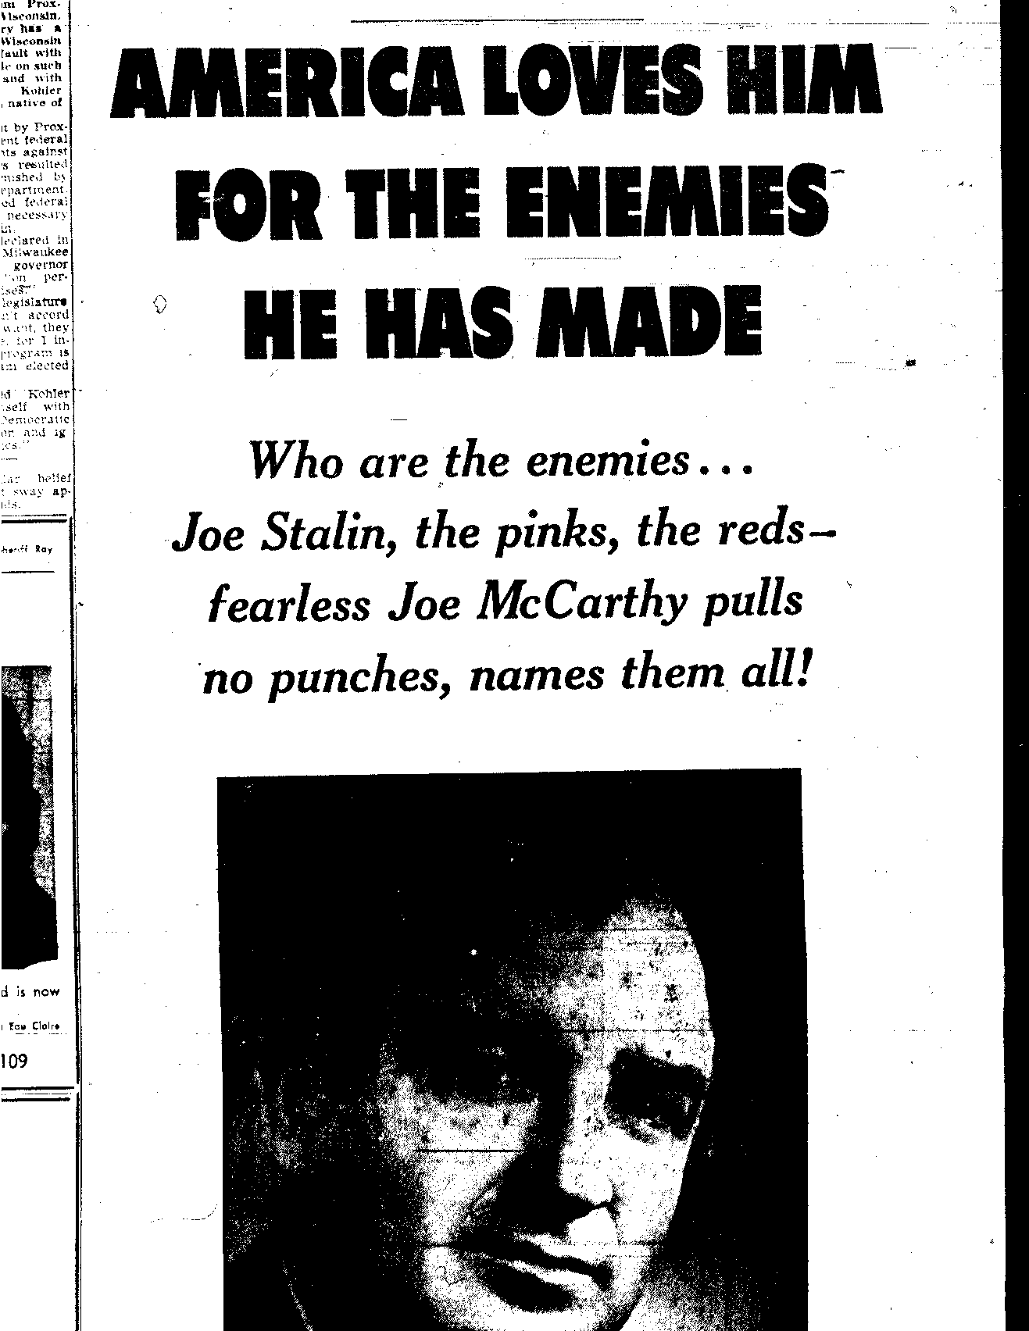
Eau Claire Leader-Telegram, November 2nd 1952
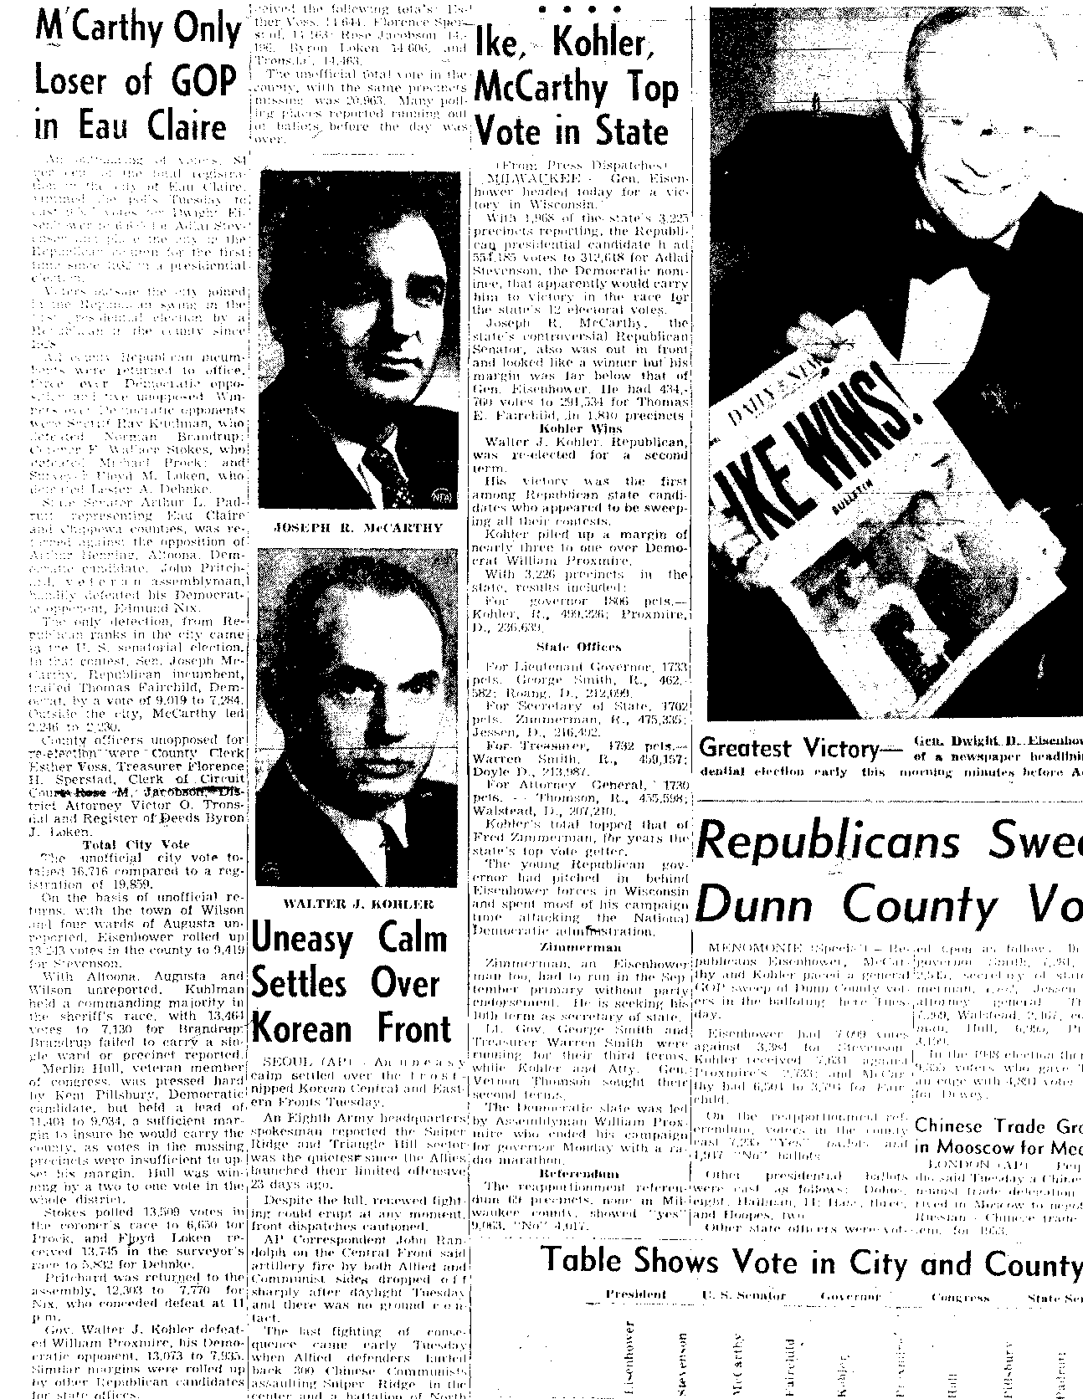
Eau Claire Leader-Telegram, November 5th, 1952
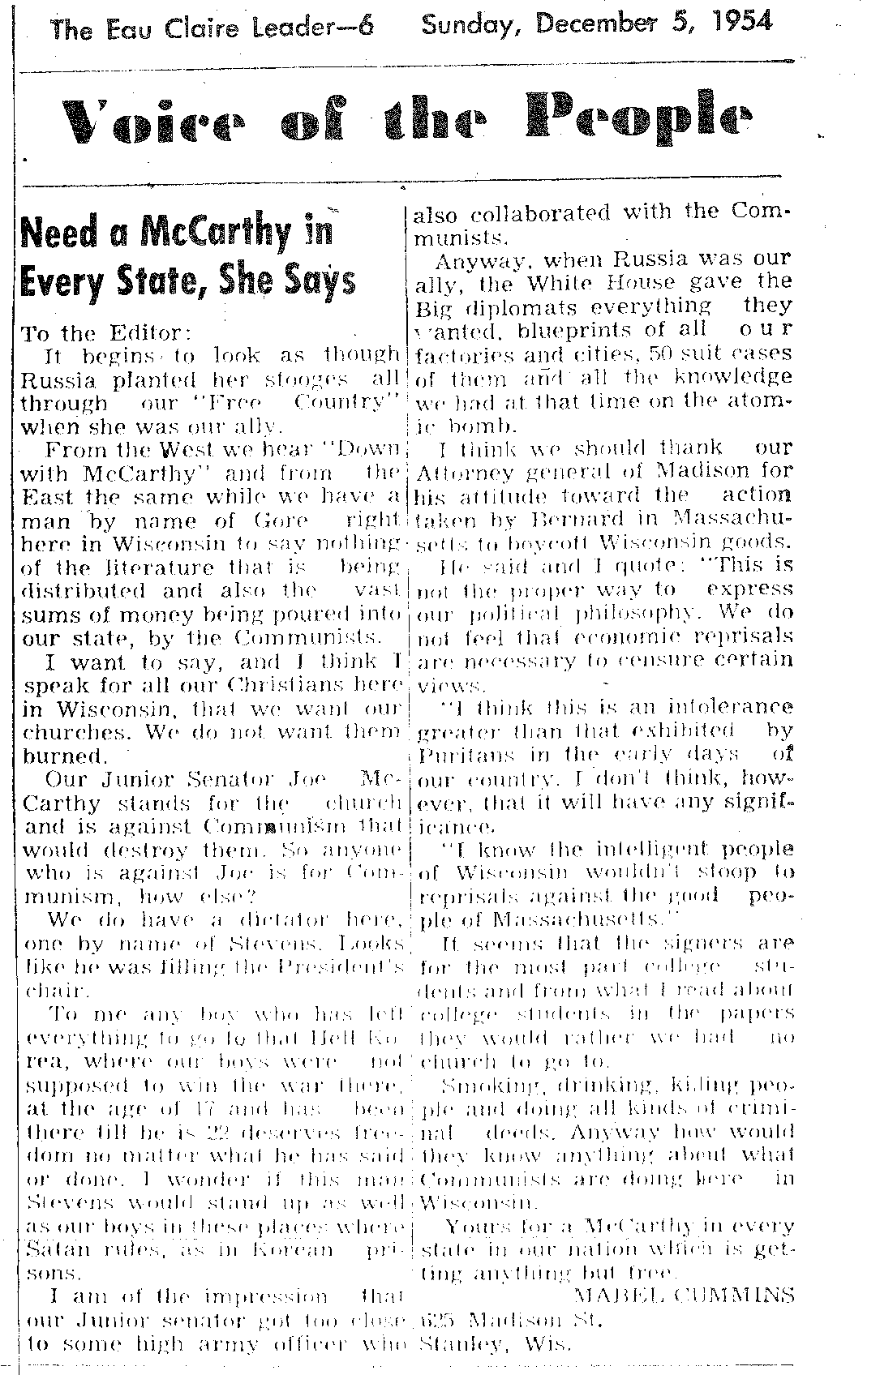
Eau Claire Leader-Telegram, December 5th 1954

Bibliography

Primary Sources

Bean, Louis H. Influences in the 1954 Mid-Term Elections. (Washington D.C.: Public Affairs Institute, 1954)

Benjamin Leighton Papers, “Hints and Suggestions for Workers in the Campaign to Recall Joseph McCarthy as One of its Representatives in United States Congress” The ‘Joe Must Go’ Clubs of WI, Inc., (Sauk City, April and May 1954) and Joe Must Go Club Meeting Reports, State Historical Society, Archives Main Stacks, Madison, Wisconsin

Eau Claire Leader Telegram, 2 November-5 November 1952, 5 December 1954

Gore, Leroy. Joe Must Go. (Julian Messner, Inc.: New York, 1954)

“Interview With Senator Joseph R. McCarthy” Longines Chronoscope. Accessed 26 September, 2010. <http://www.youtube.com/watch?v=KSmiE62YQTI>

Ivan Nestigen Papers, Joe Must Go Club Meeting Reports, State Historical Society, Archives Main Stacks, Madison, Wisconsin

Pace, Eric. “Louis H. Bean, 98, Analyst Best Known for 1948 Prediction”. The New York Times. Accessed 24 September 2010. < http://www.nytimes.com/1994/08/08/obituaries/louis-h-bean-98-analyst-best-known-for-1948-prediction.html>

Frank Theodore Cloak Papers, Joe Must Go: The Story of Dane County, Wis., in the 1954 Recall Effort Against Senator Joseph McCarthy, Madison, Wisconsin, 1954, State Historical Society, Archives Main Stacks, Madison, Wisconsin

William Benton Papers. Essays and Letters. State Historical Society, Archives Main Stacks, Madison, Wisconsin

Secondary Sources

“Benton, William (1900-1973)”. Biographical Directory of the United States Congress. Accessed 23 September, 2010. <http://bioguide.congress.gov/scripts/biodisplay.pl?index=b000399>

Fried, Richard M. Men Against McCarthy. New York: Columbia University Press, 1976

Griffith, Robert. “The General and the Senator: Republican Politics and the 1952 Campaign in Wisconsin”. The Wisconsin Magazine of History, Vol. 54, No. 1 (Autumn, 1970), pp. 23-29

O’Brien, Michael. McCarthy and McCarthyism in Wisconsin. Columbia: University of Missouri Press, 1980, preface viii

Oshinsky, David. “Wisconsin Labor and the Campaign of 1952”. The Wisconsin Magazine of History, Vol. 56, No. 2 (Winter, 1972-73), pp. 109-118

“Recall of State Officials”. Nation Conference of State Legislatures. Accessed 2 October. http://www.ncsl.org/LegislaturesElections/ElectionsCampaigns/RecallofStateOfficials/tabid/16581/Default.aspx

Thelen, David P. and Esther S. “Joe Must Go: The Movement to Recall Senator Joseph R. McCarthy”. The Wisconsin Magazine of History, Vol. 49, No.3 (Spring, 1966), p 186

Several Photos Shown In the Appendices
McCarthy, Joseph. “Speech At Wheeling, West Virginia” (1950). <http://us.history.wisc.edu/hist102/pdocs/mccarthy_wheeling.pdf> Accessed 18 September
David P. and Esther S. Thelen. “Joe Must Go: The Movement to Recall Senator Joseph R. McCarthy”. The Wisconsin Magazine of History, Vol. 49, No.3 (Spring, 1966), p 186
Thelen, “Joe Must Go”, 186-190
Thelen, “Joe Must Go”, 195
Michael O’Brien. McCarthy and McCarthyism in Wisconsin. Columbia: University of Missouri Press, 1980, preface viii
O’Brien, McCarthy and McCarthyism, 143-146
O’Brien, McCarthy and McCarthyism, 144
O’Brien, McCarthy and McCarthyism, 122-126
O’Brien, McCarthy and McCarthyism, 126-130
David Oshinsky. “Wisconsin Labor and the Campaign of 1952”. The Wisconsin Magazine of History, Vol. 56, No. 2 (Winter, 1972-73), pp. 109-118
Oshinsky. “Wisconsin Labor and the Campaign of 1952”, p 112
Oshinsky. “Wisconsin Labor and the Campaign of 1952”, p 114-118
Robert Griffith. “The General and the Senator: Republican Politics and the 1952 Campaign in Wisconsin”. The Wisconsin Magazine of History, Vol. 54, No. 1 (Autumn, 1970), pp. 23-29
Griffith, “The General and the Senator”, pp. 23-29
Richard M. Fried. Men Against McCarthy. New York: Columbia University Press, 1976
Robert Griffith. The Politics of Fear. Amherst: University of Massachusetts Press, 1987, 221-223
“Benton, William (1900-1973)”. Biographical Directory of the United States Congress. Accessed 23 September, 2010. <http://bioguide.congress.gov/scripts/biodisplay.pl?index=b000399>
William Benton, “Europe and Senator McCarthy”, The Fortnightly Review, April 1954, The Papers of William Benton, State Historical Society, Archives Main Stacks, Madison, Wisconsin, p 4
“Europe and McCarthy”, Papers of William Benton, pp. 7-8
Herbert Brownell, Jr. to William Benton, 25 August, 1951, Papers of William Benton,
Herbert Brownell, Jr. to William Benton, 25 August, 1951, Papers of William Benton
Joseph R. McCarthy to William Benton, 7 May 1952, Papers of William Benton
“Interview With Senator Joseph R. McCarthy” Longines Chronoscope. Accessed 26 September, 2010. <http://www.youtube.com/watch?v=KSmiE62YQTI>
Box 3, Papers of William Benton
Eric Pace. “Louis H. Bean, 98, Analyst Best Known for 1948 Prediction”. The New York Times. Accessed 24 September 2010. < http://www.nytimes.com/1994/08/08/obituaries/louis-h-bean-98-analyst-best-known-for-1948-prediction.html> Louis H. Bean. Influences in the 1954 Mid-Term Elections. (Washington D.C.: Public Affairs Institute, 1954), pp. ii-iii
Bean, pp. 11-14
Bean, pp. 14-18
Bean, pp. 14-18; “McCarthy Only Loser of GOP in Eau Claire”. Eau Claire Leader Telegram, 5 Nov., 1952
Bean, p. 32
Louis H. Bean to John Howe, 1 December 1954, Papers of William Benton
John Howe to William Benton, 7 May 1954, Papers of William Benton
“Recall of State Officials”. Nation Conference of State Legislatures. Accessed 2 October. http://www.ncsl.org/LegislaturesElections/ElectionsCampaigns/RecallofStateOfficials/tabid/16581/Default.aspx; Thelen, “Joe Must Go”, 186
Wisconsin Constitution. (Madison: Revisor of Statutes Bureau, 2004), Accessed 2 October 2010, http://www.legis.state.wi.us/rsb/2wiscon.html
Thelen, “Joe Must Go”, 188
Leroy Gore, Joe Must Go. (Julian Messner, Inc.: New York, 1954), pp. 27-28
Gore, Joe Must Go, 26
Joe Must Go Meeting, 28 March 1954, Ivan Nestigen Papers, State Historical Society, Archives Main Stacks, Madison, Wisconsin
Joe Must Go Meeting, 17 April 1954, Nestigen Papers; Joe Must Go Meeting, 15 May 1954, Nestigen Papers
“Hints and Suggestions for Workers in the Campaign to Recall Joseph McCarthy as One of its Representatives in United States Congress.” The ‘Joe Must Go’ Clubs of WI, Inc., (Sauk City, April and May 1954), Benjamin Leighton Papers, State Historical Society, Archives Main Stacks, Madison, Wisconsin
Ibid
⁴² Ted and Jane Cloak, Joe Must Go: The Story of Dane County, Wis., in the 1954 Recall Effort Against Senator Joseph McCarthy, Madison, Wisconsin, 1954, Frank Theodore Cloak Papers, State Historical Society, Archives Main Stacks, Madison, Wisconsin “Hints and Suggestions for Workers in the Campaign to Recall Joseph McCarthy as One of its Representatives in United States Congress”, Benjamin Leighton Papers

