DUAL SENIOR HONORS THESIS

ROCK SAMIZDAT AND UNDERGROUND CULTURE IN SOVIET RUSSIA

by
Alec Streed Luhn

Dual Senior Honors Thesis (History and Journalism)
University of Wisconsin
Submitted to the departments of History and Journalism
in fulfillment of the requirements for the degree of
Bachelor of Arts with Comprehensive Honors
May, 2010

Approved by:
_____________________________________________________

Primary Thesis Advisor
_____________________________________________________

Secondary Thesis Advisor
_____________________________________________________

Honors Department Director

Table of Contents
- Introduction…….……………………………………………………….…………3
- History of Samizdat………………………...……………….…………………..…9

ORIGINS OF SAMIZDAT…………………………………………………..9

HISTORICAL FUNCTIONS OF SAMIZDAT…………………….………12
- Rock Around the Bloc……………………………………………………………15

THE DEVELOPMENT OF SOVIET ROCK………………………………15

THE SIGNIFICANCE OF THE ROCK UNDERGROUND………………23

THE ROCK COUNTERCULTURE………………………………………...27
- Creating Rock Samizdat…………………………………………………………33

“WE DIDN’T SLEEP”: THE IMPETUS BEHIND ROCK JOURNALS…33

ROKSI AND THE MERGENCE OF ROCK SAMIZDAT……………...…39

RIO AND THE NEXT PHASE OF ROCK SAMIZDAT………………….48

SHARED FUNCTIONS OF THE LENINGRAD JOURNALS……………55
- Reflection and Analysis………….……………………………………………….62

INTERPRETING ROCK SAMIZDAT…………………………………..…62

CONCLUSION…………………………………………………………......66

SUPPLEMENTARY DOCUMENTS

Document 1: “HATE!” Drawing…...………………………………………...……71

Document 2: Excerpt from Roksi, issue 2 (January 1978)…………………...……72

Document 3: Excerpt from RIO, issue 2 (November 1986)……………….....……81

Document 4: Excerpt from RIO, issue 4 (20) (April 1988)………………………..98

Selected Bibliography…………………………………………………………….103
I. Introduction
Despite its homespun, amateurish quality, the pencil sketch is nonetheless striking: “HATE!” is scrawled thickly in English across the sheath of A4 paper under a rough yet unmistakable representation of the fig, a sign of insult formed by placing the outstretched thumb between the index and middle fingers of the same hand. Given the modern connotations of the selected English word, the picture could be interpreted as an expression of racism or bigotry. According to Oleg Reshetnikov, the physicist, former underground rock fan and editor who preserved it, the drawing is a piece of “abstract art” originally intended for inclusion in an issue of Roksi, an underground rock journal that was published in Leningrad during the 1980s in the historically unique form of unofficial publishing known as samizdat. It was meant as a “symbol of dissent, of an unofficial point of view” amidst the forced compliance of Soviet Russia, where the ruling regime at best ignored and at worst crusaded against the music that the young rock fans who wrote and read Roksi followed. It was a sign of youthful self-expression amid involuntary cultural conformity. “We won’t agree with you—fig to you!” was the message the drawing was meant to convey. “What can you tell people who don’t allow you to express yourself?” Reshetnikov asked. At the same time, the picture exhibited the playful nature of rock samizdat writing, since the English letters can also be read as Cyrillic letters to form the phrase “na te!” (“take that!”), which typically accompanied the fig.
Although it was never published in Roksi, the “HATE!” drawing represents the self-expression facilitated by the underground journals that covered the incipient Russian rock movement, which are collectively known as “rock samizdat” (rok-samizdat). It captures rock samizdat’s youthful rebelliousness, its struggle for identity, alienation from official society, interest in a new way of life, and independent communication amid conformity. These restive sentiments found expression in the vibrant new music of Russian-language rock and were also voiced in print form when rock samizdat appeared in 1979, during zastoi, an era of economic and social stagnation that led up to perestroika and the fall of the Soviet Union. Since it shared the feelings of Russian rock and was written by and for fans of this music, rock samizdat was truly part of the Russian rock movement and helped create the underground, alternative community surrounding it. Moreover, by expressing their views in the pages of rock samizdat, rock fans could participate in this community and find a sense of belonging and personal identity within it. Thus, rock samizdat facilitated both self-expression and membership in the rock counterculture.
As the liveliest part, at that time, of the “underground” or “second” culture that opposed the Soviet government’s vision of society, the rock movement had important antecedents in the different trends of cultural and political opposition that had appeared after World War II, especially after Joseph Stalin’s death in 1953: The jazz- and fashion-centered youth counterculture of the stiliagi in the 1940s and ‘50s, the iconoclastic student opposition that arose during Soviet leader Nikita Khrushchev’s thaw of 1956, the “cultural opposition” following the breakup of the student movement, and the new wave of “rebel youth” in the 1960s. Likewise, rock samizdat followed in the footsteps of the samizdat literatures that arose and developed with these movements, providing each with its collective voice: The initial stage of literary samizdat exemplified by the works of Boris Pasternak and Alexander Solzhenitsyn, the social samizdat that began to fulfill the functions of a newspaper rather than those of a book, and finally the diversified samizdat that provided a vehicle for sundry statements of social and political thought.
Within this narrative, rock samizdat represents the last phase of a samizdat tradition stretching from Stalin’s death to the breakup of the Soviet Union, but it also stands apart from these metahistorical trends in samizdat—a form that by definition is extremely variegated and therefore impedes attempts at categorization—in that it was extremely specific to the Russian rock and its youth counterculture and appeared in one main format, the homemade rock journal-magazine. Furthermore, it shied away from the political orientation of earlier youth movements and lacked the political overtones of literary samizdat such as Solzhenitsyn’s work. Although as a manifestation of underground culture the rock movement was inimical to the ruling regime, the “HATE!” drawing indicates the elemental nature of this vague rebelliousness, a feeling of upheaval that echoes the core value of rock ‘n’ roll itself. With the liberalizing trends associated with perestroika and the breakup of the Soviet Union, government controls on publishing were being lifted and the samizdat form became anachronistic.
On a more basic level, the “HATE!” drawing represents the homemade production process that was a fundamental characteristic of rock samizdat. Its creators, mostly students, devoted significant amounts of time to this lengthy publishing process. Samizdat articles were written up by hand, then painstakingly and diligently pounded onto onion-skin paper, usually stacked five sheets thick in the typewriter, by hired or volunteer typists, and finally collated by a gathering of editors in a cramped apartment reeking of noxious fumes from the glue used to paste in photographs. Such a collating session would often feature the intoxicating effects not only of glue fumes, but also red wine, since rock samizdat journals were usually produced by a group of friends or acquaintances in an atmosphere more similar to the rock movement’s infamous tusovka, a term meaning both “party” and “clique,” than any sort of work environment. As far as production values, rock samizdat was far from the Western conception of the music magazine à la Rolling Stone; the first rock samizdat journal, Roksi, was initially coverless and bound in a dissertation folder. The print run was officially five copies and one original in an attempt to avoid persecution by the government; according to Soviet publishing regulations, no more than five copies of a personal document could be produced.
The distribution, as with all samizdat, was almost exclusively by hand, as issues were passed from one fan to another through circles of acquaintance. Sometimes they were hand-copied in the process. Although Yuri Andropov, who was then head of the Committee for State Security (KGB), claimed that “shady types and speculators” sold samizdat material for personal profit, the acquaintance-based nature of distribution laid out in the historiography, especially when taken in context with the recollections of those who actually exchanged samizdat materials, indicates that almost any money transaction involved in the distribution of samizdat was minimal and intended only to cover the cost of materials. The format, content, and function of rock samizdat journals changed with each journal and even with each subsequent editorial staff of the same journal. An issue might include compilations of rock lyrics, interviews with musicians, album and concert reviews, editorial columns, humorous pieces, fictional stories, news and announcements about the local and national rock scene, and various other articles that can only be classified as “miscellanea.” The intended functions of this amalgamation of material included helping rock musicians develop their art, facilitating social interaction among rock samizdat authors, chronicling current events for history, and entertaining and informing fans.
This thesis argues that the most important function of rock samizdat was allowing its young authors a degree of self-expression and personal identity in an oppressive society, which also gave them a sense of membership in the rock counterculture. Such a conceptualization of rock samizdat can explain the enormous effort these authors expended in publishing a product extremely limited in readership and distribution. Among other questions, the current work will ask: (1) How did authors use rock samizdat as a form of self-expression? (2) What motivated them to dedicate so much time to rock samizdat? (3) What continuities from earlier forms of samizdat did rock samizdat retain, and what innovations did it make? To answer these questions and support its claim about the primacy of self-expression, this paper covers the origins, forms and functions of samizdat, the history of Soviet rock music and culture, and the development and activity of rock samizdat. It is meant to be a compendium of information and interpretations of rock samizdat’s impetus, format, function and historical effect, rather than a detailed historical, linguistic, or sociological analysis. In this manner, it will contribute to the scholarship on rock samizdat, which remains virtually unstudied as a unique movement of Soviet underground publishing and as a component of Soviet rock culture. Ultimately, it will argue that the further study of rock samizdat should regard this phenomenon chiefly as an institution within the Soviet rock movement, while also acknowledging its similarities with prior forms of samizdat.
This project is based on primary sources that include written accounts of the Soviet rock scene, interviews with former authors of rock samizdat, and issues of the two longest-published Leningrad rock samizdat journals, Roksi and RIO, as well as secondary sources in both Russian and English. In the spring and summer of 2009, the author interviewed six men who wrote and edited rock samizdat journals in Leningrad during the late 1970s and 1980s. Aleksandr and Valerii Andreev are brothers; Aleksandr played in the Soviet rock group Vykhod (“Exit”) and participated in the creation of the fourth issue of Roksi while still a student in 1981, whereas Valerii was also a student and an amateur photographer who worked on many issues of RIO, beginning with the second (November 1986). RIO editor-in-chief Andrei Burlaka worked as an engineer in the late 1980s, writing and compiling the journal on evenings and weekends. Sergei Afonin and Sergei Chernov, who were then studying English language at Leningrad State Pedagogical University, created the first issue of RIO with Burlaka and contributed to subsequent issues. Oleg Reshetnikov, then a physics student at Leningrad State University, helped edit and type articles for Roksi in 1981 and again in 1983. In addition, the author interviewed John Bailyn, a professor of linguistics at Stony Brook University with a focus on Slavic languages, in March 2010. Bailyn first traveled to Leningrad as an exchange student in 1983 and befriended many rock musicians and fans there over the next four years. He has worked with preeminent Soviet rocker Boris Grebenschikov to translate some of this artist’s songs into English. These interviews were an especially informative source throughout this project.
II. History of Samizdat
ORIGINS OF SAMIZDAT
The most basic definition of samizdat is the publication and circulation of uncensored, unofficial material, the “literature outside of censorship” cited by then-KGB president Yuri Andropov in a 1969 document on the dangers of samizdat. Andropov went on to note that samizdat was generally handwritten or typed, passed from hand to hand and was reproduced on photocopiers or duplicator machines. The word etymologically is derived from the Russian root words for “self” and “publishing.” It captures the essence of the phenomenon it describes better than the comparatively pale and cumbersome English translation of “underground publishing.” The English translation also lacks the irony and wit of the Russian original, as the word samizdat parodies the Soviet bureaucratic acronym for official publishing apparati, Gosizdat (from “Gosudarstvennoe Izdatel’stvo,” or “State Publishing House”). Although the exact etymology of the word remains somewhat apocryphal, it may have first emerged as Samsebyaizdat, which could be translated as “I Myself Publishing House.” The shortening of samsebyaizdat, which meant, at root, “I publish myself,” to samizdat, or “self-publishing,” has been interpreted as a shift in emphasis from the publication of the author’s own work to that of material not necessarily written by the author, but published of his or her own free will.
The historically unique phenomenon of samizdat arose after World War II in the distinctive conditions of the communist states of the Eastern Bloc as a reaction to the information control practiced by the governments of these societies. It materialized on a large scale in Soviet Russia in the mid-1960s and in other communist countries in the mid-1970s. Hungarian political scientist György Schöpflin wrote that the main source of the Communist Party’s legitimacy in these states was a “myth of unanimity” that required a monopoly of information through censorship and other forms of control. Independent communications, including to a great extent samizdat, challenged this “myth of unanimity,” weakening the monopoly of information and therefore the legitimacy of the party regime. The accuracy of Schöpflin’s interpretation is indicated by the strictly delineated state control of printing presses.

Samizdat is an inherently unofficial, underground phenomenon documented primarily by the material it produced. The sheer variety of this material, though, resists categorization: Should samizdat be interpreted as primarily a literary, political or cultural form of publishing? Should its study focus on the audacity of the content or the ingenuity and resourcefulness of the format? The existing scholarship has focused on the “classic Soviet samizdat” produced between 1956 and 1986, often in the form of periodicals. Almost all the groups that created samizdat journals during this time defined themselves in relation to the democratic dissident political movement within the Soviet Union. Given this purview, samizdat scholarship has traditionally proceeded along one of three paths: (1) the study of the ideas and arguments of samizdat publication, (2) the study of how the government reacted to samizdat, and (3) the study of how samizdat was used in the organization of cultural and political opposition movements.
Where does rock samizdat—an organic, spontaneous phenomenon intended to provide young people with a mode of self-expression and participation in a community—fit into this schema? Its content does not resemble that of the literary, political, and religious journals typical of classic samizdat. Furthermore, the seminal rock samizdat journal RIO was published from 1986 until 1989, whereas classic samizdat is said to have ended in 1986. Neither does rock samizdat lend itself to the three traditional approaches to the study of samizdat. Considering rock samizdat’s inherently introspective overall aim, taking the first approach would not be likely to uncover many stimulating trends. Many samizdat authors looked down upon philosophical arguments or engagement with any wider discourses, and the Leningrad journals shied away from polemics. The second approach also lacks any particular appeal, since the Soviet government did not take a definite stance on rock samizdat nor actively repress it, according to authors. Furthermore, the official policy on rock music loosened during the latter days of rock samizdat. The third approach could be used to address the role rock samizdat played in Soviet rock as a cultural movement, but its use would overemphasize the political aspect of this movement, which was marked more by an indifference and cynicism toward the Soviet state rather than opposition to it. As has been mentioned, rock samizdat authors were focused on rock music rather than politics. Instead, this thesis will argue for an interpretation of samizdat chiefly as an institution of the Soviet rock movement, rather than merely the latest arrival in a long line of samizdat genres.

HISTORICAL FUNCTIONS OF SAMIZDAT
Samizdat is difficult to typify as a publishing form because of the wide variety of uses to which it has been put. The samizdat corpus includes genres such as poetry, prose, memoirs, essays, documents, statements of protest, trial records, and open letters to the Soviet government or the Communist Party. Even Saunders’s narrowly focused study of samizdat as a mode of communication and tactical debate for the Soviet political opposition includes a political poem in its anthology. Later samizdat expanded into music sales—music recordings were listed for purchase in a samizdat catalogue from Brno in Czechoslovakia—and other materials, even pornography.
Nonetheless, it is possible to identify two main functions that samizdat has, at various points, been intended to fill. For one, samizdat was a way for the individual to preserve some degree of freedom and specifically personal expression in the repressive circumstances of the Eastern Bloc. In the sense that personal expression allows an individual to voice his thoughts and feelings openly and thereby come to discover his personal identity, this vocalizing function was tied to self-actualization. Of course, personal identity, although formed by the individual, is often based in part on membership in some sort of community. Samizdat’s role in identity formation culminated with rock samizdat, which, as we will see, was used by its young authors as a way to understand the new music that was bubbling up from below, but also as a way to participate in the community surrounding the music. Therefore, a main goal of rock samizdat, for its authors, was “to understand ourselves,” forming identities as individuals and as members of the rock community.
A second important function of samizdat was to aid in the development of a dynamic culture independent of the official vision of Soviet society. Indeed, the emergence of such a culture was almost always accompanied by an enormous upswing in samizdat activity. The phenomenon of such a “second” or “underground” culture has been defined as an authentic system of communication arising when “relatively free and genuine culture emerges in the form of samizdat and other self-directed kinds of activity.” This culture is usually limited because it functions in “a kind of ghetto” outside the awareness of the general public. Czech poet Ivan Jirous, who is known for devising the theory of the “second culture” of Communist societies, went further in defining the underground as “a mental attitude” of people who “consciously and critically determine their own stance toward the world in which they live” and challenge the establishment. The second culture forms a community of mutual support for these people. In the creation of this underground culture, samizdat often complemented independent activity in areas such as painting, music and drama, even though underground samizdat activity has often been framed in terms of direct reaction to government repression. Rock samizdat provides a specific example of this fusion of spheres of independent activity, joining independent journalism and independent music in the creation of a rock counterculture that embodies the concept of underground culture and its ideal of free communication.
- Rock Around the Bloc
THE DEVELOPMENT OF SOVIET ROCK
As was previously discussed, the emergence of an underground culture has typically resulted in corresponding samizdat activity, and the rock counterculture that developed around the Soviet rock movement was no exception. Rock music played an extremely important, if unofficial, role in Soviet life, serving as a fountain of independent information amid Soviet propaganda’s world of half-truths and open lies. Since rock music and culture was so intrinsic to rock samizdat, any investigation of this form of publishing requires that we delve briefly into the history of Soviet rock. Of course, a study of Soviet rock as a musical form is little more than an entrée into an entire counterculture that centered on rock music. Rock samizdat was one of many components of this youth-based alternative culture and lifestyle. In the late 1970s and 1980s, the rapidly growing Russian-language rock movement and its burgeoning press (rock samizdat) interacted in a way that was formative for both.
Soviet rock music, in the broadest cultural sense, was a social revolution that had been growing gradually in the USSR since the end of World War Two, according to paramount Soviet rock critic Artemii Troitskii, who could be considered the Soviet Lester Bangs for his prolificacy, high visibility on the rock scene and participatory “gonzo” style of journalism. This revolution was precipitated by the import of Western rock music and culture into the Soviet Union. Once the seed of rock was sown behind the Iron Curtain, it immediately began to mutate and grow into its own distinct organism, following a different course of development than rock music had in the West. Soviet citizens often reworked Western cultural products to put them to use in their own culture. In the case of rock ‘n’ roll, they adopted elements of Western rock to create an alternative form of music and way of life within the USSR, notes Wellesley sociologist Thomas Cushman, who interviewed 40 members of the Leningrad musical community before and after the breakup of the USSR for his exhaustive analysis of Soviet rock counterculture. Until at least the mid-1980s, the Soviet regime viewed this swiftly nativizing cultural phenomenon with various degrees of apprehension due to its Western influences and nonconformity to the apparatus of official culture. Thus, as Soviet rock developed its own distinct sound and dedicated counterculture, Soviet rock musicians suffered limited opportunities and sometimes active persecution at the hands of official actors.
Although Soviet rock was spawned by imported Western rock, its subsequent development was nonetheless informed by two Soviet cultural predecessors. The first of these was the stiliagi movement of the 1940s and ‘50s. The young stiliagi (the nearest translation would be “mods”) shocked official Soviet cultural sensibility with their bright and checkered clothing, slangy, English-influenced jargon and penchant for expressive dancing. Although they listened to jazz, they prefigured the denizens of the rock underground in several ways, such as in their following of foreign music, “hunger for information,” predominantly young male demographic, alternative lifestyle and high degree of isolation from mainstream Soviet society. Soviet rock was likewise influenced by avtorskaia pesnia (“authorial song”), a musical genre of guitar-playing singer-songwriters who often sang about social issues. The “mass song” of bards such as Bulat Okhudzhava and Vladimir Vysotsky, which was often heard on unofficial recordings and in some cases published, represented cultural freedom within the constraints of the Soviet state for several decades. Although the music of Vysotsky and other bards represented an important musical precedent for rock musicians, Soviet rock music featured an additional situational component in the form of the alternative lifestyle that developed around it.
According to popular Soviet musician Alexei Kozlov, “Soviet rock started with the Beatles.” The Fab Four’s recordings made a stunning impression on young people when they first began to trickle into the Soviet Union in the late 1960s. This infatuation with the Beatles only grew in the ensuing decades. Beginning in the 1970s and continuing to the present day, Russian rock musicians celebrated the group members’ birthdays by giving concerts and writing songs. Soviet youth began copying Beatles recordings on used X-ray film (an infamous technique known as recording “on the bones”) and playing them at nighttime gatherings in apartment yards. Around the same time, the first Russian Soviet rock groups were appearing, although this new music was called “big-beat” or simply “beat” at that time. They performed Western songs at dances at schools, institutes, student cafes and dormitories, trying to copy the original inspiration as closely as possible with their accented vocals and homemade instruments. They served as little more than “live jukeboxes,” since private recordings of Western music were inaccessible to most and music clubs were nonexistent. Besides Western records that were smuggled in from abroad, Soviet rock developed in isolation, its only international contacts being with groups from other Eastern Bloc countries. It was not until 1969 that the Soviet Union’s “first rock bard,” Andrei Makarevich, and his group Mashina Vremeni (“Time Machine”), began to popularize Russian-language rock music.
It seemed that Soviet rockers, who had initially aped English lyrics that they often did not understand, now moved toward the opposite extreme, placing a greater emphasis on lyrics than has ever been found in Western rock. Whereas the music of Elvis Presley in the U.S. was shocking not for its lyrics, but rather for its physical accompaniment—that is, Presley’s infamously provocative dancing—the most inflammatory facet of Soviet rock music was its lyrical content, which included open criticism of Soviet society and its economic system. Troitskii, who is also a longtime fan and critic of Western rock, likewise acknowledges the high literary level of Soviet rock lyrics, which often dealt not just with love and sex, but also with social and ethical issues. According to Troitskii, several contingencies influenced the development of this lyrical emphasis, including the poetic traditions of Russia (both academic poetry and the avtorskaia pesnia school of bard music were extremely popular), the initial absence of a commercial potential for rock music, Soviet rock musicians’ weaker technical virtuosity and limited access to high-quality equipment for musical performance and recording, and their awareness that the music half of the equation had been borrowed from the West.
The frankness of Soviet rock’s lyrical content inspired devotion on the part of its fans and apprehension on the part of the Soviet government, which at times ignored rock musicians and fans, but at other times actively persecuted them. Only in the 1980s did it begin to increasingly allow them to pursue their passion in a relatively unfettered environment. The previous limitations may have contributed to the artistic development of Soviet rock, as Troitskii avers that the best rock music is produced under conditions of strife. This cultural maxim finds scholarly credence in Cushman’s formulation of Soviet culture, of which rock music is an important manifestation. Cushman maintains that Soviet culture developed from its interaction with the exigencies of life in a totalitarian state, but also conflicted with the invasive strictures posed by the cultural infrastructure of that state: “The sociology of Russian culture situates Russian cultural practices within the larger framework of socialist industrial existence, as both a product of that existence and a force which [sic] resisted it.”
Before 1980, the Soviet government’s policy on rock music was, in essence, an ill-defined, informal position that gave it wide latitude to persecute or promote rock music as it saw fit: “no formal ban, but no official support.” “Nothing was directly forbidden” as far as rock music was concerned, but police often arrested fans after underground rock shows, remembered rock samizdat author and rock fan Sergei Afonin. As early as October 1971, a decade before the opening of the first legal rock music venue, rock groups were sometimes allowed to rehearse in the state-run recreation halls known as “palaces of culture.” The state did explicitly limit rockers’ earning potential, however: Before the end of the 1970s, all rock groups were forced to play as amateurs, meaning they were not legally allowed to make money from their musical efforts. The vacillation between various degrees of intolerance and forbearance was not atypical of Soviet communist rule: The party sought to modernize the USSR but simultaneously attempted to counter the “forces unleashed by the process of modernization,” including social forces such as rock music. When Soviet rock music was first emerging in the mid- to late-1960s, the government’s stance was one of “total indifference.” By the early 1970s, however, the authorities were closing every new rock club that opened in Moscow. Even in the mid-1970s, when the authorities had allowed several discotheques where rock music was played to begin operating, the official press still mostly refused to cover rock music. When the press did write about Western rock music, its coverage was negative and depicted rock music as dangerous and harmful. For example, a series of articles in the Soviet youth press in the 1970s drew on rhetoric deriding Western bourgeois aesthetics “to describe the insidious effects of low frequencies, loud volumes, and distorted sounds of Western rock bands on the human psyche.”
The “first era of rock on an official foundation” began in 1980 in the wake of the Tbilisi-80 festival, when positive articles about rock music began to appear in the official press, state radio began to broadcast previously unacceptable rock songs, and the first official rock records came out. Moscow rock groups were allowed to perform on the professional stage at the 1980 Summer Olympics so that the government could show off its ostensible “liberalism.” Even then, rock received relatively low billing in the mass media. For instance, a brief survey of archived issues of Izvestiia, the official newspaper of the Soviet government, from the dates of two milestone events on the Soviet rock scene in the 1980s—the founding of Rok-klub on March 7-8, 1981 and the second Rok-klub festival on May 18-20, 1984—as well as the days immediately following them, turned up no mention of these events. This newfound embrace of rock music arose in response to the obvious impossibility of stamping out the growing art form. In addition, the government recognized the commercial potential of producing legal rock records for consumption. After decade of imported Western rock records and unofficial concerts, “rock had become the favourite music of millions of people, had become the norm.” The music became a catalyst for self-expression on a massive scale: When the official newspaper Komsomol’skaia Pravda published a diatribe against Mashina Vremeni after the group’s Siberian tour in 1980, the editors received 250,000 angry letters, some of them with more than 100 signatures.
The opening of the country’s first rock club in Leningrad in 1981 gave rock musicians a legal venue for the performance of their music and provided fans with a place to socialize and form a greater sense of community. By 1983 organizers had begun to hold festivals in the aptly named Rok-klub, and increasing numbers of festivals and concerts sprung up in other domy kultury (“houses of culture”). A string of concerts by Akvarium between October 28 and November 2, 1986 in Leningrad’s Jubilee Palace of Sport, which can hold up to 7,012 spectators under current regulations, demonstrated the Soviet authorities’ increasing permissiveness toward rock music events. It was during this time in the mid-1980s that Western rock groups began to perform, albeit rarely, in the Soviet Union. Festivals in particular gave fans and musicians a chance to socialize with one another and exchange knowledge of the contemporary Russian rock music scene, lending increasing cohesiveness to Soviet rock culture. In the mid-1980s, Leningrad hosted two to four rock concerts a month, Afonin estimated. RIO covered 14 concert events in October 1986, some of them featuring multiple bands and some lasting several nights. By 1988, rock concerts had grown so numerous that it was impossible to write about all of them, according to Afonin. Such a number indicates the effect the liberalizing trends of glasnost had on rock music. Nonetheless, a divide still existed between the state-sanctioned professional artists and the “amateur” musicians of the rock underground, who created their music outside the realm of state supervision and were not allowed, legally speaking, to make money off their art. This division further helped promote a sense of community among both rockers and fans. For example, an article in the April 1988 issue of RIO titled “Oni nam ne konkurenty” (“They can’t compete with us”) lambasted those professional artists who had begun to imitate the music of amateur rock musicians.
THE SIGNIFICANCE OF THE ROCK UNDERGROUND
Just as important as the musical innovations of Soviet rock was the development of a rock counterculture in which both musicians and fans explored new, alternative forms of identity and self-expression. The basic tenet of Soviet rock musical counterculture, according to Cushman, was the production and dissemination of rock music free from the interference of outside political or economic forces. Whereas the music itself was the distilled self-expression of the musicians—though it often indirectly mirrored the sentiments of their listeners—the culture surrounding it was a space in which rock fans could express themselves. The apex of this countercultural self-expression was rock samizdat, which was created by and for members of the rock underground.
It is important to note that the Soviet rock underground was not monolithic. Indeed, Troitskii describes it as a “series of overlapping youth cultures” that were unified in their challenge to the state and its enforcement of official culture. Broadly speaking, however, we can distinguish a group of people who listened to rock music and identified with the alternative culture it represented. For the Western reader, it is tempting to assume the presence in the Soviet rock culture of many of the qualities inherent to Western rock culture. At the most basic level, we do indeed find that many of the “social climactics” catalyzed by rock music in the Soviet Union are the same as those initially galvanized by its counterpart in the West: the generation gap, the rise of youth culture and a youth market, and defiance of the status quo.
However, the fundamental social dynamics and context of Soviet rock music were completely distinct from those in the United States, as a strict delineation between musicians and fans did not exist. As seminal Soviet rock musician Boris Grebenschikov of the group Akvarium (“Aquarium”) noted, “rock stardom” in Leningrad before perestroika was incredibly parochial in essence: No money could be made by selling records or giving concerts, and rock musicians lacked access to the national exposure only the mass media could provide. The dearth of money and fame, however, translated into greater communication between the different actors of the rock counterculture.
Soviet rock culture also developed characteristics that had few parallels in Western rock culture. John Bailyn, who became acquainted with many rock musicians when he studied and taught English at a high school in Leningrad over several periods between 1983 and 1987, noted that rock music took on additional meaning for Soviet youth as an alternative lifestyle, he explained: “People didn’t have anything to do, so they could put their whole life into this.” Grebenschikov argues that Soviet rock culture was more “significant, powerful, active” than alternative rock culture in the U.S.—especially hippie culture—because it was totally cut off from both state and society. “Hippies turned out to be more or less connected with the government under which they lived,” Grebenschikov said, “because in a sense the two were both sides of the same coin.” Soviet rock culture, on the other hand, could in no way fit into the framework of the society enforced by the Soviet government. Rock music espoused numerous credos that were counter to those promoted by the Soviet state, including the exaltation of personal feelings, adoration of cult figures, glorification of Western culture, promotion of dissent, and endorsement of cultural standards, fashions and behavior independent of party control. Such rebellion against the parameters of official culture provoked not only moral stigmatization, but also occasional legal persecution. Afonin recounted that Soviet police often tried to break up underground home concerts. “It was actually scary when police were picking people up after concerts, searching for drugs,” he remembered. For the many students within the rock counterculture, an arrest at a concert could lead to expulsion and, consequently, conscription into the army.
Cushman interprets the cultural independence of rock music à la Jürgen Habermas, framing this phenomenon in terms of a communicative movement of individuals against the strictures of the state apparatus. Habermas posits that music, in its capacity to allow individuals to share their experiences, is a form of expressive “communicative action” that facilitates both inner autonomy and shared consciousness among its listeners. Since humans are first and foremost communicators, the main struggle of modernity is one against distorted communication, in which communicative movements arise to protect the subjective experience of the individual against the invasive “instrumental rationality” of his society. For the Soviet citizen, this struggle was particularly acute, with individuals engaging “the most pronounced form of bureaucratic rationality in the twentieth century.” In this context, rock music was communicative action and the counterculture surrounding it a communicative movement against the invasive bureaucratic rationality practiced by the Soviet state, which attempted to control, among other areas, the cultural sphere of individual existence. One of the three shared conceptions of rock music that Cushman identified among Leningrad rock musicians equated independent self-expression with identity formation. This conception conceived of rock as way to claim social role “outside” normal hierarchy of roles and to produce an identity and sense of self outside the accepted Soviet prescriptions. Notably, we see the same values echoed by the counterculture authors of rock samizdat, as well.
THE ROCK COUNTERCULTURE
The social conditions of the zastoi era of the late 1970s and early 1980s encouraged the development of a youth counterculture. The younger segments of the Soviet populace were rife with feelings of dissatisfaction and alienation caused by frustration with employment opportunities, crowded and scarce housing, enforced conformity, the Komsomol (the youth wing of the Communist Party) and its forced inculcation of official values, and war weariness (among the veterans of Afghanistan). Many yearned for a new style of life, and some turned to drugs, alcohol or violence within vigilante gangs. For those seeking an alternative ideology, hippiedom, the “most massive and visibly ‘alternative’ movement ever observed” in the Soviet Union, held definite appeal. The ideology of Soviet hippiedom was less political than its American namesake, oriented completely toward Russian rock. The disillusioned youth of this later era found expression of their values and approach to life in hippiedom and in rock music. Rock lyrics served as “a challenge, explicit or implicit, to the consumer society and the totalitarian polity in which they had to live.” The interactions that formed the rock counterculture took place in a variety of venues where young people could engage in self-expression, find solidarity with like-minded people, and exchange news and music.
With the development of Russian-language rock in 1960s and 1970s, centers of rock culture emerged in Tallinn, Estonia, and in Soviet Russia in Leningrad and Moscow. This study focuses on Leningrad because of its smaller size and more “unitary” layout, which facilitated the formation of a single, more cohesive community of rock musicians and other bohemians. In combination with the greater penetration of foreign ideas, trends, and music among the Leningrad youth due to its international port and occasional foreign tourists, the Leningrad atmosphere allowed amateur performance of electric music to blossom “in an especially grand manner.” Most importantly, however, Leningrad was the home of the first rock samizdat journal and two of the longest-running rock samizdat publications, Roksi and RIO.
In typifying the Leningrad rock underground, we must remember that this community was notable for its diversity of personal styles. “We were all interesting to each other,” explained Valerii Andreev, who wrote for the Leningrad rock samizdat journal RIO. “One person was a punk, another was a metalhead, but we all understood that fascism was bad, that we weren’t hoodlums, that we had something in common.” Rock fans distinguished themselves with some form of fashion attire, rather than an adherence to a particular style. In the Soviet Union, Afonin explained, “this was suspicious; any fashion elements were immediately noticeable.” Long hair was typical and many members of the rock community wore various hippie regalia until the end of the 1980s. Afonin estimated that in the 1980s, at least half of the rock counterculture was students and many others had already earned a higher education degree. According to Sergei Chernov, another RIO author, the age demographic added an element of risk, since young people were worried about jeopardizing their university studies if they were found to be rock fans. Grebenschikov likewise characterized the rock underground as a highly educated milieu, going so far as to call it the near-exclusive domain of the intelligentsia, a “state within a state.” Perhaps consequently, Soviet rock music tended to display a chronic misunderstanding of the working class, Troitskii notes.
On the whole, the Leningrad rock underground was a small, insular community, a “closed world,” according to Andreev. “We practically all knew each other,” remembered Andrei Burlaka, the editor of the RIO. At the very most, the counterculture comprised an estimated 1,000 people who saw each other at concerts and over coffee at the infamous Café Saigon. This group formed the rock tusovka, a slang word ubiquitous in discussions of the Soviet rock era that could mean anything from a party to a “club of some type,” but always carried connotations of informality. Before perestroika, there was practically no barrier between fans and musicians, or rock samizdat journalists and musicians, for that matter. In Leningrad, Café Saigon on the main thoroughfare Nevsky Prospekt was the “center of the underground,” a physical focal point of the counterculture where rock fans and alternative types would gather to drink coffee, waste time, see and be seen. The existence of such a meeting place facilitated the exchange of news and gossip within the rock underground. Rock fans would run into each other at Saigon, at concerts, and at the city’s two main universities, often using the opportunity to swap records or cassettes that they constantly carried with them.
Soviet rock remained centered on live performance, given its limited access to recording equipment and the relatively low quality of recorded music. This performance emphasis initially took the form of seisheny, (“sessions” or “concerts”) at whatever venue could be reserved with a minimal amount of bureaucratic hassle. Shows in restaurants were not considered professional concerts, so groups performing in such venues were not required to have the content of their show vetted by the authorities. This proved to be an appealing option for some rock musicians, and many English-singing vocalists established a niche on this circuit. For example, in October 1966, the quartet Lesnye Brat’ia (“Forest Brotherhood,” a name that most commonly refers to the rebel groups who fought for the Baltic countries’ independence from the Soviet Union beginning in World War II) sang Western pop songs at Evrika, a café located near the eastern outskirts of Leningrad. The rock-samizdat journal RIO later praised them for their four-part harmonies and “close adherence to the original” at the concert.
At some point (accounts are generally apocryphal), the phenomenon of kvartirniki, or home concerts, emerged as a way to play music free from interference by the authorities, although police would break up these apartment performances and arrest attendees if they could. Kvartirnik performances continued until 1988, becoming ubiquitous on the rock scene. Large-scale rock festivals, which first appeared at the end of the 1970s as legal or semi-legal events, offered the opportunity for musicians to reach more diverse audiences and for rock fans to widen the circle of their interaction with fellow members of the rock underground. Burlaka recalled that meeting fans from other cities and realizing there were others like you around the Soviet Union gave a feeling of assurance and solidarity. In an effort to lend prestige to rock music (rock was constantly denigrated as simplistic even within some progressive circles of intellectuals), the rockers put together judging committees of professional musicians and critics to award best-in-show prizes.
The final venue for the interaction of the rock community was the rock club, the first fully legal venue designated to the performance of rock music. The first of these, Rok-klub, was established in a hall in the Leningrad All-Union House of Amateur Creative Work on March 7, 1981, and quickly became the vortex of the rock underground’s social currents. In fact, Rok-klub quickly came to dominate the Leningrad rock scene. Propelled by the discontent of rock musicians and fans in the face of ever more limited opportunities for performance, Rok-klub emerged out of an attempt at collaboration between rock “managers” (underground promoters and organizers) and the Soviet authorities. Government officials would authorize the club’s concerts and its roster of bands, while an elected council of seven club members and a president would audition groups for membership, find rehearsal space, and organize concerts and seminars. Burlaka, who was elected to the club soviet (“council”) in 1984, called Rok-klub a “damper” between the state and the rockers. “Someone in power thought that it would be better to allow [the performance of rock music] but to monitor it,” he said.
The club immediately became the linchpin of the Leningrad rock community, providing rock samizdat journals with numerous events to cover. With its 1983 festival, which brought together journalists, art critics, official composers, poets, rock activists and fans, the club went from “dubious repute” to a “cultural institution.” It was immortalized in the lyrics of Soviet rockers who described the thrill of seeing Russian-language rock music on a Saturday night. Despite certain problems—the member bands couldn’t be paid because of their amateur status, the club had no equipment of its own, and many of the “more extreme bands in town” were denied membership by the club’s top brass—Rok-klub had a transformative effect on the Soviet rock underground. For the first time, rock fans had a dedicated space to gather and hear music. As concerts began to occur more frequently at the venue, Rok-klub also became a place where fans could regularly interact and exchange information, reducing the need for the function—formerly overseen by the first Leningrad rock samizdat journal Roksi—of informing the community about what was taking place within it. An analogous club called Rok-laboratoriia (“Rock Laboratory”) was organized from the top-down by the Moscow city government in 1985. Rok-klub closed in 1989, no longer necessary now that government was allowing rock concerts to occur unimpeded.
- Creating Rock Samizdat
“WE DIDN’T SLEEP”: THE IMPETUS BEHIND ROCK JOURNALS
The production of samizdat represented a colossal endeavor for the author, as well as for any reader who might copy it. Paper and carbon of passable quality had to be procured, both of which were not easily acquired and carried high prices on black market. Good quality materials were necessary because samizdat authors usually typed on five sheaves of paper stacked together and fed into the typewriter to produce five copies at once, the last of which was so light as to be barely legible. According to Andrei Burlaka, typewriters were hard to come by due to their overall scarcity. In fact, the 16 issues of RIO were each produced in different places on different machines, including typewriters, rotoprint and copying machines. For longer publications, as issues of rock samizdat typically were, typists had to be found, whether voluntary or paid. Oleg Reshetnikov recalled that it took about 40 minutes to type a page; if the typist made more than 3 mistakes on a sheet, he or she re-typed the passage. However, an analysis of a copy of Roksi’s second issue either shows that not all typists were so picky, or that the original typist was did not always follow this rule of thumb. English words and other additions to the text were sometimes written in with a pencil. The process of printing was time consuming due to the production methods used, as well as the level of secrecy sometimes required. Samizdat authors had to hide their activities from authorities, which might necessitate a change of venue midway through the process. Assembling materials, personnel and equipment and collating the final product could take up to ten times more time than actually printing the work.
Why would the creators of rock samizdat undertake such a massively time-consuming ordeal? Many authors described their rock-samizdat endeavors as a hobby, something they put a lot of time into simply for the enjoyment of the pursuit. “I had the energy and the desire,” said Reshetnikov. “I didn’t think about if it was hard or not.” Aleksandr Andreev, brother of Valerii and a member of the Roksi editorial staff, was dismissive of the overall workload given that Roksi came out rarely and not by any set schedule. “It wasn’t difficult work, but rather pleasurable work,” he said. In addition, since most rock samizdat authors were young—Afonin put the average age of the RIO authors around 22, and noted that virtually no one was over 25—and still in school, they had flexible schedules and could spend time on such endeavors as rock samizdat. Not all authors were so free of obligations, however; Burlaka worked eight-to-five at a factory, then in the evenings edited RIO, worked at Rok-klub, and listened to new releases and performances, despite the stresses of caring for two young children. “We didn’t sleep,” Burlaka explained, only half-jokingly. Yet rock samizdat represented something deeper than a time-consuming hobby; it was a defining part of the identity of its authors. Something more significant than pure entertainment was driving the creation of rock samizdat. In fact, it shared the impetus behind all of Soviet rock: Just like playing rock music or leading the alternative lifestyle of the rock fan, writing rock samizdat was fundamentally a means of self-expression.
In many ways, rock samizdat was simply another natural outgrowth of rock music’s development in the Soviet Union. As Soviet rock music grew and developed, related cultural phenomena metastasized on the fringes of Soviet official culture, including rock festivals, rock clubs and both officially sanctioned and non-sanctioned rock concerts. Like these other phenomena, rock samizdat focused on self-expression in a repressive society, which in turn promoted membership in the underground rock community. Interviews with rock samizdat authors, all of whom were either musicians, writers, fans or a mix of these three, reveal a preoccupation with expressing in print the emotional meaning that rock music induced in them. They were struggling to understand their visceral attraction to this new style of music, to explain the power and meaning it held. For them, the natural way to do this was in the form of a journal dedicated to rock music. Such an explanation of the phenomenon of rock samizdat hinges rather heavily on a certain je ne sais quoi, an almost mystical force generated within a person by rock music, that compelled the authors to spend long hours creating a publication without the prospect of any tangible reward in order to express this feeling. Although such emphasis on an unknown quotient is perhaps academically unsatisfying, this is the framework in which the authors themselves explain rock-samizdat and the self-expression it allowed. Oleg Reshetnikov spoke of the desire to work out the meaning of rock’s mesmerizing “energy,” Valerii Andreev spoke of the need to understand “what was going on” and put your own reaction to it on paper, and Andrei Burlaka spoke of creating a feeling of “self-affirmation” by making the statement that “We exist!” By expressing the force of rock music in words, authors were participating in the rock counterculture and attaining a sense of membership in this underground community. Although they were writing articles rather than songs, they felt their role was also vital to the development of the Soviet rock movement. Valerii Andreev explained that as a rock-samizdat author, you could be an “important actor” within the rock tusovka.
The official press began to cover the rock music scene only with glasnost in the late 1980s. Troitskii writes that before this, the Soviet media waged a “campaign of silence” against rock music, leaving the public to base its knowledge of happenings in the rock underground on rumors. Even after the press started to report news of Western bands in the late 1970s, it continued to ignore the burgeoning movement of Soviet groups. The stonewalling of local rock music continued into the 1980s, when, in the words of Valerii Andreev, “The people who listened to rock music and those who played didn’t have any way to exchange information” outside of rock samizdat. According to Andreev, rock music wasn’t played on the radio and appeared on television only on New Year’s. Fans gleaned occasional information from small articles in the last pages of journals like Komsomol’skaia Pravda, but for the most part they had no way of getting information about the rock underground—except for over the grapevine—until rock samizdat began to fill the void.
Although rock-samizdat authors were writing about topics that were forbidden in the official mass media, repression of their activities was minimal due both to lenience on the part of the authorities and savviness on the part of authors. Although at least one rock-samizdat writer was arrested for his activities, this happened in Moscow and appears to have been a rare occurrence. Leningrad rock-samizdat authors could recall few instances of direct action against them by the authorities. Roksi and RIO typist Natal’ia Vasil’eva’s apartment was searched, but no serious legal action followed this incident. It was the specter of repression—a very real concern in light of the history of the Soviet Union—that influenced the authors in their actions. After the search of Vasil’eva’s apartment, for instance, Reshetnikov feared a similar search of his place, and so he tried to socialize with only a small number of the people who were active in the rock underground, mainly those who also participated in Roksi. Although Reshetnikov was a dedicated communist, he was nonetheless worried that his rock-samizdat material, which was difficult to compile and print, would be confiscated. According to Aleksandr Andreev, the authorities put “light pressure” on some of the authors, but this was nothing very serious. He believed the authorities regarded rock samizdat as mostly benign. True resistance should have intellectual side, which rock samizdat didn’t have, he said. All the same, most rock-samizdat authors were careful not to write anything that might provoke the wrath of the state. “We knew the boundaries,” Burlaka explained. “The KGB read the journal, but we weren’t dangerous to those in power,” he said, referring to the Soviet security service. Rock samizdat virtually never ventured into political commentary. Instead, the authors focused on rock music and avoided what might be construed as anti-Soviet activity. “We didn’t write about that, didn’t think about that,” Valerii Andreev said.
Despite the lack of precedent for coverage of Soviet rock music, rock samizdat was not entirely innovative in its form. Aleksandr Andreev framed Roksi as a rock-focused successor to the literary and jazz samizdat journals that already existed in the U.S.S.R. Leningrad's most prominent jazz samizdat journal, Kvadrat (“Square”), began in 1965 as the semi-official bulletin of the Leningrad Jazz Club, but later became an entirely unofficial samizdat journal and continued publication until 1978. The first samizdat journal focused on rock music made its debut in 1967 in Kharkov, Ukrainian Soviet Socialist Republic, concomitant with the formation of the first student beat groups in the city. Later that year, Troitskii, then a student in Prague, Czechoslovakia, started to publish the rock bulletin New Diamond. These first examples of rock samizdat soon stopped publication, however, as the KGB shut down Beat-Ekho, and New Diamond ceased operations after Troitskii returned to Russia. No further rock samizdat is known to have been published before Roksi 10 years later. According to Aleksandr Andreev, the idea of creating Roksi hardly seemed innovative in light of these predecessors: “We didn't think about it; it was just another journal, only associated with rock music.” The journal did in fact break new ground, however, as it was the first in the Soviet Union to fully orient itself toward the subculture and creative output of Russian rock. It was the first journal whose content was wholly centered on rock music.
ROKSI AND THE EMERGENCE OF ROCK SAMIZDAT
The beginnings of Roksi have become slightly murky, since two main sources agree on the time of its creation, but differ on the composition of its initial editorial staff. Most accounts seem to trace the initial idea to the wedding of Boris Grebenschikov in 1976, which brought together many prominent musicians and members of the rock underground, including members of Mashina Vremeni and the Leningrad band Mify (“Myths”). According to contemporary Russian rock historian Aleksandr Kushnir, who published what remains the only book on rock samizdat, Grebenschikov and several acquaintances came up with the idea of putting together a rock samizdat journal at the wedding. According to Reshetnikov, who first participated in the publication of Roksi in the spring of 1981, Natalia Vasil’eva and members of Mify created the first issue, while Grebenschikov was head editor for another early issue. The initial impetus was the desire to gather together, not just to listen to and discuss music, but to create something concrete and lasting and in the process socialize with one another. The first issue came out in October 1977.
The format of Roksi featured little of the glossy panache of Western rock magazines. Until Aleksandr Startsev became head editor for the seventh issue of the journal in winter 1984 and started producing covers for the initial print run, the typewritten pages of the journal were packaged in a standard dissertation folder without any semblance of a cover. The only artwork was the photographs that were sometimes glued onto pages of the journal. The first three issues consisted of 20 typewriter-produced pages with three to four glued-in photographs, whereas the fourth through seventh issues increased to 60 pages and the remaining eight issues grew to around 100 pages. Although Roksi's homely appearance can be attributed mostly to a dearth of materials and equipment, it must also be noted that the authors of Roksi had few examples of Western-style rock magazine publishing to emulate. It was impossible to read any rock magazines regularly, since the only time such publications were available was on the rare occasion that someone had managed to smuggle one in from abroad. For this reason, the Roksi authors did not aspire to create a rock magazine in the Western mould, at least in the early years.
By Kushnir's account, the first editorial staff of Roksi was comprised of musicians, fans and journalists. The diverse staff highlights the fact that Roksi was not a publication designed to cover the rock scene and sell that coverage back to its fans, but rather a forum for members of that community who sought a form of self-expression. Besides Grebenschikov, it included Nikolai “Kolia” Vasin, a renowned rock fan who to this day organizes Beatles “seisheny” (concerts featuring the music of the Beatles) and celebrates the birthdays of members of the band, Natalya Vasil’eva, a photographer and, according to Troitskii, an active participant in the rock underground, Michael “Maik” Naumenko, a now-legendary musician who often played with Akvarium and who soon after the creation of Roksi formed the Leningrad rock group Zoopark, and Yuri Il’chenko, a musician who played in Mify and many other seminal Leningrad bands, as well as in Mashina Vremeni. Later incarnations of the editorial staff included the artist Ol’ia Tyshkevich, the photographer Igor Leonov, the musicians Aleksandr Andreyev and Mikhail Bruk, who played in the band Vykhod, Oleg Reshetnikov, who was studying to be a physicist, an aspiring writer, Vladimir Sorokin (no apparent relation to the famous Russian postmodernist writer of the same name), the writer Anatolii Gunitskii, whose works before this had been published in literary samizdat, and sociologist Boris Maliyshev, a former colleague of Grebenschikov who had been invited by him to work on the journal. The journalist and critic Aleksander Startsev came to head the publication of Roksi in its later years. According to Skilling’s definition, the history of Roksi was typical of samizdat publishing in general, with a group of acquaintances compiling their own and others' articles into an initial issue, then putting out further issues.
The staff of Roksi, however, was also constantly in flux. A group of editors would gather to compile one issue, then another group would form to create the next issue. Over the 15-odd years of Roksi’s publication, the process by which issues were compiled changed all the time, according to Aleksandr Andreev. Such a haphazard method of publication seems natural given the lack of a publication schedule. In fact, Roksi came out rarely by the standards of almost any popular periodical. In one of the few concomitant accounts of Roksi’s publication, Sergei Khrenov, a music correspondent for the literary samizdat journal Chasy (“Hours”), notes that at the printing of his article in 1986, Roksi had put out only four issues over the past two years. The gap between issues could grow even longer; the journal was on hiatus from 1981-3, for instance.
To the extent that the production of Roksi may be characterized across the many incarnations of its editorial staff and method of publication, the process was entirely informal. When editors came together to work on an issue, the ensuing gathering resembled a house party more than an editorial meeting. For example, a description by head editor Aleksandr Startsev of how an issue was produced under the third editorial staff points to the highly social atmosphere of interaction between the authors. Startsev, photographer Igor Leonov and writer Anatolii Gunitskii would gather in Startsev’s apartment and compile an issue “under the influence of dry wine.” Then Startsev and the artist Tyshkevich would lay 20 copies of the journal out on the floor (the print run of later issues of Roksi ranged from 15 to 20 copies) and paste photographs into them. By the end of the session, you could “go simply insane” from the concentrated stench of glue. Similarly, Aleksandr Andreev remembered other Roksi editors compiling the journal in one corner of an apartment while he practiced with his band Vykhod in another room. This informal atmosphere extended to the research and writing of articles, as well. Reshetnikov, for instance, recalled drinking liberal amounts of port wine with Boris Grebenschikov while interviewing the songwriter for Roksi’s fifth issue. Such informal production methods were likely a natural outgrowth of the laidback lifestyle of the rock underground, but they also seemed to create a level of comfort for both authors and their subjects that allowed them to freely express their thoughts. Afonin recounted another time that Grebenschikov enjoyed an interview so much, the printed transcript of it ran over 40 pages.
Other contributors joined with the principle editors in creating each issue, most often writing articles, taking photographs and helping to edit content. Kushnir cites a wide participation of up to 50 people per issue, whereas former Roksi editors said the participating staff was never more than 10 people for any one issue. Just as there was no strict delineation between musicians and fans in the rock community, there was little delineation between authors and readers of rock samizdat. For example, to cover the main topic—an examination of Russian rock’s lyrical content—of the fourth issue, the editors requested the participation of people from outside the editorial staff. The discussion consisted of three essays, written by a circle of acquaintances, that espoused a wide variety of opinions. Indeed, the authors of these essays in many places disagreed with the general opinion of the editorial staff; it is obvious that there was no final authority as to which conclusions should be drawn. This kind of discourse matched Reshetnikov’s vision of the journal as a “tribune, from which all who want to can speak.”
The content that was generated by editors and contributors was not planned or arranged according to a well-defined rubric. According to Aleksandr Andreev, Roksi printed anything that “was interesting to everyone who listened to [rock] music.” Khrenov characterized the purview of Roksi’s subject matter in even more expansive terms, describing Roksi as a publication “dedicated to rock, or more broadly, to youth music, or even more broadly, to youth culture.” The articles were, on the whole, not complex in their themes, but strove to be philosophical nonetheless, according to Reshetnikov. “The journalistic art is to, as a result of live interaction, discuss a serious philosophical problem, to express a complex philosophical meaning in simple words,” he explained. As an example of this material, the content of the first issue included:
- Analytical reflections on the state of Russian rock
- A compilation of lyrics from selected rock songs
- An interview with musician Vladimir Kozlov
- A “hit-parade” of local bands and instrumentalists, humorous musical news and a literary page featuring a “fantasy story” of a day in the life of a Leningrad rock fan, both with heavy doses of styob humor
- An announcement by Andre Makarevich about the just-beginning regular Leningrad concert series (seisheny, or “sessions”) by his group, Mashina Vremeni.
The functions of Roksi as a publication can be interpreted in a variety of ways, especially if we consider it in the light of Khrenov’s description of the journal as one designed to cover youth culture in general. Aleksandr Andreev adamantly maintained that Roksi had no real function or purpose and lacked any sort of broader goal, but this interpretation seems extreme and unfair in view of the commentary of other Roksi authors and readers. Rather, four main functions emerge when looking retrospectively at Roksi’s content and the role it played in the rock underground.
First, the journal provided news and commentary of interest to rock fans. Before the advent of Rok-klub, fans had little means of finding out about rock events. They had no place to assemble on a regular basis and exchange the latest information about happenings on the rock scene. After the creation of clubs dedicated, at least in part, to rock music, fans began to gather at these establishments on a weekly basis and interact with their fellows, and the necessity of Roksi gradually declined. Meanwhile, interest in rock music was growing quickly. As Aleksandr Andreev explained, after first recordings of Russian groups resembling rock music started to appear in 1975-6, Andreev and his friends were eager to learn more about Western and Soviet rock music. Roksi emerged to fill this niche, informing fans of the latest developments on the rock scene, mainly those happening in Leningrad but also those in other cities and sometimes abroad. However, the currency of such information should not be overstated. American exchange student Bailyn noted that Roksi’s informational function was severely limited by the irregularity with which the journal appeared.
A second function, entertainment, perhaps helped make up for the limitations of the first. The best example of this was the frequent use of styob humor. By the time the third issue of Roksi came out in the fall of 1978, the authors had managed to some extent to realize the idea of putting out a journal with the unique humor typical of rock culture, which was known as styob. This bit of jargon refers to the subtle ridicule of an unsuspecting third party by a straight-faced speaker, usually incorporating elements of irony, sarcasm and deadpan humor. Often, it played upon the tropes of Soviet bureaucratic speech. In the third issue, an anonymous author (a majority of Roksi pieces were written anonymously or pseudonymously) used styob to make fun of Andrei Makarevich, the leader of the Mashina Vremeni, which was just starting to become popular in Leningrad. From this moment, humor and, in particular, styob humor gradually took root in Roksi and became a main feature of the journal. In fact, Startsev was originally brought into the editorial staff during the creation of the sixth issue so that he could add more such humor to the journal.
The third function of Roksi was related to the self-expression of a vital group of readers: musicians. The journal was intended to provide a venue for the exchange of ideas between musicians. In the words of Reshetnikov, serious musicians had a tendency to “retreat into themselves,” losing themselves in their art, within the already insular world of the rock underground. For the creation of a vibrant Russian rock, a form still very much in its infancy, they would have to share ideas and play off each other, but the ability to do so was restricted before the advent of Roksi. “Musicians without musical education needed to discuss music and making music, and the rock journals wrote about this,” Reshetnikov explained. In the pages of Roksi, musicians could find reviews of new rock albums, both foreign and Russian, by critics and other musicians. When the authors of Roksi wrote about a new musician or band, other musicians would often start to imitate the new music. Furthermore, the journal featured commentary on the latest developments on the Soviet rock scene and interviews with musicians. For example, the first four issues included five extended interviews with prominent musicians.
Finally, another main function of Roksi consisted of unifying people in the rock underground for the simple pleasure of interaction. Indeed, the original inspiration with which the founders set about creating their journal was this “idea of human interaction.” In this spirit, the editors surveyed 54 fans and musicians about their musical tastes for the first issue, thereby starting a dialogue about Russian rock on a level more massive than the casual conversation that could be had between friends around the kitchen table. This number is more significant, however, as an indication of the awareness of Roksi in the rock underground. According to Bailyn, by the time he had arrived in 1983, most everyone involved in the rock underground knew about Roksi. As far as those who actually read it, this group included at the very least local musicians and much of the patronage of Café Saigon. In addition, we know that at least some Rok-klub concertgoers saw the publication, since the sixth issue of Roksi was published under the name Rok-Biulletin’ (“Rock Bulletin”) and pasted page-by-page to the walls of the club during the rock festival of November 1983. By all indications, the journal eventually spread to Moscow and other cities within Soviet Russia, as Sergei Khrenov maintained in his Chasy article that Roksi was read throughout the entire country. More importantly, once rock samizdat journals had appeared in Moscow, the authors of these publications regularly read Roksi, just as the Leningrad authors read the Moscow journals. Unfortunately, more exact readership numbers are nonexistent.
RIO AND THE NEXT PHASE OF ROCK SAMIZDAT
In September of 1986, the first issue of a new Leningrad rock samizdat journal appeared. Called RIO for Reklamno-Informatsionnoe Obozrenie (“Promotional-Informational Survey”), the new journal and Roksi were like night and day in terms of both content and appearance. Starting with its second issue in October 1986, RIO departed from the dissertation-folder aesthetic of early Roksi issues with a sleek, modern format. Sheaves of A5 paper (about 5.8 by 8.3 inches) were bound in a glossy cover of the same size that displayed a photograph of the issue’s featured performer. The look strongly resembled the design of Western magazines like Rolling Stone, with the journal’s logo and article teasers superimposed on the artist photo. As RIO creator Andrei Burlaka explained, the founding editors of the journal wanted to create a local version of the Western rock magazines that were smuggled into Leningrad from time to time. Also of note is the quality of the typewritten pages of RIO, which were sharper, cleaner, and more often free of mistakes than surviving examples of Roksi. The difference in quality afforded by better equipment, most often a copying machine, is obvious from surviving examples of RIO. Furthermore, the content of the journal was oriented toward a different goal than that of its predecessor; Burlaka criticized Roksi for having “no inner concept.” In his estimation, if Roksi was a work of “analysis,” then RIO was a “chronicle of rock events” intended to regularly record the latest happenings on the rock scene.
Whereas Kushnir explained the formation of RIO in convoluted terms, framing it as a backlash against the staid Roksi that was originally provoked by an award presented at the fourth Rok-klub festival, Burlaka maintains that the RIO editors simply wanted to create a publication to cover the mid-1980s burgeoning of rock-related events. According to the accounts of RIO authors, the editors of the journal fell in together somewhat haphazardly, quickly coalescing under the leadership of the workaholic editor Burlaka. Valerii Andreev, who was at that time an amateur photographer, recounted that the staff initially came together as a group of friends with a shared interest in both rock music and creative endeavors. Soon after, this group became acquainted with Burlaka. Sergei Afonin recalled how he met Burlaka at a concert through mutual acquaintances and began to associate with the group at the same time as his classmate Sergei Chernov did. Next, the staff met at someone’s apartment and discussed the idea of a rock journal briefly, after which Afonin, Burlaka and Chernov compiled the first issue mainly between themselves over the next month. In response to Kushnir’s description of the RIO editors as a “cult,” Burlaka said they were a “narrow circle of people but not a cult.”
RIO, which started out as a monthly publication, was compiled according to the “method of the tusovka,” Afonin said, on an informal and flexible basis. The planning of each issue was relatively freeform, with content usually proposed by the contributors. If someone had seen a concert or heard a new album, he would write an article to share the experience with his friends. The editorial staff ultimately chose what would be in the issue, worked with the text of articles and corrected mistakes. The group would meet at Burlaka’s house or someone else’s, at Café Saigon or even at a rock festival to discuss the latest issue. Since most of the contributors were students, they would also meet at Leningrad State University and Leningrad State Pedagogical University in the name of A. I. Herzen (now St. Petersburg State University and Russian State Pedagogical University in the name of A. I. Herzen, respectively) to discuss plans and make decisions about content. Afonin recounted that once the articles were written, Burlaka would do most of the work, editing them for grammar and style and then passing them along to the typist. Natalia Vasil’eva, who had previously worked on Roksi, most often filled this role. She worked as a typist during the day and typed RIO during her spare time in the evenings. Issues were printed in different places and on different machines: some on a typewriter, some on a rotoprint machine, some on a copying machine normally used to copy the schematic data from various factories. The journal included no photographs aside from the one on the cover because they complicated the process, and because Burlaka hoped it would eventually be possible to increase circulation to more than five copies.
For the most part, each issue of RIO was centered on a band that was featured on the cover in the same manner as Western music magazines. Issues of Western publications were reaching Leningrad with more frequency now, and the authors read them avidly. Besides the feature articles, issues of RIO would include updates on band activity and changes in lineups, concert reviews, song lyrics, humorous styob pieces, reviews of new Western releases that had reached editors, excerpts from literature then circulating in samizdat, and interviews with musicians, including the rare Western musician to play in USSR. Of course, there were sometimes articles that didn’t fit this rubric and that ran as “Miscellanea.” Later on, RIO developed a “network of correspondents” in other cities and began to publish rock music news from those places. All this content dovetailed with the ultimate goal of chronicling events for history. According to Afonin, the publication was driven by “no other motivation than … this feeling that someone needed to put down on paper all the events that were happening.” The editors tried to cover every bit of news related to Soviet rock, he said, which became more and more difficult as the presence of rock music in the Soviet mass media grew in the second half of the 1980s. Although the occasional Western tour was a “wildly important event,” the journal was focused on Russian-language rock music.
The second issue of RIO, which featured Boris Grebenschikov on the first-ever RIO cover, represented Burlaka and the other editors’ first full attempt at creating a Leningrad rock chronicle. In 57 pages, the journal attempted to provide a snapshot of one the month in the life of the Leningrad rock scene, with an eye to both historical perspective and current events. The issue began with an article that would from then on open each issue of RIO, “Skazhi, kuda ushli te vremena?” (“Say, where did those times go?”). The events of past Octobers in the Leningrad rock community are detailed under the subheading, “What our journal would have written about, if it would have come out [in] …” This is followed by an article titled “O!fitsial’naia khronika” (“O!fficial chronicle”), which serves as something of an editorial column. Here, the editors gave a list and an explanation of the songs they had selected for a “sampler” of Leningrad rock groups, jokingly referring to themselves in classic styob form as the “khud-soveta po estradnoi muzyke” (“art-soviet of pop music”), a title that mockingly employs the terminology of the Soviet bureaucracy. Next, a ten-page section called “Live & More (pops zhivyom)” recounted the rock music-related events of October 1986, including a rare performance by a Western rock group that demonstrates the opportunities becoming possible under Gorbachev’s glasnost policy, as well as the continued influence of Western music on Soviet rock. In an unusual turn of events, musicians from the British reggae band UB40 appeared onstage to play two Soviet rock songs—Akvarium’s “Vavilon” and “Aristokrat”—and to improvise with around 30 Soviet rock musicians. The article made it clear that these musicians were idolized by Soviet fans and rockers alike.
Burlaka chose the twentieth issue of RIO, which appeared in April 1988 and featured the Leningrad event organizer, artist and prominent member of the rock counterculture Kirill Miller on its cover, as a good example of a typical RIO issue. The first two pages were again devoted to an article recounting rock events of past Aprils. Next was an article congratulating the hard rock band Alisa on the fifth anniversary of its inception. After the “O!fficial chronicle” editorial column followed an excerpt from an article originally published elsewhere in samizdat form (I. Smirnov’s “Gorizonty svobody,” or “Horizons of freedom”). The section recounting that month’s events, “Live & More (pops zhivyom),” led off a sequence of articles on live music, including three concert reviews and two pieces on rock tours. These were followed by a humorous article that exhibited styob even in its title, “RIO upolnomochen zaiavit’” (“RIO is authorized to declare”). Other articles summarized changes in band lineups, profiled two new rock groups, reviewed a rock festival in Gorky (now Nizhny Novgorod), and cataloged appearances by rock groups or the use of their music on Soviet television and mentions of them in the official press. There was also, of course, the cover story, an interview with Kirill Miller, as well as rock music news from other cities that had been compiled by RIO’s network of correspondents. The issue concluded with the lyrics of seven rock songs in a section called, “Sing with us!”
Besides chronicling the events of the rock underground for posterity, RIO’s authors also sought to promote the unity of the rock counterculture in their own time, mainly by keeping rock fans informed of the happenings in this community. Correspondingly, each issue was intended to pass on information to the maximum number of potential listeners. Of course, we cannot know how many potential listeners the journal actually reached, but the number may have been very small. Afonin, for instance, estimated that 10 to 20 people read each issue. In order to establish itself as a useful source of news and information for rock fans, RIO needed to come out with more regularity than Roksi, which had no set publishing schedule and had been plagued by long periods of inactivity as editors came and went. Whereas Roksi had been an almanac, RIO was to be a periodical in every sense of the word. Originally, the RIO authors planned for their publication to come out monthly, but soon the “incredibly hard work” of compiling a lengthy journal each month took its toll on the group of participants. In addition, the total number of rock music events was increasing all the time. By May 1987, issues were taking up to three months to prepare, and after this month’s issue, no new issues were put out until January 1988.
RIO published its last issue in September 1989, three years after it had put out its first issue. In essence, perestroika had killed the journal. As the Soviet Union continued to enact economic and political reforms, slowly coming apart at the seams (the republics would conclusively dissolve the union in December 1991), the dichotomy between officially sanctioned and underground publishing gradually disappeared. The very idea of unofficial publishing was becoming anachronistic. Limits on rock music’s inclusion in the mass media and on the ability of unofficial amateur musicians to sell their work were no longer enforced. Once non-state publishers began to produce and sell large numbers of copies, samizdat lost its usefulness. “RIO lost its meaning when it became possible to do a professional publication,” Afonin explained. Meanwhile, the rock scene was growing as it commercialized and entered the mainstream. The amount of material to cover had multiplied several times by the end of the 1980s, and writing about rock music became “full-time job, not a hobby.” Although the authors discussed recreating RIO as an commercial publication, they never came together to make a concerted effort to do so. Burlaka and former RIO author Viacheslav Bachurov did, however, write for the first commercial Russian-language rock magazine, Fuzz, in the early 1990s. The unique window of time in which RIO was born had now closed, ending with it rock samizdat as a publishing phenomenon. “There was only three years when there wasn’t another method (of exchanging information about rock music); the journal was needed and we did it,” summed up Afonin.
SHARED FUNCTIONS OF THE LENINGRAD JOURNALS
The rock samizdat movement had ended. Some would say it failed. Aleksandr Andreev, for instance, maintained that rock samizdat had not achieved its main goal of shaping a vital, enduring cultural movement centered on rock music: “Rudely speaking, we lost,” he said. “We would have wanted Russian rock to go in a more creative artistic direction.” Andreev blamed what he saw as rock samizdat’s minimal effect on its small circulation. Yet despite the limitations rock samizdat faced, it impacted the rock movement in several other ways. Interviews with the authors of the two main Leningrad rock-samizdat journals identified a number of functions both journals fulfilled: Providing the burgeoning rock movement with its own press, promoting the sense of community within the rock underground, fostering an atmosphere conducive to the development of Soviet rock music and facilitating interaction among rock-samizdat authors and readers.
Central to all of these functions was the desire to write about rock music as a way to understand this tumultuous new musical movement. At its most basic level, this could take the form of discussing obscure and abstract song lyrics. Grebenschikov, for instance, was famous for his abstruse lyrics; although his songs were known all over country, listeners didn’t always know what he meant. Rock samizdat was a perfect venue to debate and promulgate interpretations of the lyrics. But emotion was often more important than lyrics, Valerii Andreev noted. “Russian rock had its own energy, and we wanted to understand why,” explained Reshetnikov, noting that this thread ran through all Roksi issues. For the authors, the natural first step toward understanding was to formulate in words the excitement around them. Even the first article of the second issue of Roksi, which poked fun at the exaggerated self-pity sometimes affected by rock fans, described the force of rock music and its irresistibility even to the most melodramatic concertgoer: “You sit and you’re good. They hit the drum – it’s good. On the guitar—drin-drin-drin—also good.”
Rock samizdat complemented the music itself to form a complete second culture. To some, it seemed only inevitable that a publication such as RIO would emerge in middle of a burgeoning musical movement. “Every movement needs a print organ, also its own legends, myths, chronicles, news, announcements, its own ideology and its own idols,” Valerii Andreev said. He pictured the rock underground as a separate society with its own cultural institutions analogous to those in normal Soviet society: “In place of Komsomol badges, we had guitars. In pace of a restaurant, we had (Café) Saigon. When we appeared, there was already every analogy of ordinary life in [the rock underground] … but we didn’t have our own print organ.” As Bailyn put it, rock samizdat “was another sign that the thing was really happening, the rock movement was gaining momentum and sprouting a literature; it was a kind of vindication.” Rock samizdat’s mere existence was a “self-affirmation” for rock community, showing its viability as a freestanding cultural phenomenon and bastion of nonconformity. Thus, rock samizdat was vital to the creation of a sense of community among rock fans. Indeed, earlier forms of samizdat were also noted for their ability to forge an underground community out of an “interest group” as young people developed an interest in the new forms of art and culture. Leningrad rock samizdat similarly provided a way for fans across the Soviet Union a way to broaden their musical horizons. “We opened new things for ourselves that we didn’t know earlier, new music, new rhythms, new people,” Aleksandr Andreev said.
Personal interaction was what drove the movement, whether at Café Saigon, Rok-klub, or one of the city’s many campuses. “We wanted to somehow unite these sites into a kind of network so as to spread information,” Valerii Andreev explained. There was a wide group of people who were “close to the rock culture but had their own circles,” and one main goal of RIO was to survey non-intersecting circles of people and facilitate interaction between them. In the model of the “tribune” Reshetnikov envisioned, editors of both journals solicited the contribution of readers who did not normally participate in the making of the journal. For instance, in the fourth issue of Roksi, Bruk and company requested the participation of people “from outside” the editorial staff for a section examining the lyrical content of Soviet rock. The discussion consisted of three essays written by a circle of acquaintances that espoused a wide variety of opinions. Indeed, the authors of these essays in many places disagreed with the general opinion of the editorial staff; it is obvious that there was no final authority as to which conclusions should be drawn. In the case of RIO, the scope of this endeavor grew beyond Leningrad as fans started to copy the journal in Moscow, Sverdlovsk and other cities. At first, personal connections in other rock scenes were informal, mainly called upon for intelligence on the tactics of local police when rock fans traveled to attend festivals or concerts. Burlaka, however, eventually recruited a network of rock journalists from the largest of these cities. By 1988, RIO was publishing reviews of concerts in other cities written by these correspondents. As both journals continued to publish and grow in status, rock fans began to provide news and give input.
The journals also tried to acquaint readers with each other. To give just one example, one of the items in the “Spleten’” gossip section of the fourth issue of Roksi tried to entice readers to visit Café Saigon between 4 and 6 p.m. any day of the week to meet “one collector of B. Grebenschikov’s body of work” and help him expand his collection. The author, of course, poked fun at the collector, describing him thus: “Like Karlson (the title character of an iconic Soviet cartoon), he wears a red moustache and shoes from the time of (the Beatles’) The White Album.” Nevertheless, the Roksi reader could presumably find this collector during the indicated time period in Café Saigon and become acquainted with him thanks to the notice in the journal.
But the rock journals promoted socialization among authors far more than readers. “We did it for ourselves, for each other, then it became interesting for others, too,” Andreev explained. “What has talent always spreads.” Interaction between the ten or so people involved in putting together an average rock-samizdat issue was one of the best parts of the difficult work, described by both Reshetnikov and Valerii Andreev as “a high.” With no money involved, it was this pleasure of interaction that made rock samizdat worthwhile for Reshetnikov. At RIO, many articles began as telephone conversations between friends, and Burlaka sought to foment a sense of collectiveness and promote collaboration among others. Since the interaction among authors was so central to the functioning of the journal, Reshetnikov noted, a journal needed to change authors at least every three issues to stay fresh. “If authors don’t change up, zastoi (“stagnation”) appears,” agreed Andreev. “At RIO, there were always new people, which meant new ideas.”
Thus, rock samizdat journals promoted a sense of community among both readers and authors. A sense of community, however, presupposes a sense of exclusivity, and the rock underground was no different in this respect. Grebenschikov’s article in the first issue of Roksi, “O vrube” (“On getting it”), provided an explanation of how the rock counterculture defined who was part of the community—and who wasn’t. “People differ in their attitude toward rock music, some get it, others don’t, and there are more of the latter,” Grebenschikov wrote. “To this day it remains a riddle whether anything unites those who get it besides the fact that they get it.” The article nonetheless implied that this shared understanding of something that most Soviet citizens would not understand was indeed the basic building block of unity. It also promoted a sense of cachet and superiority: “And who hasn’t experienced bewilderment, bordering on spite, when an old acquaintance who was been at your place a million times asks whether you have any James Last? Well isn’t this person flawed? And indeed, aren’t all those who don’t get it flawed?”
Besides rock samizdat’s impact on the Soviet rock community, authors pointed out the influence it exercised on the Soviet rock music. Even the pessimistic Aleksandr Andreev admitted that rock-samizdat helped to develop Soviet rock music. The Leningrad journals strived to generate an atmosphere that would both nurture and critique creative endeavors by local rock musicians. According to the seminal Soviet rock musician Georgii Ordanovskii, musicians always wanted to know listeners’ opinions of their music, and reading rock samizdat was the best way to keep one’s ear to the ground in this regard. The authors did their part to keep the rockers’ egos in check, always treating them “with a light irony.” Nevertheless, for the period when rock samizdat exercised a virtual monopoly on rock music coverage, the musicians paid great heed to the editors’ criticism, Burlaka maintained. This was true even during Roksi’s reign as the sole rock-samizdat journal; at the beginning of the fourth issue of Roksi, the editors, albeit a biased source, describe the enthusiasm with which the musicians they had interviewed greeted the publication of another issue after a two-year hiatus. For musicians, rock samizdat was not merely a source of criticism, but also a way to publicize their latest endeavors. Furthermore, many rockers were self-taught, and RIO and Roksi could suggest ways to approach their craft, since the journals also wrote about the process of making music. Bailyn, however, played down the actual effect rock samizdat had on the music, maintaining that the rockers’ interest in the genre was merely part of their support for the movement as a whole.
V. Reflection and Analysis
INTERPRETING ROCK SAMZIDAT
This thesis has explored the historical roots of rock samizdat both as an institution of the Soviet rock movement and as a genre related to “classic Soviet samizdat,” the literary or political journals published between 1956 and 1986. Although rock samizdat was indeed a successor of classic samizdat, it should be interpreted primarily as an outgrowth of the Soviet rock movement. On the one hand, rock samizdat shared many continuities with previous genres of samizdat. It was an unofficial, uncensored method of publishing and was distributed by the authors and readers themselves, most of whom were affiliated with the educated strata of society (in fact, it may be said that students dominated the authorship of rock samizdat). It was for the most part published not for an audience but for a group of acquaintances out of the desire to pass along information. On the other hand, rock samizdat did not define self in relationship to democratic dissident movement, unlike almost every group involved in publishing classic samizdat. In fact, considering the musically oriented content of rock samizdat, the lenience of the authorities toward its activities, and statements by its authors, who held wide-ranging political views, we may say that rock samizdat was little concerned with politics. As Aleksandr Andreev put it, “We listened to our music and everything else was far away.”
Political apathy on the part of rock samizdat authors and readers, however, does not preclude the possibility that this genre posed an indirect political effect. John Bailyn noted that membership in the rock underground was “indirectly political” in that many rock fans felt a greater allegiance to this identity than to any of the professional and personal ideals endorsed by the Soviet state. Nonetheless, we must exercise caution in making such an interpretation given the retrospective tendency to view all aspects of Soviet life in political terms. Although Soviet rock was subversive of the official musical and cultural ideal, it wasn’t “protest rock.” Most rock samizdat authors did not feel that they were doing anything political or revolutionary. “They didn’t think they were going to change anything because it was hopeless,” Bailyn said, describing the prevailing attitude he encountered. If Reshetnikov’s “HATE” drawing is any indication, rock samizdat authors enjoyed being rebellious and subversive, but they were not political dissidents.
In the cultural sphere, rock samizdat emulated the role that earlier forms of samizdat had played, but with notable differences. Classic samizdat was noted for its part in facilitating self-expression and in aiding the development of a second culture. The former role is certainly evinced by rock samizdat, which allowed an individual to express his thoughts openly and develop his personal identity. In the case of rock samizdat, this identity was almost always couched in the framework of the rock counterculture. However, the influence of rock samizdat on the second culture of the rock underground marked a departure from this model. Previously, samizdat had served as a mode of intra- and extra-organizational communications in a system of underground memos and external publicity. For example, samizdat was the primary means of communication for nationalist and religious movements, such as the movements for the emigration of Germans and Jews, as well as for human rights organizations such as the Moscow Helsinki Watch group. It facilitated debate over tactics in the democratic movement. Within academia, it facilitated independent scholarship. As for communications outside the inner discussions of independent groups, samizdat writers attempted to create authentic public opinion and influence public affairs, often by transmitting their materials to agencies outside the Soviet Union. But the Soviet rock movement was a nebulous community of fans, not a political movement, organization or profession. It was oriented toward a genre of music and a lifestyle that tended to accompany it rather than a large-scale cause. Although rock samizdat provided fans with information about new releases and upcoming concerts, it was not a forum for developing tactics or, in most instances, publicizing Soviet rock abroad.
For these reasons, rock samizdat is better understood as an institution of the Soviet rock movement than as a genre within classic samizdat. It arose organically from the rock movement with little connection to the already rich history of Soviet samizdat. For instance, all the rock samizdat authors interviewed for this project first became involved in the rock underground and only later began to work on rock-samizdat journals as a way to further participate in this community. Aleksandr Andreev played bass in the band Vykhod and became involved in Roksi through his bandmate Mikhail Bruk, who was instrumental in creating the fourth issue of the journal. Although Valerii Andreev had tried to learn guitar, he felt that taking photos and writing articles for RIO was a better way for him to participate in the rock movement. Burlaka had attended Leningrad rock concerts religiously from the very beginning, and in 1984 he became a member of the annual Rok-klub soviet. He later met his RIO collaborators at a concert. Oleg Reshetnikov had been a fan of rock since he first heard Credence Clearwater Revival in 1971 and listened to rock music radio broadcasts by Voice of America and the BBC. As a phyiscs student, his goal was to research and think about problems his whole life, and when he heard Russian-language rock in 1977, it felt natural to apply these analytical skills to Russian rock music. Afonin and Chernov, who both studied English language, translated Western rock magazines and were attracted to rock samizdat writing as a form of journalism, but they were also dedicated rock fans who sought out the most current music available. For all these authors, creating rock samizdat was a means of participating in the rock community. As Valerii Andreev phrased it, “Each person did what he could do, just like musicians play what they can play.”
Expressing themselves in rock samizdat allowed authors to attain a sense of belonging in the rock community. “There were a lot of different ways to express yourself in the rock underground,” and one such mode of expression was rock-samizdat, remembered Bailyn. In part, this expression was driven by a struggle to understand one’s place in the world, as an individual and as part of a community. By participating actively in the rock counterculture, an individual could attain status in this community and incorporate this into his identity. As Valerii Andreev explained it, an identity as a rock samizdat author was one to be proud of: “To be a journalist was respectable,” he said. Amid the few hundred people in rock tusovka, the author was an “important actor,” his status cemented by the act of his self-expression in rock samizdat. It was “pretty important that your opinion was published,” Afonin agreed.
CONCLUSION
Although Soviet rock began as a poor mimicry of Western rock music, it quickly developed into its own distinct style of music amid the isolation of the Eastern Bloc. It was not until the first rock club was created in Leningrad in 1981, however, that rock musicians had access to a legal performance venue. Meanwhile, a counterculture developed along with rock music that was inherently inimical to the culture envisioned by the state and sought to avoid state interference. Despite the Western influences and nonconformity with official culture present in Soviet rock music, the Soviet state lacked a well-defined policy on rock music and alternately persecuted and promoted members of the counterculture.
Rock samizdat arose in 1977 as part of this rock-centric second culture. Although it was difficult to gather necessary materials and equipment and time-consuming to compile an issue, the authors were for the most part students, with the youthful energy and flexible schedules necessary to complete the task. They were musicians, journalists and fans who sought a forum of self-expression within the rock community. Roksi, the first rock samizdat journal, was a simple package of typewritten pages bound in a plain dissertation folder, occasionally with glued-in photos. It was produced without any fixed schedule or set rubric by a fluctuating cast of editors, oftentimes with the participation of readers and musicians. The journal sought to provide news and commentary on rock music, entertainment and humor, a forum for dialogue between musicians, and a means of interaction for rock fans.
In September 1986, RIO put out its first issue. Subsequent issues were designed to resemble Western rock magazines, with a photo-based cover and better quality printing. Furthermore, the journal was to be published with greater regularity than Roksi, so as to fulfill its goal of chronicling for history the events of the Leningrad rock scene. At the same time, RIO informed fans of rock music happenings as they took place, promoting a sense of community among those who read the journal. As perestroika and glasnost liberalized the Soviet economy and society, tearing down the dichotomy between official and unofficial culture, RIO became less needed and eventually stopped publishing in 1989.
During the time of their publication, RIO and Roksi played a number of important roles. They each served as a print organ for the rock underground, proving the viability of the Soviet rock movement and enabling its further detachment from mainstream society. Furthermore, they bolstered community spirit on the rock scene by acquainting readers with one another and promoting socialization among authors. This sense of community was rooted in exclusivity, a feeling of superiority that was based in a shared understanding of the cultural milieu that rock samizdat journals perpetuated. Finally, they created an atmosphere conducive to the musical development of Soviet rock, criticizing the work of musicians but also supporting their endeavors by providing a forum for ideas and advice. Most importantly, Leningrad rock samizdat promoted both self-expression and a sense of community among its authors, most of them students and young people who participated in the rock underground. These two attributes are in fact intimately related, since self-expression can facilitate the formation of a personal identity, which in turn often includes membership in a community. Status as a member of the rock community was premised on participation in the counterculture. By expressing their opinions in rock samizdat, authors were participating in a very visible way, thereby claiming membership and prestige within the community.
This thesis has argued that rock samizdat is a genre of samizdat in its own right, presenting the scholar with both continuities from classic samizdat and departures from this tradition. Although two established functions of samizdat—the facilitation of self-expression and identity formation and the development of underground culture—are found in rock samizdat, they take on new configurations within a community that was not a political movement, an organization or a profession. The Soviet rock movement did indeed seek to develop independently of state control, but its aversion did not take the form of opposition to the state. Since its authors came from the rock counterculture and its content focused almost exclusively on this phenomenon, rock samizdat was inextricably tied to this cultural movement. Therefore, scholarship according to traditional approaches, such as analyzing the use of samizdat in the organization of opposition movements, would retroactively project a political emphasis onto rock samizdat. Instead, this genre should be studied primarily as an institution of the Soviet rock movement.
The implications of the argument presented here are far-reaching, given that no scholarly article or book has been written about rock samizdat in English, and only one book—long out of print—has been published on the topic in Russian. It is hoped that this thesis will begin to fill this lacuna in the existing scholarship on samizdat. Rock samizdat merits inclusion in this body of scholarship for a number of reasons. For one, it played a vital role in the growth of the Soviet rock movement by providing information about events and new music, criticizing musical developments, connecting members of the rock underground and promoting a sense of community among the rock fans who wrote it and read it. It also documented the history of this second culture and has rightfully begun to be exploited as a source for historians studying Soviet rock, although it holds possibilities for scholars from other disciplines, as well. For instance, it is unique from a literary standpoint as the paramount locus for styob humor and rock samizdat’s distinctive style of writing.
In view of the fact that the study of rock samizdat remains in its infancy, a number of avenues of inquiry are open to be explored. Perhaps the murkiest area concerns state policy toward rock samizdat. Although the documents examined and authors interviewed here do not recall any instances of serious repression of rock samizdat activity, this is hardly conclusive evidence that such repression did not occur. A survey of government documents and articles from the official Soviet press would be fruitful in teasing out the state policy and actions toward rock samizdat at different times during its existence. Furthermore, the unique language of rock samizdat has yet to be analyzed. Rock samizdat created its own style of writing, a mix of literary Russian and slang to express Western concepts “that needed a euphemism in Russian because they didn’t exist in Russian.” This style of writing reflected the rock community’s manner of speaking and often incorporated English words, giving insight into rock culture and the lifestyle its members sought to cultivate. Valerii Andreev even said he occasionally notices the legacy of rock samizdat in writing that’s currently being published: “That sense of style is always visible … even to this day.”

Document 1: “HATE!” Drawing
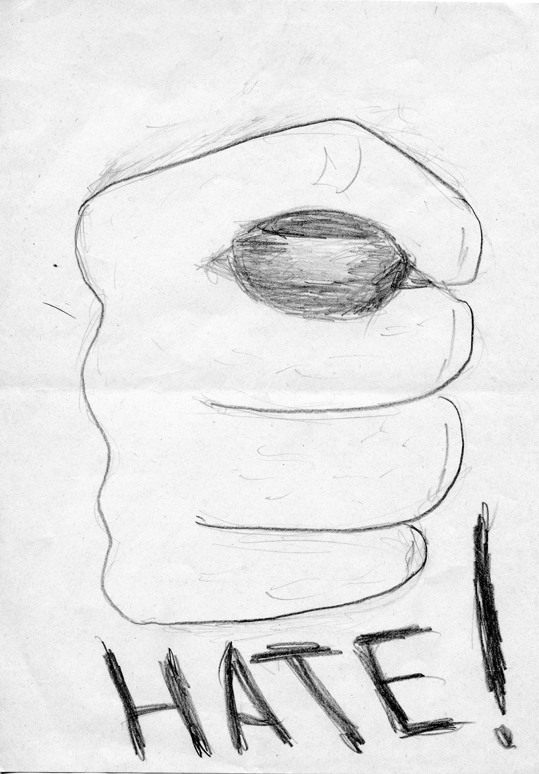
Document 2: Excerpt from Roksi, issue 2 (January 1978)
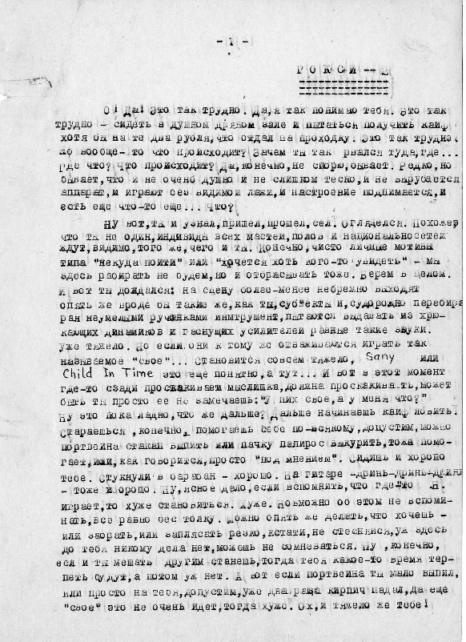
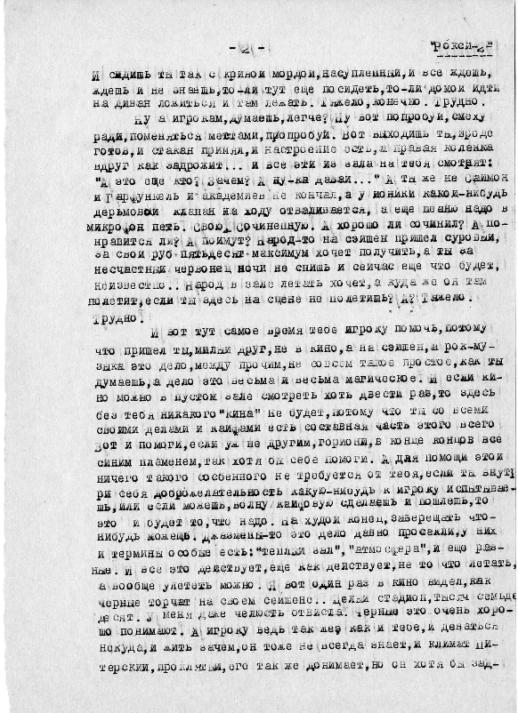



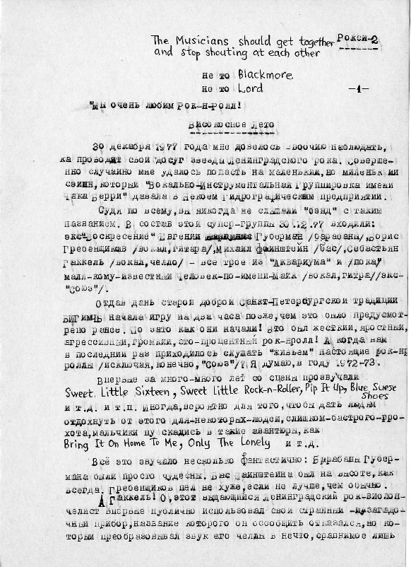

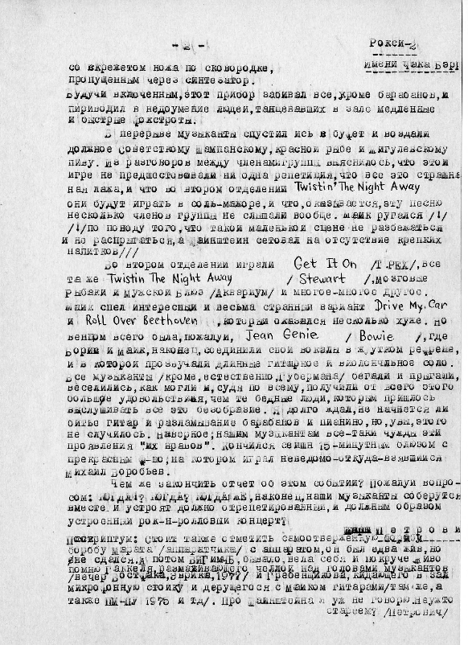

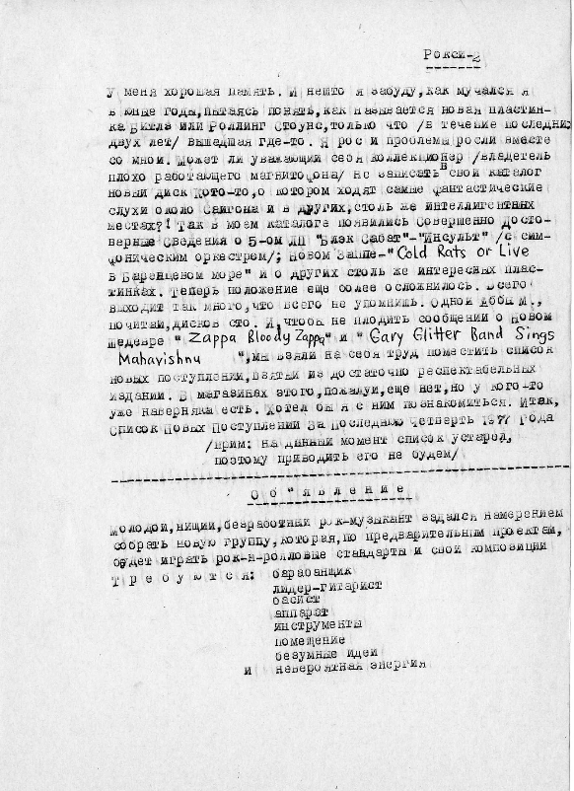

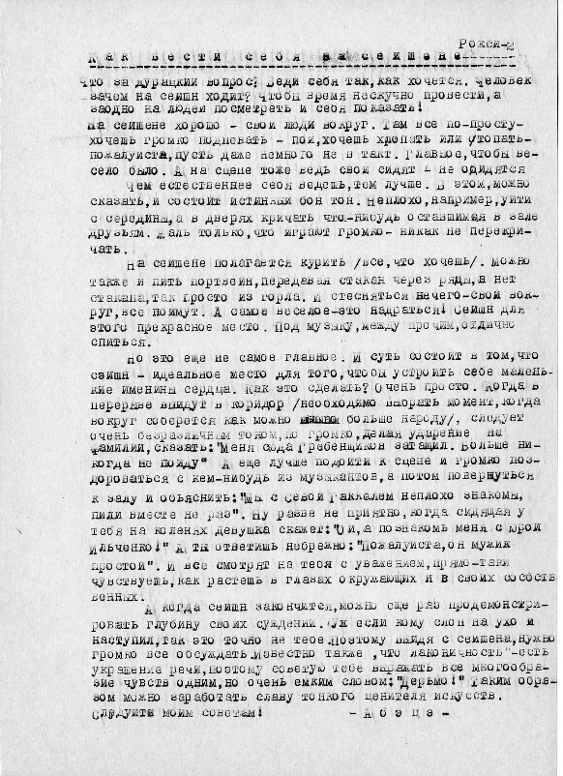

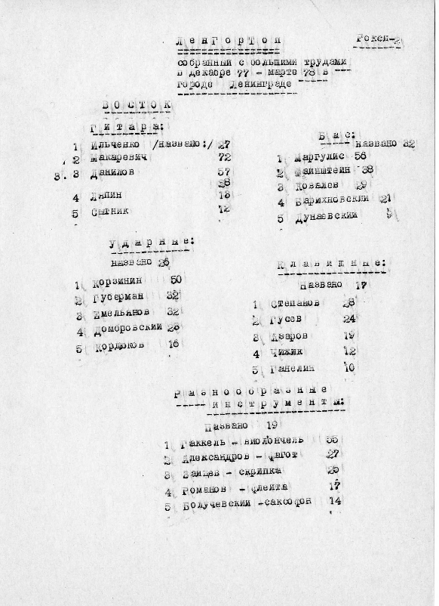

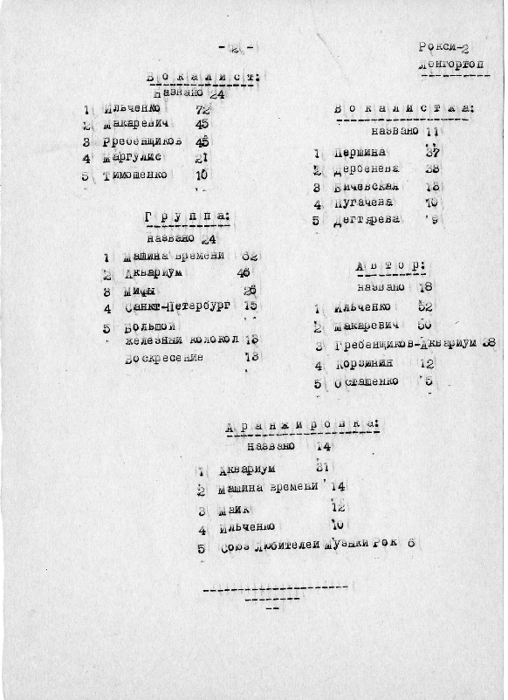

Document 3: Excerpt from RIO, issue 2 (November 1986)
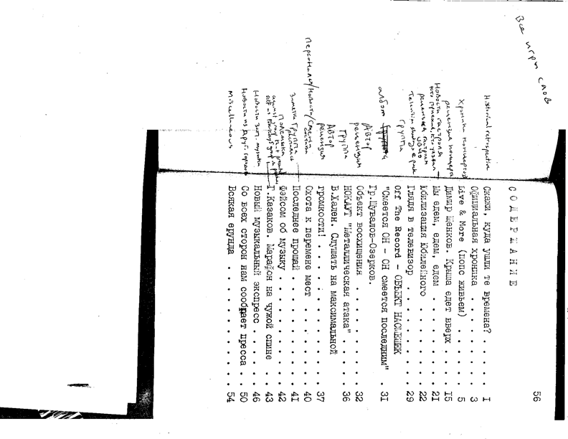
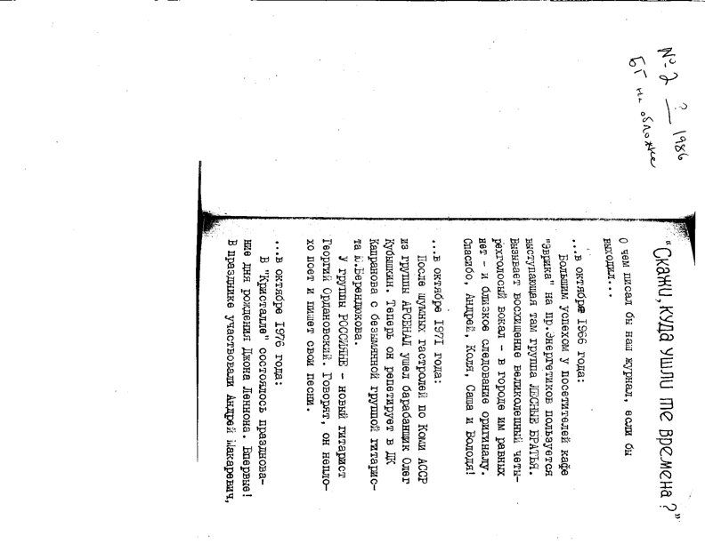
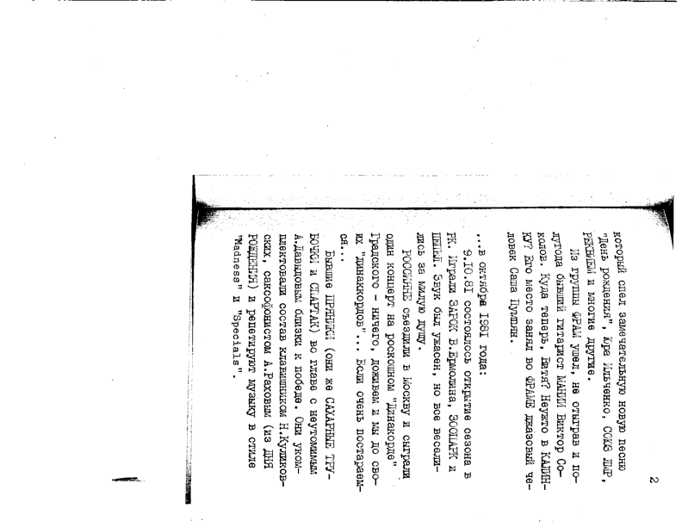
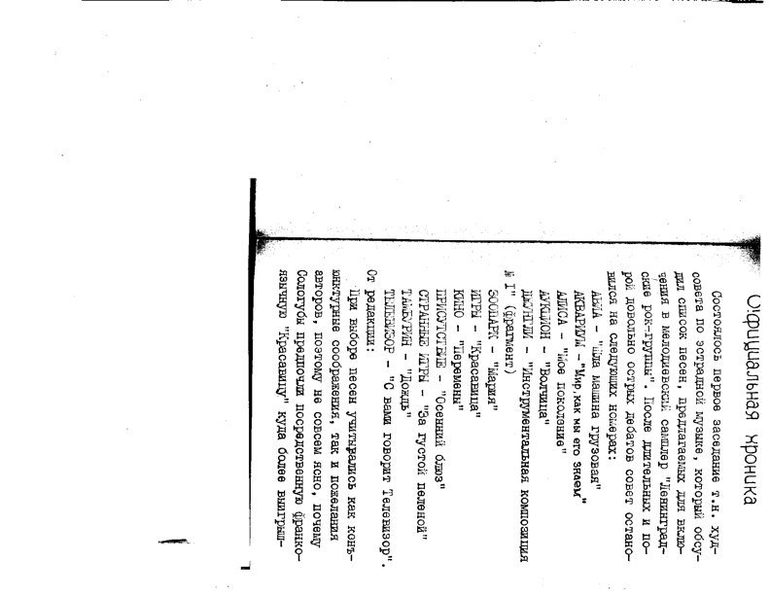
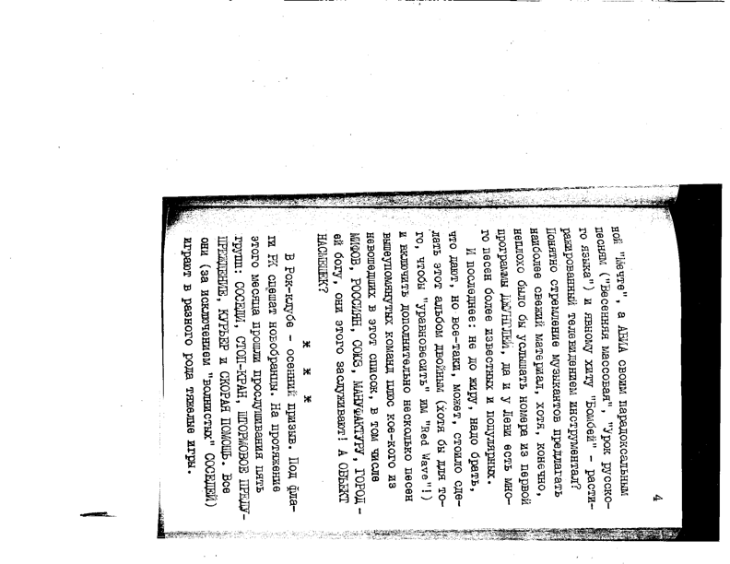

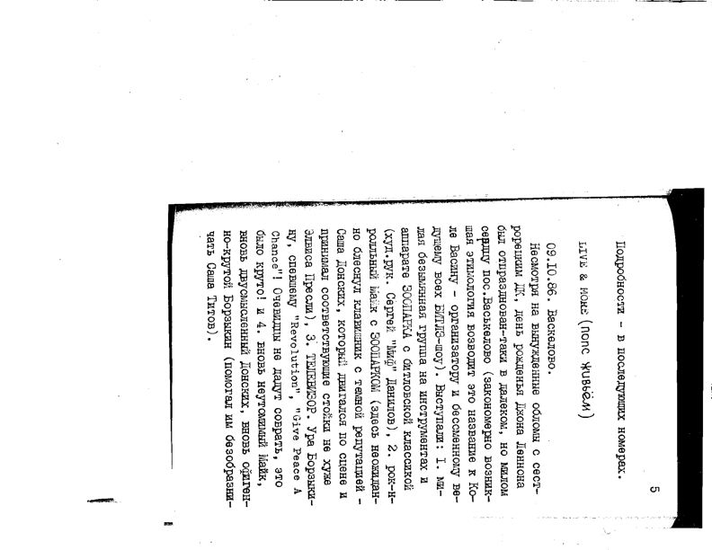
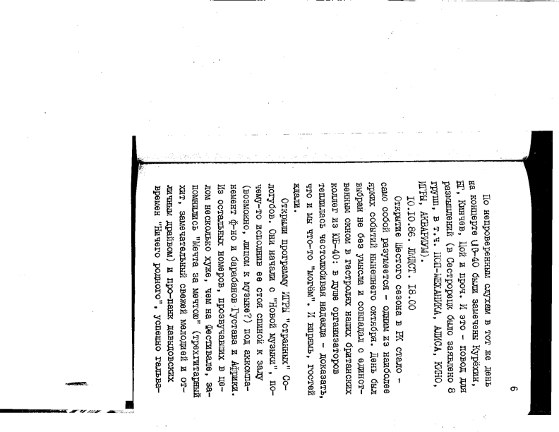
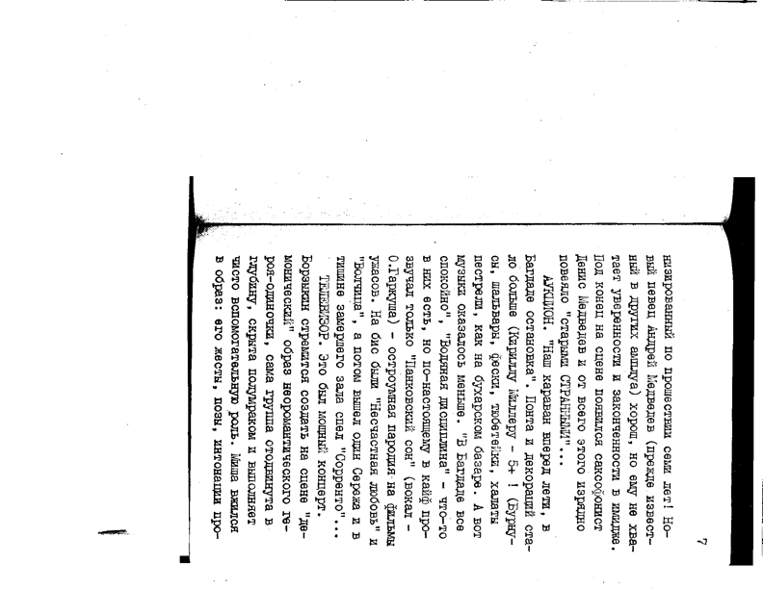
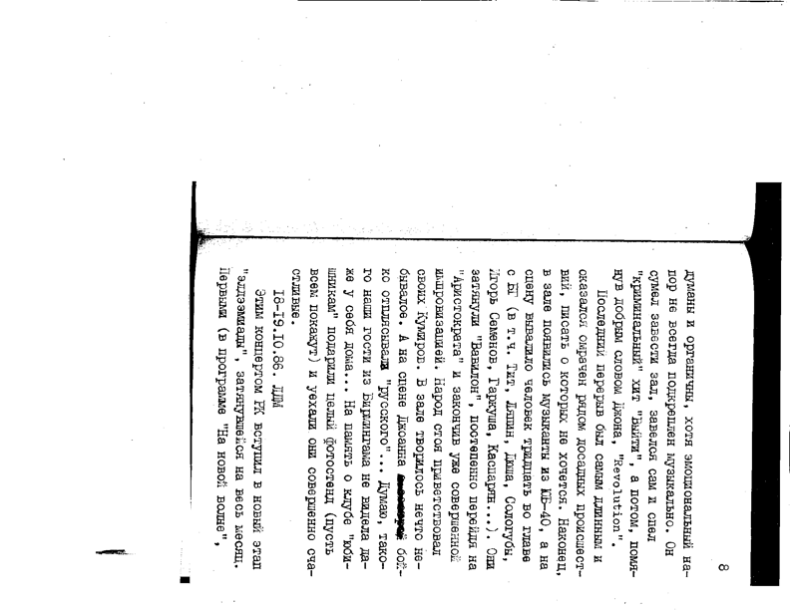
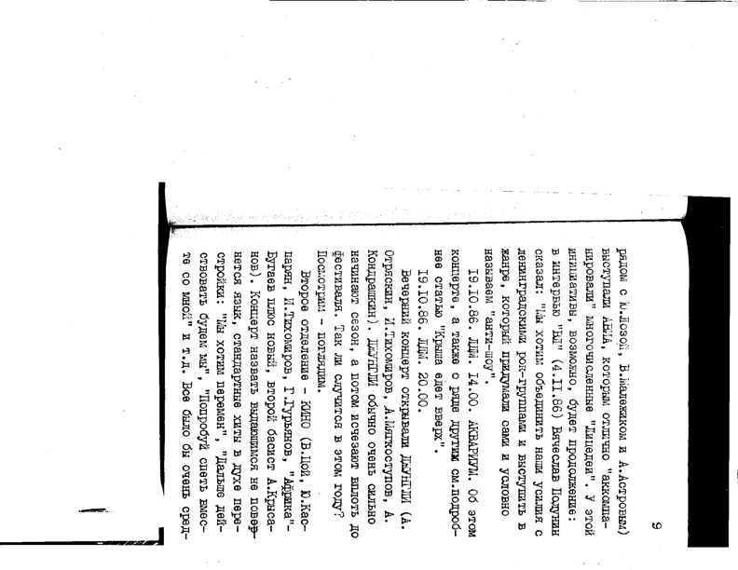
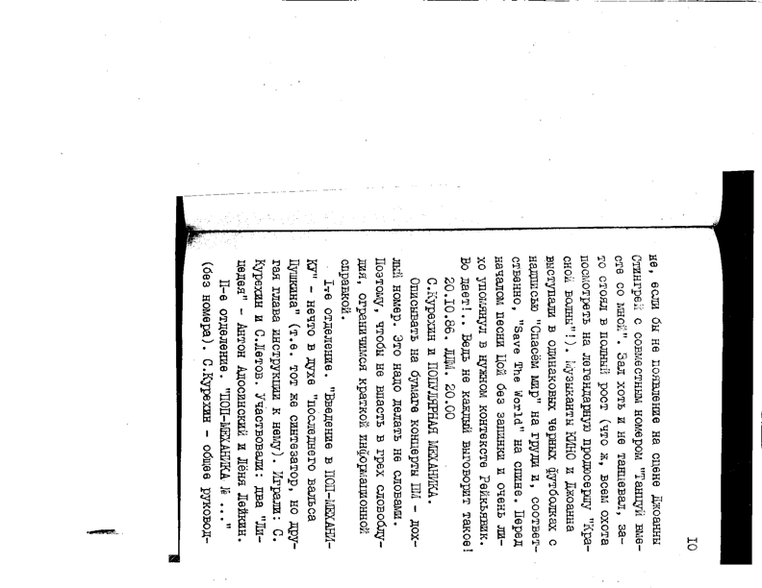
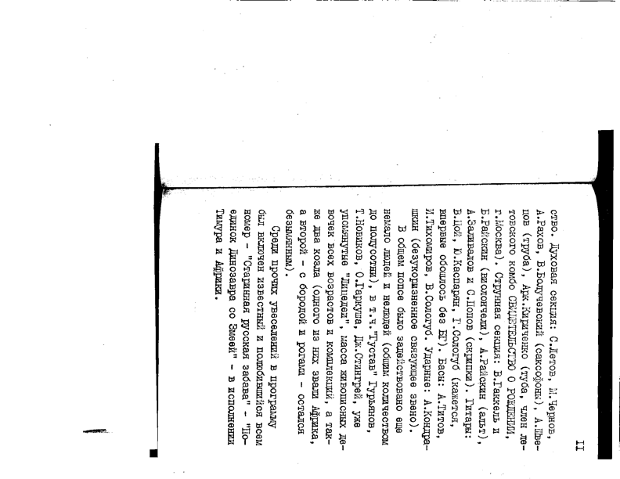
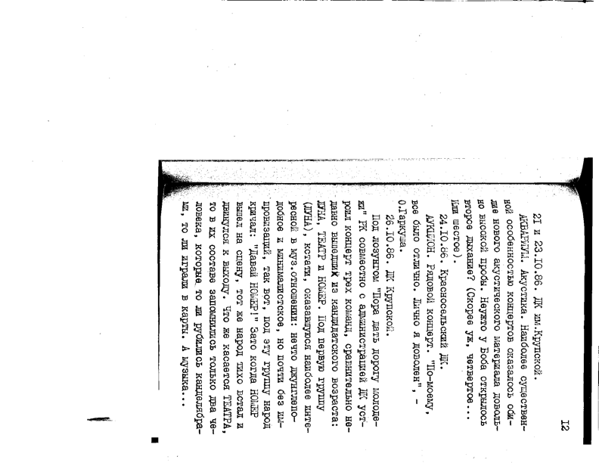
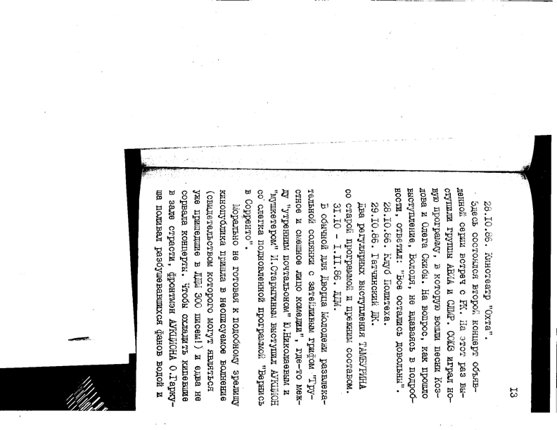
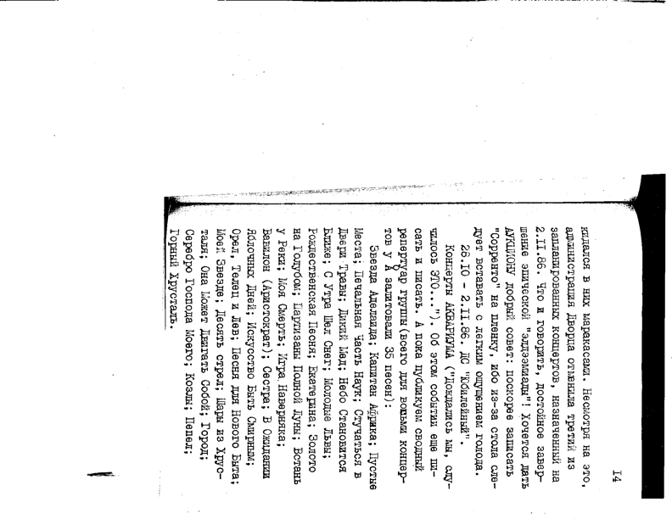
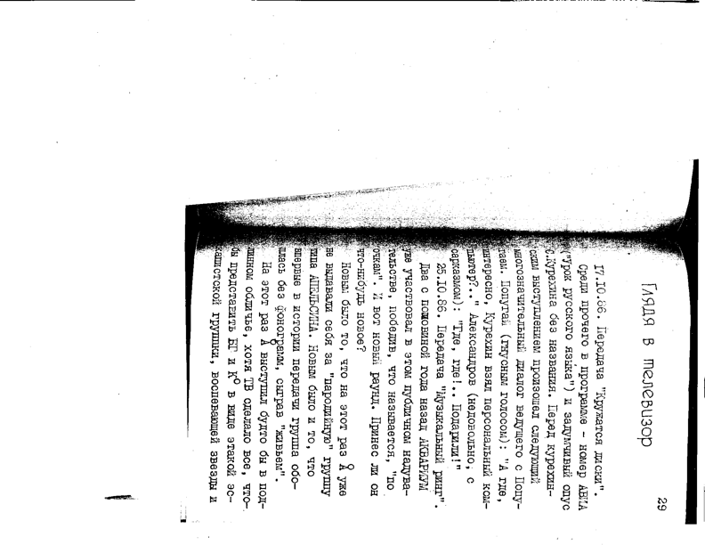
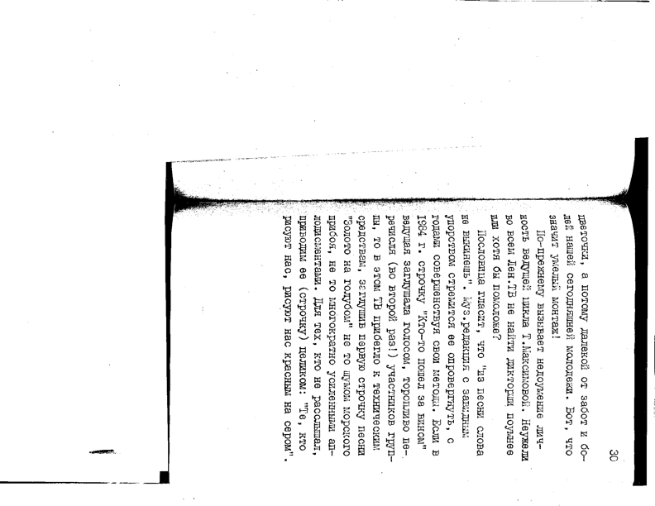

Document 4: Excerpt from RIO, issue 4 (20) (April 1988)
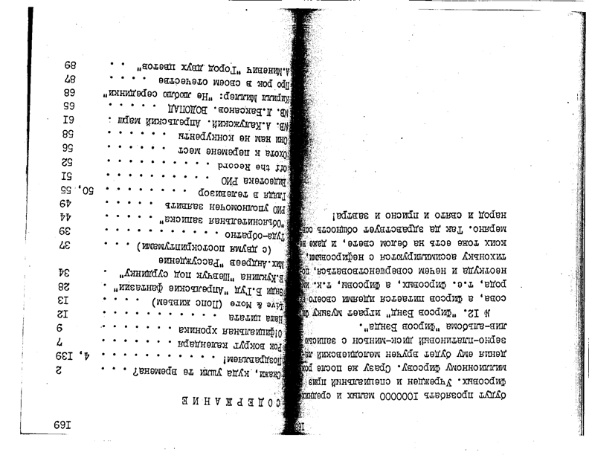
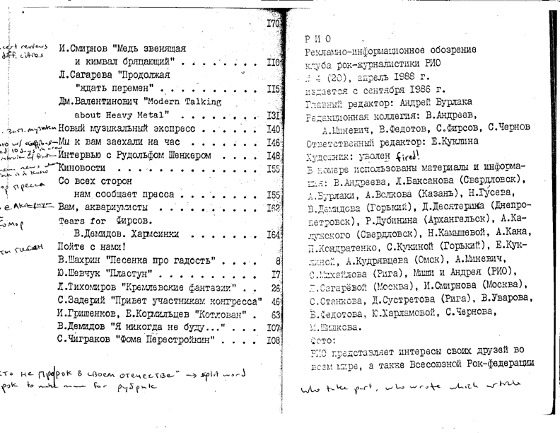
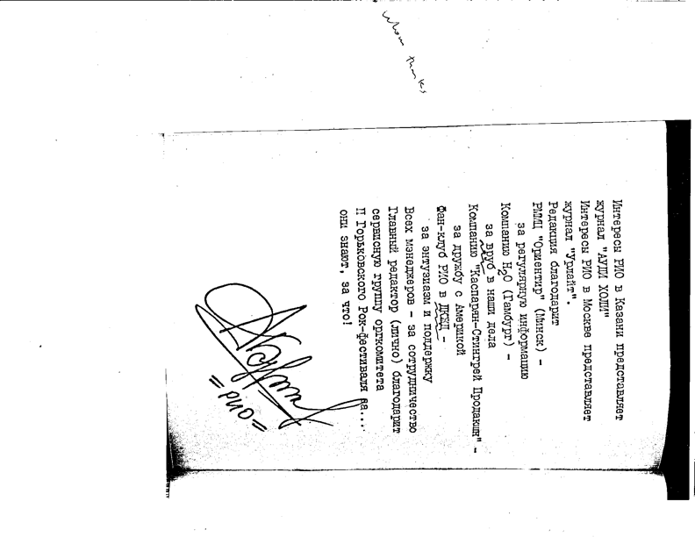
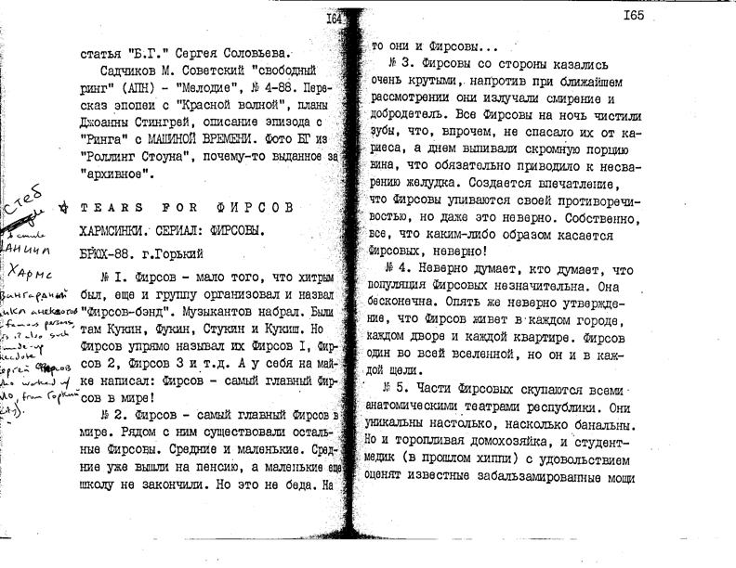

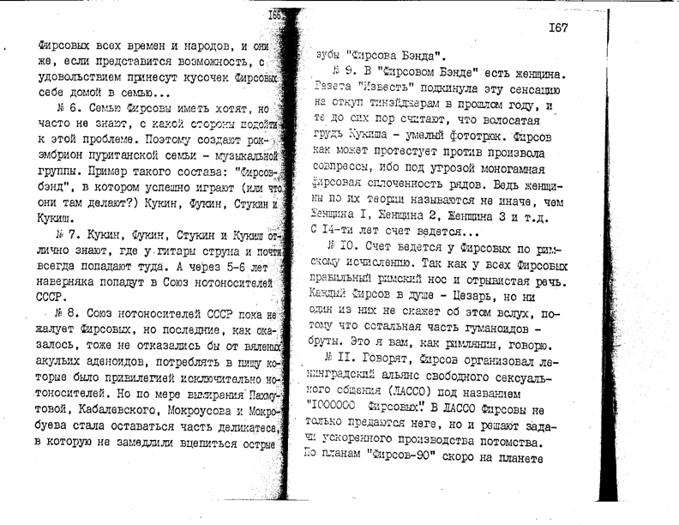

Selected Bibliography
Russian-language primary:
Afonin, Sergei. Interview by author. St. Petersburg, Russia, 29 August 2009.
Afonin, S., Andreyev, V., Burlaka, A., Chernov, S., et al. RIO, issue 2, (November 1986).
Afonin, S., Andreyev, V., Burlaka, A., Chernov, S., et al. RIO, issue 4 (20), (April 1988).
Afonin, S., Andreyev, V., Burlaka, A., Chernov, S., et al. RIO, issue 37 (elsewhere referred to as issue 23 (27)), (September 1989) [http://lib.rus.ec/b/170491/read], accessed 5/13/2010.
Andreyev, A., Bruk, M., Reshetnikov, O., et al. Roksi, issue 2, (January 1978).
Andreyev, A., Bruk, M., Reshetnikov, O., et al. Roksi, issue 4, (January 1981). Reprinted in “Vorokh starykh gazyet,” ed. Vadim Shesterikova [http://handbook.severov.net/handbook.nsf/Main], accessed 5/13/2010.
Andreyev, Aleksandr. Interview by author, St. Petersburg, Russia, 18 August 2009.
Andreyev, Valerii. Interview by author, St. Petersburg, Russia, 26 August 2009.
Astrakhovich, Rimma F. Interview by author. Saint Petersburg, Russia, 12 Nov. 2008.
Burlaka, Andrei P. Interview by author, St. Petersburg, Russia,6 August 2009.
Burlaka, Andrei P. Interview by author, St. Petersburg, Russia, 20 August 2009.
Burlaka, Andrei P. Rok entsiklopediya populyarnaya muzyka v Leningradye-Peterburgye 1965-2005.
Chernov, Sergei. Interview by author, St. Petersburg, Russia, 19 April 2009.
Didurov, Aleksei. Soldaty russkovo roka. Moscow: MP “Rus’ 96”: Gosudarstvenniy tsentr russkovo fol’klora, 199.
Gakkel’, Vsyevolod. Akvarium: Kak sposob ukhoda za tennisnym kortom. St. Petersburg: Amfora, 2007.
Grebenshikov, Boris. “O vrube.” Roski, Issue 1, (1977), reprinted in Kushnir, Zolotoye podpol’ye: Polnaya illyustrirovannaya entsiklopediya rok-samizdata (1967 – 1994), Nizhnii Novgorod, 1994.
Grebenshikov, Boris. Pesni: Polnoe sobranie vsekh tekstov pesen. Tver’: Lean, 1997.
Gunitskii, A. “Roksi vernulsya na piterskuyu rok-orbitu.” Fontanka.ru, 24 Sept. 2008, [http://www.fontanka.ru/2008/09/24/112/], accessed 6/29/2009.
Kamyshev, Nikita. “70-letie Dzhona Lennona budut praznovat’ dva mesiatsa.” Komsomol’skaia Pravda, 25 March 2010, [http://www.kp.ru/daily/24462.4/623387/], accessed 5/13/2010.
Khrenov, S. “Rok vokrug chasov.” Chasy, Issue 62, (1986).
Matveyev, Andrei A. “Live Rock ‘n’ Roll”: Apokrify molchalivykh dnyei. Ekaterinburg: U-faktoriya, 2001.
Naumenko, Mikhail V. Pesni I stikhi/Mikhail “Maik” Naumenko. Moscow: Sokol, 2000.
Reshetnikov, Oleg. Interview by author, St. Petersburg, Russia, 12 August 2009.
Rybin, A. V., et al. Akvarium: Sny o chem-to bol’shem… Edited by B. Grebenshikov. Moscow: Sofiya, 2004.
Rybin, A. V., ed. Kino s samogo nachala do samogo kontsa. Rostov-on-the-Don: Feniks, 2001.
Sagaryeva, O., ed. Akvarium, 1972-1992: Sbornik materialov o rok-gruppe. Moscow: Alfavit, 1992.
Troitskii, Artemii K. Gremuchiye skelety v shkafu. St. Petersburg: Amfora, 2008.
Troitskii, Artemii K. “Kino byez kartinki – dyen’gi na vyeter.” Introductory note to the exhibit “Neznakomoye ‘Kino’” by Natalya Vasil’yeva. Cityscan.ru, 8 Nov. 2006, [http://www.cityscan.ru/news.php?view=1120], accessed 6/29/2009.
Tsoi, Viktor R. Zvezda po imeni solntse: Stikhi, pesni, vospominaniya. Moscow: EKSMO-Press, 2000.
Tsoi, Viktor R. Viktor Tsoi: Illyustrirovannaya istoriya zhizni i tvorchestva V. Tsoya I gruppy kino. Moscow: LEAN, 2001.
Universal Database of Russian Newspapers, Izvestiia [http://dlib.eastview.com.ezproxy.library.wisc.edu/sources/publication.jsp?id=518&uid=1], accessed 5/13/2010.
Valieva, Iu. M., ed. Sumerki “Saigona”. St. Petersburg: Tvorcheskie ob’edineniia Leningrada, 2009.
Vasin, Nikolai. Rok na russkikh kostyakh: Sbornik. St. Petersburg: Dean, 2007.
Venzel’, E. “Na boikom mestye: K istorii odnogo sovetskogo bestiariya.” In Semidyesyatiye kak predmyet istorii russkoi kul’tury, edited by K. Yu. Rogov. Moscow: Venetsiya, 1998.
Zhitinskii, Aleksandr N. Al’manakh rok-diletanta: Muzykal’niy roman. St. Petersburg: Amfora, 2006.
Zhitinskii, Aleksandr N. Puteshestvyie rok-diletanta: Muzykal’niy roman. St. Petersburg: Amfora, 2007.
Secondary:
Dobryukha, N. Rok iz pervykh ruk. Moscow: Molodaya gvardiya, 1992.
Dolinin, Vyacheslav E. Samizdat Leningrada 1950 – 1980. Moscow: Novoye literaturnoye obozreniye, 2003.
Fedorov, E. Rok v neskol’kikh litsakh. Moscow: Molodaya gvardiya, 1989.
Kushnir, Aleksandr I. Zolotoye podpol’ye: Polnaya illyustrirovannaya entsiklopediya rok-samizdata (1967 – 1994). Nizhnii Novgorod, 1994.
Kushnir, Aleksandr I. 100 magnitoal’bomov sovyetskovo roka: 1977-91: 15 lyet podpol’noi zvukozapisi: Izbranniye stranitsy istorii otechestvennogo roka. Moscow: Kraft+, 2003.
Levitan A. and M., eds. Ot kostra do mikrofony: Iz istorii samodeyatel’nost’ pesni v Leningrade v 50 – 60 godax. St. Petersburg: Respeks, 1996.
Lisitana, Svetlana, ed. Rok: Entsiklopedia: Populyarnaya muzyka v Leningrade-Peterburge, 1965-2005. St. Petersburg: Amfora, 2007.
Lur’ye, L. “Rok-samizdat.” Episode of “Kul’turniy Sloi,” Pyatiy Kanal, 29 Feb. 2008. Transcript [http://www.5-tv.ru/video/501947/], accessed 6/29/2009.
Savitskii, Stanislav. Andegraund: Istoriya i mify leningradskoi neofitsial’noi literatury. Moscow: Novoye literaturnoye obozreniye, 2002.
Trofimov, Aleksandr, ed. Russkii rok: Entsiklopedia/Vsyerossiiskaya assotsiatsia rokerov. A.T.P., 2003.
Troitskii, Artemii K., ed. Rok-muzyka v SSSR: Opyt popyularnoi entsiklopedii. Moscow: Kniga, 1990.
Troitskii, Artemii K. Rok v soyuze: 60-e, 70-e, 80-e. Moscow: Iskusstvo, 1991.
English-language primary:
Andropov, Yuri. “KGB Files: Birth of Samizdat.” Written 7 Feb. 1969, in Index on Censorship 3 (1995): 62-63.
Bailyn, John F. Phone interview by author, 27 March 2010.
Troitskii, Artemii. Back in the USSR: The True Story of Rock in Russia. Boston and London: Faber and Faber, 1988.
Troitskii, Artemii. “Simply Red.” In Gremuchiye skelety v shkafu. St. Petersburg: Amfora, 2008: 190-197.
Secondary:
Cushman, Thomas. Notes from Underground: Rock Music Counterculture in Russia. Albany: State University of New York Press, 1995.
Easton, Paul. “The Rock Music Community.” In Soviet Youth Culture, edited by Jim Riordan. Bloomington and Indianapolis: Indiana University Press, 1989.
Johnston, Gordon. “What Is the History of Samizdat?” Social History 24, 2 (1999): 115-133.
Komaromi, Ann. “Samizdat: Material Texts and Imagined Communities.” Public lecture, University of Wisconsin-Madison, 5 May 2010.
Komaromi, Ann. “The Material Existence of Soviet Samizdat.” Slavic Review 63, 3 (2004): 597-618.
McMichael, Polly. “After All, You're a Rock and Roll Star (At Least, That's What They Say): Roksi and the Creation of the Soviet Rock Musician.” Slavonic and East European Review 83 (2005): 664 – 684.
Oushakine, Serguei A. “The Terrifying Mimicry of Samizdat.” Public Culture 13, 2 (2001): 191-214.
Taylor, Pauline B. “Underground Soviet Broadcasting.” Russian Review 31, 2 (1972): 173-174.
Traver, Nancy. Kife: The Lives and Dreams of Soviet Youth. New York: St. Martin’s Press, 1989.
Yakushev, Aleksei A. “The Samizdat Movement in the USSR: A Note on Spontaneity and Organization.” Russian Review, 34, 2 (1975): 186-193.
Yurchak, Aleksei V. Everything Was Forever, Until It Was No More: The Last Soviet Generation. Princeton: Princeton University Press, 2006.

See Document 1.
Oleg Reshetnikov, interview by author, St. Petersburg, Russia, 12 August 2009.
Although rock samizdat has been presented in other formats—articles were read aloud at events called ustnie vypuski (“oral issues”) and were posted on the walls of a Leningrad concert venue—it was traditionally published in magazine format first. I will refer to rock samizdat publications as “journals,” since calling them “magazines” conjures images of glossy Western rock magazines, which they were not.
A. K. Kushnir, Zolotoye podpol’ye: Polnaya illyustrirovannaya entsiklopediya rok-samizdata (1967 – 1994) (Nizhnii Novgorod, 1994), 57-8. Reproduction by photocopier was rare until at least the 1980s, given the scarcity of the technology and the extremely limited access to it where it did exist. For instance, only the twelfth issue of Roksi (1988) was copied on a Xerox machine. Sergei Koval’skii, “Passion Play,” in Sumerki Saigona, ed. Iu. M. Valieva (St. Petersburg: Tvorcheskie ob’edineniia Leningrada, 2009), 391, Kushnir, 55, 61.
Polly McMichael, “After All, You're a Rock and Roll Star (At Least, That's What They Say): Roksi and the Creation of the Soviet Rock Musician,” Slavonic and East European Review 83 (2005), 676.
Reshetnikov interview.
Ibid.
Koval’skii, 391, Saunders, 7-8.
According to rock samizdat publisher Andrei Burlaka, more copies were produced “unofficially.” Andrei Burlaka, interview by author, St. Petersburg, Russia, 6 August 2009, McMichael, 670, Aleksandr Andreev, qtd. in L. Lur’e, “Rok-samizdat,” Piatyi Kanal, 29 Feb. 2008.
Andropov, 62, Johnston, 121, Koval’skii, 391, Saunders, 7, Skilling, 6. The primitive nature of the technology used in samizdat production should not be underemphasized; Skilling notes that several samizdat authors typified samizdat as a “reversion to a less efficient form of printing” and used the phrase “overcoming Gutenberg” to describe their activities (10).
Kushnir, 55, Vyacheslav E. Dolinin, Samizdat Leningrada 1950 – 1980 (Moscow, 2003), 447. It should be noted that the Soviet rock scene was at first largely confined to Leningrad and Moscow, although the pioneer journal Roksi was circulated in places in Siberia and Ukraine. Later, RIO would develop a network of correspondents in other cities.
Burlaka interview 6 August 2009, Kushnir, 215, Reshetnikov interview.
McMichael, 670.
Yuri V. Andropov, “The birth of samizdat,” Index on Censorship 3 (1995): 62.
Seminal samizdat historian George Saunders attributed the creation of the word samizdat to post-Stalin dissidents, whereas political scientist H. Gordon Skilling, an expert on underground culture in East European communist societies, traced its origins to Moscow poet Nikolai Glazkov in late 1950’s, who typed Samsebyaizdat in the space for the publisher’s name on homemade collections of his poetry. Samizdat: Voices of the Soviet Opposition, ed. George Saunders, 1st ed. (New York: Monad Press, 1974), 7, H. Gordon Skilling, Samizdat and an Independent Society in Central and Eastern Europe (Columbus: Ohio State University Press, 1989), 4-5.
Julius Telesin, “Inside ‘Samizdat,’” Encounter 40, 2 (1973): 25.
Skilling, 3, 37. Samizdat also appeared in China in the 1970s, but often took on different forms than in Eastern Europe. See Robin Munro, “China’s Democracy Movement: A Midwinter Spring,” Survey 28, 2 (1984): 70-98.
The “myth of unanimity” refers specifically to the party’s desire to show that the citizenry unanimously supported its policymaking. Consequently, official source of information attempted to mould public opinion to fit official policy and to socialize the population in officially sanctioned values. Skilling, 37.
The Soviet state publishing monopoly OGIZ (Union of State Book and Magazine Publishers) was started in 1930 by the top Soviet government authority, the Council of the People’s Commissars. “Gosizdat” refers to the literature produced by these publishing houses, which published according to strictly delineated of areas of topical responsibility: Politizdat published political literature, Voyenizdat published military literature, Yurizdat published legal literature, etc. Telesin, 25, Dmitrii Pospielovsky, “From ‘Gosizdat’ to ‘Samizdat’ and ‘Tamizdat,’” Canadian Slavonic Papers 20, 1 (1978): 44.
Alternative non-written forms and written subforms of unofficial publishing have often been categorized as samizdat, although they are in fact distinct in medium, format, or process of distribution: Kolizdat referred to the practice of publishing subscription-based periodicals and/or several items of samizdat together in a typewritten journal or book, magnitizdat, from the words magnitnaya plenka (“magnetic tape”), was the underground copying and distribution of sound recordings, radizdat, from the Russian cognate for “radio,” was the copying by listeners of materials, including books and music, broadcast by foreign radio stations, tamizdat, from the word tam (“there”), was samizdat published abroad for distribution there or in the country whence the material originated. Johnston, 123, Skilling, 5. Rock samizdat was almost exclusively in written form. The journal RIO experimented with a few “audio issues” (ustnye vypuski) in the late 1980s, but these events were centered around a corresponding printed issue. Burlaka interview, 6 August 2009.
Ann Komaromi, “Samizdat: Material Texts and Imagined Communities,” (Public lecture, University of Wisconsin-Madison, 5 May 2010).
Gordon Johnston, “What Is the History of Samizdat?” Social History 24, 2 (1999), 116.
Kushnir, 62.
Burlaka interview 6 August 2009.
Ibid.
Paul Easton, “The Rock Music Community,” in Soviet Youth Culture, ed. Jim Riordan (Bloomington: Indiana University Press, 1989), 53.
Ibid., 63.
Saunders, 12-13, Andropov, 62, Skilling, 8.
Saunders, 21, 29.
Skilling, 80.
Ibid., 38.
Reshetnikov, 12 August 2009.
Skilling, 19, 26-27, 79. In perhaps the best example of this phenomenon, the Czechoslovak opposition movement Charter 77 (which, incidentally, was created partly in response to persecution of rock musicians and included the participation of many rock musicians) and its eponymous manifesto led to expansion of the local underground culture, which was immediately manifested in a flood of written materials—both authorized by the movement and produced independently—that were mostly published in samizdat form. The parallel communications system of this “typewriter cult” continued for a decade and included youth groups who published several journals.
Ibid., 38-39.
Ibid.
Jirous differentiated between the terms “underground” and “second culture,” arguing that the aim of the underground “mentality” was the creation of a “second culture” independent of official channels of communication and the official hierarchy of values. Quoted in Skilling, 171.
Ibid., 17, 22, Andropov, 62. For example, the institution of military rule in Poland in December 1981 was marked by a growth of independent culture that was most obvious in its institutionalization of the underground samizdat-based press. Andropov noted samizdat demands for an end to censorship and rehabilitation of those falsely condemned by the regime.
Artemii K. Troitskii, Back in the USSR: The True Story of Rock in Russia (Boston and London: Faber and Faber, 1988), 7. Back in the USSR is an impressively encyclopedic memoir of Soviet rock, and Troitskii was present at almost every contemporary event he reports in this work. The author notes that in his adventures within the rock underground he “tried not to miss a single important event or interesting character.” Back in the USSR, 9.
Artemii K. Troitskii, Rok v Soyuze: 60-e, 70-e, 80-e (Moscow:1991), 6.
Thomas Cushman, Notes from Underground: Rock Music Counterculture in Russia (Albany: Sate University of New York Press, 1995), 19, 14.
Troitskii, Rok v Soyuze, 9, 11, Back in the USSR, 15. The Stiliagi were re-popularized in the eponymous 2009 Russian film, which likewise portrays them as forefathers of alternative culture.
Troitskii, Back in the USSR, 15, 18.
Skilling, 207.
John Bailyn, phone interview by author, 27 March 2010.
Troitskii, Rok v Soyuze, 20. Troitskii has argued that the Beatles interested young Soviet listeners more than any other groups due to the melodic nature of their songs, which was more readily accepted by the Slavic listener than the hard, rhythmic ostinatos of the Rolling Stones.Troitskii, Gremuchie skelety v shkafu.(Saint Petersburg, 2008): 73.
“Skazhi, kyda ushli te vremena?,” RIO, issue 2 (November 1986), 1-2, Nikita Kamyshev, “70-letie Dzhona Lennona budut praznovat’ dva mesiatsa,” Komsomol’skaia Pravda, 25 March 2010, [http://www.kp.ru/daily/24462.4/623387/] (accessed 5/13/2010).
Ibid., 6. In fact, Russian listeners had been copying Western music recordings since long before this; the first copies of recordings were made in Moscow in the 1950’s at studios designed for recording audio letters and messages (_____).
The first Soviet rock group appeared in 1961 in Riga, Latvia, a band with the grammatically questionable moniker “Revengers.” The chronological nature necessitated by what is supposed to be a concise yet comprehensive historical overview will cause us to lay out a number of “firsts,” but, given the undocumented nature of an underground movement such as rock music, these are in many cases speculative and cannot be definitively proven. Ibid., 21, 17.
Troitskii, Back in the USSR, 25.
Ibid., 37. Elton John became the first Western rock star to play in the USSR when he performed in Moscow in May 1979. Ibid., 46.
Kushnir, 55, Troitskii, Back in the USSR, 36. Although Troitskii names Oloviannie Soldatiki (“Tin Soldiers”) as the first Russian-language rock group, Mashina Vremeni, as the first “superstar” rock group, was far more impactful, according to Reshetnikov. Reshetnikov holds that Russian rock was born in 1972, when Iurii Il’chenko joined Mashina and brought the “missing energy” to their art. Reshetnikov interview.
Skilling, 173.
Troitskii, Back in the USSR, 41. Most Russian lyrics were “stylized and formal” until Maik Naumenko opened up a new “street aesthetic” in the early 1980’s. Naumenko did this by singing about “the Big Taboo, the skeleton in the closet of our rock music and, in fact, all our art—sex.” Ibid., 67.
Ibid., 40.
Ibid., 99.
Cushman, 5.
Troitskii, Back in the USSR, 63.
Sergei Afonin, interview by author, St. Petersburg, Russia, 29 August 2009.
“Skazhi, kyda ushli te vremena?,” 1.
Troitskii, Gremuchie skelety, 74.
Moshe Lewin, “Russia/USSR in Historical Motion: An Essay in Interpretation,” The Russian Review 50: 1-22, qtd. in Cushman, 5.
Troitskii, Back in the USSR, 26, 29.
Ibid., 33.
Aleksei Yurchak, Everything Was Forever, Until It Was No More (Princeton: Princeton University Press, 2006), 227.
Ibid., 59-60, 62. By 1983, almost all youth newspapers had a pop music column. Ibid., 89.
Andrei Burlaka, interview by author, St. Petersburg, Russia, 20 August 2009
Universal Database of Russian Newspapers, Izvestiia [http://dlib.eastview.com.ezproxy.library.wisc.edu/sources/publication.jsp?id=518&uid=1], accessed 5/13/2010. A more comprehensive search of Soviet newspaper archives, including Komsomol’skaya Pravda and other youth-oriented publications, would be required to make any authoritative comment on the presence of Soviet rock in the official press.
Ibid., 61.
Lur’e.
Burlaka interview, 20 August 2009.
“Live & More (pops zhiv’yom),” RIO, issue 2 (November 1986), 14.
“Live & More (pops zhiv’yom),” 8.
Troitskii, Gremuchie skelety, 90.
Afonin interview.
“Live & More (pops zhiv’yom),” 5-14.
Afonin interview.
“Oni nam ne konkurenty,” RIO, issue 4 (20), (April 1988), 58.
Cushman, 8. He defines “counterculture” as follows: “If culture is the practical knowledge gained in the course of communicating with others in the process of living, then counterculture is simply practical knowledge which is the result of engagement in alternative forms of communication among actors engaged in the collective pursuit of alternative ways of living.” Cushman, 7-8.
I use the terms “rock counterculture” and “rock underground” interchangeably to describe Soviet citizens who not only listened to rock music, but also based their identity in one form or another on the ideals espoused by it, the most important of which was an alternative, unsanctioned way of life. “Underground” is one of the English terms adopted by members of the rock underground to describe their community and is particularly apropos given the unofficial, non-commercial nature of Soviet rock culture.
Troitskii, Back in the USSR, 8.
Ibid., 8.
McMichael, 666.
Bailyn interview. Bailyn went on to become a professor of linguistics at Stony Brook University and has worked with Boris Grebenschikov to translate several of the artist’s songs into English.
Boris Grebenschikov, “Intoduction,” in Kushnir, 3.
Skilling, 173.
Afonin interview. After an underground Akvarium concert with approximately 40 people in attendance, the police chased Afonin and a friend down Nevskii Prospekt. Upon catching the two, the officers found three books about Buddhism on the friend, who was made to write official letter of apology to the university. The friend was later called to the KGB (the Committee of State Security) office, “but only to ask him to work for them, to tell them about whom he met with, strange people, drug users, etc. … it was very hard to refuse because KGB threatened to get you expelled. Thank God it was already the mid-‘80s, five years earlier it would have been different.”
Jürgen Habermas, The Theory of Communicative Action, vol. 2 (Boston: Beacon Press, 1989), qtd. in Cushman, 9-12.
Ibid., 8.
Skilling, 207.
Troitskii, Rok v soiuze, 21, 26.
Troitskii, Back in the USSR, 32, 30. Soviet hippies hitchhiked to sunny locales in Ukraine for giant outdoor festivals, just as modern Russian music fans flock to the shores of the Sea of Azov each summer for the festival Kazantip.
Skilling, 79.
Troitskii, Back in the USSR, 23.
Troitskii, Gremuchie skelety, 90.
Valerii Andreev, interview by author, St. Petersburg, Russia, 26 August 2009.
Chernov interview, Afonin interview. By Afonin’s count, very few members of the rock underground were over 25 and there was “absolutely no one over 30.”
Chernov interview.
Boris Grebenschikov, “Intoduction,” in Kushnir, 3.
Troitskii, Back in the USSR, 102.
Andreev interview.
Burlaka interview, 6 August 2009.
Reshetnikov interview.
Afonin interview. The word could also be used to describe an informal gathering of kindred spirits who lived and created together, as in the case of Grebenschikov’s Akvarium. “It was a large collective of people wandering from one apartment to another, from one café to another; we drank coffee, smoked, talked about this and that and did everything together … At that time it was said that Akvarium was not a band, but a way of life. This was true.” Grebenschikov, qtd. in Andrei A. Matveyev, “Live Rock ‘n’ Roll”: Apokrify molchalivykh dnyei, (Ekaterinburg: U-faktoriya, 2001).
Burlaka interview, 6 August 2009. “Until 1988, there was a very permeable barrier between musicians and us,” Burlaka remembered. “After they became popular, to talk to musicians was hard because they were on tough, playing stadiums, so there was more of a barrier.”
Kirill Miller in Iu. M. Valieva, ed., Sumerki “Saigona,” (St. Petersburg: Tvorcheskie ob’edineniia Leningrada, 2009), 363.
Troitskii, Back in the USSR, 23.
Andreev interview, Afonin interview.
Troitskii, Back in the USSR, 28, 89.
“Skazhi, kuda ushli te vremena?,” 1.
Reshetnikov attributed the advent of the kvartirnik to Grebenschikov, who purportedly suggested that Akvarium simply play at someone’s apartment after an ill-fated attempt to stage a concert on the steps of Leningrad’s Mikhailovskii Castle. A similar phenomenon was the podval’shik, or basement concert (“podval’” means “basement”). Reshetnikov interview.
Afonin interview.
Burlaka interview, 6 August 2009.
Cushman, 13, Troitskii, Back in the USSR, 46. Although they seem a paltry reward, the certificates presented at the end of the festival were the only material recognition Soviet rockers received for their work before the mid-1980s.
Burlaka interview, 20 August 2009
Ibid., Troitskii, Back in the USSR, 74.
Ibid. Troitskii shared a similar view, describing the creation of Rok-klub as a “conscious and intelligent compromise” by city authorities who had realized that controlling the increasingly restive rock fans would be problematic. Troitskii, Back in the USSR, 82.
Andreev interview.
Troitskii, Back in the USSR, 74, 80.
“Pesnia prostogo cheloveka” (“Simple Guy’s Song”), Zoopark, Belaia polosa, 1984, sound recording.
Burlaka interview, 20 August 2009.
Ibid.
I will refer to those involved in the creation of rock samizdat as both “authors” and “editors,” since the fluctuating membership of the informal groups that produced these publications did not operate according to prescribed positions like “editor-in-chief” or “contributing author.”
Skilling, 36.
Afonin interview.
Burlaka interview, 6 August 2009.
Burlaka interview, 20 August 2009.
Reshetnikov interview.
For example, in the excerpt from the copy of the second issue of Roksi included among the supplementary documents, page four features six errors.
Ibid.
Skilling, 36-7.
Afonin interview.
Reshetnikov interview.
Aleksandr Andreev, interview by author, St. Petersburg, Russia, 18 August 2009.
Afonin interview.
Burlaka interviews, 6 and 20 August 2009.
Burlaka interview, 20 August 2009.
Reshetnikov interview, Andreev interview, Burlaka interview, 6 August 2009.
Valerii Andreev interview.
Troitskii, Back in the U.S.S.R., 33.
Ibid., 43.
Valerii Andreev interview.
Kushnir, 79.
Reshetnikov interview.
Ibid.
Aleksandr Andreev interview.
Burlaka interview 6 August 2009.
Valerii Andreev interview.
Aleksandr Andreev interview.
Dolinin, 30.
Kushnir, 8.
Aleksandr Andreev interview.
Kushnir, 9.
Ibid., 55.
Reshetnikov interview.
Reshetnikov interview with RIO, qtd. in Kushnir, 216.
Kushnir, 55.
Ibid.
Ibid.
Aleksandr Andreev interview.
Vyacheslav Dolinin, Samizdat Leningrada: 1950-e – 1980-e: Literaturnaya Entsiklopediya (2003), 447, Troitskii, “Kino bes kartinki – den’gi na veter,” (2006), Kushnir, 55, McMichael, 670-2, “Redaktsionnoe obosrenie,” Roksi, issue 4 (1981), 1.
Dolinin, 447, Kushnir, 55.
Skilling, 28.
Aleksandr Andreev interview.
Sergei Khrenov, “Rok vokrug chasov,” Chasy 62 (1986): 174-5.
Kushnir, 55.
Aleksandr Andreev interview.
Reshetnikov interview.
Afonin interview. It should be noted that besides just being loquacious, Grebenschikov was an active “PRshik” (something akin to a “publicity hound”) who amassed more coverage in rock samizdat than perhaps any other artist.
Kushnir, 55, Aleksandr Andreev interview, Reshetnikov interview.
Roksi, issue 4, Kushnir, 55.
Reshetnikov interview with RIO, qtd. in Kushnir, 217.
Aleksandr Andreev interview.
Khrenov, 175.
Reshetnikov interview.
For an explanation of styob humor, see the next page.
Kushnir, 55.
Aleksandr Andreev interview.
Kushnir, 216.
Aleksandr Andreev interview.
Bailyn interview.
McMichael, 677-8.
Kushnir, 216.
Kushnir, 55.
Kushnir, 216.
Reshetnikov interview.
Aleksandr Andreev interview.
First four issues of Roksi, 1977 – 1981.
Kushnir, 55, 215.
McMichael, 677-8.
“Redaktsionnoe obosrenie.”
Reshetnikov interview. According to Reshetnikov, this was done to make rock samizdat appear more official in the hopes of eventually having it legalized. The conversion of the journal into the official organ of Rok-klub was abandoned once Startsev took over leadership of the journal for the seventh issue.
Khrenov, 175.
Reshetnikov interview. In 1983, the Moscow journals Zerkalo (“Mirror”) and Ukho (“Ear”) went so far as to approach Reshetnikov about reprinting articles from Roksi and vice versa, although this syndication scheme never materialized.
RIO, issue 2 (November 1986).
Burlaka interview, 6 August 2009. The first issue was published without a cover.
Ibid., RIO, issue 4 (20) (April 1988). Beginning in March of 1987, issues of RIO began to be referred to by two issue numbers, the first corresponding to the number of issues published (which was reset starting with the January 1988 issue), the second to the number of months the publication had existed, so that the overworked authors could come back and complete an issue for each month that was missing one. Kushnir, 65.
Burlaka interview, 6 August 2009.
Ibid.
Valerii Andreev interview.
Afonin interview.
Burlaka interview 6 August 2009.
Ibid.
Valerii Andreev interview.
Afonin interview.
Burlaka interview, 6 August 2010.
Afonin interview.
Ibid. Afonin and Chernov, who both studied in the English department at Herzen, would read any issue of Rolling Stone they acquired from cover to cover and translate the most interesting parts into Russian, sometimes for inclusion in RIO.
Valerii Andreev interview. Andreev, for one, prided himself on the interview style practiced at RIO. The journalists tried to make interviews more of a conversation than a formal interview, he recalled: “Very few (subjects) want to let you deep into their soul. You had to be interesting to him for him to let you in.” Valerii Andreev interview.
The twentieth issue, for instance, included an article about Chernobyl. “Rok vokrug kalendaria,” RIO, issue 4 (20) (April 1988), 7.
Burlaka interview 6 August 2009.
Afonin interview.
RIO, issue 2 (November 1986). Note: It is impossible to affix the exact date of publication, since the cover simply read “October 1986” and none the editors interviewed remembered the day they finished the issue. However, the last event documented in the issue—a string of concerts by Akvarium in the Jubilee Palace of Sport in Leningrad—concluded on November 2, 1986.
“O!fitsial’naia khronika,” 3-4.
“Live & More (pops zhiv’yom),” 8.
“Soderzhanie,” RIO, issue 4 (20), (April 1988), 169.
Burlaka interview 6 August 2009.
Afonin interview.
Burlaka interview 6 August 2009.
Ibid.
Kushnir, 65.
Ibid., 62.
Afonin interview.
Burlaka interview 6 August 2009.
Afonin interview.
Burlaka interview 6 August 2009.
Ibid., Afonin interview.
Ibid.
Aleksandr Andreev interview.
Valerii Andreev interview.
Reshetnikov interview.
Valerii Andreev interview.
Roksi, issue 2 (January 1978), 1.
Aleksandr Andreev interview.
Valerii Andreev interview.
Bailyn interview.
Burlaka interview 6 August 2009.
Skilling, 80.
Aleksandr Andreev interview.
Valerii Andreev.
P. Krusanov, “Tri stat’i ob odnom i tom zhe,” Roksi, issue 4 (January 1981).
Ibid.
I. Smirnov, “Med’ zveniaschaia i kimval briatsaiuschii,” RIO, issue 4 (20) (April 1988), 110.
Valerii Andreev interview.
“Spleten’ (Svetskaia khronika),” Roksi, issue 4 (January 1981).
Valerii Andreev interview,
Ibid., Reshetnikov interview. The Russian term used—v kaif—was essential to any rock fan’s vocabulary and referred to any type of pleasurable experience, not just a drug high.
Reshetnikov interview.
Burlaka interview 6 August 2009.
Reshetnikov interview.
Boris Grebenschikov, “On getting it,” Roksi, issue 1 (1977), reprinted in Kushnir, 202.
Ibid.
Reshetnikov interview.
Burlaka interview 6 August 2009, Afonin interview.
“Redaktsionnoe obozrenie.”
Ibid.
Reshetnikov interview.
Bailyn interview.
Ibid.
Aleksandr Andreev interview.
Bailyn interview.
Ibid.
Ibid., Reshetnikov interview, Aleksandr Andreev interview.
Bailyn interview.
Skilling, 38.
Ibid., 8, 38. Another reason samizdat can be hard to study is because sometimes it is difficult to classify the material as official or unofficial, a problem that arises in the use of samizdat by officially sanctioned groups. For instance, the Jazz Section of the Union of Musicians in Czechoslovakia, a legal entity directed toward the promotion of jazz and later rock, also published a bulletin for its members and several paperback series on painting, poetry, photography and domestic and Western rock music, endeavors that were persecuted and which eventually led to the organization’s dissolution by the Czechoslovak government (31).
Saunders, 14, 24, Andropov, 62.
Skilling, 37, 27.
Aleksandr Andreev interview.
Valerii Andreev interview.
Burlaka interview 6 August 2009.
Reshetnikov interview.
Afonin interview, Chernov interview.
Valerii Andreev interview.
Bailyn interview.
Reshetnikov interview.
Valerii Andreev interview.
Afonin interview.
Burlaka interview 6 August 2009.
Valerii Andreev intereview.

