BEAM Lesson Plan
This creative commons publication provides a lesson plan on writing with sources in an academic context. The plan is designed for use in a higher education setting and is aligned with AAC&U LEAP Value Rubric for Information Literacy and the Framework for Information Literacy in Higher Education.

Aim
Critical engagement with sources

Learning Outcomes
- Plan and execute a search strategy (Frame: Searching is Strategic)
- Evaluate sources for relevance (Frame: Research as Inquiry)
- Describe ways in which a variety of source formats could be used for a scholarly purpose (Frame: Information Creation as a Process)
- Discuss the potential value of a source in the context of her/his own writing topic (Frame: Authority is constructed and contextual)
- Select sources for a rhetorical purpose (Frame: Research as Inquiry)

Resources [anchor links]
- What could a writer do with this source? (learning object) [jpg]
- Beam Metacognition (learning object) [jpg]
- Library Research Activity(worksheet) [pdf]
- Flipped Instruction Outline (lesson plan)
- Assessment Strategies [pdf]

BEAM Learning Object
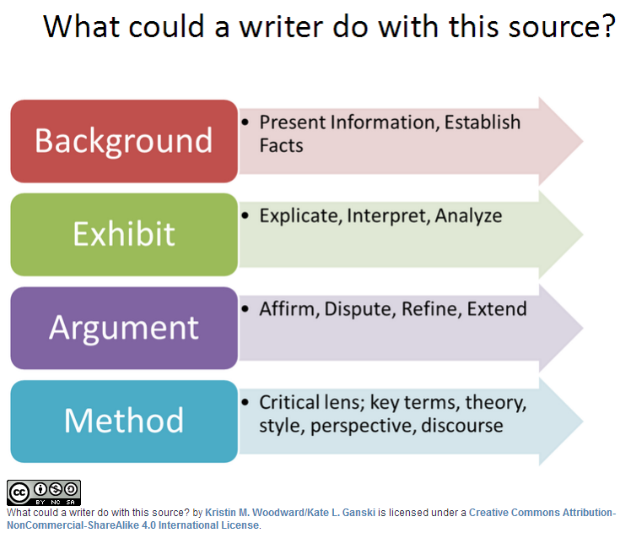

BEAM Metacognition Learning Object
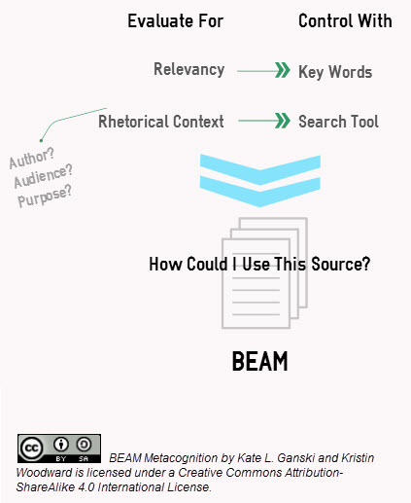

Worksheet

Library Research Activity Your Name:_________________________

Task One: Concept Mapping
Your topic is part of a conversation. Write down a few words that describe the main conversation in the center of the circle. Use the short lines (or branches) to note different parts of the conversation. Fill all of the lines, leave some blank, or add more as needed.



Task Two: Exploring other Sources
Search the library homepage on the ideas from your concept map.
Identify any new ideas that authors are talking about in the descriptions and abstracts.
Add these new ideas to your concept map above (see Task One). Fill all of the lines or add more as needed.

Task Three: Selecting Sources
Research is connected to your writing. Relevant sources will address your questions and fit your purpose.
Review the infographic below.

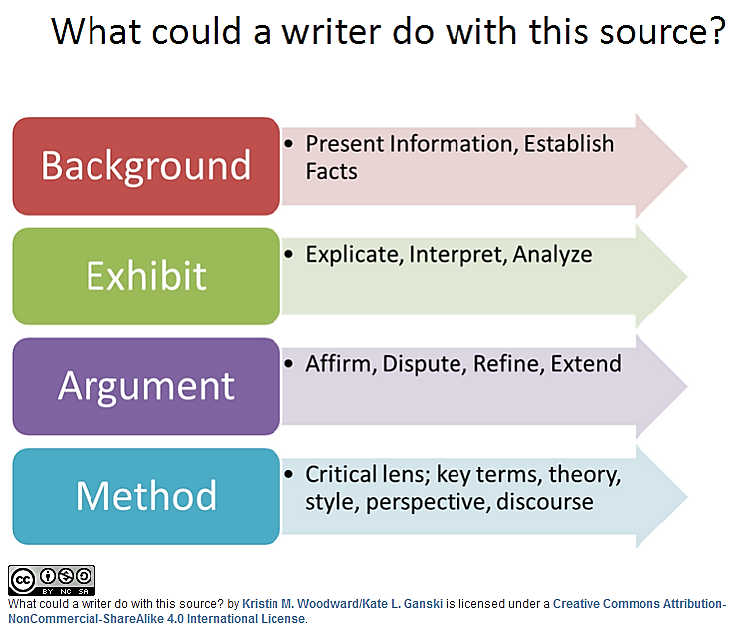

Do a search on the library homepage using concepts and ideas from your concept map. Evaluate your results based on how useful the source may be to your writing. Use the table below to list the sources you find and their purpose in your research. Keep in mind, one source could be used for many purposes.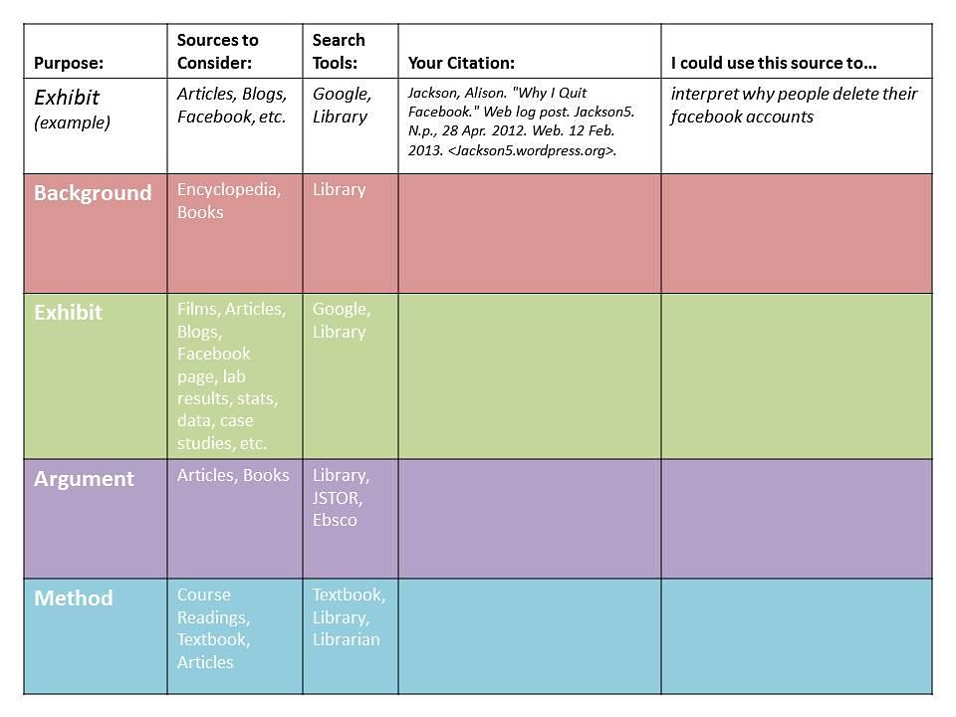

Lesson
Outline

- Source Spectrum Block (approximately=15 min)
  - popular ←-----------------------------------------------> scholarly [on whiteboard]
  - list student suggested sources on whiteboard
    - ask students “What are some sources that you think will be good to use in your paper?”
    - ask students “What are some sources that you think are off limits for this paper?”
  - Working through a selection of the list, ask students to place the source on the spectrum and provide reasons for that position. Ex. Newspaper= somewhere in the middle because it’s written by journalists, reviewed by editors, for large audience, and to inform (author, audience & purpose)
  - Discussion of what to think about when evaluating your search results
    - Relevancy
    - Rhetorical Situation
    - Your Purposes

- BEAM Introduction Block (DIgital Learning Object from course guide* with Whiteboard examples) Example topic: Why are vampires so popular with teens? (approximately=15 min)
  - Background. What information would you need to give your reader to establish the popularity of vampires as factual? [materials a writer relies on for general information or factual evidence] Ex. News article with book sale statistics
  - Exhibit. What could you analyze for your reader? [materials a writer analyzes or interprets] Ex. passage or clip from Twilight
  - Argument. What have the experts uncovered in their research? [materials whose claims a writer engages] Ex. scholarly article concludes teens drawn to ideas of eternal love
  - Method. How might you analyze or frame your question? [materials from which a writer takes a governing concept or derives a manner of working] Ex. Book on pop culture theory or history of vampires
- Group tasks (approximately=15 min)
  - Shared question: How has social media affected relationships?
  - Brainstorm key concepts and search terms.
  - Give each group the task of finding a source for a specific use (double up on Background and Argument if necessary for the number of groups.)
- Search time (approximately=15 min)
    - Check in with each group
    - Direct students to best search tools as needed/helpful
    - Each group presents their findings

Assessment
- Active Learning Strategies
  - peer discussions
  - mock research scenario
  - peer to peer group work
  - group presentations
- Portfolio : Critical Inquiry Paper and Reflective Essay

Learning Target Rubric
 | Exceeds  3 | Exhibits  2 | Developing  1
Plan and execute a search strategy | Applies and refines a variety of search strategies in response to search results | Uses descriptive keywords in a search tool appropriate for the information need | States information need and develops list of related concepts
Evaluate sources for relevance | Analyzes multiple sources to select the most appropriate source for her/his purpose | Identifies multiple stakeholders and maps to germane search tools | Discusses goals and search tools with peers
Describe ways in which a variety of source formats could be used for a scholarly purpose | Articulate how her/his choices impact her/his  purposes for which the information product will be used and the message it conveys | State the fit between an information product’s creation process and her/his particular information need | Accepts ambiguity of potential usefulness of emerging and traditional formats
Discuss the potential value of a source in the context of her/his own writing topic | Illustrates how her/his own ideas were refined or changed by the source | Identifies and summarizes source contributions to her/his own topic | Point out the type of authority valued in a particular source
Select sources for a rhetorical purpose | Maps a source to one or more rhetorical purposes | Describes desired attributes of sources for a rhetorical purpose | Restates rhetorical purpose in her/his own words
BEAM Assessment Rubric by Kate L. Ganski/Kristin M. Woodward is licensed under a Creative Commons Attribution-NonCommercial-ShareAlike 4.0 International License.

