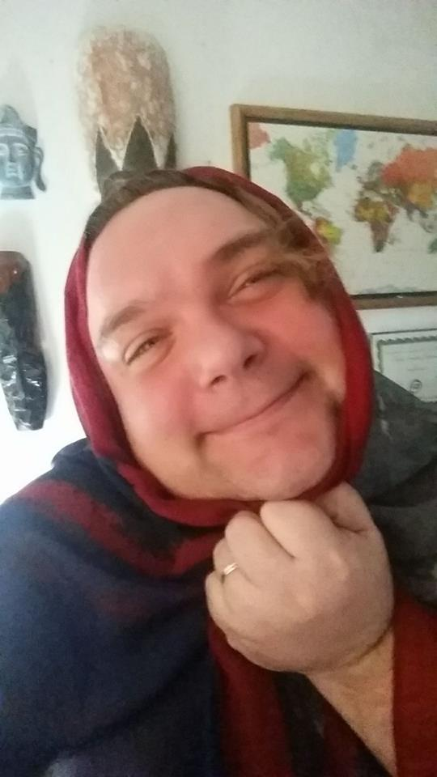

Memory Keepers & Dual Faith
  - Surviving Pagan and Pre-Christian
  - elements in slavic culture
Sean Alan Heinritz | Religious Studies 361: Russian and Slavic Folklore | Spring 2018
INITIO

Once upon a time … when I was still a baby, my mother held me in her arms while I rested my hands on her shoulder, my fingers playing lightly with the long curls of her chestnut colored hair. Being at a point in my life where I had little responsibility and hardly any worries, I smiled and giggled softly as she bounced me around and spoke gentle words to me - casting me into a sphere of protection. She was young, beautiful, and filled with a joy I was only beginning to understand.
Together we were dancing joyfully in the basement of my childhood home. With the swift motion of a few steps she moved toward a darkened portion of our basement, very nearly underneath the stairs. Later in my life I would learn this was the roughly constructed first phase of our basement bathroom, the continuation of the project my father had started in converting our basement to a livable space. At the time it had not yet had a sink, toilet, or shower stall nor did it have walls but only a pipe coming down from the rafters with an opening on the end of it which was wrapped in black electrical tape.
I still remember the roller coaster ride of emotion I experienced, the flailing arms I thrust in front of me as a shield, the wailing and screaming as I panicked - seeking refuge from the very person who had betrayed me. I cried in terror as the water escaped the hold of the spigot and assaulted my entire person while my mother smothered my head in tear free shampoo.
In the 37 years since that incident I have retold that memory many times and with each retelling I remember more and more of the details. Those details may have become exaggerated to an extreme, bordering on the comical, but the intensity of the memory and the emotion I felt then still causes the hair on the back of my neck to stand on end and the goosebumps to run rampant on my forearms. It seems then that memory can be a fickle mistress, revealing to us what she chooses – when she chooses.
Memory can influence us and allowing us to experience intense emotions. When we lose our memory, we can be robbed of those moments which give us our greatest joy. Memory has been said to hold the keys to our past while simultaneously being heralded as the guide and teacher for our future. It was memory that urged the Neanderthals to bury their dead with antlers and precious flowers instead of leaving them where they had fallen, alone and at the mercy of the earth. It was memory that compelled our ancestors to dye a young man’s bones red, singling him out as special among the clan and marking him as unique among those who he now joined in the next world.
The veneration of our ancestors – which would later be coupled with late Bronze Age hero worship – with its mysterious rituals, demanding traditions, and its sacred places set apart from the community could easily become tangled up with myth and religion. It is then the realm and responsibility of religion to become the vehicle for keeping and reliving memory, sheltering within it the archaic and sacred rituals of the past.
In a world dominated by patriarchal norms, neo-liberalism, and a generational antagonism towards women, how was it that memory-keeping and the overlay of religious ritual and practice created the dual faith that survives in Slavic culture today? What do these surviving elements tell us about the devotion of the Slavic peoples to their ancient religion and where do we actively see them?
SINGING THE SONG OF OUR ANCESTORS
Over time, the preparation and the care of the ancestors became the work of a select few, those who were trained in the art of burial and the transmission of the soul from this world to the next. Memory became wrapped up in mystery and near the Nile River, a priestly class emerged who began to embalm their dead and perform elaborate rituals to preserve them. Through intensive initiation, they called upon magic spells and the intercession of archaic, chimeric gods, none of whom they had ever seen with their own eyes. Devotion, love, and a desire to perpetuate the memory of her heroic husband caused a wife to lavishly build a rudimentary version of a temple complete with peristyle, pronaos, and cella. She would later be buried next to him with other members of the community of Lefkandi, surrounding the monument with small graves and votive figures.
Like the Egyptians and the Greeks, the Slavic peoples did not believe the journey of the individual ended with their last breath. Indeed, as one in modern times finds relief in pre-planning and paying for their own funeral, the Slavic peoples went to their deaths joyfully and fully prepared, guided by the women of their village. They lived and died with the security that their memory would be preserved actively, keeping the deceased peaceful and happy in their new state.
“Accounts of ancient myths and detailed descriptions of cults such as we have for Greece and the ancient Near East are almost entirely lacking. What East Slavic written sources do give is a list of probable deities, and, occasionally, their attributes and functions. Yet, while these documents give very little information about the content of East Slavic paganism, they leave us no doubt whatsoever that the broad masses clung to their ancient gods and rituals for centuries after Russia’s baptism and that the lower clergy sometimes joined in these celebrations.” (Ivantis, pgs. 12, 13)
Death to the Slavic people then is not just an experience passively undergone it is but also a practice. Those who performed the laments gained a measure of control over their future existence in the land of the dead or the other world, where they will join the roditeli, the honored ancestors.
Like our modern eulogies, the funeral laments sung by the babas—middle aged to elderly mothers—survived their pagan roots and were carried through the conversion of Rus, the Russian Revolution, and the Soviet era. These laments, existing alongside the litany of the church, lost none of their worth over time and would be sung to highlight the life of the recently deceased to carry the words of grief for those unable to share their emotion publicly. The lamenters would often wail in honor of a surviving member of the deceased, such as the head of the family, the widow, the children, or the brothers and sisters.
Though lamenters themselves were a specialized group of people who performed a specialized task, in the Slavic villages, the individuals who could participate in the funeral rituals were often limited to women, the memory-keepers, and even then, pruned down to the elder women known as bol’shukha (bol’shukhi, pl.). After a married woman had given birth to her first child, she was then allowed to begin participating in the funeral ritual and would often start by learning how to cook for the families of the deceased. Only after she had experienced the death of someone close to her could she take on a more principal role in the ritual, for if she lost a husband, she became a widow and if she lost a parent, she became an orphan. As professional performers of funeral laments the bol’shukha were often sought out for their skill and knowledge in the order of the funeral ceremony, which was guided by tradition and handed down from generation to generation. The laments themselves were different and varied depending on where the village was located, if there was a trade route nearby, or if the village was isolated.
In southern Russia brief, lyrical songs that were filled with sorrow and made appeals to the ancestors on behalf of the recently deceased as they transitioned from this world into the world to come were common. In northern Russia the laments were closer to what we would call an epic, akin to the Greek poems of Homer and the rhetoric of Plato. These epics would include a vast array of emotion and carry information on how the dead had passed away, the situation the family was in because of their death, and how the death was received by the close relatives.
Having gained special knowledge through their experiences, the repeated rhythm of the lament song would cause a mystical state upon both the lamenter and those who witnessed the lamenting allowing them to transcend the earthly plane and see the land of the dead. The emotions invoked by the lamenters and the care and concern for the deceased show a unique addition to the funeral ceremony not seen in other cultures. More importantly, the role of women in the rituals and the proficiency of their skill show that even in death we are connected to our eternal mother. We come from her womb in birth, we add to her family in marriage, and we reenter her womb at death welcomed by the very arms that bore us.
THE ONCOMING STORM
In the Slavic culture the replacement of religion did not have the same impact as it would in the Mediterranean and Near East and was used to negotiate and adjust the faith to the times. The baptism of Rus was approached much like language is today – it needed to add elements to its own basic structure to survive in the world that was changing around it. Near the end of the 10th century, motivated by the sanction of divine rule, Grand Prince Vladimir of Rus strengthened his trading ties and solidified his reign by accepting and embracing Christianity. First introduced to this faith through the conversion and piety of his grandmother, Olga, Vladimir and his court were able to gain access to networks of trade, received a generation of income by way of taxes, and most importantly – marriages and alliances to wealthy and powerful families.
The acceptance of Christianity among the Slavic people began in two ways, the conversion of the upper classes and the work of missionaries from the Western and newly created Eastern Churches. While the elite converted from the top, missionaries worked from the ground up converting villagers throughout the Empire. These missionaries were not trusted by the peasants initially because the god of the Christian was male, he was a foreign deity, and his worship began with the father and husband. Conversely, Moist Mother Earth was visible in the land farmed by the peasants and in the rebirth each Spring of the world around them. Through the peasant mother as priestess, she controlled the life of the village and she embodied the protective and benign aspect of the feminine-natural cycle as a sacred womb, protecting its human children.
With the church’s imposition of faith also came education and relief from the burden of care for the sick, elderly, widow and orphan. It offered masons and carpenters work in the building of churches not only in the village but also in the major cities of trade and commerce. Artists would gain access to an entirely new genre, the icon, and would earn great commissions for their skill.
“In the nineteenth century, folk religion of the Russians was given two designations in scholarly and church circles, defining its essence as a synthesis of the Christian dogma and “pagan” beliefs – dual faith [dvoeverie] and customary orthodoxy [bytovoi provaslavie]. The term dvoeverie is still used to this day in scholarly works and is understood by certain scholars as a straightforward and rather formal, superficial blending of “dual faiths” in folk religion. In many general and particular investigations of Eastern Slavic religious beliefs, including the Russian, ethnographers’ main interest is focused on “pagan survivals,” their interpretation and the reconstruction of archaic forms, usually directly traceable to a proto-Slavic mythological source. Such an approach is often determined by the conception that “paganism” comprises the greater and essential component of a folk system of beliefs, poorly and transparently covered by Christianity, which has only to be “stripped away” to reveal pre-Christian archaism in almost “pure” form.” (Balzer, pg. 35)
The Domostroi or Law of the Home, written by the monk Sylvestor provided a way to ease the troubles of conversion for the Slavic peoples for those who would seek it. Written like a monastic guide, the Domostroi set the wife as abbotess over her home and guide to her family in the worship of God, as personified by her husband. His rule not that of the baba, would be tantamount and would not be challenged. The new Christianity and the old religion had combined to create something completely original. The church was able to subvert the authority a mother once had and supplant that authority in the person of the father – patriarchy would begin to rule the home of the Slavic peoples and divisions within the family would begin to grow.
FINIS
It was the faith of my mother that began in me the desire to study religion. Though we attended the same church, sang the same songs, and prayed the same liturgy there were moments at home when I saw her silently holding a rosary while thumbing the beads or when I heard her singing a novena to St. Anthony to find her misplaced car keys. In retrospect, I can now understand that the surviving elements of her faith, the rosary and intercession of saints, to her, enhanced the overlay of the new faith she expressed in her marriage. As a dutiful wife she raised my siblings and I in the Lutheran faith, instructing us in those things to which she had now become accustomed. It was only in moments of deepest need that she would ever share her primal faith with us, making it feel foreign yet potent and awe-inspiring.
I have lived my life entirely as a Christian, a member of the Evangelical Lutheran Church in America. My father was Lutheran, and my mother was Catholic – a Roman Catholic according to my venerable Polish grandmother. My secular education at the University of Wisconsin-Milwaukee has been seen through that lens and has inevitably afforded me an outstanding opportunity to expand my worldview. I have come to allow myself to understand that multiple aspects and elements combined with the core of my established faith can truly enhance that faith I have without being viewed as heresy.
The depth of Slavic Christian ritual appeals to me. Their faith reminds me of the faith I had when I was younger, back when I had more questions than answers and more hope than despair and the mystery of the cross still held its magical fascination. The closer I come to completing my course of study at the University the closer I come to a new and refined faith, tempered by academia. I have most of the answers I have been looking for … at least I have the answer to all the big questions and the smaller details, the nagging nuances, time has taught me to no longer question. The dual faith and overlay of religious ritual and practice created by the ancient Slavs taught their modern Russian descendants that life does not end at the last breath. Life continues beyond death, in the company of our relatives and ancestors.
“Although the deceased are bodily located in a new place (underground in the cemetery) and spiritually occupy a new space (the other world), they are still part of the extended community of the living. In order to maintain this contact, the living must accommodate the deceased by moving to “their” space (the space of the cemetery), by including them in toasts and feasts, and by speaking to and about them.” (Olson/Adonyeva, pg. 289)
Memory and the keeping of it, serves us then as an active element in our religious ritual. We live in the memory of our children and grandchildren. We carry the memory of our parents and grandparents. When we come here from the other world our new souls are welcomed by ancient spirits. When we are ready to leave this place and return to that which bore us we leave our footprint in the earth.
I suggest getting your feet dirty.
* * * * *
WORKS CITED
Ivantis, Linda J. Russian Folk Belief New York: M.E. Sharpe, Inc., 1989. Print.
Balzer, Marjorie Mandelstam Russian Traditional Culture: Religion, Gender, and Customary Law New York: M.E. Sharpe, Inc., 1992. Print.
Olson, Laura J. and Adonyeva, Svetlana The Worlds of Russian Village Women: Tradition, Transgression, Compromise The University of Wisconsin Press. Print.

