THE UNIVERSITY OF WISCONSIN-EAU CLAIRE

“LASKA K VLASTI”: LOVE TO FATHERLAND
A LOOK AT 19TH CENTURY CZECH IMMIGRATION IN WISCONSIN

DEPARTMENT OF HISTORY

BY
JENNIFER KICK

SUPERVISING PROFESSOR: JOSEPH ORSER

EAU CLAIRE, WISCONSIN
DECEMBER 2011

Copyright of this work is owned by the author. This digital version is published by McIntyre Library, University of Wisconsin-Eau Claire, with the consent of the author.

CONTENTS

Abstract……………..…………………………………………………………………………….iii
Introduction..…..………………………………………………………………………………....1
Part One: Living Under Oppression.…………………….………………………………………..2
Part Two: Leaving for America.…………………………………………………………………..5
Part Three: Finding a New Home..………………………………………………………………10
Part Four: Making a New Home………………………………………………………………...16
Part Five: Leaving Wisconsin……………………………………………………………………22
Conclusion……………………………………………………………………………………….28
Bibliography……………………………………………………………………………………..30

Abstract

A boom of Czech immigration into America began after revolutions in Europe in 1848, and for a number of years Wisconsin was the most popular destination for these incoming immigrants. This paper will discuss the reasons that Wisconsin held the most Czech immigrants from 1850 to 1880. Specifically, the paper will focus on the counties of Manitowoc and Kewaunee to serve as a sample for Czech economic and cultural life in Wisconsin during the nineteenth century. Finally, the paper will also look at why there was a decrease in the Czech population of Wisconsin after 1880, and discuss different theories as to their migration from Wisconsin during this time.

Introduction
The United States has had a truly spectacular history of open borders for immigrants. This is not a country of one nationality; instead over our history this country has brought in people of all races, cultures, and creeds to form the most diverse nation in this world. When an average person thinks about immigration into the state of Wisconsin, the most commonly thought of nationalities are German and Norwegian. It’s true; many people who were raised here have an ancestry that stems from one or both of these backgrounds. But one thing that has been overlooked is that Wisconsin was a major destination for Czech immigrants in the mid to late nineteenth century. The simple fact is that from 1850 until 1890, Wisconsin held the most Czech immigrants out of any state in America. One of the first books about the American Czech population was written by Jan Habenicht in 1910. Habenicht’s book, History of Czechs in America, was a thorough study of Czech history in every state. For each state Habenicht listed the important Czech individuals who had come to that state, what organizations had been started, and where the most populous Czech communities had been. While Habenicht’s work can be extremely useful to any Czech historian, it lacks any real scholarly analysis. There is no questioning of why the Czechs lived where they did, or any thesis at all to the work. It is a simple fact-book of names, places, and events. Ten years later, Thomas Capek published his work on Czech immigration: The Cechs (Bohemians) in America. While Capeck’s work did not go into detail about every state as Habenicht had, he answers some of the questions that surfaced in History of Czechs in America. Capek uses census data and personal accounts to deliver answers to the questions of why did the Czechs live where they did, and why did they form the organizations that they did? This work seeks to add to the work previously done by Habenicht and Capek by forming a history of Czech immigration in Wisconsin alone. This work will focus simply on Wisconsin, and will seek to not only narrate the stories of Wisconsin Czechs, but also analyze the lives they led in the state. It will be discussed why Czech immigrants chose Wisconsin as a home. In 1870, Wisconsin held the highest number of Czech immigrants over any other state. As so many other works fall short of giving an explanation for the popularity of Wisconsin, it is important to discuss the reasons that Wisconsin would have been the desired destination for Czech immigrants. A decrease in Czech population in Wisconsin after 1880 will be discussed as Wisconsin loses the title of having the most Czech immigrants in America. Throughout this paper, the story of Czech immigration to Wisconsin will be told completely from their beginnings in Europe to their reasons for avoiding Wisconsin in the later nineteenth century. The main purpose of this paper will be to prove that Wisconsin was popular to early Czech settlers due to successful advertising by the state of Wisconsin in foreign newspapers, and that the Homestead Act and death of first-generation Czech family members were causes for the decline in the Wisconsin Czech population.

Part One: Living Under Oppression

When discussing the emigration of a number of people from their home lands to a nation widely known for freedom and liberty, it is important to look at why it is these people were leaving their home. For the people of the Czech lands, it was mostly because of oppression by the Austrian rulers of the Hapsburg Empire. The Hapsburgs claims to the Czech lands had been created when The Holy Roman Emperor, Maximilian I (a member of the Hapsburg line), adopted the young king of Bohemia and Hungary. The Hapsburgs did not have claim to the Bohemian throne until 1526 when Ferdinand I, grandson of Maximilian I, claimed the rights to the Kingdom of Bohemia when his brother-in-law, the king of Bohemia and Hungary, died in battle. The creation of a Catholic rule in Czech lands upset the largely Protestant Czechs, though they continued to enjoy religious freedom until 1618.
It was in 1618 that more fiercely Catholic Hapsburg, Ferdinand II, was appointed to the royal throne of Bohemia and Hungary. The Protestant Czechs again began to fear that a Catholic ruler would take away their right to practice the Protestant faith. They felt this fear was confirmed when two Catholic councilors sent to Prague by King Ferdinand got into a dispute with some Bohemian nobles over a royal guarantee of religious freedom made by a predecessor of Ferdinand. When Ferdinand heard of this rebellion by the Bohemians, he made an attempt to punish those involved. Ferdinand’s actions against the nobles further confirmed in the Bohemians’ eyes a fear of religious oppression, and ignited a conflict known as the Bohemian Revolt of 1618. The revolt was defeated in Prague at the significant Battle of White Mountain in 1620.
The Battle of White Mountain has been called “the most momentous event in the history of Bohemia.”When speaking of the Bohemian Revolt and the defeat on White Mountain, Czech historian Frantiseck Kavka wrote that “The defeat on the White Mountain was a fatal day in Czech history since it led to the final destruction of national independence.” After that, the Czech lands became absolute Hapsburg provinces, and the will of the rulers was the only law. Hapsburgs started heavier taxation to pay for the armies and the peasantry was subjected to harsh violence as they were converted by Catholic Jesuits. It took over one hundred years for the Czech people to receive any relief when, in 1782, Joseph II put out the Edict of Toleration which allowed non-Catholics to live in the Czech lands without persecution. For the next fifty years or so, the Czech people saw little improvement to their lifestyle under the Hapsburg regime, only seeing the abolition of serfdom (but the rise of unpaid corvée labor) and the introduction of the textile industry bringing jobs to the region.
By 1830, despite small economic advances the Czech people were still dissatisfied with living under the repressive Hapsburg regime, which denied these people basic national rights, as well as their own schools and the recognition of Czech as an official language. At this time there was a rising cost of living, the textile industry was failing from competition from England, and there was high unemployment. In March of 1848 there was a meeting of the people in Prague to demand from Emperor Ferdinand V things such as the right to work and the abolition of corvée without compensation. They also wanted the introduction of Czech in offices and schools and the establishment of Czech self-governing institutions. The Czech representatives of the people thought that by compromising with the Emperor would put them in his favor and he would grant their national demands. In 1848, the Czechs were not the only ones who had tried to stand up to the absolutist Habsburgs. Throughout 1848 and into 1849 many of the Hapsburg provinces had tried to rise up against the Empire through revolutions. Like the Czechs, the revolutions across the Empire took two different paths. One was of an intellectual stance, trying to negotiate independence with the Emperor through meetings and petitions. The other way to independence was through revolts. In the Czech lands this took the form of the corvée laborers refusing to fulfill their duties and, in some cases, even taking away the land of their masters. Unfortunately, in the Czech lands the revolution had failed and by 1851 the Hapsburg dynasty had installed a stricter non-constitutional system that included strict censorship, police surveillance, and made political expression impossible.
After the revolution had failed, the Hapsburgs set out to make an example of those who had risen up against them. For those who had revolted, leaving for America was the only option for them to escape prosecution. For the many other Czechs, life under the Hapsburg Empire was only made harder as their rulers made harsher laws in order to prevent even the thought of another revolution. For these reasons, as well as the economic failures that were brought on by failing potato crops, emigration from the Czech lands between 1848 and 1890 was extremely high. Over the course of just thirty years, it has been said that over half a million people left from the Czech lands to come to America.

Part Two: Leaving for America

It has now been discussed the many reasons that the Czech people would have to look for a better life in America. After all, who would choose to stay under a regime that denied your right to practice your religious beliefs, created heavy taxation, forced you to fight in their armies with mandatory military service, and allowed the practice of a lesser form of slavery to continue in the country? With all the different reasons for people to leave this land and come to America, no two stories of the journey are the same. Looking at the stories of the Doubrava and Chloupeck families, the differences between choice and obligation, and wealth and poverty can be seen clearly.
The antipathy to the situations in the Czech lands as a reason for coming to America is seen clearly in the story of a Moravian immigrant, Ferdinand Doubrava. In his memoirs, he describes his father as a fervent Protestant and having “a spirit in which the love of freedom burned brightly.” Despite his father being a Protestant, Ferdinand was (by law) baptized by a Catholic priest and received his schooling at a rural school that was controlled by Catholics. It was at this school that Ferdinand was subject to many nicknames that poked fun at his Protestant upbringing. Once his primary education was completed, his father was quick to send him to an advanced school where Ferdinand could learn the German language and receive a better education. It was while Ferdinand was away at this school when he was ordered to come home by his father, so that he and the rest of the family could leave for America. While this came as a surprise to young Ferdinand, who was nearing the age of sixteen, it had been something his father was debating for some time. While Ferdinand was off at school unaware, his father had been at home watching his freedoms and quality of life slowly unravel. At this time, the Czechs under the Hapsburg Monarchy were subject to what Ferdinand later described as “heavy, almost crushing, taxation, compulsory military service, religious intolerance, [and] constant reminders of the lack of freedom in official suggestions of what they might do or how they might speak.” Fortunately Ferdinand’s father had leased a baronial estate that contained many mills and farmlands that kept him economically secure, and thus not affected by the taxation. He was also fortunate enough to have close friendships with the baron of the estate and the local Catholic bishop, thereby protecting him from religious intolerance by the government. However, Ferdinand’s father had a true love for liberty and freedom. Because of this he did not want to see his sons subject to the compulsory military service and sent off to fight for the Hapsburgs against Sardinia. So it was Ferdinand’s approaching sixteenth birthday that finally compelled the elder Doubrava to pick up his family and head for America.
For the Doubravas, the trip to America was harrowing. The family was easily able to travel to Bremen, Germany and receive passage on the next freighter bound for Galveston, Texas. It is not mentioned explicitly why the Doubravas chose to make their port of arrival in Texas rather than New York, but it can be assumed that because of the father’s correspondence with a Protestant pastor from Moravia who had established a church in Texas. Unfortunately, it was after the Doubravas had secured a passage to America that bad luck began to fall on them. The freighter the family was on was first struck by a massive storm and was forced to return to the harbor. On a second attempt to make it to the ocean, another storm caused massive destruction to the ship, which made its way back to the harbor for repairs. Proving that the third time’s the charm, once the repairs were completed the freighter finally made its way to the Atlantic Ocean. After three and a half months of easy sailing over the deep seas, The Doubravas’ ship almost arrived at its destination of Galveston, Texas when a third storm slowed the ships arrival. Despite all, Ferdinand and his family safely arrived in America at the port of Galveston, Texas.
Sadly, the rough times for the Doubravas had just begun when they arrived at Texas. With the railroad bridge that could take them to mainland Texas under repairs, the Doubravas had to then take a boat to Harrisburg, where they boarded a train to take them, over one hundred miles on a decaying track, to their destination of Allentown. After just a short while in Texas, Ferdinand’s father was upset about Texas’ use of slaves. He had finally decided that moving back to Moravia was the best decision for the family when the Civil War had begun, closing off the port of Galveston. The family realized that they were stuck in America at least while the war was ongoing. Not knowing how long they were to stay, they rented twenty-five acres of land to use for growing cotton and corn, crops with which they knew little about the process of raising. During the Doubravas’ four years in Texas, they were met with experiences that made life in Moravia look like the better option. First they became plagued with malaria and typhoid, and the medicine for malaria alone was eighty-five dollars an ounce. Next, living in Texas during the Civil War, they were subjected to the harshness of the members of the Confederate Army. On one encounter with the soldiers, Ferdinand was rounded up by bloodhounds and the Confederates tried to force him into the army. During the investigation into Ferdinand’s background, the soldiers stole all of the food the Doubravas had stored and even tried to steal their clothing. Finally, Ferdinand’s father was able to sell his four years’ worth of cotton crops to the North for a fortune. After a four year period of bad luck in the South, the Doubravas took their earnings and traveled to Wisconsin. Why they chose Wisconsin is never explicitly stated in Ferdinand’s memoir.
Other Czechs did not merely leave the country to escape oppression, instead choosing to stand up for their rights and fight for what was right, such as the case of brothers Anton and Vaclav Chloupeck. In 1848, the brothers were students at a University in Budapest when they joined the Hungarian Revolutionary Lajos Kossuth against the absolutist Austrian forces. This revolt was crushed by the Austrian army, and the revolutionaries began to be prosecuted. Fearing for their lives, the brothers fled Hungary and went home to their father in Bohemia who raised enough money for them to immigrate to America. Their father and younger brother soon were forced to follow them after soldiers monitored their every move and tormented them for aiding in the escape of Anton and Vaclav.
While for Ferdinand, the trip to America was the rough part, the Chloupeck brothers found their adversity upon arrival to America. When Anton and Vaclav arrived in New York, they found that all their money had been used to gain passage to the United States. This left the brothers stranded in a strange city with no money to start a life. Fortunately for them, Vaclav was an accomplished guitarist and Anton was a good singer, so they were able to make a living with their musical abilities. When they had enough money, they left for Wisconsin. It is unclear why they chose Wisconsin as their destination for a home, but they settled near Manitowoc and founded the Town of Kossuth, named after the Hungarian patriot. They were considered the best entrepreneurs in Kossuth where they owned mills and a brewery distillery. Despite their rough beginnings, they found financial success in Kossuth and “every immigrant that settled in Kossuth found their first home and work with the Chloupecks.”
After 1848 and throughout the rest of the nineteenth century, Czech immigration to America was very high. Oppression of their rights from both political and religious leaders had created an unsavory lifestyle for the Czech people in the Hapsburg Empire, and their failed revolts forced many to leave for America. For many people life in America was not simply a choice, but the only option if they wanted to live without fear. What came after their arrival in America, however, is the mystery. Most of the Czech immigrants arrived in New York, but instead of staying where they landed, they opted to travel hundreds of miles to settle in Wisconsin. In both the stories of the Doubravas and the Chloupecks, it is not stated why they chose to come to Wisconsin. But much like them, thousands of Czech families chose Wisconsin as their home upon arrival to America. With their reasons unclear, this begs the question: why Wisconsin?

Part Three: Finding a New Home

Once the Czech immigrants had arrived in the United States, it was up to them to find places to settle down and start a new life. In 1870, the population of Bohemian-born people in America was 36,317 while the population of Bohemian-born people in Wisconsin was 10,570 (see Figure 1). That means that Wisconsin held about 30% of the Bohemian-born population in America, which was quite a significant portion considering that Illinois held the second-largest portion at 20%. Overall, the Midwest seemed to be the desired destination for the Czech immigrants, especially Wisconsin. Immigration into America from the Czech lands had been occurring in large numbers since 1850, so what happened in the twenty years between 1850 and 1870 that made Wisconsin so popular to Czech immigrants?
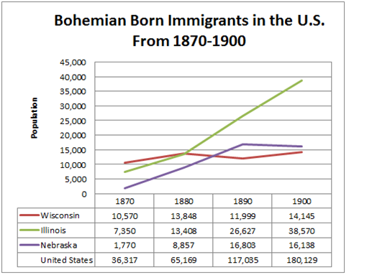
Figure 1: Bohemian-Born Immigrants in the U.S. 1870-1900. Table created by author with data retrieved from The University of Virginia Historical Census Browser, Geospatial and Statistical Data Center. <http://fisher.lib.virginia.edu/collections/stats/histcensus/index.html>

When it comes to the question of “why Wisconsin?” the general conclusion that can be found after consulting numerous primary sources is word of mouth. This conclusion was made after studying three different stories of Czech immigrants who found themselves in Wisconsin. Jan Novak came to America in 1852 after seeing a letter from a Czech in America who lived in St. Louis. Like many others, Novak arrived in New York and took a train to Chicago where he found a place to stay for him and his wife. After a year of unsteady work, Novak met other Czech immigrants who were on their way to live in Wisconsin. Novak stayed in Chicago for a few more months, but soon grew tired of trying to find work and left for Racine. It was in the village of Caledonia that Novak found the other Czechs and he was able to buy some land. A similar story is that of Frank Stejskal, whose family came to Chicago in 1854. It was here that Frank’s father met another Czech who had a brother that lived in Manitowoc country. This man convinced Frank’s father to go to Wisconsin so he too could buy a piece of virgin Wisconsin forest. Finally, in Ferdinand Doubrava’s story, his family started their new American life in Texas. Unfortunately for the Doubravas, a rocky passage to America was not the end of their troubles. While Doubrava makes no mentions of years in his memoir, he mentions living in Texas after “the struggle between the North and South broke loose.” The years spent in Texas also brought malaria and typhoid to the Doubrava family and violent encounters with the Confederate Army. Finally, Ferdinand’s father was able to sell four years’ worth of cotton to the North, earning him and his family enough money to leave for Wisconsin. Ferdinand’s father had belonged to a miller’s guild when he had lived in the Czech lands, and he knew a couple of other members who had settled in Wisconsin, and while it is not explicitly stated, this is perhaps the reason that the family left Texas for Wisconsin.
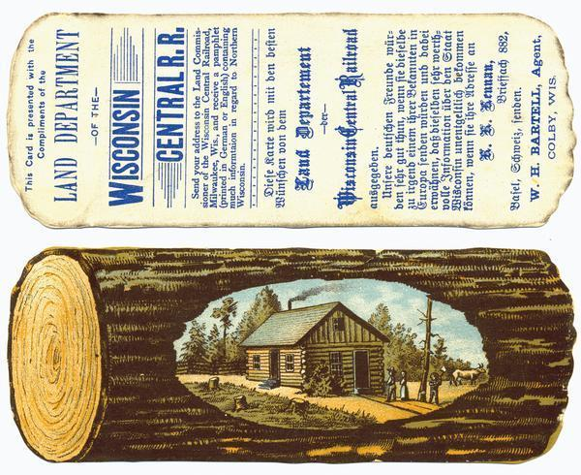
The other possible reasons for Wisconsin’s popularity among Czech immigrants are the favorable climate and advertising. Some of the earliest Czech settlements in America were located in Texas, where the climate was hotter and more prone to carry diseases. Wisconsin, while having a drastically cold winter, had a more mild spring and summer much like what the Czechs were already used to. Along with a better climate for their well-being, Wisconsin had more fertile soil than the South, and was easily able to support crops that Czech farmers had experience in producing such as corn, oats, and wheat. While many Czech people may have relied on letters from family members and talk amongst other Czech immigrants about the bounty that Wisconsin had to offer, there were also advertisements telling them of the great state of Wisconsin. Officials in Wisconsin knew of their states more favorable conditions for central European immigrants, and had advertised their state in German and Austrian newspapers. The state also had a paid official living in New York City, whose job was to direct the flow of incoming immigrants to Wisconsin. This official also paid for advertisements to be placed in foreign language newspapers in New York, advertising Wisconsin’s cheap land and low taxes (See Figure 2).
Once Czech immigrants had found their way to Wisconsin, they congregated together in certain areas of Wisconsin. Instead of settling wherever they pleased in the vast territory of the state of Wisconsin, they settled with other Czech immigrants in large numbers, mostly in the counties of Manitowoc, Kewaunee, Milwaukee, and Racine (see Figure 3). It was common for Czechs to live in places that were near large bodies of water, as these places had the most developed railroad systems and easily accessible forms of water transportation. As Manitowoc and Kewaunee counties held the most concentrated amount of Czech immigrants living in one area, it was a logical choice to focus on these counties as a sample to discuss Czech lives in Wisconsin.
Figure 2: Advertisement of the Land Department of the Wisconsin Central Railroad Circa 1850. Wisconsin Historical Society Image ID# 24505. Reproduced with permission of the Wisconsin Historical Society.

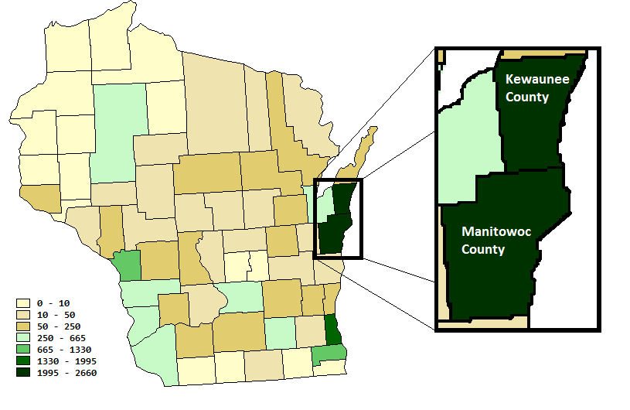
Figure 3: Persons Born in Bohemia 1880. Retrieved from The University of Virginia Historical Census Browser, Geospatial and Statistical Data Center. <http://fisher.lib.virginia.edu/collections/stats/histcensus/index.html>

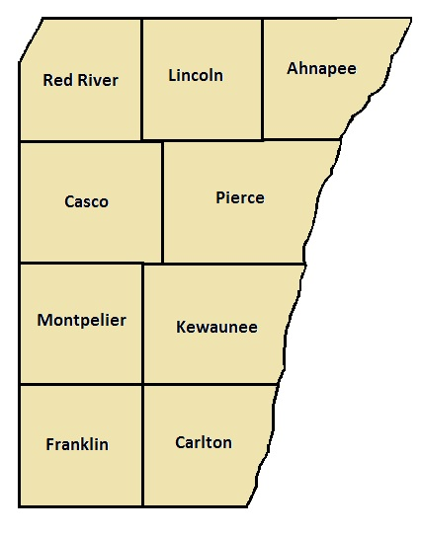
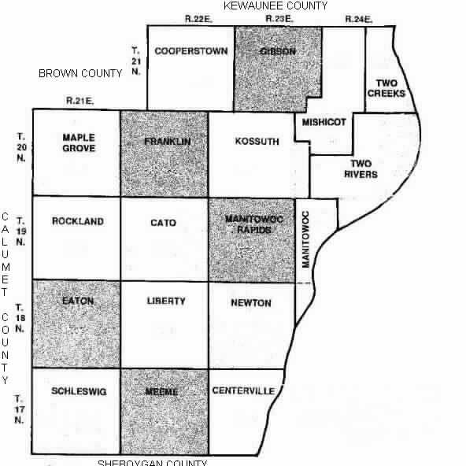
Manitowoc and Kewaunee counties, located in Northeastern Wisconsin, held the most amounts of Czech immigrants. While it is unknown who the first Czech immigrants were in Manitowoc County, it is recorded in Frank Benes’ manuscript that Anton and Vaclav Chloupeck have founded the town of Koussuth in 1849. Benes also records that by 1852 there were fifteen Czech families settled near the town of Kellnersville. It is certain however that Vojta Stransky was the first Czech settler to Kewaunee in 1853. Looking through the records of the 1870 Federal Census of the United States about Bohemian-born persons living in Manitowoc and Kewaunee counties yields a plentiful wealth of information about the ways that Czech immigrants lived their lives in Wisconsin. One of the first things to be learned about the Czech inhabitants of Manitowoc and Kewaunee counties is that in the rural areas, the Bohemian born population would in some areas be the majority of the population, such as in the townships of Kossuth, Franklin, and Carlton; while in other areas such as Centerville and Ahnapee there were few to no Czech families (See Figures 4 and 5).
Figure 4: Index of townships in Mantitowoc County in 1878. Image reproduced with permission from <www.2manitowoc.com>
Figure 5: Index of townships in Kewaunee County in 1878. Image created by author.

This shows that the Czech people in the rural areas preferred to live in community settings, surrounded by other Czechs. In the urban settings of Kewaunee and Manitowoc, however, the story is quite different. The Czech population here is more spread out, and does not make up an obvious majority of the population in those cities. Also in the urban areas it is more common to see a Czech husband or wife intermarried with a spouse of a different nationality. This practice was unheard of in the rural communities, with the Czech families being composed of members only of Czech heritage. Perhaps this is because the Czechs living in the rural areas had stuck together in Czech communities and tried to remain traditional, whereas the Czechs living in the larger cities amongst people of many different nationalities had been assimilated further into the diverse American lifestyle. One last interesting piece of information to be gleaned from the census pages is the fact that many of the large rural Czech families were made up of a mother and father who had both been born in Bohemia who had many children whose birthplace was also listed as Bohemia. This suggests that a majority of the Czech settlers to these counties emigrated from Europe as family units. This was vastly different from the norm in nineteenth century European emigration, which normally saw just a single young male of a household immigrating to America.

Part Four: Making A New Home

Throughout Wisconsin there are many stories told about Czech immigrants; some stories of heroism and achievement while others were of sorrow and hardship. When many of the first Czech settlers came to Wisconsin, they were met with the latter. Despite this however, they created a life for themselves in Wisconsin and eventually created a flourishing social life. When discussing the history of Czech immigration in Wisconsin, it is not just about why they came here, but it is also about what they did after they arrived.
The first problem any new settler faces is creating a home out of wilderness. When many Czech settlers arrived to Manitowoc and Kewaunee Counties, they came face to face with miles upon miles of thick virgin forests. It did not help that Czechs coming to America had highly glorified images of what life in America would be like. Ferdinand Doubrava wrote about a letter sent to Bohemia from an American settler that described America in a highly fictitious manner. Included in this letter were details about the “gold in California [that] grew on the sides of the hills like the antlers of deer.” The letter became even more dramatic stating that “the fences generally were made of bologna sausages, and pigs ran about ready roasted with [a] carving knife and fork sticking in their backs.” When speaking of the hopefulness of early settlers, Frank Benes said:
“The pioneers recalled life in Cechy where they at least ate to their hearts content. Before they came to Wisconsin, the mothers promised their children that they were going to the promise land, where everything was plentiful. The mother said, ‘Just wait. When you get there you will find candy trees and you can eat all the candy you want.’ How disenchanted they were when they not only did not find candy on the trees, but nothing to eat.”

In reality, early Czech settlers were not met with candy trees and bologna fences but miles of untamed forests and homes far from the nearest city. One young immigrant lamented his father’s choice to leave the grand urban lifestyle in Chicago to instead live in Manitowoc where they would be tasked with turning the “virgin forests into meadows.” This man was not unfounded in his grief. Many early settlers to the Manitowoc area found themselves in the midst of a heavy forest. While their goal was to clear the forests so they could create suitable farm land, many settlers had very little money and it would take them years to earn enough to buy any equipment. When they were finally able to clear the trees, there was no money to be made from the wood so they had to burn everything, and they had no plows to loosen the earth or to cultivate the stumps. By the time the settlers were able to plant, early harvests generally did not yield much potatoes or turnips, and those settlers that were able to grow wheat found even more trouble. In order to turn the grain into flour, the grain would have to be carried on their backs through miles of untamed woods to the nearest grain mill. There were no roads in those days, either settlers would use Indian paths or they would have to mark the trees with axes to find their way. On one such trip to Kewaunee to process their grain, one settler was forced to give birth while she and her husband were walking on one of these rough paths.
Another account of this hardship of settling in this desolate area is the story about Vaclav Stupecky. He and his family had moved to Manitowoc County in 1856 and had very little money upon arrival. While they were earning the money to build their house, they had to stay with the local blacksmith whose house was of very poor construction. It was said that Stupecky’s wife would have to sit under the table when it rained so as not to get wet. Eventually the family moved into their own house before it had been finished. It was in this house that poor Mrs. Stupecky had a startling experience of waking up to strangers in her house. Luckily the strangers meant no harm to the Stupeckys. They were Oneida Indians who simply wanted to use their (the Stupecky’s) fireplace to cook their food.
Despite all of these hardships, the early Czech settlers proved themselves to be able to surpass the challenges they were faced with. Soon the land that the Czechs have bought had been turned into hearty farmland and with time they were able to create a strong social life in the cities of Manitowoc and Kewaunee. At the heart of Czech social life in these cities were organizations such as the Slovanska Lipa, Sokols, and different branches of the C.S.P.S. and the Z.C.B.J.
Many of the societies of the Czechs in nineteenth century Wisconsin were formed and run by freethinkers. Freethought is a social phenomenon where people meet together and form freethinking societies that value education and discussions that are separate from religion. Freethought societies usually form in places where religious leaders control the schools and discourage analytical thinking and discussion. In the Czech lands, Catholicism was forced onto the people and there were no options for children’s schooling other than the Catholic schools. It was only natural for the independent-minded Czech people to have freethought societies at the root of their cultural life in America, where they could freely run such societies. Because of the strict Catholic punishment of the Protestant Czechs in Europe, religion was not an important quality in Czech-American life. There were still some Catholic and Protestant churches run by Czechs in Czech communities, but it was not a central part of their culture.
The earliest organizations formed in Manitowoc and Kewaunee counties by the Czechs were called the Slovanska Lipa, and were theatrical and singing organizations. Slovanska Lipa is a Czech phrase that translates to “the Slavonic linden tree”; the linden tree being held sacred by ancient Czechs and was a place for intellectuals and leaders of communities to meet and discuss important matters. The first Slovanska Lipa in Wisconsin was organized in Kewaunee in 1863, with a hall built in the same year as a place for the organization to meet, also bearing the name “Slovanska Lipa.” Manitowoc had a Slovanksa Lipa hall where Czech people met as early as 1864, but they did not form a Slovanska Lipa society until 1895. The Slovanska Lipa is an example of a freethinking society, and since in their homeland the Czech people were oppressed by Catholic rulers on what they could do or say, the Slovanksa Lipa societies and halls enjoyed much popularity in the early days of Czech life in Wisconsin. It was at such places that the people could attend or give lectures on any subject, perform and see plays about Czech life, and listen to groups sing national Czech songs. Finally, Czech people were able to express their views and experience true freedom with the Slovanska Lipa.
The Slovanska Lipas, though providing a channel for the Czechs to display their proud heritage and enjoy political and religious freedoms, began to decline in popularity after a few years. This may be because the Slovanska Lipa societies were formed by the older Czech immigrants who had emigrated from Europe as adults and were more attached to their Czech nationality. Thus, it was in later years that the younger Czechs formed the Sokol organizations. Sokols (Sokol meaning falcon in the Czech language) were gymnastic clubs that sponsored an athletic lifestyle and was popular amongst the younger generation for hosting athletic competitions. When the Kewaunee Slovanska Lipa disbanded in 1876, the Czech-American Sokol was formed and use of the Slovanska Lipa hall was turned over to the new organization. While primarily a gymnastics club, the Sokol still hosted dramatic plays for the Czech people.
The first Sokol was created in Prague in the 1860s where they formed to benefit any member physically, morally, and intellectually. These benefits were accomplished through fitness training, lectures, discussions, and group outings. The strong bond that the organization created between their members made the Sokol a cherished part of Czech life in Europe. Many of the immigrants to America created their own Sokol organizations where they settled, and this pattern was no different in Wisconsin. They undoubtedly did this because of their dedication to their nationality and their love for their fatherland. The Sokol helped fellow Czech immigrants adapt to life in America by keeping a piece of home close by. In America, the purpose of the Sokol was to “cultivate gymnastics and the dramatics.” With the addition of fitness training and athletic competitions, the activities of the Sokol in Manitowoc and Kewaunee were similar to those of the Slovanksa Lipa. The Sokol was another outlet for Czech freethinkers to practice their religious liberalism, but it held more of an appeal to younger Czechs than the Slovanksa Lipa had. The Sokol also proved to be beneficial to the futures of its Czech members. One family had two sons, former members of the Sokol in Manitowoc, who succeeded in the athletic profession, one becoming a gym teacher at the schools in Manitowoc and the other became the athletic instructor at Alabama University. The Sokol organization helped these young men to succeed in their life as it did for many other members.
While the Slovanska Lipa and the Sokol were important organizations to Czech life in Wisconsin, they were both non-profit organizations whose purpose was to promote Czech-American culture. One other type of organization that was important to Czech life was fraternal organizations such as the C.S.P.S. and the Z.C.B.J. (the Czech Slavic Benevolent Society and the Western Bohemian Fraternal Association, respectively). While these organizations were not cultural in nature, they were still mostly run by freethinkers much like the Slovanska Lipa and the Sokol. The C.S.P.S. was the oldest existing Czech fraternal organization, the first lodge being organized in St. Louis in March of 1854. The Z.C.B.J., however, was more prominent than the C.S.P.S. in Kewaunee. It was the purpose of these organizations to sell health and life insurance to Czech immigrants that had just arrived to Wisconsin. These organizations also had social services for the elderly, and provided help for single mothers in order to make their lives in Wisconsin easier.
There is one important part of Czech life in Wisconsin that was not prevalent in the counties of Manitowoc and Kewaunee, and that was Czech language newspapers. Czech language newspapers had been the major player to the culture of the Czech people of Racine and Milwaukee counties, and had been important to many other Czech communities across America. In fact, Racine was the home of the first Czech language newspaper in all of America, the Slavie, which had its first issue published in January of 1860. Like the Sokols, Czech newspapers served as a link to the homeland for their readers, and as a place for them to practice the political freedoms they had not known in Europe. Why there had not been a major Czech language newspaper in Manitowoc or Kewaunee it not known, but it is probable that the Czech inhabitants of these counties were able to receive copies of the Slavie and saw no need to start their own.
Life in Wisconsin was far from the vision of candy trees and gold mines that early Czech settlers were hoping for. In fact, it was filled with grueling work that provided little profit for years and was not much different from the labor and poverty-filled lives they had lived in Europe. But over time, the Czechs made Wisconsin into a bountiful place to live, and their creation of organizations was essential to creating a happy life. Whether an organization helped immigrants start a new life in Wisconsin or created a link to the life they had left in Europe, these organizations were important to Wisconsin Czech communities. It may have taken years of difficult work, but the Czechs had finally made a new home for themselves in Wisconsin.

Part Five: Leaving Wisconsin

When looking at the collected census data about Bohemian immigrants from 1870 to 1890 it is clear to see that while Wisconsin was a popular home for Bohemian-born persons in 1870 and 1880, that number dropped drastically by 1890 and other states had surpassed Wisconsin for numbers of Bohemian immigrants (see Figures 6 and 7). While a number for Bohemian immigrants in America is not available for years prior to 1870, the documentary evidence can easily allude to the popularity of Wisconsin for Czech immigrants since 1848. In one book on Czech immigration, it is mentioned that one out of every three citizens in Wisconsin in the year 1850 were foreign born. It is also mentioned that the state paid for an official to live in New York City to not only attract incoming immigrants to live in Wisconsin, but to also send advertisements to Germany and Austria about living in Wisconsin. Why then, did the number of Bohemian-born citizens living in Wisconsin drop after 1880? While Bohemian-born citizens had dropped between 1880 and 1890 in Wisconsin, the numbers of Bohemians had been continually rising in states like Illinois and Nebraska since 1870. Many could make the argument that the numbers had dropped because emigration from the Czech lands simply slowed and the first generation immigrants had been growing old and dying. This argument does not hold water, however, as the census data shows a continual rise in the population of the United States of persons born in Bohemia. Since the total number of Bohemian-born people within the United States had actually increased during the time that the number had decreased in Wisconsin, this means that Czech people were either leaving Wisconsin or incoming immigrants were ceasing to make the choice to live there.

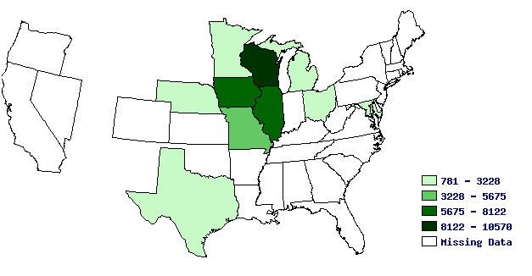
Figure 6: Persons Born in Bohemia 1870. Retrieved from the University of Virginia Historical Census Browser, Geospatial and Statistical Data Center. <http://fisher.lib.virginia.edu/collections/stats/histcensus/index.html>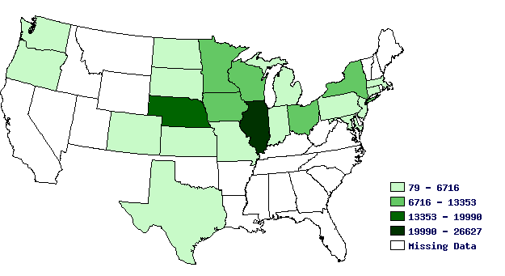
Figure 7: Persons Born in Bohemia 1890. Retrieved from the University of Virginia Historical Census Browser, Geospatial and Statistical Data Center. <http://fisher.lib.virginia.edu/collections/stats/histcensus/index.html>

There are many reasons for immigrants to move from state to state. If such a large exodus of Czech immigrants left Wisconsin between the mid-1870s and 1890, there is a reason. One of the most common reasons for a group of people to leave an area is problems with assimilation. Historian Matthew Frye Jacobson discussed in his book Whiteness of a Different Color: European Immigrants and the Alchemy of Race how European immigrants were defined by where they were born, leading to racial tension between Europeans of different birthplaces. Perhaps it is the case that Czech people were not of the right ethnicity for other Wisconsin citizens, receiving poorer social status than others thus causing them to leave and look for a more accepting home. This theory certainly would make sense. Looking at the 1870 United States Federal Census Records for Manitowoc and Kewaunee counties shows a high number of German and Austrian immigrants living there along with Czechs. After the discussion of the oppression caused to the Czechs by the Austrian Hapsburgs from Part One, it is not difficult to consider that Czechs may not have been fully welcomed by the Austrians in America. Czechs could have also been uncomfortable living amongst Germans as the German nobility had owned much of the land that the Czechs had once worked on as serfs and corvees. So perhaps it was the case that Czech people were not of the right ethnicity for other Wisconsin citizens, receiving poorer social status than others, thus causing them to leave and look for a more accepting home.
Fortunately for the Czech people, this was actually not the case. While in their own homeland, the Czechs had been serfs and were treated as lower beings than their Austrian leaders; in Wisconsin they enjoyed a higher status. They were not all members of the upper class, but they were equal citizens enjoying the same rights and privileges as their German, Austrian, and Prussian neighbors in Wisconsin. In fact, there were many cases of a Czech immigrant marrying an Austrian or German immigrant. This is actually quite surprising. At home the Austrians were the cause for Czech oppression and Czechs had refused to be part of a German nation. By all reason, these groups should not be amicable, yet it appears that all differences were forgotten in the new world. With no problems of assimilation into society in Wisconsin, what then could cause so many Czechs to leave? The answer that has been given many times over by scholars, as well as the immigrants themselves, is the Homestead Act.
The Homestead Act was a piece of legislation that was passed by United States Congress and signed into law by President Lincoln in 1862. This law allowed any citizen of the United States who was the head of a household, or was twenty-one years of age, to claim a “homestead” (a 160 acre parcel of land). The restrictions, however, called for that person to file an affidavit confirming that that person was eligible to receive the land, and that the land was to be used only for his or her benefit. Finally, the person who had filed the affidavit could only receive a deed to the land after they had lived on the land for five years and could show proof that they had improved the homestead. Land certainly was very important to the Czech settlers of Wisconsin, as most of them were farmers and had owned some portion of land. While some of the first Czech immigrants had been attracted to Wisconsin because of their cheap prices for land, the heavy influx of Czech people to Wisconsin throughout the 1850s and 1860s had negative effects to the attraction of Wisconsin to the Czech immigrants. With the growing population of foreign-born Wisconsinites buying the land, the land values in Wisconsin had risen and many Czechs would have left for a place that had more land to offer.
Others, however, may not have left simply because of the scarcity of the land available in Wisconsin, but because of the quality of the land. Robert Kutak, in his sociological study on a Bohemian-American village in Nebraska, quoted many of the inhabitants on their reasons for settling in Nebraska. One such inhabitant talked about his father’s aversion to heavily forested land in Wisconsin, and had moved to Nebraska after hearing of the open plains that it had to offer. Finally, the Homestead Act made it easy to start new in the West for those that had failed in Wisconsin, as in the case of John Herman. John Herman had been a wealthy landowner in the Czech lands, and had paid the passage for many people to come to America with him, in the hopes that they would work for him. He came to Manitowoc County in 1853 with the intent of owning a farm. However, the people he had brought with him did not work on his land like he had hoped, so he gave up farming to open a saw mill and a grain mill. When Herman heard of a railroad that was to be built near his mills, he invested most of what he had into the project. Unfortunately, the railroad was never built and he lost a large amount of money. Discontented with how his ventures had failed in Wisconsin, he left for Nebraska in 1865.
One problem found with using the Homestead Act as a reason for the falling numbers of the Czech population in Wisconsin is that the people who actually left Wisconsin to move to the West had left by the mid 1870s. It was not until after 1880 that the Czech population in Wisconsin had shown a significant decrease. What is left for an explanation for the decrease in Wisconsin after that time is death. While the Homestead Act certainly had caused a number of Czech people to leave Wisconsin during the 1860s and 1870s, and had been a reason for many new immigrants to bypass Wisconsin and instead choose to make a home out West or in Chicago; it is not the reason for the drop after 1880. Instead, death of the first generation Czechs whose birthplace had been in Bohemia would cause the drop in the census numbers. Certainly there would still be Czech families in Wisconsin, but being born in Wisconsin they would not be listed as Bohemian in the census records. This theory holds true when looking at the accounts of the Czechs living in Manitowoc and Kewaunee counties. There are plenty of stories of people leaving in the 1860s, but it is hard to find a report of a family or a person leaving after 1870.
While many Czech people had actually left Wisconsin during the 1860s and 70s because of the cheap government land available after the Homestead Act, it was not the departure of Czechs that caused the drop in the Czech population of Wisconsin. Instead, it is probable to assume that many of the first generation Czechs who had left Europe and came to Wisconsin had simply died and left behind a family of full-blooded Czechs that had been born in America.

Conclusion

While many people think of Wisconsin as a state of Germans and Norwegians, what they do not know is that Wisconsin was the home for a significant number of the Czech-American population for much of the later nineteenth century. Driven here by their want for a more free life than what was available to them under the oppressive Hapsburg Empire, Czech culture flourished in Wisconsin. They created a home for themselves in the wild Wisconsin forests and, for the first time for many a Czech person, they were able to live exactly how they wanted without anyone telling them what they could and could not do. The Czech life in Wisconsin was a happy one, full of theatrical plays, athletic competition, and wonderful Czech music being sung. Unfortunately, Wisconsin eventually failed to attract the majority of new Czech immigrants after 1880, and the abundance of Czech culture in Wisconsin towns soon died. As more and more of the first-generation Czech immigrants died, their American-born children drew farther and farther away from their Czech heritage, becoming a part of America’s melting pot. However, the Czech people of Wisconsin did not easily let go of their love for their fatherland. They were Americans, yes, but in their hearts they would always be part of the Czech nation.

Bibliography
Primary Sources
1870 United States Census. Scanned copies of handwritten documents. Ancestry Library Edition. <http://ancestrylibrary.com/default.aspx>
Benes, Frank. 1935. Essays. Translated by Charles H. Vyskocil. Manuscript collection. Green Bay Area Research Center.
Doubrava, Ferdinand F. 1925. Experiences of a Bohemian Emigrant Family. The Wisconsin Magazine of History 8, no 4 (June): 393-406.
Historical Census Browser. University of Virginia, Geospatial and Statistical Data Center; <http://fisher.lib.virginia.edu/collections/stats/histcensus/index.html>.
Mikulesky, J.W. 1940. Historical essay. Manuscript collection. Parkside Area Research Center.

Secondary Sources
Bicha, Karel D. Spring 1970. The Czechs in Wisconsin History. The Wisconsin Magazine of History 53, no. 3: 132-154. Madison.
Capek, Thomas. The Čechs in America. New York: Arno Press, 1969.
Drbohlav, Dušan. 2003. Immigration and the Czech Republic (With a Special Focus on the Foreign Labor Force). International Migration Review 37, no. 1 (Spring): 194-224.
Habenicht, Jan. History of Czechs in America. St. Paul, MN: Czechoslovak Genealogical Society International, 1996.
Jacobson, Matthew Frye. Whiteness of a Different Color: European Immigrants and the Alchemy of Race. Cambridge, Massachusetts: Harvard University Press, 1998.
Kavka, Frantiseck. An Outline of Czechoslovak History. (Translated from the original by Jarmila and Ian Milner). Prague: Orbis, 1960
Kutak, Robert Ingersoll. The Story of a Bohemian-American Village. New York: Arno Press, 1970
Laska, Vera. The Czechs in America, 1633-1977: A Chronology and Factbook. Dobbs Ferry, NY: Oceana Publications, 1978.
Orton, Lawrence D. The Prauge Slav Congress of 1848. New York: Columbia University Press, 1978
Pech, Stanley Z. The Czech Revolution of 1848. Chapel Hill: University of North Carolina Press, 1969
Problems of Assimilation: A Study of Czechoslovaks in the United States.” Sociology and Social Research. September – October 1932.
Smetanka, Jaroslav F. 1921. Bohemians and Slovaks – Now Czechoslovaks. Annals of the American Academy of Political and Social Science 93, (January): 149-153.
The History of Racine and Kenosha Counties, Wisconsin ... Chicago: Western Historical, 1879. Print.
Wojta, J.F. 1941. The Town of Two Creeks: Manitowoc County. The Wisconsin Magazine of History 25, no. 2 (December): 132-154.

Czechoslovakia was not a formal country until the year 1918, and therefore its people not referred to as Czechs until this time. Before then, the lands of the Czech people were known as the Lands of the Bohemian Crown and included the Kingdom of Bohemia, the March of Moravia, Silesia, and Upper and Lower Lusatia. Many of the Czech people referred to themselves as Bohemian before 1918. However, some people were offended by this title as they felt their nationality was Czech but they were not from the territory of the Kingdom of Bohemia. I will be referring to these people as Czechs, rather than simply Bohemians, in this paper because the term Bohemian excludes Moravians and Silesians that would also become Czechs in 1918. However, Bohemia was the birthplace listed for these people on the census records for much of the nineteenth century and some of my data will refer to Bohemians or Bohemian-born people.
Frantiseck Kavka, An Outline of Czechoslovak History, (Prauge: Orbis, 1960), 61-71
Thomas Capek, The Cechs (Bohemians) in America: A Study of Their National, Cultural, Political, Social, Economic, and Religious Life, (New York: Houghton Mifflin Company, 1920), 1
Kavka, Czechoslovak History, 65
Serfdom is a form of slavery where the laborers live by working on a feudal lord’s property in exchange for living on their land. Corvée labor is labor that is often unpaid and is imposed on people of lower social standing by their superiors, much like serfdom.
Kavka, Czechoslovak History, 71-74.
Kavka, Czechoslovak History, 81-88.
Vera Laska, The Czechs in America, 1633-1977: A Chronology and Factbook (New York: Oceana Publications, 1978), 7; Capek, The Cechs in America, 25.
Kavka, Czechoslovak History, 93.
Ferdinand Doubrava, “Experiences of a Bohemian Emigrant Family”, The Wisconsin Magazine of History 8 (June, 1925): 395.
Doubrava, Experiences of a Bohemian Emigrant Family, 395-397.
Ibid, 394
Ibid, 397-398
Doubrava, Experiences of a Bohemian Emigrant Family, 398-399
Lajos Kossuth, a Hungarian patriot who began a riot against the Austrians in Budapest in 1848.
Frank Benes, “Essays” [ca. 1935], Manuscript collection, Green Bay Area Research Center, WI.
“Bohemian Born Persons by State” Historical Census Browser. University of Virginia, Geospatial and Statistical Data Center : http://fisher.lib.virginia.edu/collections/stats/histcensus/index.html; last accessed 12/11/11.
Laska, The Czechs in America, 69-70.
Laska, The Czechs in America, 73.
Doubrava, Experiences of a Bohemian Emigrant Family, 399
Ibid, 396-399
Capek, The Cechs in America, 36-37. Karel D. Bicha, “The Czechs in Wisconsin History,” The Wisconsin Magazine of History 53, no. 3 (Spring, 1970): 194
“Wisconsin County-Level Results for Persons Born in Bohemia 1880” Historical Census Browser. University of Virginia, Geospatial and Statistical Data Center. <http://fisher.lib.virginia.edu/collections/stats/histcensus/index.html> Accessed 12/11/11.
Frank Benes, “Essays” [ca. 1935], Green Bay Area Research Center
Doubrava, Experiences of a Bohemian Emigrant Family, 395.
Cechy is the Czech word for the Bohemian lands of Europe
Frank Benes, “Essays” [ca. 1935], Green Bay Area Research Center
Laska, The Czechs in America, 73.
Frank Benes, “Essays” [ca. 1935], Green Bay Area Research Center
Frank Benes, “Essays” [ca. 1935], Green Bay Area Research Center
Western Historical Company, The History of Racine and Kenosha Counties, Wisconsin. (Harvard: Western Historical Company, 1879), 162
Frank Benes, “Essays” [ca. 1935], Green Bay Area Research Center
Doubrava, Experiences of a Bohemian Emigrant Family, 395.
Frank Benes, “Essays” [ca. 1935], Green Bay Area Research Center.
Frank Benes, “Essays” [ca. 1935], Green Bay Area Research Center
Frank Benes, “Essays” [ca. 1935], Green Bay Area Research Center; Robert Kutak, The Story of a Bohemian-American Village (New York: Arno Press, 1970), 102.
Capek, The Cechs in America, 258.
Karel D. Bicha, “The Czechs in Wisconsin History,” The Wisconsin Magazine of History 53, no. 3 (Spring, 1970): 203; Frank Benes, “Essays” [ca. 1935], Green Bay Area Research Center
“Persons Born in Bohemia 1870, 1880, 1890” Historical Census Browser. University of Virginia, Geospatial and Statistical Data Center. <http://fisher.lib.virginia.edu/collections/stats/histcensus/index.html> Accessed 12/11/11.
Capek, The Cechs in America, 37
Robert Kutak, The Story of a Bohemian-American Village (New York: Arno Press, 1970), 9.
Kavka, Outline of Czechoslovak History, 84.
Homestead Act of 1862, Public Law 37-64, 37th Cong., 2d sess. [May 20, 1862], 392-393. Under “Statutes at Large, 1789-1875.” http://memory.loc.gov/ammem/amlaw/lwsllink.html [accessed December 11, 2011].
Ancestry.com. 1870 United States Federal Census [database on-line] (Provo, UT: Ancestry.com Operations, Inc., 2009)
Capek, The Cechs in America, 37; Doubrava, Experiences of a Bohemian Emigrant Family, 402; Jan Habenicht, History of Czechs in America (St. Paul, MN: Czechoslovak Genealogical Society International, 1996), 304.
Kutak, Story of a Bohemian-American Village, 12
Frank Benes, “Essays” [ca. 1935], Green Bay Area Research Center
Frank Benes, “Essays” [ca. 1935], Green Bay Area Research Center

