Reminiscing Thomsonian Medicine:
The Rise and Fall of a Botanical Medical Movement

Tess Isabella Newhouse
History 489: Research Seminar
November 2015

Copyright for this work is owned by the author. This digital version is published by the McIntyre Library, University of Wisconsin-Eau Claire with the consent of the author.
Contents
Abstract ………………………………………………………………………………………………………………………………………………… iii
List of Figures and Maps ……………………………………………………………………………………………………………………….. iv
Introduction ………………………………………………………………………………………………………………………………………….. 1
Background ……………………………………………………………………………………………………………………………….………….. 2
Historiography and Primary Source Analysis ………………………………………………………………………..……………….. 7
The End of a Revolutionary Botanical Movement ……………………………………..……………………………………….. 10
Conclusion …………………………………………………………………………………………………………………………………………… 14
Works Cited ………………………………………………………………………………………………………………………………………… 17
Glossary …….………………………………………………………………………………………………………………………………………… 23

Abstract

The 19th century contained many different practices of medicine. Similar to the present day, natural-based botanical medicine and conventional pharmaceutical medicine collided. Between the years 1800-1870, a small holistic approach referred to as Thomsonian medicine sparked. The ideology, created by a farmer with no formal education, spread swiftly throughout the East Coast of the United States and eventually reached many parts in the South as well as Mid-West. This practice of medicine held a steadfast base with an extensive following of believers. However, Thomsonian medicine slowly withered away to a faint memory by the late 1800’s. This paper touches on the founder of Thomsonianism as well as his critics. It will also explore social, economic and political factors which contribute to the development as well as demise of a once touted doctrine.

Figures and Maps

Figures
Figure 1. Portrait of Samuel Thomson…………………………………………………………… 19
Figure 2. Lobelia, No. 1, A Thomsonian Herb………………….………………………… 19
Figure 3. Illustration of Traditional vs. Thomsonian Medicine …….…………… 20
Figure 4. Advertisement of Thomsonian Medical Supplies ……….……………… 21

Maps
Map 1. Thomsonian Presence in America ……………………………………………. 22

Introduction
What comes to mind when medicine is considered? Perhaps thoughts of cough syrup are the first to be drawn, as it is most likely the first medicine introduced to our bodies that one can recollect. A clinic or hospital where medicine is practiced and distributed might be conjured. The television advertises pharmaceutical drugs during every commercial break, to the point where side effects no longer alarm us. Conventional or Western medicine envelops American society. When plagued with sickness, it is generally modern and scientific medicine Americans turn to.
After further brainstorming, natural and botanical medicine will surely appear. Although studies have proven some natural remedies to be just as effective as standard pharmaceutical medicine, most Americans have been calloused to believe in the standard conventional medicine as the only way. However, this is not a debate in regards to holistic medicine’s legitimacy. It is to question why certain forms of alternative medicine were wiped out while the paradigm of modern medicine keeps shifting.
The 19th century in America contained many different models of alternative medicine. One variation in particular, created by Samuel Thomson, was exceptionally popular and made its way around the United States. After Thomson’s method had gained in popularity, it also gained a name: Thomsonianism. Thomson’s method would last for decades and become one of the most well-known form of homeopathy during his time. That isn’t to say it lasted. In fact, many are unaware of what Thomsonian medicine entailed- let alone know that it was even existent at one point in time.
How could this practice of medicine hold such valor for so many years, only to be extinguished? There are several specific factors that drove the Thomsonian method of medicine into its grave. Social factors, such as education were a contributing attribute to the end of Thomsonian medicine. In addition, internal political factors and disagreement among the founder and his peers caused great turmoil. Lastly, decisions made during the Civil War helped seal the Thomsonian fate.
Background
In order to understand Thomsonian medicine, the creator of this movement must be analyzed. Samuel Thomson had humble beginnings born on a farm in New Hampshire in the year 1769. Thomson can be seen in Figure 1; this portrait was published in Thomson’s own book in 1822.
Influences such as his surroundings and neighbor, Widow Benton, sparked his curiosity in herbal remedies. Little is known about Benton, other than the mention of her work as a healer through botanical means in Thomson’s New Guide to Health. On the account that Thomson’s family lived in the country, he was surrounded by herbs. He experimented with these readily available resources.
Country life also meant quite a far distance from any sort of doctor. Benton would administer natural remedies, and Thomson was extremely observant and inspired.
Years later, Thomson inherited his father’s farm. Due to excessive sickness and a five mile distance from the nearest doctor, he requested that his family doctor move onto his farm. Thomson watched the doctor work and took note of his practices. While the doctor proved to be helpful and effective with his methods most of the time, this wasn’t always the case. At this time, traditional medicine was growing and for serious illness there was little hope. However, Thomson restored his family back to health by his own means. In one case the doctor had diagnosed his two year old daughter with the worst case of canker rash he had encountered and stated “she could not live”. She was covered in cankers, even her vision was lost in one eye because the canker spread to her face and took over her eye. Thomson begged the doctor to save her other eye, but he stated it was a lost cause, as this was incurable. Since the doctor had done everything in his power, Thomson dismissed him. At this point, anything Thomson tried to do in order to restore his daughters health was better than nothing, for she was thought to be close to death. Using his acquired skills, he gave her steam baths and administered selected herbs. He attentively cared for her using his methods until she was restored. Although the vision in her eye was never regained, she still was blessed with the gift of life. From this point, Thomsonian medicine would grow to become a phenomenon. With his first patients being his immediate family, he was eager to expand. Family and friends would request his services to be healed from their conditions. At this time, he was not making any money. Although it was a rather hard decision, he gave up farming to develop his practice in medicine and healing.
His method consisted of six basic remedies that were meant to cleanse the body and bring it back to typical functioning. The first, and what he considered to be the most important remedy, was an herb called Lobelia (Figure 2). He used this to induce vomiting which in turn would “cleanse the stomach, overpower the cold and promote a free perspiration.”
The second of his six step process was cayenne, or capsicum. This was to keep internal vital heat steady as well as encourage perspiration. Capsicum is the chemical (commonly found in different varieties of peppers) that causes a burning or heat sensation when ingested. Seemingly, it would make sense this chemical would facilitate a higher body temperature.
The third step in his process consisted of consumption of various herbs, roots and leaves which caused diarrhea. This in turn led to the completion of “scouring the bowels to remove the canker” followed by consumption of Bitters- the fourth herb to be administered. This herb encouraged digestions and regulated stomach bile. In addition, the patient was dispensed peach or cherry pits to cure their dysentery and restore their strength. Lastly, Rheumatic drops, which consisted of Myrrh and capsicum, were administered to relieve pain and, like many of the other steps, render a homeostatic body temperature.
These steps could be used in order or a certain single step could be used. Essentially the goal was to raise the body temperature and cast out impurities. Thomson also used steaming to raise the body temperature and expel impurities and detoxify the body. This is similar to a sauna, which causes one to perspire.
With an established process and a growing clientele, Samuel Thomson started one of the most popular alternative medicine the country had seen thus far. He truly believed in his system, as did many of his clients. Thomson had published literature of his method in various forms. From books to magazine articles and advertisements the word of this medical process, in which one could practice at home, gained vast popularity and recognition. The most successful means of spreading his work was through testimonials and advertisements. Thomson’s son had also published literature in regards to his father’s medicine. In his writings, he includes testimonials from those who have used or been cured through Thomsonian medicine. John Thomson circulated a family’s claim where Dr. Thomson had successfully cured their second child after their traditional doctor could not, resulting in the first child’s death. The children had the same ailment; parents Nathaniel and Elizabeth White touted the Thomsonian system as superior to all others.
Thomson had very strong convictions that medicine should be “natural” and continuously defaced the approach allopathic doctors used to heal their patients. Many remedies used by traditional doctors were, in fact, hazardous to humans. Allopathic doctors used botanical solutions as well, but included mercury, lead, tin, copper and arsenic in their “cures”. Calomel, for example, was used to treat various ailments- from syphilis to dysentery. This “unnatural” drug opposed by Thomson was also administered to children. Today, calomel is recognized as hazardous to human health. It is labeled unfit for human consumption, so it would make sense that more often than not, the outcome of using calomel as medicine was unfavorable.
People were desperate for a cure, which boosted the reputation of Thomsonian medicine when his method appeared to be successful (See Figure 3). This figure shows a doctor on the left who uses traditional medicine and calomel in attempt to heal his patients. The bludgeon he is holding up represents calomel. He is beating his patient down with this hazardous “medicine” while the man in the middle tries to reason with him. He is persuading the traditional doctor to take a step back and consider Thomsonian healing. This is natural and gentle, it does not harm the patient. Instead it uplifts the patient and restores them effectively. The man on the right represents Thomsonian medicine and he is helping the patient up. This cartoon clearly cuts down traditional medicine and puts Thomsonian medicine in high esteem. Through his outlandish claims and high publicity, his practice spread with ease.
Although Thomson had gained the trust and support of many, his attacks on licensed doctors and educated professionals did not go unreturned. Many criticized his work and tried to have the government involved. As he sold rights to the “At Home” Thomsonian medicine rights, groups of people accused him of manslaughter in attempt to revoke his ability to practice this natural form of medicine. His opponents proved to be unsuccessful, however. The court did not have enough grounds to terminate his practice and therefore legally bound to let him go about his business.

Historiography and Primary Sources

Although some refer to his medicine as superior, others would hardly believe the same. Modern authors view Thomson’s work with dissent. Author Virginia Smith considers Thomsonian medicine to be a fad. This terminology would lead one to believe that his methods and ideology cannot be taken seriously. In retrospect, it is easy to see that his means were not the most scientific-based or trustworthy. Although his medicine did not cause harm to patients, they put their faith in Thomson to restore their health.
During the 1800’s, disease was rampant. In particular, cholera was an epidemic that effected a myriad of Americans. Charles Rosenberg, author of The Cholera Years, refers to Thomsonian medicine as a “medical heresy”- such a description carries negative connotations. People constantly requested Thomson’s assistance and a testimonial from Daniel Adams, published in Historical Sketch of the Thomsonian System, states Thomson’s medicine relieved his wife of cholera. This may draw skepticism as the sources comes from Thomson’s son.
As noted prior, author James Breeden states “Their claims of cures and resulting records must be taken with a large grain of salt, however, because of much misdiagnosis and exaggeration.” Additionally he makes a point of the clever Thomsonian technique to “diagnose a mild disease as a severe one.” Taking into consideration a patient who had been diagnosed with cholera while they actually had a common cold, their recovery would be considerably less remarkable.
John S. Haller Jr, who has published many works on historical medicine, actually titled his book after a foe of Samuel Thomson. His introduction leads us to believe that “Dr. Thomson” wasn’t as respectable as he presents himself to be in his own published writings, A Guide to New Health. While he describes Thomson’s life in great detail, there is apprehension in his work. Although he studies Thomson, one would presume the author believes him to be a fraud.
His work was criticized by many, but we can also see how prevalent Thomsonian medicine was at the time. Many newspapers marketed Thomsonian paraphernalia, hoping to sell items such as shakers, herbs, extracts and roots (see Figure 4). This advertisement (Figure 4) is one of many published in newspapers across the United States. This particular advertisement appeared in the Daily Free Democrat- published in Milwaukee, Wisconsin. This publishing encourages clients to pick up the necessary equipment to exercise Thomsonian medicine at their home.
It is interesting to review the written works of Samuel Thomson, himself, as well as his son’s published work. Samuel Thomson gives a thorough explanation on his process and his principles. His work exalts an aura of sureness and security- the procedure and products listed in his work would lead one to believe that he must know what he is talking about, as they are extremely detailed.
Dubbed A Dead Medical System, Joel Benton nostalgically considers Samuel Thomson’s practice. He notes the widespread movement is now hard to be found. His products could be found in every pharmacy, but now it is essentially unheard of and extinct. His description paints a picture of an old Western town with only tumbleweeds left or a deserted, vacant house that hasn’t been entered for years.
This leads to the question, what happened to Thomsonian medicine? He was so built up- people sung praises for his work. Additionally, there were several chapters of his medical practice which allowed him to influence many different areas across the United States. The following dialogue will look to answer this question.

The End of a Revolutionary Botanical Movement

Although there has been a plethora of dialogue on the efficacy of his medicine, few mention why this leader in botanical medicine disintegrated. Thomson had many who opposed and attacked his movement. There are a few major factors that inadvertently squelched out his system; the catalyst of Thomsonian fate was American education. Thomson, who had no medical training, or any formal education for that matter, was self-taught. This notion of forgoing specific training was a trademark of the Thomsonian medical movement. Thomson regularly called out professionals such as doctors, lawyers and clergy claiming they were in business to make money- not to help the public with good will:
The nest of college-birds are three,
Law, Physic and Divinity
And while these three remain combined,
They keep the world oppressed and blind.
On Lab’rers money lawyers feast,
Also the Doctor and the Priest;

The Priest pretends to save the soul,
The doctor to make the body whole;
For money, lawyers make their plea;
We’ll save it and dismiss all three.
-Samuel Thomson, Learned Quackery Exposed

It was common in the 19th century for those to without a diploma or license to practice medicine of various types, however Thomsonian followers were the most prominent to do so. Formal education in the 19th century boasts no comparison to our educational system today. The fact that literacy rates in the United States were not recorded until the mid-1800’s reflects the neglect American education endured. In addition, statistics reflecting attendance, demographics and other information regarding education are not archived.
Towards the mid-1800’s, the educational system experienced significant changes. More government spending was directed towards education. The notion that an educated country was a successful country became more prominent. The first “normal” schools were opening at this time; these schools faced adversity such as inexperienced teachers and low funding. However, it was still a very large step towards progress.
What some might perceive as progress, others might view as misfortune. Samuel Thomson consistently attacked education and considered the system hogwash. It is common sense that the support of educational development would therefore push out Thomsonian medicine. A surveyor of public schools records “it may, I think, be concluded that the South has certainly much less abundant and complete educational resources than the North; and that the best systems of American state education that of Massachusetts may fairly be taken as representative.” Many Thomsonians resided in Massachusetts; if this state housed the most elite in state education that would truly be a detriment to the Thomsonian organization. Map 1 displays where Thomsonian medicine had traveled and where is was most prominent. It is clear to see that Thomsonian medicine had a strong presence in the state of Massachusetts. The emergent importance of education would in turn discredit Thomsonian medicine, which deemed it to be nonsense and more importantly irrelevant.

In relation to education gaining stamina, there was internal turmoil within the movement that caused irreparable damage. At this point it is clear Samuel Thomson had no desire, support or affection for formal education. Therefore, it would make sense when “Thomson rejected any attempt at creating schools in which to train the Thomsonian faithful.” This ideology caused his faithful lieutenant, Alva Curtis, to break off in 1838. The ideology was extremely similar, however Curtis generated colleges to thoroughly train followers. The major rift between the founder and Curtis shattered the cornerstone of the movement. They went their separate ways, resulting in a split of the movement’s following as well. Instead of having a solitary and powerful association, weaker subsidiaries of Thomsonianism rose up and crept away.
Although the Civil War was towards the end of Thomsonian medicine’s popularity, this event sealed its fate. Medical education was an important aspect of the commissioned medical officers. Those serving were required to attain a degree from a standard medical school. Hypothetically, with Thomson’s support of medical colleges issuing degrees in Thomsonian medicine, it would not have mattered on the account that medical officers were to be trained in traditional medicine.
Disease was so destructive during the Civil War that is was considered a “third army”. Furthermore, two out of every third death was caused by disease- not combat! With statistics like these, what person would want to put their trust in uneducated, unresearched and rickety medicine? This was a time where medicine could not be questionable- it was pertinent to obtain effective healthcare. Traditional medicine, without a doubt had its faults. However “it was not so much that the physicians were obviously effective as it was that their competitors were not”
It was also decided that having different systems of care would prove to be less efficient. Traditional medicine came out as the standard technique for healing. Unnatural remedies, such as calomel, that Thomson preached against were being used on the battle ground. The Northern upper class pushed for the traditional medical organization. This information, paired with the previously mentioned observation that Northern education is superior to Southern education reflects the relationship of education and medical preference. Simultaneously, the United States Sanitary Commission was incorporated in decisions made regarding medical infrastructure. Their goal: elite medical procedures carried out through the Civil War medical providers as well as hospitals and other medical facilities. Do-it-yourself Thomsonian medical practices clearly did not fall into this elite category. Commissioners called for medical professionals who had licenses and experience. Again, this left no place for Thomsonian practice.
Conclusion
The existence of Thomsonian medicine is truly a remarkable one. Samuel Thomson defeated many odds and his project lasted nearly a century. It is interesting to think how his movement would fair in today’s era. There are many natural methods of healing existent now, such as acupuncture, chiropractic and even ayurvedic medicine. These sects have gone through their own opposition, yet are still techniques of healing used today. Judgment may be cast upon Thomsonian medicine for his outrageous claims and unconventional healing. However, there are a vast array of natural herbs, vitamins and so on available for us to purchase. Similar to Thomsonian medicine, they are advertised and many people buy into them. They obtain little research with their product, but just like Thomson offer many testimonials. Will these “cures” eventually disappear as well? It is likely that they will remain for some time and slowly fade away.
Thomsonian medicine clearly did not have what it took to stand the test of time, for it had several challenging factors. The successful and growing educational system clearly caused the botanical movement to falter, as more people gravitated towards science, facts and research. This issue was assisted with a problematic core; without a strong leadership and central focus, how could this movement expect to survive? Had Thomson compromised in lieu of rejecting formal education for his medicine, perhaps his movement would have lasted longer.
Lastly, the Civil War closed the doors on Thomsonian medicine. The Civil War caused a major shift from homeopathic, natural medicine to allopathic, traditional medicine. The feeble presence of Thomsonian medicine established America’s transferal to modern medical practice. The reputation of modern medicine truly has carried though into recent times. The procedure of traditional medicine has obviously transformed into an entirely new practice. However, its roots, which have been formed through education, science and research have stood the test of time.
Thomsonian medicine is no longer. The seed of traditional medicine had been planted in the 19th century, and has matured from there. As previously mentioned, current day holds different forms of “Thomsonian” medicine but it is not the original. Once a robust system, Thomsonian medicine was the most popular of alternative medicine. Whether it be considered unfortunate or not, Thomsonian medicine has disintegrated into nothing due to education, internal unsteadiness and the Civil War.

Works Cited
Primary
Benton, Joel. “A Dead Medical System.” New York Times, September 22, 1901.
Blake, Sophia Jex, A Visit to Some American Schools and Colleges. London: Macmillan and Co, 1867.
H Bosworth & Son, “Western Drug House” (advertisement) Wisconsin Democrat, October 14, 1848.
N.Y. Mail and Express. “Opium Consumers.” Chippewa Falls Herald, April 30, 1886.
Sheboygan Drug and Book Store and General. “Patent Medicine Depot” (advertisement) Sheboygan Mercury, March 22, 1851.

S. Johnson, Jun’r, “Drugs and Medicines” (advertisement) Janesville Gazette, June 14, 1849.

Thomson, John. Historical Sketch of the Thomsonian System of the Practice of Medicine of the Botanical Principles as Originated by Samuel Thomson, and Continued by his Coadjutors. Albany: B. D. Packard and Co, 1830. Microfilm.
Thomson, Samuel. New Guide to Health, or, Botanic Family Physician: Containing a Complete System of Practice, Upon a Plan Entirely New; with a Description of the Vegetables Made Use of, and Directions for Preparing and Administering Them to Cure Disease; to Which is Prefixed A Narrative of the Life and Medical Discoveries of the Author. Boston: E.G. House, 1822.

Secondary
Appel, Toby A., “The Thomsonian Movement, the Regular Profession, and the State in Antebellum
Connecticut: A Case Study of the Repeal of Early Medical Licensing Laws,” Journal of the History of Medicine and Allied Sciences 65, no. 2 (April 2010): 153-186. Accessed October 29, 2015. http://jhmas.oxfordjournals.org.

Birch , Joanne L., A Comparative Study of Nineteenth Century Pharmacopoeias in the Southern United States: A Case Study Based on the Gideon Lincecum Herbarium, Economic Botany 63, no 4. (December 2009): 427-440. Accessed October 10, 2015. Jstor.org/stable/40686787.
Blustein, Bonnie Ellen, To Increase the Efficiency of the Medical Department: A New Approach to U.S. Civil War Medicine, Civil War History 33, no. 1 (March 1987): 22-41.
Breeden, James O., “Thomsonianism in Virginia,” The Virginia Magazine of History and Biography 82, no 2. (April 1974): 150-180. Accessed November 11, 2015. http://www.jstor.org/stable/4247865.
Davis, Emerson, The Half Century; or, the History of Changes that have taken Place, and Events that have Transpired, Chiefly in the United States between 1800 and 1850. Boston: Tappan and Whittemore, 1857.
Fillmore, Susan E., “Samuel Thomson and His Effect on the American Health Care System,” Pharmacy in History 28, no. 4 (1986): 188-191. Accessed October 10, 2015. Jstor.org/stable/41109829.
Flannery , Michael, A Brief Review of Therapeutic Contention in America 1790-1864, Pharmacy in History 41, no. 4 (1999): 153-163. Accessed November 11, 2015. http://www.jstor.org/stable/41112658.
Flannery, Michael A., “The Early Botanical Medical Movement as a Reflection of Life, Liberty and Literacy in Jacksonian America,” Journal of the Medical Library Association 90, no. 4 (October 2002): 442 454. Accessed October 29, 2015. http://www.ncbi.nlm.nih.gov/pmc/articles/PMC128961/.
Haller Jr, John S., The People’s Doctors: Samuel Thomson and the American Botanical Movement, 1790- 1860. Carbondale and Edwardsville: Southern Illinois University Press, 2000.
Hoolihan, Christopher, An Annotated Catalogue of the Edward C. Atwater Collection of American Popular Medicine and Health Reform. Minnesota: Boydell & Brewer, University of Rochester Press, 2008.
John S. Haller, Jr., Samson of the Materia Mearca: Medical Theory and the Use and Abuse of Calomel in the Nineteenth Century America. Pharmacy in History 13, no. 2 (1971): 67-76. Accessed November -11, 2015. http://www.jstor.org/stable/4110876.
Michael A. Flannery, Civil War Medicine: Approaches for Teaching, OAH Magazine of History 19, no. 5 September 2005): 41-43. Accessed November 11, 2015. http://www.jstor.org/stable/25161979.
Schroeder-Lein, Glenna R., The Encyclopedia of Civil War Medicine. New York: ME Sharp Inc, 2008.
Smith, Dale C., Military Medical History: The American Civil War, OAH Magazine of History 19, no. 5 September 2005): 17-19. Accessed November 11, 2015. http://www.jstor.org/stable/251619793.
Smith, Virginia. Clean: A History of Personal Hygiene and Purity. New York: Oxford University Press, 2007.
Rosenberg, Charles E., The Cholera Years: The United States in 1832, 1849 and 1866. Chicago: University of Chicago Press, 1987.

Figure 1. Portrait of Samuel Thomson
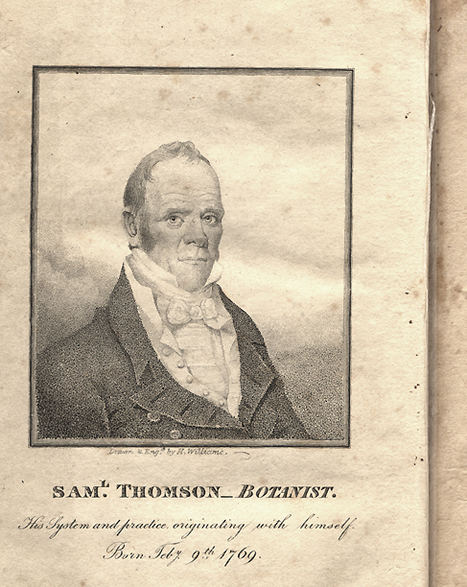
Source: https://www.nlm.nih.gov/hmd/sowhatsnew/images/1b1-a.jpg, accessed Nov 27, 2015.
Figure 2. Lobelia, the most important herb in Thomsonian medicine
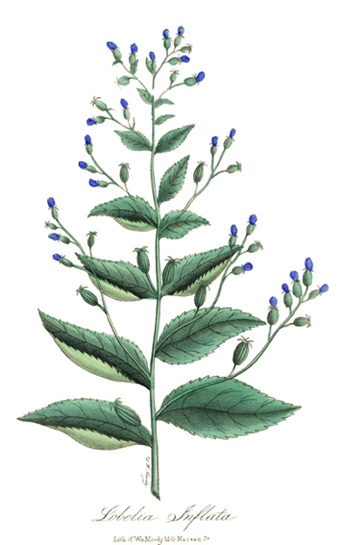
Source: http://www.lloydlibrary.org/Haller/hallerpoetrychtwo.html, accessed Nov 27, 2015.
Figure 3. Illustration depicting the difference between Traditional and Thomsonian healing
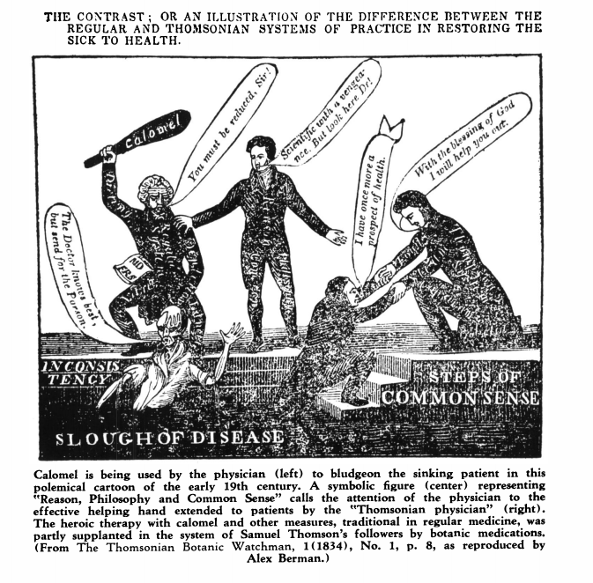
http://www.jstor.org.proxy.uwec.edu/stable/pdf/41108706.pdf, accessed Nov 27, 2015.

Figure 4. Advertisement in Daily Free Democrat, 1851- Milwaukee, WI
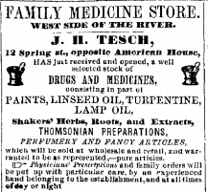
http://access.newspaperarchive.com.proxy.uwec.edu/Viewer/fullpagepdfviewer?img=33322803, accessed Nov 27, 2015.

Map 1. Illustration of the presence of Thomsonian Medicine
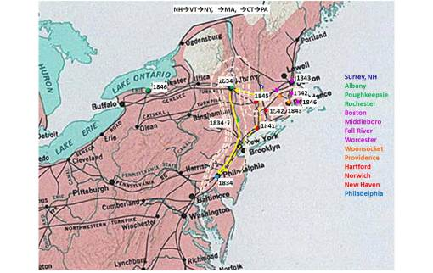
http://brianaltonenmph.com/6-history-of-medicine-and-pharmacy/hudson-valley-medical-history/early-thomsonianism/the-essentials-of-thomsonianism/thomsonianbotanical-medicine-professional-journals/, accessed November 27, 2015.

Glossary
Allopathy: The practice of traditional medicine.
Calomel: Considered medicine in the 1800’s until proven harmful. This was used to purge the system and clear out bacteria. It is a chemical that has mercury in it.
Canker Rash: A form of Scarlet Fever.
Cholera: Infection inside intestines. Causes diarrhea and is usually spread through water.
Dysentery: Ailment that entails infectious diarrhea. It is a bacterial infection inside intestines.
Homeopathy: The means of practicing medicine using natural resources, herbs and methods. Alternative medicine to traditional mainstream options.

Samuel Thomson. New Guide to Health, or, Botanic Family Physician: Containing a Complete System of Practice, Upon a Plan Entirely New; with a Description of the Vegetables Made Use of, and Directions for Preparing and Administering Them to Cure Disease; to Which is Prefixed A Narrative of the Life and Medical Discoveries of the Author. (Boston: E.G. House, 1822.) 13-16.
John Thomson, Historical Sketch of the Thomsonian System of the Practice of Medicine of the Botanical Principles as Originated by Samuel Thomson, and Continued by his Coadjutors. (Albany: B. D. Packard and Co, 1830.) 3-4.
Samuel Thomson, New Guide to Health, 13-16
Ibid, 28-29.
Haller Jr, John S., The People’s Doctors: Samuel Thomson and the American Botanical Movement, 1790-1860. Carbondale and Edwardsville: Southern Illinois University Press, 2000. 10-12.
Thomson, New Guide to Health, 38.
Ibid, 48.
Ibid, 54
Ibid, 59.
Thomson, New Guide to Health, 62-63.
Christopher Hoolihan, An Annotated Catalogue of the Edward C. Atwater Collection of American Popular Medicine and Health Reform. (Minnesota: Boydell & Brewer, University of Rochester Press. 2008.) 606-608.
John Thomson, Historical Sketch of the Thomsonian System, 21.
Charles E. Rosenberg, The Cholera Years: The United States in 1832, 1849, 1866. Chicago: University of Chicago Press, 1987. 70.
Joanne L. Birch, A Comparative Study of Nineteenth Century Pharnacopoeias in the Southern United States: A Case Study Based on the Gideon Lincecum Herbarium, Economic Botany 63, no 4. (December 2009):430.
John S. Haller, Jr., Samson of the Materia Mearca: Medical Theory and The Use and Abuse of Calomel in the Nineteenth Century America. Pharmacy in History 13. No. 2 (1971). 67-68.
James O. Breeden, Thomsonianism in Virginia. The Virginia Magazine of History and Biography 82, no 2. (April 1974) 158.
Toby A. Appel, Connecticut: A Case Study of the Repeal of Early Medical Licensing Laws,” Journal of the History of Medicine and Allied Sciences 65, no. 2 (April 2010): 158-169.
Virginia Smith, Clean: A History of Personal Hygiene and Purity. (New York: Oxford University Press. 2007.) 457.
Rosenberg, The Cholera Years. 70.
Susan Fillmore, Samuel Thomson and His Effect on the American Health Care System
Thomson, Historical Sketch of the Thomsonian System, 34.
Breeden, Thomsonianism in Virginia, 161.
John S. Haller Jr, The People’s Doctors, Samuel Thomson and the American Botanical Movement, 1790-1860. (Carbondale and Edwardsville: Southern Illinois University Press, 2000.) 3-5.
Joel Benton, A Dead Medical System
Rosenberg, The Cholera Years, 71.
Ibid, 70.
Michael A. Flannery, The Early Botanical Medical Movement as a Reflection of Life, Liberty, and Literacy in Jacksonian America. Journal of the Medical Library Association 90, no. 4. (October 2002): 445.
Emerson Davis, The Half Century; or, the History of Changes that have taken Place, and Events that have Transpired, Chiefly in the United States between 1800 and 1850. Boston: Tappan and Whittemore, 1857. 50-68.
Sophia Jex Blake, A Visit to Some American Schools and Colleges. London: Macmillan and Co, 1867.
Michael Flannery, A Brief Review of Therapeutic Contention in America 1790-1864, Pharmacy in History 41, no. 4 (1999): 155.
Glenna R. Schroeder-Lein, The Encyclopedia of Civil War Medicine, (New York: ME Sharp Inc. 2008.) 95.
Michael A. Flannery, Civil War Medicine: Approaches for Teaching, OAH Magazine of History 19, no. 5 (September 2005), 41.
Dale C. Smith, Military Medical History: The American Civil War, OAH Magazine of History 19, no. 5 (September 2005), 17.
Bonnie Ellen Blustein, To Increase the Efficiency of the Medical Department: A New Approach to U.S. Civil War Medicine, Civil War History 33, no. 1 (March 1987): 38.
Schroeder-Lein, Civil War Medicine, 7.
Blustein, Efficiency of the Medical Department, 23.
Ibid, 23-26.
Ibid, 33.
Smith, Military Medical History, 17.
Flannery, Trouble in Paradise, 161.

