FROM VICTIMS TO SURVIVORS:
HOLOCAUST SURIVORS’ ADAPTATION TO LIFE IN WISCONSIN

MONICA R. ROLBIECKI
HISTORY 489
PROFESSOR ROBERT GOUGH
FALL 2012

Copyright for this work is owned by the author. This digital version is published by McIntyre Library, University of Wisconsin Eau Claire with the consent of the author

“I cannot live in the past…I want to live in the future.”

-Rosa Katz (Holocaust survivor)

Abstract

This paper will explore the post World War II (WWII) adaptation experience of Holocaust survivors to life in Wisconsin. It will discuss how well they adapted as well as why; the focus will be on their work, the support they received and anti-Semitism they faced in Wisconsin. Another theme that will be expanded on is their unwillingness to discuss the experiences that had occurred during WWII, and whether this led to difficulties in adapting to life in Wisconsin or helped to make the process a positive one.

Holocaust survivor: For the purposes of this paper, the term Holocaust survivor refers to a person of Jewish heritage who lived in a country occupied by the Nazis during World War II and, no matter his/her circumstances, stayed alive.
TABLE OF CONTENTS
ABSTRACT iii
INTRODUCTION 1
PART ONE: COMING TO WISCONSIN 5
PART TWO: EXPERIENCING WISCONSIN 10
PART THREE: DISCUSSING WWII—“CONSPIRACY OF SILENCE” 16
CONCLUSION 21
APPENDICES 23
BIBLIOGRAPHY 32

INTRODUCTION:

The experience of Holocaust victims during World War II (WWII) has been a widely explored subject portrayed in both academic and popular outlets. The focus has largely been on the experiences of victims while they were either in concentration and labor camps or attempting to stay hidden throughout WWII; the most well-known account may be that of Anne Frank and her family. This author chose to focus on the experiences of Holocaust victims post WWII as they attempted to rebuild their lives in a place far from home.
After the liberation of concentration camps and the surrender to the western Allies by the Nazi military in Europe, those who had experienced persecution and had survived were faced with many difficult tasks, including accumulating shelter and finances, seeking medical attention, and searching for loved ones they had lost contact with during the time of persecution. Camps were set up throughout Europe by organizations such as the Red Cross in order to assist survivors in completing these tasks. Possibly one of the most difficult decisions these Holocaust victims, now survivors, had to make was where to rebuild their lives; they questioned whether to rebuild in Europe or seek refuge in a completely foreign place. Many chose to find a new home in either Israel or the United States.
Following the Nazi surrender in May of 1945, 140,000 Holocaust survivors immigrated to the United States between 1945 and 1954. Beth Cohen is one of several researchers who argue that these survivors led difficult lives for the first several years after arriving in the U.S. She argues that the image of the well-adjusted Holocaust survivor living in the United States in the years just following WWII is a lie; the evidence, according to Cohen, for this can be found in discussions and interviews with the survivors themselves. She claims that much of the difficulties faced by those survivors who had settled throughout the United States came from the stigma and shame associated with what they had experienced during WWII. This motivated the unwillingness of the survivors to discuss their experiences with others and the disinclination of the public to hear their stories; this is referred to as the “conspiracy of silence.”
The information on which Cohen basis her conclusions comes from evidence provided by Holocaust survivors through the use of storytelling and interviews; much of this research was conducted with those survivors who had settled on the East Coast. Cohen and other’s previous research done in this manner motivated the replication of this process through the use of interviews with Holocaust survivors who settled in Wisconsin in the years following WWII to make conclusions about their experiences. The goal of this research was to identify whether or not the survivors were able to positively adapt to life in Wisconsin, and to determine whether or not the “conspiracy of silence” was as prominent in Wisconsin as it had been on the East Coast.
About 1,000 Holocaust survivors eventually settled in Wisconsin. Nearly 500 of those settled in Milwaukee. The focus of this research has been narrowed to those survivors who settled in Wisconsin during the 1940s and 1950s. Those immigrants who preceded Holocaust survivors in settling in Wisconsin between the late 1880s and 1925 were most often families who sought work and retreat from the crowded conditions in New York City. Those survivors who settled in Wisconsin during the 1940s and 1950s tended to be younger and had faced persecution at a much more intense level in Europe than their predecessors. In order to examine their experience, transcripts of interviews done with twenty-two Holocaust survivors who settled in Wisconsin in the years following WWII were carefully reviewed; these oral interviews were conducted and transcribed by the Wisconsin Historical Society.
The words of these individual Holocaust survivors were used to make connections between them in order to make conclusions about their experience as a group in adapting to life in Wisconsin. Contrary to conclusions made about Holocaust survivors who settled in different parts of the United States, the adaptation experience of those Holocaust survivors who immigrated to Wisconsin in the years following the end of WWII was a positive one. This was due to their economic success in Wisconsin, the support they received from others, and the lack of anti-Semitism they faced in Wisconsin, as well as their ability to suppress their experiences during the war. Those survivors who settled in Wisconsin emulated the Jewish community’s long-standing reputation of strength in overcoming adversary.

Part One: Coming to Wisconsin

For many survivors of the Holocaust the decision of where to go post WWII was based largely on the goal of being able to reconnect with someone they knew and loved. This task was made difficult by the vast separation between friends and family caused by WWII; however, there were ways in which families and friends were able to reconnect. One such way was through radio announcements. This is how Pela Rosen Alpert (see appendix A), a Polish woman living in Holsbybrunn, Sweden after being liberated, was reunited with her family. Alpert described how her brother, living in Israel at the time, found out she was alive and living in a displacement camp in Sweden:
My brother in Israel was sitting at the radio that time and heard it—“Pela Rosen is looking for her brother in Israel and a sister.” And he almost passed out. He just, he never knew that I am alive or anybody. He didn’t know. We were not in contact anyone. So, my brother in Israel telegrammed my sister here in Green Bay, that I am alive and I am in Sweden.

Once her brother heard the announcement over the radio he contacted their sister and brother-in-law who lived in Green Bay, Wisconsin. They were then able to find and connect with Alpert through a family friend living in Sweden.
Others reconnected with relatives in the United States through the help of organizations. Harry Gordon (see appendix B) received help from one such committee while staying in a displaced persons camp in Germany after escaping a train leaving Dachau. Gordon described his interaction with a man who represented the Jewish Distribution Committee who came to the displaced persons camp, “…he investigated, he says, ‘Anybody having any relatives in the United States, I will try and find out for you.’ So I tried.” The man fulfilled his promise; Gordon received a letter from family living in the United States after they read in a newspaper that he had been looking for them. Newspaper ads, radio announcements, and letters were the primary ways in which Holocaust survivors were able to reconnect with lost loved ones.
Alpert and Gordon are two examples of those whose interest in immigrating to the United States stemmed from the fact that they had family that was already living there. Others like Flora van Brink Hony Bader (see appendix C) made the decision based on the personal desire to immigrate to the United States even without a familial connection. Bader described how she, her husband, and her best friend and friend’s husband came to the conclusion that they were going to move to the United States, “they were sure also that, having survived Auschwitz, they didn’t want to stay in Europe. We four, on Sunday afternoons would come together…We decided to go to America.” Bader’s friend and her husband eventually made the decision not to leave Europe; however, Bader, having promised her husband she would, immigrated to the United States where they had no family.
No matter their motivation, most of those Holocaust survivors who settled in Wisconsin did not come directly following the liberation and the end of WWII. Many spent years in Europe before immigrating to the United States, and then spent time in a different state before they finally settled in Wisconsin. Much of the time spent in Europe before immigrating to the United States occurred because they were awaiting immigration papers to be approved.
Saul Sorrin, an American administrator in a German displacement camp between 1945 and 1950, discussed the difficulties that stood in the way of Holocaust survivors as they tried to immigrate to the U.S.:
The United States and most of the western countries — Canada, England — were dreadfully, terribly, unenthusiastic about the potential of the Jews to come to their countries… these people who had survived the most terrible of all experiences were told "I'm sorry, we don't want you," you know?

In his interview Sorrin described the tactics he, the survivors, and other workers in displacement camps used to aid survivors in successfully receiving papers and sponsorship for those who wished to emmigrate to the U.S. and other countries; he describes falsifying dates, names, and countries of origin to help survivors circumvent quotas and other restrictions imposed by the United States.
Once they had circumvented the difficulties faced during the immigration process and had arrived in the United States, many of those interviewed discussed how they spent some time in another state before they settled in Wisconsin. Reasons for this varied; the most cited reasons were economic or a connection to people in another state. When they eventually moved to Wisconsin individuals cited the same two reasons or a combination of the two as the primary reason for doing so.
When asked about his family’s decision to move to Wisconsin, Mendel (Manny) Chulew (see appendix D) cites economic reasons for the decision:
We preferred to stay in New York, but it was very difficult to find good jobs and to get a good apartment. In Kenosha we had an opportunity to open up a business… Charlie [Chulew’s uncle], who lived in Kenosha, offered us an empty store to start some kind of a business. So we took him up on the offer and we came here.

Although he did have family in Wisconsin, Chulew cites the economic reason for his move to Wisconsin; he was already living with family in New York City. Unlike Chulew, Salvator Moshe (see appendix E) settled in Wisconsin directly after he immigrated to the United States; however, his reason for doing so was also economic, “my destination was to, here…Milwaukee, because I declare I know from shoes, and a lot of shoe factories in Milwaukee, and they send me direct to Milwaukee.” Moshe had no family to reconnect with in Milwaukee, Wisconsin. Pela Rosa Alpert, mentioned previously in this paper, was one who settled in Wisconsin in order to reconnect with her family; she said that her motivation to settle in Wisconsin was that she was “kinda lonely for family.” Work and family played a dynamic role in Holocaust survivors’ decisions to settle in Wisconsin; these two features would also play a vital role in their experience adapting to life in Wisconsin.

Part Two: Experiencing Wisconsin

Whatever their path had been getting to Wisconsin, once they had arrived each survivor faced the challenge of creating a new life in the Midwest. They had to establish a career and build a social life in a new environment. Each experience was unique; however, there were common themes that allowed for their adaptation experience in Wisconsin, as a group, to be a positive one. These themes included their work, the support they received, and the anti-Semitic behavior they were exposed to.
As discussed in part one, work was a motivation for many survivors to settle in Wisconsin. It was also a large part of what made their adaptation to Wisconsin a positive experience. This positive experience can be seen within the experiences of both those who settled in Wisconsin specifically for work and for those who did not.
Flora Bader’s work experience depicts how those who settled in Wisconsin for reasons other than work were able to find good work in a supportive environment. Bader described her experience working at Gimbels in Milwaukee, “I had very lovely conditions to work in…it was a marvelous time…I was complimented on my capacity to sell, I was having raise after raise after raise.” Bader’s husband at the time also worked for the department store; both were offered management positions. Bader expressed great pride in the fact that years after she had quit, the store was still referring to her as the Dutch woman who barely spoke English but was “the best saleswoman they had in stationery.”
Manny Chulew is one survivor who settled in Wisconsin specifically for work and saw great success in his career. Chulew and his father opened their own store selling furniture within a month after they had arrived in Kenosha, Wisconsin. Chulew described how his family found success in their business, eventually buying out a larger store; he went on to describe how his family developed a good reputation within the community, and had several repeat customers and customers who would come to their store based on its reputation. After only six months in Kenosha others expressed to the Chulew family how impressed they were with the family’s business success.
Rosa Katz (see appendix F) discussed how, after the plywood factory her husband worked for in North Carolina burned down, her family moved to Wisconsin. The owner of the factory that had burnt down was kind enough to offer her husband a job at another factory in Oshkosh. Katz went on to discuss her husband’s satisfaction with the job, and that he was still working as a supervisor at the factory at the time of her interview. She described how his job provided her with happiness as well; it allowed her to shop for the things she wanted as well as provided her with the social network of factory wives with which she surrounded herself.
Work was not the only contributing factor to their positive adaptation to life in Wisconsin; the acceptance of those around them, and the social circles they were able to build also played a large role in their positive experiences in Wisconsin. Many of those survivors who settled in larger Wisconsin cities, particularly Milwaukee, were offered the help or guidance of Jewish organizations in order to make their adaption easier. Salvator Moshe was aided in finding jobs by these organizations, and Flora Bader discussed the willingness of the Jewish Family Services in Milwaukee to help her family when they had first settled in Wisconsin. They offered them advice, networking, and financial support; Bader stated that they had “tried everything in their power to make us at ease here.”
Those in smaller towns also discussed a supportive environment from both their neighbors and the Jewish community within those towns. Lucy Baras (see appendix G) told interviewers that six months after her family had settled in Sheboygan, Wisconsin, “a nice Jewish family” gave them an apartment to live in free of charge, and that other members of the Jewish community gave them furniture to help make their apartment more like a home. Pela Alpert discussed how, although she did not receive help from any Jewish organizations when she settled in Green Bay, Wisconsin, she interacted with “a lot of supportive people;” she described how her Polish heritage and language led to understanding and support from the Polish community in Green Bay. She reflected on “the warmth and love and kindness” she received when she first settled in Wisconsin.
Often times their success in their work and the support they received from others intertwined; Bader, Chulew, and Katz (along with many other survivors) described how they met many of those who supported them through the work environment. Others described how those who supported them assisted the survivors in finding work. The support they received from organizations and individuals often led to the formation of social networks. For many the social networks led to the development of friendships and other relationships; many were able to find love within these social networks.
Another important part of the survivors’ adaptation to life in Wisconsin was their exposure to anti-Semitism. With the exception of those who settled in Milwaukee, anti-Semitism did not appear to be something that Holocaust survivors were often exposed to in Wisconsin. When asked about whether or not they had witnessed or been the target of any anti-Semitic behavior during their first years in Wisconsin Baras, Chulew, Katz, and Alpert, along with many others described few to absolutely no issues involving anti-Semitism.
Of those survivors who did witness or fall victim to some form of anti-Semitic behavior in the town they settled in, the vast majority of them lived in Milwaukee; Salvator Moshe discussed that he faced anti-Semitism in the work environment, particularly around holidays. It is important to note that although Milwaukee was the city cited with the most anti-Semitic behavior, not all of those survivors who settled there, such as Bader and Golde, reported anti-Semitic behavior directed at them personally.
The reason anti-Semitic behavior was rarely experienced by survivors was due to changing attitudes in Wisconsin. One such change was the amount of emphasis being placed on an individual’s ethnicity. By the time they had arrived in Wisconsin, communities had become less segregated on the basis of ethnicity; neighborhoods, schools, and social organizations had begun becoming more integrated. Less attention was being placed on people’s origins and more on the fact that were now members of a Wisconsin community. The Wisconsin government also played a strong role in decreasing discrimination against Jews during the 1940s.
Governor Walter Goodland sought to eliminate anti-Semitic attitudes and behavior through both educational and legal means. In 1944, Goodland prompted the revocation of the Gentile League (a small organization chartered by the Wisconsin government) through circuit courts due to their anti-Semitic goals of denying Jewish citizens their rights. He also initiated the Governor’s Commission on Human Rights in 1945; this Commission sought “the elimination of all discriminatory practices.” Goodland hoped this program would educate Wisconsinites “to a greater understanding, appreciation and practice of tolerance” through the dissemination of information and other forms of education on different religions, races, and ethnicities.

Part Three: “Conspiracy of Silence”:

The “conspiracy of silence” that was discussed in the introduction was another prominent theme in the experiences of those survivors who settled in Wisconsin. During their first ten years in the United States the survivors did not discuss what they had experienced during WWII. Their tendency to avoid discussing their pasts can be seen throughout their interviews with the Wisconsin Historical Society; unless specifically asked to comment about the experiences they had during WWII, the survivors did not mention them when they discussed life in Wisconsin. Many of the survivors stated that they had even hesitated before they agreed to participate in the interviews with the Wisconsin Historical Society because discussing life during WWII was difficult for them.
When they were directly asked about the extent to which they had discussed their Holocaust experiences once they had arrived in Wisconsin, the vast majority of those interviewed told interviewers that they simply did not discuss it. When asked why she did not discuss her Holocaust experience with anyone, even her children, Rosa Katz explained, “You know, talking about it brings out all the horrible memories, although you always think about it, it’s inside of you. How can you forget that? By talking and bringing it out I think it hurts even more you.” The other survivors interviewed presented similar explanations for why they had avoided discussing their experiences during WWII; they said that it hurt too much to speak out loud about their experiences, or that they did not want others to have to know the horrors that they had seen.
It was not until after their first decade or two after living in Wisconsin that some of the survivors began to speak publically about what they had experienced during WWII. Publically speaking about their experiences became more common as more information about what had happened in Europe during WWII became more widely known. Throughout the l950s, as information was being published and made available to the public about what European Jews had experienced during WWII, the phrase “The Holocaust” became more widely published. The phrase was solidified in the English language, to represent the Nazis’ persecution of Jews, during 1978 with the release of the movie Holocaust and President Carter’s use of the phrase. The increasing popularity of the subject, and people’s desire to learn about it provided outlets, such as schools, television programs, and religious centers, for survivors to share their stories.
Walter Peltz (see appendix H) was one who began to speak to large audiences about what he had experienced during his life in Europe. For over three decades Peltz took the time to discuss his experiences with anyone who would listen; when asked, Peltz told interviewers that the reason he had chosen to speak to the public was “to make the people aware.” Henry Golde (see appendix I) and Harry Gordon are two more examples of survivors that spoke very publically about their Holocaust experiences only after they had settled in Wisconsin for a couple of decades. For other survivors, such as Pela Alpert, the interviews with the Wisconsin Historical Society were the very first time they had publically discussed what they had experienced during WWII.
As discussed in the introduction, this inability or unwillingness of survivors to discuss their experiences during WWII when they first immigrated to the United States has been viewed by several researchers as a contributing factor to the negative experiences of survivors adapting to life in the United States. However, from analyzing the interviews done with those survivors who had settled in Wisconsin, the “conspiracy of silence” present in Wisconsin may have actually been a contributing factor to their successful, positive adaptation to life in Wisconsin.
As documented by Stein, the concept of post-traumatic stress was not emphasized, and often went untreated during the years shortly following WWII. Many, like Cohen, argue that the stigma affiliated with mental health issues during this time and feelings of shame about what they had experienced caused Holocaust survivors to remain silent. They argue that this is the primary reason for difficulties in adapting to life in the United States. They have provided several examples of Holocaust survivors who lived on the East Coast who expressed this shame. Stein provides Irene Hizme’s, a Holocaust survivor who settled in New York City, feelings of shame, “I was so totally ashamed…I certainly didn’t want anybody to know that I was in a concentration camp. I mean that was like, my God, I would sooner die than have someone know.” Another survivor who expressed feelings of shame to Stein was Eva Edmands; Edmands described how Nazi propaganda had convinced even her that she was scum, “you’re being told, you know, over these years, you’re scum, you’re scum, you wind up believing. I said, well maybe I am inferior; maybe I’m not good as anybody else.” Her own belief that she was scum and shame about who she was led Edmands to hide the fact that she had survived the Holocaust when she immigrated to the United States.
Although this argument may be applied to those survivors studied in other research, like Hizme and Edmands, this author believes that those survivors who had settled in Wisconsin remained silent in order to cope with what they had experienced rather than the fear of being stigmatized or feelings of shame. Other research has been done that documents this as a possibility; as cited in Stein, Simic’s writing refers to the idea that in order for some individual victims of trauma, putting up a mental barrier in order to divide their current lives from the past helps them move on from their experiences. This is what those survivors who settled in Wisconsin attempted to do; talking about what they had experienced during WWII would have caused them too much pain, and made it more difficult for them to concentrate on building a life in Wisconsin.
This conclusion about those survivors who settled in Wisconsin comes from the fact that the survivors interviewed did not express the fear of being stigmatized by the public or feelings of shame. Throughout their interviews they discussed the acceptance they felt by the communities they settled in and the social networks they established once they were there. They were open when asked about why they kept their pasts secret; the explanations they provided revolved around the hurt it would cause them and others. Their willingness to begin to discuss their pasts after they had lived in Wisconsin for several years revealed that rather than feeling their experiences were shameful ones, they thought their experiences were important and needed to be told.

CONCLUSION:

Although the use of the experiences of 22 Holocaust survivors to make conclusions about the group as a whole may seem disproportionate to the number of those who had settled in post-World War II Wisconsin, the diverse group of those who make up The Wisconsin Survivors of the Holocaust: A Documentation Project provide great insight into the experiences of the larger group as a whole. The commonalities among this group of diverse interviewees’ experiences lead to the conclusion that the Holocaust survivor’s adaptation to life in Wisconsin was a positive experience. Not all twenty-two interviews were quoted or used to present examples in this paper; however, those that were used were representative of the group as a whole. As with most conclusions, there are exceptions to these statements; however, survivors’ success in their work, the support they received from others, and the minimal anti-Semitism they were exposed to were largely what created that positive experience.
Although, the “conspiracy of silence” was a prominent factor in the vast majority of their lives, the choice not to discuss what they had experienced during WWII was part of what allowed these Holocaust survivors to move forward and create new lives in Wisconsin. Those survivors who had settled in Wisconsin emulated the long recognized reputation of the Jewish community to be able to overcome discrimination. The success and happiness they were able to achieve after they had experienced persecution to such a great extent truly revealed the power of human resilience.
The conclusions of this research stand out because they have been made about survivors in a region not typically highlighted when discussing the adaptation experience of Holocaust survivors who immigrated to post WWII United States. Further comparative research could be done on those survivors who settled in Wisconsin and those who chose to settle in other Midwestern states. The large number of survivors who settled in Milwaukee may also motivate a comparative study between the experiences of those who settled in Milwaukee and other large Midwest metropolis cities such as Minneapolis or Chicago. As time passes comparative histories and other primary research based on oral interviews and storytelling will continue to become more difficult because of the declining number of Holocaust survivors still alive to tell their stories. Any further research done specifically on Wisconsin’s Holocaust survivors, and the survivors as a whole, should be conducted in a timely manner in order to preserve the words of the people themselves. It is important to remember that it takes a large amount of time and patience in order to accumulate the vast wealth of information that Holocaust survivors can provide. Henry Golde emulates this thought best in his closing words to interviewers, “I could sit with you here for a month and talk about it and still wouldn't tell you my whole story.”

Appendix A: Pela Rosen Alpert
Pela Rosen Alpert was born in Dobrzyn, Poland in 1920. During the 1930s Alpert’s sister and brother-in-law, Rose and Jacob Fogel, attempted to convince Alpert’s father to leave Poland before the outbreak of WWII. Alpert’s father refused to move his family, and the Fogel’s moved to Green Bay, Wisconsin on their own. Alpert’s family originally fled to Warsaw with the outbreak of WWII; eventually Alpert’s father convinced her to escape the Ghetto by crawling through a hole in a wall. Alpert was eventually captured and sent to work in a munitions factory; she was then transported to a labor camp and then the concentration camp at Ravensbruck, Germany. She was liberated by the Swedish Red Cross from the camp in April 1945. She then spent four years in Sweden before immigrating to Green Bay, Wisconsin in 1949. Alpert’s daughter initiated The Wisconsin Survivors of the Holocaust: A Documentation Project by asking for her mother’s story to be documented.
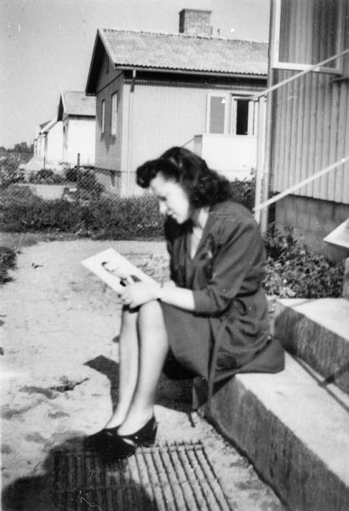
Oral Histories: Wisconsin Survivors of the Holocaust.” Wisconsin Historical Society, 1983. http:www.wisconsinhistory.org/holocaustsurvivors.
Appendix A image 1:
Pela Rosen Alpert

Oral Histories: Wisconsin Survivors of the Holocaust.” Wisconsin Historical Society, 1983. http:www.wisconsinhistory.org/holocaustsurvivors.

Appendix B: Harry Gordon
Harry Gordon was born in 1925 in Lithuania. Gordon spent his late teen years in a ghetto and labor camps before he was sent to Dachau. In 1945, a year after he had arrived at Dachau, Himmler ordered that all of the remaining prisoners of the concentration camp be brought to the German Alps to be executed; Gordon and his uncle escaped the train while it was on its way to their execution. They were hid in a barn until they got word that American troops were close enough to walk to. Gordon weighed 50 pounds when he reached American troops. He received medical attention and rehabilitated in at a displacement camp in Germany where he met and married his wife as well as got in contact with family in the United States. After he waited four years for a visa, Gordon and his wife immigrated to the United States in 1949; they lived in Pennsylvania and New York City before settling in Madison, Wisconsin in 1951. In 1992 Gordan wrote a book about his experiences in Lithuania during WWII: The Shadow of Death: The Holocaust in Lithuania.
Oral Histories: Wisconsin Survivors of the Holocaust.” Wisconsin Historical Society, 1983. http:www.wisconsinhistory.org/holocaustsurvivors.

Appendix C: Flora van Brink Hony Bader
Flora van Brink Hony Bader (nee Melkman) was born in 1919 in Amsterdam, Holland. When she was twenty-four, Bader went into hiding in a Dutch home. Throughout WWII Bader was able to remain hidden by moving from home to home. After the Allied liberation in 1945 Bader moved back Amsterdam where she married her second husband and had a child. The family immigrated to the United States in 1954; they had already planned to settle in Milwaukee, Wisconsin. Bader had her doubts about living in the United States; these doubts did not cease once she settled in Wisconsin. There were several times when she intended to move back to Holland, but she never did. Bader’s second husband passed away in 1967; she once again remarried.
Oral Histories: Wisconsin Survivors of the Holocaust.” Wisconsin Historical Society, 1983. http:www.wisconsinhistory.org/holocaustsurvivors.
Appendix C image 1: Flora van Brink Hony Bader

Oral Histories: Wisconsin Survivors of the Holocaust.” Wisconsin Historical Society, 1983. http:www.wisconsinhistory.org/holocaustsurvivors.

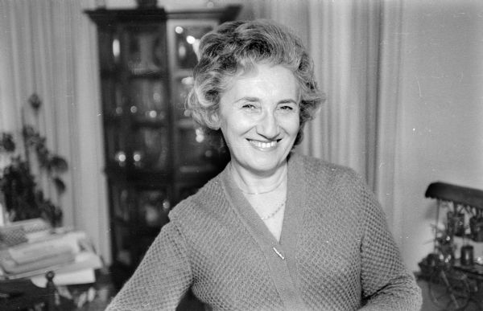
Appendix D: Mendel (Manny) Chulew
Manny Chulew was born in Poland during 1924. Manny’s family fled from persecution by moving to Russia; there they were put to work in a Siberian camp. After Germany had attacked Russia the Chulew family fled to Kazakhstan. After the death of his mother, Manny’s family made their way to a displacement camp; the family spent years in different camps before immigrating to New York City in 1951. In 1952 Manny’s uncle was able to convince the family to move to Kenosha, Wisconsin, where he could offer them the opportunity to start their own business.
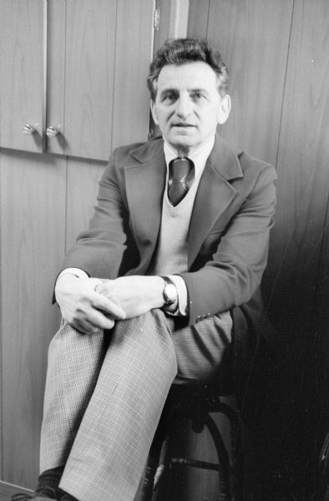
Oral Histories: Wisconsin Survivors of the Holocaust.” Wisconsin Historical Society, 1983. http:www.wisconsinhistory.org/holocaustsurvivors.
Appendix D image 2:
Manny Culew

Oral Histories: Wisconsin Survivors of the Holocaust.” Wisconsin Historical Society, 1983. http:www.wisconsinhistory.org/holocaustsurvivors.

Appendix E: Salvator Moshe
Salvator Moshe was born in Greece during 1915. During WWII Moshe and his brother-in-law spent time working in the Warsaw Ghetto, Dachau, and a forced labor camp in Germany. While en route to a massive extermination by the Germans, Moshe and other victims were liberated by the U.S. Army. After spending time in a displacement camp Moshe immigrated to the United States in 1949. He was sent to Milwaukee, WI to work in a tannery due to his previous experience working with shoes.
Oral Histories: Wisconsin Survivors of the Holocaust.” Wisconsin Historical Society, 1983. http:www.wisconsinhistory.org/holocaustsurvivors.
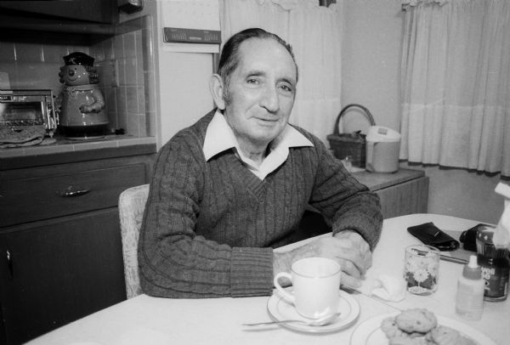
Appendix E image 1: Salvator Moshe

Oral Histories: Wisconsin Survivors of the Holocaust.” Wisconsin Historical Society, 1983. http:www.wisconsinhistory.org/holocaustsurvivors.

Appendix F: Rosa (Rachel) Goldberg Katz
Rosa (Rachel) Goldberg Katz, born 1924 in Poland, spent the beginning of WWII in a Polish ghetto. From there her mother was deported, and in 1944 Rosa, her father, brother, and sister-in-law were sent to Auschwitz. After they arrived at Auschwitz the family was separated, and Rosa never saw or spoke to her father or brother again. Rosa was then sent to work in a munitions factory in Berlin for several months; from there she was sent to the extermination camp in Ravensbruck, Germany. There she was liberated by the Swedish Red Cross, and in 1948 she and her husband immigrated to the United States. They spent their first five years in the United States living in North Carolina, and in 1953 they moved to Oshkosh, Wisconsin.
Oral Histories: Wisconsin Survivors of the Holocaust.” Wisconsin Historical Society, 1983. http:www.wisconsinhistory.org/holocaustsurvivors.
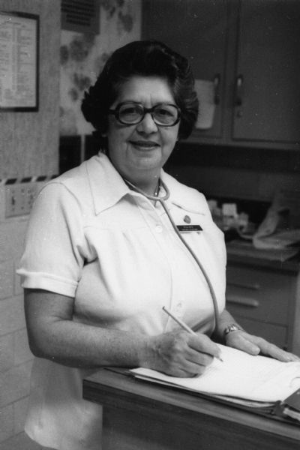
Appendix F image 1:
Rosa (Rachel) Goldberg Katz

Oral Histories: Wisconsin Survivors of the Holocaust.” Wisconsin Historical Society, 1983. http:www.wisconsinhistory.org/holocaustsurvivors.

Appendix G: Lucy Rothstein Baras
Lucy Baras was born in Poland during 1913. Baras’ father was killed when Nazi’s invaded her home town in 1941. After her father’s death the Baras family went to work making shoes for the Jewish prisoners in concentration camps. Baras was eventually transferred to a labor camp, and in 1943 she escaped and stayed hidden in the woods until liberated by the Russians. Baras married a man she had met at the labor camp; their family immigrated to the United States in 1950. They then joined Baras’ husband’s brother and sister in Sheboygan.
Oral Histories: Wisconsin Survivors of the Holocaust.” Wisconsin Historical Society, 1983. http:www.wisconsinhistory.org/holocaustsurvivors.
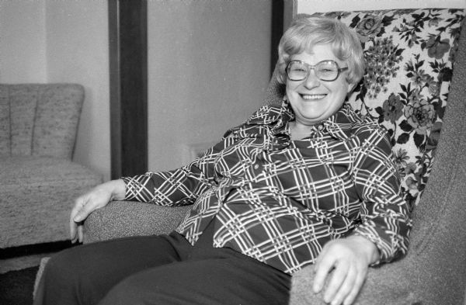
Appendix G image 1:
Lucy Baras

Oral Histories: Wisconsin Survivors of the Holocaust.” Wisconsin Historical Society, 1983. http:www.wisconsinhistory.org/holocaustsurvivors.

Appendix H: Walter Wolf Peltz
Walter Wolf Peltz was born in Warsaw, Poland during 1919. Walter fled Warsaw at the beginning of WWII and was hidden by a family for over a year; he was eventually discovered, and those families that had aided him were punished severely by the German military. After he was found and arrested he spent time at four different concentration camps including Auschwitz and Dachau. After liberation in 1945 Peltz married another survivor of Dachau; their family left Germany and settled in Milwaukee, WI in 1949. Peltz gave lectures on his experiences for over 30 years. When asked by interviewers from the Wisconsin Historical Society about some of the things Peltz had done in Europe during WWII he declined to answer based on the fact that interview was being recorded.
Oral Histories: Wisconsin Survivors of the Holocaust.” Wisconsin Historical Society, 1983. http:www.wisconsinhistory.org/holocaustsurvivors.
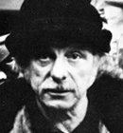
Appendix H image 1: Walter Wolf Peltz
Oral Histories: Wisconsin Survivors of the Holocaust.” Wisconsin Historical Society, 1983. http:www.wisconsinhistory.org/holocaustsurvivors.

Appendix I: Henry Golde
Henry Golde was born during 1929 in Poland. Golde spent the first two years after Germany occupied Poland in Jewish ghettos. He was then sent to work in a munitions factory; the rest of Golde’s family was sent to the gas chambers at Treblinka extermination camp. Throughout the rest of WWII Golde was transferred to work in different labor camps and factories. He was liberated by the Russian army in 1945. In 1952 Golde and his wife immigrated to the United States; they lived in several other states before they settled in Milwaukee, WI in 1954.
Oral Histories: Wisconsin Survivors of the Holocaust.” Wisconsin Historical Society, 1983. http:www.wisconsinhistory.org/holocaustsurvivors.
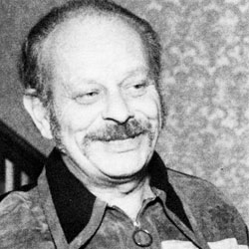
Appendix I image 1: Henry Golde

Oral Histories: Wisconsin Survivors of the Holocaust.” Wisconsin Historical Society, 1983. http:www.wisconsinhistory.org/holocaustsurvivors.

Bibliography
Primary Sources:
Oral Histories: Wisconsin Survivors of the Holocaust.” Wisconsin Historical Society, 1983. http:www.wisconsinhistory.org/holocaustsurvivors.
This collection is the basis for this author’s research. It provides recordings and transcripts of oral interviews conducted with Holocaust survivors who settled in Wisconsin post WWII. The interviews were recorded between 1974 and 1981; the collection also includes a vast number of photos provided by the survivors and their families. The recordings and transcripts of interviews, as well as a limited amount of photographs have been made available online. More photographs and further information can be found by contacting the Wisconsin Historical Society.

Secondary Sources:
Cohen, Beth. Case Closed: Holocaust Survivors in Postwar America. New Brunswick, NJ: Rutgers University Press, 2007.
This book was used to provide background knowledge about Holocaust survivors’ experiences in the United States as a whole. Cohen provided the basis to compare other Holocaust survivors’ experience with remaining silent to those that settled in Wisconsin.
“Frequently Asked Questions: What is the origin of the word ‘Holocaust.’” United States Holocaust Memorial Museum. http://www.ushmm.org/research/library/faq/details.php?topic=01#02 (accessed December 14, 2012).
This website provided history on the term ‘holocaust,’ and how it came to describe the persecution of European Jews during World War II.
Industrial Commission of Wisconsin, and Wisconsin. The Wisconsin Blue Book. Madison, Wisconsin: Industrial Commission, 1950.
Used for information on the Governor’s Commission on Human Rights of 1945.

Leuchter, Sara, and Jean Loeb Lettofsky. Guide to Wisconsin Survivors of the Holocaust: A Documentation Project of the Wisconsin. Jewish Archives, Madison: State Historical Society of Wisconsin, 1983.
This document aided the author in better understanding the collection of interviews used as the primary source for this paper. It provided background information on The Wisconsin Survivors of the Holocaust: A Documentation Project itself including the formation of and the intention of the collection. It also provided biographical information about the interviewees.
Simic, Charles. Conspiracy of Silence. New York: New York Review of Books, 2003. Cited in Stein, Arlene. ““As Far as They Knew I Came from France”: Stigma, Passing, and Speaking about the Holocaust.” Symbolic Interaction. 32, no. 1(Winter 2009): 44-60
Charles Simic examines reasons why victims of trauma may keep silent about those experiences. This author applied these reasons to the Holocaust survivor who settled in Wisconsin
Stein, Arlene. “’As Far as They Knew I Came from France’: Stigma, Passing, and Speaking about the Holocaust.” Symbolic Interaction 32, no. 1(Winter 2009): 44-60
Stein presents the idea that the lack of discussion about Holocaust survivors’ experiences during WWII could be considered a coping method, but she emphasizes the idea that this lack of discussion led to difficulties for survivors trying to adapt to life in a new place. Stein provided the author of this paper with the basis for a comparison of those Holocaust survivors who settled in Wisconsin to survivors who settled in other parts of the United States post WWII.
Thompson, William Fletcher. The History of Wisconsin: Continuity and Change 1940-1965. Vol. 6. Madison: State Historical Society of Wisconsin, 1973.
Provided information on what was happening in Wisconsin as World War II ended, particularly on segregation of ethnic groups within communities and anti-Semitic attitudes.

Traxler, Ruth. The Golden Land: 150 Years of Jewish Life in Milwaukee. Milwaukee, WI: Sesquicentennial Celebration, 1994.
This source provided background information on the Jewish Community in Milwaukee, WI. The author sought information about the Jewish community in this particular city because it is where the largest number of Holocaust survivors who settled in Wisconsin chose to live. The survivors who settled in Milwaukee had slightly different experiences than those that settled in other Wisconsin cities, denoting further attention to this area.

Beth Cohen, Case Closed: Holocaust Survivors in Postwar America (New Brunswick, NJ: Rutgers University Press, 2007), 1.
Cohen, Case Closed.
Arlene Stein, “‘As Far as They Knew I Came from France’: Stigma, Passing, and Speaking about the Holocaust,” Symbolic Interaction 32, no. 1(Winter 2009): 45-47.
Arlene Stein, “’As Far as They Knew I Came from France,’” 47.
“Oral Histories: Wisconsin Survivors of the Holocaust,” Wisconsin Historical Society, 1983, http:www.wisconsinhistory.org/holocaustsurvivors.
Ruth Traxler, The Golden Land: 150 Years of Jewish Life in Milwaukee (Milwaukee, WI: Sesquicentennial Celebration, 1994), 6-11.
Pela Alpert, “Oral Histories,” 17.
Pela Alpert, “Oral Histories,” 17.
After WWII the Jewish Distribution Committee worked to serve those who had survived the Holocaust in several ways including rehabilitation programs and assisting those attempting to immigrate to the United States and Israel. It was also known as “the Joint.” The organization is still active today in assisting the Jewish community. For more information visit http://archives.jdc.org/our-story/?s=archivestopnav
Harry Gordon, “Oral Histories,” 66.
Harry Gordon, “Oral Histories,” 66.
Flora Bader , “Oral Histories,” 112.
Flora Bader , “Oral Histories,” 112-113.
Saul Sorrin, “Oral Histories,” 16-17.
Saul Sorrin, “Oral Histories.”
Manny Chulew, “Oral Histories,” 57.
Salvator Moshe interview, “Oral Histories,” 79.
Pela Alpert, “Oral Histories,” 24.
Gimbel Brothers department store; for more on Gimbel Brothers of Milwaukee contact the Milwaukee County Historical Society.
Flora Bader , “Oral Histories,” 117.
Flora Bader, “Oral Histories,”, 118.
Manny Chulew, “Oral Histories,” 58-61. The family store was originally named Chulew Furniture, but changed to Barr Furniture in 1960 with the purchase of the larger store.
Rosa Katz, “Oral Histories,” 95-101.
Salvator Moshe, “Oral Histories,” 85. Moshe was aided by the Jewish Vocational Services
Flora Bader, “Oral Histories,” 121.
Lucy Baras, “Oral Histories,” 104.
Pela Alpert, “Oral Histories,” 32-33.
Salvator Moshe, “Oral Histories,” 91.
William Fletcher Thompson, The History of Wisconsin: Continuity and Change 1940-1965, Vol. 6. (Madison: State Historical Society of Wisconsin, 1973), 55-56, 327-328.
Industrial Commission of Wisconsin, and Wisconsin, The Wisconsin Blue Book (Madison, Wisconsin: Industrial Commission, 1950), 302-305.
Rosa Katz, “Oral Histories,” 114.
“Frequently Asked Questions: What is the origin of the word ‘Holocaust,’” United States Holocaust Memorial Museum, http://www.ushmm.org/research/library/faq/details.php?topic=01#02 (accessed December 14, 2012).
Walter Peltz, “Oral Histories,” 100.
Pela Alpert, “Oral Histories,” 38.
Arlene Stein, “’As Far as They Knew I Came from France,’” 54.
Arlene Stein, “’As Far as They Knew I Came from France,’” 53.
Arlene Stein, “’As Far as They Knew I Came from France,’” 53.
Charles Simic, Conspiracy of Silence ( New York: New York Review of Books, 2003), 8-10, Cited in Arlene Stein, “’As Far as They Knew I Came from France’: Stigma, Passing, and Speaking about the Holocaust,” Symbolic Interaction. 32, no. 1(Winter 2009): 44-60.
Henry Golde, “Oral Histories,” 107.

