Taylor Wyman
The Portrayal of Constantine in Art and Architecture

Taylor Wyman graduated from University of Wisconsin-Milwaukee in May 2013. She earned a Bachelor of Arts in History and Religious Studies. In her undergraduate career she served as President of the Middle East and North African Studies Student Association and President of the Religious Studies Student Organization. In the summer of 2013 she completed a Latin Reading Graduate Course at Marquette University and she plans to continue studying Latin. She enjoys nature, music, history, art, architecture, writing, reading, and learning. In her future, she hopes to travel, continue on to graduate school, and eventually teach.

Constantine was the first Christian ruler of the Roman Empire. Throughout his reign, numerous depictions of his likeness were made. These served not only aesthetic purposes but also conveyed certain ideas to the inhabitants of the empire. In the same fashion as other Roman emperors, Constantine utilized art as propaganda. It was a means of conveying particular messages to the public about his rule and the way he hoped to be perceived. Insight can be gained by analysis of various mediums of art, such as coins and monuments, as well as Constantine's treatment and creation of these depictions. From these, one can conclude that Constantine utilized art as a means of expressing his power and his proximity to divinity by a display of Christian emblems.
Constantine began his reign as part of the tetrarchy, or four-person rule that was established during a time a crisis. There were noticeable attributes of his portraiture that characterized the overriding tetrarchic model of imperial portraiture. (See Figures 1 and 2.) There was a unified style that sought to convey the principles the tetrarchy strived to maintain. This style reflected the turbulent time of the tetrarchy, when control and stability were pertinent to ruling. The elements that were evident in tetrarchic and early Constantinian portraiture were the angular features, a kind of 'geometricized' form, thick neck and furrowed brow. L. Breglia explained it well when she stated that the "arched eyebrow, half-closed eyelid and turned lips heighten the impression of penetrating scrutiny", very appropriate for the tetrarchic times. When Constantine was elevated in power to Augustus he also gained control over his portraiture. It is at this time that we discern a break in the tetrarchic style. (See Figures 2 and 3.) For Constantine, demonstrating his control over his portraiture could be interpreted as a means of conveying his new political control. He did this by breaking away from the tetrarchic model in style as well as in action, through the abolition of the tetrarchy. This is significant as it reflects his political ambitions to rule as a sole Emperor. There was less concentration on a specific deed or historical event as there was on elevating the role of the emperor through depictions on coins. For instance, in the later years Constantine is depicted with magnificent robes and an insignia. This linked him to the Senate and the ancient source of government. Though the Senate had lost much of their power by this time, Constantine was appropriating what sentiment remained of the respect of the Senate towards his own rule. Furthermore, the Senate still formally legitimized rulers. As such, it was important to Constantine that he showed himself as part of that tradition. Constantine's new style evoked such great predecessors as Trajan and Augustus. Since Trajan, he was the first mature emperor to be represented as beardless. His portraiture began to take on other qualities. These were a classicizing hairstyle, idealization of facial features, large eyes and in time an upward gaze that conveyed an element of spirituality about him. He was conveyed in a way to evoke "serenity, calm[ness], tranquility, and personal illumination". (Figures 4 and 5.)
The Arch of Constantine was built to commemorate Constantine's victory over Maxentius at the Battle of the Milvian Bridge. (Figure 6.) Consequently, he acquired control of the Western Empire. Significantly, Constantine utilized this monument as a means of legitimizing his rule, as he had essentially usurped power through civil war and dismantled the tetrarchy. He had claimed to liberate the country from a tyrant, Maxentius, another contender for emperor in the west. This victory marks the beginning of the end of the tetrarchy. Looking at this monument one recognizes another instance of the pervasive influence of the tetrarchic style. It is characterized by a new kind of mechanical order. This reflected the ideas of the time and the concerns of the tetrarchy and Constantine. In the Oratio (Figure 7.) and the Liberalitas (Figure 8.) of the Arch of Constantine it is noted that the figures are uniform elements in side-by-side rows. Everything is "strictly subordinated to and symmetrized according to the dominant figure of the Emperor at the center of the relief". This "mechanical partitioning" expressed the ideals of the tetrarchy. At the same time it also conveyed a different ideology that Constantine could use to his advantage. The prevailing tetrarchic concept noted here is the mechanized order that is a reflection of the ambitions of the governing tetrarchic model. This was a time when stability and order was needed, as the rule of the tetrarchy was a response to crisis. Contrasting with this, the Emperor is depicted front and center as the object of attention. The dependence and subordination of all the individuals is upon the Emperor. This is distinct from the four-person rule of the tetrarchy. Thus Constantine was able to mediate between the two models of rule; that of the tetrarchy which was still in place, and that of his ambitions to rule as an independent emperor.
On the Arch of Constantine, Constantine made use of spolia, which are portions of a monument or statue taken from one place and reincorporated into a new monument. In one instance of spolia, he took stone carvings depicting previous emperors, Trajan and Hadrian, and fashioned his own head where theirs was. (Figures 9, 10 and 11.) This move would become a common practice in Byzantine art, but Constantine was an innovator of sorts when he made these changes. The re-working of these pieces with his own head was a way to establish himself within the flow of Roman emperors. Notably, he was calling upon the Golden Age for his influence in an attempt to suggest he would usher in a similar era. On the Arch of Constantine are representations of the enemies Constantine conquered, which symbolized the entirety of Rome's enemies as subdued. Thus, the Arch of Constantine was not only a triumphal arch for the specific victory over Maxentius but also a perpetual victory. It was a means of conveying Constantine's authority and rise to power. This is further instilled by the perpetual representation of imperial victory on coinage and triumphal art.
Constantine drew upon several key influences for his portraiture, which can be analyzed to ascertain what he had hoped to convey through art. As noted, Constantine employed spolia and used previous emperor's depictions in the Arch of Constantine and replaced them with his head. It was also noted that he modeled his initial likeness after the images of Trajan. His imagery also called upon Augustus and particularly Alexander the Great. Calling upon these renowned predecessors allowed Constantine to appropriate the victories associated with them to his own rule. It also allowed for comparisons to be made about him to these great leaders. On one note Constantine was calling upon the great predecessors to invoke the illustrious past. At the same time he was also glossing over the more recent disconcerting past of the turbulent tetrarchy years. Another area to look for influences is in two predominant features of Constantine's portraiture: the jeweled diadem and the heavenly gaze. The jeweled diadem had root in Hellenistic rulers and Alexander the Great. (Figures 4, 5 and 11.) Wearing the jeweled diadem, Constantine distanced himself from the Caesars immediately preceding him who wore only plain diadems. He also called upon the ideas associated with the diadem of Alexander in which he claimed for himself a monarchic-like status that was earned through military victory. The heavenly gaze also goes back to Hellenistic precedents, as well as in a statue of Alexander who was depicted looking upward, and also in the portrayals of philosophers in art. (Figures 12, 13, 14, and 15.) Constantine's aim in the use of the heavenly gaze is therefore questionable, given the variety of influences. There are politically motivated reasons that could be present, such as the comparison that would be made between him and Alexander the Great. There are also religious reasons for this depiction. These are far more difficult to ascertain, as the object of his veneration is left for the viewer to determine. There are contentions by contemporary scholars on the authenticity of Constantine's conversion, but we know from primary sources and Constantine's own professions that it was acknowledged that Constantine had recognized and venerated the Christian God. However, in the heavenly gaze there is no clear indication that he is directing his attention to the Christian God. In the context of the philosophers, the gaze was intended to convey a desire to be closer with the gods or even achieve a state of unification with the divine. However, Eusebius stated that "he had his own portrait so depicted on the gold coinage that he appeared to look upwards in the manner of one reaching out to God in prayer". Scholars have contended that Eusebius may be inclined to view Constantine's gaze as directed to the Christian God as Eusebius was a Christian himself. Skeptics may at least agree that Constantine was intending to portray himself as searching to the divine for guidance.
Contextualizing the image with the evidence of Constantine's veneration of Christ suggests that he may be directing his attention to the Christian God, although the portrayal leaves the viewer guessing and arguably, the ambiguity was intentional.
The authenticity of Constantine's conversion to Christianity can be assessed through depictions of pagan and Christian emblems. In 314, notably the time following his victory over Maxentius in 312, Constantine was depicted on coins as 'radiating' beams of light. (Figure 16.) This calls upon themes of the pagan god Sol. In addition, Constantine erected a tall column of purple Theban stone and placed at the top of it a large statue of himself with rays on his head. (Slides 17 and 18.) This also evokes Sol and for some scholars this calls into question Constantine's Christianity as he portrayed himself with conspicuous pagan influences. This may be circumvented by the presence of the conception of the connection between Sol or the Sun god and Christ, as Christ is the Son of God and the Light of the world. Constantine's intention may have been to express his illumination through Christ. Furthermore, the pagan gods disappeared from coins almost entirely between 312 and 317, corresponding to Constantine's conversion. The exception is the use of Victory, which served to demonstrate the Roman concept of perpetual victory. However, especially early in Constantine's rule, his attribution of victory to the Christian God was less than overt. This is best demonstrated in the Arch of Constantine, in which the inscription reads that Constantine was "inspired by the divine". This is a particularly ambiguous suggestion to an entity that could be interpreted as pagan or Christian depending on the audience. This trend would suggest that early on Constantine had reason to appease the pagan population that still had sway and predominance in Rome. With time and particularly as his power increased, Constantine was able and more willing to assert his Christian faith and his owing of all victories to the Christian God. This is demonstrated in the use of the Chi-Rho and other Christian emblems such as the slaying of the serpent.
The pagan gods are immediately followed with the use of the Chi-Rho, which are the first two letters of Christ's name in Greek. (Figures 19 and 20.) The Chi-Rho is significant as it appeared to Constantine in a vision on the eve of the Battle of the Milvian Bridge. Constantine prevailed and attributed his victory to the aid of the Christian God and as the story goes, he converted to Christianity. The Chi-Rho's first appearance on coins was on the front of Constantine's imperial helmet, as Constantine paid homage to Christ for the victory he accredited to him. A short time later was the use of the labarum, which is the Roman standard bearing the Chi-Rho that led Constantine's army to victory. (Figure 21.) It is depicted slaying a serpent. In addition, Eusebius shared another depiction of Constantine in which he is slaying the dragon-serpent. Like the serpent on the labarum coin, this was drawn from scripture and meant to convey the enemy – whether of Rome's or of the devil. In this painting, Constantine is victorious over the enemy and is marked by the sign of the Savior on his head. Eusebius noted the careful accordance with scripture and the display of the sign of Christ. Aptly so, he interpreted it as having strong Christian connotations that conveyed the victory of Constantine through Christ. As stated, the goddess Victory was sometimes still featured on coins. In particular this was in conjunction with the labarum that bore the Chi-Rho. (Figure 22.) Again, this instills the notion of a perpetual victory but notably, one that is attributed to Christ. Eusebius also maintained that the heavenly gaze was evidence of Constantine's divinely inspired faith. (Figures 4 and 5.) Eusebius further stated that Constantine was depicted in works of art as standing up, looking up to heaven and his hands in a gesture of prayer. Constantine's depictions of Christianity are key to his assertion of political power as he continually emphasized that the Christian God had been responsible for his victory. Thus, Constantine's appropriation of Christian imagery functioned to convey his allegiance to the Christian God and also to demonstrate that he was a divinely ordained ruler.
Constantine employed art early on in a manner to continue the tetrarchic model. However, after his rise to power he exerted control not only politically but also artistically. His portraiture changed to reflect the influences of great leaders of the past that he sought to draw comparisons from. Constantine also put forth many Christian symbols that attested to his Christianity. However, early in his rule he maintained a policy of ambiguity and conciliation that suggests he was attempting appease the pagan population under his control. Overall, the art and portraiture of Constantine functioned in the same fashion as it had for past rulers. It was a method of expressing the power and authority an individual had attained and hoped to achieve. It was also a way of conveying these ideas to the public by building upon already existing styles and elements associated with noteworthy artistic renderings. Through using the influences of the great leaders of the past and by breaking away from the tetrarchic model, Constantine conveyed his unique leadership as a growing monarchic-style rule and a vast amount of power consolidated by military victory through the Christian God. All this culminated to create art that conveyed the power, gained through Christ, which Constantine exerted as the first Christian ruler of the Roman Empire.

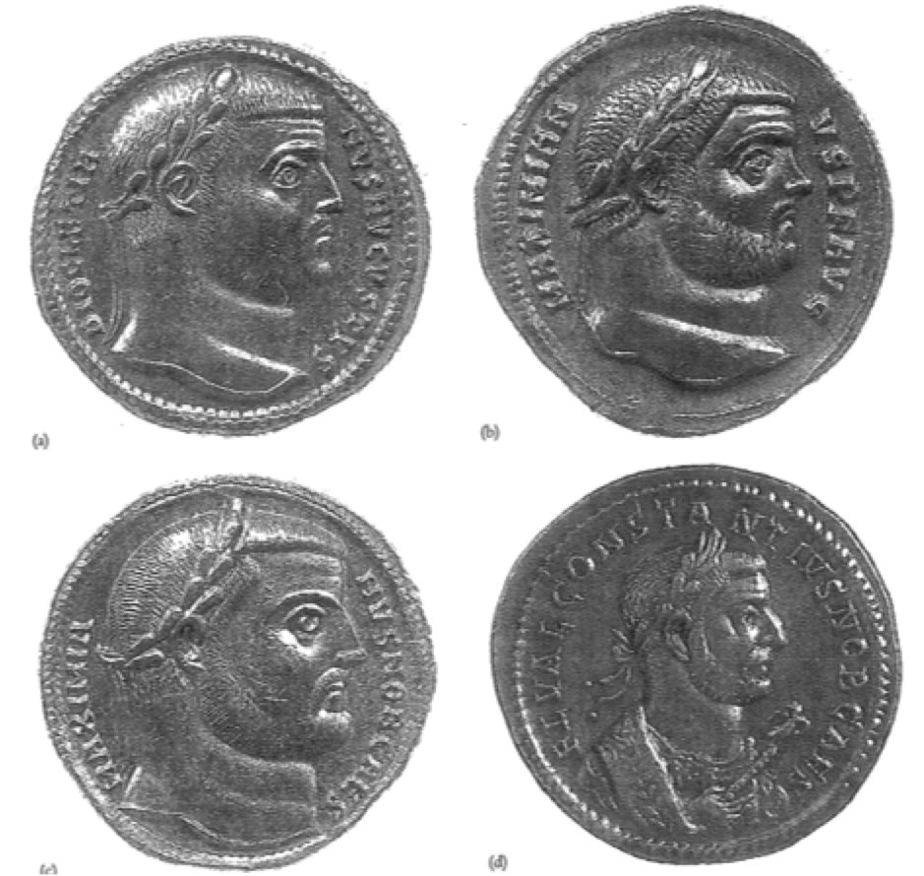
Figure 1
The Tetrarchs: rule by four.
From upper left, clockwise: Diocletian (Augustus), 295 A.D.; Maximian (Augustus), 294 A.D.; Galerius (Caesar), 294-295 A.D.; Constantius (Caesar), 297 A.D.

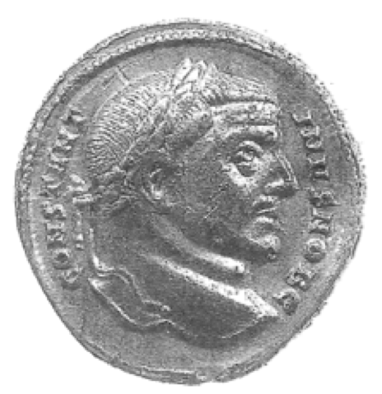
Figure 2
Constantine (as Caesar), 307 A.D.

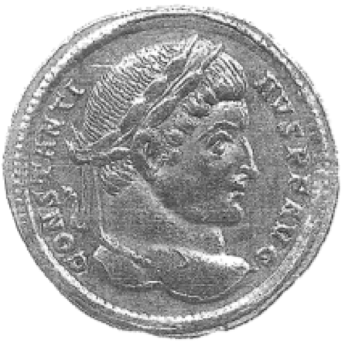
Figure 3
Constantine (as Augustus), 319-320 A.D.
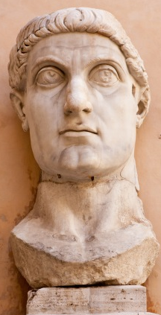
Figure 4
Classicizing, Idealization, Heavenly Gaze, Large Eyes

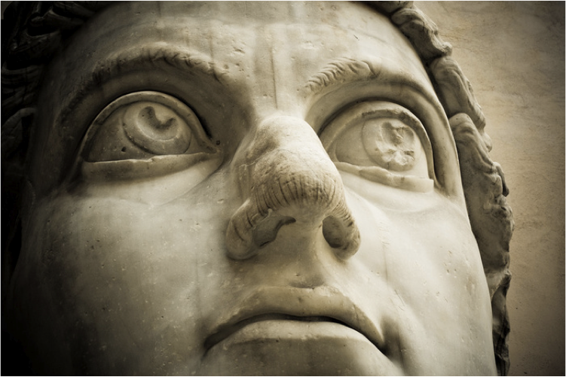
Figure 5
As above
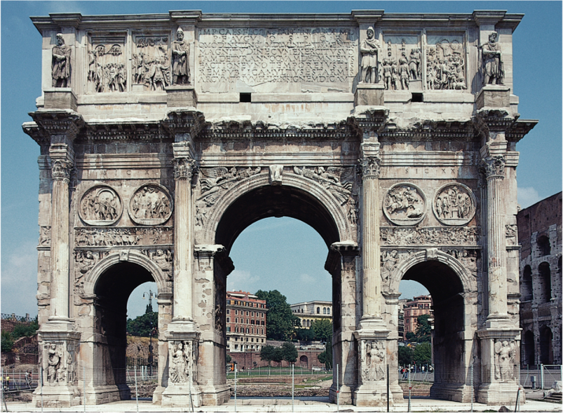
Figure 6
Arch of Constantine

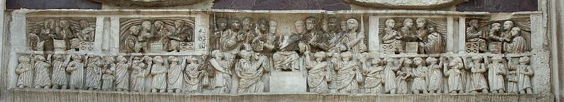
Figure 7
Oratio

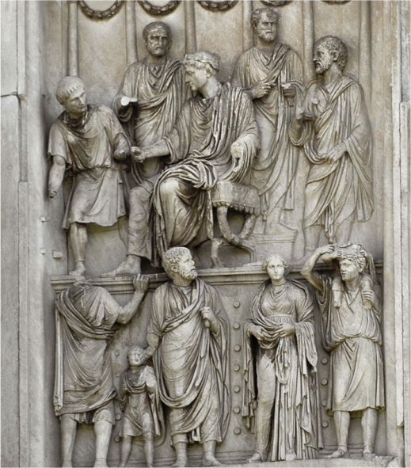
Figure 8
Liberalitas

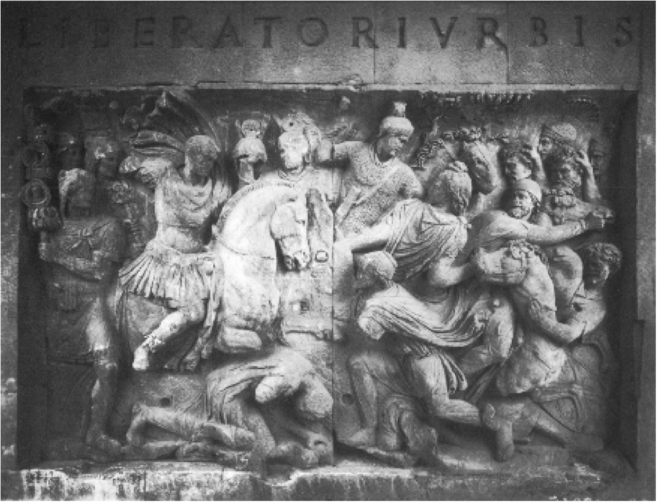
Figure 9
Constantine's head re-cut from Trajan's.

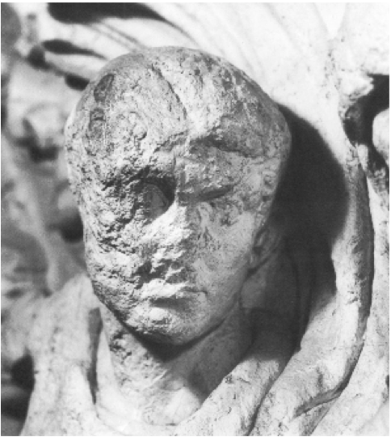
Figure 10
Close up: Constantine's head re-cut from head of Trajan.
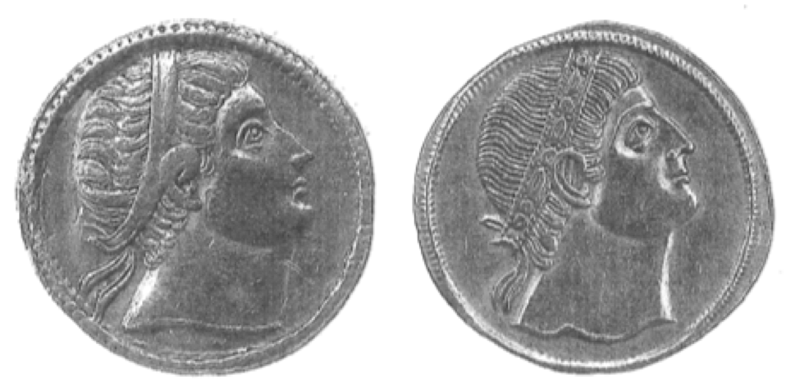
Figure 11
Jeweled diadem.

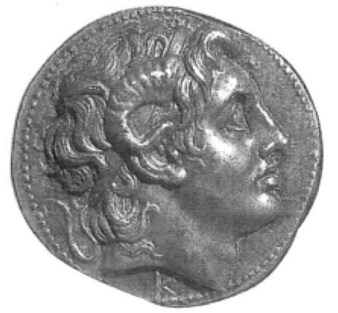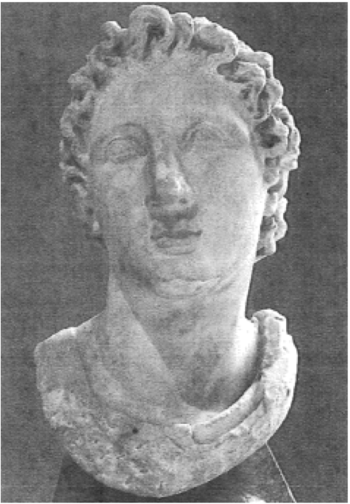
Figure 12 Figure 13
Jeweled diadem of Alexander. Alexander and the heavenly gaze.

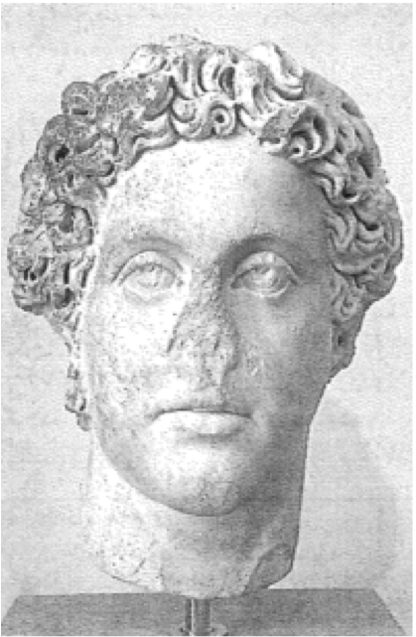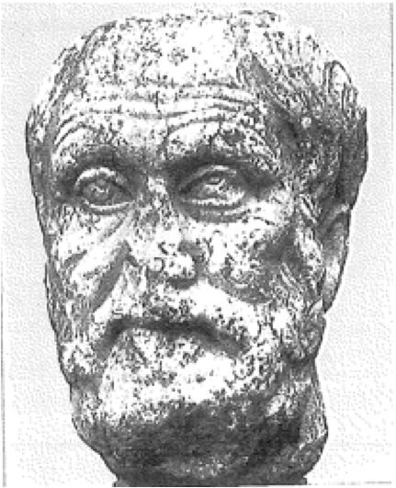
Figure 14 Figure 15
Commodus (Philosopher) Carneades (Philosopher)
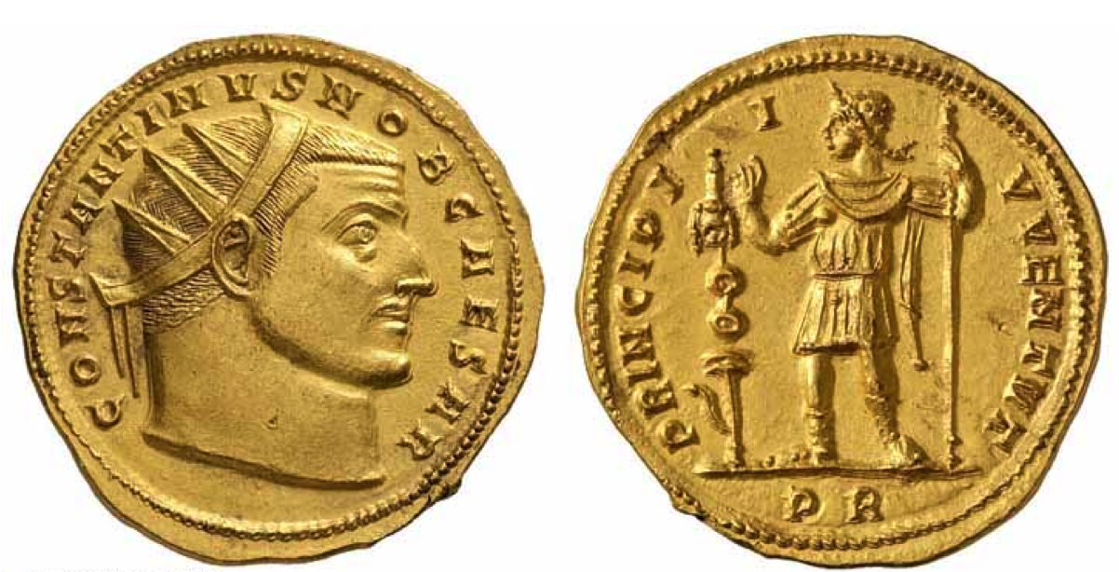
Figure 16
Constantine and Sol: Constantine 'radiating' rays of light.
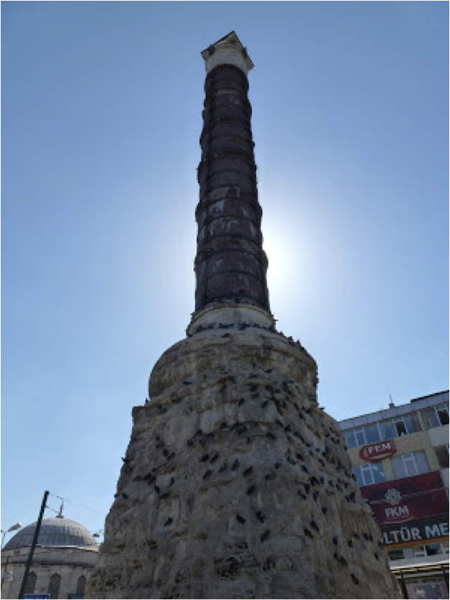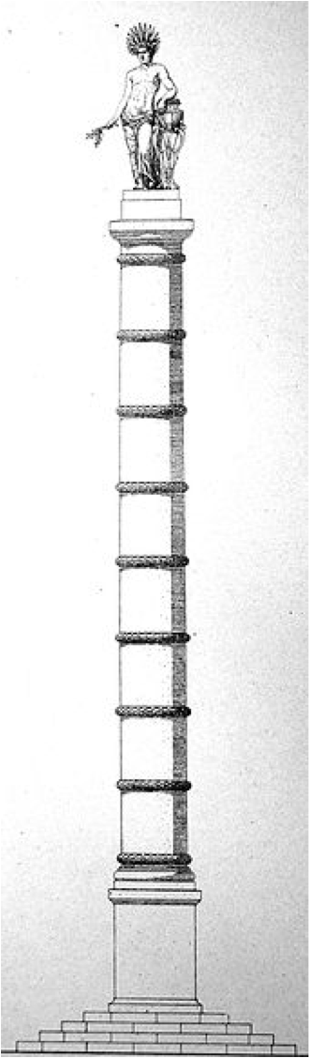
Figure 17 Figure 18
Column of Constantine. Column of Constantine:
Reconstruction

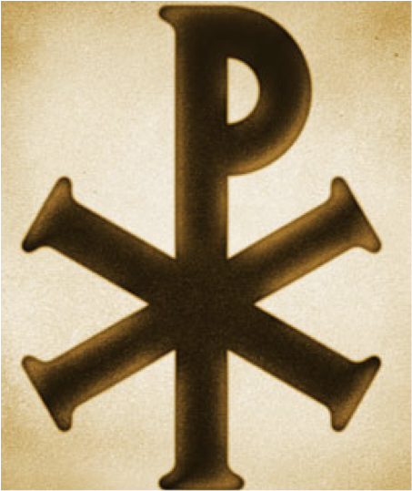
Figure 19
The Chi-Rho.
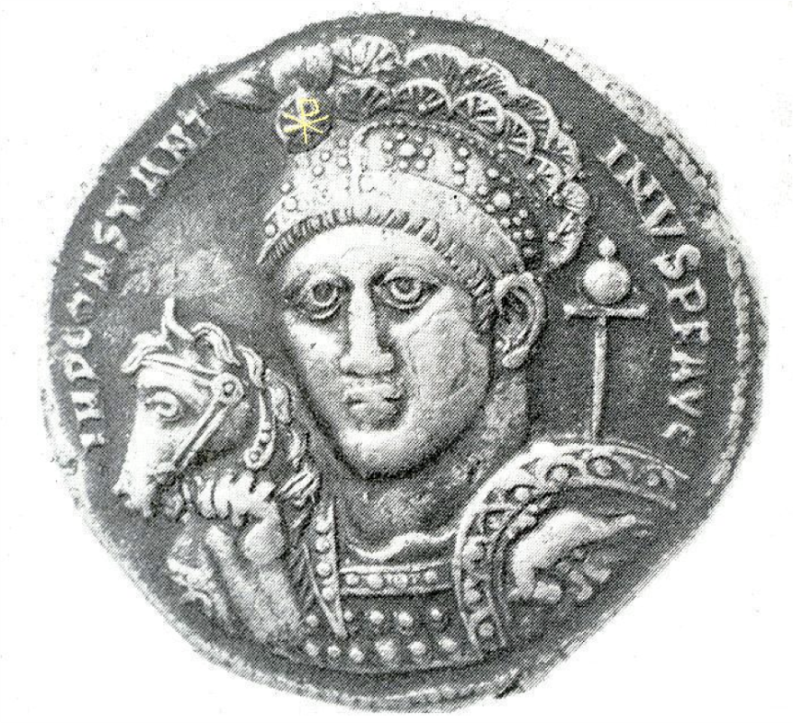
Figure 20
The Chi-Rho on a Constantinian coin.

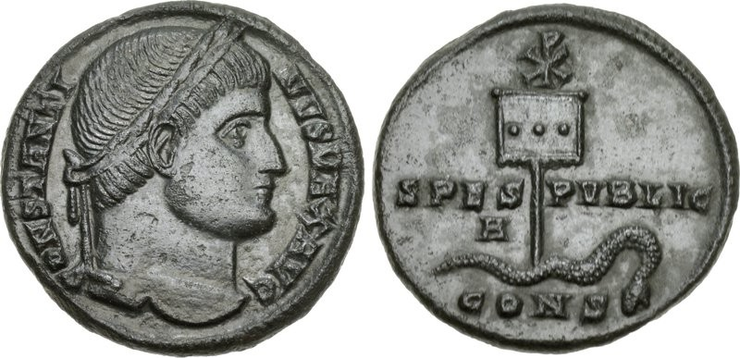
Figure 21
The Labarum (Roman standard with the Chi-Rho) on a Constantinian coin.
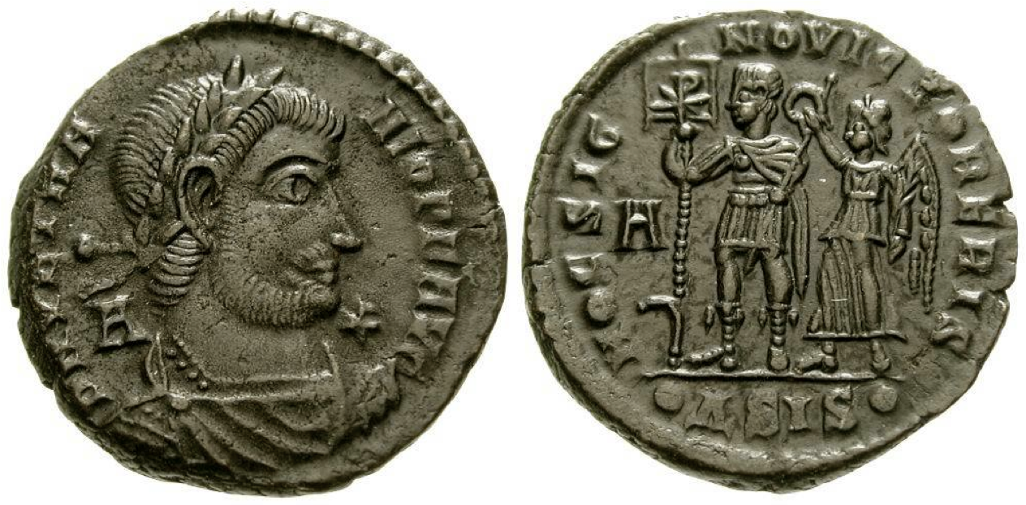
Figure 22
Constantinian coin with Victory, the Labarum and Chi-Rho.

Jonathan Bardill, "A Change of Image," in Constantine Divine Emperor of the Golden Age (Cambridge: Cambridge University Press, 2012), 11.
Laura Breglia, Roman Imperial Coins: Their Art & Technique (New York: Frederick A. Praeger, Inc., 1968), 216.
Patrick M. Bruun, The Roman Imperial Coinage: Volume VII, ed. C.H.V. Sutherland, D. Litt, and R.A.G. Carson (London: Spink & Son Ltd., 1966), 32.
J.P.C. Kent, Roman Coins (London: Thames and Hudson Ltd., 1978), 51.
Ibid., 52.
Eric R. Varner, ed., From Caligula to Constantine: Tyranny & Transformation in Roman Portraiture (Atlanta: Michael C. Carlos Museum, 2000), 171.
Bardill, 11.
H.P. L'Orange, Art Forms and Civic Life (Princeton: Princeton University Press, 1965), 90.
Ibid., 102.
Ibid., 159.
Ibid., 152.
L'Orange, 31.
Bruun, 33.
Bardill, 11.
Ibid., 15.
Ibid., 18.
Ibid., 19, 23.
Ibid., 22, 23.
Eusebius, Life of Constantine, trans. and ed. Averil Cameron and Stuart Hall (Oxford: Clarendon Press, 1999), 4.15.1, 158.
L'Orange, 50.
Kent, 284.
"Arch of Constantine," accessed April 5, 2013, http://en.wikipedia.org/wiki/Arch_of_Constantine#Inscriptions.
Kent, 284.
Eusebius, 3.3.1-3.3.3, 122.
Ibid.
Eusebius, 4.15.2, 158.
Ibid., 12.
Ibid., 13.
Ibid.
"Capitoline Museums: Colossal Statue of Constantine: Head," accessed May 8, 2013, http://art-history-images.com/photo/7357.
Accessed April 5, 2013, http://www.redcrossofconstantine.co.uk/index/constantine.gif.
"193-337 CE Late Empire Art," accessed April 6, 2013, http://klimtlover.wordpress.com/7-the-roman-empire/193-337-ce-late-empire-art/.
"Arch of Constantine," accessed April 6, 2013, http://www.bluffton.edu/~sullivanm/italy/rome/archconstantine/0049.jpg.
"Liberalitas," accessed May 6, 2013, http://ancientrome.ru/art/artworken/img.htm?id=3600.
Jas Elsner, "From the Culture of Spolia to the Cult of Relics: The Arch of Constantine and the Genesis of Late Antique Forms," in Papers of the British School at Rome, Vol. 68 (2000): 164.
Ibid.
Ibid., 14.
Ibid., 16.
Ibid., 20.
Bardill, 21.
Bardill, 23.
"Constantine I," accessed April 5, 2013, http://www.dirtyoldcoins.com/roman/id/Coins-of-Roman-Emperor-Constantine-I.htm.
"Searching for Traces of the Byzantine Empire in Modern Istanbul," accessed April 5, 2013, http://www.sedefscorner.com/2012/10/searching-for-traces-of-byzantine.html.
"Column of Constantine," accessed April 5, 2013, http://en.wikipedia.org/wiki/Column_of_Constantine.
"Catholic Revolution Under Constantine," accessed April 5, 2013, http://catholiclane.com/christian-revolution-under-constantine-1700th-anniversary-series-part-3-2/chr-rho/.
"Christian Symbols on Bronzes of Constantine the Great," accessed April 5, 2013, http://www.constantinethegreatcoins.com/symbols/.
"From the Grading Room: Rare and Historically Significant Bronze of Constantine the Great," accessed May 22, 2013, http://www.ngccoin.com/news/viewarticle.aspx?IDArticle=2742.
"The 'Sign' that Changed the World," accessed April 5, 2013, http://www.forumancientcoins.com/articles/constantine_ch_rho_files/constantine_ch_rho.htm.

