“White Devils”:
The Nation of Islam - Origins, Recruitment and the F.B.I.

Nick Sabin
History 489 Research Capstone
December 2018

Copyright for this work is owned by the author. This digital version is published by McIntyre Library, University of Wisconsin Eau Claire with the consent of the author.

Abstract

The Nation of Islam has often been described as a radical and aggressive social and political movement occurring simultaneously with the Civil Rights movement in the United States. Founded in 1930 by a mysterious traveling peddler, the Nation of Islam began recruiting followers that same year. After the founder disappeared, with his “messenger” prophesizing him as God in human form, the Nation of Islam began to expand in number of members and in popularity. But it wasn’t until a bright, intelligent ex-convict was converted that we started to see the numbers of the Nation of Islam increase. How had this increase in popularity happened when the Nation of Islam teaches that the most popular religion (Christianity) and the race majority (whites) were taught to be the “devil”? This essay will cover the history of the Nation of Islam, discuss the ways in which the Nation was effective in recruiting, and opposition to the religion.

Contents
Abstract ii
Introduction 1
Islam and the Nation of Islam: Two Different Ideologies 3
W. D. Fard and The Nation of Islam 4
Elijah Muhammad and the Emerging Movement 9
Malcolm X 12
Malcolm X Splits the Nation of Islam 20
Black Pride and Prisons: The Nation of Islam’s Recruitment 23
Conclusion 30

Table of Figures
Fig. 1 “Malcolm and Martin, closer than we ever thought” 2
Fig. 2 Mug Shots of Elijah Muhammad after his arrest in 1942 11
Fig. 3 Malcolm’s comments to President Truman 17
Fig. 4 F.B.I. records of Malcolm’s “chickens coming home to roost” speech 21
Fig. 5 F.B.I. records of a New York Times article of Malcolm’s comments on President Kennedy’s assassination 21
Fig. 6 “Malcolm X Kidding Around with Muhammad Ali” 29

Introduction
I believe in Allah, God of the Muslims, creator of all worlds, and in Elijah Muhammad, his last Apostle, who was conceived by a black man, born of a black woman, suffered under the white man, was economically crucified, mentally dead and racially buried. He is still in hell (America) but has risen from the dead the so-called Negroes, and is raising his people from their graves of ignorance, to inherit heaven on this earth….Thence Allah shall judge the living (devils) and the dead (so-called Negroes). I believe in no ‘Holy Ghost tales; no murderous Spanish Inquisition Catholic Church; no communion of saints, angels, spirits or spooks; no forgiveness of your [white] people’s sins against mine; no dry bones and decayed flesh resurrecting; and no life after physical death.’
-Sylane X, Muhammad Speaks

March 26, 1964. In the Senate, a filibuster against the Civil Rights Bill had just adjourned. A tall, slender black man with glasses walks out and waits patiently for another black man to finish his news conference. The black man at the news conference walks out and is greeted by the tall black individual. Despite their differing social opinions, the two exchange brief pleasantries as cameras snap photos of the two men. The shorter man initiated the conversation saying, “Well Malcolm, good to see you.” The taller man replied, “Good to see you.” Both men began walking down the hall of the Senate and Malcolm stated that he was “throwing himself into the heart of the civil rights struggle.” Two of the most important black rights leaders of the twentieth century have just met in person. The tall, slender individual was named Malcolm X and the smaller man was Martin Luther King Jr. Their exchange lasted only a few moments and it would be the last time they would see each other before both were assassinated (X in 1965, King in 1968). A beckoning question looms upon knowledge of their only meeting together. Malcolm and Martin both preached of an end to black inequality and advocated for different variations of black rights in America, so how come the two only encountered each other on this one brief, momentous occasion?
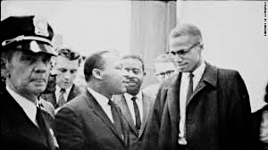During the 1930s, when America was filled with racism, discrimination, segregation and lynching of black Americans was the norm; many black Americans seemed to be in a living hell. After countless attempts to prove to the white majority in the United States that they were equals, many had no idea where to turn. Christianity appeared to be offering little reassurance for African-Americans as the segregation and lynchings were committed by the very people who preached Christianity, a religion that preached to “love thy neighbor as themselves”! Where would these people turn to in a time where their own religion appears to offer little assistance with what they should do to prevent these atrocities. Most were losing hope and craved a religion that could yield results and action. Until a small group originating in the Midwest had the solution for some of these lost people: The Nation of Islam. This religion provided combined teachings of Christianity and Islam to appeal to African-Americans and offer a solution to their problems. It changed the lives of hundreds of thousands, claiming that the religion was salvation and brought an appreciation to their culture and heritage. But how was this religious movement able to recruit in an era fueled by Martin Luther King Jr.’s philosophy of nonviolent protests: especially when the Nation of Islam preached action and resistance to oppression? In order to determine why the Nation of Islam was so effective in recruiting black men and women requires a deep analysis into the construction of the movement, the appeal of the movement, and the Nation of Islam’s recruitment.

Islam and the Nation of Islam: Two Different Ideologies
First, there is a need to differentiate the Nation of Islam from Islam. Although the Nation of Islam does include traditions from historically Islamic symbols, texts, and practices into their religion, the religion includes elements and aspects that are relatable to their American conditions of living. The Nation of Islam’s religious life is understood as a process in which members debated the significance of their religion and integrated or rejected certain elements of other Islamic traditions as they attempted to implement their own circumstances in America. This new approach instructed that religious identity is “not only a matter of one’s theological beliefs but also one’s ritual activities, ethical imperatives, and communal affiliations.” There are a couple of key differences in theology as to why traditional Muslims don’t regard Nation of Islam followers as true Muslims. The Nation of Islam worships both its founder, W. D. Fard (as the messiah) and Elijah Muhammad (as His messenger). Worshipping these individuals contradicts the Muslim belief that Islam’s founder, the prophet Muhammad, was the last of God’s prophets and that God has never taken human form. The Nation of Islam also teaches that white people were created roughly 6,500 years ago by a black scientist named Yakub in a rebellion against God. According to retired religious professor Dr. C. Eric Lincoln claims that this belief “is the fundamental premise upon which [the Nation of Islam] rests the whole theory of black supremacy and white degradation.” Although there are numerous other differences between these two ideologies, these two are among the most important for our purposes.

W. D. Fard and The Nation of Islam
Before diving into the significance of the Nation of Islam, it is helpful to determine what the origins and intentions were of their early leaders. The Nation of Islam was founded on the fourth of July in 1930 by W. D. Fard in Detroit, Michigan. Its original roots can be traced back to religious movements in northern cities during the early decades of the twentieth century in Afro-American communities. Fard emerged as a Muslim Missionary in America, sold silks and was a peddler who went door-to-door selling Asian and African clothing. He became a frequent visitor in the Detroit houses of many low-income blacks who were not only anxious to buy his goods, but also hear stories of the history of their homeland in the Eastern Hemisphere. According to Fard, the Asiatics, which included the continent of Africa, were the original human beings and their civilization included the Nile Valley as well as the city Mecca. He continues to tell the story of a mad black scientist named Yacub, who developed blue-eyed mutants whose descendants became the white race who enslaved the Asiatics for six thousand years. As Fard grew in popularity in Detroit, he began to warn his followers against consuming certain foods that were “poisonous” and to eat the foods of their home countries to prevent illnesses.
Eventually, Fard’s numbers grew and he offered many solutions to the problems that African-Americans were facing in the early 20th century. Fard’s teachings openly attacked the white race, Christianity, and certain teachings of the bible. Fard elaborated on the Book of Revelation, found in the Bible, and stated that the impending “War on Armageddon, a battle between good and evil” would be fought in North America (specifically in the United States). He continued explaining that the Armageddon would be the final conflict between white and black people and the only way in which black people could win is if they converted to Islam, their “natural religion and reclaim their original identity as Muslims.” According to the official website of the Nation of Islam, the entire purpose of W. D. Fard’s mission was to “restore His lost and found people, who were identified as the original members of the Tribe of Shabazz from the Lost Nation of Asia.” (Whenever he is referenced, W. D. Fard’s pronouns are always capitalized at the beginning of each word; such as in the previous quote “restore His…people.” This was due to Fard’s self-proclamation that he was the Master and his words come directly from God himself.) W. D. Fard’s teachings explained that these lost people from the original nation of Africa were kidnapped, forced into slavery, and dehumanized in order to serve as slaves of America for centuries.
When the soon-to-be messenger of Allah, Elijah Muhammad, heard of Fard’s teachings, he strove to meet him. Upon their first encounter in 1931, Elijah Muhammad recalls that he shook hands with Him and emphasized, “You are the One that the Bible prophesied would come at the end of the world under the name Son of Man and under the name The Second Coming of Jesus." Elijah remembers that W. D. Fard looked slightly stern at him, leaned in and said “Yes I am the One, but who knows that but yourself” and indicates to Elijah not to share that information. During his teaching, W. D. Fard mentioned that He had studied every educational system of the civilized world and could even speak sixteen languages fluently. W.D. Fard said that His father informed him to study these educational systems for His people. He would teach Elijah night and day about Islam and what has occurred and what is to come for their people. After about a month, Elijah Muhammad was informed by Him to start teaching around Detroit, Michigan that Fard was a prophet from God. Elijah Muhammad elaborates on the mission Fard’s father sent him on, “He said that His Father wanted to make a son that would be able to go and search all the civilizations of the Earth to locate this people and when He found them, teach them and make a disciple of His Own of them, to teach them and try and get them together and return them again to their own people. And so, he said He was that Man.” Muhammad seems to avoid discussing specifics with regards to the mission and uses generalizations that could align with a majority of religions around the globe.
Little is known about Fard’s early life and His messenger and prominent leader of the Nation of Islam, Elijah Muhammad, didn’t even know much of his origin. Elijah Muhammad admitted that he didn’t know much information other than He was born in Mecca, Arabia, and that He had been coming in and out of the United States for twenty years before ever making himself known. Elijah explains that Fard’s father wanted a son who would search for their lost people around the world and upon discovery, teach these people and convert them into disciples in an attempt to reunite and return them to their own people in Asia. Some stories insist that He was the son of wealthy parents of the Koreish tribe which linked him in ancestry to Muhammad, the prophet of the early Islamic religion. The mysterious and small amount of information that is known on W.D. Fard’s origins only adds to the power of religion if people truly believe in everything that he says. If Fard’s followers believe in His words and teachings, they are less likely to question his upbringing and life before peddling around Detroit.
Fard self-proclaimed to be a prophet sent from God himself and had the solutions to the problems of the African-American community in the United States. There were three concepts which became cemented in His ideology: “Allah is God, the white man is the devil and the so-called Negroes are the Asiatic Black people, the cream of the planet earth.” The next few paragraphs elaborate on deconstructing Fard’s ideology.
Fard believed that Christianity was the white man’s religion, one that offered no assistance to issues of the social problems or development in the Asiatic Nation. Upon the arrival of Africans in slave ships, slave masters forced their slaves to accept the Christian religion as the correct religion. The slaves were forced to accept and worship an unfamiliar and alien God which had none of the same features that slaves could identify with. According to the slave owners, God had blond hair, pale skin and blue eyes: characteristics that aligned with the majority of slave masters.
Christianity taught black people that black was a curse. It taught them that everything white was good and to be respected and beloved by all. In contrast, it taught followers to hate everything black, including themselves. Fard expressed that Christianity brainwashed black Americans to believe that they would be superior to other races if their complexion showed more similarity of the slave master. Instead of being accepting and loving for all, as the Bible repeatedly emphasizes, there was emphasis that the white man’s Christian religion continued to deceive the black population to “always turn the other cheek, and grin, and scrape, and bow, and be humble, and to sing, and to pray, and to take whatever was dished out by the devilish white man; and to look for his pie in the sky, and for his heaven in the hereafter while right here on earth the slavemaster white man enjoyed his heaven.” Rather than love thy neighbor as themselves, the Nation of Islam assumed that the white Christians would offer the promise of a better afterlife while they are on earth doing the bidding of their slave master. This assumption that the white man was enjoying his heaven on earth implies that they were doing the work of Satan and would continue their afterlife in hell.
A major point of emphasis for Fard was his mission to gain freedom and justice for African descendants living in the United States. Fard published two documents transcribing his ideologies: Teachings for the Lost-Found Nation in a Mathematical Way and Secret Ritual of the Nation of Islam. His documents explained that “freedom, justice, and equality could not be achieved in the United States” until blacks regained their original language, Arabic; their true religion, Islam; and established a separate autonomous state specifically for African-American communities.
After a couple of years of teaching Islam, Fard mysteriously disappeared in 1934. Despite his disappearance, there appeared to not be any foul play involved as Elijah Muhammad explained that after Fard had given him the teachings and the work of preparedness for his people, it was no longer necessary for Him to remain here among his people. Muhammad even elaborates that in the Qur’an it states that the people are not worthy that God remain among his people, rather that God makes a messenger for his people and through the messenger, God will reach his people. Upon Fard’s disappearance, Elijah Muhammad became the leader of the Nation of Islam and was adamant to continue what Fard had started for their people.

Elijah Muhammad and the Emerging Movement
Elijah Muhammad was born Elijah Poole on October 7, 1897 in Georgia. His father was a Baptist minister and a sharecropper while raising thirteen children and supporting his wife. Elijah attended public school, but mainly only learned the minimal basics of arithmetic, reading and writing before he left to help support his family in the fields. At the age of fifteen, Elijah was about to experience a traumatic event that would lay the foundation for his black nationalist endeavors. In 1912, A close friend to the Poole family was accused of “accosting a white female in the city of Cordele.” Upon this accusation, a white mob lynched this teenager named Albert Hamilton and this experience gave Elijah a first-hand experience of the atrocities of life for African-Americans in the South and personally impacted him years later when he first heard the teachings of W. D. Fard.
While working in Macon, Georgia, he met and married Clara Evans. In 1920 – during a time of great migration of black families from the South to the North – Elijah and his wife moved with his two sons to Detroit, Michigan in hopes of better economic and social opportunities. Shortly after arriving in Detroit, Elijah traveled with a friend to Chicago to hear a remarkable speaker and leader of the black masses: Marcus Garvey. Elijah was profoundly moved by Garvey’s message which “focused on the redemption of Africa, racial identity, pride and solidarity, and black economic independence” and believed this to be the “great truth” about their people. While Garvey advocated for all black people to rise up and begin a great migration to Africa, Elijah argued that this would not solve the problems present in the United States. Elijah believed that only a drastic change in black American identity would be the solution to the problem. He found this similar belief in Fard’s teachings and became his follower in 1931.
Immediately following W. D. Fard’s abrupt and mysterious disappearance, the Nation of Islam found itself at a crossroad. Elijah Muhammad found himself faced with not only external challenges to his authority of the Nation of Islam, but also internally. Upon his ascension to leader of the Nation of Islam, Elijah Muhammad left his Detroit group and set up his headquarters in Chicago, Illinois. A rift developed between Elijah Muhammad and his younger brother, Kallat, due to Elijah’s claim that before his departure, Fard had instructed him to lead the Nation of Islam. Adding to the rift was Elijah Muhammad’s belief that Fard was Allah himself, which many members questioned or flat out refused to believe in adding to the depletion in members of the Nation of Islam in the following years after Fard’s disappearance. It was not only Kallat who questioned Muhammad’s ideas on Fard and the leader succession that should occur. What split the Nation of Islam from the larger Muslim community and separate black religious and political groups was the idea that W. D. Fard had dispensed this “hidden truth” stating that white people and black people did not come from the same God. Richard Turner writes that according to this “hidden truth” idea, black people were “fundamentally different in nature.” He continues, “black people were ‘righteous and divine’ and white people were wicked ‘blond blue-eyed devils.’ ‘America is under Divine Judgment to destroy her for the evils done to Allah’s people in slavery.’” These differences in ideology led to a sharp decline in the Nation of Islam’s members; dropping from roughly 20,000 followers to about 5,000 in 1937. Though his numbers dropped, his rivals grew; some expressing that they wanted Elijah Muhammad dead. For fear of his life, Elijah was forced to abandon his family and traveled along the east coast of the United States as a preacher for his movement.
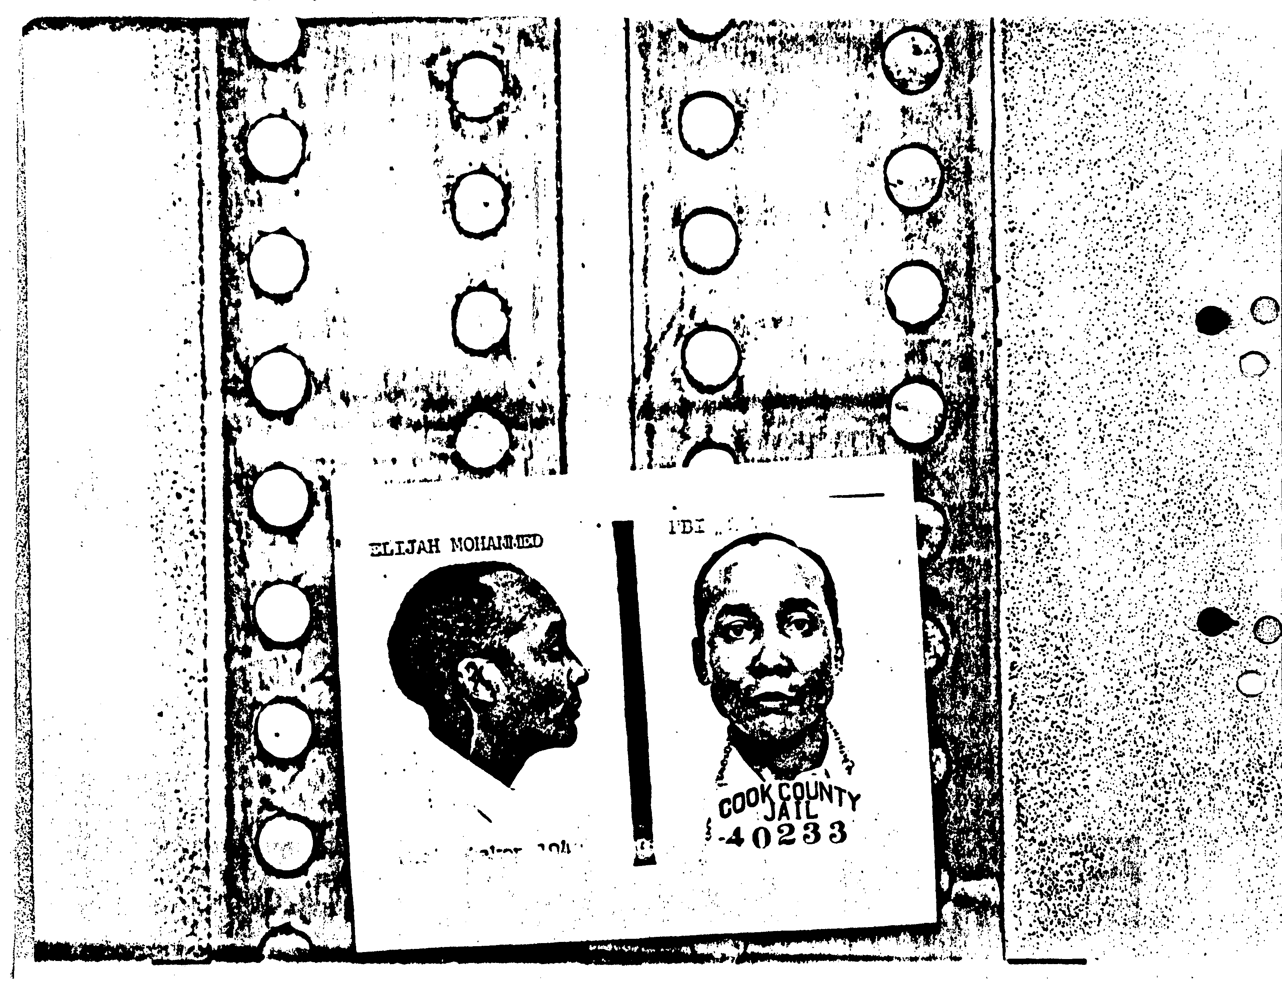Beginning in 1942, the F.B.I. carried out a series of raids on black Muslim homes and mosques in Detroit, Chicago, Milwaukee and New Jersey. It was during this year that Elijah Muhammad was arrested for failing to register for the draft. Four years later, he was released from prison and his incarceration helped him look like a martyr and he returned to Chicago as the absolute leader of his movement. It was upon his return that the Nation of Islam expanded its operations throughout the United States and its members grew drastically. Elijah Muhammad was finally back on the top of his movement after fifteen years of fighting. He was in his element. That was until another intelligent black man propelled the movement into the national spotlight: Malcolm X. It was not until Malcolm X became involved in the movement that we truly got to see the true colors of Elijah Muhammad. Was he simply an incredibly intelligent, enlightened black Muslim who was adamant on continuing the movement for the salvation of black Americans? Or was Elijah Muhammad simply power hungry and used this movement as the stepping stones for control over massive amounts of followers?

Malcolm X
Malcolm Little was born in Omaha, Nebraska in 1925. He was one of eight children and had two parents who were active members in Marcus Garvey’s Universal Negro Improvement Association. Malcolm grew up with two black nationalist parents, meaning that he and his siblings experienced rough childhoods on account of white racist opposition to their parents’ political agendas. In 1925, the Littles were expelled from Omaha by the powerful Ku Klux Klan and relocated to Milwaukee, Wisconsin and eventually settled in East Lansing, Michigan. At the age of five, Malcolm’s father, Earl Little, was crushed and almost torn apart in an automobile accident in Lansing. For the next eight years, Malcolm’s mother, Louise Little struggled to keep her family together during the Great Depression. However, the economy was in shambles and loneliness caused Louise to lose her children one by one to the state authorities. On January 31, 1939, Louise Little was declared legally insane and committed to the state mental hospital for twenty-four years at Kalamazoo.
By this time, Malcolm had already begun to commit crimes. In 1934, the same year W. D. Fard mysteriously disappeared, Malcolm began to hang out around stores and swipe treats for himself. Malcolm explains “I began drifting from store to store, hanging around outside where things like apples were displayed in boxes and barrels and baskets, and I would watch my chance and steal me a treat. You know what a treat was to me? Anything!” After the span of merely a few years, institutionalized American racism had resulted in his father’s death, the institution of his mother, the separation of his siblings, and the beginning of criminal behavior that appeared to be self-destructing. Malcolm assumed the role of a juvenile delinquent and committed crimes that America’s institutionalized racism had “constructed for young African-American men.” It seemed as though Malcolm accepted the implication that black men could only live in the vicious cycle of crime and prison.
When Malcolm was fifteen years old, his older half-sister, Ella Collins, received legal custody of Malcolm and brought him to Boston to live with her and Malcolm’s half-siblings. In Boston, Malcolm began to assume his hustling identity, Red. Red signified all of the negative aspects of the institutionalized racism that affected black men in America: an unemployed, high school dropout where he sold narcotics, promiscuous in sexuality, a thief and a hustler with a volatile streak. He was the embodiment of African-Americans to the white majority. In 1943, Malcolm moved to New York and later Boston. Three years after being in the east coast, Malcolm was arrested with larceny, breaking and entering, and carrying firearms. It was at the age of twenty that Malcolm began his six-year sentence in Charleston Prison in Massachusetts. Unbeknownst to Malcolm, who was entering prison a known atheist, he was about to embark on a journey that would steer his life in a more meaningful direction and become the face of active resistance of black oppression during the Civil Rights Era.
While Malcolm was imprisoned, Elijah Muhammad had altered the agenda of the Nation of Islam to focus on rehabilitating those in the black lower class: the young criminals of the black society. Elijah Muhammad implemented spiritual therapy that was central to the programs that he strove to convert and save this demographic. Leaders of the Nation of Islam helped recruit thousands of prisoners after implementing the strategy of providing the incarcerated with salvation and a chance for a new life. One such prisoner that heard of Elijah Muhammad’s teachings was Malcolm Little. Through Malcolm’s brothers, Reginald and Philbert, Malcolm heard of Elijah Muhammad and the teachings of this newly established Midwestern movement. His brothers had recently joined the Nation of Islam and encouraged him to give up cigarettes and pork and stop speaking profanities. Through tedious studying and research, Malcolm greatly improved his otherwise minimal reading and writing skills and began to have debates with some of the other prisoners to enhance his knowledge. His relatives continued to send Malcolm literature on the Nation of Islam and on the teachings of its prophetic leader, Elijah Muhammad. Upon reading the literature, Malcolm was moved. He could now envision his life as a part of something greater, something bigger than himself. He now understand that he was a piece in a much larger puzzle and the teachings all seemed to be a logical continuum that intertwined with his life and the past glory of the black man and Yacub. Malcolm no longer restricted himself to accept the fact that society had instructed him to “be realistic about being a nigger.” He now understood who was to blame for all of the misfortune that had occurred in his life. There was only one explanation that the Nation of Islam provided him. Everything that had happened to him and every other black person that has ever lived in America had occurred as a direct, or indirect, result of actions that occurred by white men. The words that his brothers had taught him on their many visits to his jail cell came flooding back to Malcolm: “The white man is the devil.”
After his awakening, Malcolm proceeded to write to Elijah Muhammad consistently until his parole on August 7th, 1952. Letter after letter, Malcolm’s became noticeably more intelligent and contained the faith of a real believer. Not only was Malcolm writing to his prophet, Elijah Muhammad, but he was receiving warm replies as well, some even containing a five-dollar-bill. After he was released from prison, Malcolm was honored to personally meet Muhammad. Three weeks after his parole, Malcolm journeyed to Chicago to hear Muhammad speak at a temple. There was a modest turnout, approximately 200 people, and he spoke out on the deception of the white men’s trickery on the black man with and how “the true knowledge of ourselves would lift up the black man.” While in the middle of a pause in his speech, Muhammad beckoned Malcolm to stand up in front of the congregation. Muhammad proceeded to praise the young convert for his faith and diligence in writing leaders and persistent studying. Muhammad challenged Malcolm in front of the whole congregation saying “Well, now, our good brother Malcolm’s hedge [prison cell] is removed and we will see how he does…I believe that he is going to remain faithful.” The confidence Muhammad instilled in him sent waves of awe to spread across his body and Malcolm felt as though he had just encountered his maker. Over the course of the next several months, Malcolm and Muhammad developed a relationship similar to Muhammad and his previous teacher, W. D. Fard. After that speech, Malcolm traveled back to Detroit and searched throughout the poor, predominately black neighborhoods recruiting converts whenever he had a chance to. His work ethic and production so effective that word reached Muhammad back in Chicago and Muhammad realized that he had landed a much-needed asset and leader in the young Malcolm Little. Malcolm’s incredible ability to convert and appeal to the working class propelled him to become one of the top recruiters in the Nation of Islam and become a focal point in Muhammad’s movement. Due to Malcolm’s phenomenal amount of faith and persistence, Muhammad appointed him assistant minister of Temple No. 1 and dubbed him Malcolm X in the summer of 1953. The Nation of Islam adopted the symbol X as a replacement for the “slave name” of black people who joined the religion. This symbol was “regarded as a ‘badge’ representing the rejection of the slave name and the beginning of a symbolic search for one’s ancestral identity.”
By 1960, the Nation of Islam’s membership rose to around 100,000 and around seventy-five percent of those were between the ages of seventeen and thirty-five years old. An important factor for the increase in its membership growth was the Nation of Islam’s public image. It was not nearly enough to expect people to hear of the Nation of Islam’s teachings through word of mouth and the Nation of Islam had to start recruiting in order to provide salvation to black men and women across the country. Elijah Muhammad’s leaders had the acute ability to express the message of moral reform, self-help in the economy, and separatism; and none were better at appealing to eager believers than Malcolm X. He embodied the elements of style and charisma that “captivated curious youths and convinced many to join the Nation so that they, too, could be transformed from so-called Negroes into Original People.” Malcolm seemed to have a natural gift for recruiting, having lived on the streets for years and had the innate ability to relate the religion to any black ears that would listen. As television began sculpting people’s perceptions of nearly every personality and event that aired, the Nation of Islam’s charismatic leader represented the most intelligent and respectable aspects of the movement to its followers. Malcolm X began receiving national attention and brought the Nation of Islam and its cause to the United States’ headlines.
The Nation of Islam was catching the attention of everyone throughout the country, including the Federal Bureau of Investigation. Malcolm recalls the F.B.I. and the amount of informants and agents watching him and the Nation of Islam. “We were watched. Our telephones were tapped. Still right today, on my home telephone, if I had said, ‘I’m going to bomb the Empire State Building,’ I guarantee you in five minutes it would be surrounded.” It wasn’t until June 1950 when he wrote a letter to President Truman that Malcolm was brought to the attention of the F.B.I. His letter to Truman regarded his opposition to the Korean War and explained that he had always been Communist and even bragged that everyone said he was crazy 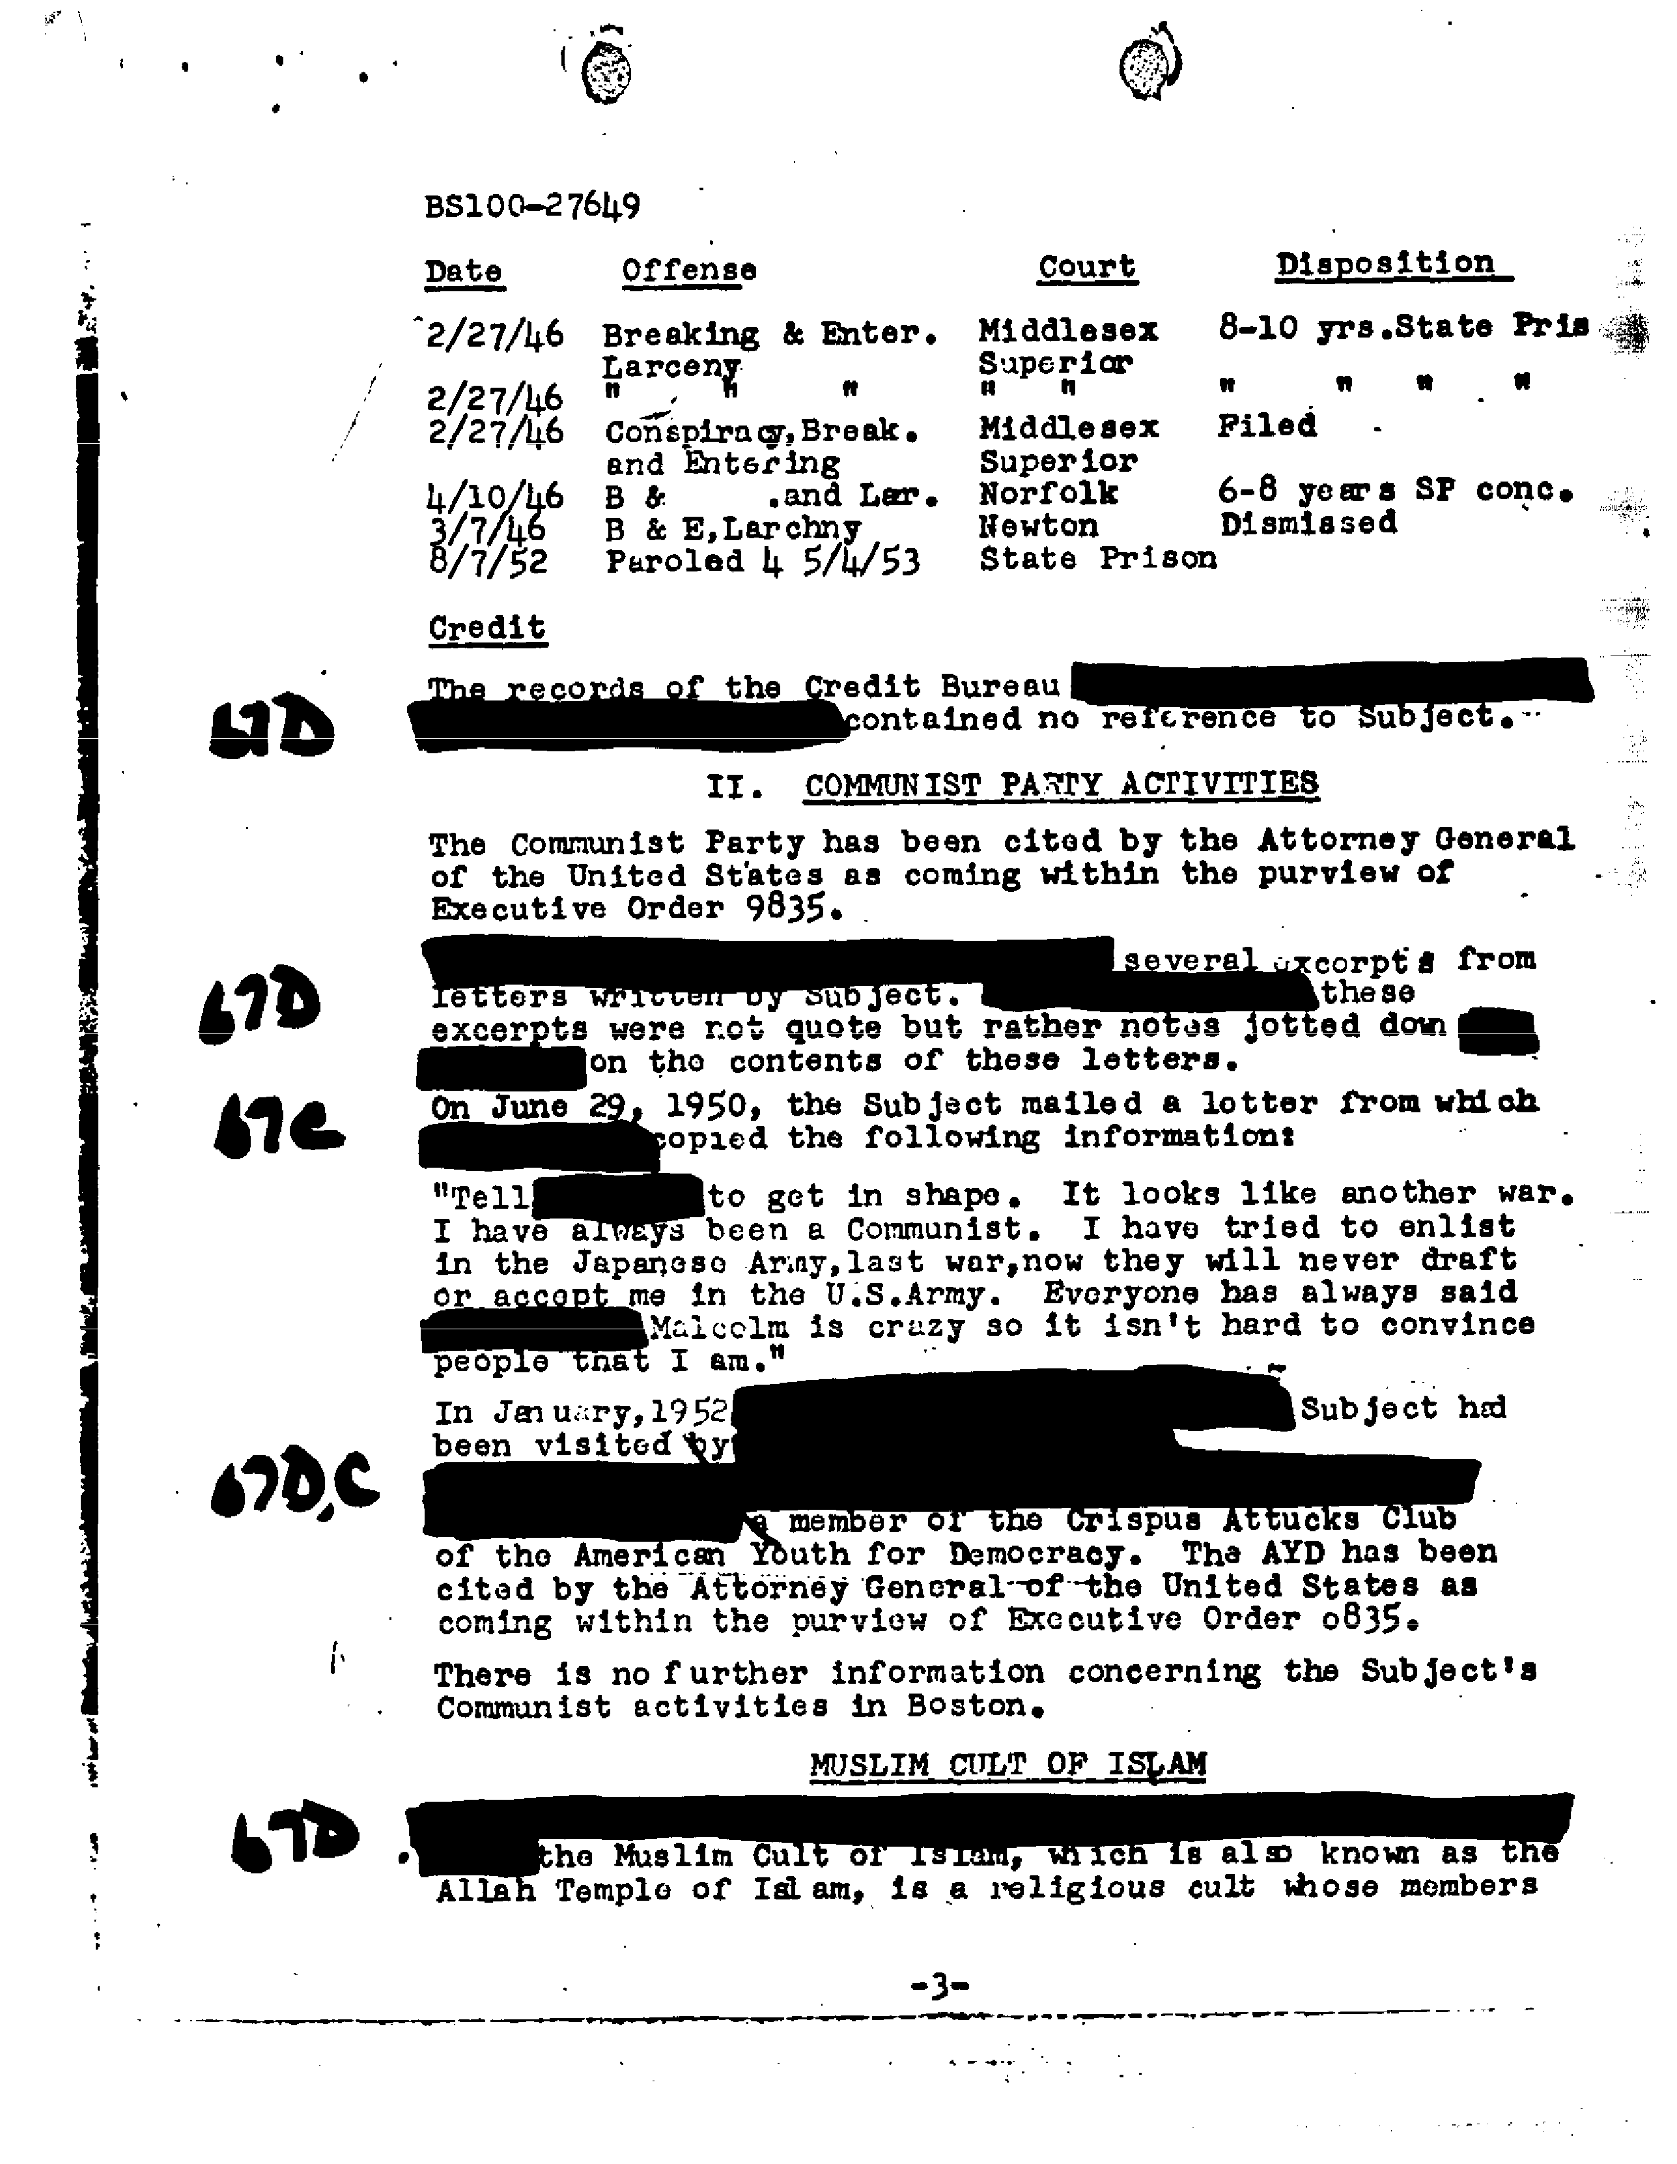so they would never draft or accept him into the U.S. Army. Malcolm continued that he tried to enlist in the Japanese Army during World War II, which only peaked the F.B.I.’s interest in Malcolm. The F.B.I. received so much information about the Nation of Islam and its members through a plethora of illegal wiretappings, surveillance, informants and disruption by law enforcement officers contributed to the F.B.I’s investigations of the group. Around the same time that the Nation of Islam was growing in numbers and gaining popularity, anti-communism was reemerging as the Cold War between Russia and the United States was beginning. This fear of communism and anyone associated with communism linked closely with the extensive records that the F.B.I. kept on the Nation of Islam and its prominent members. Since the Nation of Islam expressed their discontent of the United States’ government, the F.B.I. tabbed this group as anti-American, which, during the 1950s, associated the group with Communists.
Between W. D. Fard, Elijah Muhammad, Malcolm X and the Nation of Islam itself, all of their F.B.I. files total in tens of thousands of pages with detailed records on these individuals. These records contain personal letters, police records, interviews with the F.B.I., informant descriptions of meetings, positions held within the Nation of Islam, and almost every conceivable bit of information imaginable about them. Manning Marable writes in his biography of Malcolm X: “The fact that the Boston field office of the FBI thought it prudent to conduct surveillance even of tiny NOI (Nation of Islam) gatherings, in their homes, reveals just how potentially dangerous the sect was believed to be.”
During the mid-1950s, Malcolm X, Elijah Muhammad and the Nation of Islam quickly became a large influence in black neighborhoods in northern cities. Not only was Malcolm X a persuasive speaker, but he also was a real-life, first-hand account of someone who had received God’s salvation. Muhammad’s teachings had effectively cleansed the life of a violent, criminal atheist and transcended him into a messenger from God, thus demonstrating that Muhammad could save the most depraved, immoral human on earth. Malcolm was incredibly influential when he spoke and his behavior on stage sparked noticeable differences in the popularized image of the angry black man. Usually dressed in a crisp, moderate suit with his tie “perfectly knotted”, Malcolm appeared as more of an intellectual than a persuasive preacher. His influence reached a willing and accepting black audience. His rhetoric of seeking action as the only rational response spread throughout his believers through his persuasive and charismatic demeanor. During one of the many debates between Malcolm X and close friend of Martin Luther King and civil rights activist Bayard Rustin, Malcolm was accused of resorting to “emotionalism” without any clear plan. Malcolm carefully retorted with a metaphor expressing his “emotion” for the oppression.

When a man is sitting on a hot stove and he tells you how it feels to be there, is he supposed to speak without emotion? This is what you tell black people in this country when they begin to cry out against the injustices that they’re suffering. As long as they describe these injustices in a way that makes you believe you have another one hundred years to rectify the situation, then you don’t call that emotion. But when a man is on a hot stove, he says, ‘I’m coming up. I’m getting up. Violently or nonviolently doesn’t even enter the picture – I’m coming up, do you understand?’

Even the F.B.I. had to accept that Malcolm X was not only a charismatic speaker, but his rigid moral and behavioral code made him hard to discredit. One of the F.B.I.’s informants evaluated Malcolm’s character stating Malcolm is fearless and cannot be intimidated by words or threats against him, and that he is not likely to break any laws or ordinances due to his high moral character. As Malcolm propelled toward popularity, he became more independent with regards to his political values. Muhammad began to take notice of all of the attention that Malcolm was receiving, saw himself being overshadowed by Muhammad’s star criminal-turned-activist. In Chicago, rumblings and whispers spread that Malcolm had suspicious motives and wanted to overtake the Nation of Islam. Unlike Malcolm, Muhammad was neither charismatic in the conventional sense and had neither “a flare for dynamic oratory nor an impressive command of the English language.” Muhammad had his own unique sense of drawing in believers with his paternal presence and Malcolm X and other important converts were drawn to Muhammad for the parental guidance he provided. Malcolm X and Elijah Muhammad were very close, and their relationship was sometimes lightly referred to as a father-son duo. Despite their close-knit companionship, Malcolm X eventually split from the Nation of Islam.

Malcolm X Splits the Nation of Islam
There are a number of reasons detailing the exact reasoning behind Malcolm X’s departure with the Nation of Islam. The official explanation provided by the Nation of Islam and Muhammad was that Malcolm had disobeyed Muhammad’s insistence on neglecting to comment on President Kennedy’s assassination in November of 1963. At a rally in New York, nine days after the assassination, Malcolm was asked to comment on the assassination in which Malcolm replied, with his charismatic oratory, that Kennedy’s death was a great example of “chickens coming home to roost” and the media portrayed Malcolm dismissing the significance of the young President’s assassination. Not only had Malcolm made his “chickens” remark, but he followed that statement with some rhetoric explaining that “being an old farm boy myself, chickens coming home to roost never did make me sad; they’ve always made me glad.” When the F.B.I. received this information and noted it in their report, it characterized the “chickens” remark as suggesting that President Kennedy’s assassination gave him a pleasant sense of satisfaction, but his quip about being a farm boy more greatly emphasized his pleasure of the assassination. This comment made about the President’s assassination intensified the scrutiny of the F.B.I. and local law enforcement, causing more difficulty for the Nation of Islam to operate without being hassled.
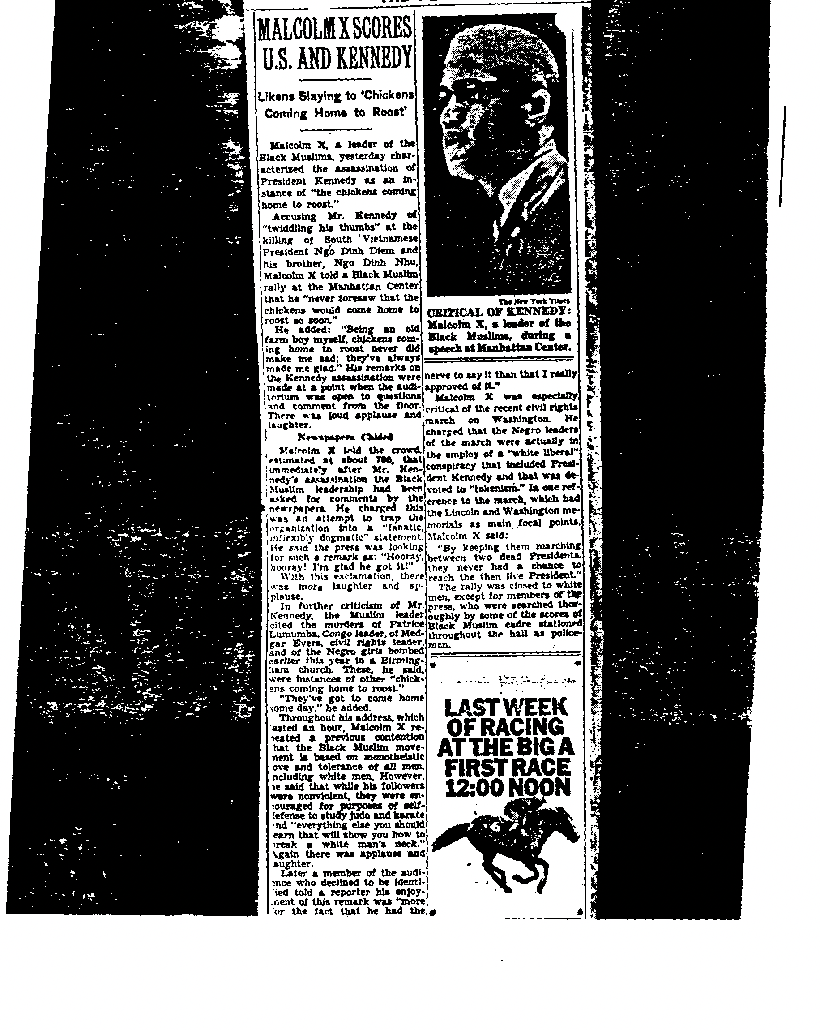

Not only was Malcolm’s comment unsettling to President Kennedy supporters across the nation, but Malcolm had disobeyed direct orders from Muhammad himself. As a consequence of his disobedience, Elijah Muhammad “silenced” Malcolm for ninety days. At first, Malcolm could have returned to the Nation of Islam after his suspension from the Nation of Islam. Malcolm would be returning back to the man who many considered he had a similar father-like relationship with. However, the media and rivals within their organization prevented reconciliation to occur between them. Malcolm X launched a campaign to denounce the teachings of the Nation of Islam and Elijah Muhammad’s morality. On March 8, 1964, Malcolm X officially split from the Nation of Islam a few weeks after he received word from Muhammad that his suspension was to continue indefinitely. Malcolm X spent his final year of life by establishing a multiracial Islamic option for African-American Muslims, exploring the culture and religious roots between African-American Islam and its origination in Western Africa. He traveled to the holy city of Mecca to make the Muslim pilgrimage called the hajj. During this trip, the F.B.I. continued to follow him throughout his trip to Africa. J. Edgar Hoover, then the Director of the F.B.I., suggested that the F.B.I. explore whether Malcolm’s stay in Cairo violated the Logan Act. This remarkable suggestion by the Hoover demonstrates the fear the F.B.I. had of Malcolm with really no evidence. The F.B.I. was so fearful, that while Malcolm was without bodyguards and alone, they searched for any possible and legal grounds to arrest and prosecute him upon his return to the United States.
After returning to America, Malcolm began shifting his ideas from religion to a critique of capitalism as an evil economic system that causes racial oppression worldwide and promotes imperialism. However, his political agenda was never fully formulated as his death came too soon. Malcolm had an ever-growing list of enemies ranging from the members involved in the Nation of Islam, the New York City Police Department, the F.B.I. and the CIA, just to name a few. Interestingly enough, on June 5, 1964, J. Edgar Hoover sent a Western Union telegram to the Bureau’s New York office stating for them to “do something about Malcolm X enough of this black violence in New York.” This telegram came as a response to false reports that a Harlem gang had reached Malcolm in New York and the F.B.I. was concerned that Malcolm now had contacts with yet another “hate group.” Malcolm X was assassinated while speaking in the Audubon Ballroom in Manhattan on February 21, 1965 and three former members of the Nation of Islam were sentenced to life in prison with connections to his death.

Pride and Prisons: The Nation of Islam’s Recruitment
The recruiting process for the Nation of Islam is one of the most fascinating aspects of the movement. Due to some of the ways that Nation of Islam members depicted and portrayed their movement, it’s understandable how so many Americans came to believe that their movement was not simply just a political and social movement, but a religious one. Leaders contributed to this image by using the word “religion” was partly a strategy used to claim social legitimacy and protect themselves in legal encounters. For instance, by claiming that their organization was religious, they fought to protect Nation of Islam males from being drafted in the military, to defend their religious leader’s status in Elijah Muhammad, and to ward off police forces and the F.B.I. Despite these legal precautions, believers in the Nation of Islam fully invested themselves in the religion as many embraced Islam as a path to self-improvement and a sense of security and protection. The Nation of Islam understood the needs of believers and used this information to effectively convert people to their movement.
One of the largest benefits to the religious aspects of the movement was the idea that the Nation of Islam embraced Islam as an alternative religion to Christianity. Believers took the “spooky” and superstitious aspects and directly compared that to Islam’s practicality and rational approach. Dr. Leo X McCallum, frequent contributor to the Muhammad Speaks newspaper, praised the rational elements of Islam in stating that “there is nothing more scientifically, biologically, physiologically, or mathematically correct than Islam.” He continues that the basic Christianity teachings about the divine nature of Jesus and his resurrection cannot be believable to the rational man. Some believers also argued that Islam teaches more on the basic facts of life and appeals to their curiosity to life’s ultimate questions.
Another reason Islam pushed people away from Christianity was how convincing Elijah Muhammad and the other leaders were on their interpretations on the bible’s teachings. Unlike Christianity, Islam offered an interpretation of the Book of Revelation on the origins of the black man, on the role of the white man in connection with the devil, and on the impending apocalypse. Some believers argued that Christianity’s claims that human beings came into existence 6,000 years ago was impossible due to the countless fossil records proving that human beings had been around at least for hundreds of thousands of years before that. One Muslim believer even stated that he “could not see how they (the preachers) could ignore these facts.” In contrast, Elijah Muhammad offered the alternative view that the earth and all human beings were millions of years old. According to Muhammad, the white man’s origins can be traced back to this “big head scientist” named Yacub around 6,500 years ago. Yacub began preaching a dangerous and alternative version of Islam on the streets of Mecca, a holy city in Islamic culture. When leaders of the community learned of this blasphemous teaching, Yacub and his tens of thousands of followers were exiled to an island in the Aegean Sea. Yacub sought his revenge by creating a new race, an evil race, that would deceit, lie, cheat, and ruthlessly gain dominant control over the black men. Yacub had created the white man. This white man that he created was physically weaker than black man. Muhammad also expressed that white men were morally weaker as well. Yacub’s intentions for this new race was to dominate the earth for more than six thousand years and dismantle the entirety of the black man’s nation.
Some former southerners also connected Christianity to their lives in the south, of segregation, discrimination and oppression. Islam, however, became associated with a future in the north that brought new hope and opportunities for black men and women. From the late 1800s until the mid 1900s, millions of African-Americans moved from the south to the north, which historians declare is the Great Migration. This definition of the Great Migration is a movement of a group of people that had a profound impact on all aspects of life (political, social, cultural, and economic) in the United States. While most African-Americans joined the same establishments and religions as they held in the south, others began to experiment with new traditions in the north. African-American members of the Nation of Islam also completely separated their southern roots and proclaimed this new religious community in search of happiness and satisfaction.
New believers also saw a sense of security and comfort in their new religion. They discovered the Nation of Islam as a new form of protection against racism and failed integration attempts. Feeling alienated from a white-dominated America, converts searched for answers to the issue of racial inequality. Ruby X Thompson was one convert who pondered such a question throughout her life. In a Fort Lauderdale high school, she admits that she was taught that all black people had to do was “qualify” themselves and we would be “totally accepted by the white race.” However, Thompson’s viewpoint changed dramatically while at work as a nurse. She claims that she discovered that her white coworkers were not only paid more than her, but also that they were expected to do less work. When Thompson brought up the issue to her supervisor, she became labeled as a troublemaker and became an outcast at her job. Upon discovery of the Nation of Islam, Thompson explains that without a true knowledge of God and following Muhammad’s teachings, one will “never attain freedom, justice, or equality.”
Another protection converts sought after was for voting rights. It was not until the Civil Rights Act of 1964 that prohibited unequal application for registering to vote in the United States for black people to be able to legally vote in every state. The Civil Rights Act of 1964 claims there is to be no employment discrimination on the basis of race, color, religion, sex or national origin. It also made segregation illegal in schools and work as well. Until then, the Justice Department had failed to protect black voters. One believer saw the affect some people faced while trying to fight for the right to vote. Sister Arnetta X stated that she saw the white backlash caused attempting to exercise their right to vote. Hailing from Louisiana, Sister Arnetta X elaborates, “In a small town very near here, a black man is living a life of misery ever since he dared to vote. He was shot, threatened and had his property burned to the ground.” She came to define her new religion from the perspective of a black individual seeking refuge from racism and discrimination. Sister Arnetta X praised the separation of the races that Islam preached and determined that the Nation of Islam was the path for black men and women to finally have their dignity. After her conversion to Islam, Sister Arnetta X felt confident in herself and steered away from fighting for suffrage. Instead, she claimed Islam made her “proud to be a woman; [Islam] made me take joy in performing feminine tasks.”
Numerous believers also construed their lives as Muslims as being an expression of their true nature of black people. It represented an expression of their identity and believers claimed that Elijah Muhammad taught that black is beautiful, and every single human being with black skin should be proud and honored to be black. Converts thought that Elijah Muhammad possessed the necessary tools for believers to feel comfortable and secure in the color of their skin. This confidence that Muhammad provided assisted in the membership increase of the Nation of Islam and made followers feel destined for salvation.
While both protection and an alternative to Christianity were vital aspects towards the recruitment process, the idea of self-improvement also influenced a plethora of black men and women to join the Nation of Islam. Believers were drawn to the Nation of Islam with aspirations of receiving their first substantial job or career, some even dreamt of greater wealth within Islam. Others stated that Islam increased their productivity in work and their confidence in their performance. However, perhaps the most fascinating topic in the discussion of Islamic self-improvement their heavy recruitment to the black men and women that were locked up behind bars.
At the beginning of the 1960s, the incarceration rate modeled the fact the justice system
was nearly five times more likely to imprison black men than if they were white. With an overabundance of black men in prison, many had no idea where to turn to after a life of crime, or conviction of a crime, had ended with them in solitude behind bars. Now, with the emergence of Malcolm X, a figure who had been redeemed from the depths of crime and street life, these convicts saw that there was an alternative path they could take. Even being in the national spotlight, Malcolm never forgot the redemption he found in the Nation of Islam and Elijah Muhammad’s teachings.
With great eagerness, Malcolm began to recruit heavily among black people who had lost their way in life. It wasn’t simply to add to the membership of the Nation of Islam that he recruited these fallen black people. Malcolm claimed that it was a way to rehabilitate while reforming the broken lives of black people who were trapped in a life of poverty and crime. This mission brought him directly into prisons, where his presence was greeted with open arms. After spending time convincing state prison officials to allow himself to enter into these prisons to spread the word of the Nation of Islam, Malcolm soon gained vast access to New York prisons, including maximum security institutions. Malcolm did not simply approach every black person imprisoned, though. He strategically only concentrated on those who had no religious affiliation upon entering prison. He did this as not to offend anyone who was already affiliated with Christianity, which, as already discussed, was not the Nation of Islam’s closest religious ally. Malcolm’s outreach to those imprisoned quickly gained traction as, not unlike those outside of prison, the inmates found Malcolm’s speech mesmerizing and his teachings were relatable and easy to take in. Despite how impactful Malcolm was at reaching those in prison, the Nation of Islam’s number of successful convict converts never left their inner circle. Malcolm’s outreach to those imprisoned showed Malcolm ready to convert those in the same, effective manner in which he was converted. A number of his recruits from prison even remained by his side and followed him as their leader upon Malcolm’s split from the Nation of Islam.
The most important athlete that exemplified the Nation of Islam was Ring Magazine’s five-time “Fighter of the Year” and International Hall of Famer Cassius Clay, better known as Muhammad Ali. Muhammad Ali provided an ideal role model for black young men as an outspoken advocate for what he believed in, living a clean life by avoiding smoking and alcohol, and never got into any legal trouble. Asides from merely being a prized boxer, Ali attended Muslim meetings and even reached out to Elijah Muhammad about the religion. While exclaiming throughout America that he was “the greatest”, he began to form a relationship with Malcolm X and the Nation of Islam. This relationship, of course, also included the F.B.I.; Ali was now under their investigative microscope. This realization by the F.B.I. came in 1963 when Ali invited Malcolm and his family down to his camp in Miami Beach for a vacation. Upon Malcolm’s arrival at the airport, they were even greeted personally by Ali. This unexpected 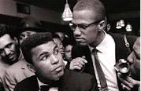encounter between the two was relayed to the Miami F.B.I. office and Ali was now officially a part of the investigation of Malcolm X and the Nation of Islam. The boxer began to take the teachings of Malcolm X seriously and the two became quite close. Malcolm X even wrote that he considered this friendship one of his most treasured in his autobiography. Malcolm would advise and guide the young boxer in his ideology and philosophy towards segregation and Ali was an eager learner and reiterated similarities to Malcolm’s speeches in the public eye. The two had even answered questions and made public statements that started to resemble each other. When Malcolm quoted, “Coffee is the only thing I like integrated” Malcolm’s influence on Ali is apparent when Ali took the metaphor one step further and proclaimed, “I want to integrate my coffee. I don’t want to drink it black. Think I’ll have my coffee weak this morning.”
But they’re relationship didn’t last long when tensions between Muhammad and Malcolm increased. When Malcolm split from the Nation of Islam, Ali decided to remain under the allegiance of Elijah Muhammad. Ali followed his new leader for a decade, but their relationship was nothing like the one he had shared with Malcolm. Malcolm had taught him to love himself and his people and guided him on the evil ways of the white-dominated world. Ali had the ability of people to listen as he spoke and was a role model for all distressed black men who sought to discover their true identity.

Conclusion
The Nation of Islam provided hope for black individuals tired of being discriminated against by the white majority with institutionalized racism. The religion provided these individuals with the opportunity of reinvention, something its leaders personally experienced and instructed their converts to practice. Through their religious ideology and its “practicality”, their charismatic leaders, and influential celebrity figures, the Nation of Islam was incredibly effective in recruiting to that specific demographic. The Nation of Islam tends to be construed as a violent social and political movement exemplifying the phrase “by any means necessary.” But the movement was religious as well. It appealed to a demographic of individuals stuck in the cycle of white institutionalized racism in the United States and gave them an outlet for self-improvement. If a religious group, such as the Muslims, start receiving negative connotations associated with their name, take a few brief moments to look at the religion’s beliefs and how they came to be before shutting them out.

Works Cited
Primary Sources

Federal Bureau of Investigation. 1942. Elijah Muhammad HQ File 01 of 20. File No. 105-24822, Section 1. https://vault.fbi.gov/elijah-muhammad/elijah-muhammad-part-01-of/view.

Federal Bureau of Investigation. 1958. Malcolm Little (Malcolm X) HQ File 04 of 27. File No. 100-399321 Section 4, Serials 23-33, 85. https://vault.fbi.gov/malcolm-little-malcolm x/malcolm-little-malcolm-x-hq-file-01-of-27/view.

Federal Bureau of Investigation. 1963. Malcolm Little (Malcolm X) HQ File 09 of 27. File No. 100-399321 Section 9, Serials 64-79, 142. https://vault.fbi.gov/malcolm-little-malcolm x/malcolm-little-malcolm-x-hq-file-01-of-27/view.

Muhammad, Elijah. History of the Nation of Islam (Phoenix: Secretarius MEMPS Publications, 2006).

Muhammad, Tynetta. “Brief history on origin of the Nation of Islam,” Nation of Islam, https://www.noi.org/noi-history/ (accessed October 15, 2018).

Thompson, Ruby X. “Islam’s Solution to Family’s Problems.” Muhammad Speaks. 31 January 1964.

X, Arnetta. “How Muhammad Reached Into Jungle Regions of the South to Light Her Path.” Muhammad Speaks. 7 May 1965.

X, Malcolm, and Haley, Alex. The Autobiography of Malcolm X. (New York: Grove Press, 1965).

X, Sylane, letter to the editor, Muhammad Speaks. April 1962.

Secondary Sources
Barboza, Steven. American Jihad: Islam after Malcolm X. (New York: Bantam Doubleday Dell Publishing Group, 1994).

Brown, DeNeen L. “Martin Luther King Jr. met Malcolm X just once. The photo still haunts us with what was lost.” The Washington Post. January 14 2018.

Clegg, Claude Andrew, III. An Original Man: The Life and Times of Elijah Muhammad. (New York: St. Martin’s Press, 1997).

Crawford, Maulachi D. Black Muslims and the Law: Civil Liberties from Elijah Muhammad to Muhammad Ali. Critical Africana Studies (Lexington Books, 2015).

Curtis, Edward E. Black Muslim Religion in the Nation of Islam, 1960-1975 (The University of North Carolina Press, 2006).

Jenkins, Roberts L. The Malcolm X Encyclopedia. (California: Greenwood Press, 2002).

Marable, Manning. Malcolm X: A Life of Reinvention (New York: Penguin Books, 2012).

Marsh, Clifton E. The Lost-found Nation of Islam in America (Maryland: Scarecrow Press, 2000).

“Muslims See Contrasts With Nation of Islam: Beliefs: Core tenets of Farrakhan's group have historically differed from mainstream Islam's. Publicity of upcoming Million Man March accents distinctions.” The Los Angeles Times. 14 October, 1995.

Religion News Service, “Muslims See Contrasts With Nation of Islam : Beliefs: Core tenets of Farrakhan's group have historically differed from mainstream Islam's. Publicity of upcoming Million Man March accents distinctions,” Los Angeles Times, October 14, 1995. http://articles.latimes.com/1995-10-14/local/me-56851_1_mainstream-islam.

Roberts, Randy, and Smith, John Matthew. Blood Brothers: The Fatal Friendship between Muhammad Ali and Malcolm X / Randy Roberts and Johnny Smith. (New York: Perseus Book Group, 2016).

Turner, Richard Brent. Islam in the African-American Experience (Bloomington & Indianapolis: Indiana University Press, 1997).

