Department of History
University of Wisconsin Eau Claire

Two Sides of the Same Coin:
A Comparative Study of the Worship of Dionysus in the City and the Country
By: Megan Ward

History 489 Research Capstone
Professor: Dr. Oscar Chamberlain
Cooperating Professor: Dr. Matthew Waters

05-16-16

Table of Contents

Abstract 2
Introduction 3
Historiography 6
Background 8
The Olympian Story
The Zagreus Story
Worship in the City 13
Worship in the Country 20
Comparison of the Settings 24
Conclusion 27
Annotated Bibliography 29
Abstract

Dionysus was one of the main gods worshipped by the ancient Greek peoples. He is most well-known as the god of wine and drunkenness, but there were other aspects to this deity. He was also the god of the vine/fertility, ritual madness, theater, and associated with death in some traditions. Many of the primary sources from ancient Greece are either written or archaeological, and allows a glimpse into the life of these ancient peoples. The ancient Greek peoples acknowledged these different aspects of the god through the myriad festivals and forms of worship in the city setting and the country setting during the 6th and 5th centuries BCE.

Introduction
It is a dark night. From a grove comes the sounds of drums. In this grove, one sees an effigy of a male figure wearing clothes and grape vines. Surrounding this effigy are groups of women dancing with staffs in hand, while others prepare some wine jars in order to pour a libation to the effigy. This effigy is a representation of a male deity. It is a ceremony in honor of the god of wine because of the wine as well as the staffs in the hands of the women which are thyrsus rods and are associated with this deity.
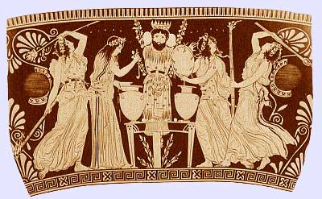
Figure 1 Worshipping Dionysus-Black Figure Pottery
The preceding story would be a way of interpreting what is happening on the above image of black figure pottery from the 6th century BCE. To the Romans, this deity was Bacchus, but to the Greeks, he was Dionysus, god of the vine, wine, fertility, ritual madness, religious/frenzied ecstasy, and the theater. “Twice-mothered, twice-born,” the origins of this god are contradictory in the sources, but the sources do agree that he is a son of Zeus, the king of the Olympian gods. Although the origin stories of this god are contrary and explained in greater detail later in the paper, they represent the complexity of this deity which was expressed in how the Ancient Greek peoples worshipped Dionysus in the city and the country. The public ceremonies celebrating this god in the city were different from the more private ceremonies in the countryside. Even though the modes of worship were different in these settings, they were similar in that they celebrate the god Dionysus and represent different aspects of this deity. Two sides of the same coin to use the colloquial phrase.
The primary sources used for this paper will be primarily written texts like The Homeric Hymns and “The Bacchae” by Euripides, and relevant secondary sources in order to write a comparative religious history piece between the settings of city and country. Studying Dionysus instead of the other gods presents a different perspective on the ancient Greek people. Some of the other gods like Athena, Zeus, and Hera are associated with politics, justice, and civility. Dionysus is the god of wine and frenzy. The iconography or portrayal of this god almost always shows him holding his special wine cup, and being surrounded by his ecstatic followers comprised of men, women, and satyrs which can be seen in figure 2 and 8. The worship of this deity varied in the city setting and the country setting, and these different forms of worship by the ancient Greeks in the 6th and 5th centuries acknowledged the different aspects of Dionysus.
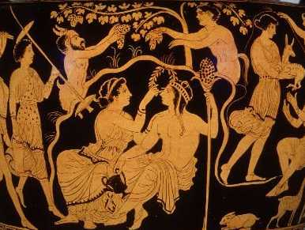
Figure 2 Marriage of Dionysus and Ariadne-Red Figure Pottery
For the purpose of this paper, the time frame has been narrowed down to about the 6th and 5th centuries BCE as this time frame covers the dates of the primary sources being used. There are some sources that fall outside of this span such as the works of Hesiod and Homer, which are dated to around the 8th century BCE as well as the works of Ovid who was a 1st century CE Roman writer, but they are very useful as they tell of the origins of the god. Some of the written sources from the narrowed down time frame include Euripides, Aristophanes, and Herodotus. Some of the other primary sources of this period are archaeological and include pottery, sculptures, and temple remains like the Theater of Dionysus in Athens where plays were held. These primary sources not only offer first-hand accounts of the worship of the god, but also in the case of the pottery, shows how the Greeks viewed this deity. Because of the age of these sources they are open to interpretation especially the archaeological sources, and the written sources are translations done by others which have stood the test of time and come from reliable publishers. Because there are only so many resources from this period of time, and they are all open to interpretation, this has led to a rich historiography and specific conclusions being made about ancient Greek religion and Dionysus.

Historiography
Some of the first research conducted on Dionysus in the 20th century CE was done by Walter F. Otto from Germany. His book Dionysus, Myth and Cult was published in 1965. Even though this book is a little over fifty years old, the information in it is still relevant and can be used today. Otto’s work was one of the first to look at Dionysus from a religious-historical perspective. This book does not focus on just one aspect of the deity, it covers the full gamut of his complexity and the roles he played in Greek religion from his origins to his association with the vine and the theater.
C. Kerenyi was a Hungarian historian and contemporary of Otto whose research was along the same track as Otto’s. Dionysos: Archetypal Image of Indestructible Life was his comprehensive work on this particular deity, and was published in 1976. It looks at the beginnings of Dionysus in the Minoan period which was before 1000 BCE to Roman times in the first century CE. Kerenyi uses a lot of archaeological sources as well as written sources from these times to inform the reader and make his conclusions.
The work of Kerenyi influenced other researchers of ancient Greek religion. One of the leading historians in the study of ancient Greek religion is Walter Burkert. In 1985, Burkert wrote a general overview of Greek religion encompassing all aspects, and this has served as a primary helping tool for all Greek religious historians since its publication because it offers quick access to primary sources and general information about the subject. Burkert’s Greek Religion covers the entire span of ancient Greek civilization from the Minoan period to the Roman conquest of the Greek peninsula. It is an excellent resource since it has chapters about specific gods like Dionysus which will be very important. It is Burkert’s work on cults that is also relevant to this project.
Ancient Mystery Cults was published in 1987. Burkert begins the book by defining what a mystery cult is in the ancient world. “Mysteries were initiation rituals of a voluntary, personal, and secret character that aimed at a change of mind through experience of the sacred.” This definition for ancient cults does not have the negative connotations like the word does today. A cult in ancient times usually referred to any group of people worshipping a particular aspect of a deity. For example, Delphi was the cultic center for the worship of Apollo and the consultation of his oracle. When Burkert uses the term mystery cult, he is meaning that not much is known about these groups of people worshipping particular aspects of deities. Burkert then continues to set up the argument for this book which is to challenge the three major stereotypes associated with mystery cults of “mystery cults being late, Oriental, and religions of salvations” as well as to argue that the mystery cults were not independent religions but were a different and optional way to worship the gods. In order to do this, Burkert compares five cults of the ancient world which were the Eleusinian mysteries of Demeter and Persephone, the Dionysiac/Bacchic mysteries, the mysteries of the Mater Magna or the Mother Goddess, the cult of Isis, and the mysteries of Mithras. He compares these five cults to each other to only prove the stereotypes are outdated, but these five also “suffice to indicated the range of differences as well as the constants in diversity” of the mystery cults. Burkert’s work on the Dionysiac/Bacchic mysteries will be discussed later in the paper.
These are just a few of the secondary sources which have helped in writing this paper. There are countless others as Greek religion and Dionysus in particular remain fascinating topics of research. The one thing this author has noticed with these sources about Dionysus is how they do not connect the worship of this deity in the city to his worship in the countryside. This is the purpose of this paper. In order to gain a better understanding of how the Greeks worshipped Dionysus, a comparative study of the city worship and the country worship will be undertaken. Before discussing how Dionysus was worshipped in the city and the country, who exactly is this deity and where did he come from?
Background
There are two main stories concerning where Dionysus comes from. The first story is something that will herein be called the “Olympian story” as it is the more well-known of the two stories, and the one most people are familiar with due to the abundance of primary sources. Dionysus’s other origin story will be known as the “Zagreus story” because it is the name of the god and is not as well-known nor are the primary sources as numerous for this story.
Olympian Story
Hesiod’s Theogony is one of the oldest written source for the origins of Dionysus. Theogony has been dated to around the 8th century BCE, and is a genealogy of all of the gods in the Greek pantheon as well as the genealogy of some of the more famous heroes like Cadmus and Heracles. According to Hesiod, the lineage of Dionysus is as follows: “To Ares the piercer of shield-hides Cytherea bore…Harmonia, whom proud Cadmus made his wife. To Cadmus Harmonia, daughter of golden Aphrodite, bore Ino, Semele…Cadmus’ daughter Semele bore him [Zeus] a resplendent son in shared intimacy, merry Dionysus, immortal son of mortal mother…” Not only is Dionysus the direct son of Zeus, but he is Zeus’s great-great grandson through his mother’s line as Harmonia, the daughter of Ares and Aphrodite, is the granddaughter of Zeus. He is twice-related to the king of the gods. This is one of the earliest mentions of the god as well as the most basic in language used to describe him.
Another early source telling of the gods and Dionysus in particular is a collected work known as The Homeric Hymns. The Homeric Hymns were once attributed to the poet Homer, but now there is no known author/authors for these poems. The exact dates for when these poems were recorded are not known, however the estimated time period is around the 7th and 6th centuries BCE. Before the hymns were written down, they were usually recited or invoked before special events, festivals, or just by that particular deity’s priest/priestess. There are three poems dedicated to or about the god Dionysus out of the thirty-three that have survived. These hymns are sycophantic when it comes to talking about the gods unlike Hesiod’s basic wording in the Theogony. The first poem to Dionysus is also the first hymn in the collection, but it is also incomplete.
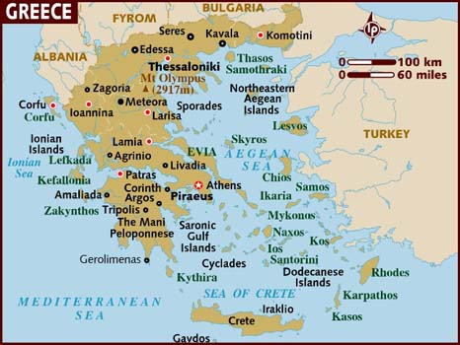
“Hymn 1: To Dionysos” talks about the birth of the god. These details include where he was born. “…it was on Drakanon, Ikaros, Naxos, Thebes…You were born by the Father of men and gods himself…a towering mountain called Nysa…” Thebes is the city where the mother of Dionysus is from while Naxos is an island in the Cyclades in the Aegean, and Drakanon is a city on the island of Kos which is part of the Dodecanese Islands near the coast of Anatolia which is modern day Turkey. Ikaros now known as Ikaria and north of Kos. These are just some of the named places where it was said he was born.
Figure 3 Map of the Greek Islands
These islands place his birth further and further away from mainland Greece with the author saying he was born on a mountain named Nysa. The author does not give any description of where Nysa is located except to say “Far away from the land of Phoinike, near to Egypt’s streams.” This is not very specific, yet Herodotus places Nysa in Ethiopia while other authors like Apollodorus say it is in Asia, but there is no consensus of where Nysa really is located. It does establish that Dionysus was a Greek god born in a foreign land. The next hymn for the god talks about how he traveled from Nysa, and brought his worship with him.
“Hymn 26: To Dionysos” is a very brief poem about the god. “This god much honored in hymns through the wooded glens went wandering, covered with ivy and bay. Behind him followed the nymphs, in front he was leading the way.” From these lines, the nymphs who raised him became his first followers, and the plants of ivy and bay become associated with this deity. The nymphs who followed Dionysus were his caregivers and raised him “remote from humans, in secret from Hera whose arms are pale.” These nymphs became the original followers of the god and followed him from Nysa as he traveled west. These nymphs would be highly honored for “Zeus turned [them] into a constellation, naming them the Hyades.”
Dionysus and his followers traveled west, and the third Homeric Hymn speaks of how Dionysus arrived on the Greek peninsula from the West. “Hymn 7: To Dionysos” is the longest of the three hymns dedicated to the god. In this story, Dionysus is alone. He is captured by some “Pirates moving swiftly over the wine-dark sea, Tyrsenians led by an evil doom.” The pirates thinking they have captured some king’s son because Dionysus is described as “a young man whose prime has just begun; round his sturdy shoulders he wore a cloak of purple” and the pirates want to ransom the god back on shore. The helmsman who is not a pirate tells the pirates not to hurt Dionysus because the helmsman has realized that this is not some mortal but a deity. Long story short: the pirates do not listen to the helmsman, they rough up and restrain Dionysus, and this leads to Dionysus turning the sea into wine, vines growing on the ship, Dionysus turning into a lion, and then turning the pirates into dolphins. The helmsman is spared by the god, and takes Dionysus to wherever he wants to go.
Zagreus Story
There is a brief mention of this story in the Homeric Hymns as well as a brief fragment by Aeschylus, but the bulk of the written sources date after the time of the Roman conquest of Greece in 146 BCE. The story of Zagreus can be found in fragments of the Library of History by Diodorus Siculus, a Roman Greek in the 1st century BCE. According to Diodorus Siculus, Zagreus was another name for Dionysus, and this Dionysus was the son of Zeus and Persephone. Zeus seduced Persephone in the form of a serpent, and she gave birth to Dionysus Chthonius. Zeus then placed the boy on his throne with his lightning bolts to signify this was his heir. The Titans who had been defeated by Zeus previously, saw this boy, tricked him away from the bolts with toys, and ripped him to pieces. Zeus was only able to save the heart of this Dionysus, which he then mixed into a drink, and the drink was given to Semele, the mortal Theban princess who conceived the current Dionysus.
Diodorus Siculus says “He [Dionysus] was also called Dimetor [of the two mothers], they relate, because the two Dionysoi were born of one father, but of two mothers. The younger one [Dionysus] also inherited the deeds of the older [Zagreus], and so men of later times, being unaware of the truth…thought there had been but one Dionysus.” From the story, this first Dionysus was a powerful deity since he was the son of Zeus and his heir, and because he was reincarnated and brought back to life, the newer Dionysus obtained all of the powers of the first Dionysus as well as his own which included power of the vine, wine, and death. Part of this story can be found in the much earlier source of the Homeric Hymns. Hymn 1: To Dionysos is missing a segment, but after the space of where the missing segment is supposed to be, there is a line “But as he cut you in three…” which this author speculates is a brief reference to this older story about Dionysus Zagreus. This older story then leads into another version of the Olympian story of Dionysus which has already been discussed.

Worship in the City
The people living in what is now known as Greece were not a unified people politically. They were citizens of their individual city-states or poleis. The worship of Dionysus in a city environment will focus on Athens as that is the setting for many of the written sources, and is also where the most archaeological evidence has been found. Athens was the name of the urban center of the polis, but the polis also encompassed the area surrounding the urban center which meant the Attic peninsula where Athens was and is located. The months of the year were named for the festivals and/or the gods who were worshipped, and the month was defined by the lunar cycle from full moon to full moon. Also, the temples/sanctuaries of the gods were only open for the festivals of those deities, they were not places where anyone could go in and worship like in modern religions. The most well-known is the Attic calendar which became the longest inscription in Athens on the King’s Stoa, and now only pieces of it survive. Figure 4 is a table based off of the inscriptions showing the name of the month, the Greek word for it on the inscription, and the corresponding month in the calendar used in modern times. All of the festivals to Dionysus were celebrated in the late winter and early spring.
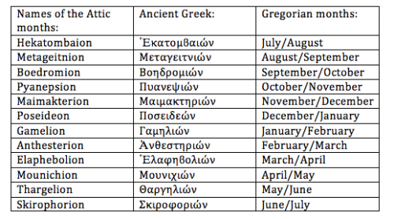
Figure 4 Table of the Attic Calendar
The month of Anthesterion was associated with the festival of the Anthesteria or Festival of Flowers. This festival heralded the beginning of spring, and was the three day festival in mid-February celebrating Dionysus. Festival days began at sunset and ended at sunset of the next day.
The Anthesteria was one of the oldest festivals dedicated to Dionysus in Athens and was known as the Older Dionysia. It celebrated Dionysus giving the gift of the vine to the Attic people, and the aspect of Dionysus for this celebration was known as the Dionysus of the Marshes. It was only during this festival that the sanctuary of Dionysus in the Marshes was open. Thucydides, a 5th century BCE Athenian historian, wrote on how the Anthesteria dates to the time of the first kings of Athens before the Bronze Age, and was celebrated on the 11th, 12th, and 13th days of the month. Apollodorus recounts the story of how Dionysus gave the vine to a man named Icarios. Icarios visited some shepherds who loved the drink so much, they drank the wine without diluting it with water. The shepherds thought they had been poisoned and killed Icarios. When they sobered up, they buried Icarios whose daughter hanged herself when she heard of his murder.
The first day of the festival was called the Pithoigia or Jar-opening. This name came from the word pithoi which was the type of jar used to store wine.
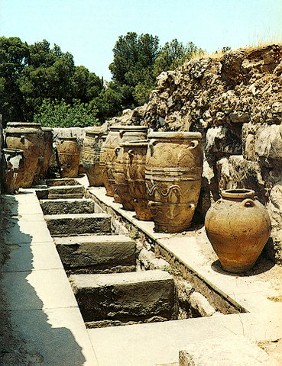
Figure 5 Pithoi at the Palace of Knossos
These jars of wine were usually sealed during the previous harvest, and during this day were opened for tasting. Before the people drank the wine, they carried the jars to the shrine of Dionysus where the wine was mixed with water. “To the ancient Greek, wine was not something which should be taken neat and Dionysus was credited with having taught men how to dilute wine correctly.” This first jar mixture of wine/water was poured as an offering to Dionysus, and then the jars with mixed wine/water were ready for tasting that day. Part of Jar-opening day also had a procession which brought the god to his shrine. A representation of him would be carried on a ship-chariot vehicle. This vehicle signified the god’s connections to the sea instead of the land. One thing that previous historians differ on is when the procession of the god takes place during this festival. Erika Simon contends that it was on the first day of the festival whereas H.W. Parke says that it was on the second day. Logically it makes sense for the first day as that is the day when the god mixes the wine, and the god cannot mix the wine for the people if he is not in his shrine. The second day of the festival was when the drinking was the greatest.
The second day of the celebration was known as the Feast of Choes or Wine jugs. Choes held the wine after it was diluted on the first day. The wine was poured from the choes into the drinking cups or vessels, and the sizes of these jugs vary from child sized to adult as children from the age of three and older could drink on this day as could slaves. On this day at sunset everyone was invited to public and private parties. The guests were to bring their own wine and cup as well as food while the host provided dessert, and this was a reversal from a typical gathering since the host was usually supposed to provide the food and drink. It was a communal sharing among everyone.
There were two aspects of this day that made it different from a typical drinking party. First, the drinking was supposed to be done in silence with no music or talking. Second, the basilinna or the wife of the basileus would be “married” to Dionysus in a mystery ceremony performed in the Boukoleion or the official seat of the Basileus near the Agora. Figure 6 shows a general outline of the center of Athens, and the procession of the Basilinna to her “wedding” with Dionysus ran from the sanctuary of Dionysus to the Boukoleion in the Agora. Referring back to figure 2 which is a depiction of Ariadne marrying Dionysus, this sacred marriage or hieros gamos between the god and the Basilinna is what makes this festival Athenian, and the part of the god was either played by one of his priests or even by the Archon Basileus himself. To explain this part of the festival better, one must revisit the story of Theseus, one of the first kings of Athens during the Age of Heroes. Theseus was one of the nine chosen to go to Crete and be sacrificed to the Minotaur. Instead of the Minotaur eating him, Theseus killed the beast and escaped the labyrinth with the help of Ariadne, the daughter of Minos of Crete. Ariadne left Crete with Theseus, but then he abandoned her on the island of Naxos on the way back to Athens, and Dionysus found her, married her, and had Zeus turn her into a minor goddess. Theseus then became king of Athens upon his return from Crete, and according to Simon, “the Archon Basileus, the successor of Theseus, had to surrender his wife to Dionysus.”
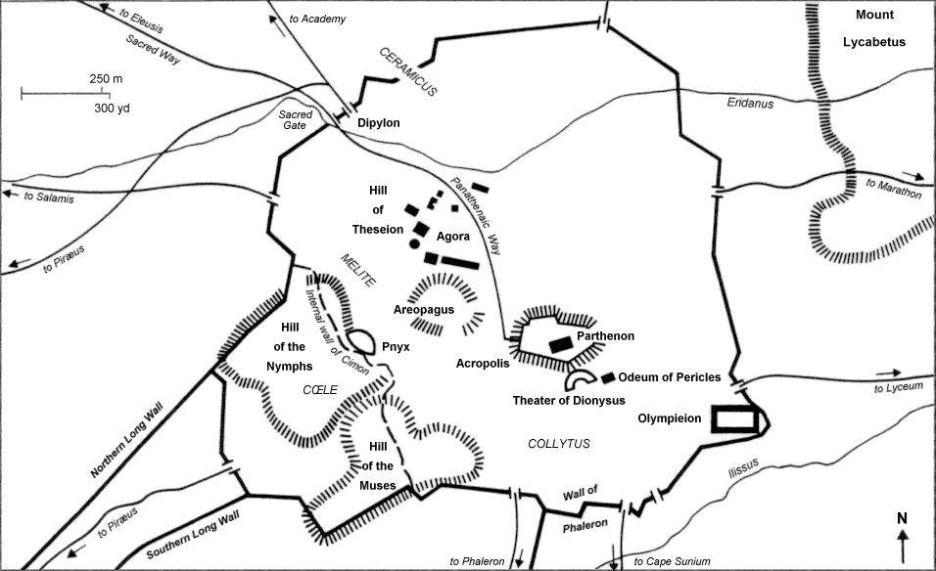
Figure 6 Map of the Athens including Acropolis and Agora
After the hieros gamos between Dionysus and the Basilinna, then it was the third and last day of the festival. The third day was the day of the Pots or Chytrai. The name of this third day comes from the cooking pots used to make food. This last day of the festival was different from the previous two days in that the rites were dedicated to Hermes of the Underworld, and the food and drink prepared were not consumed by the living but were offerings to the dead and their ghosts. At the end of the day, the ghosts were driven out of the city when someone shouted “Get out, the Anthesteria is over.” Why this day was dedicated to the dead and Hermes of the Underworld has only been speculated on by previous historians. They think that it may be in reference to the previously mentioned story of Icarios, and the offerings to the ghosts are to appease the spirit of his daughter who hanged herself while the dedications to this aspect of Hermes acknowledges his role as a psychopomp or guide to the dead. This author speculates that it may also be a slight acknowledgment to Dionysus’ origins in the Zagreus story and his connection to the Underworld, but this is only speculation as there is no evidence to support the theory. The next month of the Attic calendar featured one of the most important festivals to the Athenians.
In the month of Elaphebolion, the Greater Dionysia or City Dionysia was celebrated. If one refers back to Figure 4, this is the month after the Anthesteria. The Greater Dionysia was introduced by the tyrant Pisistratus in the 6th century BCE, and ran from the 9th day of the month through the 13th. Part of the Dionysia festival involved the procession of a highly stylized and large wooden phallus. Accompanying this procession were the priests of Dionysus, a high born maiden who was chosen to carry a basket of grapes and bread, some other followers and the sacrificial animals. The City Dionysia was the same festival as the Rural Dionysia or Country Dionysia except Pisistratus added the performance and competition of plays to the City Dionysia. Both the Rural and City Dionysia celebrated Dionysus Eleuthereus. Eleuthereus refers to Dionysus coming to Athens from Eleutherai which was the border between Attica and Boeotia, and this manifestation of the god was thought of as a land god.
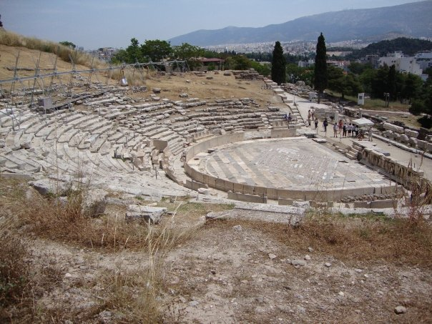
The City Dionysia festival began on the 9th day of the month or mid-March when the image of Dionysus was carried from the Academy to his temple by the outdoor theater. Looking at Figure 6, the location of the Theater of Dionysus is on the southern slope of the Acropolis, and can be seen in Figure 7. With the arrival of the god, the procession of the phallus also arrived at this temple of Dionysus, and the sacrificial animals comprising of goats and bulls were also led to this area where they were slaughtered and the people feasted and drank in celebration of Dionysus.
Figure 7 Theater of Dionysus
It was also during this festival that the great plays of tragedy and comedy were performed. In 534 BCE, the first performance of tragedy took place and is credited to a man named Thespis. The performances were presided over by the priest of Dionysus and a panel of judges who would decide which playwright had the best play. Only a fraction of the plays performed survive to this day which include the works of Aeschylus, Sophocles, Euripides, and Aristophanes who all won the festival prize several times in varying years. The plays would begin with the performance of dithyrambs similar to the Homeric Hymns, then came a day of comedic performances, and then three days of tragedy plays. The winning playwrights would usually give their prizes (if they were bulls or goats) to the god in appreciation for being acknowledged the best playwright. The plays performed during the City Dionysia could be attended by any person whether they were residents of the city or foreign visitors, but slaves could not. This allowance of almost anyone attending the performances is in contrast to the next festival.
A lesser known festival for Dionysus was the Lenaia. There is scant information about this festival unlike the two festivals previously discussed, but what is known will be addressed. The Lenaia was celebrated in the month before the Anthesteria (see figure 4). The Lenaia was a festival celebrating Dionysus Lenaios who was depicted as a column with a bearded mask on it, and the maenads would dance around this idol. “In the Ionic dialect, maenads could also be called lenai.” It was the Festival of the Maenads, and according to Aristotle consisted of a procession and a musical contest. According to Parke, the Lenaia was the “primitive Dionysia” where plays were performed before the construction of the Theater of Dionysus, and only citizens of the polis could attend these performances. This festival as well as the Anthesteria and City Dionysia were the celebrations dedicated to Dionysus in the city.

Worship in the Country
This section will not be quite as extensive as the previous one as there is less evidence and information about how the people worshipped the gods in the country. In using the word country, this author uses it to describe the people living outside of the city or in a rural setting. This section will also mention the mystery cult of Dionysus as it relates to the county setting, but no extensive detail will be addressed as that way leads to a whole other paper which could be written. The sources name one festival that was celebrated in the country that was dedicated to the god, and this was the Rural Dionysia.
The Rural Dionysia or Country Dionysia was the original festival dedicated to Dionysus, and it was from this festival that the Lenaia and the City Dionysia are derived. It had no fixed day in the calendar, but it was celebrated in the month of Poseideon, which is equated to the modern month of late December/early January. This festival was celebrated at different times of the month at the discretion of the various villages in the countryside. At the core of this celebration was the procession of the phallus with the maiden bearing the offerings of grape and vine and the sacrificial goat. Aristophanes, in his play “Acharneans,” portrays a realistic parody of this celebration, but it also shows the simplicity of the festival and lends an air of nostalgia to audience viewers, some of whom were most likely refugees because of the Peloponnesian War. The Rural Dionysia is the only named festival to Dionysus celebrated in the country, but in various locations around Greece like Thebes, small groups of people would gather to worship the god.
One of the only written sources from the 6th/5th centuries BCE depicting the worship of Dionysus by small groups of people in the country setting is Euripides’ play “The Bacchae.” This play was one of the last written by Euripides, and was first performed around 406 BCE. The general plot of the play is as follows. Pentheus, the king of Thebes, has not acknowledged that Dionysus is a god, and will not allow the citizens of Thebes to worship him; while the sisters of Semele, Dionysus’ mother, deny that Zeus impregnated Semele who died when she saw Zeus’ true form. Dionysus, in retaliation, drives the women of the city “mad,” and the women leave the city in order to dance and celebrate this god in a secluded grove located on a mountain near the city. Pentheus, after many warnings from his grandfather and a seer that he must recognize the god, has Dionysus arrested and imprisoned for inciting the women’s madness, but he escapes, and then Pentheus becomes afraid and gets help from Dionysus. Because he refuses to acknowledge the god, he is not aware that it is Dionysus who tells him how to fix his problems, and thus he is tricked into approaching the group of women including his mother, who in a violent frenzy tear him into pieces. The plays ends with Pentheus’ mother and aunts going into exile, and the chorus telling the audience the moral of the story which is there are consequences if one does not acknowledge divinity.
How does this relate to the worship of Dionysus? In one scene of the play, Dionysus arrives at the city gates of Thebes and tells the Chorus, who represent worshippers who followed the god in his travels, to rouse the city and promote his worship. The Chorus then proceeds to tell of how one can worship the god.
On, on! Run, dance, delicious, possessed! O Thebes, be ivy-garlanded, bring sprays of fir, green branches torn from oaks, fringe and bedeck your dappled fawnskin cloaks. O what delight in the mountains! While the swift-footed company streams on. There he hunts for blood, and rapturously eats the raw flesh of the slaughtered goat. Sing to the rattle of thunderous drums, praise Dionysus, god of joy!
The worship of Dionysus involved the donning of a fawn skin robe and a crown made of ivy while also carrying a fennel wand or thyrsus rod. One was then supposed to go to the mountains or at least leave the city, and dance, run, and sing the praises of the god to the music of drums and flutes. These were the proper ways to worship Dionysus, and all were invited to take part not just women. Cadmus, the former king of Thebes, and Tiriseias, an old blind seer, for example in the play, listen to the Chorus, and get ready to leave the city to worship the deity. Figure 8 shows an example of the things talked about in the play. One can see the maenads, who in this instance are women, holding the thyrsus rods and dancing in the retinue of Dionysus while some satyrs dance and play music.
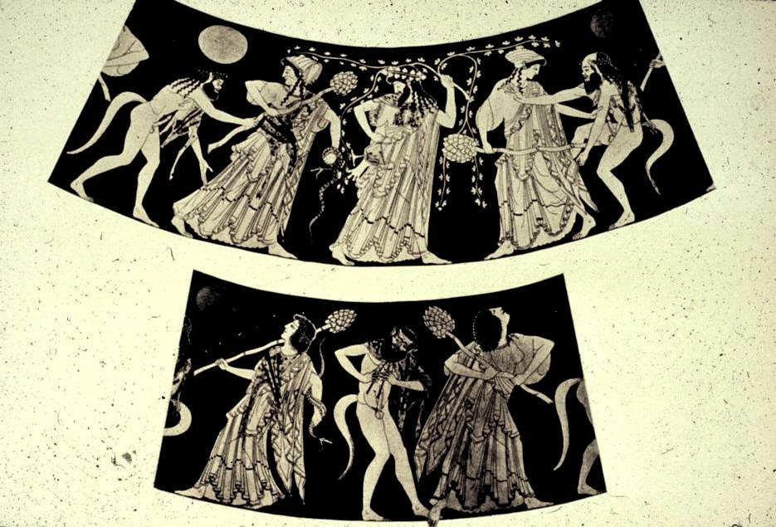
Figure 8 Dionysus, Maenads, and Satyrs
Later in the play there is a second scene describing another aspect of worshipping Dionysus retold by a herdsman to Pentheus. The herdsman tells how the women would be peaceful and calmly picnicking on the mountain drinking milk and wine provided by Dionysus, but when they were disturbed by a group of herdsmen and shepherds, they became angry and chased these men with the intent of killing them. The men escape but their livestock does not, and the animals are ripped to pieces. This scene recounted by the herdsman describes how the worshippers of Dionysus can be peaceful at one moment, but then if they are disturbed, it turns violent quickly, and the worshippers become fierce and filled with the power of the god which allows them to hunt and kill animals and men bare handed. It is part of this aspect of Dionysus’ worship as well as the previous scene which became associated with not just worship of Dionysus outside of the city, but with the followers of the mystery cult of Dionysus/Bacchus.
Those who followed the mystery cult of Dionysus chose to do it, and there was no set place to partake in these rites. The mystery cults of Dionysus could be found in different locations throughout Greece. Not much is known about these rites, but the golden tablet of Hipponion confirms the existence of these mysteries as well as speaks of personal and secret initiations, and the promise of bliss in the afterlife with the mystai and bakchoi or followers of the mysteries being led by Dionysus to the Underworld. In later antiquity during the 2nd century BCE, sexual rites and orgies became associated with the mysteries in Rome and the Italian peninsula, but there seems to be no evidence for this aspect of the rites during the 6th and 5th centuries BCE. These rites were just another way for the people to celebrate Dionysus in the country outside of the city.

Comparison of the Settings
As previously discussed, in the city there were several festivals that were held in the springtime to celebrate Dionysus. Most of these festivals involved lots of drinking by the participants which is a blatant acknowledgment that Dionysus was the god of wine. Besides getting the people drunk, these festivals also illustrate how the people celebrated other aspects of the god. The City Dionysia was a later incarnation of both the Rural Dionysia from the country setting and the Lenaia. This festival incorporated the procession of the phallus from the Rural Dionysia celebration. The procession represents how Dionysus is associated with fertility. The procession brought a phallus to the temple of Dionysus with a basket filled with grapes and vines in order to not only ask the god to continue the growth of grapes to make wine, but also as offerings to the deity in thanks for the previous year of growth.
The Rural Dionysia was celebrated in the late winter months because the people in the rural areas probably did not have anything better to do with their time. To explain better, once the harvest is gathered, and the fields are prepared for winter, the people would not have much to do before spring when they would be busy planting. So they put on a festival of sorts to the gods of growing things like Dionysus. This celebration took place for many years, and when some of those people left the country to go to the city (whether it was because of war or opportunity), then they took these traditions with them, and they become part of a larger celebration in the city. The City Dionysia took place in mid-March because the weather was better for viewing the plays.
The performance of plays during the City Dionysia comes from the previous and older festival of the Lenaia. The plays performed during the Lenaia could only be watched by citizens of the city which excluded women, slaves, children, and foreign born citizens and visitors. This festival declined in importance once Pisistratus instituted the City Dionysia in the 6th century BCE, but the element involving plays carried over into the bigger celebration at the Theater of Dionysus. The plays performed during the City Dionysia could be attended by just about everyone with the exception of slaves which is why good weather was a necessity.
The Anthesteria was primarily a city festival which heralded the arrival of spring. However, it would not have been able to go forward without the wine which had been grown, jarred, and stored by the farmers outside of the city. The farmers brought the wine into the city to be mixed by the priests of Dionysus, sold it to citizens, and then there was a great drinking party. The last day of this festival also tips its hat to the Underworld. The offerings are dedicated to Hermes who was not only a psychopomp for the dead, but was also the god who brought Dionysus to the nymphs after he was born from the thigh of Zeus. It is a “thank you” to Hermes for not only guiding the souls of the dead to the Underworld, but also for his delivery of Dionysus to be raised from youth to adult. The offerings to the dead could also be seen as an acknowledgment of the older origins of Dionysus where he is the son of Zeus and Persephone, the Queen of the Underworld, but there is no written or archaeological evidence to support this theory.
The celebrations and rites of Dionysus in the country setting also demonstrate another side of the god through the people who followed the deity. The donning of a fawn skin and the crown of ivy while holding a thyrsus shows how the people donned the items associated with the god as a way of saying “we are celebrating Dionysus by wearing items sacred to him.” The dancing, running, hunting, and killing of animals by these followers, who had left the urban environment, represents the release of inhibitions of the people, but it also represents the madness experienced by the god at various points in his life. Sometimes this madness would start with a small group of people, but it could then spread to incorporate many other people which is depicted in the play written by Euripides. This was ritual induced madness which the people took as a sign that the god was with them and present in their celebrations and rites.
The ritual induced madness became a part of the mystery cults of Dionysus. Not much is known about these mysterious rites, but they were performed outside of an urban environment. The Zagreus story of Dionysus’ origins became associated with some of the mystery cults of the god, but there is no evidence for if it was for all of them. The mystery cults of Dionysus also become mixed up with beliefs about Orpheus in later times.

Conclusion
Studying ancient history is complex. When one looks at the evidence that is left, everything seems to be connected in some way. This creates difficulties when one is trying to write a paper on a specific topic as the topic can slowly transform from the starting idea into something totally different by the end of the paper. This is particularly true when one is looking at the religious history of peoples from thousands of years ago.
Religion in the time of the ancient Greeks was complicated. Not only were their beliefs complex but religion could in some cases turn political like when the tyrant Pisistratus introduced the City Dionysia to Athens. Nothing was quite black or white or clear cut when it came to the gods of the ancient Greeks. Dionysus is a perfect example of this. The two origin stories of this deity are old and connected. The Zagreus story names him as one of the first gods and the heir to Zeus who was killed and then reborn into the Dionysus of the Olympian story. The Olympian story names him as one of the youngest gods to be born and join the other Olympian gods which is the most well-known story of this god. These stories about Dionysus intertwine with not only each other but with other stories of other gods. The different ways of worshipping this god are also intertwined.
Whether one was living in the city or in the country, Dionysus was celebrated and worshipped in both environments. Most of the festivals of the city involved drinking and were an acknowledgment that Dionysus is the god of wine, but some of the festivals recognized that there was more to him than drinking. Dionysus was a god of many aspects which ranged from life to death. The ancient Greek peoples acknowledged this multi-faceted god through their various forms of worship. The festivals of the city mostly represent the wine and drinking associated with this god while the rites performed in the country setting acknowledge that this deity was a fertility deity of growing things. Whether he was invoked in a secluded glen on a mountainside or in the opening scene of a play in the city, this deity connects the people who lived in the city and those who lived in the country. Nothing about this deity is clear cut or simple as the various forms of his worship demonstrate, but the ancient Greek peoples considered Dionysus as one of the most important gods. “Gods manifest themselves in many forms.” This is certainly true when studying Dionysus.

Annotated Bibliography
Primary Sources
Apollodorus. The Library of Greek Mythology. Translated by Robin Hard. Oxford: Oxford University Press, 1997.
1st/2nd Century CE. It is one of the most comprehensive guides to Greek mythology that has survived. It is based off of earlier sources, and is a good reference.

Aristophanes. The Complete Plays of Aristophanes. New York: Bantam Books Publishing, 2006.
“The Acharneans” was performed in 425 BCE, and is primarily a critique on the follies of war. Aristophanes in his plays is known for commenting on the political and social issues of Athens through the use of comedy. His play “The Frogs” is one of the only plays where the god Dionysus is a principal character and not just an invocation.

Aristotle. Politics. Translated by Benjamin Jowett. New York: Dover Publications Inc., 2000.
4th Century BCE. It is Aristotle’s definitive work on the relationship between a citizen and the city state with emphasis on Athens.

Euripides. The Bacchae and Other Plays. Translated by Philip Vellacott. London: Penguin Book Group, 1973.
“The Bacchae” was performed in 406 BCE. It is about the Dionysiac cult and its participants in relation to their environment, and the consequences of refusing the worship of a god. This play is one of the only plays where Dionysus is a primary character in the play, and not just a reference. The plays of Euripides were known for addressing the complexity of human nature, and trying to understand how it worked.

Herodotus. The Histories. Translated by Aubrey de Selincourt. London: Penguin Book Group, 2003.
5th Century BCE. It is a detailed history of the ancient world covering the entire Mediterranean region as well as the Near East. Based off the travels of the author but how much is true must be correlated with other evidence.

Hesiod. Theogony and Works and Days. Translated by M.L. West. Oxford: Oxford University Press, 1988.
About 8th Century BCE. It is the earliest source for the origins of the Greek Gods and the cosmogony of the Greek pantheon.

Homeric Hymns. Translated by Michael Crudden. Oxford: Oxford University Press, 2001.
About 8th/7th Century BCE. Author/authors unknown, but credit is given to Homer in the title of the work. It is dated to the time of the Iliad and the Odyssey. It contains stories of the Greek gods similar but different from Hesiod’s work.

Ovid. Metamorphoses. Translated by A.D. Melville. Oxford: Oxford University Press, 1986.
1st Century CE. It was written during the time of the Romans, and is the Roman representation of the Greek gods, heroes, and stories as well as some Roman only gods.

Pausanias. Description of Greece: Volume 1. Translated by W.H.S. Jones. 5 vol. Cambridge: Harvard University Press, 1964.
2nd Century CE. It is the travel memoir of the Roman Greek Pausanias who traveled the Greek peninsula and wrote about it in about 5 books drawing on fragments of older works as well as interviews with the people. It is a travel memoir of a sorts.

Thucydides. History of the Peloponnesian War. Translated by Benjamin Jowett. Free translation found on the Perseus Project website through Tufts University. www.perseus.tufts.edu.
This work by Thucydides is primarily about the history of the Peloponnesian Wars between Athens and Sparta, but he does tell of some of the history of Athens including some of the earliest festivals of the city.

Secondary Sources
Burkert, Walter. Greek Religion. Translated by John Raffan. Oxford: Blackwell Publishing, 1985.
This is the definitive piece of scholarship by Burkert. Every secondary source that pertains to Ancient Greek religion published after 1985 cites this work, and is in the bibliography of those secondary sources. Burkert’s work covers not only Classical Greece but also Archaic Greece, and is one of the most important sources for my topic.

Burkert, Walter. Ancient Mystery Cults. Cambridge, MA: Harvard University Press, 1987.
Burkert writes and compares about five of the most well-known cults in the ancient world. This work has helped inform the author about the cult and worship of Dionysus.

Cosmopoulos, Michael B., ed. Greek Mysteries: The Archaeology and Ritual of Ancient Greek Secret Cults. London: Routledge, 2003.
This book is a series of essays that covers a two thousand year span discussing the major cults at Eleusis and Samothrace as well as lesser known ones in Greece including that of Dionysus. Uses not only archaeological remains, but also written sources and iconographic sources as they are available. Because these cults were considered “mysteries” not a lot of evidence is available, but there is enough to draw some conclusions. There are two articles in this work that discuss cultic aspects of the Dionysian mysteries.

Gordon, R.L., ed. Myth, Religion, and Society. Cambridge: Cambridge University Press, 1981.
Series of essays that detail how myth, religion, and society worked in Ancient Greece. Slightly older source, but still has valuable information to provide.

Humphreys, Sarah C. The Strangeness of Gods: Historical Perspectives on the Interpretation of Athenian Religion. Oxford: Oxford University Press, 2004.
Studies the changes in Athenian ritual in correlation to the changing modern perspective of Greek religion. Humphreys argues that the Athenians not only practiced their rituals, but also thought about them and their place in Athenian life.

Isler-Kerenyi, Cornelia. Dionysos in Classical Athens: An Understanding through Images. Translated by Anna Beerens. Leiden: Brill, 2015.
The book follows the progression of images of the god Dionysus as it is presented on pottery from 5th and 4th century BCE. It argues that the imagery did not only show a god of the vine, but a god suitable for happy and sad occasions in Athens.

Jameson, Michael H. Cults and Rites in Ancient Greece: Essays on Religion and Society. Edited by Allaire B. Stallsmith. Cambridge: Cambridge University Press, 2014.
This is a series of essays written by Jameson about the various practices of religion in Ancient Greek society. Stallsmith compiled all of the essays spanning a fifty year range of scholarship in order to make them more accessible for modern readers. Not only uses pottery and sculpture, but also the ruins/remains of important sites in Greece as well as some Etruscan art work. There is an essay about Dionysus in particular that is an interesting read.

Kerenyi, C. Dionysos: Archetypal Image of Indestructible Life. Translated by Ralph Manheim. Princeton: Princeton University Press, 1976.
This is a comprehensive work about Dionysus broken into two parts. The first part covers early Minoan sources and stories about Dionysus, and the second part discusses the god in Greece through late antiquity. The Minoan part discusses the Zagreus story and the god’s relations to the Underworld while the second part talks about his cult in Greece and the festivals of Dionysus in the Greek peninsula.

Mikalson, Jon D. Ancient Greek Religion. Oxford: Blackwell Publishing, 2005.
This is an introductory book to the complexity of Ancient Greek religion. Its focus is primarily on classical Athens, but does introduce the concept of hero worship in a polytheistic society. Uses material sources like sculpture and pottery as well as illustrations/recreations of some of the temples in Greece.

Otto, Walter F. Dionysus: Myth and Cult. Translated by Robert B. Palmer. Bloomington: Indiana University Press, 1965.
This is a study of the myth and cult of Dionysus, and the progression of both through antiquity. It is slightly outdated as it is the translation of the earlier work by Otto in 1933.

Parke, H. W. Festivals of the Athenians. Ithaca, NY: Cornell University Press, 1977.
Parke breaks down the Attic calendar by month, and each chapter is one of the months of the calendar. These chapters discuss the festivals of each month using primarily written sources with some archaeological sources.

Simon, Erika. Festivals of Attica: An Archaeological Commentary. Madison, WI: University of Wisconsin Press, 1983.
This book has a section on the festivals of Dionysus in and around the Attic peninsula. Very well researched work using primarily archaeological sources and written sources.
Sourvinou-Inwood, Christiane. Athenian Myths and Festivals: Aglauros, Erectheus, Plynteria, Panathenaia, Dionysia. Oxford: Oxford University Press, 2011.
The work talks about how myth influenced the named festivals in the title of the book. It also talks about how the Athenian people celebrated the festivals. Uses written sources and archaeological sources.

Thyrsus rods were sticks topped with a pine cone and used in ceremonies worshipping Dionysus. This will be explained later in the paper.
Worship of Dionysus (From an Attic Black Figure kylix) 530 BCE by Exekias (Staatliche Antikensammlungen, Munich, Germany Inv. 2044) Accessed on www.hellenicaworld.com on 01-26-16
Ovid Metamorphoses Translated by A.D. Melville (Oxford University Press: Oxford, 1998) pg. 74, Book 4, line 18
Marriage of Dionysus and Ariadne (Attic Red Figure pottery-krater) by the Creusa Painter ca 380-360 BCE. Toledo Museum of Art, Toledo, OH, USA. Toledo 1981.110
Walter Burkert Ancient Mystery Cults (Harvard University Press: Cambridge, MA, 1987) pg. 11
Ibid, pg. 2-3. According to others before Burkert, mystery cults were viewed as dating around the time of the Romans and the Roman conquest of Greece.
Ibid, 4
Hesiod Theogony Translated by ML West (Oxford University Press: Oxford, 2008) pg. 30-32, lines 936-937, 940-941, 976-977. Cytherea is a name for Aphrodite
The Homeric Hymns ”Hymn 1: To Dionysos” Translated by Michael Crudden (Oxford University Press: Oxford, 2008) pg. 3, lines 1,2, 4, 7
Map of the Greek Islands Accessed through http://www.lonelyplanet.com/maps/europe/greece/
Ibid, line 8. Phoinike is the Greek name for Phoenicia which is on the eastern coast of the Mediterranean in present day Syria and Lebanon.
Herodotus The Histories Translated by Aubrey de Selincourt (Penguin Publishing: London, 2003) pg. 155 Book 2, section 146
Apollodorus The Library of Greek Mythology Translated by Robin Hard (Oxford University Press: Oxford, 2008) pg. 102, Book 3, section 5, paragraph 1
Homeric Hymns, ”Hymn 26: To Dionysos” pg. 76, lines 7-9
Homeric Hymns, “Hymn 1” pg. 3, line 6
Apollodorus The Library of Greek Mythology pg. 102, Book 3, section 4, paragraph 3
Homeric Hymns, “Hymn 7: To Dionysos” pg. 77, line 8
Ibid, lines 3 and 5
Diodorus Siculus Library of History 1st century BCE. Book 4, section 4, line 5. Accessed through http://www.theoi.com/Georgikos/Zagreus.html
Homeric Hymns, “Hymn 1” pg. 3 line 11
Poleis-plural, singular is polis which a general definition means city-state
Walter Burkert Greek Religion (Harvard University Press: Cambridge, MA, 1985) pg. 226. A stoa is a roofed colonnaded building with open walls. Pg. 237 in reference to the opening of the temples
Table of the Attic Calendar http://mythologyrules.tumblr.com/post/63562471917/the-attic-calendar-the-calendar-that-was-used-in . Accessed 03-26-16. A similar version of this table is in Parke’s Festivals of the Athenians
Burkert, Greek Religion, pg. 237
Thucydides History of the Peloponnesian War Translated by Benjamin Jowett < http://www.perseus.tufts.edu/hopper/text;jsessionid=3AC2EB4917504C644E49972E90AEB085?doc=Perseus%3Atext%3A1999.04.0105%3Abook%3D2%3Achapter%3D15 > Accessed 03-26-16
Apollodrous, Library of Greek Mythology, pg. 133, Book 3, section 14, paragraph 7
H.W. Parke Festivals of the Athenians (Cornell University Press: Ithaca, NY, 1977) pg. 107. Pithoi is the plural, pithos would be the singular. Figure 5. Pithoi near a storage room in the Palace of Knossos in Crete. < http://www.travel-to-crete.com/page.php?page_id=104 >
Parke, Festivals, pg. 108
Erika Simon Festivals of Attica: An Archaeological Commentary (University of Wisconsin Press: Madison, WI, 1983) pg. 93
Simon, Festivals, pg. 94
The Athenian government consisted of different groups of men who ruled the city. One of these groups were the Nine Archons who served one year terms. There were 6 archons or thesmothetai in charge of justice and law, the basileus or king who was the “religious leader,” the chief archon, and the polemarch or war leader.
Map of 5th Century BCE Athens. http://plato-dialogues.org/tools/athensim.htm . Accessed on 04-19-16. The path depicted on this map is not exact but an approximation as the sanctuary to Dionysus of the Anthesteria has not been found, and its location is only vaguely referred to in the sources. The arrow head refers to the Boukoleion in the Agora.
Ovid Metamorphoses Translated by A.D. Melville (Oxford University Press: Oxford, 1998) pg. 176, Book 8 lines 158-186
Simon, Festivals, pg. 97
Parke, Festivals, pg. 116
Simon, Festivals, pg. 103
Theater of Dionysus. Taken May 2009. Own picture
Parke, Festivals, pg.128
Simon, Festivals, pg. 102
Ibid, pg. 100
Aristotle Politics Translated by Benjamin Jowett (Dover Publications: New York, 2000) Ch.57, section 1.
Parke, Festivals, pg. 104-105. A person was considered a citizen if they were a man of Athenian birth and of age.
Aristophanes “Acharneans” The Complete Plays of Aristophanes Translated by B.B. Rogers (Bantam Publishing, New York, 2006) line 247 pg. 25. The Peloponnesian War was between Sparta and Athens from 432 BCE to 404 BCE. The Spartans had invaded and ravaged the country surrounding Athens which led to the people fleeing to the city and the protection of its walls. It ended in 404 with the surrender of the Athenians.
Euripides “The Bacchae” The Bacchae and Other Plays Translated by Philip Vellacott (Penguin Publishing: London, 1973) pg. 194-196, lines 69-197
Dionysus, Maenads, and Satyrs. Facsimile drawing of entire Kleophrades red figure vase to show detail, vase dates to Classical period. https://pantherfile.uwm.edu/prec/www/course/mythology/0700/dionysus.htm . Accessed 04-29-16
Euripides, “The Bacchae” pg. 216, lines 695-751
Walter Burkert Ancient Mystery Cults (Harvard University Press: Cambridge, MA, 1987) pg. 5
Demeter was a goddess of growing things as well specifically grains like wheat. At times, her rites would be mixed with those of Dionysus, and in later times both of their mystery religions became linked.
Hera, the wife of Zeus, had a nasty tendency to punish the illegitimate offspring of her philandering husband. She drove Ino, one of the nymphs caring for Dionysus mad, and even inflicted madness on Dionysus himself. The most famous example of this madness was when Heracles slaughtered his family in Hera-induced madness.
In a lesser known story, Orpheus met his demise at the hands of a band of maenads. (Ovid’s Metamorphoses is the source.) Dionysus then punished the maenads by turning them into trees. Orpheus was also connected to the Underworld. This is where some problems come in as the discussion of the Dionysiac mysteries becomes entangled with Orphic beliefs and the Eleusinian mysteries of Demeter/Persephone, and this is a whole other paper in and of itself which is why it is only briefly touched upon.
Euripides, “Bacchae,” pg. 244 line 1388

