DEPARTMENT OF HISTORY
UNIVERSITY OF WISCONSIN – EAU CLAIRE

FRIENDS AND FOES: MILWAUKEE JOURNAL’S AND SENTINEL’S CHANGING DEPICTIONS OF THE KLAN, 1920-1928

HISTORY 489: RESEARCH SEMINAR
PROFESSOR: DR. JONATHAN W. TRUTOR
DREW R. CRAMER
FALL 2011

Copyright for this work is owned by the author. This digital version is published by McIntyre Library, University of Wisconsin Eau Claire with the consent of the author.
TABLE OF CONTENTS
ABSTRACT…………………………………………………………………..……………….…3
INTRODUCTION…………………………………………………………..……………….…..4
HISTORIOGRAPHY OF THE WISCONSIN KLAN….………………..………………….…7
HISTORIOGRAPHY OF THE NATIONAL KLAN……………….…..………………….…10
METHODOLOGY……………………………………………………..…………………….…12
BACKGROUND……………………………………………………………………..……..…..15
EARLY YEARS OF WISCONSIN KLAN: 1920 – September, 1921.…….…….……….…...18
SHIFTING DEPICTIONS: THE KLAN FROM SEPTEMBER, 1921 – 1924…………..……22
THE KLAN AFTER 1924……..………………………………………………………….….…27
CONCLUSION…….…………………………………………………………….….….………31
APPENDICES………………………………………………………………….….…….……..34
APPENDIX A…………………………………………………………………………...34
APPENDIX B…………………………………………………………………………...39
APPENDIX C…………………………………………………………………………...40
BIBLIOGRAPHY………………………………………………………………..…….………49

ABSTRACT
The Ku Klux Klan of the early twentieth century became nationally recognized in large part due to media and political investigations. Though national recognition from newspapers is acknowledged and documented well in historical research, this phenomenon has not been analyzed in many specific locales. This research seeks to analyze the media’s role in the Milwaukee, Wisconsin Klan, and is contextualized by the greater Wisconsin and Indiana movements. The analysis identifies changing media depictions, from rather positive depictions of the fraternal order to predominantly negative portrayals, and notes potential causal factors for this change over time, including overarching national trends.

INTRODUCTION
The Ku Klux Klan of the early Twentieth Century was an organization varying significantly in how it operated in different areas of the United States. Whereas violence by the Klan was certainly common in some southern areas of the country, Klan violence was negligible in a place like Wisconsin – an area without a high African American demographic. Though some Klan attributes varied across city, state, and regional lines, one unarguable truism about the Klan across the nation is that the media paid attention to it. Even when considering the beginning of the second wave Klan in 1915, it is apparent that media attention worked to catalyze this movement. An illustration of this concept can be seen through William J Simmons, the man who led the restoration of the Klan in the early twentieth century. Simmons utilized the media from the beginning, when he chose to put his plans into action just as The Birth of a Nation, the silent film romanticizing the Reconstruction era Klan, was released in theatres. But it was not until more media attention was given to the Klan that Simmons newly established fraternal order was noticed in much of the country.
The media was again utilized in 1921, when the Klan made headlines in the New York World, a prominent newspaper at the time. The World made headlines with exposés into the national Klan that attempted to illuminate corrupt organizational operations, which sparked Congress to investigate into the fraternal order. These congressional investigations themselves were also covered by the World, and all these articles were magnetically popular to readers across the country picking up the paper. William J Simmons would note in later years, and quite accurately, that the media attention allowed the Klan enough exposure to make it a national force: “’It wasn’t until the newspapers began to attack the Klan that we really grew,’ he [Simmons] reminisced years later. ‘Certain newspapers also aided us by inducing Congress to investigate us. The result was that Congress gave us the best advertising we ever got. Congress made us.’” It is generally acknowledge by scholars of the Klan that Simmons was chiefly referring to the World as the newspaper that pressured Congress to investigate. Researchers in this area also largely agree with Simmons assessment – that is, that the World really helped give the Klan the advertisement, and even infamy, that would have otherwise been far too expensive, if not priceless. If national newspapers were to have such a massive effect in making the Klan a household name of the early twentieth century, it seems reasonable to consider how local newspapers worked to build up support on a smaller scale too.
In the 1920s, the Milwaukee Klan opportunistically used the World headlines on the Atlanta Klan as a way to catalyze their own efforts to build a solid foothold for the fraternal order in the city. In tracking media depictions of the Klan in the city through the Milwaukee Journal and Sentinel, it appears that there was not much exposure of the Klan early on, and what was printed was largely negative. Even with a predominantly negative depiction of the fraternal order early on, the exposure was in an area – Wisconsin – that did not realize the Klan was a local reality. However, as the Klan became established in Wisconsin over time, the depictions by the Journal and Sentinel were not only quite positive in many cases, but appeared in much more frequency. Once the Wisconsin Klan peaked in population and exposés of local Klan organizations became rampant across the country, these two newspapers shifted toward a predominantly negative depiction. Thus, even though negative exposure of the Klan could initially help establish the organization in Wisconsin, these newspapers eventually echoed the larger trends of Klan popularity in the city and state, including organizational decline.

HISTORIOGRAPHY OF THE WISCONSIN KLAN
The particular topic with which this piece is focused, the Wisconsin Klan of the 1920s has a few specific themes that scholars have concentrated on. Historians writing on the Wisconsin Klan have taken several approaches: the narrative format, analyses of causal factors for the decline of the Klan, and particular focus on Klan leaders in Wisconsin.
Perhaps the single most important piece of secondary literature related to the Wisconsin Klan during the twenties was Norman Frederic Weaver’s Doctoral thesis, entitled “The Knights of the Ku Klux Klan in Wisconsin, Indiana, Ohio, and Michigan.” Completed in 1954, Weaver’s analysis largely took a narrative format, also relying heavily on sociological and political analyses, bringing a fairly strong sense of interdisciplinary ideas to his writing. In terms of sociology, Weaver illuminates psychological perceptions, how quickly they develop in the human mind, and synthesizes these ideas in terms of larger social organizations, such as fraternities. Weaver’s main point in bringing in sociology is ostensibly to introduce early in his writing that race and racism are social constructs, and that the institutionalized nature of these constructs creates a strong disposition toward racist tendencies in individuals. In terms of political analysis, Weaver primarily focuses on the way in which the Klan became a strong political machine in some areas, such as Indiana, where the Klan had significant influence in political affairs. Interdisciplinary methods aside, Weaver’s work was primarily of the informative and narrative style, with definite attention paid to the politics of the Wisconsin Klan. That is, Weaver was illuminating the information on the Wisconsin Klan of the 1920s into the historical record through the narrative format. Though there were not many other major writings dealing specifically with the Wisconsin Klan, a few of them also carried out this informative, narrative theme to their writing. These include Gordon Lee’s and John Turcheneske’s Master’s theses.
Lee’s work, “The Ku Klux Klan in Wisconsin in the 1920s,” though of the narrative spirit, does direct its attention toward poor leadership as a major cause for the decline of the fraternal order. Klan leaders in the state, such as the viciously anti-Catholic Pat Malone, are focused on in Lee’s thesis to explain Klan decline. Turcheneske’s “The Ku Klux Klan in Northwestern Wisconsin” is a narrative that illuminated specific strategies – such as targeting education and religious figures to gain rapport in communities – that the Klan used to add legitimacy to its cause. There were only a few other scholars to write on the Wisconsin Klan in particular, though other authors have certainly written quick overviews of the Wisconsin Klan in the context of the wider movement. Of the few other scholars to write on the Wisconsin Klan, one perspective appears to be something of a media analysis. Written for the field of journalism and mass communications, Darcy Seavers’ Master’s Thesis, “Women in the Hood: Women in the 1920’s Ku Klux Klan Publications,” appears to be directed toward publications and journalism, based on the field and title of the writing. Yet, the thesis is not readily available from Minds@UW, so only the field and title of the writing can give any hints to the direction her research went in. Other than the aforementioned, the Wisconsin Klan of the twenties has not been analyzed with respect to other specific themes or topics. For the purposes of this research, the Klan’s depiction within select Milwaukee newspapers – both the local and national Klan depictions therein – is simply something that has not been analyzed yet. Though media analysis with respect to the Klan has been done for other localities, such as Indianapolis, and on a national scale, this topic hasn’t been looked at in any depth in Wisconsin.

HISTORIOGRAPHY OF THE NATIONAL KLAN
Broad themes and forms of analysis with respect to the Klan on a national level were much more diversified and shifting over time. Yet, as was the case with the Wisconsin Klan, the informative, narrative theme was initially used with the analysis of the overarching organization, too. Perhaps the best known comprehensive scholarly writing on the Klan was Hooded Americanism, by David Chalmers. Using the narrative format, Hooded Americanism looks at the Klan in all of its incarnations, from Reconstruction to the Civil Rights era Klan. Chalmers is largely analyzing the organization through a political lens in his research, and notes the political power the Klan had throughout the country. Other researchers on the national Klan address the topic as political historians too, such as The Ku Klux Klan in American Politics, written by Arnold Rice. Wyn Craig Wade’s The Fiery Cross: the Ku Klux Klan in America is another example of a narrative overview of the Klan in the United States, looking at specific themes of politics, leadership, and violence in his book. The Fiery Cross also makes an attempt to do something of a social history of the Klan within the survey, which has been another popular lens for scholars to look at the Klan through.
Analyzing the Klan from the perspective of a social historian has been a common thread in Klan historiography. Take, for example, Nancy MacLean’s Behind the Mask of Chivalry: The Making of the Second Ku Klux Klan, which makes social connections across countries to help explain the rise of hate groups globally. That is, MacLean uses the social realities of the time – heightened nationalism after the end of World War One, isolationism…etc. – to explain not just the rise of the Ku Klux Klan as a hate group, but also the rise of fascism in Europe. Similarly, Chester Quarles’s The Ku Klux Klan and Related American Racialist and Antisemitic Organizations : A History and Analysis, uses the social paradigm to find causal factors for the rise of hate groups – not just the K.K.K. – in America. One more scholar to work with the social history lens for analyzing the Klan is Kenneth T. Jackson, in his book The Ku Klux Klan in the City, 1915-1930. Specifically, Jackson is also something of a revisionist, reframing common conceptions about the 1920s Klan as largely a rural movement, when in fact cities were a hotbed for the organization too. Taken together as whole, political and social histories seem to be the general focus of much of the writing on the national Klan, with the narrative being the common frame to write from.
There has been little scholarly writing focusing on media portrayals of the Wisconsin Klan in particular. There has been wider analysis of the overall Klan with respect to the media, such as in John M. Shotwell’s Crystallizing Public Hatred: Ku Klux Klan Public Relations in the Early 1920s. Shotwell’s analysis of public relations with respect to the national Klan is certainly interesting and informative research with respect to what this research is doing for Milwaukee specifically. Klan newspaper analysis in specific locales had been done for other areas of the country though, such as in Indiana. Bradford Scharlott’s Hoosier Journalist and the Hooded Order; Indiana Press Reaction to the Ku Klux Klan in the 1920s was a great source for identifying potential methods of historical media analysis. So, though similar studies to this have been done before, none have targeted Wisconsin in specific, let alone Milwaukee newspapers. Nevertheless, these other studies certainly helped in the creation of a cohesive methodological structure for this research.
METHODOLOGY
Literature on the Wisconsin Klan of the 1920s was somewhat narrow, and so, to get a solid understanding of the Wisconsin movement as a whole, Weaver’s monograph was instrumental. Weaver’s monograph also helped point to the most important set of primary sources on the 1920s Wisconsin Klan, which are unarguably Russell Lynch’s Milwaukee Journal articles. Lynch’s articles focused on the inner workings of the Klan, and were released between April eighth and sixteenth of 1928. Lynch, who was forced into membership through threat when he snuck into a Klan meeting, had a great breadth of knowledge of how the Klan came to be in the badger state. Weaver’s work utilized these newspaper articles, and he also interviewed Lynch, and was confident in the reliability of these narratives. This research therefore trusts both Weaver and Lynch’s judgment and understanding of the fraternal order. Scholarly sources on the Klan in its entirety, as well as literature on the 1920s generally, were quite vast in comparison. There were few scholarly sources analyzing the media with respect to the Klan, but those available were instrumental in the creation and direction of this writing. Through the use of primary sources of primarily newspapers and government documents, as well as secondary literature on the Klan and the 1920s era, this paper analyzes changing depictions of the Klan through Milwaukee news sources, the Journal and Sentinel, and places these changes in the wider context of the Klan’s rise and decline in Wisconsin. Several reasons were at play in choosing these specific newspapers.
There were a few practical considerations in choosing both The Milwaukee Journal and Sentinel for this research. For one, looking through microfilm of newspapers for articles related to the Klan would have proven to be a particularly monotonous and slow process if any interesting results were to be attained. The Journal and Sentinel were both digitized and available online, with the option of searching for key terms. Thus, these two newspapers would be more readily available to the researcher, and the search process to find Klan articles within them would be less tedious. Another element at hand in choosing these two papers were their popularity during the time period in which the research was concerned. Daily circulation for the Milwaukee Journal was 107,564 in 1920, and grew to 165,378 by 1928. Information available on the circulation of the Sentinel is less comprehensive, but is put at 78,973 in 1923, 66,400 in 1924, and 55,819 in 1925. These statistics place these papers in the top 3 of all Milwaukee papers through this period in terms of circulation – with the Wisconsin News being the other paper. Though the Sentinel jumped between second and third most circulating paper in the city, it was in the top three throughout regardless of the decreasing circulation mentioned above. Given the importance of the Milwaukee Journal and Sentinel in this paper, research on these two newspapers was also essential and helpful in contextualizing information.
Perhaps the most difficult aspect of this research was simply determining what constituted a positive, negative, or neutral depiction of the Klan by these newspapers. Again, Bradford Scharlott’s article on Indiana journalists followed a similar scholarly approach in tracking media depictions of the Klan, and, thus, using it as a template made these determinations come easier. So, using Scharlott’s work as a model, the following questions were used to determine newspaper depictions:
- Did the article give more time to the Klan and their perspective, or those against the Klan? If more time is given to the Klan, it tended to be a pro-Klan article
- Was the commentary by the writer on quotes from Klan or anti-Klan individuals in support of their words or not? Supporting Klan rhetoric within the article would certainly make it a positive depiction of the organization.
- Was the Klan mentioned with respect to political corruption or violence? Who was the aggressor in the violence? The aggressor tended to be depicted negatively.
These were generally all of the criteria necessary in determining an article’s perspective. In fact, Klan depictions were usually unambiguous – that is, it tended to be pretty clear-cut as to whether the article was positive, negative, or neutral in depicting the Klan. If the article appeared in any way difficult to categorize based on the abovementioned criteria, it would simply be marked as neutral. Much of the criteria echo Scharlott’s, which was succinctly highlighted as the following:
In assessing coverage of the Klan, articles (including editorials) were judged as favorable to the Klan if on the whole promoted the Klan’s own positions – for example, that the organization was socially beneficial, or overwhelmingly popular, or that its parades and gatherings were awe-inspiring. Newspapers that published such articles in effect acted as arms of a Klan public relations campaign. In categorizing the articles, particular attention was paid to the use of sources; articles that relied heavily or entirely on Klan spokesmen generally were judged favorable to the organization. On the other hand, articles were considered unfavorable if they depicted the Klan as socially undesirable of ineffectual or debilitated. The remaining articles were judged as neutral to the Klan.

Other stipulations seemed logical as the research was being conducted, such as the exclusion of bulletins. These short messages tended to have too little substance to accurately gauge as positive or negative, and often seemed neutral based on the criteria formulated in this research to assess them. Though the methodological structure is quite similar to Scharlott’s own work, this research synthesizes Scharlott’s evaluation of the Indiana press to Milwaukee’s, a region of the country less engrossed in the Klan movement. Therefore, this research attempts to bring a comparative analysis of how the media intertwined with the Klan during the 1920s such that the variance of this organization across locales can be illuminated.

BACKGROUND
The Milwaukee Journal was established on November sixteenth, 1882, in a small room on Mason Street, in Milwaukee. The paper was originally intended to be a Democratic-oriented newspaper, as the creators, Peter Deuster and Michael Kraus, had intended. Twenty-two days after the establishment of the newspaper, Lucius Nieman took over many of the important roles of the Journal, as “its co-owner, editor, reporter and occasional typesetter.” Formerly associated with St. Paul’s Dispatch newspaper, and having quit a managing editor job just before, Nieman bought out Deuster’s part in the paper, which is what allowed him the abovementioned roles. Nieman would be the leader and most remembered individual with respect to the establishment of the Milwaukee Journal as a prominent paper in the city.
Nieman’s ideal was for the paper not to have an extreme political leaning, but strive for a balanced perspective. Not only did Nieman want an even-hand in approaching political matters, but also to keep a strong focus on local news – that is, any national or global news would come from other national newspapers. These were some of the broad strokes of the Journal initially, and even into the 1920s, the time period to which this research is concerned, there were remnants of this ideology.
As new leaders joined the Milwaukee Journal, similar ideals to Nieman’s were still represented, though the paper admittedly began to look more cosmopolitan. Such leaders include Harry Grant, who joined in 1915, and Marvin H. Creager, who joined in 1920. Creager was noted as believing that Milwaukee’s own territory was still of primary editorial importance. That is, the Journal overall began to recognize that, even located within the largest population of any city in the state, it did not want a style that was too cosmopolitan. Thus, by the period with which this research is concerned, we are situated with a newspaper in Wisconsin’s most populous city which wants to remain localized in a lot of the news it reports from its own writers. While there is much more information with regards to the Milwaukee Journal, the above mentioned is a sufficient baseline for understanding analysis of Klan articles, which will be done later in the paper. While information on the Journal was plentiful, the Sentinel was somewhat harder to research.
The Milwaukee Sentinel was established on June twenty-seventh, 1837, by Solomon Juneau, one of the early pioneers of the region eventually becoming Milwaukee. Juneau’s goal in creating the Sentinel was merely to have a paper that could compete with the Milwaukee Advertiser. After the death of the newspaper’s first editor, John O’Rourke, Harrison Reed was quickly hired for the position. O’Rourke, the original editor, states in the first issue of the Sentinel that the paper would be:
“…a disseminator of the facts; an asserter of the truth; a vindicator of the innocence and virtue; a censor of vice; an advocate of the just ‘claims’ of settlers; a promoter of harmony and social order in the community; a defender of rights of honest occupants; a detector of fraud, imposture and crime; and a vigilant Sentinel on the ramparts of Liberty and Democracy.”
A noble and idealistic ethos to start the newspaper with, there is some more concrete information the newspaper espoused early on.
Perhaps the most important piece to consider about the Sentinel in terms of its relation with the Klan was its political affiliations. As noted in Robert A. Witas’ Master’s thesis, “On the Ramparts: A History of the Milwaukee Sentinel,” the newspaper initially was politically Democratic, but shifted toward a Whig Party allegiance after Reed took over as editor. The paper was Republican leaning during the era to which this research is concerned. Though Republican, the paper was still very much against LaFollette and the Progressive movement, as well as socialist politics. Given the popularity of Socialism in Milwaukee, and, oddly enough, Klan support of some Socialist politicians, this position is particularly worth noting.

EARLY YEARS OF WISCONSIN KLAN: 1920 – SEPTEMBER, 1921
As mentioned in the introductory anecdote, the media was part of the mechanism utilized in creating initial interest in the national Klan movement, particularly through D.W. Griffith’s A Birth of a Nation. Later on, the media provoked congressional investigations into national Klan activity, and later covered the investigations in articles – chiefly through The New York World. Just as the national Klan received exposure and benefitted from the media initially, so did a Wisconsin Klan in trying to create a following itself.
Though the second awakening of the Ku Klux Klan officially occurred in 1915, it wasn’t until the early 1920s that it began making headway in the nation. In fact, during the early years of the Klan in Wisconsin – 1920-1922 – it was essentially lying dormant, waiting to be stirred into action. The beginning of the Klan in Wisconsin occurred in Milwaukee, where a request was made by a group of professionals to the Atlanta headquarters – that is, the national headquarters – for someone to come and speak about the organization to them. When a national member did indeed come to speak to a group of Milwaukee’s business class, the Klan was essentially born. The meeting was kept small and relatively secret, and was even placed aboard the U.S.S. Hawk – an American naval vessel. It was with this meeting that the Milwaukee Provisional Klan number one of Milwaukee was established.
Initially a social club called the “Milwaukee Businessman’s Club,” the meetings were casual and not geared toward creating a high member count. Though some gestures – newspaper ads – were made to gather membership in the early years, they did not garner much attention. It wasn’t until late in 1921 that the Milwaukee Journal exploded with articles that gathered exorbitant amounts of attention.
The Milwaukee Journal picked up articles by the New York World beginning on September 6th, 1921. Just as the national movement made use of the media to establish itself with A Birth of a Nation, so did the Wisconsin movement. The Journal’s exposure was in an article titled “Unmask Ku Klux Klan as ‘Terror Rule’ Force: Sweeping Quiz Exposes ‘Invisible Empire’ as Huge Profit-making Enterprise and Menace to Security in All States.” In Wisconsin, and states all across the nation picking up the World’s story, the Klan became an insanely popular topic of discussion. Inflated figures of the popularity of the organization in these articles, and the vehemently negative depiction of the Klan, helped make the fraternal order appear infamous in the eyes of many citizens. So, although the depictions were in fact negative toward the organization, it was this massive exposure of the Klan through the Milwaukee Journal that gave organizers in the state a footstool to launch a larger campaign with. Indeed, once these articles from the New York World were released in the Journal, there was a quick realization that the Klan grabbed interest in readers. Though the new media exposure of the Klan in Wisconsin certainly aided the rise of the organization there, other factors were at play concurrently.
While the media exposure from newspapers like the Journal and Sentinel helped garner Wisconsin interest in the fraternal order, other changes were occurring at the same time. For example, the Journal picked up the Klan exposés by the World, there were also shifts in leadership within the Wisconsin Klan occurring. Former King Kleagle – a term essentially meaning the Klan officer of the state – of Wisconsin, a man named Mitchell, was being replaced by the end of 1921. The new leader of the Wisconsin Klan, William Wieseman, took over and rode the Klan to peak popularity in the state. Wieseman was chosen for the job in large part due to his ability to attract popularity to Masonic festivities, another fraternal order which he was a member and leader. Klan members figured he would be a perfect fit to attract members. Though Wieseman was picked for his ostensible leadership abilities, in practice he was not a major factor in the rise of Klan popularity in Milwaukee or the state. Other cultural realities and responses to a changing world were much more central to Klan popularity.
The early 1920s lay just after the end of World War I, which, at that point in time, was viewed predominantly as the bloodiest and most shocking event the world had ever seen. There were, of course, many reactions and changes in American culture as a result of such a climactic event. One such idea, and one that is rightfully acknowledged in much of the historical analysis of the Klan, is the concept of one-hundred percent Americanism. Simply put, one-hundred percent Americanism was an ethos in response to World War I, which resulted in a heightened prioritizing of nationalism and conformity in the United States. Political initiative such as the Sedition Act, which gave the government more flexibility in prosecuting socialists and other non-conformists, were ways of forcing a sense of patriotism for government initiatives – whether right or wrong. The Klan merely took this conformity a step further, by projecting a concept of “one-hundred percent Americanism” that essentially said white, Anglo-Saxon Protestants were the only true Americans. Though these other cultural and organizational factors played a role in ushering in Klan popularity in the state, the World articles were nevertheless the centerpiece to recognition in Wisconsin. The vast majority of Wisconsinites did not realize the Klan was in their state, or even re-established again, before the World articles. These exposés catalyzed the recognition that the Klan was a functioning Wisconsin organization in September of 1921, not just a secret society from the Reconstruction era.

SHIFTING DEPICTIONS: THE KLAN FROM September, 1921 – 1924
From late 1921, when the World articles were distributed to a national audience, until 1924, the Klan had a notable presence in Milwaukee, and Wisconsin as a whole. Total enrollments throughout the era of the second Klan is estimated to be somewhere around 75,000 members, though it should be mentioned that data was not always gathered and kept by Klan leaders throughout the twenties. While historians estimate the total membership was around 75,000, they put the figure of peak active members at any one time to somewhere in the realm of 38,000. It was during the period of 1922 to 1924 where this peak active membership was reached. This range of years also saw the depictions of the Klan by the Journal and Sentinel shift more positively.
Whereas there were essentially no positive articles toward the Klan in these newspapers before the World articles, positive depictions appeared with some frequency thereafter, as is shown in the data below:

Table 1: The Milwaukee Journal and Sentinel Depictions of the Klan, September 1921 – 1928
 | Strong Klan Period in WI  (September 1921 – 1924). |  |  |  | Weak Klan Period in WI  (1925 – 1928).
 | Pos. | Neg. | Neut. | Total | Pos. | Neg. | Neut. | Total
Journal | 7 | 4 | 3 | 14 | 1 | 14 | 2 | 17
Sentinel | 5 | 3 | 5 | 14 | 1 | 15 | 7 | 23
Total | 12 | 8 | 8 | 28 | 2 | 29 | 9 | 40
% | 42.8 | 28.6 | 28.6 |  | 5 | 72.5 | 22.5
Source: Author’s personal research. Sources compiled for this data are located in Appendix A.
The data above was evaluated and gathered based on the criteria mentioned in the “METHODOLOGY” section. As is particularly notable in the case of both of these newspapers, September 1921-1924 saw a fairly radical shift in depictions toward the Klan compared to the other era compiled (the Klan after 1924). The Klan was much more likely, on average, to be depicted in a positive or neutral light from September 1921 to 1924. Though the peaking popularity in the state would certainly be one readily identifiable reason that the depictions may have shifted, other factors seem readily responsible for these shifting portrayals too.
Though the peaking Klan popularity between September 1921 and 1924 give some reason for more positive newspaper depictions, the reasoning is a bit more involved. Other possible motives could simply be the news writer’s sympathy toward the Klan. In fact, even if writers were not personally involved with the Klan, there is one thing they did know: That articles on the Klan got attention. Norman Weaver’s dissertation, “The Ku Klux Klan in Wisconsin, Indiana, Ohio, and Michigan,” notes a certain mindset of many newspaper writers that could help explain the shifting depictions of the Klan:
“Newsmen were delighted to satisfy this curiosity [of the Klan] by filling their columns with news of the latest Klan Kluxings. Once they had made their discovery that the Klan held the readers’ interest, the newspapermen of the decade never allowed the Klan issue to die. Week after week, month after month, year after year, the Klan remained NEWS. Nearly every edition of every paper featured articles about the Klan…”

Considering the intersection between the growing membership of the Klan and the media mindset that the Klan sells, it seems reasonable that writers not only mention the Klan more often, but also to mention it positively. Though Klan popularity and newspaper reactions to this reality help to explain the shifting representations, there are certainly other elements at play too.
Another consideration in explaining why the portrayals of the Klan were so positive during the era is simply that many of the editorials were wired from out of state – commonly from Indiana and New York. That is, even though the Journal and Sentinel featured the articles, they had no control over precisely what the content, and therefore depiction of the Klan, was. The only area of influence these two newspapers had for outside editorials were the titles that were given. Thus, many of the shifts in portrayals mark a larger trend nationally of the Klan’s rise in popularity. The overall concept of Klan depictions shifting more positively during peak Klan popularity in the Journal and Sentinel echoes Scharlott’s research on the Indiana Klan in the table below:

Table 2: The Number of Favorable, Unfavorable, and Neutral Klan-related Articles, Identified in Each Paper for Both Periods of the Analysis

Newspaper  (1921 Circulation) | Strong Klan Period  (1921 – April 1925) |  |  |  | Weak Klan Period  (April 1925 – 1927)
 | Pos. | Neg. | Neut. | Total | Pos. | Neg. | Neut. | Total
Bloomington Daily Telephone  (1,150) | 4 | 1 | 5 | 10 | 1 | 7 | 14 | 22
Bluffton Evening News  (2,534) | 3 | 3 | 5 | 11 | 0 | 4 | 16 | 20
Columbus Evening Republican  (3,320) | 1 | 4 | 6 | 11 | 0 | 1 | 13 | 14
Franklin Evening Star  (2,710) | 3 | 0 | 1 | 4 | 0 | 3 | 6 | 9
Gary Evening Post  (5,996) | 7 | 3 | 7 | 17 | 0 | 13 | 9 | 22
Greensburg Daily News  (2,945) | 4 | 1 | 4 | 9 | 0 | 6 | 7 | 13
Greencastle Herald  (1,235) | 0 | 0 | 0 | 0 | 0 | 0 | 0 | 0
Indianapolis News  (114,995). | 4 | 7 | 10 | 21 | 0 | 5 | 8 | 13
Muncie Star  (24,995) | 4 | 3 | 6 | 13 | 1 | 1 | 8 | 10
Richmond Palladium  (11,878). | 4 | 0 | 11 | 15 | 0 | 13 | 27 | 40
Totals | 34 | 22 | 55 | 111 | 2 | 53 | 27 | 163
% | 30.6 | 19.8 | 49.6 | 100 | 1.2 | 32.5 | 66.3 | 100
Source: Adapted from Scharlott, Bradford W., “Hoosier Journalist and the Hooded Order,” Journalism History 15, no. 4 (1988): 122-131.
Though Scharlott breaks down his periods of time a bit differently than this research, the higher rate of “favorable” illustrations of the Klan during Indiana’s period of peak Klan popularity is mirrored by the Journal and Sentinel. The Indiana research notes that, during the period of Klan strength, anti-Klan Indiana editors had threats of violence waged against them, forcing conformity and “favorable” illustrations. In a sense, Russell Lynch, editor of The Milwaukee Journal, dealt with a similar scenario by being forced into the Klan through threat of violence. The forced membership was in part a way to insure Lynch would not write anything negative about the Klan at the time. Though the extent of Klan threats of physical violence toward newspaper employees cannot possibly be ascertained accurately in Milwaukee or Wisconsin overall, Lynch’s story does show that it was a reality. Other pressures for positive Klan depictions were presented in other media outlets of the 1920s as well.
Further research into Milwaukee Newspapers would undeniably yield more comprehensive and accurate results into the shifting portrayals of the Klan. Some important newspapers to consider in future research in this area include The Badger American and The Wisconsin Kourier. Both of these newspapers were very much sympathetic to the Klan, and were released at many Klan meetings across the state. With article headings such as “The Sickening Sentinel” from The Badger American, the potential for research into media wars between different papers over the Klan issue could add significant depth to the understanding of the Milwaukee media’s interpretation thereof.

THE KLAN AFTER 1924
Many of the major Journal and Sentinel articles focusing on the Klan after March, 1925 illuminated Stephenson’s situation that was occurring in Indiana. D.C. Stephenson, the leader of the Indiana Klan, found himself in a heap of political trouble in late 1924 and early 1925, when he was accused and eventually convicted of rape and murder of Madge Oberholtzer. From the Sentinel and Journal articles examined in this research during and after 1924, Stephenson’s story was the most common Klan topic to be in the headlines. These exposés were all negative portrayals of Stephenson and the Klan, for fairly obvious reasons. Klan corruption in states besides Indiana.increasingly came up in Journal and Sentinel headlines after 1924 as well. In the data compiled by the Journal and Sentinel after 1924, only five percent of the articles depicted the Klan in a positive light, compared to the 42.8 percent during the strong Klan period:

Table 3: The Milwaukee Journal and Sentinel Depictions of the Klan, 1925 – 1928
Weak Klan Period in WI
(1925 – 1928).
 | Pos. | Neut. | Neg. | Total
Journal | 1 | 2 | 14 | 17
Sentinel | 1 | 7 | 15 | 23
Total | 2 | 9 | 29 | 40
% | 5 | 22.5 | 72.5
Source: Author’s personal research. Sources compiled for this data are located in Appendix A.

Corruption in the Wisconsin organization even came up in the Milwaukee Journal in 1928. In fact, it was these exposés that are the groundwork for much of the Wisconsin Klan research of this era.
Russell Lynch’s articles, which appeared between August eighth and sixteenth, were a comprehensive series of interpretations of the Klan in Wisconsin through the 1920s. More importantly though, Lynch, as well as the plethora of other writers across the nation, were following a general trend of exposing corruption of Klan organizations across the nation. The reality of Lynch and other writers following an exposé trend mirrors not just the World articles, but also the custom of positive depictions during Klan popularity. That is, there are distinct media themes related to the Wisconsin Klan during the scope of this research.
Similar to the popularity and mass appeal created by the World articles, the multitude of reports illuminating local Klan corruption became the craze in lieu of Stephenson’s headlines. Both circumstances show reporter attempts to illuminate Klan corruption. The primary difference was that the World articles worked to help the Klan, while later local exposés essentially marked the decline and fall of the 1920s order. Despite various similarities between the 2 sets of corruption exposures, there are significant differences that help explain why one helped the order so well – the World – while the other did not – local exposés.
Part of the reason for the latter series of articles, by writers such as Lynch, marked the decline and fall of the twenties Klan is that there simply were not many individuals communities (like Milwaukee) left to attract. That is, the sharp increase in membership between 1921 and 1924 was pervasive enough to attract the vast majority of individuals that would have thought of joining in a city like Milwaukee. Thus, once dirt like Stephenson’s surfaced in newspapers, such as in the Journal and Sentinel, the information could only have a neutral to negative depiction. On the other hand, when a very anti-Klan depiction was sold to the Journal by the New York World, most citizens in Milwaukee did not even know the Klan was an organization in their city. So, though the World articles were viciously negative, they gave the exposure and advertisement that was necessary in 1921. Sense that advertisement was already attained by 1924-1925, the local exposés were not able to attain that same positive impact for the organization. While the time period and status of citizen knowledge about the Klan were significant factors, other macro-level perspectives of many people had shifted too.
Another element to consider that contextualized Klan decline in the 1920s was the proximity of potential corruption. In other words, around the time that Stephenson’s corruption became a central topic in newspaper articles across the nation, citizens began to direct their attention toward potential corruption in their own local organizations. Of course, newspaper writers began to focus on their own locales and expose the corruption there.
Larger trends that were changing from the early 1920s to the mid and late-1920s in the United States hint toward explanations for Klan decline in Milwaukee. One trend was the concept of “One hundred percent Americanism,” which had substantial merit in the early 1920s, but not nearly as much influence later on. This is to say that the appeal of extreme patriotism that became particularly popular in war time had time to wane, and, by the mid to late-1920s, the Klan could not appeal to this frame as successfully as it formerly had. The fear of war was just one of many reactive dispositions the Klan espoused in creating popularity. Many other fears the Klan capitalized had also reduced by the time of Klan decline – such as fear of Romanism (and particularly a Roman Catholic president) and immigrants. It is also possible that Victor Berger and other Socialist leaders worked against the Klan’s nationalistic appeal of one hundred percent Americanism in Milwaukee, further weakening Klan advertising schemes. Yet, the Klan in Milwaukee was notable for allying with Socialists in many cases, so this argument gets complicated – far too much for the extent of this research.

CONCLUSION
Two of the highest circulating newspapers of Milwaukee between 1920-1928, the Journal and Sentinel, are fantastic case-studies in acquiring an understanding of Milwaukee newspaper portrayals of the Klan over time. Both papers reflect a strong bias in their coverage, as the newspaper’s depictions changed so drastically between the strong and weak Klan period. Certainly there must have been a sense of giving people what they wanted, which was undeniably the sensationalism of the Klan during this time. Though the number of articles is somewhat limited in this case study, it does appear that the Journal had stronger positive depiction of the Klan in their paper, as compared to the Sentinel. The figures during the strong period show the Journal at a fifty percent positive depiction rate, versus the Sentinel’s thirty-six percent during the same period. In fact, compared to Scharlott’s research of ten Indiana newspapers, the Journal had the highest percentage of favorable depictions of the Klan during the period of Klan strength. When considering that the Journal was a large metropolitan paper that bought many of its national stories from other papers, the Journal’s depiction is in many ways a function of the national newspaper depictions, though editors and other members of the Journal staff chose these articles specifically. With thirty-one of thirty-seven of the Journal’s articles being stories related to Klan organizations outside the state, and written out of the state, the national scope of the Journal is given more statistical credibility. Nevertheless, trends on both local and national levels appeared to shift in favor of the Klan much more often between September, 1921, and 1924. It is also worth noting that the Journal is illuminated in its historical roots as being a paper dedicated to, in Lucius Nieman’s ideal, “an analysis of the pros and cons without taking a stand.” Then, it makes sense that many of the Klan headlines within the state, written by Journal staff, were mostly neutral. Yet, most of the articles that the Journal acquired from other papers were still certainly full of political biases, and simply did not live up to the un-biased ethos Nieman and later leaders of the paper desired.
Then, the overwhelmingly negative depictions of the period of Klan decline make sense, given this reality. Also, the Wisconsin Klan’s angle of marketing itself as a friendly fraternal order, much the same as Freemasonry or the Knights of Columbus, helped explain why more positive-oriented articles may have been picked up by these two Milwaukee papers. That is, these papers featured articles from across the nation that depicted the Klan in a way that echoed their local depictions. The same case holds true for the weak Klan period, when exposés of Klan organizations outside Wisconsin came to mirror the corruption that Russell Lynch highlighted in his articles of the Milwaukee and greater Wisconsin Klans. That is, the popularity of these other expos’es made the Wisconsin area ripe to receive exposure of local corruption. Much more general in the analysis of how depictions of the Klan shifted was seen in the nature of journalism altogether.
The political affiliation of Klan members varied widely across different locales. In the case of Milwaukee in particular, there was support between Socialists and Klan members toward one another. This is precisely the opposite of the case for many Klan organizations across the nation, who were viciously anti-Socialist. Thus, it is difficult to ascertain if political biases from the Journal and Sentinel help explain their depictions of the 1920s Klan when regional associations varied so significantly. When considering such radical shifts in depictions across the two sub-periods with which this research is concerned, regardless of their affiliations, it appears that the portrayals were much more dependent on other causal factors, such as regional and national popularity, and sensationalism.
Thus, there was a strong overall sense that these two major Milwaukee newspapers were in a position of struggling between theoretical idealism and pragmatic realities of their audience. In the case of the Journal particularly, Nieman’s ideal of an even-handed analysis of news was sideswiped for the sensationalism and elevated interest that Klan articles instilled in readers. Predominantly positive depictions of the Klan during the period of Wisconsin Klan growth help illuminate the papers focus on what makes money, and also what caters to changing societal perceptions of the fraternal order. When perceptions shifted toward seeing the Klan as a largely corrupt institution, which was largely catalyzed by D.C. Stephenson in Indiana, the Journal and Sentinel adapted to this paradigm through their shifting depictions – from positive depictions to exposés.

APPENDIX A

List of articles analyzed in compiling depiction of the Klan in both the Journal and Sentinel (found in tables one and three):

Sentinel Local

“Free Marinette Klan Rioters.” The Milwaukee Sentinel, November 10, 1926.

“Mob Burns Ku Klux Klan Tent in Marinette.” The Milwaukee Sentinel, June 26, 1926.

“Klan Band, No Ham and, Blue; One Nearly Canned.” The Milwaukee Sentinel, August 13,
1925.

“Klan Charge Called a ‘Lie’ by Zimmerman: Governor Candidate Attacks Tactics of ‘Madison
Ring.’” The Milwaukee Sentinel, August 28, 1926.

“Klan Publishes ‘Bootleg’ List.” The Milwaukee Sentinel, May 3, 1926.

“Zimmerman Denies Klan Membership: Slanderers, He Calls Those Who Say he Belongs to
Order,” The Milwaukee Sentinel, July 13, 1926.

Sentinel National

“80-Foot Cross Glares on City in Hood Ritual: Robed Pastor Flays Evolution Friends.” The
Milwaukee Sentinel, August 10, 1925.

“600 Quit Klan as U.S. Menace.” The Milwaukee Sentinel, January 6, 1926.

“Alleged Klan Corruption Doesn’t Reach Them, Judge Told.” Milwaukee Sentinel, October 27,
1926.

“Empress of Klan Talks of Policies: Woman Leader Asserts Secret Order is Not Lawless
Organization.” The Milwaukee Sentinel, September 10, 1921.

“Evans is Named in Klan Killing.” The Milwaukee Sentinel, April 3, 1928.

“Harding Backs Man Opposing Friend of Klan: Indorses Fusion of Texas Republicans and
Independent Democrats in Fight on Mayfield.” The Milwaukee Sentinel, October 24
1922.

“Indiana Center of Klan Dominancy: Indianapolis Boasts it is ‘Star’ in Realm of Knights.” The
Milwaukee Sentinel, November 6, 1923.

“Klan Accepts Governor’s Order: Oklahoma Kluxers Put Ban on Masked Meetings.” The
Milwaukee Sentinel, September 11, 1923.

“Indiana Klan Charges Fail.” The Milwaukee Sentinel, December 25, 1926.

“Indiana to Press its Fight on Klan.” The Milwaukee Sentinel, February 23, 1928

“Injunction Against New York Klan Granted by Judge.” The Milwaukee Sentinel, August 15,
1923.

“Jury Accuses Grand Dragon as Instigator: Practice is Likened to Period of Spanish Inquisition.”
The Milwaukee Sentinel, October 16, 1927.

“Klan and Legion Swing Fists at Vets’ Ceremony.” The Milwaukee Sentinel, November 29,
1923.

“Klan Expects to Acquire University Next Week.” The Milwaukee Sentinel, August 19, 1923.

“Klan Keeps Open House Despite Martial Law.” The Milwaukee Sentinel, September 18, 1923.

“Klan Organizers Held.” The Milwaukee Sentinel, September 11, 1923.

“Klan Purchase of University Asked: Valparaiso School Control Offered Knights of Invisible
Empire.” The Milwaukee Sentinel, July 26, 1923.

“Klan Through with Politics, Evan Says.” The Milwaukee Sentinel, March 13, 1926.

“Klan Wins Election at Grand Forks, N.D.” The Milwaukee Sentinel, April 8, 1926.

“Man and Dusky Bride Flee Wrath of Klan.” The Milwaukee Sentinel, April 26, 1926.

“Mild Blow at Klan Voted by Legion: Resolution is Passed After pro and Anti Measure Fail.”
The Milwaukee Sentinel, October 19, 1923.

“Militia, Facing Inquiry, Disarms.” The Milwaukee Sentinel, March 20, 1928.

“More Trouble.” The Milwaukee Sentinel, October 31 1928.

“Murder, Riots Laid to Klan.” The Milwaukee Sentinel, August 7, 1927.

“New Anti-Bonus League Formed: Failure to Agree Causes Early Adjournment of Discussion.”
The Milwaukee Sentinel, October 18, 1923.

“Reed Starts Indiana Klan Slush Probe.” The Milwaukee Sentinel, October 20, 1926.

“Reed to Probe Klan Charges.” The Milwaukee Sentinel, October 14, 1926.

“Slush Inquiry to Reveal Big Contributors: Wets and Klan Also to be Called on Senate Carpet.”
The Milwaukee Sentinel, June 26, 1926.

“The Alabama Mystery.” The Milwaukee Sentinel, October 12, 1927.

“Vermont Center of Vote Interest: Elections Will be Held in Many States on Tuesday.” The Milwaukee Sentinel, November 6, 1923.

“Walton Will Quit if Klan is Fought: Governor Offers Resignation if Anti-Klan Act Passes.” The
Milwaukee Sentinel, October 10, 1923.

Journal Local

“1,200 Applaud Klan Speaker: Organizer Waves Flag in Denouncing Jew, Catholic and Negro.”
The Milwaukee Journal, October 6, 1922.

“Deny Klan Use of Auditorium: Board Adopts Resolution Forbidding Rental Organization.” The
Milwaukee Journal, October 19, 1922.

“Klan Down to 600; Once Boasted 5000.” The Milwaukee Journal, July 28, 1925.

“Klan Poisoning Voters, Charge: Democratic Chief Says Organization is Factor in State
Politics.” The Milwaukee Journal, October 12, 1922.

“Kluxer Fined; Will Quit Klan: Malone Pleads Guilty to Slander; to Expose Order, He Says.”
The Milwaukee Journal, June 5, 1927.

“Kluxers, Foes Back Official Blaine Ousted: Governor Twisted on Facts of Recent Troubles,
Grand County Residents Say.” The Milwaukee Journal, September 6, 1924.

“K.K.K. Locked Out? Perhaps: Nobody is Just Sure, but Tabernacle is Not in Use.” The
Milwaukee Journal, May 5, 1926.

“State Klansmen to Show Blaine: Governor’s Attack to be Countered by Series of
Demonstrations.” The Milwaukee Journal, September 6, 1924.

Journal National

“3 Bricks Tell Klansmen that Death is Near.” The Milwaukee Journal, October 21, 1922.

“Absense of Klan Plank a Victory, Says Bryan.” The Milwaukee Journal, June 30, 1924.

“Allies Do Not Trust Watson: Indiana Senator, with Klans Aid, Out to Get what he Can.” The
Milwaukee Journal, June 8, 1928.

“Asks Klan to Bare Names of Floggers.” The Milwaukee Journal, July 12, 1927.

“Dawes May be on the Carpet: Summoned by Coolidge for Conference After Klan Speech.” The
Milwaukee Journal, August 25, 1924.

“Defends Klan Finance Policy: Wizards Answers Graft Charge at Quiz; Flays Witness.” The
Milwaukee Journal, October 13, 1921.

“Ex-Klan Chief Goes to Trial: Stephenson Charged with Murdering Indianapolis Girl.” The
Milwaukee Journal, October 12, 1925.

“Foes of Klan Open Office in Milwaukee.” The Milwaukee Journal, October 21, 1922.

“Gen. Dawes Pussyfoots Again.” The Milwaukee Journal, August 25, 1924.

“Girl Missing in Klan Quiz: Dragon’s Stenographer Sought in Connection with ‘Black Box.’”
The Milwaukee Journal, October 15, 1926.

“Hammer Slain Buried by Klan; Widow Held.” The Milwaukee Journal, November 6, 1925.

“Klan Dragon Taken Before Indiana Jury: Stephenson is Removed from Cell to Tell of Political
Scandal.” The Milwaukee Journal, July 30, 1927.

“Klan Financed Negro Weekly.” The Milwaukee Journal, July 13, 1927.

“Klan Influence Wanes, Report: Indications are Order Will Not be Big Election Factor.” The Milwaukee Journal, February 5, 1928.

“Klan Mexico’s Ally, is Claim: $2,000,000 Spent to Fight Coolidge Policy, Democrat Asserts.”
The Milwaukee Journal, March 11, 1927.

“Klan Parodies Baptism Rites: Initiation Ceremony of Klan and Death Threat Bared,” The
Milwaukee Journal, September 13, 1921.

“Klan Prejudice’ Plea is Failure.” The Milwaukee Journal, February 27, 1928.

“Legion Attacked as Heir of Klan.” The Milwaukee Journal, May 16, 1927.

“Our First Woman Governor.” The Milwaukee Journal, August 25, 1924.

“Pistols Guard Murder Jury: Bailiffs Threaten Gang Attempting to Tamper with Klan Trial.” The
Milwaukee Journal, December 19, 1923.

“Several Hurt in Klan War: Police at Dawn Break Up All-Night Fight in Massachusetts.” The
Milwaukee Journal, July 30, 1924.

“Tear off the Klan’s Mask.” The Milwaukee Journal, October 25, 1926.

APPENDIX B
Information on Circulation of Milwaukee Journal and Sentinel

The Milwaukee Journal Circulation Information, 1920-1928

Year | Daily Circulation | Sunday Circulation
1920 | 107,564 | 95,074
1921 | 111,862 | 87,593
1922 | 114,755 | 90,043
1923 | 118,555 | 103,107
1924 | 126,988 | 121,548
1925 | 132,748 | 125,421
1926 | 148,314 | 148,798
1927 | 158,115 | 167,611
1928 | 165,378 | 198,043
Source: Data adapted from Will C. Conrad, Kathleen F. Wilson, and Dale Wilson, The Milwaukee Journal: The First Eighty Years (Madison: University of Wisconsin Press, 1964), 215.

The Milwaukee Sentinel Circulation Information, 1923-1925.

Year | Daily Circulation
1923 | 78,973
1924 | 66,400
1925 | 55,819
Source: Data adapted from Robert A. Witas, “On the Ramparts: The History of the Milwaukee Sentinel.” Master’s thesis, University of Wisconsin – Milwaukee, 1991. 70.

APPENDIX C

Part of Russell Lynch’s Article – April Eighth, 1928:
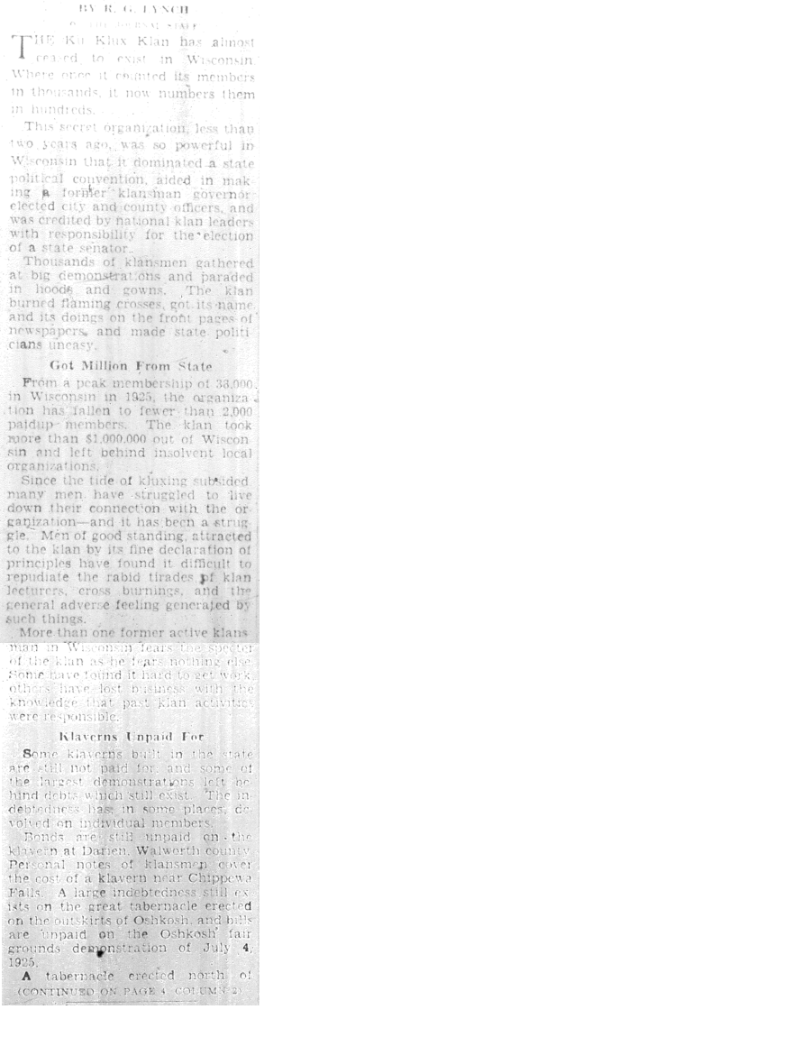
Russell Lynch’s Article – April Ninth, 1928:
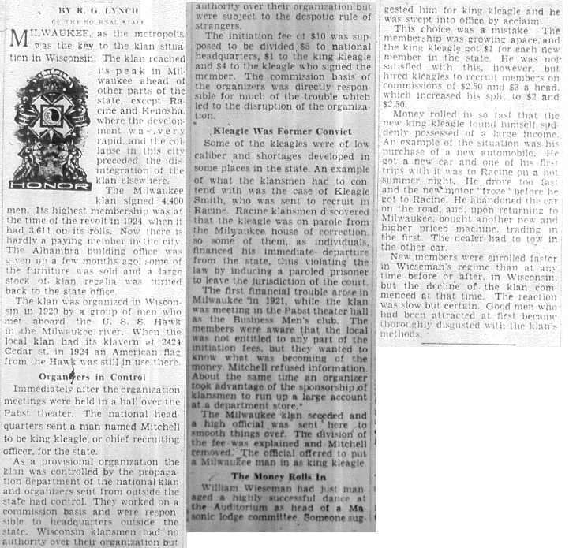

Russell Lynch’s Article – April Tenth, 1928:
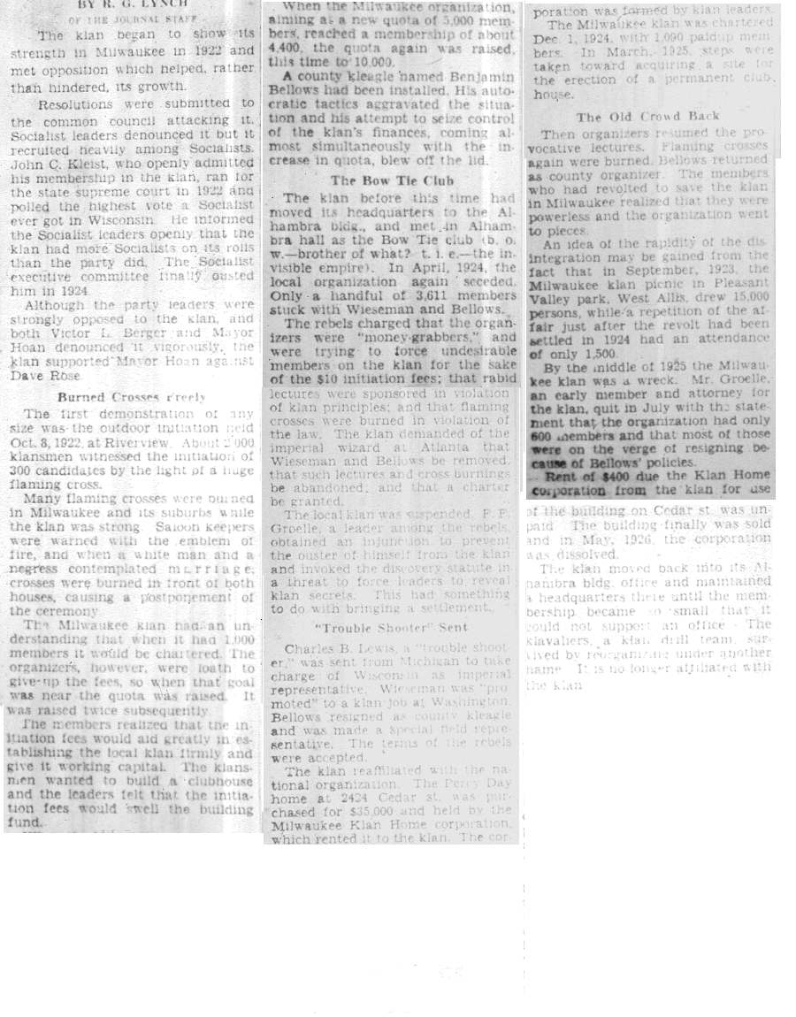

Russell Lynch’s Article – April Eleventh, 1928:
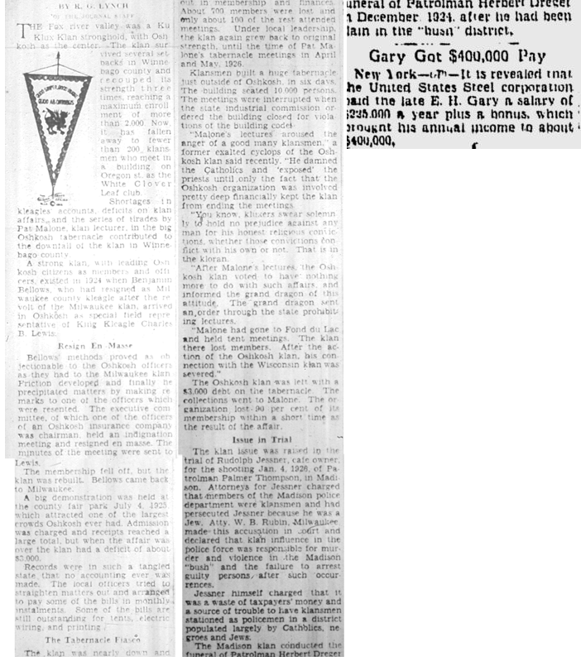

Russell Lynch’s Article – April Twelfth, 1928:
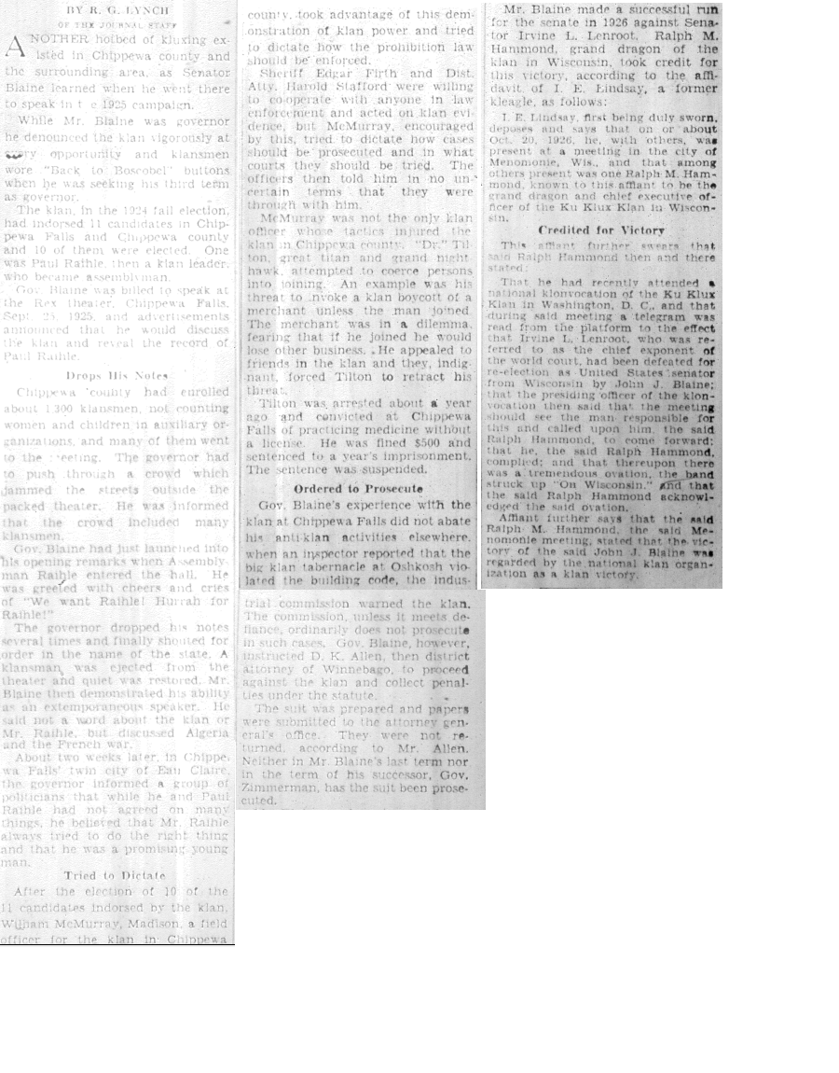

Russell Lynch’s Article – April Thirteenth, 1928:
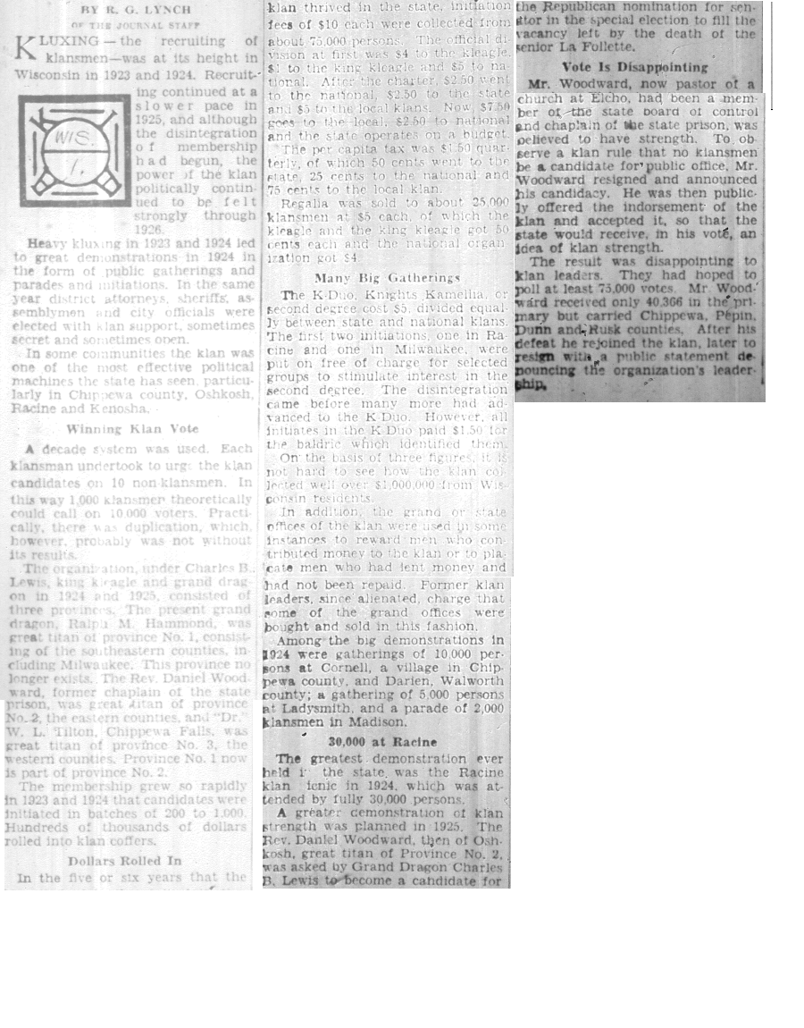

Part of Russell Lynch’s Article – April Fifteenth, 1928:
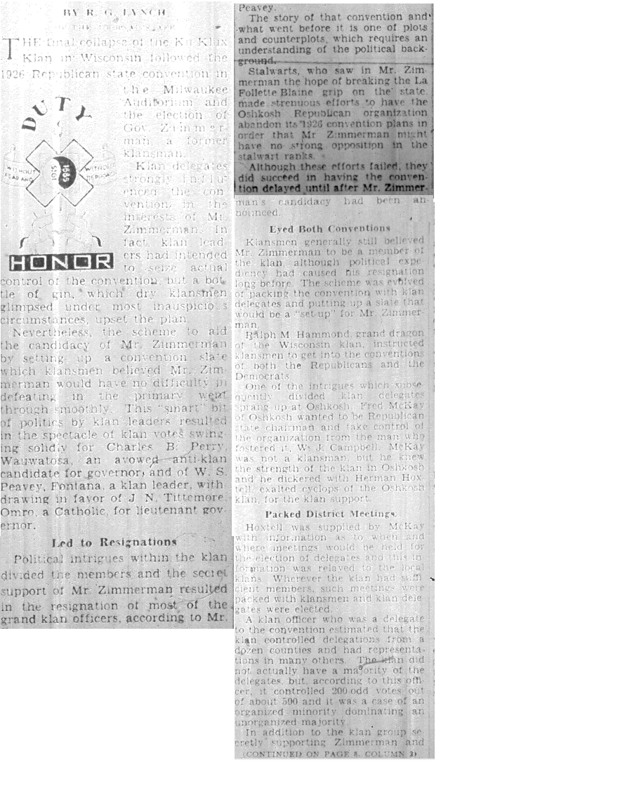

Russell Lynch’s Article – April Sixteenth, 1928:
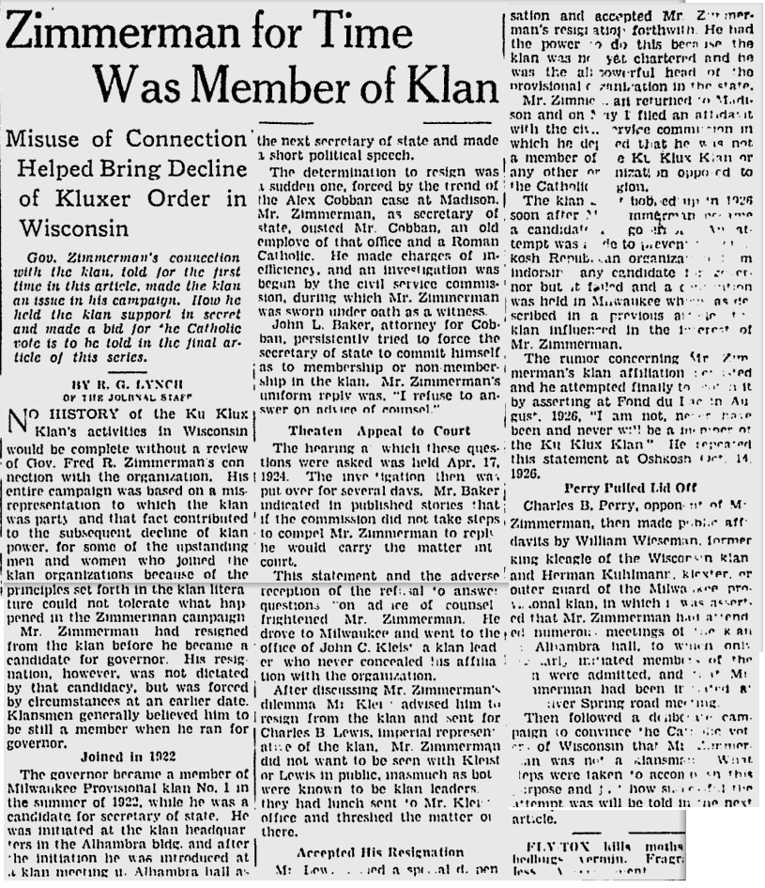

Russell Lynch’s Article – April Seventeenth, 1928:
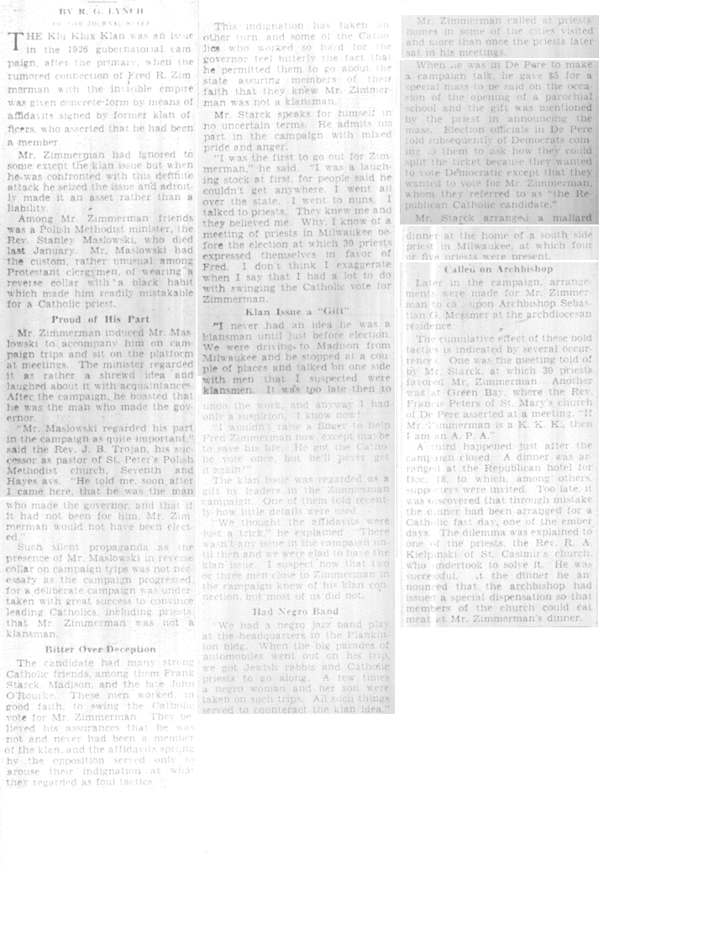

BIBLIOGRAPHY
Primary Sources

Sentinel Local

“Free Marinette Klan Rioters.” The Milwaukee Sentinel, November 10, 1926.

“Mob Burns Ku Klux Klan Tent in Marinette.” The Milwaukee Sentinel, June 26, 1926.

“Klan Band, No Ham and, Blue; One Nearly Canned.” The Milwaukee Sentinel, August 13,
1925.

“Klan Charge Called a ‘Lie’ by Zimmerman: Governor Candidate Attacks Tactics of ‘Madison
Ring.’” The Milwaukee Sentinel, August 28, 1926.

“Klan Publishes ‘Bootleg’ List.” The Milwaukee Sentinel, May 3, 1926.

“Zimmerman Denies Klan Membership: Slanderers, He Calls Those Who Say he Belongs to
Order,” The Milwaukee Sentinel, July 13, 1926.

Sentinel National

“80-Foot Cross Glares on City in Hood Ritual: Robed Pastor Flays Evolution Friends.” The
Milwaukee Sentinel, August 10, 1925.

“600 Quit Klan as U.S. Menace.” The Milwaukee Sentinel, January 6, 1926.

“Alleged Klan Corruption Doesn’t Reach Them, Judge Told.” Milwaukee Sentinel, October 27,
1926.

“Empress of Klan Talks of Policies: Woman Leader Asserts Secret Order is Not Lawless
Organization.” The Milwaukee Sentinel, September 10, 1921.

“Evans is Named in Klan Killing.” The Milwaukee Sentinel, April 3, 1928.

“Harding Backs Man Opposing Friend of Klan: Indorses Fusion of Texas Republicans and
Independent Democrats in Fight on Mayfield.” The Milwaukee Sentinel, October 24
1922.

“Indiana Center of Klan Dominancy: Indianapolis Boasts it is ‘Star’ in Realm of Knights.” The
Milwaukee Sentinel, November 6, 1923.

“Klan Accepts Governor’s Order: Oklahoma Kluxers Put Ban on Masked Meetings.” The
Milwaukee Sentinel, September 11, 1923.

“Indiana Klan Charges Fail.” The Milwaukee Sentinel, December 25, 1926.

“Indiana to Press its Fight on Klan.” The Milwaukee Sentinel, February 23, 1928

“Injunction Against New York Klan Granted by Judge.” The Milwaukee Sentinel, August 15,
1923.

“Jury Accuses Grand Dragon as Instigator: Practice is Likened to Period of Spanish Inquisition.”
The Milwaukee Sentinel, October 16, 1927.

“Klan and Legion Swing Fists at Vets’ Ceremony.” The Milwaukee Sentinel, November 29,
1923.

“Klan Expects to Acquire University Next Week.” The Milwaukee Sentinel, August 19, 1923.

“Klan Keeps Open House Despite Martial Law.” The Milwaukee Sentinel, September 18, 1923.

“Klan Organizers Held.” The Milwaukee Sentinel, September 11, 1923.

“Klan Purchase of University Asked: Valparaiso School Control Offered Knights of Invisible
Empire.” The Milwaukee Sentinel, July 26, 1923.

“Klan Through with Politics, Evan Says.” The Milwaukee Sentinel, March 13, 1926.

“Klan Wins Election at Grand Forks, N.D.” The Milwaukee Sentinel, April 8, 1926.

“Man and Dusky Bride Flee Wrath of Klan.” The Milwaukee Sentinel, April 26, 1926.

“Mild Blow at Klan Voted by Legion: Resolution is Passed After pro and Anti Measure Fail.”
The Milwaukee Sentinel, October 19, 1923.

“Militia, Facing Inquiry, Disarms.” The Milwaukee Sentinel, March 20, 1928.

“More Trouble.” The Milwaukee Sentinel, October 31 1928.

“Murder, Riots Laid to Klan.” The Milwaukee Sentinel, August 7, 1927.

“New Anti-Bonus League Formed: Failure to Agree Causes Early Adjournment of Discussion.”
The Milwaukee Sentinel, October 18, 1923.

“Reed Starts Indiana Klan Slush Probe.” The Milwaukee Sentinel, October 20, 1926.

“Reed to Probe Klan Charges.” The Milwaukee Sentinel, October 14, 1926.

“Slush Inquiry to Reveal Big Contributors: Wets and Klan Also to be Called on Senate Carpet.”
The Milwaukee Sentinel, June 26, 1926.

“The Alabama Mystery.” The Milwaukee Sentinel, October 12, 1927.

“Vermont Center of Vote Interest: Elections Will be Held in Many States on Tuesday.” The Milwaukee Sentinel, November 6, 1923.

“Walton Will Quit if Klan is Fought: Governor Offers Resignation if Anti-Klan Act Passes.” The
Milwaukee Sentinel, October 10, 1923.

Journal Local

“1,200 Applaud Klan Speaker: Organizer Waves Flag in Denouncing Jew, Catholic and Negro.”
The Milwaukee Journal, October 6, 1922.

“Deny Klan Use of Auditorium: Board Adopts Resolution Forbidding Rental Organization.” The
Milwaukee Journal, October 19, 1922.

“Klan Down to 600; Once Boasted 5000.” The Milwaukee Journal, July 28, 1925.

“Klan Poisoning Voters, Charge: Democratic Chief Says Organization is Factor in State
Politics.” The Milwaukee Journal, October 12, 1922.

“Kluxer Fined; Will Quit Klan: Malone Pleads Guilty to Slander; to Expose Order, He Says.”
The Milwaukee Journal, June 5, 1927.

“Kluxers, Foes Back Official Blaine Ousted: Governor Twisted on Facts of Recent Troubles,
Grand County Residents Say.” The Milwaukee Journal, September 6, 1924.

“K.K.K. Locked Out? Perhaps: Nobody is Just Sure, but Tabernacle is Not in Use.” The
Milwaukee Journal, May 5, 1926.

“State Klansmen to Show Blaine: Governor’s Attack to be Countered by Series of
Demonstrations.” The Milwaukee Journal, September 6, 1924.

Journal National

“3 Bricks Tell Klansmen that Death is Near.” The Milwaukee Journal, October 21, 1922.

“Absense of Klan Plank a Victory, Says Bryan.” The Milwaukee Journal, June 30, 1924.

“Allies Do Not Trust Watson: Indiana Senator, with Klans Aid, Out to Get what he Can.” The
Milwaukee Journal, June 8, 1928.

“Asks Klan to Bare Names of Floggers.” The Milwaukee Journal, July 12, 1927.

“Dawes May be on the Carpet: Summoned by Coolidge for Conference After Klan Speech.” The
Milwaukee Journal, August 25, 1924.

“Defends Klan Finance Policy: Wizards Answers Graft Charge at Quiz; Flays Witness.” The
Milwaukee Journal, October 13, 1921.

“Ex-Klan Chief Goes to Trial: Stephenson Charged with Murdering Indianapolis Girl.” The
Milwaukee Journal, October 12, 1925.

“Foes of Klan Open Office in Milwaukee.” The Milwaukee Journal, October 21, 1922.

“Gen. Dawes Pussyfoots Again.” The Milwaukee Journal, August 25, 1924.

“Girl Missing in Klan Quiz: Dragon’s Stenographer Sought in Connection with ‘Black Box.’”
The Milwaukee Journal, October 15, 1926.

“Hammer Slain Buried by Klan; Widow Held.” The Milwaukee Journal, November 6, 1925.

“Klan Dragon Taken Before Indiana Jury: Stephenson is Removed from Cell to Tell of Political
Scandal.” The Milwaukee Journal, July 30, 1927.

“Klan Financed Negro Weekly.” The Milwaukee Journal, July 13, 1927.

“Klan Influence Wanes, Report: Indications are Order Will Not be Big Election Factor.” The Milwaukee Journal, February 5, 1928.

“Klan Mexico’s Ally, is Claim: $2,000,000 Spent to Fight Coolidge Policy, Democrat Asserts.”
The Milwaukee Journal, March 11, 1927.

“Klan Parodies Baptism Rites: Initiation Ceremony of Klan and Death Threat Bared,” The
Milwaukee Journal, September 13, 1921.

“Klan Prejudice’ Plea is Failure.” The Milwaukee Journal, February 27, 1928.

“Legion Attacked as Heir of Klan.” The Milwaukee Journal, May 16, 1927.

“Our First Woman Governor.” The Milwaukee Journal, August 25, 1924.

“Pistols Guard Murder Jury: Bailiffs Threaten Gang Attempting to Tamper with Klan Trial.” The
Milwaukee Journal, December 19, 1923.

“Several Hurt in Klan War: Police at Dawn Break Up All-Night Fight in Massachusetts.” The
Milwaukee Journal, July 30, 1924.

“Tear off the Klan’s Mask.” The Milwaukee Journal, October 25, 1926.

Miscellaneous Articles

Russell Lynch. “Blaine Forgot ‘Anti’ Speech: Dragon Took Credit for Defeat of Lenroot for
Senator.” The Milwaukee Journal, April 12, 1928. Microfilm.

------. “Klan Plotted to Scuttle G.O.P. Ticket in State.” The Milwaukee Journal, April 15, 1928.
Microfilm.

------. “Kluxing Klan Signed Men so Fast Kleagle Rolled in Money.” The Milwaukee Journal,
April 9, 1928. Microfilm.

------. “Kluxing Saps Life From Klan in Wisconsin: 38,000 Peak Strength Falls to Only 2,000.”
The Milwaukee Journal, April 8, 1928. Microfilm.

------. “Money Poured into Treasury: But Effort to Capture Senatorship Failed Dismally.”
The Milwaukee Journal, April 13, 1928. Microfilm.

------. “Oshkosh was Kluxer Center,” The Milwaukee Journal, April 11, 1928. Microfilm.

------. “Revolt Failed to Save Milwaukee Klan; Handful Left of 4,400.” The Milwaukee Journal,
April 10, 1928. Microfilm.

------. “’Stigma’ of Klan Membership Erased by Clever Propaganda.” The Milwaukee Journal,
April 17, 1928.

------. “Zimmerman for Time was Member of Klan.” The Milwaukee Journal, April 16, 1928.
Microfilm.

“The Sickening Sentinel.” The Badger American, April, 1923. Microfilm.

Secondary Sources

On the Klan and Media:

Chalmers, David M. Hooded Americanism: The History of the Ku Klux Klan. New York:
Franklin Watts, 1981.

Conrad, Will C., Kathleen F. Wilson, and Dale Wilson. The Milwaukee Journal: The First
Eighty Years. Madison: University of Wisconsin Press, 1964.

Jackson, Kenneth T. The Ku Klux Klan in the City, 1915-1930. Lanham: Ivan R. Dee, 1992.

Kraemer, Lynn. “Wisconsin and the KKK.” Wisconsin Then and Now 15, no. 9 (1969): 1-3.

Lee, Gordon H. “The Ku Klux Klan in Wisconsin in the 1920’s.” Masters seminar paper,
Wisconsin State University – La Crosse, 1968. In Minds@UW index,
http://minds.wisconsin.edu/handle/1793/18735

Quarles, Chester L. The Ku Klux Klan and Related American Racialist and Antisemitic
Organizations : a History and Analysis. Jefferson: McFarland, 1999.

Rice, Arnold S. The Ku Klux Klan in American Politics. New York: Haskell House Publishers,
1972.

Shotwell, John M. “Crystallizing Public Hatred : Ku Klux Klan Public Relations in the Early
1920s.” master’s thesis, University of Wisconsin – Madison, 1974. In Minds@UW index,
http://minds.wisconsin.edu/handle/1793/28672.

Scharlott, Bradford W. “Hoosier Journalists and the Hooded Order; Indiana Press Reaction to the
Ku Klux Klan in the 1920s.” Journalism of History 15, no. 4 (1988): 122-131.

Turscheneske, John Anthony. “The Ku Klux Klan in Northwestern Wisconsin.” master’s thesis,
University of Wisconsin – River Falls, 1971. In Minds@UW index,
http://minds.wisconsin.edu/handle/1793/30645.

Wade, Wyn Craig. The Fiery Cross: the Ku Klux Klan in America. New York: Oxford University Press, 1998.

Weaver, Norman Frederic. “The Knights of the Ku Klux Klan in Wisconsin, Indiana, Ohio, and Michigan.” PhD diss., University of Wisconsin – Madison, 1954. In Minds@UW index,
http://minds.wisconsin.edu/handle/1793/368

Wells, Robert W. The Milwaukee Journal: An Informal Chronicle of its First 100 Years.
Unknown Vendor, 1981.

Witas, Robert A. “On the Ramparts: A History of the Milwaukee Sentinel.” Master’s thesis, University of Wisconsin – Milwaukee, 1991.

On the Era:

Crunden, Robert M. Ministers of Reform: The Progressives’ Achievement in American
Civilization 1889-1920. New York: Basic Books, 1982.

Frankel, Noralee, and Nancy Dye, eds. Gender, Class, Race, and Reform in the Progressive Era.
Lexington: The University Press of Kentucky, 1994.

Flanagan, Maureen. America Reformed: Progressives and Progressivisms, 1890s-1920s. New
York: Oxford University Press, 2006.

Hofstadter, Richard. The Age of Reform: From Bryan to F.D.R. New York: Alfred A. Knopf,
1955.

Kennedy, David M, ed. Progressivism: The Critical Issues. Boston: Little, Brown and Company,
1971.

Wiebe, Robert H. The Search for Order, 1877-1920. New York: Hill and Wang, 1967.

Norman Frederic Weaver, “The Knights of the Ku Klux Klan in Wisconsin, Indiana, Ohio, and Michigan” (PhD diss., University of Wisconsin–Madison, 1954), 43-44.
David M. Chalmers, Hooded Americanism: The History of the Ku Klux Klan (New York: Franklin Watts Press, 1981), 32.
Chalmer, 38.
Chalmers 35-37; Weaver 90.
Sources showing the impact the media had on the Klan nationally are quite plentiful: Weaver, 90.; Chalmers, 36-38.
In acquiring sources for statistical analysis, all of which are located in Appendix A, only two articles about the Klan were found before the World articles. Both of these, one of which was from the Journal and the other from the Sentinel, were negative depictions of the Klan.
Weaver, ii-iii, 1-11.
Turcheneske, John Anthony, “The Ku Klux Klan in Northwestern Wisconsin” (master’s thesis, University of Wisconsin – River Falls. 1971), 6-12. Gordon Lee, “The Ku Klux Klan in Wisconsin in the 1920s” (master’s thesis, University of Wisconsin – LaCrosse. 1968), 2-5.
Darcy L. Seavers, “Women in the Hood: Women in the 1920s Ku Klux Klan Publications” (master’s thesis, University of Wisconsin – Madison, 1992).
Explanation on why particular papers were chosen for this research will be made in the methodology section.
Sources looking at media depictions of Klan in Indiana and nationally: Bradford W. Scharlott, “Hoosier Journalist and the Hooded Order; Indiana Press Reaction to the Ku Klux Klan in the 1920s,” Journalism History, V. 15, N. 4.; John M. Shotwell, “Crystallizing Public Hatred: Ku Klux Klan Public Relations in the Early 1920s” (master’s thesis, University of Wisconsin – Madison, 1974).
Wyn Craig Wade, The Fiery Cross: The Ku Klux Klan in America (New York: Oxford University Press, 1988), vii-ix; Chalmers, 28-38.
Nancy MacLean, Behind the Mask of Chivalry: The Making of the Second Ku Klux Klan, New York: Oxford University Press, 1995.; Chester Quarles, The Ku Klux Klan and Related American Racialist and Antisemetic Organizations: A History and Analysis, Jefferson: McFarland Publishing, 2008.; Kenneth T. Jackson, The Ku Klux Klan in the City, 1915-1930 (Lanham: Ivan R. Dee Publishing, 1992), **.
John M. Shotwell, “Crystallizing Public Hatred: Ku Klux Klan Public Relations in the Early 1920s” (master’s thesis, University of Wisconsin – Madison, 1974), vii-xiv; Bradford W. Scharlott, “Hoosier Journalist and the Hooded Order; Indiana Press Reaction to the Ku Klux Klan in the 1920s,” Journalism History 15 (1988): 122-131.
Robert W. Wells, The Milwaukee Journal: An Informal Chronicle of its First 100 Years (Milwaukee: Milwaukee Journal, 1981), 161.
Will C. Conrad, Kathleen F. Wilson, and Dale Wilson, The Milwaukee Journal: The First Eighty Years (Madison: University of Wisconsin Press, 1964), 215; Also see Appendix B.
Robert A. Witas, “On the Ramparts: A History of the Milwaukee Sentinel” (master’s thesis, University of Wisconsin – Milwaukee, 1991), 70.
Scharlott, 124.
Robert W. Wells, The Milwaukee Journal: An Informal Chronicle of its First 100 Years (Unknown Vendor, 1981), 1-11.
Wells, 56.
Wells, 13.
Wells, 125, 142, 153.
Witas, 4.
Witas, 1-7.
Witas, 71-72.
Though Simmons timed his resurgence of the Klan movement when Birth of a Nation was released, this media outlet did not help nearly as well as the World articles released in 1921. The likely reason behind this was a lack of collusion between the actual film and the reality of the movement being alive in 1915. The reality of the World articles in illuminating the resurgence of the Klan made this particular media exposure much more potent. Nevertheless, timing and collusion with media were important to both scenarios.
Weaver, 50, 90; Russell Lynch, “Kluxing Saps Life from Klan in Wisconsin: 38,000 Peak Strength Falls to Only 2,000,” The Milwaukee Journal, April 8, 1928. Microfilm (McIntyre Library).
“Unmask Ku Klux Klan as ‘Terror Rule’ Force: Sweeping Quiz Exposes ‘Invisible Empire’ as Huge Profit-making Enterprise and Menace to Security in All States,” The Milwaukee Journal, September 6, 1921.
Weaver, 90-92.
“Kleagle, n.”. OED Online. September 2011. Oxford University Press. http://www.oed.com/view/Entry/103814?redirectedFrom=kleagle (accessed November 20, 2011).
Lynch, R. "Klan Signed Men so Fast Kleagle Rolled in Money: Wreck of Milwaukee Group Goes Back Almost to Beginning; Met on U.S. Ship." Milwaukee Journal, April 09, 1928, News Article section, First edition.
Weaver, 58 ; Lynch, “Klan Signed Men…”
Maureen A. Flanagan, America Reformed: Progressives and Progressivisms 1890s-1920s (New York: Oxford University Press, 2007), 234, 266.
Weaver, 56.
Russell Lynch, “Money Poured into Treasury: But Effort to Capture a Senatorship Failed Dismally.” The Milwaukee Journal, April 13, 1928, News Article section, 1 edition; Weaver, 128.
Weaver, 92.
Appendix A features the titles and locations of all the newspapers used in this analysis. Appendix A features many articles wired from the two areas mentioned, or, at the least, are focused in on these areas in the writing.
Wells, 161.
“The Sickening Sentinel,” The Badger American, April, 1923. Microfilm (Wisconsin State Historical Society).
Weaver, 130.
Based on research compiled from the Journal and Sentinel with respect to Klan depiction, found in Appendix A, Stephenson’s incident with Olberholtzer was the most common single topic.
Chalmers, 171-172; Weaver, 51.
Weaver, 129.
Weaver, 62; Russell Lynch, "Klan Signed Men so Fast Kleagle Rolled in Money: Wreck of Milwaukee Group Goes Back Almost to Beginning..." Milwaukee Journal, April 9, 1928, News Article section, Fist edition.
Weaver, 130.
Weaver, 192; Chalmers, 109.
Weaver, 77-78.
See Appendix A, where Journal articles are broken down between “National” and “Local.”
Wells, 56.
Appendix A.
It is no doubt that many of the Klan articles written during both the strong and weak Klan periods were very much sensationalistic. Even the World articles have strong exaggerations and sensationalist projections. So, the biased, yellow journalism that was particularly popular during this period – but against the ideals of the Journal – was largely fed by Klan articles.

