University of Wisconsin- Eau Claire

The Empire, the Land, and the Exodus
A Study of How the Roman Empire Literally Shaped Christianity: 1 C.E. – 280 C.E.

Advising Professor: Dr. Matthew Waters

Chelsea J. Wilfong
Eau Claire, WI
Fall, 2012

Copyright for this work is owned by the author. This digital version is published by McIntyre Library, University of Wisconsin Eau Claire, with the consent of the author.

Abstract
This paper explores the factors and trends involved in the movement of Christian communities from Palestine into Asia Minor and regions west of the Aegean Sea. Because the first generation of Christians generally continued to identify themselves as Jewish, this paper looks into the factors that affected the Jewish community with the perspective that a large portion of the early Christians were still members of the Jewish community. Roman land control policies, taxation, and continuous loss and division of land all but pushed many Jews out of the region while the peace of Augustus led many more to depart more voluntarily. It was the culmination of all these factors that led to Jewish emigration from the Palestinian region. The paper will begin with a brief history of the birth of Christianity and the Jewish-Roman relationship in Palestine, followed by a discussion of factors that led to emigration from Palestine, and then end with an analysis of the locations of the Christian communities.

TABLE OF CONTENTS

ABSTRACT ii
TABLE OF CONTENTS iii
INTRODUCTION 1
SECTION I: ROMAN-JEWISH RELATIONS AND A NEW SECT 3
SECTION II: FACTORS FACILITATING CHRISTIAN EMIGRATION 6
SECTION IV: CHRISTIAN COMMUNITIES IN ASIA MINOR 15
SECTION V: CHRISTIAN COMMUNITIES WEST OF ASIA MINOR 19
CONCLUSION 23
APPENDIX 24
BIBLIOGRAPHY 28

Introduction
From the first until the fourth century C.E. in the Roman Empire, the percentage of Christians in the population continued to rise despite increasing persecution. In fact, the more the Roman Emperors tried to quell Christian growth, the faster it seemed to increase. In the words of the Roman Historian Tertullian, “the blood of the martyrs is the seed of the Church.” Tertullian’s statement alludes to the idea that the persecution of Christians during the early years of the Christian faith fanned the flame instead of extinguishing it as many of the Emperors had intended. But what factors—in addition to persecution and martyrdom—could have affected and shaped the spread of Christianity before the Church began to gain political influence in the fourth century? After the beginning of the fourth century Christian communities and churches spread throughout the Roman Empire with relative consistency and a fairly indistinguishable pattern of disbursement. However, prior to 300 C.E., Christian communities were less widespread and their distribution throughout the Empire fell into a more distinguishable pattern.
Focusing on the Roman Empire between 1 C.E. and 280 C.E., this paper will explore factors that facilitated the movement of Christians out of Roman Palestine as well as identify and explain patterns of disbursement of Christian communities throughout the Empire. In addition to incorporating causes of emigration, the influence of topographical factors is also integrated into the analysis of community disbursement patterns through the use of specially constructed maps. The maps include sea and land trade routes, geographical features, and Christian communities established from the 1st to 3rd centuries and is derived from a number of different sources (including documented instances of persecution, letters between churches, letters of Roman officials, as well as other previously created maps).
According to the maps, Christian communities decreased in number and density moving westward from Palestine toward Spain. Their disbursement was denser and more conjoined in Asia Minor but more sporadic and separated west of the Aegean Sea. The patterns found in Asia Minor corresponded with the presence of land routes directly connecting to Palestine, while the patterns west of the Aegean corresponded with the lack of such land routes. As a whole, the distribution of Christian communities throughout the Roman Empire can be explained further by economic and geographic factors influencing travel from Palestine into the different regions. These factors influencing travel, the availability of land routes, and the causes for emigration from Palestine drastically influenced the disbursement of Christian communities prior to 300 C.E.

Roman-Jewish Relations and a New Sect
Beginning in the year 37 C.E., the Roman Empire found itself under the rule of a new Emperor by the name of Gaius Julius Caesar Germanicus (Caligula) who quickly gained notoriety for his extremely violent nature. And even though the city of Rome felt “the most dismal effects” of Caligula’s actions, the Emperor instituted a decree in 37 CE that marred the relationship between the Jews of Palestine and the Empire. Caligula, after deeming himself an Emperor and a god, not only required that he be worshipped as such but, to the horror of the Jews, ordered a statue of himself to be raised in the temple at Jerusalem. Though a looming revolt was prevented by the Emperor’s assassination a few years later, Cornelius Tacitus stated that the Jews would have “preferred the alternative of war” over fulfilling Caligula’s decree, forewarning of the determination with which they would resist future pressures from Rome.
By the year 66 CE Tacitus’ words were confirmed when Jewish-Roman tensions reached the breaking point under the brutal regional rule of procurator Gessius Florus. In response to numerous raids and hundreds of crucifixions, the Jewish population revolted against Florus in July of that year, crushing the procurator’s garrison. Four months later the Jewish forces defeated one Roman legion and 13 cohorts marching under the leadership of the Syrian governor. Astonished by the success of the revolting Jews, Emperor Nero then sent Vespasian, a military leader who had recently suppressed a Germanic uprising, against the Jewish forces. After heavy casualties and a number of embarrassing defeats the Romans managed to overpower a number of Jewish forces, obliterating them at Jotapata and Masada, finally ending the Jewish resistance in 73 C.E.
Some forty years prior to the defeat of the Jewish force, around the year 30 CE, a new Jewish sect was founded in the town of Galilee by a man named Jesus. Aside from the belief in the “messiahship of Christ” and a new and radical “love your enemies” mentality, the first generation of this sect was relatively indiscernible from their fellow Jews. Some scholars even argue that these new Jewish followers of Jesus were so indistinguishable from other members of the Jewish community that they “got along well with their fellow Jews, contrary to the erroneous impression of the Gospels and other New Testament writings.” In fact, they suggest that it was the upper-class Jews alone—the Sadducees—who opposed the new followers of Christ most amongst the Jews. For it was they who supported sacrifice at the Jewish temple and they who were “implicated in the trial of Jesus.” Yet, regardless of whether or not support for Christ and his followers was high within the Jewish community, Christ was arrested and executed sometime around 36 CE after openly criticizing the Jewish temple priesthood.
Shortly after his death, the newly founded sect began proclaiming that Christ was the Messiah (savior of Jewish political freedom) and the son of God. In response to this proclamation and in response to a gradual regression in observance of Jewish laws within Jesus’s sect, the remaining (and more orthodox) Jewish community began violently persecuting them. In addition, between the years 48-55 C.E. a sect member by the name of Paul actively engaged in missions to convert non-Jews, gaining further opposition from within the Jewish community. By 70 C.E., after the Romans had destroyed the Jewish temple at Jerusalem, a reconstituted Jewish leadership excluded the followers of Jesus from Jewish worship and by doing so (whether intentionally or not) further isolated the sect, pushing it closer to becoming a separate religion: Christianity. It was after this period that the core of Christianity began to move from “Jewish Jerusalem to gentile Christian communities around the Empire.”

Factors Facilitating Christian Emigration
In order to understand why Christian communities were established in certain towns and appeared to be more prevalent (in terms of density) in certain regions, it is important to understand what possible factors led to the movement of the Christians—and thus the religion—out of Palestine. Because the early Christians continued to identify themselves as Jews, it is necessary to look into factors that affected the Jewish community during the 1st and 2nd centuries, which would have undoubtedly affected early Christians in the same manner. In light of this, it will be assumed that the groups of Jews discussed in this section of the paper also included many first and some second generation Christians. A number of Roman expansion practices were already imposed upon the region of Palestine before the Jewish Revolt and more were imposed in the region after. Roman land control policies, taxation, Jewish cultural customs, and an increase in emigration throughout the Empire all played a role in the community’s emigration out of the region.
The Roman Empire’s general procedure in handling recently conquered territories often included the appropriation of both state land held by the previous regime and large estates. This practice, coupled with the frequent settlement of Roman veterans on allocated portions of the conquered land, often had a significant impact on the local communities and peoples. From Nero onward, Palestine—in addition to the settlement of 8,000 Roman veterans of the Jewish Revolt--experienced a perpetual seizure of large estates by the “emperor’s estate administration.” As a result, the land held by the emperors steadily increased over time as more and more large estates were taken into their possession. However, many of the large estates in Palestine were owned by members of groups that had previously invaded the region such as the Ptolemies and the Seleucids. Furthermore, determining whether any number of the large estates seized were from Jews as a result of the Revolt is difficult to determine due to a lack of sources. Thus, it is difficult to gage to what extent the Empire’s appropriation of the large estates affected the Jewish population. Moreover, Titus describes the Empire’s approach to land control after the Jewish Revolt, making it seem as if it was much more humane in respect to how the Empire either usually handled it or in respect to how it should have been handled, stating “to begin with, we allowed you to keep this land.” This suggests that, aside from the settlement of Vespasian’s soldiers, the Jewish population remained in control of a fair portion of their land after the Revolt.
It would seem that taxation had a more detrimental effect on the Jewish population than did the Emperor’ seizure of large estates. In the Empire the city of Rome, the government, and the armies located on the frontiers used up more in taxes than was produced regionally. Also, citizens on the Italian Peninsula were generally exempt from taxes; and, representing no small portion of the population, this had the potential to detrimentally affect the state’s finances. As a way to make up for the missing tax base, the Empire turned to the newly conquered regions to finance the state and the army. Some of these regions, such as Palestine, were so beneficial to the Empire in terms of filling the tax void that the state commissioned a specific administration in the region to ensure the full collection of taxes. Following the Jewish Revolt, the treasury branch responsible solely for the taxation of the Jewish population (the fiscus judaicus) implemented a “special tax” during the rule of Vespasian. This tax was referred to as the didrachmon tax and required the Jews to pay two denarii to the temple of Jupiter Capitolinus. Eventually this tax was instituted on women, children, and slaves and was quadrupled to eight drachmas. However, there is currently no source directly proving the presence of the fiscus judaicus within Palestine (it is widely accepted that this commission dealt specifically with Jews outside of Palestine) and so as to whether or not Jews in Palestine had to pay the didrachmon is both uncertain and unlikely.
Starting in around 50 CE, the Roman government instituted a crown tax which demanded funds from the populace to finance special occasions (“such as a victory, birthdays of the empire’s notabilities, etc”) and by the end of the second century it had become a fixed tax. A poll tax, which was traditionally “very oppressive for the Jews of Palestine,” increased in its damaging effects following the Bar Kokhba revolt in the first half of the second century CE. Apparently, after the revolt, the poll tax was made so heavy, that the Jews of Palestine had to pay the tax in a higher sum “than that of any other area.”
In the first century B.C.E., Rome began imposing a tax on its territories, demanding consumer goods (such as wheat) as payment, in order to supply the Empire’s capital. It was not until the end of the Jewish Revolt that this tax, called the annona tax, emerged in Palestine. Starting around the first century C.E. and continuing until about 200 C.E. the goods of the annona tax were shipped to Rome via boats which were built specifically for this task. The annona may have been the most burdensome of taxes upon the Jewish community and the root of the word annona—which was the term used for the official who collected the tax—actually translates to “to express violence.” This translation alludes to the extremeness and the aggressiveness with which the tax was collected. In addition to the anonna tax, Jews were required to abandon their homes in order to house Roman troops or to provide board and food to the soldiers without compensation. The combination of monetary and goods taxation had a major effect on the Jewish community. In the Palestinian region during this period, it appears that the primary cause of abandonment of Jewish lands was tax collection.
There was also an extensive division of land in the Jewish community of Palestine due to cultural customs. One such custom was the strong desire and reality to preserve a father’s property when his daughters entered into marriage which led to a “high mobility of the wife’s property” within the Jewish community. It was common for the husband to not gain land from his wife’s family but, instead, to live on the land with the permission to use the profits obtained from it to support his family. This protection of the father’s property was so extreme that the husband even had to announce he had no claims over the property before being allowed into the marriage. In the event of a divorce, the lands returned to the wife’s father, the husband had to return the dowry, and the wife could mortgage any properties belonging to the husband in order to collect whatever was owed to her as specified in the marriage contract. The second cultural custom that heavily played into the division of land among the local inhabitants was the customary laws of inheritance, which allocated for the division of a father’s property among his sons (the eldest son received a double share). It would appear that men generally only received land through their father, which oftentimes grew smaller and smaller with each generation if there was more than one son.
There was also an extreme problem in the Jewish community due to the cultural prohibition of Jews loaning their lands out to fellow Jews. Oftentimes, due to financial pressures—such as taxation—Jews would search for a way around the prohibition. According to Moshe Gil, “a farmer faced with the choice of not sowing his field because he lacked seeds, or of paying his taxes and all the rest of his debts lest he lose his field, or even go to jail because of nonpayment of taxes, would of necessity look for some loophole…to save his farm and his life.” Oftentimes this loophole included engaging in verbal deals and agreements with the local gentile—or non-Jew—community. Many Jewish landowners falsely listed their own properties to be under the ownership of a gentile so the land could then be lent out to Jews. The reality of such instances is mirrored in an ancient Jewish text denouncing such practices, declaring that “from whoever makes his money seem to be of gentile and then lends it for interest to a Jew” shall be punished. In most cases the gentile would claim the land and, because gentiles were usually favored in the courts, would retain ownership.
Additionally, non-Jews would frequently give loans to struggling Jewish landowners and then quickly seize their estates when they did not have the means to pay oppressive interest rates. The Jewish loss of land due to such transactions appears to have been relatively high. Because Palestine in general contained a rather large, dense, and highly industrious agricultural population with a relatively low number of slave workers, an increasing rate of Jewish loss of land would have been a significant phenomenon within the community. This loss of land coupled with the burdensome taxes undoubtedly led some farmers to emigrate, as evidenced in an inscription: “and we will head towards a place where we may live as free people.” As a result of the reduction in inherited land and the very real possibility of losing it to gentiles, there was a migration of the rural population to the urban centers in Palestine.
The situation in the Jewish community of Palestine also led to an increase in the emigration of the rural population to cities throughout the Mediterranean and Asia Minor. From the middle of the second century B.C.E. through the middle of the first century C.E. the boundaries of the Roman Empire were expanding, and with them, the polyethnicity of Roman society. People began emigrating from the outer territories of the Empire to Italia and from Italia to the outer territories with the result that by the second half of the 1st century C.E. twenty-five percent of the Roman senate was made up of members from outside of Italia. The increase in human mobility throughout Rome during this period of expansion was, in great part, attributable to the peace brought by the principate of Augustus.
After Augustus had wrestled the control of Rome away from his competitors, the Empire experienced a period relatively void of military activity (compared to its previous history). Strabo describes the peace of the early 1st century:
And indeed the Romans and their allies have never enjoyed such an abundance of peace and prosperity as that which Augustus Caesar provided from the time when he first assumed absolute power, and which his son and successor, Tiberius, is now providing…The peace of Augustus has spread into the regions of the rising sun and of the setting sun, to the boundaries of the southernmost and northernmost lands. The peace of Augustus protects every corner of the world from fear and banditry.

Populations within the Roman Empire could now travel with decreased worry of violence and relative safety, undoubtedly bolstering both the likeliness of emigration as well as the frequency with which it was being practiced. Aristides further speaks of the peace of the principate and the effect it had on freedom of travel, showcasing that the Empire was still experiencing the benefits of peace into the middle of the 2nd century: “Cannot everyone go with complete freedom where he wishes?”
Not only were early Christians living in a more peaceful Empire and experiencing the hardships that came with being members of the Jewish community, they were also experiencing persecution from other Jews as well as increasing suspicion from the Roman populace. With each year the Christians seemed to take another step away from orthodox Jewish beliefs and practices, something that did not go unnoticed in the Jewish community. Some Jews began to violently oppose the early Christians, persecuting what they viewed to be radical members of their own religion. An excerpt from Acts 8:1-3 briefly describes anti-Christian violence in Palestine, stating, “there was a great persecution against the church which was at Jerusalem; and they were all scattered abroad throughout the regions of Judaea and Samaria, except the apostles.” Saul, a Jew from Tarsus who would later convert to Christianity and change his name to Paul, actively engaged in the Jewish persecution of early Christians in Jerusalem. According to one account he “made havock of the church, entering into every house, and haling men and women committed them to prison.” Saul explains that on one particular occasion “many of the saints did I shut up in prison, having received authority from the chief priests; and when they were put to death, I gave my voice against them.”
In comparison, early Christians during this period faced only limited and sporadic persecution from the Roman State. However, there was a consistence increase in anti-Christian sentiment throughout the Empire. In the beginning of the 2nd century C.E., a letter to Emperor Trajan from Governor Pliny the Younger displays the manner in which he confronted Christianity: “I asked them whether they were Christians. If they admitted it, I asked them a second and even a third time, threatening them with punishment. I ordered those who persisted to be led away for execution.” Public sentiment towards the Christians was often one of growing suspicion surrounding the supposed deprivation with which they performed their rituals. Minucius Felix lists a number of the wild claims against Christians:
An infant is wrapped in bread dough…and is placed beside the person being initiated into the rites. The initiate is required to strike the surface of the bread with blows he presumes are harmless, but he thus kills the infant with wounds not seen by him…They voraciously lick up the blood of the infant and greedily tear apart its limbs, and swear alliance over this sacrificial victim…They gather for a banquet with all their children, sisters, and mothers, people of both sexes and all ages. There, after many courses of food, the party heats up and the passion of incestuous lust inflames those who are drunk.

Early Christians, preaching messages such as “blessed are you who are poor, for yours is the kingdom of God” accumulated a following that was overwhelmingly impoverished—a group of individuals that many Romans considered “illiterates from the very dregs of society.” As more and more poor Jews and Greeks began joining the ranks of the new Jewish sect, Roman suspicions rose; there was little in the Mediterranean world that the Roman State feared more than the poor congregating with one another in an organized fashion.
Early Christians were experiencing persecution from within the Jewish community as well as an increasing suspicion from the Roman populace due to their private practices. This persecution and suspicion, combined with the economic hardships as a result of taxation and land loss experienced by Christians throughout the 1st and 2nd centuries encouraged the emigration of Christians out of the region. As the Christians left Palestine, they appear to have taken two main routes: by land into Asia Minor or by sea into the western reaches of the Empire. The Christian communities located throughout Asia Minor all maintained a strikingly similar pattern: they held a linear shape, following a strip of land in the lower middle portion of the region, and then spread out west of Laodicea as they near the Aegean coast. It appears that there were two major factors that influenced this pattern of disbursement, the most influential was the region’s geography, and the lesser was the trade routes.

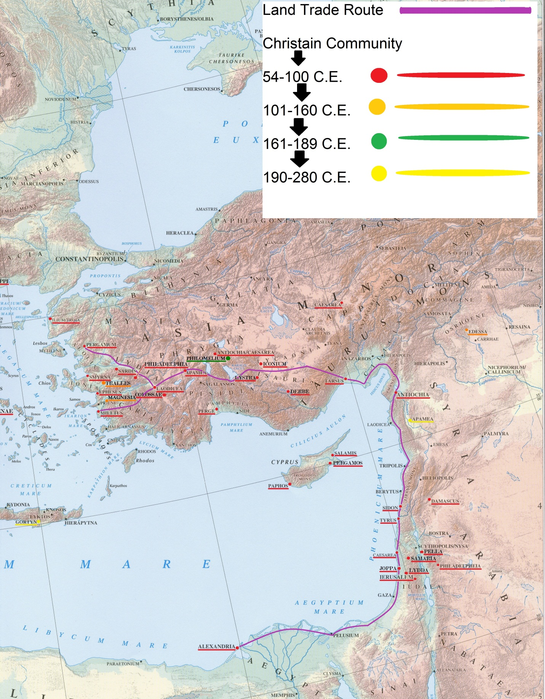
Source: Atlas from Richard J. A. Talbert and Roger S. Bagnall. Barrington Atlas of the Greek and Roman World. Princeton, N.J.: Princeton University Press, 2000; data plotted on the atlas from Water, Mark. The New Encyclopedia of Christian Martyrs. Grand Rapids, MI: Baker Books, 2001; as well as other primary and secondary sources listed in the bibliography.
Figure 1. Christian communities in Asia Minor.
Christian Communities in Asia Minor
Asia Minor is highly mountainous with a vast portion of the area reaching anywhere between 5000 to 15000 feet. It contains a plateau in its center bordered by two substantial mountain ranges, the southernmost of which is the Taurus range. Western Asia Minor contained four fertile river valleys that ran from the eastern portion of the Taurus Mountains all the way to the Aegean coast. It was this rugged and extreme terrain that forced emigrations through Asia Minor to take either the northern path through Siberia or the southern path through the Taurus mountain range. According to Ramsay, any westward movement of people, armies, or civilization—if not traveling by sea—generally took the southern path through the Taurus Mountains. The flow of Christian communities seem to have stayed true to Ramsay’s claim, flowing west out of Palestine and into the southern region of Asia Minor. Regardless of the path taken, whether northern or southern, the movement of migration was confined to that of eastward or westward, a phenomenon that is attributable to the formidable mountains.
Such a narrowly-confined movement of people led to frequent and explosive changes within the populations of Southern Anatolia; for cultures, religions, and ideas were restricted to the same narrow path, creating a region highly concentrated with diversity and an endless flow of differing concepts. Groups passing through carried with them their cultures and were exposed to that of the inhabitants of communities along the way.
From 48-51 and 52-55 C.E., Paul travelled through Asia Minor and into Eastern Greece, founding a number of communities in his travels. The early presence of these Christian communities as well as the groups of Christians that were likely traveling out of Palestine through southern Asia Minor would have exposed many non-Christians who were traveling through the region. This would have created something of a snowball effect, where the frequency of the communities would have increased from west to east as more people exposed one another to Christianity they funneled further through the pass. This type of east-to-west pattern seems to have developed through Asia Minor; Christian communities increase in frequency and density from the eastern portions of the region to the western. However, there is a geographical explanation for this pattern as well. For at Laodicea where the communities begin to increase and fan out, the main road which the majority of the communities fall along breaks off into two as it reaches the fertile river valleys of Western Asia Minor: one heading north and one heading south. So the influx of Christian communities in this western portion of Asia Minor could be a result of, not necessarily a rolling increase in exposure to the religion, but increased space and fertile lands. This type of terrain, which was fertile and near the coast, would undoubtedly have appealed to the emigrating populations, especially when compared to the lofty and harsh terrain of the Taurus Mountains. The preference to settle in this region of Asia Minor also fits the likely profile of early Christians emigrating out of Palestine who were more than likely poor, landless, and seemingly of agricultural stock.
In the Roman Empire there were two options for travel, either by land or by sea. It is evident when looking at both the terrain of Asia Minor and the location of the Christian communities in the region (see figure 1.) that the method of travel to and through the region was predominantly land based. So, what led the Christians to opt for land travel over treacherous terrain as opposed to travel by way of ship in the Mediterranean Sea? One deciding factor was probably Asia Minor’s proximity to Palestine and the speed with which Christians were emigrating. The vast majority of the communities in Asia Minor were established sometime between 50 and 100 C.E., a relatively short period of time (see figure 1.). This suggests that the move may have required less planning time, something that would have been attractive to Christians who were being driven out of Palestine by persecution and economic factors. Another deciding influence may have been the formidable Taurus Mountain range. The Taurus Mountains are often considered to have created a type of boundary between ideas, cultures, and peoples on either side; such a boundary could have offered a shield to the Christians from the hardships they were facing as well as from persecution from the Palestinian Jewish community. Also, any Christians seeking to spread the religion and convert new members would likely have taken a land route due to the vast number of people they would come in contact with when compared to sea travel. Ramsay explains the advantage of land travel over sea travel when it came to conversion:
The important movements of thought had almost always taken the land-route, for the coast-route affords only narrow and limited opportunities along its course. It was easy for the pioneers of new ideas to carry them by sea from the Syrian shore to Athens or to Rome; but by the way they made no impression and left no seed. On the other hand, along the land-route new religious movements worked their way by conquering the cities and the peoples through which they passed: they planted themselves firmly at each stage, and each step was the preparation and the basis for a further step.
This thought of Ramsay’s seems to prove true when looking at the Christian communities west of Asia Minor across the Aegean Sea. New ideas and religions can be carried by sea travel, however they reach less of the population in their course and result in thinner and more scattered locations.

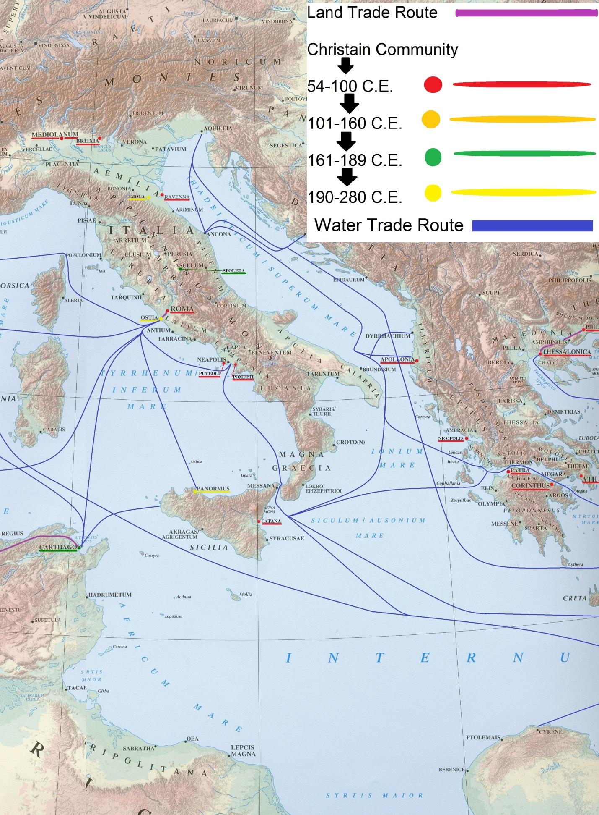
Figure 2. Christian communities in Italia and Greece.
Christian Communities West of Asia Minor

The patterns and reasons for the spread of Christian communities by sea travel are harder to identify than those of Asia Minor. The rugged terrain of Asia Minor created an environment that was limited in space and which funneled the movement of emigration down a similar path, concentrating the area of study. The Mediterranean Sea, however, is so vast in terms of space and offered so many destinations when compared to Asia Minor that any patterns are likely to be sparse and rather sporadic in comparison.
At a glance the locations of the Christian communities in the Western half of the Empire appear to be just that, both sporadic and sparse. Yet even though the reasons for their locations are not as discernible as those in Asia Minor, there is a connection that most of these communities share: close proximity to a water trade route. For example, nearly all of the communities in Western Greece fall along the path of a water trade route. Consider the appearance of Christian communities in Athenae, Corinthus, and Patra along with their contiguity to the trade route from Ephesus to Pompeii. Next, consider the cities Sparta, Messene, and Olympia which lack both the presence of Christian communities and a close proximity to a water trade route. Note as well Panoramus and Apollonia which are both attached to a water trade route and both have Christian communities.
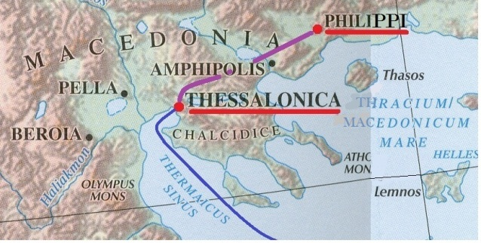
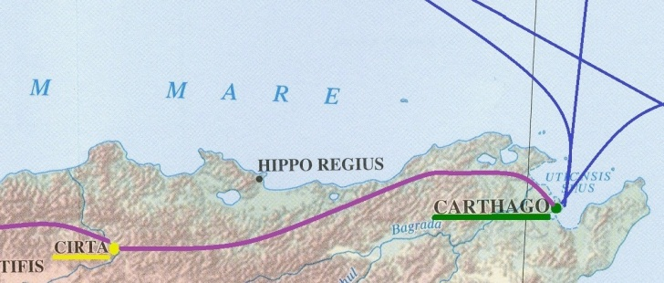
Of the twenty-eight Christian communities west of Anatolia listed on the map, thirteen shared a close connection to a water trade route and six are directly connected to one of these thirteen communities by a major land trade route. This is a pattern which is to be expected of most things spread via water travel; first establishing where the water route connects to land and then traveling farther inland. Carthago’s connection to Cirta (see figure 3.) and Thessalonica’s connection to Philippi (see figure 4.) are examples of this type of pattern. The remaining nine communities lie outside this pattern suggesting that they arrived in that location by a different means that is unclear according to the map. Some, such as Catana and Nicopolis are on a coast, while others, such as Mediolanum and Augustodunum, are farther inland.
Figure 4. Thessalonica’s and Philippi.
Figure 3. Carthago and Cirta.
Christian sea travel across the Mediterranean may have been encouraged during this period by a supposed increase in sea-faring trade. According to a study conducted within the last forty years, there appears to have been a rather significant rise in sea trade in the Mediterranean between 200 B.C.E and 200 C.E. The increase was conjectured by locating and dating shipwrecks throughout the Mediterranean. According to the findings, there was a rather large spike in shipwrecks in the 400 year span when compared to the preceding and following years. It is assumed that an increase in shipwrecks conveys an increase in sea-faring travel, which in turn suggests an increase in sea trade. Also, as previously mentioned, the annona tax was effective in Palestine from the 1st century C.E to 200 C.E. The annona tax required that goods be shipped to Rome by way of specially crafted boats, indicating that Palestine was experiencing an increase in ship-traffic along with the rest of the Mediterranean during this time.
Although sea-faring trade had increased significantly in the Roman Empire from 200 B.C.E. to 200 C.E., it is important to note that the connection of Christian communities to water travel is less consistent than the connections between Christian communities and land travel in Asia Minor. Because of this, the conclusions drawn concerning the movement of Christianity and sea travel are bound to be broader in nature than those of Asia Minor and less accurate. However, the spectrum of time periods with which these western communities are associated is much more diverse when compared to that of Asia Minor. Whereas most of Asia Minor’s Christian communities appeared by or before 100 C.E., nearly forty percent of those west of the Aegean Sea are associated with periods between 161-285 C.E. This suggests that Christian sea travel was a less frequent, more gradual, and probably less convenient when compared to Christian land travel.

Conclusion
The spread of Christianity was shaped by many different factors: cultural, psychological, social, and geographical. This paper focused on its movement from 1 C.E to 280 C.E. in relation to the geographical features of the Roman Empire as well as explored the early Christian community as an analogous extension of the Jewish community in an attempt to identify factors that facilitated the movement of Christians out of Palestine. By mapping the Christian communities during this period throughout the Empire, I was able to identify a number of patterns. First, the earliest and most dense concentration of communities outside of Palestine was located in southern Anatolia. This is attributed to the treacherous terrain of the region, especially the formidable Taurus Mountains and its proximity to Palestine. Second, the remaining Christian communities west of the Aegean Sea fell into a pattern that was less defined and more spread out when compared to that of Asia Minor. This is due to the vast space the Mediterranean Sea offered for travel when compared to the narrow path through Asia Minor. A ship offered a diverse variety of destination options and so the outcome was more diverse. Lastly, the dates of the western communities were less consistent than those of Asia Minor, showing that the spread of Christian communities by sea was more gradual, especially for those farther west in the Empire. The factors that likely influenced Christians to emigrate from Palestine included a culmination of taxation, loss of land, persecution, increasing suspicion from the Roman populace, and an increased atmosphere of travel in the Empire due to widespread peace. These patterns and factors are not the only influences on the spread of Christianity throughout the Roman Empire, but merely a small group of possible explanations and patterns compiled in an attempt to better understand the complexity and mystery that surrounds the spread of early Christianity.

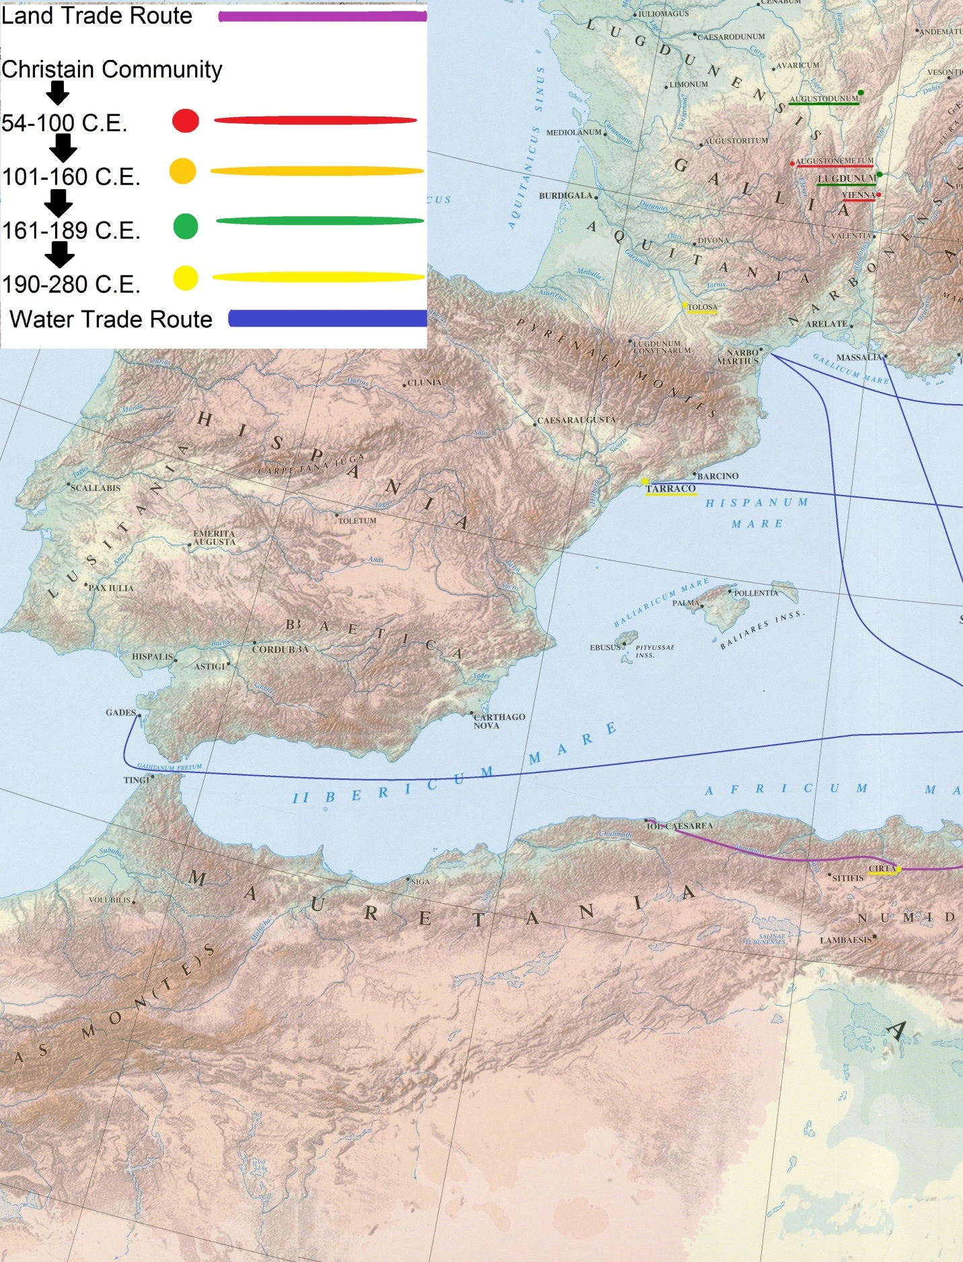
Figure 5.Left.
Appendix
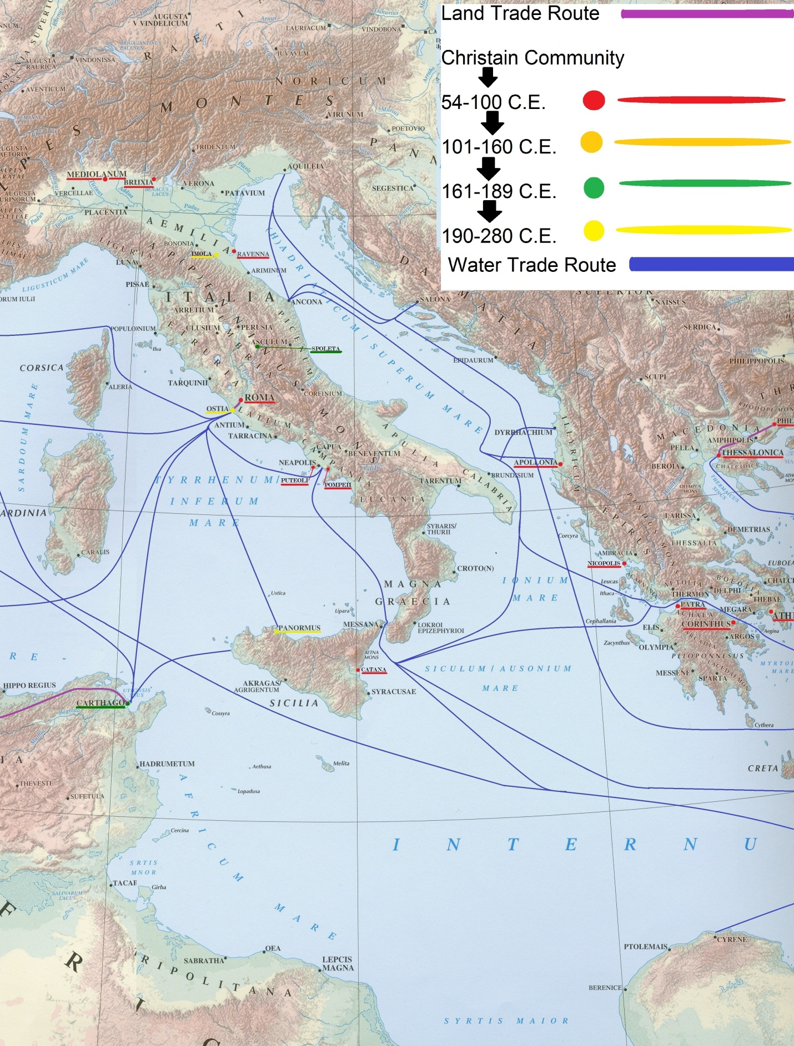
Figure 6. Middle.
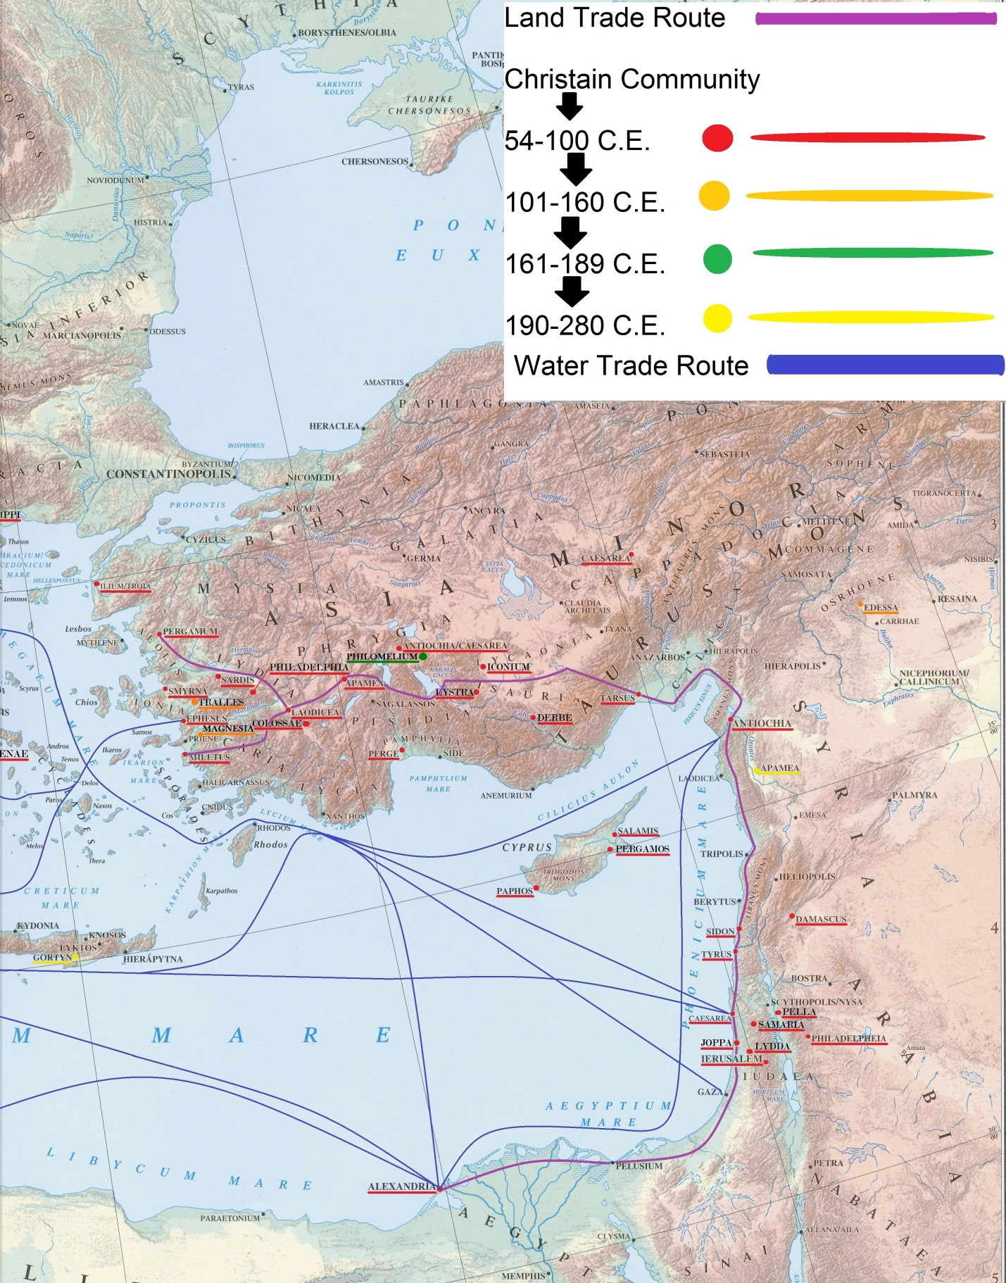
Figure 7. Right.


Bibliography
Primary Sources
Tertullian. Apologeticum. T.R. Glover, Ed. Ch. 50. Perseus Digital Library.
c.160 – c. 225 C.E. Tertullian was an early Christian writer from Carthage, Africa. He was used in the introduction of the paper.

Tacitus, Cornelius. The History. Alfred John Church, William Jackson Brodribb, Ed.
Book V. Chapter 9. Lines 14-16. Perseus Digital Library.
56 C.E. – 117 C.E. Tacitus was a senator and historian in the Roman Empire. This source provided one or two random background facts.

Josephus, Flavius. Antiquities of the Jews. William Whiston, A.M., Ed. Bk. 19 Section 1 Line 5.
Perseus Digital Library.
This is a very useful piece of classical literature. Josephus covers a wide range of topics related to the period around and after the Jewish War. Josephus was a 1st century Roman-Jewish historian.

Felix, Minucius. Octavius. Edited by Shelton, Jo-Ann. As the Romans Did: A Sourcebook in Roman
Social History. 2nd ed. Oxford, NY: Oxford University Press, 1998.
This source discusses a number of suspicious and wild ideas that many Romans believed to be true of Christians. Relatively little is known about Minucius but he is most known for his dialogue between Christians and Pagans.

Pliny the Younger, Letters, 10.96, 97.
61 C.E. – c. 112 C.E. Pliny the Younger was a lawyer, author, and magistrate of Rome. This source shows to manner in which the Roman State managed conflicts between the populace and the Christians.

Strabo. Geography. Edited by Shelton, Jo-Ann. As the Romans Did: A Sourcebook in Roman
Social History. 2nd ed. Oxford, NY: Oxford
University Press, 1998.
c. 63 B.C.E. – c. 24 C.E. Strabo was a philosopher, geographer, and a historian of Rome. This excerpt from Strabo’s Geography, provides evidence to the peace of the Empire during and after Augustus’ rule.

Secondary Sources
Biggs, Mark Wayne. "Forty Days at JOTAPATA." Military History 16, no. 1 (April 1999): 27
-33.
This particular article was useful for the first section of the paper. It provides a detailed description of the first Jewish Revolt in Palestine. It was in this article that I was introduced to Titus Flavius Josephs, whose accounts were useful in other areas of the paper as well.

Cavendish, Richard. "Birth of the Emperor Caligula," History Today 62, no. 8 (August 2012): 8.
This article was used briefly in the first section of the paper just to a brief but accurate history of the political dabbling of Caligula in Palestine. This was used in the first section and was useful for understanding the backdrop of the Jewish Revolt.

Gil, Moshe. “The Decline of the Agrarian Economy in Palestine under Roman Rule.” Journal
of the Economic and Social History of the Orient 49, No. 3 (2006): 285-328.
This was an extremely useful article for the second section of the paper. It discusses in depth, the change/decline in the agriculture of Palestine during Roman rule. It references a number of obscure manuscripts and writings. It covers the following topics: taxes, Roman policy toward outer regions, loans, and cultural customs of the Jewish community in Palestine.

Hopkins, Keith. “Taxes and Trade in the Roman Empire (200 B.C. -A.D. 400).”
The Journal of Roman Studies 70 (1980): 101-125.
This article was helpful in the last section of the paper. According Hopkins, during 200 B.C. -A.D. 200, it is inferred that “there was more sea-borne trade in the Mediterranean than ever before” due to an increased number of shipwrecks from the time period. This data corresponds directly with the time period that the paper covers. Also, this source approaches the physical break down of the empire during the “High Empire” time period a little differently when compared to other sources. It looks at the empire as if it were comprised of “three spheres”: “an outer ring of frontier provinces…an inner ring of relatively rich tax-exporting provinces…and the center, comprising Italy and the city of Rome.” Different approaches could allow for the exposure of different patterns in my research.

Jones, A. H. M. “The Urbanization of Palestine.” The Journal of Roman Studies, Vol. 21
(1931): 78-85.
This articles discusses the urbanization and Hellenization in Palestine. This article has not been included in the paper as of yet, but I may come in on the final draft.

Koslowski, Rey. “Human Migration and the Conceptualization of Pre-Modern World Politics.”
International Studies Quarterly, Vol. 46, No. 3 (Sep., 2002): 375-399.
Koslowski discusses the history of migration in the Roman Empire. This article focuses more on the policy of the Roman State toward migration, which was apparently often sporadic and lacking in uniformity. This was not overwhelming helpful in the paper, but it did provide one or two good facts.

Meyers, Eric M. “Early Judaism and Christianity in the Light of Archaeology.” The Biblical
Archaeologist, Vol. 51, No. 2 (June 1988): 69-79.
This article was helpful in the first section of the paper. It offered one or two differing opinions from other sources included in this paper.

Moatti, Claudia. “Translation, Migration, and Communication in the Roman Empire: Three
Aspects of Movement in History.” Classical Antiquity, Vol. 25, No. 1 (April 2006): 109
-140.
This article was fairly useful for the small section on peace in the Empire. It contributed a nice primary source.

Ramsay, W. M. “The Geographical Conditions Determining History and Religion in Asia
Minor.” The Geographical Journal, Vol. 20, No. 3 (Sep., 1902): 257-275.
This article was extremely helpful. It analyzed the history of movement through Anatolia. Although it did not discuss the Roman period in depth, there were still a number of ideas that were very useful. It also provides a very elaborate description of the terrain of the region.

Scarre, Christopher. The Penguin Historical Atlas of Ancient Rome. London ;
New York, NY : Viking, 1995.
This provides a small atlas deomstrating the location of Christian communities in the Empire before 100 C.E. This, combined with reading a numerous amount of primary sources, helped in the plotting of communities on the map.

Stearns, Peter N., ed. The Encyclopedia of World History: Ancient, Medieval, and Modern.
2nd. Ed. N.p.: Houghton Mifflin Company, 2001.
This encyclopedia was helpful throughout the paper for a number of random/background facts.
Talbert, Richard J. A., and Roger S. Bagnall. Barrington Atlas of the Greek and
Roman World. Princeton, N.J.: Princeton University Press, 2000.
This atlas was the foundation of the map for this paper.

Water, Mark. The New Encyclopedia of Christian Martyrs. Grand Rapids, MI:
Baker Books, 2001.
This includes over 300 pages of “martyrs under the Roman Empire”. It also includes a large list of persecutions which includes dates, emperors, those martyred, and some locations. Includes a large number of primary sources, all of which are in chronological order.

Tertullian, Apologeticum.
Biggs, Mark Wayne. "Forty Days at JOTAPATA," Military History 16, no. 1 (April 1999): 2; Cavendish, Richard. "Birth of the Emperor Caligula," History Today 62, no. 8 (August 2012): 8.
Flavius Josephus. Antiquities of the Jews, Bk. 19, Sect. 1, Line 5.
Biggs, 2.
Cornelius Tacitus, The History, Bk. V, Ch. 9.
Tacitus, Book V. Chapter 9. Lines 14-16.
Biggs, 2.
Biggs, 2.
Biggs. 8.
Stearns, Peter N., ed. The Encyclopedia of World History: Ancient, Medieval, and Modern. 2nd. Ed. N.p.: (Houghton Mifflin Company, 2001), 91.
Luke 6:27 (ESV).
Meyers, Eric M. “Early Judaism and Christianity in the Light of Archaeology.” The Biblical Archaeologist, Vol. 51, No. 2 (June 1988): 69.
Stearns, 91; Meyers, 69.
Meyers, 69.
Stearn, 91.
Stearn, 91.
Gil, Moshe. “The Decline of the Agrarian Economy in Palestine under Roman Rule,” Journal of the Economic and Social History of the Orient 49, No. 3 (2006): 286.
Gil, 286-291.
Josephus, Bellum Judaicum, VI.333.
Gil, 292.
Keith Hopkins. 1980. “Taxes and Trade in the Roman Empire (200 B.C. -A.D. 400).” The Journal of Roman Studies 70 (1980): 101.
Gil, 299.
Gil, 289-301.
Gil, 300-321.
Gil, 304.
Hopkins, 102-103.
Gil, 304.
Gil, 313-314.
Gil, 324.
Rey Koslowski, “Human Migration and the Conceptualization of Pre-Modern World Politics.” International Studies Quarterly 46, No. 3 (Sep., 2002): 392.
Claudia Moatti, “Translation, Migration, and Communication in the Roman Empire: Three Aspects of Movement in History.” Classical Antiquity 25, No. 1 (April 2006): 118.
Strabo, Geography, 6.4.2.
Pseudo.Aristides, Regarding the Emperor, 37.
Acts 8:1-3 (ESV).
Acts 8:1-3 (ESV).
Acts 26:10 (ESV).
Pliny the Younger, Letters, 10.96, 97.
Felix,Minucius, Octavius. 8.4, 5; 9.2, 4-7; 10.2,5; 12.5
Luke 6:20-21 (ESV).
Felix, Octavius 8.4, 5.
Stearns, 91.
Ramsay, W. M. “The Geographical Conditions Determining History and Religion in Asia Minor.” The Geographical Journal, Vol. 20, No. 3 (Sep., 1902): 260.
Stearns, 37.
Ramsay, 257.
Ramsay, 269.
Stearns, 91.
Ramsay, 268.
Ramsay, 275.
Hopkins, 105.

