STUMBLING DOWN THE PATH TO UNITY:
A LOOK AT RACE RELATIONS IN THE CHURCH OF GOD (ANDERSON, IN) 1881-1970 AND FIRST CHURCH OF GOD (RACINE, WI) 1955-1970

Maegan D. Brick
History 489
May 16, 2012

Copyright for this work is owned by the author. This digital version is published by McIntyre Library, University of Wisconsin Eau Claire with the consent of the author.

Abstract
The Church of God is a non-denominational Bible-based Christian church organization based in Anderson, Indiana with state organizations and local congregations across the country. This paper looks at how the church as an organization dealt with race relations from the organization inception in 1881 to 1970 to see if they allied with white southern churches segregated views or if they took an integrated stance. The Church of God was formed out of a need for progress but as it matured it lost its fervor and bowed to societal race pressures. This caused the black churchmen to begin an uphill battle for representation and rights in the church. This paper also looks at Racine, Wisconsin’s Churches of God from 1955-1970, as an example, to see if they follow the national model.

Introduction

What struck me the most about the two Churches of God my family was affiliated with while I was growing up was feeling like royalty when I walked in the door. At the First Church of God in Bedford, Indiana we were fawned over every time we visited. We were allowed to run up and down the halls like wild children and sneak around the secret passageways and doors that faded into walls. We had free reign of the church to play in the gym and back stage, to explore all the places little children were not allowed to go, because we were Pastor Brick’s grand kids. At First Church of God in Racine I had a different experience. My family were Biblical servants at this church. I remember going to the live nativity every year for the hot cider and cookies, watching grandma dress everyone up to go out in the cold and grandpa talking to everyone. I felt a somberness and a sense that if I did not behave here something bad was going to happen. It was not until many years later while on a break from my internship at the Racine Heritage Museum archives that I found out the history my family had with this church. I had found an article in the Racine Journal Times from 1976 featuring my now 46 year old uncle at 10 years of age, dressed as an angel in the live nativity scene. The article entitled “Nativity Unites Racine Family” went on to describe the three generations of my family involved in the church and nativity, and their role in the success of both. My eyes welled up with tears as I realized the history I held in my hands, and then I found myself laughing at my grandmother’s snarky quotes in the article.
I was not raised in the Church of God but after finding much of my family was, I found myself curious about its views, its history, and its role in shaping my life. For this paper I combined this curiosity with the passion I have for race relations, especially during the Civil Rights Movement. Upon researching I discovered the interesting history of race relations in the Church of God and decided to expand my focus to encompass more years.
The Church of God is a non-denominational bible-based Protestant Christian organization with beliefs similar to Baptists. They believe,
the Bible is the inspired word of God… God is the Creator and Sustainer of life (eternally existent in three persons: Father, Son and Holy Spirit)… Jesus Christ is the son of God, born of a virgin, and savior of men (His atoning death on the cross of Calvary provided the means for the forgiveness of sin)… the Holy Spirit is God at work in the world today, whose indwelling presence empowers persons for Christian living… salvation is through faith in the Lord Jesus Christ, which is expressed through confession of sin and acceptance of Christ as Savior… salvation is a free gift of grace, and not by works… the church is the body of Christ composed of all who are Christian… holiness is the way of life for the Christian… the Kingdom of God is the rule of God in the hearts and lives of His people and is in existence today… all healing comes from God with instances of miraculous "divine healing"… three ordinances are to be observed by believers only: communion, baptism, feet washing… Jesus Christ is coming again to receive His church… there is coming a resurrection and judgment of both the saved and the lost; the saved unto the resurrection of life and the lost unto the resurrection of damnation.

I found much written about race relations in The Church of God, some as part of larger works of history on the church by Church of God historians John W. V. Smith and Barry Callen, and some by historians focused on race relations like James Earl Massey. I also found a number of dissertations on the topic. Some were written during the heart of the Civil Rights Movement like David Alden Telfer’s “A study of the relationship between Negro and Caucasian Church of God congregations in metropolitan Chicago,” from 1968 and Sawak Sariu’s “Black and White in the Church of God (Anderson, Indiana),” from 1973. Others were as recent as Donelle R. Perry’s 1999, “A historical inquiry into women of the Church of God (Anderson, Indiana) and African American relations: 1932-1998.” While the two dissertations from the sixties and seventies are very informative they are too close to the events to be emotionless and unbiased. Perry’s work from 1999 looks into the relationship between African Americans and women in the church. Nothing has thus been written on the Church of God in Wisconsin.
There is no doubt that black churches were the backbone of the mainstream Civil Rights Movement but how did white churches, specifically northern white churches, react? Did they stand with their brothers in Christ and support the movement and integration, or did they stand with their white southern brethren in wanting to preserve the status quo? This paper looks at one northern church organization, The Church of God based out of Anderson, Indiana, and one such church location, The First Church of God Racine, Wisconsin. The Church of God is a hierarchical organization similar to how a democratic government is run. There is a central head association in Anderson, Indiana, with many committees and organizations at its level, there are state assemblies of the Church of God, and local congregations. This paper will cover race relations in the Church of God from 1881 to 1970 and race relations at First Church of God in Racine, Wisconsin from 1955-1970. It will look at how race relations changed over the 89 years and why. At their inception the church was at the forefront of racial progress. The Church of God preached a message of unity, and equality for all, but as time went on they lost their revolutionary fervor and fell to societal race pressures. Due to social tensions, from 1917 to 1947 they digressed in their racial progress which made the 1950s and 1960s a fight for racial equality in the church. This paper will look at the outlets of the Church of God, such as universities, missionary work, and other subsets to see how they responded to race tensions. This paper will also look at First Church of God, Racine, Wisconsin to see how it responded to race. Racine was unique in that not only did two African American Churches of God start out of the 1950s but Racine also had an ethnic church started, The German Church of God. This paper will look at how they interacted and what kept them from having more interaction or becoming one congregation.

In the Beginning: Race Relations from 1881 to Segregation
The Church of God organized in the early 1880s. From the beginning they were an integrated group, with not only African Americans within their mix, but Germans, Greeks, Slovaks, and Scandinavians. Although they did not directly advertise their integrated stance they heavily emphasized unity among all Christians. In 1890 the church’s founder Daniel S. Warner was severely beaten by a white mob in Union, Mississippi for not discriminating against African Americans in his public meetings and his other endeavors in the south. Many years later Horace Germany would learn the same lessons of his predecessor.
The numbers of black churchmen within The Church of God grew quickly. By 1910 there were 150 black leaders in the movement. The racial unity was, however, not to last. Two northeastern congregations fell to social pressure and divided their churches racially in 1909. By 1912 the Midwest had caught up to the trend. As racial tensions flared, there was a run-in at the annual camp meeting in Anderson. Reportedly white leaders told black leaders that their presence was holding back the white population from coming and it would be better if they started their own camp meeting.
John M. Clark, a black pastor at Sherman Street Church of God in Anderson, during the mid-1950s, listed these reasons for the separation in the church along racial lines:
1. The white brethren recommended that it would be better for the movement if white and colored worshipped separately.
2. The wearing of the necktie was an issue. The non-necktie wearers favored no separation and the pro-necktie wearers favored separation.
3. The better class (financially) of whites refused to come into the movement because white and colored worshiped together.
4. The white brethren feared intermarriage as the result of white and colored intermingling together.
5. Southerners migrated north and brought their segregated patterns of race relations with them and influenced the northern whites to follow suit.

Clark also stated that whites used expediency and wisdom to make decisions as reasons why they should stay separate, although Biblically they were unjustified. Clark felt that until the Church of God was a unified church they would not be representing Jesus’ church. Marcus H. Morgan, a prominent minister in the 1950s and 1960s, described the reasons for racial separatism in 1912 as resulting from white fear of losing prestige and social status by worshiping with blacks and the white parishioners’ fear of persecution from mainstream society. The General Association’s solution to the tensions was to segregate at the local level while appearing unified at the national level, thus allowing both sides to have their own functioning organization. While the national level of the Church of God never formally segregated, black leaders were encouraged to start their own institutions wherever possible.
A black minister in Pennsylvania bought a plot of land near West Middlesex, Pennsylvania, and in 1917 the black churchmen held their first camp meeting. West Middlesex became the headquarters for the newly formed Gospel Industrial Association of the Church of God. In 1943 the organization’s name was changed to The National Association of the Church of God. The National Association created their own organizations within their structure including, a General Ministerial Assembly, a Board of Christian Education, a Missionary Board, a National Youth Fellowship, a Women’s Home Missionary Society, a National Men’s Organization, and a Radio Commission.
The thirty years from 1917-1947 were the most segregated period within the Church of God. Blacks still attended and supported missions and events at Anderson, but whites had little interest in what went on in West Middlesex, Pennsylvania. While due to social tension black members in large numbers were not wanted in Anderson, the white association sought to have one black leader on committees and involved at the national level. These practices of black tokenism, having one African American involved in order to call it integrated, would later be condemned.
Segregation and Denial: 1917-1955
Outwardly the overarching theme of equality was prevalent during the 1920s, 1930s and 1940s. In the face of a strong Ku Klux Klan presence in Anderson, John A. Morrison, President of Anderson University, published an article in the Gospel Trumpet entitled “The Menace of Ku Klux Klanism.” Morrison condemned the Klan for its extralegal violence, secrecy, class antagonism, and racism saying “This is incompatible with the principle of universal love and brotherhood as …practiced by Jesus Christ.”
… such prejudice cuts off any possible avenue by which he may hope to save the person against whom the prejudice prevails. Shall we send our missionaries away from hearth and home to go to save the African if we hate the African who is here? The Klan in its very nature promotes such hatred. He who hates a Negro merely because he is a Negro is narrow and bigoted in the extreme. The same may be said of a Negro who hates a white man merely because he is a white man.

Morrison was clear in his passion that nothing (race, sex, geography), should keep any person from knowing God. He also acknowledged that he respected African Americans as people in a time when not all white Americans did, as he held them both to the same standards.
In 1933 the black National Association of the Church of God created its own newsletter in response to being denied access to publishing in the white newsletter, the Gospel Trumpet. The Shining Light Survey was published monthly and was mainly focused on spiritual matters. The Gospel Trumpet was published weekly and the content was primarily social happenings and how the church felt about societal issues. It is doubtful that the two newsletters were in direct competition. It is more likely that, as seen previously, blacks received the Shining Light Survey and possibly the Gospel Trumpet while whites received solely the Gospel Trumpet.
By the late 1940s race was on the minds of Americans. World War II and the military had brought racism to the forefront of societal issues. Soldiers had fought and died to end fascist racism, yet racism was so prevalent in their own country. The war had also catapulted America into a larger position of world leadership. With the handicapped state of other world powers and the coming Cold War, all eyes would soon be on America. The Church of God realized they were no longer at the forefront of racial progress. The Church of God Movement had begun out of a desire for change in all areas including race. They had prided themselves on allowing equality for all, yet societal pressures had changed their progressive views. This was a major problem for the ideology of the church. The war had brought new ideas to black veterans. The returning soldiers had a desire for society to see them as the same masculine ideal as white men, and therefore demanded the same opportunities.
In the 1950s racial issues began to change in mainstream America. The Church of God continued their message of unity. The Gospel Trumpet advertised various film festivals to be held. In January of 1955, the film festival was called Brethren Dwell Together in Unity. Its featured films were “The Stranger at our Door,” “My Brother,” “Of these our People,” “For all People,” “Prejudice,” “We Hold these Truths,” and “They too Need Christ.” They covered Jewish, Latino, African American and Asian American topics. But the reality was not completely in line with the unity they preached.
Race continued to be a topic of interest in the Gospel Trumpet well into the 1960s. Article’s like W.E. Reed’s, “Christ, the Church and Race,” and J. Horace Germany’s “Segregation and Superiority,” both from the February 15, 1958, issue and Kurt Singer’s “God Knows No Colorline,” from the February 12, 1961, issue, condemned segregation and discrimination based on race. In the March 6, 1960, issue Albert F. Gray, in his article, “The Quest for Unity in a Typical Community,” tells the story of two neighbors who went to church across town from each other. When their children point out how silly it is to drive across town when there is a church in their neighborhood both families decide to try their neighborhood church. Upon telling their old pastors of their new church one is supportive, but the other tells them not to return to his church lest they spread the “virus” to other church members. Although the races of the families are never said in the article, presumably they are of different races.
Changing Times: 1956-1970
In 1956 Marcus H. Morgan, a prominent black minister in the movement, wrote a resolution on race relations in the Church of God. The resolution “eloquently set forth how events of the late 1950s had brought into focus the relationship of the Christian faith to race relations.” It also pointed out that the Christian religion transcended racial, cultural and ethnic lines. It asked the Church of God Organization to put into practice what they were outwardly preaching, a non-segregated church, and to carefully examine all outlets of the Church of God and make sure they followed church policies. The black General Assembly of the National Association accepted the resolution and it was presented to the General Association on January 16, 1957, in Anderson. Morrison accepted the proposal as valid and from the author’s suggestion a commission, the Study Commission on Race Relations in the Church of God, was created. The council met in 1957, outlined seven points for study, agreed to submit a final report in five years and disbanded. Although the leaders had given race relations their attention no immediate change followed.
Two years later Marcus Morgan, the author of the resolution, published a book entitled The Living Word where he once again called out the church saying they needed to be courageous leaders in race equality and show an example to the world. “The church must rise and be a voice instead of an echo.”
Also brewing in the late fifties was a situation with a home missionary in Union, Mississippi. Horace Germany was a white man who attempted to set up an integrated Christian farm school for rural youth. At Bay Ridge Christian College he planned to teach Christian values and modern agricultural methods. The southern whites of Union, Mississippi did not share Germany’s vision and in August of 1960 they ordered him to disband the school and leave. When he did not he was beaten to the point of hospitalization, the school was partially destroyed and his helpers dismissed. Two local white newspapers recorded the event, neither gave him much credit. The Laurel Leader-Call reported that the unsuccessful attack was carried out by five drunken men. Germany called for police protection but none was given. The article also stated that 200 white neighbors to the college had warned Germany that if it was not moved they would not be held responsible for their actions. The Delta Democrat-Times reported that the attack was exaggerated and according to the police, when they arrived there was no one waiting around to harm Germany as he had stated. When word reached the National Association in West Middlesex a thousand dollars was raised for his assistance, but the white General Association treasurer of the Board of Church Extension and Home Missions denied any affiliation with the Mississippi college. Morgan again acted by drawing up a petition in Germany’s defense. Because of his action a conference was held October 28, 1960. Morgan was once again adamant that church practices should follow church policies. Germany moved the college to Kendleton, Texas where he received no such harassment.
On March 3, 1961, another informal conference on race was held in Anderson, Indiana. The previous issues were again reiterated and this time Morgan suggested five ways to conquer segregation.
He pointed to religious education as a way of:
- Enlightening the social mind to the truths leading to right race relations.
- The church can help reveal the true intentions of its colored citizens.
- (It is) the colored citizens aim to be the white citizen’s brother and not his brother-in-law.
- The church must alleviate fear and suspicion and center men’s minds and vision on God.
- The church should assert leadership in the area of social reform … make its influence felt in a determined effort to achieve the realization of a non-segregated community. (The focus must be on) housing, employment, education, recreation, restaurants, hotels, hospitals, cemeteries, social welfare agencies, prevention of civil disorders.

Morgan was pleased that eyes were opened at this conference. He was optimistic for change. Most of the gains at this time were on Anderson University’s campus, the hiring of black faculty, but they were also considering blacks for positions in the general agencies. The mood of caution still prevailed, however, when the committee from 1957 reconvened after five years as stipulated on June 15, 1962. They admitted the Church of God had regretfully abandoned the principles of the body of Christ and instead folded to societal pressure. Their final recommendations were to proceed with patience for one another and to pray for each other. The commission’s final report followed the trend of whites preferring gradualism, as was happening in other areas of the church movement and society in general.
The year 1968 shocked the Church of God. Dr. Martin Luther King’s assassination increased racial tensions. The Executive Council of the Church of God sent letters to all the black churches regretting the “cowardly act” and feeling shame that it had come to this. A meeting was planned for May 28th “to share together about how the church can best experience true unity in racial relations. The meeting was to be a cataclysmic effect. The National Association ministers were angry and frustrated with the policies of gradualism. It had been over a decade since the first conference on race relations with very little progress. Papers were submitted and after much heated discussion on race, it was evident to many that the era of stagnancy had passed. King’s death and this meeting shocked white leaders out of their policy of gradualism.
Less than a month later the yearly Business Session of the General Assembly met to discuss new policies. Dr. Charles Weber, Executive Secretary of the Executive Council recalled the reports of 1957 and 1961. He stated that the church was far behind the gain society had made in the seven years since 1961 and the church needed to increase the urgency of the situation. This time the resolution passed. Leaders from Anderson University, the Board of Christian Education, the World Service Division, the Board of Pensions, Warner Press, The Missionary Board, the Board of Church Extension and Home Missions were all called out to say what they were planning to do for race relations. They challenged the organizations to look at their policies and practices as related to race and to follow the message of unity that the Church of God preached. Reverend Edward L. Foggs, minister of the black Sherman Street Church of God in Anderson, called for the church to repent its deficiencies and failures with race relations and turn to God for forgiveness and renewal. Twelve years after the original report on race relations from 1956 it looked like things were finally going to move forward for black churchmen.
April 13-14, 1970, at the Sheraton-Cleveland Hotel in Cleveland, Ohio the black churchmen of the Church of God held a caucus (called by the Study Committee of the National Association) to discuss and publish the black experience of Christian life in a white controlled world and to discover better ways to equip the black church for its urban ministry. Their main concerns were the flight of white churches from the inner city, the churches’ position in the secular world, and what whites and blacks could do to be more racially unified. White churches were fleeing inner cities to avoid blacks at an alarming rate, with some giving their inner city properties to black churches and running to properties farther from blacks. Not only did this have the obvious problem of portraying the church as racist to the secular world, but it left the burden of ministering to the inner city’s needs to the black church alone. The racism within the church left a negative image for the secular world to see. Their banner was “a united church for a divided world” and yet within themselves they were hypocritically divided. “The church is not detached from the world’s predicament.” The Church of God had yet to fully catch up to its motto in practice. The caucus also hoped to answer what action black churchmen wanted from their white churchmen brothers.
The caucus served on some level to motivate black churchmen. It told blacks to remember history dictates: power will not be gained without confrontation, self-preservation of power in many cases precedes doctrine, racism is pervasive, and that not fighting for their rights is a sin.
The next order of business for the black churchmen was to discuss where they were within the church. Some committees and administrators were to be commended while others were a long way from their goals. Warner Press, the publishing company of the General Association of the Church of God, changed its bulletins to include minority representation but passed over hiring a black candidate for a recent vacancy. They encouraged Warner Press to create materials for the black community outside the church as well. They commended Anderson University for its steps in the right direction including the choir refusing to perform to a segregated house in South Carolina, but regretted the administration’s neglect in bestowing honorary degrees to worthy black leaders. The Radio and T.V. Commission of the Church of God not only did not feature blacks in any of its programing but it did not have any black employees. They commended the World Service Division for offering workshops for black churchmen but again regretted that the division had yet to hire an African American.
The black churchmen were concerned with the lack of investigating that went into the companies in which the church invested. They wanted all money to be removed from companies that had racist policies or ideologies. They were also concerned that the black churches were financially supporting two organizations, while the white church was only supporting one, and it was taxing to the black churches. The black churches had to pay into the black National Association and the white and overarching General Association, while the white churches only paid into the General Association. They also, because of their financial support, wanted to have more representation in the General Association. Another place they felt was lacking was the Campus Crusade movement. Campus Crusade is a Christian organization aimed at college students. They felt its ministry neglected the black campus by not being geared towards them. The administrators of the program are “lacking in exposure to the black experience” and “the literature is written for the white middle class.”
Educating the Masses: Church of God Universities
By 1968 the Church of God movement had established six Christian colleges across the country, some liberal arts and some Bible colleges. The largest and oldest, Anderson University, was founded in 1925. None of the colleges were ever segregated. Students of all races were encouraged to attend. Anderson University had the largest percentage of minority students even after the founding of the other schools. The first minority graduates were international students from Zululand (now in South Africa) and Jamaica in 1926, though there were no American minority students. There were more graduates in the thirties, including Americans, but it was not until the late forties that enrollment and activity amongst African American students began to increase rapidly. Some were returning servicemen and consecutively in 1947 and 1948 there were African American class presidents. The students were active in extracurricular activities such as sports, band and orchestra, student council, the student volunteer union, athletic associations, Glad Tidings Chorus, the missionary prayer band, pep club, glee clubs, the formal school choir and the student newspaper Orange and Black. In 1971 and 1975, two black women Eunice Hollaway and Barb Bryant beat out all white competitors to be crowned Homecoming Queen.
For most African American students the experience was much better than other integrated universities available, though it was not always smooth sailing. Most discrimination was faced from opposition outside of the University but not always. One black student was threatened with dismissal if he did not pay a delinquent bill within ten days, being told he was lucky to be there at all and no other special concessions would be made for him. Other students reported attitudes of condescension from members of the staff and faculty. Interracial dating was forbidden during Dean George Russell Olt’s tenure, 1925-1958. Dating that was allowed came with a long list of rules including no car rides with members of the opposite sex and conversations had a three minute maximum time limit.
The city of Anderson, Indiana, was segregated. There were no hotels, or restaurants that would serve blacks. At basketball away games opposing fans sometimes used racial slurs to express their displeasure at losing. At one game in the 1950s, President and Mrs. Morrison reprimanded a fan, supporting the opponent, for his blatant racism towards their star player Robert A. Culp.
In 1959, Sethard P. Dunn, a member of the college’s board of trustees and a pastor at the Langley Avenue Church in Chicago, passed away leaving a half million dollar estate. At the request of his widow a $100,000 memorial fund was set up in his honor. The college used the money to finish a male residence hall in 1960 and named it S.P. Dunn Residence Hall. It was the first major building on a predominantly white campus to be named after an African American.
In the 1960s, the campus administrators put more of an emphasis on its minority students. Not only did they make it a point to hire minority professors, but “Regional and national consultations were held to assist academicians in understanding and serving minority students, some of whom discovered that the plunge into a campus setting places them under the pressure of culture shock.”
From 1969-1970 the black student population increased by eighteen percent. Thomas Jason Sawyer, a prominent black pastor, was employed as a counselor specifically for the black student body. The goal of these changes was to retain the minority students and to help them be academically successful. Some of the things the university was worried about were stress from being in the minority or feeling racially secluded. The university realized the different needs of the minority students during this time. By the end of the 1960s the university had hired four African Americans to fill faculty roles. The presence of James Sylvester Marshall, James Earl Massey, Thomas Jason Sawyer, and Theodore Baker showed students and the black churches of the movement that they were highly valued.
In 1960, there were 38 African American students out of a student body of 1,200, or three percent. By 1970 the number had rose to 102 African American students out of a student body of 2,000, or five percent. Though this meant the total black student body had only risen two percent in ten years the total student body had almost doubled and in those ten years, the African American population had risen thirty-seven percent. Eighteen percent of that had been in the previous year. Although the growth was slow it began increasing rapidly by the end of the decade.
Church of God in Racine, Wisconsin
Racine was informally segregated in the 1950s. Housing patterns were segregated, but businesses, churches, and other public spaces were not. Racine had neighborhood elementary schools which were de facto segregated based on housing patterns. The public high schools encompassed a greater constituency area and were therefore not segregated.
First Church of God of Racine, Wisconsin, started in 1895. The congregation first met in a parishioner’s home then moved from property to property until 1956 when they bought land and built a new church on the corner of Lathrop and Victory Avenues. From 1955 to 1970 the church had three pastors, Elmer Case 1955-1960, James Williams 1961-1967, and Floyd Brick 1968-1980. Like Racine itself, the Church was never formally segregated but, like many northern institutions, was racially split.
In the 1940s and 1950s the Church of God was prominent in Wisconsin. Church locations could be found in Baraboo, Cornell, Eau Claire, Kenosha, Madison, Milwaukee, Racine, Rice Lake, Sheboygan, and Tomah. Since then churches have opened and closed their doors. Today there are ten congregations across the state in Baraboo, Madison, Milwaukee, Oak Creek, Racine, and Reedsburg.

As the largest Church of God in Wisconsin during the 1950s and 1960s, First Church of God of Racine was a mentor to many Churches of God trying to start up. Amongst these were white churches (a Church of God in Kenosha, Wisconsin), black churches (Faith Church of God in Racine), and an ethnically German Church of God in Racine, simply called the German Church of God. Outside of attending annual camp meetings, members of First Church had little interaction with the Anderson headquarters; they had more interaction amongst other Churches of God in Wisconsin and Chicago.
Faith Church of God was an African American Church of God started in 1951. It began in Mr. and Mrs. Oliver’s home, and then moved to 1028 Lockwood Avenue Racine. Their pastor was Charles Finley. In 1956 the church split. Finley moved his followers to 2008 Racine St. while the Lockwood Avenue church continued, pastored by Alvin Lewis. Finley’s church was called the Racine Street Church of God while the Lockwood Avenue church was known as Faith Church of God. Possible reasons for the split, according to Henry Dykhuis, were either ideological or personal but it was never recorded. Faith Church of God had several pastors during this time, Alvin Lewis 1956-1958, Jack Johnson 1959-1960, Willie Wright 1961-1963, Gerald Billingsley 1964-1968 and George Cleare 1969-1974. Reverend Johnson would go on to start a new Milwaukee congregation in September of 1965 and host a radio show on Sunday afternoons with radio station WAWA 1590AM. The Racine Street church under Finley was relocated in 1962 to 423 Randolph Street and a name change to Temple Church of God in 1963. It did not have much interaction with the other churches and is no longer in existence today.
Figure 1. Faith Church of God circa 1960, 1621 Albert Street Racine, WI
Source: First Church of God Library Racine, WI
In the 1950s an ethnic church also emerged in Racine. The German Church of God was made up of German immigrants who came from Europe after World War Two. The services were conducted in German. The congregation began meeting in 1957 in a location on Racine Street. Their pastors were Rudolf Fichtenberg 1957-1960, and Fritz Lenk 1969-1971.
Relations between the German church and the other churches were limited. Due to the language barrier the German Church of God had little interaction with the other three churches. The war was still fresh on the minds of Americans. Henry Dykhuis told of a friend who had, in passing, met one of the guards from the Prisoner of War camp he had been held in during the war. After the German church closed its doors the remaining families began attending First Church.
Faith Church and First Church had frequent joint services in the 1960s and 1970s. One occasion Faith Church would host, the next meeting First Church would host. According to Henry Dykhuis there were complaints, on both sides, about service preference; Faith Church members found First Church’s services to be dry and too short, First Church members found Faith Church’s service to be loud and too long. They would also support each other at events. The installation of Reverend Willie Wright in 1961 was attended by Reverend Williams from First Church of God and several African American pastors from Chicago, including Reverend Marcus Morgan of Englewood Church of God in Chicago who would help change the Church of God and would be a voice for racial equality later in the sixties. Reverend Morgan, and other prominent black churchmen, were guest speakers and guest pastors in Racine many times in the late 1950s and 1960s (see Appendix A).
An issue brought up repeatedly in the Church of God materials was African Americans were not being treated like brothers but rather step-children or brother-in-laws, implicating that African Americans were not worthy of the intimate relationship of brother . In the Racine newsletters the use of the title brother versus the use of the more formal title Reverend or Elder seems to be based on the church’s familiarity with the person in question rather than the race of the person. The title of brother is used for both black and white pastors in the same article.
Although all four churches had a working relationship that benefited them, the congregations preferred their own style of church and to be with people of their own culture. This does not seem to be an issue of racism generally, though there may have been racist individuals. It was more about being most comfortable with people who look and talk the same as they did. In 1961, there were 77 integrated congregations in the Church of God out of 2,278 total congregations. The Racine church was conservative; it was not pushing any boundaries racially or otherwise.
In 1956, eighteen percent of The Church of God congregations had some black membership (401 out of 2,191). In 1961, black congregations were down to seventeen percent of the congregations but interracial congregations were up to three percent (black 396, interracial 77, whole 2,278). Fifteen states had segregated state assemblies. Fourteen years later, the next year any statistics were taken by race, eleven states still had segregated state assemblies, with three northern states in their mix, including Illinois, New York, Pennsylvania.
Change was slow for the Church of God; they went from radical beginnings to racial stagnancy. D. S. Warner founded the Church of God with a dream of unity for all within his church. That was part of what made it so appealing for so many different kinds of people, ethnically and racially, but not long after he was gone things started to change and the church lost the fervor of the early days. Although they had started out with equality as a priority, during the thirty years from 1917 to 1947 they encountered many racial setbacks. They caved to pressure from society and segregated the church, thereby creating two racially separate Church of God organizations. In the 1950s and 1960s African Americans in The Church of God fought for their representation and rights, as they did in organizations across the country. As they fought for progress things slowly turned around and by the 1970s they had made considerable gains. In 1960 Marcus H. Morgan was elected President of the Board of Directors of the Executive Council of the Church of God, a position he held for eleven years. In 1974, the General Association gave the National Association fifteen thousand dollars to help build a new tabernacle on the camp grounds at West Middlesex, Pennsylvania. In 1977 the General Assembly approved a Fund for Black Ministerial education to be part of the World Service budget. Portions were sent to the previously neglected Bay Ridge Christian College, set up by Horace Germany in 1959, and a scholarship fund was made for black ministry students attending Church of God colleges. State Ministerial Assemblies began merging across color lines in the 1980s. In 1996 Robert Culp was elected chair of the General Assembly.
The National Assembly is still going strong today. They are still headquartered in West Middlesex, Pennsylvania. They sponsor a training institute and many conventions yearly. The National Association no longer operates out of a void of representation in the General Assembly. Today they focus on many things but mainly mission work and supporting its pastors and congregations. The largest growth in the Church of God today is in Africa, with 2,800 congregations and 330,000 members out of a total 7,400 congregations and 800,000 members in 87 different countries, as of 2011. There is hope for continued growth within the Church of God family. Their willingness to change can be counted among their strengths. The racial events of the 1950s and 1960s led directly into the success of mission work in Africa today.

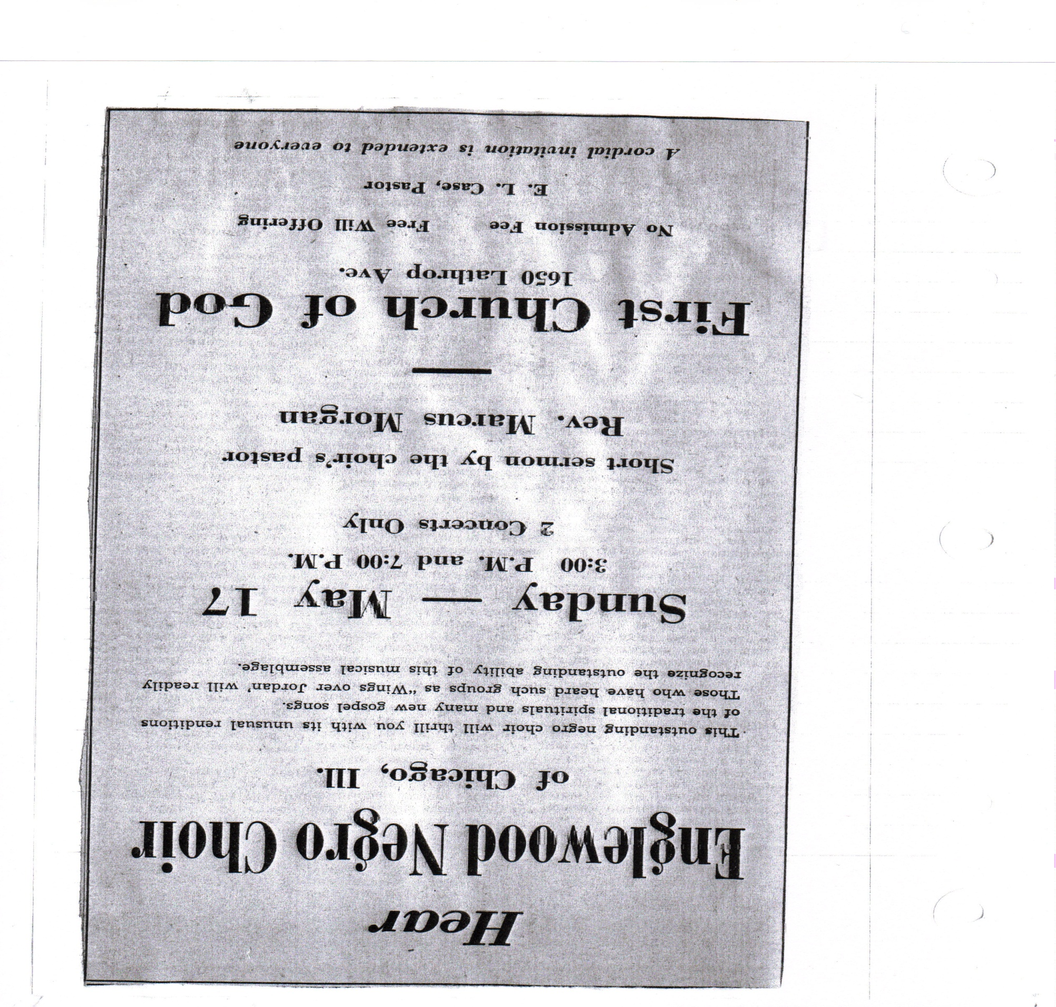
Appendix A
Racine Journal Times (Racine) 16 May 1959, p. 5.
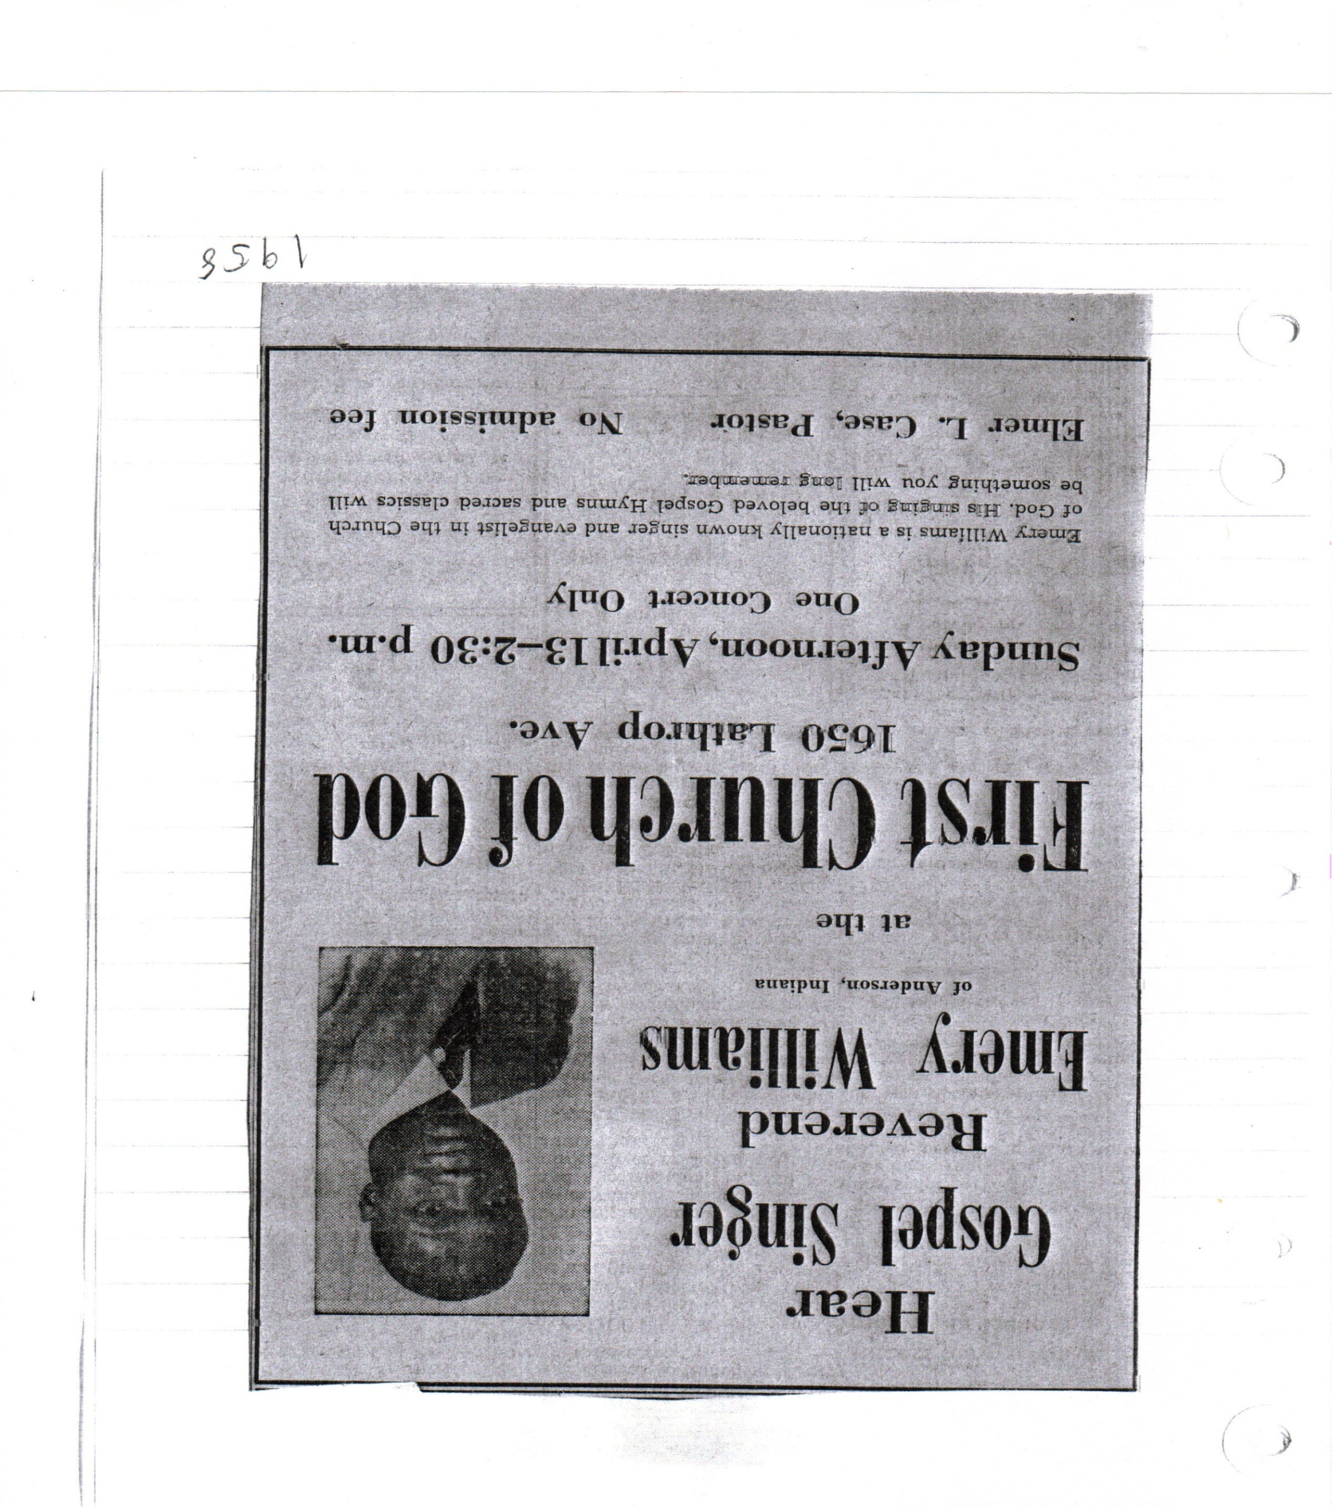
Racine Journal Times (Racine) March 1958, First Church of God Library, Racine, WI.

Works Cited
Primary Sources
Beverly, Sethard A., Dulin, Robert O., Foggs, Edward L., Massey, James Earl, Morgan, Marcus H., Reid, Benjamin F., Sawyer, Thomas J. The Church of God in Black Perspective. West Middlesex: Shinning Light Survey Press, 1970.
Delta Democrat-Times (Greenville, MS).
Dykhuis, Henry. Interview by author. 20 March, 2012. Racine, WI.
First Church of God Newsletter, September, 1965: First Church of God Library, Racine, WI.
First Church of God Racine, WI. “What We Believe.” http://fcogracine.org/believe.html (accessed 27 March, 2012).
Laurel Leader-Call (Laurel, MS).
Gospel Trumpet (Anderson, Indiana).
NACOG Brochure, Did You Know That? http://www.nacog.com/site/LinkClick.aspx?fileticket=QAmetwsVzPU%3d&tabid=36&mid=522 (accessed 14 May, 2012)
Racine Journal Times (Racine, WI).
Wisconsin Assembly of the Church of God. “Church of God Locations in Wisconsin.” http://www.wichurchofgod.org/local_congregations.htm (accessed 1 April, 2012).

Secondary Sources
Callen, Barry. Enriching the Mind and Spirit. Anderson: Anderson University Press, 2007.
Massay, James Earl. African Americans and the Church of God. Anderson: Anderson University Press, 2005.
Sariu, Sawak, “Black and White in the Church of God” Ph.D. Diss., Mennonite Brethren Biblical Seminary, 1973.
Smith, John W. V. A Brief History of the Church of God Reformation Movement. Anderson: Warner Press, 1976.
--------. The Quest for Holiness and Unity. Anderson: Warner Press, 1980.
Telfer, David Alden. “Sociological and Theological Foundations for Church of God Ministry in Ethnic Minority Communities in the United States” Ph.D. Diss., Iliff School of Theology, 1975.

Racine Journal Times (Wisconsin), 19 December 1976, section c.
First Church of God, “What We Believe,” (2008): http://fcogracine.org/believe.html (accessed 27 March, 2012).
John W. V. Smith, The Quest for Holiness and Unity (Anderson: Warner Press, 1980), 162.
Barry Callen, Enriching Mind and Spirit (Anderson: Anderson University Press, 2007), 93-94.
The annual camp meeting was a fellowship get together for Church of God members and their families from across the nation. There were seminars and meetings with a nightly worship church service. It took place on the camp grounds next to the university.
David Alden Telfer, “Sociological and Theological foundations for Church of God Ministry in Ethnic Minority Communities in the United States” (Ph. D. diss., Iliff School of Theology, 1975), 117.
Ibid., 118.
John W. V. Smith, A Brief History of the Church of God Reformation Movement (Anderson: Warner Press, 1976), 122-123.
Telfer,” Sociological and Theological,” 119.
Ibid., 124.
Gospel Trumpet (Anderson, IN), 15 February 1923, 7.
Ibid., 8.
Gospel Trumpet (Anderson, IN), 1 January 1955, 18.
Gospel Trumpet (Anderson, IN), 6 March 1960, 2.
Sethard A. Beverly et al., The Church of God in Black Perspective (West Middlesex: Shinning Light Survey Press, 1970), 86.
Ibid., 87.
Ibid.
Laurel Leader-Call (Laurel, MS), 20 August 1960, 12.
Delta Democrat-Times (Greenville, MS), 21 August 1960, 2.
Beverly, The Church of God in Black Perspective, 88-89.
Ibid., 89-90.
Ibid.
Ibid., 93.
Ibid., 93-96.
Beverly, The Church of God in Black Perspective, i-iii.
Sawak Sariu, “Black and White in the Church of God” (Ph.D. diss., Mennonite Brethren Biblical Seminary, 1973), 17.
Beverly, The Church of God in Black Perspective, iii.
Ibid., ii.
Ibid., 108-109.
Ibid., 110-113.
James Earl Massey, African Americans and the Church of God (Anderson: Anderson University Press, 2005), 107.
Ibid., 114.
Ibid., 109.
Ibid., 104.
Ibid., 107.
Ibid., 113.
Ibid., 111.
Ibid., 112.
Ibid., 113.
Wisconsin Assembly of the Church of God, “Church of God Locations in Wisconsin,” http://www.wichurchofgod.org/local_congregations.htm (accessed 1 April, 2012).
Henry Dykhuis is an active long time First Church of God member who has been attending since the early 1940s.
Henry Dykhuis, Interview by author, 20 March 2012, Racine.
First Church of God Newsletter, September, 1965: First Church of God Library, Racine, WI.
Henry Dykhuis, Interview by author, 20 March 2012, Racine.
First Church of God Newsletter, September, 1965: First Church of God Library, Racine, WI.
Telfer, “Sociological and Theological,” 122.
NACOG Brochure, Did You Know That? http://www.nacog.com/site/LinkClick.aspx?fileticket=QAmetwsVzPU%3d&tabid=36&mid=522 (Accessed 14 May, 2012)

