Biosand Filter Business
Wisconsin Idea Fellowship Project
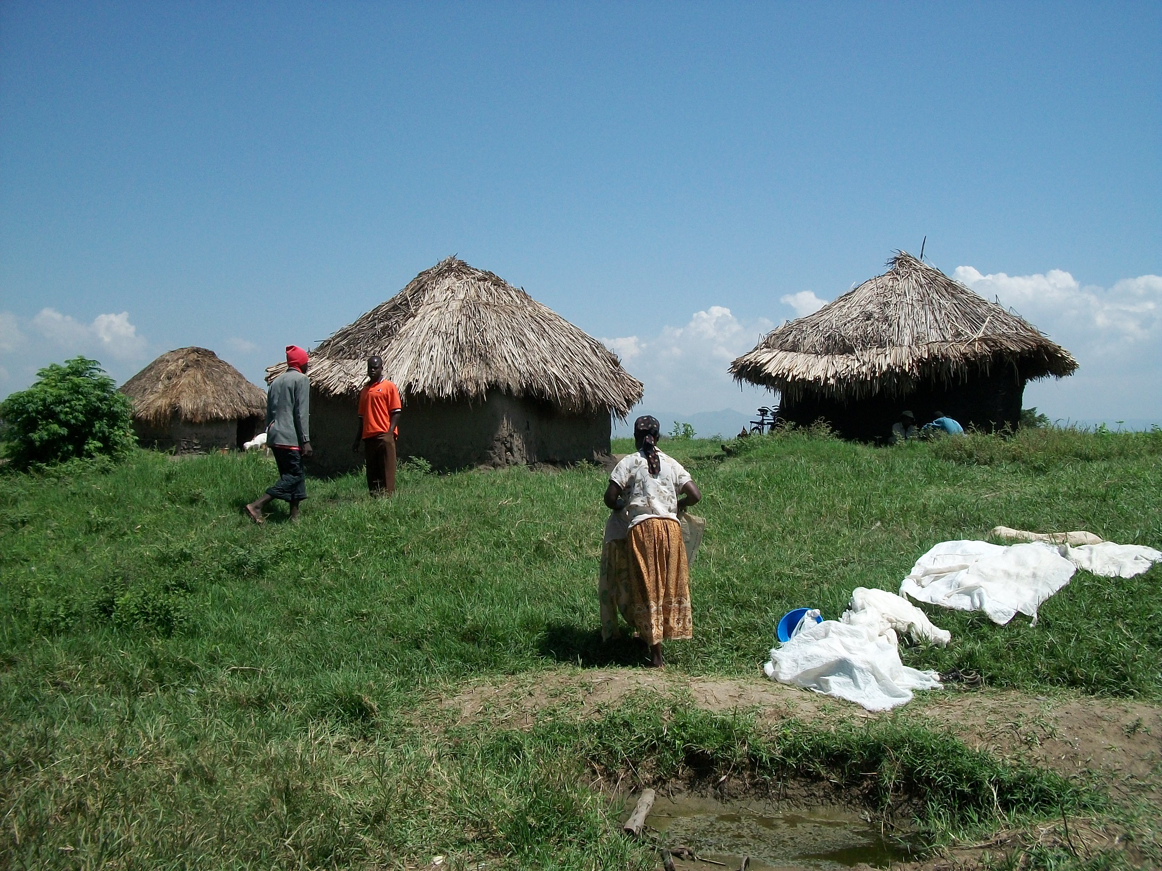
Orongo, Kenya
By: Shannon Lisowe

This project began under the direction of Engineers Without Borders at the University of Wisconsin-Madison. Claire Davis and Shannon Lisowe were awarded the Wisconsin Idea Fellowship (WIF), which is given to projects that enhance student learning while meeting a community need. For more information regarding the WIF, refer to the following website. http://morgridge.wisc.edu/programs/wif/index.html
Table of Contents
Project Proposal 3
Abstract 4
Purpose 5
Background Information 5
Project Summary 7
Timeline 7
Benefits 9
Appendices
A: Citations 10
B: Biosand Filter Diagram 11
C: Effectiveness of Biosand Filters 13
D: Proposed Project Budget 14
E: Budget Notes and Explanation 15

Business Plan 16
Table of Contents 17
Marketing Documents
Filter Reciept 32
Marketing Plan 33
Communication 34
Memorandum of Understanding 35
Educational Materials
Informational Handout 37
Quarter Sheet 40
Funding 42
Shopping List 44
Notes 47
Local Suppliers 48
Mapping 49

Engineers Without Borders – UW Madison Kenya
Biosand Filter Project Proposal

Claire Davis
Shannon Lisowe
February 12, 2010

Abstract
The lack of safe potable water is a serious problem all around the world. We are addressing this problem in a small rural community in Kenya called Orongo. The biosand filter project seeks to provide inexpensive and sustainable access to clean water through the start-up of a biosand filter business to be run by Mr. Amos Omondi Oyoo and the Buoye Quarry Youth Group. After coming to understand Orongo’s current water situation and the serious health implications that result from a lack of clean water, we concluded that biosand filters will be the most effective way to address the issue because they only require an initial start-up cost, they are easy to operate and maintain, and they are effective in removing most infection-causing pathogens. In addition to the health benefits that will result, the project will serve as an example of how to improve the economy in Orongo through entrepreneurial activities. We plan to work with the student organization, Engineers Without Borders, our advisor, Norm Doll, and the Buoye Quarry Youth Group Community Based Organization, to further analyze the water situation in Orongo, develop business and education plans, and travel to Orongo for implementation of the filters. Successful completion of this project will leave the entire village of Orongo with access to potable water in a way that will be sustainable. It will also allow us to utilize our resources at the university to learn more about sustainable development and share our knowledge with a community who is in need.

Biosand Filter Project Proposal
I. Purpose
There are two main goals of the biosand filter project: to provide easy access to drinkable water for families in Orongo, Kenya, and to assist Amos Omondi Oyoo and the Buoye Quarry Youth Group Community Based Organization (CBO) in the formation of a self-sustaining biosand filter business. Through Engineers Without Borders, we have partnered with the village of Orongo, and learned that there is a lack of potable water throughout the community. We are confident that this project is the best way to bring about significant health and fiscal benefits for the entire village of Orongo.

II. Background Information
Orongo, Kenya
Located in the south of Kenya, about ten minutes from Kisumu, is a small farming community called Orongo. Almost all of the people in Orongo are subsistence farmers who live off less than $1 a day (Levicki, 2004). The three main ways that villagers get their water are boreholes (water pumped from 50+ m wells), shallow wells (hand dug), and rain water (gathered from rain catchment tanks or streams). Water quality testing of two boreholes, which we collected in our most recent trip, resulted in colony forming units (CFU) too numerous to count (TNTC), which, according to World Health Organization (WHO) standards, means that it requires treatment to be safe for drinking (Ministry of Water and Irrigation, 2010; Levicki, 2004). The current methods available in Orongo for treatment are chlorine disinfectant and boiling. However, the cost and taste of chlorine, the time and fuel it takes to boil water, and simply the lack of information prevents these methods from being used regularly. Without treatment, the pathogenic micro-organism-containing water can result in serious infections such as cholera, E-coli, typhoid fever, and diarrheal disease.
Biosand Filters
Biosand filters use slow sand filtration to remove harmful pathogens from water. In addition to being relatively inexpensive, and simple to operate, the filters are one of the best single-process methods of improving the physical, chemical, and bacteriological quality of surface waters. A filter is constructed with a layer of fine sand and two layers of different sized gravel. As water is poured through the filter, the microorganisms in the water collide and collect, forming a biolayer on top of the sand layer. The biolayer is critical because it consumes pathogens from the water that passes through it. The sand and gravel layers then work to filter out the larger particles in the water. Studies done in Kenya show that together these processes can remove more than 93% of fecal coliform (Snider, 2002) and result in 54% reduction in child diarrhea (Tiwari, 2009). For filter diagram refer to Appendix 1.
Engineers Without Borders
Engineers Without Borders-Madison (EWB) is a student group whose mission is to “partner with disadvantaged communities to implement sustainable solutions to community problems” (About Engineers Without Borders, 2010). Our project in Orongo, Kenya is one of five projects in the EWB-Madison organization. The Kenya project was formed in 2007 in response to a student’s personal interest in Orongo and its poor water quality. Since its formation, group members have traveled to Orongo four times and have come to a consensus with the community that a project addressing water and sanitation is of the highest urgency. We believe that biosand filters are the most effective and feasible way to do this.

III. Project Summary
In August 2009, we introduced and built two biosand filters for two families in Orongo. That same trip we met a young man named Amos Omondi Oyoo. Before hearing about our project, he had learned about the biosand filters and had been given a Center for Affordable Water and Sanitation (CAWST) manual for how to build them. However, he lacked the resources to act on his newfound knowledge. When we returned to Orongo in January 2010, Mr. Oyoo had conducted a water survey in his community and concluded that there was a strong need for new technology and education on water treatment. Additionally, Mr. Oyoo organized people from the Buoye Quarry Youth Group CBO, to which he belonged, taught them about the filters, saved up money to build some, and donated them to needy members of the community. In the future, he hopes to sell the filters to those who can afford it and use profits to subsidize the cost of filters for others. We were thrilled to learn that Mr. Oyoo had taken his own initiative to start this project, but realized that financial and educational support are essential for him to reach his goals. After meeting with Mr. Oyoo several times to discuss the project, we are confident in his ability to build and distribute the filters. We would like to jumpstart his business and improve the water quality in Orongo by purchasing the necessary molds and materials for construction of the filters. While our first project was focused on building the filters, we have realized the importance of broadening the project to contain educational components. Thus, in addition to supplying the building materials, our project will involve educational materials to teach each recipient of a filter about the maintenance and operation of the filters and the importance of combining water treatment with proper sanitation and water storage.
IV. Timeline
The biosand filter project involves five main stages: research, education and training, business planning, implementation, and follow up.
Stage 1 will be to conduct research that is necessary for implementation. We have been researching biosand filters and other treatment options for over a year, but we want to make sure we are experts before implementation. This will involve reading and analyzing biosand filter case studies, reviewing the CAWST manual, and conducting more extensive and accurate water testing in Orongo. Research will start immediately and continue until our August 2010 trip during which we will do water testing and start to coordinate materials.
Stage 2 is to create educational materials and training programs for the community. These will need to be detailed enough so that recipients of the filters can operate and maintain them on their own, but they must also be created to overcome the cultural barriers that exist. UW graduate student, Beatrice Nguono Okelo, will be helping us to translate all of our materials into the local language. Stage 3 will be to collaborate with students, professors, and Mr. Oyoo to brainstorm, evaluate, and design a suitable business plan. We will have four months, from September 2010 when we return from Orongo until January 2011 when we go back, to complete stages 2 and 3.
Stage 4 is implementation. While we will have prior coordination to get materials in order, most of the implementation will occur during our January 2011 trip. During this month, we will sign contract agreements with Mr. Oyoo, oversee and help with the purchasing of molds and building the initial filters, and share our educational materials with the community and Mr. Oyoo so that he can continue to provide instruction.
Stage 5 will involve follow up contact with Mr. Oyoo and the community to analyze the success of the project and work out any complications. We will produce a report detailing the implementation process, the benefits that resulted, and the challenges that were met and overcome to serve as a reference for future and follow-up projects. This stage will last for the remainder of the fellowship.

V. Benefits
Group
Part of the EWB-USA mission is to create internationally responsible members. The completion of this project will fulfill that mission by allowing us to expand our knowledge of sustainable development and share it with others who are less fortunate than us. The project will teach us to utilize the university’s resources for research, and it will teach us about communicating and implementing internationally. While our group has been to Orongo four times, this will be our first project that encompasses cultural, educational, and technical components and will thus serve as a model for our future projects.
Advisor
Our advisor, Norman Doll, will benefit because the successful completion of the project will increase the achievements and credibility of Engineers Without Borders, for which he is a faculty advisor. Also it will add to his long resume of international engineering projects and contribute to his personal interest in and goals to provide drinkable water to people with limited access.
Community Partner
The primary beneficiary of this project will be the community of Orongo, but the building process will also give jobs to Mr. Oyoo and other kids in the Buoye Quarry Youth Group. We hope that eventually, everyone in the village will have the opportunity to purchase or receive a biosand filter, and thus have a sustainable and affordable method to treat their water. This will directly reduce the amount of water-borne illnesses in the village.

APPENDIX A – Citations

About Engineers Without Borders. Retrieved February 4, 2010, from UW Madison, Engineers Without Borders website, http://www.ewbuw.org/about.

Levicki, Ken. (2004). A catchment to consumer approach to rural water resource assessment: baseline study and safe drinking supply strategy for orongo village, lake victoria basin, kenya (Master of Science Thesis). Royal Institute of Technology (KTH)

Ministry of Water and Irrigation. (2010). Bacteriological Analysis. Analyzed by Alex Mulima, Lake Victoria Environment Management Programme.

Snider, B., Maertens, M., Liang, K., Kaiser, N. (2002). BSF evaluation report samaritan’s purse – 6 country study. Retrieved from http://www.cawst.org/assets/File/BSF_Literature_Brief.pdf. Pg. 13.

Tiwari, S.K., Schmidt, W-P., Darby, J., Kariuki, Z. G., Jenkins, M.W. (2009). Intermittent slow sand filtration for preventing diarrhoea among children in Kenyan households using unimproved water sources: randomized controlled trial. Tropical Medicine and International Health, Volume 14 No 11, 1380.

APPENDIX B – Biosand Filter Diagram
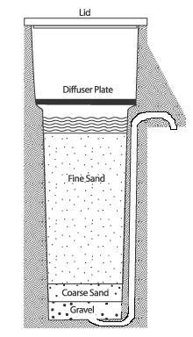

Filtration – Biosand Filters. (n.d). In Centre for Affordable Water and Sanitation Technology. Retrieved on
February 7, 2010 from CAWST website: http://www.cawst.org/index.php?id=128#BSF
APPENDIX B – Biosand Filter Diagram

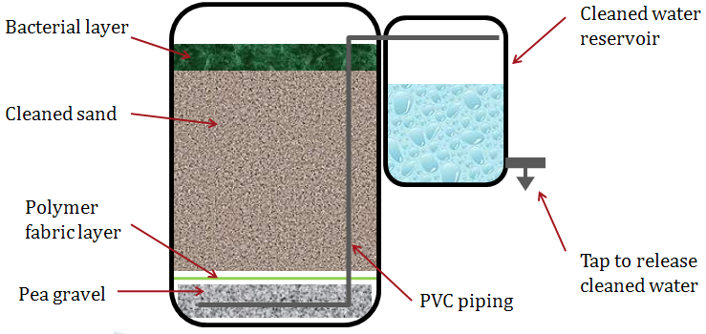

APPENDIX C – Effectiveness of Biosand Filters

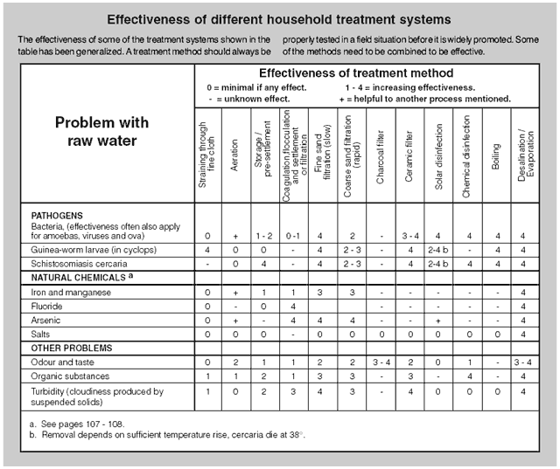
The table above ranks slow sand filtration as the second most effective of all single treatment processes.

Shaw, R. (Ed) (1999). Running Water: more technical briefs on health, water and sanitation. Intermediate Technology, London, UK, p.103.
APPENDIX D – Proposed Project Budget

UW-Madison Engineers Without Borders Kenya Biosand Filter Project Budget

 | Item | Quantity | Cost (per unit) Ksh | Cost (total)  Ksh | Cost (total)  USD
Capital Costs | Mold | 3 Molds | 20,000 | 60,000 | $800.00
 | Sieve | 6 Sieves | 3,000 | 18,000 | $240.00
Capital Costs Subtotal: $1,040.00
Rental Costs | Lorie | 10 Days | 2,500 | 25,000 | $333.33
Rental Costs Subtotal: $333.33
Material Costs | Sand | 10 Lories | 1,500 | 15,000 | $200.00
 | Cement | 80 Bags | 900 | 72,000 | $960.00
 | Rocks | 35 Bags | 2,000 | 70,000 | $933.33
Material Costs Subtotal: $2,093.33
Educational Costs | Informational Handouts | 120 Handouts | 400 | 48,000 | $640.00
 | Construction Guide | 20 Guides | 1000 | 20,000 | $266.67
 | Educational Workshops | 2 Workshops | 10,000 | 20,000 | $266.67
Educational Costs Subtotal: $1,173.33
Water Testing Costs | Pipettes:Flasks:Incubator | --- | --- | --- | $180.00
Prototype Costs | Prototype | 1 Prototype | --- | --- | $145.00
Water Testing & Prototype Costs: $850.00
Total Projected Cost: $5,490.00

BIOSAND FILTER PROGRAM PROJECTED INCOME
WIF Project Implementation Budget | Faculty Award | $1,000.00
 | Community Partner Award | $1,000.00
WIF Project Student Stipend | Portion Contributed From Stipend | $2,000.00
Other Funds | Personal Contributions | $1,500.00
 |  | Total Projected Income: $5,500.00

APPENDIX E – Budget Notes and Explanation
Notes: This is all assuming conversion rate of 75 Kshs/USD
Orongo Population Size: 3000 people/6 people per family = 500 Familes. We aim to build one filter per group of houses, and typically each group has around 5 houses, so we intend to build 100 filters.
There are no management and labor costs here because the Buoye Quarry Youth Group Community Based Organization has offered to work for free. Their incentive lies in two places:
1) Helping the poor people of Orongo
2) Becoming respected experts in the area of biosand filter construction in order to eventually run a self-sustaining business of their own
Cost Justification:
Sieve: The cost of building each sieve is based off of estimates of a sieve built by EWB-Madison in January 2009
Lorie: A lorie is the Kenyan equilvalent of a dump truck.
Sand: Sand costs 1500Ksh/lorie and it takes 1/10 lorie to build one filter
Cement: Cement costs 900Ksh/bag and it takes 3/4 bag for one filter
Rocks: This cost was very much estimated and could be off by as much as a factor of 2. We were unable to identify an exact cost in country. For now assume 2000/bag and each filter needs 1/3 bag.
Water Testing Supplies: This is necessary so we can do water testing before and after the biosand filters to insure they are working properly and effectively. We got the price of this from Professor Greg Harrington. We will be using his lab to conduct these water tests.
Biosand Filter Business and Marketing Plan

Developed by: Engineers Without Borders – University of Wisconsin Madison Kenya Group in conjuntion with the Buoye Quarry Youth Group of Orongo, Kenya

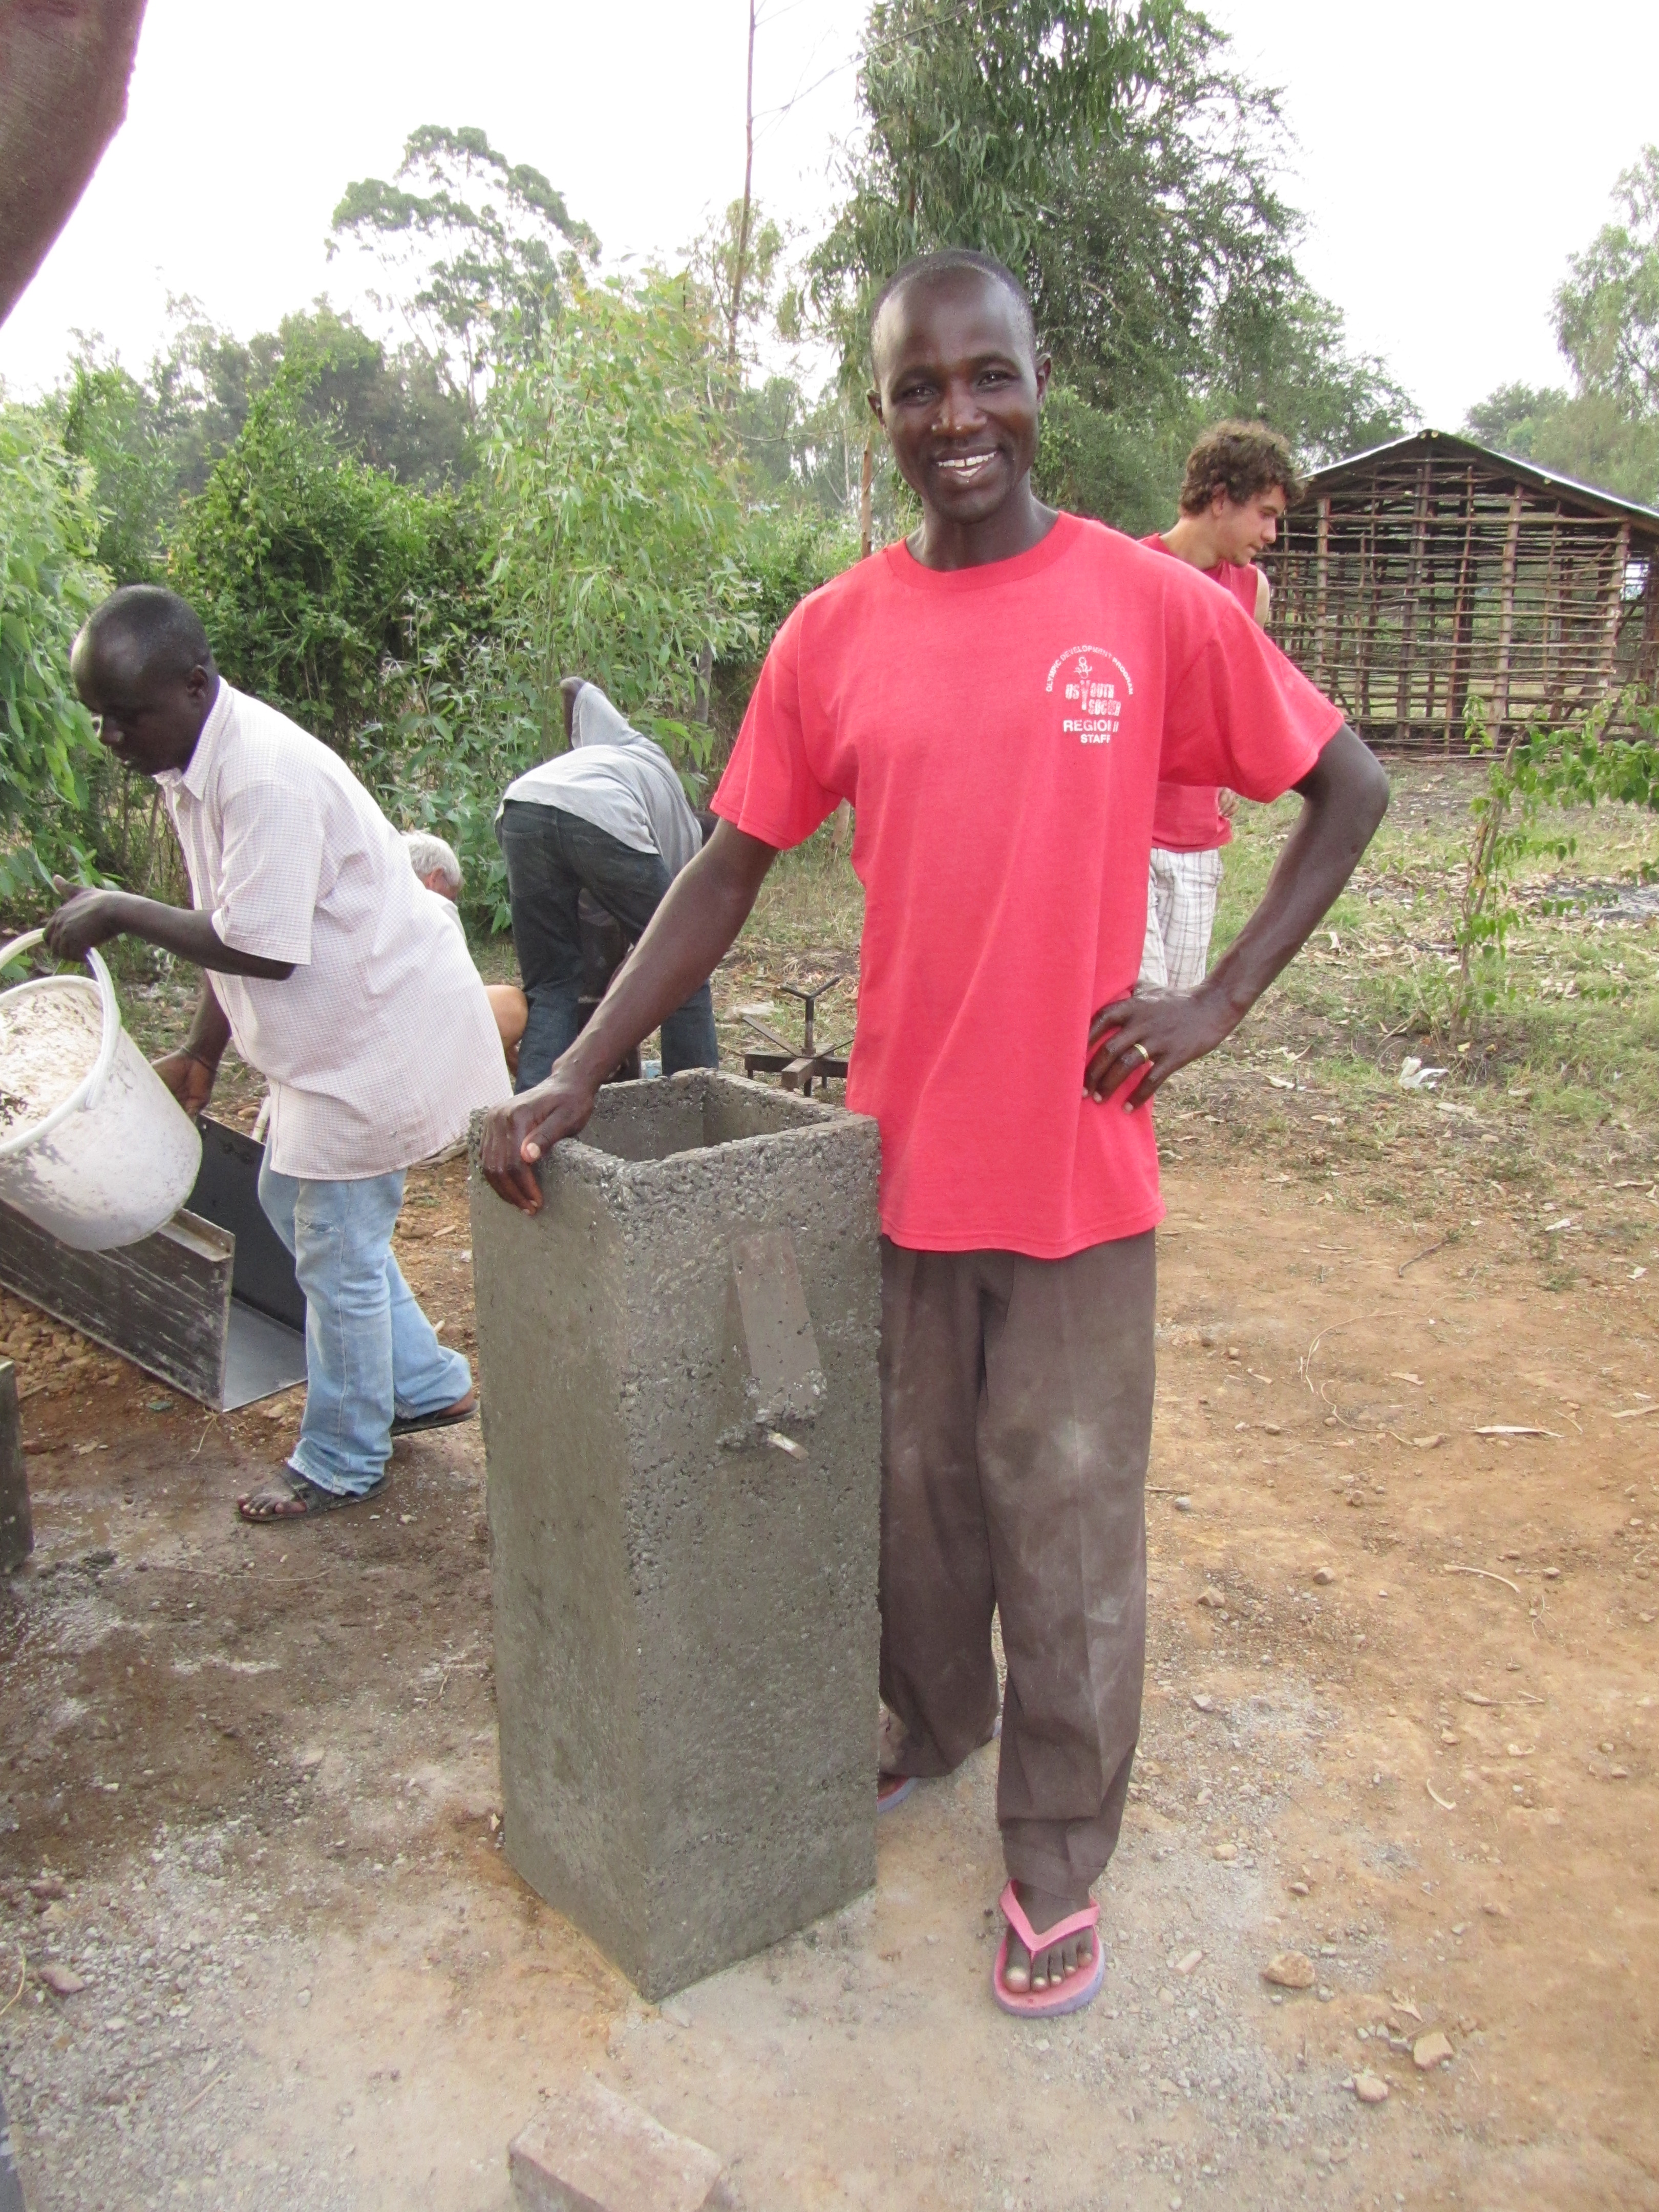
Table of Contents

Table of Contents....................................................................17
Company Overview…………....................................................19
Introduction………….......................................................19
Mission Statement…………............................................19
Objectives………….........................................................19
History and Current Status………………………………..20
Products and Services……………………...............................21
Competitor Project Service Matrix…………….………….21
Features……………………………….…………………….23
Benefits…………………………………………………...…23
SWOT Analysis…………………………………………………...24
Market and Industry Analysis..................................................25
Marketing Plan......................................................................26
Target Market Strategy…………………………………26
Channel Strategy………………..………………………27
Positioning………………………………………………..27
Product/Service Strategy……………………………….27
Pricing Strategy..........................................................28
Operations..................................................................29
Company Organization...............................................29
Competitive Advantage...............................................30
Financial Plan..............................................................30
Appendices……………………………………………………….32
Company Overview

Introduction
Oyoo Filters (this name is a work in progress) is a small business that plans to launch in 2011. The focus of the business is to sell biosand filters that will improve the quality of peoples’ drinking water. It is based out of Orongo, Kenya, a rural farming village 8km Southeast of Kisumu. The initial market will be the residents of Orongo, Buoye and Nyimbo with the reach of Oyoo Filters expanding once these markets have been saturated.
The CEO of Oyoo Filters is Amos Omondi Oyoo. He is a 30 year old man who grew up in Orongo, Kenya and is the Chairman of the Buoye Quarry Youth Group. He has experience and training in biosand filters and knows the community well enough to understand what will work and what will not. He is the sole owner of the company, but will work with several members of the Buoye Quarry Youth Group.

Mission Statement
We aim to manufacture biosand water filters at an affordable local cost and distribute them at a cost that each recipient can afford while maintaining sustainable business practices. An integrated goal is the building of awareness about water quality and the necessity to practice clean water usage. We want to be financially self-sustaining and distribute to the greater Kisumu area.

Objectives
Achievement of long-term profitability, to the level of covering all manufacturing costs and making a profit equal to a liveable local salary.
Achievement of short-term profitability, to the level of covering capital costs of proceeding several rounds of manufacturing filters after first round where start-up costs will be covered by donor (EWB.)
  - Achievement of community education initiative:
  - Community members are not opposed to education initiative
  - Community members are receptive to information and demonstrate understanding of the health risks of contaminated water
  - Community members demonstrate a drive to take action
  - Achievement of marketing initiative [direct relationship to achievement of education initiative]:
  - Oyoo filters are a desirable commodity
  - Achievement of business sustainability:
  - The purchase of a filter is a seemingly one-time cost. Achievement of a process that will insure long-term cash flow. I.e., maintenance, water testing, enlargement of market area.
  - Achievement of established supply chain

History and Current Status
In 2008 Amos Omondi Oyoo received training on CAWST biosand filter construction during a workshop at the Divinity Church in Kisumu. At this workshop a man from Canada taught Amos and approximately 10 others how to properly construct and install biosand filters.

In January 2009, Amos met Engineers Without Borders from the University of Wisconsin Madison in the USA. This EWB project was hoping to begin a CAWST biosand filter project and realized that Amos and his Buoye Quarry Youth Group would be a perfect partner for implementing such a project. In August 2009, Engineers Without Borders USA returned to Orongo and continued discussing the way forward with Amos on this project. During this trip, Amos, Geoffrey, Frederick, and the Engineers Without Borders team successfully constructed 4 biosand filters and Amos and his crew constructed 4 more after the team left. The extent of this partnership is outlined in the agreement signed between Engineers Without Borders and the Buoye Quarry Youth group in August 2009. Basically, Amos and the Buoye Quarry Youth Group will work together with EWB to implement several biosand filters successfully and will do so without any pay or compensation. These filters will be paid for by EWB. Upon completion of this, Amos and the Buoye Quarry Youth Group will be awarded the mold used to construct these filters. While EWB does not intend to be involved in the long term operations of the Oyoo Filters business, EWB will assist Oyoo Filters in developing a business plan and will help guide Oyoo Filters in its very early stages to be successful.

In January 2011, Engineers Without Borders returned to Orongo, Kenya to continue the biosand filter project and consult with Oyoo Filters about this business plan.

Products and Services

Competitor Product Service Matrix

 | CAWST Biosand Filter | Chlorine | Personal Rain Water Catchment Systems | Buying water from Nyamasaria treatment plant | Buying water from the market | Drinking straight from the borehole | Drinking straight from shallow wells/river
Upfront cost (KSh) | 1000 | 0 | ? | 0 | 0 | 0 | 0
Cost per 20L Jerry Can | 0 | 0.4-0.8 KSh + cost of water | 0 | 3-15 KSh depending on where you live | 200 KSh? | 0.5 KSh | 0
Cleanliness | removes 90-98% of pathogens | removes 99.9% of bacteria and viruses. Not parasites | Theoretically cleaner than shallow wells/river | 100% safe to drink | 100% safe to drink | Theoretically much cleaner than shallow wells/river | Very dirty
Taste | Same as original water source | Terrible | Great | Great | Great | Salty, bad. | Great

Availability | N/A. Same as original water source | N/A. Same as original water source | Only during rainy season and immediately after | Year round | Year round | Year round, occasionally it dries up | Only during rainy season and immediately after
Ease of access when available | N/A.  Same as original water source | N/A.  Same as original water source | Very easy. Right at the home | Somewhat easy. Delivers nearby at certain times | Moderate. It’s a hassle to go to the store. | Moderate to difficult depending on distance from borehole | Moderate to difficult depending on distance from Stream or well
Ease of treatment | Easy. Need to wait 20+ minutes | Easy. Need to wait 30+ minutes | N/A | N/A | N/A | N/A | N/A
% of people currently using this method | 0 | 30 | 3 | 15 | 2 | 25 | 25

Features
Oyoo filters will serve one main product to its customers. This product is the CAWST biosand filter and the information about this filter can be found in the CAWST manual.

Notable features of the CAWST biosand filter:
-it is made entirely with locally available materials.
-it can be repaired and maintained entirely using locally available materials
-it has solid construction and should last many many years
-It filters out approximately 95% of all pathogens
-it filters out 100% of parasites which Chlorine cannot kill
-it is recommended that users still treat the water with Chlorine after it passes through the filter
-it filters approximately 40 Liters of water per day

Benefits
The key benefits of the CAWST biosand filter provide to its users are:
-it gives users an additional option for water treatment
-users do not have to pay for water treatment each time they need drinking water
-users do not have to change their daily workflow very much to get this clean water
-it doesn’t taste as bad as chlorine, and if users still add chlorine after it is treated, they can add less chlorine since the chlorine will be more effective when used in less turbid water

SWOT Analysis

Strengths
Amos is a highly motivated individual who grew up in Orongo and knows the community. He holds much more influence than a white person from a typical NGO and is more likely to be able to get the community excited about biosand filters. He is trained in the CAWST filter construction process and has other enthusiastic individuals from the Buoye Quarry Youth Group willing to help him out. Further, he has Engineers Without Borders - USA helping him on this project. This group has the resources to assist him with the ideas and direction to start his business, as well as the technical know-how to ensure things are running smoothly. This group has a small amount of money from a March 2010 grant to begin work on a small number of filters. EWB intends to build a steel mold to construct more filters and will hand over the ownership of this mold to Oyoo Filters once the first several filters have been built. EWB also will help with the education portion of the business.

Weaknesses
Oyoo filters does not have much start up money for getting the business going. Further, Amos does not have much experience in creating business plans and may need additional guidance along the way. The community of Orongo does not currently have a strong passion for biosand filters because they are unaware of this technology. It may be difficult to overcome this, especially given Amos’s limited budget. Further, the demand for biosand filters outside of Orongo is relatively unknown.

Opportunities
Orongo is a relatively well educated Kenyan village and thus may be willing to accept a different clean water technology into their lifestyles. Information spreads very quickly by word of mouth within Orongo and thus people might begin talking about these filters and get excited for them on their own. Oyoo filters has a chance to be the primary supplier for biosand filters and biosand filter maintenance in Orongo and the surrounding areas, and if interest in these filters grows significantly, he can have potentially a lot of customers.

Threats
The biggest threat for Oyoo filters is indifference. If Amos, the Buoye Quarry Youth Group, and Engineers Without Borders cannot get the community of Orongo excited about biosand filters, this business will likely fail.

Market and Industry Analysis

Market Size and Growth
The market that Oyoo filters is catering to is everyone who lives in Orongo, lives in one of the nearby villages, or people in Kisumu who drive past the Buoye Market. Orongo has approximately 3,000 residents and about 500 households which is the absolute maximum number of biosand filters that could exist in Orongo. Buoye and Alara are similarly sized. There are villages beyond these that have similar population densities and are also well suited for biosand filters.

Trends
More residents are getting their water from improved sources such as from the Nyamasaria water treatment plant. Typically, the wealthier the resident, the more likely that resident drinks treated water. The wealthier residents of Orongo tend to live closer to Nairobi Road and some of them have electricity as well.

Target Market
The initial target market is the residents of Orongo who are highly educated and have some disposable income that allows them to buy a biosand filter. These residents are likely the ones that are located near an unimproved water source but do not have easy access to improved water sources like the trucks that drop off Nyamasaria water. Also, the friends and family of members of the Buoye Quarry Youth Group are likely good candidates for this as they may be more willing to take the time to learn and understand this new technology. The size of this initial target market is approximately 50-100 households.

In addition to this initial target market, Oyoo filters will build a few free filters for the poorest residents using money donated by Engineers Without Borders.

Once this initial target market reaches saturation, Oyoo filters will branch out and focus on the rest of the residents of Orongo, Buoye, and Alara. This market represents an additional 1000-1500 potential households.

Finally, once Oyoo filters becomes substantially profitable, the company will begin selling these filters at the Buoye Market and the target market will expand to include residents of Kisumu and other people who drive past the Buoye Market. This represents at least an additional 5,000-10,000 potential households.

Marketing Plan

Oyoo filters will be using a hybrid between a subsidy business model and a full commercial business model. Basically, Engineers Without Borders will subsidize the cost of the early filters and help provide some start up costs but Oyoo Filters will eventually become completely self sufficient and rely solely on payments from its customers.

Target Market Strategy
Based on the target markets that we mentioned, one of the biggest problems with getting clean water is that consistently buying aqua guard or clean Nyamasaria water is a big hassle. Even though people seem generally aware that drinking straight borehole, shallow well, or stream water can make them sick, people often still drink from these sources because of convenience or taste.

Thus, to meet this target market’s needs, we must emphasize these two key points of biosand filters: convenience and taste. Further, we must emphasize a third point in that owning a biosand filter demonstrates that you care about you and your family’s health and are being proactive in improving your livelihoods.

In regards to convenience, biosand filters will last for a very long time and owners will not have to buy water guard as frequently. CAWST does suggest adding a small amount of water guard after the biosand filter completes its treatment. To achieve near 100% effectiveness it is recommended to add one 30mg tablet of WaterGuard (or comparable product) per 40 litres of filtered water; this amount is less than the amount needed without the CAWST biosand filter treatment. Further, even if chlorine is not used, the filter is still an improvement over the original water source. Not having to buy chlorine, or buying it half as often, is a major convenience to people who live far from the road.

The second major point of emphasis is that these filters do not make the water taste bad like chlorine does. Residents of Orongo do not like the taste of chlorine in their water, and thus biosand filters may appear to be a more attractive solution. Even if they do add small amounts of chlorine after the biosand filter treatment, this taste will not be as bad as the standard amount of chlorine.

Another place where taste concerns come into play is peoples’ opinions of borehole water. The water from all of the boreholes in Orongo is salty and people do not like the taste. Thus, even though borehole water is theoretically much cleaner than shallow well or stream water, people will sometimes prefer shallow well or stream water simply because of the taste. Biosand filters are very effective at treating the dirty shallow well or stream water and thus people who choose these sources can continue to enjoy the better taste while also improving the safety of their water by using biosand filters.

The third point of emphasis revolves around proving to your neighbors that you are actively taking steps in your life to improve you and your family’s health. The need to be accepted by your neighbors is prevalent in any country in the world and must not be underestimated. If residents view these filters as markers of health and hold high regard for those families who take the time and energy to install them, they will want one for themselves.

This third point is especially important when we consider how buying decisions are made in Orongo. The men are primarily in charge of the money while the women are primarily in charge of fetching and treating the water. Because it is the men who will likely decide whether or not to buy a biosand filter, one of the key drivers for them will be to convince the men that owning a filter will improve their status.

Channel Strategy
Amos, Fred and Geoffery will be working to directly sell the biosand filters to the community. No channels such as distributers, wholesalers or retailers are needed because our market strategy relies on Amos reaching out the community directly and selling a filter he has manufactured to each individual family and establishment.

Positioning
Customers need to believe that owning an Oyoo filter will improve their quality of life and health. Commercial customers such as restaurants need to believe that placing an Oyoo filter in their establishment will give them more customers and popularity. Owning an Oyoo filter will provide status within the community because it will show that the customer cares about their health and the health of their family by using an attractive device that is preferable above other options because of the superior convenience and taste it provides. Oyoo filters provide the customer with the ability to have commercial-quality water at a very low price in their own homes.

Product/Service Strategy
The biosand filter provided by Oyoo filters offers healthy drinking water and therefore a healthy lifestyle for its consumers. It will provide a constant source of clean water that tastes better than water treated with chlorine tablets. The filter will be a symbol of sanitation and health conscious families who care about improving and bettering their lives. It will be convenient due to the fact that there will be clean water in their homes and each filter will be painted attractively so that families will feel as though it adds to the beauty of their homes.
Repairs? warranty? fees?
As people begin buying the filters in Orongo, the company will be able to expand to other villages and eventually Kisumu, making the market increasingly larger.

Loan system: model would look like this:
Restaurant in market/hotel/hospital/churches or homes already perceived as having status in the community receive filter for free for a trial period and is told they can use the water for free (better to put loan filter in a location with highly turbid water will turn from brown to clear) for 3 months (?). They are told it’s being used as a performance study. The reason for doing this is for the filter to show positive enough effects that the borrower wants to purchase it. It is also to tangibly demonstrate the filters' status and commercial quality and prove that they work without having to have someone make an investment.
If the person the filter is loaned to wants to purchase the filter, that’s great. If they don’t, the filter MUST BE REMOVED to prove that Amos is serious!

Make the filters attractive:
Paint them! Some possibilities are attractive, bright paint, Amos’s contact info, or slogans. The reason for doing this is to make them stand out and to make them more “modern” so people want them more. Make them beautiful.

Amos needs to:
If he decides that making the filters a status symbol is okay, he needs to write a short elevator speech about them. A lot of the material is already in this document. Ask for Josie’s help?

Pricing Strategy
Two pricing strategies:
- For establishments that the filters are loaned to, they will pay full purchase price + a markup, paid in small installments.
- For individual customers that buy filters, the first [as of yet unspecified] percentage of customers will pay a reduced price, paid in small installments. Customers after this percentage will pay full purchase price + a markup in small installments.

To be determined by Amos, Fred, and Geoffrey: how much of a markup do they need to make a profit? How much should a small installment be (what is affordable?)

Loan system: restaurant/hotel/school teacher’s building/hospital/churches or homes with small children receive filter for free for a trial period and is told they can use the water for free (better to put loan filter in a location with highly turbid water will turn from brown to clear) for 3 months (?). They are told it’s being used as a performance study. The reason for doing this is for the filter to show positive enough effects that the borrower wants to purchase it.

Paint them! Attractive, bright paint, Amos’s contact info, slogans. The reason for doing this is to make them stand out and to make them more “modern” so people want them more.

Start selling them at a super low price and then once demand increases incrementally increase the selling price so a profit can be made. The reason for doing this is to make the product very affordable so people will buy them and talk about them and then more people will want them. Possible problem: will be people be mad and not accept a higher price?

Operations:
The biosand filters will be created according to the CAWST manual and delivered via hand cart. The filters are of high quality material (ie concrete) which are a one time cost and when properly maintained provides the family with a water filtering source. The manufacturer is located in the community that it is served, therefore reducing transport time to the customer. Also, there is no competition.

Will maintence be supplied? Free vs paid? Will it have a warranty?
Production, product development, order fulfillment, customer service, warehouse and shipping, tech support, installation, and warranty service and repairs will be done in house by Fred, Amos, and Geoffrey.
Identify the key vendors, suppliers, strategic partners, and associates. What arrangements have you discussed with them? What price agreements have you reached?
Based on your sales forecast, estimate how much production or service capacity is required over the next five years. This is usually expressed as some rate per hour, day, week, month or year. For example, 100 lighting fixtures per month or 150 meals per day for a restaurant.

Company Organization:
What is the ownership structure of your company? What percent of the company do each of the founders own?
We highly recommend that Amos take the majority of the ownership so that decisions can be made and business can run smoothly.

Competitive Advantage:
This is not as important because the goal is NOT to compete with existing filtration services and products. Amos is competing with existing dirty water sources, but not informing his customers of this.
see Balance Score Card Strategy Map in appendix
Highlights:
Customer Intimacy (this contributes to making the filters more of a “status symbol” if the supplier is personally available, it makes the filters seem like a more high-quality product)
Excellence of Product

Financial Plan

Initial Capital Costs
Item | Cost (KSh) | Vendor | Paid by | Bought on
Mold materials and construction | Estimate: 80500 |  | EWB-USA | Spring 2011
Sieves | Estimate: 6100 |  | EWB-USA | Spring 2011
Mold Transportation | Estimate: 2000 |  | EWB-USA | Spring 2011

First Batch of Operating Costs
Item | Cost (KSh) | Vendor | Paid by | Bought on
Garbage bags and Blue Band | 430 | Yatin Limited | EWB-USA | August 2010
More Blue Band | 440 | Tusky’s | EWB-USA | August 2010
Buckets | 1050 | Nakumatt | EWB-USA | August 2010
Sand paper, Wrenches, Trowel | 1500 | Nakumatt | EWB-USA | August 2010
Large Gravel, Small Gravel and Dust | 3016 | Ndugu Transport CO | EWB-USA | August 2010
Material Transportation |  |  | EWB-USA | August 2010
Tarps | 400 | Cement Center Limited | EWB-USA | August 2010
Biosand Filter Rentals | 15000 | Divinity Church | EWB-USA | August 2010
Cement | 820 | Bahati Hardware | EWB-USA | August 2010
More Cement | 800 | Lakhami Electrical and Hardware Limited | EWB-USA | August 2010
Piping and Shovels | 1300 | Alpha Hardware Supplies | EWB-USA | August 2010
Mold Transportation | 4000 | Michael Ouma | EWB-USA | August 2010
Piping and Wire Brush | 1620 | Alpha Hardware | EWB-USA | August 2010
More piping | 1880 | Alpha Hardware | EWB-USA | August 2010
More Cement | 2380 | Kisumu Shiva Enterprises | EWB-USA | August 2010
More Cement | 3950 | Migosi Hardware | EWB-USA | August 2010
Tape | 70 | National Printing Press Limited | EWB-USA | August 2010
Total: | 41135

Appendix

Dictionary of Terms

Buoye Quarry Youth Group – The community based organization located in Orongo, Kenya that is partnering with Engineers Without Borders.

CAWST – The Center for Affordable Water and Sanitation Technology

CEO - Chief Executive Officer. Also known as an owner, president, or founder.

EWB – Engineers Without Borders. In this paper, used to represent Engineers Without Borders at the University of Wisconsin – Madison Kenya Group.

Profitability - A financial benefit that is realized when the amount of revenue gained from a business activity exceeds the expenses, costs and taxes needed to sustain the activity.

Biosand Filter Business
Memorandum of Understanding (MOU)

Between
Engineers Without Borders—Madison
And
AFGO Filters
Amos Omondi Oyoo, Geoffrey Odhiambo Yengo, Fred Agonda

I. Purpose and Scope
- The previous Memo of Understanding (from August 2010) is invalid after the completion and signing of this memo.

II. EWB Responsibilities under this MOU
- Pay for the labor, materials, and transportation of one mold. Will also oversee construction and provide technical assistance.
  - EWB is not liable for errors found within the construction of the mold, or malfunctions of the mold. For further assistance consult the welder.
  - After delivery of the mold, EWB is not responsible for replacement or repair costs (i.e. if the mold is broken or stolen)
- EWB will provide three copies of the CAWST manual instructions to Geoffrey, Amos, and Fred Agonda. Also, a copy of the welding sections will be supplied for the welder.
  - While in country, EWB will provide technical assistance pertaining to this manual, to the best of our ability.
- EWB has provided 130,000 Ksh to assist in the start up of this business. These funds were allocated for the purchase of a mold, sieves, and supplies to create the first batch of filters. This also includes transportation, and other costs associated with obtaining these materials.
- EWB will provide the outline of how to construct a business plan
- EWB will fill the role of a consultant by providing recommendations and suggestions.

III. AFGO Filter’s Responsibilities under this MOU
- Carry out all operations related to the business. This includes, but is not limited to: labor for biosand filter construction, maintenance, procurement of additional materials, marketing
- Keep accurate and detailed records of sales and costs.
- Carry out marketing plan as agreed on.
- Maintenance and upkeep on materials purchased by EWB.

IV. Funding
- Beyond the funding provided by EWB, Amos, Geoffrey, and Fred must raise their own funding through selling filters or alternative means.

Signatures

EWB Representatives
__________________________ _________________________

AFGO Filters
_________________
_______________________ _______________________

Funding

All of the funding for this portion of the project was obtained from the Wisconsin Idea Fellowship (WIF), which was applied for by Claire Davis and Shannon Lisowe of Engineers Without Borders UW – Madison Kenya group. The biosand filter business project was awarded $2000.00 for project implementation costs. The breakdown of actual costs is as follows:

Pre August 2010 Trip Costs
Water Testing Supplies (w/o tax & shipping)
Pipettes - $35.50
Flasks/Bottles - $96.82
Incubator - $39.95

Biosand Filter Prototypes (w/o tax & shipping)
Cement (5 bags) - $42.45
Sand (8 bags) - $35.92
Gravel (9 bags) - $49.41
Trowels (2) - $3.98

Total = $321.54

August 2010 Trip Costs
Filter Supplies
See spreadsheet located on next page for breakdown.
Total = $495.44

January 2011 Trip Costs
Mold Supplies
Labor & Materials (1 mold) - $842.11
Travel and Transportation - $90.13

Sieve Supplies
Wood - $11.84
Labor - $14.47
Mesh - $47.37

Other Materials - $52.63

Total = $1058.55

August 2010 Trip Costs Breakdown

Vendor Name | Items Purchased | Amount Paid (KS) | Amount Paid ($$)
Cement Center Ltd. | 4 meters of tarps | 400 | 4.792
Yatin Limited | garbage bags and blue band | 430 | 5.1514
Deliverance Church Kondele | biosand filter mold rental | 2500 | 29.95
Nakumatt | wrenches, trowel, sandpaper, tarps | 1500 | 17.97
Bahati Hardware | one bag of cement | 820 | 9.8236
Ndugu Transport CO Ltd | gravel/sand | 3016 | 36.13168
Lakhami Electrical and Hardwares LTD | one bag of cement | 800 | 9.584
Alpha Hardware Supplies Ltd | piping and shovels | 1300 | 15.574
Michael Ouma | transportation of mold | 4000 | 47.92
Deliverance Church Kondele | mold hiring | 12500 | 149.75
Alpha Hardware Supplies Ltd | piping and wirebrush | 1620 | 19.4076
Amos Omondi Oyoo | Biosand Filters | 2700 | 32.346
Alpha Hardware Supplies Ltd | PVC | 1880 | 22.5224
Nakumatt | buckets for cement | 1050 | 12.579
Tusky's United | blue band | 440 | 5.2712
Kisumu Shiva Enterprises | Simba & Cement | 2380 | 28.5124
Migosi Hardware | cement | 3950 | 47.321
National Printing Press Ltd | tape | 70 | 0.8386
 |  | 41356 | 495.44488

Mold Shopping List

All of these material lists and notes were obtained from CAWST. All CAWST education materials are available for download off of the CAWST website.

All of our filters are built according to CAWST specifications as seen in the current CAWST Biosand Filter Complete Manual.
Suppliers (from August 2010 trip)
All located within Kisumu, Kenya.

Deliverance Church Kondele
Mold Rental

Cement Center Ltd
4 meters of tarps

Yatin Limited
Garbage bags and blue band

Nakumatt
Wrenches, trowel, sandpaper, tarps

Bahati Hardware
Cement

Ndugu Transport CO Ltd
Gravel, sand

Lakhami Electrical and Hardwares LTD
One bag of cement

Alpha Hardware Supplies Ltd
Piping, shovels, wirebrush

Tusky’s United
Blue band

Kisumu Shiva Enterprises
Simba, cement

Migosi Hardware
Cement

National Printing Press Ltd
Tape

Mapping of Orongo, Kenya

