College and Community:
The Forum Series at UW Eau Claire to 1980

Brian T. King
History 489
April 2012

Copyright for this work is owned by the author. This digital version is published by McIntyre
Library, University of Wisconsin Eau Claire with the consent of the author.

Introduction
The Forum Series at UW-Eau Claire is one of, if not the longest running series like it in the country. It has had famous names such as Reverend Martin Luther King Jr., Henry Kissinger, Jane Goodall, Maya Angelou, Richard Nixon, and Ralph Nader speak to its audiences. It has become a tradition in Eau Claire, tracing its history back 70 years. It has added a unique cultural element to the community and University by bringing in ideas and speakers from a national and global level. In my paper, I will first look at what I feel is the predecessor to the Forum series; the national movement known as Chautauqua. Through looking at this, I hope to gain a better appreciation for the thinking that eventually created the Forum in Eau Claire. Although the Forum was not a direct by product of Chautauqua, it was a predecessor in spirit. Then I will examine both how and why the Forum was started. Next I will go into detail about some of the Forums’ challenges and successes. (I will only examine the Forums’ history up until 1980 as that’s about as far as I am in my research.) I will argue that the successes of both the Forum and the Chautauqua movement resulted in their ability to change over time to reflect what went on in the culture and major national and global issues.
Chautauqua
The Chautauqua movement began on the shores of Lake Chautauqua in 1874. It started as a gathering of Sunday school teachers and lay people to discuss methods of teaching and how they could be improved. America had a long history of outdoor interdenominational gatherings. As opposed to some of the older religious camp meetings held around the country, the Sunday School Teacher’s Assembly on Chautauqua Lake had few sermons, and was concerned more with education than evangelism. That is not to say that the gathering was not just as religious; its focus was simply different.
Over the next few decades, the focus of Chautauqua gatherings expanded and it became an extremely popular event that many Americans took part in. In his book The Chautauqua Moment: Protestants, Progressives, and the Culture of Modern Liberalism, Andrew C. Rieser asks why and how so many towns across the nation experienced a “Chautauqua Moment” at the end of the 19th century. He feels that one of the reasons Chautauqua became so popular and widespread over a relatively lengthy period of time was its ability to adapt and broaden its scope as it grew. He writes “The movement seemed to reinvent itself from decade to decade. Both the somnolescent Sunday school assembly of 1874 and the vaudevillian circuit troupes of the 1920’s bore the Chautauqua name, as do the radio revues and traveling historical pageants of today” Rieser‘s theory is that Chautauqua was (and perhaps still is is) able to reflect what was going on in the culture and was a vehicle for expression of ideas. He opposes an earlier theory of Chautauqua’s success which argues that it served to fill a spiritual and cultural void or “thirst” in the American people. He feels that this makes some biological assumptions about humanity that he is not comfortable with.
Rieser calls John H. Vincent the patriarch of the original Chautauqua. He gives him this credit above other men who were there at the founding of the movement. In his own book, “The Chautauqua Movement” (not to be confused with Rieser’s (The Chautauqua Moment) Vincent talks about the first meeting on the shores of the lake.
“…a two-weeks’ session of lectures, normal lessons, sermons, devotional meetings, conferences and illustrative exercises, with recreative features in concerts, fireworks, and one or two humorous lectures” and “The most radical questions pertaining to pedagogy were considered. Foundations were laid. First principles were discussed by the leaders in educational science. Plans of teaching were shown in actual operation by most gifted instructors. Criticism, favorable and adverse, was freely encouraged.”

Vincent’s original idea of Chautauqua was one born out of his great love for education and learning. Vincent felt that its lofty goal was to bring the education to every person regardless of class. Rieser on the other hand, has a much more skeptical look at the Chautauqua movement. He feels that there was a serious disconnect between the knowledge that was supposed to be gained and actual action. He feels that there was success in terms of giving information and knowledge to the audience, but failure in terms of using that information for any kind of political action. He argues that although Chautauqua may have had good intentions, it was plagued with a sense of classism, elitism, and sometimes racism that held it back from its potential. Although Vincent declares that Chautauqua “must awaken in all genuine souls a fresh enthusiasm in true living, and bring rich and poor, learned and unlearned, into neighborship and comradeship, helpful and honorable to both”. Rieser feels that although this may have been talked about in theory, it was not usually put into practice. Those outside certain norms such as race, class and culture were sometimes discouraged from participation either explicitly or more incidentally through circumstances. Nevertheless the movement had a great influence on the nation. I see it as one of the predecessors of the Forum both in concept and even more so in spirit. Its’ embrace and promotion of community education and learning across the country provided a background for the development of the Forum.
The Chippewa Valley Forum
President W.R. Davies arrived at the University of Wisconsin Eau Claire in December 1940. Formally a school superintendent in Superior, WI, he impacted both the University and the surrounding community significantly. Just a short time later, in 1942, he would create the predecessor of the University forum to Eau Claire, the Chippewa Valley Forum. “Hilda Belle Oxby, member of the first Forum Committee, recalls that there was a “knife and fork club” in Eau Claire which heard only speakers pre-selected for their meetings, and Mr. Davies felt a better type of forum could be organized with wider community participation.”
Oxby, a teacher at the University, helped President Davies establish the forum; and was in charge of handling all ticket sales for the next ten years. An attorney from the area, Francis Wilcox, drew up the constitution for the Forum Committee. The format of the speaking engagements was very similar to what would later take hold at the University. “Together the committee selected the speakers, usually five each year, who lectured for an hour, answered questions from the audience for a half hour, and were then guests at an informal reception.” This setup allowed for a large amount of community participation with the speaker which was something Davies was striving for in his creation of the forum. The reception would allow forum goers to discuss what they had just heard with other people from the community with the same shared experience; and even get a chance to meet the speaker in person. This allowed for more interaction between the members of the community and each other, and the speaker.
There were already special programs and speakers scheduled during the semester at the University that bore some similarities to both the Chippewa Valley and later Eau Claire Forum. For example, a convocation was regularly held on Monday mornings around 10 A.M. that invited speakers from both the state and national level, and actually quite a few from abroad as well, to present to members of the University. Some of these were not targeted at the community and only a few seats were open to “friends of the College”. Others were open to a general audience. Speakers presented on diverse topics like foreign policy and diplomacy, literature, science, religion and race. Often times these topics were related to events relevant at the time, such as what our Governments plans should be in relation to Japan, or whether race or personal background contributes more to attributes of behavior. Convocations were even held during the summer. Unfortunately, few people other than University students and perhaps professors would have the ability or the desire to listen to a speaker at 10 A.M. on a week-day which I feel suggests that was who it was aimed at.
I would argue that these could be viewed as parallels to the Chippewa Valley Forum in that they were running alongside one another during the 1940’s and had much of the same focus. Although the target audience was likely different, and the convocations were probably never as popular as the forums (which were held at a more accessible hour) the two programs goals were similar.
In a 1956 letter to Supreme Court Justice William O. Douglas, President Davies implored him to come speak at the college, saying, “We are still in an isolationist area of the state and the expression of the kind of sound thinking you do on things international is needed not only for the graduates but for the parents and friends... even though they refuse to take the time to read an article” Davies emphasized what he felt was a need for community education in the Eau Claire area. He felt strongly that ideas from the outside world were necessary, not just for students, but for their friends, parents, and grandparents. Davies’ Forum was one way he accomplished his goal.
Reflecting National Issues
I argue that one of the main reasons for the success of the forum is its ability to bring issues of a national scale to the community level. It has the ability, much like the Chautauqua movement that predated it, to stay relevant through continual renovation. The format and preparations can remain the same for decades and yet it can remain relevant. This is because world issues are constantly coming in and out of the spotlight of awareness and importance. This provides an essentially never ending supply of new topics and speakers.
The Eau Claire Forums focus on these large issues is helped greatly in its ability to speak to current issues without even explicitly attempting to. This is because of the nature of the speakers the forum has sought out in the past. “We’re after the doers, not talkers” Johannes Dahle, former director of University Programs said in a newspaper interview in 1969. He said this in response to a request to be relieved of speaking engagements by Jules Feiffer; a famous cartoonist. Dahle said that although they sometimes have problems with scheduling when they go for quality speakers, he qualified it saying, “We could pick third rate speakers who would be there, but these are not the people we want. We want those willing [to come] if they can---- those whose job is doing what they’re doing” Dahle further commented on the busy and much in demand nature of the people he seeks out. “With these kinds of people the old concept of the lecture tour is out of the question,” “they fly in the night before the forum and fly out the same night or next morning.”

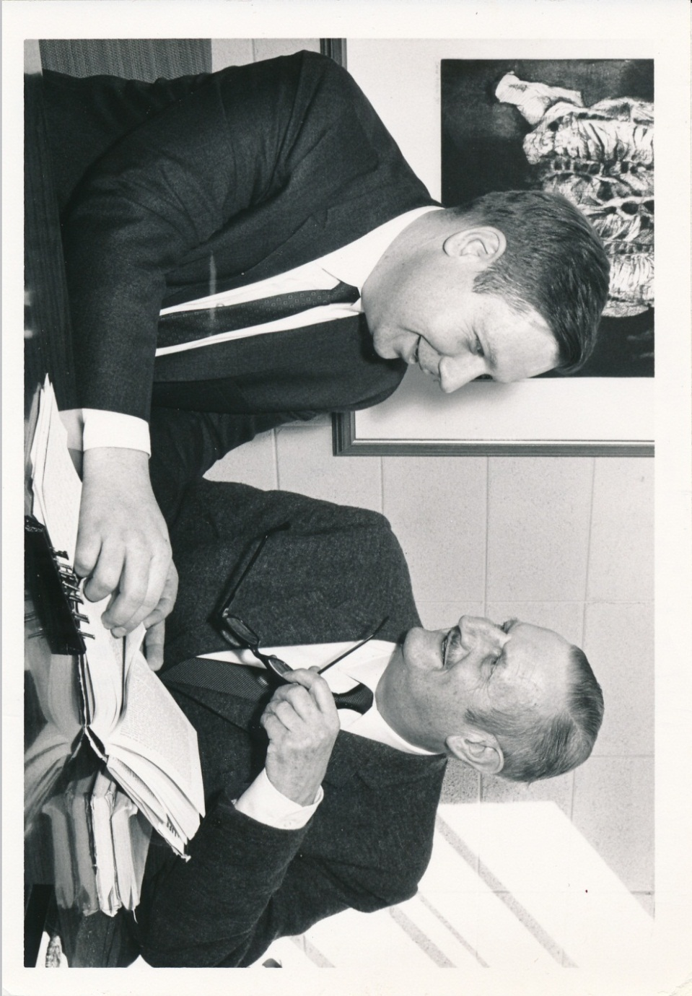
Figure 1.
Forum Director Johannes Dahle (Left) with Forum speaker Sir Tyrone Guthrie, 1969
Source: Eau Claire University Centers Activities and Programs programming files, 1917-2006 Box 1 folder 84

These types of speakers are often already speaking to a national audience about national or global issues in which they are often active players. The forum committee does not have to pick out important issues they think the community will be interested in and then find speakers to discuss those topics. To some extent they can choose speakers based on their popularity and merits and those men and women will naturally discuss topics that are of importance and interest.
The Success of the Forum
Dahle's attempt to successfully carry out Davies vision of bringing outside ideas to the community was not overlooked. An editorial article of wholehearted praise was written in the Chippewa Herald Telegram on October 12, 1968. The article actually starts out by describing its previous extensive criticism of the forum. It is rather descriptive and states that in previous years the speakers spoke on topics that were too academic and were just not of interest or value to the community. “Hence, the speeches were dry and boring” the editorial said flatly. Although the forum was seeking after experts in their fields, the speakers were simply not good at public speaking in the sense of making it interesting for the audience. In the few years since the newspaper had written this criticism, the forum committee shifted their focus to what Dahle called “the doers” The article continued on. “As much as we could criticize the Forum a few years ago, today we can only unreservedly compliment it. The forum speakers are outstanding. Their subjects are extremely topical and lively. And the general worth of the Forum presentations are unparalleled”
To acquire guests of this magnitude required a substantial amount of money. At this time in 1969, a speaker for the forum was paid around $1,000 to $1,500. Adjusted for inflation, this would be about $6,200-$9,300 per-engagement. At this time the ticket price for a seasons pass was five dollars to the public and two dollars for students. Inflation considered, this was more like $31 for the public and $12 for students. The ticket price changed over time and free forum events were even offered as specials starting in 1967. The Chippewa Herald Telegram also glowingly praised the relatively low cost of a ticket.
…it is fair to say that no greater value for the dollar exists in the Chippewa Valley than a season set of tickets to the Forum. These tickets cost only $5.00 for a set, which admits the bearer to each of the Forum presentations….on behalf of everyone in the area, sincerely thank the University and the group that brings the Forum for giving this area a program of cultural enrichment of the highest caliber, most topical nature, and the greatest interest.

Johannes Dahle was motivated to select quality speakers because, much like President Davies, he felt there was a lack of culture on campus (and likely in the community as well). Dahle helped to change the forum from being a requirement for students to actually requiring reserve ticket seating. He felt that this brought the forum more dignity. Students that do not really want to be there, and show it by their dress and actions, no longer came. He also wanted to make the forum something that people looked forward to. He said that reserve seating makes the Forum, “an anticipation builder”, instead of being forced, “People plan to go”.
The Forum committee had put a good deal of effort into improving the Forum. While the community seemed to appreciate it, that does not mean that the students always did. The Chippewa Herald Telegram had interviewed students asking them what factors prevented them from coming to the forum events. “Interviews with students indicated that time and physical unfitness are crowd-limiting factors. ‘The time is inconvenient’ commented a student ‘It’s something you have to come back for.” Another said, “Once you’ve gone up the hill. I don’t think Moses himself could draw you back down those 90 steps” One student with an enthusiastic use of a red pen commented on a response card handed out by the Forum committee in 1967 “Do not schedule forums on same night as night classes are held!!!”
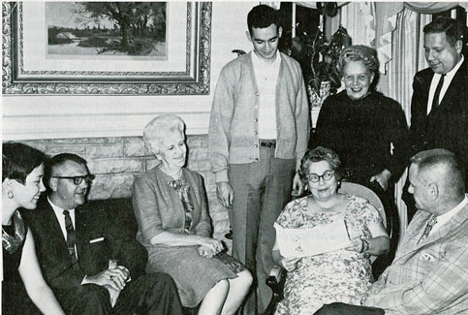
One fascinating aspect of the Forum is that the Forum Committee took active measures to inquire what the audience wanted to hear. In 1967, hundreds of sheets were collected from students and faculty asking a variety of questions. Although there are a few years when these cards were kept, this year has one of the more substantial collections. An excerpt from the response sheet reads “All aspects of The Forum are being scrutinized in order that the rich heritage (note reverse side) can be reinterpreted with meaning and vitality.”
Figure 2. 1967 Forum Committee
From Left to right: Nina Macheel, Dr. W. C. Puttman, Mrs Estelle Fletcher, Prof. Grace Walsh, Dr. Robert Fossland, Standing: Richard Steinke, Mrs. Winifred German, Johannes Dahle.
Source (picture and caption) Hilda Carter, and John Jenswold. The University of Wisconsin Eau Claire: a History, 1916-1976. University of Wisconsin: Eau Claire Foundation, 1976. p 91

It then went on to ask a series of questions to the recipient. Which building would they prefer Forum events be held in? Would they prefer reserve or general admission seating? Which speakers or topics would they like to hear about? These provide a really candid look into what the audience thought in response to, and wanted from, the Forum. The large range of differing opinions from the audience is both humorous and informative. One respondent wrote “I would like to see students properly dressed for the occasion- no cut-offs, sweatshirts, or girls wearing slacks. The ushers should refuse to admit them.” They had no additional suggestions as to topics, speakers, or location; only that it remain in the same format. One man recommended “Stay away from journalists” and felt that the forum should focus on speakers who were more “directly involved in events of today” Another agreed with him saying, “Please stay away from those on the ‘speaker circuit.’ They are always tired and give unstimulating pat talks. Journalists are among the worst.”
As you perhaps would expect, the speakers that were chosen by the Forum Committee tended to be more politically liberal than both the student body and community would have liked. This was a frequent complaint among respondents from several years of surveys. One man praised the sound system in the University Fieldhouse but then remarked, “Please try and balance the program next year with at least ONE conservative, and I do not mean the Arthur Larson kind.” One respondent’s only recommendation for the forum was simply “Richard Nixon”
Some respondents were sick of hearing about politics altogether “It seemed there was too heavy an emphasis on political speakers- one in this area would suffice. How about music and the arts.” She, and several others, asked for an afternoon forum for those with children at home.
A few friends must have filled out their responses together. Three sheets in a row asked for Hugh Hefner to speak to the forum, one asked him to speak on “Sex” and another on the “Values of Morality”. One of the students (most likely one of the ones that the aforementioned persnickety lady felt should be turned away at the door) answered very honestly “How about something the college student is really interesting, (sic) like L.S.D., sex or suicide, or expert (sic) on social life. More convocations are extremely boring, we’re bombarded with lectures, how about some good interesting speakers talking about subjects that aren’t so well worn.”
Martin Luther King Jr. was the most frequently requested speaker; confirming that racial issues were at the forefront of topics that students and faculty found important on campus during this time (he had spoken at the forum five years earlier). Sadly, he would die the next year in 1968. A close second and third was probably Hugh Hefner and Barry Goldwater. Other
popular topics included elimination of the requirement that students attend a certain number of Forum presentations (this was before that requirement was relaxed) and (likely related) requests to allow people to leave once the lecture portion was over.
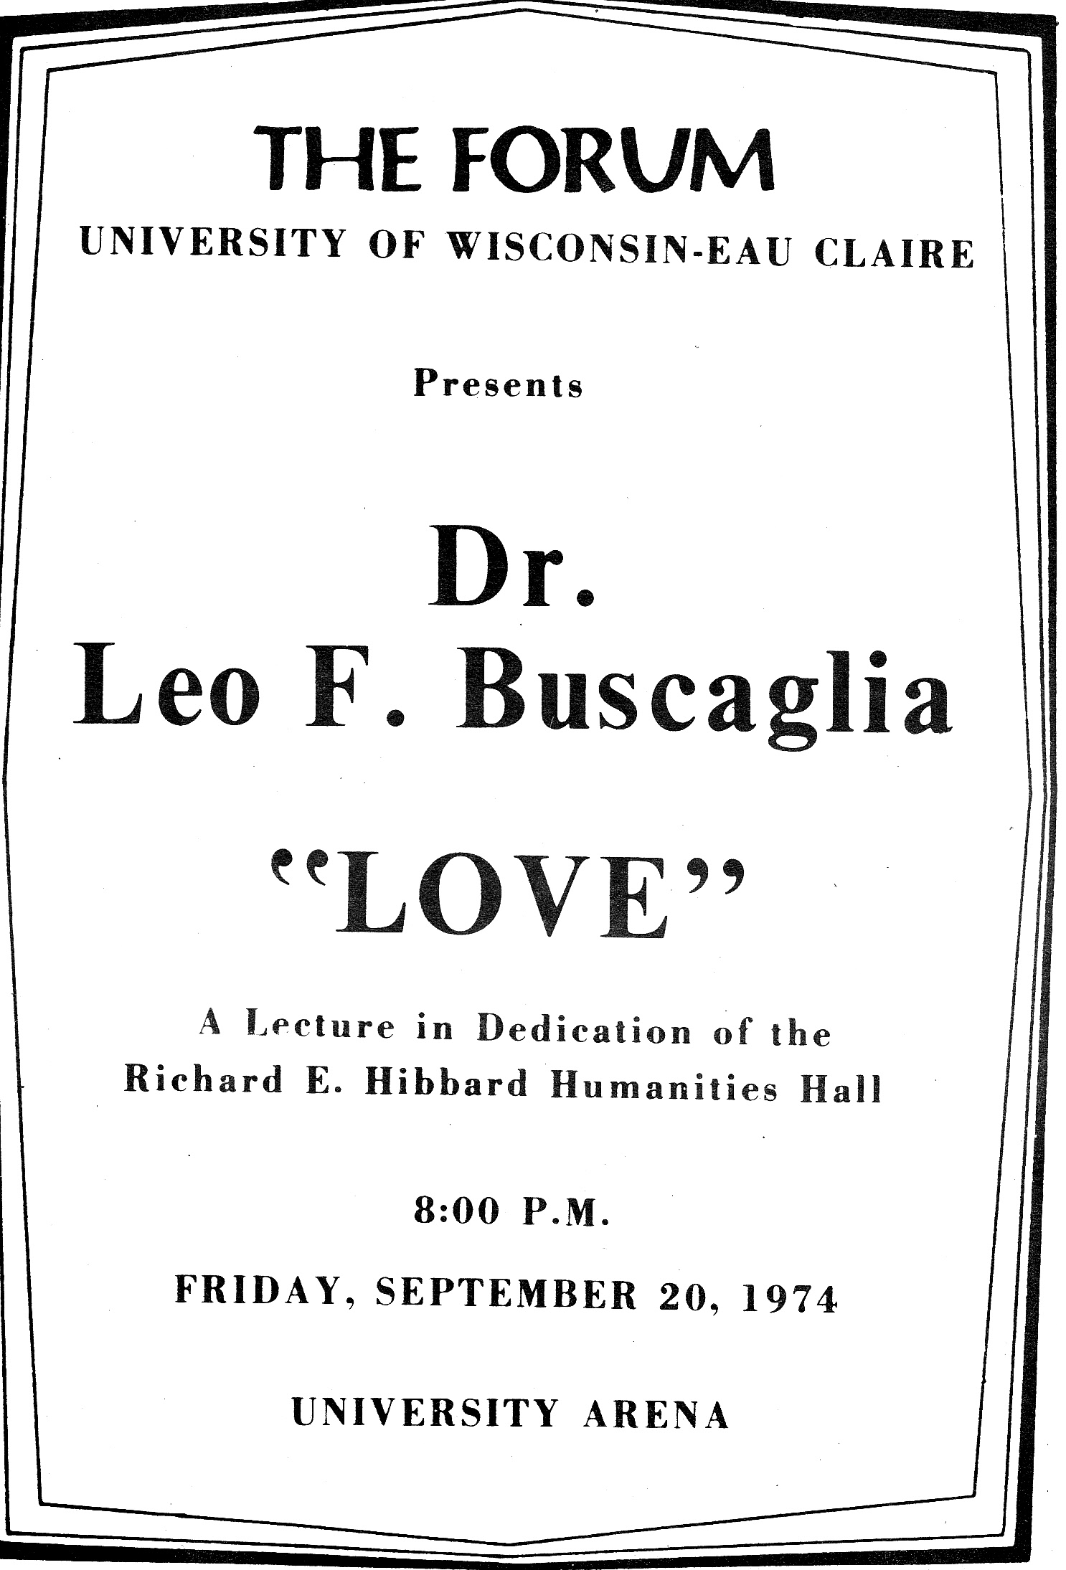
Probably the most prominent forum speaker that ever came to Eau Claire was indeed Dr. King. On March 20, 1962, he famously challenged President John F. Kennedy to give a second Emancipation Proclamation. “The first proclamation freed us from slavery---- the second will free us from segregation, which is actually nothing more than slavery.” Although the presentation was arguably the highest point in the Forum’s history, unfortunately, the speech held a bittersweet memory for many of the faculty and student on campus. “…just a few minutes after listening to the man he so much admired, and whose civil rights cause he had advanced so many years in the classroom, Dr. John S. Schneider was struck by a fatal heart attack.” Schneider was a professor emeritus and taught both history and sociology. He was with his wife, as well as his friends and colleagues Bill Zorn and Leonard Haas when he died.
Lessons Learned, The 1970’s
A budget request form from the 1979-80 school year gives us a great look into what was going on with the Forum from the committees’ perspective from previous years. They explain some of the challenges they have faced in the last five or 10 years. One of the first challenges the forum faces is to “maintain the quality of offering with lowered revenue.” Looking back the committee realized that certain speakers brought huge crowds to the forum. For example in 1980, Leo Buscaglia, the so-called “Dr. Love”, brought in over 4,000 people in attendance and $2,168 in single ticket sales. To give some perspective, a respectable audience at the time would be around 1,500 in attendance. The forum committee recognized this. However, they also argued that they did not just want to bring in popular speakers that would draw large crowds. Their true focus, as Davies originally intended, was to bring intellectual enlightenment to the region. “Programming for 1979-80 will focus on topics and speakers that will challenge stimulate and perhaps antagonize members of the University community.” This was challenging to do while still meeting budget demands. As they further explained, inflation of lecturer fees was a serious problem to the forum. Some very famous people such as Dr. Henry Kissinger, once spoke for some very modest fees ($750 in this case) Now, they explained, an average fee for most speakers of the quality the Forum expects range from $2000-$5000. Along with speaker fees, production costs such as printing, ushers and stage crews, postage, advertising and promotion cost had gone up as well to about $4,500 a presentation. This was more than the average cost a speaker charged. This meant that they would need about $17,500 in addition to the $3,500 they expected to raise.
Figure 3.
Source: Archives Series 115, Box 2 Folder 27
Figure 3.
Source: Archives Series 115, Box 2 Folder 27
Another issue the forum faced was obtaining a sufficient auditorium. They felt this was lacking at the University and needed a good auditorium with seating for around 2,500 people. There was also the issue of acoustics in the building, and finding parking for that many people that was close by. An argument was made that this auditorium was needed for other campus groups on campus as well, such as music and theater groups.
The committee remained optimistic, but also issued some words of caution about allowing the Forum to become filled with speakers whose main draw was popularity, not educational value. They said the greatest threat to the Forum was for it to become “entertainment”. They stressed the enlightening and educational role of the Forum saying, “It is essential that students, faculty and others in the Eau Claire community be a part of the mainstream of America and world society and not merely a provincial school in the hinterlands of Wisconsin. The Forum is one of the principle contact points between Eau Claire and the world of thought and action.”
Another useful document we can look at to gain a deeper understanding of the forum is a paper written by Gerry Woods and Nancy Comerford in 1979. This was a study by two ushers who worked for both the Forum and the Artists Series. They wanted to figure out why attendance for season ticket holders was so sporadic. They first explained the savings that a regular attendee would get from buying season tickets as opposed to going to all the forums via single ticked admission. A season ticket would save you $10 dollars as it was $18 to go to all the forums via single admission tickets. Woods and Comerford sent out a mail questionnaire asking patrons various questions relating to purchasing tickets for and attending Forum and Artists Series events. These are potentially skewed as 40 percent of people that were mailed the questionnaire responded. When asked what their reason was for purchasing season tickets, 59.3 percent said that “cultural experience” was most important to them followed by “entertainment” at 25.4 percent. Interestingly, these two responses are respectively both the best and worst of what the Forum committee wanted the forum to bring to the community. The Committee would be happy to know though, that respondents said that the Forum did a good job of picking speakers that appealed to both the students and the community (64.4 percent). They also answered favorably when asked whether or not the Forum “enriched the life of the community”. 52.5 percent agreed and 35 percent said they strongly agreed.
The authors gave some recommendations to alleviate the sporadic nature of some season ticket holders’ attendance. They felt that an increase in season ticket price would “award them higher status in the minds of the patrons” This, they thought, would make patrons think twice about skipping a Forum night for a television program. They also felt that because so many ticket holders said they would be willing to share their tickets with someone else when they themselves could not go; a location to drop off tickets for others should be created. Reflecting the forum’s emphasis of education over entertainment, their final, and perhaps most important suggestion to the committee was to increase the advertising for forum events around the community. They said that there is probably enough advertising of an informative nature. In contrast though they felt there was a lack of advertising that was designed to bring people in and showcase the forums entertainment value.

Conclusion and Future Work
The Forum has played a significant role, both in the community and University in Eau Claire. Davies original idea of the Forum as a way to bring outside ideas into the region was more or less followed faithfully since its creation. Although there has been fluctuation in the popularity and also the success of the forum over time, it has been largely successful in the long run. It has involved both the surrounding community and students and faculty from the university for 70 years. Not only that, the Forum here in Eau Claire was an example to the rest of the country. “The Forum at Eau Claire may be the oldest such continuous program in the United States. The original arrangement was later modified to provide more support from student activity fees, but community involvement has remained strong.” Although the Forum has faded from significance in recent years, it will likely continue to bring the community and University together. This paper ends in the 80’s. For the next step of research, I could look at later years of the Forum and also the years that the Forum transitioned from the Chippewa Valley Forum to the University as information on the early years in particular is hard to find. Another available option I might pursue is to look at budget information from past meetings notes and see if I can figure out how severely inflation and the rising cost of speakers has affected the Forum.

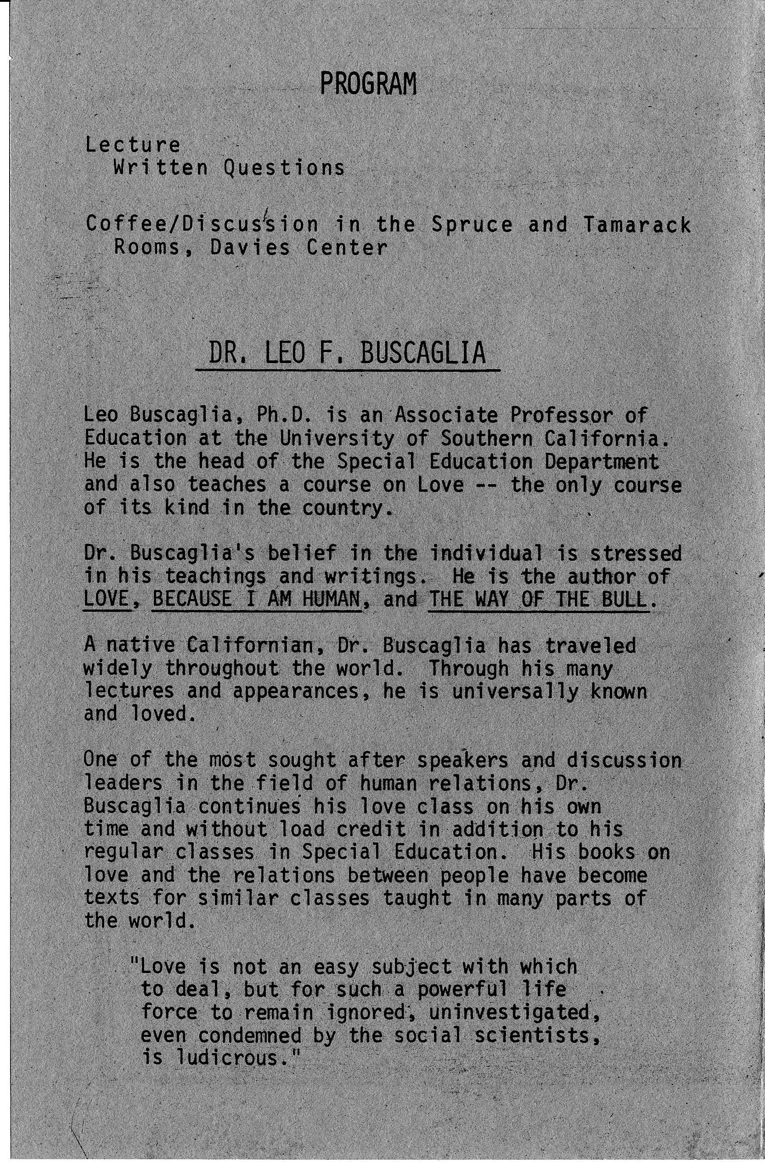
Appendix

An example of the description that appears on the inside of the Forums programs.
Source: Archives Series 115, Eau Claire University Centers Activities and Programs programming files, 1917-2006, UWEC Special Collections and Archives, McIntyre Library, Eau Claire Wisconsin Box 2, Folder 24

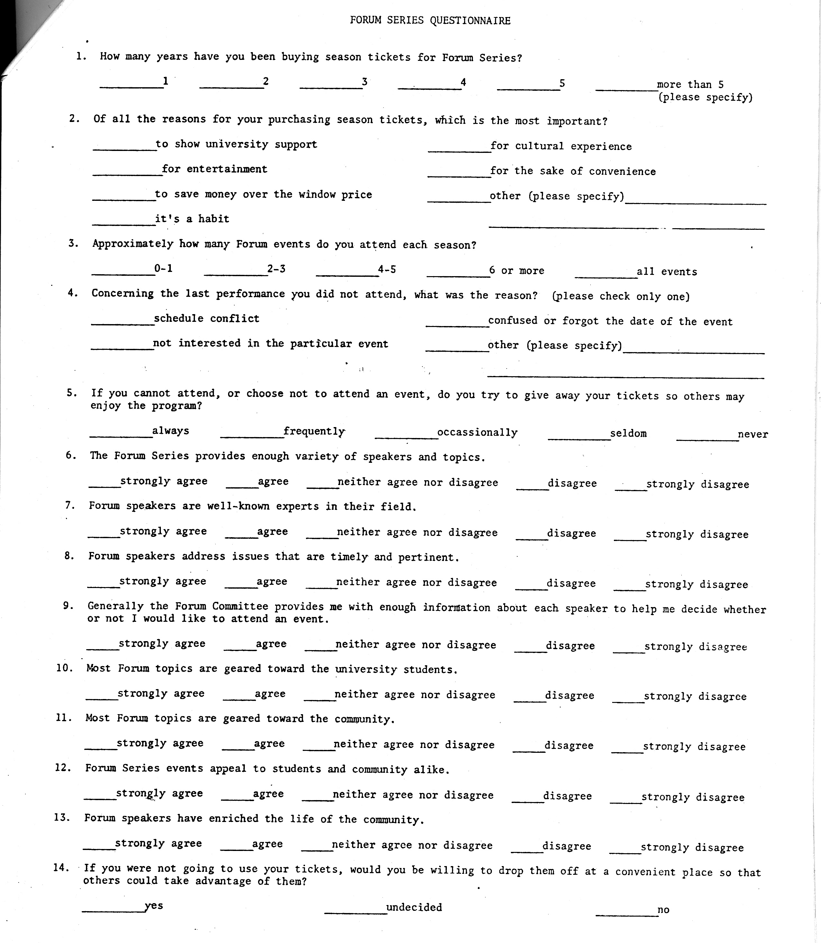
The questionnaire mailed to Forum season ticket holders
Source: Archives Series 115, Eau Claire University Centers Activities and Programs programming files, 1917-2006, UWEC Special Collections and Archives, McIntyre Library, Eau Claire Wisconsin Box 2, Folder 80

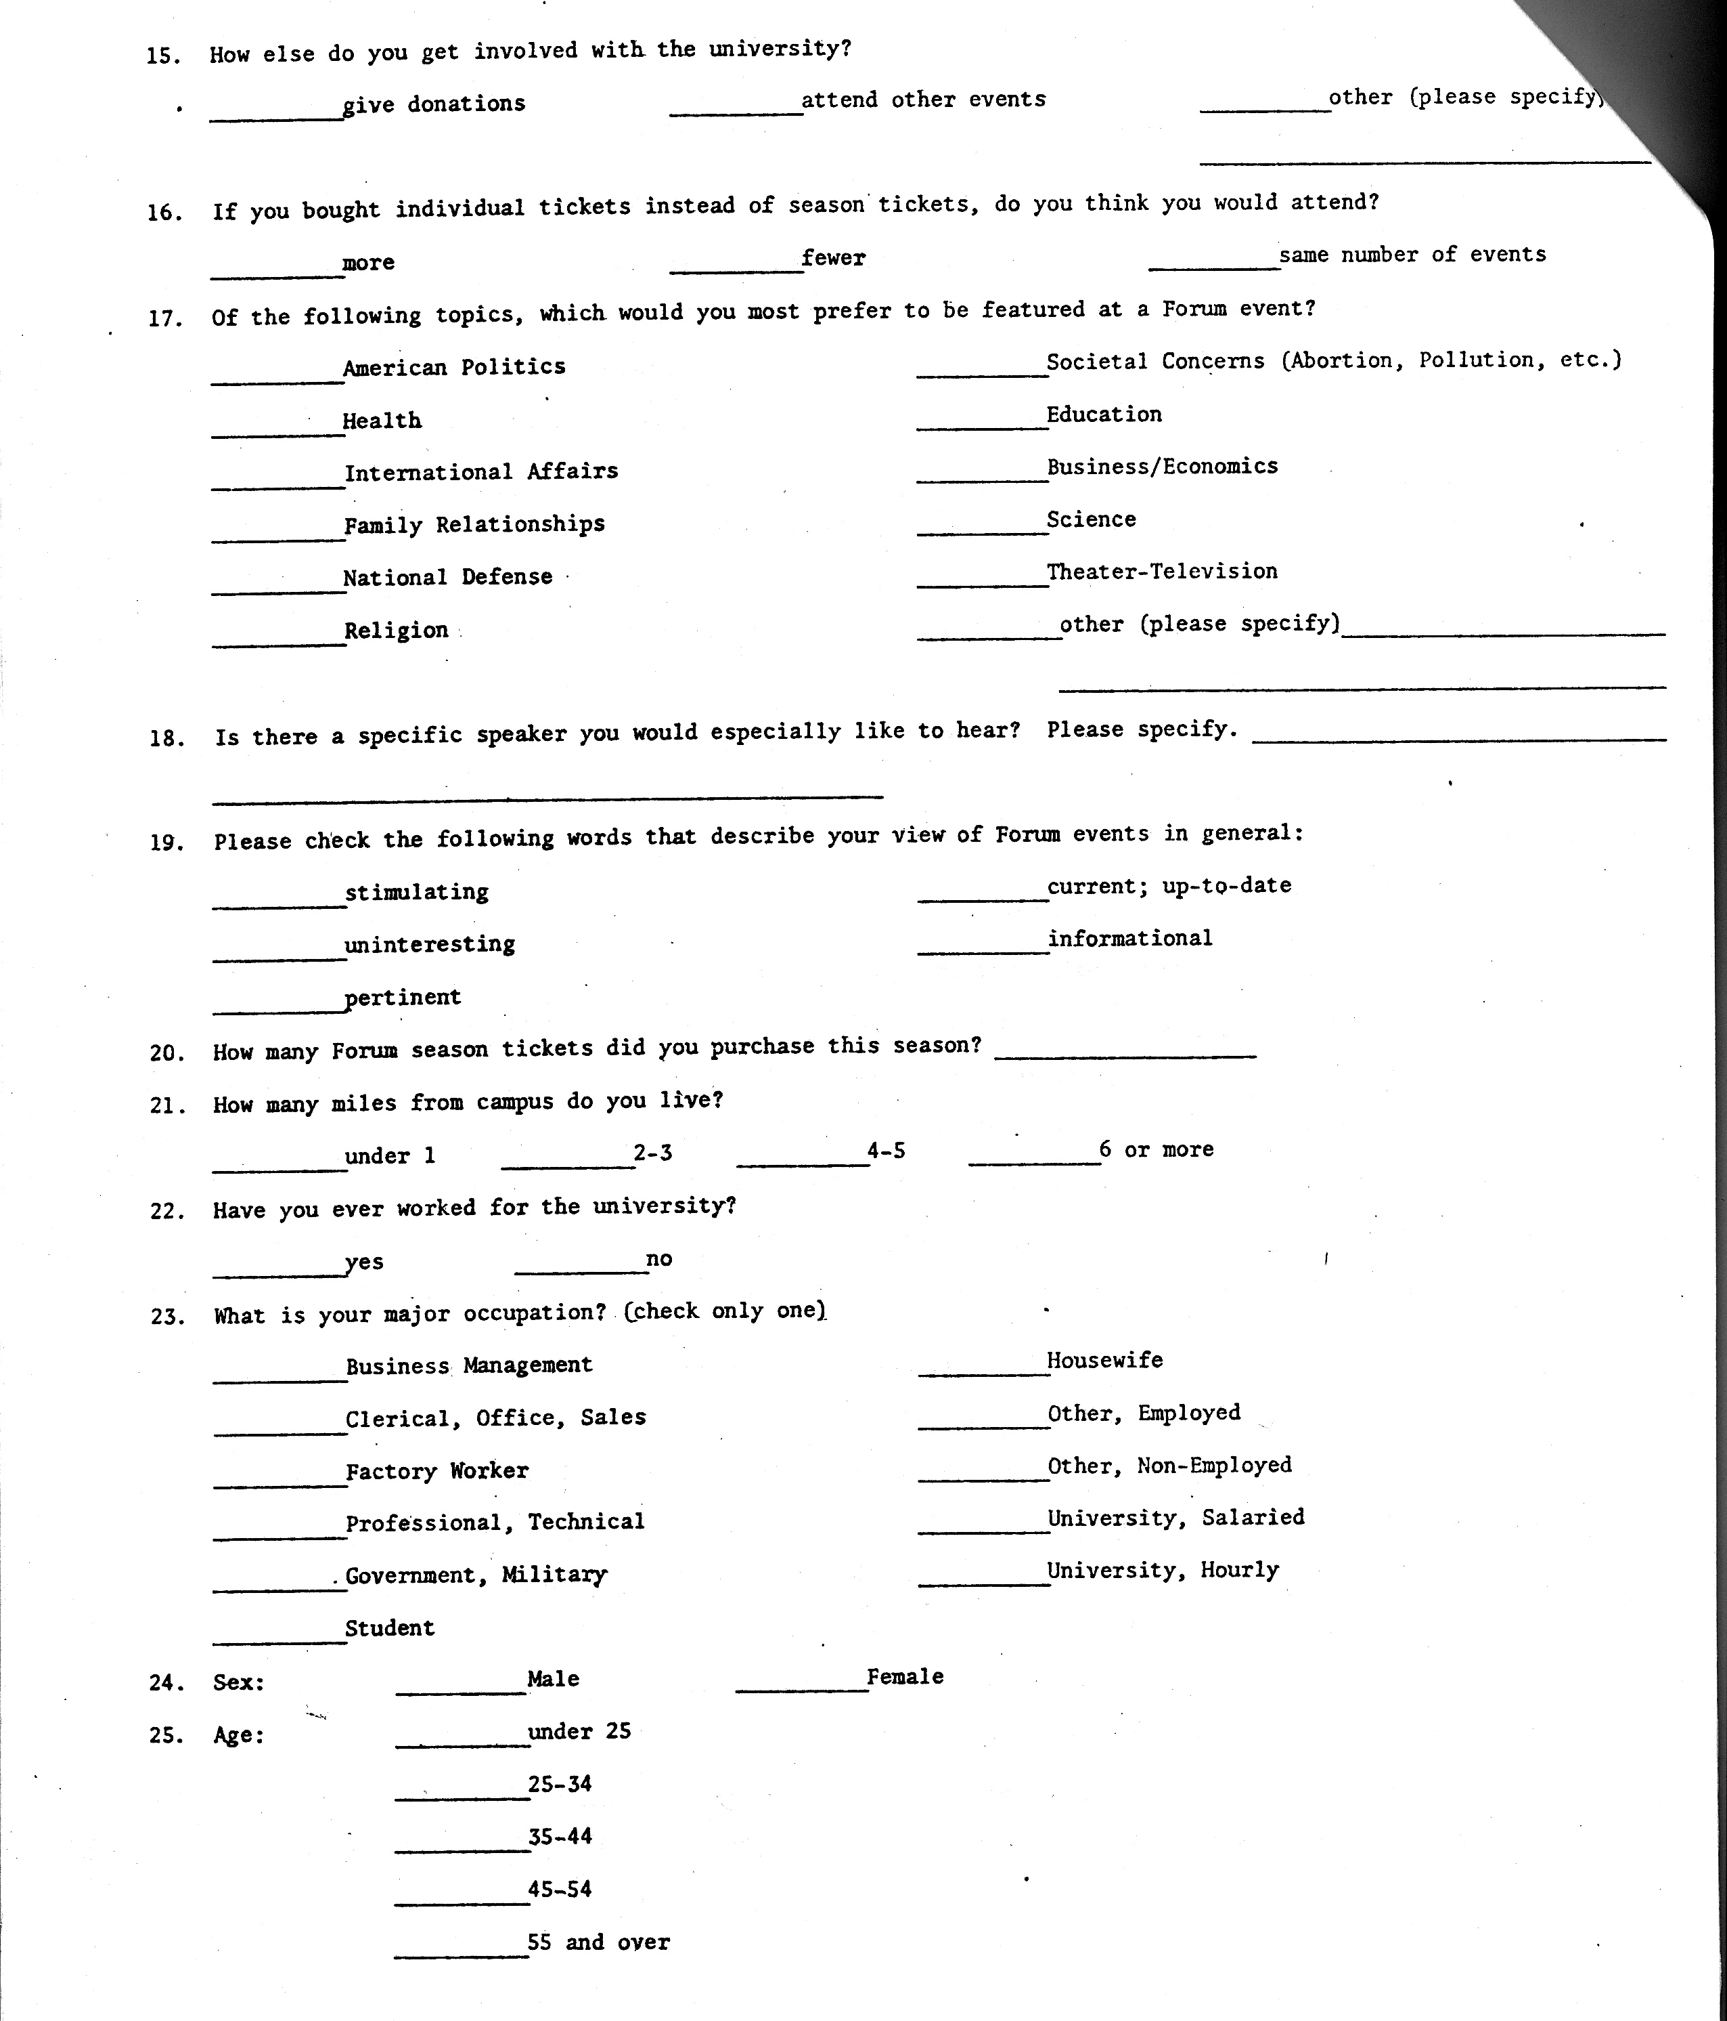

The questionnaire mailed to Forum season ticket holders
Source: Archives Series 115, Eau Claire University Centers Activities and Programs programming files, 1917-2006, UWEC Special Collections and Archives, McIntyre Library, Eau Claire Wisconsin Box 2, Folder 80
Works Cited
I. Primary Sources
Archives Series 115, Eau Claire University Centers Activities and Programs programming files, 1917-2006, UWEC Special Collections and Archives, McIntyre Library, Eau Claire, Wisconsin

Archives Series 367, Commission on Cultural Activities Scrapbook, 1968-1973 Volume 1. UWEC Special Collections and Archives, McIntyre Library, Eau Claire, Wisconsin

Chippewa Herald-Telegram

Eau Claire Leader-Telegram

University Historical Collection 301, Eau Claire normal School/ Wisconsin State Teachers’ College clippings, 1913-1950, UWEC Special Collections and Archives, McIntyre Library, Eau Claire, Wisconsin

II. Secondary sources
Vincent, John H., The Chautauqua movement, Books for Libraries Press, Freeport, New York, 1885 re 1971.

Rieser, Andrew C, The Chautauqua Moment: Protestants, Progressives, and the Culture of Modern Liberalism, 1874-1920, Columbia University Press, New York, 2003.
Carter, Hilda, and Jenswold, John, The University of Wisconsin Eau Claire: a History, 1916-1976. University of Wisconsin: Eau Claire Foundation, 1976.

Andrew C. Rieser. The Chautauqua Moment: Protestants, Progressives, and the Culture of Modern Liberalism, 1874-1920. (New York: Columbia University Press, 2003,) 3
Ibid., p.4
Ibid., p.4
John H Vincent, The Chautauqua Movement, Books for Libraries Press, Freeport, New York: 1885, re 1971) p. 16-17.
Ibid., 2
Andrew C. Rieser. The Chautauqua Moment. 159
Hilda Carter and John Jenswold, The University of Wisconsin Eau Claire: a History, 1916-1976, (University of Wisconsin: Eau Claire Foundation, 1976) 46.
Hilda Carter and John Jenswold, 46.
University Historical Collection 301, Eau Claire Normal School/ Wisconsin State Teachers’ College clippings, 1913-1950, UWEC Special Collections and Archives, McIntyre Library, Eau Claire, Wisconsin. Box 1 Folder 2
Ibid
Special Collections and Archives, UW Eau Claire, Scrapbook of social and Cultural Commissions 88-107 vol. 1 “Preview of Second Semester Forums: Forum Programs Strive for Quality “
Archives Series 115, Eau Claire University Centers Activities and Programs programming files, 1917-2006, UWEC Special Collections and Archives, McIntyre Library, Eau Claire Wisconsin. Box 1, folder 84
Archives Series 115, Box 1, folder 84
CPI Inflation calculator http://146.142.4.24/cgi-bin/cpicalc.pl Accessed March 2012
Archives Series 115, Eau Claire University Centers Activities and Programs programming files, 1917-2006, UWEC Special Collections and Archives, McIntyre Library, Eau Claire Wisconsin. Box 1, folder 84
UW Eau Claire, Scrapbook of social and Cultural Commissions 88-107 vol. 1 “Preview of Second Semester Forums: Forum Programs Strive for Quality
Ibid.
Ibid.
Archives Series 115, box 1, folder 74
Archives Series 115, box 1, folder 74
Ibid.
Ibid.
Archives Series 115, Eau Claire University Centers Activities and Programs programming files, 1917-2006, UWEC Special Collections and Archives, McIntyre Library, Eau Claire Wisconsin. Box 1, folder 74.
Hilda Carter and John Jenswold The University of Wisconsin Eau Claire: a History, 1916-1976. University of Wisconsin: Eau Claire Foundation, 1976. Pgs 90-91
Ibid. Pg 91
Archives Series 115, Box 2, Folder 80
Archives Series 115, Eau Claire University Centers Activities and Programs programming files, 1917-2006, UWEC Special Collections and Archives, McIntyre Library, Eau Claire Wisconsin Box 2, Folder 80, Budget Request Form. Sentences just like this one were in most of the budget requests for several years before and after this.
Ibid
Archives Series 115, Box 2, Folder 80
Archives Series 115, Box 2, Folder 80
Ibid.
Ibid.
Hilda Carter and John Jenswold, The University of Wisconsin Eau Claire: a History, 1916-1976, (University of Wisconsin: Eau Claire Foundation, 1976), p.49.

