OUTDOORSWOMEN OF THE SIERRA CLUB: WRITINGS, EXPERIENCES, FRIENDSHIPS, AND ACTIVISM AT THE TURN OF THE TWENTIETH CENTURY

Allison Foster
History 489
Course Professor: Jane Pederson
Cooperating Professor: Teresa Sanislo
May 13, 2013

Copyright for this work is owned by the author. This digital version is published by McIntyre Library, University of Wisconsin Eau Claire with the consent of the author.
CONTENTS

ABSTRACT iii
LIST OF FIGURES iv

INTRODUCTION 1
ON THE TRAILS AND UP THE MOUNTAINS 9
TOGETHER IN THE WILDERNESS 18
PRESERVATION ACTIVISM 24
CONCLUSION 30

APPENDICES 32
BIBLIOGRAPHY 34

ABSTRACT

Created in 1892, the Sierra Club of California became one of the most popular and influential groups during the conservation and preservation movement of the late nineteenth and early twentieth century. Beginning as an outdoor club, its members organized and participated in many outings in the Sierra Nevada wilderness—particularly Yosemite National Park— and the American west. It was also dedicated to promoting wilderness recreation and the preservation of land for public use. During a time period when many women joined clubs exclusively for their gender and related conservation causes with their role as the caretakers of society, Sierra Club women connected with nature through outdoor activity and became wilderness preservation activists based on those experiences. The Sierra Club had both male and female members who came together through their shared love of nature and the belief that wilderness areas were sacred because of their beauty. The women’s own writings, which are examined in this paper, expressed feelings of love and awe towards the natural landscapes they explored. Sierra Club women hiked through remote wilderness areas and climbed mountain summits, finding these outdoor activities joyful, liberating, challenging, and fulfilling. This paper also highlights the relationships between the men and women of the club, and the atmosphere that enabled friendships and admiration to form during days and weeks long outings. This paper also discusses the early Sierra Club women as activists, describing their efforts to engage with the public and government, and why they believed it was so important to preserve and promote nature.

LIST OF FIGURES

- Sierra Club Seal 1894-1939 3
- Two Sierra Club women in the Yosemite wilderness 9
- Marion Randall Parsons 13
- A Sierra Club Outing in 1902 18
- Sierra Club members climbing Mt. Williamson in 1903 22

Introduction
“The Sierra Club has great and noble purposes, for which we honor it, but besides these its name has come to mean an ideal to us. It means comradeship and chivalry, simplicity and joyousness, and the care-free life of the open.” –Marion Randall Parsons in “Some Aspects of a Sierra Club Outing,” Sierra Club Bulletin, 1905.

The conservation and preservation movement in the late nineteenth and early twentieth century consisted of many different groups engaging in public discourse and activism regarding human interaction with nature. The movement began in California, and many women found themselves part of it, contributing in different ways. Some of these women joined the Sierra Club, created in San Francisco, California in 1892 by John Muir, along with professors from Stanford and Berkeley. As an “outdoor club”, its main activities focused on exploring and promoting the protection of the Sierra Nevada wilderness areas, particularly ones in and around Yosemite National Park.
As the presence of women in the American west grew, so did their engagement with the landscapes around them. Many women developed a relationship with the environment as they settled west of the Mississippi in the eighteenth and nineteenth centuries. But most of them only explored areas close to their home or studied and wrote about the plants and animals in their backyards and gardens.
Starting in the mid-nineteenth century, western women with an interest in nature began traveling to rugged wilderness areas and climbing mountain summits. Outdoor clubs like the Sierra Club began to form toward the end of the nineteenth century, giving women more opportunities in the outdoors. Mountaineering groups in Oregon, Seattle, and Colorado mirrored the Sierra Club’s early adventures and outlook on wilderness use and protection, and most of them contained both male and female members. Women who became part of these organizations enjoyed and challenged themselves, and “the more that women club members came to accept their legitimate place in the wilderness, the more they supported moves to protect those spaces as national parks.”
Stanford E. Demars wrote that people who joined groups like the Sierra Club at the end of the nineteenth century “represented a major break from earlier tourist society wherein wealth, social status, and fashion were considered paramount in determining one’s ability to understand and appreciate nature.” They were a “new generation of nature lovers,” and the essential qualification was a “sensitive and willing spirit and a responsive intellect” with the recognition of “wild nature as a source of beauty and spiritual truth.” Describing the characteristics of the Sierra Club members, Demars wrote they had “an enthusiasm for outdoor life and a desire to see it promulgated as widely as possible. They also felt a keen sense of responsibility for the mountains and a sincere desire to engage themselves in efforts to protect their scenic resources.”
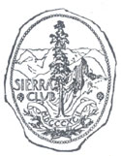
Women who joined the Sierra Club in its early years were mostly white, educated, middle-class, and living in California or surrounding states. Many of them were single college students, with a large number coming from Stanford and Berkeley. Some also found more than just hiking companions and went on to marry fellow male members they met during the outings. They valued genuine outdoor experiences and desired spending weeks at a time in remote wilderness areas, hiking through meadows and forests, and climbing up rough, snowy mountain trails. In Preserving the Nation: The Conservation and Environmental Movements 1870-2000, Thomas R. Wellock described how women who participated in outdoor activities during the late nineteenth and early twentieth century often felt liberated, writing that venturing out into the wilderness and climbing mountains summits allowed them to escape structured society and life. These were the women of the Sierra Club, who found nature as a haven for adventure and freedom, far removed from their ordinary lives in the cities and towns they resided in during most of the year.
Figure 1. The Sierra Club Seal from 1894 to 1939. A giant sequoia tree is depicted with Yosemite's Half Dome in the background. Source: Sierraclub.org.
Their own revelations and positive discoveries in the club led them to view wilderness areas as sacred because of their uniqueness and beauty, but also as places that belonged to the American public to enjoy and connect with nature. These women recognized, because they experienced it for themselves, that being outdoors produced physical, emotional, and mental benefits, and certain places on Earth needed to be protected for these human purposes. Their deep love of nature came from personal journeys through the wilderness, and they became friends and partners with their male counterparts in both outdoor activities and political activism. Women’s experiences in the Sierra Club led them to become writers, mountaineers, joyful friends, and wilderness preservation activists.
Women’s importance and heavy involvement in the preservation and conservation movement in the early twentieth century has largely only been written about by historians over the last few decades. The lack of historical research on these women is acknowledged by some authors, such as Stephen Fox in his book The American Conservation Movement, where he wrote that “women in particular, usually working as supporters and helpmeets in the background, are invisible to history. For these two reasons most accounts of American conservation, including this one, have understated the participation of women in the movement.”
Many authors agree that the movement’s successes would not have been possible without women supporting and joining the significant organizations and campaigns. Carolyn Merchant wrote that “women transformed the crusade from an elite male enterprise into a widely based movement.” In Polly Welts Kaufman’s book, National Parks and the Woman’s Voice: A History, she wrote that the binding goal of women in the movement was to “preserve the national and historic landscapes they thought best represented the country’s core values, both to teach and enrich the lives of all generations to come.”
Some women got involved in conservation and preservation efforts out of the belief that it was their responsibility as the caretakers of society. At a time when society defined female roles as domestic duties, many women formed groups such as literary clubs so they could extend their public activities, and some of these clubs became concerned with issues in the movement. Merchant wrote that at the turn of the twentieth century, separate male and female spheres still largely existed in most public arenas, and while these women’s clubs began to engage in political activism, “they nevertheless accepted the traditional sex roles assigned to them by late nineteenth century American society as caretakers of the nation’s home, husbands, and offspring, supporting rather than challenging the two spheres ideology.” Merchant described women’s clubs’ philosophy as the “conservation trilogy”, which consisted of “of true womanhood, the home, and the child,” with all three related to the environment.
Wellock also wrote about these kinds of women in the conservation and preservation movements. Like Merchant, he said many of them included wilderness protection in their perceived female duties while also maintaining the separate spheres ideology. Their membership in women’s clubs allowed them to engage in the public sphere and movement efforts without challenging their roles as wives and mothers, because they declared their activism as an extension of their roles in society.
While many women’s motivations stemmed from gendered societal duties, Sierra Club women differed from other members of their sex during the movement because they did not tie their club activism to their gender. They were wilderness lovers and explorers first, and they held different views and relationships regarding nature, motivating them to protect wilderness areas they developed a great love for through the liberating and joyful experiences within the club. Sierra Club women viewed human relationships with nature as deeply personal and did not divide them into male and female perspectives.
Although these separate male and female spheres existed when it came to the movement and other public activities in the late nineteenth and early twentieth century, many groups like the Sierra Club had members of both sexes. The women’s engagement in outdoor activities and activism with their male counterparts also distinguished them from other women in this time period. Rebecca Solnit wrote about California women active in the outdoors, saying that:
The Sierra Club made them welcome and seems to have provided many with
opportunities for mountaineering they might have found few other places. At a time when a woman could hardly go unchaperoned around London, it says something for the freedom of the West Coast or the club that women seem to have gone wherever they like, with whomever they liked, in the mountains.

The club encouraged an atmosphere of gender equality, and hiking in the mountains and camping in the woods for days with large groups of people “tended to break down social barriers and foster a general spirit of comradery.” The men and women of the club participated in many outings together, talking about the sights and sharing their thoughts, spending many days and nights in the areas they both loved so much. Gender and societal roles lost their hold, and they were left with the same underlying principles and feelings of simplicity and joy that the Sierra Nevada wilderness provided the men and women of the club.
Although men held the leadership positions for the first twenty years, women members participated in all the club meetings and activism. Glenda Riley wrote that “women who were perhaps more feminist and assertive in philosophy…. gave speeches, organized lobbying campaigns, and wrote books and essays,” which many of the Sierra Club women did. Preserving the areas that the club frequented became a priority for the women and they interacted with both the government and the public to promote and secure the club’s visions and goals. They encouraged others to embrace, enjoy, experience, and fight to preserve everything the wilderness in California, and the country, had to offer.
The historical record of women involved with the movement has been growing, with writers seeking to give more detail about their activities, clubs, causes and viewpoints, but the women of the Sierra Club have not been examined in depth by historians. The club is widely written about as one of the most popular and powerful wilderness organizations during the progressive era—and continued to be one throughout the twentieth century and into the twenty-first—but the members who are most known and written about are the males.

In The History of the Sierra Club, Richard Cohen wrote about a few notable female
members who participated in climbs and other activities, but he did not detail their views and feelings regarding nature, or the significant time and efforts they made on behalf of the club and the movement. Most of the literature about the Sierra Club widely acknowledges John Muir and other men who held high positions, discussing their involvement and viewpoints regarding the preservation and conservation movement, along with their contributions and activities within the club.
The women of the club are acknowledged here and there by historians, but their feelings towards nature and experiences in the club are largely absent. The close relationships that formed between the men and women of the Sierra Club are also missing from current literature, and highlighting this aspect of the club will add to the history of the club as well as gender relations of the movement and outdoor activities. This paper will also add to the existing literature of the different types of women during the movement by focusing on multiple female members of the early days of Sierra Club who were writers, outdoorswomen, and preservationist activists that made the Sierra Nevada wilderness their second home at the turn of the twentieth century.

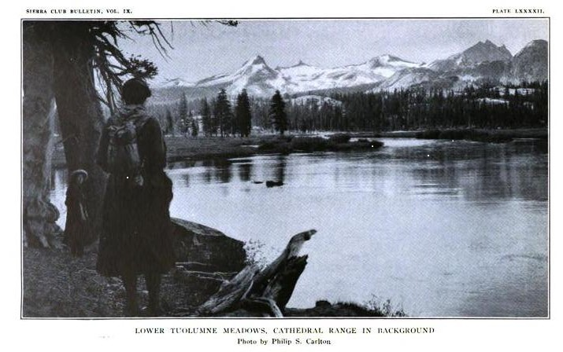
On the Trails and Up the Mountains
Figure 2. Two Sierra Club women in the Yosemite wilderness. Published in the Sierra Club Bulletin, Volume
9, 1914.

The Sierra Club women’s own accounts of their outdoor experiences reveal the positive emotions produced from witnessing the beauty of nature, and the freedom they felt in those special places. Seeing the wilderness unfold on the trail, the thrill and sense of accomplishment in climbing to a mountain’s summit, and the joy of being with people who appreciated and loved nature in the same way outside city lines were included in their writings. Many women wrote articles about their feelings towards nature and time in the wilderness for the club’s annual Sierra Club Bulletin. They also wrote articles and poems for other California publications, including Out West and Sunset magazines.
The annual summer outings of the club were the highlight for many of the members, as it took them away from their everyday life and into a setting free from societal norms. Charlotte Sanderson, a Sierra Club member born in Maine in 1855 but living in San Francisco with her husband George by 1880, wrote an article about a club trip published in a 1903 edition of the Bulletin. She described a train ride with her fellow club members, saying that “a crowd of expectant mountaineers was flying away from urban haunts and habits toward the freedom of wild nature.” Going to the mountains and into the wilderness was an escape from crowded spaces for Sanderson, and this feeling of liberation that the mountains evoked can be seen in many of the Sierra Club women’s writings.
Helen Gompertz, born in California in 1865, was one of the earliest female members of the Sierra Club, and she married fellow club member and Berkeley Professor Joseph Nisbet LeConte in 1901. In an article for the Bulletin, Gompertz wrote about climbing Mt. Lyell in the Yosemite wilderness with one other female and two male club members in 1896. She noted in the beginning that she and Miss Isabel Miller were the first women to ever make the climb. In describing the four day trip, she wrote about the rugged terrain, carrying their camping supplies, having fun and laughing about the difficulty of crossing rivers on their donkey, and the beautiful sights she encountered.
When the mountains peaks came into view during the trip, she wrote that “the highest of these marked the summit of our ambition.” They helped each other make the last part of the journey where no trail existed, and once they reached the summit the party felt tired but also a great sense of accomplishment at reaching their goal. They decided to make their way down from the summit by sliding on the snow, with Gompertz writing, “How exhilarating it was to go down like a rush of wind, where we had toiled up step by step!” Once she had gone up the mountain and seen the sights, she found it fun to let loose on the way back down after such a challenge.
In another article, Gompertz wrote about a hike with two male and two female members of the club. Describing how they packed only necessities for the days long trip, Gompertz wrote that she tried to “feel a glow of pride in the thought of doing her best to rough it,” and that “the dust of Bubb’s Creek trail lured us on, and all such vexations were forgotten in the pleasure of viewing the unfolding beauty disclosed at every turn of the narrow gorge.”
She described how triumphant she felt as she climbed the steep terrain, and expressed her excitement at the beautiful scenery she saw once they reached the summit of University Peak. At the top, Gompertz remembered a previous conversation with John Muir in which he desired spending each starry night in the mountains rather than sleeping in a bed under a roof. She wrote, “I now recall the strong desire I felt to stretch myself on the warm rocks and spend the night on the summit.” The feeling of wanting to stay on the mountain top and lay under the stars at night speaks to the emotions that nature evoked in Gompertz. The beautiful and serene landscapes in nature brought out feelings of freedom and peace, and she wanted to stay on top of a mountain at night because it was so different from daily life.
An active member of the club with her husband Robert, Jennie E. Price was born in California in 1874, but lived in Reno, Nevada for most of her life. She wrote an article in the Bulletin about one of her outdoor experiences in 1899. The first part of the title was “A Woman’s View”, but she made no assertion that her gender held any importance in the outing other than writing that she carried nine pounds of supplies while the three men on the trip carried twenty-five.
She described crossing rivers, seeing snakes, being enthusiastic about climbing great elevations, and wrote that “anyone who is anything of a mountaineer… should journey through the entire length of the cañon , for it is a scenic wonderland, with never a dull step in the whole distance.” She also wrote that when the journey was over, “regret and sadness mingled… regret, that so much of the grandeur and magnificence was far behind us in the cañon.” The adventure and constant challenge of the wilderness outings made her develop a relationship with herself and the natural world around her. She saw herself as a mountaineer, and those personal triumphs and feelings made her long to stay in the wilderness she encountered.
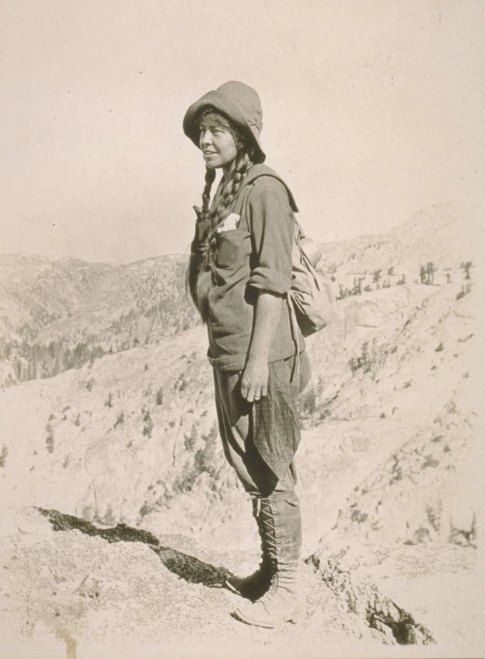
Marion Randall Parsons authored numerous articles for the Bulletin during her membership in the Sierra Club. She led an active and interesting life as a writer, outdoorswoman, painter, and photographer. Born in Berkeley, California in 1878, Parsons joined the Sierra Club in 1902 while attending college. Richard Cohen wrote about Parsons as “the first woman who was truly a club activist,” and she remained involved with the club for the rest of her life. She married fellow member Edward Taylor Parsons in 1907, became a member of the board of directors in 1914—a seat she occupied for twenty-two years—and
Figure 3. Marion Randall Parsons. Courtesy of Bancroft Library, University of California Berkeley.
later a club lobbyist in Washington, D.C.
In an article she published for the 1905 edition of the Bulletin, Parsons detailed one of her trips with the club, writing about sleeping outside, looking up at the stars through the trees at night, “being awed into stillness” by the sight of the mountains, and the joy of waking up to the sounds of laughter, streams, and birdsong. She wrote that “these things live with you long after the outing has passed and you are back in the working world, linger even until the growing year once more brings around the vacation days, and you are ready to return to the hills again… your strength, your inspiration, and some of the brightest hours you have ever lived.” The experiences in the club outing and the things she saw in nature stayed with her when she went back to daily life, and she found herself continually looking forward for the next summer trip.
Parsons also wrote about the club getting together with the men and women of the Mazamas Mountain Club of Portland, Oregon to climb Mt. St. Helens. She remarked that the Mazamas were “the first mountaineering club in the West to organize summer outings for its members” but noted their experiences differed from the Sierra Club regarding the wilderness terrain they frequented, writing that the Mazamas took shorter hikes because of the smaller land area, while the Sierra Club had a large area which allowed them to be “nomads.” Parsons considered this a disadvantage for the Mazamas because in her opinion the more time spent in the outdoors the better. The expanse of the Sierra Nevada wilderness allowed the club to stay in the wilderness for weeks at a time and explore more areas, which is exactly what Parsons favored. Parsons wrote about her reluctance to leave the wilderness at the end of the trip when she realized that “it was time to leave the summer country and go back to the world of roofs again.” She was the kind of person who preferred to be outside rather than indoors surrounded by walls, far away from the wild lands of California.
Evelyn Marianne Ratcliff was born in England in 1879 and immigrated to Berkeley, California with her family in 1895, and she later attended the University of California Berkeley. She married fellow club member William Frederic Bade, also a Berkeley Professor, in 1906, but sadly passed away only one year later at the age of 28. A 1908 edition of the Bulletin published her article about the club’s 1906 ascent of Mt. Rainer, her first time climbing a mountain summit. The group consisted of fifty-three people, which she described as “a goodly array of mountaineers we were—a greater number than had ever before attempted the ascent, and greater probably than ever will again.” The trip offered sights and sounds that only climbing a mountain could provide. She wrote about the exciting scenes she witnessed:

Every now and then an avalanche came hurtling down on the glacier…as we stopped time to time for breath, we had leisure to watch the great white field, and were delighted if we caught sight of the falling mass before its boom reached our ears. What an awe-inspiring sight it is to see a thunderbolt of ice and snow flash down a mountain-side!
The pure wildness of the mountain trail caused her and fellow climbers to just simply watch the scenes around them on their way up the slope. She felt excited to see the awesome power of an avalanche in their midst, something that was a rare sight and only something a mountaineer could experience.
When the group reached the top, the evidence of previous volcanic activity was witnessed by Ratcliff. She wrote that “only a mountaineer can appreciate the sense of exhilaration with which we contemplated the vast expanse of the crater and told ourselves that we had conquered the kingliest among all the mountains in the United States.” Ratcliff felt a special accomplishment by climbing the summit and the unique journey up mountain slopes held wonder and triumph for those who made it.
Harriet Monroe, an authored poet, literary critic, and founder of Poetry magazine, was born in Chicago, Illinois in 1880. She moved to Arizona in 1899 and the western wilderness had a great effect on her writings and life. She then made her way to California, and there she joined the Sierra Club’s summer outings. In one of the numerous articles she wrote for the Bulletin, she detailed her experience camping in the Yosemite wilderness with 140 other members of the club. Describing when she and a friend arrived to camp, she wrote, “we felt strange in our mountain clothes…very strange and most wonderfully free of all conventions and traditions.” The mountain clothes she referred to consisted of knee-length skirts and bloomers, high hob-nail boots, and wide-brimmed sombreros. On the hike they took to Yosemite Falls, Monroe wrote that the sound of rushing water was “on a scale the most grandly melodious I ever heard in nature.” The feelings of freedom and awe were what the women club members experienced when they traveled into the wilderness, and she was no different.
Monroe used vivid and romantic language to describe the wonderful sights, sounds, and feelings that the mountain wonderlands of the California wilderness provided. During her week in the Yosemite Valley, Monroe wrote that she “felt a sense of close intimacy with the grand old earth” and that “for however nature may brood or smile or grieve, or be angry or serene in the rest of the world, here is the sunken magic Valley she chooses to exult, to build a bower for her majesty, and sing and shout and be glad.” That personal closeness Monroe felt with nature was something that the outdoorswomen of the Sierra club developed when they went out into those magnificent wilderness areas.

Together in the Wilderness

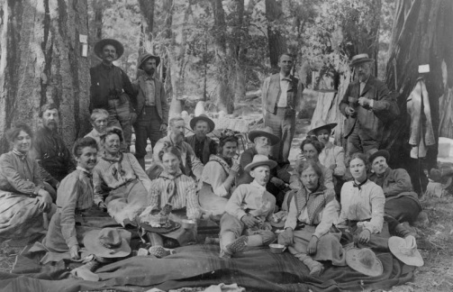

Figure 4. A Sierra Club outing in 1902. Courtesy of Bancroft Library, University of California Berkeley.

At an 1895 Sierra Club meeting in San Francisco, John Muir gave a speech to the members in which he declared:
It is encouraging to know that so many of the young men and women growing up in California are going to the mountains every summer and becoming good mountaineers, and of course, good defenders of the Sierra forests and all of the reviving beauty that belongs to them… many of these mountaineers were young girls, in parties of ten or fifteen, making bright pictures as they tramped merrily along the forest aisles, with the sparkle and exhilaration of the mountains in their eyes—a fine, hopeful sign of the times.

Muir recognized that the club in its first few years attracted many people who wanted to engage with nature and devote time to protecting the lands the club explored. He felt glad to see young women being active in the club, remarking that their presence gave him hope more would join and become active in the outdoors. More did join, and the men and women of the Sierra Club took great joy in each other’s company, knowing that they were part of something special, and seeing beautiful and unique places with fellow wilderness lovers made their experiences richer. They formed friendships based on shared values and outlook on life, transcending the separate spheres ideology and social structures that existed during the time period.
Marion Randall Parsons wrote about the atmosphere created within the Sierra Club, describing “the crowd” as being its unique feature, with all sorts of different people in the camp and on the outings:

It sounds rather alarming at first—to camp for a month with a party of one hundred and fifty persons, strangers for the greater part, gathered from all quarters of California and distant points throughout the world, representatives of every profession, every science, every art, who have only one common bond, the love of nature.

She went on to say, “you discover the unshaven gentlemen in spotted khaki with a scratch on his nose has seen the same beauty and thought the same thought you have,” and after a few days on the trail “you make the discovery that you yourself look as queer as your neighbor. You are a Sierran by that time, body and soul, ready to find your place in the socialist Utopia which you inhabit for a few short weeks.” The men and women of the club came from different walks of life but felt close to one another through their shared experiences in the outdoors.
Born in Illinois in 1851, member Ella Sexton was a teacher, and also married mother of three, living in San Francisco by 1880. In an article she wrote for the Bulletin in 1903, she described the members of the club gathered around a campfire discussing an upcoming excursion, writing that “grave professors, giddy co-eds, the poet, the historian, and sundry medical, clerical, and legal lights blushed alike in the camp-fire’s rosy glow. For here was the Sierra Club of mountain-lovers, equipped and more than ready.” Sexton painted a picture of the different backgrounds of the members, highlighting how people who otherwise might not have found themselves together occupied the same space because they all wanted to explore and enjoy the wilderness.
She went on to describe the outing and camp life where everyone would gather around the fire at the end of each day and tell stories and sing. The friendships and joy that formed during these outings caused Sexton to remark at the end of her article that the trip ended all too soon, and “the inevitable day came when we looked our last on the snowy mountains and rushing river” and with “more precious memories Time himself cannot obliterate, went out cityward.” The club outings provided members with the chance to see mountain landscapes with people of similar interests but not always similar backgrounds. The club brought nature lovers together, and they enjoyed their experiences even more because of that. Sexton longed to stay there in the wilderness together, reluctant to return to the city but glad for the memories she could carry with her.

In Charlotte Sanderson’s article, she described a camp of 200 people, writing that “the place became a small village… and it was not hard to drop from town formalities into the delightful vagabond ways of outdoor existence.” She recognized the wilderness as a special place where social boundaries that existed in public settings melted away, and that made camp life and hiking more enjoyable. The club members wanted to soak up the natural wonders of the world alongside people with the same appreciation for wilderness. Gender roles and societal rules did not hold significance because their love of the nature and club goals transcended them.
Harriet Monroe also wrote about the relationships she formed with her fellow club members and the areas of wilderness they inhabited together, writing that her week in Yosemite was “full of good fellowship with people, and of high fellowship with mountains, and mountain lakes, and lofty pines, and snowfields, and sharp difficult summits.” The members enjoyed each other’s company as they hiked through the woods and up the hills. Surrounded by friends in the wilderness made the trips these women took all the more enjoyable.
In an article for the Bulletin, William Frederic Bade described the camp life and nights after spending the day trekking through the wilderness, writing, “superlatives come unbidden to one who would attempt a description of the wonderfully varied costumes, the camp-fire comradeship, and the splendid pageant of scents and events.” For another large night time gathering of club, Bade wrote about people giving speeches and singing songs, and that “both men and women contributed to these camp-fire entertainments.”
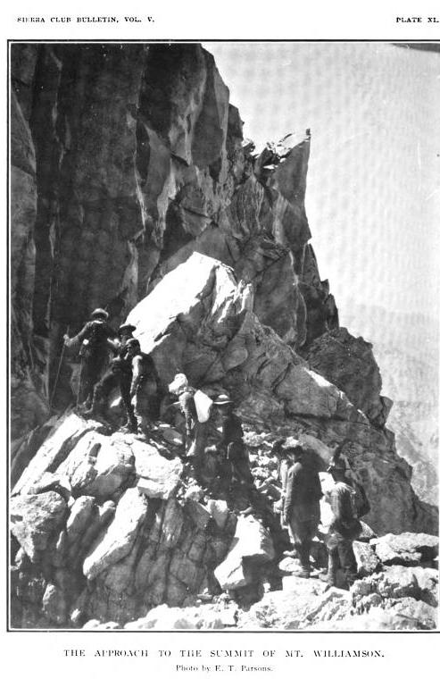
The women in the club knew themselves to be just as capable and excited about exploring the wilderness as men, and if the opposite sex didn’t realize that, they soon found out after spending time with them. Edward Taylor Parsons wrote an article about the club’s first wilderness high trip in 1901 in which he said a large portion of the women were students from Stanford and Berkeley. Their enthusiasm and abilities on the trail impressed everyone in the club, and a male mountaineer remarked that it was his first time hiking with women, and he had “started in with serious misgivings, but after this experience he would never go to the mountains again without the added pleasure of the companionship of women.”
Parsons also wrote about the club’s mountaineering experiences in 1903, recording that the group of ten who climbed Mt. Williamson’s summit contained four
Figure 5. Sierra Club members climbing Mt. Williamson
in 1903. Published in the Sierra Club Bulletin, Volume 5.
women, among the first to accomplish the task. The female members of the club demonstrated their love of nature and proved to be capable mountaineers, convincing the male members that their presence benefited their experiences within the club immensely.
When Evelyn Ratcliff passed away, the Sierra Club Bulletin editor Elliot McAllister wrote an entry about what it meant for her to be in the club, and how much she would be missed. He said that her death “had deprived the Sierra Club of one of its most talented and charming young women… whose brightness, untiring energy, and splendid voice won admiration from the most casual acquaintance.” He also noted that she climbed three summits during the summer outing of 1905—Mt. Hood, Mr. Rainer, and Mt. Shasta—being one of only a few members who accomplished the feat. The entry remarked on the character and achievements of one of their beloved members, and the club’s loss of a mountain companion was felt by all.
John Muir also expressed admiration for his female counterpart Jennie Price, making an editor’s note at the end of her article about traveling the Tuolumne trail. Remarking on her ability, he said that “the Sierra Club is developing some capital mountaineers and Mrs. Price must be one of the best,” adding she was the only woman to complete the entire length of the trip to his knowledge. The men in the club acknowledged how capable and passionate the women were on the trips, and Muir felt the need to share how proud he was to have Price in the club.
In another writing by Marion Randall Parsons, she again wrote about the enjoyment of being around her fellow members in the wilderness, appreciating the opportunity of being in the wilderness, and reflected on leaving: “Around the last camp-fires the climax of fellowship is reached; and in the day long ramblings the freshness and beauty of the mountain life seem to gather new meaning as we approach the time when it must all be left behind.” Many of the women lived in the surrounding cities, and after spending weeks in the open air and spaces of the mountain wilderness with friends, they didn’t find themselves eager to be returning home to urban areas and normal routines of everyday life.

Preservation Activism
As the women became more involved in the club and the outdoors, they developed views about human interaction with nature that compelled them to take action to preserve wilderness in California and also the nation. They engaged with the public and the government in an effort to save certain areas. As writers they published articles in other magazines to raise awareness about the need to protect wilderness from development and destruction. They also wrote and spoke to government officials about the Sierra Club’s positions and recommendations for lands to be preserved.
In an article Marion Randall Parsons published to inform the public about the Sierra Club, she conveyed the members’ goals of wanting “to establish national parks; to save the more wonderful regions from destructive invasion of any sort, and finally to arouse the people themselves to a knowledge of the great, unexplored treasure-house that lay neglected at their very doors.” She expressed the central message of the club and why they felt so strongly about
preserving the land around them:
Those of us who have learned to know the uplifting of spirit, the renewal of bodily strength and activity of mind which accompanies every visit to these wonderful alpine regions, feel that we owe it, not only in the present, but to future generations, to do our utmost to preserve in its natural beauty some portions of the Sierra wonderland for the enjoyment and benefit of the public.

In trying to convince the public of the importance of recreational wilderness areas, Parsons wrote that “no form of rest and recreation can compare with the untrammeled life in the open air that our national parks offer,” and they were “not a luxury for the few, but a growing need for thousands in this complex life of ours; and if the Sierra Club has helped, be it ever so little, toward bringing about the recognition of their value and urging people to their support, its organization has not been in vain.” Parsons believed that unique and beautiful wilderness areas belonged to the public, meant only for human enjoyment, and her interest and work in preservation campaigns rested on the conviction that American citizens’ quality of life improved with access to these lands.
The Hetchy Hetchy Valley in Yosemite National Park was one of the places that became a battleground for the Sierra Club and other groups involved in the movement. In 1903, the city of San Francisco proposed converting the valley into a dam, and true preservationists like the Sierra Club were bitterly opposed. When Congress approved the project in 1905, it caused a major split among people and organizations in the movement that up until then largely held the same goals. Two sides emerged in the conflict: conservationists who favored using the valley’s water resources, and preservationists who wanted to keep the valley pristine and free of human intervention.
Members of the Sierra Club were particularly attached to the Hetchy Hetchy Valley because they spent so much time there and planned to develop trails and make it a public space for others to enjoy. Parsons wrote about the valley in an article for the Bulletin in 1907. She described an outing the club took there, and that members hoped to work on areas that were still rugged to make the trail more accessible for others. Parsons described the trek, writing that “the scenic splendor of such a circuit, starting from the Yosemite and traversing the Merced Cañon, the Tuolumne meadows, the Tuolumne Cañon, and the Hetchy Hetchy, could never be equaled in the Sierra.”
While Harriet Monroe advocated for the government to bring in engineers and provide funds for Yosemite National Park to make it more accessible to people, she stated the public should give an absolute “no” to any “predatory schemes.” In describing the plan by the San Francisco City Board to convert Hetchy Hetchy Valley into a reservoir, she wrote that it “set a vicious precedent and should be revoked.” In explaining her reasons for the opposition, she said that the city could find other sources to get water from, and if the reservoir was built, “a little garden of paradise, the focal point of so many trails, and the jewel-casket of the upper park, would be destroyed forever.” Hetchy Hetchy Valley became one of the most treasured places in the Sierra Club, and the members felt a deep connection to it because of its spectacular beauty. They felt fiercely protective of it because of the time they spent within the valley, hiking and camping with their fellow club members.
The women of the Sierra Club reached out to other groups to help save Hetchy Hetchy, and gained support from the California Federation of Women’s Clubs, which then called on the 800,000 members of the General Federation of Women’s Clubs to help preserve the valley. By speaking to other groups about the need to preserve the valley for future use of the public, the Sierra Club women convinced others to join them in their vision of preservation.
Sierra Club women also traveled to Washington, D.C. to speak before Congress in 1909 at a hearing about the Hetchy Hetchy dam bill. Monroe made a statement declaring the American public the rightful owners of the valley because it had been “dedicated to the people by our government, preserved forever from despoiling hands within the sacred boundaries of a national park and therefore indestructible, inviolable.” She acknowledged the remoteness and inaccessibility of the area, saying that “it is my good fortune to be one of those few happy hundreds who have camped in this valley. Through days of sunshine and nights of moonlight I wandered through its flowery meadows, along the swift Tuolumne, and slept under its mighty trees.” She declared that it was Congress’ duty to preserve this area so that access could be improved, making it better known to the people and just as popular as Yosemite Valley.
Sierra Club member Cora Calvert Foy also took their message to the public, writing an article in the Los Angeles magazine Out West, in which she described the merits of the valley and provided pictures of the different features. Foy insisted the city of San Francisco was committing an act of vandalism by building the dam, and that they could use other sources of water, as California engineers had already testified to before Congress.
She wrote about her personal experience of viewing the valley for the first time and how it affected her, writing that “after three weeks of strenuous tramping and climbing…standing at the edge of Sunrise Point in the soft light on that late July afternoon, I looked down on that which ever remains in my memory as the most beautiful spot I have ever seen.” Seeing such a beautiful place produced feelings that stayed with her, and Foy wished for others to recognize the power wilderness areas such as Hetchy Hetchy contained. Citing the increasing travel to the Yosemite, Foy wrote that keeping the valley inside the park’s boundaries prevented future overcrowding, and if it became more accessible she believed it would be the most beautiful place in the park.
In the end, the efforts of the Sierra Club and fellow preservationists were not enough. In 1913 Congress voted on and passed the bill to build the dam, and the people who had fought in the campaign felt devastated to lose the valley. Those who knew the beauty and the inspiration of the valley felt it was paramount to keep Hetchy Hetchy part of Yosemite so they and others could enjoy and experience it in the future.
The Sierra Club did not achieve every preservation goal they had, but it did not deter the members from continuing to be activists for the cause. They continued to make their voices heard in Congress and other public outlets. In 1915, Parsons attended the National Park Conference in Berkeley, California, along with Mary Belle King Sherman, the chairwoman of the General Federation of Women’s Clubs Conservation Committee, and they were the only two women to attend the conference.
Parsons also went to lobby at the nation’s capital in 1920, speaking before Congress about a hearing to expand the borders and change the name of Sequoia National Park. In her statement, Parsons said she represented the 2,000 members of “the Sierra Club of San Francisco. We are a mountaineering club, but we have been interested in forest reservations and national parks since 1892.” She said the club wanted to include certain meadows and forests to the park, providing more space for large groups of people to set up camps and allow surrounding areas to be explored. She pointed out the boundaries on maps at the hearing, describing the natural features, unique trees and animals. She said the aspects of these areas added something to the park, improving its scenic beauty and making it a better place for people to enjoy.

Conclusion

The women of the Sierra Club were nature lovers who reveled in exploring and living in the wilderness for days and weeks at a time. The writings of the first outdoorswomen of the Sierra Club reveal just how much they enjoyed engaging in outdoor activities. The language they used when writing about their journeys on the trail was personal, emotional, and passionate. They wrote about the majestic landscapes of the Sierra Nevada wilderness, marveling at the natural world around them. Climbing mountain summits, walking through flowered meadows, crossing rushing rivers, and sleeping under giant trees produced feelings of liberation and adventure. Their experiences in the club outings made them recognize these wilderness areas as places of freedom where they were able to enjoy a certain way of life outside of the confines of society, and they often felt reluctant to leave the open air and natural settings of the outings.
While journeying through the beautiful and wild land they formed positive and emotional attachments with their fellow members, forming friendships with their male counterparts. The Sierra Club did not contain separate spheres, and the women participated in wilderness activities and preservation activism right alongside the men. Sierra Club women also did not tie their motivations to protect nature to female duties as caretakers, but as wilderness lovers and advocates for outdoor activities, distinguishing them from other women who worked on issues in the movement. The common bond of love for nature and the need to protect it transcended the gendered roles and views that existed in society. The men and women of the club cherished their mountain companions, enjoying the company of all different types of people on the trail during the day and around the campfires at night.
They beauty and spectacular nature of the lands the women engaged with motivated them to become wilderness preservation activists, taking their views and messages to the government and public, hoping to gain support for the protection of the places they knew and loved. They became active in preservation discussions and campaigns not only so they could continue their outdoor activities, but so others could as well. The Sierra Club women viewed the wilderness as a sanctuary for the human spirit and fought to protect these places which created such happy memories and connections to nature and the soul.

APPENDIX A
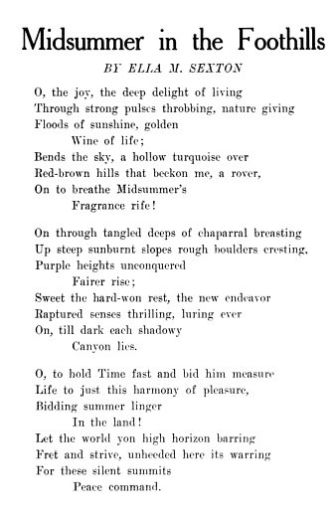
Ella Sexton’s poem published in Sunset magazine, 1903.

APPENDIX B
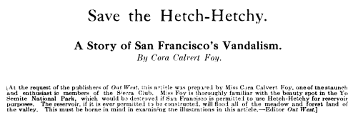
Excerpt from the title page of Foy’s article published in Out West magazine, 1910.

`
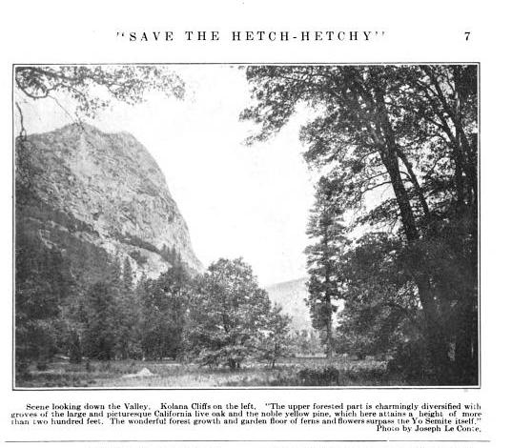
One of the article’s photographs promoting the valley:
BIBLIOGRAPHY
Primary Sources
Bade, William Frederic. “On the Trail with the Sierra Club.” Sierra Club Bulletin, 5 (1905): 50-
65.

Foy, Cora Calvert. “Save the Hetchy Hetchy.” Out West, 1 (1910): 1-17.

Gompertz, Helen. “A Tramp to Mt. Lyell.” Sierra Club Bulletin, 1 (1896): 136-141.

———. “Up and Down Bubb’s Creek.” Sierra Club Bulletin, 2 (1899): 79-89.

McAllister, Elliot. “Notes and Correspondence.” Sierra Club Bulletin, 6 (1908).

Monroe, Harriet. “Camping Above the Yosemite—A Summer Outing with the Sierra Club.”
Sierra Club Bulletin, 7 (1909): 85-98.

Muir, John. Quoted in “Proceedings of the Meeting of the Sierra Club.” Sierra Club Bulletin, 1
(1896).

Parsons, Edward Taylor. “The Notable Mountaineering of the Sierra Club in 1903.” Sierra Club
Bulletin, 5 (1905): 44-49.

———. “The Sierra Club Outing to the Tuolumne Meadows.” Sierra Club Bulletin, 4 (1903):
19-24.

Parsons, Marion Randall. “Grand Cañons of Tuolumne and Merced.” Sierra Club Bulletin, 6
(1908): 235-243.

———. “On Mt. St. Helens with the Mazamas.” Sierra Club Bulletin, 7 (1909):
170-179.

———. “Some Aspects of a Sierra Club Outing.” Sierra Club Bulletin, 5 (1905): 221-228.

———. “The Sierra Club.” Annals of American Academy of Political and Social Science, 35
(1910): 204-209.

Price, Jennie E. “A Woman’s Trip through the Tuolumne Meadows.” Sierra Club Bulletin, 2
(1899): 174-184.

Ratcliff, Evelyn Marianne. “The Sierra Club’s Ascent of Mt. Rainer.” Sierra Club Bulletin, 6
(1908): 2-6.

Sanderson, Charlotte. “With the Sierra Club in King’s River Cañon.” Sierra Club Bulletin, 4
(1903): 185-192.

Sexton, Ella. “Camp Muir in the Tuolumne Meadows, Where the Sierra Club Went A-Camping.
(A Women’s View of the Outing.)” Sierra Club Bulletin, 4 (1902): 12-18.

U.S. Bureau of the Census. 1880 United States Federal Census, San Francisco, San Francisco,
California. Washington, D.C.: National Archives Microfilm Publication T9.

———. 1900 United States Federal Census, San Francisco, San Francisco, California.
Washington, D.C.: National Archives Microfilm Publication T623.

———. 1900 United States Federal Census, Berkeley, Alameda, California. Washington, D.C.:
National Archives Microfilm Publication T623.

———. 1910 United States Federal Census, Reno, Washoe, Nevada. Washington, D.C.:
National Archives Microfilm Publication T624.

———. 1930 United States Federal Census, Reno, Washoe, Nevada. Washington, D.C.:
National Archives Microfilm Publication T626.

U.S. Congress. House. Roosevelt National Park Bill: Hearing before the Committee on the
Public Lands. 66th Cong., 2nd Sess. January 24, 1920.

U.S. Congress. Senate. Hetchy Hetchy Reservoir Site: Hearing before the Committee on Public
Lands. 60th Cong., 2nd Sess. February 10, 1909.

Secondary Sources

Ancestry.com Operations Inc. www.ancestry.com. (accessed 29 April, 2013).

Cohen, Michael P. The History of the Sierra Club 1892-1970. San Francisco: Sierra Club Books,
1988.

Demars, Stanford E. The Tourist in Yosemite, 1855-1985. Salt Lake City: University of Utah
Press, 1991.

Fox, Stephen. The American Conservation Movement. Madison: The University of Wisconsin
Press, 1981.

Kaufman, Polly Welts. National Parks and the Woman’s Voice: A History. Albuquerque:
University of New Mexico Press, 2006.

Merchant, Carolyn. “Women of the Progressive Conservation Movement: 1900-1916.” Environmental Review, 8 (1984): 57-85.
Norwood, Vera. “Women’s Roles in Nature Study and Environmental Protection.” OAH
Magazine of History (1996): 12-17.

Riley, Glenda. “‘Wimmin is Everywhere’: Conserving and Feminizing Western Landscapes,
1870 to 1940,” The Western Historical Quarterly, 29 (1998): 4-23.

Sierra Club. www.sierrclub.org. (accessed 19 April 2013).

Schulze, Robin G. “Harriet Monroe’s Pioneer Modernism: Nature, National Identity, and Poetry,
A Magazine of Verse.” Legacy, 21 (2004): 50-67.

Solnit, Rebecca. Wanderlust: A History of Walking. New York: Viking, 2003.

Wellock, Thomas R. Preserving the Nation: The Conservation and Environmental Movements
1870-2000. Wheeling: Harlan Davidson, Inc., 2007.

Wikipedia. www.wikipedia.org. (accessed 29 April, 2013).

The terms “preservation” and “conservation” can be—and often are—used interchangeably for this time period, but there is a difference. Preservationists held a strict view that certain wilderness areas should be protected from development and used only for human enjoyment, and conservationists believed that these areas should be managed for their resources. The Sierra Club were the former, and will be referred to as such in this paper, but the word “movement” is meant to include both conservation and preservation causes.
Stanford E. Demars, The Tourist in Yosemite, 1855-1985 (Salt Lake City: University of Utah Press, 1991), 73.
Glenda Riley, “‘Wimmin is Everywhere’: Conserving and Feminizing Western Landscapes, 1870 to 1940,” The Western Historical Quarterly 29 (1998): 4.
Vera Norwood, “Women’s Roles in Nature Study and Environmental Protection,” OAH Magazine of History (1996): 16.
Polly Welts Kaufman, National Parks and the Woman’s Voice: A History (Albuquerque: University of New Mexico Press, 2006), 20.
Demars, 73.
Ibid., 73-74.
Ibid., 73.
Ibid., 76.
Thomas R. Wellock, Preserving the Nation: The Conservation and Environmental Movements 1870-2000 (Wheeling: Harlan Davidson, Inc., 2007), 51.
Stephen Fox, The American Conservation Movement (Madison: The University of Wisconsin Press, 1981), 341.
Carolyn Merchant, “Women of the Progressive Conservation Movement: 1900-1916,” Environmental Review 8 (1984): 57.
Kaufman, 55.
Merchant, 73.
Ibid., 74.
Rebecca Solnit, Wanderlust: A History of Walking (New York: Viking, 2000), 152-153.
Demars, 75-76.
Riley, 11.
Michael P. Cohen, The History of the Sierra Club 1892-1970 (San Francisco: Sierra Club Books, 1988).
See Appendix A for a poem written by Sierra Club member Ella Sexton published in Sunset.
U.S. Bureau of the Census, 1800 United States Federal Census, San Francisco, San Francisco, California, in National Archives Microfilm Publication T9, Ancestry.com Operations Inc., http://search.ancestrylibrary.com/cgi-bin/sse.dll?rank=1&new=1&MSAV=0&msT=1&gss=angs-g&gsfn=Charlotte&gsln=Sanderson&mswpn__ftp=Maine&MSFMC=1&uidh=xf6&mssng0=Richard&msns0=Sanderson&pcat=ROOT_CATEGORY&h=20609880&db=1880usfedcen&indiv=1 (accessed 29 April, 2013); U.S. Bureau of the Census, 1900 United States Federal Census, San Francisco, San Francisco, California, in National Archives Microfilm Publication T623, Ancestry.com Operations Inc., http://search.ancestrylibrary.com/cgibin/sse.dll?db=1900usfedcen&h=6456118&indiv= try&o_vc=Record:OtherRecord&rhSource=6742 (accessed 29 April, 2013).
Charlotte Sanderson, “With the Sierra Club in King’s River Cañon,” Sierra Club Bulletin 4 (1903): 185.
Ancestry.com Operations Inc., “Helen M. Gompertz,” http://trees.ancestrylibrary.com/tree/9677342/person/6302499855 (accessed 29 April, 2013).
Helen Gompertz, “A Tramp to Mt. Lyell,” Sierra Club Bulletin 1 (1896): 136-137.
Ibid., 138.
.Ibid., 141.
Helen Gompertz, “Up and Down Bubb’s Creek,” Sierra Club Bulletin 2 (1899): 80.
Ibid., 84.
U.S. Bureau of the Census, 1910 United States Federal Census, Reno, Washoe, Nevada, in National Archives Microfilm Publication T624, Ancestry.com Operations Inc., http://search.ancestrylibrary.com/cgibin/sse.dll?rank=1&new=1&MSAV=0&msT=1&gss=angsg&gsfn=Jennifer+E.&gsln=Price&mswpn__ftp=California%2c+USA&msbdy=1875&MSLEC=1&MSFMC=1&uidh=xf6&mssng0=Robert&mssns0=Price&pcat=ROOT_CATEGORY&h=190107180&db=1910USCenIndex&indiv=1 (accessed 29 April, 2013); U.S. Bureau of the Census, 1930 United States Federal Census, Reno, Washoe, Nevada, in National Archives Microfilm Publication T626, Ancestry.com Operations Inc., http://search.ancestrylibrary.com/cgibin/sse.dll?db=1930usfedcen&h=107897254&indiv=try&o_vc=Record:OtherRecord&rhSource=7884 (accessed 29 April, 2013).
Jennie E. Price, “A Woman’s Trip through the Tuolumne Meadows,” Sierra Club Bulletin 2 (1899): 174.
Ibid., 184.
Ibid., 183.
Sierra Club, “Marion Randall Parsons,” http://www.sierraclub.org/john_muir_exhibit/ people/parsonsm.aspx (accessed 29 April, 2013); Sierra Club, “Edward Taylor Parsons,” http://www.sierraclub.org/history/marian-parsons.aspx (accessed 29 April, 2013); Cohen, 35.
Marion Randall Parsons, “Some Aspects of a Sierra Club Outing” Sierra Club Bulletin 5 (1905): 227.
Ibid., 228.
Marion Randall Parsons, “On Mt. St. Helens with the Mazamas,” Sierra Club Bulletin 7 (1908): 172.
Ibid., 179.
U.S. Bureau of the Census, 1900 United States Federal Census, Berkeley, Alameda, California, in National Archives Microfilm Publication T623, Ancestry.com Operations Inc., http://search.ancestrylibrary.com/iexec?htx=View&r=5542&dbid=7602&iid=004118417_00213&fn=Evelyn+M&ln=Ratcliff&st=r&ssrc=&pid=36120830 (accessed 29 April 2013); Ancestry.com Operations Inc., “U.S. School Yearbooks about Evelyn Marianne Ratcliff,” http://search.ancestrylibrary.com/cgibin/ sse.dll?rank=1&new=1&MSAV=0&msT=1&gss=angsg&gsfn=Evelyn+Marianne&gsln=Ratcliff&mswpn__ftp=Berkeley%2c+Alameda%2c+California%2c+USA&mswpn=67710&mswpn_PInfo=8%7c0%7c1652393%7c0%7c2%7c3249%7c7%7c0%7c126%7c67710%7c0%7c&uidh=xf6&pcat=ROOT_CATEGORY&h=3094056&db=YearbooksIndex&indiv=1 (accessed 29 April, 2013); Ibid., “Evelyn Marianne Ratcliff,” http://trees.ancestrylibrary.com/tree/26303983/person/13452121971 (accessed 29 April, 2013).
Evelyn Marianne Ratcliff, “The Sierra Club’s Ascent of Mt. Rainer,” Sierra Club Bulletin 6 (1908): 1.
Ibid., 2.
Ibid., 6.
Robin G. Schulze, “Harriet Monroe’s Pioneer Modernism: Nature, National Identity, and Poetry, A Magazine of Verse,” Legacy 21 (2004): 51-52.; Wikipedia, “Harriet Monroe,” http://en.wikipedia.org/wiki/Harriet_Monroe (accessed 29 April, 2013).
Harriet Monroe, “Camping Above the Yosemite—A Summer Outing with the Sierra Club,” Sierra Club Bulletin 7 (1908): 87.
Ibid., 89.
Ibid., 90.
John Muir as quoted in “Proceedings of the Meeting of the Sierra Club,” Sierra Club Bulletin 1 (1896): 280.
Parsons, “Some Aspects”, 221.
Ibid., 223-224.
U.S. Bureau of the Census, 1880 United States Federal Census, San Francisco, San Francisco, California, in National Archives Microfilm Publication T9, Ancestry.com. Operations, Inc., http://search.ancestrylibrary.com/cgi-bin/sse.dll?db=1880usfedcen&indiv=try&h=43606461 (accessed 29 April, 2013).
Ella Sexton, “Camp Muir in the Tuolumne Meadows, Where the Sierra Club Went A-Camping. (A Women’s View of the Outing.),” Sierra Club Bulletin 4 (1902): 13.
Ibid., 18.
Sanderson, 188.
Monroe, 91.
William Frederic Bade, “On the Trail with the Sierra Club,” Sierra Club Bulletin 5 (1905): 51.
Ibid., 65.
Edward Taylor Parsons, “The Sierra Club Outing to the Tuolumne Meadows,” Sierra Club Bulletin 4 (1903): 22.
Edward Taylor Parsons, “The Notable Mountaineering of the Sierra Club in 1903,” Sierra Club Bulletin 5 (1905): 48.
Elliot McAllister, “Notes and Correspondence,” Sierra Club Bulletin 6 (1908): 275
Ibid.
John Muir’s editor’s note in “A Woman’s Trip through the Tuolumne Meadows,” Sierra Club Bulletin 2 (1899): 184.
Marion Randall Parsons, “Grand Cañons of Tuolumne and Merced,” Sierra Club Bulletin 6 (1907): 243.
Marion Randall Parsons, “The Sierra Club,” Annals of the American Academy of Political and Social Science 35 (1910): 204.
Ibid., 207.
Ibid., 207-208.
Wellock, 60-62
Parsons,“Grand Cañons,” 243.
Monroe, 90.
Ibid.
Ibid.
Kaufman, 30-31.
Congress, Senate, Committee on the Public Lands, Hetchy Hetchy Reservoir Site: Hearing before the Committee on Public Lands,; 60th Cong., 2nd Sess., 10 February 1909, 32.
Ibid., 31.
Ibid., 30.
See Appendix B.
Cora Calvert Foy, “Save the Hetchy Hetchy” Out West 1 (1910): 1-9.
Ibid., 13.
Ibid., 15.
Wellock, 63.
Kaufman, 33.
Congress, House of Representatives, Committee on the Public Lands, Roosevelt National Park Bill: Hearing before the Committee on the Public Lands,; 66th Cong., 2nd Sess., 24 January 1920, 11-12.
Ibid., 17.

