CARPE DIEM: THE TEACHING OF FOREIGN LANGUAGE AT THE UNIVERSITY OF WISCONSIN – EAU CLAIRE 1916-2000

Michael R. Brauchla History 489 May 8, 2012

CONTENTS
INTRODUCTION 1
A Fast Start 3
A New Age for a New University 7
Extraordinary Opportunities: Credit Outreach and CAMPUS 15
Recent History and Emerging Trends 19
Moving Forward: Where We’re going and Where We’ve Been 21
CONCLUSION 24
Future Work 25
WORKS CITED 26

Copyright for this work is owned by the author. This digital version is published by McIntyre Library, University of Wisconsin – Eau Claire, with the consent of the author.
To professors Roma Hoff, Paul Hoff, Manfred Poitzsch, and Richard Gunn, without whom this paper would not have been possible, and who have dutifully carried on the great tradition of teaching foreign language at UWEC
Introduction
It was a wonderful, wonderful place to teach. What my children would remember, and what I remember, is that after they got off for school at 7:30 or 8:00 in the morning I’d trot over to school and be there until 5:00 in the afternoon. I really put in long days, but I loved every minute. It really liked teaching, it just made my life.
- Roma Hoff, retired UWEC professor, Interview with the author, 2012

The University of Wisconsin – Eau Claire has, for nearly a century, has enjoyed a rich tradition of teaching foreign language. Beginning in just its second year as a primary school, the faculty at the Eau Claire State Normal School (what the school was named in the first half of the 20th century) began to offer students the chance to take courses in foreign language. Since these humble beginnings the University has grown rapidly, and by extension, so has the teaching of foreign language. Though foreign language would not become its own department until the 1960s, its role in providing for a more rounded college course offering has been vital to many students since 1917, when the college first began instruction in Latin, French, and German.
By the time the school was renamed as Wisconsin State College in 1951, the school had stopped teaching Latin in favor of Spanish, following the increasing need for fluency in a language growing rapidly in importance for American students. In 1964, the school finally achieved University status, and became the University of Wisconsin—Eau Claire (UWEC). With the continued growth of the University the courses in foreign language offered by the University were expanded as well. While there were only 3 languages taught during the 1958-59 school year; French, German and Spanish; by 1968 that number had more than doubled to eight, adding course offerings in Latin (again), Greek, Russian, Norwegian, and Swedish. By the 1990s this number had grown again, adding new foreign languages while also beginning instruction in English as a Foreign Language. As stated before, in 1917 the Eau Claire state normal school taught 3 languages, and had a faculty of one (Hilda Oxby).
By the year 2000, UWEC had offerings in 11 foreign languages, and a faculty of 17. Clearly, the University’s foreign language department has grown steadily in size, and in my opinion importance, since the school’s founding. What I desire to do with this work is to take the reader on a tour of the Foreign Language offerings at UWEC from 1917-2000, providing as much background as possible through insights from former, and current, professors and administrators. My hope is that by providing a more thorough, and up to date, record on our foreign language instruction , I can supplement the work that has by done by authors such as Hilda Carter and John Jenswald, and provide the reader with a more accurate overall picture of where the department has been, and where it is going.
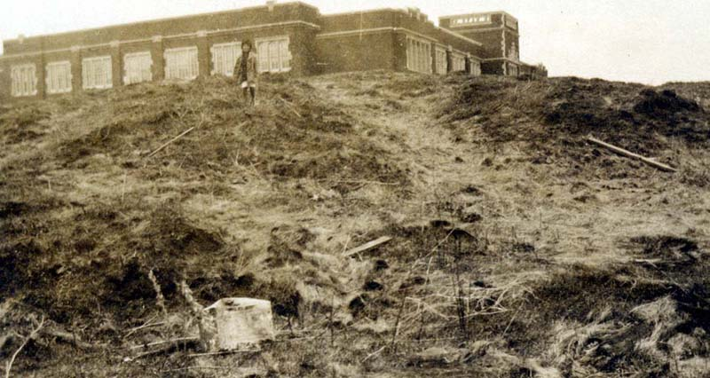
Figure 1: Schofield Hall, circa 1916. University website. Accessed April 24, 2012.

A Fast Start
In America, the tradition of foreign language instruction at the highest level of education has endured since the late 18th century, when Thomas Jefferson first established a professorship of modern languages in 1779, at the College of William and Mary.The Eau Claire State Normal school opened more than a century later in 1916, and by 1917 began offering courses in Latin, German, and French. These courses were all taught by the same woman, Hilda Oxby, who would be characterized some 70 years later as “an incredible woman, absolutely incredible, a little bit frightening if you were just green out of high school” by her former student, Barbara Rolland, who herself eventually became a foreign language professor at UWEC. Oxby graduated from the University of Michigan and had also studied at multiple universities in Germany. During her tenure here, she taught German, English, and eventually Spanish as well. Decades into her tenure here, her fervor for teaching language was still an inspiration to her students. “There was an enthusiasm there that sort of swept you along, and if you weren’t quite ready for it, it was almost frightening… but it was really, honestly, a sign of the advanced language program even then.” Barbara Rolland’s quote is all the more revealing when noting that Rolland first took Spanish with Hilda Oxby it was 1947, a full three decades after her arrival on campus. If her enthusiasm bordered frightening for Rolland in 1947, one can only imagine her passion in her younger years.
In the initial days of the Eau Claire State Normal School the requirements for a foreign language major or minor were much less strenuous than those of today. During the 1917-1918 school year, to complete a Major, a student needed to earn 30 hours (or credits). For a minor, a student need complete only 10 credits of coursework in the subject. At this point in the school’s history the actual course offerings for foreign language were not yet listed in the catalog, instead requiring students interested to “Arrange courses with language teacher.”
By 1921 the Eau Claire State Normal School began to experiment with providing coursework in addition languages, a tradition that has continued into the 21st century. It was in this year that classes in Greek, Spanish, and Norse, were first offered, and the year in which German made its return to the curriculum after being eliminated from the offerings in the 1917-1918 school year. While Greek and Spanish courses might seem like obvious choices to join French and Latin, Norse sticks out for being a choice that is perhaps influenced most by the heritage of the students attending the school. The instruction in Norse, the father language of Swedish and Norwegian, continued for only two years, but it was not the last time the languages of Scandinavia would be taught in Eau Claire. As for the resurrection of the German course offerings, it is interesting to note that when German was dropped, World War I was underway, adding intrigue to its omission. Though political circumstances might very well have caused the temporary discontinuance of the German courses, it is also entirely possible that their disappearance had to do with the general turmoil cause on campus by the war, which caused many young men and professors to leave Eau Claire and join the war effort.
Between the 1926-27 and 1934-35 school years, the Eau Claire State Primary School only offered instruction in two languages, French and Spanish. While this decade saw a decline in the overall number of languages spoken, there was also an expansion of the class offerings in the languages that were kept. For instance, by the 1928-29 school year, students of Spanish could not only take introductory and composition courses, but were also offered classes like “Elementary Survey of Spanish Literature”, “Don Quixote”, “The Spanish Drama”, and “The Spanish Novel.” By delving into classic Spanish literature and drama, the school showed that not only were its instructors concerned with teaching their students to be proficient in speaking and writing in their chosen foreign language, but that they also cared a great deal about infusing cultural knowledge into the coursework as well.
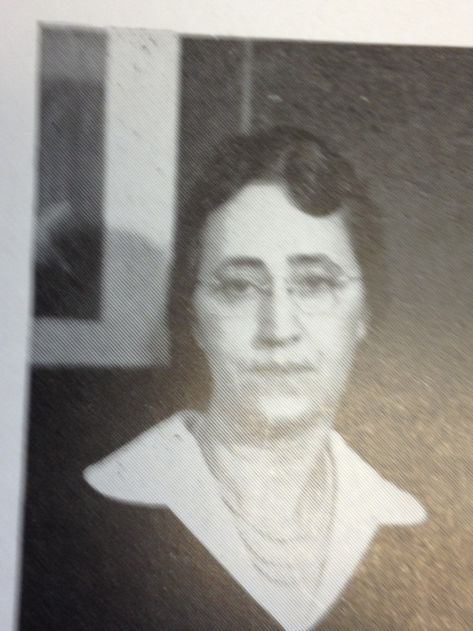
Figure 2: Hilda Oxby. Source: The Periscope, 1938.
Between the school years of 1935-36 and 1941-42, Spanish courses were discontinued in favor of a return to German language instruction. By this time, credit requirements for Majors and Minors in foreign language had increased dramatically. While in 1917 a foreign language minor could be earned for a mere 10 credits, that obligation was increased twofold to 20 by 1941. Though the languages offered remained in flux, the commitment to teaching about the culture as well as the language remained, evidenced by course titles like “Introduction to German Civilization” and “Survey of German Literature.” It is also interesting to note that the return of German came less than 3 years before the beginning of World War II. If the political fallout from World War I had anything to do with the halting of German instruction in the primary school’s early days, the same was not the case for the language in the Second World War. In fact, German has been taught on campus continuously since 1935, the second longest active streak for a foreign language, after French, a subject which hasn’t been neglected for a single year since 1917.
By the mid 1940’s instruction in Spanish had returned, and has remained ever since. With its return came a new emphasis on not only learning about the culture and classic literature of Spain, but also on that of Latin America. The course “The novel in Spanish-America” exemplifies this effort, by undertaking a “study of ten of the most important novelists of Spanish America.” Though the term “Spanish America” may seem outdated, it is clear that an effort was made to diversify the course selection by incorporating elements of Latino culture into the class offerings. The course requirements for those wishing to earn a Major or Minor in foreign language was also changing. By 1958, Majors were offered in both French and Spanish for 32 credits, while Minors were 22 credits. There was also a “General Language Major” offered, for which a student would have to earn 22 credits in two different languages. A Major such as this would become increasingly relevant as new languages began to be taught. The 1960s would see a great increase in the foreign languages taught at the university. In short, the days of offering instruction in only three to four languages at a time were nearing an end.

A New Age for a New University
The 1960s was a tumultuous time period for Americans, especially those on college campuses. While the decade represents different things to different people, for the University, and more precisely it’s Foreign Language Department, it was an era of expansion. The decade started with small increases to the foreign language curriculum, like adding Greek. The course, entitled “Beginning New Testament Greek”, was designed to give students a deeper and more scholarly knowledge of the Bible, and is described as an “introduction to New Testament grammar, with preparation for reading simple passages from the epistles of John, and from John.” The Teachers College received University status in 1964 and was rechristened Wisconsin State University – Eau Claire (WSEC). Soon after, the foreign language department blossomed, and increased its average number of languages taught each year by double of what it had been in the 1930s and 1940s. By the 1968-1969 school year, WSEC, offered courses in French, Spanish German, Greek, Latin, Russian, Norwegian, and Swedish. Much of this growth would not have been possible if not, perhaps, for the space race with the Soviet Union, which was a major factor in the United States enacting the National Defense Education Act in 1958, which provided funding for education at all levels. Indeed, the Sputnik crisis transformed the politics of federal aid concerning education, temporarily neutralizing those opposed to increasing funding towards education. “It was a very exciting time in America”, said Dr. Poitzsch, a German professor at UWEC from 1964-1996. “A lot of money had been given to education, and it was because of sputnik.”
Though during the 1960s UWEC saw relatively little unrest when compared to bigger campuses like UW -- Madison, the changing political atmosphere did cause shifts in academic requirements. Dr. Richard Gunn, a foreign language professor at the University from 1968-2004, explains the changing dynamics as such,
During the Vietnam War, on some of the larger campuses there were protests against the war, and, simultaneously, against the curriculum. And so a lot of the requirements were gotten rid of. And what happened at Eau Claire was very unusual. The history and foreign language requirements were both eliminated. And it was strange because it was a reaction to demands that the students had not made. Students had made those demands on other campuses, but not here. So it was a preemptive strike to keep students in the library I think.
It would seem that the University decided it would squash any potential reason for students to protest during this time of civil unrest. In this case, though, it seems the University was overcompensating, making major changes to the education of each student in response to a perceived future threat, real or imaginary.
Though the foreign language requirement would be abolished for a time, student commitment to learning foreign language did not wane, as the 1960s also saw a growing membership in foreign language speaking and honors clubs. German students organized “Der Deutsche Verein”, a club open to any student who had previously studied German. Der Deutsche Verein offered “an opportunity to practice the spoken language outside of the regular classroom as well as in skits, games, and songs.” French students joined both “Le Salon Francais”, the French parallel to the Deutsche Verein group, and Pi Delta Phi, the “national French honor society established to foster a wider appreciation of France to world culture.” Unlike Le Salon, Pi Delta Phi members were required to carry a grade point of at least 3.0 in three or more French classes to be eligible to join its ranks. Spanish, too, had its own club and honor society. El Rayo Espanol, which touted itself as a club “for students who have studied Spanish America and for students from that area. Weekly Spanish conversation table is sponsored, as well as the annual fiesta panamericana for High School and college Spanish students of the area.” The proliferation of foreign language clubs shows that not only were students engaged in learning their respective languages inside the classroom, but outside of it as well.
As UWEC transitioned into its new role as a University, the liberal arts were becoming a more pronounced focus, which was a benefit to the Foreign Language Department. Dr. Poitzsch explains, “What I found very attractive about Eau Claire as compared to the school I came from in Mankato, Minnesota. They were very education oriented; here it was more liberal arts. I like this.” The professor’s quote is revealing because historically, the UWEC started out as a primary school, devoted almost completely to training those going on into the field of education. By the mid-1960s though, the remnants of this tradition had been cast off to a great degree.
The expansion of the Foreign Language department during this decade also yielded a more diverse, and increasing better-qualified, professors. “The department was always very international, we always had people from all over the world coming for one or two years, and this made for a very interesting mix in the department. And the other interesting thing was that there were always more women than men.” Undoubtedly, the increased funding of Universities through the NDEA, and the precipitous rise in the student population at Eau Claire, were of great benefit to the Foreign Language Department.
It was also during the 1960’s when the University began seeking out more professors with doctorates, or those who would soon earn them. In the past decades, having staff members with a Ph. D. was certainly prestigious and allowed for greater upward mobility within the University structure, though it was not a requirement to become a professor. When both Dr. Gunn and Dr. Poitzsch arrived on campus in the mid-1960s neither had yet earned their doctorate. Dr. Poitzsch explained to me that, “When I was hired the people who hired me wanted to know when I would finish my doctorate. It was important but it was not a precondition.” Such was also the case for Dr. Gunn, who also finished his doctoral work while already employed at the University. Though the degrees earned by the faculty certainly help promote the prestige of the department, and by extension the University, both professors mentioned above also noted the fact that it was a good thing that UWEC did not make the rigid requirement of a Ph.D. a necessity for employment as an instructor. As Dr. Poitszsch noted, “At a Liberal Arts University you want individuals who are talented in their field, be it language or music, or what have you. So I think it is a good thing not to impose these restrictions.” I also agree that the University was practical in its employment policies, and this is evidenced by the more than sixty years teaching these two particular professors brought to the University after their hiring.
After the UWEC was given the title of University, the Foreign Language Department’s study abroad program slowly began to grow in both the number of students participating, and the duration of their visits overseas. Though cutbacks were made, and the classic languages of latin and Greek were once again eliminated from the offerings, the University still offered courses in French, German, Italian, Portuguese, Norwegian, and Spanish. For at least a few of these languages, trips to study internationally were available to students. “The department encourages study in France, Mexico, Spain, or Germany for students majoring in the languages of these countries. Whenever possible, the University develops its own program for study abroad.”The groundwork laid for study abroad programs in the 1960s and 1970s would pay dividends in the 1980s and 1990s, during which time there was a great increase in the number of students both traveling abroad for study, and foreign students traveling to Eau Claire for education as well. Though travel abroad programs were trending upward, it still wouldn’t be until the mid-1980s that UWEC’s German program finally began sending students abroad for an entire semester, as opposed to a three week summer trip. Dr. Gunn began chaperoning trips to Kiel University in northern Germany in 1985, after which there were exchange student programs set up with Universities in other German-speaking cities like Bonn, and Graz in Austria, in which one UWEC student would travel abroad for every one student that came to Eau Claire from central Europe.
As for the teaching being done back here on campus, certain new methods of teaching were coming into educational vogue, changing the methodology of teaching foreign language at the University level. Dr. Poitszch points out that, “there was a lot of excitement in foreign language teaching. The theories, the books, we were able to use, the conferences we went to, it was a very exciting time.” Though Poitsch was admittedly caught up in the excitement of the new wealth of research and discussion about foreign language, he was a bit more apprehensive when it came to the new technologies being implemented in the classroom:
Many of my colleagues were trying to invent teaching machines, and the big excitement at the time was the language laboratory. [The idea was] To solve the problem of learning things with machines, and faster. Of course it’s a fallacy, but it is exciting to Americans. So this was the age of the language lab. We didn’t have the computers yet at the time, what this would have done to us at this time I don’t know. [laughter]
Dr. Roma Hoff, another retired professor who taught at the University for more than three decades, beginning in 1965, shared her recollections of this new influx of technology into the teaching of foreign language as well. “We didn’t have, you know, computers, things like that. We used tape recorders and thought that was quite advanced. If a student had four credits, one day a week they would have lab. They would be speaking and listening to themselves. That was very good for pronunciation.” While not suited to every teaching style, the flood of technology into education was an inevitable occurrence, and its influence continues to increase to this day. The challenge for educators then, as now, is to figure out how to utilize the technology without sacrificing gains made by using older methods or instruction.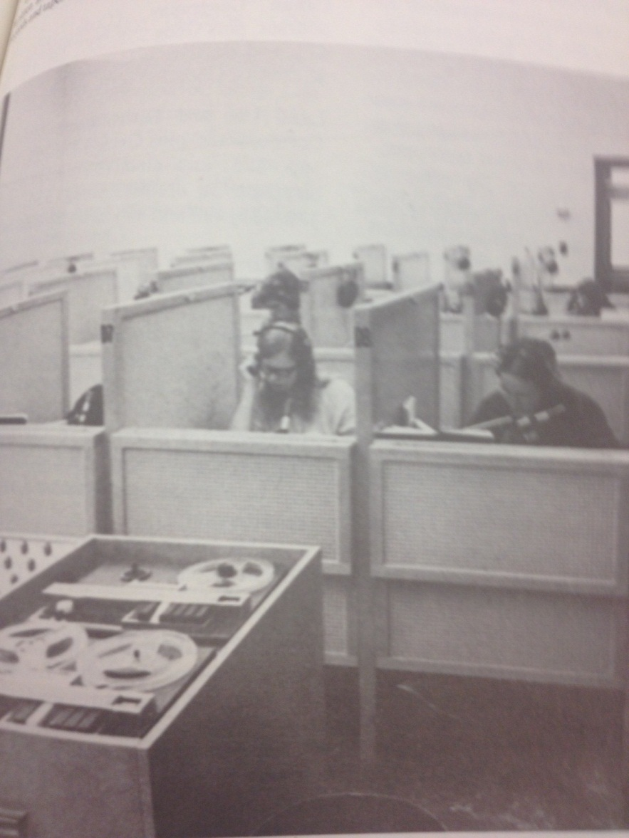Figure 3: Source 1976-1977 UWEC Course Catalog.
By the 1990s a new emphasis emerged on teaching language, the total immersion classroom. This setting, in which the class is held in entirely (or nearly entirely) the foreign language being taught, has become the de facto standard in foreign language classrooms throughout the country. Dr. Paul Hoff, son of Roma Hoff, is a current Spanish professor at the University, explained the emergence of this new tactic, and its inherent conflicts, thusly,

A lot of research says that the more you conduct the class in the target language, the better…It’s a challenge sometimes to get students comfortable with hearing so much Spanish, because maybe they come from a high school where they heard a lot of English in a Spanish classroom. So you kind of have to break the mold and say “this is a Spanish speaking environment. We’re going to use Spanish the vast majority of the time.”
Though Dr. Hoff has worked to become better at teaching foreign language in the target language as much as possible, he still leaves room for making adjustments particular to each class or individual student.
If you look historically at foreign languages there have been kind of waves of popularity of certain techniques, kind of like people jumping on the bandwagon to try this or that. And a lot of that pre-dates me. But, I would say certainly that I’ve learned since I’ve been here. I’ve discovered new techniques and ultimately found what im comfortable with and what works for me with students. And I realize that students can be very different from one another so I think it can be an error to buy into one model.
Dr. Roma’s sentiment is one that I believe resonates with educators in all areas of the practice. That being, each student is unique and what works best for one may not be best for another. Writing on the subject, Carol A. Herron posits that the new emphasis on staying in the target language during class does not mean that skills like composition need not be sacrificed. “This does not mean, however, that rote learning of basic structures can be entirely replaced by spontaneous personal expression in beginning language courses.” So, the best strategy is to try to teach in a way that maximizes production in the classroom for the most students, and then take a more nuanced approach to teaching those whose learning styles are less compatible.
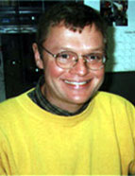Figure 4:Paul Hoff Source: http://www.uwec.edu/newsbureau/images/0421_hoffpj.jpg Accesed: 5/1/12
Extraordinary Opportunites: Credit Outreach and CAMPUS
Over the course of the interview process, certain people, and certain programs, seemed so successful that the author would be remiss if a portion of this project were not dedicated to their specific narrative. This is surely the case with Dr. Roma Hoff, who not only spent parts of 26 summers guiding tours of Western Europe, and was also a pioneer in launching CAMPUS, a program that brought Central American students to UWEC for the last two years of their college education. The leading role she played in the organization and successful implementation of these programs positively impacted the lives of countless people, both students and citizens alike.
When Dr. Hoff arrived on campus in 1965, she was already a veteran of several trips abroad taken during her time in Madison. Soon after her arrival, Dr. Hoff began to chaperone overseas trips to Spain and Portugal. Between 1965 and 1996, she went on no less than 26 of these trips. The unusual facet of these trips abroad was that they were not just for students. On the contrary, this program was open to the public, allowing for citizens from all sorts of backgrounds to participate in the trip, an opportunity many townspeople would take. During the course of the interview, Hoff shared with me some of the materials she had kept from these trips, which have been printed below. It is especially interesting to note the quotes from the townspeople who embarked on the trip, who shared their thoughts about the program after their return. 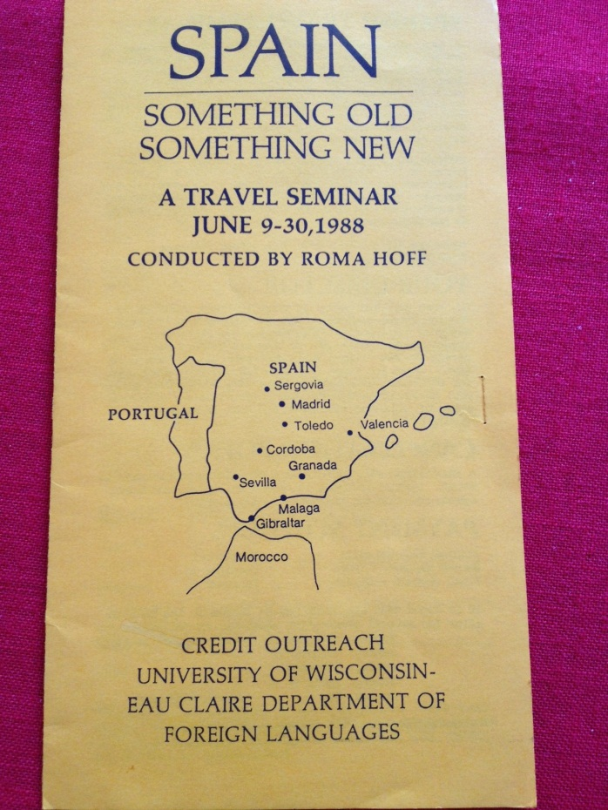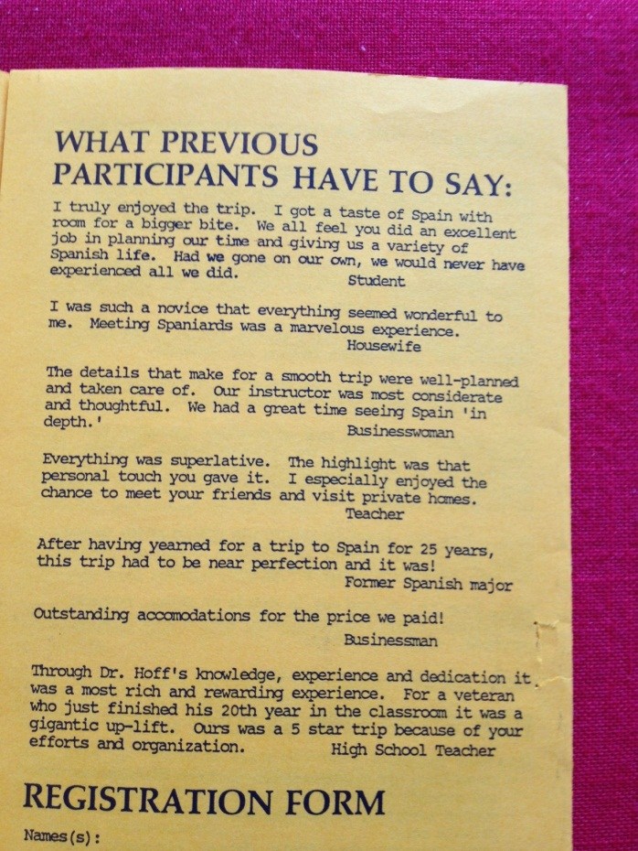Figure5: Travel Seminar Brochure source: author’s photo
Dr. Roma Hoff was not only invested in helping Eau Claire students and citizens explore cultures outside their own, but also helped those of foreign background to gain a valuable education during her tenure. This passion for helping foreign students was exemplified by her work in CAMPUS, or the Central American Program for Undergraduate Studies. The program, which operated for eight years off and on between the years of 1985-1995, afforded central American college students the chance to finish their last two years of higher education at UWEC, with the caveat that they must got back to their home country for at least two years afterwards, so that their home country might benefit from their instruction in America. Through her long tenure here at the University, Dr. Hoff, regards the implementation and success of this program as perhaps the most rewarding experience of her scholarly career. “This was a unique experience and of all the things I’ve done here I’d say this ten year period was just incredible. So that’s one of the highlights of my whole career here…This was a government project, thinking it would be good for relations (with other nations), and it was.” The success of a program like CAMPUS demonstrates how important the Foreign Language Department at UWEC has been not just for the American students who come to the University to gain their degree, but also for citizens of foreign nations as well.
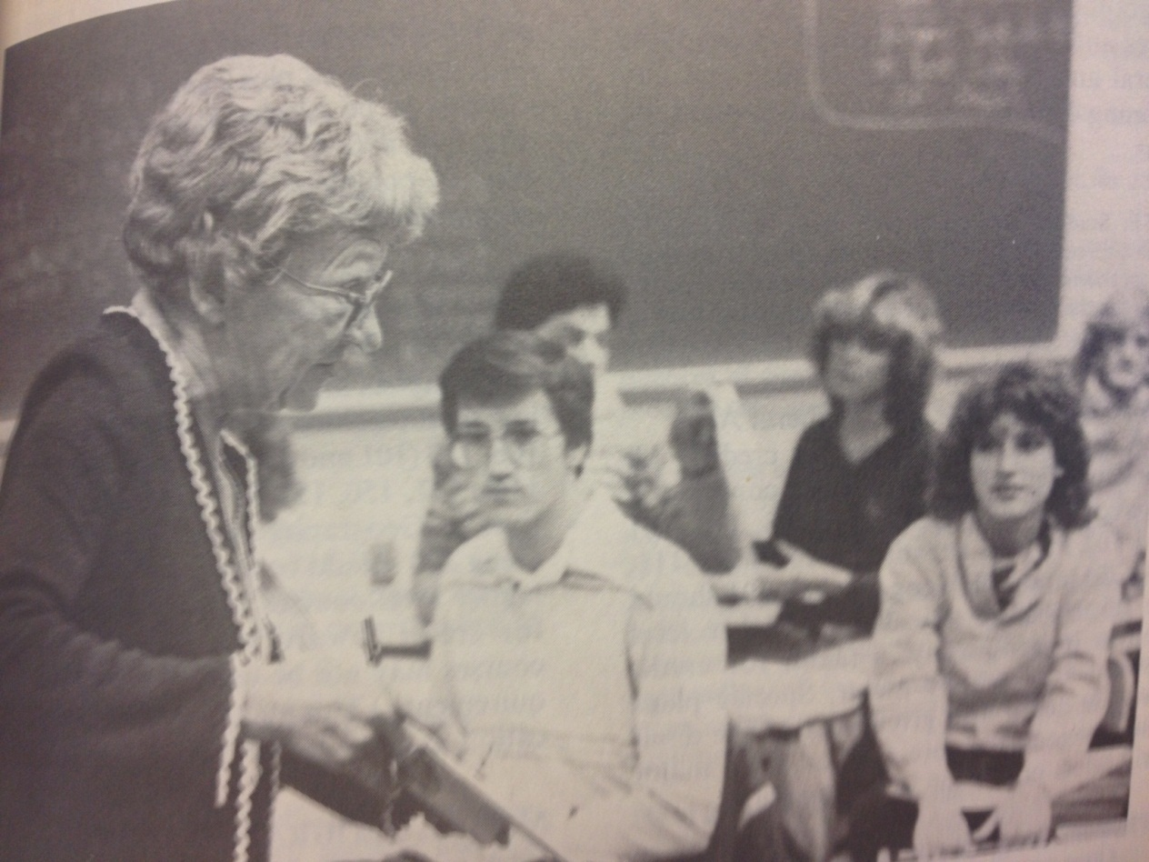Figure 6:Dr. Roma Hoff teaching. Source: UWEC Course Catalog 1984-1985
Not only was the CAMPUS program a fantastic idea for promoting better relations with Central American countries, but the program was also an unmitigated success. During the eight years the program existed, our University hosted some 76 Central American students. Of those 76, 75 left the University after earning a degree, equaling out to a staggering 98.68% graduation rate for those enrolled. Much of the credit has to go to Dr. Hoff, who served as “cultural advisor” to all of the CAMPUS participants. Hoff’s family was also a host family during this period, as each Central American student stayed with a local a family during their time in Wisconsin. Hoff explains,
Each one of them had a home family, a host family. And we were the host family for Jose. They were just like family to us… One young man came up here not knowing a word of English. And he really taught himself English, graduated with honors, and he teaches in Green Bay now. When you haven’t had a chance in your own country and something like this comes along you’re going to work hard.
When talking with Hoff about this particular time in her career, it became quite clear that this program had brought great joy to her, and to the students as well. Included below is a copy of a home photograph of Dr. Hoff’s, taken in her back yard, of her and some of the CAMPUS students. As she explained the photographs to me, Hoff pointed out certain students and updated me as to their current whereabouts and accomplishments. As she pointed to different students in the pictures, a proud Dr. Hoff added, “They are doing incredible things. One of them has been the president of his University in Costa Rica… Two of them got married. They’ve been back several times. She’s at the Panama Canal now, with a very big job. ” By 1996 the program had been discontinued, but the legacy of these students surely remains, whether it is back in their home country, or as close as Green Bay.
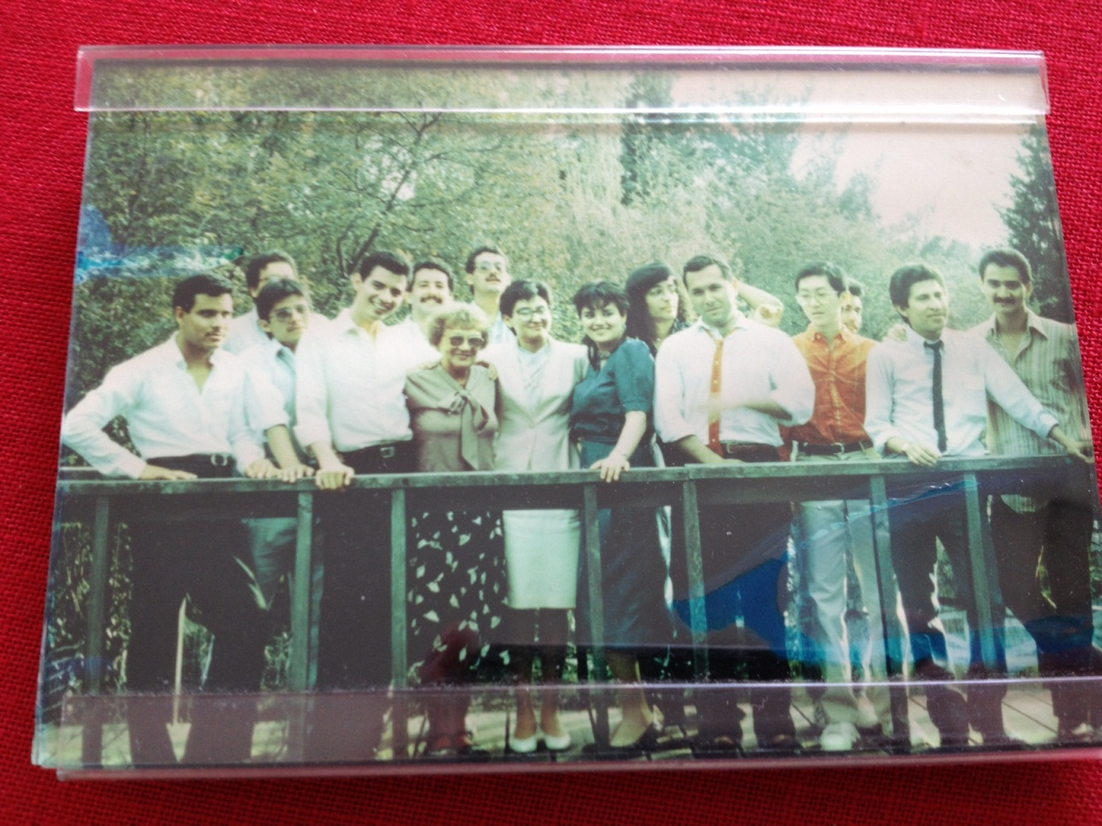Figure 7: Dr. Roma Hoff and CAMPUS students. Source: author’s photo

Continuing Forward: Recent History and Emerging Trends
By the 1990-91 school year the University offered courses in Chinese, Danish, French, German, Italian, Japanese, Latin, Norweigan, Russian, Spanish, Swedish, and English as a Foreign Language. While Spanish was the most popular language in terms of enrollment, the fastest developing section of the Foreign Language Department was English as a second language. At the genesis of this section all non-native speakers were put into the same class, though this antiquated system was soon done away with:
As the number of foreign students increased, there was a greater need for that. At one point there was Enlish115, and all of the foreign students would be lumped together in that class. When it got bigger it didn’t really work. You’d have students from Sweden who were already pretty fluent in English alongside someone maybe from Ethiopia whose English was more halting. So they decided to farm that task out to our department. The demand initiated the supply.
This new task given to the faculty of the Foreign Language Department was not an easy one to fulfill. Professors like Dr. Gunn, untrained in ESL-specific methodologies, were now asked to do the best they could with the new courses:
Classes were difficult to teach. With my native language students would ask me a question and I would know the answer but I wouldn’t know why it was. I didn’t know what an appositive was, for example. I knew the right thing to say but I couldn’t explain anything for a while. I found the handle after a while.
As the demand for ESL classes grew, the University began to hire more specialized professors to teach the courses. After the hiring of Dr. Kate Reynolds, the ESL section of the department began to take its current, more specialized shape. “We began to hire people with degrees in that area and now I think it’s actually a very good program. Foreign students are tested and put into a group appropriate to their knowledge of English, you have advance learners and beginers and people in between, so it works quite well.” In our interview, Dr. Gunn called Dr. Reynolds a “whiz kid”, indicating that it is through her forceful approach to the curriculum and vast knowledge of the subject that the makes the contemporary design work so well.
Despite the continued advancement of the ESL course offerings at UWEC there has been diminished attendance by Mexican students since the mid-1990s due to political strife within the country:
In the early 1980s into the mid90s there were really big summer programs. Students coming in primarily from Mexico. UWEC had a longstanding relationship with a system of colleges in Mexico called Monterey Tech. This relationship brought lots of undergrad Mexican students and Mexican faculty to Eau Claire to improve their English in the summer.
Starting in the mid1990s American Universities began to question the security in Mexico, which eventually led to a halting of programs like the Monterey Tech summer program.
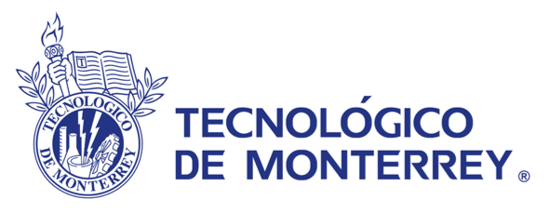Figure 8. Source: http://webstudies.info/ws2010/ Accesed 5/1/12
Moving Forward: Where We’re Going and Where We’ve Been
In the year 2000 the Foreign Language Department offered course offerings in all of the same languages as were offered in the 1990-1991 school year, with the exception of Swedish, which was dropped from the curriculum. From 1917-2000, the University, and its previous incarnations, offered classes in a total of 14 languages, counting ESL. Growing from a beginning faculty of just one in 1917, there are currently 17 faculty members in the Foreign Language Department, with 10 being tenured or tenure-track professors. Though the expansion has, in general, meant good things for the professors who come to the University to teach foreign language, there are some regrets about how the evolution of the curriculum has taken shape among the retired staff. During the interview process for this work, I asked the question, “What was (or has been) the biggest change that took place over your tenure with the Foreign Language Department?” The answers I received indicated that both structural and philosophical alterations to the department had made major impacts over the careers of the educators interviewed. Dr. Paul Hoff, the only professor interviewed who is still on staff at the University, logically explained that the biggest change so far has been that now in the Spanish department there are three tracks for students; liberal arts, teaching, and Spanish for business; as opposed to just two before (the latter track accounting for the new edition). Others, like Dr. Gunn, thought that the University has lost its focus on liberal arts. He summed up his thoughts on the subject succinctly, saying, “The biggest change from the time we came to now is a de-emphasis, if not devaluation, of the study of literature. He and I (Dr. Poitszch) endued up in this profession out of a love for literature but that has, for a number of reasons, been diminished.” Dr. Poitzsch agreed with this sentiment, adding “It takes away from the liberal arts. It is not always practical what is done at the University, but there should be another reason.” What I find clear from these statements is that in the teaching of a foreign language, there is a pendulum balanced between teaching for utility, a more business-like approach, and teaching to shape the most well rounded student, a liberal arts focused approach. Debates like this are sure never to be settled but rather must conform to the prevailing methodologies and structures that shape the contemporary landscape.
The current state of the Foreign Language Department is strong, providing a solid foundation to continue with the languages being offered currently, even through this current period of economic hardship. Dr. Paul Hoff explains,
Overall the department is bigger than ever, and quite healthy in most respects. I think we’re in a good position to continue our offerings, but the overarching question is “What else can we do? What can we do better, to create a niche in the community? The question is, are there possible collaborations with other departments on campus, for example Business. Is there more we can do together?” I think the question is how can we kind of expand our net, to become more connected to the broader University Community.
This is a question that has been salient with the department for years, as evidenced by Dr. Paul Hoff’s mother’s work with the credit outreach program, which offered overseas trips to townspeople, as well as students. Dr. Paul Hoff also hints at building synergy between the departments, as to create collaborations that would better connect with the community. As the Foreign Department moves forward through the 21st century, these questions, with no obvious answers, are bound to continue to be asked.

Conclusion
The University of Wisconsin – Eau Claire has perpetuated a long, and impressive history of instruction in foreign language. Through the school’s many names, and structural changes, foreign language instruction has been ubiquitous on campus. By undertaking this work, I hope to have laid out a somewhat comprehensive history of the foreign language offerings on campus from its earliest days, until the year 2000. By providing this overview, combined with the reflections of former faculty members, my goal has been to paint a clearer picture of the progression of foreign language instruction at UWEC than has been compiled so far, as well as to offer glimpses into some of the more unique programs and opportunities provided by the Foreign Language Department to date. In closing, the results of my research on this topic have led me to conclude that foreign language instruction at UWEC is an integral part of the liberal arts experience, and the influential presence of the Foreign Language Department on campus is a staple of the educational opportunities provided to students. One that is sure to continue on into the foreseeable future.

Future Work
Additional work that could be extremely useful in the future would be the compilation of an easy to read graph, showing which classes were offered at what time during the history of UWEC. It was my intention to create such a graph but having little experience compiling such ancillary materials I was unable to come up with a design that would be simple enough to read correctly, while small enough to fit on a page. Another pitfall of this work is the lack of input from the French department. Though Spanish has been the dominant language in the department for decades, French was the first subject taught here, and the language with the longest consecutive streak of years with courses offered. To shore up this absence of input it would be especially helpful to interview Dr. Edith O’Connor, a retired professor from the University who lives in Chippewa Falls, whom the author tried unsuccessfully to contact.

WORKS CITED
Primary Sources
Gunn, Richard. Interviewed by author April, 7. 2012.
Haas, Leonard C., et al. An Oral History of the University of Wisconsin--Eau Claire: A 75th Anniversary Publication. Eau Claire, Wis: Special Collections, McIntyre Library, UW--Eau Claire, 1991.
Hoff, Paul. Interviewed by author. March 19, 2012.
Hoff, Roma. Interviewed by author. April 23, 2012.
Poitzsch, Manfred. Interviewed by author. April 7, 2012.
University of Wisconsin – Eau Claire Catalogs, 1917-2011. AS 067. Special Collections & Archives. McIntyre Library. University of Wisconsin – Eau Claire. Eau Claire, WI.
University of Wisconsin – Eau Claire. “The Periscope, 1917-1995”. Loc. Hist. LD 6090 .A58. Special Collections & Archives. McIntyre Library. University of Wisconsin – Eau Claire.Eau Claire, WI.

Secondary sources
Carter, Hilda R., and John R. Jenswold. The University of Wisconsin – Eau Claire, A History, 1916-1976. Stevens Point, Wisconsin: University of Wisconsin – Eau Claire Foundation, Inc., 1976.
Clowse, Barbara Barksdale. Brainpower for the Cold War: The Sputnik Crisis and the National Defense Act of 1958.Westport, Conn: Greenwood Press, 1981.
Freeman, Stephen Albert. The Middlebury College Foreign Language Schools, 1915-1970: The Story of a Unique Idea. Middlebury, Vt: Middlebury College Press, 1975.
Gaudiani, Claire, and Carol A. Herron. Strategies for Development of Foreign Language & Literature Programs. New York: Modern Language Association of America, 1984.

Registrar Undergraduate Catalogs 1915-1966(1917-1918), AS 67, Special Collections &Archives, McIntyre Library, University of Wisconsin – Eau Claire, folder 4.
Ibid.
University of Wisconsin – Eau Claire Catalogs, 1917-2011(1958-1959), AS 67, Special Collections & Archives, McIntyre Library, University of Wisconsin – EauClaire.
University of Wisconsin – Eau Claire Catalogs, 1966-1968.
University of Wisconsin – Eau Claire Catalogs, 1999-2000.
Stephen Albert Freeman. The Middlebury College Foreign Language Schools, 1915-1970: The Story of a Unique Idea. Middlebury, VT: Middlebury College Press, 1975. Print. 1-2.
Leonard C. Haas, An Oral History of the University of Wisconsin – Eau Claire: A 75th Anniversary Publication. Eau Claire, Wis: Special Collections, McIntyre Library, UW – Eau Claire, 1991, 46:1.
Hilda R. Carter and John R. Jenswold. The University of Wisconsin – Eau Claire, A History, 1916-1976. Stevens Point, WI: University of Wisconsin – Eau Claire Foundation, 1976. Print. 30.
Leonard C. Haas, An Oral History of the University of Wisconsin – Eau Claire: A 75th Anniversary Publication. Eau Claire, Wis: Special Collections, McIntyre Library, UW – Eau Claire, 1991, 46:1.
Registrar Undergraduate Catalogs 1915-1966(1917-1918), AS 67, Special Collections &Archives, McIntyre Library, University of Wisconsin – Eau Claire, folder 4.
Ibid.
University of Wisconsin – Eau Claire Catalogs, 1923-1924.
University of Wisconsin – Eau Claire Catalogs, 1926-1935.
University of Wisconsin – Eau Claire Catalogs, 1928-1929.
University of Wisconsin – Eau Claire Catalogs, 1935-1936,1941-1942.
University of Wisconsin – Eau Claire Catalogs, 1941-1942
University of Wisconsin – Eau Claire Catalogs, 1938-1939
University of Wisconsin – Eau Claire Catalogs, 1917-2000
University of Wisconsin – Eau Claire Catalogs, 1942-2000
University of Wisconsin – Eau Claire Catalogs, 1954-1956
University of Wisconsin – Eau Claire Catalogs, 1956-1958
University of Wisconsin – Eau Claire Catalogs, 1958-1960
University of Wisconsin – Eau Claire Catalogs, 1960-1962
University of Wisconsin – Eau Claire Catalogs, 1968-1969
Barbara Barksdale Clowse. Brainpower for the Cold War: The Sputnik Crisis and the National Defense Act of 1958.Westport, Conn: Greenwood Press, 1981.4.
Manfred Poitzsch. Interviewed by author. April 7, 2012. Eau Claire.
Richard Gunn. Interviewed by author. April 7, 2012. Eau Claire.
University of Wisconsin – Eau Claire Catalogs, 1964-1966.
Ibid, 1964-1966.
Ibid.
Manfred Poitzsch. Interviewed by author. April 7, 2012.
Manfred Poitzsch. Interviewed by author. April 7, 2012.
Ibid.
Richard Gunn. Interviewed by author. April 7, 2012.
Manfred Poitzsch. Interviewed by author. April 7, 2012.
University of Wisconsin – Eau Claire Catalogs, 1973-1974
Richard Gunn. Interviewed by author. April 7, 2012.
Manfred Poitzsch. Interviewed by author. April 7, 2012.
Ibid.
Roma Hoff. Interviewed by the author. April 23, 2012.
Paul Hoff. Interviewed by author. March 19, 2012.
Ibid.
Gaudiani, Claire, and Carol A Herron. Strategies for Development of Foreign Languaes & Literature Programs. New York: Modern Language Association of America, 1984. Print. 123.
Roma Hoff. Interviewed by author. April 23, 2012.
Ibid.
Roma Hoff. Interviewed by author. April 23, 2012
Ibid
Roma Hoff. Interviewed by author. April 23, 2012.
Ibid
Ibid.
Ibid.
University of Wisconsin – Eau Claire Catalogs, 1990-1991.
Paul Hoff. Interviewed by author. March 19, 2012.
Richard Gunn. Interviewed by the author. April 23, 2012.
Ibid.
Ibid.
Paul Hoff. Interviewed by author. March 13, 2012.
University of Wisconsin – Eau Claire Catalogs, 2000-2001.
University of Wisconsin – Eau Claire Catalogs, 1917-2001
Paul Hoff. Interviewed by author. March 13, 2012.
Ibid.
Richard Gunn. Interviewed by the author. April 23, 2012.
Manfred Poitzsch. Interviewed by the author. April 23, 2012.
Paul Hoff. Interviewed by the author. March 13, 2012.

