FATIGUE CRACKING OF CEMENTITIOUSLY STABILIZED PAVEMENT LAYERS THROUGH LARGE-SCALE MODEL EXPERIMENTS

by
JEFFREY DAVID CASMER

A thesis submitted in partial fulfillment
of the requirements for the degree of

MASTER OF SCIENCE
GEOLOGICAL ENGINEERING
at the
UNIVERSITY OF WISCONSIN-MADISON
2011

FATIGUE CRACKING OF CEMENTITIOUSLY STABILIZED PAVEMENT LAYERS THROUGH LARGE-SCALE MODEL EXPERIMENTS

Jeffrey D Casmer 9024937774
Student Name campus ID Number

Approved:

_________________ 8-25-11 ________________ 8-25-11
signature date signature date

Tuncer B. Edil, PE James M. Tinjum, PE
Professor Assistant Professor

EXECUTIVE SUMMARY
The objective of National Cooperative Highway Research Program (NCHRP) Project 04-36 was to recommend laboratory procedures to measure performance related characteristics of pavement layers stabilized with cement, lime, and fly ash and to provide validated distress models to be incorporated into the Mechanistic-Empirical Pavement Design Guide (MEPDG). As part of this project, the objective of this study was to identify a procedure for determining the number of load cycles to fatigue crack initiation for cement-stabilized base course and subgrade materials using a Large-Scale Model Experiment (LSME). This procedure was intended to provide a validation for the newly calibrated MEPDG fatigue model by replicating field conditions. Additionally, a series of unconfined compressive strength (UCS) tests were conducted to provide a Level 2 correlation between UCS and several MEPDG performance model inputs.
Initial LSMEs consisted of silt-cement (4% by weight) layers approximately 1 m x 1m and 0.2-m-thick. Surface and subgrade deflections were measured and the stabilized layer monitored for fatigue cracking. Changes in the deflection characteristics were expected to manifest during or after cracking of the materials. Cracking was not observed after 325,000 cycles at loads ranging from 11.1 – 31.1 kN. A second silt-cement layer of the same geometry was tested next. To increase deflections during loading and thus increase stress/strain in the layer, a piece of extruded polystyrene (XPS) was placed beneath the stabilized layer. The presence of the foam layer more than doubled the elastic deflections compared to the first experiment. Even with the increase in deflections, no cracking was observed after 140,000 cycles at 17.8 kN and 260,000 cycles at 22.2 kN.
For subsequent experiments, the geometry of the stabilized layer was changed to approximately 1 m x 2 m and 0.1-m-thick. Recycled pavement material (RPM) was stabilized with 3% cement by weight and supported on a 1 m x 1 m, 25-mm-thick layer of XPS. The applied load ranged from 15.6 – 26.7 kN. After about 179,000 cycles at 26.7 kN, a fatigue crack was observed on the RPM surface. Deflection data gave no clear indication of the exact time of crack initiation. Another layer of gravel and cement (3% by weight) was set up in the same configuration. The applied load was set to 26.7 kN at the beginning of the experiment. Two fatigue cracks were observed on the gravel surface in less than 5,000 cycles. Like the RPM experiment results, the deflection data for gravel-cement appeared unchanged by the presence of these cracks. For the next gravel-cement specimen the XPS layer was removed and the applied load reduced to 20.0 kN for more than 900,000 cycles. The load was increased to 26.7 kN for an additional 400,000 cycles. A crack was observed just prior to 400,000 cycles. Deflection results were difficult to interpret and there was an equipment malfunction during this experiment causing some uncertainty in the results.
Three silt-cement layers (8% by weight) were placed on an expanded polystyrene (EPS) support with the same geometry as the previous RPM and gravel layers. The first silt-cement layer cracked in less than 200 cycles at 6.7 kN. For the second layer the applied load was reduced to 4.0 kN and a crack was observed at ≅ 3,000 cycles. The third layer was subjected to a load of 3.3 kN. Small cracks (2.5-cm-long) were observed after 1,500 cycles. The cracks continued to grow and connect to additional observed cracks. After 16,000 cycles, the cracks appeared to be forming a ring around the steel load plate. As with the previous LSMEs where cracking was observed, the deflection data provided no indications of the exact time of crack initiation.
Results from the final two silt-cement LSMEs were used to attempt a validation of the fatigue model incorporated into MEPDG. The unknown regression coefficients (k₁ and k₂) were first calibrated using laboratory beam fatigue tests. The tensile stress at the bottom of the stabilized layer in the LSME was determined from the finite element program MichPAVE, simulating the LSME setup. The applied stress ratio was calculated by dividing the MichPAVE calculated stress by modulus of rupture (MR) obtained from the beam tests. This stress ratio was used with the calibrated fatigue model to predict the number of cycles to cracking and compared to the observed number of cycles to cracking from the LSME. Alternatively, the observed number of cycles to cracking was used as a model input to predict the required stress ratio and compared to the stress ratios calculated from the MichPAVE analysis. Both techniques did not provide a good validation of the model calibration. Cracking during both LSMEs of silt-cement was observed prior to 20,000 cycles and the model predicted cycles to cracking in excess of 100,000 cycles. MichPAVE predicted stress ratios were 38% and 24% for the second and third silt-cement LSMEs, respectively. Fatigue model predictions of stress ratio ranged from 69% to 123%.
Unconfined compressive strength tests were conducted on gravel, sand, silt, and clay stabilized with cement, lime, and fly-ash. Nine of the possible twelve different mix combinations were tested. Lime-stabilized sand and gravel, along with clay-fly ash were omitted from testing as unlikely combinations. The combination of silt-lime required the addition of Class F fly ash to produce a stabilized mixture. The 28-d UCS for cement stabilized mixtures ranged from 3.6 – 4.5 MPa. Cement content ranged from 3% for gravel to 12% for clay and were based on the minimum amount to achieve 7-d strength of 2.1 MPa. Fly ash content of 13% by weight was used for gravel, sand, and silt based on FHWA and MEPDG strength recommendations. Materials stabilized with fly ash were subjected to a 7-d accelerated cure at 40°C. The UCS after 7-d accelerated curing ranged from 0.63 – 2.0 MPa, with gravel-fly ash having the highest strength. Clay-lime (6% by weight) had a 7-d accelerated UCS of 1.03 MPa and silt-lime-fly ash (4% lime, 12% fly ash by weight) 1.87 MPa. The results of the UCS study will be used in the model development phase of NCHRP Project 4-36.
The results of this study show the deformational performance of stabilized layers are not affected by fatigue cracking in the LSME. There does not appear to be any changes in the deflection data corresponding to observed cracks. Fatigue behavior of stabilized layers is controlled by stress conditions and material defects. As a result, cracking does not always occur at the location of maximum stress but at local weak points. Also, performance of the stabilized layer in the LSME provided a poor validation for the calibrated fatigue model coefficients based on preliminary laboratory beam fatigue data due to material variability. Therefore, the LSME will not provide usable results for fatigue model validation. Correlation of UCS to MR for gravel-cement and silt-cement proved similar to current MEPDG recommendations. Additional MR testing will be conducted to determine the correlation with UCS for incorporation into MEPDG.

ACKNOWLEDGMENT
I would like to thank my advisors, Professors Tuncer Edil and James Tinjum for their guidance during this project. Thank you to Professor Hussain Bahia for serving on my committee and to our project partners at Washington State University Professor Haifang Wen, Professor Balasingam Muhunthan, and Jingan Wang. Contributions from Dr. Ahmet Gokce and Zhipeng Su are also recognized. I am also very appreciative to Dr. Ali Ebrahimi and Greg Schaertl for their guidance and experience with using the LSME setup. Additional thanks and gratitude are extended to Xiaodong “Buff” Wang and William Lang for their willingness to help solve problems, and Melinda Mallory, Timothy Alex Boecher, Andrew Keene, and Jonathan “Finn” Hotstream for their help and support along the way.

TABLE OF CONTENTS
EXECUTIVE SUMMARY i
ACKNOWLEDGMENT vi
TABLE OF CONTENTS vii
LIST OF FIGURES ix
LIST OF TABLES xi
1. INTRODUCTION 1
2. BACKGROUND 3
2.1. STABILIZATION OF ROADWAY BASE 3
2.1.1. Base Materials Blended with Cement 3
2.1.2. Base Materials Blended with Lime 6
2.1.3. Base Materials Blended with Class C Fly Ash 8
2.2. FATIGUE CRACKING 10
2.2.1 Determination of Fatigue 11
2.2.2. Fatigue Cracking in MEPDG 11
2.2.3. MEPDG Level 2 Correlation 13
2.3. RESEARCH OBJECTIVE 14
3. MATERIALS 16
3.1. BASE MATERIALS 16
3.2. BINDERS 17
4. LARGE-SCALE FATIGUE TEST DEVELOPMENT AND VALIDATION OF BEAM FATIGUE MODEL CALIBRATION 20
4.1. LARGE-SCALE MODEL EXPERIMENT SETUP 20
4.1.1. Apparatus and Loading 20
4.1.2. Deflections 21
4.1.3. Material Placement 22
4.2. LSME RESULTS 22
4.3. FATIGUE MODEL VALIDATION 33
4.3.1. Validation Procedure 33
4.3.2. Preliminary Validation Attempt 34
5. UCS TESTS 37
5.1. UCS TEST PROCEDURES 37
5.2. UCS RESULTS 38
6. SUMMARY AND CONCLUSIONS 41
REFERENCES 43
TABLES 48
FIGURES 58

LIST OF FIGURES
Fig. 3.1. Particle size distributions for gravel, sand, silt, and clay.
Fig. 3.2. Compaction curves for gravel, sand, silt, and clay.
Fig. 4.1. Schematic of LSME setup.
Fig. 4.2. Measured deflections for 1 m x 1 m silt-cement without foam a) total and plastic deformation b) elastic deflection.
Fig. 4.3. Measured deflections for 1 m x 1 m silt-cement with foam a) total and plastic deformation b) elastic deflection.
Fig. 4.4. Measured deflections for 1 m x 2 m RPM-cement with foam a) total and plastic deformation b) elastic deflection.
Fig. 4.5. Observed fatigue cracking of RPM-cement after 179,000 cycles at 26.7 kN.
Fig. 4.6. Elastic deflection of RPM-cement at time of crack observation.
Fig. 4.7. Observed fatigue cracking of gravel-cement after 1,500 cycles at 26.7 kN.
Fig. 4.8. Measured deflections for 1 m x 2 m gravel-cement with foam a) total and plastic deformation b) elastic deflection.
Fig. 4.9. Observed gravel-cement crack after 398,000 cycles at 26.7 kN (less than 1-mm-wide).
Fig. 4.10. Measured deflections for 1 m x 2 m gravel-cement without a) total and plastic deformation b) elastic deflection.
Fig. 4.11. Measured loads during equipment malfunction for gravel-cement without foam.
Fig. 4.12. Observed early crack for silt-cement at 6.7 kN.
Fig. 4.13. Measured loading for early cracking silt-cement.
Fig. 4 14. Measured deflections for 1 m x 2 m silt-cement with foam a) total and plastic deformation b) elastic deflection.
Fig. 4.15. Fatigue crack at center of silt-cement specimen after 20,000 cycles at 4.0 kN.
Fig. 4.16. Measured deflections for 1 m x 2 m silt-cement with foam a) total and plastic deformation b) elastic deflection.
Fig. 4.17. Crack maps for final silt-cement experiment a) 1,500 cycles b) 9,000 cycles.
Fig. 4.18. Crack maps for final silt-cement experiment a) 16,000 cycles b) 28,000 cycles.
Fig. 4.19. Crack map for final silt-cement experiment at 40,000 cycles
Fig. 4.20. Measured deflections for 1 m x 2 m silt-cement with foam a) total and plastic deformation b) elastic deflection.
Fig. 4.21. Crack location for all LSMEs.
Fig. 5.1. Cement-stabilized material UCS results.
Fig. 5.2. Fly ash, lime, and lime-fly ash stabilized material UCS results.

LIST OF TABLES
Table 3.1. Index properties for gravel, sand, silt, and clay.
Table 3.2. Optimum water content and maximum dry unit weight of unstabilized and stabilized material.
Table 3.3. Mixture Binder Contents.
Table 3.4. Lime properties and chemical composition.
Table 4.1. Summary of LSME applied loading.
Table 4.2. Summary of LSME results.
Table 4.3. Shrinkage crack correction factor, d_{s}.
Table 4.4. Silt-cement beam fatigue test results for model validation.
Table 4.5. Fatigue model validation results.

- INTRODUCTION
According to the Federal Highway Administration’s (FHWA) Office of Highway Policy Information, there were approximately 208 million licensed drivers and approximately 248 million registered motor vehicles in the United States in 2008. To relieve pressure on an already stressed transportation system, government agencies have constructed new roads at a rate of approximately 13,000 miles per year since 1998. This level of construction activity places significant strain on the availability and quality of natural aggregates and soils used in highway construction. Therefore, many government agencies have been using different means of stabilization of roadway material as a means of constructing roads with less desirable natural resources.
Excavating weak subgrade soil along with transportation of select fill and base course can be cost prohibitive. This may result in highway construction on poor quality subgrades or use of inferior local products. Stabilization is often necessary for marginal soil or substandard aggregate material (Sobhan and Das 2007). Stabilization of roadway materials often involves the blending of binder material, such as portland cement, with subgrade soil or subbase aggregate to improve their engineering properties. The addition of such binders transforms unbound material layers to bound layers, sometimes referred to as chemically or cementitiously stabilized layers (CSL).
While a great amount of research has been conducted on the properties of stabilized soil and aggregate, there is a significant lack of research relating the properties to the performance of pavements in which they are used. A methodology for analyzing and predicting the performance of pavements with CSL has been included in the American Association of State Highway and Transportation Officials (AASHTO) Interim Mechanistic-Empirical Pavement Design Guide Manual of Practice (MEPDG) developed under National Cooperative Highway Research Program (NCHRP) Project 01-37A. However, the characterization of CSL over time and associated distress models have not been adequately addressed in the MEPDG (Wen et al. 2010).
The particular objectives of this study were to identify a procedure for determining the fatigue life of base course aggregate and subgrade soil with cement stabilization in a large-scale model experiment (LSME) for validation of the fatigue cracking model incorporated in the MEPDG. Unconfined compressive strength (UCS) of base and subgrade soil with cement, fly ash, and lime stabilization were determined for correlation with fatigue properties in MEPDG. This thesis describes the findings of this study and is part of a broader investigation of CSL for NCHRP Project 04-36 Characterization of Cementitiously Stabilized Layers for Use in Pavement Design and Analysis. Background information is provided in Section 2 and materials are described in Section 3. Methods, results and analysis are provided in Section 4 and 5 for LSME and UCS, respectively. Summary and conclusions are in Section 6.

- BACKGROUND

2.1. STABILIZATION OF ROADWAY BASE
Stabilization of natural aggregates and subgrade soil for use in pavement layers involves the addition of one or more binder materials with the goal of improving the engineering properties of the host material. Common improvements include reduced plasticity index and increases in strength, stiffness and durability. As a result of increased strength and stiffness, the thickness of the corresponding layer may be reduced when compared to unstabilized material (Department of Army, Navy, and Air Force 1994). A 2009 survey conducted by Washington State University indicated that 28 state Departments of Transportation (DOT) used some type of stabilization for subgrade, subbase, or base materials in pavement construction (Wen et al. 2010). The most commonly used additives were portland cement, lime, and Class C fly ash.

2.1.1. Base Materials Blended with Cement
Cement is a common binder that hardens during the hydration process when mixed with water. This hydration process allows the cement to bond with granular material to produce a strong concrete matrix. The Portland Cement Association (PCA) indicates the typical 7d UCS of soil-cement ranges from 2.1 – 5.5 MPa (300 – 800 psi) for cement contents between 3% and 10% (PCA 2011). Scullion et al (2008) tested gravel and sand stabilized with 3% and 8% cement, respectively. Gravel-cement specimens achieved a 7-d UCS ranging from 3.1 – 4.8 MPa (450 – 700 psi) and sand-cement ranging from 2.4 – 2.8 MPa (350 – 400 psi). Modulus of rupture (MR) at 28 d ranged from 1.0 – 1.4 MPa (150 – 200 psi) for gravel-cement and 0.69 – 0.97 MPa (100 – 140 psi) for sand-cement. Cement is widely accepted as an additive to substandard gravel base and subgrade soil to increase strength and stiffness and improve durability.
Nussbaum and Childs (1975) evaluated the significance of cracks in cement-treated subbase. Pavement sections were constructed in 0.76-m-deep concrete containers with an inside dimension approximately 1.2 m x 4.8 m. Concrete slabs of varying thickness were placed either directly on subgrade sand compacted to 95% standard maximum dry density or cement-treated (5% by weight) subbase. Fiber insulation board was placed at the bottom of each container to reduce the effect of the rigid concrete base. A hydraulic actuator with 44-kN capacity was positioned at the slab center to apply cyclic loads with a 0.3-m-diameter steel load plate. Tests were terminated when the crack width exceeded 1.27 mm, faulting exceeded 2.5 mm, or deflections increased 100%.
Test results showed a significant increase in cycles to cracking in the concrete slab when cement-treated subbase was used compared to slab placement directly on subgrade. In some cases, the cycles to cracking were as much as 30 times greater while in other cases, only about 1 to 3 times greater. The ratio of cycles-to-test-termination to cycles-to-crack varied greatly. Some specimens achieved the termination criteria at first crack and others had to be arbitrarily terminated due to time and laboratory space demand. The average ratio of cycles-to-termination was 15, suggesting the slabs maintained significant load-carrying ability even after the first crack. In general, the load carrying ability of cement-treated subbases was around 40% to 70% greater than similar pavements without cement-treated subbase.
Paige-Green and Netterberg (2004) studied the impact on compaction and strength characteristics of seven different cements on two materials typically used as stabilized layers. Using modified AASHTO compaction procedures with 2-h or 4-h compaction delay, the addition of 3% cement by weight tended to decrease the maximum dry density (MDD) and increase the optimum moisture content (OMC). Decreases in dry density ranged from 1 to 4% and increases in OMC ranged from 1 to 2.8% when compared to the natural unstabilized materials. Unconfined compressive strength test results showed a range of 2.0 MPa to 3.4 MPa (290 – 490 psi) after 7-d curing.
The Accelerated Loading Facility (ALF) device at the Louisiana Research Center (LTRC) was used to assess both conventional and cement-stabilized pavement sections by measuring rutting and surface cracking (Romanoschi et al. 1999). A 1.5-m-high embankment 65 m by 40 m was constructed with a silty soil on which nine pavement lanes were placed. Three of the lanes consisted of crushed stone base of varied thickness with and without geogrid reinforcement. The remaining six had a soil-cement layer of either 4% or 10% cement. Four consisted of a 216-mm soil-cement layer, one a 305-mm soil-cement layer, and the final was an inverted section. The inverted section consisted of a 100-mm crushed stone layer between the asphalt and a 152-mm soil-cement layer. All lanes had 89-mm-thick asphalt pavement. A 25-mm surface rut depth or cracking in excess of 5 m/m² over 50% of the trafficked area was selected as the failure criteria. Rutting was the primary mode of failure for the crushed-stone base and inverted pavement sections. Postmortem core samples indicated most of the rutting initiated in the unbound layer. The soil-cement sections primarily failed due to cracking and at similar load repetitions. Cracking rates in the sections with crushed-stone layers were significantly lower. The inverted pavement section performed the best in both rutting and crack development.

2.1.2. Base Materials Blended with Lime
Lime is commonly mixed with fine-grained subgrade soil to improve workability, decrease plasticity, and reduce swelling potential. While strength increase is possible with lime stabilization, some soil types do not exhibit improved strength characteristics (Department of Army, Navy, and Air Force 1994). Strength gain in lime-stabilized soil occurs due to long-term pozzolanic reactions. Soluble silicates and aluminates from clay react with the calcium from lime to produce stable calcium silicate hydrates and calcium aluminate hydrates. As long as there is sufficient lime content and the pH remains high (>10) these reactions can continues for years (National Lime Association 2001). Evans (1997) determined that California Bearing Ratio (CBR) increased with increasing lime content. Field test sections with 6% lime content had a CBR 5 times greater than untreated control sections.
Swanson and Thompson (1967) evaluated the flexural fatigue response of four different soil-lime mixtures. The soils selected for the study represented typical reactive soils from Illinois. According to AASHTO classification, the soil classified as A-4, A-6, and two as A-7-6. Lime content of the specimens ranged from 3% to 5% by weight. Beam specimens with dimensions 50 mm x 50 mm x 178 mm were subjected to cyclic loading until failure. The stress level (ratio of applied stress to static flexural strength) was plotted vs. the log of the number of cycles (N) to failure to create a series of S-N curves. The S-N curves of the four soil-lime mixtures were found to be similar to those for portland cement concrete and lime-fly ash aggregate mixtures. As the ultimate strength of soil-lime mixtures increase during curing, the stress level will decrease; thus, the fatigue life will increase since the magnitude of stress repetitions in pavements are relatively constant during its design life.
Consoli et al. (2009) studied the influence of lime and moisture content on the strength of a lime-treated clayey soil. Unconfined compressive strength tests were carried out on specimens with lime content ranging from 3% to 11%. Seven different molding points were utilized to study the impact of unit weight and moisture content. The strength of soil-lime increased linearly with lime content at constant unit weights. Specimens with a greater degree of compaction and increased curing time displayed an increased rate of strength gain. For 28-d curing, the UCS ranged from 200 kPa (3% lime, 16 kN/m³) to 750 kPa (11% lime, 18.8 kN/m³). At 90 d, strength ranged from 1100 kPa (3% lime, 16 kN/m³) to 1600 kPa (11% lime, 18.8 kN/m³). Unconfined compressive strength was found to be insensitive to the molding moisture content.

2.1.3. Base Materials Blended with Class C Fly Ash
Fly ash is an industrial byproduct from the combustion of pulverized coal. Certain fly ashes, including those meeting the designation of Class C by ASTM C618, have pozzolanic properties and sufficient calcium to be self cementing. As a result of these properties, fly ash is mixed with subgrade sand and sometimes base aggregate to increase strength and stiffness. Addition of self-cementing fly ash may also allow for a reduction in layer thickness (Siekmeier and Blue 2000) and increase the structural capacity of a pavement (Wen, Tharaniyil, and Ramme 2003; Wen and Edil 2009).
Kootstra et al (2009) assessed the engineering properties of recycled material with and without fly ash stabilization (10% by weight) in a Large Scale Model Experiment. Two different recycled materials, recycled pavement material (RPM) and road surface gravel (RSG), were used in this study. Specimens were subjected to 10,000 cycles of loads simulating 4-axle trucks (70 kN per axle and 35 kN per wheel set). Stabilized specimens were subjected to 10,000 cycles at 7, 14, 21, and 28 days for a total of 40,000 cycles. The resilient modulus (M_{r}) of each material was backcalculated from elastic deflection data using finite element computer models. Fly ash stabilization resulted in stiffness increases for both RPM and RSG as indicated by the increase in resilient modulus. The resilient modulus of RPM increased 67% after 28 days of curing compared to RPM without fly ash, while RSG increased by 325% for 300-mm-thick layers. RPM exhibited a 28-d resilient modulus 1.8 times greater than at 7 d and RSG 1.4 times greater.
Camargo (2008) utilized the same RPM and RSG as Kootstra et al. (2009) to conduct CBR, M_{r}, and UCS at two fly ash contents (10% and 15% by weight). RPM and RSG both exhibited CBRs less than desired for base course (CBR > 50). After 7 days of curing, the CBR of RPM with fly ash increased 3 to 6 times compared to RPM without fly ash; CBR for RSG increased 6 to 11 times. Unconfined compressive strength for fly ash stabilization ranged from 0.78 to 2.26 MPa for RPM and 1.41 to 3.61 MPa for RSG. The addition of fly ash increased summary resilient modulus (SRM) for both RPM and RSG. Prior to fly ash stabilization RPM had an SRM of 309 MPa and RSG 212 MPa. The SRM of RPM with fly ash ranged from 1,800 to 6,800 MPa and RSG with fly ash from 5,800 to 12,000 MPa.
Recycled asphalt pavement (RAP) from western Kansas stabilized with Class C fly ash was evaluated by Cross and Young (1997). Cold in-place recycling (CIR) pavement sections constructed by the Kansas Department of Transportation exhibited increased cracking with increased fly ash content. Therefore, fatigue life, durability, and thermal crack potential of fly ash-stabilized RAP were studied. Fly ash contents ranged from 3% to 15% by weight and specimens were tested after 7-d curing at room temperature. Freeze-thaw test specimens experienced less total weight loss with increasing ash content. Only the 3% fly ash specimens failed to meet PCA recommended maximum weight loss percentage. Thermal cracking potential tests indicated the tensile strength of CIR was not temperature dependent although all specimens failed at temperatures above -17°C (1.4°F), well above the average minimum air temperature of Kansas, -23°C (-9.4°F). Fatigue samples were loaded in indirect tension according to ASTM D4123 at approximately 7.5%, 10% and 15% of the tensile strength of the material. Results showed a general increase in fatigue life with increased ash content. The slope of the S-N curves indicated that as fly ash content increases, the material becomes more brittle and more sensitive to changes in applied stress level. For example, an increase in applied stress from 30 kPa to 40 kPa would result in an approximate 11,000 cycle decrease in fatigue life for 7% fly ash content. The same change in applied stress at 11% fly ash would result in an approximate 140,000 cycle decrease. Therefore, due to the increased brittleness and thermal cracking potential of higher ash content, use of fly ash content at levels more than necessary to prevent durability failure was not recommended.

2.2. FATIGUE CRACKING
Stabilized material subject to repetitive traffic loading is susceptible to fatigue cracking. Cementitious stabilization tends to produce a brittle material that is weak in tension (Cross and Young 1997; Sobhan and Das 2007). Traffic loading induces tensile stress/strain at the bottom of the stabilized layer, which can result in microcracks. Generally, these stresses are less than the ultimate strength of the CSL. Fatigue failure occurs due to the growth and propagation of these cracks through the stabilized layer (Sobhan and Mashnad 2000). Fatigue cracking in the stabilized base layer may lead to stress concentrations in the pavement resulting in cracks propagating to the surface. Surface cracks significantly reduce ride quality and can allow water to infiltrate the underlying layers, causing further deterioration. Cracking in the pavement layer may be minimized or eliminated if an unbound layer is placed between the pavement and CSL (Li et al. 1999; ARA Inc. 2004).

2.2.1 Determination of Fatigue
There are no standard test procedures for determining fatigue of stabilized material. Some researchers have conducted flexural beam tests using a cyclic load until specimen failure to determine fatigue (Sobhan and Das 2007; Midgley and Yeo 2008). Beam specimens are supported at the ends while the load is applied vertically at the third-points along the span. Generally, a series of flexural strength, also known as MR, tests are conducted prior to fatigue testing. Flexural strength can be determined from standard procedures such as ASTM D1635, where a constant load rate is applied until the specimen fails. During fatigue testing, the applied cyclic load is reduced to a range of 50% to 90% of the breaking load. Midgley and Yeo (2008) noted the flexural modulus of cement-stabilized materials tended to drop to 50% of the initial modulus just prior to failure. Other researchers have used large- or field-scale methods to determine fatigue life of stabilized materials (Nussbaum and Childs 1975; Romanoschi et al. 1999). Findings from these large-scale experiments were discussed in the previous section.

2.2.2. Fatigue Cracking in MEPDG
The pavement design guides used in the early 1990s utilized empirical equations developed from road tests conducted in the late 1950s. In 1996, AASHTO began development of a new design guide through NCHRP Project 1-37A. After eight years of development, the Mechanistic Empirical Pavement Design Guide was released. This new design guide uses mechanistic-empirical numerical models to predict pavement performance over the service life (AASHTO 2004).
Currently, the MEPDG performance models only consider fatigue for chemically stabilized material used in flexible pavement. The fatigue cracking model incorporated in the MEPDG is currently uncalibrated and takes the form of Eqn. 2.1,
$\log{N_{f}= \left[\frac{k_{1}β_{c1}-\left[\frac{σ_{t}}{MR}\right]}{k_{2}β_{c2}}\right]}$ (2.1)
where N_{f} is the number of load repetitions to fatigue cracking, σ_{t} is the tensile stress at the bottom of the CSL, MR the 28-d modulus of rupture, k₁ and k₂ are regression coefficients, and β_{c1} and β_{c2} are field calibration factors. Currently, the fatigue cracking model has not been field calibrated due to the complexity of carrying out such a field test. The MEPDG recommends the field calibration factors, β_{c1} and β_{c2}, be defined as unity (ARA Inc. 2004). Additionally, the regression coefficients, k₁ and k₂, have not been defined for different types of CSL. Analysis of CSL using the MEPDG model is conducted within a predefined analysis period of one to four weeks (ARA Inc. 2004). The result from Eqn. 2.1 is used to predict the accumulated damage during an analysis period based on Miner’s law (Miner 1945):
$D_{i}=\frac{n_{i}}{N_{fi}}$ (2.2)
which gives a damage index (D_{i}) as the ratio of actual number of load repetitions (n_{i}) to the number of load repetitions to fatigue cracking (N_{fi}). Fatigue damage leads to a reduction in modulus of the CSL, thus affecting pavement response (Yeo et al. 2002). The MEPDG accounts for the modulus reduction by calculating a new modulus for each analysis period given the associated damage index, D_{i}, using:
$E_{CSM}\left(t\right)=E_{CSM}\left(min\right)+\frac{\left(E_{CSM}\left(max\right)-E_{CSM}\left(min\right)\right)}{1+e^{\left(-4+14D\right)}}$ (2.3)
where E_{CSM}(t) is the new CSL modulus at damage level D, E_{CSM}(max) the maximum CSL modulus for an intact layer, and E_{CSM}(min) the minimum CSL modulus after total layer destruction. All modulus terms in Eqn. 2.3 are in pounds per square inch.

2.2.3. MEPDG Level 2 Correlation
The MEPDG uses three input levels for material properties. Level 1 input is based on direct measurement of material properties and has the highest accuracy. Level 2 input is based on correlation with other material properties (e.g., UCS). Level 3 input relies on default values and represents the lowest level of accuracy. The U.S. Army Corps of Engineers developed a relationship between the modulus of a cracked section of CSL and the original UCS, Eqn. 2.4 (Department of Army, Navy, and Air Force 1994):
$E_{CSM}\left(min\right)=0.135UCS-21.5$ (2.4)
The MEPDG recommends several different models for estimating the elastic modulus (E) and M_{r}.
$E\left(soil cement\right)=1200UCS$ (2.5)
$E\left(soil lime fly ash\right)=500+UCS$ (2.6)
$M_{r}\left(soil lime\right)=0.124UCS+9.98$ (2.7)
Equations 2.5 through 2.7 are recommended for soil-cement, lime-fly ash, and lime stabilized soils, respectively. The MEPDG also suggests the modulus of rupture can be conservatively estimated for Level 2 correlation as 20% of the UCS (ARA Inc. 2004).

2.3. RESEARCH OBJECTIVE
The main objective of NCHRP Project 04-36 is to recommend laboratory procedures to measure performance-related characteristics of CSL stabilized with cement, lime, and fly ash and provide validated distress models for CSL to be incorporated into MEPDG. Based on a literature review, the key properties of CSL impacting pavement performance are strength, stiffness, shrinkage, durability, erosion, and fatigue (Wen et al. 2010). The portion of the study related to durability and fatigue was assigned to the University of Wisconsin-Madison and the remainder to our project partners at Washington State University.
For the fatigue portion of this study a series of laboratory scale beam fatigue tests were conducted in order to calibrate the unknown coefficients (k₁ and k₂) in the current MEPDG fatigue model (Wen et al. 2011). The objective of this thesis was to identify an LSME procedure to determine the number of load cycles to fatigue crack initiation for gravel and silt stabilized with cement. This procedure was intended to provide a validation for the newly calibrated fatigue model. Additionally, a series of UCS tests were conducted to provide a Level 2 correlation between UCS and several performance model inputs.
Literature suggests the modulus of CSL will decline as the material accumulates fatigue damage (Yeo et al. 2002). Additionally, Meng et al (2004) observed increases in measured deflection during fatigue failure of an asphalt layer. Therefore, the measured deflections over the course of a fatigue test may provide some evidence of fatigue cracking either through a sudden increase in intensity or a change in accumulation rate. The objective of the LSMEs was to determine the number of cyclic loads of a given magnitude to induce fatigue cracking by monitoring measured deflection data and visual observation of the specimen. A series of different LSME configurations were attempted to induce and measure time to fatigue. These configurations are described within this thesis.
- MATERIALS

3.1. BASE MATERIALS
The host materials selected for this study represent material classified as gravel, sand, silt, and clay based on the Unified Soil Classification System (USCS). The gravel was procured from a quarry in Jefferson County, Wisconsin, owned by Evenson Construction Company. Wisconsin DOT testing indicated the gravel at this quarry does not meet specification for use without stabilization. In particular, the gravel does not meet the criteria for freeze-thaw maximum of 18 (AASHTO T-103). Sand was procured locally from Capital Sand and Gravel in Cross Plains, Wisconsin. Commercially, the product is known as ‘torpedo’ sand. The silt and clay were obtained from the Dane County Public Works Landfill on USH 12 in Madison, Wisconsin. Silt was brought to the landfill during construction excavation for a project on the University of Wisconsin-Madison campus, while the clay was part of a remnant stockpile from the landfill’s clay liner construction.
A summary of the index properties for these four host materials is shown in Table 3.1. The particle size distribution curves, determined using ASTM D6913, are shown in Fig. 3.1. According to the USCS (ASTM D2487) the gravel classifies as GM, the sand as SP, the silt as ML, and the clay as CL. The clay had a liquid limit (LL) of 39 and a plastic limit (PL) of 19. The remaining materials are non-plastic (NP), although the silt had a LL of 18.
Compaction tests were performed for each material at standard compactive effort (ASTM D698) except for the gravel, where modified compactive effort (ASTM D1557) was used. Optimum water contents and maximum dry unit weights with and without stabilization are summarized in Table 3.2. The compaction curves in Fig. 3.2 show the gravel to be insensitive to water content, while the bell-shaped curves of the silt and clay indicate their maximum dry unit weights are sensitive to water content. The curve for sand shows some sensitivity to water content between 10 and 12%.

3.2. BINDERS
The host materials were stabilized with four different binders. A total of nine mix combinations were selected based on survey results from various DOTs (Wen et al 2010). The optimum binder content for each mix combination (Table 3.3) was determined at Washington State University from the appropriate standards (Wen et al 2011). Each mix combination was compacted to maximum density at the optimum moisture content for three binder contents. Specimens were cured for 7 d and then subjected to UCS testing. The minimum binder content to achieve a specified strength was selected for each mix combination.
Type I portland cement was used to stabilize each of the host materials for this study. The cement was manufactured by Lafarge and purchased from a local supplier in 21.3-kg (47-lb) bags. The PCA recommends cement-stabilized soils have at least a 7-d UCS of 2.1 MPa (300 psi) based on ASTM D 1633 (PCA 1992). Based on these recommendations, cement content for gravel, sand, silt, and clay were determined to be 3%, 6%, 8%, and 12%, respectively.
Class C fly ash was used to stabilize each host material with the exception of clay. Class C fly ash was obtained from the Oak Creek Power Plant in Oak Creek, Wisconsin. The plant pulverizes coal prior to combustion to produce electricity using four boiler units. Fly ash is removed from the system with electrostatic precipitators. The FHWA recommends fly ash stabilized soils have at least a 7-d UCS of 2.8 MPa (400 psi) based on ASTM D 1633 (FHWA 2003). Sand-fly ash was the only mix combination to exceed this criterion at 13% fly ash by weight. The MEPDG also recommends fly ash stabilized soils have at least a 7-d UCS of 1.4 MPa (200 psi) based on ASTM C 593 (ARA Inc. 2004). Gravel-fly ash met this criterion using 13% fly ash. Silt-fly ash failed to meet either recommendation; therefore, the fly-ash content (13%) yielding the highest strength was chosen.
Lime was used to stabilize both clay and silt for this study. High calcium hydrated lime (Pure Cal, manufactured by Western Lime Corporation) was purchased from a local supplier in 22.7 kg (50 lb) bags. The chemical and physical properties of Pure Cal are summarized in Table 3.4. National Lime Association (NLA) standards recommend that lime-stabilized soils have a UCS of at least 0.5 MPa (70 psi) after 7-d curing at 40°C (104°F) based on ASTM D 5102 (NLA 2006). Clay-lime specimens met this recommendation at 6% lime by weight. Silt-lime did not meet the recommendation by NLA. Therefore, Class F fly ash was combined with lime for silt stabilization. Class F fly ash is similar to Class C fly ash, but lacks sufficient calcium to be self cementing. Lime provides the necessary calcium content to produce a cementing reaction when mixed with water (American Coal Ash Association 2008). Class F fly ash was obtained from the Elm Road Generating Station at the Oak Creek power plant. The MEPDG recommend soil-lime-fly ash specimens have a 7-d UCS of at least 1.4 MPa (200 psi) based on ASTM C 593 (ARA Inc. 2004). Based on the mix design results, 4% lime and 12% Class F fly ash by weight met the recommendation.
- LARGE-SCALE FATIGUE TEST DEVELOPMENT AND VALIDATION OF BEAM FATIGUE MODEL CALIBRATION

4.1. LARGE-SCALE MODEL EXPERIMENT SETUP

4.1.1. Apparatus and Loading
The LSME is a prototype-scale test designed to simulate a pavement section (Tanyu et al. 2003). A test pit of dimensions 3 m x 3 m x 3 m contains the pavement profile (Fig. 4.1). Loads are generated using an MTS 280 L/m hydraulic actuator with a 100-kN load capacity and 168-mm stroke supported by a steel load frame. Applied loads are transferred to the pavement profile using a 25-mm-thick steel plate with a radius of 125 mm. The applied load varies temporally as a haversine function (Kootstra 2009). The bottom 2.5 m of the test pit are filled with a dense, uniformly graded sand. Tested materials are placed on top of the subgrade sand to the desired thickness.
Previous experiments in LSME have used the entire 3 m x 3 m section to evaluate pavement profiles (Tanyu et al. 2003; Kootstra 2009), while other experiments used a smaller 1 m x 1 m section (Schaertl 2010). Using the entire test pit section requires substantial material. Thus, experimental trials commenced with stabilized layers utilizing the same setup as Schaertl (2010) with dimensions approximately 1 m x 1 m and 0.2-m thick. With the absence of an asphalt layer, a force of 6.7 kN was applied using a 125-mm steel load plate by Kootstra (2009) and Schaertl (2010) to simulate truck traffic with a 70 kN axle load and 700 kPa tire pressure. This load level was estimated from a non-linear finite element analysis using MICHPAVE (Harichandran et al 1989). The analysis included a 0.13-m-thick asphalt layer with an assumed elastic modulus of 3540 MPa and Poisson’s ratio of 0.35 (Huang 2004). The modulus of the base course layer was assumed to follow the power function proposed by Moosazedh and Witczak (1981).
$M_{r}=k_{1}{\left(\frac{θ}{p_{o}}\right)}^{k_{2}}$ (4.1)
Where θ is the bulk stress, p_{o} is a reference stress (1 kPa), and k₁ and k₂ are empirically fitted constants unique to a given material. The parameters k₁ and k₂ were assumed to be 27.8 MPa and 0.5, respectively (Huang 2004). The subgrade layer was assumed to have an elastic modulus of 48 MPa and poisson’s ratio of 0.45. The applied load at the asphalt surface was set to 35 kN with a 700 kPa tire pressure. Results showed the maximum stress at the base course surface was 133 kPa. An applied load of 6.7 kN with a 125-mm-diameter load plate provides an equivalent stress with the absence of an asphalt layer.

4.1.2. Deflections
Vertical deflections of the pavement profile were measured using linear variable differential transducers (LVDT) with a precision of +/- 0.005 mm. Surface deflections were measured using an LVDT mounted on the surface of the loading plate. The steel plate was assumed to be rigid and thus any movement of the plate was translated to the pavement section. Subgrade deflections were measured by attaching two small plates at either end of a thin rod. One plate was placed flush at the subgrade surface beneath the load plate. The thin rod passed through a tube extending through the stabilized layer, allowing the rod to freely move with the subgrade. The second plate was positioned above the stabilized layer surface where another LVDT was mounted. Deflections and applied load data were collected using LabView 7.1 software. A schematic of the LSME is shown in Fig. 4.1.

4.1.3. Material Placement
Mixing of the materials was accomplished using a Gilson portable concrete mixer in 100 kg (220 lb) batches. The appropriate mass of cement was added to the host material dry of optimum water content and allowed to mix for at least two minutes. Water was added slowly until the batch was evenly coated and brought to the water content near optimum for the mixture. After mixing for approximately five minutes, the mixture was shoveled into the test pit. Additional batches were created in the same manner until enough material to compact a single lift was placed. A jumping-jack style compactor and hand tamper were used to compact the stabilized layer to the desired thickness at the maximum dry unit weight. The assessment of fatigue in an asphalt layer was not part of the research objective and, therefore, was not included in the LSME setup.

4.2. LSME RESULTS
A silt-cement layer (4% by weight) approximately 1 m x 1 m and 0.2-m-thick was placed and covered with plastic to cure. The cement content of 4% was arbitrarily chosen during this early trial since the mix design study was not yet complete. After allowing the layer to cure for 7 d, fatigue testing commenced with an applied load of 11.1 kN. While a force of 6.7 kN was determined to more closely simulate truck traffic, a larger load was utilized to achieve fatigue failure sooner. If the applied force is too small, the material may never fail in fatigue (Sobhan and Das 2007). Testing was conducted during the day in increments of 20,000 to 40,000 cycles. The equipment was shutdown overnight and restarted the following day. Measured deflections for the silt-cement layer are shown in Fig. 4.2. The applied load varied temporally as a haversine function with a 0.1-s load pulse followed by a 0.9-s rest period. Total deflection is the peak deflection experienced during the load pulse and plastic deformation is the unrecovered deflection from the rest period. The difference between the total deflection and plastic deformation is the recoverable or elastic deformation experienced during each load cycle. No cracking was observed after 100,000 cycles at 11.1 kN. Thus the applied load was subsequently increased to 17.8 kN. After another 130,000 cycles and no observable cracking the load was increased to 26.7 kN and 31.1kN for 70,000 and 25,000 cycles respectively (Table 4.1). By the end of the 31.1 kN loading sequence and a total of 325,000 cycles, the accumulated total surface deflection was about 2.5 mm. The deformation showed some changes in rate of accumulation; however, these increases typically occurred during sequence restarts on different days or after an increase in load level. Elastic deflections were generally constant at a given load level and exhibited a sharp increase after corresponding increase in applied load. At the maximum applied load of 31.1 kN, the surface elastic deflections only reached 0.41 mm and the net elastic deflection of silt, 0.076 mm.
A second silt-cement layer (4% by weight) of the same dimensions was placed and allowed to cure for 7 d. A 1 m x 1 m piece of 50.8-mm-thick extruded polystyrene (XPS) manufactured by Owens Corning was placed at the interface between the stabilized layer and subgrade sand. This XPS typically has a density between 23 – 25 kg/m³. The purpose of the foam layer was to increase the deflections and thus increase the stress/strain within the material at a given load. Loading commenced at 17.8 kN for 140,000 cycles. Elastic deflections increased as a result of the foam layer from 0.25 mm at 17.8 kN during the previous experiment to > 0.60 mm (Figure 4.3). No fatigue cracks were visually observed on the specimen at this point. Therefore, the load was increased to 22.2 kN for an additional 260,000 cycles. Accumulation of total deformation was fairly constant during the experiment. As with the previous experiment, small jumps in deformation can be observed after load increases (140,000 cycles) and during test segment restarts (e.g., 200,000 and 300,000 cycles). The accumulations of plastic strain after a test apparatus restart are attributed to possible material rebound experienced while the equipment was idle. This rebound is recovered within the first few hundred cycles of the following test segment, resulting in the appearance of small spikes in strain accumulation when the data are combined with previous segments.
Visual observations of the CSL movement suggested the silt-cement was likely compressing with little flexural response. This appeared to be due to the relatively small size of the layer compared to the steel load plate. Therefore, the CSL size was increased to a 1 m x 2 m test section to induce more flexural bending similar to a soil-cement beam. Additionally, the CSL and foam layer thickness were reduced to 0.1 m and 25.4 mm, respectively. The foam layer was centered beneath the specimen and remained at 1 m x 1 m, effectively leaving 0.5 m on each end of the specimen supported on the subgrade sand. The intent was to simulate a simply supported lab-scale beam specimen in the LSME test pit and induce flexure.
Using the new test configuration, a layer of RPM-cement (3% by weight) was placed and cured under plastic for 14 d. The RPM was the same material studied by Camargo (2008) and Kootstra (2009). Since the previous LSMEs failed to yield fatigue cracking, RPM was chosen for this trial to limit wasting the limited stockpile of materials procured for this study. Raad et al. (1977) suggested that fatigue life of CSL is independent of loading frequencies. Several researchers have used loading frequencies of 2 to 3 Hz (Nussbaum and Childs 1975; Sobhan and Das 2007) and some as high 12 Hz (Swanson and Thompson 1967). For the LSME with RPM, the frequency was increased to 5 Hz by reducing the rest period to 0.1-s and keeping the pulse width set to 0.1-s. Loading commenced at 15.6 kN for 100,000 cycles. With no fatigue cracking observed and no sudden changes in measured deflections (Fig. 4.4), the applied load was increased to 17.8 kN. Elastic deformation at the 17.8 kN load level measured 0.37 mm, a decrease from the 0.65-mm elastic deflections from the previous experiment at the same load level. The RPM-cement layer was also half the thickness of the silt-cement layer, suggesting the RPM-cement was stiffer than silt-cement. After 200,000 cycles and no fatigue cracks observed, the applied load was again increased to 22.2 kN and 24.5 kN each for a total of 200,000 cycles. Over the course of these two applied load levels the elastic deflections began to increase, suggesting the material was softening and losing resistance to applied loads. Fatigue cracks were not observed in the RPM at these load levels; thus, the load level was increased to 26.7 kN. After 179,000 cycles, a thin crack was observed approximately 35 cm from the edge of the load plate (Fig. 4.5). The crack ran perpendicular to the long dimension of the CSL and slight movement was visually observed during each load application. Elastic deflections at this time measured about 0.91 mm. Just prior to the observation of cracking, there was a very slight increase in the surface elastic measurement (up from 0.90 mm); after cracking, deflections exceeded 0.92 mm (Fig. 4.6). This change is extremely small and cannot be causatively linked to the observed crack.
With fatigue cracking achieved, a new layer using the gravel procured for this project and 3% cement by weight was placed and allowed to cure. At this point, the mix design for the overall project had been determined and all future specimens would be conducted according to these specifications. After 28-d curing, the gravel-cement layer was subjected to the same 26.7 kN loading that cracked the RPM-cement. After only 1,300 cycles, a small crack was observed approximately 35 cm to the right of the steel load plate (Fig. 4.7). Another crack became visible after 4,900 cycles at the same distance to the left of the load plate. The ability of RPM-cement to survive almost 200,000 cycles at 26.7 kN may have been enhanced due to 700,000 cycles at lower loads. These lower loads may have slowly increased the specimen density, increasing the strength. Kootstra (2009) noted a general decline in the elastic deflection of cement stabilized materials and attributed this to a combination of continued hydration and increased density from loading. Elastic deflections for gravel-cement were 36% greater than those for RPM-cement, ranging from 1.2 mm to 1.4 mm (Fig. 4.8). Total deflection exceeded 3 mm at the time of crack observation. The previous experiment did not exceed 3 mm in total deformation until about 400,000 cycles, though this is likely due to the lower load levels initially used. As with all previous experiments, the deflection data yield no clear connection to time of crack formation. The data look similar to findings from past researchers (Kootstra et al. 2009, Schaertl 2010), where most of the plastic strain accumulation occurs during the first 1,000 cycles, after which the strain rate become relatively constant, and the elastic deflections tend to slowly decrease during the test as the material becomes more densely compacted under loading.
A second gravel-cement (3% by weight) layer was placed in the LSME pit and cured for 18 d. For this experiment, the XPS layer between the CSL and subgrade sand was removed because the cracks observed during the previous two experiments were near the transition between XPS and sand support. During loading, the XPS layer curled upwards at the edges, potentially increasing the stresses in the surrounding area and impacting the crack location. The foam layer also appeared to impact the mechanics of the CSL deflection. When no foam layer was present, the elastic deflection at the surface exceeded those measured at the subgrade, allowing the net CSL elastic deflection to be determined as the difference between the two measurements. When the foam layer was present, the surface deflections and subgrade deflections were virtually identical, which suggests that the foam was the main source of deflection and resulted in the specimen behaving more like a beam. At times the surface deflections appeared to be less than the subgrade deflections. This was most likely a result of slight differences in LVDT calibration or tipping of the steel plate during loading.
The applied load for the second gravel-cement layer was reduced to 20.0 kN and run for 840,000 uninterrupted cycles, followed by an additional 100,000 cycles at the same load. With no observed cracking, the load was again increased to 26.7 kN for a total of 400,000 cycles. After about 398,000 cycles at 26.7 kN, a small crack was observed, which opened and closed during loading. The crack was observed at the center of the CSL running perpendicular to the long dimension (Fig. 4.9). The absence of a foam layer reduced the elastic deflections from > 1 mm to < 0.4 mm (Fig. 4.10). Relying on deflection data to provide an indication of fatigue cracking was complicated during this experiment due to erratic behavior of the hydraulic equipment. The actuator applied an inconsistent load level over the course of the specified test period. At times, the measured load exceeded the intended load by 3 kN to 8 kN (Fig. 4.11). These large fluctuations in load resulted in corresponding fluctuations in the measured deflections.
After the hydraulic equipment was repaired, new layers were placed using silt and 8% cement by weight. The host material was changed to silt because fatigue cracking was difficult to ascertain in gravel-cement layers due to the rough surface, deflection data with no clear signs of cracking, and limited stockpiles. A foam layer was reintroduced to the setup; however, instead of using a 1 m x 1m piece of foam, as done in previous experiments, enough foam to support the entire 1 m x 2 m CSL specimen was used. The foam material was also changed from XPS to expanded polystyrene (EPS) (manufactured by Cellofoam) with a density of 16 kg/m³. Tanyu et al (2003) indicated the stress-strain behavior of a low-density EPS (17.1 kg/m³) was comparable to Antigo silt loam, a typical soft subgrade soil in Wisconsin.
After 28-d curing, loading commenced on the first silt-cement layer at an applied load of 6.7 kN. The load was reduced to account for the softer EPS support condition and the anticipated larger deflections. The cyclic load frequency was also reduced to 3 Hz by increasing the rest period to 0.2 s and leaving the pulse width at 0.1 s. Less than 200 cycles into the experiment, a crack was observed opening and closing with each load repetition (Fig. 4.12). The crack was located approximately 10-cm from the steel load plate and ran nearly perpendicular to the long dimension of the specimen. The experiment ran for 5,000 cycles before termination. Inspection of the measured load and deflection data indicated the equipment did not apply the instructed load of 6.7 kN and, for the first 2,000 cycles, did not apply a steady load (Figs. 4.13 and 4.14). The inability of the equipment to reach the instructed load may be attributed to the soft foam and short 0.1-s pulse width. The actuator was unable to apply the desired load in this short time period due to continued movement of the CSL surface and began removing load prior to achieving the targeted 6.7 kN. Even with the reduced applied load, the elastic deflections with each application exceeded 1 mm. The early failure of the previous gravel-cement layer also exhibited elastic deflections exceeding 1 mm. Deflections of this magnitude appear to be the key to inducing early cracking in the large-scale tests. The RPM-cement layer survived nearly 200,000 cycles with slightly lower elastic deflections (0.94-mm) prior to crack observation. There appears to be some link between deflections of this magnitude and the development of cracks.
For the second silt-cement layer (8% by weight), the applied load was reduced to 4.0 kN and the loading frequency to 1 Hz. The pulse width was increased to 0.5 s to allow the system time to reach the applied load. Several cracks were observed on the CSL surface after 3,000 cycles. All but one of these cracks did not appear to penetrate beyond the layer surface or yield perceptible movement during loading. These were most likely shrinkage cracks. However, one crack, located at the center of the CSL perpendicular to the long dimension appeared to be loading induced (Fig. 4.15). While thin (< 1 mm), this crack appeared visibly wider than the rest, exhibited perceivable movement during loading, and propagated the entire CSL thickness. By 15,000 cycles, more shrinkage cracks were observed and some previously observed cracks were exhibiting slight movement. However, none of these cracks were as wide nor exhibited as much visible movement as the crack shown in Fig. 4.15. The experiment was halted after 20,000 cycles but restarted several more times until 120,000 cycles were applied. During the first 20,000 cycle increment and all following test increments, the measured deflections did not provide evidence of cracking (Fig. 4.16). There were no sudden increases in deflection and no noticeable changes in strain accumulation. The only observed changes in deflection occurred at equipment stoppages and were mostly a result of slight applied load variations from test to test.
A third silt-cement layer (8% by weight) with the same dimensions and support conditions as the previous experiments was cured for 14 d. To prevent dry out and limit the occurrence of shrinkage cracking a piece of wetted geotextile was placed on the CSL surface beneath the plastic sheeting. The CSL surface and geotextile were rewetted daily. Enough additional material was batched to produce a series of 100 x 100 x 400 mm prismatic beam specimens for MR testing. These beam specimens were subjected to the same curing regime as the LSME layer in the soil test pit. Results of the MR tests are discussed in the following section. The LSME layer was subjected to a repeated load of 3.3 kN. After 1,500 cycles, a series of thin cracks were observed approximately 35 cm from the edge of the steel load plate. Each crack was approximately 2.5-cm-long. By 9,000 cycles some of the cracks had grown together and increased in length to approximately 7.5 cm. The cracks continued to increase in length and new cracks became visible. After 16,000 cycles, cracks became visible near both long edges of the CSL. At this point the crack pattern appeared to be forming a ring 30 - 40 cm from the edge of the steel plate. Many of these cracks grew in length and connected with other cracks by the time test apparatus was shut down after 40,000 cycles. Figures 4.17 to 4.19 show the progression of the crack development. The deflection data (Fig. 4.20) do not appear to be impacted by the presence of cracks. There does appear to be a sudden change in the subgrade total deflection and plastic deformation around 2,300 cycles. Linking this change to cracking was difficult because the net difference was small, 0.03 mm, and resulted in an apparent decrease in magnitude. The expectation prior to testing was cracking would cause an increase in deflections due to a decrease in stiffness.
Table 4.2 provides a summary of all LSMEs conducted. Gravel and RPM layers cracked with an applied load of 26.7 kN. RPM was subjected to 700,000 cycles at lower loads before cracking after 179,000 cycles at 26.7 kN. Gravel with a foam support cracked in less than 1,500 cycles at 26.7 kN, while gravel without foam survived about 398,000 cycles after being subjected to over 900,000 cycles at 20.0 kN. Silt-cement supported by softer EPS foam cracked in less than 200 cycles at 6.7 kN and about 3,000 cycles at 4.0 kN. A third silt-cement layer started forming small cracks after 1,500 cycles that continued to grow and form a ring pattern around the steel load plate after 16,000 cycles. For all foam supported CSL, surface elastic deflections exceeded 0.65 mm at the time cracking was observed. For the early cracking gravel (1,500 cycles) and silt cement (200 cycles) the surface elastic deflections exceeded 1.0 mm. Surface elastic deflections for gravel-cement without foam were only 0.32 mm at the time cracking was observed. Figure 4.21 illustrates the observed location of CSL cracking from the LSME. Cracking did not always occur at the point of maximum stress at the layer center but rather at various locations within the layer.

4.3. FATIGUE MODEL VALIDATION
As of the writing of this thesis, a majority of the laboratory fatigue testing had yet to be conducted. The purpose of this section is to layout the intended procedure for future fatigue model calibration and validation based on LSME results. Preliminary attempts at model validation are also presented based on partial laboratory results for silt-cement.

4.3.1. Validation Procedure
The fatigue model currently incorporated into the MEPDG (Eqn 2.1) contains uncalibrated regression coefficients, k₁ and k₂. Wen et al. (2011) proposed to conduct a series of laboratory tests to determine these coefficients for the 9 mix combinations used for this study. Simply supported prismatic beam specimens, 100 x 100 x 400 mm, were tested for MR using ASTM D1635. The MR of each mix combination was determined from the average of 3 replicate tests. For fatigue testing, additional beams were subjected to cyclic loads until failure. The applied load was reduced for cyclic testing to produce a tensile stress at the bottom of the beam ranging from 65% to 80% of the MR. Three replicate tests were conducted at three different stress levels for the fatigue study.
The number of cycles to fatigue cracking (N_{f}) and the stress ratio (σ_{t}/M_{rup}) from the beam fatigue tests were used to determine the unknown regression coefficients using a least squares optimization scheme. Validation was attempted using two different methods. Using the finite element program MichPAVE, the modulus of the CSL, EPS, and sand layers were varied until the predicted deflection matched (±0.005 mm) the elastic deflections from the LSME at the time of crack observation. All three layers were assumed to be linearly elastic. The predicted stress at the base of the CSL directly under the load plate was used to determine the applied stress ratio by dividing this stress with the MR obtained from the beam test. With the MichPAVE predicted stress ratio and the calibrated coefficients (k₁ and k₂) from the beam tests the fatigue model was used to predict the theoretical number of cycles to fatigue cracking for the LSME. Alternatively, the observed number of cycles to cracking for the LSME and the calibrated coefficients were used to predict the theoretical stress ratio to cause failure after the observed number of cycles.
Wen et al (2010) proposed adding a correction factor to account for the presence of shrinkage cracks. After shrinkage cracks form, the CSL no longer behaves as a continuous layer but rather as a series of slabs that transfer loading across the cracks. This results in an increase in the tensile stress at the bottom of the layer. Otte (1978) determined a correction factor for shrinkage cracking in CSL based on the crack width, material strength, and layer thickness (Table 4.3). Adding a shrinkage crack factor, d_{s}, results in the MEPDG fatigue model taking the form of Eqn. 4.2.
$\log{N_{f}= \left[\frac{k_{1}β_{c1}-\left[\frac{d_{s}σ_{t}}{MR}\right]}{k_{2}β_{c2}}\right]}$ (4.2)

4.3.2. Preliminary Validation Attempt
Beam fatigue tests were conducted on silt-cement (8% by weight) at a stress ratio of 65% and 75%. Results of the fatigue tests are summarized in Table 4.4. A least square optimization based on these results produced regression coefficients of 2.94 and 0.49 for k₁ and k₂, respectively. The MR for model validation was based on results from the beam specimens produced and cured with the final silt-cement LSME specimen. The average MR from these specimens was 0.53 MPa.
Cracking was observed for the second silt-cement layer supported on EPS after 3,000 cycles at 4 kN. At the time of crack observation, the surface and subgrade elastic deflections both measured 0.67 mm. Predicted deflections using MichPAVE matched the observed LSME deflections with a CSL modulus of 248 MPa, EPS modulus of 4.5 MPa, and subgrade sand modulus of 13.8 MPa. The predicted tensile stress at the bottom of the CSL layer was 0.21 MPa, resulting in a predicted stress ratio of 38% (0.21 MPa / 0.53 MPa). With a stress ratio of 38%, the calibrated fatigue model predicted fatigue cracking will occur after approximately 98,000 to 154,000 cycles depending on whether a shrinkage cracking factor is applied. A shrinkage crack factor of 1.25 was used based on the UCS strength (> 3 MPa) and CSL thickness (< 200 mm). The fatigue model predicted stress level ranges from 98% to 123% depending on use of a shrinkage factor when the number of cycles to fatigue cracking was set at 3,000 based on LSME observed cracking.
For the third silt-cement specimen, small cracks were visible after only 1,500 cycles. However, the cracks propagated across the specimen to form a ring pattern around the load plate by 16,000 cycles. After 16,000 cycles, the surface elastic deflection measured 0.81 mm and the subgrade elastic 0.45 mm. MichPAVE deflections matched observed LSME deflections with a CSL modulus of 96.5 MPa, EPS modulus of 3.1 MPa, and subgrade sand modulus of 13.8 MPa. The predicted tensile stress and resulting stress level were 0.13 MPa and 24%, respectively. Using the predicted stress level from MichPAVE, the fatigue model predicts between 232,000 and 306,000 cycles to crack initiation depending on whether the shrinkage cracking factor of 1.25 is included. For 16,000 cycles to crack initiation, the calibrated model predicts a stress ratio between 69% and 87%.
- UCS TESTS
The MEPDG allows users to apply varying levels of accuracy and sophistication when using the incorporated mechanistic-empirical models to design pavements. These levels are simply known as Level 1, Level 2, and Level 3. Level 1 requires direct measurement of the model inputs and represents the highest degree of accuracy. Level 2 allows for correlation between the necessary model inputs and other tested measurements, with less accuracy. Level 3 represents the lowest accuracy by utilizing default values found in tables within MEPDG.
The current fatigue life model incorporated in the MEPDG requires the 28-d flexural strength or modulus of rupture (MR). For Level 2 input, the MR can be estimated from the UCS of cured samples. The MEPDG suggests MR may be conservatively estimated as 20% of UCS. Recommended test procedures to determine the UCS include ASTM D 1633 (soil-cement), ASTM C 593 (soil-lime-fly ash), and ASTM D 5102 (soil-lime).

5.1. UCS TEST PROCEDURES
Unconfined compressive strength was determined for each of the nine mix design combination for NCHRP 4-36. Specimens were prepared at optimum moisture content and compacted at 95 to 100% maximum density. Cement stabilized mixtures (gravel, sand, silt, and clay) were tested in accordance with ASTM D 1633: Standard Test Methods for Compressive Strength of Molded Soil-Cement Cylinders (Method A). Specimens were allowed to cure in the moist room for a few days prior to removing the molds. After removing the molds, specimens were returned to the moist room until they reached a curing age of 28 d. Prior to testing, the cement-stabilized specimens were capped with a sulfur compound and submerged in water for 4 h. A Satec Systems servo-hydraulic compression machine was used to apply load at a rate of 140 kPa/min.
Fly ash-stabilized mixtures (sand, silt, and gravel) and silt-lime-Class F fly ash were tested in accordance with ASTM C 593: Standard Specification for Fly Ash and Other Pozzolans for Use with Lime for Soil Stabilization. Specimens were sealed with plastic wrap and allowed to cure for 7 d in an oven set to 40°C. Prior to testing, specimens were submerged in water and allowed to soak for 4 h. The Satec Systems servo-hydraulic compression machine was used to apply load at a rate of 140 kPa/min.
Clay-lime specimens were tested in accordance with ASTM D 5102: Standard Test Methods for Unconfined Compressive Strength of Compacted Soil-Lime Mixtures (Procedure A). Note 7 allows for accelerated curing at 40°C. Specimens were sealed with plastic wrap and cured for 7 d in an oven set to 40°C. The Satec Systems servo-hydraulic compression machine was used to apply load at a strain rate of 2% per minute or 4 mm per minute for 203-mm-tall specimens.

5.2. UCS RESULTS
The results for UCS tests on cement stabilized mixtures are presented in Fig. 5.1. All four cement stabilized materials exhibited similar compressive strength even though different cement contents were used. This result was not unexpected since the binder contents were selected based on the minimum amount of cement to achieve a 7-d UCS of at least 2.1 MPa. Sand-cement exhibited the lowest UCS, 3.58 MPa, with 6% cement. Even with the highest cement content of 12%, clay-cement had the second lowest UCS at 3.68 MPa. Silt-cement exhibited the largest UCS with 4.5 MPa, while gravel-cement was slightly lower at 4.41 MPa. The PCA gives typical compressive strength for cement-stabilized base materials of between 2.1 and 5.5 MPa (PCA 2011).
Wen et al. (2011) proposed to conduct MR tests on beam specimens of the same cement mixtures for use in the laboratory fatigue study. At the writing of this thesis, only the gravel-cement (3% by weight) and silt-cement (8% by weight) mixtures had been tested. The average MR for three replicates was 0.73 MPa and 0.72 MPa for gravel-cement and silt-cement, respectively. MEPDG currently suggests MR can be conservatively estimated as 20% of the UCS. Based on these results, the flexural strength of cement-stabilized gravel can be estimated as 17% of the UCS and cement-stabilized silt 16% of the UCS.
Class C fly ash was used to stabilize gravel, sand, and silt specimens. The optimum fly ash content for each mixture was determined to be 13% by weight. Results for UCS of fly ash stabilized host materials are presented in Fig. 5.2. Gravel-fly ash exhibited the largest UCS at 1.99 MPa and silt-fly ash the lowest with 0.63 MPa. Sand-fly ash achieved a UCS of 1.42 MPa.
Silt with Class C fly ash resulted in the lowest UCS when compared to all mixes tested. However, silt with lime (4% by weight) and Class F fly ash (12% by weight) had a UCS of 1.87 MPa. Excluding the cement stabilized mixes, this combination exhibited the largest strength. Clay with 6% lime by weight achieved a UCS of 1.03 MPa. Results for lime-stabilized mixes are presented in Fig. 5.2.
5.3 FUTURE USES FOR UCS DATA
The UCS data collected during this study are intended for future use as part of the model development phase of NCHRP Project 4-36. As previously described, the MEPDG allows for correlation between model inputs and other properties such as UCS. The current fatigue model in MEPDG uses the 28-d MR as a key input. For a level 2 correlation the MR may be estimated from UCS. A correlation between MR and UCS for cement stabilized materials was described in the previous section. Going forward, MR tests will be conducted on the remaining cement-stabilized materials as well as fly ash, lime, and lime-fly ash specimens. The UCS results will be used to provide a correlation with MR to be incorporated into MEPDG by the University of Wisconsin-Madison. In addition to the fatigue model, the UCS results will be used for the development of performance models for shrinkage and erodibility by Washington State University.

- SUMMARY AND CONCLUSIONS
This investigation dealt with the determination of fatigue life for cementitiously stabilized layers for use in pavement design. The objective was to identify a Large Scale Model Experiment (LSME) procedure to determine the number of load cycles to fatigue crack initiation for gravel and silt stabilized with cement. This procedure was intended to provide a validation for the newly calibrated fatigue model as part of NCHRP Project 4-36. Additionally, a series of unconfined compressive strength (UCS) tests were conducted on gravel, sand, silt, and clay stabilized with cement, lime, and fly ash to provide a Level 2 correlation between UCS and several MEPDG performance model inputs.
Based on the results of this study the following conclusions can be made:
- The deformational performance of CSL is not affected by fatigue cracking in the LSME. Visual observations of cracking resulted in no corresponding changes in deflection data.
- Fatigue behavior of CSL is not controlled by the stress condition alone. By nature, CSLs are not homogeneous and as a result are susceptible to material defects. Therefore, cracking may not occur at the point of maximum stress within the CSL but at local weak points. This was demonstrated in the LSME results by the variable location of crack observation. Variability in the cycles to cracking in similar LSME experiments and replicate beam fatigue tests also suggest the inherent heterogeneity of CSL impacts the fatigue behavior.
- Results from the LSME provided a poor validation for the calibrated fatigue model coefficients of silt-cement. Laboratory beam fatigue tests show significant scatter in the number of cycles to failure as a result of specimen variability. Since specimen variability occurs in laboratory scale beam specimens where compaction and curing conditions are more easily controlled, the larger LSME layers will inevitably develop weak points that influence fatigue cracking. The fatigue model incorporated into MEPDG does not consider the non-homogeneous nature of CSL. As a result, the LSME will not provide usable results for model validation.
- Unconfined compressive strength is a good test for estimating the MR of cement-stabilized mixtures. Correlation of UCS to MR for gravel-cement and silt-cement proved similar to current MEPDG recommendations. This correlation may prove valuable in practice since laboratories are more likely to produce the smaller cylindrical UCS specimens than prismatic beams for testing. Additional MR testing of the remaining mix combinations will be conducted to determine the correlation with UCS for incorporation into MEPDG.

REFERENCES

AASHTO (2004). Distribution of the Recommended Mechanistic-Empirical Pavement Design Guide (NCHRP Project 1-37A), Memo to Interested Reviewers.

American Coal Ash Association (2008). Soil Stabilization and Pavement Recycling with Self-Cementing Coal Fly Ash.

ARA (2004). “Guide for Mechanistic-Empirical Design of New and Rehabilitated Pavement Structures,” NCHRP Project 1-37A, prepared for National Cooperative Highway Research Program, Washington D.C.

Camargo, F. (2008). “Strength and Stiffness of Recycled Base Materials Blended with Fly Ash,” MS Thesis, University of Wisconsin-Madison, Madison, WI.

Consoli, N. C., da Silva Lopes Jr., L., and Heineck, K. S. (2009). “Key Parameters for the Strength Control of Lime Stabilized Soils,” Journal of Materials in Civil Engineering, ASCE, pp 210-216.

Cross, S. A. and Young, D. A. (1997). “Evaluation of Type C Fly Ash in Cold In-Place Recycling,” Transportation Research Record 1583, 1997, pp 82-90.

Department of the Army, the Navy, and the Air Force (1994). “Soil Stabilization for Pavements,” Army TM 5-822-14/Air Force AFJMAN 32-1019, October 1994.

Evans, P. (1997). “Update on Lime Stabilisation,” QMR Technology Transfer Seminar, 12 July 1997.

Federal Highway Administration, (2003). “Ch. 4 Fly Ash in Stabilized Base Course,” Fly Ash Facts for Highway Engineers, Web Site, http:www.fhwa.dot.gov/pavement/recycling/fach04.cfm.

Harichandran, R. S., Baladi, G. Y., and Yeh, M. (1989). “Development of a Computer Program for Design of Pavement Systems Consisting of Bound and Unbound Materials,” Department of Civil and Environmental Engineering, Michigan State University, Lansing, Michigan.

Huang, Y. (2004). Pavement Analysis and Design, 2nd Ed., Prentice-Hall, Inc., Upper Saddle River, New Jersey.

Kootstra, B. R. (2009). “Large Scale Model Experiments of Recycled Base Course Materials Stabilized with Cement and Cement Kiln Dust,” MS Thesis, University of Wisconsin-Madison, Madison, WI.

Kootstra, B. R., Ebrahimi, A., Edil, T. B., and Benson, C. H. (2009). “Use of Fly Ash For Reconstruction of Bituminous Roads Appendix C Large Scale Model Experiments,” Appendices to Use of Fly Ash for Reconstruction of Bituminous Roads, LRRB.

Leonard, J. and Richard, G. (2004). “Estimation of Runoff Critical Shear Stress for Soil Erosion from Soil Shear Strength,” Catena, Vol. 57, 2004, pp 233-249.

Li, Y., Metcalf, J. B., Romanoschi, S. A., and Rasoulian, M. (1999). “Performance and Failure Modes of Louisiana Asphalt Pavements with Soil-Cement Bases Under Full-Scale Accelerated Loading,” Transportation Research Record 1673, 1999, pp 9-15.

Meng, S., Hu, L., Wei, D., Shen, J., and Li, Y. (2004). “The Performance of Stabilized Base Pavements Under Accelerated Loading,” In the Proceedings of 2004 Accelerated Pavement Testing International Conference, Minneapolis, MN, 2004.

Midgley, L. and Yeo, R. (2008). “The Development and Evaluation of Protocols for the Laboratory Characterisation of Cemented Materials,” Austroads Technical Report AP-T101/08, Austroads Inc.

Miner, M.A. (1945). “Cumulative Damage in Fatigue,” Trans. ASME, 67, A159-A164.

Moosazedh, J. and Witczak, M. (1981). “Prediction of Subgrade Moduli for Soil That Exhibits Nonlinear Behavior”, Transportation Research Record 810, 1981, pp 10-17.

National Lime Association (2001). “Using Lime for Soil Stabilization and Modification.”

National Lime Association (2006). “Technical Brief: Mixture Design and Testing Procedures for Lime Stabilized Soil.” Web Site, http://www.lime.org.

Nussbaum, P. J. and Childs, L. D. (1975). “Repetitive Load Tests of Concrete Slabs on Cement-Treated Subbases,” Research and Development Bulletin RD025.01P, Portland Cement Association, Skokie, IL.

Otte, E. (1978). “A Structural Design Procedure for Cement-Treated Layers In Pavements,” PhD Dissertation, Faculty of Engineering, University of Pretoria.

Paige-Green, P. and Netterberg, F. (2004). “Cement Stabilization of Road Pavement Materials: Laboratory Testing Programme Phase 1,” Confidential Contract Report CR-2003/42 prepared for Cement and Concrete Institute.

Portland Cement Association, (1992). Soil-Cement Laboratory Handbook.

Portland Cement Association, (2011). Web Site, http://www.cement.org

Raad, L., Monismith, C. L., and Mitchell, J. K. (1977). “Fatigue Behavior of Cement-Treated Materials,” Transportation Research Record 641, 1977, pp 7-11.

Romanoschi, S. A., Metcalf, J. B., Li, Y., and Rasoulian, M. (1999). “Assessment of Pavement Life at First Full-Scale Accelerated Pavement Test in Louisiana,” Transportation Research Record 1655, 1999, pp 219-226.

Schaertl, G. J. (2010). “Scaling and Equivalency of Bench-Scale Tests to Field Scale Conditions,” MS Thesis, University of Wisconsin-Madison, Madison, WI.

Scullion, T., Uzan, J., Hilbrich, S., and Chen, P. (2008). “Thickness Design Systems for Pavements Containing Soil-Cement Bases,” SN2863, Portland Cement Association, Skokie, IL.

Siekmeier, J. and Blue, J. (2000). “Fly Ash Soil Stabilization on Waseca CSAH 8 LRRB Investigation 736 Executive Summary,” Appendices to Use of Fly Ash for Reconstruction of Bituminous Roads, LRRB.

Sobhan, K. and Mashnad, M. (2000). “Fatigue Durability of Stabilized Recycled Aggregate Base Course Containing Fly Ash and Waste-Plastic Strip Reinforcement,” Final Report submitted to Recycled Materials Resource Center, University of New Hampshire.

Sobhan, K. and Das, B. M. (2007). “Durability of Soil-Cements against Fatigue Fracture,” Journal of Materials in Civil Engineering, ASCE, pp. 26-32.

Swanson, T. E. and Thompson, M. R. (1967). “Flexural Fatigue Strength of Lime-Soil Mixtures,” Highway Research Record 198, 1967, pp 9-18.

Tanyu, B. F., Kim, W. H., Edil, T. B., and Benson, C. H. (2003). “Comparison of Laboratory Resilient Modulus with Back-Calculated Elastic Moduli from Large-Scale Model Experiments and FWD Tests on Granular Materials,” Resilient Modulus Testing for Pavement Components, ASTM STP 1437, G. N. Durham, W. A. Marr, and W. L. De Groff, Eds., ASTM International, West Conshohocken, PA.

Thoman, R. W. and Niezgoda, S. L. (2008). “Determining Erodibility, Critical Shear Stress, and Allowable Discharge Estimate for Cohesive Channels – Case Study in the Powder River Basin of Wyoming,” Journal of Hydraulic Engineering, Vol. 134, No. 12, December 1, 2008, pp 1677-1687.

Wen, H. and Edil, T. B. (2009). “Sustainable Reconstruction of Highways with In-Situ Reclamation of Materials Stabilized for Heavier Loads, “ BCR2A Conference, Proc. 2nd Int. Conf. on Bearing Capacity of Roads, Railways and Airfields 2009, Champaign, IL, CD-ROM, pp. 1011-1017.

Wen, H., Tharaniyil, M. P., and Ramme, B. (2003). “Investigation of Performance of Asphalt Pavement with Fly-Ash Stabilized Cold In-Place Recycled Base Course,” Transportation Research Record 1819, 2003, pp 27-31.

Wen, H., Balasingam, M., Edil, T., Tinjum, J., Gokce, A., Wang, J., and Casmer, J. (2010). “Characterization of Cementitiously Stabilized Layers for Use in Pavement Design and Analysis,” Project 04-36 Interim Report, prepared for National Cooperative Highway Research Program, Washington D.C.

Wen, H., Balasingam, M., Edil, T., Tinjum, J., Gokce, A., Wang, J., Casmer, J., Su, Z. (2011). “Characterization of Cementitiously Stabilized Layers for Use in Pavement Design and Analysis,” Project 04-36 Test Procedure Evaluation Report, prepared for National Cooperative Highway Research Program, Washington D.C.

Yeo, R., Vuong, B., Alderson, A. (2002). “Towards National Test Methods for Stiffness and Fatigue Characterisation of Stabilised Materials,” Report RC2028-002 for Austroads, ARRB Transport Research.

TABLES

Table 3.1. Index properties for gravel, sand, silt, and clay.
Sample | D₅₀ (mm) | C_{u} | C_{c} | G_{s} | w_{opt} (%) | γ_{dmax} (kN/m³) | LL (%) | PL (%) | Gravel Content (%) | Sand Content (%) | Fines Content (%) | USCS Symbol | AASHTO Symbol
Gravel | 3.5 | 110 | 1.3 | - | 7.0 | 22.0 | NP | NP | 45.4 | 40.5 | 14.1 | GM | A-1-a
Sand | 0.5 | 2.8 | 0.83 | 2.69 | 11.0 | 18.7 | NP | NP | 2.1 | 97.8 | 0.1 | SP | A-1-b
Silt | 0.01 | 15.0 | 6.7 | 2.72 | 10.5 | 19.4 | 18 | NP | 3.0 | 37.0 | 60.0 | ML | A-4
Clay | 0.015 | 33.3 | 2.1 | 2.62 | 16.0 | 16.9 | 39 | 19 | 2.0 | 18.0 | 80.0 | CL | A-6
D₅₀ = median particle size, C_{u} = coefficient of uniformity, C_{c} = coefficient of curvature, G_{s} = specific gravity, w_{opt} = optimum water content,
γ_{dmax} = maximum dry unit weight, LL = liquid limit, PL = plastic limit, NP = nonplastic.
Note: Particle size analysis conducted following ASTM D6913, G_{s} determined by ASTM D854, γ_{dmax} and w_{opt} determined by ASTM D698 except for gravel determined by ASTM D1557, USCS classification determined by ASTM D2487, AASHTO classification determined by ASTM D3282, and Atterberg limits determined by ASTM D4318.

Table 3.2. Optimum water content and maximum dry unit weight of unstabilized and stabilized material (after Wen et al 2011).

Material | Optimum Water Content (%) | Maximum Dry Unit Weight (kN/m³)
Gravel | 7.0 | 22.1
Gravel + 3% Cement | 6.2 | 21.9
Gravel + 13% Fly Ash | 7.4 | 21.9
Sand | 11.0 | 18.7
Sand + 6% Cement | 8.7 | 19.2
Sand + 13% Fly Ash | 7.3 | 21.3
Silt | 10.5 | 19.4
Silt + 8% Cement | 11.1 | 18.8
Silt + 13% Fly Ash | 10.0 | 19.0
Silt + 4% Lime + 12% Fly Ash* | 12.4 | 18.5
Clay | 14.5 | 16.9
Clay + 12% Cement | 18.0 | 16.2
Clay + 6% Lime | 19.4 | 16.5
*Class F Fly Ash
Note: Data generated at Washington State University

Table 3.3. Mixture Binder Contents.
 | Cement | Fly Ash | Lime
Gravel | 3% | 13% | NT*
Sand | 6% | 13% | NT*
Silt | 8% | 13% | 4/12%**
Clay | 12% | NT* | 6%
*NT = not tested, **Lime/Class F Fly Ash

Table 3.4. Lime properties and chemical composition.
Component or Property (% by weight) | Western Pure Cal Hydrated Lime
Ca(OH)₂ | 92.0
CaO | 70.0
CaCO₃ | <0.5
MgO | <1.5
Insoluble Matter | <1
Total Unhydrated Oxides | <0.5
Free Moisture | <0.5
Avg. Bulk Density¹ | 25
Data provided by manufacturer
¹ Bulk density in lbs/cu.ft.

Table 4.1. Summary of LSME applied loading.
Host Material | Cement Content | Cure Time | Dimensions (m) |  |  | Support | Applied Load | Number of Cycles
Host Material | Cement Content | Cure Time | L | W | T | Support | Applied Load | Number of Cycles
Silt | 4% | 7 d | 1 | 1 | 0.2 | Sand | 11.1 kN | 100,000
 |  |  |  |  |  |  | 17.8 kN | 130,000
 |  |  |  |  |  |  | 26.7 kN | 70,000
 |  |  |  |  |  |  | 31.1 kN | 25,000
Silt | 4% | 7 d | 1 | 1 | 0.2 | 50 mm XPS | 17.8 kN | 140,000
 |  |  |  |  |  |  | 22.2 kN | 260,000
RPM | 3% | 14 d | 2 | 1 | 0.1 | 25 mm XPS | 15.6 kN | 100,000
 |  |  |  |  |  |  | 17.8 kN | 200,000
 |  |  |  |  |  |  | 22.2 kN | 200,000
 |  |  |  |  |  |  | 24.5 kN | 200,000
 |  |  |  |  |  |  | 26.7 kN | 200,000
Gravel | 3% | 28 d | 2 | 1 | 0.1 | 25 mm XPS | 26.7 kN | 8,000
Gravel | 3% | 18 d | 2 | 1 | 0.1 | Sand | 20.0 kN | 940,000
 |  |  |  |  |  |  | 26.7 kN | 400,000
Silt | 8% | 28 d | 2 | 1 | 0.1 | 76 mm EPS | 6.7 kN | 5,000
Silt | 8% | 28 d | 2 | 1 | 0.1 | 76 mm EPS | 4.0 kN | 120,000
Silt | 8% | 14 d | 2 | 1 | 0.1 | 76 mm EPS | 3.3 kN | 40,000

Table 4.2. Summary of LSME results.
Host Material | Cement Content | Cure Time | Dimensions (m) |  |  | Support | Applied Load (kN) | Load to Crack | Cycles at Crack Load | Surface Deflection After Crack (mm)
Host Material | Cement Content | Cure Time | L | W | T |  |  |  |  | Total | Plastic | Elastic
Silt | 4% | 7 d | 1 | 1 | 0.2 | Sand | 11.1 - 31.1 | N/A | N/A | N/A | N/A | N/A
Silt | 4% | 7 d | 1 | 1 | 0.2 | 50 mm XPS | 17.8 - 22.2 | N/A | N/A | N/A | N/A | N/A
RPM | 3% | 14 d | 2 | 1 | 0.1 | 25 mm XPS | 15.6 - 26.7 | 26.7 | 179,000 | 6.29 | 5.38 | 0.91
Gravel | 3% | 28 d | 2 | 1 | 0.1 | 25 mm XPS | 26.7 | 26.7 | < 1,500 | 3.07 | 1.82 | 1.25
Gravel | 3% | 18 d | 2 | 1 | 0.1 | Sand | 20 - 26.7 | 26.7 | 398,000 | 6.36 | 6.03 | 0.33
Silt | 8% | 28 d | 2 | 1 | 0.1 | 76 mm EPS | 6.7 | 6.7 | < 200 | 2.28 | 1.22 | 1.06
Silt | 8% | 28 d | 2 | 1 | 0.1 | 76 mm EPS | 4 | 4 | 3,000 | 1.11 | 0.46 | 0.66
Silt | 8% | 14 d | 2 | 1 | 0.1 | 76 mm EPS | 3.3 | 3.3 | 16,000 | 2.07 | 1.26 | 0.81

Table 4.3. Shrinkage crack correction factor, d_{s}. (after Otte 1978)
Crack Width (mm) | UCS (MPa) | Factor ds for CSL thickness
Crack Width (mm) | UCS (MPa) | < 200 mm | > 200 mm
< 2 | 0.75-1.5 | 1.1 | 1.2
< 2 | 1.5 – 3.0 | 1.15 | 1.3
> 2 | 3 - 12 | 1.25 | 1.4

Table 4.4. Silt-cement beam fatigue test results for model validation (after Wen et al 2011).
Specimen | Stress Level | MR (MPa) | Cycles to Failure
MR-1 | N/A | 0.74 | N/A
MR-2 | N/A | 0.79 | N/A
MR-3 | N/A | 0.63 | N/A
Fatigue-1 | 65% | N/A | 27,579
Fatigue-2 | 65% | N/A | 75,538
Fatigue-3 | 65% | N/A | 30,260
Fatigue-4 | 75% | N/A | 14,382
Fatigue-5 | 75% | N/A | 41,378
Note: Tests performed by Dr. A. Gokce.

Table 4.5. Fatigue model validation results.
Material | Cycle Cracking Observed | MichPAVE Stress (MPa) | Stress Ratio* | Predicted Ratio |  | Predicted N_{f}
 |  |  |  | With d_{s}** | Without d_{s} | With d_{s}** | Without d_{s}
Silt-Cement | 3,000 | 0.20 | 0.38 | 0.98 | 1.23 | 98,000 | 154,000
Silt-Cement | 16,000 | 0.13 | 0.24 | 0.69 | 0.87 | 232,000 | 306,000
*stress ratio = stress/MR (MR of 0.53 MPa used for analysis)
**d_{s} = 1.25

FIGURES

Fig. 3.1. Particle size distributions for gravel, sand, silt, and clay.

Fig. 3.2. Compaction curves for gravel, sand, silt, and clay.

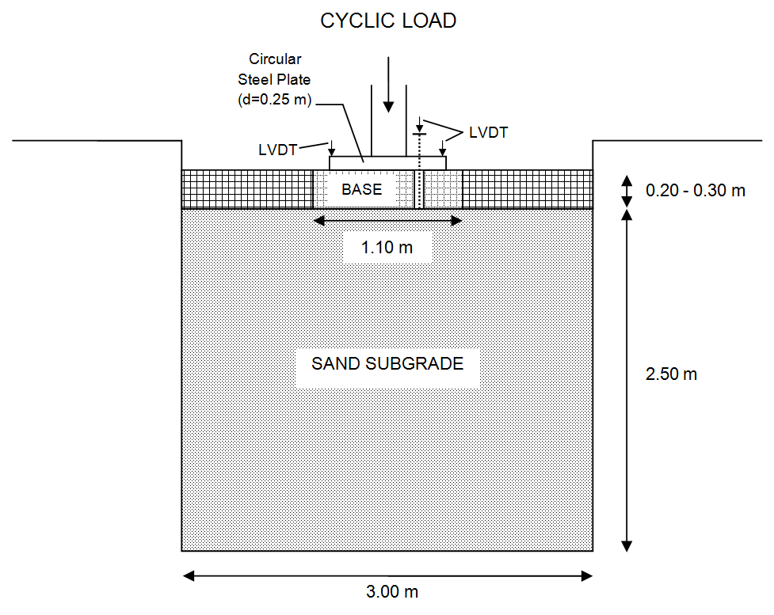

Fig. 4.1. Schematic of LSME setup (after Schaertl 2010).

a)
31.1 kN
26.7 kN
17.8 kN
11.1 kN
b)
31.1 kN
26.7 kN
17.8 kN
11.1 kN
Fig. 4.2. Measured deflections for 1 m x 1 m silt-cement without foam a) total and plastic deformation b) elastic deflection.
a)
22.2 kN
17.8 kN
b)
22.2 kN
17.8 kN
Fig. 4.3. Measured deflections for 1 m x 1 m silt-cement with foam a) total and plastic deformation b) elastic deflection.
a)
15.6 kN
26.7 kN
24.5 kN
22.2 kN
17.8 kN
b)
15.6 kN
17.8 kN
22.2 kN
24.5 kN
26.7 kN
Fig. 4.4. Measured deflections for 1 m x 2 m RPM-cement with foam a) total and plastic deformation b) elastic deflection.

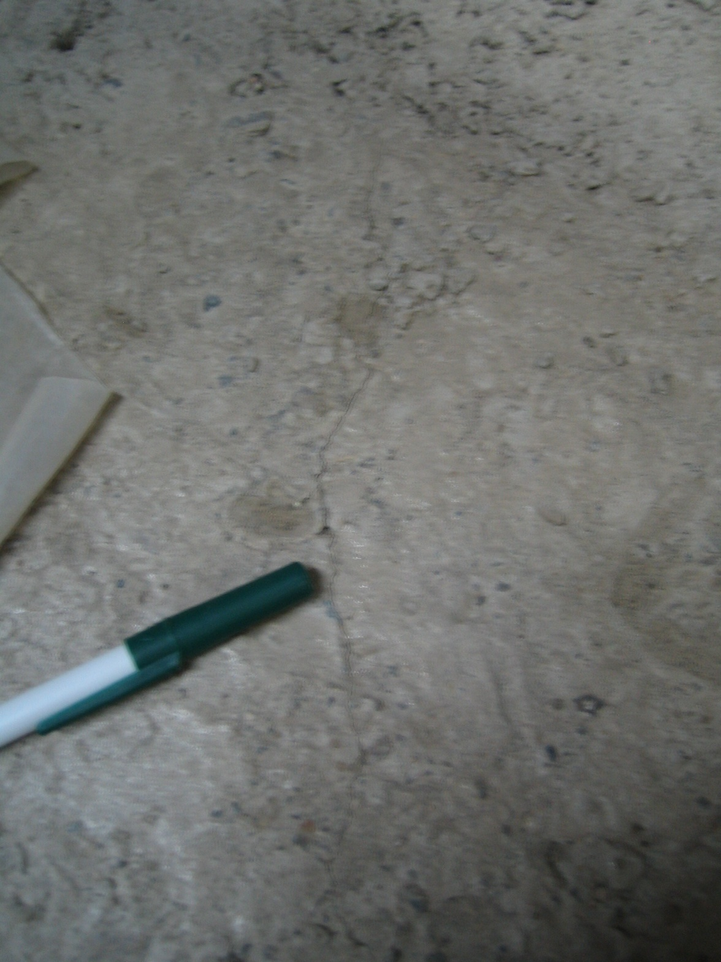

Fig. 4.5. Observed fatigue cracking of RPM-cement after 179,000 cycles at 26.7 kN.

Time of crack observation

Fig. 4.6. Elastic deflection of RPM at time of crack observation.

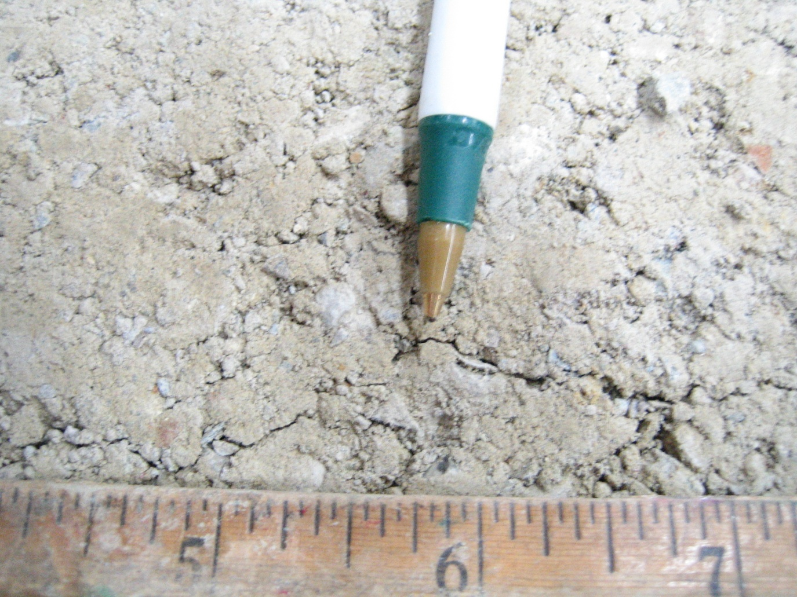

Fig. 4.7. Observed fatigue cracking of gravel-cement after 1,500 cycles at 26.7 kN.
a)

b)

Fig. 4.8. Measured deflections for 1 m x 2 m gravel-cement with foam a) Total and plastic deformation b) elastic deflection.

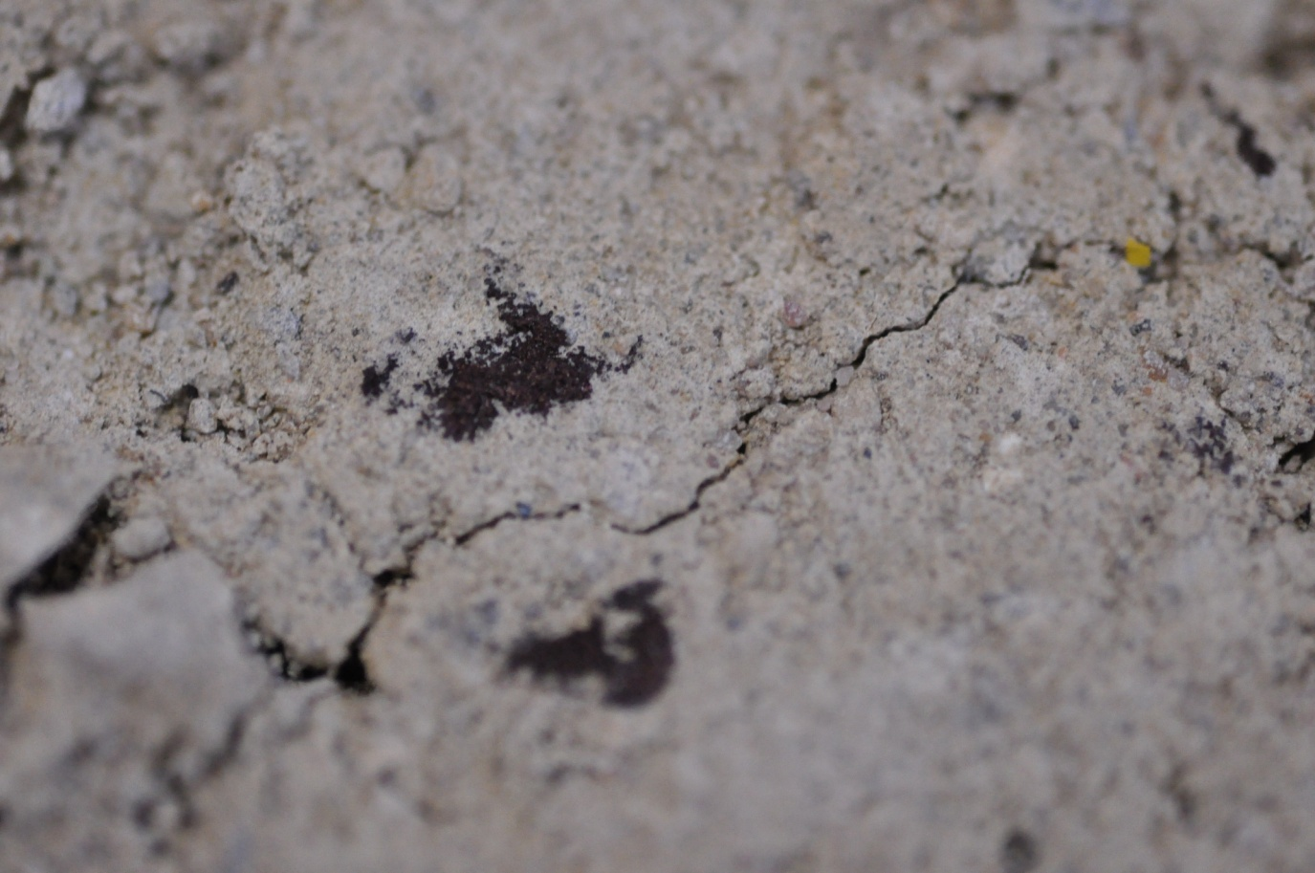

Fig. 4.9. Observed gravel-cement crack after 398,000 cycles at 26.7 kN (less than 1-mm-wide).
a)
b)
20.0 kN
26.7 kN
20.0 kN
26.7 kN
Fig. 4.10. Measured deflections for 1 m x 2 m gravel-cement without foam a) total and plastic deformation b) elastic deflection.

Fig. 4.11. Measured loads during equipment malfunction for gravel-cement without foam.

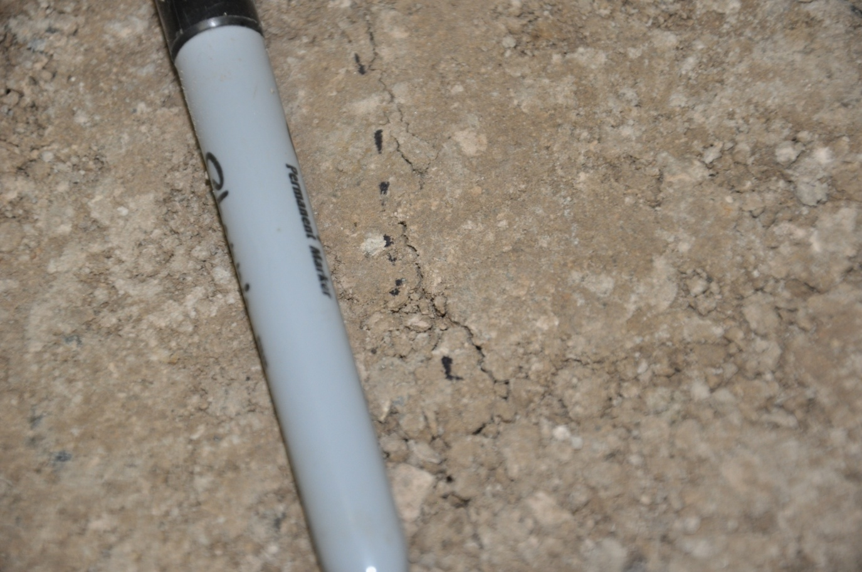

Fig. 4.12. Observed early crack for silt-cement at 6.7 kN.

Fig. 4.13. Measured loading for early cracking silt-cement.

a)

b)

Fig. 4.14. Measured deflections for 1 m x 2 m silt-cement with foam a) total and plastic deformation b) elastic deflection.

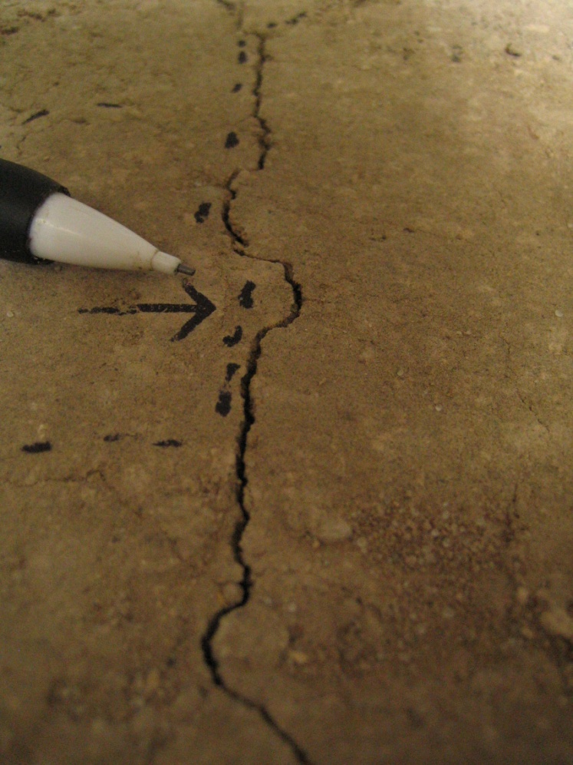

Fig. 4.15. Fatigue crack at center of silt-cement layer after 20,000 cycles at 4 kN.

a)

b)

Fig. 4.16. Measured deflections for 1 m x 2 m silt-cement with foam a) total and plastic deformation b) elastic deflection.

a)
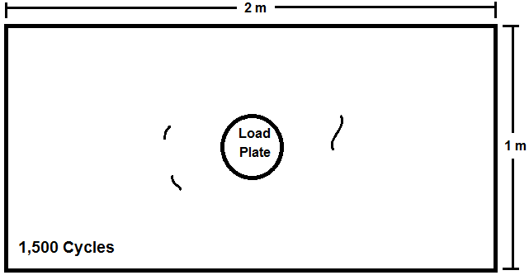
b)
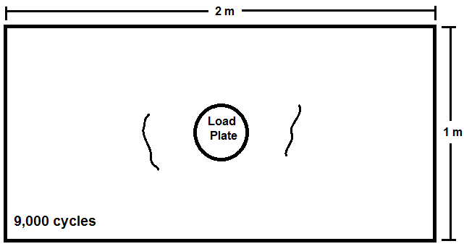

Fig. 4.17. Crack maps for final silt-cement experiment a) 1,500 cycles and b) 9,000 cycles.

a)
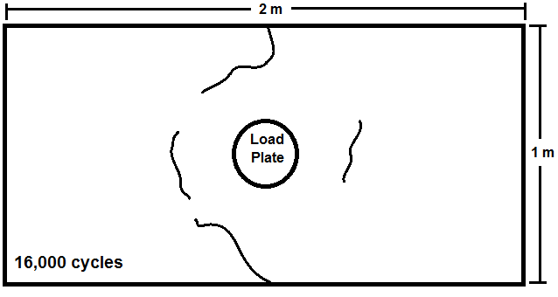
b)
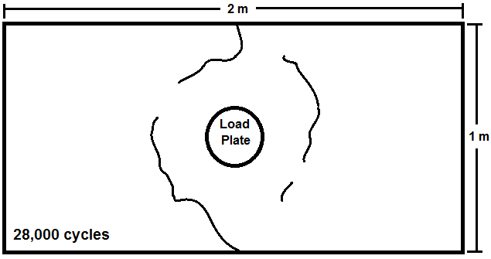

Fig. 4.18. Crack maps for final silt-cement experiment a) 16,000 cycles and b) 28,000 cycles.

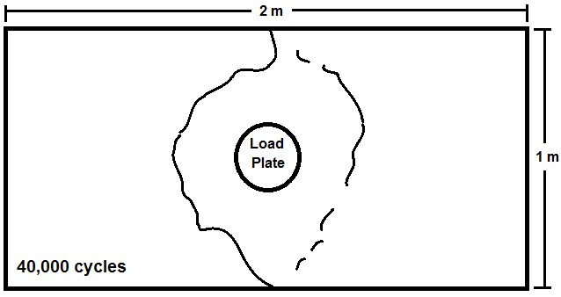

Fig. 4.19. Crack map for final silt-cement experiment at 40,000 cycles.

a)

b)

Fig. 4.20. Measured deflections for 1 m x 2 m silt-cement with foam a) total and plastic deformation b) elastic deflection.
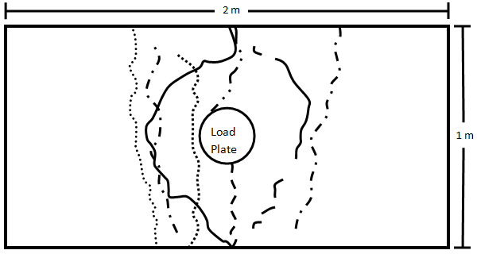
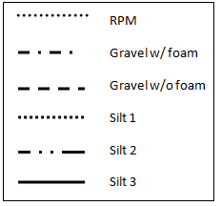

Fig. 4.21. Crack location for all LSMEs

Fig. 5.1. Cement-stabilized material UCS results.

Fig. 5.2. Fly ash, lime, and lime-fly ash stabilized material UCS results.

