THE HISTORY OF THE 301ST COLLEGE TRAINING DETACHMENT AT EAU CLAIRE STATE TEACHER’S COLLEGE, 1943-1944

Brendan James Quirk History 489:001 April 13, 2012

CONTENTS
INTRODUCTION 2
The Beginning of the CPTP 4
The Transition from Peace to War 6
Securing the 301st 7
Arrival 10
College Training: The Academic Program 12
Physical Training 15
Military Training 18
Flight Training 20
Summary and Evaluation 23
CONCLUSION 25
WORKS CITED 26

Introduction

The following is a letter written in 1944 by Cpl. Harold Kessler, Co. D, 304 Infantry, Camp McCoy, Wisconsin, on April 21, 1944 to President Davies, State Teacher’s College, Eau Claire, WI:
Dear Sir,
We, the students who have been eliminated from Air Crew Training, for the convenience of the government, wish to thank the State Teacher’s College of Eau Claire for the splendid educational opportunities afforded us during our stay. While with you, all of us added profoundly, to our education, character, and understanding of all that is to be learned.
In particular, we would like to thank Mr. Kolka, our geography instructor who gave us a clear thinking picture of the vital problems of the world combined with the science of geography and meteorology. He presented his course in a clear precise manner, and kept our keen interest in his course by being well read in every important news event of the war. In this way he correlated learned in every course with modern worldy problems. If the civilian students in the college had more instructors like Mr. Kolka, we are sure that they too would have much finer understanding of the world we are living in.
We hope that the school will continually maintain the high standards of education we experienced there, and that after the alienation we may all be back to thank you, in person, for the interest all the teachers took in us.
Yours truly,
Class D

World War II invaded all corners of American society during its years. While colleges and universities were slightly more insulated from this, the war still had a pervasive impact on campuses across the United States. Faculty and staff were focused on education, but World War II was a frequent topic of discussion both in and out of the classroom. As V.R. Cardozier states “It is not possible to portray colleges during the war without consideration of the impact of the military on them and college life.”
The Eau Claire State Teacher’s College first applied to secure a college training program at the school on December 20, 1942. Their goal was to become one of the many school’s across the country to be involved with the Civilian Pilot Training Program (CPTP) which had originally been conceived in October, 1938. The CPTP was a federally funded program designed to create a broader civilian base of aviation pilots in the United States. With the outbreak of World War II, the program became the War Training Service as a first step in the training of military pilots. Due to a lack of space to house the large amount of enlistees, the War Training Service partnered with colleges and universities and used their facilities as a place where pilots could receive their first bit of training as well as a well-rounded academic education. At the same time, this boosted the dwindling numbers of students (thanks to WWII) at these academic institutions.
Cadets first arrived for training in Eau Claire in March 1943. The original classes consisted of 300 men, however over time these numbers dwindled, with the size of the last class numbering only 31 cadets. In June 1944, with the war heating up in Europe there was a need for pilots on and the battlefield. So, with that fact and the increased need for military funding elsewhere, the program at the college was terminated.
The following chapters will provide an extensive history of the 301st Army Air Force College Training Detachment, or simply, the 301st, at the Eau Claire State Teachers College, compiling all the information pertaining to it in one place, which has yet to be done. Additionally, the history of the 301st will be placed into the context of the CPTP and War Training Service (WTS) as a whole.
The Beginnings of the CPTP: The Civil Aeronautics Act and the Civil Aeronautics Authority
The CPTP can trace its beginnings to the Civil Aeronautics Act of 1938, which transferred federal responsibilities for non-military aviation from the now defunct Bureau of Air Commerce to the Civil Aeronautics Authority, an independent agency. Split into two agencies, the Civil Aeronautics Authority consisted of the Civil Aeronautics Board (CAB) and the Civil Aeronautics Administration (CAA). The CAA was responsible for the functional aspects of air-travel in the United States: air traffic control, safety programs and development of air ways. On the other hand, the CAB was tasked with rulemaking, accident investigations, and the economic regulation of airlines. Soon after the Civil Aeronautics Authority was established, its original chair, Edward J. Noble, moved to the Department of Commerce, and Robert H. Hinckley was appointed as its new head. Hinckley would be instrumental in revitalizing the stagnant aviation industry and establishing the CPTP.
Hinckley had a passion for aviation, being the former owner of the Utah-Pacific Airways Aviation Company. However, in 1933, he turned his attentions to government, and served as director of the New Deal programs of the Civilian Conservation Corps and Federal Emergency Relief Administration (FERA) in Utah. Hinckley then made his way in to the federal government, serving as an assistant administrator to FERA before he became head of the western region of the Works Progress Administration. Eventually, he became tired of this work and went back to private industry. This absence from government turned out to be short-lived, however, as he was easily convinced to return to government when the spot as chair of the Civil Aeronautics Authority opened up. Hinckley would prove instrumental in designing and advocating for the CPTP, which proved to be an important step in training pilots and bolstering the United States air power during World War II.
In 1939, the CPTP was officially established by the CAA, thanks in part to Hinckley’s noble efforts, in an attempt to create a larger base of civilian pilots in the United States. At the time “Civilian lightplane aviation was on dead center if not in full retreat. Small fields were closing down by the score, others had such a small margin of profit that only love of flying kept their operators in business, lightplane builders were even closer to the brink of bankruptcy, and the entire industry was faced with disaster.” The CPTP would be the impetus that would help turn the American aviation industry into the massive industry that exists today. According to Jane Gardner Birch in her book, They Flew Proud, “The Civilian Pilot Training Program (also known as the CPTP, and later the War Training Service, or WTS) was the legislative culmination of what has come to be known as the Golden Age of Aviation… The Civilian Pilot Training Program, which was designed to create a pool of civilian pilots in the event of war and stimulate the private flying industry, fits into the concept of interpreting the Golden Age as an era of federal stimulation of aviation through financial support and regulatory legislation”. Many of those who participated in the CPTP before the United States’ entry into World War II had a passion for flying and would make commitments to the Army Air Force for continued flight training. The implementation of the CPTP could be seen as federal stimulus with two practical goals: to create a base of pilots if the United States did eventually enter the war (the program was started in 1939, three years before the United States entered World War II), and to stimulate and otherwise kick-start the fledgling aviation industry in the country.
The Transition from Peace to War
Despite Hinckley’s strong opposition to changing the nature of the CPTP from a civilian to a military program, in 1941 the war in Europe was gaining momentum and it became increasingly apparent that the United States would be entering the war at some point in the near future. Then, on December 7, 1941, the Japanese attacked Pearl Harbor. At this point, the United States entry into World War II was all but inevitable
The nature of the program at the time was very confusing because students entering the CPTP were required to sign a pledge to enter military aviation if it was necessary for national defense. While Hinckley opposed using the CPTP as a military training program, its usefulness as a military tool was apparent from the beginning, and those in power would allow the program to remain strictly civilian. In order to “Formalize the military aspects of the CPTP in wartime, the name of the program was changed on December 7, 1942, to the War Training Service (WTS), but its scope and direction had already begun to be altered drastically by the demands placed on it in the year following Pearl Harbor.” Perhaps symbolic, it is interesting that this happened exactly one year to the day after the attacks on Pearl Harbor.
At this time, the AAF attempted to take control of the CPTP, which threatened the independence of the CAA. After many attempts by the AAF to take direct control of the CAA’s facilities and personnel, the dispute between the CAA and the AAF was settled when the secretaries of war and the navy wrote to the secretary of commerce and ensured that the CAA would retain its independence, and thus control of the CPTP. However, the relations between the AAF and the CAA would remain rocky.
The compromise between the two groups concerning the CPTP would not be an easy one. Henry H. Arnold, the commanding general of the AAF during World War II, wanted the pilots that were trained specifically by the AAF, and thus placed many stumbling blocks in the way of the program. According to Dominick Pisano in his book To Fill the Skies With Pilots, “evidence indicates that the AAF deliberately refused to cooperate with the CAA and Congress in making full use of the program, imposed unrealistic training goals and quotas on it, and then did nothing to assist in getting required training aircraft and spare parts.” It was under this atmosphere of conflict and lack of equipment that the 301st arrived at Eau Claire State Teacher’s College in March 1943.
Securing the 301st
As stated previously, the Eau Claire State Teacher’s College originally applied to be part of the college training program on December 20, 1942. After a survey of the college’s facilities, the Army Air Force’s Material Command and the president of the school, W.R. Davies, had to work together to determine how many cadets the campus could handle. Davies felt as though the school could adequately house a detachment of 200 men while representatives from the Army Air Corps wanted President Davies to take on a detachment of 400. After several debates over the best possible utilization of facilities, the two sides compromised, and Davies agreed to take a group of 300 men. This was in part due to the fact that the college’s normal enrollment had been 650 to 750 students. However, during wartime, enrollment had dropped to approximately three hundred students. Housing an additional three hundred cadets would have brought the campus population back up to pre-World War II numbers.
The first notification that a college training detachment would indeed be stationed at Eau Claire State Teacher’s College came on February 6, 1943 in a telegram from Congressman Merlin Hull. Between the time of Davies’ correspondence with the Army Air Corps and the reception of the telegram from Congressman Hull, college officials had to secure financing for certain improvements, in order that the school could properly train military pilots. This came in the form of $10,000 from “a group of Eau Claire business men who agreed to undertake financing certain improvements including a new hangar at the airport.” At this time, the airport was located approximately one mile south of town, on top of Putnam Bluff, in the area where Clairemont Avenue runs past the University of Wisconsin-Eau Claire and Chippewa Valley Technical College.
After it was officially decided that the college would be part of the college training program, a contract between Eau Claire State Teacher’s College and the United States government had to be negotiated. This happened on March 31, 1943 when a group of military officials met with a group of school officials, led by President Davies, and the two sides worked out an agreement. The contract, as negotiated at the meeting, detailed the compensation that the government would provide the school for housing a detachment there. These included a “$42,528 activation fee to be used for extension and remodeling of facilities and the purchase of necessary dormitory, mess, instructional and other equipment required for training… monthly compensation for instruction was fixed at $10,540.13 for the month of March and $5,350.13 per month thereafter.” For medical services, supplies and emergency dental care, the college would receive $927.17 per month. The contract also included compensation for subsistence, utilities, janitorial services and maintenance charges. Considering the year, this seems like a large amount of money to support 300 people. In fact “The CPTP was one of the largest federally funded vocational programs in history.” Given that this all happened at a time when the college was in need of both finances for expansion and greater enrollment, it is no wonder that President Davies welcomed the 301st with open arms. Additionally, the detachment’s presence provided a morale boost for students, faculty, and the surrounding community.
On February 18, 1943, Captain Ellis M. Ellingson, who was to be the first commanding officer of the detachment, arrived on campus to begin making arrangements prior to the arrival of the first trainees. Originally, since there were no existing housing accommodations for the men, Captain Ellingson and President Davies, “made tentative arrangements to use the entire facilities of the Galloway Hotel and the Y.M.C.A. and two floors of the Eau Claire Hotel for housing.” However, once Ellingson reported these arrangements to his Headquarters, the Army Air Force’s Gulf Coast training Center in Randolph Field, Texas, the Army Air Force told him this would be unacceptable due to the distance from these locations (all of them being located in downtown Eau Claire, about a mile and a half from campus). Davies and Ellingson were forced to adopt a new plan, this time to convert a number of class rooms and locker rooms in Schofield Hall and the college gymnasium into living quarters for the men. Steel triple deck bunks, canvas cots and other necessary bedding was borrowed from the 4-H club and nearby Camp McCoy in order to make this possible
Over the next week or so, more officers arrived to prepare for the imminent arrival of the trainees. By the end of February, 1943, the campus was prepared to receive 300 hundred new students.

Arrival
Figure 1: 301st Trainees First Arrive on Campus, March 11, 1943
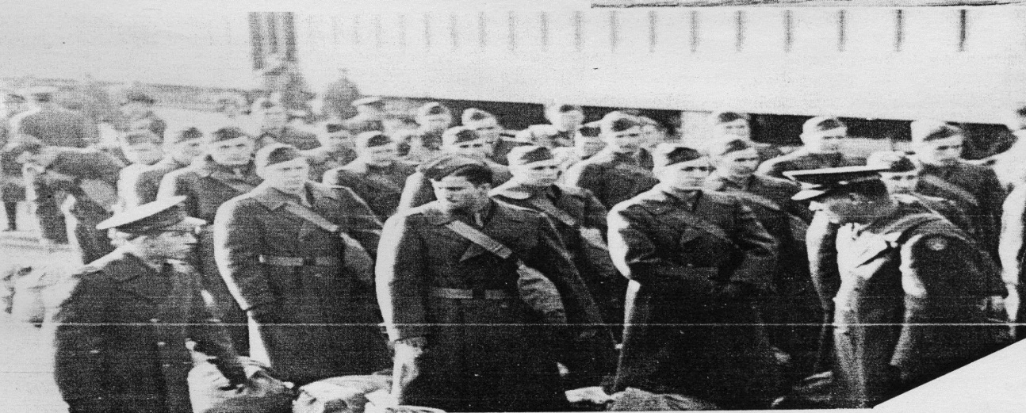
Source: The Periscope 1943, 119.
The first wave of trainees arrived in Eau Claire on March 11, 1943. This group consisted of 300 men, of which 60 became the first group to graduate the program in August, 1943. Interestingly enough, this first group arrived almost three weeks before Eau Claire State Teacher’s College signed a contract with the government. Davies was taking a small risk, as the school had already spent money building adequate facilities to train the cadets, so Eau Claire would be out this $10,000 if the Army Air Force did not come through.
The training program at the college contained four dimensions: academic instruction by the college, physical training instruction by the college, flight instruction by the CAA contractor and military indoctrination courses and drill by military personnel.
According to Army Air Force directives, the initial shipment of three hundred students was to be divided into five groups of 60, based on the individual student’s score on the AC 20-A, a placement test used by the WTS. The students were then shipped to a classification center based on their test scores.
Early in May 1943 there was a complete re-assignment of students to academic sections. Each group of sixty men was divided into two academic “flights” of thirty students each based on their AC 20-A scores; students with higher scores were placed in Flight One and students with lower scores were placed in Flight Two. Once assigned, the students remained in these “flights” permanently and would attend all classes in these sections. The same system of class assignment was followed when replacements for graduating classes were received.
When the aviation students arrived, scheduling presented its problems. At this time, in early March, the civilian program at the college was in full swing, and it was necessary to fit the Army program into this. The result was the bulk of the cadet’s academic program being scheduled for the afternoon classes (as the regular student population had the majority of their classes in the morning), with the morning hours concentrated in drill, study, physical training and military subjects. The AAF found this to be unacceptable because the cadets were physically exhausted by the time they started their daily academic training, so the AAF took steps to correct it. By the first of September, 1943, the entire academic program for the aviation students was concentrated in the morning, while physical training, drill and military subjects were scheduled primarily for the afternoon.
College Training: The Academic Program
Due to the terms of the contract, the Eau Claire State Teacher’s College was responsible for all academic and physical training within the program. Before the cadets arrived, they were required to take a placement test, known as the AC 20 A, which tested their knowledge of arithmetic and algebra. This proved to be particularly helpful in placing the new arrivals into the proper mathematics and physics classes. After this, it was up to the school to decide which faculty members would take part in teaching the cadets.
President Davies appointed A.J. Fox, the current Dean of Instruction, as the Coordinator of Academic Training for the 301st. Fox then established coordinators for each different academic department. They were as follows: Dr. Bjarne Ullsvik (Mathematics), Dr. R. C. Judd (Physics), Mr. H. W. Kolka (Geography), Dr. John S. Schneider (History), and Miss Ruth Johnson (English). It is interesting to note that Dr. John S. Schneider was a professor of sociology and history at the college from 1930-1961, and it is he who provided the namesake for Schneider Hall, constructed in 1967 and located on the University of Wisconsin-Eau Claire’s lower campus.
The day before the scheduled arrival of the first set of trainees, President Davies and Mr. Fox called a faculty meeting, during which they discussed, “general instructions about the handling of courses and the scope of the entire program”. After this, weekly staff meetings were held in which the Western Flying Training Command (WFTC) requested each faculty member to provide their lesson plans a week in advance, due on the Monday of the week they were to be used. Occasionally, Captain S. J. DeBrum from the WFTC headquarters would visit Eau Claire State Teacher’s College and make recommendations to the faculty-members regarding their class curriculums and teaching methods.
The AAF designated five core classes that Eau Claire State Teacher’s College was to teach the aviation students: Mathematics, Physics, Geography, History and English. According to the AAF review of the detachment “deficiencies in these subjects were determined on the basis of scores in the AC 20-A test and students who were deficient in any subject were required to take that subject. In addition, four elective courses, Meteorology, Navigation, Radio and Conversational Spanish were offered which were available to students who were not required to take a full program of regular courses.” However, beginning in July 1943, the elective classes were dropped from the curriculum and academic instruction now solely focused on the core classes. While all the required subjects were important to the cadet’s general education, the subjects of mathematics, physics, and geography were of particular significance in regards to their knowledge of aviation.
Aviation students progressed through five classes under the academic program: Classes, “A”, “B”, “C”, “D”, and “E”. As they progressed, their schedules changed. Once they reached Class “D” their military indoctrination class was replaced with a class in medical aid, given five days a week. Then, once they reached Class “E”, mathematics was dropped and their flight training began. The differences between a Class “D” and a Class “E” student’s schedule can be seen in the following figures:
Time | Subject | Day | Room
0700 | Physics | M W F | 221
 | P Lab | T Th Sat | 227
0800 | P Lab | T Th Sat | 227
0900 | History | M W F | 205
1000 | Geography | T Th Sat | 229
 | English | M W F | 107
1100 | Physical Training | M – Sat
1200 | MESS
1300 – 1600 | Flying | M – Sat
1700 | Drill | M T Th Sat
 | Parade | W
1800 | MESS
1915 | Study | M T | Library
 | Study | W Th | 207
2015 | Study | M T | 207
 | Study | W Th | Library
Figure 2 – Class “D” and Class “E” Schedules, Respectively
Time | Subject | Day | Room
0700 | Geography | T Th Sat | 229
 | P Lab | M W F | 225
0800 | Physics | T Th Sat | 221
 | P Lab | M W F | 225
0900 | Math | M – F | 107
1000 | Physical Training | M – Sat
1100 | Free | M – F
 | History | Sat | 203
1200 | MESS
1300 | History | T Th | 203
 | English | T Th | 111
1400 | Medical Aid | M – F | 106
 | Review | Sat
1500 | Intramural Games | M – F
1600 | Study | M – F | Library
1700 | Drill | M T Th F
 | Parade | W
1800 | MESS
1915 | Study | M T | Library
 | Study | W Th | 205
2015 | Study | M T | 205
 | Study | W Th | Library
Source: History: 301st, 20-21.
Initially, classes were scheduled on the basis of a five day instructional week, with the exception of Physics and Physical training which were scheduled for six days. Students attended certain classes each day until their course of instruction was completed, at which time the subject was dropped and another one was taken up.
Academic instructors who helped teach the program frequently criticized the breadth of the subject matter to be taught in such a short period of time, “There was not time for mastery of subject matter. Too frequently, touching the high spots was a shallow method of skimming. The diversity of ability in training each of the classes, in spite of careful testing and placement, was too great to bring best results. Motivation became very difficult with such a range of capacity.” Indeed, according to Cardozier, the 21-week course of instruction offered by the Army Air Force was the shortest period of instruction of all the military college training programs.
Physical Training
When the aviation students arrived in Eau Claire on March 11, 1943, the physical education department at Eau Claire State Teacher’s College consisted of one man, W.L. Zorn. Needless to say, with the addition of three hundred new students (essentially doubling the school’s enrollment) Zorn was confronted with an enormous task. Since March still usually means sub-freezing temperatures in Wisconsin and most of the initial quota of cadets was from the South, much of the early training had to be completed indoors. Zorn’s work as lone instructor was satisfactory, but when spring weather came and physical training could be more effectively taken outside, the school hired an additional physical education instructor, Mr. Clifford Fagan, on May 3, 1943.
According to the Army Air Force’s review of the 301st’s training at the school, “The [physical training] program was set up for the purpose of improving the physical powers of the individuals, sharpening their reflexes, giving them a feeling of aggressiveness and developing co-ordination”. This increased physicality and coordination would be essential to not only effectively flying and aircraft, but also were these cadets to somehow find themselves on the ground during the war.
WTS regulations allowed for, “one (1) hour per day for six (6) days per week or 126 hours in regularly scheduled classes… in intramural athletics and recreational periods”. Intramural sports that the aviation students participated in included soft ball, volley ball, touch football, basketball, baseball, soccer. True to the competitive nature of the military, the cadets took these sports seriously and showed a great deal of enthusiasm and rivalry when competing against each other.
It would take a great deal of space and equipment in order to implement the physical training program on campus. Outdoor facilities utilized by the school for this purpose included: the YMCA swimming pool, a quarter mile track, football field, two tennis courts, two horseshoe courts, a basketball court, three volley ball courts, two softball diamonds, one baseball diamond, two speedball or soccer fields, an obstacle course, and a three-mile cross country course. Indoor facilities included: a gymnasium with climbing ropes, mats, and paralleled bars. It is quite impressive that the school, whose only education building was Schofield Hall (known as the Main Building in military records) at the time, managed to fit all this in the space of what is now known as lower campus.
Cadets of the 301st could expect a rigorous physical training program. They participated in activities such as calisthenics (both group drills and guerilla exercises), running of the obstacle course, a three-mile cross country run, sprinting, relay races, the aforementioned intramural sports, swimming (emphasized especially for those with weak swimming backgrounds), tumbling (“stressed because of the fact that there is a fairly high correlation between the muscular responses involved in tumbling and those concerned with learning to fly. Forward, backward, shoulder rolls were all stressed. All were taught the ability to fall.), and gymnastics. Aviation students were administered the air force’s physical fitness test their first week and within a week of their departure to note their progress.
Figure 3 – 301st’s Physical Education
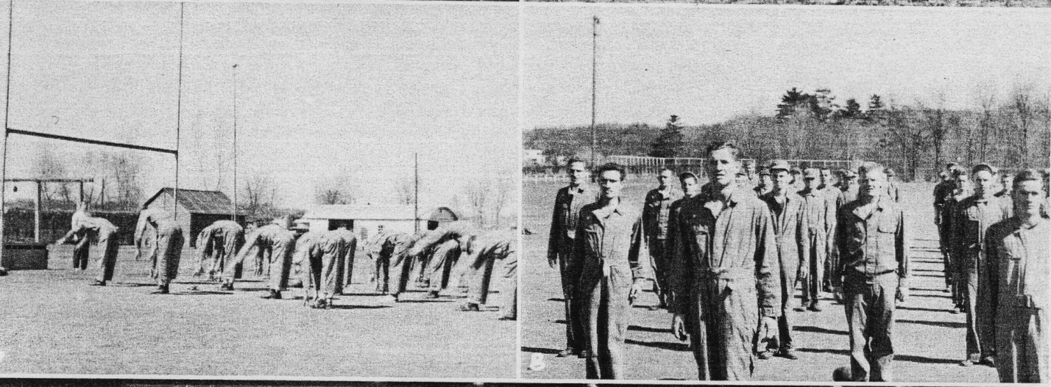
Source: The Periscope, 1943, 119.

Military Training
The general mission of the 301st in terms of military training was to indoctrinate the cadets in terms of military conduct and in “developing in them the high standards necessary for Army Air Forces commissioned personnel.”
For military drill purposes, the detachment was comprised of two squadrons and a band. The strength of the squadrons varied depending on the strength of the class as a whole. Generally, each squadron consisted of four flights of three squads each. Additionally, the band had a typical strength of 25 men and formed a separate unit that would attach to one of the squadrons during drill.
Typical of military training units, “A system of squadron competition was inaugurated shortly after the activation of the detachment, which has developed a keen rivalry between the two organizations.” The winning squadron would receive “open post” privileges as its reward, while the loser was to patrol all portions of the school that were used exclusively by the army.
While students were in the lower three classes, one hour a day was assigned for military indoctrination lectures or in some cases for close order and gas mask drills. The students were required to undergo 27 hours for the lectures and between 30 and 35 hours for the close order, gas mask, and squadron drills.
The cadets of the 301st were generally well behaved. Disciplinary problems at the detachment were not serious. During the detachment’s time on campus, only one case was referred to a court martial. In this particular instance, an unnamed student was found guilty of larceny of jewelry from an Eau Claire store. The student was sentenced to a six month confinement at Billy Mitchell Field in Milwaukee, Wisconsin. Additionally, the perpetrator was forced to forfeit his $18.66 monthly pay for this period. All other disciplinary problems involving the 301st were handled internally through a military demerit system.
According to the AAF’s review of the detachment “the only problem encountered in relations between the detachment and the civilian population has been the curtailment of civilian activities so that they would not interfere with the training program.” Whether or not this is completely true remains unseen, but this researcher could find no reports of bad blood between the community and the detachment in the records of the city’s newspaper, The Eau Claire Leader.
Flight Training of the 301st
Flight training was conducted at the Eau Claire Airport which was “situated south of town, approximately 872 feet above sea level. It consists of 240 acres of land, and has four sod runways, ranging from 3,000 to 3,500 feet in length.”
The Chief Flight Instructor at the airport was Mr. Leo Watson. Under the contract negotiated with the school, it was his duty to train the aviation students to fly. Watson worked with two Assistant Chief Pilots, Lawrence Stephens and Daniel Wakefield, and seven other instructors. To train the cadets, thirteen Piper J-3 Cubs were obtained from the nearby Defense Plant Corporation. Ten of these had 65 horsepower engines while the other three had only 50 horsepower. Later in the detachment’s lifetime four new aircraft were obtained: three L2B Taylorcrafts and one L2M Taylorcraft. These airplanes, especially the Piper J-3 Cubs, were the typical aircraft used to train first-time pilots in this era. The reason for such a large number of planes was that they had to be routinely maintenance so they were rotated in and out of service.
Figure 4 – Piper J-3 Cub
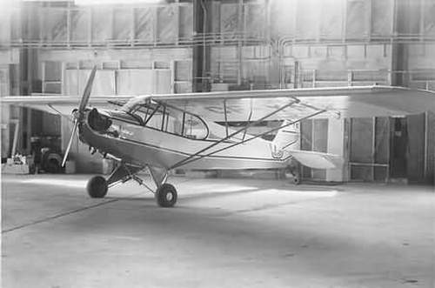
Source: Google Images
Prior to the arrival of the 301st detachment, the AAF surveyed the airport and found its facilities to be inadequate. Because of this a group of Eau Claire businessmen agreed to undertake the financing of additional construction and they raised approximately $10,000.
With these finances, a frame hangar was built which could house more planes than the airport could previously. One of the old hangars was converted into a shop for maintenance. A barracks was brought in from Menomonee which was partitioned off so it contained a classroom for instruction, a pilot’s room and a ready room. Office space for the CAA Flight Supervisor and other airport staff was made available in an existing airport building. Flight training then began on April 1, 1943 with two classes of 60 each. After this, the program was revised so that only one class of 60 would be trained at a time, in order to make it more efficient for both the instructors and the students.
While at the airport, each class received instruction in Civil Air regulations, ground school and flying. In October 1943, with the onset of winter, the flying schedule was changed because of the anticipated difficulties in completing the program “due to inclement weather and additional requirements as to the amount of ground school instruction, so that each flight remained at the airport four hours rather than three.” Due to weather conditions, many times flight training had to be scheduled on Sundays as well as Saturdays in order that the students receive the proper amount of training.
In the AAF’s own words “Under the contract with the CAA, the flight contractor is responsible for carrying out the program of instructions… providing airplanes and instructors as outlined in Controlled Indoctrination Flight Course Outline... And providing the Resident CAA Flight Supervisor with office space and an airplane as well as other facilities necessary to perform his line of duties.” This, coupled with the fact that, upon graduation from the program, the cadets were shipped to the Santa Ana Army Air Base in Santa Ana, California, for 3 more levels of flight training, illustrates the preference of the AAF to train its own pilots. One can argue that had they truly supported the program, they would have provided better equipment (rather than forcing the CAA to supply it) and required more than the mere ten hours of dual instruction that they called for.
The course given to the trainees covered the following: “cockpit procedure, taxiing, use of brakes, take-offs, accurate traffic pattern, straight and level, rectangular course, s-turns across a road, series of eights, climbing turns, series of turns, 360 degree steep turns, stalls, spins, glides and gliding turns, coordination exercises, forced landings, 180 degree side approach, 90 degree approach, landings, power wheel landings, parking the airplane, planning, looking around, holding altitude, throttle-elevator coordination, ability to analyze errors, aptitude, judgment.” Later this was revised to place more emphasis on take-offs and landings, which had been a rough spot for some of the earlier classes. Still, this all seems like a lot to cover in the limited space of ten hours. Additionally, at least in the 301st’s case, the students were not required to pass a flying test solo, which again shows the apparent lack of interest of the AAF in having the program produce well trained pilots.
Summary and Evaluation of the 301st at Eau Claire State Teacher’s College 69
On the whole, the AAF reviewed the execution of the program at Eau Claire State Teacher’s college favorably. They especially praised the academic and physical fitness programs. The AAF claimed “There was evidence of a sincere attempt by all instructors in the academic program to teach the units as outlined by both the WFTC and the Gulf Coast Training Center. The Air Corps Officers and college staff worked harmoniously and effectively toward providing a program supplementary to each other and yet so coordinated that the educational and indoctrination objectives were evident to both aviation students and instructors.”
During their stay at Eau Claire State Teacher’s College, the 301st affected both the school and the community. Each trainee had a host family who would occasionally treat them to dinner or simply some time away from the other cadets. Also, the men of the 301st enjoyed weekly dances at the City Auditorium, and a graduation dance. In fact “for the first time in the history of the college, young women students were required to be in their residences by 10:30 on weekday nights and 12:30 on weekends,” although this did not upset them, as they enjoyed the companionship of men in uniform, and their ability to take them to military balls. In general, the men of the 301st enjoyed their time at the college, as they had access to a USO show at the YMCA, were provided with free access to the Chippewa Valley Forum, and attended the aforementioned dances.

Figure 5 – 301st Cadets at a Weekly Dance
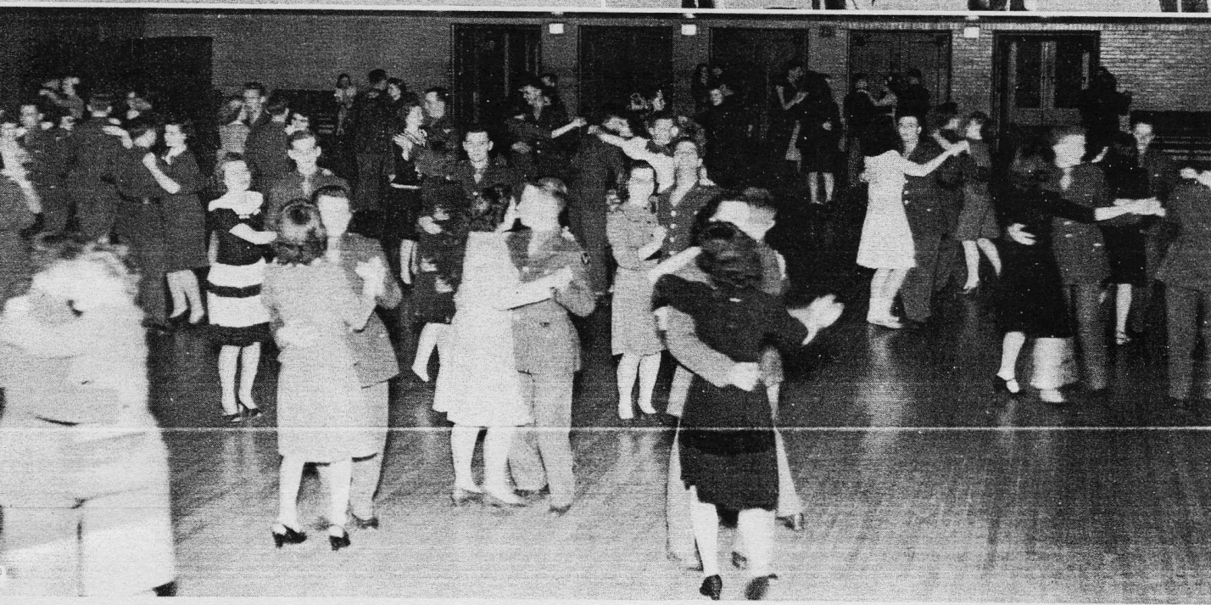
Source: The Periscope, 1943, 133.
The presence of the 301st Detachment at Eau Claire benefited both the college and the community of Eau Claire. The permanent college staff and the extra staff brought on to help with instruct the detachment were proud to be a part of the war effort. Additionally, the extra staff was most likely pleased with the fact that the detachment provided them an employment opportunity during wartime. Three hundred aviation students supplementing the depleted civilian student body allowed the college to utilize its facilities to the fullest. In addition to this, the maintenance upgrades and federal funds that came with the 301st’s stay at Eau Claire helped the college through a tough financial time of reduced enrollment. As the AAF puts it “the program provided an opportunity to use a state institution and its staff to carry out a task and to preserve the very ideals that created a need for the college.” After review by the “Psychological Testing Unit at Santa Ana Army Base, Eau Claire placed in the top ten percent of the colleges in the Western Flying Command.” On top of this A.J. Fox and Willis Zorn were selected for special commendation by the military for their roles in training the cadets.
Conclusion
In April 1944 the Eau Claire State Teacher’s College received word that the 301st College Training Detachment would be terminated because the quota for aircrew personnel had been filled. At first, President Davies expressed surprise at this, saying in a letter to R.C. Williams, president of Superior State College, that some of the young men had been taken out of class but kept on campus at that time and that “they are thoroughly disgusted with life and their morale is zero.” However, in a later statement to The Eau Claire Leader he expressed that this announcement did not surprise him because the college needed time for the program to taper off and the school to return to normalcy. Another article in The Eau Claire Leader expressed concern over the loss of educated young men and the financial effect the discontinuation of the program would have on the school.
In the end, the federal funding provided to Eau Claire State Teacher’s College for accommodation and training of the 301st College Training Detachment helped keep the school afloat during a period of crisis. The 301st provided a morale boost on campus as well as in the Eau Claire community. While the actual flight training of the cadets was not satisfactory, according to the Army Air Force, this was in part due to the conflict between the CAA and AAF authorities, and many of the students went on to more advanced flight training at the Santa Ana Army Air Base. The program provided these young men an entrance into the pipeline of aviation training. Future work on this subject could include profiles of some of the aviation students or the faculty involved in training the 301st.

Works Cited: Primary Sources

Eau Claire Leader, 31 January 1944
Fletcher, Eugene. Mister: The Training of an Aviation Cadet in World War II. Seattle: University of Washington Press, 1992.
Mabel Chipman, The Mabel Chipman Papers. World War II Scrapbook. Special Collections & Archives. University of Wisconsin-Eau Claire. McIntyre Library. Eau Claire, WI.
University of Wisconsin-Eau Claire. The Periscope, 1943-1944. Special Collections & Archives. McIntyre Library. University of Wisconsin-Eau Claire. Eau Claire, WI.
University History Research Files, United States Army Air Force, History: 301st College Training Detachment (Aircrew), State Teachers College, Eau Claire, Wisconsin.
U.S. Congress. House. The Civil Aeronautics Act of 1938. HR. 75th Cong., 3rd sess. (June 23, 1938).
W.R. Davies. Interview by Leonard Haas. An Oral History of the University of Wisconsin-Eau Claire. February 15, 1943. Special Collections & Archives. McIntyre Library. University of Wisconsin Eau-Claire. Eau Claire, WI.

Works Cited: Secondary Sources
Birch, Jane Gardner. They Flew Proud. Nappanee: Evangel Press, 2007.
Cardozier, V.R. Colleges and Universities in World War II. Westport: Praeger Publishers, 1993.
Carter, Hilda and John Jenswold. The University of Wisconsin-Eau Claire: A History, 1916-1976. Eau Claire: University of Wisconsin-Eau Claire Foundation, 1976.
Pisano, Dominick A. To Fill The Skies With Pilots. Champagne: University of Illinois Press, 1993.
“The Story of Glen Seeber”. http://www.b17tailgunner.com/ (Accessed April 1, 2012).
University of Wisconsin-Eau Claire. “Schneider Social Science Hall”. http://www.uwec.edu/Maps/bldgtour/sss/ (accessed April 1, 2012).

Corporal Harold Kessler to W. R. Davies in Series 14, General University History, 301st College Training Detachment, Box 3 Folder 5.
V.R. Cardozier, Colleges and Universities in World War II. (Westport: Praeger Publishers, 1993), x.
Hilda R. Carter and Jenswold, John R., The University of Wisconsin-Eau Claire: A History, 1916-1976. (Eau Claire: University of Wisconsin-Eau Claire Foundation, Inc.), 45.
Eau Claire Leader, 31 January 1944, p. 2
Civil Aeronautics Act of 1938, HR, 75th Cong., 3rd sess., (June 23, 1938). Accessed at http://libraryonline.erau.edu/online-full-text/books-online/CivilAeronauticsAct.pdf on March 30, 2012
Dominick A. Pisano, To Fill the Skies with Pilots, (Champaign: University of Illinois Press, 1993), 9-10.
Ibid., 10-11.
Jane Gardner Birch, They Flew Proud, (Nappanee: Evangel Press, 2007), 5.
Eugene Fletcher, Mister: The Training of an Aviation Cadet in World War II, (Seattle: University of Washington Press, 1992), 16-18.
Pisano, To Fill the Skies with Pilots, 84.
Pisano, To Fill the Skies With Pilots, 85.
Ibid., 86.
W.R. Davies, Interview by Leonard Haas, An Oral History of the University of Wisconsin-Eau Claire, Eau Claire, WI, February 15, 1943.
United States Army Air Force, History: 301st College Training Detachment (Aircrew), State Teachers College, Eau Claire, Wisconsin, p. 2. Located in Series 14, Box 3, Folder 5, University History Research Files.
United States Army Air Force, History: 301st, 8.
Ibid., 8.
Birch, They Flew Proud, 5.
United States Army Air Force, History: 310st, 10.
Ibid., 11.
United States Army Air Force, History: 301st, 81.
Ibid., 16.
United States Army Air Force, History: 301st, 17.
Ibid., 18.
University of Wisconsin-Eau Claire, “Schneider Social Science Hall,” http://www.uwec.edu/Maps/bldgtour/sss/ (accessed April 1, 2012).
United States Army Air Force, History: 301st, 24.
United States Army Air Force, History: 301st, 18.
Ibid., 17.
United States Army Air Force, History: 301st, 20.
United States Army Air Force, History: 301st, 71.
Cardozier, Colleges and Universities in World War II, 90.
United States Army Air Force, History: 301st, 41.
Ibid., 42.
Ibid., 43.
Ibid., 45-46.
United States Army Air Force, History: 301st, 48.
United States Army Air Force, History: 301st, 50.
Ibid., 51.
Ibid., 52
United States Army Air Force, History: 301st , 54.
Ibid., 54.
Ibid., 55.
Ibid., 56.
Fletcher, Mister, 14.
Carter and Jenswold, University of Wisconsin-Eau Claire, History, 45.
United States Air Force, History: 301st, 56.
Ibid., 57.
United States Army Air Force, History: 301st, 58.
Fletcher, Mister, 18.
United States Army Air Force, History: 301st, 59.
United States Army Air Force, History: 301st, 69.
“The Story of Glen Seeber,” http://www.b17tailgunner.com/ (Accessed April 1, 2012).
The Periscope, 1943, 133.
Carter and Jenswold, University of Wisconsin-Eau Claire, History, 45.
United States Army Air Force, History: 301st, 71.
Carter and Jenswold, University of Wisconsin-Eau Claire, History, 45.
Ibid., 45.
Ibid., 45.
The Eau Claire Leader, April 12, 1944, The Mabel Chipman Papers. World War II Scrapbook. University of Wisconsin- Eau Claire, McIntyre Library Archives, Eau Claire, WI.

