Constructing and Deconstructing the Home Front: The Badger Army Ammunition Plant and Rural Wisconsin, 1941-1998.

Emily Baum
Capstone Advisor: Dr. Patricia Turner
Cooperating Professor: Dr. Selika Ducksworth-Lawton

University of Wisconsin-Eau Claire
Eau Claire, Wisconsin
History 489
Fall 2017

This page was intentionally left blank.

Table of Contents

Illustrations….…………………………………………………………………………………...3
Abstract……………………………………………………………………………….…………4
Introduction………………………………………………………………………………….…..5
Literature Review………………………………………………………………………….……8
Constructing the Home Front…….…….………………………………………………………………………………..11
Working at the Plant
World War II………………………………………………………………….……….18
Korean War……………………………………………………………………………25
Vietnam War………………………………………………………………….…….…31
Dismantling the Home Front…….……...………………………………………………………….………………..…36
Conclusion.………………………………………………………………………………...….39
Annotated Bibliography………………………………………………………………………45

Illustrations

Figures
- The location of the Badger Army Ammunition Plant…………………………………...12

- The headline that appeared in the Sauk County News on October 30, 1941……………13

- An aerial photo of the Badger Army Ammunition Plant, May 1942……………………17

- A map of a 90-mile radius around the Badger Army Ammunition Plant……………….20

- Signs and telephone box that were present at the entrance to the Badger Army Ammunition Plant………………………………………………………...……………..22

- “The Six ‘Be’s’” Sign meant to remind everyone of their number one priority………..28

- A sample of some of the ammunition made by the Badger Army Ammunition Plant....30

- A more recent aerial photo of the Badger Army Ammunition Plant…………..……….38

- A map of how the land of the Badger Army Ammunition Plant is being divided up…………………………………………………………………………………….…42

Table
- Type of Powder, When it was Produced and What Weapon it was used for……….…35
Abstract
The Badger Ordnance Works was once the largest ammunition plant in the world, producing thousands of tons of propellants, explosives, and acids over the course of three wars. By March of 1942, the farmers who had fought to keep their land had moved away and construction on the Plant had begun; a village was erected for workers to live in if they were not from a nearby area. At the end of World War II, the B.O.W. closed, only to reopen under new ownership to produce materials for the Korean War. After being shut down after the Korean War, the newly named Badger Army Ammunition Plant would be reactivated to produce ammunition for the Vietnam War, and would close down again when the war ended. While rumors would swirl that the Plant would be opened yet again, in 1998 the Army officially declared that the Badger Army Ammunition Plant would never again open its doors. This began a new phase in the life of the B.A.A.P., which would focus on decontaminating the location before tearing it down, and the finalization of what will happen with the land the Plant stood on. This paper will examine the controversy surrounding the construction of the Plant before looking at the lives of individuals working at the Plant during the Second World War, the Korean War and the Vietnam War. Finally, the paper will close by exploring the reactions to the closing of the Plant and the hopes for the future of the site. Throughout all of this, the concepts of home front and community will be examined as both were essential components of the Plant, as well as its significant role in the history of one region in Wisconsin. This will be explored through a variety of primary and secondary sources, ranging from stories from people who worked at the Plant to visiting the Museum that stands on the land that once held a Plant that was one dubbed the largest ammunition Plant in the world.

Introduction
The Badger Army Ammunition Plant, (also known as the B.A.A.P. and previously known as the Badger Ordnance Works or B.O.W.), was once the largest ammunition plant in the world; producing thousands of tons of propellants, explosives, and acids over the course of three wars. The announcement that the Plant was to build on some of the best farmland in the state of Wisconsin upset the area farmers who were told they had to leave their land behind as quickly as possible. Many farmers worked to convince local and state representatives to move the Plant elsewhere so they could keep the land that had been in their family for at least 100 years. But in the aftermath of the Pearl Harbor attack, support for the farmers dried up and by March of 1942 farmers had moved off their land and construction began on the Plant. Production began less than a year later.
Once the Plant was operational, many who had once opposed the Plant began working there or had family members working there. As men joined the Army, women filtered into B.O.W. to take over many jobs that were once held only by men. When labor was hard to come by, the B.O.W. drew on workers from the Caribbean Islands, and coaxed farmers into working at the Plant during the winter and teachers and boys too young for the draft during the summer. At the end of World War II, the Plant closed, only to reopen under new ownership to produce materials for the Korean War. At the end of the Korean War, the Plant was shut down yet again to hopefully keep it from being a target of a Soviet nuclear attack during the Cold War.
When the Vietnam War broke out, the Badger Army Ammunition Plant was reactivated to produce supplies for the Armed Forces. At the end of the Vietnam War, the Plant was deactivated, and while rumors would swirl that the Plant would be opened again due to Cold War tensions, in 1998 the Army declared that the Badger Army Ammunition Plant would be permanently closed. This small section of the American home front had finally been decommissioned. This began an extended period of time focused on decontaminating the location after decades of pollution before the facility was torn down, though there are still concerns about contamination from local communities. As the location was in its final stages of being decontaminated and torn down, plans for what would happen to the land were being finalized. Many different groups had ideas for what the land could become, but farmers who originally lived on that land and workers who were there for at least one war hoped that the plant land would be converted back into farm and prairie land.
Information for this paper was found in numerous sources, including a plethora of secondary sources, particularly those written by two of the most eminent historians on the Badger Army Ammunition Plant: Michael Goc and Erhart Mueller. Other secondary sources that were of vital importance were written by government officials who explained the importance of the Plant to the United States Armed Forces (with a particular focus on the geographic significance of the area), as well as the website of the Badger Army Ammunition Plant. Books regarding women’s experiences were also utilized throughout the paper to understand the unique role that women played in this factory and others like it during the Second World War. In addition to all of these, sources discussing the home front in the United States, and books discussing the history of Wisconsin were also used to examine what life and the home front was like in Wisconsin throughout the 20th century and how that may have impacted the Badger Army Ammunition Plant. Information about what the current plans for the land that B.A.A.P. once stood on also contributed to the paper, particularly the websites of the USDA Dairy Forage and the Sauk Prairie State Recreation Area.
Primary sources that were utilized include interviews with people who worked in the B.A.A.P. or in plants similar to it—both in print and video format—as well as the microfilmed papers of Erhart Mueller, which contain a wide array of newspaper and magazine clippings, images, and other tidbits of information related to the Plant. Lastly, a discussion with the archivist of the Museum of the Badger Army Ammunition Plant as well as a trip to the Museum itself was made to explore the actual location that many people worked at for three wars and lived on for centuries before.
In many ways, the Badger Army Ammunition Plant was a significant part of Wisconsin history. This part of Wisconsin history explains how despite the best efforts of farmers to keep their land, the urge to do their part for their country during wartime trumped their love for their land. Then, throughout three wars, a huge, unique workforce was drawn upon to run the largest ammunition plant in the world. During the Second World War, those who worked at the Plant served as part of the home front that was needed to produce the materials, among many other things, that helped the United States and their allies win the war. While many similar ammunition plants were decommissioned after the end of the war or converted to serve a new purpose and their home front dismantled, the Badger Army Ammunition Plant and the home front in Wisconsin remained. When the Plant was reactivated for the Korean War, the workforce that had worked at the Plant during World War II came back, ready to play their part, just like they did later during the Vietnam War. While the experiences of those who worked at the Plant was different every time it reopened, the people who worked there had the same goals: to serve their country and to protect their loved ones who were overseas.
After the Vietnam War ended and the Plant was left dormant, a community of individuals was ready and willing to return to work at the Plant if it was ever reactivated. When it was announced that the Plant would never again be reopened and would be torn down and converted into something different like many other World War II era ammunition plants were, the home front in Wisconsin was finally dismantled. The Badger Army Ammunition Plant is a significant part of the history of Wisconsin because it shows how a war on the other side of the World shaped Wisconsin and drastically affected those who lived on the land that would be used for the Plant. Time and time again, these same rural workers mobilized to work at the Plant; even now, as the last stages of the land restoration is being completed, they continue to be affected by the Plant as it is decontaminated and the land given a new, peaceful, purpose.

Literature Review
There is a wide array of secondary sources that provide useful perspectives and information on the Plant, the region surrounding it, Wisconsin’s role in World War II and subsequent wars, and more generally the American home front. An example of one of these sources is the book Powder, People, and Place. This book describes the entire history of the area that would one day become the Badger Army Ammunition Plant before bringing the story of the Plant close to present day. It contains a lot of unique information, such as names of people who farmed the land before the Plant was built, as well as those who were injured or killed in accidents that occurred at the Plant despite the safety measures that were in place.
The website of the Badger History Group is another important source of information for the paper because it provides quick and easy access to information about the Plant through all three of the wars that it was involved in, its status today, as well as images of the Plant over time to illustrate the narrative of its existence. Websites are straight and to the point and have links to other, similar, sites to help users continue exploring the story of the Badger Army Ammunition Plant and those who worked there.
The films Powder on the Prairie and Powder to the People contain interviews with people who lived on what would become the Plant and who worked at the Plant. In the films, the interviewees share their stories and memories, as well as their hopes for the future of the site. In a similar fashion, the films Badger Village: Our Prairie Home, Wisconsin World War Two Stories, and The Life and Times of Rosie the Riveter contain interviews with people where they describe what it was like to work at the Badger Army Ammunition Plant and other World War Two era factories—with a particular focus on the experience of women—and what the living conditions in nearby areas were like.
The book Beyond Rosie: A Documentary History of Women and World War II explores what it was like for women working in World War Two era plants because women provided a great deal of the labor force during this war, more so than they had for any war before it. Women had experiences that were unique to men because of the “second shift” that they had to work at home after they had finished their shift at a factory, and their reasons for leaving their homes to help out with the war effort are also examined. Rosie the Riveter, perhaps one of the most famous pieces of propaganda from the era, is also looked at because of how influential her image was at helping to draw women into the work force.
The collection of essays in the book The Civilian in War: The Home Front in Europe, Japan and the USA in World War II discusses how different countries mobilized their citizens during the Second World War in order to create a home front and how differences between countries existed despite the similar experiences that they were having on the battlefront. The notable exception to this is the United States, who, with the exception of Pearl Harbor and skirmishes throughout the West Coast, experienced the war significantly different than those living in Europe or Japan as they were able to avoid a majority of the destruction from the war.
Lastly, the piece “Badger Army Ammunition Plant Historical Overview 1941-2006” provides a very detailed account of the history of the Plant as well as the plans for its future. It is important for this project because it provides information about getting the land for the Plant from the point of view of the government officials who carried out that job, showing that there are two sides to every story. This also demonstrates the importance of the Plant to the Army throughout all three of the wars it was involved in as well as the effects it had on the residents of the area.
Overall, these sources are important to the writing of the paper because they discuss a topic that many Wisconsinites, unless they are from the surrounding area or know someone who worked at the B.A.A.P., are unaware of. The sources help to explain how conflicts in a wider world affected one local group of people and altered their lives and where they lived forevermore by making necessary the construction of what was once the largest ammunition plant in the world. They also discuss how, even though the Plant has been torn down, it still lives on in people’s memories and affects the land it stood on as it is given a new purpose.

Constructing the Home Front
The land of the Sauk Prairie was considered to be some of the best farmland around, at least that is what the settlers who took over the land from the Native Americans thought. Those settlers laid down their roots in the fertile soil, and as time went on, their farms were passed down from generation to generation as the towns of Merrimac and Sumpter grew nearby. These towns were located at the foot of the Baraboo Bluffs, only 8 miles south of Baraboo and 30 miles north of Madison; and less than ten miles from the Wisconsin River and Devil’s Lake, (fig. 1).

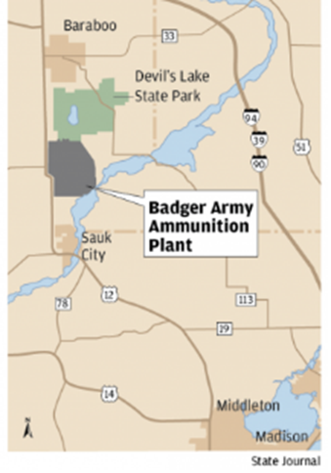
Figure 1. The location of the Badger Army Ammunition Plant.
Source: Ron Seely, “Conservations guarded, hopeful as plans for former ammunition plant approach next step,” Wisconsin State Journal, (Madison, Wisconsin), August 17, 2012. http://host.madison.com/wsj/news/local/environment/conservationists-guarded-hopeful-as-plans-for-former-ammunition-plant-approach/article_f8995f78-e7e3-11e1-8601-0019bb2963f4.html

When government officials came to the Sauk Prairie in 1941, they were not thinking about the quality of the farmland, the scenic landscape, or the farm families that thrived in the rural towns. Instead, they were thinking about the war that was breaking out in Europe and the hostilities in Japan because in response to these what was happening, the President had declared a state of emergency, Congress had enacted a peace time draft, and the War Department had commenced a rearmament program. The United States had been caught sleeping when the First World War broke out, and the government was determined to ensure that that was not going to happen again.
These government officials were looking for the location of a new ammunition plant to create a home front that could help support those on the frontlines, and they had a few criteria to follow. First, the area had to be rural and away from metropolitan areas. Next, the location had to be close to a large supply of water as well as have a good source of electrical energy. Lastly, the area had to have access to both railways and highways, have a large labor force nearby, and be at least 250 miles away from the closest border. The Sauk Prairie fit the bill perfectly, and even though it was a rural area, the effects of the Great Depression were still felt around the state, meaning there was a vast labor supply within driving distance of the Plant that was eager to get any job that they could. As government officials took down detailed records of the area, it was announced that money had been allocated for the construction of the newest ammunition plant there in the Sauk Prairie, (fig. 2).

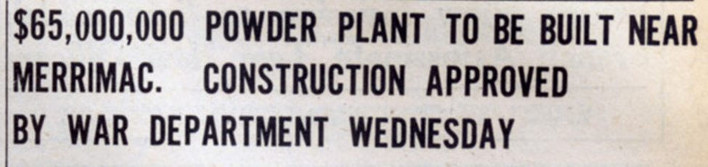
Figure 2. The headline that appeared in the Sauk County News on October 30, 1941.
Source: Badger History Group, Inc., “Welcome to the Museum of Badger Army Ammunition Telling the Story of the World’s Largest Ammunition Plant in 1942,” Museum of Badger Army Ammunition, Accessed 25 September 2017. http://www.badgerordnancehistory.org

When the farmers found out that their land was to be taken, they felt—among many other feelings—outraged. Under the leadership of Garth Premo, Sumpter Supervisor, they went “on record as being opposed to the erection of the proposed powder plant” the same day that “President Franklin Roosevelt signed the orders establishing the Badger Ordnance Works in Sauk County.” The farmers, including their neighbors who were not in danger of losing their land, did all that they could to have the Plant moved elsewhere. They compiled a list of other areas that would be suitable for the Plant including the town of Stanley in the western part of the state, Barksdale in the northern part of the state, and Adams or Juneau Counties, which were just up the river from the Sauk Prairie. Adams County was particularly interested in the site and met all of the same criteria as the Sauk Prairie, save for two things. First, Adams County wanted the Plant built within their borders, unlike the inhabitants of the Sauk Prairie. Second, Adams County was much less developed than the Sauk Prairie was, meaning fertile soil would not be lost, especially since the “bumper crop” of Adams County “was the sand burr.” This point in particular was important to the farmers because they could not “understand why the government wants to take the best land in the state for a powder plant,” especially since the “eighty farmers whose land was threatened had previously agreed to raise 5.3 million pounds of milk, 175 million eggs and 1.5 million pounds of pork more in 1942 than they had in 1941.” As they made their voices heard from Madison to Washington D.C., plans for the construction of the Plant on the Sauk Prairie marched forward as appraisers calculated the value of the 10,500 acres of land that would be needed for its construction.
While the farmers gained support for their cause, things dramatically changed on December 7th, 1941. War had come to the United States of America, war had come to the Sauk Prairie. “They were patriotic—all of them,” and they sent word to Washington D.C. on December 8th saying that they no longer opposed the Plant being constructed on the Sauk Prairie.
The first order of business for the government officials was getting the land after the entire tract was appraised at $1.1 million, just 10% over the budget allotted by the Army to acquire the land. The government was able to do this due to the eminent domain clause of the fifth amendment of the Constitution. This clause, which is used by all levels of government, stated that “…private property [shall not] be taken for public use, without just compensation,” which meant that as long as the government compensated the farmers for the land that they were taking, they were acting within their Constitutional rights. The problem was agreeing to what equated just compensation; this was a problem that would plague the last few months that farmers would spend on their land. While “a dozen or so landowners were willing to sell, none accepted the government’s first appraisal and offer to purchase,” especially after they felt they were insulted by the official in charge of acquiring the land who told the farmers that their “standard of living is too high.” The farmers of the Sauk Prairie were proud of all of their accomplishments and the progress that had been made on their land and were not about to change their ways. On the 28th of December, the Secretary of War of the United States asked that the Attorney General “order that all the property [necessary for the Plant] be condemned and taken prior to final purchase.” Hearings would be held where the government would defend the appraisal that was made while the landowner would attempt to overturn it, and the land would be reappraised. If the land owner was unsatisfied with the findings, they could take the case to a higher court, and the government could do the same if they were displeased with the findings of the reassessment.
In the meanwhile, the condemnation order prevented the landowners from delaying the
construction of the powder plant through court action. It enabled the Army to act, while
the lawyers and the landowners argued. The farmers could fight for more money, but
they could not halt the military juggernaut from taking their homes.

The 80 farmers and their families were told that they had until March 1st, 1942 to move off of their land, at which point, construction on Badger Ordnance Works would commence.
Farmers spent January and February of 1942 searching for a new place to live, a difficult task to do in the middle of winter when they could not judge the quality of the land they were looking at, and auctioning off what they could not bring with them. Because of all of the work that they were doing to find a new place to live and move what they could take with them, they often could not attend auctions to get supplies, and those who were not affected or were from out of town would swoop in and buy materials for next to nothing. When March 1st, 1942—moving day—came to Sumpter and Merrimac, farmers young and old mourned leaving the land their family had lived on for over 100 years. Some carefully guided their homes to their new land in chunks while others watched the buildings that they had worked so hard to build and maintain be torn to the ground and used for scraps. In some instances, farmers were given a single dollar bill prior to moving, and that is all they had when they left the area, as many “did not receive even a partial payment for their property until May of 1942.” Ground was broken shortly after moving day, and though some areas of the Plant were not yet completed, in January 1943, Badger Ordnance Works, owned by the Hercules Company, began production, (fig. 3). However, it would take until the end of 1944 for the farmers to receive the final payment for their property, and many still believed that the government had made a poor decision when they decided to take the Sauk Prairie land and build an ammunition plant.

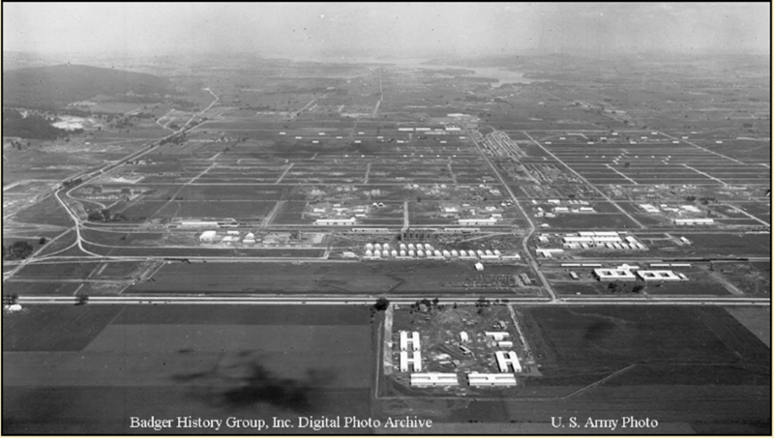
Figure 3. (Above) An aerial photo of the Badger Army Ammunition Plant, May 1942
Source: Badger History Group, Inc., “Welcome to the Museum of Badger Army Ammunition Telling the Story of the World’s Largest Ammunition Plant in 1942,” Museum of Badger Army Ammunition, Accessed 25 September 2017. http://www.badgerordnancehistory.org

Working at the Plant
World War II
The first workers to flood into the Sauk Prairie came to build the Plant and their purchases at local businesses helped to bring the Sauk Prairie out of the Great Depression. So many of them came into the area that available housing was exhausted; some ended up living in attics and a few even lived in a chicken coop. Some farmers who had not been displaced but had lost friends in the process even opened their homes to the influx of people. To help ease the housing shortage, Badger Village was constructed right across the road for workers to live in. From the outside, Badger Village looked like army barracks, but on the inside, they were thin-walled to the point that neighbors nearly lived with one another, though they had all new furniture, and wood burning ranges and water heaters. Badger Village was truly its own village as it had a post office, school, child care facility, grocery store and drug store for the people who lived there and who worked right across the street, helping to create an atmosphere of a community around the Plant.
To help ease the burden on working parents, including those who worked separate shifts, the child care facilities and a school were opened for children to attend while parents worked, which was particularly important for working mothers if their husband was drafted and they did not have any family nearby to care for the children. These facilities were unique in that there had never been any quite like them before; the child care facilities were open around the clock because shifts were around the clock. The around-the-clock child care provided a great deal of freedom for some women, to the point that they had to be reminded to come and at least bathe their children. The school was unique as well because it was constantly changing rooms, teachers, and groups of children attending, and because classes were staggered due to the large number of children attending; some had class from 8-10:30 a.m., others from 10-noon then back from 2-5 p.m., while others attended from 11-3 p.m..
When the Plant opened, labor was primarily being drawn from a 90-mile radius around the Plant, (fig. 4). Due to rationing of gasoline and rubber, those traveling from further away had two options: they could carpool with neighbors who were working the same shift at the Plant or they could take one of the shuttle buses that was provided to transport workers. Eventually, shift change at the Plant was so massive, the first rural four lane highway in Wisconsin was constructed just to handle it.

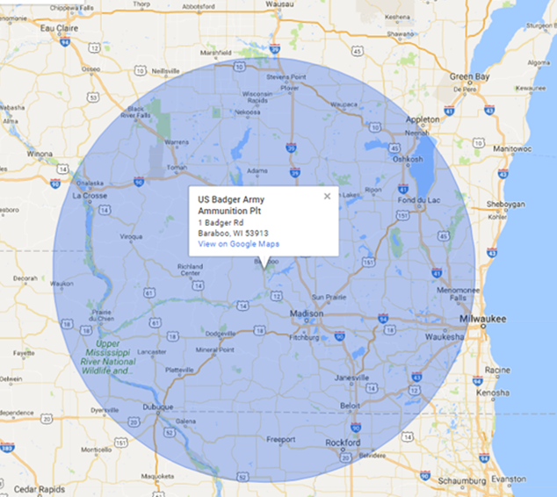
Figure 4. A map of a 90-mile radius around the Badger Army Ammunition Plant
Source: Google Maps. 2017. “90 Mile Radius Around the Badger Army Ammunition Plant.” Accessed 23 October 2017. http://obeattie.github.io/gmapsradius/?radiusInput=90&unitSelector=mi&lat=43.54199&lng=-88.97427&z=8&u=mi&r=90.

There were three shifts at Badger: 8 a.m. to 4 p.m., 4 p.m. to midnight and midnight to 8 a.m. For some, the day was even longer than that because travelling to get to the Plant meant an additional 3-4 hours a day of traveling on World War II era roads at 55 mph on top of working an eight-hour shift. For many people, once they got accustomed to a shift, they were moved to a different shift, meaning they had to start the process of rearranging their entire schedule and transportation plans all over again. Because of a feeling of being a part of “a bigger cause” and witnessing “a…coming together of people, working as a team,” those who worked at the Plant were willing to make these changes and do their part to help the soldiers out.
Arriving for work meant presenting an ID badge at the gate, occasionally being pulled aside for a random search to ensure contraband (such as matches, lighters, alcohol, and cameras), was not being smuggled in, (fig. 5), and then going into a changing room to store personal items and change into specially treated clothing that was meant to reduce static build-up to avoid sparks and, depending upon where one was working, it was either treated to be flame or acid retardant. The clothing was NOT resistant to these materials; they were meant to provide just enough protection for a person to evacuate or change clothes and get to a safety shower. After changing, people were loaded onto yet another shuttle and driven to where they were assigned to work face to face with materials that could explode at any time. An ID badge was meant to be worn at all times, and a temporary replacement would be given if the ID badge was left at home. It was embarrassing to wear a replacement badge because it meant everyone knew who had forgotten their badge that day, and left people to wonder if the badge had landed in the wrong hands and whether or not their Plant was in danger of being sabotaged.,

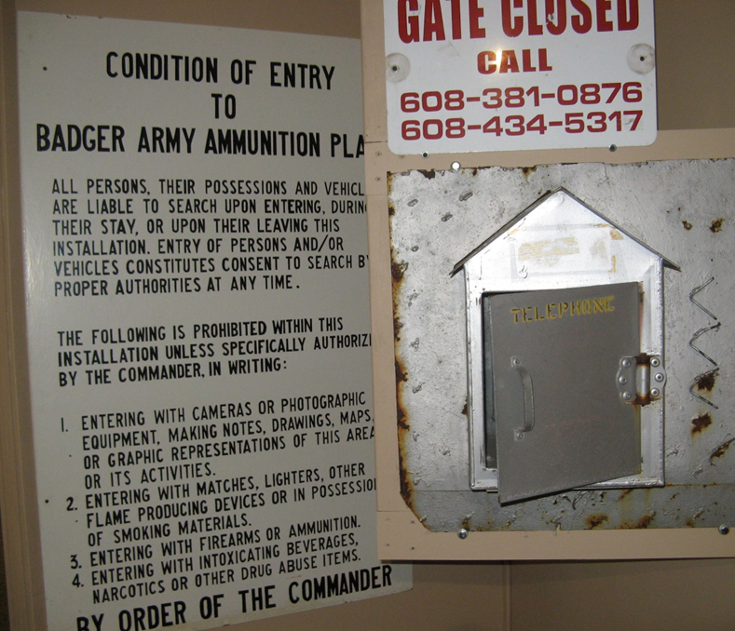
Figure 5. Signs and telephone box that were present at the entrance to the Badger
Army Ammunition Plant
Source: Museum of Badger Army Ammunition, North Freedom, Wisconsin, Visited by the author, 14 October 2017

As men were beginning to be drafted into the army, women were recruited to work at the Plant. Officials of the B.A.A.P. told a large group of women that were interested in learning more about the Plant that “a powder plant is the fourteenth safest industry in which to work—being much safer than housekeeping.” Officials went on to assure women that there were plenty of jobs for women to do even though “ordinarily, powder making is a man’s job” and that “it was a policy of [the owners] to hire local people whenever possible.” Slowly, women started to trickle into the Plant, first in “traditional female jobs” such as “clerks, receptionists, typists, nurses, cafeteria workers and cleaning staff.” By 1943, women were working in jobs on the factory floor. Women would often work in pairs in the more physically demanding jobs, and were paid less than their male counterparts. As this was the first factory job for many women, the leaders of the Plant hired female counselors to help the women workers through their transition from their previous occupations to the factory life.
Every woman who worked at the Plant was targeted by propaganda that was created during World War II, Rosie the Riveter being the most famous example. They were told that the “battlefields of America” were the production lines, and women were the “Hidden Army” of America; “an untapped resource” that will keep “Hitler and his hordes [from coming].” The reasons for women working at the Plant varied as they were from every walk of life; some simply wanted to do their patriotic duty, while others wanted to gain new experiences. Other women found a sense of purpose in working at the Plant, while others were working to keep a loved one overseas, whether they were a P.O.W., M.I.A., or on the front lines, safe.
Just like the war provided an opportunity for women to find employment in industries where they usually would not have readily been hired, people of color also had found new opportunities. People of color who found employment at the Plant included “over 200 men from Jamaica and Barbados,” as well as a small number of Ho-Chunk, Ojibwa, Menominee, and Oneida people, who lived just as close to the Plant as the other people who commuted there. However, “Indian, African-American, Hispanic and Asian workers were about as scarce at Badger as they were anywhere in 1940s Wisconsin.” While Jim Crow Laws were seen in some form throughout America, they were not seen at the Plant simply because it was not feasible. People of color were not segregated from white people in the bathrooms or changing rooms, and it was too dangerous to segregate the people of color from the white people on the factory floor because the people of color were more likely to be inexperienced and needed to be trained by those who were more experienced, typically white people. While attempts were also made to keep the people of color away from the white women, that too failed. “Jamaicans, Barbadians and Wisconsinites—male and female—worked side by side as the job required…integrated by necessity of war.”
After the Second World War ended, everyone was given a 48-hour holiday, the first “day off” since production had begun. The Plant kept producing material with fewer and fewer workers; when layoffs occurred, women often were the first let go. Every women worker had different experiences at the end of the war: some were ready and willing to leave their job because it meant everything was going to go back to normal and their loved ones would be returning from overseas. Other women loved the new jobs and independence that they had found and did not want to leave. Women who lost their jobs during this time period “felt like it was a big joke” because they had “thought that [they] were the new women,” due to the fact that “women are equally effective, and for some skills, superior, to males.” When the Plant was deactivated and placed on standby in August of 1945, only a few personnel remained to help maintain and guard the Plant. Those who lost jobs were left to find some place new to work, a cycle that would repeat itself in the future. Badger Village, on the other hand, found new life as housing for GI’s and their families while they attended UW-Madison on the GI Bill before moving on and beginning the next chapter of their lives.

Korean War
After the Plant was deactivated at the end of World War II, it was on the shortlist to be torn down entirely. The Plant was decontaminated through the destruction of buildings and land that had not been built on was sold, with 768 acres being sold to the Wisconsin Conservation Department and four farmers buying their farms back. Equipment that was no longer being used was given away to high schools, vocational schools and the University of Wisconsin for free. However, the Plant was not torn down in its entirety. A member of the Ordnance Department went on a tour of the Plant and discovered that destroying the Plant “would mean destroying a brand new manufacturing plant that had been carefully mothballed in excellent condition.” This discovery halted the destruction of the Plant, and parts of it were reclassified as being on standby, though it would remain in limbo for the remainder of the 1940’s.
In the summer of 1950, North Korea invaded South Korea and by the end of the year, the company that had been in charge of the Plant announced that they had no interest in resuming work at the Plant. At the beginning of 1951, it was announced that the Badger Army Ammunition Plant, now under the control of the Liberty Defense Powder Company, would be rehabilitated and reopened in order to supply powder and ammunition to the Armed Forces. Workers who had worked at the Plant during World War II were recalled but in smaller numbers. It was predicted that less would be invested in the Korean War when compared to the Second World War and thus “the total workforce numbered no more than a third to one-half of the top levels of World War II.” Because fewer workers were needed, housing was not as highly in demand as it had been for the Second World War, and those who lived further away from the Plant were more likely to commute to and from the Plant than they had been in the 40’s as gasoline and rubber were not rationed. This meant that GI’s who were living in Badger Village while they attended UW-Madison could continue to live there as they completed their degrees.
Unlike World War II, more men than women worked at the Plant because fewer men were in uniform. While almost fifty percent of the workers at the Plant during the final year of the Second World War were women, for the Korean War only a little more than thirty percent of workers were women. Instead of being out on the Plant floor like they had been during the Second World War, many of the women employed by the B.A.A.P. were working in traditionally female jobs. While government propaganda had helped bring women out of their homes and into the workforce during World War II, propaganda in the 1950’s worked to keep women in their homes. This propaganda focused particularly on “child-related problems”, in particular, the “’eight-hour orphans’ and latch-key orphans and…juvenile delinquency.” By doing this, it was suggested that women participating in the war effort was harmful to children and it was argued that women in a post-World War II world should remain at home to take care of the children and the household because the work that they had done during the Second World War was “exceptional” and they would not need to work in that capacity again. People of Color were always employed at the Plant, though fewer during the Korean War then during World War II.
The work that they were doing was much the same as what they had done during the Second World War, with the exception of the fact that the Plant was now a manufacturer of Ball Powder, and the work “was much less hectic” than it had been in the 1940s. Just as it had been in the 1940s and would be in the decades to come, there was a great deal of emphasis on safety at the Plant, particularly because of the sensitivity of the chemicals that were necessary for the production of the Ball Powder, (fig. 6).
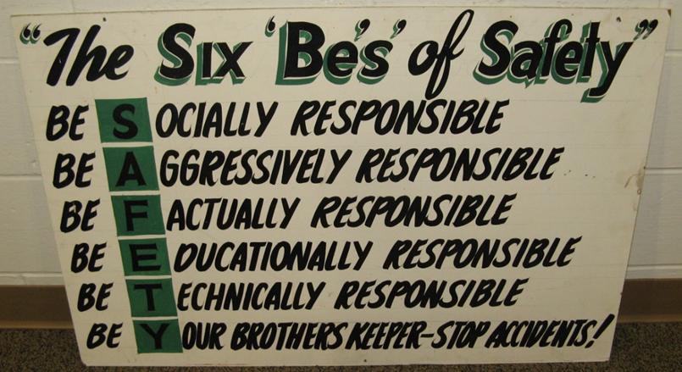
Figure 6. “The Six ‘Be’s’” Sign meant to remind everyone of their number one priority, date unknown
Source: Museum of Badger Army Ammunition, North Freedom, Wisconsin, Visited by the author 14 October 2017

The wages at the Plant were higher than other employers in the area, helping to attract workers, though shifts had changed. “Powder makers worked five days, changed shifts, worked five more days, then took four days off. They came back to spend five days on a different shift, then five on another, then had four more days off, and so on.” Because the Plant was unionized, negotiations over a change to wages and benefits nearly caused a strike in May of 1952, a situation that was reflected across the country. In 1954 however, a strike did occur over a similar disagreement, compounded by the fact that employees working at the Plant were being laid off as production decreased.
While it was not originally believed that the Korean War would require all of the Plant to be reactivated, this proved to be false and more and more portions were rehabilitated and reactivated. After the Korean War ended, the B.A.A.P. continued to produce ammunition well into 1955 because “many months of production [were] necessary to build up the ammunition reserves sufficient to take care of the defense needs of the nation.” Ultimately, total production at the Plant in the 1950s surpassed the total pounds of ammunition made during the Second World War.
The Badger Army Ammunition Plant was closed down in 1958, five years after the cease-fire that ended the Korean War. When it had been closed a decade prior, many of the people in the Sauk Prairie area still viewed the Plant as “an intruder.” When the Plant closed down at the end of the Korean War, opinions towards the Plant were much more positive, in part due to the economic stimulation of the area, courtesy of the wages the workers made at the Plant. Instead of being slated for demolition like it was after the Second World War, the Plant was much better maintained than it had been in the past “so they could remobilize as quickly and inexpensively as possible.” Many hoped that because the Plant was being maintained, a peace time operation would continue and the Plant would thus be able to supply the area with the same kind of economic aid as it had during wartime. Though numerous offers did come in from companies willing to rent a portion of the Plant, ranging from Soils Research Inc. to Farmer Union Central Exchange, none were accepted.
As the 1960s began, the Cold War began to heat up, shutting down the idea that the Plant could be used for civilian purposes because
Badger ‘has the only ball powder capabilities in the military establishment’. It could also produce ‘single and double base propellants’ and ‘the condition of the physical plant is such that reactivation costs would be low,’ though it would only officially be reactivated in the event of a war breaking out.

Keeping the Plant from being reactivated unless a war broke out was done to keep it from being the target of a Soviet nuclear attack. When troops began to be deployed to Vietnam in 1965, it was rumored that the Plant was going to reopen and eager job seekers stopped at the Plant to try and get a job, though they were turned away. It was officially announced at the end of the year that the Badger Army Ammunition Plant would reopen.

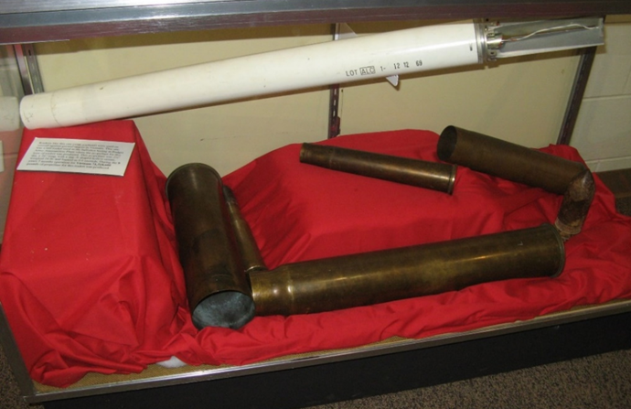
Figure 7. A sample of some of the ammunition made by the Badger Army Ammunition Plant
Source: Museum Badger Army Ammunition, North Freedom, Wisconsin, Visited by the author 14 October 2017.
Vietnam War
Initially, the Badger Army Ammunition Plant was not going to be reactivated for the Vietnam War because it was believed that a smaller Plant that was run by the same company was able to produce all of the ammunition that would be necessary for the war. However, when the workers of that Plant went on strike because a disagreement with the union workers, the reactivation of the newly renamed Badger Army Ammunition Plant became necessary. (The announcement that the B.A.A.P. would be reopened helped to end the strike at the smaller Plant, and it would go on to produce ammunition throughout the Vietnam War as well.) When the Plant reopened for the Vietnam War, job seekers lined up to apply because “they knew Badger would pay higher wages for unskilled and semi-skilled work than most other employers in the area.” Many of the people in line were ready to leave their current employer if they were hired at the Plant; some of those people had worked at the Plant during a past conflict and were ready to rejoin for another conflict because they knew that they made up the “highly productive…armies of skilled and semiskilled laborers” that stood “behind [the] effective fighting power [of the United States Armed Forces]”. Others who stood in line were young men who were eligible for the draft, and knew that getting a job at the Badger Army Ammunition Plant meant that they would earn a draft deferment. Just like in previous wars, there were also people in line to apply to the Plant who wanted to help keep their husbands, sons, brothers, and boyfriends in arms for the duration of the conflict. Because commuting to work was easier than it had been during the Second World War and because bus lines would resume running, workers could live at home and not have to worry about finding someplace nearby to live like they might have had to do previously.
One quarter of the workforce, especially at the beginning of the War, were people under 25 years old who needed summer jobs, some of them were even allowed to do work-study programs depending upon what field they were majoring in college. Women, on the other hand, had reasons to work in the Plant beyond money, though for some, that was the motivation. For other women, their decision to work was born out of the “right of middle class women to work outside their homes.” Throughout “the late 1960’s…society began to publicly revisit and reconsider the importance of women’s rights and equal access to employment”; some of the women going to work at the Plant were going to take full advantage of those rights and work outside of their homes, just like their Rosie the Riveter mothers had. More women were employed at the Plant than there ever had been before and the jobs they did were the same jobs that the men were doing, something that people were more accepting of them doing. Though women were still making less money than their male counterparts, they were making about 50 cents more than they had at any previous jobs. In an era of constant inflation, regular pay increases meant that a single family who had two members working at the Plant could enjoy all the comforts of a middle-class life, making working at B.A.A.P. even more appealing.
A majority of B.A.A.P. workers did support the War in Vietnam, their primary reason being that the bulk of the young men drafted into the fight were from working class and low-income families and hence many of the Plant workers had sons fighting in the war. Wisconsin, in fact, was overrepresented in the number of young men from working class and low-income families being drafted “by a proportion of two to one in relation to their numbers in the population.” Anyone who was against the Vietnam War made sure to leave their opinion at the gate so as to not make any waves with their co-workers or employers. However, just as the general public changed their mind about the Vietnam War, so too did the workers at the Plant. While some were bothered by the fact that they were making the powder and ammunition that was being used in Vietnam, “most did not have a choice”; a job was a job, and a job at the Plant “was a good job.”
Just because the employees of the Badger Army Ammunition Plant kept their opinions of the war to themselves does not mean the Plant was immune to anti-war protests. In June of 1966, 45 people marched to the Plant and arrived after the day shift workers had already clocked in. They sat down and staged their protest at the Plant; the Plant which was almost solely responsible for keeping the United States Armed Forces supplied with ammunition and powder for the duration of the war. The local Sherriff, who had seen what had happened at other protests throughout the country, kept the protestors and counter-protestors separate from each other and was so committed to keeping any violence from happening that he ensured his officers were unarmed. The protestors were gone by the end of the day, having achieved their primary goal of television coverage.
Another protest occurred in 1969 when Karl Armstrong—the nephew of one of the men killed in the deadliest explosion at the Plant in 1945 right before the war with Japan ended—decided to stage a protest of his own at the Plant. He targeted the Plant because he recognized that it was symbolically important and a major part of the war effort. On New Year’s Eve, he and his brother stole a plane and flew it towards the Plant, using the highway to guide them. He threw bombs at the Plant and missed it by 100 yards; the bombs landed harmlessly on the ground. Had the bombing been successful, the damage would have been catastrophic due to the millions of pounds of propellants, ammunition, and other flammable materials within the Plant’s boundaries. While his bombing attempt on the B.A.A.P. became an urban legend, his next bombing attempt was much more widely known; on August 24th, 1970, Karl Armstrong and three others, again including his brother, bombed Stirling Hall on the UW-Madison campus.
Just as the number of troops in Vietnam peaked in 1969, so too did the number of workers at the B.A.A.P. From there, the number of workers began to decrease to the point that production of some material was halted by 1973. While the war in Vietnam ended with the Fall of Saigon in April, production at the Plant did not officially stop until June. With the closing of the Plant came an increase in unemployment in the Sauk Prairie area, just like there had been at the end of World War II and the end of the Korean War. Women would struggle more than men would to find employment after the Plant closed, but everyone who found a job afterwards accepted a job with a lower wage than what they had made at the Plant, and the economy of the whole area would suffer drastically. The residents of the Sauk Prairie and the surrounding area were resilient; just as they had survived being removed from the land so the Plant could be built and the economic bust that occurred each time the Plant closed, they would find a way to survive this closing and bust too.

Table 1. Type of Powder, When it was Produced, and What Weapon it was used for
 | World War II | Korean War | Vietnam War
 | Small Arms Powder
 | Cannon Powder
 | Rocket Grains
E.C. Powder | M1 Rifle Blanks, MK2 Hand Grenades
Ball Powder Propellant  Made from nitrocotton (nitrocellulose), nitroglycerin, and a burn rate control agent |  | 30 Caliber Rifle, 20 mm Gun | 7.62 mm Rifle, 5.56 mm Rifle, 30 Caliber Rifle, 20 mm Gun, 50 Caliber Guns
Smokeless Powder  Made from nitrocotton (nitrocellulose) and nitric acid |  | 75 mm Rifle, 75 mm Gun, 76 mm Gun, 90 mm Gun, 105 mm Rifle, 105 mm Howitzer, 155 mm Howitzer, 8 inch Howitzer, 240 mm Howitzer | 105 mm Howitzer, 155 mm Howitzer, 175 mm Howitzer, 8 inch Howitzer
Rocket Mortar |  | MK-18, MK-22, MK 21, M-16 | MK-43
 |  | 115 Mortar
 |  |  | 5” Navy Gun
Sources: Data from Michael J. Goc, Powder, People and Place: Badger Ordnance Works and the Sauk Prairie, (New Freedom, Wisconsin: New Past Press Inc., 2002), 378.
Museum of Badger Army Ammunition, “E.C. Powder” panel, North Freedom,
Wisconsin, Visited by the author, 14 October 2017.

Dismantling the Home Front
In the late 1960’s, Plant operators “were working on pollution control plans,” partially in response to complaints of sulfuric mist and smog from the people who lived in what was formerly Badger Village and other nearby areas. While concerns about air pollution were resolved through the installation of machinery that would reduce emissions being let into the air, concerns about water pollution began to arise. The company that was in charge of operations at the Plant pointed out that they were not technically responsible for reducing the pollution that was occurring at the Plant; it was, they claimed, the responsibility of the United States’ government. In response to that, the Government’s “federal budget appropriated $1.6 million to implement the measures …drawn up at Badger.” This coincided with the call to build a brand-new Badger Army Ammunition Plant, particularly because “it was built in World War II and used technology from World War I.” The old technology from World War I required constant upkeep and upgrades in order to continue functioning and also emitted large amounts of pollution into the air and water. Modernization began with new facilities for production being constructed as well as other facilities being “constructed to clean groundwater contaminated by earlier, unsafe disposal practices, and polluted soil and other materials were treated or land-filled.” All of this proposed work meant that jobs would come back to the area and the new version of the Plant would meet the standards called for by the Clean Air and Water Acts. While the new facilities were built, no other projects were started. By the time 1991 came around, “funding…was all there but the Army, rather than start to put it in, said, ‘when we need it again, we’ll start it up’.”
It was assumed that the Plant would always be around. As one person put it, the Plant was “like a fire extinguisher. You hope you don’t need it but like having one just in case.” This sentiment especially rang true in the Cold War world, and because of this belief, the Plant was better maintained then it had been after World War II or the Korean War so it was ready to go the moment it was needed. When the Persian Gulf War broke out, everyone thought the Plant would be reactivated and people who had worked at the Plant even as long ago as World War II were ready to go back to work. Instead, it laid dormant, and pressure to permanently close the B.A.A.P. grew. In 1998, the United States Army decided to decommission the Badger Army Ammunition Plant; it would never see another war.
Despite the fact that environmental cleanup had been occurring since the 1970’s, in the 1990s it was reported that “studies have discovered numerous pollution issues.” One of the groups most vocal about these pollution issues is the Citizens for Safe Water Around Badger Group, especially after it was discovered that those living in the area around the Plant were at an elevated risk for cancer and that the Army was considering abandoning the cleanup. While this group focuses more on the contamination that has been done to the water and the groundwater—contamination that lingers to this day—they agitate for overall cleanup of the area and support the Wisconsin DNR and the Ho-Chunk Nation in their plans to restore the area’s plant and animal life and continue decontaminating the area.
In September of 2000, thousands of people, from farmers who gave up their land so the Plant could be built, to veterans who used the ammunition created by the B.A.A.P., to curious onlookers, took one last tour of the Plant. In 2010, demolition of the Plant began. Because of the explosive powder engrained into the walls, water had to be sprayed onto the buildings as they were torn down in order to keep anything from blowing up. The deconstruction of the home front in Wisconsin, a project that was first constructed almost 70 years earlier, was finally complete.

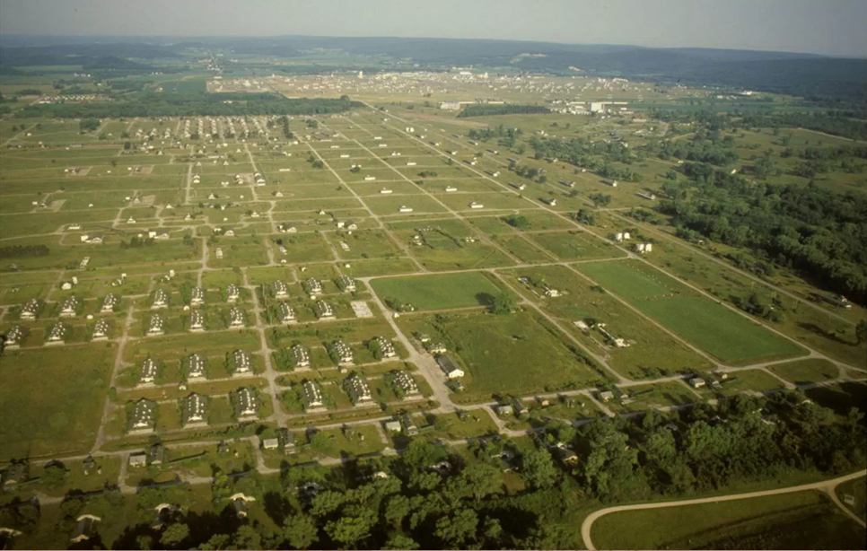
Figure 8. A more recent aerial photo of the Badger Army Ammunition Plant
Source: Sauk Prairie Vision, Accessed 8 December 2017, http://www.saukprairievision.org/event/fall-lecture-series-begins-the-badger-archives-and-the-history-of-badger-army-ammunition-plant/

Conclusion
Today, the Badger Army Ammunition Plant has been reduced to 35 buildings, one of which houses the Museum of Badger Army Ammunition, which was once the home of a computer while the Plant was in operation during the Vietnam War. A few other remaining buildings house NASA rocket engine testing through the ORBITEC company. As the land is decontaminated, it is being claimed by a few new owners, one of them being the USDA Dairy Forage Research Facility run by UW-Madison. The USDA Dairy Forage Research Facility first opened on Plant land in 1981 where different cattle and dairy studies and research on field management are conducted. Their research will help the Dairy Forage industry as well as farmers who work in the industry. In September of 2004, the USDA Dairy Forage Research Facility received approximately 1,943 acres of Badger Army Ammunition Plant land to expand their farms and research facility on, which are closed to public access except for when people are crossing from one portion of the DNR’s land to another.
A vast majority of the land now belongs to another owner, the Wisconsin Department of Natural Resources. The Wisconsin DNR is using this land to create the Sauk Prairie State Recreation Area (SPSRA), which connects to Devil’s Lake State Park in the north. When completed, the SPSRA will serve many different purposes. First, the area will help to conserve the savannah and prairie land that the Badger Army Ammunition Plant was built on, as well as monitor the many different kinds of plants and animals that inhabit those lands. Second, the SPSRA will preserve geological features in the area. Third, an interpretive trail will be provided so that the cultural aspects of the area can be preserved out of respect for the tribal nations that owned the land before White settlers entered the area, the farmers whose land was taken for the construction of the Plant, and the workers who helped produce the ammunition. (Two areas of particular cultural importance are the Pioneer and Thoelke Cemeteries, which will be maintained by the town of Sumpter so the residents can reclaim bits of their history that they did not have access to while the Plant was in operation and so family members can visit the graves of loved ones once again.) Lastly, the DNR will monitor and work to rehabilitate contaminated land and water sources.
Another sizeable portion of land will be given to the third owner, the Ho-Chunk Nation, who went through quite a lot to get this land. Initially, the Ho-Chunk Nation hoped to gain nearly half of the land, but in 2011, they agreed to accept a fraction of that land. However, “in 2011, tribal leaders were devastated when the Bureau of Indian Affairs (BIA) announced that it would not accept the parcel on behalf of the Ho-Chunk because of the contamination.” The Ho-Chunk Nation were disappointed when they did not receive a portion of ancestral land, but they remained committed to helping the Government of the United States maintain the area as well as advocate for the best quality clean up and protection of the natural resources in the area. That all changed in 2014 when, after legal wrangling, it was decided that the Ho-Chunk Nation could after all have the portion of land that was offered to them in 2011. Jon Greendeer, former President of the Ho-Chunk Nation, said in a 2015 interview that while plans for their piece of the former Plant site are not finalized, “the future is about creating a sustainable piece of property for the nation…And that means making sure that we cover all aspects. We’re doing a lot of prairie restoration and maybe some light recreational areas, visiting history, interpretative centers and perhaps the eventual reintroduction of bison on the property.” Currently, the Ho-Chunk Nation’s land is closed to public access, but they are still working with their neighbors to preserve and decontaminate the land.
All of the work that is being done to preserve the land that the Badger Army Ammunition Plant stood on is in keeping with the hopes of those who once owned the land, because they hoped that the land would be reverted to farm and prairie land. Those farmers, who still remember vividly where their farms or neighboring farms once stood, do still wish to see some of the Plant preserved because it is a very important part of the history of the area. Many also want to see specific memorials added to the area. These memorials range from The Farmer’s Memorial (which currently stands just off of Highway 12), the “Symbol of Strength” Munitions Workers Memorial (which is currently in a parking lot off of Highway 12), a Ho-Chunk Removal Memorial, and Family Farm Markers which would be placed at the sites of former family farms, similar to how other state parks allow for memorial benches. As the land where the Badger Army Ammunition Plant once stood goes through a dramatic transformation, across the highway, Badger Village still stands; a housing operation for the Plant meant to last only five years will live on as family houses.

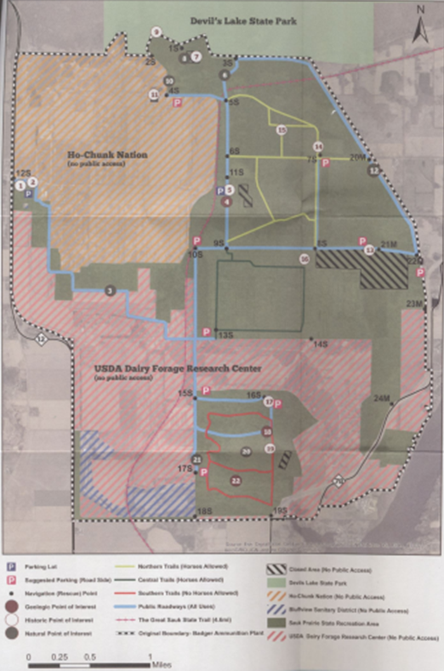
Figure 9. A map of how the land of the Badger Army Ammunition Plant is being divided up
Source: Sauk Prairie Conservation Alliance, Sauk Prairie Conservation Alliance Visitor Guide: Badger Lands Sauk Prairie State Recreation Area, (2017).

The Badger Army Ammunition Plant is not the only World War II era ammunition plant where the home front had to be constructed and later had to be deconstructed. Some Plants had a very similar story to that of the B.A.A.P., such as the Sunflower Army Ammunition Plant in Kansas or the Joliet Army Ammunition Plant in Illinois. They were constantly shut down and reopened, only to finally be declared excess in the 1990s. After undergoing remediation, the lands that these Plants once stood on are now home to a variety of different things. At other Plant locations, such as Gopher Ordnance Works in Minnesota or the Green River Ordnance Plant in Illinois, the home front ended with the end of the Second World War; these were Plants that were built in response to the outbreak of the Second World War and were closed at the end of it with some of the land being returned to those who originally owned it while other tracts of land were repurposed. There is another group of Plants whose home fronts were only recently deconstructed, such as the Kansas Army Ammunition Plant or the Lone Star Army Ammunition Plant, which were closed in 2005 because of the Base Realignment and Closure (2005), a policy which is meant to increase the efficiency of the United States Department of Defense. The work from these Plants has gone to the few remaining Plants, like the Iowa Army Ammunition Plant or the McAlester Army Ammunition Plant in Oklahoma, which were constructed for use during the Second World War and whose home fronts have yet to be deconstructed.
These other plants need to be explored as widely as the Badger Army Ammunition Plant because of the effects they had on their communities in one way or another. Some of these plants were like the B.A.A.P. in that the land that they stood on was taken using the eminent domain clause but went on to help bring the area surrounding the plant out of the Great Depression because of the economic boom that occurred due to the influx of workers and because they provided jobs to those who lived in the area. However, these same areas would suffer an economic bust when the Plants closed at the end of the war. At some Plants, the home front began with the Second World War and ended with the end of the Second World War as the Plants were torn down and farmers were allowed to reclaim their land. At other Plants, the home front that was created for the Second World War lasted well into the 20th century and for some, still continues to the present day, showing the importance of the home front in the wars after World War II. Despite the closure of many of these Plants, these areas are still affected by the work that was done there through the lingering effects of pollution. For now, “all is at rest, at peace, and hopefully will be for many years to come.”

Bibliography
Primary
Crown, Deborah L. The World War II Ordnance Department’s Government-Owned
Contractor-Operated (GOCO) Industrial Facilities: Badger Ordnance Works Transcripts
of Oral History Interviews. Plano, Texas: Geo-Marine, Inc., 1996.
http://www.dtic.mil/get-tr-doc/pdf?AD=ADA315703.

This source is six oral interviews of people who worked at the Badger Army Ammunition Plant; some of them only worked there when it was being constructed and throughout the Second World War, while others continued their job there through the Korean War and the Vietnam War. The interviews were conducted to help understand what life was like at the Badger Army Ammunition Plant while it was being constructed and what it was like there during the Second World War, both of which will be important for the paper.

“About the Commission.” Defense Base Closure and Realignment Commission. Accessed 9
December 2017. www.brac.gov/About.html

This is the website for the Defense Base Closure and Realignment Commission, specifically the “About” section for the 2005 Commission. This website explains what the Defense Base Closure and Realignment Commission is, what their goal is, and the report that the Commission presented to President Bush in 2005. This website is important to the paper because it is the reason for the closure in 2005 of some of the Government-Owned Contractor-Operated Plants that were built during the Second World War like the Badger Army Ammunition Plant.

Gasser, Doris Litscher. World War Two: The Coming of Badger Ordnance. Prairie du Sac, Wisconsin: Giegerich Sons, 2002.

This source is a collection of oral interviews the author had with residents of the Sumpter-Merrimac area, exploring what life was like before the Badger Army Ammunition Plant was created and what happened after the government evicted the farmers off of their land, which are important aspects for the paper.

Mueller, Erhart. “Register of the Erhart Mueller Papers, 1864-1993.” Microfilm, Wisconsin
Historical Society, 1993.

These papers of the historian, Erhart Mueller, contain everything about the area that became the Badger Army Ammunition Plant. This paper contains images of the area, newspaper clippings, theses on the Plant, records of various Clubs and Groups in the area, as well as records of the appraisals that occurred on every tract of land before the Plant was built and how to lease land in the late 70’s when the Plant was closed. These papers are important to the paper because Erhart Mueller captured every bit of information about the Plant possible and has information that would otherwise be lost to time as people passed away and papers were disposed of.

“Property Master Plans: Sauk Prairie State Recreation Area,” Wisconsin Department of Natural
Resources. Accessed 28 November 2017. http://dnr.wi.gov/topic/lands/masterplanning/saukprairie/.

This is the Master Plan published by the Wisconsin Department of Natural Resources for the Sauk Prairie State Recreation Area, which will take up most of the land that was once the Badger Army Ammunition Plant. The plan details all of the work that has gone into developing the area, including studying the environmental impacts, looking into the history of the area, and looking at alternatives for the area. The plan also discusses what the purpose of the SPSRA will be. This plan is important to the paper because it discusses what exactly will be happening with the former Badger Army Ammunition Plant land in the section that the DNR was given.

Stevens, Michael E., and Ellen D. Goldlust, eds. Women Remember the War 1941-1945.
Madison, Wisconsin: State Historical Society of Wisconsin, 1993.

In this book, women who were living in Wisconsin remember how they spent World War II. The women interviewed for the book were from all different walks of life: some women had children and had to find childcare while they were working, others were single and working closer to the front lines of the war effort, while yet another group of women talked about their time raising and caring for children during the War when their husbands were away and they had to deal with “the second shift”, where they spend the day working to supply manpower to the war effort and then go home to care for their household. These interviews were conducted to help better understand the experiences and roles Wisconsin women in the Second World War. Understanding the experiences of women during the Second World War is a pertinent bit of history that will need to be included in the paper in order to contrast the experiences that men had throughout the duration of the War.

The Life and Times of Rosie the Riveter. Directed by Connie Field. 1980. Franklin Lakes, New
Jersey: Clarity Educational Productions, 2014. DVD.

This DVD explores the experiences of women who held different jobs, particularly in factories, during the Second World War. In the interviews, the women discuss topics ranging from child care to housing to what happened to them after the war ended and they were let go from their jobs. Also explored are the roles that women of color played throughout the war. Interspersed with the interviews are different “Rosie the Riveter” propaganda pieces, meant to highlight the differences between what was shown in the media of women’s experiences and the actual experiences of women. This DVD is important to the paper because of all of the different ways it explores the experiences of working women throughout the Second World War and what they thought the future would hold for them at the end of the war. Furthermore, their experiences are necessary to understand in order to contrast them with that of men, and it is necessary to also be able to compare the experiences of women of color with that of White women.

“What the Future Holds for Former Propellant Facility.” Wisconsin Public Television. 1 July
2016. https://wpt.org/Here_and_Now/what-future-holds-former-propellant-facility.

This is a news report by Wisconsin Public Television detailing what would be happening on the land where the Badger Army Ammunition Plant once stood. This is important to the paper because it includes an interview with the President of the Ho-Chunk Nation—one of the groups that will be receiving former B.A.A.P. land—in which he discusses what their current plans for the land are.

“$65,000,000 Power Plant to be Built Near Merrimac. Construction Approved by War
Department Wednesday.” Sauk County News (Prairie du Sac, WI), Oct. 31, 1941.

This newspaper article announces the plan to construct an ammunition and powder plant that will be known as the Badger Ordnance Works. This plant had just been approved by the War Department the day prior. The article goes on to discuss the size of the Badger Ordnance Works Plant in comparison to other plants around the country, the geography of the area it is planned to be built on, and that construction would commence immediately. Lastly, the article mentions why Wisconsin was selected as the location for the new Plant. This will be important to the paper because it announces the beginning of the Plant that would change the area and the people living in there forever.
Secondary
Badger History Group, Inc, “Welcome to the Museum of Badger Army Ammunition Telling the
Story of the World’s Largest Ammunition Plant in 1942,” Museum of Badger Army
Ammunition, Accessed 25 September 2017. http://www.badgerordnancehistory.org/

This is the website of the Museum that is located where the Badger Army Ammunition Plant once stood. The website discusses the history of the plant, from the initial announcement of its creation, to the land acquisition, to what is left of the plant today and what is happening to the land where the plant once stood. The group works to make sure the history and memory of the Plant is not lost even as the people who worked there pass away and the land is divided up and given to new owners. This website, as well as the actual Museum, are an invaluable trove of information for the paper because they provide access to artifacts from the Badger Army Ammunition Plant.

Badger Village: Our Prairie Home. Directed by Dave Erickson. 2006. Prairie du Sac and
Baraboo, Wisconsin: Badger History Group and University of Wisconsin-Baraboo/Sauk
County, 2006. DVD.

This film interviews people who lived at in Badger Village; some of them lived in the Village when it was used during WWII, others lived there immediately after WWII when it was housing for GI’s who were attending school at UW-Madison, and other people interviewed were (or currently are) owners of the Village. Some of people interviewed reflected on what it was like living across the street from the Badger Army Ammunition Plant, and the current owners reflect upon how the Village was not meant to last as long as it has, and how it will outlive the Plant. This film has valuable facts and stories from the people who lived in Badger Village that would otherwise be lost to time, adding important first-hand accounts to the paper.

Brock, Julia, Jennifer W. Dickey, Richard Harker, and Catherine Lewis. Beyond Rosie: A
Documentary History of Women and World War II. Fayetteville, Arkansas: University of
Arkansas Press, 2015. https://muse-jhu-edu.proxy.uwec.edu/book/35988/

This book, through a variety of different sources, explores the experiences of women throughout the Second World War, with an emphasis on the importance and endurance of Rosie the Riveter. This book is important to the paper because it helps explore the roles women played in the war, as well as how society adjusted to the increased reliance on women throughout the duration of the war.

Crilley, Gabe M., and David R. Silverman. “Landscapes of Change: Badger Army Ammunition
and Sauk Prairie.” UW Geography Undergraduate Colloquium, University of Wisconsin,
Madison, 2009. http://digital.library.wisc.edu/1793/37984.

This thesis talks about the geography of the area that the Badger Army Ammunition Plant was built on, as well as provides some information on the history of the plant, including how the nearby towns were affected both positively and negatively by its construction. It also includes images of the land that would become the Badger Army Ammunition Plant and how it evolved as the Plant was built and expanded. This thesis is an important source for the paper because one of the main reasons why Sauk County was selected to be the site of the Plant was because of the geography of the area, which is described in the thesis.

CSWAB-Citizens For Safe Water Around Badger. Accessed 12 November 2017.
https://cswab.org/.

This is the website for a group that is based in the Sauk Prairie that focuses on the decontamination of the area around the Badger Army Ammunition Plant with an emphasis on ensuring that the water table is properly taken care of. The group focuses on the impact that decades of pollution has had on the water in the areas surrounding the Badger Army Ammunition Plant and constantly agitates to ensure that the water is properly taken care of and, in the meanwhile, communities in the area have access to clean, safe water. This website is an important source for the paper because it provides links to maps and fact sheets that provide information about the ecological systems that surround B.A.A.P. as they are decontaminated, which is an important aspect of the future of the location.

“Dairy Forage Research Center,” University of Wisconsin-Madison, Accessed 28 November
2017 http://dairyforage.ars.wisc.edu/.

This is the website of the USDA Dairy Forage Research Center, one of the three groups that now own the land that the Badger Army Ammunition Plant once stood on. This website explains what types of research occur at their location in Sauk County as well as their history in the area prior to the official shut down of the Plant. This is important to the paper because it elaborates on the plans of one of the entities taking over the land where the Badger Army Ammunition Plant once stood and their plans for the future of the area.

Goc, Michael J. Powder, People, and Place: Badger Ordnance Works and the Sauk Prairie.
Friendship, Wisconsin: New Past Press, Inc., 2002.

This book encompasses the entire history of the Sauk Prairie, from when the glaciers scraped out a terminal moraine to the legacy of the Badger Army Ammunition Plant today and everything in between. A large portion of the book is dedicated to the history of the Badger Army Ammunition Plant and the book has a treasure trove of information in the back pertinent to the Plant, such as names of farmers whose land was taken for the Plant, names of the people who passed away due to accidents that occurred at the sight, and all sorts of other sources that could be explored for further information. This book is important to the paper because it explores the history of Sauk Prairie before, during, and after the Plant and how the people and the area were affected positively and negatively by its existence.

Google Maps. 2017. “90 Mile Radius Around the Badger Army Ammunition Plant.” Accessed
23 October 2017. http://obeattie.github.io/gmapsradius/?radiusInput=90&unitSelector=mi&lat=43.54199&lng=-88.97427&z=8&u=mi&r=90.

This is a map showing the 90-mile radius around the Badger Army Ammunition Plant that labor would have been drawn from to produce all of the materials that were put out at the Plant. This is important to the paper because it shows all of the areas that workers came from and how even though the area was rural, there was still a large work force available to work at the Plant.

Hill, Diana Murray. “Ladies May Now Leave Their Machines.” In Beyond the Home Front:
Women’s Autobiographical Writing of the Two World Wars, edited by Yvonne M. Klein, 146-150. New York, New York: New York University Press, 1997.

This book is a collection of writings written by women who were living through and working through the First or Second World Wars, touching on all aspects of life during the war, from factory work, to working on the front lines, to reporting from the front lines, and everything in between. This book is important to the paper because it explains what life may have been like in the Badger Ordnance Works for the women who worked there during the Second World War.

Jamakaya. Like Our Sisters Before Us: Women of Wisconsin Labor. Milwaukee, Wisconsin: The
Wisconsin Labor History Society, 1998.

This book describes the lives of some women who worked in factories in Wisconsin from the late 1930’s through the late 1980’s. These women were very active in the labor unions at the factories that they worked at, oftentimes being the only women on the executive board of the union, and many made a point of becoming educated in labor laws and employee rights so they could accurately advocate for their fellow workers (particularly women) who felt they otherwise did not have a voice. (This book is based off of interviews conducted for a larger project that specifically looks at the experiences women have had in the labor movements in Wisconsin.) This book is important to the paper because it explores the lives of some women who were working at a similar time and in similar conditions to women who were working at the Badger Army Ammunition Plant.

Janik, Erika. A Short History of Wisconsin. Madison, Wisconsin: Wisconsin Historical Society
Press, 2010.

This book describes some of the problems and resulting solutions that would have occurred in factories, such as the Badger Army Ammunition Plant, as women entered the work force during World War II to make up for the labor that was lost when the men were going overseas. This book is important to the paper because it focuses specifically on the experience that women had in factories, which were unique to the experiences men would have had when working in a factory.

Kotkin, Stephen. "World War Two and Labor: A Lost Cause?" International Labor and
Working-Class History, no. 58 (2000): 181-91.
http://www.jstor.org.proxy.uwec.edu/stable/27672679

This article discusses the importance of researching the labor force during the Second World War because it was a subject that was largely ignored during the war. The article also discusses the importance of labor in all of the countries involved in the Second World War and the different ways that the labor force manifested itself in those countries. This article is important to the paper because it explores the idea of labor in the Second World War and the importance of furthering that research.

Loew, Patty. Indian Nations of Wisconsin, Histories of Endurance and Renewal. Madison,
Wisconsin: Wisconsin Historical Society Press, 2013.

This book talks briefly about to Ho-Chunk Nation of Wisconsin trying to gain possession of all of the land surrounding the Badger Army Ammunition Plant and then a smaller portion of the land. It also discusses what they planned to do with the land. It also describes their reaction in 2011 to the Bureau of Indian Affairs turning down the transfer of land from the Government to the Ho-Chunk Nation. This book is important to the paper because the Ho-Chunk Nation were affected by the development, and later destruction, of the Plant and their voice is important to include in the history of the Plant.

Loew, Patty. “The Back of the Homefront: Black and American Indian Women in Wisconsin
during World War II.” In Women’s Wisconsin From Native Matriarchies to the New
Millennium, edited by Genevieve G. McBride, 395-403. Madison, Wisconsin: Wisconsin
Historical Society Press, 2005.

This section talks about the attempts women of color made to find jobs during the Second World War as most jobs and propaganda pieces were directed to white women. The jobs they took ranged from secretarial work to working in factories, and they had to deal with some of the same struggles as women of European descent, such as childcare arrangements while they were working and the “second shift” that they had once they returned home from work. Similar to the why the book on discussing the Ho-Chunk Nation is important, this book is important because people of color had a unique experience when working on the Plant, and their voice is also necessary to include in the history of the Plant simply because of the similar and different experiences they would have had when working there.

Mueller, Erhart A. Forever in Sumpter. Stevens Point, Wisconsin: Worzalla Publishing Co.,
1987.

This is one of the many books on the town of Sumpter that Erhart Mueller wrote; a compilation of songs, poems, illustrations and photographs, and stories by, about and of the people who lived in the area. This book provides information about the coming of the Plant through stories about the railroads, one of the necessities for the Plant being located on the Sauk Prairie, to important figures in the area at the time, such as Garth Premo. This is important to the paper because it discusses what life was like before the Plant from the point of view of people who lived in the area and watched the world change around them.

Mueller, Erhart A. Only in Sumpter. Stevens Point, Wisconsin: Worzalla Publishing Co., 1977.

This is another of the books on the town of Sumpter that Erhart Mueller wrote; it too is a compilation of songs, poems, illustrations and photographs, and stories by, about and of the people who lived in the area. This book details information about the Plant, such as one of the explosions that occurred in at the site; the same explosion that would later partially inspire the bombing attempt on the Plant while it was in operation during the Vietnam War. This is an important source to the paper because it discusses aspects of the Plant from the point of view of the people who lived in the area and dealt with the Plant as a part of their everyday lives.

Mueller, Erhart A. Return to Sumpter. Amherst, Wisconsin: Amherst Press, 1994.

This is another book on the town of Sumpter that Erhart Mueller wrote; it is also a compilation of songs, poems, illustrations and photographs, and stories by, about and of the people who lived in the area. This book was published after Erhart Mueller passed away. This book discusses parts of the town that were erased by the coming of the Plant, such as area schools. This is important to the paper because it discusses important parts of the community that were disposed of so the Plant could exist and only lived on in the memories of the people who lived in the area.

Museum of Badger Army Ammunition. North Freedom, Wisconsin. Visited by the author. 14
October 2017.

The Museum of Badger Army Ammunition is one of the remaining buildings on the Plant’s location. The Museum is housed in a building that once held a computer, along with an extensive archive.

Powder on the Prairie and Erhart Remembered. Directed by Dave Erickson. 1993. Spring
Green, Wisconsin: Ootek Productions, 1993. VHS.

This film is a combination film; the first half explores the early history of the Badger Ordnance Works plant, interviewing people who displaced by the plant and sharing their memories of the area. The second half of the film was produced in memoriam of Erhart Mueller, who captured the history of the plant from its inception to the end of its use as an ammunition plant by collecting papers, newspaper clippings, and memories of people who lived on the land taken for the Plant and those who worked on the Plant. This film contains invaluable information and memories from the people who saw the land change from farm to factory that would otherwise be lost to time, adding an important facts and stories to the paper.

Powder to the People. Directed by Dave Erickson. 2000. New Freedom, Wisconsin: Wisconsin
Public Television, the Sauk County Historical Society, and the Badger History Group, 2000. VHS.

This film interviews people who were associated with the Badger Army Ammunition Plant in some way; some of them were farmers displaced by the Plant, others worked at the Plant during at least one of the wars it was used for, while yet another group of people discuss protesting at the Plant site during the Vietnam War. Another group of people interviewed discuss what the Plant has become after the United States Army decided that it was no longer needed. A vast majority of people interviewed are asked what should become of the land when the Plant is finally torn down, and many believe it should be returned to farm and prairie land. This film has valuable facts and stories from the people who lived on the land that would become the Plant and those who worked on the Plant that would otherwise be lost to time, adding important first-hand accounts to the paper.

Sauk County Historical Society. “Korean War 1950-1953.” Sauk County Historical Society.
Accessed 27 September 2017. http://www.saukcountyhistory.org/koreanwar.html.

This website focuses on the history of Sauk County during the Korean War, mentioning the Badger Army Ammunition Plant and how the troops were affected by the ammunition plants being shut down in between World War II and the Korean War. This information is important to the paper because it describes the effect of the Plant being deactivated between the two conflicts and how the military was negatively affected as they waited for production and shipments to begin again.

Sauk County Historical Society. “World War Two 1939-1945.” Sauk County Historical Society.
Accessed 27 September 2017. http://www.saukcountyhistory.org/wwiidisplay.html.

This website focuses on the history of Sauk County during World War II, with a section dedicated to the Badger Army Ammunition Plant and the mixed feelings people had towards the plant—ranging from displeasure to losing farmland in favor of the plant to enthusiastic about having a factory nearby where they could serve their country without serving overseas and the fact that the Plant would help to jumpstart the economy of the area that was still suffering from the effects of the Great Depression. This webpage is important because it shows the different reactions people had to the construction of the Plant and how even those who were not in favor of the Plant joined in on the war effort despite their disapproval of the Plant’s construction.

Sauk County Historical Society. “Viet Nam War 1961-1975.” Sauk County Historical Society.
Accessed 27 September 2017. http://www.saukcountyhistory.org/vietnamwardisplay.html.

This website focuses on the history of Sauk County during the Vietnam War, with a section dedicated to the Badger Army Ammunition Plant. This article is written in contrast to the article on the Second World War, particularly the differences in opinions about the plant in between the two wars. During World War II, lots of people were enthusiastic about being able to serve their country by working at the Plant, whereas during the Vietnam War, people were less enthusiastic about the war effort and made attempts to halt production at the plant, including attempting to bomb the Plant and protesting outside of it. This article is important to the paper because it contrasts the reaction people had in World War II to the Vietnam War and how people were not as on board with the war effort during the Vietnam War as they had been during the Second World War and how that affected the Plant.

Thompson, William F. History of Wisconsin: Continuity and Change, 1940-1965. Madison, Wisconsin: Wisconsin Historical Society Press, 1988.

This book is a part of a series that explores the history of Wisconsin, with this particular one focusing on the Second World War era through the beginning of the Vietnam War era. It discusses changes that occurred throughout the state, with a very heavy influence on how Wisconsin was affected by the war in areas ranging from industry to life at home. The book also pays attention to how women were affected by these changes and their experiences as they entered the work force for the first time in their lives. This book is important to the paper because it explores the history of Wisconsin at the time that the Plant was at its peak production and how the state of Wisconsin was affected by industries moving into the state to help with the war effort during the Second World War, the Korean War, and the Vietnam War.

Trigg, Mary K. Feminism as Life’s Work: Four Modern American Women through Two World
Wars. New Brunswick, New Jersey: Rutgers University Press, 2014.

This book describes the life and experiences of four women who lived through both World Wars, focusing primarily on their experiences as women. The book describes what it was like when jobs that had been male dominated were opened to women during the war, as well as what happened to these working women and the men started coming back home. This book is important to the paper because it describes what life may have been like for women working on the Badger Ordnance Works during the Second World War, as well as what their life may have been like immediately after the war ended and soldiers began returning home to their jobs.

U.S. Army Joint Munitions Command. Badger Army Ammunition Plant Historical Overview
1941-2006. Rock Island, Illinois: AMSJM-HI (History Office), no date. http://www.jmc.army.mil/Docs/History/Badger%20Army%20Ammunition%20Plant%20-%20V3%20Internet.pdf
This article explores the history of the Badger Army Ammunition Plant from its creation to its closure. It also provides a detailed account about the products, both common and unique (such as Ball Powder), that were produced at the Plant. It includes photographs of the Plant as it expanded throughout the years, and interviews with some of the residents of the area who were impacted in some way by the Badger Army Ammunition Plant. This article is important to the paper because it explores the whole history of the Plant, how the products it was creating changed or stayed the same throughout the year, as well as the effects the Plant had on the residents.

Werner, Debra. “Spotlight Orbital Technologies Corp.” Space News. 27 May 2013,
http://spacenews.com/35509spotlight-orbital-technologies-corp/.

This is the website that discusses the work that NASA and ORIBTEC are doing in some of the remaining Badger Army Ammunition Plant buildings. This website is important to the paper because it discusses work that is being done currently at the Plant even though it has long since closed down.

Wisconsin World War II Stories Part Two: Homefront. Directed by Wisconsin Historical Society
Press. 2005. Madison, Wisconsin: Wisconsin Public Television and Wisconsin Historical Society, 2005. DVD.

This film interviews men and women from Wisconsin who participated in some way in the Second World War. What they did during the war ranges from serving in either the Atlantic or the Pacific theatre, working in a factory, such as Badger Ordnance Works, or being in an auxiliary corp. A section of the second part of the story includes the experiences of some people who worked in at the Badger Ordnance Works factory, some who worked at the school/childcare that was run to help families where both parents worked, as well as what happened to those who had their land taken from them so the Plant could be built.

Wynn, Neil A. “The United States.” In The Civilian in War: The Home Front in Europe, Japan,
and the USA in World War II, edited by Jeremy Noakes, 80-92. Exeter, United Kingdom:
University of Exeter Press, 1992.

This book discusses the impact of the Second World War on the home front in Britain, Germany, the Soviet Union, the United States, Japan, Italy, The Netherlands, Poland, and France. The book also looks at how some countries, such as the United States, were impacted differently than the countries in Europe or in Japan were because of their distance from many of the battles, as well as looking at differences between countries that equally experienced the destruction of war. This book is important to the paper because it looks at how different countries mobilized the civilians in order to construct a home front at the beginning of the war and the deconstruction of the home front at the end of the war.

Also referred to throughout as “the Plant” or “Badger”
Michael J. Goc, Powder, People, and Place: Badger Ordnance Works and the Sauk Prairie, (Friendship, Wisconsin: New Past Press, Inc., 2002), 138.
Michael J. Goc, Powder, People, and Place: Badger Ordnance Works and the Sauk Prairie, (Friendship, Wisconsin: New Past Press, Inc., 2002).
Badger History Group, Inc, “Welcome to the Museum of Badger Army Ammunition Telling the Story of the World’s Largest Ammunition Plant in 1942,” Museum of Badger Army Ammunition, Accessed 25 September 2017. http://www.badgerordnancehistory.org/
Powder on the Prairie and Erhart Remembered, directed by Dave Erickson, (1993, Spring Green, Wisconsin: Ootek Productions, 1993), VHS.
Powder to the People, directed by Dave Erickson, (2000, New Freedom, Wisconsin: Wisconsin Public Television, The Sauk County Historical Society, and the Badger History Group, 2000), VHS.
Badger Village: Our Prairie Home, directed by Dave Erickson, (2006, Prairie du Sac and Baraboo, Wisconsin: Badger History Group and University of Wisconsin-Baraboo/Sauk County, 2006), DVD.
Wisconsin World War II Stories Part Two: Homefront, directed by Wisconsin Historical Society Press, (2005, Madison, Wisconsin: Wisconsin Public Television and Wisconsin Historical Society, 2005), DVD.
The Life and Times of Rosie the Riveter, directed by Connie Field, (1980, Franklin Lakes, New Jersey: Clarity Educational Productions, 2014), DVD.
Julia Brock, Jennifer W. Dickey, Richard Harker, and Catherine Lewis. Beyond Rosie: A Documentary History of Women and World War II, (Fayetteville, Arkansas: University of Arkansas Press, 2015). https://muse-jhu-edu.proxy.uwec.edu/book/35988/.
Wynn, Neil A, “The United States,” In The Civilian in War: The Home Front in Europe, Japan, and the USA in World War II, edited by Jeremy Noakes, 80-92, (Exeter, United Kingdom: University of Exeter Press, 1992).
U.S. Army Joint Munitions Command. Badger Army Ammunition Plant Historical Overview 1941-2006 (Rock Island, Illinois: AMSJM-HI (History Office), no date).
Badger History Group, Inc, “Welcome to the Museum of Badger Army Ammunition Telling the Story of the World’s Largest Ammunition Plant in 1942,” Museum of Badger Army Ammunition, Accessed 25 September 2017. http://www.badgerordnancehistory.org/
Michael J. Goc, Powder, People, and Place: Badger Ordnance Works and the Sauk Prairie, (Friendship, Wisconsin: New Past Press, Inc., 2002), 78.
Museum of Badger Army Ammunition, “Criteria for Site Location Included” Panel, North Freedom, Wisconsin, Visited by the author 14 October 2017.
Michael J. Goc, Powder, People, and Place: Badger Ordnance Works and the Sauk Prairie, (Friendship, Wisconsin: New Past Press, Inc., 2002), 84-85.
Ibid., 88-89.
Ibid., 89.
Powder on the Prairie and Erhart Remembered, directed by Dave Erickson, (1993, Spring Green, Wisconsin: Ootek Productions, 1993), VHS.
Michael J. Goc, Powder, People, and Place: Badger Ordnance Works and the Sauk Prairie, (Friendship, Wisconsin: New Past Press, Inc., 2002), 95.
Michael J. Goc, Powder, People and Place: Badger Ordnance Works and the Sauk Prairie, (New Freedom, Wisconsin: New Past Press Inc., 2002), 94-95.
Powder on the Prairie and Erhart Remembered, directed by Dave Erickson, (1993, Spring Green, Wisconsin: Ootek Productions, 1993), VHS.
Michael J. Goc, Powder, People, and Place: Badger Ordnance Works and the Sauk Prairie, (Friendship, Wisconsin: New Past Press, Inc., 2002), 97.
Ibid., 99, 101.
U.S. Constitution, Amendment Five.
Michael J. Goc, Powder, People, and Place: Badger Ordnance Works and the Sauk Prairie, (Friendship, Wisconsin: New Past Press, Inc., 2002), 104, 101.
Ibid., 101.
Ibid., 104.
Ibid., 104.
Ibid., 104.
Wisconsin World War II Stories Part Two: Homefront, directed by Wisconsin Historical Society Press, (2005, Madison, Wisconsin: Wisconsin Public Television and Wisconsin Historical Society, 2005), DVD.
Michael J. Goc, Powder, People, and Place: Badger Ordnance Works and the Sauk Prairie, (Friendship, Wisconsin: New Past Press, Inc., 2002), 106.
Ibid., 106.
Sauk County Historical Society, Sauk County Historical Society, Accessed 27 September 2017. http://www.saukcountyhistory.org/.
Badger Village: Our Prairie Home, directed by Dave Erickson, (2006, Prairie du Sac and Baraboo, Wisconsin: Badger History Group and University of Wisconsin-Baraboo/Sauk County, 2006), DVD.
Ibid.
Ibid.
Wisconsin World War II Stories Part Two: Homefront, directed by Wisconsin Historical Society Press, (2005, Madison, Wisconsin: Wisconsin Public Television and Wisconsin Historical Society, 2005), DVD.
Ibid.
Badger Village: Our Prairie Home, directed by Dave Erickson, (2006, Prairie du Sac and Baraboo, Wisconsin: Badger History Group and University of Wisconsin-Baraboo/Sauk County, 2006), DVD.
Wisconsin World War II Stories Part Two: Homefront, directed by Wisconsin Historical Society Press, (2005, Madison, Wisconsin: Wisconsin Public Television and Wisconsin Historical Society, 2005), DVD.
Verlyn Mueller, 2017, Interview by author. North Freedom, Wisconsin, 14 October.
Wisconsin World War II Stories Part Two: Homefront, directed by Wisconsin Historical Society Press, (2005, Madison, Wisconsin: Wisconsin Public Television and Wisconsin Historical Society, 2005,) DVD.
Wynn, Neil A, “The United States,” In The Civilian in War: The Home Front in Europe, Japan, and the USA in World War II, ed. Jeremy Noakes, (Exeter, United Kingdom: University of Exeter Press, 1992), 83.
Museum of Badger Army Ammunition, North Freedom, Wisconsin, Visited by the author, 14 October 2017.
Verlyn Mueller, 2017, Interview by author. North Freedom, Wisconsin, 14 October.
Erhart Mueller, “Register of the Erhart Mueller Papers, 1864-1993,” (Microfilm, Wisconsin Historical Society), 1993.
Erhart Mueller, “Register of the Erhart Mueller Papers, 1864-1993,” (Microfilm, Wisconsin Historical Society), 1993.
Michael J. Goc, Powder, People and Place: Badger Ordnance Works and the Sauk Prairie, (New Freedom, Wisconsin: New Past Press Inc., 2002), 139.
Ibid., 139.
Ibid., 139.
Ibid., 139-140.
The Life and Times of Rosie the Riveter, directed by Connie Field, (1980, Franklin Lakes, New Jersey: Clarity Educational Productions, 2014), DVD.
Julia Brock, Jennifer W. Dickey, Richard Harker, and Catherine Lewis. Beyond Rosie: A Documentary History of Women and World War II, (Fayetteville, Arkansas: University of Arkansas Press, 2015), xiv, 8. https://muse-jhu-edu.proxy.uwec.edu/book/35988/.
Ibid., xi.
The Life and Times of Rosie the Riveter, directed by Connie Field, (1980, Franklin Lakes, New Jersey: Clarity Educational Productions, 2014), DVD.
Michael J. Goc, Powder, People and Place: Badger Ordnance Works and the Sauk Prairie, (New Freedom, Wisconsin: New Past Press Inc., 2002), 138.
Ibid., 138.
Ibid., 145.
Ibid., 145.
Museum of Badger Army Ammunition, North Freedom, Wisconsin, Visited by the author, 14 October 2017.
The Life and Times of Rosie the Riveter, directed by Connie Field, (1980, Franklin Lakes, New Jersey: Clarity Educational Productions, 2014), DVD.
Julia Brock, Jennifer W. Dickey, Richard Harker, and Catherine Lewis. Beyond Rosie: A Documentary History of Women and World War II, (Fayetteville, Arkansas: University of Arkansas Press, 2015), xxxii. https://muse-jhu-edu.proxy.uwec.edu/book/35988/.
Badger Village: Our Prairie Home, directed by Dave Erickson, (2006, Prairie du Sac and Baraboo, Wisconsin: Badger History Group and University of Wisconsin-Baraboo/Sauk County, 2006), DVD.
Michael J. Goc, Powder, People and Place: Badger Ordnance Works and the Sauk Prairie, (New Freedom, Wisconsin: New Past Press Inc., 2002), 265.
Michael J. Goc, Powder, People and Place: Badger Ordnance Works and the Sauk Prairie, (New Freedom, Wisconsin: New Past Press Inc., 2002), 267.
Ibid., 287.
Ibid., 287.
Michael J. Goc, Powder, People and Place: Badger Ordnance Works and the Sauk Prairie, (New Freedom, Wisconsin: New Past Press Inc., 2002), 287
Wynn, Neil A, “The United States,” In The Civilian in War: The Home Front in Europe, Japan, and the USA in World War II, ed. Jeremy Noakes, (Exeter, United Kingdom: University of Exeter Press, 1992), 86.
Ibid., 88.
Ibid., 88.
Michael J. Goc, Powder, People and Place: Badger Ordnance Works and the Sauk Prairie, (New Freedom, Wisconsin: New Past Press Inc., 2002), 287.
Ibid., 289.
Michael J. Goc, Powder, People and Place: Badger Ordnance Works and the Sauk Prairie, (New Freedom, Wisconsin: New Past Press Inc., 2002), 292.
Ibid., 293.
Michael J. Goc, Powder, People and Place: Badger Ordnance Works and the Sauk Prairie, (New Freedom, Wisconsin: New Past Press Inc., 2002), 296.
Ibid., 302.
Ibid., 302.
Ibid., 303.
Ibid., 304.
Michael J. Goc, Powder, People and Place: Badger Ordnance Works and the Sauk Prairie, (New Freedom, Wisconsin: New Past Press Inc., 2002), 306.
Ibid., 308.
Michael J. Goc, Powder, People and Place: Badger Ordnance Works and the Sauk Prairie, (New Freedom, Wisconsin: New Past Press Inc., 2002), 310.
Ibid., 318.
Kotkin, Stephen, "World War Two and Labor: A Lost Cause?" International Labor and Working-Class History, no. 58 (2000): 182. http://www.jstor.org.proxy.uwec.edu/stable/27672679
Michael J. Goc, Powder, People and Place: Badger Ordnance Works and the Sauk Prairie, (New Freedom, Wisconsin: New Past Press Inc., 2002), 319.
Ibid., 321.
Michael J. Goc, Powder, People and Place: Badger Ordnance Works and the Sauk Prairie, (New Freedom, Wisconsin: New Past Press Inc., 2002), 319-320.
Ibid., 322.
Ibid., 323.
Julia Brock, Jennifer W. Dickey, Richard Harker, and Catherine Lewis. Beyond Rosie: A Documentary History of Women and World War II, (Fayetteville, Arkansas: University of Arkansas Press, 2015), xxxiii. https://muse-jhu-edu.proxy.uwec.edu/book/35988/.
Michael J. Goc, Powder, People and Place: Badger Ordnance Works and the Sauk Prairie, (New Freedom, Wisconsin: New Past Press Inc., 2002), 324.
Ibid., 324.
Michael J. Goc, Powder, People and Place: Badger Ordnance Works and the Sauk Prairie, (New Freedom, Wisconsin: New Past Press Inc., 2002), 321.
Ibid., 323.
Museum of Badger Army Ammunition, North Freedom, Wisconsin, Visited by the author, 14 October 2017.
Powder to the People, directed by Dave Erickson, (2000, New Freedom, Wisconsin: Wisconsin Public Television, The Sauk County Historical Society, and the Badger History Group, 2000), VHS.
Michael J. Goc, Powder, People and Place: Badger Ordnance Works and the Sauk Prairie, (New Freedom, Wisconsin: New Past Press Inc., 2002), 341.
Powder to the People, directed by Dave Erickson, (2000, New Freedom, Wisconsin: Wisconsin Public Television, The Sauk County Historical Society, and the Badger History Group, 2000), VHS.
Michael J. Goc, Powder, People and Place: Badger Ordnance Works and the Sauk Prairie, (New Freedom, Wisconsin: New Past Press Inc., 2002), 343.
Ibid., 320.
Ibid., 345.
Michael J. Goc, Powder, People and Place: Badger Ordnance Works and the Sauk Prairie, (New Freedom, Wisconsin: New Past Press Inc., 2002), 345-346.
Michael J. Goc, Powder, People and Place: Badger Ordnance Works and the Sauk Prairie, (New Freedom, Wisconsin: New Past Press Inc., 2002), 332.
Ibid., 334.
Ibid., 346.
U.S. Army Joint Munitions Command, Badger Army Ammunition Plant Historical Overview 1941-2006, (Rock Island, Illinois: AMSJM-HI (History Office), no date), 10, http://www.jmc.army.mil/Docs/History/Badger%20Army%20Ammunition%20Plant%20-%20V3%20Internet.pdf.
Michael J. Goc, Powder, People and Place: Badger Ordnance Works and the Sauk Prairie, (New Freedom, Wisconsin: New Past Press Inc., 2002), 348.
Powder to the People, directed by Dave Erickson, (2000, New Freedom, Wisconsin: Wisconsin Public Television, The Sauk County Historical Society, and the Badger History Group, 2000), VHS.
U.S. Army Joint Munitions Command, Badger Army Ammunition Plant Historical Overview 1941-2006, (Rock Island, Illinois: AMSJM-HI (History Office), no date), 14, http://www.jmc.army.mil/Docs/History/Badger%20Army%20Ammunition%20Plant%20-%20V3%20Internet.pdf.
CSWAB-Citizens For Safe Water Around Badger. Accessed 12 November 2017. https://cswab.org/.
U.S. Army Joint Munitions Command, Badger Army Ammunition Plant Historical Overview 1941-2006, (Rock Island, Illinois: AMSJM-HI (History Office), no date), 14, http://www.jmc.army.mil/Docs/History/Badger%20Army%20Ammunition%20Plant%20-%20V3%20Internet.pdf.
Verlyn Mueller, 2017, Interview by author. North Freedom, Wisconsin, 14 October.
Debra Werner, “Spotlight Orbital Technologies Corp.”, Space News, 27 May 2013, http://spacenews.com/35509spotlight-orbital-technologies-corp/.
“Dairy Forage Research Center,” University of Wisconsin-Madison, Accessed 28 November 2017 http://dairyforage.ars.wisc.edu/.
Museum of Badger Army Ammunition, “U.S. Dairy Forage Research Center” panel, North Freedom, Wisconsin, Visited by the author, 14 October 2017.
“Dairy Forage Research Center,” University of Wisconsin-Madison, Accessed 28 November 2017 http://dairyforage.ars.wisc.edu/.
“Property Master Plans: Sauk Prairie State Recreation Area,” Wisconsin Department of Natural Resources, Accessed 28 November 2017, http://dnr.wi.gov/topic/lands/masterplanning/saukprairie/.
Patty Loew, Indian Nations of Wisconsin, Histories of Endurance and Renewal, (Madison, Wisconsin: Wisconsin Historical Society Press, 2013), 55.
Ibid., 55.
Patty Loew, Indian Nations of Wisconsin, Histories of Endurance and Renewal, (Madison, Wisconsin: Wisconsin Historical Society Press, 2013), 55.
“What the Future Holds for Former Propellant Facility,” Wisconsin Public Television, 1 July 2016, https://wpt.org/Here_and_Now/what-future-holds-former-propellant-facility.
Powder to the People, directed by Dave Erickson, (2000, New Freedom, Wisconsin: Wisconsin Public Television, The Sauk County Historical Society, and the Badger History Group, 2000), VHS.
Ibid.
Badger History Group, Inc, “Welcome to the Museum of Badger Army Ammunition Telling the Story of the World’s Largest Ammunition Plant in 1942,” Museum of Badger Army Ammunition, Accessed 25 September 2017. http://www.badgerordnancehistory.org/
Badger Village: Our Prairie Home, directed by Dave Erickson, (2006, Prairie du Sac and Baraboo, Wisconsin: Badger History Group and University of Wisconsin-Baraboo/Sauk County, 2006), DVD.
“About the Commission,” Defense Base Closure and Realignment Commission, Accessed 9 December 2017. www.brac.gov/About.html
Powder on the Prairie and Erhart Remembered, directed by Dave Erickson, (1993, Spring Green, Wisconsin: Ootek Productions, 1993), VHS.

