Egyptianization: Tackling Faulty Narratives with Respect to Ancient Nubian and Ancient Egyptian Relationships

Antony Schultz
University of Manchester

Abstract: The study of Ancient Nubia has been beset by barriers to accurate information. One such barrier, Egyptocentrism, negatively impacts the narrative of Ancient Egyptian and Ancient Nubian relationships by solely placing focus on Egypt without regard to Nubia. Egyptocentric thought, such as the idea of “Egyptianization”, and the theory of Egypt in a vacuum are two of the most poignant narratives perpetrated by scholars. Egyptianization implies the assimilation of Egyptian traits and downplays Nubian identity, agency, and culture. It suggests that Nubians lacked a distinct culture of their own and relied upon Egypt for their identity and ability to nation build. The theory of Egypt suggests that Egypt came into being separately from Nubia and Africa as a whole. In doing so, the theory perpetuates otherness by claiming that Nubia and Egypt are not related in their identity. Through archaeological, iconographic, and historical evidence, this article will examine these theories and the validity of them. At length, it will be shown why such narratives are faulty, outdated, and in need of re-evaluation.

Keywords: Nubia, Ancient Egypt, Contact, Archeology, Entanglement, Narrative, Egyptianization

Introduction
The study of Ancient Nubia has been marred by barriers which affect the presentation of an accurate narrative. Such barriers include evidence biases caused by poor preservation, site accessibility, and Egyptocentric thought; this article focuses on the latter barrier. Egyptocentric thought, which has historically permeated the study of Ancient Nubia, suggests that Nubian-Egyptian cultural exchanges can be described as a process whereby Nubians were “Egyptianized”. This idea of Egyptianization suggests a process in which Nubians imitated Egyptian customs but lacked traditions of their own. In addition, these narratives suggest that Nubia lacked a distinctive and refined culture, and that characteristics that would be classified as refined were imports from the Egyptians.
Based on an analysis of material remains such as burial items and ceramic wares, burial customs, and iconographic depictions, the article posits that the relationship between Nubia and Egypt was a relationship of entanglement rather than a relationship of one-sided influence. Entanglement means that in long-term contact, both groups display agency on varying levels of the cultural exchange (Carrano et al. 2009, 786; Smith and Buzon 2014, 131). The Egyptian-Nubian entanglement saw exchanges of customs between Nubians and Egyptians while maintaining distinct identities. For Nubia, the process of adopting Egyptian traits was disjointed as Nubians accepted and rejected certain aspects of material culture and custom on an individual level. This process saw Nubians negotiate new meanings that were uniquely their own while maintaining both their identity and agency. In the process of exploring Egyptocentric thought, the theory of Egypt in a vacuum will also be examined. This theory suggests that Egypt developed apart from Nubia and the rest of Africa, negating a shared history and mitigating Nubian contributions to Ancient Egyptian culture. This article will also demonstrate that Egypt and Nubia shared an early development, negating the possibility of Egyptian development as separate from the rest of Africa. Above all, this article will assess Egyptocentric narratives to deny their validity and suggest alternative evaluations.
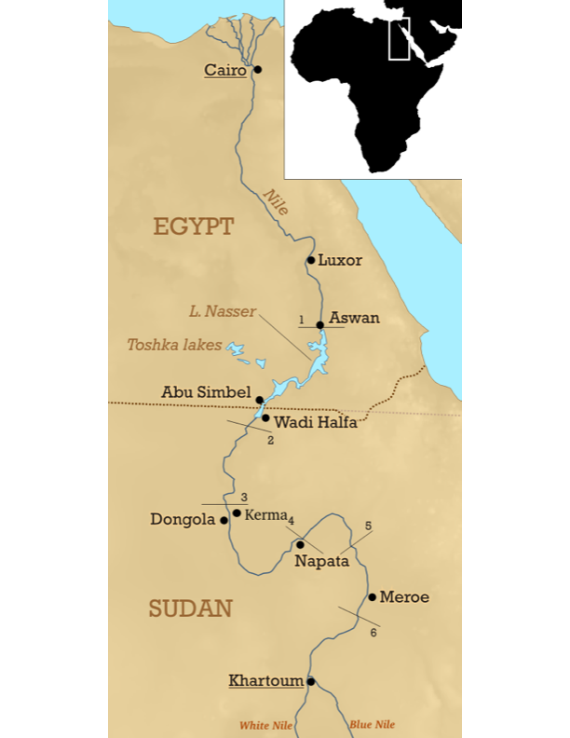
Nubian Political and Geographic Landscape
To understand Egypto-Nubian relationships, it is crucial to understand the history of Ancient Nubia. Ancient Nubia lay in what is today the nation of Sudan. Its approximate range spanned the area from the junction of the Blue and White Nile near Khartoum, to the first cataract of the Nile at Aswan (Adams 1974, 1; 1977, 20; Auenmüller 2019, 39; Shinnie 1996, 5-11; Figure 1). Nubians sustained themselves through agriculture and pastoralism. The seasonal inundation of the Nile provided Nubians with most of the water required for agriculture (Adams 1974, 1; Shinnie 1996, 5-11). In areas lacking sufficient water, the Ancient Nubians utilized a method unique to their culture whereby water was stored in man-made basins called hafirs. The construction of hafirs required immense organization of labor, such that their presence attests to the centralized power of Nubian kings (Edwards 1998, 185; Klemm, et al. 2019, 25).
Like Ancient Egypt, Nubian history includes some overlap among its various cultural groupings, making it difficult to create a cohesive narrative. A basic history of Ancient Nubia begins with the Nubian A-Group (3500-2900 B.C.E.), an egalitarian group of chiefdoms. By the late A-Group period, there was a shift to a system of complex hierarchal chiefdoms wherein several settlements ruled by local chiefs combined into a unit governed by a single chief. An example of this transition is found in the autobiography of Harkhuf, an Egyptian Nomarch and expedition leader to Nubia. In his travels, Harkhuf witnessed the uniting of the Nubian polities of Wawa, Irtjet and Setju under a single ruler in 2240 B.C.E. (Akinboye 2020, 4-5; Bietak 1987, 117; Goedicke 1981, 9; O’Connor 1993; Raue 2019, 301). The development of complex chiefdoms can be attributed to raids and long-distance trade; evidenced in elite burials containing imported metals, jewelry, and wine. Such luxury goods were hoarded by the elites, who controlled and redistributed this wealth creating a power dynamic that led to the establishment of kingdoms (Edwards 1998, 175,184-8).
Figure 1: Map of Nubia including cataracts 1-6 (labeled) (Image: Mark Dingemanse. work adapted under CC BY 2.5).
Succeeding the A-Group indirectly, was the Nubian C-Group (2400-1550 B.C.E.) which occupied Lower Nubia while the contemporary Kerma culture occupied Upper Nubia where Kerma was the capital. The subsequent Napatan period (850-650 B.C.E.) was known as the Kushite polity as rulers from Kush, based in Napata, dominated Egypt and ruled as the 25th Dynasty of Pharaohs. This was followed by the Meroitic period (400 B.C.E.-400 C.E.) which was marked by a shift in the center of influence from Napata to Meroe (Boozer 2017, 209; 2019, 1). This period was a continuation of the Kushite Dynasty that had ruled Egypt and continued until the subsequent decline of Nubia at the end of the fourth century C.E. which was the result of a decline in trade (Hassan 2007, 77-8; Smith 2015, 238-9). As Nubian monarchs relied on trade to maintain centralized control, the collapse of trade meant the collapse of their power base (Adams 1977, 383-5; Edwards 1998, 184,188).
Barriers Affecting the Study of Nubia
Within the study of Nubia, there are countless barriers resulting in incomplete knowledge and misunderstanding. Ancient Nubians, while maintaining their own spoken languages, did not possess a well-documented writing system prior to Meroitic which first appeared in 220 B.C.E. (Raue 2019, 4; Rilly 2019, 129, 131-7). While Meroitic is a heavily modified version of Egyptian, it was not a copy and due to its uniqueness, only 140 words are fully understood (Greenberg 1971, 438-9; Rilly 2019, 140-2). In addition, little is known about non-Egyptian gods in Nubian Kush, and representations of these gods from earlier periods have not been found (Almansa-Villatoro 2018, 175; Khalil and Miller 1996, 1-2). Unlike Egyptians, most Nubians were not intentionally mummified for burial. This makes it more difficult to understand aspects of their culture, such as when they began practicing scarification, and without preserved tissue, scarce iconographic inscriptions are the only evidence of these practices. Generally speaking, a lack of written sources and iconographic evidence prior to Egyptian contact makes it difficult to study the Nubian narrative from a Nubian perspective.
Another problem contributing to the knowledge gap involves the inaccessibility of many archaeological sites in Nubia. Several dams built from 1902 to 1971 submerged numerous Nubian sites and due to this, only a limited number of sites between the first cataract and the Batn el-Haggar can be excavated (Hassan 2007, 85; Raue 2019, 3-8; Rowan 2017, 178-9). With two prior civil wars and other ongoing hostilities, the War in Sudan has also made it too dangerous to excavate in many regions (Young 2003, 421, 430). As of 2023, conflicts in Sudan have escalated and fighting in Khartoum which began on April 15, 2023, has resulted in the deaths of more than 750 people and left over 51,000 injured (International Rescue Committee 2023).
One of the greatest barriers to a complete understanding of Ancient Nubia is that of Egyptocentrism, which Dr. Robin Derricourt described as “a movement to credit ancient Egypt with far greater influence and more widespread activity than is allowed by conventional scholarly explanations” (Derricourt 2015, 104). Most references to the development of the Kushite state contextualize it with reference to Egypt, suggesting that Nubia was only a secondary state on the margin of Egypt. These sources neglect to consider Nubia’s development into a complex state through centralized control over trade and its proximity to Egypt is often credited for the ascent of the Nubian kingdoms of Napata, Meroe, and Kerma. Notably, excavations at the city of Kerma attributed the imposing Nubian monuments as by-products of Egypt and the sculptures as gifts received from the Egyptians. Kerma had been suggested by some to be nothing more than an Egyptian outpost, and even today, many Nubian monuments and sites are ignored or left unexplored by excavators while other Nubian monuments have been incorrectly labeled as Egyptian monuments within Nubia (Edwards 1998, 175; Raue 2019, 3, 7; Sadig 2012, 157).
The father of American Egyptology, James Henry Breasted (1865-1935), thought the Nubian Kingdom of Napata could only have come about from Egyptian influence, suggesting that Nubians were incapable of producing their own history and innovations (Lemos and Tipper 2021, 1-6). Anthropologist William Y. Adams (1927-2019) suggested that after the 25th Dynasty (Nubian pharaohs) had ended, Nubians became less Egyptian and more barbaric (Schrader 2019, 168-9). German Egyptologist Adolf Erman (1854-1937) once stated (translated from German by author), “It's strange how Nubia is now gaining shape and history, in my imagination it's still the land of cultureless barbarians, where nothing can be found and nothing has ever existed but what the Egyptians were there have left” (Raue 2019, 4; Voss 2016, 248).
Egyptianization: The Material Evidence
The theory of Egyptianization, which lies under the umbrella of Egyptocentrism, suggests a process whereby Nubia was wholly given its culture by Egyptians. Egyptologist George Reisner (1867-1942) suggested that Nubians were incapable of producing a distinguished material culture of their own. He attributed the increased quality of black-topped Kerma ceramics found in the later Classical Kerma Period (1700-1550 B.C.E.) to Egyptian influence, rather than local improvement (Matic 2018, 30-2). However, it is far more likely that these wares were the result of a natural evolution of Nubian black-topped wares since black-topped wares first appear in the archaeological record in Nabta Playa, located in the Nubian desert, and could have influenced early Egyptian black-topped styles (Arkell 1953, 76; Gatto 2019, 265; Nelson and Khalifa 2011, 136; Sowada 1999, 86). The later Kerma black-topped wares were some of the most polished pieces of ceramic work in the Nile Valley and followed a pattern of quality consistent with other Nubian wares (“Classic Kerma Beaker”, The Met 20.2.45; “Beaker”, BM EA55424; Hayes 1978, 39-40; O’Connor 2015, 178-9; Strudwick 2006, 116-7). Incised black or dotted wavy line wares (Figure 2) were another vessel type found in both Egyptian and Nubian contexts. Incised line wares appeared in the Egyptian Naqada II Period (3500-3200 B.C.E.) at the Egyptian site of Naqada and in earlier forms at the site of Merimde (4800-4300 B.C.E.) northwest of Cairo. However, incised line wares were found in Nubia as early as the Khartoum Neolithic Period (5000-3800 B.C.E.) at sites like Esh-Shaheinab near Khartoum, central Sudan. Wavy line wares first appeared as early as the Mesolithic (10,000-8,000 B.C.E.) at sites such as Abu Darbein, Aneibis, and el Damer in northern Sudan (Arkell 1953, 76-9; Hayes 1990,18; Mohammed-Ali and Khabir 2003, 37; Raue 2019, 299; Wodzińska 2009, 49 fig. 23, 34). All of this indicates that both styles are unlikely to be a result of Egyptian influence and most likely originated independently.
Other styles such as painted egg-shell wares (Figure 3) were not found in Egypt at any point. Egg-shell wares, aptly named for their refined egg-shell thin ceramic walls, were often painted with distinctive basketry designs. They appeared as early as 3100-3000 B.C.E. during the Nubian A-Group Period and their use continued well into the Meroitic Period (300 B.C.E.-400 C.E.) Nubian ceramics, especially in the Meroitic period, were carefully decorated with scenes of people and everyday life, plants, and lively depictions of animals and animated serpents (Yellin 2020, 608). Other abstract depictions included depictions of crescents, horns, and disks and these styles were more expressive than the rigid conventions of Egyptian styles (Hale 1979, 76; Wenig 2019, 851). Comparisons (shown below) of decorated designs found in Egypt (Figures 8-10) around the same time as the Meroitic period show that decorations were markedly different than those in Nubia (Figures 4-7). Compared to the lifelike animals, geometric designs, and figural images of the Meroitic Nubians, typical Egyptian decorations were heavily inspired by Greek features. Simple bands or abstract wavy designs were popular and flower motifs and lotus decorations were especially popular. Surface decorations were far less common than in Nubia, and from the Late Period to the early Ptolemaic Period, Egyptian vessels displayed almost no decoration (Wodzińska 2019, 29, fig. 39, 40, 65, 105, 106). Altogether, Nubian ceramics are a testament to a refined tradition that began in the early Holocene and, although threatened by plastic containers, has persisted in contemporary Sudan. This admired craft of ceramic making is passed down through generations, with such wares demonstrating exceptional continuity from Ancient Nubia, including trademarks such as thin-walled ceramics and incised line wares (Cedro and Żurawski 2019, 30; Czyżewska-Zalewska and Kowarska 2020, 575-81, 586-7; D’Ercole et al. 2017, 553-5, 561; "The Art of Pottery Making in Sudan “, Africa Geographic 2016).
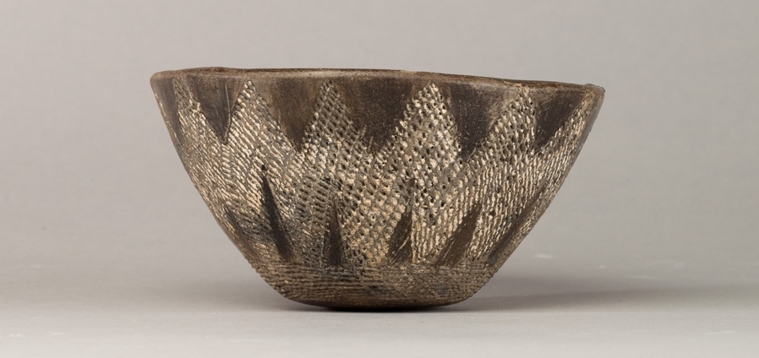

Figure 2: Black incised ware bowl. Egypt, Predynastic Period ca. 3850-2960 B.C.E. The Met, New York (15.2.29). License: CC0.

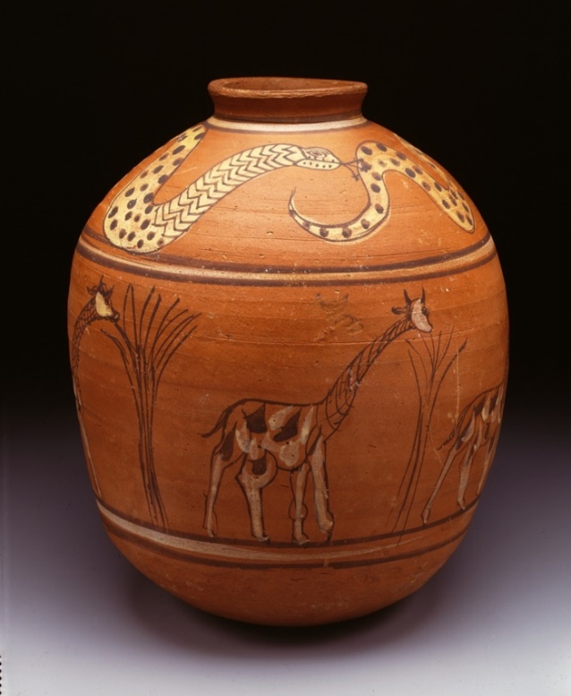
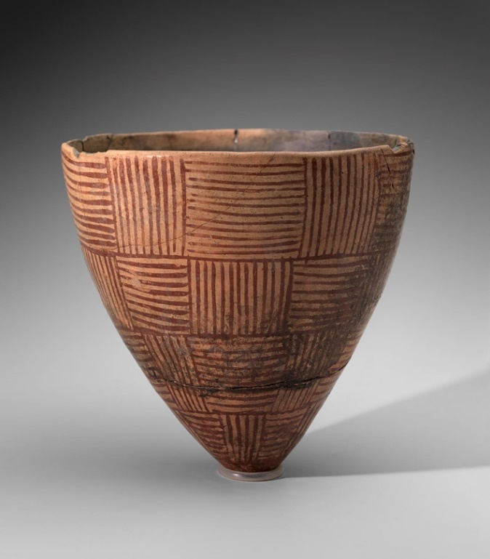

Figure 4: Meroitic ceramic work. Karanog Cemetery, Kush (Lower Nubia) ca. 100-1 B.C.E. Penn Museum Philadelphia (E8183). Use provided under Penn Museum Rights and Permissions: https://www.penn.museum/about-collections/rights-and-permissions.
Figure 3: “Egg-shell” ware. Painted with geometric patterns imitating basketry. Near Egeba, Nubia, Nubian A-Group ca. 3800-3100 B.C.E. MFA, Boston (19.1540). License: CC0.
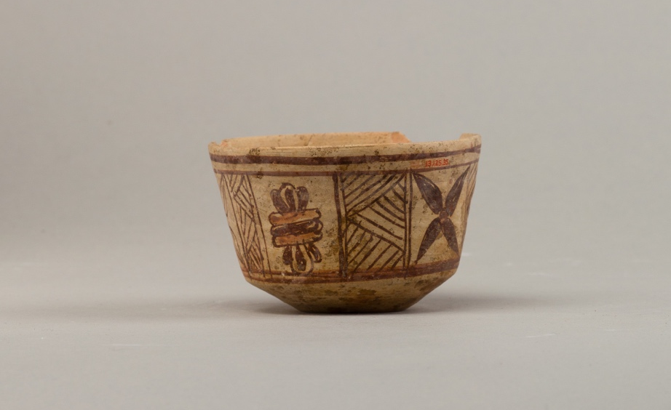

Figure 5: Bowl with floral and geometric designs. Sudan, Lower Nubia, Meroitic Period ca. 100-300 C.E. The Met, New York (13.125.35). License: CC0.

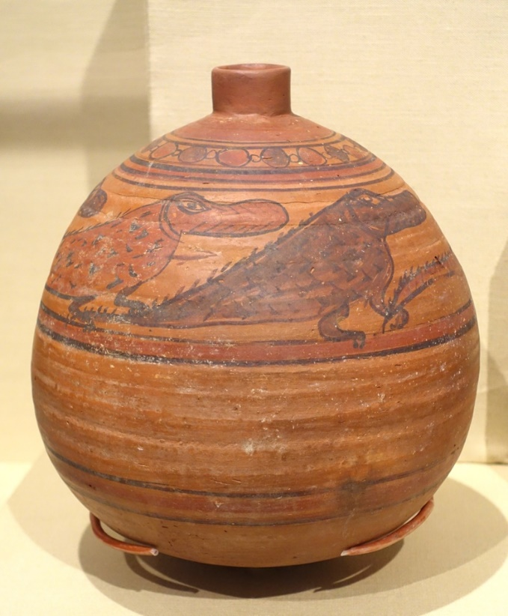
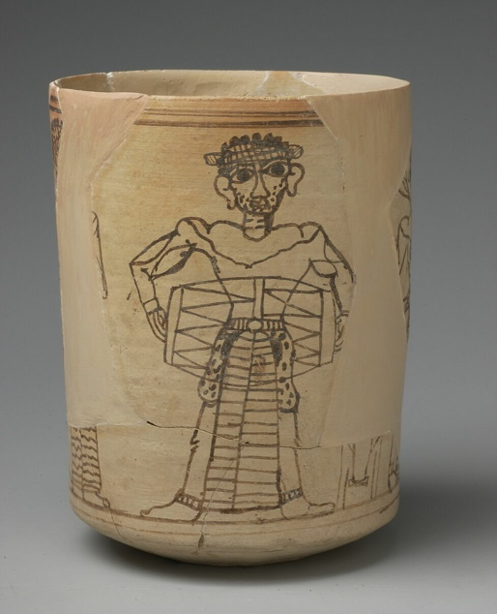

Figure 7: Jar with procession of crocodiles. Ballana, Nubia, Meroitic Phase III ca. 250-200 C.E. Oriental Institute of Chicago (photo: Daderot, CC0 1.0).
Figure 6: Decorated cup. Meroe, Sudan, Meroitic Period ca.100 B.C.E.-100 C.E. The Louvre, Paris (E11378). https://collections.louvre.fr/en/ark:/53355/cl010009825. Use permitted under Louvre article 4.1.1
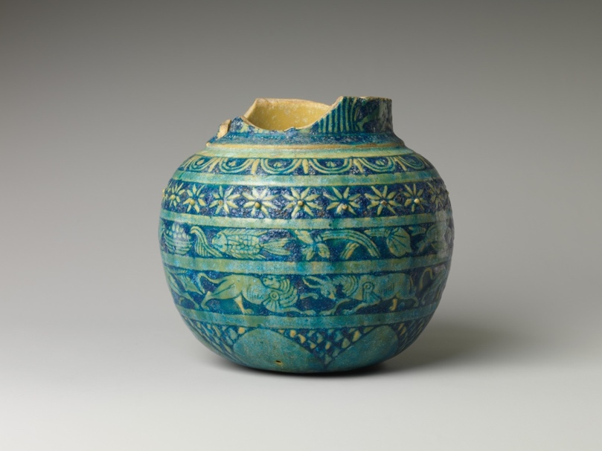

Figure 8: Storage jar with floral decorations. Thebes, Egypt, late 3rd-2nd century B.C.E. The Met, New York (13.180.34a). License: CC0.

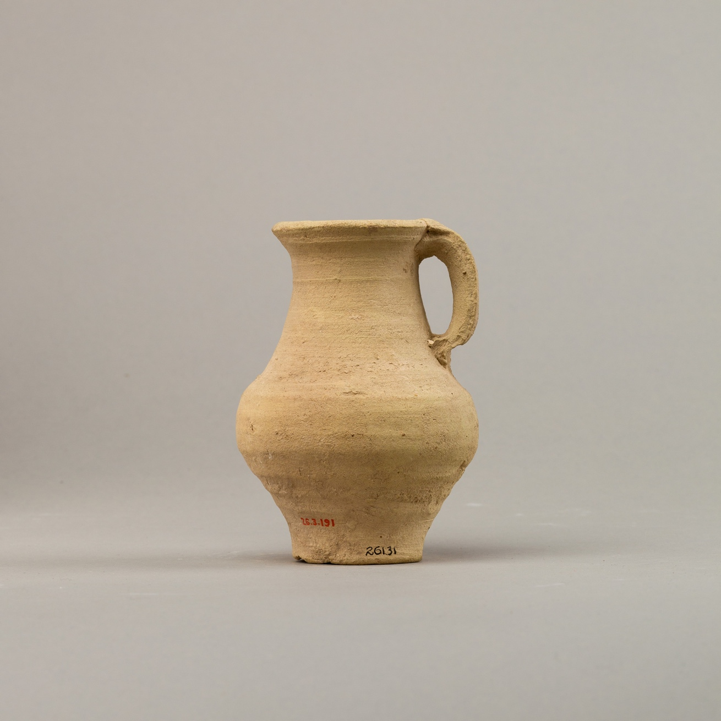
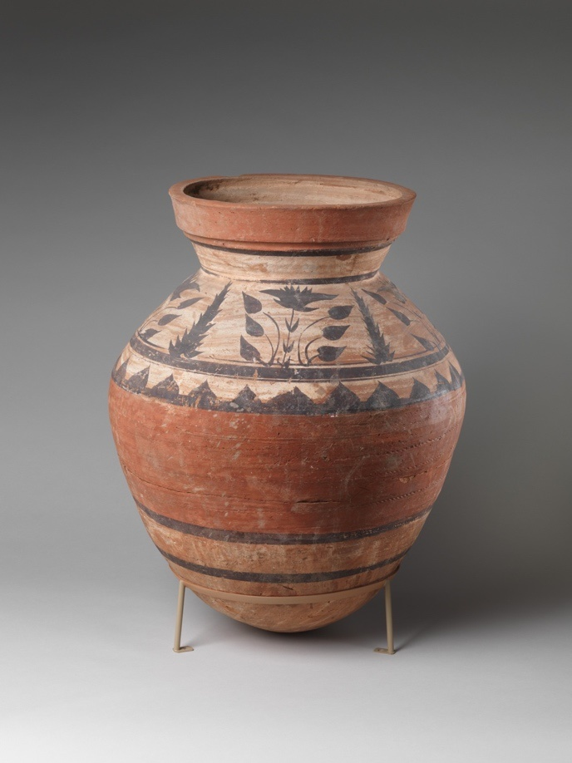
Figure 10: Undecorated jug. Thebes, Egypt ca. 300 B.C.E.-100 C.E. The Met, New York (26.3.191). License: CC0.
Figure 9: Jar with plant and animal decorations. Middle Egypt, Tuna el-Gebel. Ptolemaic Period ca. 100-30 B.C.E. The Met, New York (26.7.1013). License: CC0.

Egyptianization suggests that Nubia not only received its culture from Egypt, but also that Nubia imitated Egypt. When George Reisner led the initial Archaeological Survey of Nubia (1907-1908), he found nothing unique about Nubian artifacts, remarking that they were identical in nearly every way to those found in Egypt (Lemos and Tipper 2021, 3). Certainly, Nubians adopted many Egyptian items, such as ushabtis, which are funerary figures that were placed in the tomb and designed to serve the deceased in the afterlife. Despite employing ushabtis, the figurines were adapted to Nubian sensibilities in several ways. Both locally made and imported ushabtis often featured unique decorative patterns to fit with local Nubian interests. They were also often left uninscribed, negating the inclusion of names which were required in Egyptian custom (Lemos and Budka 2021, 407-10; Lemos and Tipper 2021, 3).
Other examples of adapted cultural practices can be found in the Kushite Tomb 26 at Sai Island, dating from the pre-Napatan (1250-800 B.C.E.) to the Napatan period (850-650 B.C.E). Here, Nubian versions of the canopic jars were made using ordinary local pottery vessels and topping them with clay lumps to simulate human heads (Budka 2018, 188; Lemos and Budka 2021, 407; Retzmann et al. 2020, 356). Locally made incense burners belonging to the Nubian A-Group (3800-3100 B.C.E.) such as the Qustul Incense Burner, featured elements of Egyptian symbolism, such as a bound prisoner scene, a serekh, and the Horus falcon. Others, however, like the Archaic Horus Incense Burner, also contained unique Nubian iconographic aspects, such as a bow standing behind the ruler depicted (Williams 2011, 83-92). Seal impressions found in a northern Nubian cemetery at the site of Sili contained similar bow depictions, possibly invoking the name Ta-Seti (land of the bow), the early Egyptian name for Nubia. The impressions, like the incense burners, contain essential Egyptian elements, such as the royal falcon of kingship, and the serekh itself. They also contain other Nubian elements such as depictions of cattle and incense burners, both of which were significant in Nubian culture (Gatto 2020, 135). Incense burners, while employed in Egypt, were especially sacred in Nubia as they were linked to royal funerary rites and symbolized prestige and importance. Thus, reproducing the imagery of these burners would symbolically link the owner to the Nubian king in their afterlife (Baldi 2014, 77,81).
Egyptianization: The Burial Evidence
In addition to material culture, burial customs also illustrate that when Nubians adopted Egyptian customs, they negotiated their own meanings and maintained a distinctive Nubian identity. At the Third Intermediate Period (744-656 B.C.E.) Nubian site of Tombos, the burials of four women contained mostly Egyptian goods, yet the bodies were oriented in flexed positions with the head facing west in the Nubian manner, as opposed to the contemporaneous Egyptian custom of having the body extended, lying on the back with the head facing east (Bard 2015, 282; Manfred 1987, 119; Peressinotto et al. 2003, 109-11). In addition, while Nubian flexed burials have been found in Egyptian styled burial structures, extended Egyptian styled burials have also been found in Nubian tumulus (mounds) burials (Buzon et al. 2023, 7-9). Cemeteries at administrative colonial centers in Nubia, such as Sai, Soleb, and Aniba, all feature Egyptian style monumental tombs due to their proximity to the dominant culture. Yet, even at these centers, there was a disjointed acculturation to Egyptian customs occurring to varying degrees. For example, at the sites of Amara West and Tombos, four underground Egyptian styled chambers featured Nubian styled tumuli atop them (Lemos and Budka 2021, 407,413).
Egyptianization: The Nubian Kings
When the Nubians became pharaohs, they borrowed many elements from Egyptian kingship. This did not, however, include the principle of kingship itself. As mentioned previously, Nubian kingdoms based on trade were established prior to the adoption of pharaonic principles. For example, Kerma was already a complex state by 2400 B.C.E. In addition, polities with a population exceeding 100,000, such as Nubia are typically considered states, and their rulers called kings instead of chiefs (O’Connor 1993; Smith 2015, 237). Certainly, when Nubians ruled Egypt as the 25th Dynasty (747-656 B.C.E.), they borrowed Egyptian iconography in order to be seen as political equals to Egyptian pharaohs while simultaneously retrofitting it to Nubian sensibilities. Royal titles for instance, such as those found at the rock inscription at the Nubian site of Umm Nabari, show a unique lion element included within the king’s name (Cooper 2018, 148-50). Other aspects of iconography, such as the title Sa-Re (son of the Sun), were not unknown to Nubians. For example, at the site of Eastern Deffufa, there is evidence of a solar cult and royal cemetery that predates the Kushite 25th Dynasty. There, a depiction of a solar disc on a royal title indicates the Nubian solar God, Masa, linking the royal deceased with the Nubian sun deity (Cooper 2018, 148-50).
As Pharaohs, Nubians also maintained their own social and political beliefs, which are reflected in the iconography of the 25th Dynasty. For instance, ruling women in Nubia had different rights and expectations than Egyptian women. In Egypt, female rulers were not generally depicted as equal to male rulers, yet in Nubia, this was more common. All depictions of Queen Amanitore show her as coregent and equal to her husband Natakamani (Phillips 2016, 291). Queen Amanitore and King Natakamani are depicted across from one another in equal size, suggesting equal status. Both are performing the same actions of a king such as smiting the enemies of Nubia or presenting offerings to the Nubian god Apedemak. Stylistically, Amanitore is depicted as robust in a manner not reflective of Egyptian iconographic conventions for both men and women. The dress worn by the king and queen are Nubian in style (Figure 13,14) and Natakamani can be seen wearing a hemhem cap crown with an uraeus headband (Figure 13). Such styles of royal headwear do not appear in Egyptian contexts. Other depictions show rulers such as Taharqa or Amanitore with double cobra uraei (Figure 12, 14) rather than the Eqyptian cobra uraeus and vulture (Figure 11). Uniquely Nubian elements retained by kings additionally included ram necklaces and loose-fitting dresses under a cape tied at the shoulders (Buzon et al. 2016, 296; Phillips 2016, 294; “Ram’s-head Amulet” 1989.281.98; “The Oriental Institute of the University of Chicago n.d.).
The Theory of Egypt in a Vacuum
Outside of Egyptianization, the theory of Egypt developing apart from Nubia, and Africa as a whole, is equally problematic. Historically the founders of Nubian archaeology (of which none were Nubian) pushed ideas of diffusionism (Raue 2019, 5) which suggested that Mediterranean migrants from the north were the ones that brought the elements of pharaonic civilization into Egypt, not peoples of African origin. Of Sub-Saharan Africans, James Henry Breasted remarked, “These people occupy an important place in the modern world, but they played no part in the rise of civilization” (1944, 131). Egyptologist Cyril Aldred asserted that early people living along the Nile valley were a race of peoples that had mixed Mediterranean blood, negating any mention regarding Africa; “…the Mediterranean race mingled their blood and speech before the dawn of history, though the Egyptians were to be reinforced in historic times by infiltrations and migrations of different peoples from the Sudan, Libya and the Levant” (Aldred 1965,16). Such theories not only separated pharaonic Egypt from Africa but negated the reality that Nubians and Egyptians shared much of their cultural origins through early contacts.
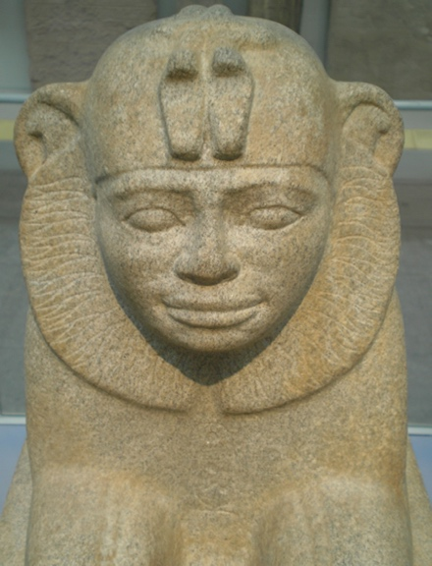
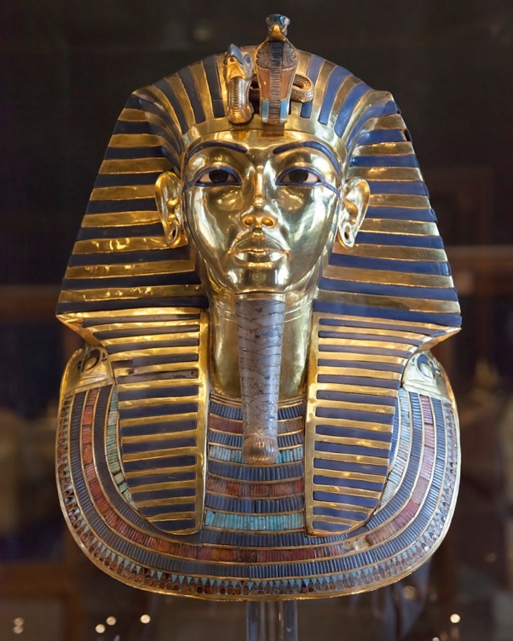
Figure 12: Sphinx of the Nubian Pharaoh Taharqa. Double cobra uraei are above the brow of the king. British Museum (photo: Udimu, CC BY-SA 3.0).
Figure 11: The funerary mask of Tutankhamun. Cobra ureaus and vulture are above the brow of the king. Egyptian Museum, Cairo (photo: Roland Unger, CC BY-SA 3.0).
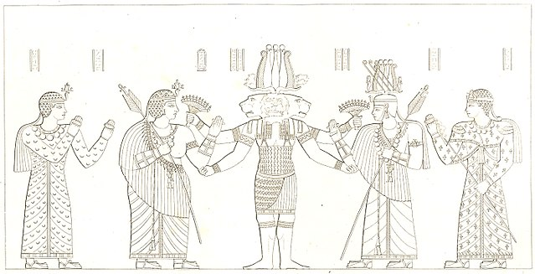
Figure 13: Drawing of relief found on Naga temple, Nubia. Queen Amanitore is left nearest Apedemak (center). King Natakamani is on the right nearest the god (Haaland 2014, 662; Phillips 2016 293-294) (photo: Frédéric Cailliaud, public domain).

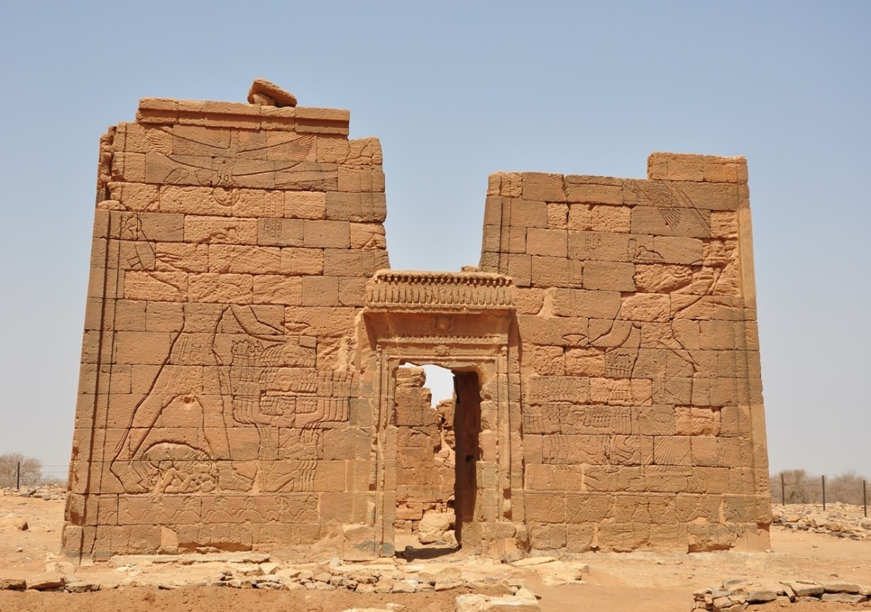

Figure 14: Relief at temple of Naga in Nubia. The left side features King Natakamani, while the right features Queen Amanitore (photo: TrackHD, CC BY 3.0).

All these assertions which perpetrate otherness and separate Nubians and Africans in general from Egyptians, are not factually sound. By the end of the Middle Neolithic (approx. 6000 B.C.E.), the sub-Saharan regions inhabited by mobile pastoralists became arid, leading to their eventual abandonment. This led to a subsequent migration into the Nile Valley by both Nubians and Egyptians (D’Ercole 2017, 13; Hassan 1986, 92; Nelson and Khalifa 2011,135-6; Manfred 1987, 116; Usai 2016, 19-20). When Neolithic peoples settled in various scattered regions along the Nile, such as Naqada, the Kharga Oasis, and Nabta Playa, this migration featured population and cultural exchanges leading to a merging of traits from the Naqada II period onward (Crawford 2021, 700; Hassan 1986, 92). The similarities in tradition from the earliest points are a testament to this contact. Strong cattle culture flowered in Nubia, as indicated by Neolithic A-Group rock art depicting cattle, such as those found at Abka (now submerged). A distinctive feature of burials from around all of Nubia is the inclusion of cattle skulls surrounding the burial tumuli (Schrader et al. 2018, 9; Shinnie 1996, 41) indicating that Nubians conferred religious significance on cattle from quite early on (Schrader 2019, 138; Shinnie 1996, 7). Given that cattle were far more common in Nubia, cattle culture could have spread northward into Egypt through early Nubian contact (Crawford 2021, 700). In Egypt, the earliest depictions of the king show him as a bull or wearing a bull’s tail, symbols associated with strength and kingship. In addition, Bull cults of Buchis, Mnevis, or Kemwer, and the worship of Gods with cattle attributes persisted in Egypt (Ikram and Dodson 2005, 7)
Similar iconographic styles also suggest early contacts between predynastic Egyptians and early Nubian groups. Comparisons between rock art found in Dakhla, Egypt and the Kharga Oasis display petroglyphs that are stylistically similar to Nubian-made examples at sites like Toshka East, Amada, Wadi El-Arab, Gerf Hussein (Berger 2010, 187, fig. 6, 7, 8, 9; Dunbar 1934, 153, 155, p. III, IV, VIII; Ikram 2009, 71, fig. 4). Both sites contain stylistically similar depictions of animals, boats, and people. Further evidence of early cultural mingling can be found at the hamlet of Nag el-Qarmila, north of Aswan, located in Upper Egypt and dating to 3800-3600 B.C.E. This hamlet contained a cemetery with graves consisting of shallow pits dug into the sand in the Nubian style. Inside the graves Egyptian Naqada ceramic wares and Nubian black-topped wares were found in addition to hybrid Nubian-Naqada objects such as Naqada red polished bowls with Nubian milled rim decorations. Ceramics found at the Naqada period site (3200-3000 B.C.E.) of Bir Sahara in the Western Desert also contained Naqada ceramics and Nubian black-topped ceramics, both of which were left in a pit (Gatto 2020, 130-1). For both early Egyptians and Nubians, the body of the deceased was laid out in a flexed position on its side in a shallow ovoid or circular pit with the head facing west (Bard 2015, 108-9; Murray 1956, 87-90). Both the Nubian and Egyptian burials featured body ornaments such as colored stone beads and worked bone as well as stone and clay cosmetic vessels and combs of bone or ivory along with black-topped wares. To illustrate this, Figure 15, a Nubian Kerma burial, is compared with Figure 16, an Egyptian Predynastic burial. Both are buried in ovoid or circular shallow pits with the bodies in flexed positions, lacking embalming, and featuring black-topped ware inclusions (Almansa-Villatoro 2018, 172; Bard 2015, 110; Peressinotto et al. 2003, 111).
Just as there was a shared development in the early prehistoric phases of Egyptian and Nubian culture, the exchanges continued into later dynastic times. Many Nubians migrated into Egypt to work as mercenaries or to live a civilian life. There is evidence of the latter at sites like Hierakonpolis in Egypt, where a C-Group cemetery contained skeletal remains that displayed no signs of trauma (Friedman 2007, 58-65). Egyptian burials at Tombos in Nubia show that there was a great deal of Egyptian immigration into Nubia (Buzon et al. 2023, 1-6, 9; Retzmann et al. 2020, 372). At Tombos, there is clear evidence that Egyptians had long-standing ties to the Nubian population, with isotopic and morphometric evidence along with burial goods showing evidence of intermarriage between Nubians and Egyptians (Buzon et al. 2016, 295-6). Great migrations of Egyptian artists and priests are also known to have occurred during the 25th Dynasty (Burstein 2021, 42).
Conclusion
Several barriers surround the study of Ancient Nubia. Poor preservation, a lack of written sources and material remains, and the inaccessibility of many archaeological sites have created a knowledge gap and a subsequent evidence bias. On top of this, scholars have historically possessed an Egyptological bias and suggested that much of what made Nubia noteworthy was due to the adoption of Egyptian culture. Contradicting this, is the evidence presented in this paper, which shows that Nubians possessed elaborate ceramics, religious practices, burial traditions, and their own ruling customs. They never required Egypt as an inspiration to nation-build or to give them an identity. Egyptianization mitigates Nubian culture by suggesting that it was replaced by a homogenized Egyptian culture. This is not unlike other theories of assimilation, such as Hellenism or Romanization, which were founded on assumptions that have been heavily scrutinized in recent decades (Smith and Buzon 2014, 131). In fact, iconographic and historical
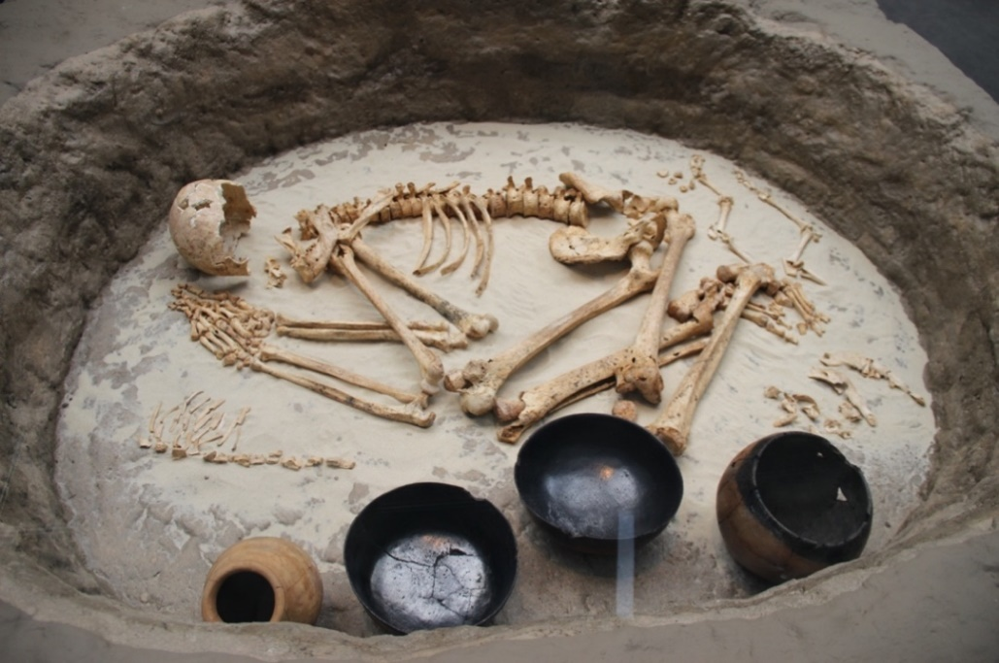

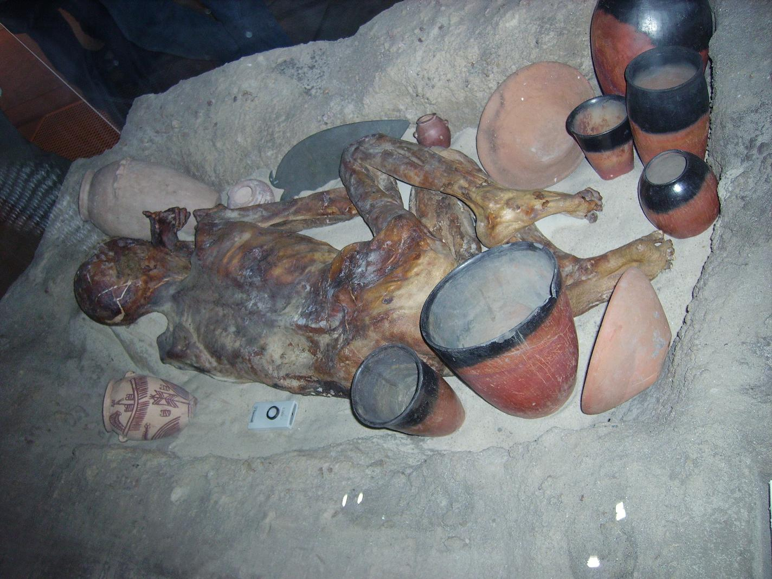
Figure 15: Reconstructed Nubian Kerma burial, now in the British Museum (photo: Gary Todd, CC0 1.0).

Figure 16: Egyptian Predynastic burial (photo: Popperipopp, public domain).

evidence shows that Nubians selectively adopted some traits, rejected others, and created new cultural blends of their own and that the relationship between Nubia and Egypt was fluid and more akin to one of cultural entanglement. The term “Egyptianization” is outdated by most definitions and does not accurately describe the relationships at play between the two civilizations. The theory of Egypt in a vacuum likewise suggested that Egypt developed apart from Nubia and sub-Saharan Africa. By suggesting that Egypt came into being separate from Africa, scholars were able to push the idea that Nubians were not like the Egyptians and did not share cultural similarities. Altogether, Egyptocentric narratives regarding Ancient Egypt and Ancient Nubia present incorrect views on the interplay between the two civilizations and these narratives must be re-examined to properly understand the complex relationships between these two early states.
References

Adams, William Y.
1974. “Sacred and Secular Polities in Ancient Nubia." World Archaeology 6, no. 1: 39–51.
doi:10.1080/00438243.1974.9979587
———.
1977. Nubia, Corridor to Africa. Princeton, New Jersey: Princeton University Press.
Africa Geographic.
2016. "The Art of Pottery Making in Sudan ". https://africageographic.com/stories/art-pottery-making-sudan/.
Akinboye, 'Goke.
2020. “Beautiful Nubia: The Rise of an Ancient African Kingdom.” University of Ibadan Department of
Classics.
Aldred, Cyril.
1965. Egypt to the End of the Old Kingdom. London: Thames & Hudson.
Almansa-Villatoro, M. Victoria.
2018. “Reconstructing the Pre-Meroitic Indigenous Pantheon of Kush.” Journal of Ancient Near Eastern
Religions 18, no. 2: 167–189. doi:10.1163/15692124-12341299
Arkell, A.J.
1953. "The Sudanic Origin of Predynastic ‘Black Incised’ Pottery." The Journal of Egyptian Archaeology 39,
no: 1: 76-79. doi:10.1177/030751335303900108
Auenmüller, Johannes.
2019. "Topography and Regional Geography of Nubia: River, Cataract and Desert Landscapes." In Handbook
of Ancient Nubia, edited by Dietrich Raue. Berlin, Germany: De Gruyter.
Baldi, Marco.
2014."Aromatic Essences in Ancient Nubia: The Sacredness of Perfumes and Incense in the Meroitic
Kingdom." Journal of Intercultural and Interdisciplinary Archaeology 1: 73-104.
doi:10.11588/jiia.2014.01.20018
Bard, Kathryn A.
2015. An Introduction to the Archaeology of Ancient Egypt, 2nd Edition. Hoboken, New Jersey: John Wiley &
Sons.
Bietak, Manfred.
1987. “The C-Group and the Pan-Grave Culture in Nubia.” In Nubian Culture: Past and Present. Kunigl.
Vitterhets Historie Och Antikvitets Akademiens Konferenser 17. Stockholm, Sweden.
Berger, Friedrich.
2010. "Djedefre’s Water Mountain: Phases of Degradation." Rock Art Research 27, no: 2: 185-194.
Boozer, Anne Lucille.
2017. "A Historiography of Archaeological Research at Meroë, Sudan." Ancient West and East 16: 209-248.
doi:10.2143/AWE.16.0.3214940
———.
2019. "Meroë." In Encyclopedia of Global Archaeology, edited by Claire Smith. New York, NY: Springer.
Breasted, James Henry.
1944. Ancient Times: A History of the Early World Second Edition. Boston, MA: Ginn and Company.
Budka, Julia.
2018. From Microcosm to Macrocosm. Individual Households and Cities in Ancient Egypt and Nubia, edited
by Julia Budka and Johannes Auenmüller. Leiden, Netherlands: Sidestone Press.
Burstein, Stanley M.
2021. “Egypt and the Kingdom of Kush.” Ancient Egypt Magazine.
Buzon, Michele R., Stuart Tyson Smith, and Antonio Simonetti.
2016. “Entanglement and the Formation of the Ancient Nubian Napatan State.” American Anthropologist 118,
no. 2: 284–300. doi:10.1111/aman.12524
Buzon, Michele R., Kari A. Guilbault, and Antonio Simonetti.
2023. "Exploring Intersectional Identities and Geographic Origins in Ancient Nubia at Tombos, Sudan."
Bioarchaeology International. doi:0.5744/bi.2022.0029
Carrano, Julia L., Gary H. Girty, and Carl J. Carrano.
2009. "Re-Examining the Egyptian Colonial Encounter in Nubia through a Compositional, Mineralogical, and
Textural Comparison of Ceramics." Journal of Archaeological Science 36, no. 3: 785-797.
doi:10.1016/j.jas.2008.11.002
Cooper, Julien.
2018. “Kushites Expressing ‘Egyptian’ Kingship: Nubian Dynasties in Hieroglyphic Texts and a Phantom
Kushite King.” Ägypten und Levante 28: 143–168. doi:10.1553/AEundL28s143
Crawford, Keith W.
2021. “Critique of the ‘Black Pharaohs’ Theme: Racist Perspectives of Egyptian and Kushite/Nubian
Interactions in Popular Media.” African Archaeological Review 38, no. 4: 695–712. doi:10.1007/s10437-021-
09453-7
Cedro, Aneta, and Bogdan Żurawski.
2019. "Living with the Past in Modern Sudanese Village Traditional Pottery Production in the Ad-Dabba Bend
of the Nile." Études et Travaux 32: 23-52. doi:10.12775/EtudTrav.32.003
Czyżewska-Zalewska, Ewa and Zofia Kowarska.
2020. "Modern and Ancient Pottery Traditions in the El-Zuma and Karima Region in Sudan: An Introduction
to Comparative Studies (Pots Project)." International Journal of Historical Archaeology 24: 571-88. doi:
10.1007/s10761-019-00524-9
D'Ercole, Giulia, Elena A.A. Garceab, Giacomo Eramoc, and Italo M. Muntonid.
2017. "Variability and Continuity of Ceramic Manufacturing of Prehistoric Pottery from Upper Nubia, Sudan:
An Ethnographic Comparison." Journal of Archaeological Science: Reports 16: 553-563.
doi:10.1016/j.jasrep.2017.04.012
D’Ercole, Giulia.
2017. Ceramic Manufacturing Techniques and Cultural Traditions in Nubia from the 8th to the 3rd
Millennium BC: Examples from Sai Island. Oxford: Archaeopress.
Derricourt, Robin.
2015. Antiquity Imagined: The Remarkable Legacy of Egypt and the Ancient Near East. London: I.B. Tauris.
Dietrich Klemm, Rosemarie Klemm, and Andreas Murr.
2019. "Geologically Induced Raw Materials Stimulating the Development of Nubian Culture." In Handbook of
Ancient Nubia, edited by Dietrich Raue. Berlin, Germany: De Gruyter.
Dunbar, J.H.
1934. "Some Nubian Rock Pictures." Sudan Notes and Records 17: 139-64.
Edwards, David N.
1998. "Meroe and the Sudanic Kingdoms." The Journal of African History 39, no. 2: 175-193.
doi:10.1017/S0021853797007172
Friedman, Renée.
2007. "The Nubian Cemetery at Hierakonpolis, Egypt. Results of the 2007 Season." Sudan and Nubia 11.
Gatto, Maria Carmela.
2019. "The Later Prehistory of Nubia in Its Interregional Setting." In Handbook of Ancient Nubia. Berlin,
Germany: De Gruyter.
———.
2020. “The A-Group and the 4th Millenium B.C.E. Nubia.” In The Oxford Handbook of Ancient Nubia, edited
by Bruce Beyer Williams, and Geoff Emberling, 125-142. New York, NY: Oxford University Press.
Goedicke, Hans.
1981. Harkhuf's travels. Journal of Near Eastern Studies 40, no.1:1–20. doi:10.1086/372836
Greenberg, Joseph H.
1971. "Nilo-Saharan and Meroitic." In Linguisitics in Sub-Saharan Africa. Dre Gruyter Mouton.
Haaland, Randi.
2014. “The Meroitic Empire: Trade and Cultural Influences in an Indian Ocean Context.” African
Archaeological Review 31, no. 4: 649–673. doi:10.1007/s10437-014-9169-0
Hassan, Fekri A.
1986. "Chronology of the Khartoum ‘Mesolithic’ and ‘Neolithic’ and Related Sites in the Sudan: Statistical
Analysis and Comparisons with Egypt." African Archaeological Review 4: 83-102. doi:10.1007/BF01117036
———.
2007."The Aswan High Dam and the International Rescue Nubia Campaign." African Archaeological Review
24: 73-94. doi:10.1007/S10437-007-9018-5
Hayes, William C.
1978. The Scepter of Egypt a Background for the Study of the Egyptian Antiquities in the Metropolitan
Museum of Art. Vol. 1. New York, NY: The Metropolitan Museum of Art.
———.
1978. The Scepter of Egypt: A Background for the Study of the Egyptian Antiquities in the Metropolitan
Museum of Art. Vol. 2. the Hyksos Period and the New Kingdom (1675–1080 B.C.). New York, NY: The
Metropolitan Museum of Art.
Hale, Sondra.
1979. “Africa in Antiquity: The Arts of Ancient Nubia and the Sudan.” African Arts 12, no. 2: 75-76.
doi:10.2307/3335491
Ikram, Salima, and Aidan Dodson.
2005. “Bull Cults” Essay. In Divine Creatures: Animal Mummies in Ancient Egypt, 72–102. Cairo: American
University in Cairo Press.
Ikram, Salima.
2009. "Drawing the World: Petroglyphs from Kharga Oasis." Archéo-Nil 19: 67-82.
doi:10.3406/arnil.2009.980
International Rescue Committee.
2023. "Fighting in Sudan: What You Need to Know About the Crisis." International Rescue Committee.
https://www.rescue.org/article/fighting-sudan-what-you-need-know-about-crisis.
Khalil, Mokhtar, and Catherine Miller.
1996. “Old Nubian and Language Uses in Nubia.” Égypte/Monde arabe, no. 27-28: 67–76.
doi:10.4000/ema.1032
Lemos, Rennan, and Julia Budka.
2021. “Alternatives to Colonization and Marginal Identities in New Kingdom Colonial Nubia (1550–1070
BCE).” World Archaeology 53, no. 3: 401–418. doi:10.1080/00438243.2021.1999853
Lemos, Rennan and Samantha Tipper.
2021.Current Perspectives in Sudanese and Nubian Archaeology: A Collection of Papers Presented at the
2018 Sudan Studies Research Conference, Cambridge. Oxford: Archaeopress Publishing Ltd.
Mohammed-Ali, Abbas and M. Khabir, Abdel-Rahim.
2003. "The Wavy Line and the Dotted Wavy Line Pottery in the Prehistory of the Central Nile and the Sahara-
Sahel Belt." African Archaeological Review 20, no. 1: 25-58. doi:10.1023/A:1022882305448
Murray, M.A.
1956. "Burial Customs and Beliefs in the Hereafter in Predynastic Egypt." The Journal of Egyptian
Archaeology 42, no. 1: 1-131. doi:10.1177/030751335604200112
Nelson, Kit and Eman Khalifa.
2011. “Nabta Playa Black-Topped Pottery: Technological Innovation and Social Change.” Essay. In Egypt at
Its Origins 3: Proceedings of the Third International Conference "Origin of the State: Predynastic and Early
Dynastic Egypt",133–148. Leuven, Belgium: Uitgeverij Peeters en department oosterse studies.
The Oriental Institute of the University of Chicago.
n.d. “Kushite Kingdom”. https://oi.uchicago.edu/museum-exhibits/nubia/kushite-kingdom.
O'Connor, David.
1993. “Chiefs or Kings? Rethinking Early Nubian Politics”. Expedition Magazine, 35, no. 2.
———.
2015. “An Expanding Worldview: Conquest, Colonization, and Coexistence" In Ancient Egypt Transformed:
The Middle Kingdom, edited by Adela Oppenheim, Dorothea Arnold, Dieter Arnold and Kei Yamamoto. New
York, NY: The Metropolitan Museum of Art.
Peressinotto, David, Aurore Schmitt, Y. Lecointe, Raphaël Pouriel, and Francis Geus.
2003. "Neolithic Nomads at El Multaga, Upper Nubia, Sudan." Antiquity 78, no. 299: 106-112.
doi:10.1017/S0003598X00092929
Phillips, Jacke.
2016. “Women in Ancient Nubia.” in Women in Antiquity, edited by Stephanie Lynn Budin and Jean
Macintosh Turfa, 316–334. Oxfordshire: Routledge.
Raue, Dietrich.
2019. "Cultural Diversity of Nubia in the Later 3rd–Mid 2nd Millennium BC." In Handbook of Ancient Nubia
edited by Dietrich Raue. Berlin, Germany: De Gruyter.
———.
2019. "Introduction." In Handbook of Ancient Nubia, edited by Dietrich Raue. Berlin, Germany: De Gruyter.
Reisner, George Andrew.
1966. "Black-Topped Pottery." Journal of the American Research Center in Egypt 5: 7-10.
doi:10.2307/40000165
Retzmann, Anika., Julia Budka, Helmut Sattmann, Johanna Irrgeher, and Thomas Prohaska.
2020. “The New Kingdom Population on Sai Island: Application of Sr Isotopes to Investigate Cultural
Entanglement in Ancient Nubia.” Ägypten und Levante 29: 354–79. doi:10.1553/0x003b51b5
Rilly, Claude.
2019. "Languages of Ancient Nubia." In Handbook of Ancient Nubia edited by Dietrich Raue. Berlin,
Germany: De Gruyter.
Rowan, Kirsty.
2017. "Flooded Lands, Forgotten Voices." International Journal of Intangible Heritage 12: 175-187.
doi:10.35638/ijih.2017..12.019
Schrader, Sara, Michele R. Buzon, and S.T. Smith.
2018. “Colonial-Indigene Interaction in Ancient Nubia an Integrative Analysis of Stress, Diet, and Ceramic
Data.” Bioarchaeology of the Near East 12: 1–32.
Schrader, Sarah.
2019. Activity, Diet and Social Practice: Addressing Everyday Life in Human Skeletal Remains.
Bioarchaeology and Social Theory. New York, NY: Springer.
Sadig, Azhari.
2012. "Chronology and Cultural Development of the Sudanese Neolithic." BEITRÄGE ZUR
SUDANFORSCHUNG 11: 136-184.
Shinnie, Peter L.
1996. Ancient Nubia. London: Kegan Paul International Unlimited.
Smith, S.T., and Michele R. Buzon.
2014. "Colonial Entanglements: “Egyptianization” in Egypt’s Nubian Empire and the Nubian Dynasty." In The
Fourth Cataract and Beyond: Proceedings of the 12th International Conference for Nubian Studies, edited by
Julie R. Anderson and Derek Welsby, 431-443. London: British Museum Press.
Smith, S.T.
2015. “Nubia and Egypt: Interaction, Acculturation, and Secondary State Formation from the Third to First
Millennium B.C.” Essay. In Studies in Culture Contact: Interaction, Culture Change, and Archaeology.
Carbondale, Il: Southern Illinois University Press.
Sowada, Karin N.
1999. "Black-Topped Ware in Early Dynastic Contexts." The Journal of Egyptian Archaeology 85: 85-102.
doi:10.2307/3822428
Usai, Donatella.
2015. A Picture of Prehistoric Sudan: The Mesolithic and Neolithic Periods. Oxford: Oxford University Press.
Voss, Susanne.
2016. Wissenshintergründe … – Die Ägyptologie Als ‚Völkische‘ Wissenschaft Entlang Des Nachlasses Georg
Steindorffs Von Der Weimarer Republik Über Die Ns- Bis Zur Nachkriegszeit. Berlin, Germany: De Gruyter.
Wenig, Steffen.
2019. "Art of the Meroitic Kingdom." In Handbook of Ancient Nubia, edited by Dietrich Raue. Berlin,
Germany: De Gruyter.
Williams, Bruce B.
2011 “Relations between Egypt and Nubia in the Naqada Period.” In Before the Pyramids: The Origins of
Egyptian Civilization, edited by Emily Teeter. Chicago, Il: Oriental Institute of the University of Chicago.
Wodzińska, Anna.
2009. A Manual of Egyptian Pottery Volume 1 Ptolemaic through Modern Period. A Manual of Egyptian
Pottery Vol. 1. Boston, MA: Ancient Egypt Research Associates (AERA).
———.
2019. A Manual of Egyptian Pottery Volume 4: Ptolemaic through Modern Period. A Manual of Egyptian
Pottery Vol. 4. Boston, MA: Ancient Egypt Research Associates (AERA).
Yellin, Janice.
2020. "Ancient Nubian Art - Prolegomena to the Study of Meroitic Art." In The Oxford Handbook of Ancient
Nubia, edited by Geoff Emberling and Bruce Williams. Oxford: Oxford University Press.
Young, John.
2003. "Sudan: Liberation Movements, Regional Armies, Ethnic Militias & Peace." Review of African Political
Economy 97: 423-34. doi:abs/10.1080/06

