Queen Cow and the Eau Claire Rule:
Eau Claire as the New Deal Base Point for the Federal Milk Marketing Order

Carissa Dowden
HIST 489: Research Seminar
Fall 2018

Copyright for this work is owned by the author. This digital version is published by McIntyre Library, University of Wisconsin Eau Claire with the consent of the author.
Table of Contents

List of Figures and Tables iii
Abstract iv

Acknowledgments v
Introduction 1
Historiography 5
History of Agricultural Problems in Wisconsin 7
Terms 11
USDA Publication Analysis 15
Conclusion 25
Bibliography 27

List of Images
Figures
1 Equal Price Lines of Milk in 1975 2
2 FMMOs’ link with FPSP 14
3 The Eau Claire Rule 14
4 Number of cows milked, and products produced in 1929 and 1939 in Wisconsin 21
5 Number of cows milked, and products produced in 1929 and 1939 in Eau Claire County 21
6 Number of cows milked, and products produced in 1929 and 1939 in Buffalo County 22
7 Number of cows milked, and products produced in 1929 and 1939 in Chippewa County. 22
8 Number of cows milked, and products produced in 1929 and 1939 in Clark County. 23 9 Number of cows milked, and products produced in 1929 and 1939 in Dunn County 23
10 Number of cows milked, and products produced in 1929 and 1939 in Jackson County 23
11 Number of cows milked, and products produced in 1929 and 1939 in Pepin County 24
12 Number of cows milked, and products produced in 1929 and 1939 in Trempealeau County 24
Tables
1 Fluid-milk receipts at Boston, Chicago, New York and Philadelphia by state, from 1930 to 1935 20

Abstract

As a part of Franklin Delano Roosevelt’s New Deal, Eau Claire quietly was labeled the base point, or the geographical site at which minimum fluid milk prices are set for the federal milking marketing order. This research seeks to identify the reasons why the federal government labeled Eau Claire as a point of national minimum milk prices, both geographically and economically speaking. It will use contemporary governmental documents before and during FDR’s administration and New Deal legislation, as well as agricultural yearbooks to analyze and evaluate statistical data on fluid milk. This paper is seminal research in the agricultural history of both Wisconsin and the US, as this topic has yet to be approached by historians in any capacity.

Acknowledgements
To my Bapa, who gave me my first book on the New Deal, and to my Gramma, who told me stories about the old farm.

Introduction
"This outdated, idiot Eau Claire law makes no sense," once said a disappointed Minnesota Governor Jesse Ventura. In the same spirit, Carla Kostka, owner of Castle Rock Organic Farms in Osseo, WI, once asked “Have you ever figured out anything that the federal government does and the reason for doing it?”
The colloquially-known “Eau Claire Rule” sets Class 1 (beverage) milk prices as a function of distance from Eau Claire, Wisconsin. That is, the farther that one travels from Eau Claire, Wisconsin, the more that Class 1 milk prices increase. This phenomenon is shown in the 1975 Price Structure for Milk map by Floyd Lasley (Figure 1). With an added quantitative color scheme, one can see that prices generally increased as one got farther in distance from the tri-state area of Minnesota, western Wisconsin, and northeastern Iowa. For example, at this point, the southernmost tip of Florida had the highest dealer buying prices for milk. The only exceptions to this Eau Claire rule are the area of northern New York and Vermont, as well as the Central Valley of California. 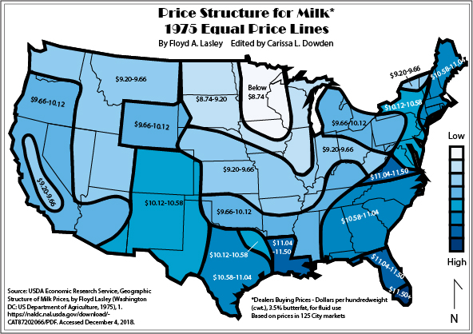
Figure 1. Equal Price Lines of Milk in 1975. USDA Economic Research Service, Geographic Structure of Milk Prices, by Floyd Lasley (Washington DC: US Department of Agriculture, 1975), 1. https://naldc.nal.usda.gov/download/CAT87202066/PDF. Accessed December 4, 2018.
This rule, according to dairy economist Mark Stephenson when interviewed by John Allen for On Wisconsin magazine, is widely accepted due to common belief in the industry that Eau Claire is the “center of the milk universe.” Backing this belief is the fact that Eau Claire is located in a high producing and low cost area for the dairy industry, leading to greater efficiency in the region than elsewhere in the country. Despite this, there is no governmental document that officially labels Eau Claire as the base point for the federal milk market.
In 1935, Wisconsin easily led the nation in total milk production and engaged in diversified uses of milk, so for these reasons it was chosen as a study area of changes for research on large-scale organization of the dairy industry by R. K. Froker, A. W. Colebank and A. C. Hoffman. In the post-war era, there was a tendency toward large-scale organization in manufacturing and distribution of dairy products. While national companies owned less than 5% of the total number of dairy plants in Wisconsin, they handled 23% of total milk produced in state. National companies in Wisconsin did not produce much of the state’s butter, cream, and cheese, but manufactured nearly all condensed and evaporated milk in Wisconsin. Of the state’s 329 creameries, national companies operated only 10, and received less than 3% of the total milk manufactured by Wisconsin creameries. Furthermore, for American-cheese factories, national companies received less than 2% of total milk receipts in that industry. According to Wisconsin Senator and farmer Alexander Wiley at the congressional hearings in 1939 to regulate commerce in agricultural products, most of the milk that he produced on his farm went into cheese factories or creameries. During the summer of 1936, carloads of powdered milk from Europe flooded the eastern US, so Wisconsin dairy farmers were priced out of the market. This led to milk “flowing onto the swamps up there in Wisconsin,” despite their already lower-than-national-average prices. While this happened years after the stock market crash in 1929, this event joined a string of tragedies befalling agricultural producers. “Tremendous price disparity” threatened the entire nation, not just the Upper Midwest and Wisconsin, and “agriculture, in short, was very sick.” “The dilemma of the surpluses,” the title of the letter to the President in the Yearbook of Agriculture in 1934, seems to sum up the main issue of agriculture during the Great Depression; while domestic consumption had exceeded domestic production by an average of one percent in 1929, in 1930, prices began dropping. In 1930, the nation began what would end up being a seven year climactic drought, more severe than any in the previous fifty years. The immediate economic consequences of the drought fell predominantly on farmers, rather than the public, and demand for agricultural products fell as well. The reduced demand forced farmers to increase production just to cover costs, despite plummeting prices, and the industry soon became locked in a continually deepening nadir of economic despair. With these historical factors in mind, this research seeks to illuminate the reasons why, of all places, the federal government assigned Eau Claire as the base point of minimum milk prices.
Historiography
There has not been any formal research done on why Eau Claire was chosen as the basepoint for the Federal Milk Marketing Order, so this paper will address a gap in historical literature. Any sources that concern this very topic are brief and vague, so this paper seeks to fill that void of knowledge. As such, secondary sources found for this paper primarily concern subsets of the topic: agricultural history of Wisconsin, agricultural economics, Depression Era history, geographic perspectives and economic policy history.
Many scholars have written on early state agricultural history in Wisconsin. Edward Janus and Norman K. Risjord both wrote histories on Wisconsin as America’s Dairyland. Janus, author of Creating Dairyland: How Caring for Cows Saved Our Soil, Created Our Landscape, Brought Prosperity to Our State, and Still Shapes Our Way of Life in Wisconsin, gives a brief history of dairying in Wisconsin, as well as provides interviews with Wisconsin farmers about their experiences in the industry. In Norman K. Risjord’s article, "From the Plow to the Cow: William D. Hoard and America's Dairyland," he also discusses early Wisconsin history, but primarily through the story of William Dempster Hoard, a New Yorker who immigrated to Wisconsin, was instrumental in Wisconsin’s transition to dairy farming from wheat, and eventually became its governor.
To better understand the nuances of agricultural policy in the 1930s and on, scholars with works in agricultural economic history also had to be consulted. Laurie Winn Carlson wrote William J. Spillman and the Birth of Agricultural Economics about the father of agricultural economics, as well as the history of agricultural economics post-World War One and during the Great Depression. Eric M. Erba and Andrew M. Novakovic mention some aspects of this in their paper, “The Evolution of Milk Pricing and Government Intervention in Dairy Markets,” but offer a milk-centric interpretation of the history of agricultural economics, in addition to explaining the ways that the federal government intervened during crisis.
Geographers primarily explore the topic of agriculture through quantitative change over time and cartographic analyses of geographic distributions of phenomena. John A. Cross, author of “Change in America’s Dairyland,” explores the impact of dairy farming on the landscape of Wisconsin through cartography. Cross and other scholars, like Loyal Durand, also explore patterns of spatial distribution on the landscape, like the regionality of milk and manufactured dairy products in Wisconsin (e.g. Dodge County cheese). Spatial pattern analysis is heavily applied to the dairy market in geographic study; for example, Durand examines locational factors in Wisconsin source regions of dairy products in order to better understand the causes of geographic shift in markets in his 1947 paper, “Recent Market Orientations of the American Dairy Region.” This type of analysis is even found in R. H. Whitbeck’s paper from 1912, “Industries of Wisconsin and their Geographic Basis,” which is a comprehensive geographic and cartographic analysis of Wisconsin’s industries.
History of Agricultural Problems in Wisconsin
For those coming to Wisconsin in the late 1840s, it was not milk that reigned king, but wheat. Called the “wheat error” by Edward Janus, the newly colonized land of Wisconsin was virgin, fertile, and ripe for the taking. Wisconsin was a forested region, often called the “Big Woods,” so before attempting to farm the land with wheat, white settlers first had to log the land bare. Wheat was a cash crop, and farmers were now “wheat miners.” Like many other mining operations, the results are often disastrous to the environment; by the 1870s, in addition to settlers clearing of the state’s natural forests, wheat yields in Wisconsin were plummeting as the land became less fertile. Disease struck farmers’ crops, and cinch bugs further destroyed potentially successful harvests. As Wisconsin land quickly became a liability for farmers, many sold and/or abandoned their farms for new properties even further west in Minnesota and the Dakotas. At this point in agricultural history, farmers knew little of fertilization, crop rotation, and techniques to improve soil fertility. It would take the gospel of livestock to turn around Wisconsin soils.
In looking for “salvation” for their Wisconsin soil, farmers experimented with various types of animals to add nutrients back into the ground via manure and feed-grass. Sheep were the original favorite, as they require little labor or capital in order to turn a profit. In comparison, cows were a considerable amount of work for slow return on the investment. Dairy farming involves long days just to produce prior to preserve the quality of a small product, whereas sheep easily produce their wool whenever and wherever without extensive time taken by the farmer to care for them. Originally, cattle were brought to Wisconsin by French Canadian traders for meat consumption, not milk. Even then, the meat from hunted deer and buffalo was often considered superior to beef. Soil exhaustion and declining wheat yields in southeastern Wisconsin by the 1860s invited many dairy advocates, mainly from New York, where they had replaced wheat agriculture with dairy two decades previous. Yankee emigrants brought English milk cows to Wisconsin territory, and it became more common for farmers to keep a cow or two to produce milk seasonally for their family.
Wheat farmers had difficulty switching to dairy farming; men often couldn’t be caught dead milking the cows at the back of the horse barn. Taking care of the cows, in addition to work associated with keeping them, was considered women's work. However, the milk produced by the single or couple cows exceeded the amount consumed by a family, so women’s dairy work became valuable supplementary income. This developing surplus couldn’t be ignored much longer, and soon, it became common practice to convert excess milk into low quality butter for trade. With increasing profit from dairy cows, Wisconsin slowly began transitioning into the Dairy State. In 1870, Wisconsin had ninety cheese factories. By 1905, that number had increased to 1518, and in 1922, to 2807. Former New Yorker, William Dempster, the editor of Hoard's Dairyman, aptly said "Queen Cow dethroned King Wheat." By the early 1920s, Wisconsin was America’s Dairyland; "In a mere sixty years Wisconsin had risen from a state of economic and moral depletion to become a national icon of wholesomeness and rural rectitude." In 1919, more than 63% of total cheese produced in United States was from Wisconsin, and in 1923, 55% of Wisconsin farm income derived from dairying.
After WWI, farm prices slumped, “as economic recovery in Europe lessened the demand for US farm products,” leading to producer struggles during the 1920s. During the decade, farm journals and organizations had been advising farmers to control their production. Crop withholding movements were organized around the theory that speculative manipulation caused price declines, but these attempts were unsuccessful in increasing prices. Furthermore, the decline in the farmers’ position in the US beginning in the summer of 1920 was impacted by the nation’s transition from a debtor to a creditor nation after WWI. Advocates were calling for government intervention throughout the 1920s, but no steps were taken, even when farm prices fell more than fifty percent between 1929 and 1932 at the beginning of the Depression. Farm commodity programs were a product of the Great Depression and Franklin Delano Roosevelt’s administration. Nationally, agricultural prices declined the most, as a trade depression caused those prices to fall sooner and lower than the prices of other goods. Production in agriculture wasn’t easily or quickly adjusted to market changes, and because production continued to overshoot demand, agriculture was continually penalized. The dairy industry could only re-adjust slowly to the changing market conditions, as cows must be milked every day, so production also remained high throughout extended periods of low demand. Short-term solutions to this issue were reducing costs and finding supplementary income, but long-term solutions were culling low-producing animals, and decreasing the proportion of heifers in herds. Cows must be milked, or they can become sick, so many farmers took the long-term option and cut their losses in the dairy industry. In 1933, Congress passed the Agricultural Adjustment Act, of which mandatory USDA price supports for specific commodities were enacted (milk, however, was not one of these commodities). In 1938, the Agricultural Adjustment Act was further amended to include butter for price support (this is considered part of permanent agriculture legislation), and in 1941, the Steagall Amendment included milk and butterfat as non-basic commodities. Despite these federal support programs, as said by the Henry A. Wallace, Secretary of Agriculture in 1934, “the depression robbed farmers of their independence, formerly the chief attraction of country life, and thereby weakened the foundations of our whole economic system.”
Terms
There are four classes of milk defined by the US Department of Agriculture: Class I, or fluid milk, Class II, or milk used for soft products like cottage cheese and cream, Class III, or milk used for hard cheeses and cream cheese, and Class IV, or milk used for butter and dry products, primarily nonfat dry milk. Class I, fluid-grade milk, is also often referred to as Grade A milk or beverage milk. Grade A milk is the highest quality grade of milk for health requirements, and is the only grade of fluid-milk sold for drinkable consumption. Grade B milk is produced under conditions acceptable only for certain manufactured products (e.g. cheeses), and its prices are not regulated by Federal Milk Marketing Orders.
As designated by the Congressional Research Service, FMMOs are geographically defined fluid-milk demand areas. Introduced in the 1930s, FMMOs set guidelines under which dairy processors purchase fresh milk from dairy farmers in a marketing area. In these guidelines, processors are referred to as “handlers,” and farmers are “producers.” A marketing area is a geographic area where handlers typically compete for packaged fluid milk sales. By establishing marketing areas, stable marketing relationships between producers and handlers are fostered, and consumers have greater access to fresh milk. FMMOs also assure producers of a reasonable minimum price for their fluid-grade milk throughout the year. The concept of a pricing system was created almost from the beginning of commercial milk production after the Civil War; Seasonal fluctuations in milk supply and its use led to short-term instability in prices and long-term uncertainty. Producers’ uncertainty in addition to these unstable prices drove substantial numbers of producers out of business, leading to even greater swings in supply and pricing. As milk is not an annual crop, it cannot be subject to the same pricing standards of annually harvested commodities. Milk as a commodity is subject to unique market conditions: fluid milk is highly perishable, is harvested continuously, and tends to have surplus and deficits seasonally. Milk consumption is not very sensitive to price changes and can be manufactured into other forms easily in event of surplus, but is part of a high fixed-cost industry with many long-term investments. Because of these factors, the dairy industry rests in a difficult position with continuous opportunities for instability.
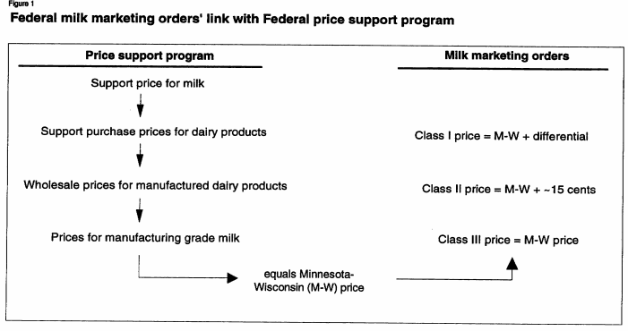
FMMOs are linked with the Federal Price Support Program (FPSP). The support price, which is determined annually under provisions of the Agricultural Act of 1949, underlies the entire price structure for bulk milk sold by producers to either handlers or through cooperatives. FPSP also sets prices to purchase dairy products from manufacturers to return to producers. From this, wholesale prices for manufactured dairy products are set. Prices for manufacturing-grade milk (Class III milk) were set equal to Minnesota prices minus Wisconsin prices (M-W), determined via a monthly survey of prices from areas where most manufacturing-grade milk is produced. Class II milk was then set equal to M-W plus an average fifteen cents per 100 pounds of fluid-milk (hundredweight). Class I milk was also set equal to M-W plus fixed differentials. The differential in 1994 was $1.04 per hundredweight, but as of November 21, 2018, was $1.80 per hundredweight. The M-W price was replaced by the Basic Formula Price system in 1995, but this was still calculated using manufacturing grade milk prices in Minnesota and Wisconsin from both the prior and current month. This pricing system is shown as a flow-chart in Figure 2 from the USDA document, “The U.S. Dairy Pricing System.”
Figure 2. FMMOs’ link with FPSP. USDA Economic Research Service. “The U.S. Dairy Pricing System.” Alden Manchester, Mark Weimar, and Richard Fallert. Washington DC: USDA, 1994. 5. Accessed December 1, 2018. https://pdfs.semanticscholar.org/2a89/1f6bf8d72cac81e05a9ba81264aabe04145e.pdf.
Figure 3 is a simpler version of the above chart from the same USDA document:
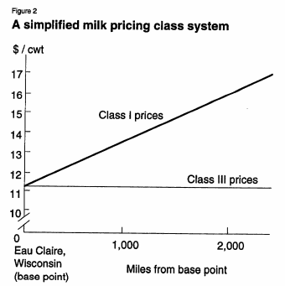
Figure 3. The Eau Claire Rule. USDA Economic Research Service. “The U.S. Dairy Pricing System.” Alden Manchester, Mark Weimar, and Richard Fallert. Washington DC: USDA, 1994. 5. Accessed December 1, 2018. https://pdfs.semanticscholar.org/2a89/1f6bf8d72cac81e05a9ba81264aabe04145e.pdf.

Geographically speaking, while Class III prices remain the same 5 miles from the base point to 1000 miles from base point, Class I prices increase with distance from Eau Claire.
A base point is the geographic minimum site/mean center for milk pricing in a FMMO. The federal order base point is Eau Claire, Wisconsin. Northern Wisconsin has the largest supply of Grade A milk above local needs for Class I milk. Because of this surplus, theoretically, anywhere in the United States could be supplied with Wisconsin milk for the base point price plus transportation costs. This provides geographic reason for the Eau Claire Rule.
USDA Publication Analysis
The USDA was established in 1862, and from 1862 to 1893, the newly formed department issued its own annual one volume report. In the year of 1894, the annual report expanded into two volumes: one for executive reports (known as the Secretary’s Report to the President) and the other the Yearbook of Agriculture. The executive reports often included “This Year in Agriculture,” and offered a comprehensive snapshot of the successes and failures experienced by farmers nationwide during the previous year. This section was included until 1936, when the series changed and instead focused on single topic per volume, increasingly addressing American consumers rather than the farmer. In 1992, Congress ended funding for the Yearbooks of Agriculture, briefly replacing it with the “Agricultural Fact Book” in 1996, but this too was cancelled in 2002. Because of this, this paper will be primarily analyzing the data in Yearbooks from 1930 to 1935, and utilizing data from other governmental sources, such as USDA’s Census of Agriculture Historical Archive.
Using the Yearbooks of Agriculture as a glimpse into contemporary American agricultural life, analysis starts with the Secretary of Agriculture’s report to the President. Drought during 1929 reduced crop yield significantly across the entire country, impacting dairy production in the fall. In 1929, the position of the dairy industry was apparently favorable, though there was a marked price drop from the previous year due to a surplus from the warm season. At this point, production was outpaced by consumption, and the Secretary predicted increased foreign competition in dairy products. The average price per head of milk cow was $94.10 in 1929, increasing rapidly from an average price of $57.87 just in 1925. The price of retail quart of milk in Milwaukee was an average of 11.25 cents in 1929, and 12 cents in Minneapolis, but the lowest recorded price was in Salt Lake City at an average of 10 cents.
In 1932, the Secretary’s letter immediately discussed the climatic drought of 1930, which was the worst drought in the country recorded up to that point. The dairy industry became unstable due to a drop in demand in late 1929 due to the economic depression. However, at this point, the more specialized dairy regions (e.g. the Upper Midwest), were in better shape than other areas, especially places that were more affected by the drought. The average price per head of milk cow dropped to an average of $74.16. The retail price of a quart of milk was 11.5 cents in Milwaukee and 11 cents in Minneapolis, the lowest value in city prices. The following year, the Secretary was increasingly worried about the increasing agricultural surpluses, and with European recovery outpacing recovery in the US, exporting these surpluses was challenging to farmers. Prices in the dairy industry continued to decline sharply, in addition to farmers’ incomes. As mentioned previously, the dairy industry readjusts to changes in the market very slowly, and solutions to low prices range from attaining supplementary income to culling low-producing cows. As a result, value per milk cow dropped to $51.28. Consequently, the price per quart of milk in Milwaukee dropped to 9.75 cents, and 10 cents in Minneapolis, the lowest values in the country.
The Yearbook of Agriculture in 1932 took a different tone than previous publications; in this publication, the authors sought to show what the depression had done to agriculture nationwide, as well as to show how farmers were adapting. Production of butter, cheese, evaporated milk was down 1.1% from 1931 to 1932, and dairy-product prices were 24% lower in the first eight months of 1932 than in the first eight months of 1931. The average price per head for dairy cows was $36.95, and the retail price of milk decreased to 8.1 cents per quart in Minneapolis, the lowest in the country, and Milwaukee at 8.3 cents. The tone of the 1934 Yearbook is increasingly pessimistic, bemoaning the days when production only occasionally overshot demand and foreign markets had demand for American goods, but the also mentions that the new FDR administration’s guidance have improved agricultural conditions immensely. The value per milk cow head, however, dropped to a US average of $27.09 ($28 in Wisconsin), and the price of a quart of milk was 7.1 cents in Minneapolis and 8.4 cents in Milwaukee. Lastly, in 1935, the Secretary was increasingly positive, saying that the Agricultural Adjustment Act of 1933 was so far successful to adjusting production to demand. The value per head of milk cows jumped to $30.38 on average nationally ($33 in Wisconsin), and the retail price per quart of milk rose to 9.3 cents in Milwaukee and 9.2 in Minneapolis. While the Agricultural Adjustment Act stabilized the exponentially increasing surplus in the early 1930s, slow-to-adjust dairy was still impacted by low prices. Wisconsin and Minnesota, being a part of high-producing areas in the United States and being more prone to surplus, were plagued by lower prices than the wider nation, as shown by the increasingly low retail milk prices. Mr. Weis, a Michigander farmer, said in 1939 that a farmer received $3.80 per hundredweight of milk in 1918, the milk-wagon driver $90 per month, and the customer only paid 10 cents per quart. In 1933, that same farmer was only receiving $1.85 per hundredweight, the wagon driver $224 per month, and the customer paid 12 cents per quart. These lower prices were based on surplus, and the Eau Claire Rule was based on this upper Midwest propensity to efficiently overproduce dairy products.
However, a different pattern is shown regarding the collection of fluid milk receipt data from Boston, Chicago, New York, and Philadelphia from 1930-1935; Table 1 shows the collection of states’ fluid-milk receipts from the markets of Boston, Chicago, New York, and Philadelphia during the years of 1930 through 1935. While individual states had smaller markets, they often sent their products (40-quart units of fluid-milk in this case) to larger, typically international markets. For example, many Wisconsin farmers had their milk sold at the Chicago market. The stacked bars show each state’s total receipts per year. New York easily led in national receipts, followed by Pennsylvania in second and Wisconsin in third. Arguably, Wisconsin’s tendency in producing milk was not in fluid-milk/beverage milk, but instead in cheese; the average amount of Wisconsin cheese produced in factories between 1930 and 1934 was 241,669,000 pounds, 270,851,000 pounds in 1935 and 270,193,000 pounds in 1936.
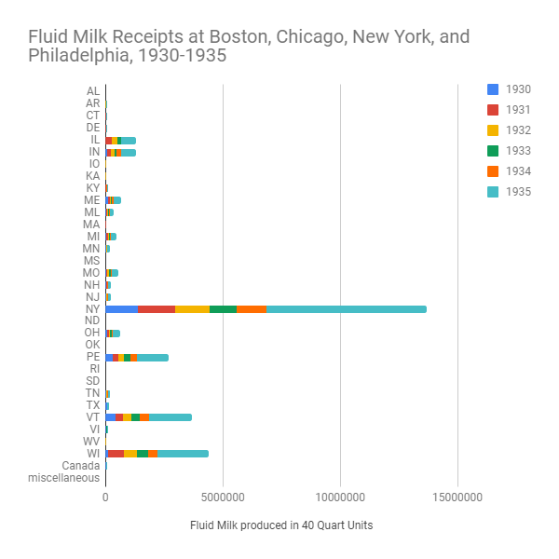
Table 1: Cumulative Fluid-milk receipts received at Boston, Chicago, New York and Philadelphia by state, from 1930 to 1935.
USDA. Yearbook of Agriculture: 1932, 1935. (Washington DC: US Department of Agriculture, 1932, 1935)
Looking at the Agricultural Census of the United States in 1940, the supposed center of the milk surplus in Eau Claire can be directly compared to other counties in Wisconsin. The counties that are contiguous to the county of Eau Claire are Buffalo, Chippewa, Clark, Dunn, Jackson, Pepin, and Trempealeau. Putting together a miniature case-study, if Eau Claire is at the heart of dairy surplus in the Upper Midwest, then theoretically, the counties will have like or slightly less production counts.
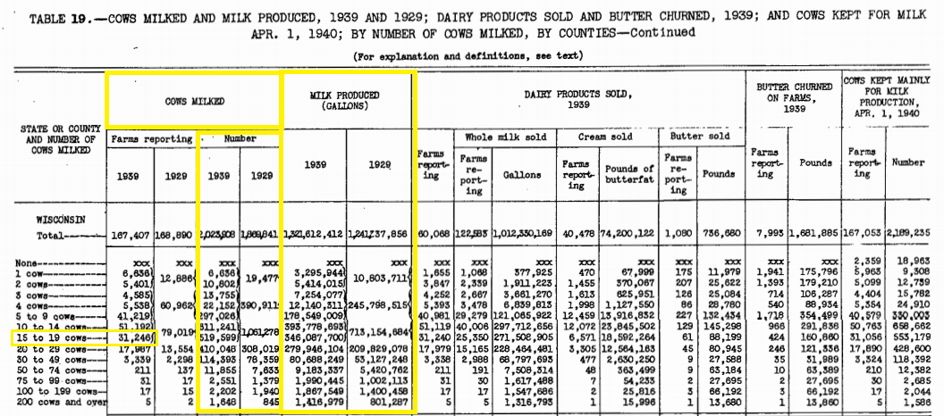
Figure 4: Number of cows milked, and products produced in 1929 and 1939 in Wisconsin. USDA. “Cows milked, and milk produced in 1929 and 1939; Dairy products sold and butter churned, 1939; and cows kept for milk on April 1, 1940; by number of cows milked, by counties.” Census of Agriculture Historical Archive. Accessed December 5, 2018. http://usda.mannlib.cornell.edu/usda/AgCensusImages/1940/04/03/1329/Table-19.pdf..
The number of reported cows milked increased in Wisconsin between 1929 and 1939, as well as the amount of milk produced. Furthermore, the largest reported group for cow ownership was 15-19 cows on a farm. The additional yellow boxes serve to highlight this information.
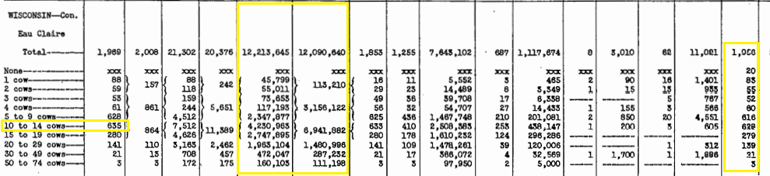
Figure 5: Number of cows milked, and products produced in 1929 and 1939 in Eau Claire County. USDA. Census of Agriculture Historical Archive. Accessed December 5, 2018. http://usda.mannlib.cornell.edu/usda/AgCensusImages/1940/04/03/1329/Table-19.pdf.
Comparing Eau Claire county to Wisconsin as a whole, in 1940, farmers tended to own slightly smaller herds, produced millions of gallons of whole milk for sale in both 1929 and 1939 (left yellow box), and primarily had cows for milk production (right box).
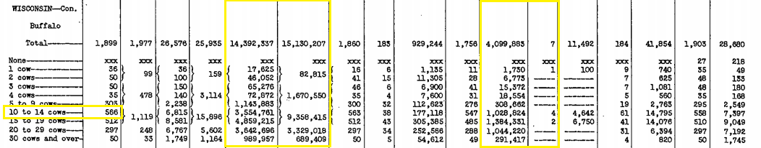
Figure 6: Number of cows milked, and products produced in 1929 and 1939 in Buffalo County. USDA. Census of Agriculture Historical Archive. Accessed December 5, 2018. http://usda.mannlib.cornell.edu/usda/AgCensusImages/1940/04/03/1329/Table-19.pdf.
Buffalo County followed the same trend as Eau Claire county, with slightly smaller herd sizes, but higher milk production in larger herds and in total both years (left yellow box), and much less whole milk for sale in comparison. Buffalo County, however, sold much more cream than Eau Claire County in 1940 (right box).
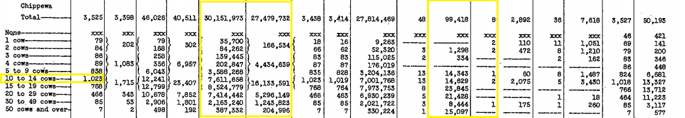
Figure 7: Number of cows milked, and products produced in 1929 and 1939 in Chippewa County. USDA. Census of Agriculture Historical Archive. Accessed December 5, 2018. http://usda.mannlib.cornell.edu/usda/AgCensusImages/1940/04/03/1329/Table-19.pdf.
In comparison to Buffalo, Chippewa County had more than double the milk production (left yellow box), even more than Eau Claire. While Chippewa tended to have similar herd sizes to Eau Claire, it sold three times the amount of whole milk, but less cream (right box).
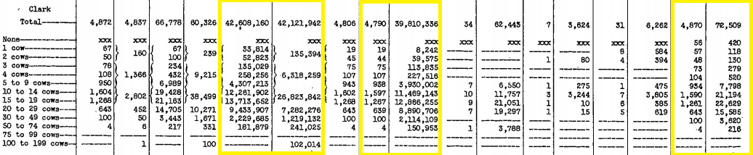
Figure 8: Number of cows milked, and products produced in 1929 and 1939 in Clark County. USDA. Census of Agriculture Historical Archive. Accessed December 5, 2018. http://usda.mannlib.cornell.edu/usda/AgCensusImages/1940/04/03/1329/Table-19.pdf..
Clark County produced more than 150% more gallons of milk than Chippewa both in 1929 and 1939 (left box). It also sold primarily just that whole milk (middle box), as most cows were used only for milk production in that county compared to Eau Claire (right box).
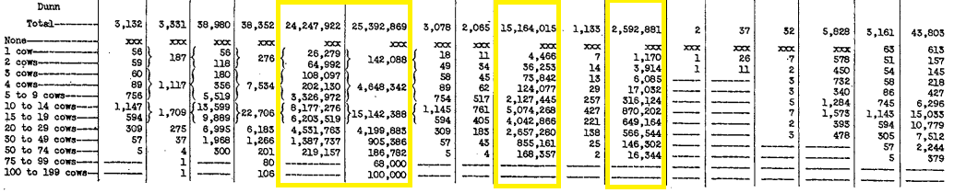
Figure 9: Number of cows milked, and products produced in 1929 and 1939 in Dunn County. USDA. Census of Agriculture Historical Archive. Accessed December 5, 2018. http://usda.mannlib.cornell.edu/usda/AgCensusImages/1940/04/03/1329/Table-19.pdf.
Compared to the other counties, Dunn produced more than both Eau Claire and Buffalo both years (left box), but less than Chippewa and Clark. The whole milk produced was primarily sold as fluid milk or as cream, following a regional trend (middle and right boxes respectively).
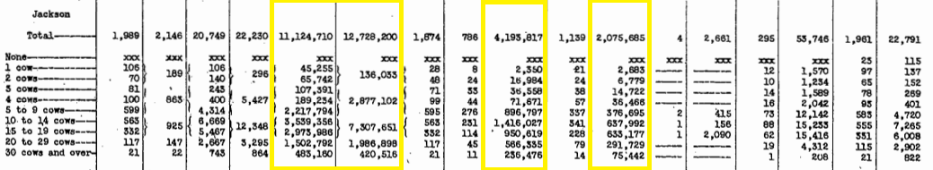
Figure 10: Number of cows milked, and products produced in 1929 and 1939 in Jackson County. USDA. Census of Agriculture Historical Archive. Accessed December 5, 2018. http://usda.mannlib.cornell.edu/usda/AgCensusImages/1940/04/03/1329/Table-19.pdf.
Jackson County produced the least whole milk in 1939, but slightly more than Eau Claire County in 1929 (left box). Because of this, farmers sold much less whole milk and cream in the county (middle and right boxes respectively).
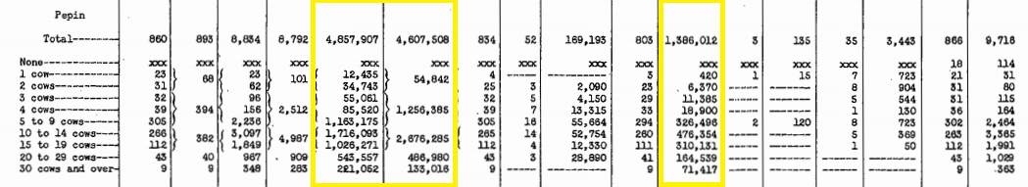Figure 11: Number of cows milked, and products produced in 1929 and 1939 in Pepin County. USDA Census of Agriculture Historical Archive. Accessed December 5, 2018. http://usda.mannlib.cornell.edu/usda/AgCensusImages/1940/04/03/1329/Table-19.pdf.
Pepin County produced even less milk than Jackson both years (left box). However, a significant portion of their milk production was sold as cream, in comparison to other counties (right box).
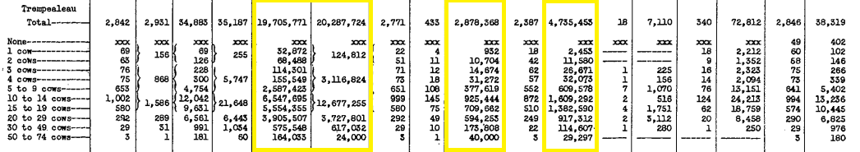
Figure 12: Number of cows milked, and products produced in 1929 and 1939 in Trempealeau County. USDA. Census of Agriculture Historical Archive. Accessed December 5, 2018. http://usda.mannlib.cornell.edu/usda/AgCensusImages/1940/04/03/1329/Table-19.pdf.
Lastly, Trempealeau County produced more milk than Eau Claire both years, but sold a significantly smaller portion of it as whole milk and cream (left, middle, and right boxes respectively). None of the counties had significant production of butter, and primarily dealt with whole milk and sometimes cream. This study is important because it shows statistically that Eau Claire county was in one of the largest milk producing and selling areas of the state historically. While the county itself was not the largest producer of the surveyed counties, and the northern contiguous counties won this survey, Eau Claire is a city in the northwestern part of the county; the city of Eau Claire was closer to the highest producing counties of Chippewa, Clark, and Dunn, though Buffalo county pulled the high values slightly southwest. If one were to look further north and west, county milk production and sales most likely continued to increase, showcasing the historical Upper Midwest surplus of milk. As such, while there was no specific federal proclamation as the city as a base point for the FMMO, Eau Claire can be understood as a contemporary general geographic mean center of milk production in both the upper Midwest and the United States as a whole. However, this case study would benefit from further research and addition of production cost data.
Conclusion
Upon going through every bit of the USDA’s language concerning the Federal Milk Marketing Order, there is not one mention of Eau Claire, Wisconsin, or even the concept of a base point. Even in the Milk in the Upper Midwest Marketing Area subpart of the General Provisions of Federal Milk Marketing Orders, there is not an instance where the city is brought up. Whether or not this was a governmental oversight, the lack of reasoning allows for personal conjecture; Statistically speaking, however, the upper Midwest was and remains a bastion of dairy production in the United States. While the only visible governmental evidence of this is the “Eau Claire Rule” in agricultural pricing, it has become an ingrained part of Wisconsin culture as well as a myth of dairy farming in America. “We have urban myths, and we have rural myths,” said Mark Stephenson for On Wisconsin Magazine,“Eau Claire is a rural myth,” started in the 1920s and rolled out in the 1930s. While Eau Claire may be in a part of the United States with a tendency to produce dairy products over local demand, there are other parts of the country with the same propensities (e.g. New York). However, agricultural production costs in the upper Midwest tend to be lower than in other parts of the country, contributing to this continuation of myth. Well after FDR’s America, the power of that base point is be weakening today, with California operating its own FMMO in October 2018 as an example. However, the silent power of a mid-sized community in the west-central part of Wisconsin has held the both the milk prices in the state and the rest of the country captive for almost a century. Therefore, the Eau Claire rule can be associated with a paradigm shift in agricultural policy and the interaction between the federal government and citizens during times of crisis.

Bibliography
Primary Sources
Allen, John. “Milk Matters.” On Wisconsin (Madison, WI), Winter 2013. Accessed December 5,
2018, https://onwisconsin.uwalumni.com/features/milk-matters/.

Committee on Agriculture and Forestry, To Regulate Commerce in Agricultural Products. HRG-
1939-AFS-0004 (Washington DC, February 1-3, 7-8, 10-11, 17, 1939). ProQuest: Congressional. Accessed December 5, 2018. https://congressional-proquest-com.proxy.uwec.edu/congressional/docview/t29.d30.hrg-1939-afs-0004?accountid=14790.

Library of Congress, Congressional Research Service, Farm Commodity Legislation:
Chronology, 1933-2002, 2002, CRS-1.

Library of Congress, Congressional Research Service, Federal Milk Marketing Orders: An
Overview, 2017, 6.

US Library of Congress, Congressional Research Service, Farm Commodity Legislation:
Chronology, 1933-2002, 2002, CRS-1.

US Library of Congress, Congressional Research Service. Federal Milk Marketing Orders: An
Overview, 2017, 6.

USDA Agricultural Marketing Service. “Advanced Announcement of Class Prices and Related
Data for December 2018.” Accessed online December 15, 2018. http://www.fmma30.com/ClassPrice/2018/AdvancePrice--12-18.pdf.

USDA Agricultural Marketing Service. “Federal Milk Marketing Orders.”.
https://www.ams.usda.gov/rules-regulations/moa/dairy (accessed November 11, 2018).

USDA Economic Research Service, Geographic Structure of Milk Prices, by Floyd Lasley.
(Washington DC: US Department of Agriculture, 1975), 1. Accessed December 4, 2018. https://naldc.nal.usda.gov/download/CAT87202066/PDF.

USDA Economic Research Service. History of Agricultural Price-Support and Adjustment
Programs, 1933-1984. (Washington DC: US Department of Agriculture, 1985), 1.

USDA. “Cows milked and milk produced in 1929 and 1939; Dairy products sold and butter
churned, 1939; and cows kept for milk on April 1, 1940; by number of cows milked, by counties.” Census of Agriculture Historical Archive. http://usda.mannlib.cornell.edu/usda/AgCensusImages/1940/04/03/1329/Table-19.pdf. Accessed December 5, 2018.

USDA, Large-scale organization in the dairy industry, Rudolph K. Froker, Colebank, A. W.,
and Hoffman, A. C. (Washington D.C.: US Department of Agriculture, 1939), 19.

USDA. “PART 1030--MILK IN THE UPPER MIDWEST MARKETING AREA.” (Washington
DC, Electronic Code of Federal Regulations, 2018). 1-20. https://www.ecfr.gov/cgi-bin/textidx?SID=a709893419f11845a46bb42e7d66b531&mc=true&node=pt7.9.1030&rgn=div5. Accessed December 5, 2018.

USDA. Yearbook of Agriculture: 1930. (Washington DC, US Department of Agriculture, 1930).

USDA. Yearbook of Agriculture: 1931. (Washington DC, US Department of Agriculture, 1931).

USDA. Yearbook of Agriculture: 1932. (Washington DC, US Department of Agriculture, 1932).

USDA. Yearbook of Agriculture: 1933. (Washington DC, US Department of Agriculture, 1933).

USDA. Yearbook of Agriculture: 1934. (Washington DC, US Department of Agriculture, 1934).

USDA. Yearbook of Agriculture: 1938. (Washington DC: US Department of Agriculture).

US. Congress, Senate, Committee on Agriculture and Forestry, To Regulate Commerce in
Agricultural Products. 76th Cong., 1st sess., 1939, 1-427. ProQuest: Congressional. Accessed December 5, 2018. https://congressional-proquest-com.proxy.uwec.edu/congressional/docview/t29.d30.hrg-1939-afs-0004?accountid=14790.

USDA. “PART 1030--MILK IN THE UPPER MIDWEST MARKETING AREA.” (Washington
DC, Electronic Code of Federal Regulations, 2018). 1-20. Accessed December 5, 2018. https://www.ecfr.gov/cgi-bin/text-idx?SID=a709893419f11845a46bb42e7d66b531&mc=true&node=pt7.9.1030&rgn=div5.

Secondary Sources
American Dairy Products Institute. “Milk Pricing 101.”
https://www.adpi.org/Portals/0/Academy/Milk%20Pricing%20101.pdf (Accessed December 2, 2018).

Apps, Jerry. “Dethroning King Wheat.” Voyageur: Historical Review of Brown County and
Northeast Wisconsin 26, no. 1 (2009): 49.

Carlson, Laurie Winn. William J. Spillman and the Birth of Agricultural Economics. Columbia:
University of Missouri Press, 2005. Accessed December 5, 2018. ProQuest Ebook Central. https://ebookcentral.proquest.com/lib/uwec/reader.action?ppg=1&docID=3570852&tm=1544227708912.

Cross, John A. “Change in America’s Dairyland.” Geographical Review, 91, no. 4 (October
2001), 702-714.

Durand, Loyal Jr. “Cheese Region of Southeastern Wisconsin.” Economic Geography, 15, no 3
(July 1939) 283-292. Accessed December 6, 2018. Taylor & Francis, Ltd. https://www.jstor.org/stable/141547?seq=1#metadata_info_tab_contents

Durand, Loyal Jr. “Recent Market Orientations of the American Dairy Region.” Economic
Geography, 23, no. 1 (January 1947), 32-40. Accessed December 6, 2018. Taylor & Francis, Ltd. https://www.jstor.org/stable/141652?seq=1#metadata_info_tab_contents.

Erba, Eric M. and Novakovic, Andrew M. “The Evolution of Milk Pricing and Government
Intervention in Dairy Markets.” Ithaca, NY: Cornell Program on Dairy Markets and Policy, 1995.

Janus, Edward. Creating Dairyland: How Caring for Cows Saved Our Soil, Created Our
Landscape, Brought Prosperity to Our State, and Still Shapes Our Way of Life in Wisconsin. Madison, Wis.: Wisconsin Historical Society Press, 2011.

Risjord, Norman K. "From the Plow to the Cow: William D. Hoard and America's Dairyland."
The Wisconsin Magazine of History 88, no. 3 (2005): 40-49. http://www.jstor.org.proxy.uwec.edu/stable/4637137.

Victory Horticultural Group. “Department of Agriculture Yearbooks.”
http://www.saveseeds.org/library/holdings/yoa.html (Accessed December 2, 2018).

Whitbeck, R. H. “Industries of Wisconsin and Their Geographic Basis.” Annals of the
Association of American Geographers, 2 (1912), 55-64. Accessed December 5, 2018. Taylor & Francis, Ltd. https://www.jstor.org/stable/2560641?seq=1#metadata_info_tab_contents.

Coralie Carlson, "House Votes against Dairy Pricing Change; Minnesota Delegates Upset: `Eau Claire Law Makes No Sense,' Ventura Says. (NEWS)." Star Tribune (Minneapolis, MN), 1999, accessed December 5, 2018, https://www-lexisnexis.com.proxy.uwec.edu/hottopics/lnacademic/?verb=sr&csi=8384&sr=HEADLINE(House+votes+against+dairy+pricing+change)%2BAND%2BDATE%2BIS%2B1999.
Noah Bierman, “Changes to dairy subsidies may take Boston out of equation.” The Boston Globe (Boston, MS), 2013, accessed December 5, 2018, https://www.bostonglobe.com/business/2013/06/08/what-does-boston-have-with-milk-prices-wisconsin-turns-out-lot/AUfXl8MXtCffhdw3PD79bJ/story.html.
Joe Mahon, “Got MILC?:New federal dairy policy benefits district, but are there unintended consequences?” fedgazette (Minneapolis, MN), 2004, accessed December 5, 2018, https://www.minneapolisfed.org/publications/fedgazette/got-milc.
John Allen, “Milk Matters.” On Wisconsin (Madison, WI), Winter 2013, accessed December 5, 2018, https://onwisconsin.uwalumni.com/features/milk-matters/.
US Department of Agriculture Economic Research Service, Geographic Structure of Milk Prices, by Floyd Lasley. (Washington DC: US Department of Agriculture, 1975), 1. Accessed December 4, 2018. https://naldc.nal.usda.gov/download/CAT87202066/PDF.
US Department of Agriculture, Large-scale organization in the dairy industry, Rudolph K. Froker, Colebank, A. W., and Hoffman, A. C. (Washington D.C.: US Department of Agriculture, 1939), 19.
Ibid., 1.
Ibid., 19.
Ibid., 56.
US. Congress, Senate, Committee on Agriculture and Forestry, To Regulate Commerce in Agricultural Products. 76th Cong., 1st sess., 1939, 1-427. ProQuest: Congressional. Accessed December 5, 2018. https://congressional-proquest-com.proxy.uwec.edu/congressional/docview/t29.d30.hrg-1939-afs-0004?accountid=14790.
Ibid., 68.
US Department of Agriculture, Yearbook of Agriculture: 1934. (Washington DC, US Department of Agriculture, 1934), 2.
Ibid., 1.
US Department of Agriculture, Yearbook of Agriculture: 1930. (Washington DC, US Department of Agriculture, 1930), 8.
US Department of Agriculture, Yearbook of Agriculture: 1931. (Washington DC, US Department of Agriculture, 1931), 1.
Ibid., 8.
Laurie Winn Carlson. William J. Spillman and the Birth of Agricultural Economics. (Columbia: University of Missouri Press, 2005) 1-220. Accessed December 5, 2018. ProQuest Ebook Central. https://ebookcentral.proquest.com/lib/uwec/reader.action?ppg=1&docID=3570852&tm=1544227708912.
Edward Janus. Creating Dairyland: How Caring for Cows Saved Our Soil, Created Our Landscape, Brought Prosperity to Our State, and Still Shapes Our Way of Life in Wisconsin. (Madison, Wis.: Wisconsin Historical Society Press, 2011) 1-58.
Norman K. Risjord. "From the Plow to the Cow: William D. Hoard and America's Dairyland." The Wisconsin Magazine of History 88, no. 3 (2005): 40-49. Accessed December 5, 2018. JSTOR. http://www.jstor.org.proxy.uwec.edu/stable/4637137.
Carlson. William J. Spillman and the Birth of Agricultural Economics.
Eric M. Erba and Andrew M. Novakovic. “The Evolution of Milk Pricing and Government Intervention in Dairy Markets.” Ithaca, NY: Cornell Program on Dairy Markets and Policy, 1995.
John A. Cross. “Change in America’s Dairyland.” Geographical Review, 91, no. 4 (October 2001), 702-714.
Loyal Durand, Jr. “Cheese Region of Southeastern Wisconsin.” Economic Geography, 15, no 3 (July 1939) 283-292. Accessed December 6, 2018. Taylor & Francis, Ltd. https://www.jstor.org/stable/141547?seq=1#metadata_info_tab_contents.
Loyal Durand. “Recent Market Orientations of the American Dairy Region.” Economic Geography, 23, no. 1 (January 1947), 32-40. Accessed December 6, 2018. Taylor & Francis, Ltd. https://www.jstor.org/stable/141652?seq=1#metadata_info_tab_contents.
R. H. Whitbeck. “Industries of Wisconsin and Their Geographic Basis.” Annals of the Association of American Geographers, 2 (1912), 55-64. Taylor & Francis, Ltd. https://www.jstor.org/stable/2560641?seq=1#metadata_info_tab_contents.
Janus, 6.
Ibid.
Janus, 7.
Jerry Apps. “Dethroning King Wheat.” Voyageur : Historical Review of Brown County and Northeast Wisconsin 26, no. 1 (2009): 49.
Apps, 8.
Apps, 48.
Janus, 9.
Risjord, 42.
Ibid., 43.
Apps, 49.
Janus, 10-11.
Apps, 49.
Ibid., 50.
Janus, 47.
Ibid.
USDA Economic Research Service. History of Agricultural Price-Support and Adjustment Programs, 1933-1984. (Washington DC: US Department of Agriculture, 1985), 1.
Ibid.
US Library of Congress, Congressional Research Service, Farm Commodity Legislation: Chronology, 1933-2002, 2002, CRS-1.
US Department of Agriculture, Yearbook of Agriculture: 1932. (Washington DC, US Department of Agriculture, 1932), 10.
Ibid., 11.
USDA. Yearbook of Agriculture: 1932. 31.
Farm Commodity Legislation, CRS-2.
USDA, Yearbook of Agriculture: 1934. 2.
US Library of Congress, Congressional Research Service. Federal Milk Marketing Orders: An Overview, 2017, 6.
USDA Economic Research Service. “The U.S. Dairy Pricing System.” Alden Manchester, Mark Weimar, and Richard Fallert. Washington DC: USDA, 1994. 1. Accessed December 1, 2018. https://pdfs.semanticscholar.org/2a89/1f6bf8d72cac81e05a9ba81264aabe04145e.pdf.
CRS, Federal Milk Marketing Orders. 5.
CRS, Federal Milk Marketing Orders. Summary.
USDA Agricultural Marketing Service, “Federal Milk Marketing Orders.” Accessed November 11, 2018. https://www.ams.usda.gov/rules-regulations/moa/dairy.
Manchester, Weimar, and Fallert, 1.
Ibid., 2.
Manchester, Weimar, and Fallert, 3.
CRS, Federal Milk Marketing Orders. 1.
CRS, Federal Milk Marketing Orders, 3.
Manchester, Weimar, and Fallert, 4.
Ibid., 5.
Manchester, Weimar, and Fallert, 5.
Ibid.
USDA Agricultural Marketing Service. “Advanced Announcement of Class Prices and Related Data for December 2018.” Accessed online December 15, 2018. http://www.fmma30.com/ClassPrice/2018/AdvancePrice--12-18.pdf.
American Dairy Products Institute. “Milk Pricing 101.” Accessed December 2, 2018. https://www.adpi.org/Portals/0/Academy/Milk%20Pricing%20101.pdf.
American Dairy Products Institute, 5.
Victory Horticultural Group. “Department of Agriculture Yearbooks.” http://www.saveseeds.org/library/holdings/yoa.html (Accessed December 2, 2018).
USDA. Yearbook of Agriculture: 1930., 8.
Ibid., 903.
Ibid., 909.
USDA Yearbook of Agriculture: 1931, 1.
Ibid., 15.
Ibid., 16.
USDA Yearbook of Agriculture: 1931, 908.
Ibid., 915.
USDA, Yearbook of Agriculture: 1932. 4-5.
Ibid., 31.
Ibid., 830.
Ibid., 835.
USDA, Yearbook of Agriculture: 1933 (Washington DC, US Department of Agriculture, 1933), iii.
Ibid., 11.
USDA, Yearbook of Agriculture: 1933, 639.
Ibid., 645.
USDA. Yearbook of Agriculture 1934. 1.
Ibid., 626.
Ibid., 637.
USDA. Yearbook of Agriculture: 1935. 1.
Ibid., 598.
Ibid., 617.
US. Congress, Senate, Committee on Agriculture and Forestry, To Regulate Commerce in Agricultural Products. 76th Cong., 1st sess., 1939, 1-427.
USDA. Yearbook of Agriculture: 1938. (Washington DC: US Department of Agriculture), 361.
USDA, “Cows milked, and milk produced in 1929 and 1939; Dairy products sold and butter churned, 1939; and cows kept for milk on April 1, 1940; by number of cows milked, by counties.” Census of Agriculture Historical Archive. Accessed December 5, 2018. http://usda.mannlib.cornell.edu/usda/AgCensusImages/1940/04/03/1329/Table-19.pdf.
USDA. “PART 1030--MILK IN THE UPPER MIDWEST MARKETING AREA.” (Washington DC, Electronic Code of Federal Regulations, 2018). 1-20. https://www.ecfr.gov/cgi-bin/text-idx?SID=a709893419f11845a46bb42e7d66b531&mc=true&node=pt7.9.1030&rgn=div5. Accessed December 5, 2018.
Allen. “Milk Matters.”
Lasley, 1.
USDA. “USDA Announces Producer Approval of California Federal Milk Marketing Order.” News Release, (June 7, 2018). Accessed December 6, 2018. https://www.usda.gov/media/press-releases/2018/06/07/usda-announces-producer-approval-california-federal-milk-marketing

