Asperger' s Syndrome: Two Case Studies By
Erika Ann Andrle

A Thesis Submitted in Partial Fulfillment of the
Requirements for the Degree of

Master of Science Communication Sciences and Disorders

At

University of Wisconsin-Eau Claire

April 10, 2013

Graduate Studies

The members of the Committee approve the thesis of Erika Ann Andrle presented on April 10, 2013

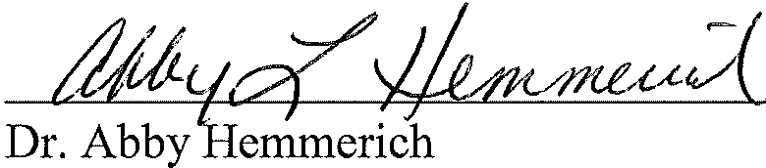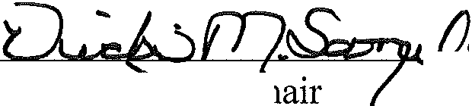

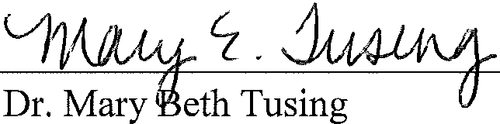



11

Asperger' s Syndrome: Two Case Studies

By

Erika Ann Andrle

The University of Wisconsin-Eau Claire, 2013 Under the Supervision of Dr. Vicki Samelson

ABSTRACT

Asperger Syndrome (AS) is a well-known developmental disability within society, but the research describing the cognitive and linguistic characteristics is
conflicting. The existing literature suggests heterogeneity of academic skills, social skills, behaviors, and concomitant diagnoses; however, the available research has focused primarily on group studies of individuals with AS. Consideration of the individual differences seen within this population is essential and may benefit individuals with AS academically, socially, and during the transition from high school. Two case studies are presented to gain knowledge about the participants' unique characteristics and how these characteristics may or may not relate to the scores and observations obtained from a battery of language, cognitive, and academic assessments. The aims of this research study were to describe the cognitive and linguistic profiles of two adolescents with AS and consider how their profiles may influence academic and social interactions in high school

iii

and in the transition to post-secondary education or employment after graduation. The results of this study indicated that each participant exhibited strengths and challenges in the battery of assessments. While both participants scored similarly in formal cognition and pragmatic assessments, considerable differences were observed in writing and math skills, awareness of diagnoses, and informal pragmatic skills. These results illustrate the individual differences seen across individuals with AS.

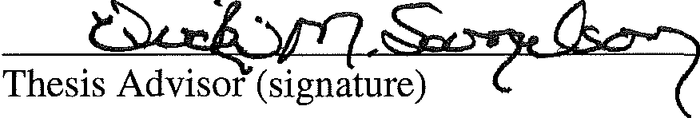

iv

DEDICATION

I dedicate this thesis to my cousin, Zachary Pitzen. Without him, I would not have chosen to pursue this field of study. Observing how the speech and language services he received as a child supported his success at home and school inspired me to become a speech­ language pathologist. He also taught me perseverance and not to take anything for granted. Thank you Zacho !

v

ACKNOWLEDGEMENTS

This research project was funded through the Abigail Joy Stellmacher Graduate CSD Scholarship. A special thank you to the University of Wisconsin-Eau Claire Center for Communication Disorders and Human Development Center for allowing me to use their space and materials for my thesis.

I would like to thank the participants and their families for volunteering to be a part of this study and taking time out of their busy schedules to participate. It was a pleasure working with all of them, and I gained valuable insights into the individual variation seen in adolescents with Asperger' s Syndrome.

A special thank you goes out to the volunteers who spent many hours preparing, administering, and scoring assessments. They were very knowledgeable about their areas of expertise, and their time and effort was greatly appreciated.

I owe an extraordinary amount of thanks and gratitude to my thesis advisor, Dr. Vicki Samelson. She spent countless hours editing chapters and was an irreplaceable resource to me. Dr. Samelson was not only a wonderful research mentor but also a cheerleader during the times when the process became overbearing. I would not have completed this thesis without her.

In addition, I would like to thank the other two members of my thesis committee. Dr. Abby Hemmerich provided useful resources, feedback, and encouragement throughout the process. It was a pleasure to work with Dr. Mary Beth Tusing because of her depth of knowledge about the field of psychology and willingness to discuss my ideas.

I would also like to thank Dr. Michael Axelrod for his assistance with interpreting the results of the CPT II.

Thank you to my family and friends who have supported me for the past two years. Even though I had to sacrifice my time with them to complete this project, they were very understanding. Your encouraging words helped me through the challenging times when I thought I would never be done.

Vl

TABLE OF CONTENTS

Page
LIST OF TABLES xii
LIST OF FIGURES xiv
Chapter
I. INTRODUCTION 1
Cognition 3
Typical Cognitive Development and the Brain 3
Self-Regulated Learning and Executive Functioning 4
Language 6
Terminology: Communication, Speech, and Language 6
Language Acquisition Theories 8
Typical Language Development 9
Spoken language 9
Literate language 10
Transition from spoken to written language 12
Written language 13
Language Disorders 16
Dysgraphia 19
Asperger's Syndrome 20
Introduction to Asperger's Syndrome 20
Definition of Asperger's Syndrome 21
History of Asperger's Syndrome 21
Diagnostic Criteria for Asperger' s Syndrome 22
Prevalence of Asperger's Syndrome 24
Language Form in Asperger' s Syndrome 25
Language Content in Asperger' s Syndrome 26
Language Use in Asperger's Syndrome 26
Written Language and Handwriting in Asperger' s Syndrome 29
Concomitant Deficits and Differences 31
Cognition and Asperger's Syndrome 31
Motor/Sensory Needs and Asperger's Syndrome 32
Behavior and Asperger's Syndrome 33
Academics and Asperger's Syndrome 33
vii

Asperger' s Syndrome through the Lifespan 35
Importance of Communication Assessment in Individuals with AS 39
Statement of the Problem 41
- METHODS 43
Participants 43
Participant 1 44
Participant 2 46
Assessment Plans 47
Objective Measures 49
Hearing 49
Voice Quality 49
Informal Assessments 50
Spoken Language 50
Written Language 51
Standardized Assessments 52
Language 53
Cognition 56
Academic Achievement 57
Attention and Focus 58
Problem Solving and Executive Functions 59
Reliability of Standardized Measures ...................................., 59
Validity of Standardized Measures 60
Procedures 61
Reliability of the Examiner's Responses 64
Data Analysis 64
- RESULTS 65
Participant 1 65
Objective Measures 65
Hearing Evaluation 65
Voice Assessments 66
Informal Assessments 67
Double Interview 67
Language Sample 68
Writing Sample 69
Additional Observations 73
Standardized Assessments 76
vm

Clinical Evaluation of Language Fundamentals-4th Edition
(CELF-4) 77
Test of Problem Solving-Adolescence (TOPS-A) 80
The Word Test 2™: Adolescent 81
Test of Pragmatic Language-2nd Edition (TOPL-2) 81
Woodcock-Johnson III Tests of Cognitive Abilities (WJ III Cognitive) 83
WJ III Tests of Achievement (WJ III Achievement) 84
Conners' Continuous Peiformance Test II (CPT II) 85
Behavior Rating Inventory of Executive Functioning (BRIEF) ... 86 Summary 90
Participant 2 93
Objective Measures 93
Hearing Evaluation 93
Voice Assessments 93
Informal Assessments 94
Double Interview 94
Language Sample 95
Writing Sample 96
Additional Observations 100
Standardized Assessments 103
Clinical Evaluation of Language Fundamentals-Fourth edition (CELF-4) 103
Test of Problem Solving-Adolescent (TOPS-A) 104
The Word Test 2™: Adolescent 106
Test of Pragmatic Language-2nd Edition (TOPL-2) 106
Woodcock-Johnson III Tests of Cognitive Abilities (WJ III Cognitive) 108
Woodcock-Johnson III Tests of Achievement (WJ III
Achievement) 108
Conners' Continuous Peiformance Test II (CPT II) 110
Behavior Rating Inventory of Executive Functioning BRIEF) 110
Summary 113
Inter-Rater Reliability 116
Participant Comparisons 117
Language 117
IX

Cognition and Academic Achievement 121
Attention, Executive Functioning, and Problem Solving 122
Additional Observations 124
- DISCUSSION 126
Comparison to Literature 127
Cognition 127
Language Acquisition 128
Spoken Language 129
Written Language 132
Academics 134
Concomitant Deficits and Differences 136
Summary Comparison of the Participants 138
Discussion of Results with Parents and Transition after High School. 139
Participant 1 140
Participant 2 141
Limitations 143
Future Directions 144
Concluding Remarks 146
LITERATURE CITED 147
APPENDICES 154
  - Recruitment Letter 154
  - Parent Questionnaire 156
  - Rainbow Passage 163
  - Double Interview Protocol: Both Participants 164
  - Double Interview Questions 165
  - Double Interview Pictures: Both Participants 167
  - Writing Prompts 169
  - Metacognitive Reflection Questions after Writing: Both Participants 170
  - Confidentiality Assurance Agreement 171
  - Consent Form 172
  - Assent Form 174
  - Double Interview Analysis 175
  - Participant 1 Narrative Writing Sample 176
  - Writing Evaluation Scale (Woodcock, McGrew, & Mather, 200la):
Participant 1 Narrative 177
0. Participant 1 Expository Writing Sample 179
x

P. Writing Evaluation Scale (Woodcock et al., 200la): Participant 1
Expository 180
Q. Participant 2 Narrative Writing Sample 182
- Writing Evaluation Scale (Woodcock et al., 2001a): Participant 2
Narrative 183
- Participant 2 Expository Writing Sample 185
- Writing Evaluation Scale (Woodcock et al., 2001a): Participant 2
Expository 186
- Video Recording Release Form 188

Xl

LIST OF TABLES

Table 2.1

Table 2.2
Table 2.3
Table 2.4
Table 2.5
Table 2.6
Table 2.7
Table 2.8
Table 2.9
Table 3.1
Table 3.2
Table 3.3
Table 3.4
Table 3.5
Table 3.6
Table 3.7
Table 3.8
Table 3.9
Table 3.10
Table 3.11
Table 3.12
Table 3.13
Table 3.14
Table 3.15
Table 3.16
Table 3.17
Table 3.18
Table 3.19
Table 3.20
Table 3.21
Table 3.22

Table 3.23
Participant 1's Developmental Milestones in Comparison to Typical Development 44
Description of Vocal Analysis Measurements 50
Description of CELF-4 Subtests 54
Description of The Word Test 2™: Adolescent Subtests 55
Description of the WJ III Cognitive Subtests 56
Description of the WJ III Achievement Subtests 58
Standardized Assessments and their Reliability Coefficients 60
Standardized Assessments and their Validity Information 61
Assessments Completed during Sessions 63
Participant 1Tympanometry Results 65
Participant 1 Sustained /a/ Acoustic Analysis Data 66
Participant 1 Connected Speech Acoustic Analysis Data 67
Participant 1Loban Analysis Data from Language Sample 70
Participant 1Narrative Writing Sample Analysis 70
Participant 1Expository Writing Sample Analysis 72
Participant 1 CELF-4 Scaled Scores and SDs 78
CELF-4 Subtest Groupings and Indexes 79
Participant 1 CELF-4 Standard Scores, SDs, and Percentile Ranks 80
Participant 1 The Word Test 2™: Adolescent SD and Percentile Rank ...81 Participant 1 WJ III Achievement SD and Percentile Ranks 84
Participant 1 CPT II Percentiles and Interpretations 87
Participant 1 BRIEF T-Scores and Percentiles 90
Participant 2 Tympanometry Results 93
Participant 2 Sustained /a/ Acoustic Analysis Data 94
Participant 2 Connected Speech Acoustic Analysis Data 94
Participant 2 Loban Analysis Data from Language Sample 96
Participant 2 Narrative Writing Sample Analysis 97
Participant 2 Expository Writing Sample Analysis 99
Participant 2 CELF-4 Scaled Scores and SDs 104
Participant 2 CELF-4 Standard Scores, SDs, and Percentile Ranks 105
Participant 2 The Word Test 2™: Adolescent SDs and Percentile
Ranks 106
Participant 2 WJ III Achievement SDs and Percentile Ranks 109
xii

Table 3.24
Table 3.25
Table 3.26
Table 3.27

Table 3.28

Table 3.29

Participant 2 CPT II Percentiles and Interpretations 110
Participant 2 BRIEF T-Scores and Percentiles 113
Point-to-Point Inter-Rater Reliability for Standardized Assessments 116
Comparison of Both Participants' Loban (1976) Analysis Data from Language Samples 118
Comparison of Both Participants' Informal Narrative Written Language
Samples 121
Comparison of Both Participants' Informal Expository Written Language Samples 121

xiii

LIST OF FIGURES
Figure 3.1. Participant 1results of CELF-4 subtests 78
Figure 3.2. Participant 1 results of CELF-4 indexes 80
Figure 3.3. Participant 1results of The Word Test 2™: Adolescent tasks 82
Figure 3.4. Participant 1 results of WJ III Achievement clusters 85
Figure 3.5. Participant 1 results of BRIEF scales and indexes 90
Figure 3.6. Participant 1 comparison of standard scores on formal language measures . 92
Figure 3.7. Participant 2 results of CELF-4 subtests 105
Figure 3.8. Participant 2 results of CELF-4 indexes 106
Figure 3.9. Participant 2 results of The Word Test 2™: Adolescent tasks 107
Figure 3.10. Participant 2 results of WJ III Achievement clusters 109
Figure 3.11. Participant 2 results of BRIEF scales and indexes 113
Figure 3.12. Participant 2 comparison of standard scores on formal language measures
....................................................................................... 114
Figure 3.13. Comparison of both participants' CELF-4 scaled scores 119
Figure 3.14. Comparison of both participants' standardized language measures 120
Figure 3.15. Comparison of both participants' WJ III Cognitive and Achievement
clusters 122
Figure 3.16. Comparison of both participants' BRIEF T-Scores 123

xiv

INTRODUCTION

Transitions occur numerous times throughout an individual's lifetime. Whether the transitions occur in academic settings or are more personal in nature, these times can be stressful for individuals and their families. Some of the first transitions in a person's life are in academics (e.g., home to preschool or kindergarten, elementary school to middle school). Children with disabilities may have a more difficult time with these transitions; however, if the appropriate supports are implemented, these academic transitions may go smoothly.
As the demands at school increase, stress and anxiety levels can increase as well (Adreon & Stella, 2001). These more stressful times include the transitions into middle and high school. Typically developing children as well as those with disabilities experience stress and anxiety about similar situations (e.g., locker combinations, meeting new teachers). Other new situations bring about excitement in typically developing children (e.g., changing classes, independence between classes); however, these factors cause more stress for some individuals with disabilities. A group of individuals that has stress and anxiety about academic transitions are those with Asperger's Syndrome (AS).
In high school, individuals begin to prepare for the transition period to adulthood. Some look forward to post-secondary education and gaining independence from their parents. Others join the work force in an occupation of choice. In 2011, 89.8% of Wisconsin high school seniors without disabilities graduated from high school, but this number was only 67.1% for adolescents with disabilities (Wisconsin Department of Public Instruction, 2012). This is a significant gap in graduation rates between typically developing adolescents and those with disabilities. After graduation, typically developing

individuals and those with disabilities, including those with AS, plan for the next period in their lives.
Most individuals transition into a post-secondary education program or employment after high school. Although this transition comes easy for some adolescents, others, including those with AS, find this time very difficult. There is little existing literature on young adults with AS during this transition period (Hurlbutt & Chalmers, 2004). Under the Americans with Disabilities Act and the Rehabilitation Act, individuals with AS can receive support services in post-secondary education (Graetz & Spampinato, 2008). Being a self-:advocate is important to receiving these services. Education and employment are important to becoming an independent member of society.
Of the existing literature, some is focused on the employment status of individuals with AS. A recent study by Hurlbutt and Chalmers (2004) explored the employment of adults with AS. Most participants in their research study experienced frequent unemployment and underemployment due to a variety of factors. These factors included social skills, communication, and sensory issues. Often these individuals were capable of fulfilling the job duties, but interacting with coworkers was difficult. Communicating in job interviews and taking constructive criticism was also difficult for those individuals. Many times, these individuals experienced anxiety about the social situations they encountered, and concentrating on how to act was exhausting. Even though maintaining employment may be difficult for individuals with AS, it was critical to the participants' quality of life.
Many factors are associated with academic achievement, social interactions, and the transition to independence after high school. Two of these factors are cognition and

language. The literature on AS characteristics is somewhat conflicting; however, common challenges documented in this population include impaired pragmatics (i.e., social skills), spoken and written language, and executive functioning (Attwood, 1998;
Bennett, et al., 2008; Brown & Klein, 2011). For enhanced understanding of this population and the challenges they face, typical cognition and language development will be reviewed in the next sections, followed by a description of AS and the characteristics typically seen in individuals with AS. The transition from high school faced by all individuals can be difficult, but when adolescents are diagnosed with impairments involving cognition and language, parents and professionals must look more closely at support systems to facilitate successful transitions.

Cognition Typical Cognitive Development and the Brain
The brain controls what people do and how they act and feel. A fetus needs proper growth and development in order to have a typically developing brain. By the sixteenth week of gestation, brain cells begin to develop and differentiate according to the region
of the brain where they are located (Owens, 2008). After differentiation of brain cells is complete, the areas in the brain that undergo rapid growth first include the brainstem and the areas responsible for movement and sensation. After birth, the regions of the brain that undergo rapid growth include the cerebellum, responsible for autonomic functions, and the occipital lobe, responsible for vision. From conception to early adulthood, the brain changes and grows until it becomes mature. The areas in the brain responsible for general speech and language fully develop by the time children reach preschool age; however, the higher-level cognitive processes involved in language do not fully mature

until adulthood. A basic knowledge of brain development specific to language development will aid in the understanding of the structures of the brain and how they support language development and use.
The brain has three basic functions: regulation, processing, and formulation (Owens, 2008). The regulatory processes of energy, alertness, and self-monitoring reside in the reticular formation, an area in the brainstem. This function is important for sustaining the energy level and alertness needed to be successful in academics, social situations, and vocations. The brain processes information by analyzing, coding, and storing the input in posterior regions of the brain to access at a later time. Processing involves all types of input (e.g., auditory, visual); integrating this input to the brain is critical for learning in an academic setting, and to acquire knowledge and process it correctly for later retrieval. The third function, formulation, allows individuals to monitor behavior, attend, concentrate, and plan movements. This function requires the frontal lobes of the brain to be fully developed in order to work properly (Owens, 2008). All three of these functions work together in a typically developing individual to help that person stay alert and monitor behavior so incoming information and stimuli can be processed and stored. The importance of these functions for academics is critical for successfully obtaining knowledge in the classroom.

Self-Regulated Learning and Executive Functioning

When academics become forefront in an individual's life, many cognitive processes are at work to actively engage in the learning process. Young children who have not had exposure to formal education need to shape their thinking to become accustomed to regulating their own learning. Self-regulated learning is a "self-directive

process through which learners transform their mental abilities into task-related academic skills" (Zimmerman, 2001, p. 1). To achieve self-regulation, individuals need to become active participants in their own learning. This can be achieved by thinking about learning, monitoring thinking and understanding, and implementing behaviors to become more effective learners. These are often referred to as the processes of metacognition. Because self-regulated learning is a skill set that is learned over time, it is thought that external factors also help shape how individuals develop this skill.
Another cognitive process closely linked to sel -regulated learning is executive functioning. Although it is thought by some that executive functions and self-regulated learning are the same, they are closely linked, but differ in an important way. Whereas executive functions are the actual brain processes that help to self-regulate the body for optimal learning and thinking (e.g., attention, inhibition, working memory; Bashir & Singer, 2006; Crone, 2009; Owens, 2008), self-regulated learning is the intentional, metacognitive use of strategies to achieve optimal task completion (Bashir & Singer, 2006). As children enter adolescence, maturation of the executive function systems begins to refine self-regulated learning skills for higher-level thinking (Crone, 2009). Both executive functions and self-regulated learning are imperative for academic success and higher-level thinking in new situations that may arise.
Cognition is important to becoming an effective learner and communicator. From the earliest stages of development, the brain constantly changes and refines the neural pathways and processes used to communicate and learn. Research on individuals with AS suggests that brain development in this population is different than in typically
developing people (Bennett et al., 2008; Pierangelo & Giuliani, 2008; Saalasti et al.,

2008). Repeated exposure to learning experiences assists in brain development as well. Once most individuals reach early adulthood, these executive function processes are fully developed, allowing efficient higher-level thinking and decision-making. Cognition is not the only factor that plays a role in communication and learning, however.

Language Terminology: Communication, Speech, and Language
All individuals, regardless of culture, communicate with one another in different environments. Communication is the active process of two or more individuals sharing information (Owens, 2008). Within the communication process, a speaker is responsible for encoding information, or forming the message, and transmitting information via efficient modes, while a listener decodes the received message. Communication is an encompassing term which includes speech and language in combination with other processes. Speech is the aspect of communication that uses sounds in a multi-step process to communicate. Combining multiple speech sounds forms words, and combining words into sentence patterns constitutes language. Language is "a socially shared code or conventional system for representing concepts through the use of arbitrary symbols and rule-governed combinations of those symbols" (Owens, 2008, p. 4). Language allows individuals to communicate and understand one another; however, multiple factors can create barriers to communication. By clarifying this terminology, the process of communication through speech and language can be more easily understood.
Language, as a rule-based system for communicating with other individuals, contains three main components: form, content, and function/use (American Speech­ Language Hearing Association [ASHA], 1993; Bloom, Lahey, Hood, Lifter, & Fiess,

1980). Language form, or the rules governing how language is sequenced (Bloom et al, 1980), consists of the subcomponents syntax, morphology, and phonology (ASHA, 1993). Word and sentence meanings, or semantics, are categorized as language content (ASHA, 1993; Bloom et al., 1980). Lastly, language use (i.e., pragmatics) is how individuals interact with others by incorporating all components of language (Bloom et al., 1980).
To fully understand the three main components of language, each of the five subcomponents will be discussed. Syntax is the set of rules governing the formation of words into sentences and dictates the appropriate word order in sentences (ASHA, 1993; Owens, 2008). Spoken and written language have the same basic rules of syntax; however, Owens (2008) suggested that using appropriate syntactic rules in written language is more difficult because the process of writing is more constrained and formal, and requires the development of metacognitive skills. Morphology is the set of rules dictating how individual words are structured (ASHA, 1993; Owens, 2008). Each word is made up of at least one morpheme, or unit. As words begin to convey relational meaning, or time (e.g., walked), they require more morphemes (Owens, 2008). For example, walk is one morpheme; however, when used in the past tense form (e.g., walked), the verb contains two morphemes (e.g., walk, -ed).
Phonology refers to the rules of individual and combined speech sounds (ASHA, 1993). Although a phoneme is the smallest unit in speech and language, the rules of phonology are important because they govern how sounds can be combined to make words. This is seen when adjacent sounds affect the pronunciation of each other (Owens, 2008).

The meanings of words and phrases are referred to as semantics. Individuals need to understand what words mean through definitions and personal experiences (Owens, 2008). Lastly, pragmatics is the set of rules which explain how to use language in social contexts (ASHA, 1993; Owens, 2008). Examples of appropriate social interactions include taking conversational turns, using eye contact when speaking, and repairing communication breakdowns when the message isn't understood. All five subcomponents of language are important in the communication and language processes.

Language Acquisition Theories

Individuals who use language successfully have the ability to sequence words, apply the rules of language, and recognize patterns within language. Language
acquisition theories attempt to explain how individuals develop this abstract concept. One theory of language acquisition describes how the different components of language collaborate (Bennett et al., 2008; Chapman, 2000). This process involves the ability to learn one component of language through other language components, (i.e., bootstrapping). By using bootstrapping, children with deficits in syntax can learn
syntactic rules though the other components of language (e.g., pragmatics, morphology). Although this is a plausible concept to consider, some children with language deficits may not learn language through bootstrapping because all the components of language are not well-developed. This may help to explain why some children have a difficult time learning language when they are unable to learn information through other mediums and sources (Bennett et al., 2008). Therefore, the bootstrapping theory may explain why
children with AS struggle to learn language, because their deficits in pragmatics and possibly other components of language do not allow them to use existing language

knowledge to bootstrap other areas of language acquisition (Boucher, 2009; Church, Alisanski, & Amanullah, 2000; Sansosti, Powell-Smith, & Cowan, 2010; Silverman & Weinfeld, 2007).
Myklebust (1965) presented an additional theory of language acquisition and a hierarchical approach to language learning that encompasses other modalities beyond spoken language. Spoken language is the first modality to be acquired through listening to others speak. An understanding of spoken language is acquired before expression of spoken language develops fully. Myklebust (1965) explained the process of language acquisition as follows: after learning spoken language, reading and writing develop in a sequential order. According to this theory, it is argued that written language deficits stem from an underdevelopment or disruption in either spoken language or reading. Both of these theories may help explain the potential language deficits reported in children and adolescents with AS.

Typical Language Development

Spoken language. The development of language, both spoken and written, is a complex process that requires many years to master. As children develop from infancy to adolescence, language acquisition occurs in different stages (Dore, Franklin, Miller, & Ramer, 1976). Spoken language begins in children as babbling and nonsense words, which develop into real words and complex sentences. Mastery of most basic spoken language skills by typically developing children, including articulation, syntax,
semantics, and pragmatics, occurs by five or six years of age (Bailet, 2001). Nippold, Hesketh, Duthie, and Mansfield (2005a) found, however, that adolescents and even young adults continue to develop and refine their syntactic skills.

Literate language. As language develops, the style of language used shifts. Children use the oral style of language in everyday interactions to hold conversations and get their needs met. Upon entering school, children learn a more-literate style of language for thinking, reading, writing, and learning (Paul, 2007). Learning a literate style of language helps children transition into using metacognitive skills to think about and use more-complex language. Children entering school are also expected to use a variety of discourse genres. Discourse genres are spoken or written forms of communication, each requiring a different skill set. Three important discourse genres include conversational, narrative, and expository styles of communicating (Scott & Windsor, 2000).
Conversational discourse occurs when two or more individuals communicate and speak in a social situation which can be either casual or formal. Conversational discourse uses language along with environmental and personal cues (i.e., objects, facial expressions) to convey a message. Children typically acquire language using conversational discourse. Although using conversational discourse is effortless for typically developing individuals, those with language deficits and other developmental disorders, such as AS, have difficulty developing these skills, which has repercussions for learning, forming relationships, and obtaining employment.
Narrative discourse uses stories to convey messages in a monologue-type fashion. Unlike conversational discourse, narratives require all the information to be said or written down because they are decontextualized (Owens, 2008). Children develop the basic underpinnings of narratives at a very young age. As children experience new
events, they learn the order of familiar happenings. By two years of age, children talk about past events in simple language. As children develop, they acquire the different

elements required for understanding and telling basic narratives. By the time children enter elementary school, they have developed the elements needed for telling more­ complex narratives (Owens, 2008). Children listen to peers and adults tell narratives which helps to develop and refine their concept of an oral narrative. Eventually, children learn to read and write narratives. Not only are narratives a way to acquire information, individuals are also expected to deduce meaning from information that is not explicitly available in the narrative (Paul, 2007). These inferencing skills become important when using narratives in conversations, comprehending complex written narratives, writing an essay for school, or telling a story about overcoming obstacles in a job interview.
Expository discourse is used when an individual communicates, by speaking or writing, an explanation of a subject matter, using detailed and specific language to convey his or her message (Nippold, Mansfield, Billow, & Tomblin, 2008). It is common for oral class lectures and classroom textbooks to be expository in nature because these are typical ways information is transmitted to the learner (Paul, 2007). Because the
demands of expository discourse are higher than other forms of discourse, comprehension and production of the expository text genre typically develops later than the conversational and narrative discourse genres. Individuals who engage in expository discourse use complex language and draw upon in-depth background knowledge to form and understand messages and concepts (Nippold et al., 2008). Examples of expository discourse used by adolescents include describing the steps to a favorite board game, giving directions to a specific location, or reading about the Civil War. Individuals who struggle with expository text may also struggle with learning and developing important skill sets for interacting with others. Mastering discourse genres at developmentally

appropriate ages is important as children acquire knowledge and develop peer and adult relationships throughout the school-age years.
During the school-age years, children are expected to develop reading and writing skills which are more difficult tasks than mastering spoken language skills. The processes of reading and writing each involve multiple skills. Producing language is felt to be more challenging than understanding language; therefore, reading is deemed an easier task than writing (Bailet, 2001). Developing these receptive and expressive spoken and written language skills requires an intersensory approach to integrate the auditory, visual, and other input modalities (Myklebust, 1965).

Transition from spoken to written language. As spoken language develops and becomes more complex, children transition from spoken language to writing as a form of communication. The demands of academics also require more-complex language in both spoken and written modalities. Learning specific language patterns is required in written language much like spoken language. Because in the developmental process spoken language is acquired first, it is important to understand how the transition occurs.
Language first involves listening, talking, and being aware of the sound and letter patterns within words, and word order patterns within sentences. Once the rules and patterns of spoken language are learned, meaning is derived from written words and the orthographic patterns of letters and sounds. This stage of learning written language
integrates the different sensory input modalities. For example, writing letters involves the motor aspect of writing as well as the visual input of the orthography. Individuals can
also integrate auditory and visual input modalities by listening to language and looking at the orthography of the words. This last stage of language development involves the

metacognitive component of thinking and talking about language in a meaningful way (Myklebust, 1965). Therefore, the skills in spoken language must first be developed in order to appropriately develop and learn written language skills (Nippold, 2006). Support from different environments (e.g., home, school, work) must be provided to foster· optimal spoken and written language learning. Previous discussion focused primarily on the learning process of spoken language. In the following section, the interactive processes of writing and cognition will be discussed.

Written language. The development and knowledge of writing begins well before children actually start to write. As preschoolers, children show knowledge of writing when playing (e.g., scribbling notes when playing school) and develop prerequisite skills to writing. By first grade, children know letter-sound correspondences, and begin learning how to spell and write short, simple phrases or sentences. A shift occurs during third grade when writing in a variety of discourse styles is required for different assignments (e.g., book reports, letters), and expectations are raised to write in more-complex and complete sentences. Also at this age, children may be required to write some assignments individually; however, the writing process still incorporates collaboration with teachers and other students. By the end of elementary school, children
become more independent writers by performing their own work, but still receive support from teachers and parents to create finished products. They are also expected to develop organized writing skills in a wide variety of discourse genres. The beginning of variation in length and complexity between different genres of writing emerges. during fifth grade (Nippold, 2006). The prerequisite writing skills learned in elementary school are very important in the development of the writing process.

Although most of the written language development happens in the elementary years, middle school and high school are times when children and adolescents continue to build and refine their writing (Nippold, 2006). At this time, writing is the main focus for most individuals because of the preparation for college entrance exams and writing at a college level. Proficient writing skills are also important for independence and acquiring
a job. One area of challenge for some individuals as they enter high school and adulthood is writing in a persuasive frame of mind. This type of writing can remain a difficult area for some because of the required skills of organization and complex language. Not only do individuals need to know complex syntax, semantics, and other components of language, they also need to understand the audience who will be reading their written work. Even though persuasive writing tends to be difficult for typically developing high school adolescents and young adults, other genres of writing also yield written work that is lengthy and complex.
Multiple variables play a role in developing written language skills. Cognition and language are two variables that are required to perform this complex communication
form (Gregg & Hafer, 2001). The writing process requires individuals to express language using symbols in an abstract manner (Myklebust, 1965). Taking this into consideration, written language requires some of the same skills as spoken language such as pattern-finding and attaching meaning to words. Writing differs from spoken language because different motor and sensory components are used to express ideas.
Several cognitive processes are employed during the writing process. Integrating sensory input is one part of the cognitive process. Myklebust (1965) refers to this as the transmodal learning of language. In order for children to fully develop written language,

they must have an adequate level of "intellectual competence, psychomotor coordination, emotional maturity, and psychosensory integration" (Myklebust, 1965, p. 13). As the sensory input from writing is integrated in the brain, individuals must also apply the executive function processes of inhibition, to differentiate between relevant and irrelevant information and organization, to plan their thoughts before producing the written product.
Writing also requires an individual to be aware of the audience he or she is addressing. Understanding the structure of a particular discourse genre and adjusting a writing style to audience preference or knowledge entails having a sense of audience awareness (Gregg & Hafer, 2001). This process is known as theory of mind. An individual who uses metacognitive theory of mind skills when reflecting on his or her writing will be able to envision the needs of the audience. Sometimes individuals do not take the audience into consideration and provide too few or too many details in their writing. Writers must filter out what the audience already knows and envision the information they need to know in order to produce meaningful written work (Flower, 1979). Having the skills of metacognition and theory of mind may result in writing samples which are easier for an audience to comprehend.
After a child has acquired the ability and language skills to write for expression of oneself, the child must be motivated to use the skills he or she possesses. The affective system in the brain is responsible for motivating and engaging individuals in the writing process (Meyer, Murray, & Pisha, 2001). It is also responsible for adjusting writing styles to meet the needs of different contexts or audiences. Having the motivation and skill to write for different audiences may allow a child to write more. Another aspect of

motivation may include previous experiences. Gregg and Hafer (2001) suggested that children with more world experience produce more written product.
As mentioned earlier, written language differs from spoken language in multiple ways, but one of the major differences is the motor component of writing. The act of handwriting or typing on a keyboard involves integration of the motor (Bain, 2001) and visual systems which permits individuals to use symbols as the representation of language (Broun, 2009). This aspect of writing has the potential to greatly impact the writing process; however, handwriting is often overlooked by professionals.
In summary, communication is segmented into speech and language. Language is the pattern-governed means by which individuals communicate with one another. The acquisition of spoken and written language is a developmental process which can be explained by different theories. In general, it is easier to acquire and apply the rules of spoken language, whereas written language is more complex and requires an underlying level of skill in spoken language.

Language Disorders

When an individual does not develop spoken or written language skills as expected, a language disorder may be the underlying cause. The American Speech­ Language Hearing Association (ASHA) defines a language disorder as "impaired comprehension and/or use of spoken, written and/or other symbol systems" (1993, p. 1). This can occur due to a mislearning of the language rules that were discussed previously or ineffective language processing by the brain (Caplan, 1992). In either circumstance, individuals with language disorders have limited language systems that affect their communication in daily functional activities (Caplan, 1992). Language disorders can

affect the three components of language discussed previously (form, function, and use; ASHA, 2004). Children with language disorders are especially prone to the effects of their disorder because of the communication demands of social and academic environments. It is beyond the scope of this literature review to describe the different natures and underlying causes of language disorders; however, keep in mind that all individuals with language disorders have difficulties interacting in their environments which can hinder academic and social development in many ways.
Although language disorders can impact any component or modality of language, it is difficult to make a distinction between disorders that occur only in spoken or written language. The remainder of the discussion on language disorders will incorporate all areas and modalities of language, with a slight emphasis on written language disorders. The characteristics in a child's written language can often be traced back to spoken language. If spoken language is disordered in any component, it is likely that the child will have disordered written language in the same component. For example, if a child has difficulties with syntax and the rules governing word order in sentences during speaking, it is likely that this deficit will carry over into his or her written language (Gregg & Hafer, 2001).
A number of studies on language impairment completed in recent years have focused on the challenges older children and adolescents have with written language (Nippold et al., 2008; Scott & Windsor, 2000); however, some research has been done comparing the spoken and written language skills of older children with language impairment. Gillam and Johnston (1992) found that older elementary-age children with language/learning impairment (LLI) produced written language samples that contained

more grammatical errors than in spoken language samples. An emphasis was placed on the difficulties children with LLI have in spoken and written language when compared to typically developing children. Children with LLI in the study performed similarly to their typically developing peers on measures of the quantity of written language form as well as in the organization and amount of language content (Gillam & Johnston, 1992). In general, the spoken language of children with LLI was comparable to that of the typically developing children in the study; however, their written language contained more errors, especially in the area of syntax.
Other studies have explored the spoken and written language of children with la guage impairment across different discourse genres and found conflicting results.
Scott and Windsor (2000) found sixth-graders with language impairment to have deficits in syntax when speaking and writing in narrative and expository discourse genres compared to typically developing peers. Nippold and colleagues (2008) saw different results in their study. Adolescents with language impairment had a higher complexity of syntax when speaking in an expository discourse than during conversational speech, but produced shorter sentences than typically developing peers. Although studies have found children with language impairment to have different skill sets in different discourse genres, it is clear that this population has deficits using syntax in both speaking and writing situations.
As seen in these research studies, children with language impairments have similar deficits in syntax, which span modalities and discourse genres. Researchers have theorized different explanations of written language impairments. Myklebust (1965) theorized that children with written language disorders have breakdowns in the sequence

of learning. Difficulties in auditory processing, recognition of letter-to-sound correspondence, or visual representations of letters might play a role in language disorders. This theory may play a role not just in syntactic disorders but in all areas of language. Individuals with language impairments exhibit different characteristics, so it is difficult to determine an exact cause for language impairments. According to Gregg and Hafer (2001), more research is needed to better understand how written language is affected in individuals with different developmental disabilities. One aspect of written language that these studies did not include was handwriting. Children with learning disabilities sometimes have difficulty with handwriting which may also impact written language output (Bain, 2001).

Dysgraphia

It is important to recognize and discuss variables that may impact an individual's written language apart from a language disorder. A discussion of multiple variables is beyond the scope of this literature review; however, of importance is a description of handwriting disorders. Dysgraphia is a difficulty in translating the auditory and visual aspects of language to the motor aspect of writing. When visually inspecting the written work of individuals with dysgraphia, readers have a difficult time interpreting the letters and words (Myklebust, 1965). Because writing is so difficult for these individuals, often their written content and form are compromised. Writing samples from these individuals usually contain the least amount of writing possible to make the writing process shorter. To achieve this, children with dysgraphia also think in fewer words to make their written responses shorter (Broun, 2009). The language bootstrapping theories would then say that

the act of thinking in fewer words might then impact the development of more-complex language skills (Bennett et al., 2008; Chapman, 2000).
Considering the difficulty individuals with dysgraphia have with writing, other areas such as academics may be affected. In stressful situations such as tests, children with dysgraphia may produce written work that is poorer in quality. Handwriting quality decreases when individuals focus strongly on the motor aspect of writing. Children in these situations are more worried about their handwriting than about the content of what they are writing. In stressful situations, Broun (2009) suggested children should be allowed supports such as computers and keyboards for writing purposes to reduce the demands of handwriting and focus on the quality of writing.

Asperger's Syndrome

Introduction to Asperger's Syndrome

Certain populations diagnosed with a particular disorder might also be diagnosed with a comorbid language disorder. Although this may be the case for some disorders, in others, language may develop normally. One group of individuals who often receive multiple diagnoses is those with AS. AS lies on the high-functioning end of Autism Spectrum Disorders (ASDs). AS is set apart from ASD because the two disorders have different diagnostic criteria (American Psychological Association [APA], 2000). Due to the similarities seen in these two disorders, however, professionals who work with and study people with AS and ASDs do not agree on the definitions and diagnostic criteria used (Church et al., 2000).

Definition of Asperger's Syndrome

Church and colleagues (2000) defined AS as "a developmental disorder characterized by significant difficulties in social interaction and emotional relatedness and by unusual patterns of narrow interests and unique stereotyped behaviors" (p. 12). Much debate has occurred in professional fields surrounding AS and high-functioning ASD. Many professionals disagree as to whether or not AS and high-functioning ASD are the same disorder or different disorders that manifest themselves in similar ways (Bennett et al., 2008; Bernier & Gerdts, 2010; Boucher, 2009). Although some
professionals refer to both disorders as the same entity, this research study refers to AS as that which is clinically diagnosed by a professional using the currently accepted diagnostic criteria (APA, 2000).

History of Asperger's Syndrome

Despite the recent attention on AS in the United States, researchers in other parts of the world were studying ASD and AS much earlier. Kanner (1943) was the first individual to describe children with ASD. He studied 11 young children with characteristics known today as ASD. The children he studied were described as having the "inability to relate themselves" in daily interactions from birth (Kanner, 1943, p. 242). Other characteristics included typical, delayed, or no development of language; literal interpretations of language; sensory deficits; and perseverative behaviors. One of the most notable differences included the repetition of phrases or sentences previously heard, accompanied by difficulty generating novel sentences. These children had severe deficits when interacting with other individuals.

During the same time period, another individual was independently studying children with similar characteristics. In 1944, Hans Asperger was one of the first individuals to describe AS, or "autistic psychopathy" (Frith, 1991). He followed four children in Vienna who had characteristics now known as AS. Asperger (1944) collected qualitative data on these four children and compared the characteristics displayed by each. Many of the characteristics were common across all the children. Prevalent
characteristics noted by Asperger (1944) included lack of eye gaze or eye contact, little to no facial expressions or gestures when talking, and intense special interests which continued throughout the lifespan. Along with these strong interests, some children had poor impulse control and frequently engaged in inappropriate behaviors at inappropriate times.
Asperger (1944) also noted other similarities in the children's intelligence, learning style, and language. Children with autistic psychopathy (i.e., AS) had difficulty with mechanical learning but could produce their own ideas. This was also seen in their language characteristics. The children had high intelligence but often failed in academics, particularly math, reading, and writing. The language used by these children often showed deficits in pragmatics, characterized by not considering other's feelings. The social withdrawal exhibited by these children affected relationships, particularly with
family members. The children's voices were often soft or not modulated, and their conversations often were not directed to people.

Diagnostic Criteria for Asperger's Syndrome

According to the APA (2000), a diagnosis of AS requires that each candidate meet six main criteria. The criteria include "(l) qualitative impairment in social

interaction" and "(2) restricted repetitive and stereotyped patterns of behavior, interest, and activities" which causes "(3) clinically significant impairment in social, occupational, or other important areas of functioning" (APA, 2000, p. 84). The candidate must also show "(4) no significant general delay in language and (5) cognitive development, or in the development of age-appropriate self-help skills, adaptive behavior, and curiosity
about the environment in childhood" while (6) not meeting diagnostic criteria for other disorders or conditions (APA, 2000, p. 84). All six criteria must be met for a diagnosis of AS.
With the first two criteria, subcategories describing specific characteristics are used to determine if the general category is present. To meet the first criteria of impairment in social interaction, two of four characteristics must be present. These include "marked impairment in the use of multiple nonverbal behaviors; failure to develop peer relationships appropriate to developmental level; a lack of spontaneous seeking to share enjoyment, interests, or achievements with other people; and lack of social or emotional reciprocity" (APA, 2000, p. 84). To meet the diagnostic criteria for restricted behaviors, interests, and activities, one of the following must be met: "encompassing preoccupation with one or more stereotyped and restricted patterns of interest that is abnormal either in intensity or focus; apparently inflexible adherence to specific, nonfunctional routines or rituals; stereotyped and repetitive motor mannerisms; or persistent preoccupation with parts of objects" (APA, 2000, pp. 84). Looking at a candidate's developmental history is important in order to assess these characteristics.
Because AS is on the continuum of ASDs, there are similarities and differences seen in the diagnostic criteria for both. The social interaction aspect of both disorders is

similar in that individuals have deficits in social interaction which significantly affect their relationships and personal lives. Although both disorders share this characteristic, individuals diagnosed with AS tend to have a central view and focus on themselves rather than having no interest in communicating with others. One main difference in the criteria for both disorders centers around the language aspect of the disorders. As stated earlier, there are no developmental language delays in individuals diagnosed with AS; however, language delays are part of the diagnostic requirement for ASD. Individuals with ASD have impairments in language which may affect multiple areas of social interaction
(APA, 2000). It has been found that children with ASD are diagnosed, on the average, at an earlier age (48 months) than children with AS (75 months; Centers for Disease Control [CDC], 2012).
Although one of the criteria for a diagnosis of AS specifies typical language development, the existing literature contains information which conflicts with this criteria. The language characteristics seen in individuals with AS are discussed later in this chapter.

Prevalence of Asperger's Syndrome

The prevalence of ASD and AS is not well known (APA, 2000). This may be due to the relatively new diagnostic label, the lack of research, or other unknown factors. Since the publication of the Diagnostic and Statistical Manual of Mental Disorders, Fourth Edition Text Revised (DSM-IV TR; APA, 2000), which states the diagnostic criteria for AS, few studies have attempted to find the prevalence of this disorder. Recently, the CDC (2012) published a study completed by the Autism and Developmental Disabilities Monitoring Network estimating the prevalence of ASD.

Although this study only identified the overall prevalence of ASD and not specific disorders on the spectrum, it is still important to consider the trends seen. In 2008, it was estimated that 11.3 out of 1,000 eight-year-old children were diagnosed with ASD. This was an increase compared to their data published in 2006. The prevalence of ASD varied by state, gender, and ethnicity. More males were diagnosed with ASD than females (CDC, 2012), which mirrors the trend in AS (APA, 2000). Because AS is a distinct disorder, different than ASD, and research available to support the prevalence of ASD is greater than that of AS, more information is needed to conclusively measure the prevalence of AS.

Language Form in Asperger's Syndrome

As described earlier, language consists of three main components: form, content, and use. Children with AS develop language milestones at appropriate times; however, some language characteristics seen in children with AS suggest differences in all three language components. It is important to note, however, that compared to children with ASD, children with AS have fewer deficits in language (Church et al., 2000). The first aspect of language to be explored is language form. Again, language form includes the rules of spoken and written language for formulating complete, syntactically correct, complex sentences. Some research suggests that children with AS may exhibit difficulties in sequencing words, applying rules, and recognizing patterns of language (Bennett et al., 2008). These difficulties may be caused by executive functioning deficits in the brain.
Other literature suggests that children with AS have above-average skills in this area. Children with AS may have typically developing, appropriate, and sometimes above-average spoken language skills in terms of language form (e.g., syntax, grammar;

Boucher, 2009; Sansosti et al., 2010). Other individuals may even develop and use advanced expressive language at an early age as described by Church and colleagues (2000). Some individuals may develop language that is not age-appropriate because it is too complex (Sansosti et al., 2010). When children have language skills that are too developed for their peers, this can lead to deficits in language content and use. Another possible theory to consider is the bootstrapping mentioned previously. Because children with AS may have deficits in other areas of language, it may be more difficult for them to learn aspects of language such as language form (Bennett et al., 2008).

Language Content in Asperger's Syndrome

Language content refers to the meanings of words, or semantics. It is unknown whether children and adolescents with AS have relatively few deficits in language content or if this is an area that has not been sufficiently explored. The characteristics reported in this population are often closely linked to the deficits seen in language use. When children with AS interact with others, especially peers, the topics of conversation may revolve around the child's areas of interest (Sansosti et al., 2010). Individuals with AS also have challenges interpreting language correctly. This population tends to have literal interpretations of language and misunderstands words with multiple meanings (Attwood, 1998). This literal interpretation of language is best seen when sarcasm is used. Although language content may be relatively unaffected in isolation, deficits in language use may in turn influence comprehension and use of language content.

Language Use in Asperger's Syndrome

Children with AS may perform similarly to or have slight challenges with language form and content compared to typically developing children; however, multiple

instances and examples of deficits in language use (i.e., pragmatics) are noted in the literature (Boucher, 2009; Church et al., 2000; Sansosti et al., 2010; Silverman & Weinfeld, 2007). Sharing and talking about special interests may be easy for children with AS; however, they do not readily engage in conversational exchanges with their listeners (Sansosti et al., 2010). Instead of a mutual conversation, the child with AS may seem to speak at the listener instead of with him or her (Church et al., 2000). To illustrate
how different aspects of language interact, language form can impact language use. When individuals speak in a more formal manner, the listener may lose interest and not want to engage in conversation (Sansosti et al., 2010), thereby contributing to some of the social language use deficits seen in children with AS. Children in elementary school show multiple deficits with pragmatics and social interactions, and these behaviors carry over into the later school years (Church et al., 2000).
Church and colleagues (2000) conducted a retrospective study of the characteristics and behaviors of children and adolescents with AS. They noted challenges in language use, in the form of interacting with other individuals, as one of the most prominent features of AS from childhood through adolescence. Preschoolers were more likely to show appropriate social skills when communicating with adults but had difficulty forming meaningful relationships with peers. They also exhibited eye contact
that varied from appropriate to inappropriate. Elementary-age students with AS demonstrated variable levels of social skills; however, the majority of cases reviewed were noted to include some form of pragmatic deficits. Meaningful peer relationships were still underdeveloped. Middle-school-aged children were noted to have the most deficits in social skills. Again, they built relationships more easily with adults or with

younger children. By high school, adolescents with AS often chose to not engage in meaningful friendships. As revealed by this retrospective study, children and adolescents with AS formed relationships and used more appropriate social skills with adults than with peers.
Although children with AS may develop language milestones at appropriate ages during childhood, use language to form relationships with adults, or have more-complex language than is expected for their age, these children develop communication difficulties because of their deficits in conversational skills (Sansosti et al., 2010). In spoken language, children with AS have difficulty organizing and expressing their thoughts in a socially-appropriate manner (Periangelo & Giuliani, 2008); therefore, this may account for some of the deficits seen when attempting to interact and build relationships with
others.

Also, individuals with AS may use atypical language and voice characteristics. For example, children with AS may speak in a voice that is too high or low in pitch, talk at a speed that is faster or slower than typical, or use a volume that is too loud or soft (Attwood, 1998; Sansosti et al. 2010). This difficulty in using different features of the voice to adapt to surroundings is known as difficulty with modulating the voice. Preschoolers with AS may use echolalia or perseverative language (Church et al., 2000). Considering that children with AS may appear to have language skills within normal limits, it's important to consider these other areas of language that may have a profound impact on their conversational skills (Sansosti et al., 2010).

Written Language and Handwriting in Asperger's Syndrome

The final difference to be discussed related to individuals with AS is written language. As mentioned previously, one diagnostic criterion for AS includes having typically developing language skills. Therefore when children are diagnosed with AS, language deficits might not be identified. Research suggests, however, that differences in written language may exist (Brown & Klein, 2011; Myles, Rome-Lake, Barnhill,
Higgins, Hagiwara, & Griswold, 2003; Sansosti et al., 2010). To date, very few studies have been completed on written language with this population; therefore, further research is needed to clarify characteristics of their written language. A discussion of the existing research follows.
Brown and Klein (2011) compared the narrative and expository writing of typically developing adults and adults with High Functioning Autism Spectrum Disorder (HFASD). Although these individuals did not have AS, this study is worthy of consideration due to the lack of research on this topic. Researchers' aims were to explore theory of mind and whether deficits in this area affect the written language of these individuals. The study compared the length, mechanics, and quality of the participants' narrative and expository writing. Their findings revealed that adults with.HFASD wrote shorter narratives with fewer total words and lower quality content in both genres than typically developing adults. The authors also suggested that future research should focus on expository writing in the HFASD population because of the impact this genre has on educational outcomes and on an individual's employment.
Myles and colleagues (2003) compared the written language of children and adolescents with AS to that of their typically developing peers. The study analyzed

writing samples using standardized normative data along with informal observations. The Test of Written Language (TOWL) was used along with a handwriting measure to compare samples. The TOWL used written samples to measure the strengths,
weaknesses, and complexity of written language. The researchers found that on four of the eight subtests, children with AS scored higher than the control group of typically developing children. When looking informally at the writing samples, however, children with AS wrote shorter and less-complex sentences in regards to number of morphemes and t-units. There was no significant difference in the number of sentences written by each group. The handwriting analysis revealed that handwriting was more difficult and significantly impaired for children with AS compared to typically developing children.
The handwriting analysis suggests a difference in the fine motor skills of children with AS and the impact this has on their writing, however other factors may have also impacted their written samples. Based on the findings of their study, Myles et al. (2003) suggested that children with AS write about topics of interest in an attempt to produce longer written samples; however, it has been found that individuals with AS sometimes have difficulty attending to pertinent information (Sansosti et al., 2010). This may become a barrier to the writing task, and may also affect note-taking in school. Students with AS may not understand what to attend to, so handwritten notes may be too difficult for them for more than one reason. Accommodations should be made for these children. These may include having other students take notes for them or letting individuals use computers for taking notes.
In summary, the research concerning individuals with AS and the characteristics of their written language is limited and somewhat conflicting, and therefore an area to be

explored in greater depth. These studies suggested that children, adolescents, and adults with AS or HFASD may have written language abilities which are lower than, consistent with, and/or above those skills of their typically developing age-matched peers. Because of the lack of research available surrounding this population, researchers have suggested that more studies be conducted to add to the literature (Brown & Klein, 2011; Myles et al., 2003).

Concomitant Deficits and Differences

Cognition and Asperger's Syndrome. According to the diagnostic criteria set forth by the APA (2000), individuals with AS do not have a cognitive delay in childhood; however, AS can co-occur with other psychological and cognitive disorders and deficits. Individuals with AS can be diagnosed with mild mental retardation in elementary school so long as it was documented that cognitive functioning was within normal limits before entering school. This would indicate a change in cognition after these individuals started school.
Because children with AS have differences in the way their brains regulate the input, store, and output information, they have difficulty processing sensory information and making sense of it (Pierangelo & Giuliani, 2008). Deficits in basic brain functions can affect how individuals learn and apply knowledge. Children with AS are known to have deficits in executive functions as well (Bennett et al., 2008; Saalasti et al., 2008), which may inhibit their ability to sequence language and recognize patterns. The executive dysfunction may also account for their perseverations on topics of interest and their rigid thinking patterns (Bennett et al., 2008). This population has also been known to have poor organization of their thoughts and actions as well as deficits in planning and

prioritizing information (Sansosti et al., 2010). These characteristics may account for some of the difficulties seen in academics, language, and social interactions.
Another area to consider in cognitive development is theory of mind. Theory of mind is the concept that a person can understand that another individual has independent thoughts and feelings. This skill typically develops in children by the age of four; however, children with AS often develop theory of mind between the ages of nine and fourteen. Because of their slower development, children with AS do not understand that other people have emotions, thoughts, and needs different from their own mental states (Pierangelo & Giuliani, 2008). This is easily seen in the relationships that are built by individuals with AS. They tend to interact with children who are much younger or they play by themselves, and struggle to understand other's emotions (Attwood, 1998). Again, the way these cognitive skills develop may account for some of the social deficits seen in children with AS.

Motor/Sensory Needs and Asperger's Syndrome. Other deficits seen in children with AS include those pertaining to motor movements and the integration of sensory information. Some younger children with AS in the preschool and elementary years develop sensory deficits (Church et al., 2000). These manifest as hypersensitivity, hyposensitivity, or a combination of both to sound, touch, taste, or vision (Attwood, 1998). As children reach elementary school age, these sensory deficits tend to resolve, but children may develop clumsiness or awkward movements (Church et al., 2000). The characteristics shown by these children may lead to social isolation when they attempt to play sports or other activities requiring motor coordination and display these clumsy

movements (APA, 2000). Motor delays and clumsiness may also affect a child's handwriting, walking, and balance (Attwood, 1998).

Behavior and Asperger's Syndrome. A number of behaviors have been documented in children with AS. These behaviors may co-occur with other characteristics or may not be evident. Across all age ranges, it has been noted that children with AS prefer rigid routines, perform rituals, and have difficulty with transitions. Younger children engage in repetitive and stereotypical behaviors such as hand flapping. By elementary school, many children that exhibited difficult behaviors have overcome them except in high-anxiety or stressful situations. Older children do not demonstrate many of these behaviors, but difficulty with transitions and rigid thinking persist for some (Church et al., 2000). Children may also exhibit perseverations or
fixations on unusual subjects (Attwood, 1998; Pierangelo & Giuliani, 2008). The subjects can vary from transportation to dinosaurs to electronics and science (Attwood, 1998). Many of these behaviors manifest in obsessive-compulsive-like tendencies (i.e., perseverations on topics; Pierangelo & Giuliani, 2008). Hyperactivity and inattentive behaviors have also been seen in children with AS, and often these children are
diagnosed with Attention-Deficit/Hyperactivity Disorder (ADHD; APA, 2000). Inattention and hyperactivity may interfere with daily functioning and impact their social interactions and academic performance.

Academics and Asperger's Syndrome. Although some information is known about the learning characteristics of children with AS, specific information is still unknown and not fully understood by professionals. From the early research done by Asperger (1944), these children excel in some areas of academics and struggle with

others. More recent research has attempted to look at the learning characteristics of this population. Church and colleagues (2000) observed multiple children with AS in different age groups across different environments to describe characteristics and behaviors seen in this population. Observations made in school settings were somewhat representative of the findings of Asperger (1944). At the elementary level, children were described as very bright individuals excelling in subjects such as math, computers, and reading; however, these children also demonstrated poor reading comprehension skills, difficulty with handwriting, and being very particular about their schoolwork to the point that it distracted them from completing their work (Church et al., 2000). Older children observed with AS continued to have similar strengths in math and reading, but some additional challenges were noted. These adolescents exhibited difficulty understanding abstract concepts and being motivated about topics that were not of interest to them.
Academic skills for high school adolescents were seen to be an area of concern. The most difficult area for the high school students was English, thought to be because of the difficulty of creative and analytical writing. These adolescents also found organizing their thoughts to be a difficult task, and writing was a noted challenge for participants in the study.
Few research studies have followed up on the academic skills of individuals with AS. A study completed by Griswold, Barnhill, Myles, Hagiwara, and Simpson (2002) examined the academic profiles of children with AS, including problem-solving and critical thinking skills. The Wechsler Individual Achievement Test (WIAT) and the Test of Problem Solving-Elementary (Revised or Adolescent) were used to measure these characteristics. The findings of the study indicated that although the mean scores on the

WIAT were within the average range, there was great variability in the subtest scores. The lowest scores for most of the participants included the written expression portion of the assessments. Participants also performed significantly lower on the problem solving tasks than the academic subtests. Although this was an important study to describe some of the academic abilities of this population, the authors suggested additional research be completed in the area of academics and children with AS.
An important concept to consider when analyzing the abilities of these children is the idiosyncrasy of behaviors and characteristics. Because each individual, even those with AS, is unique, assessment approaches are difficult to plan (Sansosti et al., 2010). Children or adolescents may appear to present with certain strengths and difficulties, but it is only until thorough assessments are completed that underlying deficits may be discovered. Depending on the findings of functional assessments, children may or may not receive services in schools because of their current level of functioning under existing diagnostic criteria, despite the potential benefits of receiving services. Language and cognition play a major role in academic functioning, so increasing our understanding of how deficits in language and cognition affect the process of learning will help us better
understand this population.

Asperger's Syndrome through the Lifespan

Although AS is usually diagnosed during childhood, this syndrome can be the most debilitating in adolescence and adulthood, when social interactions are vital for success. Although adults with AS may have had concomitant sensory or behavioral deficits in childhood, many of these disappear by adulthood (Church et al., 2000). Most of the deficits that remain are pragmatic in nature as described earlier. An individual's

interests will vary based on his or her intelligence and are often very complex and unique to that individual (Tantam, 2000). Special interests that may be talked about incessantly still persist (Tantam, 1991) and may be at the root of some of the challenges with pragmatics skills.
Although some characteristics fade in the transition from childhood to adolescence or adulthood, other characteristics remain. One characteristic that continues through adolescence and into adulthood is nonverbal communication deficits. The nature of these deficits is both receptive and expressive in the sense that people with AS have difficulty understanding and using nonverbal cues (Tantam, 2000). Adults with AS use very few, if any, non-verbal language cues such as facial expressions or hand gestures (Tantam, 1991). Other nonverbal communication deficits include challenges in understanding tone of voice, body postures, or eye contact (Attwood, 1998; Tantam, 2000). Deficits in these areas may contribute to the challenges these individuals face when communicating with others.
One of the defining characteristics of AS, as stated previously, is the relatively typical language development. Although this is the case, most children and adults use vocabulary that is inappropriate (Tantam, 2000). Some of the language used by adults with AS is very precise, and they may use words not common in everyday conversations. They also use jargon or words that pertain to their special interests when conversing with others. Tantam (2000) also described their language as having some grammatical and semantic, or meaning, errors. This parallels what is found in the language of children with AS. It is also common for adults with AS to use syntactically-correct sentences but
use language that is awkward and not meaningful to their communication partners. When

adults with AS do engage in conversations with others, they rarely use small-talk, so many people without AS think of adults with AS as egocentric and strange (Frith, 1991). A final characteristic that continues into adulthood are the voice differences seen in childhood (i.e., pitch, volume). Adults with AS are known to speak during both expiration and inspiration. Disfluencies can also occur in adult speech. Although these language characteristics seen in adulthood may impact individuals with AS, other changes and disorders can also have a negative effect on their lives.
A common characteristic of adolescents and adults with AS that may arise during this time period is emotional disorders. Depression, anxiety, and the side effects that occur with these emotional disorders are common, and they may make other characteristics of AS more noticeable (Tantam, 2000). These disorders may also foster some of the social isolation and transition difficulties these individuals face. Accompanying these emotional difficulties is the avoidance of change. As with childhood, many individuals follow strict routines and schedules. For example, a strict daily schedule of events may be kept, including exact times for waking up, eating meals, going to bed, etc. Although some of these behaviors may continue from childhood, the emotional disorders sometimes seen in this population (e.g., depression, anxiety) may exacerbate these rituals or routines. This is one of the characteristics seen in adolescents and adults with AS that can negatively impact their lives.
Although some adults learn how to adapt and live successful lives, they can remain socially reserved and tend not to interact and engage in conversation with other individuals (Frith, 1991). As individuals with AS become adolescents and adults, they are very aware of the social isolation that sets them apart from other individuals (Tantam,

2000). This period in an individual's life is full of transitions (e.g., from school to work, from living at home to living independently) and building relationships. Most of the time, the parents of these adults are still involved in their son's or daughter's life and help them through these transitions and beyond. Adolescents and adults with AS are highly aware of their social deficits and how their interaction skills hold them back from fully
participating in conversations and building relationships, and sometimes have difficulty finding employment and places to live because of these characteristics (Frith, 1991). However successful individuals with AS may be, as adults they may have trouble finding the support and help needed to live fulfilling lives.
During this transition period from adolescence to adulthood, young adults with AS may attend college or post-secondary education. According to Smith (2007), the percent of individuals with AS attending college is increasing significantly. Attending college and moving away from home presents a unique set of challenges for any adolescent; however, when considering the skill sets and profiles of adolescents with AS, transitioning to college can be more difficult than for typically developing adolescents. Smith (2007) completed a study exploring the accommodations available to young adults with AS ·attending post-secondary education, and found that most accommodations were designed for students with other disabilities and did not always meet the needs of the students with AS. Receiving ineffective accommodations greatly reduces academic success. Not only may the students with AS be unprepared for their educational experience, professors and support staff may have limited understanding of AS and how to best accommodate these students (Graetz & Spampinato, 2008). Other factors besides academics present challenges for transitioning to college. Society expects that individuals

in college will socialize with one another and form friendships. Individuals with AS struggle with this aspect of communication, which can also make the transition to college difficult.
Another characteristic of many individuals with AS arises when they interact with professionals and other people. During evaluations, assessments, or daily conversations, the information given by an adolescent or adult with AS may not always be reliable. Over time, these individuals have become aware of their deficits and therefore do not always tell the truth (Tantam, 2000). When these individuals are younger, the parents can be asked to clarify information, but as adults, the information cannot always be clarified.
As individuals transition from childhood to adolescence and adulthood, characteristics of AS can dissolve, continue, or new behaviors and characteristics can surface. Being aware of these characteristics and how they can transform over developmental time is essential to understanding how this population functions. It is important to keep in mind that although the characteristics described in this review of the literature are common in most individuals with AS, there is variability within the population. An individual may display some, all, or very few of the characteristics. While a fair amount of information is known about adolescents and adults with AS, there is still much to be learned. According to Tantam (2000), the characteristics of this population
are still relatively unexplored and researched in the literature.

Importance of Communication Assessment in Individuals with AS

The research regarding AS is limited, as seen in this review of the literature, and the studies concerning language development in this population are even more limited. Many studies focused on spoken language; however, recent research on written language

skills in this population is conflicting. Employers and other professionals expect individuals to have mastered the basics of the writing process and to communicate effectively via writing (Bain, 2001). If individuals use language at a level below what is expected, academic, career, and social opportunities may not be as readily accessible to them as to typically developing peers (Scott, 2011). To explore the effects of spoken and written language deficits on social and academic outcomes, a comprehensive language assessment is necessary.
An individual's skills can be assessed through many different means; however, the importance of using both standardized and informal methods is imperative to understanding the whole person. Standardized measures are those that identify a disorder or difference by comparing results to a normative sample, and informal measures help to describe an individual's communication disorder. By using a combination of both types of assessments, a comprehensive communication profile can be created to help conceptualize an individual and his or her disorder (Tyler & Tolbert, 2002).
Individuals referred for communication assessments are typically seen by multiple professionals who assess them in different areas, including academics and cognitive function. Collaboration between parents, teachers, speech-language pathologists, psychologists, and other professionals will yield a complete profile. Taking into consideration the individual's family background and developmental history will add to the profile and may help account for individual differences seen in language and other areas. Keeping the person's needs and skills in mind, a comprehensive evaluation of his
or her expressive and receptive language will help to generate a profile of strengths and challenges which may then be used to develop future treatments and recommendations

(Scott, 2011). The heterogeneous nature of every individual, including those with AS, is of major concern when designing a communication assessment.

Statement of the Problem

Even though recent attention has been given to individuals with AS, discrepancies in the literature still exist. The majority of the studies discussed thus far were group studies comparing individuals with AS or ASD to typically developing peers or other populations (Bennett et al., 2008; Brown & Klein, 2011; Myles et al., 2003), or included
a group of participants with AS or ASD (Church et al., 2000; Griswold et al., 2002; Mayes & Calhoun, 2003; Saalasti et al., 2008). These studies did not consider the unique characteristics of individuals in the participant groups. Because AS is a population that can have multiple concomitant disorders and differences compared to typically developing peers, the results of these studies are difficult to interpret unless these other factors are accounted for. Very few research studies to date have taken individual variation into account and looked at the possible effects this variability might have on language and coIILrnunication in individuals with AS.
Conducting and collecting group research data may be appropriate for certain types of research questions; however, using group data in particular situations may be inappropriate. When these situations arise, it may be more plausible to conduct case study research. Case study research consists of an in-depth examination of one or multiple
single participants to obtain data (Kazdin, 1982) which can serve the purposes of explaining, describing, and/or discovering causal relationships between different factors (Yin, 1993). A recent single-case study was completed by Worth and Reynolds (2008) concerning the assessment and identification of a language impairment in an individual

with AS. Their findings differed from the results of the group studies previously discussed. The male individual in their study had strengths in sentence comprehension, forming sentences, and vocabulary, with challenges in inferential comprehension and semantics. The researchers did a thorough examination of the participant's developmental and medical history; however, a limited set of assessments was used to analyze language and communication.
Also, it is evident that the research and literature available concerning the language characteristics of individuals with AS is sparse and conflicting. Adding to the existing research would enrich the field's knowledge of AS, especially if individual differences were taken into consideration. If professionals, educators, and parents are to provide appropriate educational and social experiences for individuals with AS, individual differences need to be taken into account during an in-depth assessment of a variety of language and cognitive tasks, including spoken and written language across different discourse genres.
The aims of this research study are to describe the cognitive and language characteristics of two adolescents with AS and explore how these characteristics might influence academic and social interactions in high school and in the transition to post­ secondary education or employment after graduation.

II.METHODS

A population that has received recent attention is individuals with Asperger' s Syndrome (AS). The research available which explores the different characteristics of this population is conflicting and rarely takes individual differences into consideration; therefore, additional research is needed to better understand how these individual differences might impact adolescents with AS both academically and socially. Although there are specific published criteria to diagnose AS, concomitant deficits often accompany this diagnosis. In order to add to the literature, two case studies are presented to gain knowledge about the participants' unique characteristics and how these characteristics may or may not relate to the scores and observations obtained from a
battery of language, cognitive, and academic assessments. The characteristics can also be referred to a profile that describes an individual's strengths and challenges to better comprehend his or her abilities. The aims of this research study are to describe the communication profiles of two adolescents with AS and consider how their profiles may influence academic and social interactions in high school and in the transition to post­ secondary education or employment after graduation.

Participants

The two participants in this study were recruited from high school social skills groups affiliated with the Center for Communication Disorders (CCD) at the University of Wisconsin-Eau Claire (UWEC). Potential participants and their families were approached by the investigator because they were adolescents with AS, diagnosed by a physician or other appropriate professionals (see Appendix A for the recruitment letter given to potential participants' parents). It was not a requirement to have concomitant

diagnoses or particular differences when compared to typically-developing adolescents; however, any noted individual variation was taken into account. In-depth descriptions of the participants as well as their background information follow.

Participant 1

Participant 1 is a fifteen-year-old male who is in the 10th grade. Medical and developmental history for both participants were obtained from parent report. Participant 1 had an unremarkable birth and medical history except for a hospitalization in 2010 for Lyme Disease. His developmental milestones were compared to normative data (Retherford, 2003). See Table 2.1 for a description of Participant l's developmental milestones compared to typical acquisition. His parents reported estimates of the developmental milestones. The early developmental milestones of smiling, rolling over, and babbling developed later than expected, and the remaining milestones developed earlier than expected; however, individual variation is seen in the typical development of infants and toddlers. Participant 1's developmental milestones were acquired at appropriate ages.
Table 2.1
Participant l's Developmental Milestones in Comparison to Typical Development
Developmental Milestone Participant l's Typical Acquisition
Development (Retherford, 2003)
Smiling 3 Yz-4 months 3 weeks
Roll over 4 Yz-5 months 3 months

Babbling Pull self up
Sit up unaided Crawling Walk unaided First word
Using 8-10 words
Using 2-3 word sentences
- Y2-6 months 4 months
5 Y2months 6-10 months
- -6 Yz months 8-11 months
- -7 Y2 months 8-14 months
9 Yz-10 months 12-18 months
7 months 15 months
11-12 months 18 months
15-16 months 24 months

In addition to the developmental milestones discussed above, Participant 1's parents reported other developmental milestones of interest to the study. As an infant, he did not copy facial expressions such as sticking out his tongue. Participant 1 recited his ABCs between the ages of two and two-and-a-half. He wrestled with other children his age as a toddler instead of playing with toys, which was thought to be his way of expressing emotions. Despite these behaviors, he typically wanted others to play with him instead of playing alone.
Participant 1 was diagnosed with AS in 2008, at 10 years of age, after his parents reported concerns consistent with Obsessive Compulsive Disorder (OCD). At the time of the AS diagnosis, he was also evaluated for and diagnosed with OCD. Participant l's father reported that, before the diagnosis, it was difficult to understand his son's actions and behaviors, but the professional worked closely with the family to explain AS and the characteristics their son displayed. He has received approximately three years of speech and language therapy since the diagnosis of AS. His parents reported that this therapy has significantly enhanced Participant 1's life and increased a.ppropriate social skill use. He didn't have any immediate or extended family members diagnosed with AS at the time of the study.
His parents also reported on recent behaviors and characteristics seen at home and in school. Participant 1 follows a daily routine or schedule; however, if the schedule is broken or not consistent, he has a hard time focusing and is "thrown off' for the rest of the day. He enjoys school and receives above-average grades in all subjects. Per parent report, Participant 1 independently participates in class, completes homework in a timely manner, enjoys most core subjects in school, and stays focused on homework and in class

most of the time. He displays challenges with thinking ahead during problem-solving situations, thinking before acting, and staying focused on homework problems for long periods of time. Participant 1is a hard-working adolescent with tremendous perseverance and vigilance when completing tasks.

Participant 2

Participant 2 is also a fifteen-year-old male in the 10th grade. His birth and medical history were unremarkable. Developmental milestones were not available for Participant 2; however, informal parent reports revealed information regarding early development. As an infant and toddler, early non-verbal communication skills developed as expected per parent report. He played alone and with other children his age. His
energy levels, seen through unfocused play and rapid changing of activities, were usually higher than those of other children. As a teenager, Participant 2 spends little time with peers his age. He doesn't seek out peer interaction outside of school activities. His
parents reported he is satisfied to be by himself, engaged in activities of interest. He has few interests in con1mon with his peers.
Throughout childhood and now in adolescence, Participant 2 speaks at a rapid pace with a high-pitched voice when he becomes excited. At other times, he speaks very quietly and uses imprecise articulation which makes him difficult to understand. His parents reported that he can be very difficult to understand during both of these scenarios.
Participant 2 was diagnosed with AS at the age of seven by his school psychologist. His parents noticed a lack of eye contact and repetitive behaviors which led them to seek a diagnosis. He has received speech and language therapy since the diagnosis. Participant 2 was also diagnosed with Attention Deficit/Hyperactivity Disorder

at the age of six by a physician, for which he has also received medical services and medication. He has an older brother who is also diagnosed with AS. His parents reported that his brother displays the characteristics of poor eye contact, egocentric thoughts, repetitive behaviors, intense interests in certain topics, and difficulty understanding a different point of view. Similar characteristics were noted in Participant 2.
Behaviors that Participant 2 displays at home and in school were reported by parents. Participant 2 follows a schedule and is very rigid with his morning routine. If the schedule and routine are broken, he has a difficult time adjusting initially but then becomes accustomed to the change. His grades are above average in most subjects, and
he enjoys going to school; however, he doesn't get excited about school. Participant 2 is independent when completing his homework, participates in class, and prefers subjects with facts such as math and science over English and language arts. He also completes most homework assignments on time, but may hand in more challenging assignments late. His parents and teachers redirect him occasionally when he becomes distracted from activities he doesn't find interesting. Tasks which are more challenging for Participant 2 include planning ahead and solving problems, thinking before acting, and focusing on activities that are not motivating to him. Participant 2 enjoys pleasing other people and
can be successful completing tasks independently.

Assessment Plans

Recall that a comprehensive evaluation of an individual's expressive and receptive language skills and consideration of his or her strengths and challenges can inform the development of transition plans for his or her future (Scott, 2011). Other diagnoses can accompany a diagnosis of AS (American Psychological Association

[APA], 2000; Attwood, 1998; Church, Alsanski, & Amanullah, 2000; Pierangelo & Giuliani, 2008); therefore, the need to assess the participants' language and cognitive skills with their individual variations in mind was imperative. The assessments and materials used in this study were chosen based on the skills and characteristics typically associated with the AS population, and are frequently used in the fields of speech­ language pathology and psychology. All assessments were administered by the investigator except those for which the investigator was not trained. A detailed description of the assessments and protocols used in this study is provided later in this chapter.
Before the first session with each participant, questionnaires were sent to parents to gather information related to medical history, developmental history and milestones, AS and other diagnoses, education, and other pertinent skill sets (Appendix B). Based on the answers provided in these questionnaires, follow-up interview questions with the parents were designed as needed to clarify any responses and to gain further insight into each participant's developmental history and abilities.
When developing an assessment plan, multiple factors affect the types of assessments that can be used. Informal assessments are used in the field of speech­ language pathology to gather information about an individual's skill sets and the unique characteristics they possess. The information obtained from these evaluations helps to describe the observed behaviors and skills. Although this information can be valuable in creating and adding to an individual's profile, comparisons to other individuals cannot be made. In developing this study, informal assessments were used to enrich the language and cognitive profiles and describe the participants' strengths and challenges.

Objective Measures

Hearing. The participants' hearing was assessed with a pure-tone audiometry screening. Participants were asked to raise their hands when they heard a tone. Tones were presented bilaterally at 20 dB for the frequencies of 500 Hz, 1000 Hz, 2000 Hz, and 4,000 Hz. Results from the pure-tone screenings revealed if the participants had adequate hearing to support academic and social development. Otoscopy was also performed to visually inspect the ear drum and determine if any obstructions or abnormalities were present in the outer ear. To check the function of the middle ear, tympanometry was performed. These three assessments were chosen as part of the informal evaluations because adequate hearing supports individuals academically and socially. Inadequate hearing function can lead to missed information and social isolation. For participants to continue with the study, normal ear function was required.

Voice quality. Two different voice assessments were administered to analyze vocal quality. Voice samples were recorded in a controlled sound booth in the CCD Voice Lab and analyzed using the Multi-Dimensional Voice Program (Kay Elemetrics, 1993) version 4150 through the Kay Elemetrics' Computerized Speech Lab™ Model 4300b. See Table 2.2 for a description of the voice measurements taken in this study. Individuals with AS have been reported to use their voice in atypical ways during conversation (e.g., using inappropriate volume and tone; Attwood, 1998; Sansosti, Powell-Smith, & Cowan, 2010), therefore, voice assessments were necessary to assess this aspect of communication. To measure vocal quality, participants were asked to do three tasks: (a) sustain the vowel /a/ for five trials, (b) read the Rainbow Passage (Fairbanks, 1960; see Appendix C), and (c) provide a 30-second monologue from the

Table 2.2
Description of Vocal Analysis Measurements (Colton, Casper, & Leonard, 2006) Voice Measurement Description
Average Fundamental Frequency Measure of participant's vocal frequency,
averaged across the samples
Relative Average Perturbation (RAP) Measures variability in cycle-to-cycle
deviations in frequency, or pitch

Amplitude Perturbation Quotient (APQ)
Measures variability in cycle-to-cycle deviations in amplitude, or loudness

Noise-to-Harmonic Ratio (NHR) Measures if more noise than voice is present Soft Phonation Index (SPI) Measures adequacy of vocal fold adduction Pitch Sigma Standard deviation of fundamental frequency;
estimated variability measured in fundamental
fre uency

prompt "Describe your daily routine or schedule." To measure the participants' maximum vocal volume, a Digital Display RadioShack sound-level meter was held six inches from the participants' mouths while sustaining "ah" as loud as possible for two to three seconds.

Informal Assessments

Spoken Language. A spoken language sample, in the form of a double interview, was collected from both participants. It was analyzed to determine the length and complexity of the participants' spoken language. The purposes of the double interview task were to gather informal observations about pragmatic skills (e.g., eye contact, turn taking), gain insight into the interaction style of the participants, and collect a spoken language sample. The literature surrounding AS is conflicting as to whether or not this population has deficits in spoken language despite the diagnostic criteria of developmentally appropriate language skills (APA, 2000).
The double interview task used in this study was designed after a double interview task used by Miller (2004). Open-ended interview questions were asked to ,

allow the participants to answer questions about themselves. Including this informal assessment in the study allowed for observations related to spoken language skills and pragmatic skills. Individuals with AS have difficulty with social interactions (Boucher, 2009; Church et al., 2000; Sansosti et al., 2010; Silverman & Weinfeld, 2007), so it was deemed appropriate to include this assessment. Interview questions were individualized and tailored to each participant. After the investigator modeled interview questions and behaviors, the participants were given the opportunity to interview the investigator. Three pictures of the investigator were provided as visual prompts for the participants (see Appendix D for the double interview protocol, Appendix E for the individual participant interview questions, and Appendix F for the pictures used). The double interview was
also used as a representative language sample to assess complex sentence structure in

spoken language. The language samples were transcribed and analyzed according to Loban' s (1976) procedure.

Written Language. Informal writing samples were collected from each participant in the study. Writing is an area that many individuals with AS struggle with, and this affects their academic performance (Myles, Rome-Lake, Barnhill, Higgins, Hagiwara, & Griswold, 2003). Writing is also a critical skill for higher education and employment in certain fields. To create participant profiles in the area of written
language, two writing samples were collected. One sample was expository, or factual, in .. nature, and the other sample required a story plot, or narrative. Prompts for each writing sample, based on individual participant interests, were provided in spoken and written form. After introduction of the task, each participant was told they could either write the samples by hand or use a computer to type them. Children and adolescents with AS are

also known to have difficulty with handwriting, and Broun (2009) states those individuals who have difficulty with handwriting produce shorter sentences and writing samples; therefore, the option of handwriting or typing was provided to support the longest, most complex writing samples. A time limit of 30 minutes was given for each sample. See Appendix G for the writing prompts used with each participant. After collecting each sample, the participants were interviewed about their thought process, strategies used to organize and complete the writing sample, perceived challenges, and other pertinent information. Appendix H contains the interview questions asked after each writing sample. Samples were analyzed for length and complexity as well as rated using the
Writing Evaluation Scale from the Woodcock-Johnson III Tests of Achievement (WJ III Achievement; Woodcock, McGrew, & Mather, 200la).

Standardized Assessments

Standardized assessments are used in many professions to diagnose a variety of disorders and conditions. These differ from informal assessments in that they not only describe behaviors and skills but also compare performances to a normative sample. Choosing the most appropriate assessments for a participant is critical in obtaining accurate and precise measurements as well as creating a detailed profile of that individual's strengths and challenges. One factor in selecting appropriate assessments is the sample used in the standardization process. Much debate has occurred in the field of speech-language pathology over whether or not to include individuals with disorders in the normative sample (e.g., children with language impairments for a language assessment; Pena, Spaulding, & Plante, 2006). Many factors contribute to this debate; however, Pena and colleagues (2006) concluded that individuals with language disorders

should not be included in normative samples because it skews the curve of the sample. If the normative curve is skewed, a representative score would not be obtained for diagnosing a disorder or condition. All of the standardized assessments included in this assessment battery, except the Test of Pragmatic Language-2nd edition (TOPL-2; Phelps­ Terasaki & Phelps-Gunn, 2007) and the Clinical Evaluation of Language Fundamentals- 4th Edition (CELF-4; Semel, Wiig, & Secord, 2003), did not include individuals with AS in the normative sample. Although other standardized assessments are available that do not include this population in the sample (e.g., the Social Language Development Test™: Adolescent; Bowers, Huisingh, & LoGiudice, 2010), it was deemed more appropriate to administer the TOPL-2 and CELF-4 because they have greater reliability. Because the purpose of this study was to create language profiles of adolescents with AS and not to diagnose, it was appropriate to use these assessments.

Language. The CELF-4 (Semel et al., 2003) was administered to assess the participants' spoken language capabilities. In this study, all CELF-4 subtests were administered to develop an in-depth profile of the participants' strengths and challenges in language form, content, and use. See Table 2.3 for a description of each subtest administered. Individuals with AS may have difficulty sequencing words, applying the rules of language, and recognizing patterns in language (Bennett et al., 2008), and the CELF-4 evaluates these skills along with others to create spoken language profiles. Results from this test give insight into the participants' academic skills and ability to access the curriculum. Administration protocol was followed.

Table 2.3
Description of CELF-4 Subtests (Semel et al., 2003)
Name of Subtest Description of Subtest

Recalling Sentences Participants listen to and repeat sentences verbatim
that increase in length and complexity. This skill is used in academics when students listen to lectures, take notes, follow directions, and store information to recall at a later time.
Formulated Sentences Given a word or phrase, participants say a sentence
based on picture stimuli. Using language in a flexible manner for formulating simple and complex sentences is a critical academic skill.
Word Classes 2-Total Given four words, participants choose the two
related words and describe how they are related. Understanding and expressing abstract reasoning is an important skill in secondary education and endeavors after high school.
Word Definitions Participants give definitions of words after hearing each word and a sentence containing the target word. The skills used to define and describe concepts in an abstract manner are used in secondary education curricula. Having the word and
world knowledge of these concepts aids in learning
language and acquiring new information.
Understanding Spoken Paragraphs Participants listen to narrative and expository
paragraphs while maintaining attention and focus and then answer questions requiring abstract thinking. Students use this skill often in academic settings to deduce information.
Sentence Assembly Given visual stimuli, participants create two grammatically correct and semantically appropriate sentences. Having the skills to use language in a flexible manner fosters academic achievement.
Semantic Relationships Given four printed words, participants answer
questions relating to concepts and meanings. Understanding basic concepts in all content areas in academics is important for acquiring and applying
knowledge.

The Word Test 2™: Adolescent (Bowers, Huisingh, LoGiudice, & Orman, 2005) measures spoken language in the areas of expressive vocabulary and semantics. Some adolescents with AS have difficulty with figurative language and interpret language

literally (Attwood, 1998). Literal interpretations of language and decreased language flexibility can hinder academic and social development. Not all subtests of the assessment were administered because the CELF-4 (Semel et al., 2003) assessed some semantics skills in similar ways.See Table 2.4 for a description of the subtests administered. Each subtest was standardized on the normative population; therefore, omitting subtests did not interfere with overall scoring. Administration protocol was followed.

Table 2.4
Description of The Word Test 2™: Adolescent Subtests (Bowers et al., 2005) Subtest Description
Synonyms After hearing a word, participants provide a synonym. This subtest was used because it looks at language flexibility, which individuals with AS struggle with. This skill is used in the classroom and in social situations.

Semantic Absurdities
Participants listen to a semantically inappropriate sentence. The sentence is read again, and the semantically inappropriate word is left out for participants to fill in with a semantically appropriate word. Individuals with AS can interpret language literally; therefore, this

skill set was appropriate to assess.

Flexible Word Use
Participants listen to a word and provide two meanings for the word. This skill tends to be challenging for individuals with AS. Knowing different word meanings assists with text editing and interacting with

others in conversation.

To obtain standardized profiles of the participants' pragmatic language, the TOPL-

2 (Phelps-Terasaki & Phelps-Gunn, 2007) was administered. This test measures pragmatic language through social scenarios that may occur in everyday interactions.
Assessment questions evaluate adolescents' understanding of pragmatic language through situational, discourse, and semantic contexts. Pragmatic language is the area that has received the most attention in the AS literature and these deficits are an essential diagnostic criterion. Characteristics seen in adolescents with AS include not readily

engaging in conversation with a partner (Sansosti et al., 2010), using inconsistent eye contact, and having few friends which are typically much older or younger (Church et al., 2000). The TOPL-2 provides a profile of the participants' strengths and challenges with pragmatic language. The assessment was administered according to protocol. Since pragmatics is an area the participants may struggle with, the investigator judged whether or not the participants should break from the test in attempt to support more valid responses at a later time.

Cognition. The brief battery of the Woodcock-Iohnson III Tests of Cognitive Abilities (WI III Cognitive; Woodcock, McGrew, & Mather, 200lb) was administered to assess the cognitive abilities of the participants. A diagnostic criterion for AS includes having average cognitive abilities (APA, 2000); however, it was deemed necessary to administer this assessment battery to obtain an accurate measure of the participants' cognitive abilities and create a cognitive profile describing the unique skills of each individual. The different skill sets individuals possess play a major role in academic success (see Table 2.5 for a description of the three tests given).

Table 2.5
Description of the WJ III Cognitive Subtests (Woodcock et al., 2001b)
Tests Description
Verbal Comprehension Participants complete four subtests (e.g., picture vocabulary,
synonyms, antonyms, verbal analogies) to measure semantic knowledge.
Concept Formation Fluid reasoning and cognitive flexibility is measured by
looking at stimuli and identifying rules. Memory is not used in this task.
Visual Matching Processing speed is measured through discrimination of
different visual stimuli.

Two graduate students in the School Psychology department at UWEC volunteered to administer the brief battery of the WJ III Cognitive to each participant (see Appendix I for the confidentiality assurance agreement all volunteers signed). The
student volunteers met the criteria for administration and had administered the battery under clinical supervision multiple times. This assessment was chosen over the Leiter International Peiformance Scale-Revised (Leiter-R; Raid & Miller, 1997) as a cognitive measure because the Leiter-Ruses nonverbal communication (e.g., facial expressions, gestures) for giving directions. The literature suggests that individuals with AS have difficulty reading facial expressions and nonverbal communication cues (Attwood, 1998); therefore, using the Leiter-R to assess cognition may have not provided a representative profile of their cognitive abilities. Administration protocols were followed.

Academic achievement. The WJ III Achievement (Woodcock, McGrew, & Mather, 200la) brief battery was administered to assess the academic achievement of the participants. It allows a look into the participants' strengths and weaknesses related to acadeIPic sldlls. Broad reading, broad writing, and broad math were the three areas assessed. The literature on AS suggests that this population struggles academically in the areas of English, writing, and understanding abstract ideas (Church et al., 2000). Again, the same volunteer graduate students in the school psychology department at UWEC administered the assessment battery to each participant. The entire brief battery was administered to obtain a more comprehensive view of the participants' skills. See Table
2.6 for a description of the subtests administered. The assessment was administered following prescribed protocols.

Table 2.6
Description of the WJ III Achievement Subtests (Woodcock et al., 2001a)

Test Description
Letter-Word Participants identify letters and pronounce words from visually- Identification presented stimuli.
Reading Fluency In three minutes, participants read sentences that increase in difficulty and answer yes/no questions about them.
Calculation Participants complete math problems involving addition, subtraction, multiplication, and division. Higher level math skills (e.g., geometry, trigonometry) and math calculations are evaluated.
Math Fluency Participants have three minutes to complete as many addition, subtraction, and multiplication problems as possible.
Spelling Participants listen to words and are asked to spell them.
Writing Fluency Given three words and picture stimuli, participants write as many sentences as possible in seven minutes.

Passage Comprehension
Picture and symbol stimuli are taught to participants, and then paragraphs with missing words and symbols are used to measure symbolic learning and comprehension of passages.

Applied Problems Mathematical word problems containing extraneous information are read to participants. Participants then solve the problems.
Writing Samples Handwritten writing samples are collected from participants using a variety of story starters and directions. Samples are scored for
written language complexity.

Attention and Focus. The Conners' Continuous Performance Test II (CPT II; Conners & MHS Staff, 2000) was used to measure impulsivity, attention, and ability to inhibit irrelevant information. Hyperactivity and inattentive behaviors have been documented in children with AS, and often these children are diagnosed with Attention- Deficit Hyperactivity Disorder (APA, 2000). If children exhibit these behaviors, it may interfere with their daily lives and cause issues with their social interactions and learning.
The CPT II is administered on a computer per standard protocol. Participants watch the computer screen while letters are displayed at different intervals of time. Participants press the space bar on a standard keyboard when they see any letter except the letter X. This test describes the participants' sustained attention and impulsivity which plays a major role in learning and using language in appropriate ways.

Problem Solving and Executive Functions. Another standardized assessment administered was the Test of Problem Solving-Adolescent (TOPS-A; Zachman, Barrett, Huisingh, Orman, & Blagden, 1991). This test evaluates critical thinking skills through orally presented expository and narrative scenarios. Individuals with AS have been known to have poor organization of their thoughts and actions as well as deficits in planning and prioritizing information (Sansosti et al., 2010). These challenges may also be seen in problem solving tasks and may account for some of the difficulties with academics, language, and social interactions. The TOPS-A was administered in one session according to administration protocol.
The Behavior Rating Inventory of Executive Functioning (BRIEF; Gioia, Isquith, Guy, & Kenworthy, 2000) is a standardized questionnaire developed to assess caregivers' perceptions of students' cognitive processes of executive functioning in daily living situations. The BRIEF complimented the assessment findings from the WJ III Cognitive (Woodcock et al., 200lb) for creating cognitive profiles of the participants. A volunteer graduate school psychology student administered the questionnaire to the parents because the primary investigator was not qualified to administer the BRIEF. Targeting daily living situations can create a better understanding of how the participants function at school, in the home, and community. Due to the nature of this research the participants were not observed in their natural environments, so parent reports were used as an indication of the participants' functioning in these environments.

Reliability of Standardized Measures

When developing the battery of assessments used in this study, the reliability and validity of each assessment was considered. Reliability is "the degree to which we can

depend on a measure" (Schiavetti, Metz, & Orlikoff, 2001, p. 182). A standardized assessment is deemed reliable if similar results are achieved after multiple assessments with one participant. Reliability can be defined in two ways. The first, referred to as interobserver agreement, compares two or more examiners' scoring of the same event. The second definition of reliability, intraobserver agreement, compares the scores of one participant across multiple administrations of the assessment by a single examiner. The stability of standardized assessments, also referred to as the test-retest method, is one measure of reliability. Table 2.7 includes the reliability coefficients for the standardized assessments used in this study.

Table 2.7

Standardized Assessments and their Reliability Coefficients

Standardized Assessments | Type of Reliability | Reliability Coefficients
CELF-4 | Interrater Reliability | .88 to .99
TOPS-A | Test-Retest Reliability | .86
The Word Test i'M | Test-Retest Reliability | .89
TOPL-2 | Interrater Reliability | .98
Woodcock-Johnson III | Test-Retest Reliability | .73 to .89
CPTII | Test-Retest Reliability | .43 to .92

Validity of Standardized Measures

Considering the validity of standardized assessments is also critical when making decisions regarding testing instruments. Validity is the extent to which a standardized assessment is measuring the expected behaviors or skills it purports to assess (Schiavetti et al., 2011). Validity can be broken down into three different types. First, content
validity is measured within test questions to determine if the assessment is measuring expected behaviors or skills. Second, criterion validity is measured through how certain behaviors or skills correlate with an outside validating criterion. Third, construct validity is used to measure behaviors and skills against theoretical constructs. It is important to

note that a standardized assessment must first be reliable before it can be valid. The importance of using valid standardized assessments is critical when measuring specific behaviors and skills. See Table 2.8 for validity information on the standardized assessments used in this study.

Table 2.8
Standardized Assessments and their Validity Information Standardized Description of Validity Process Assessments
CELF-4 Validity was measured through extensive processes by collecting information on test content, responses to questions, and internal structure. Individuals with language impairment, Autistic Disorder, mental retardation, and hearing impairment were also included in the normative sample to determine differential diagnoses.
TOPS-A A random selection of the normative population was compared to peers with language disorders, and it was determined that the assessment has the ability to differentiate between typically­ developing individuals and those with language disorders.

The Word Test 21
M
Random selections of the normative population were compared to peers with language disorders. It was determined that the assessment has the ability to differentiate between typically­ developing individuals and those with language impairments.

TOPL-2 This assessment was compared to the Comprehensive Assessment of Spoken Language (Carrow-Woolfolk, 1999), Test of Adolescent and Adult Language-Fourth Edition (Hammill, Brown, Larsen, &
·wiederholt, 2007), and Pragrnatic Language Skills Inventory
(Gilliam & Miller, 2005).
WJIII Validity was measured through extensive processes by collecting information on test content, developmental patterns, internal structure, and relationships to other variables.
CPTII Randomly selected subsets of the normative sample with specific conditions and diagnoses were compared to each other. The authors suggest that the CPT II has the ability to differentiate individuals with attention-deficit hyperactivity disorder from
typically-developing individuals.

Procedures

During initial contact with the participants' parents, a brief description of the study was presented, in addition to the rationale for assessing adolescents with AS.

Institutional Review Board (IRB) approval for the research study was obtained on October 5, 2012 (approval number ANDRLEEA6312012). After IRB approval, consent and assent from the parents and participants was obtained. (See Appendix J for the consent form and Appendix K for the assent form.)
Assessment sessions were held at the UWEC Center for Communication Disorders (CCD). All assessments were completed in four to five sessions lasting thirty minutes to three hours each. The variability in session length was attributed to participant schedules and length of remaining assessments. See Table 2.9 for the number of sessions and the assessment batteries administered during each session for both participants. Assessments were spread out over multiple sessions at approximately one-week intervals to decrease fatigue and inattentive behaviors. Parents of participants were offered the opportunity to observe the assessment sessions. Participant 1 completed sessions in quiet CCD therapy rooms and a mutually agreed-upon location, both of which had minimal distractions. Sessions with Participant 2 were held in quiet CCD therapy rooms with minimal distractions on the walls. The order of assessments was determined based on the complexity of the tasks as well as time constraints. For example, multiple difficult, time­ consuming tasks were not administered in the same assessment period. Standard administrative protocols for each assessment were followed for each participant,
including break periods during the assessments.

All assessment sessions were digitally audio-recorded using a Sony IC Recorder, Model ICD-UX70. Sessions held at the CCD were video recorded with the Intelligent Stream Recorder system, and sessions held at the other location were video recorded with a Panasonic Digital Video Camera, model SDR-H80. Once assessment sessions were

Table 2.9

Assessments Completed during Sessions
Session Participant 1 Number Assessments and Time
- Hearing Screening Otoscopy Tympanometry Voice Samples
Session Time: 30 minutes

- Language Sample/Double Interview
CELF-4 CPTII
Session Time: 2 hours
- TOPS-A
The Word Test 2™: Adolescent WJ III Cognitive
WJ III Achievement
BRIEF (parent) Session Time: 3 hours
- TOPL-2
Session Time: 45 minutes
- Writing Samples Session Time: 1hour

Participant 2 Assessments and Time
Hearing Screening Otoscopy Tympanometry Voice Samples
Language Sample/Double
Interview
CELF-4
Session Time: 2 hours
WJ III Cognitive WJ III Achievement BRIEF (parent)
Session Time: 2 hours

TOPS-A TOPL-2
The Word Test 2™: Adolescent CPTII
Session Time: 2 hours, 15 minutes

Writing Samples Session Time: 1hour NIA

Total Time: 7 hours, 15 minutes 7 hours, 15 minutes

completed, audio and video recordings were downloaded and stored on a password- protected computer.
After completion of the study, parents and adolescents were offered compensation for their time by receiving the results of the assessments during a conference with the investigator. The participants and their families could then use the assessment data for transition planning to post-secondary education, employment, or other vocational opportunities if they chose. The information obtained from these assessments was intended to provide critical insight into each adolescent's strengths and challenges, which

could play a role when planning their transitions. Parents were offered the opportunity to read any documents to be published that contained assessment findings, to allow for confirmation or clarification of information. Any appropriate corrections were made qefore publication.

Reliability of the Examiner's Responses

All formal and informal language and communication assessments were transcribed, scored, and analyzed by the primary investigator. To assess the reliability of the primary investigator's standardized assessment scores, language sample transcriptions, and language sample analyses, a second-year graduate student from the UWEC Communication Sciences and Disorders program independently scored at least 15% of the assessment data by viewing and listening to the video and audio files. Point­ to-point reliability was calculated for each assessment. The School Psychology graduate students who administered the WJ III Achievement (Woodcock et al., 200la) and the WJ III Cognitive (Woodcock et al., 200lb) scored and analyzed these assessments.

Data Analysis

After the data were collected from the participants, the standardized assessments were scored and the informal tasks and observations were analyzed for the appropriateness of the responses and behaviors. A comparison between the two participants was made to demonstrate individual variation of strengths and challenges in the areas of cognition and language skills.

III. RESULTS

The aims of this research study were to describe cognitive and linguistic characteristics of two adolescents with Asperger's Syndrome (AS) and consider how these characteristics may influence academic and social interactions in high school and in the transition to post-secondary education or employment after graduation. The results of
the cognitive and language profiles obtained throµgh the battery of assessments are described in the following chapter.

Participant 1 Objective Measures

Hearing Evaluation. Three assessments were performed to evaluate the hearing function of both participants. Participant 1passed a hearing screening when the frequencies of 500 Hz, 1000 Hz, 2000 Hz, and 4000 Hz were presented bilaterally at 20 dB. Otoscopy, or visual inspection of the ear canal, revealed redness in the ear canal and excess cerumen. Tympanometry results indicated normal middle ear function. See Table
3.1 for the tympanometry results. All three assessments revealed adequate hearing and middle ear function to continue participation in the study.

Table 3.1

Participant 1 Tympanometry Results
Measurement Results Typical Measurements

Interpretation

Peale Compliance Left Ear: 1.1 cm3
Right Ear: 1.0 cm3
Normal > 0.2 cm3 *WNL

Ear Canal Volume Left Ear: 1.9 mm
Normal = 0.9-1.6
Larger than normal

Right Ear: 1.8 mm mm
Tympanometry Type Both Ears: Type A Normal = Type A WNL
Note:* Within Normal Limits

Voice Assessments. Both participants recorded voice samples for analysis of vocal quality. The procedures described in Chapter Two were used to capture the samples. Five prolongations of /a/, a reading of the Rainbow Passage (Fairbanks, 1960), and a monologue in response to the question "Describe your daily routine or schedule" were analyzed for the measurements also described in Chapter Two. The Multi- Dimensional Voice Program (Kay Elemetrics, 1993) through the Computerized Speech Lab was used to analyze the voice samples. The acoustic data obtained through the
sustained trials of /a/ measurement result can be found in Table 3.2. It is important to note that normative data doesn't exist for adolescents, and the normative data reported in
Table 3.2 for all measures is for males over the age of 18. The most notable measurement is average fundamental frequency (Fo). Although the average Fo for adult males is 130 Hz (Owens, Metz, & Haas, 2003), a range is typically reported, so frequencies above and

Table 3.2

Participant 1 Sustained /a/ Acoustic Analysis Data
Measurement Results Normative Data Interpretation

Average 114.624 Hz 130 Hz Fundamental
Frequency (Fo)
WNL

Relative Average Perturbation (RAP) Amplitude Perturbation Quotient (APQ) Noise-to-Harmonic Ratio (NHR)
Soft Phonation
1.236% Normal< 1.15% Slightly Elevated

3.87% Normal< 3.1% Slightly Elevated

.177 Normal< .135 Slightly Elevated

16.784 Normal < 20.2 WNL

Index (SPI)

below the average are also within a functional range. The results of the sustained voice samples revealed a Fo and soft phonation index (SPI) within normal limits. The measurements of relative average perturbation (RAP), amplitude perturbation quotient

(APQ), and nose-to-harmonics ratio (NRH) were slightly elevated, but as mentioned above, the normative data are for adult males. Because the measurements are only slightly elevated and the norms are not based on fifteen-year-old males, concern was not raised. The connected speech samples of the reading and monologue are listed in Table
3.3. The analysis of the connected speech samples showed average Po for both samples to be within normal limits. Pitch sigma for the reading sample was slightly elevated, and the conversational pitch sigma was within normal limits. Perceptually, Participant 1's voice sounded like a typical teenager's voice without any hoarseness or roughness noted.

Table 3.3

Participant 1 Connected Speech Acoustic Analysis Data
Task | Measurement | Results | Normative Data | Interpretation
Rainbow  Passage | Average Po  Pitch Sigma | 156.05 Hz  4.47 semitones | 130 Hz  Normal= 2-4 semitones | WNL  Elevated
 | Average Po | 140.13 Hz | 130 Hz | WNL
Monologue | Pitch Sigma | 2.60 semitones | Normal = 2-4 | WNL

semitones

The second voice assessment conducted was maximum intensity. Maximum intensity was measured to see if the participants were capable of producing speech louder than the conversational level. Conversational volume is typically 60 dB (Owens et al., 2003). Participant 1 produced speech at 110 dB; therefore, his vocal mechanism is capable of producing speech above an appropriate conversational level.

Informal Assessments

Double Interview. A double interview was conducted with Participant 1to gather informal observations about pragmatic skills and gain insight into his interaction style. The protocol for the interview was developed after a double interview conducted by

Miller (2004). First, Participant 1 answered open-ended interview questions about himself as a model of appropriate interview questions. After those questions were
completed, he was shown three photographs of the investigator in different settings. After brief explanations of the photographs, Participant 1 was given the opportunity to ask the investigator questions. His answers to the investigator's questions were used as a language sample, and the questions he asked of the investigator were informally analyzed (see Appendix L for a description of how the participant's questions were analyzed and the results). Participant 1 asked a total of eight relevant questions to the investigator
during the task. Two of the questions were modeled after the investigator's questions, and two more questions were based on the photographs. The remaining four questions were ideas he thought of independently. When listening to the investigator's answers, Participant 1made four relevant comments. No irrelevant questions or comments were made throughout the interview.
Three informal observations during the double interview task were noted. First, Participant 1remained on topic during the entire interview. Second, he used an appropriate amount of eye contact during the task. Third, the inflection he used when commenting and asking questions conveyed genuine interest. Whether the comment was based on the investigators answers (e.g., "Oh yeah, I've done those before") or a general acknowledgement of an answer (e.g., "OK" and "yeah"), Participant 1used inflection and tone in his voice that suggested he was interested in the interview.

Language Sample. The double interview sample was also used as a language sample. Language samples capture the complexity of an individual's spoken language abilities. The middle one hundred Communication Units (C-Units; sentences containing a

noun and verb) used to answer the investigator's questions were transcribed and analyzed using Laban's (1976) procedures. See Table 3.4 for the results of the Loban analysis. The Loban analysis revealed that Participant 1 used fewer words per sentence and less­ complex sentences in the form of dependent clauses than the average 10th grader. In addition to the length and complexity of sentences, the language sample was analyzed for mazes. Mazes are one or multiple words used in a sentence that don't provide meaning. Individuals use mazing if they reformulate ideas, repeat words, talk around words, or use filler words (e.g., like, umm). Although Participant 1 used fewer words per maze, he had
a greater percentage of maze words than expected for students his age. He often used "umm" to start a sentence or included it within the sentence. Overall, the spoken language abilities of Participant 1 as measured with a Loban (1976) analysis are below what is expected in 10th grade. Caution should be used when interpreting these results, as the nature of the task for collecting the language sample may not have resulted in a true representation of the participants' spoken language abilities.

Writing Sample. Two informal writing samples were elicited from Participant 1. Given the choice to hand-write or type the samples, he chose to type both samples. The first sample collected was the narrative sample. The writing prompt was presented orally and visually to him (see Appendix G for the writing prompts). The writing prompts were formulated to include the participant's interests, and Participant 1 wrote about dinosaurs for his narrative sample. A time limit of 30 minutes was given to Participant 1. Verbal reminders were provided after fifteen minutes had passed and when there were five minutes left. He took the entire 30 minutes to complete the narrative writing sample. At

Table 3.4

Participant 1 Loban Analysis Data from Language Sample
Measurement Results Normative Data for 10th Interpretation
Grade (Loban, 1976)

 |  | High | Random | Low
Average Number of Words per C- | 7.14 | 12.34 | 10.68 | 9.41 | Shorter C-Units than average
Unit
Average Number of Dependent  Clauses per C-Unit | .14 | .61 | .48 | .33 | Less complex  sentences than average
Average Number  of Words per Maze | 1.52 | 1.85 | 1.92 | 1.92 | Fewer words per maze than average
Maze Words as a Percentage of Total | 13.24% | 7.45% | 7.4% | 7.51% | Greater percentage  of maze words than
Words average

the end of the writing sample, he asked the investigator if he could get a copy of the sample because "that was [his] favorite subject that [he's] ever written about." See Appendix M for Participant l's narrative writing sample. Table 3.5 contains the informal analysis of the narrative writing sample. Gathering a writing sample was important to gain insights into these skills which are important in high school and adulthood.

Table 3.5

Participant 1 Narrative Writing Sample Analysis

Number of | Number of | Average | Number of | Spelling | Writing
Paragraphs | Sentences | Number of | Dependant | Errors | Mechanic
 |  | Words per  Sentence | Clauses |  | Errors
1 | 26 | 15 | 9 | 1 | 6

Informal observations included the cohesion, grammar, length and complexity, spelling, and writing mechanics of the sample. Participant 1 used adequate organization, or microstructure, within the paragraph. All the sentences were organized in a logical order and contained correct grammatical forms. Evidence of complexity was seen through the use of nine dependent clauses. Participant 1 misspelled one word (e.g.,

loose/lose); however, when typing the sample, he was observed using the spell check function on the word processing program. It was also noted that commas were absent from sentences where they would have been appropriate. The macrostructure, or organization of the entire sample, was also analyzed. Participant 1 used a logical
narrative structure with a beginning, middle, and end and included a character and events that happened to the character. Within the paragraph, he alternated between present and past verb tense which is not appropriate for adolescent language.
The Writing Evaluation Scale from the Woodcock-Johnson III Tests of Achievement (WJ III Achievement; Woodcock, McGrew, & Mather, 2001a) was used to informally evaluate the writing sample as well. Appendix N lists the rating criteria and results for the narrative writing sample. Participant 1received the lowest scores for the categories of describing external characteristics of characters and outcomes. These were relative weaknesses of his writing sample. Overall, his ratings on the Writing Evaluation Scale were "good" or "very good." In summary, Participant 1's writing sample followed a narrative outline and was neatly organized with few spelling errors, but it contained some mechanical errors (e.g., missing commas) and did not adequately describe external characteristics of characters or outcomes.
Upon completion of the writing sample, Participant 1 answered interview questions about the task. See Appendix H for the list of interview questions. He provided insightful thoughts about the writing process and his perception of writing. As mentioned earlier, writing about dinosaurs was a topic Participant 1enjoyed, and he wanted to continue his story at a later time. He reported that the easiest thing about writing the sample was that the story line 'just came to [him]." He didn't use any strategies while

planning the narrative; however, he reported that he has learned about writing strategies in school, including organizing thoughts in chronological order. Participant 1 showed awareness of different writing genres by stating that in stories there is no wrong way to
write, but informative or persuasive writing is more difficult because you need to plan out the steps. He enjoys writing for fun and for school, but only if on a topic of choice. Participant l's answers to the interview questions revealed that he enjoys writing and is aware of the writing process.
The second writing sample assessed Participant l's expository writing skills. Similar to the narrative sample, the prompt was given orally along with a visual prompt. He was given 30 minutes to complete a thorough expository writing sample on biology (see Appendix G for the complete writing prompt and Appendix 0 for the expository writing sample). No verbal reminders were given because he finished the writing sample in 10 minutes. The informal analysis of the expository sample can be found in Table 3.6. The writing sample had adequate organization within the paragraph, and there was evidence of complexity and linking words. It didn't contain grammar or spelling errors. Again, Participant 1used spell check while writing the sample. One punctuation error was found.

Table 3.6

Participant 1 Expository Writing Sample Analysis

Number of | Number of | Average | Number of | Spelling | Writing
Paragraphs | Sentences | Number of | Dependant | Errors | Mechanic
 |  | Words per  Sentence | Clauses |  | Errors
1 | 10 | 15 | 0 | 0 | 1

The Writing Evaluation Scale (Woodcock et al., 200la) was used to informally analyze the sample, and the results can be found in Appendix P. The lowest ratings

Participant 2 received were in the categories of using internal punctuation correctly and including major details. All other categories received ratings of "good" or "very good." Overall, his expository writing sample was well organized, contained complex sentences, and received high ratings on the Writing Evaluation Scale.
Similar interview questions were asked after the expository sample was completed. When comparing the expository writing sample to the narrative, he commented that the expository sample "was more cut and dry." For this sample, he had to organize the order to present information. He reported that the easiest part of writing
the expository sample was that he already knew the facts; whereas in narratives, you have to think of what information you will include in your story. Throughout both interviews, Participant 1remained on topic and shared information on the writing and his thought processes.
When comparing the narrative and expository writing samples, similarities and differences were found. The narrative writing sample contained more sentences, more misspellings, and more dependent clauses. Both samples had an equal average number of words per sentence, and they followed the outline of the genres. The expository sample used the same verb tense throughout the sample while the narrative sample changed verb tenses. Overall, both writing samples were well organized and followed the genre with a few differences in complexity and length of sample.

Additional Observations. Throughout all five sessions with Participant 1, informal observations of his oral communication skills were made. The first observations to be discussed include those that describe speech and fluency. Recall from Chapter 1 that speech is the aspect of communication which uses sounds in a multi-step process to

74

communicate (Owens, 2008). Participant 1 used the correct speech sounds when communicating at all times; therefore, his speech was not of concern. Fluency, or the smooth forward flow of speech, was also observed. He frequently used the interjection "umm" at the beginning or in the middle of sentences, and he occasionally restarted his words or revised his ideas; however, this behavior didn't impact his intelligibility. Participant 1used intelligible speech during all assessment sessions, and the interjections and reformulation of his sentences didn't impact the message.
Pragmatics is another aspect of communication that was informally observed. Although pragmatics was formally assessed through the Test of Pragmatic Language-2 11
d
edition (TOPL-2), this assessment didn't take the participant's actions in a real-life setting into consideration. The three skills observed include eye contact, topic of conversation, and conversational appropriateness. Participant 1used appropriate eye contact for the majority of the sessions, especially when he was greeting the investigator and during casual conversations. There were times when he didn't make eye contact as frequently as others, but these were times during assessments when he was looking at visual stimuli and formulating answers. Staying on the topic of conversation was one of Participant 1's strengths. There were only a few instances in the five sessions when he made off-topic comments, but he easily returned to the topic being discussed. When sharing information, he answered questions with appropriate amounts of information. During conversations, Participant 1 was engaged in the conversation and asked the investigator questions instead of only answering questions. He also chose appropriate conversation topics throughout the sessions. The pragmatic skills observed throughout the study were appropriate and not of concern.

Several noteworthy behaviors were observed throughout the five sessions. During the majority of the assessments, both formal and informal, Participant 1was noticeably bouncing his legs and feet. This behavior didn't seem to distract him from performing his best, and he remained engaged and focused for all of the assessments. Participant 1 also showed persistence. He never wanted to take a break between assessments, even when
the investigator suggested a break. He was required to take a short break during the third session because the investigator felt that taking four assessments without a break would not yield his best performance. Participant 1 asked many questions during many of the sessions. Some of the questions related to his curiosity about the assessments (e.g., "How long is this going to take" or "is it going to hurt" in relation to the hearing screening), but some questions and comments were very straightforward and assertive (e.g., "Can we just get this over with?" and "Let's hurry up, I'm hungry.") Many of the assertive questions and comments were made when sessions were later at night or when he wanted to get home. Even though Participant 1 showed assertiveness and persistence to finish assessments quickly, his performance did not seem to be affected.
Individuals with AS are known to have difficulty when routines and schedules are broken, so informal observations were made regarding schedules. When verbal schedules were given during sessions and time did not allow for completing the assessments, Participant 1reacted in an appropriate way. On the day of the fifth session, Participant 1 reported that the day had not followed his typical schedule. He did not seem agitated or affected by the change in his daily routine despite the fact his mother reported a change in daily routines to be upsetting to him.

Participant 1 showed complete awareness of his diagnosis of AS. When the study was explained to him by the investigator, he didn't make any comments or show any confusion about having AS. Before one of the sessions, Participant 1was having a conversation with an acquaintance about doing research and public speaking on AS. He proceeded to relate what he found in his research to some of the characteristics he displays. Having awareness of AS did not appear to negatively impact Participant 1.
Finally, the investigator informally asked Participant l's mother questions during and after sessions to gain more insight into his skills. His mother reported that Participant 1 has "very messy handwriting" that is sometimes difficult to read. Participant 1 is a very fast reader when reading silently. His mother thought that he is just a fast reader, but he also rushes to get his homework done. When he rushes, he doesn't take the time to review his work to check for mistakes. This fast-paced reading was seen during a few of the formal assessments. When the stimuli were presented visually, he would read ahead on his own while the stimulus item was read aloud, and he would answer before the
examiner finished reading. Despite the quick pace of his reading, he performed well on most of the assessments which suggests this behavior did not detract from his performance. It may also suggest impulsive tendencies.

Standardized Assessments

Seven standardized assessments were administered to Participant 1 to create a cognitive and language profile and to compare his performance with adolescents his age. The assessments follow specific protocols, and all protocols were followed according to the assessment manual. Some assessments allow for breaks to be taken between subtests, and opportunities for breaks were offered between subtests. Participant 1 worked

continuously through assessments and did not want to take breaks between subtests or assessments.
For each standardized assessment, scaled or standard scores are reported. All standardized assessments have a mean, or average, score which was derived from the performance of the normative sample. Individual scaled and standard scores are compared to the group mean to determine the standard deviation (SD), or variance, from the mean (Schiavetti, Metz, & Orlikoff, 2011). Most standardized assessments, including the ones used in this study, use one SD above and below the mean as the limits of the average range. Standard scores also correspond to a percentile rank, which is the percentage of the individuals in the standardized population who earned a score at or below a particular scaled or standard score. A short description of the standardized assessments used in this study, the scaled or standard score, the participant's
performance, SD, and percentile rank are given in the following section.

Clinical Evaluation of Language Fundamentals-i 11 Edition (CELF-4). The CELF-4 (Semel, \Viig, & Secord, 2003) was adIPjnistered to both participants to assess spoken language skills. Information obtained from this assessment creates an in-depth
language profile of an individual in all areas of language. All subtests administered from the CELF-4 were completed in one session without breaks. Refer to Table 2.3 for a listing of the subtests administered along with a description of each. The standardized
protocol was used for administration of the assessment. Two different scores are given on the CELF-4. The performances on each subtest are scored according to a scaled score (mean=lO, SD=3). Table 3.7 lists Participant 1's scaled scores and standard deviations

Table 3.7
Participant 1CELF-4 Scaled Scores and SDs
Subtest | Scaled Score | SD Above/Below Mean | Percentile Rank
Recalling Sentences | 11 | +0.33 | 63
Formulated Sentences | 13 | +l.00 | 84
Word Classes-Receptive | 13 | +1.00 | 84
Word Classes- | 9 | -0.33 | 37
Ex.12ressive
Word Classes-Total | 11 | +0.33 | 63
Word Definitions | 16 | +2.00 | 98
Understand Spoken Paragraphs | 7 | -1.00 | 16
Sentence Assembly | 10 | +0.00 | 50
Semantic Relationships | 12 | +0.67 | 75

for each subtest. See Figure 3.1 for a display of the scaled scores Participant 1 received on all subtests.

18 -

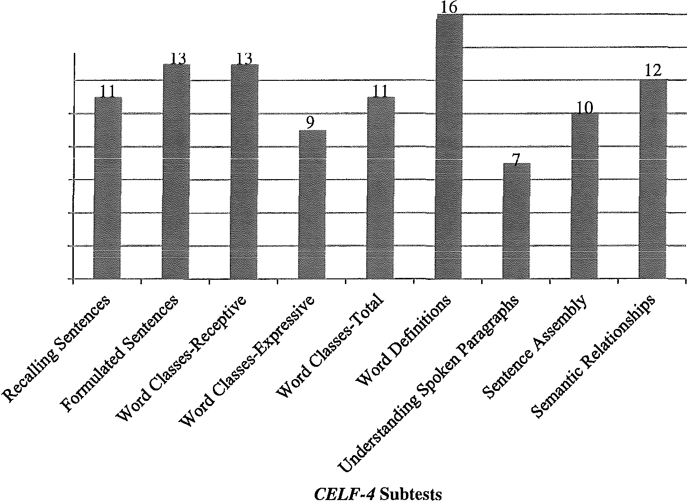16 -+-

14 +-

8""
010
00
12 -

10

8
6

4

2

0

Figure 3.1. Participant 1 results of CELF-4 subtests.

The subtests can also be grouped together according to the different skill sets being assessed. The scores that are obtained by combining subtests include the Core Language Score (CLS), Receptive Language Index (RLI), Expressive Language Index (ELI), Language Content Index (LCI), and Language Memory Index (LMI). See Table
3.8 for a listing of the subtests that are combined to form the different indexes. The CLS reflects the overall receptive and expressive language abilities of an individual. The RLI is a measure of an individual's receptive language abilities. The ability for an individual to use language is measured through the ELI. The LCI combines the subtests that measure an individual's ability to understand and use the meaning of words. An individual's ability to use memory during language tasks is seen through the LMI. The scaled scores from these subtests are combined to make a standard score which is also a measure of an individual's abilities in comparison to the normative data (mean=lOO,

Table 3.8
CELF-4 Subtest Groupings and Indexes (Semel et al., 2003)
Indexes Subtests
CLS Recalling Sentences Formulated Sentences Word Classes-Total
Word Definitions
RLI Word Classes-Receptive Understanding Spoken Paragarphs
Semantic Relationships
ELI Recalling Sentences Formulated Sentences
Word Classes-Expressive
LCI Word Definitions
Understanding Spoken Paragraphs Sentence Assembly
LMI Recalling Sentences Formulated Sentences
Semantic Relationships

SD=l5). Table 3.9 lists Participant l's standard scores, SD, and percentile ranks for the indexes. See Figure 3.2 for a summary of the standard scores for each index. In summary, Participant 1's performance on all indexes was greater than a standard score of 100 with one index, CLS, being above average. This suggests his ability to use and understand language is at or above the skills of adolescents his age.

Table 3.9

Participant 1CELF-4 Standard Scores, SDs, and Percentile Ranks
Index | Standard Score | SD Above/Below Mean | Percentile Rank
CLS | 117 | +l.13 | 87
RLI | 103 | +0.20 | 58
ELI | 105 | +0.33 | 63
LCI | 106 | +0.40 | 66
LMI | 113 | +0.87 | 81

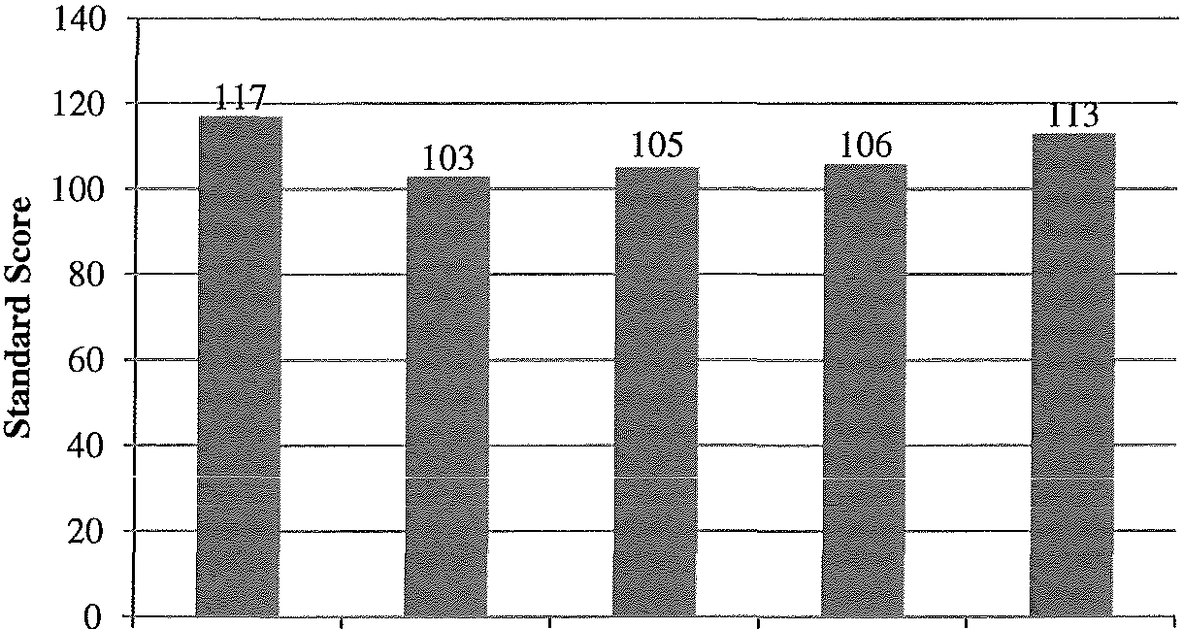

CLS RLI ELI
CELF-4 Indexes
LCI LMI

Figure 3.2. Participant 1 results of CELF-4 indexes.

Test of Problem Solving-Adolescence (TOPS-A). Participant 1 was assessed on his problem solving skills with the TOPS-A. Narrative and expository paragraphs were read by the investigator while Participant 1 followed along with the text. After each paragraph was read, he answered questions related to the passages that required problem

solving skills. This skill set is used frequently in daily living situations that may occur in the home, school, or community and is important to assess because problem solving skills help individuals to be independent. Participant 1received a standard score of 111 (mean=lOO, SD=l5) on the TOPS-A. This score is .73 SD above the mean. A standard score of 111 corresponds to the 73rd percentile rank. This score is within one standard deviation above the mean when compared to adolescents his age.

The Word Test 2 ™:Adolescent. Expressive vocabulary and semantics was assessed through The Word Test 2™: Adolescent (Bowers, Huisingh, & LoGiudice, 2010). The three tasks included Synonyms, Semantic Absurdities, and Flexible Word Use. All tasks were presented to the participants orally without visual stimuli. SDs and percentile ranks for Participant l's performance can be found in Table 3.10. Figure 3.3 contains his standard scores for each task (mean=lOO, SD=l5). Participant l's

Table 3.10
Participant 1The Word Test 2: Adolescent SD and Percentile Rank
Task | Standard Score | SD Above/Below Mean | Percentile Rank
Synonyms | 119 | +l.27 | 90
Semantic  Absurdities | 118 | +l.20 | 88
Flexible Word Use | 120 | +l.33 | 91

performance on all the tasks was more than one standard deviation above the mean. He responded quickly to all stimuli throughout all three tasks. Compared to peers his age in the normative data, Participant 1performed above average on all three tasks.

120 -

,...
0
u
00
'c:l
100

80

la 60
'c:l
B
00 40

20

0 -,

Synonyms Semantic Absurdities Flexible Word Use
The Word Test 2 TM: Adolescent Tasks

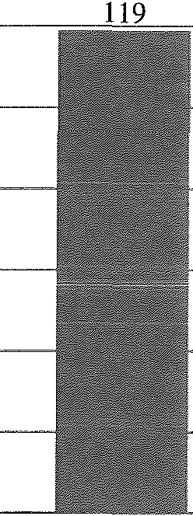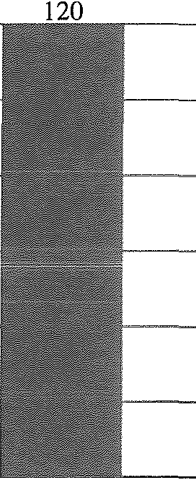Figure 3.3. Participant 1results of The Word Test 2™: Adolescent Tasks.

Test of Pragmatic Language-2 11a Edition (TOPL-2). The TOPL-2 (Phelps- Terasaki & Phelps-Gunn, 2007) was used as an assessment of Participant l's pragmatic, or social, language skills. Scenarios were read aloud to Participant 1 while he looked at pictures. He was asked to verbally respond to questions about the scenarios. Participant 1 received a Pragmatic Language Usage Index (PLUI) of 107 (mean=lOO, SD=15) which corresponds to the 68th percentile. His score is .47 SD above the mean, which is within
the average range for adolescents his age.

Informal qualitative data was gathered from the TOPL-2 in conjunction with the formal quantitative data. An item analysis of Participant 1's incorrect answers was completed based on a variety of social skills. The TOPL-2 manual provides a guideline for the core skills assessed and the questions that evaluate each skill. The core skills that Participant 1 answered with three or more incorrect answers are discussed. The core skill set of "attending to, gauging, noticing, remarking on, and adjusting to the mood, point of view, or 'feel' of the audience" was one of his challenges. Questions where the "topic

introduction is direct or indirect and may be delivered in a manner that is careful, polite, tactful, cautious, or respectful" were also difficult for Participant 1 to answer. Another core skill that was more challenging included questions of "expressing feelings, emotions, sensations, perceptions, intents, telling jokes, apologizing, or congratulating or reporting the effects of another's behaviors." The two core skills that were the most challenging for Participant 1 were questions relating to "persuading or negotiating in order to obtain a goal" and "monitoring, evaluating, and appraising how effective
pragmatic language is, with an emphasis on evaluating and predicting how much success a message will achieve" (Phelps-Terasaki & Phelps-Gunn, 2007). Despite these relatively more challenging core skills, Participant 1's performance on the TOPL-2 reflected his ability to use and understand pragmatic language in an appropriate way.

Woodcock-Johnson III Tests of Cognitive Abilities (WJ III Cognitive). The Brief Intellectual Ability (BIA) from the WJ III Cognitive (Woodcock, McGrew, and Mather, 2001b) was administered by a volunteer graduate student from the School Psychology department at the University of Wisconsin-Eau Claire (UWEC) to assess Participant 1's cognitive abilities. Cognition plays an important role in language as well as academic performance; therefore, a formal assessment of cognition was needed to create a comprehensive profile of the participants. The BIA uses four tests from the comprehensive test to measure intellectual ability. The following tests were used to form the BIA: Test 1 Verbal Comprehension; Test 5 Concept Formation; and Test 6 Visual Matching. Participant 1 received a standard score of 100 (mean=lOO, SD=15) on the BIA which corresponds to the 51st percentile. According to the developmental norms of the BIA, Participant 1's standard score was age-appropriate compared to adolescents his age.

The BIA and the WJ III Achievement were both given by the same volunteer graduate student in the same session. Informal observations were made by the volunteer graduate student. Throughout both assessments, Participant 1's conversational proficiency seemed advanced for his age level. He was exceptionally cooperative throughout the assessment, and his attention seemed typical for his age. He demonstrated confidence throughout the assessments and was "unusually absorbed" by the tasks. Participant 1responded
promptly and carefully to each question, and his level of effort increased as the stimuli became more difficult.

Woodcock-Johnson III Tests of Achievement (WJ III Achievement). Participant

1was assessed in the area of academics with subtests from the WJ III Achievement battery (Woodcock et al., 200la). To get a general picture of his academic skills, the following tests were administered: Test 1Letter-Word Identification; Test 2 Reading Fluency; Test 5 Calculation; Test 6 Math Fluency; Test 7 Spelling; Test 8 Writing Fluency; Test 9 Passage Comprehension; Test 10 Applied Problems; and Test 11Writing
Samples. These tests are divided into clusters, and the scores for each test within a cluster are combined to form standard scores. See Table 3.11 for a listing of Participant l's SDs and percentile ranks for each cluster, and Figure 3.4 for a visual

Table 3.11
Participant 1WJ III Achievement SD and Percentile Ranks

Cluster Standard SD Above/Below Score Mean

Percentile Rank

Broad Reading 110 +0.67 75
BroadMath 115 +l.00 84
Broad Written Language 112 +0.80 78

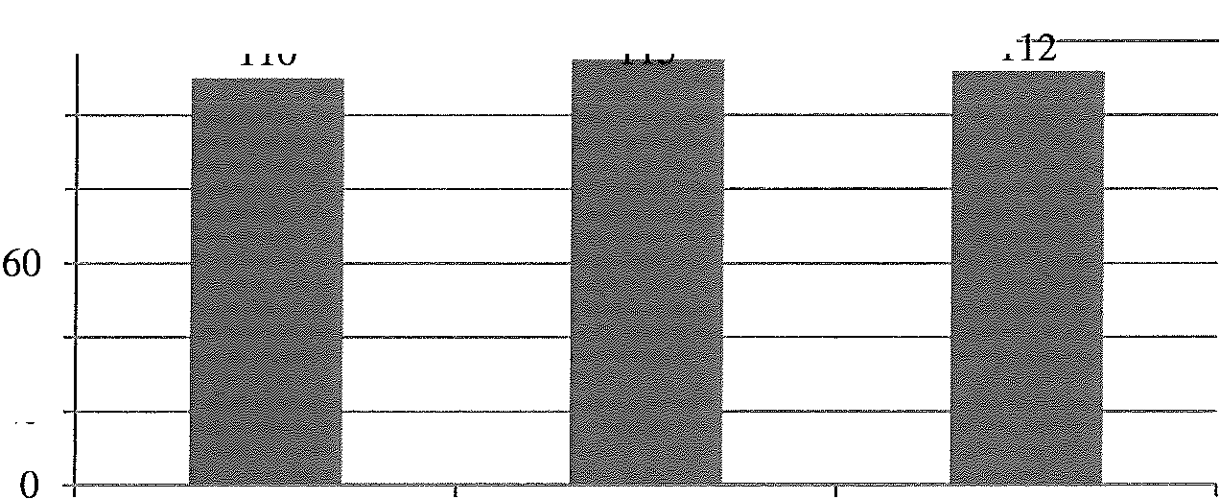representation of his standard scores (mean=lOO, SD=l5). His performance on all three clusters was appropriate, to advanced, compared to the normative sample. His overall level of achievement according to the WJ III Achievement was in the high-average range. These scores are comparable to the grades he receives in school.
120 -,-- -. -n- --;1 ---l

J.;
100

8 80 -;-----
rfj
140 +---
rfj 20 -;-----

Broad Reading Broad Math Broad Written
Language
WJ III Achievement Clusters

Figure 3.4. Participant 1results of WJ III Achievement clusters.

Conners' Continuous Performance Test II (CPT II). The CPT //was used with

Participant 1 as a measure of impulsivity, attention, and ability to inhibit irrelevant

information. This assessment was completed on a laptop computer in a quiet room which did not simulate typical academic or home environments; however, the data collected during this assessment can be valuable. The directions were read aloud to him before starting the assessment. This assessment has individuals watch the computer screen while letters are displayed at different time intervals. Individuals are asked to press the space bar when they see any letter except for the letter X. After completion of the assessment, a
professor in the School Psychology department at UWEC who has ample experience with the CPT II volunteered to help interpret the data. Although this assessment measures

attention, impulsivity, and inhibition, caution should be taken during interpretation because it is not intended for the sole use of diagnosing these conditions.
The CPT II measures multiple variables, but for the purposes of creating cognitive and language profiles of the participants, the following measures were chosen to be analyzed: Omissions, Commissions, Overall Hit Reaction Time, Response Style, and Standard Error by Block. Omission is a measure of inattention and occurs when the participant fails to respond to the target, or does not press the space bar for any letters except the letter X. Commissions occurred when the participant responded to non-targets, or the letter X. It is also a measure of inattention. Overall Hit Reaction Time is the
average speed of correct responses made over the entire test and measures impulsivity and inattention. The Response Style of the participant describes his or her response tendencies and is a measure of impulsivity. Participant l's response style reflected a response that was more free and less concerned about responding to the correct target. This may suggest that Participant 1 was more impulsive than the normative group. Finally, the Standard Error by Block is a vigilance and inattention measure and detects changes in response consistency over the duration of the test. Throughout the test, Participant 1 maintained and improved his response. According to the results of the CPT II, his attention and vigilance was within or better than average compared to the normative group, but he may have demonstrated impulsive tendencies. Table 3.12 lists the t-scores, percentile, and interpretation for each measure on the CPT II.

Behavior Rating Inventory of Executive Functioning (BRIEF). The BRIEF (Gioia, Isquith, Guy, & Kenworthy, 2000) was a questionnaire completed by Participant l's mother. It is a standardized inventory designed to gather information on the cognitive

Table 3.12

Participant 1CPT II Percentiles and Interpretations
Measure T-Score Percentile Interpretation
Omissions 41.55 22.86 Fewer omissions than average
Commissions 48.42 43.74 Within average range
Overall Hit Reaction 43.56 29.35 Faster reaction time than average Time
Response Style 40.40 16.88 Atypical response style

Standard Error by
56.00 75.79 Improvement over time

Block

processes of executive functioning and how individuals may act in daily living situations. The same volunteer from the graduate school psychology program at UWEC that completed the WJ III assessments also scored and interpreted the BRIEF. The results of the inventory were divided into scales, and scales were combined to form three composite scores. The first score is the Global Executive Composite (GEC), a summary score that incorporates all of the BRIEF clinical scales. All scores on the BRIEF are reported as T- scores (with an average of 50) and abnormally elevated scores above 65. Participant 1 received at-score of 95 on the GEC, which is abnormally elevated. This score suggests that he may have difficulty in one or more areas of executive functioning.
The Behavior Regulation Index (BRI) is the second composite score, and it attempted to capture Participant l's ability to shift his thinking and control behaviors through inhibition. The BRI is comprised of the Inhibit, Shift, and Emotional Control scales. The skills measured through the BRI are likely a precursor to appropriate metacognitive problem solving, and they support self-regulation. He received a BRIT- score of 78 which may suggest that flexible thinking and problem solving are challenging for him to complete independently. The Inhibit scale assesses the ability to resist
impulses and stop one's own behavior at the appropriate times. Participant 1 scored in the

abnormally elevated range (T=83). This may suggest that he may be unaware of how his

behavior causes negative reactions in others; he may have tendencies to interrupt and

I
disrupt group activities; and he may act before thinking about consequences. The Shift

scale is also a part of the BRI, and it assesses the ability to be flexible when moving between situations, activities, or demands. His T-score was 75, which is abnormally elevated. Based on this T-score, Participant 1may have difficulty making transitions, tolerating changes, thinking flexibly, and changing topics rapidly. The third scale in the BRI is Emotional Control. He received a T-score of 66, which is abnormally elevated. From parent report, Participant 1 has difficulty with flexible thinking and inhibiting actions in daily living situations.
The third grouping of scales forms the Metacognition Index (MI). The MI reflects Participant 1's ability to initiate, plan, organize, self-monitor, and sustain working memory which can be interpreted as the ability to cognitively self-manage tasks and monitor his own performance. This index is comprised of the Initiate, Working Memory, Plan/Organize, Organization of Materials, and Monitor scales. Participant 1's scores on the MI were abnormally elevated (T=98). This score suggests possible challenges with inhibitory control, emotional modulation, and ability to shift thinking. The first two scales, Initiate and Working Memory, were both abnormally elevated. The Initiate Scale reflects the ability to begin a task or activity and independently generate ideas, responses, or problem-solving strategies. His score (T=80) suggests challenges with independently initiating tasks such as homework and needing reminders to stay on task. Holding information in the mind while completing a task, encoding information, or generating ideas to achieve goals was measured by the Working Memory scale. He received a T-

score of 98 which may reflect difficulty with remembering the rules of a task, sticking to an activity for an age-appropriate amount of time, and sticking to a task until completion.
The last three scales that comprise the MI include the Plan/Organize, Organization of Materials, and Monitor scales. The Plan/Organize scale measures the ability to manage current and future task demands. Participant 1's T-score was abnormally elevated (T=95). Based on the individual questions completed by his mother, he may have challenges with organizing written material or keeping track of his 'homework assignments. The Organization of Materials scale measures orderliness of work, play, and storage spaces such as a locker, backpack, and bedroom. Participant l's score was abnormally elevated (T=l 16). Questions on the BRIEF that may indicate challenges with organizing materials include difficulty keeping track of and cleaning up his belongings. The final scale of MI is the Monitor scale. It assesses work-checking habits and self-monitoring. Participant 1 received a T-score of 82 which was abnormally elevated. This score suggests that understanding how his actions affect others may be challenging for him.
In summary, the BRIEF that was completed by Participant 1's mother revealed abnormally elevated T-scores for all indexes and scales (see Table 3.13 for T-scores and percentiles and Figure 3.5 for a summary of all index and scale scores). Because of the abnormally elevated GEC T-score, Participant 1may have difficulty in one or more areas of executive functioning in daily living situations. All of the scales also suggest this. Although the BRIEF may suggest executive dysfunctions, a questionnaire only encompasses one individual's thoughts and ideas. That said, the skills needed in academics, relationships, and the community all require executive functioning.

Table 3.13
Participant 1BRIEF T-Scores and Percentile
Scale/Index T-Score Percentile

Interpretation

Inhibit 83 96 Abnormally Elevated
Shift 75 96 Abnormally Elevated
Emotional Control 66 90 Abnormally Elevated
BRI 78 96 Abnormally Elevated
Initiate 80 97 Abnormally Elevated
Working Memory 97 99 Abnormally Elevated
Plan/Organize 95 99 Abnormally Elevated Organization of Materials 116 99 Abnormally Elevated Monitor 82 95 Abnormally Elevated
MI 98 99 Abnormally Elevated
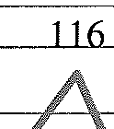GEC 95 99 Abnormally Elevated

,...
0
C.I
120

110
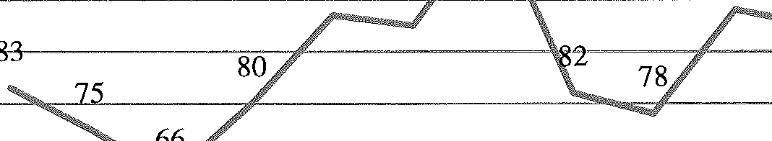100 9

90

rJJ 80
I
E--1
70 +-

60 -
50 +-- -
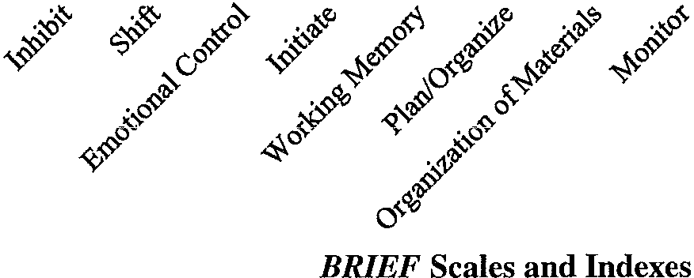

Figure 3.5. Participant 1 results of BRIEF scales and indexes.

Summary

The battery of assessments Participant 1 completed created a distinct language and cognitive profile. He showed many areas of strength across the informal and formal assessments. The informal observations made by the investigator that were considered to be exceptional skills include pragmatics, the double interview task, written language, and

awareness of writing and his AS diagnosis. Participant 1used appropriate eye contact and stayed on the topic of conversation throughout most of the sessions. During the double interview task, he formulated novel questions to ask the investigator and used inflection
in his voice to convey his interest in the task. His informal writing samples were well organized, followed typical narrative and expository formats, and the narrative sample contained many complex sentences. Throughout the sessions, Participant 1portrayed in­ depth metacognitive awareness of his writing skills as well as awareness of his AS diagnosis. These skills seen in the informal assessments were noted as some of Participant 1's strengths.
Language skills evaluated with formal standardized assessments revealed more of Participant 1's strengths. Language form, content, and use were all assessed with standardized measures. Participant 1 performed within the average or above-average range on most of the language assessments. A comparison between the three language assessments where standard scores were reported can be found in Figure 3.6. The scores depicted in this figure reveal four indexes or subtests that were above one SD from the mean.
Strengths in the areas of problem solving and academic achievement were also identified through standardized measures. Participant 1received a standard score in the high-average range on the TOPS-A compared to adolescents his age. This demonstrates his problem solving skills are commensurate with expectations for students his age. He also received a standard score for the Broad Math cluster for the WJ III Achievement that was in the high-average range. These two skills combine with the other areas assessed to form a unique cognitive profile.

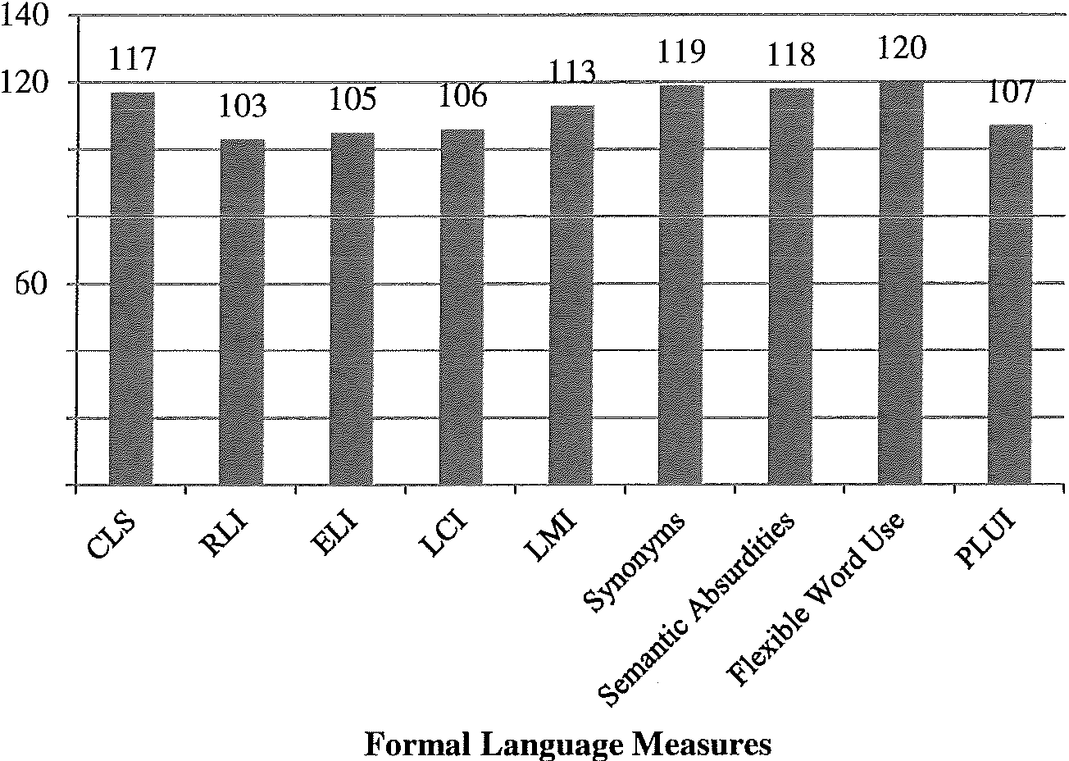'8""
100

r.ri 80
j
r'1 40

20

0

Figure 3.6. Participant 1 comparison of standard scores on formal language measures.

Participant 1 also demonstrated skills that were more challenging for him in the

informal and formal assessments. He used assertive comments and demonstrated impatient behaviors during the sessions which deterred from his strengths. The informal language sample collected and analyzed with Laban's (1976) procedure revealed shorter C-Units, less complex sentences, and a higher percentage of mazes than the 10th grade students used in the normative sample. Another challenge in the language domain was on the Understanding Spoken Paragraphs subtest from the CELF-4. His scaled score was
one SD below the mean compared to the normative data. Challenges were also noted in cognitive assessments. The CPT II indicated that Participant 1may have impulsive tendencies. The answers given by his mother on the BRIEF signified that he may have difficulty with one or more executive functions. All of the t-scores were in the

abnormally elevated range. The challenges Participant 1 exhibited also contribute to his unique language and cognitive profile.

Participant 2

Objective Measures

Hearing Evaluation. Participant 2 passed a hearing screening bilaterally at 20 dB when the frequencies of 500 Hz, 1000 Hz, 2000 Hz, and 4000 Hz were presented. A
build-up of cerumen was noted in the ear canal during otoscopy. Tympanometry revealed normal middle ear function even though his ear canal volume was greater than expected. Table 3.14 contains the results obtained during the tympanometry evaluation. Participant 2 had adequate hearing and middle ear function as revealed through the hearing evaluation to continue participation in the study.

Table 3.14

Participant 2 Tympanometry Results
Measurement Results Typical Measurements

Interpretation

Peak Compliance Left Ear: 0.7 cm3
Right Ear: 0.7 cm3
Normal > 0.2 cm3 WNL

Ear Canal Volume Left Ear: 1.8 mm
Normal = 0.9-1.6
Larger than normal

Right Ear: 1.9 mm mm
Tympanometry Type Both Ears: Type A Normal = Type A WNL

Voice Assessments. Participant 2 also recorded five sustained trials of /a/, a reading of the Rainbow Passage (Fairbanks, 1960), and a monologue. Table 3.15 contains the acoustic data from the sustained /a/ trials, and the data from the connected speech samples can be found in Table 3.16. As mentioned in the previous section, the normative data reported are for adult males because normative data don't exist for children. The results of the sustained voice samples revealed an average Fo, RAP, and SPI to be within

normal limits. Participant 2's NRH was slightly elevated. The analysis of the connected speech samples showed the average Fo and pitch sigma for both samples to be within normal limits. His voice was perceived to be slightly higher than expected with no hoarseness or roughness noted.

Table 3.15

Participant 2 Sustained /a/ Acoustic Analysis Data
Measurement | Results | Normative Data | Interpretation
Average Fo | 150.804 Hz | 130 Hz | WNL
RAP | .420% | Normal< 1.15% | WNL
APQ | .365% | Normal< 3.1% | WNL
NHR | .145 | Normal< .135 | Slightly Elevated
SPI | 4.807 | Normal < 20.2 | WNL

Table 3.16

Participant 2 Connected Speech Acoustic Analysis Data

Task | Measurement | Results | Normative Data | Interpretati on
Rainbow | AverageFo | 166.667 Hz | 130Hz | WNL
Passage | Pitch Sigma | 2.59 semitones | Normal= 2-4  semitones | WNL
 | AverageFo | 165.927 Hz | 130Hz | WNL
Monologue | Pitch Sigma | 2.812 semitones | Normal= 2-4 | WNL
semitones

Maximum intensity was measured in the same manner as described for Participant

- Participant 2 produced speech at 110 dB; therefore, his vocal mechanism was capable of producing speech above an appropriate conversational level.

Informal Assessments

Double Interview. Participant 2 shared information about himself and was given the opportunity to ask the investigator questions during a double interview task. The same procedures and protocol were used as described in the previous section. A language

sample was taken from his answers to the investigator's questions, and the questions he asked the investigator were informally analyzed using the criteria in Appendix L. Participant 2 asked a total of seven relevant questions during the task, all of which were based on the three photographs provided by the investigator. During the portion of the double interview when he asked the investigator questions, he only made one comment which was related to the pictures. Irrelevant comments or questions were not made during that time.
Throughout the duration of the double interview task, informal observations were made. When Participant 2 was telling a story or was excited about a topic, he talked with a rapid rate of speech. This made it very difficult to understand him, and he was asked frequently to repeat his answers. Another observation made during the double interview task related to staying on topic. When he asked the investigator questions, he stayed on topic easily; however, during the first part of the interview when he was answering questions, he frequently got off topic and provided too much information. There were also times during the interview when he brought up topics that were inappropriate for an interview context.

Language Sample. The content of the double interview was also used as a language sample. Language samples capture the complexity of an individual's spoken language. Participant 2's double interview sample was analyzed with the Loban (1976) procedure to measure the length and complexity of his spoken sentences. The data collected from the analysis is reported in Table 3.17. According to the Loban analysis, Participant 2 used an appropriate sentence length; however, his sentence complexity was lower than expected for individuals in 10th grade. The number of words per maze and the

Table 3.17

Participant 2 Loban Analysis Data from Language Sample
Measurement Results Normative Data for 10th
Grade (Loban, 1976)

Interpretation

 |  | High | Random Low
Average Number of | 9.51 | 12.34 | 10.68 9.41 | C-Unit length low
Words per C-Unit average
Average Number of Dependent Clauses per C-Unit | .2 | .61 | .48 | .33 | Less complex sentences than average
Average Number of Words per Maze | 2.48 | 1.85 | 1.92 | 1.92 | More words per maze than average
Maze Words as a Percentage of Total | 16.72% | 7.45% | 7.4% | 7.51% | Greater percentage of maze words than

Words average

percentage of mazed words were both higher than what is expected. Participant 2 frequently reformulated his ideas or words (e.g., "But I have no I have I have no idea if I still am.") and used the filler word well. Sentence complexity and percentage of mazes were atypical of 10th graders, and Participant 2's sentence length was within the low- average range. Caution should be used when interpreting these results, as the nature of
the task for collecting the language sample may not have been a true representation of the participants' spoken language abilities.

Writing Sample. Two informal writing s mples were collected from Participant 2. When given the choice to hand-write or type the samples, he chose to write the samples by
hand. He commented, "I prefer to write by hand on paper because I'm not the best typer. It's kind of what you people would call hunt for the keys." The narrative writing prompt was read aloud and written on paper (see Appendix G for the writing prompts). After the prompt was read, he disputed the prompt because he thought the situation would never arise. His interpretation of the prompt was very literal and had difficulty being flexible with the prompt. A new writing prompt was agreed upon. Participant 2 was given 30

minutes to complete the writing prompt, and verbal reminders were given after 15 minutes. He completed the narrative writing sample in 15 minutes (Appendix Q). Table
3.18 contains the informal analysis of the writing sample. Gathering a writing sample was important to gain insights to those skills which are important in high school and adulthood.

Table 3.18

Participant 2 Narrative Writing Sample Analysis

Number of | Number of | Average | Number of | Spelling | Writing
Paragraphs | Sentences | Number of | Dependant | Errors | Mechanic
 |  | Words per  Sentence | Clauses |  | Errors
1 | 8 | 14 | 4 | 15 | 1

Informal observations included the cohesion, grammar, length and complexity, spelling, and writing mechanics of the sample. Participant 2 used adequate organization within the paragraph, or microstructure. All the sentences were organized in a logical order and contained correct grammatical forms. Evidence of complexity was seen
through the use of four dependent clauses. Spelling correctly was a challenge in this task, as evidenced by 15 misspellings (e.g., doore/door, alonge/along, flore/floor, and prety/pretty). One capitalization error occurred in the sample as well. The macrostructure, or organization of the entire sample, was also analyzed. Even though the purpose of this writing sample was to provide a narrative, or story, Participant 2 introduced the
characters and setting with few details and didn't include a problem or ending to his story.
The Writing Evaluation Scale from the WJ III Achievement (Woodcock et al., 200la) was also used to informally evaluate the writing sample. Appendix R lists the rating criteria as well as the results. Based on the investigator's ratings of his narrative

sample, Participant 2 did not describe external characteristics or internal responses of characters or provide an ending or outcome to the story. He also demonstrated challenges with highlighting important events, providing the setting, including major details, and maintaining the discourse genre throughout the sample, as rated in the Writing Evaluation Scale. As a whole, Participant 2's writing sample used organized sentences with appropriate grammar but was shorter than anticipated and didn't include all of the characteristics expected in a narrative format.
Upon completion of the writing sample, Participant 2 answered interview questions about the task. See Appendix H for the list of interview questions. Throughout the interview process, he frequently changed topics and didn't answer the questions directly. Because the narrative was based on a daily routine, he commented that the easiest part of writing the sample was "because it's happened for over a year now." Participant 2 was also asked about writing strategies he's learned in the past, to which he replied, "It's pretty much always been the same thing: think about what you're going to write before you put it." Before writing, he did take a few minutes to think about what he was going to write. Participant 2 reported that he doesn't enjoy writing for fun or school. Questions directed toward his thoughts or feelings were unanswered or diverged into an off-topic conversation. The interview conducted after the narrative writing sample revealed that Participant 2 has a challenging time talking about his thoughts and feelings about writing but draws on his prior knowledge and routines to support his writing.
The second writing sample assessed Participant 2's expository writing skills. Similar to the narrative sample, the prompt was given orally along with a visual prompt. He was given 30 minutes to complete a thorough expository writing sample by hand on

his favorite television show (see Appendix G for the complete writing prompt and Appendix S for the expository sample). A verbal reminder was given after 15 minutes, to which he informed the investigator that he was finished. The informal analysis of the expository sample can be found in Table 3.19. The writing sample had adequate microstructure with the exception of one incomplete sentence. All sentences were organized in a logical order. Grammar was also found to be adequate, and four dependant clauses were used throughout the sample. The sample contained nine misspelled words, including exsited/excited, driveingldriving, and suggegst/suggest, and punctuation was omitted at the end of one sentence.

Table 3.19

Participant 2 Expository Writing Sample Analysis

Number of |  | Number of | Average | Number of |  | Spelling | Writing
Paragraphs |  | Sentences | Number of | Dependant |  | Errors | Mechanic
 |  |  | Words per  Sentence | Clauses |  |  | Errors
1 | 6 |  | 16 | 4 | 9 |  | 2

The Writing Evaluation Scale (Woodcock et al., 200la) was used to informally analyze the sample, and results can be found in Appendix T. Compared to the narrative sample, Participant 2's expository writing sample received higher ratings. Maintaining focus and intent of the expository sample was more challenging for him, and the
inclusion of major details and appropriate linking words (e.g., first, next, then, last) was a relative weakness of the sample. Overall, his expository writing sample was appropriately organized and received higher ratings on the Writing Evaluation Scale from the investigator.
Similar interview questions were asked after the expository sample was completed. Again, Participant 2 was challenged to answer questions about his feelings on

the task; however, he did give more information about his thought process than he provided after the narrative sample. He thought the expository prompt was easier to write on but didn't give a direct explanation as to why that was the case. He reported that he drew upon prior knowledge to help him plan and write the sample. When asked if he used any strategies when planning, he stated, "They already know how the process worked because they did it already so I didn't need to explain that." This comment relates to theory of mind and the ability to understand that a na'ive listener would not know this information. Participant 2 got off-topic only once during the interview.
When comparing the narrative and expository writing samples, similarities and differences were found. The narrative writing sample contained more sentences and more misspellings, but the expository writing sample had a longer sentence length on average. The expository format was followed more closely than the narrative. Both samples had the same number of dependent clauses, contained punctuation or capitalization errors,
and were organized across and throughout sentences. Participant 2 wrote equivalent writing samples in terms of length, complexity, and organization.

Additional Observations. In addition to the informal tasks used to describe Participant 2's hearing, voice, and language, his speech and fluency were also observed informally. There was no opportunity to observe Participant 2's behaviors related to daily routines or schedules. During conversation and assessments, Participant 2 used all the correct speech sounds except for the "th" sound. He inconsistently substituted the /f/ sound for "th" in words. According to Sanders (1972), the "th" sound should be fully developed by seven years of age. He also talked with a rapid speech rate, reformulated ideas, or revised the wording in his sentences which disrupted the forward flow of

speech. The speech errors combined with the disfluencies (mazing) made Participant 2 unintelligible at times, resulting in requests from the examiner for repetition or clarification. His intelligibility decreased as his sentences and stories became longer or when he was excited about the topic. It was easier to understand Participant 2 if he used shorter sentences or slowed his rate of speech.
Participant 2's pragmatic skills were also informally observed. He demonstrated appropriate eye contact during the majority of sessions, especially during the double interview task. Excessive eye contact was noted occasionally. Staying on the topic of conversation was challenging for Participant 2. He frequently changed the topic of conversation when he was asked questions during the double interview task, and he made comments that were off topic during a few formal assessments. At times, he perseverated on topics and would return to them, even if they were off topic or had already been discussed. Examples of perseverative topics included going to church, YouTube videos, and television shows. His initiation of inappropriate topics during conversation was also a concern. There were two instances in which he brought up two inappropriate topics, considering the investigator was an adult and an unfamiliar communication partner. He made faces and used body language that suggested he understood the topic was inappropriate (e.g., facial grimace, quiet voice), but he continued to discuss the topics. During conversations, Participant 2 also interrupted the investigator and demonstrated reduced awareness of personal space by walking closely to the investigator in the
hallways and leaning over the table to place himself in close proximity to the investigator. Many of the pragmatic skills informally observed throughout the four

sessions with Participant,2 were not consistent with appropriate social skills for adolescents.
Three behaviors were observed during the study that contributed to Participant 2's communication profile. During the first two sessions, Participant 2 hid behind cupboards and walls in an attempt to frighten the investigator. The topic of hiding or scaring people had not been discussed previously, and he commented on the humor of the situation even after the investigator explained why this behavior was not appropriate. Attention was the second behavior observed. During the assessments and conversations, Participant 2 had difficulty sitting still, especially during the lengthier assessments. He also made irrelevant comments and noticed minute details (e.g., the audiometer looked like a breathalyzer
from a television show, the door handle in the room was "weird"). Despite the fidgeting and irrelevant comments, he appeared to be on task and participated actively in the assessments. Third, Participant 2 was inappropriately assertive at times throughout the sessions. For example, he attempted to convince the investigator to change the protocol of reading questions aloud because he could read them independently. He also responded
before questions were completed, which may suggest impulsivity. Assertiveness was also seen when Participant 2 grabbed the paper out of the investigator's hands during the writing prompts. Although some of these behaviors might be considered typical of adolescents interacting with peers, they were inappropriate for interaction with an adult.
Finally, observations were made regarding Participant 2's awareness of his diagnoses. His mother reported in the questionnaire completed before the assessments began that he was diagnosed with AS and Attention-Deficit/Hyperactivity Disorder (ADHD) at the ages of seven and six respectively. When the investigator was explaining

the study and obtaining assent, Participant 2 exclaimed, "I don't have Asperger's!" He also had a very confused look on his face which suggested that he was unaware of his diagnosis or doesn't acknowledge that diagnosis. The following session, while conversing with the investigator, he commented, "I have ADHD, not Asperger' s. Remember?" This comment was not related to the topic being discussed at the time and suggested that he is aware of his inattentive behaviors, but not of his AS diagnosis. Another comment he made during the double interview also provided insight into his awareness of social communication. When he was asked about friends, Participant 2
commented that he has a best friend, but has never spent time with him outside of school. The only time he talks to his friend is in the hallways at school. These observations revealed that he may be aware of his ADHD, but he may not be aware of his AS
diagnosis and social communication abilities, even though he is currently participating in a social skills group for adolescents.

Standardized Assessments

All assessment protocols and procedures \Vere followed. Some assessments allowed for breaks after the completion of a subtest; however, no breaks were needed or requested after individual subtests. He did take a short break after the completion of more lengthy assessments.

Clinical Evaluation of Language Fundamentals-Fourth edition (CELF-4). The receptive and expressive language abilities of Participant 2 were assessed using the CELF-4 (Semel et al., 2003). The standardized protocol and procedures explained in the
manual were followed throughout the assessment. Participant 2 completed this test in one session without taking breaks between subtests. Table 3.20 contains Participant 2's scaled

scores and SDs from the mean (mean=lO, SD=3). See Figure 3.7 for a summary of Participant 2's scaled scores for each subtest. His performance ranged from below- average to above-average on the subtests. The subtests that were more challenging included Understanding Spoken Paragraphs and Recalling Sentences, and Word Classes- Total and Word Definitions were Participant 2's strengths.

Table 3.20

Participant 2 CELF-4 Scaled Scores and SDs
Subtest Scaled Score SD Above/Below Percentile Rank
Mean
Recalling Sentences 7 -1.00 16
Formulated Sentences 11 +0.33 63
Word Classes-Receptive 9 -0.33 37
Word Classes-Expressive 10 0.00 50
Word Classes-Total 9 -0.33 37
Word Definitions 14 +1.33 91
Understanding Spoken 6 -1.33 9
Paragraphs
Sentence Assembly 8 -0.67 25
Semantic Relationships 11 +0.33 63

As stated previously, the subtests from the CELF-4 are combined to form indexes which reflect different skill sets. The standard scores Participant 2 received on the five indexes are reported in Table 3.21 and Figure 3.8. His highest standard score, the CLS, was average, and the other four indexes were within one standard deviation below the mean. In summary, Participant 2's expressive and receptive language skills were within the average range when compared to adolescents his age.

Test of Problem Solving-Adolescent (TOPS-A). The TOPS-A was also given to Participant 2 to assess his problem solving skills. The same protocol and procedures were used as with Participant 1. Participant 2 received a standard score of 90 (mean=lOO,

16
14
14

0
c.J
""
IJJ
"C
Cl)
Ci!
c.J
IJJ
4
2

0

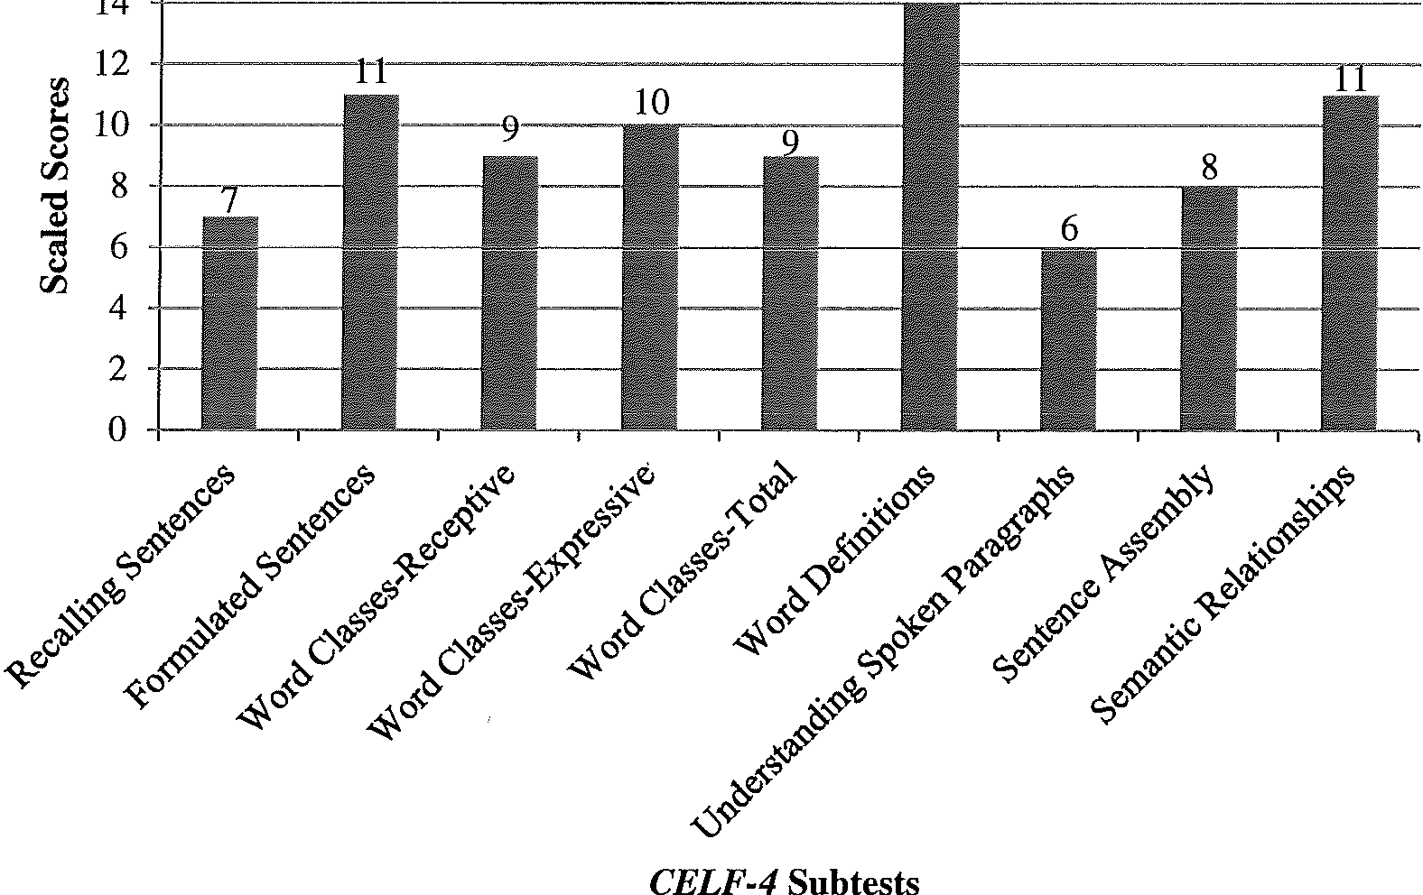Figure 3.7. Participant 2 results of CELF-4 subtests.

Table 3.21

Participant 2 CELF-4 Standard Scores, SDs, and Percentile Ranks
Index | Standard Score | SD Above/Below Mean | Percentile Rank
CLS | 100 | +0.00 | 50
RLI | 92 | -0.53 | 30
ELI | 96 | -0.27 | 39
LCI | 96 | -0.27 | 39

LMI 98 -0.13 45

SD=15) on the TOPS-A, which corresponds to the 29th percentile rank. This score is .67 SDs below the mean when compared to adolescents his age, which is within the average range. An informal observation made during the administration of this assessment was that Participant 2 was very impatient with the investigator and preferred to read the paragraphs and questions by himself instead of having them read to him. After an

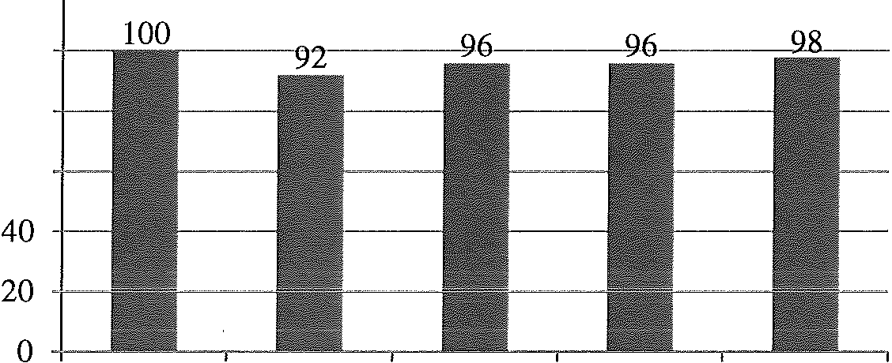120 -r------··-------- -----

J.;
100

8 80
rJJ
"ti 60
j

CLS RLI ELI
CELF-4 Indexes
LCI LMI

Figure 3.8. Participant 2 results of CELF-4 indexes.

explanation of the protocol, he continued to read it independently but waited patiently while the paragraphs and questions were read aloud.

The Word Test 2 ™:Adolescent. The Word Test 2™: Adolescent (Bowers et al., 2010) was also administered to assess spoken language skills. The three tasks were administered in the same manner as for Participant 1. The standard scores and percentile ranks for all three tasks are listed in Table 3.22 (mean=lOO, SD=15). Participant 2's performance on all three tasks was within the average range for adolescents his age. Figure 3.9 is a visual representation of his standard scores for each task. He remained on task for the duration of the assessment.

Table 3.22
Participant 2 Word Test 2: Adolescent SDs and Percentile Ranks

Task Standard Score SD Above/Below Percentile Rank
Mean

Synonyms
96 -0.27 40

Semantic Absurdities 110 +0.67 75
Flexible Word Use 114 +0.93 83
Test of Pragmatic Language-Second edition (TOPL-2). Participant 2's pragmatic language skills were assessed with the TOPL-2 (Phelps-Terasaki & Phelps-

Gunn, 2007). The same protocol and procedures were used as described previously. He received a Pragmatic Language Usage Index (PLUI) of 101 (mean=lOO, SD=15) which

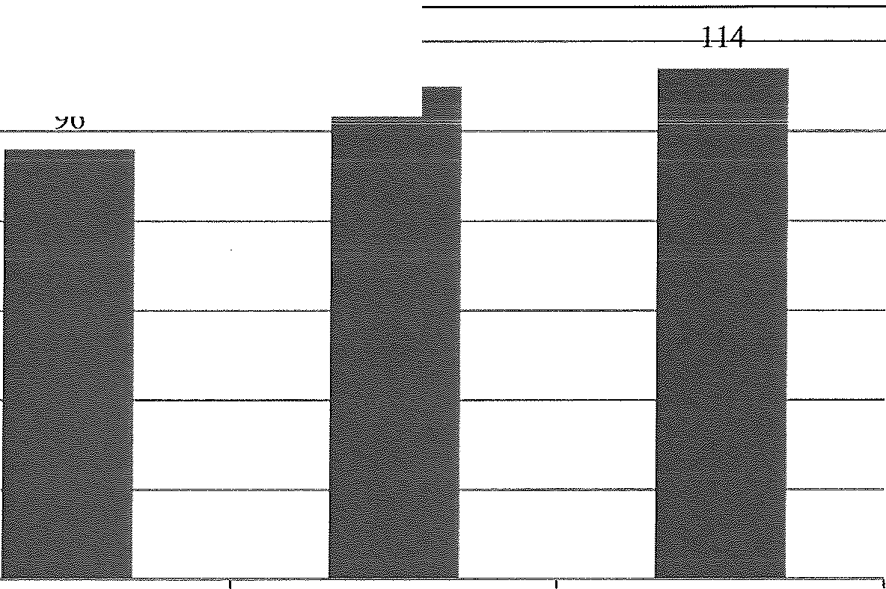120 110

100

II> 80
('"J'
rJJ
"Cl 60 -
'"'
ell
"Cl
$=3
rJJ 40

20

0
Synonyms Semantic Absurdities Flexible Word Use
The Word Test 2 TM: Adolescent Tasks

Figure 3.9. Participant 2 results of The Word Test 2™: Adolescent Tasks

corresponds to the 53rd percentile. Participant 2's score was .07 SD above the mean. He

scored within the average range compared to adolescents his age.

An informal analysis of the core skills assessed by the TOPL-2 was also completed in the same manner as for Participant 1. Of the 18 core skills included in the TOPL-2, Participant 2 incorrectly answered questions from 14 of the core skills. The core skills that Participant 2 answered with three or more incorrect answers are discussed. One of the core skills that was challenging for him included questions where "breakdown and repair skills are needed to correct problems related to communication." "Expressing feelings, emotions, sensations, perceptions, intents, telling jokes, apologizing, or congratulating or reporting the effects of another's behaviors" was another core skill that was challenging for Participant 2. The core skill set of "monitoring facial expressions, body language, and gestures" was also challenging. It was more difficult for Participant 2

to "understand the symbolic or abstract messages in proverbs or metaphors." There were two core skills that he answered the most questions incorrectly. These included "regulating, in some way exerting control over something or someone" and "monitoring, evaluating, and appraising how effective pragmatic language is, with an emphasis on evaluating and predicting how much success a message will achieve (Phelps-Terasaki & Phelps-Gunn, 2007)." Although many core skills were challenging for Participant 2, his performance on this assessment was within the average range.

Woodcock-Johnson III Tests of Cognitive Abilities (WJ III Cognitive). Participant 2's cognitive abilities were assessed through the BIA from the WJ III Cognitive (Woodcock et al., 200lb). The assessment was administered by a different volunteer graduate student from the School Psychology department at UWEC who met the criteria for administering the assessment. Participant 2 received a standard score of 99 (mean=lOO, SD=l5) on the BIA which corresponds to the 4?1h percentile. This score is
.07 SDs below the mean. According to the developmental norms of the BIA, Participant 2's standard score was age-appropriate compared to adolescents his age. The BLA. and the WJ III Achievement were both administered by the same volunteer graduate student
during the same session.

Woodcock-Johnson III Tests of Achievement (WJ III Achievement). Participant 2 was also assessed in the area of academics with subtests from the WJ III Achievement battery (Woodcock et al., 200la). Table 3.23 summarizes his standard scores for the three clusters, Broad Reading, Broad Math, and Broad Written Language as well as the
standard deviation from the mean (mean=lOO, SD=15). The only cluster that was below average was Broad Written Language. Participant 2's performance on this cluster was

similar to that seen in his informal written language sample and reported by his parents. His overall level of achievement according to the WJ III Achievement was in the average range. These scores are similar to the grades he receives in school. Figure 3.10 gives a visual representation of the standard scores for all three WJ III Achievement clusters.
Table 3.23
Participant 2 WJ III Achievement SDs and Percentile Ranks

Cluster Standard Score SD Above/Below Mean Percentile
Rank

Broad Reading BroadMath Broad Written
94 -0.40 34
93 -0.47 33
79 -1.40 8

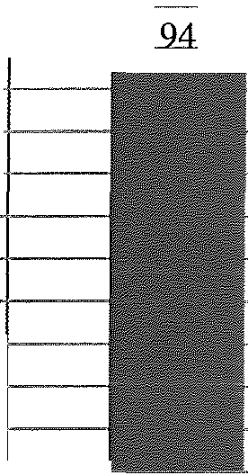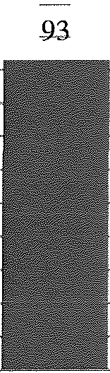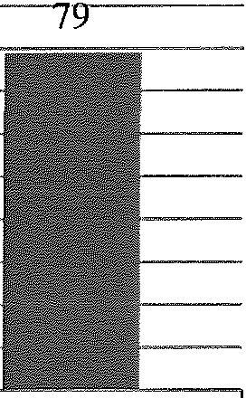 Language

100 ---'-"''--- >-- -
90
"' 80

8f:
70 -

00 60
"C 50
j
j +---
"'-' 20 -l--
10 -
0 +--
Broad Reading Broad Math Broad Written
Language
WJ ID Achievement Clusters

Figure 3.10. Participant 2 results of WJ III Achievement clusters.

The volunteer graduate student also reported the following informal observations. Throughout both assessments, Participant 2's conversational proficiency seemed typical for his age level. He was cooperative throughout the assessment, but appeared lethargic at times. He appeared at ease, comfortable, and attentive to the tasks during the assessment. Participant 2's responses varied between prompt and slower response times. Most of the

time, he was persistent with difficult tasks but sometimes would give up easily after attempting the task.

Conners' Continuous Performance Test II (CPT II). The CPT II was administered to assess impulsivity, attention, and Participant 2's ability to inhibit irrelevant information. The same procedures and protocol were used as described previously. The same professor from the UWEC School Psychology department assisted with the interpretation of the data. Omissions, Commissions, Overall Hit Reaction Time, Response Style, and Standard Error by Block were the five measures assessed and analyzed. For a description of the five measures, see the CPT II section under Participant
- See Table 3.24 for a summary of Participant 2's t-scores, percentiles, and interpretation

for each measure. Participant 2 remained attentive for the duration of the test. The data obtained from the CPT II revealed that Participant 2 exhibited average attention and impulsive tendencies.

Table 3.24
Participant 2 CPT II Percentiles and Interpretations

Measure | T-Score | Percentile | Interpretation
Omissions | 44.17 | 28.00 | Fewer omissions than average
Commissions | 38.50 | 12.54 | Fewer commissions than average
Overall Hit Reaction Time | 51.44 | 55.71 | Within average range
Response Style | 47.19 | 38.94 | Within average range
Standard Error by Block | 49.16 | 46.66 | Within average range

Behavior Rating Inventory of Executive Functioning (BRIEF). Participant 2's mother completed the BRIEF (Gioia et al., 2000) to gather information on his executive functions and how they may or may not affect his participation in daily living situations. The same volunteer from the graduate School Psychology program at UWEC who administered the WJ III assessments scored and interpreted the BRIEF. Refer to the

Participant 1 section of this chapter for the description of each index and scale. The three index scores created a general profile of Participant 2' s executive functions. He received a T-score of 63 for the GEC (average t-score 50, abnormally elevated t-score;::: 65).
This score is elevated compared to the normative sample and may suggest some difficulty with one or more executive functions. There was not a significant discrepancy between the BRI and the MI scores; therefore, the GEC is an accurate reflection of Participant 2's executive functioning. On the second index, BRI, he received a T-score of 62. This is an elevated T-score which suggests challenges with problem solving and self-regulation. Participant 2's scores on the MI were also elevated (T=62). Elevated MI scores suggest that he may have difficulties with inhibitory control, emotional modulation, and ability to shift thinking.
The BRI is comprised of the Inhibit, Shift, and Emotional Control scales. Participant 2's scores on the Inhibit scale were abnormally elevated (T=66). Based on the individual items that comprise the Inhibit scale, he may demonstrate a tendency to interrupt and disrupt group activities and have trouble holding back his actions. His T­ score for the Shift scale was 66, which is abnormally elevated. Based on this T-score, Participant 2 may have difficulty making transitions, tolerating changes, and changing focus from one mindset or topic to another. He received a T-score of 53 on the Emotional Control scale, which is somewhat elevated compared to the normative sample. Participant 2' s mother rated items on the BRIEF, related to the BRI, that suggest challenges in inhibiting behaviors, shifting attention, and controlling emotions.
The Initiate, Working Memory, Plan/Organize, Organization of Materials, and Monitor scales form the Ml The Initiate and Working Memory scale scores were both

within the average range. Participant 2 received T-scores of 46 and 56 respectively on these scales. This reflects his ability to begin a task and independently generate ideas as well as carry out multistep activities and following complex instructions. The Plan/Organize scale was the only score in the MI that was in the elevated range (T=61). Based on the individual questions completed by his mother, Participant 2 may have difficulty organizing and keeping track of homework assignments and may become overwhelmed when faced with large assignments. Participant 2 received a T-score of 72 for the Organization of Materials scale. Not keeping track of and leaving messes were questions his mother rated as happening often. He received an abnormally elevated T­ score of 65 on the Monitor scale. This score suggests that he may have difficulty checking work for mistakes and understanding how his actions might affect others.
An analysis of the BRIEF indexes and scales revealed an elevated summary score that suggests some difficulty in one or more areas of executive functioning. Again, caution should be used in interpretation of these scores because it was one person's interpretation of how Participant 2 reacts to daily living situations. Some of the scales, including Initiate and Working Memory, indicated that he is functioning within the average range when compared to adolescents his age; however, the remaining scales suggest other processes and executive functions ·are not as developed, compared to the normative sample. This executive functions profile can be taken into consideration along with data collected from other assessments to gauge how Participant 2' s skill sets may promote or inhibit success after high school. See Table 3.25 for a summary of Participant 2' s T-scores, percentiles, and interpretation of his performance, and Figure 3.11 is a visual representation of his BRIEF scale and index scores.

Table 3.25
Participant 2 BRIEF T-Scores and Percentiles
Scale/Index T-Score Percentile Interpretation
Inhibit 66 91 Abnormally Elevated
Shift 65 91 Abnormally Elevated

Emotional Control 53 70
BRI 62 86
Initiate 46 47
Working Memory 56 77
Plan/Organize 61 85
Organization of Materials 72 99
Monitor 65 96
MI 62 87
Elevated Elevated Average Average Elevated
Abnormally Elevated Abnormally Elevated Elevated

 GEC 63 87 Elevated

80
70
60
50
J.;
8

66 65
-

-4-6-

56 _,,,,,,,
61

-
- 65 62---62,.--63-

40
r:ri.
-
30
20
10
0 - -------,
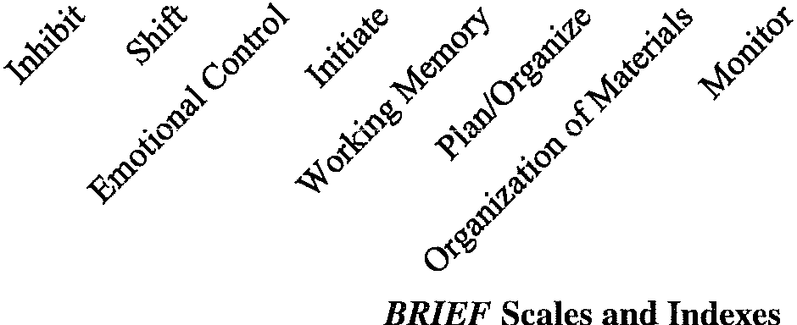

Figure 3.11. Participant 2 results of BRIEF scales and indexes.

Summary

Participant 2's performances on the above assessments combine to form a distinctive language and cognitive profile. Some of the skills observed were strengths. Participant 2 demonstrated strengths in many of the standardized language assessments.

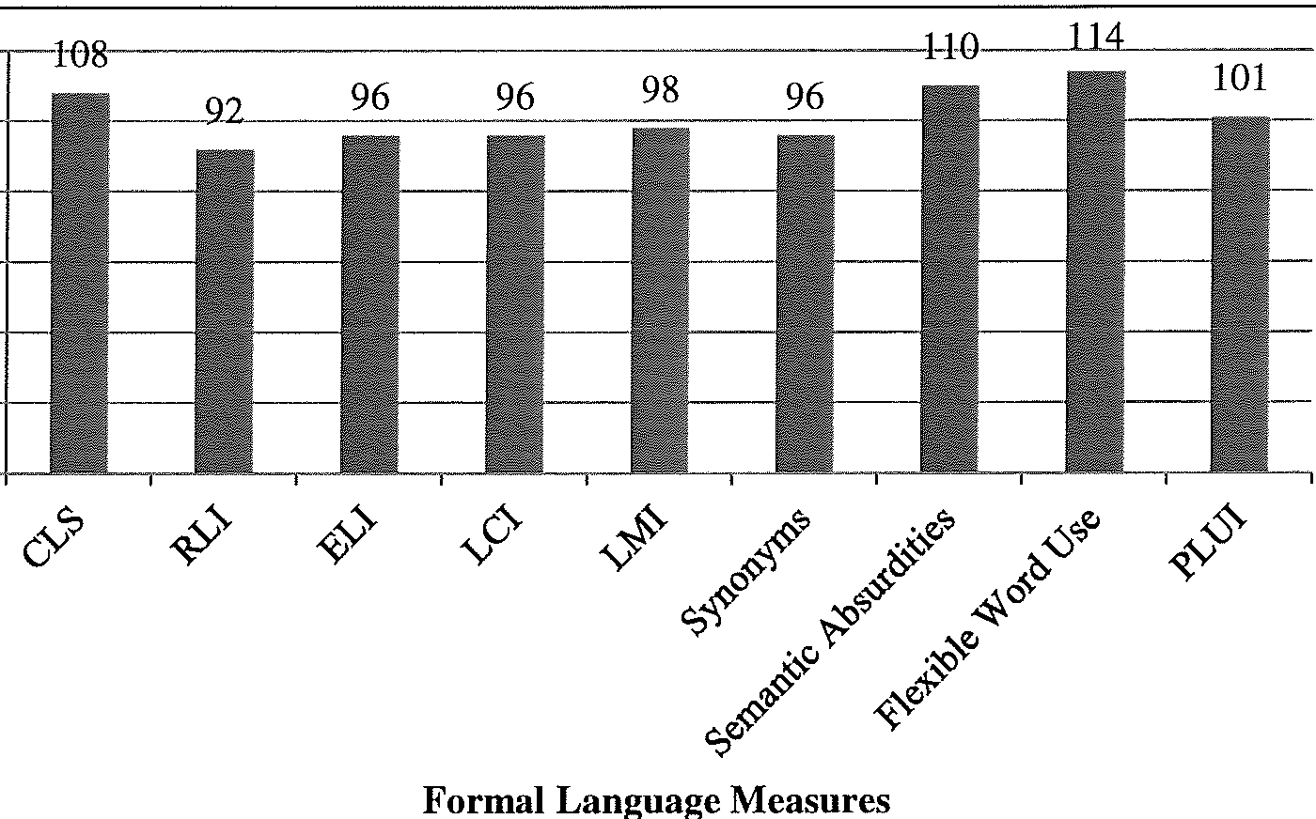Notably, his performance on the Word Classes-Total and Word Definitions subtests on the CELF-4 and the CLS were among his highest standard scores. He also performed well on The Word Test 2™: Adolescent and TOPL-2 assessments. A comparison of the standard scores from the formal language measures can be found in Figure 3.12. Participant 2 demonstrated strengths in attention and a lack of impulsive tendencies on the CPT II. Strengths in spoken language are important for successful communication.

120

8""
00
100

80

"ti 60
i

!! 40
00 20

0

Figure 3.12. Participant 2 comparison of standard scores on formal language measures.

Among his strengths, some skills were relatively more challenging for Participant 2.

Some of these challenges were noted throughout the informal assessments. During the

double interview task, Participant 2 formed questions only based on the photographs provided as visual support. The analysis of his spoken language sample revealed less- complex sentences and a higher percentage of mazed words in the sample compared to the normative data. Participant 2 produced shorter language samples that didn't follow the expected narrative and expository formats. The informal written language samples

also contained many spelling errors, most of which were common words in the English language. Finally, he frequently interrupted the investigator and made off-topic comments during all sessions. These challenges are an essential part of his language profile.
More challenges were observed informally throughout the sessions. Participant 2 exhibited behaviors that were immature for his age. For example, he attempted to hide behind cupboards and walls to scare the investigator. At times, he was unintelligible, especially if he was talking about a high-interest topic or reformulated his ideas. By 15 years of age, all individuals should produce all speech sounds correctly, but Participant 2 inconsistently substituted the /f/ sound for 'th.' The sound substitutions combined with a fast rate of speech made his speech less intelligible. When conversing with Participant 2, he demonstrated a lack of awareness about his writing skills and his diagnosis of AS. He had extreme difficulty answering questions related to his feelings about writing, and spontaneously denied having an AS diagnosis. These immature behaviors in combination with his reduced self-awareness may put Participant 2 at a disadvantage when communicating with others.
In addition to the challenges noted in some of the informal assessments, other challenges were found in standardized assessments. Although his performance on some CELF-4 subtests was above average, the Understanding Spoken Paragraphs and Recalling Sentences subtest scores were below average. Participant 2's performance on the Broad Written Language cluster as part of the WJ III Achievement was also below
average compared to the normative sample. This was congruent with the challenges noted on the informal written language sample. Executive functions as measured by the BRIEF

may be challenging for him as well. The overarching summary t-score of executive functions was abnormally elevated, as were other scales. Participant 2's unique language and cognitive profile consists of strengths and challenges that will both support his academic and social success and may create barriers after the transition after high school.

Inter-Rater Reliability

The investigator transcribed all spoken language samples and scored all informal and formal assessments that she administered. A volunteer graduate student in the Communication Sciences and Disorders Program at UWEC also transcribed the language samples and scored approximately 15% of the informal and formal language assessments. Point-to-point inter-rater reliability analyses were computed on the language sample, and item-level scores for the CELF-4, TOPS-A, The Word Test, and the TOPL-2. Table 3.26 contains the reliability measurements for these assessments.

Table 3.26
Point-to-Point Inter-Rater Reliability for Standardized Assessments

Assessment | Number of Items  Scored in Agreement | Total Number of  Items | Percent Agreement
Language Sample | 44 | 95 | 46.3%
CELF-4 | 155 | 192 | 80.7%
TOPS-A | 80 | 100 | 80.0%
The Word Test 2 Adolescent | 22 | 30 | 73.3%
TOPL-2 | 66 | 86 | 76.7%

It should be noted that the point-to-point inter-rater reliability for the language samples were based on the total number of C-Units the investigator and volunteer agreed on, divided by the total number of C-Units. This resulted in a lower percentage of agreement; however, the investigator was more familiar with the participants' speech and

had more contextual cues than the volunteer. The point-to-point inter-rater reliability analyzed for the other standardized assessments listed in Table 3.26 was based on the number of items scored in agreement, divided by the total number of items. Because the standardized assessments were scored in a more-objective manner, the percent of items scored in agreement were higher than the language sample.

Participant Comparisons

After looking at each participant, comparisons between the two can be made. Although the aims of this study were to look at each participant as an individual, some insight may be gained by comparing the performances on the informal and formal assessments. Both formal and informal results yielded valuable information about the participants' strengths and challenges. Although differences in skills were observed, most assessments revealed that both participants are functioning within or above the expected range when compared to other adolescents their age. In the following section, a brief comparison of the battery of assessments administered is presented.

Language

Although most of the informal data collected regarding the participants' spoken language skills cannot be compared to normative data, the information obtained from these tasks adds to the unique language profiles of these adolescents. The informal language sample that was collected and analyzed according to Laban's (1976) procedure showed that both participants used less-complex sentences and more mazed words as a percentage of total words compared to the normative sample. Participant 2's sentence length was in the low-average range while Participant 1had a lower average number of words per maze than the normative data for 10th graders. Table 3.27 presents the data

from the Loban analysis. During the double interview task, Participant 1 asked more questions and asked novel questions while Participant 2 asked fewer questions and only used the photographs as topics for questions. The participants' pragmatic skills were observed informally over the course of the sessions. Both participants used appropriate eye contact throughout the assessments; however, Participant 2 frequently made off-topic comments during conversation and was unaware of personal space when walking in the hallways and sitting at the table. The most noticeable difference in the informal observations of spoken language between the participants was the number of comments made off the topic of conversation.

Table 3.27
Comparison of Both Participants' Loban (1976) Analysis Data from Language Samples
Measurement Participant 1 Participant 2 Normative Data for 10th Grade
(Loban, 1976)

 |  |  | High | Random | Low
Average Number | 7.14 | 9.51 | 12.34 | 10.68 | 9.41
of Words per C­
Unit
Average Number of Dependent | .14 | .2 | .61 | .48 | .33
Clauses per C-Unit
Average Number | 1.52 | 2.48 | 1.85 | 1.92 | 1.92
of Words per Maze
Maze Words as a | 13.24% | 16.72% | 7.45% | 7.4% | 7.51%
Percentage of
Total Words

A comparison of the participants' spoken language skills can also be made from the formal language assessments. The first comparison to be made is on the subtests of the CELF-4. A comparison of the participants' subtest scaled scores can be found in Figure 3.13. The Understand Spoken Paragraphs subtest on the CELF-4 was challenging

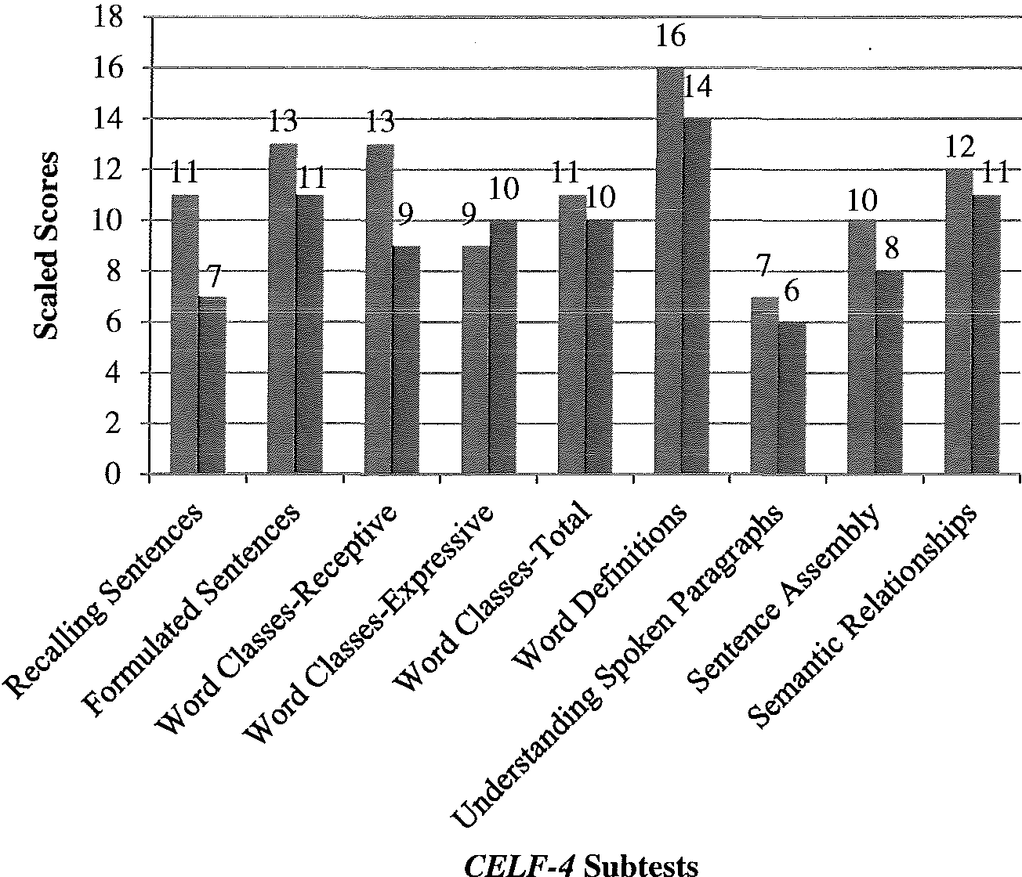

Figure 3.13. Comparison of both participants' CELF-4 scaled scores.

Participant 1

Participant 2

for both participants, and they received their highest scaled score on the Word Definitions subtest. Overall, Participant 1 scored higher than Participant 2 on all but one subtest. When analyzing the CELF-4 more broadly, both participants scored above the mean for the CLS. Figure 3.14 compares the participants' CELF-4 index scores along with the
three tasks from The Word Test 2™: Adolescent (Bowers, Huisingh, LoGiudice, &

Orman, 2005) and the TOPL-2 (Phelps-Terasaki & Phelps-Gunn, 2002). Participant 1 earned standard scores that were above average on The Word Test 2™: Adolescent while Participant 2 scored average to high average. Both participants received a standard score within the average range on the TOPL-2, suggesting their pragmatic skills are similar to those of other adolescents their age despite the informal observations made on Participant 2.

Figure 3.14
Comparison of Both Participants' Standardized Language Measures

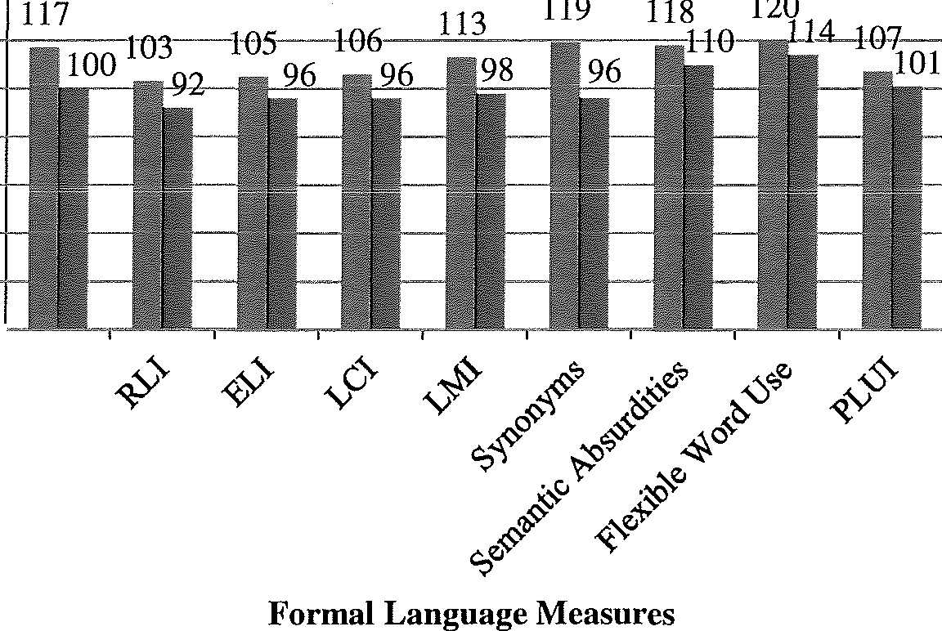140 --- ---------------'

120
s
100
CJ
00 80
I:

00 20
0 -

&

Participant 1

Participant 2

Figure 3.14. Comparison of both participants' standardized language measures.

The participants' narrative and expository written language skills were informally assessed. They were given the option of typing or writing the samples by hand. Participant 1 chose to type the samples while Participant 2 used paper and pencil. Tables
3.28 and 3.29 compare the analyses of the written language samples. Participant l's samples contained more sentences, fewer spelling errors, and followed the narrative and expository formats better than Participant 2's samples. Participant 2 made fewer mechanical writing errors than Participant 1. When interviewed about the writing process and their feelings about the task, Participant 1had a more positive attitude and shared more information about his feelings than Participant 2. Participant 2 avoided questions related to his feelings by answering "I don't know" or changing the topic of conversation. Participant 1exceeded the investigator's expectations for the task through his enthusiasm about writing and the length of his samples.

Table 3.28
Comparison of Both Participants' Informal Narrative Written Language Samples
Participant Paragraphs Number  of | Avg. Number | # of Dependant | Spelling Errors | Writing Mechanic
Sentences | of  Words/ | Clauses |  | Errors
 | Sentence
1 1 26 15 9 1 6
2 1 8 14 4 15 1

Table 3.29
Comparison of Both Participants' Informal Expository Written Language Samples
Participant Paragraphs Number  of | Avg. Number | #of Dependant | Spelling Errors | Writing Mechanic
Sentences | of  Words/ Sentence | Clauses |  | Errors
1 1 10 15 0 0 1
2 1 6 16 4 9 2

Cognition and Academic Achievement
In addition to creating language profiles, cognition and academic achievement were assessed with the WJ III Cognitive and Achievement tests. Figure 3.15 depicts both participants' standard scores for the different clusters. Both participants received a BIA score for cognition within the average range compared to the normative sample.

Academic achievement was assessed because of the importance of these skill sets for success in high school, post-secondary education, and careers. Participant 1 scored in the high-average range on all three clusters of the WJ III Achievement. Different results were seen with Participant 2. He received standard scores within the average range on the Broad Reading and Broad Math clusters of the WJ III Achievement, but his Broad Written Language standard score was below average compared to adolescents his age. Participant 2's parents reported that writing is more challenging for him, and they felt that his skills

140

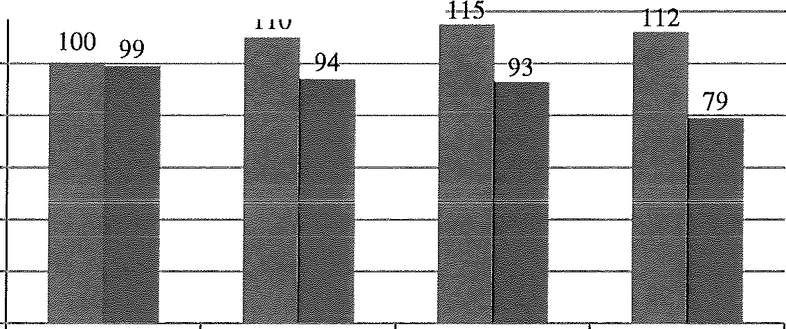120 +------- --

100
00 80
j

60
00 40

20

0

BIA Broad Reading Broad Math Broad Written
Language

llil Participant 1

1111 Participant 2

WJ III Clusters

Figure 3.15. Comparison of both participants' WI III Cognitive and Achievement
clusters.

were lower than his peers. The skill sets used in cognition and academics can vary greatly between individuals, as is seen from this study.

Attention, Executive Functioning, and Problem Solving

The final skill sets assessed during this study included attention, executive functioning and problem solving. The BRIEF and TOPS-A evaluated executive function and problem solving, and the CPT II assessed attention. Parent reports were used to determine the t-scores for the BRIEF. Figure 3.16 contains the T-scores for the different scales and indexes from that assessment. Both participants received a GEC, or an overarching summary score, that suggests difficulty with one or more executive functions. As is visible in the figure, Participant l's scores were more elevated than Participant 2's for all scales and indexes, and the T-scores were significantly elevated compared to the normative sample. There was also a large discrepancy between the indexes which suggests caution be used when interpreting the scores. Participant 2 received T-scores that varied from average to significantly elevated. The Organization of

Materials scale was the highest elevation for both participants. The BRIEF illustrated the challenges both participants may have with executive functions.
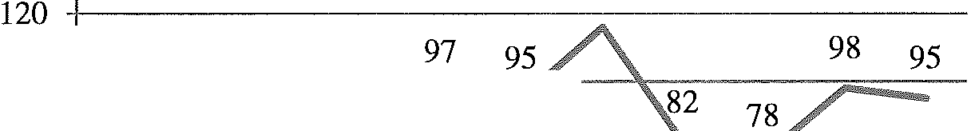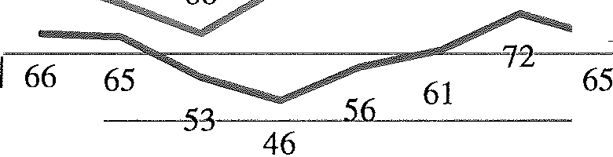The other assessment that evaluated executive functions and problem solving was the TOPS-A (Zachman, Barrett, Huisingh, Orman, & Blagden, 1991). Both participants scored within the average range compared to the normative sample, with Participant 1 receiving a standard score of 111, high average, and Participant 2 earning a standard score of 90. Caution should be used when interpreting these results. The TOPS-A used

116

8
rHr.i
100 -+------ - ---:::;;;;;;;;;;;;;;;;;;;; ­

80 -l- =--Afr- ::_ -- !"'.:_ -
-Participant 1

60 -

-Participant 2
::j1 -

•.,;... • OI.. O . A . '"'
CP '<:I - f...<ft

-$'

.v - ·'b-" 0..,., ·'b-"' . o
* ""
0
. - 'o
;_..,.o "'*'-$' .q,_'. o
o o -$!

#<(Ji
o"'qo
BRIEF Scales and Indexes

Figure 3.16. Comparison of both participants' BRIEF T-scores.

hypothetical situations and problems instead of real-life scenarios the participants may encounter. Individuals with AS may make different choices in the moment when faced with a problem than thinking about the problem when removed from the situation.
The CPT II (Conners & MHS Staff, 2000) was the assessment tool that measured the participants' impulsivity, attention, and ability to inhibit irrelevant information. Five

different measures were used to evaluate these skills. Both participants made fewer omission errors than the normative sample. Participant 1 had an average number of commission errors, and Participant 2 had fewer commission errors than the average. Omission and Commission errors measure attention, and both participants exhibited average or above average attention skills. Attention and impulsivity was measured by the Overall Hit Reaction Time. Participant 1 had a faster reaction time than the normative sample, and Participant 2's reaction time was within the average range. Participant 1 responded with a style that was atypical, characterized by being less concerned about responding to the correct target, while Participant 2 had a response style that was typical for adolescents his age. A change in responses over time was measured by the Standard Error Block for which Participant 1improved his performance over time, and Participant 2 was consistent with his performance.
In summary, Participant 1 performed with attention and vigilance within or better than average with impulsive tendencies, and Participant 2 had attention and vigilance scores within the average range. These skills were observed in a one-on-one setting
which may be very different from an academic or vocational setting.

Additional Observations

Along with the informal observations about the participants' language skills, other behaviors were observed that add information to their profiles. Speech and fluency were monitored informally across all sessions. Participant 2 used one speech sound inconsistently which should have developed by the age of seven. His speech was also fast at times, and he reformulated his sentences often. These two variables decreased his intelligibility. Participant 1 was easily understood 100% of the time.

Participant 1 made assertive comments occasionally. These behaviors may have conveyed his impulsive tendencies, as seen in the BRIEF. Participant 2 displayed behaviors that suggested immaturity, including hiding behind objects and attempting to frighten the investigator. The final observation made for both participants was their awareness of their AS diagnosis. Participant 1 openly discussed his diagnosis with the investigator and other acquaintances, and Participant 2 refused to acknowledge his AS diagnosis; however, Participant 2 did comment on his Attention-Deficit/Hyperactivity Disorder. These behaviors also separate the participants and make them unique individuals.
As these two case studies suggest, individual variation played a significant role in the two participants' performance on the assessments and tasks. Gathering background information from their parents provided a basic understanding of the participants and was essential for a complete conceptualization of the participants. Meeting with each participant and gathering formal and informal data on their language and cognitive skills supplemented this background knowledge. From these results, profiles of the participants were created and consideration was taken for how these skills may impact their transition after high school. These results will support the participants and their families when making current academic decisions and future transitional decisions.

IV. DISCUSSION

The first aim of this study was to describe the cognitive and linguistic profiles of two adolescents with Asperger's Syndrome (AS). This was accomplished by selecting informal and formal assessments to describe and measure the participants' skills. The results of this study indicated that each participant demonstrated strengths and challenges in the areas of language and cognition. The similarities and differences in the
participants' skills illustrates the individual variation within individuals with AS. Although some assessment results supported the existing literature on the strengths and challenges of individuals with AS, other results conflicted with the literature. The disagreement within the literature may account for some of this variation; however, other factors may account for the differences seen in this study.
An additional aim of the study was to consider how the participants' cognitive and language profiles may influence academic and social interactions in high school and
in the transition to post-secondary education or employment after graduation. To evaluate this, the results of the formal and informal assessments were presented to the parents of the participants, and the goal was to schedule a follow-up meeting with the parents to discuss how the strengths and challenges in their adolescents' cognitive and linguistic profiles may affect the environment to which they transition. Achieving independence after high school is important for many teenagers; however, the characteristics that individuals with AS possess can make this transition more difficult. Understanding the participants' skill sets may support a smoother transition and help them chose a path that fits their interests as well as their profiles.

Comparison to the Literature

To better understand how the results of this research study correspond to the existing literature discussed in Chapter 1, the participants' performances on the battery of assessments are compared with the existing literature. A summary and discussion of the main topics of the literature review follow.

Cognition

The brain is responsible for many functions, including language (Owens, 2008), metacognition and self-regulation, and executive functions (Zimmerman, 2001). The area of the brain responsible for language doesn't fully develop until early adulthood (Owens, 2008); therefore, it is presumed that the participants are still refining their language skills. The participants' metacognitive skills, i.e., reflecting on thought processes, self­ regulation, and executive functions, were evaluated through two main assessments: the informal interview questions about the writing samples and the Behavior Rating
Inventory of Executive Functions (BRIEF; Gioia, Isquith, Guy, & Kenworthy, 2000). Participant 1 displayed appropriate metacognitive skills when answering the interview questions related to his writing abilities; however, it was more challenging for Participant 2 to answer these questions. The BRIEF revealed that both participants may have difficulty with one or more executive functions. Participant 1's scores as a whole were more elevated than Participant 2's scores, which may suggest these skills to be more challenging for Participant 1. The scores from the BRIEF are consistent with the literature describing the challenges individuals with AS have in executive functions (Bennett et al., 2008; Saalasti et al., 2008).

Language Acquisition

Recall from Chapter 1that two theories of language acquisition were discussed. The first theory encompassed the idea that children can learn one subcomponent of language though another subcomponent, i.e., bootstrapping (Bennett et al., 2008; Chapman, 2000). After analyzing the data from the formal language assessments, both participants received standard scores within the average range or above, with the exception of Participant 2's standard score on the.Broad Written Language subtest of the Woodcock-Johnson III Tests of Achievement (WI III Achievement; Woodcock, McGrew,
& Mather, 2001a). This suggests that both participants have appropriate language skills. The language samples that were analyzed and compared to normative data revealed that both participants used fewer complex sentences and a high percentage of mazed words. It is possible that the stressful pragmatic context of an interview with an unfamiliar individual could have resulted in the low syntactic complexity. During other conversational interchanges between the investigator and the participants, it was evident that the adolescents were capable of producing long, complex sentences. Even though the Loban analysis suggests that the participants have below-average complex syntax skills,
it is important to consider the demands of the task and observations from other less­ demanding conversational contexts.
Informal observations revealed that Participant 2 frequently displayed inappropriate pragmatic skills and behaviors, which suggest a deficit in social language. According to the bootstrapping theory (Bennett et al., 2008; Chapman, 2000), the participants' strong semantic skills and average skills on many other standardized assessments should support the development of pragmatic skills as well. It may be

possible that the typical language profile of individuals with AS does not support the bootstrapping theory. Again, individual variation and other environmental factors can play a role in the development of language skills.
The second theory discussed previously is Myklebust's (1965) hierarchy of language learning. This theory explains that individuals understand language before they can use it appropriately. After these spoken language skills are developed, reading skills are learned, followed by written language development. Myklebust proposed that a deficit in the latter three hierarchical components was due to deficits in a previous stage of language learning. Participant 1 demonstrated through the informal and formal assessments that he has mastered Myklebust' s hierarchy of language learning. Written language was a challenge for Participant 2 which suggests a breakdown in the hierarchy. His Broad Written Language score from the WJ III Achievement was more than one standard deviation below the mean compared to adolescents his age, and the informal writing sample revealed written difficulties as well. Although the standardized and informal writing tasks were different, challenges were still seen in both. This supports Myklebust's hierarchical approach to language acquisition because Participant 2's Broad
Reading scores were within the average range but his written language scores were below average. This could be explored further in future research.

Spoken Language

The literature regarding the spoken language skills of individuals with AS is somewhat conflicting. For example, Bennett and colleagues (2008) explained that the skills of sequencing words, applying the rules of language, and recognizing patterns in language are challenging for individuals with AS, but other researchers report above-

average skills in these areas (Boucher, 2009; Sansosti, Powell-Smith, & Cowan, 2010). Both participants in this study exhibited average or above-average skills in these areas as seen on the Clinical Evaluation of Language Fundamentals-4th edition (CELF-4; Semel, Wiig, & Secord, 2003) and The Word Test 2™: Adolescent (Bowers, Huisingh, LoGiudice, & Orman, 2005), thus supporting Boucher (2009) and Sansosti and colleagues' (2010) findings.
One point regarding the participants' performances on two CELF-4 subtests is warranted. Both participants received the lowest scaled score on the Understanding Spoken Paragraphs subtest on the CELF-4. In contrast, their performances on the Word Definitions subtest were very strong. A major difference between the two subtests is the level of language. Understanding Spoken Paragraphs assesses language at the discourse level, while Word Definitions evaluates skills at the word level. It is assumed from the participants' performances that their skills at the word level are stronger than the discourse level. A similar performance might be observed in a classroom setting during a lecture. Integrating multiple pieces of information is more difficult for the participants, but their overall expressive and receptive word and sentence-level skills are within the average range to support their academic performance and social interactions.
Another language characteristic of this population is their literal interpretation of language (Attwood, 1998). During the informal written language samples, Participant 2 interpreted the narrative writing prompt in a very literal fashion and would not write on the topic because of this. The formal assessment that measured literal interpretation of language, i.e., The Word Test 2™: Adolescent, however, revealed that both participants can use language in a flexible manner and understand words with more than one

meaning. This may be due to the nature of the two assessments. The Flexible Word Use task in The Word Test 2™: Adolescent measured language at the word level, while understanding a writing prompt and thinking flexibly about a topic requires language comprehension at the discourse level. Also, the writing tasks were more challenging for Participant 2; therefore, this behavior of inflexible thinking may have been an avoidance behavior.
Pragmatics has been cited in the literature as a significant challenge for individuals with AS (Boucher, 2009; Church, Alisanski, & Amanullah, 2000; Sansosti et al., 2010; Silverman & Weinfeld, 2007). Typically, these individuals easily talk about their interests but do not fully engage in a conversation (Sansosti et al., 2010). They also have difficulty organizing and expressing their thoughts (Periangelo & Giuliani, 2008). Both participants scored within the average range on the Test of Pragmatic Language-2nd edition (TOPL-2); however, informal observations revealed that Participant 2 had some challenges with pragmatic skills. As Sansosti and colleagues (2010) suggested, Participant 2 often talked at the primary investigator instead of taking conversational turns with her. Participant 1's performance on the standardized and informal pragmatic assessments conflicted with the literature; however, many challenges were noted with Participant 2's social skills as observed in the informal tasks and observations. Both participants have had multiple years of speech therapy focusing on social skills which may be why their scores on the TOPL-2 were within the average range. It is relatively easy for individuals with AS to learn the rules for social interactions, but it is more difficult to carry out the rules when interacting with others. The differences seen in Participant 2' s pragmatic abilities may also be due to the severity of AS and his home

environment. Living with another family member who has AS may impact his exposure to socially-appropriate actions and provide limited opportunities to practice these skills. These factors are important for speech-language pathologists (SLPs) and other professionals to keep in mind when implementing intervention plans with adolescents with AS.

Written Language

Although the literature on written language in individuals with AS is somewhat conflicting, it does suggest that, as a group, their writing skills are different than those of typically developing individuals. Brown and Klein (2011) found that adults with AS wrote shorter narratives and wrote lower-quality narratives and expository samples than typically developing age-matched peers. Myles and colleagues (2003) found similar results with the addition of handwriting differences. Despite these differences, it was found that individuals with AS write more when they are writing on topics of interest (Sansosti et al., 2010). In the current study, informal measures were used to assess narrative and expository \Vriting. Because no normative data exists for adolescent written language, the samples were not compared to data on typically developing adolescents. Participant 1 wrote a long narrative sample with lengthy, complex sentences. In contrast, he did not use complexity in his expository writing; however, it was well organized with information explained in detail. These two topics were of high interest to him. Participant 2 also wrote on topics of high interest, but his samples were shorter than Participant 1's and contained many spelling errors. These results clearly show how individual variation can play a role in academic skills.

A comparison of the discourse genres can also be made. Both participants had a challenging time including essential elements of narratives (e.g., development of characters, internal feelings of characters, complete ending), but they followed the expository format with ease. Despite the difficulty with following the narrative format, both participants wrote longer narratives (i.e., more sentences) than expository samples; however, all the writing samples had similar average sentence lengths. Writing assignments given at school can be completed in a variety of discourse genres, but the participants in this study may be more successful when writing in expository discourse.
Two other ways that individuals with AS can have different written language skills than their peers involve theory of mind and motivation. Theory of mind is having the skills to take another person's perspective and write for the needs of the audience (Gregg & Hafer, 2001). Participant 1 understood theory of mind because both of his writing samples included specific details and explanations of information that readers might not understand. Participant 2 had more difficulty with his because both of his writing samples did not include information the audience may have needed. For example, his expository writing sample included the names of hosts on a television show without explaining who the people were. As an unfamiliar audience member, I was unsure of the named individuals. When asked an interview question about his decision of what to include, he assumed all readers of the sample would know who and what his favorite television show was about.
Meyer, Murray, and Pisha (2001) discuss how individuals who have motivation to write will produce a longer sample. This was easily seen in Participant 1's narrative writing sample. He commented that the writing prompt was very motivating to him, and

the length of his writing sample was congruent with Meyer and colleagues' (2001) information. Participant 2 seemed motivated by his expository topic because he talked about it for a long period of time; however, his expository sample contained fewer sentences than his narrative, and the depth of information was less than what was expected. The investigator asked many clarification questions during the conversation but didn't receive thorough explanations to her questions. Although having a long conversation about this topic prior to the writing task may have made the investigator a more-familiar listener, Participant 2 was not aware of the investigator's lack of understanding. Because the investigator was still an unfamiliar listener, more explanation of the topic was needed for a complete understanding of the written sample. As was
stated in the literature, challenges were seen in the written language of these participants; however, some of these skills were not what was expected based on the existing literature, specifically the challenge of using a narrative format, incorrect spelling, and few complex sentence structures.

Academics

Individuals with AS have been reported to have numerous strengths and challenges in academic skills. Church and colleagues (2000) described elementary-age students with AS as having strengths in the areas of math and reading, but students in high school struggled with English. Some of these challenges may stem from difficulty with understanding abstract concepts and written language. Another challenge noted in
the literature included a lack of motivation for topics of low interest (Church et al., 2000). In the current research study, both participants received above-average grades in high school; however, Participant 2's parents noted that he is not motivated by the subjects in

school. Although the English academic grades of both participants are conflicting with the literature (Church et al., 2000), Participant 2's motivation in school is congruent with Church and colleagues' findings.
Language is a skill that is closely related to academics. Even though spoken and written language were discussed previously, a short discussion on vocabulary and it's relation to academics is warranted. Adolescents and adults with AS typically use inappropriate vocabulary, i.e., very precise or uncommon words, when communicating in academic or social situations (Tantam, 2000). Both participants in this study were observed using vocabulary in this manner. Participant 1used vocabulary that was unfamiliar to most audiences in his expository writing sample (e.g., paleobiology); however, he explained what these words meant. This skill may support his success in
high school and other environments beyond high school. Participant 2 used inappropriate vocabulary without explanations when he was talking about his favorite television shows and other areas of high interest (e.g., Pokemon). This can make it more difficult for communication partners to understand him and follow his conversations. This characteristic of using inappropriate vocabulary in written and spoken language is congruent with the literature (Tantam, 2000). Using inappropriate vocabulary in spoken language may impact Participant 2's social interactions with others while in high school
as well as in a post-secondary education or employment setting. Academics could also be affected if inappropriate vocabulary continues to be used, depending on the assignment and the level of understanding teachers have of the subject.

Concomitant Deficits and Differences

Four concomitant deficits and differences that were noted in the literature were also observed in the two participants. The first observed deficit was dysgraphia, or difficulty with writing, which is often described in the AS literature (Myles et al., 2003). Although handwriting was not formally assessed, challenges were noted in both participants' handwriting. Participant l's mother reported that his handwriting can be difficult to read, especially when he is rushed. Participant 2's handwriting on the written language samples was difficult to read at times because of his formation of letters and spacing. The handwriting skills of both participants were expected characteristics based on the literature. This skill may impact academic performance or employment responsibilities, but the increase in use of technology may lessen the burden of handwriting challenges.
Disfluencies, or the disruption of the forward flow of speech, is the second area of concomitant differences noted in the AS literature (Frith, 1991). During the informal double interview task, Participant 1demonstrated disfluencies in the form of interjections (e.g., umm); however, these disruptions did not affect his intelligibility. Participant 2
used disfluencies throughout most of the assessment sessions. In addition to interjections, he frequently repeated whole phrases or reformulated a phrase in the middle of a sentence. This made it very difficult to understand him at times when combined with his fast rate of speech. Again, both participants exhibited the characteristic of disfluency which has been noted in the AS literature.
Other concomitant behaviors are typically seen in individuals with AS (American Psychological Association [APA], 2000; Attwood, 1998; Church et al., 2000;

Pierangelo & Giuliani, 2008). These include but are not limited to: difficulty with transitions between activities or environments; rigid thinking (Church et al., 2000); perseverations and fixations on unusual subjects (Attwood, 1998; Pierangelo & Giuliani, 2008); and Attention-Deficit/Hyperactivity Disorder (ADHD; APA, 2000). Both participants were observed to have smooth transitions before and after sessions as well as within sessions with no signs of difficulty, except for reports from both parents saying the participants do struggle with transitions and changes in their schedules at times. Participant 2 showed rigid thinking with the narrative writing prompt. He was unable to write on the first writing prompt because he felt the situation would never arise. This is typical for adolescents with AS; however, this rigidity may hinder his academic and
social success in the future. Ample opportunities were given to the participants to have unstructured, casual conversations, and Participant 2 often perseverated on the topics of his pets, favorite television shows, and internet websites. These perseverations occurred even after the topic of conversation was changed by the investigator. Again, this is characteristic of individuals with AS; however, this behavior may impede his success in academic and social contexts. Finally, ADHD is a common concomitant diagnosis with AS. Only Participant 2 was diagnosed with ADHD. Both of the participants in the study exhibited some of the characteristics typically associated with AS, such as disfluencies, rigid thinking, and perseverations on topics.
The voice characteristics of individuals with AS vary in pitch, volume, and rate (Attwood, 1998; Sansosti et al., 2010). Participant l's voice characteristics were typical for adolescents his age. Participant 2's voice was appropriate in pitch, but his rate of

speech was very fast at times. This made it challenging to understand him and may impact his conversational skills is social contexts.

Summary Comparison of the Participants

In addition to a comparison with the existing literature, a comparison of the participants' formal and informal assessment data warrants discussion. With the exception of a few subtests, the participants' spoken language skills were similar. Most scaled and standard scores were within the average range compared to the normative data. The participants' profiles in relation to the skills evaluated have some similarities. For example, on the CELF-4 (Semel et al., 2003), both participants received their lowest scaled score on the Understanding Spoken Paragraphs subtest and the highest score in Word Definitions. Despite these similarities in their formal language assessment results, apparent differences were found in the results of the cognitive and achievement tests. For example, the executive function profiles as measured by BRIEF (Gioia et al., 2000) identified distinct differences between the adolescents. The Broad Written Language subtest from the \VJ III .Achievement also illustrated differences in the participants' academic skills. Valuable information was gained through the formal assessments in this study, and many similarities and differences were noted between the two participants.
Informal assessments and observations were also completed during this study. Even though these assessments are not compared to normative data, valuable information about individuals can be gained from them. Compared to the formal assessments, more variation in abilities, especially pragmatics, was seen in the informal assessments and observations. For example, both participants scored within the average range on the TOPL-2 which suggests typical social skills; however, observations made during the

assessment sessions conflicted with these scores. Participant 2's difficulty with staying on the topic of conversation and formulating novel questions during the double interview
task are examples of individual variation in pragmatic skills. After observing the value of informal assessments and observations in the current study, professionals are encouraged to consider using both formal and informal assessments when evaluating adolescents with AS.

Discussion of Results with Parents and Transition after High School

Upon completion of the analysis of informal and formal assessment results, the parents of the participants were invited to discuss their adolescent's results with the investigator. Multiple attempts were made to contact both participants' families; however, they did not respond to the investigator for a follow-up discussion. A
description of the assessments as well as the scores and observations were provided to the parents as compensation for their adolescents' participation in the study. It was expressed that the families could contact the investigator at any time with questions regarding the assessment results. They were also asked to sign a video recording release form (Appendix U).
It was intended that the investigator and parents discuss the participants' results to explore how the cognitive and linguistic characteristics of both adolescents might influence the academic and social interactions in high school and in the transition to post­ secondary education or employment after graduation. Because a follow-up contact was not made with the parents, this aim was not explored in great detail with the participants' families.

Participant 1

A discussion of the potential impact of the participants' profiles on their success in high school as well as their transition into adulthood follows. Participant 1possesses many important skills which will support his academic, social, and employment success. His spoken and written language skills are very strong as was seen by the scores he received on the CELF-4, The Word Test 2™: Adolescent, WJ III Achievement, double interview task, and the informal writing samples. Participant 1's expressive and receptive language skills will support his participation in current and future classroom discussions, writing assignments, and communication during employment. Another area of strength for Participant 1was his understanding and use of pragmatic skills. His use of eye contact and remaining on the topic of conversation will positively influence his interactions with
peers and adults in academic, social, and employment settings. For instance, these skills are important when interviewing for a job or.when giving a speech for a class. As Participant 1prepares for the transition after high school, it is important that these areas of strength are used to assist in a successful transition.
The areas that were more challenging for Participant 1 could make the rest of high school and the transition after high school more difficult for him. These skills include impulsivity and assertiveness, executive functioning, and interviewing. Impulsivity and assertiveness may negatively impact his relationship with others by making him appear domineering to others. In a setting where listening to directions is important for completion of a task (e.g., school, job), having impulsive tendencies may lead to completing the task incorrectly, even though he possesses the cognitive and language skills to support successful task completion. This may become especially

challenging in a college setting when professors give out many directions for projects, test, and assignments. The second area of challenge for Participant 1, executive functions, can have a great impact on his future success. The results from the BRIEF suggested difficulty with one or more areas of executive functioning, especially in the areas of organization of materials and planning/organizing. These skills are important for managing time, assignments, and personal schedules, especially in college when individuals may be living on their own for the first time. Difficulty with these skills may present as turning in assignments late or losing personal belongings. Finally, Participant 1's performance during the double interview task may suggest future challenges with job interviews. In general conversation, he used long, complex sentences; however, when the demands increased to answering specific questions about himself, his answers became shorter and contained more mazes. Being aware of these challenges when transitioning beyond high school may help Participant 1 prepare for the difficulties he may face.

Participant 2

Participant 2 also demonstrated areas of strength that will support his future academic, social, and employment success. These two areas include spoken language and attention. His expressive and receptive spoken language skills as measured with the CELF-4 and The Word Test 2™: Adolescent will support his participation in the
classroom and his understanding of directions in a job setting. A foundation of average spoken language skills allows for other skills to be built from that (e.g., written language, pragmatics). Attention is the other area of strength for Participant 2. Although movement and distractibility were observed during the sessions, Participant 2's attention as measured by the Conners' Continuous Peiformance Test II (CPT II; Conners & MHS

Staff, 2000) was within the average range. These results suggest that he has the ability to attend to a task for an extended period of time. This skill is essential for listening to lectures in college or staying on tasks in a work setting. As long as his Attention Deficit/Hyperactivity Disorder continues to be managed, his attention will remain a strength to support future success.
Many areas of concern for Participant 2 were noted from the standardized and informal assessment results. The first concern is written language. The Broad Written Language score from the WJ III Achievement suggested a deficit in written language. Participant 2 may struggle with written assignments in high school and college, taking tests, or written work assigned for a job. Written communication is very important in today's society, and difficulties with this skill may impact his success in different environments. Participant 2' s pragmatic skills and behaviors also pose a concern for success after the high school transition. Having reduced awareness of body proximity, behaving in an inappropriate manner (e.g., hiding behind walls to scare others), and dominating a conversation are behaviors that can lead to challenges with making and maintaining friendships at any academic level. It may also make co-workers or executives in a job setting uncomfortable. This in turn can lead to social isolation. Interviewing for jobs may also be difficult with inappropriate social skills. Participant 2 may give too much information to potential employers, get off topic easily, or partially answer interview questions. Knowing the challenges Participant 2 has with social interactions and written language, these should be areas of focus for him and his family when preparing for the transition after high school.

Limitations

As is seen with many research studies, this study has limitations that influence how the results should be interpreted. First, the study was a single-subject case study research design, and the results of this study cannot be generalized to other individuals with AS. One of the limitations of using this design is the inability to generalize to the target population; therefore, group studies examining the cognitive and linguistic profiles of individuals with AS need to be conducted to support generalization of results. That said, the results of this study clearly demonstrated that although two adolescents may have the same diagnosis, their academic and language skills can differ greatly and conflict with the existing literature.
The second limitation to the study was the time frame in which the data was collected. Initially, it was expected that four to five weekly sessions were needed to collect all the data; however, the data was collected over two to four months due to conflicts in schedules and illnesses. The length of time from the initial to final sessions may have allowed time for the participants to mature and refine their cognitive and language skills; however, the likelihood of an extended data collection period interfering with results is reduced because the developmental time frame for adolescents is slower than that for young children. Because of the elapsed time, the skill sets that were described in the study may not be representative of their current skills. Despite this limitation, the appropriate chronological age of the participants was used for each standardized assessment, so the standard and scaled scores received on those assessments was an accurate comparison to the normative data.

A third limitation to this study is that the results of the informal assessments could not be compared to normative data. That said, standardized, formal assessments provide the opportunity to compare an individual's performance with normative data, but
informal assessments add a more in-depth description of an individual's skills, to compliment the formal assessment data. Data obtained through informal assessments is valuable for identifying individual variation that may otherwise go undetected with standardized measures.
Giving the participants a choice to type or handwrite the written language sample is the final limitation of this study. The informal task was designed to give the participants an option to create their sample in their preferred method of writing, because
individuals with AS may have difficulty with handwriting which can decrease the amount of written product (Myles et al., 2003). Participant 1 chose to type the written language sample while Participant 2 preferred to write by hand. Typing on a keyboard can produce writing at a faster rate than handwriting; therefore, giving each participant options and the same amount of time to complete each sample may have resulted in longer typed
samples. The data collected from these samples should be interpreted with caution because of this limitation.

Future Directions

After completion of this study, it is apparent that multiple directions can be taken to continue the research. First, evaluating additional skills would create a more complete profile. The skills that would be beneficial to add to the assessment battery include reading and phonological awareness. Reading is an important skill that fosters academic success, and it may also impact success and effectiveness in different employment

settings. Evaluating reading with an interdisciplinary assessment approach may be the most beneficial approach. Phonological awareness is an individual's "underlying knowledge that words are created from sounds and sound combinations" (Pena-Brooks & Hegde, 2000, p.159). Many different skills are included in phonological awareness; however, mastery of these skills has been correlated to early literacy and spelling skills (Stackhouse, 1997). The bootstrapping theory oflanguage (Bennett et al., 2008;
Chapman, 2000) may explain some of the difficulties Participant 2 has with spelling. Because Participant 2 had multiple spelling errors in his written language sample, assessing his phonological skills may give some insight into these errors.
Second, a more in-depth post hoc analysis of the writing samples could be completed to gain more information. Because normative data for written language in the field of speech-language pathology is sparse, our profession needs to develop updated normative data for writing skills in children and adolescents.
Finally, the addition of other participants to the study could enrich the data set and help conceptualize how individual differences can influence the transition period after high school. Evaluating typically developing age-matched peers with the same battery of assessments may support or refute the hypothesis of individual variation in individuals with AS and will help SLPs and professionals incorporate individual differences into
their intervention plans. Another direction of this study could be to include younger adolescents with AS. Using younger participants would facilitate earlier identification of individuals' strengths and challenges, support earlier intervention for the skills that are below average, and assist the participants and their families for the transition to post­ secondary education or employment sooner.

Concluding Remarks

In conclusion, the current study provided an in-depth look at the cognitive and linguistic profiles of two adolescents with AS. As the literature suggests, individuals with AS demonstrate distinctive profiles of strengths and challenges in these areas. These skill sets can affect academic performance in high school, social interactions with peers, and performance in post-secondary education or employment. Because the current research was a single-subject case study design, the results of the informal and formal assessments cannot be generalized to all individuals with AS; however; it does demonstrate the importance of closely examining the skill sets of individuals with AS to support their performances in academic settings and daily living situations. All professionals who work and collaborate with individuals with AS should consider the unique needs and profiles
of these students, as measured by both formal and informal assessments.

REFERENCES

Adreon, D., & Stella, J. (2001). Transition to middle and high school: Increasing the success of students with Asperger Syndrome. Intervention in School and Clinic, 36(5), 266-271.

American Psychological Association. (2000). Diagnostic and statistical manual of mental disorders (4th ed., text revision). Washington, DC: Author.

American Speech-Language Hearing Association (ASHA). (1993). Definitions of communication disorder and variations [Relevant Paper]. Retrieved from www .asha.org/policy.

American Speech-Language Hearing Association (ASHA). (2004). Roles and responsibilities of speech-language pathologists with respect to augmentative and alternative communication: Technical report. Retrieved from:
www .asha.org/policy/TR2004-00262.htm

Asperger, H. (1944). "Autistic psychopathy in childhood. In U. Frith (Ed.), Autism and Asperger syndrome (pp. 37-92). Cambridge, England: Cambridge University Press.

Attwood, T. (1998). Asperger's syndrome: A guide for parents and professionals.
London, England: Jessica Kingsley Publishers.

Bailet, L. L. (2001). Development and disorders of spelling in the beginning school years.
In A. M. Bain, L. L. Bailet, & L. C. Moats (Eds.), Written language disorders: Theory into practice (2nd ed.) (pp. 1-41). Austin, TX: Pro-Ed.

Bain, A. M. (2001). Handwriting disorders. In A. M. Bain, L. L. Bailet, & L. C. Moats (Eds.), Written language disorders: Theory into practice (2nd ed.) (pp. 1-41). Austin, TX: Pro-Ed.

Bashir, A. S., & Singer, B. D. (2006). Assisting student in becoming self-regulated writers. In T. A. Ukrainetz (Ed.), Contextualized language intervention (pp. 566- 598). Eau Claire, WI: Thinking Publications.

Bennett, T., Szatmari, P., Bryson, S., Volden, J., Zwaigenbaum, L., Vaccarella, L., Duku, E., & Boyle, M. (2008). Differentiating Autism and Asperger syndrome on the basis of language delay or impairment. Journal of Autism and Developmental Disorders, 38, 616-625.

Bernier, R., & Gerdts, J. (2010). Autism spectrum disorders: A reference handbook.
Santa Barbara, CA: ABC-CLIO, LLC.

Bloom, L., Lahey, M., Hood, L., Lifter, K., & Fiess, K. (1980). Complex sentences: Acquisition of syntactic connectives and semantic relations they encode. In M. B. Franklin & S.S. Barten (Eds.), Child language: A reader (pp. 89-105). New York, NY: Oxford University Press, Inc.

Boucher, J. (2009). The Autistic spectrum: Characteristics, causes, and practical issues.
London, UK: The Cromwell Press Ltd.

Bowers, L., Huisingh, R., & LoGiudice, C. (2010). Social Language Development Test™:Adolescent. East Moline: IL, LinguiSystems, Inc.

Bowers, L., Huisingh, R., LoGiudice, C., & Orman, J. (2005). The Word Test 2™: Adolescent. East Moline, IL: LinguiSystems, Inc.

Broun, L. (2009). Take the pencil out of the process. Teaching Exceptional Children,
42(1), 14-21.

Brown, H. M., & Klein, P. D. (2011). Writing, Asperger syndrome, and theory of mind.
Journal of Autism and Developmental Disorders, 41, 1464-1474.

Caplan, D. (1992). Language: Structure, processing, and disorders. Cambridge, MA: MIT Press.

Carrow-Woolfolk, E. (1999). Comprehensive Assessment of Spoken Language. Circle Pines, MN: American Guidance Service.

Centers for Disease Control and Prevention. (2012). Prevalence of Autism Spectrum Disorders-Autism and developmental disabilities monitoring network, 14 sites, United States, 2008. Surveillance Summaries, 61(3), 1-19. Atlanta, GA. Retrieved from http://www.cdc.gov/mmwr/pdf/ss/ss6 l03.pdf.

Chapman, R. S. (2000). Children's language learning: An interactionist perspective.
Journal of Child Psychology and Psychiatry, 41, 33-54.

Church, C., Alisanski, S., & Amanullah, S. (2000). The social, behavioral, and academic experiences of children with Asperger syndrome. Focus on Autism and Other Developmental Disabilities, 15(1), 12-20.

Colton, R.H., Casper, J. K., Leonard, R. (2006). Understanding voice problems: A physiological perspective for diagnosis and treatment (3rd ed.). Philadelphia, PA: Lippincott Williams & Wilkins.

Conners, C.K. & MHS Staff. (Eds.) (2000). Conners' Continuous Perfonnance Test II: Computer program for windows technical guide and software manual. North Tonawanda, NY: Multi-Health Systems, Inc.

Crone, E. A. (2009). Executive functions in adolescence: Inferences from brain and behavior. Developmental Science, 12(6), 825-830.

Dore, J., Franklin, M. B., Miller, R. T., & Ramer, A. L. H. (1976). Transitional phenomena in early language acquisition. In M. B. Franklin & S.S. Barten (Eds.), Child language: A reader (pp. 10-19). New York, NY: Oxford University Press, Inc.

Fairbanks, G. (1960). Voice and articulation drillbook (2nd ed.). (pp. 124-139). New York: Harper & Row.

Flower, L. (1979). Writer-based prose: A cognitive basis for problems in writing. College English, 41(1), 19-37.

Frith, U. (1991). Asperger and his syndrome. In U. Frith (Ed.), Autism and Asperger syndrome (pp. 1-36), Cambridge, England: Cambridge University Press.

Gillam, R., & Johnston, J. (1992). Spoken and written language relationships in language/learning impaired and normally achieving school-age children. Journal of Speech and Hearing Research, 35, 1303-1315.

Gilliam, J.E., & Miller, L. (2005). Pragmatic Language Skills Inventory. Austin, TX: PRO-ED.

Gioia, G. A., Isquith, P. K., Guy, S. C., & Kenworthy, L. (2000). Behavior Rating Inventory of Executive Function. Lutz, FL: Psychological Assessment Resources, Inc.

Graetz, J.E., & Spampinato, K. (2008). Asperger's syndrome and the voyage through high school: Not the final frontier. Journal of College Admission, Winter (198), 16-24.

Gregg, N., & Hafer, T. (2001). Disorders of written expression. In A. M. Bain, L. L. Bailet, & L. C. Moats (Eds.), Written language disorders: Theory into practice (2nd ed.) (pp. 1-41). Austin, TX: Pro-Ed.

Griswold, D. E., Barnhill, G. P., Myles, B. S., Hagiwara, T., & Simpson, R. (2002).
Asperger syndrome and academic achievement. Focus on Autism and Other Developmental Disabilities, 17(2), 94-102.

Hammill, D. D., Brown, V. L., Larsen, S. C., & Wiederholt, J. L. (2007). Test of Adolescent and Adult Language-Fourth Edition. Austin, TX: PRO-ED.

Hurlbutt, K., & Chalmers, L. (2004). Employment and adults with Asperger Syndrome.
Focus on Autism and Other Developmental Disabilities, 19(4), 215-222.

Kanner, L. (1943). Autistic disturbances of affective contact. Nervous Child, 2, 217-250.

Kay Elemetrics. (1993). Multi-Dimensional Voice Program (MDVP). [Computer program.] Pine Brook, NJ: Author.

Kazdin, A. E. (1982). Single-case research designs: Methods for clinical and applied settings. New York, NY: Oxford University Press, Inc.

Loban, W. (1976). Language development: Kindergarten through grade twelve. Urbana, IL: National Council of Teachers of English.

Mayes, S. D., & Calhoun, S. L. (2003). Analysis of WISC-III, Stanford-Binet: IV, and academic achievement scores in children with Autism. Journal of Autism and Developmental Disorders, 33(3), 329-341.

Meyer, A., Murray, E., & Pisha, B. (2001). More than words: Learning to write in the digital world. In A. M. Bain, L. L. Bailet, & L. C. Moats (Eds.), Written language disorders: Theory into practice (2nd ed.) (pp. 1-41). Austin, TX: Pro-Ed.

Miller, A. C. (2004). The double interview task: Assessing the social communication of children with Asperger syndrome. Retrieved from http://www.socialthinking.com/what-is-social-thinking/social-thinking­ research/96-the-d.

Myklebust, H. R. (1965). Development and disorders of written language: Picture story language test (Vol. 1). New York, NY: Grune & Stratton, Inc.

Myles, B. S., Rome-Lake, M., Barnhill, G. P., Higgins, A., Hagiwara, T., & Griswold, D.
E. (2003). Written language profile of children and youth with Asperger syndrome: Research to practice. Education and Training in Developmental Disabilities, 38 (4), 362-369.

Nippold, M. A. (2006). Later language development: School-age children, adolescents, and young children (3rd ed.). Austin, TX: Pro-Ed.

Nippold, M. A., Hesketh, L. J., Duthie, J. K., & Mansfield, T. C. (2005a). Conversational versus expository discourse: A study of syntactic development in children, adolescents, and adults. Journal of Speech, Language, and Hearing Research, 48, 1048-1064.

Nippold, M.A., Mansfield, T.C., Billow, J. L., & Tomblin, J.B. (2008). Expository discourse in adolescents with language impairments: Examining syntactic development. American Journal of Speech-Language Pathology, 17, 356-366.

Owens, R. E., Jr. (2008). Language development: An introduction (5th ed.). Boston, MA: Pearson Education, Inc.

Owens, R. E. Jr., Metz, D. E., & Haas, A. (2003). Introduction to communication disorders: A life span perspective (2nd ed.). Boston, MA: Allyn and Bacon.

Paul, R. (2007). Language disorders from infancy through adolescence: Assessment and intervention (3rd ed.). St. Louis, MO: Mosby.

Pena, E. D., Spaulding, T. J., & Plante, E. (2006). The composition of normative groups and diagnostic decision making: Shooting ourselves in the foot. American Journal of Speech-Language Pathology, 15, 247-254.

Pena-Brooks, A., & Hegde, M. N. (2000). Assessment and treatment of articulation and phonological disorders in children: A dual-level text. Austin, TX: Pro-Ed.

Phelps-Terasaki, D., & Phelps-Gunn, T. (2002). Test of Pragmatic Language (2nd ed.).
Austin, TX: Pro-Ed.

Pierangelo, R., & Giuliani, G. (2008). Teaching students with Autism spectrum disorders: A step- by-step guide for educators. Thousand Oaks, CA: Corwin Press.

Retherford, K. S. (2003). Normal development: A database of communication and related behaviors (2nd ed.). [Computer software]. Eau Claire, WI: Thinking Publications.

Raid, G. H., & Miller, L. J. (1997). Leiter International Performance Scale-Revised
(Leiter-R). Wood Dale, IL: Stoelting Co.

Saalasti, S., LepistO, T., Toppila, E., Kujala, T., Laakso, M., Nieminen-van Wendt, T., von Wendt, L., & Jansson-Verkasalo, E. (2008). Language abilities in children with Asperger syndrome. Journal of Autism and Developmental Disorders, 38, 1574-1580.

Sanders, E. (1972). When are speech sounds learned? Journal of Speech and Hearing Disorders, 37, 55-63.

Sansosti, F. J., Powell-Smith, K. A., & Cowan, R. J. (2010). High-functioning Autism/Asperger syndrome in schools: Assessment and intervention. New York, NY: The Guilford Press.

Schiavetti, N., Metz, D. E., & Orlikoff, R. F. (2011). Evaluating research in communicative disorders (6th ed.). Upper Saddle River, NJ: Pearson Education, Inc.

Scott, C. M. (2011). Assessment of language and literacy: A process of hypothesis testing for individual differences. Topics in Language Disorders, 31(1), 24-39.

Scott, C. M., & Windsor, J. (2000). General language performance measures in spoken and written narrative and expository discourse of school-age children with language learning disabilities. Journal of Speech, Language, and Hearing Research, 3, 324-339.

Semel, E., Wiig, E. H., & Secord, W. A. (2003). Clinical Evaluation of Language Fundamentals (4th ed.). San Antonio, TX: Harcourt Assessments, Inc.

Silverman, S. M., & Weinfeld, R. (2007). School success for kids withAsperger's syndrome. Waco, TX: Prufrock Press Inc.

Smith, C. P. (2007). Support services for students with Asperger's syndrome in higher education. College Student Journal, 41 (3), 515-531.

Stackhouse, J. (1997). Phonological awareness: Connecting speech and literacy
problems. In B. Hodson & M. Edwards (Eds.)., Perspectives in applied phonology
(pp. 157-196). Gaithersburg, MD: Aspen Publishers.

Tantam, D. (1991). Asperger syndrome in adulthood. In U. Frith (Ed.). Autism and Asperger syndrome (pp. 147-183). Cambridge, England: Cambridge University Press.

Tantam, D. (2000). Adolescence and adulthood of individuals with Asperger syndrome.
In A. Klin, F. R. Volkrnar, & S.S. Sparrow (Eds.), Asperger syndrome (pp. 367- 399). New York, NY: The Guilford Press.

Tyler, A. A., & Tolbert, L. C. (2002). Speech-language assessment in the clinical setting.
American Journal of Speech-Language Pathology, 11, 215-220.

Wisconsin Department of Public Instruction. (2012). Graduation rates increase. Retrieved from http://dpi.wi.gov/eis/pdf/dpinr2012_66.pdf.

Woodcock, R. W., McGrew, K. S., & Mather, N. (2001a). Woodcock-Johnson III Tests of Achievement. Itasca, IL: Riverside Publishing.

Woodcock, R. W., McGrew, K. S., & Mather, N. (200lb). Woodcock-Johnson III Tests of Cognitive Abilities. Itasca, IL: Riverside Publishing.

Worth, S., & Reynolds, S. (2008). The assessment and identification of language impairment in Asperger's syndrome: A case study. Child Language Teaching and Therapy, 24(1), 55-71.

Yin, R. K. (1993). Applications of case study research. Newbury Park, CA: Sage Publications, Inc.

Zachman, L., Barrett, M., Huisingh, R., Orman, J., & Blagden, C. (1991). Test of Problem Solving: Adolescent. East Moline, IL: LinguiSystems, Inc.

Zimmerman, B. J. (2001). Theories of self-regulated learning and academic achievement: An overview and analysis. In Zimmerman, B. J., & Schunk, D. H. (Eds.), Self­ regulated learning and academic achievement: Theoretical perspectives. (pp. 1- 38). Retrieved from
http:!/web .ebscohost.com/ehost/ebookviewer/ebook/nlebk_ 6100 LAN? sid=70c68
Oe9-8cc6-4 22f-af05-e94b5503e 78f@sessionmgr 12&vid= 1

Appendix A Recruitment Letter
October 5, 2012

Dear Parents or Guardian and Student:

My name is Erika Andrle, and I am a Graduate student in Communication
Sciences and Disorders at the University of Wisconsin-Eau Claire. At this point in time in my program, I am writing a thesis, which is a research project. I am collaborating with three university faculty members to plan and carry out my research project/study.

Your adolescent is invited to participate in my research study called "Cognitive and Language Characteristics of Adolescents with Asperger' s Syndrome: Two Case Studies." This study is conducted by me under the supervision of Dr. Vicki Samelson, Ph.D., CCC-SLP, in the Communication Sciences and Disorders department. We are inviting adolescents diagnosed with Asperger' s Syndrome to participate in this study.

The aims of my research study are to collect information on adolescents with Asperger' s Syndrome to describe and explain their cognitive and language
characteristics. This will be done using a variety of tasks and assessments to obtain an in­ depth profile of their skills. By searching the research literature, I have discovered that some individuals diagnosed with Asperger's Syndrome struggle in different areas that
can impact their academic success as well as social interactions. These areas include
written language, social skills, and spoken language. The existing research is conflicting and doesn't take individual variation into consideration, so I will be analyzing how your adolescent is similar to other teens with Asperger's and how he/she is unique.

If you and your adolescent would like to participate in my study, a series of questionnaires and interviews will be conducted with you as well as your adolescent. These interviews will collect information regarding developmental and medical history, academic performance, and other pertinent information. Following the interviews, a series of sessions will be held to perform the assessments and collect data to describe your adolescent's skills. Throughout these sessions, my goal is to gather information, taking your adolescent's unique characteristics into account, to help describe the areas he

or she may struggle with. My study will attempt to encourage future research to consider individual variation when describing the language and cognitive skills of adolescents with Asperger's Syndrome.

The interview and assessment sessions will be held at a mutually-agreed-upon location. We will schedule four to five, two- to three-hour sessions across five to six weeks. Total participation time is estimated to be 10-12 hours. These sessions are intended to be enjoyable for your adolescent. Results obtained could lead to a better understanding of any challenging areas your adolescent may encounter in the school, home, or community environments.

All identifying information and data will be kept confidential. There are no known immediate or long-term economic, legal, physical, psychological, or social risks to your child for participating in this study. If you are interested in having your adolescent participate in my study, you will be asked to sign a consent form during a
scheduled meeting time. You may choose to discontinue your child's participation in this study at any time.

If you are interested in my study and/or would like more information about this research project, please contact:

Erika Andrle, Graduate Student
Department of Communication Sciences and Disorders, UW-Eau Claire Email: andrleea@uwec.edu

or

Dr. Vicki Samelson, Assistant Professor
Department of Communication Sciences and Disorders, UW-Eau Claire Telephone: (715) 836-4919 Email: samelsvm@uwec.edu
Thank you for your consideration, andIlook forward to hearing from you! Sincerely,
Erika Andrle

AppendixB Parent Questionnaire
October 5, 2012

Dear Parents,

Thank you for volunteering to participate in my study. The informationIobtain from administering the assessments described to you will create an in-depth profile of your child's strengths and challenges in cognition (thinking) and language.
Before begin to work with your adolescent,Ineed a better understanding of their background and history. This will help me to better understand their development and how they have gotten to where they are now. It can also help me to understand the assessment results and help you to support your adolescent's transition from high school to post-secondary education, employment, or other future plans.
Ithank you in advance for completing this questionnaire to the best of your abilities.
Please fill out this questionnaire with accurate information. The information you provide will be kept confidential. If elements of this study are published or presented, no identifying information will be given. If you have any questions or want clarifications regarding any part of the questionnaire, do not hesitate to contact:

Erika Andrle, Graduate Student
Department of Communication Sciences and Disorders, UW-Eau Claire Email: andrleea@uwec.edu

or

Dr. Vicki Samelson, Assistant Professor
Department of Communication Sciences and Disorders, UW-Eau Claire Telephone: (715) 836-4919 Email: samelsvm@uwec.edu

Upon completion of the questionnaire, please place in the postage-paid, pre-addressed envelope provided. If possible, I would like to receive the completed questionnaire by
so I have time to look it over and ask any clarification questions I may have.

Erika Andrle

IDENTIFICATION

Child's name: _ Date of Birth: _ Gender: _ Age: _

Address: _ Home phone: _

Mother's name: _ Age at child's birth: _

Current Age:

Occupation: _

Father's name: _ Current Age:

Age at child's birth: _
Occupation: _

Person completing this form: _ Relationship: _

Name(s) of brother(s) or sister(s) | Age | Sex | Grade | Speech or hearing difficulties or other diagnoses

Are there any other children or adults in the immediate or extended family with diagnoses of Asperger's Syndrome or Autism Specturm Disorders or who exhibit similar characteristics?

If so, please describe individual, how they are related to your child, diagnoses, and typical characteristics they display.

GENERAL DEVELOPMENT

Pregnancy and Birth History:

If there were any illnesses, accidents, or complications during the pregnancy, please describe: _

Length of labor: _ Birth weight: _ Full Term or Premature: _

If born premature, how many weeks gestation? _

Please describe any unusual problems at birth or shortly thereafter, such as bruises, "blue" at birth, jaundice (yellowish skin), or oxygen required: _

Developmental (Speech, Hearing, and Motor) History: At what age did the following occur?

Smiling:

Rolling over:
Sitting alone unsupported:

Walking unaided: _
Crawling

Pulling self up:

Babbling:

First word: Using 8-10 words (not imitating): _

Using 2-3 word sentences:

Scribbling: _

Playing with others in meaningful way: _ Using toys and objects in imaginative way (ex. Blocks as a phone): _
Describe the development of your child's play (i.e., play alone or with others, imaginative play,
play with appropriate toys/objects,
etc.) _

Currently, does your child play or spend time with others his/her age? If so, how often? If not, what are some reasons why?

As an infant and young child, did he/she respond to facial expressions, body language, or hand gestures? _

Describe:

Do you think your child hears adequately? _ reason? _
If not, what do you feel is the

Does your child's hearing or speech appear to be consistent, or does it vary?

Is hearing poorer when he/she has a cold?
_ Has your child's hearing been tested?

If so, who did the test, when, and what were the results? _

Medical History:

Please check all illness or operations your child has had:

Whooping cough: | Influenza: | Earaches:
High fevers: | Running ears: | Headaches:
Chronic colds:  Head injuries: | Tonsillitis:  Tonsillectomy: | Sinus Problems:  Meningitis:
Asthma: | Adenoidectomy: | Pneumonia:
Allergies: | Seizures: | Cleft palate:
For any items checked above, please note the child's age, severity, and any complications such as high fevers:-------------------------------

Please describe any other operations or serious illnesses: _

Where has the child been hospitalized?
_ When? _

Name of physician:---------------------------- When were your child's eyes last examined? _ By whom? _

Does your child wear glasses/contact lenses? _
If so, what situations does he/she need

them for? _

What medications (if any), is your child currently taking? (please indicate name and what the medication is prescribed for) _

ASPERGER'S SYNDROME/OTHER DIAGNOSES

Has your child been diagnosed with Asperger's syndrome? _ If so, when? _ Age: _ By whom? _ What behaviors/characteristics led you to seek a diagnosis? _

Has your child received speech therapy or other related services for Asperger's syndrome?
If so, please describe how long and where services were provided: _

Please fill out the chart below of other diagnoses your child has (ex. ADHD, OCD, depression, etc.):

Other diagnoses? | Age | By Whom | Therapy/Services Received | How long/Where

EDUCATIONAL HISTORY

Grade (starting Fall 2012): _

List average grades in: Math _ Reading _ Language Arts Science _ Computer Classes _
Speech Therapist (if seen): _

Grades Failed: _ Grades Skipped: _ Did child attend preschool? _ Is child frequently absent from school? _ If so, why? _ How does your child feel about school and about his/her teachers? _

LIKES AND INTERESTS

What does your child enjoy doing in his/her free time? _

Does your child talk about certain topics more than others? If so, what topics? _

What motivates your child to work hard and complete given assignments or tasks? _

HOME AND SCHOOL BEHAVIORS

Does your child follow a set routine at different times of the day? For example, does he/she have a routine for waking up and getting ready for school? _

If these routines are not followed, does your child get upset or seem to be "off' the rest of the day? _

Read each statement carefully and rate how you would agree with these statements. On an average day in my child's life, I:

1: Strongly Disagree

2: Disagree

3: Somewhat Disagree

4: Neutral 7: Strongly Agree

5: Somewhat Agree

6: Agree

Please comment on questions with examples or expand on your thoughts for a more in-depth understa11ding of your child.

My child completes homework assignments on time:

1 2 3 4 5 6 7

Comments:

I give minimal help or assistance on homework assignments when my child asks:

1 2 3 4 5 6 7

Comments:

My child is easily distracted when completing homework assignments:

1 2 3 4 5 6 7

Comments:

My child independently thinks ahead in problem-solving situations:

1 2 3 4 5 6 7

Comments:

Per teacher report, my child raises his/her hand in class and participates in class discussions:
1 2 3 4 5 6 7
Comments:
When given a set of directions, my child needs minimal reminders to follow and complete tasks:
1 2 3 4 5 6 7

Comments:

My child thinks before saying or doing something they may regret later:

1 2 3 4 5 6 7

Comments:

It's easy for my child to stay focused, even in a busy environment with a lot of background noise:

1 2 3 4 5 6 7

Comments:

My child enjoys subjects such as math, science, and computers:

1 2 3 4 5 6 7

Comments:

My child enjoys subjects such as English and Language Arts:

1 2 3 4 5 6 7

Comments:

Any other comments related to home and school behaviors or areas covered by the above questions:

Appendix C

Rainbow Passage (Fairbanks, 1960)

When the sunlight strikes raindrops in the air, they act as a prism and form a rainbow. The rainbow is a division of white light into many beautiful colors. These take the shape of a long round arch, with its path high above, and its two ends apparently beyond the horizon. There is, according to legend, a boiling pot of gold at one end. People look, but no one ever finds it. When a man looks for something beyond his reach, his friends say he is looking for the pot of gold at the end of the rainbow.

AppendixD

Double Interview Protocol: Both Participants

We are going to start with an interview. I have only met you a few times, and I want to get to know you a little bit more. During the interview, I'm going to only ask questions about you so I can learn more about you and your school, family, and what you like to do. (Interview questions from Appendix E asked here.)

Now that I have interviewed you, I know more about you. I learned _

I know more about you now, but you don't know very much about me. Now you get to interview me to learn more about me.
Here are three pictures of me. You can use these pictures to learn about me, or you can ask me anything you might be wondering about. Let's start with my pictures.
Tell me about what you think is happening in this picture? (family)

Why do you think I would have a picture with these people? These people are my close friends Isaac and Mike. How can you tell that we are friends?

This is a picture of me. What do you think I'm doing in this picture? How do you think I feel? What do you see that makes you think that?

Now it's your turn to interview me. Remember that people only ask questions about another person so they can get to know them better. Some words we can use to ask questions are who, what, where, when, why, how, and do. Whenever you are ready, you can ask me questions about my pictures or things you are interested in learning about me.

AppendixE

Double Interview Questions

Participant 1 Questions
What are your hobbies, or what do you like to do?
What is your favorite video game? How do you play that game? What got you interested? What system do you like to play on?
Would you rather play basketball and baseball or watch them on TV?
If you had to pick your favorite sport, what would it be? Do you have a favorite player? How long have you lived in Wisconsin?
Who are your teachers at school? What similarities do you have with them? Who are your friends at school?
What do you like to do with them?
If someone isn't treating you nice at school, what do you do?
How does it make you feel if someone's teasing you or not being nice?
Do you get distracted easily in class or when you're trying to do your homework? In what situations are you more likely to? What strategies do you use to help you stay focused? Who lives with you at your house, and what do they like to do?
Do you have any pets at home?
If there is a problem you have to solve at home or at school, what do you do?
If there is something you have to do that you don't want to or don't like to do, what do you do?
If something unexpected happens at school, what steps would you take?

Participant 2 Questions
What are your hobbies, or what do you like to do? What is your favorite TV Show?
I know we talked about Myth Busters, but I've not really heard a lot about it. Tell me what the show's about.
What was the last episode you watched on TV? Do you like to do anything on the computer?
Do you have favorite YouTube videos that you like to watch?
Who are your teachers at school, or who is your favorite teacher? What are your favorite subjects in school, if you have any?

Do you get to pick your classes, or are they assigned to you? What do you like most about computer classes?
Who are your friends at school?
*What do you like to do with him?
If kids aren't treating you nice at school, what do you do, and how does it make you feel? If you're sitting in class or doing homework at school, do you get easily distracted and find it hard to focus?
Who lives with you at your house, and what do they like to do?
*Do you only have one pet?
If there's a problem you have to solve at home or school, what do you do, or what do you think about?
What if something happens out of the blue that doesn't usually happen, how do you think things through and solve it?
If you're at school, and you look in your backpack for a book that you need for class, and
it's not there, what would you do?
What do you do if you need to do something that you don't like?

Note: Questions noted by an asterisks(*) indicate those questions that were changed to de-identify to protect the participants' identities.

AppendixF

Double Interview Pictures: Both Participants
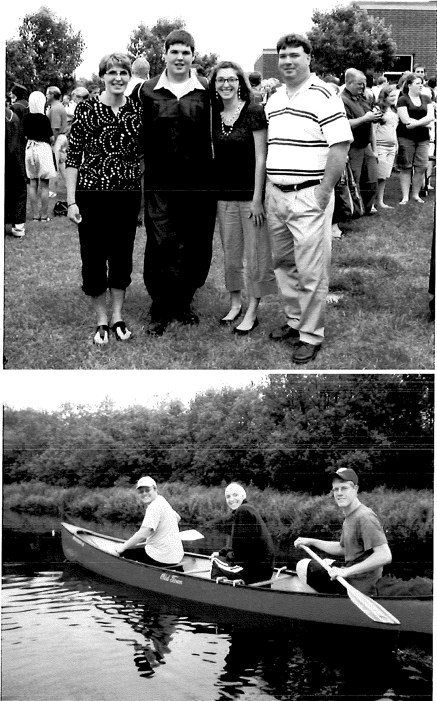

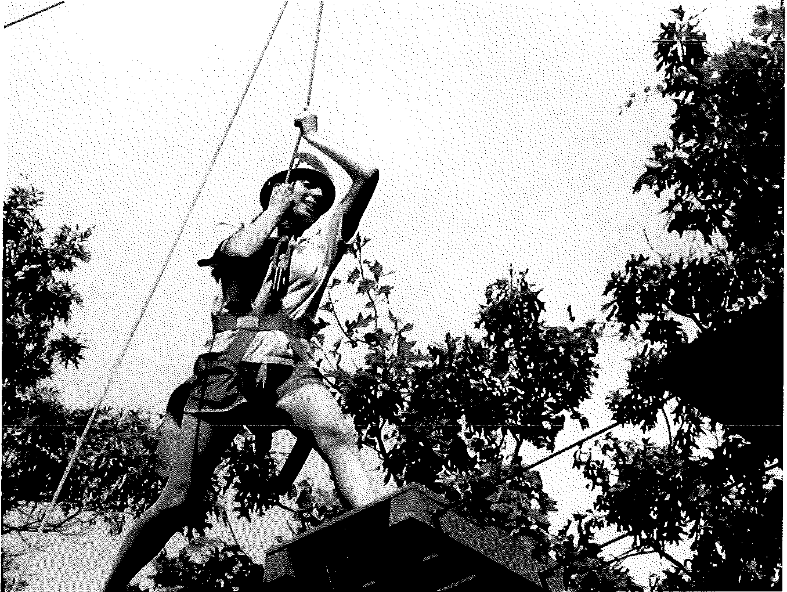

Appendix G Writing Prompts
Participant 1

Narrative Prompt:
Pretend you lived during the period when dinosaurs were still roaming Earth. One morning, you woke up to a Tyrannosaurus Rex staring you in the face. Write a story about what your day would be like if that's how you woke up. Be sure to include lots of details and as much as possible about what would happen. You have 30 minutes to plan and write your story.

Expository Prompt:
You have been selected to give a presentation at a biology conference in March. Pick your favorite topic in biology, and describe what you would be giving your presentation on. Give examples and explain as many details as possible. You have 30 minutes to plan and write the information you would be presenting on.

Participant 2 Narrative Prompt:
Your whole family is going to school and work for the day, but your dog is staying at home by himself. You tell him "goodbye" and walk out the door. Write a story about what your dog does at home all day by himself. Be sure to include lots of details and as much as possible about what he does when no one is home. You have 30 minutes to plan and write your story.

Expository Prompt:
You have been asked to be on an episode of Myth Busters. Adam and Jamie have run out of myths to try and bust. Come up with a myth you would like them to bust and explain how they might go about busting it. Include as many details as possible and explain as much as possible. You have 30 minutes to think through and write your plan.

AppendixH

Metacognitive Reflection Questions after Writing: Both Participants

Narrative Writing Questions:
- Tell me what you thought about writing this piece?
- What was the most difficult part of writing this piece?
- What was the easiest part of writing this?
- Did you use any strategies when you were planning what to write?

Expository Writing Questions:
- Tell me what you thought about writing this piece?
- What was the most difficult part of writing this piece?
- What was the easiest part of writing this?
- Do you like writing either for fun or for school? Why?
- Did you use any strategies when you were planning what to write?
- Have you ever learned any strategies in school to help you plan out what to write?

Appendix I Confidentiality Assurance Agreement

Title of Investigation: Cognitive and Language Characteristics of Adolescents with Asperger' s Syndrome: Two Case Studies

Name of Principal Investigator: Erika Andrle, B.S.
Name of Volunteer:------------------------- I acknowledge that as a volunteer graduate student or faculty member at the University of
Wisconsin-Eau Claire, any assessment data I collect and analyze during the course of my affiliation with this research project is to be used solely for the purpose of fulfilling assigned tasks and not to be distributed or discussed with anyone except the research team, graduate student volunteer, or faculty mentor at any time.

I will not record video or audio samples of any participant for personal use. Copies of video and audio recordings are available from the investigator and can only be used in confidential areas. These copies must be returned to the investigator or faculty mentor immediately following use.
My authorized activities are being carried out as a: (please check all that apply) o Student clinician
- Transcript analyst
- Assessment analyst

By signing below, I also acknowledge that I have received a copy of this document, have received answers to any questions I had, and may have personal liability for any breach of confidentially I commit regarding the participants in this research study.

Signature: Date: _

AppendixJ Consent Form
Title of Investigation: Cognitive and Language Characteristics of Adolescents with Asperger' s Syndrome: Two Case Studies

Names of Principal Investigator: Erika Andrle, B.S.

This document is to certify that I, _ hereby freely agree to give permission to have my adolescent participate as a volunteer in a study as an authorized part of the educational and research program of the University of Wisconsin-Eau Claire under the supervision of Vicki Samelson, Ph.D., CCC-SLP

- The research project and my adolescent's role in the research project have been fully explained to me by , and I
understand her explanation as well as what will be expected of me and my adolescent by virtue of our participation in this research project. A copy of the procedures of this investigation and a description of any risks, discomforts and benefits associated with my participation has been provided and discussed in detail with me.
- I have been given an opportunity to ask questions, and all such questions and inquiries have been answered to my satisfaction.
- I understand that my adolescent and I are free to decline to answer any specific items or questions in interviews or questionnaires.
- I understand that all data will remain confidential with regard to my adolescent's identity.
- I understand that participation in this research project is voluntary and not a requirement or a condition for being the recipient of benefits or services from the University of Wisconsin-Eau Claire or any other organization sponsoring the research project.
- I understand that the approximate length of time required for participation in this research project is 10-12 hours.
- I understand that if I have any questions or concerns about the treatment of human subjects in this study, I may call or write:

Dr. Don Bredle
Chair, Institutional Review Board for the Protection of Human Subjects Schofield 17
University of Wisconsin-Eau Claire
Eau Claire, Wisconsin 54702-4004 Telephone: 715-836-2373

Although this person will ask my name, I understand that all inquiries will be kept in the strictest confidence.
- Furthermore, I understand that if I have any questions concerning the purposes or the procedures associated with this research project, I may call or write:

Erika Andrle
239 Water Street
Human Sciences and Services 112 Eau Claire, WI 54702
(715) 836-4186

- I also understand that it will not be necessary to reveal my name in order to obtain additional information about this research project from the principal
investigator( s).
- I FURTHER UNDERSTAND THAT I AM FREE TO WITHDRAW MY CONSENT AND DISCONTINUE MY ADOLESCENT'S PARTICIPATION AT ANYTIME.

I hereby consent to the participation of _ a minor/subject in the investigation herein described.

Date Signature of Minor/Handicapped Subject's Parent or Guardian

I, the undersigned, have defined and fully explained the investigation to the above subject.

Date Signature of Investigator

AppendixK Assent Form
Title of Investigation: Cognitive and Language Characteristics of Adolescents with Asperger' s Syndrome: Two Case Studies

Name of Principal Investigator: Erika Andrle, B.S.

I am doing a research study. A research study is a scientific way of finding information about something. I am trying to learn more about teenagers with Asperger's Syndrome and the different skills they use in school and the community.
If you decide you want to be a part of this study, this is what will happen. We will get together about four or five times which will add up to ten to twelve hours total. Each time we meet we will complete different tasks. Some of these tasks will include recording your voice, solving problems related to social situations, writing, and working through different word and sentence activities.
There are some things you should know about this study. We will be doing things that you might do in school. Some of these tasks may be more difficult, and most teenagers your age would make mistakes. It is normal to make mistakes, and I just want you to give a lot of effort in all the tasks. In order for you to feel comfortable, we will take breaks between tasks.
I don't know if being in this research study will help you, but I hope to learn about your different skills and share those with you to help you better understand your strengths and challenges. When we are done with the study, I will write a report about what I found. Your name won't be used in the report. What I find may help other adolescents with Asperger' s Syndrome in school and the community.
You don't have to be a part of this study. It's up to you. If you agree now but change your mind later, just let me know. There will be no punishment for asking to stop being a part of the study.
If you want to be a part of this research study, please print and sign your name
below.

I, , want to be a part of this research study. (Teenager's name)

(Sign your name here) (Date)

AppendixL

Double Interview Analysis

Criteria Participant 1 Participant 2
Number of relevant questions 8 7
asked
Number of irrelevant questions 0 0
asked
Number of questions based on 2 7
pictures
Number of questions asked 4 0
spontaneous!y
Number of questions modeled 2 0
after given questions
Number of relevant comments 4 1
made
Number of irrelevant comments 0 0
made

Other comments/observations When asking questions,
he used inflection when commenting that relayed interest in what was being said
Stayed on topic of
conversation really well Eye contact most of the time
Very hard to understand when providing a lot of information or when excited
Stayed on topic when asking questions, but sometimes went off topic or provided too much information when he was

asked questions

AppendixM

Participant 1 Narrative Writing Sample

lwake up to find myself staring into the reptilian eyes of the Tyrannosaurus rex. I don't know why but an odd sort of pleasure deluges me. I find myself both scared out of my wits and happy beyond my fondest memories. Next, I proceeded to back away slowly not wanting to draw much attention to the predator thinking maybe if I smell like a mammal it will ignore me for mammals were small at the time. Fortunate for me that was the case and the T-rex's eyes drifted to a wandering mixed herd of Hypacrosaurs and Corythasaurs. The predator seemed intent on finding its next meal so it hurried stealthily over to the herd trying to stalk one of the younger members of the herd. I took the chance to get up and look around some more. The Earth was mostly tropics at the time and was quite warm. I see a low hanging branch of a tree. I decide to camp for the day to make a place where I could be sure I was a little safe. I think that I should hunt for food or try to scavenge. I couldn't shake the feeling that I was being watched though. I take off to find something I could possibly use as a spear or weapon for defense and hunting. I didn't know where to start. All I had when I woke up was the clothes on my back. I think back
to my knowledge of dinosaurs. Predators loose teeth, so if I could find a shed tooth then I could use it as a knife or a spear. I proceed to carefully look for shed teeth. Although that feeling I was being watched had never left me. In taking precautions, I proceed to check to see if anything is behind me. All of a sudden, I see a flash of green and I recognize the culprit. It's a Dryasaurus. It's a medium dinosaur so I think I can take it down. I reason that if I can catch one I might be able to break its neck by having a rock with me. As I found later it work, I grabbed a rock and jumped from the tree, landed on the Dryasaurus neck and smashed out it eyes and made it run into a rock. I then had something for supper.

AppendixN

Writing Evaluation Scale (Woodcock, McGrew, & Mather, 2001a): Participant 1Narrative

Components | Very  Poor | Poor | Adequate | Good | Very  Good
Handwriting-not applicable
Forms letters correctly | 0 | 1 | 2 | 3 | 4
Uses consistent spacing | 0 | 1 | 2 | 3 | 4
Stays on line | 0 | 1 | 2 | 3 | 4
Forms letters correctly 0 1 2 3 4
s elling
S2ells regular words correctly | 0 | 1 | 2 | 3 | 4
Spells exception words correctly | 0 | 1 | 2 | 3 | 4
Punctuation and Ca_Qitalization
Ends sentences with correct | 0 | 1 | 2 | 3 | 4
_QUnctuation
Uses internal 2unctuation correctly | 0 | 1 | 2 | 3 | 4
Uses ca2ital letters a22ro2riately | 0 | 1 | 2 | 3 | 4
fudents paragra,Qhs | 0 | 1 | 2 | 3 | 4
Vocabular
Uses age-ap_Qropriate vocabulary | 0 | 1 | 2 | 3 | 4
Uses varied vocabulary | 0 | 1 | 2 | 3 | 4
Uses ,Qrecise vocabulary | 0 | 1 | 2 | 3 | 4
Syntax,'Usage
Uses correct word endings | 0 | 1 | 2 | 3 | 4
Maintains verb tense | 0 | 1 | 2 | 3 | 4
Uses _Qronouns correctly | 0 | 1 | 2 | 3 | 4
Writes com2lete sentences | 0 | 1 | 2 | 3 | 4
Writes sentences with varied lengths | 0 | 1 | 2 | 3 | 4

and
Structures
Narrative Text Structure

Provides setting (time, place) | 0 | 1 | 2 | 3 | 4
Describes external characteristics of | 0 | 1 | 2 | 3 | 4
Characters
Describes internal response of | 0 | 1 | 2 | 3 | 4
characters
Seguences ideas logically | 0 | 1 | 2 | 3 | 4
Highlights important events | 0 | 1 | 2 | 3 | 4
fucludes major details | 0 | 1 | 2 | 3 | 4
Uses appropriate words to link ideas | 0 | 1 | 2 | 3 | 4
Combines sentences into cohesive | 0 | 1 | 2 | 3 | 4

Paragraphs  Describes ending or outcome | 0 | 1 | 2 | 3 | 4
Sense of Audience
Maintains focus and intent | 0 | 1 | 2 | 3 | 4
Maintains appropriate voice | 0 | 1 | 2 | 3 | 4
Maintains discourse genre | 0 | 1 | 2 | 3 | 4
Affective
Maintains positive attitude when | 0 | 1 | 2 | 3 | 4
writing
Appears confident when writing | 0 | 1 | 2 | 3 | 4

AppendixO

Participant 1 Expository Writing Sample

The topic I am going to present is on the wide world of paleobiology. Paleobiology is the study of extinct organisms and their environment. It can trace the remains of an organism by its fossils. It can tell you the story of a forgotten land, or tell you what kind of place the world was like. It is split into subgroups. The first covers the first life in the Precambrian era. The second covers the Paleozoic era and the evolution of life and the species that lived at the time. The third section discusses the Mesozoic era, the age of reptiles and other species that evolved. The last section is the Cenozoic, the most modern era including the present day and may be a few more million years and its life leading up to the current modern organisms that live today. This covers the entire broad paleobiology; I hope you enjoy it as much as I do.

AppendixP

Writing Evaluation Scale (Woodcock et al., 2001a): Participant 1 Expository
Components | Very  Poor | Poor | Adequate | Good | Very  Good
Handwriting-not applicable
Forms letters correctly | 0 | 1 | 2 | 3 | 4
Uses consistent spacing | 0 | 1 | 2 | 3 | 4
Stays on line | 0 | 1 | 2 | 3 | 4
Forms letters correctly 0 1 2 3 4
s elling
SEells regular words correctly | 0 | 1 | 2 | 3 | 4
Spells exception words correctly | 0 | 1 | 2 | 3 | 4
Punctuation and Ca12italization
Ends sentences with correct | 0 | 1 | 2 | 3 | 4
eunctuation
Uses internal punctuation correctly | 0 | 1 | 2 | 3 | 4
Uses caEital letters aEEroEriately | 0 | 1 | 2 | 3 | 4
Indents Earagraphs | 0 | 1 | 2 | 3 | 4
Vocabulary
Uses age-aEEroEriate vocabulary | 0 | 1 | 2 | 3 | 4
Uses varied vocabulary | 0 | 1 | 2 | 3 | 4
Uses erecise vocabulary | 0 | 1 | 2 | 3 | 4
S}'ntax/Usagc
Uses correct word endings | 0 | 1 | 2 | 3 | 4
Maintains verb tense | 0 | 1 | 2 | 3 | 4
Uses pronouns correctly | 0 | 1 | 2 | 3 | 4
Writes com12lete sentences | 0 | 1 | 2 | 3 | 4
Writes sentences with varied lengths | 0 | 1 | 2 | 3 | 4

and
structures
Ex12ository or Event Text Structure

Highlights important ideas and main conce ts | 0 | 1 | 2 | 3 | 4
Sequences ideas logically | 0 | 1 | 2 | 3 | 4
Includes major details | 0 | 1 | 2 | 3 | 4
Uses appropriate words to link ideas together | 0 | 1 | 2 | 3 | 4
Combines sentences into cohesive | 0 | 1 | 2 | 3 | 4
Earagraehs
Sense of Audience
Maintains focus and intent | 0 | 1 | 2 | 3 | 4

Maintains appropriate voice | 0 | 1 | 2 | 3 | 4
Maintains discourse genre | 0 | 1 | 2 | 3 | 4
Affective
Maintains positive attitude when 0 1 2 3 4
writing
Appears confident when writing 0 1 2 3 4

AppendixQ

Participant 2 Narrative Writing Sample

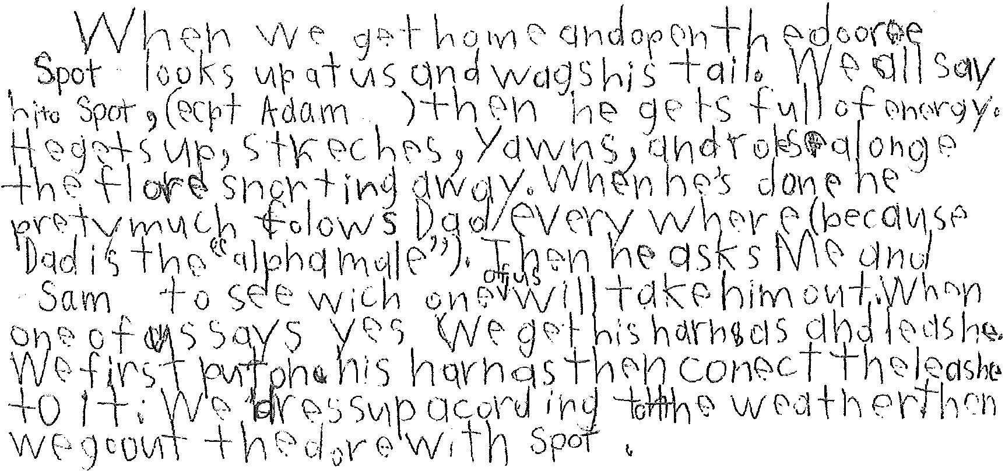

Nate: All names were de-identified to protect Participant l's identity.

AppendixR

Writing Evaluation Scale (Woodcock et al., 2001a): Participant 2 Narrative
Components | Very Poor | Poor· | Adequate | Good | Very  Good
Handwriting
Forms letters correctly | 0 | 1 | 2 | 3 | 4
Uses consistent spacing | 0 | 1 | 2 | 3 | 4
Stays on line | 0 | 1 | 2 | 3 | 4
Forms letters correctly 0 1 2 3 4
s elling
S2ells regular words correctly | 0 | 1 | 2 | 3 | 4
Spells exception words correctly | 0 | 1 | 2 | 3 | 4
Punctuation and CaEitalization
Ends sentences with correct punctuation | 0 | 1 | 2 | 3 | 4
Uses internal Eunctuation correctly | 0 | 1 | 2 | 3 | 4
Uses capital letters appropriately | 0 | 1 | 2 | 3 | 4
Indents Earagra2hs | 0 | 1 | 2 | 3 | 4
Vocabulary
Uses age-appropriate vocabulary | 0 | 1 | 2 | 3 | 4
Uses varied vocabulary | 0 | 1 | 2 | 3 | 4
Uses precise vocabulary | 0 | 1 | 2 | 3 | 4
Syntax/Usage
Uses correct word endings | 0 | 1  i | ,_.,, | 3 | 4
Maintains verb tense | 0 | 1 | 2 | 3 | 4
Uses Eronouns correctly | 0 | 1 | 2 | 3 | 4
Writes complete sentences | 0 | 1 | 2 | 3 | 4
Writes sentences with varied lengths | 0 | 1 | 2 | 3 | 4

and
structures
Narrative Text Structure

Provides setting (time, Elace) | 0 | 1 | 2 | 3 | 4
Describes external characteristics of characters | 0 | 1 | 2 | 3 | 4
Describes internal response of | 0 | 1 | 2 | 3 | 4
characters
Sequences ideas logically | 0 | 1 | 2 | 3 | 4
Highlights im2ortant events | 0 | 1 | 2 | 3 | 4
Includes major details | 0 | 1 | 2 | 3 | 4
Uses a22ro2riate words to link ideas | 0 | 1 | 2 | 3 | 4
Combines sentences into cohesive | 0 | 1 | 2 | 3 | 4
paragraphs

Describes ending or outcome | 0 | 1 | 2 | 3 | 4
Sense of Audience
Maintains focus and intent | 0 | 1 | 2 | 3 | 4
Maintains appropriate voice | 0 | 1 | 2 | 3 | 4
Maintains discourse genre | 0 | 1 | 2 | 3 | 4
Affective
Maintains positive attitude when writing | 0 | 1 | 2 | 3 | 4
Appears confident when writing | 0 | 1 | 2 | 3 | 4

AppendixS

Participant 2 Expository Writing Sample

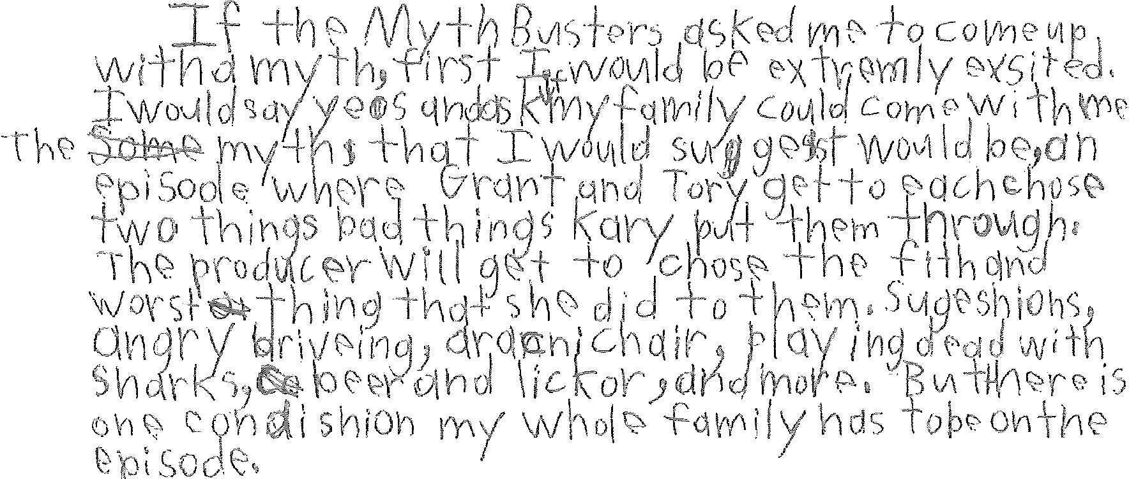

AppendixT

Writing Evaluation Scale (Woodcock et al., 2001a): Participant Two Expository
Components | Very  Poor | Poor | Adequate | Good | Very  Good
Handwriting
Forms letters correctly | 0 | 1 | 2 | 3 | 4
Uses consistent spacing | 0 | 1 | 2 | 3 | 4
Stays on line | 0 | 1 | 2 | 3 | 4
Forms letters correctly 0 1 2 3 4
s elling
S£ells regular words correctly | 0 | 1 | 2 | 3 | 4
Spells exception words correctly | 0 | 1 | 2 | 3 | 4
Punctuation and Caeitalization
Ends sentences with correct punctuation | 0 | 1 | 2 | 3 | 4
Uses internal eunctuation correctly | 0 | 1 | 2 | 3 | 4
Uses capital letters appropriately | 0 | 1 | 2 | 3 | 4
Indents EaragraEhs | 0 | 1 | 2 | 3 | 4
Vocabulary
Uses age-appropriate vocabulary | 0 | 1 | 2 | 3 | 4
Uses varied vocabulary | 0 | 1 | 2 | 3 | 4
Uses precise vocabulary | 0 | 1 | 2 | 3 | 4
Syntax/Usage
Uses correct word endings | (\  v | 1 | 2 | 'l  J | 4
Maintains verb tense | 0 | 1 | 2 | 3 | 4
Uses eronouns correctly | 0 | 1 | 2 | 3 | 4
Writes complete sentences | 0 | 1 | 2 | 3 | 4
Writes sentences with varied lengths | 0 | 1 | 2 | 3 | 4

and
Structures
Expository or Event Text Structure

Highlights important ideas and main Concepts | 0 | 1 | 2 | 3 | 4
Seguences ideas logically | 0 | 1 | 2 | 3 | 4
Includes major details | 0 | 1 | 2 | 3 | 4
Uses appropriate words to link ideas Together | 0 | 1 | 2 | 3 | 4
Combines sentences into cohesive | 0 | 1 | 2 | 3 | 4
Paragraphs
Sense of Audience
Maintains focus and intent | 0 | 1 | 2 | 3 | 4
Maintains appropriate voice | 0 | 1 | 2 | 3 | 4

Maintains discourse genre 0 1 2 3 4
Affective
Maintains positive attitude when writing | 0 | 1 | 2 | 3 | 4
Appears confident when writing | 0 | . 1 | 2 | 3 | 4

AppendixU

Video Recording Release Form

Title of Investigation: Cognitive and Language Characteristics of Adolescents with Asperger' s Syndrome: Two Case Studies

Name of Principal Investigator: Erika Andrle, B.S.
Department of Communication Sciences and Disorders University of Wisconsin - Eau Claire

I hereby give permission for the use of video clips from my adolescent's video recording data files for research and educational presentations. These presentations will focus on how cognitive and language characteristics of adolescents with Asperger's Syndrome can influence academic success and social interactions.

(Participant's Name)

I understand that these video clips will remain the property of the research team, and as such, will only be used for research and educational presentations.

(Signature) (Date)

(Relationship to Participant)

