Americanization and “The Settlement”:
Jewish Immigration to Milwaukee,
1880-1920

Elizabeth Jackson
History 489
May 12, 2014

Abstract

Between 1880s and 1920 massive waves of Jewish immigrants from Eastern Europe began to flood the shores of the United States. As an extent of this immigration, Milwaukee, Wisconsin, began to grow – creating a diverse mix of German-Jewish and “Russian”-Jewish immigrants. It was during these years that the “Settlement House” was created and thrived under the direction of Lizzie Black Kander, the “Jane Addams of Milwaukee.” This essay will examine the process Kander and the rest of the Settlement House staff took to Americanize the Russian-Jewish immigrants during this time period, and the ultimate success they had.

In January of 1922 Mildred McKay submitted a report to the Board of the Abraham Lincoln House. She had been asked by the board and its President, Lizzie Black Kander, to look at the efficiency of the “Settlement House” -- as it was called, harkening back to the previous decades -- and suggest any changes. In 1922 The Settlement House served a Milwaukee Jewish population of about 3000 families, mostly children between the ages of 10 and 18. For years the primary purpose of the Settlement was to serve the “Russian” immigrants coming to Milwaukee during the massive immigration period between 1880 and 1910. Programs for new immigrants ranged from evening English classes, to the cooking classes for young girls managed by Lizzie Black Kander, a founder and later president of the Settlement, and co-author the The Settlement Cookbook.
McKay’s review of the Settlement focused primarily on the impact it had in the community – either through membership, which had seen a fluctuation in years previous, or through the programs that the Settlement offered. McKay thought the Settlement’s programs needed some updates, including that Abraham Lincoln House should start “housekeeping center classes for girls,” which McKay believed to be “even more practical than that of the cooking class.” The cooking class referred to being the brain child of Lizzie Black Kander more than twenty years before.
Overall Mildred McKay found relatively few faults in the organization. Her suggested changes were few, and her data on the membership numbers were succinct. She even went to lengths to point out that the Abraham Lincoln House was beneficial to the Jewish community in Milwaukee. “Everywhere there was a good word for the House, and a feeling that the work is needed, but almost everyone whom I interviewed, either directly or indirectly, expressed the opinion that the House is not as active in previous years,” McKay stated. An interesting aspect of McKay’s analysis of the membership and activity at the Abraham Lincoln House is that the review came at the tail end of mass Eastern European immigration to the United States.
1922 was, more or less, the end of an era of massive immigration from Eastern Europe. Recent years saw a push to limit the number of immigrants from this area. In 1917 Immigration Act, colloquially called the “Asiatic Barred Zone Act” sought to stop the immigration of “idiots, imbeciles, feeble-minded person … persons with chronic alcoholism; paupers ….” While the 1917 act affected the Russian Jewish immigrants very little, the 1921 Emergency Quota act cut the number of immigrants to the United States to three percent of the respective nationality from the 1910 census. While there is no way to tell with certainty how many of Russian nationality in 1910 were Jewish, in 1910 57,926 people listed Russian as their “Mother Tongue.” Had all Russian Jewish immigrants listed Russian as their native language, this would have meant that a little more than 1,700 Russian immigrants. While this is significant in itself, we can’t fully count on the entire Jewish immigrant population in 1910 to list Russian as their native language. However, the same census data listed 1,051,767 native Yiddish speakers. The Emergency Quota Act would have cut the number of Yiddish (and therefore Jewish) immigrants down to about 31,500.
Table 1
Native Russian Speakers,1910 | Emergency Quota Act Cuts,1921 | Native Yiddish Speakers, 1910 | Emergency Quota Act Cuts, 1921
57,926 | 1,700 | 1,051,767 | 31,500
Source: US Census Bureau: Mother Tongue of the Foreign-Born Population: 1910 to 1940, 1960, 1970.

The cut in immigration quotas during the 1920s meant tremendous changes for the Abraham Lincoln House and the process of Americanization.
For most of its history, however, the Settlement served an important role in Milwaukee. It gathered together the small community of Jews, and helped new immigrants assimilate. It was one of many “houses” during the Progressive era that served this purpose. The Settlement, and its founders, such as Lizzie Black Kander, had the ultimate goal of Americanizing the men, women, and children who came through the doors of the Settlement. “Americanization” of the new “Russian” immigrant included the “uplift” of these new immigrants, even though Kander and McKay were adamant that such “uplift” was not part of the mission of the Settlement and other social reform houses. As much as Kander stated she did not believe in uplift of people, she was involved directly the type of organization – settlement houses – that made this the primary goal.
The changing of the times following the cuts to immigration after World War I meant that the overall use of the Settlement needed to change. By the 1920s inclusion of “Jewish” societies – such as the two Zionist Organizations that emerged during this decade – was allowed at the Settlement. This marked an extreme shift in attitudes not only of Kander, who had been adamant that the Settlement was not a place for politics, but also of the community as a whole. This signaled a change in direction for the Settlement, but Americanization of the new Russian-Jewish immigrants had already made its impact.
Philanthropy: A Jewish Tradition
A major factor in the historical analysis of Jews in the United States is how they identified themselves within the influx of new immigrants. A vast part of the immigration experience in the United States is the concept of identity: what made a certain immigrant group stand out among others. From Rachel “Ray” Frank, a woman “rabbi” who was popular in the 1890s, to Anarchist Emma Goldman, the idea of what an American Jew was permeates the historiography. As these two examples show, the idea of what Judaism in the United States meant in terms of interpreting history is vastly different. Historians who study Jewish American history tend to only focus on the “identity” of Jews in the United States – that is, how they identify themselves in the melting pot. There has seldom been much deviation from using identity to interpret the history of Jewish immigrants in the United States. Identity, however, does not always mean the same thing for every section of Jewish American society. Jewish identity in the United States has been a malleable thing, and has changed over the years.
How does this, then, effect the historiography of Jewish immigrants in the United States? It opens up the historians to look at individual experiences, and, instead of basing their research on what it meant to be a Jewish immigrant; historians have the ability to analyze the identity through the experiences. Shari Rabin states that “while Jewish studies generally has responded to the challenges posed by gender studies, American Jewish history has been somewhat slower, producing a long rich historiography on ‘experiences’ with much less attention paid to ‘representations.’” It’s important to understand and examine how historians have studied and written about the Jewish identity in the United States as a whole, but also what specific identity Jewish men and Jewish women had. It will also look at how this identity affected the Jewish benefit societies that became popular in the mid-nineteenth century.
Jewish identity around the turn of the twentieth century, could, according to Eli Ledarhendler, be classified through five layers: the term “Jewish race” being replaced for “more acceptable ‘ethnic’ usage” ; a “post-religious evolution of American Jewish identity” where terms such as “Jewishness” incorporate secular and religious aspects of Jewish American life; the term “ethnicity” allows Jews to stand out less in the American historical record than they would as a religious community and that the historiography of American Jews pre-1881 was not viewed in terms of “ethnicity” but “rather (Jews) have been investigated in terms of their religion, social class, or ‘community.’” Lederhendler’s essay, “The New Filiopietism, or Toward a New History of Jewish Immigration to America” focuses on the historiography of Jewish immigration, which he defines as “of all the classifications used by American social historians to subdivide the national population – class, race, ethnicity, religion, and gender – contemporary Jewish scholars have evinced the greatest preference for ethnicity, with or without gendered perspective. By basing the identity of Jews solely through ethnicity, a historian may run into a problem.
Identity through community in the Jewish-American historiography is still used widely, however. In her 2010 essay, Idana Goldberg points out that when, in the late nineteenth century, Isaac Meyer Wise, a Jewish Reformer, visited Jewish communities in the Midwest. After touring multiple Jewish women’s societies, which served as social benefit societies, he stated that the women who ran these were “Judaism, personified.” Charitable work connected those Jews who were involved in it with their community, and thus solidified some sort of identity, be it Isaac Meyer Wise’s “Judaism, personified” or another form of identity.
The topic of Jewish identity based through community leads to a more extensive analysis of what charity meant to the Jewish identity. Throughout the nineteenth century, charitable organizations were being formed by Christians and Jews alike. The definition of those who needed charity varied between these two groups. There was the concept in Christian benefit societies of the “worthy poor” – widow, orphans and the elderly that required limited aid from the societies – and the “unworthy poor” – beggars and “schemers” who did not deserve aid. This, according to Goldberg, was where Jews who worked in these charities were caught between the American identity in charities, and the Jewish identity of “helping every needy person regardless of worth.” Charity was a driving force behind the identity of Jews in the United States at the end of the nineteenth century. “American Jews,” Goldberg states, “seized upon charity not only out of practical necessity, but also as a mechanism for belonging and defining themselves within the American gender and religious landscape.” Goldberg attempts to show a different way than how Ledarhendler sees the historiography. Instead of focusing on ethnicity, which Ledarhendler stated would be a problem when studying Eastern European Jewish immigrants; Goldberg focuses on how gender and religion play into the late-nineteenth century identity of Jews in the United States.
The fact is that gender played a large role in the formation and running of Jewish charitable organizations, or havarat. During most of the nineteenth century, Jewish men and women’s charitable organizations worked side by side, but under the pressure of the nineteenth century ideal of separate “spheres” Jewish men and women began to increasingly isolate their charities from the opposite sex. Goldberg states that the “masculinization” of Jewish philanthropy had started because of the pressure of the American “spheres.” At the Philadelphia Jewish Foster Home, the women who ran the home lost some control to the Board of Council – which was all male. Towards the end of the nineteenth century women across the United States were generally kept out of the overseeing boards in Jewish benevolent societies.
The benevolent and charitable societies were an important part of the Jewish-American culture that exemplifies not only the identity, but also experiences. Goldberg pointed out the importance of the charitable organization for the Jewish immigrant identity, “with the dissolution of the traditional structures of Jewish life, philanthropy emerges as a characteristic feature of the modern Jewish identity.” Of course, Jewish-American identity during the mid- and late-nineteenth century was not solely based on philanthropy. As historians have seen, Jewish women played a large role in the Jewish identity in America.
In nineteenth century America women were thought of to be the “natural” philanthropists, based on their motherly nature. However, Jewish women, while working with benevolent organizations tended to refute this stereotype. They saw their Jewish identity as being the reason for their philanthropy – rather than their “female heart.” However, Jewish men continued to echo the same statement as the rest of America; that women’s nature is what inherently qualified them for charitable works. Working in benevolent societies brought Jewish women outside of the home, which was seldom seen in nineteenth century America. However, benevolent societies weren’t the only things that brought Jewish women out of the private sphere and into the public. Women such as Rachel “Ray” Frank, Emma Goldman, and the Yiddish Theatre actresses, stepped out into the public sphere, and created a new definition of Jewish-American identity.
Rachel “Ray” Frank was a women “Rabbi” – although never ordained, she was called a Rabbi by the media – who was part of the Revivalist Judaism movement around the turn of the century. Frank, along with anarchist Emma Goldman, and actresses Adah Menken and Sarah Bernhardt, took the Jewish female identity out of the household, and into the spotlight. Particularly, Frank and Goldman were women in male professions, carving a new identity for them and other Jewish American women. However, Frank tended to stick somewhat with the issues that concerned Jewish women in the late nineteenth century. In one speech Frank stated “my work is directed chiefly to the Jewish woman, who, through all the ages, has been the great home-builder, the foundation of the family.” While there was a significant shift in the identity of Jewish women – going outside of the home to champion ideas – there was still the identity of Jewish women as those who took care of the home.
Finally, Jewish immigrant identity also molded itself around Americanization. In the later years of the nineteenth century until the beginning of World War One, almost two million Eastern European Jewish immigrants fled to the United States. These immigrants and even the German-Jewish immigrants before them had a common language of Yiddish that the community could use as a form of identification. Yiddish helped to play an important role in the Jewish community. Even with Americanization shaping the Jewish immigrant’s identity, there was still somewhat of a Jewish identity being promoted by the Yiddish theatre in the late nineteenth and early twentieth century. Americanization also shaped the Jewish identity through the clothing that Eastern European Jewish women wore. According to Barbara Schreier, these “Russian” Jewish immigrants often times adjusted their clothing to meet with American standards before stepping on the ship to the United States.
Identity does not just characterize the thoughts and historiography of Jewish immigrants to the United States. According to Charles Hirschman, immigration also clarifies the identity of the United States. Hirschman’s article, “Immigration and the American Century,” is an overview of immigration in twentieth century America. Charles Hirschman focuses on the impact the immigration has had on the United States in the past one hundred years, employing data from three different immigrant generations: 1900, 1970, and 2000. Hirschman stresses the importance of immigration not only being a good thing for the immigrants themselves, but for the nation as a whole. Hirschman, along with stating that the American identity stems not from nationalism, but from the “welcoming of strangers” , emphasizes that immigration “along with preexisting sources of population diversity, has created a more cosmopolitan and tolerant society that is much less susceptible to monolithic claims of American nationalism.” Hirschman looks at immigration in a very broad sense, covering a whole century, and is at times exceptionally optimistic about the positive impacts of immigration during the twentieth century.
American Jewish identity, and historians interpretations of this identity, have varied considerably, even in recent years. There is no specific way to look at the identity of Jews in the United States. Experiences have helped to shape this identity, however. Jewish men and Jewish women in the United States developed different identities based on different experiences – through work, charities, or even the “public” and “private” spheres that were prevalent in nineteenth century America. The question of identity, not just for American Jewish immigrants, but for all immigrants, is what makes up their identity? There is no one factor, but multiple that is shaped by the experiences of immigrants.

Milwaukee’s Jewish Immigrants
The driving force behind the Settlement, and other organizations built for the Americanization of immigrants, was the sheer number of Eastern European Jewish immigrants in the city. In the early days of Milwaukee German Jews began to settle there. According to Louis J. Swichkow and Lloyd P. Gartner in The History of The Jews of Milwaukee, in 1850 about seventy Jewish families were already living in the Milwaukee area. Growth over the next few years was substantial.
Table 2 Growth of Jewish Families in Milwaukee
Jewish Families in Milwaukee  1850 | Jewish Families in Milwaukee  1852 | Jewish Families in Milwaukee  1856
70 | 100 | 200
Source: Louis J. Swichkow and Lloyd P. Gartner, The History of The Jews of Milwaukee.
Essentially, Jews from Germany were the only Jewish immigrants to Milwaukee until the 1880s, when substantial numbers of “Russian” Jews immigrated to the United States. Between 1880 and 1910 the Russian-born population of Milwaukee County grew twenty-two times in size. What is interesting is that in the decade between 1910 and 1920 the Russian-Born Population of Milwaukee County decreased to almost 8,000 citizens.
Table 3 Russian-Born Population of Milwaukee County
1890 | 1900 | 1910 | 1920
567 | 1,175 | 12,932 | 7,808
Source: Historical Census Browser, University of Virginia Library.
Reasons for Jewish immigration from East Europe and Russia were vast. Where most German Jews immigrated because of economic reasons, Jews from East Europe and Russia immigrated because of famine (Lithuania in the 1860s), religious persecution (Pogroms in Russian and Roumania throughout the latter half of the nineteenth century), and limited living areas. Economics played some role in immigration, but not to the extent it did to German Jews.
For the most part, the Jewish immigrants of East Europe settled in the same cities and areas of cities as the “coreligionists.” This could be seen from the Lower East Side of New York to Milwaukee, with immigrants settling in the areas of Milwaukee around Haymarket (see map 1, page 14). The German Jews, already assimilated into American culture, tended to not live in the same area as the new immigrant Jews. There was still contact, but as employers or philanthropists, rather than as neighbors. According to Susan A. Glenn in her book Daughters of the Shtetl, there was a distinct difference between the German Jews of the United States, and the new Eastern European Jewish immigrants. “Apart from all these east European subgroups stood the German Jews, who had largely arrived during an earlier wave of immigration that began in the mid-nineteenth century. Disclaiming an cultural or social affinity to their East European coreligionists, many German Jews preferred to think of themselves as assimilated Americans with a duty to educate, modernize, and ‘uplift’ the newcomers from eastern Europe.” The idea of “uplifting” the new Jewish immigrants was prevalent in the thought process of those at The Settlement.
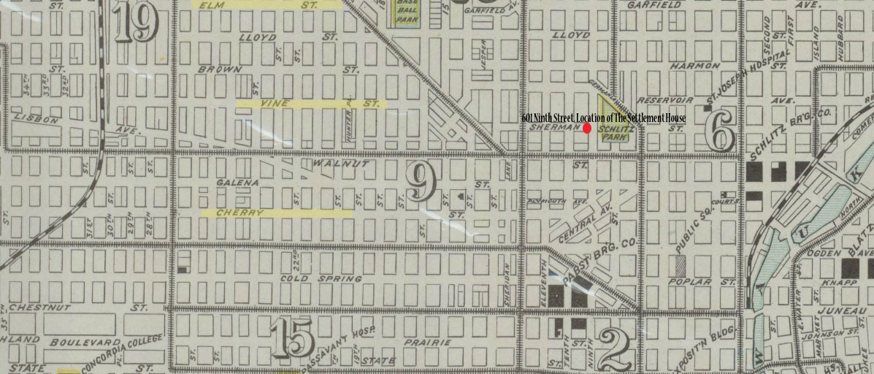
Source: UWM Libraries: Milwaukee Neighborhoods, Photos and Maps, 1885-1992.
The Settlement House’s longtime location at 601 Ninth Street, Milwaukee is indicated in red. Vine, Cherry, and Elm Streets are indicated in yellow. These were popular residential streets for many new Russian immigrants from 1880 to 1920. Many of the young girls who attended Kander’s cooking class listed these streets as their addresses. Map has been edited by author from original.

Lizzie Black Kander found the 1929 article “The Jewish Community Center: It’s Past, Present and Future Possibilities” by Philip Seman, general director of the Jewish People’s Institute in Chicago to have interesting thoughts on Settlement houses, as well as immigration. Seman notes in the article that by 1912 nearly one third of the Jewish population in the United States had arrived in just the past decade. “This fact alone needs very little comment to explain what an enormous problem American Jewry were confronted with in the matter of adjusting so huge an arm of newcomers to an entirely new environment.” Kander was most likely drawn to this article because of the stress on how the Jewish community center, and settlements, grew and expanded to meet the needs of the mass immigration. According to Seman, during the 1900s and 1910s, Americanization was the most important thing taught at the Jewish community center.
What is, perhaps, the most interesting about Jewish immigration to the United States at this time is that that many of the large Jewish organizations in the United States believed that the Jews of Eastern Europe should stay in Europe, even with persecution happening throughout the region. The major Jewish organizations however, wanted “a selective, well planned immigration of skilled healthy and unmarried workers.” As much as the major Jewish organizations wanted to limit immigration, it wasn’t the case: Between 1883 and 1890 347,551 Jews arrived in the United States, mostly from Eastern Europe. About half that number – 111,284 – arrived just in 1891. And again, 136,742 in 1892. Most of the immigration in the 1890s, according to Yivo Archives, was from pogroms. The immigrants could not have all been the skilled workers that the organizations wanted – and they, perhaps, were looking solely for male skilled workers. But during the latter half of the nineteenth century the majority of Jewish immigrants to the United States were female.
Women were largely the main immigrant group because of the “economic, political and social oppression” in Eastern Europe. Women made the journey to the United States because of the idea Eastern European Jews held that there was nothing left for them in the Pale. The “Pale” being, of course, the Pale of the Settlement, the part of Western Russia (now Ukraine) where Jews were regulated to living in small communities called “Shtetls”. The Settlement House’s main concern was with the living conditions of the new immigrants from Eastern Europe. This concern, naturally led programming at the Settlement to be concerned for a larger part, with the female’s role in the household, and how they could affect the Americanization of the family as a whole.

Leading the Way: Lizzie Black Kander

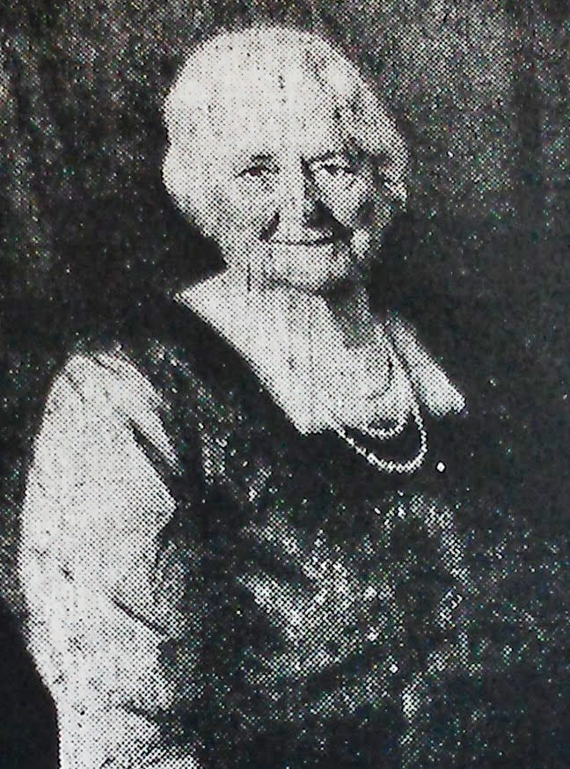
The guiding force of the Settlement was Lizzie Black Kander, President of the Board of Directors, wife of a state representative, and member of the Milwaukee school board for a short time. It was Kander, along with a small group of other leading women and men of the Jewish community in Milwaukee, which created the original Settlement, and later the Abraham Lincoln House.
Kander is, perhaps, best known for her cookbook: The Settlement Cook Book: A Way to a Man’s Heart. Originally published in 1903, the cookbook went through multiple printings, and funded the Settlement in a small way. The cookbook was inspired though, by one of the first programs hosted by Kander and The Settlement – even before The Settlement existed as an actual organization.
Lizzie Black Kander
Source: The Milwaukee Sentinel, Feb. 1948.
Starting in 1898, Kander began to manage and teach a cooking school for the daughters of recent immigrants. Held once a week for much of the history of The Settlement, the cooking classes focused on the preparation of healthy meals. In November and December of 1900 Kander put together 9 cooking classes. For these two months nineteen girls attended, some more regularly than others. Annie Charness, of 615 Prairie Street, missed almost half the classes held during these two months. Her reasons for doing so are unknown.
Kander kept a rough outline of the meals taught at these classes. The lessons varied from the relatively simple, soft cooked and hard cooked eggs, to more difficult custards. Overall, the meals stayed in the level of the young girls, usually ranging in ages of ten to sixteen, but taught lessons needed for the home.
Often times Kander is called the “Jane Addams of Milwaukee.” While there are similarities between the two, there were differences that stand out. As Angela Fritz states in “Lizzie Black Kander and Culinary Reform in Milwaukee, 1880-1920,” Kander didn’t focus on the collection of scientific data like Addams did – instead, she understood the importance of food in the Americanization of immigrants. “Kander understood that food was a powerful means of religious and cultural expression, and she used culinary reform to gain control over the effects of massive immigration and industrialization, to aid in the assimilation of immigrant girls, and to introduce immigrant women to American consumer culture.” If any social program at The Settlement taught Americanization in a quick and effective way, it was the cooking classes for young girls.

Americanization at The Settlement
“Many then from persecution,
Came to us from Russia’s shore,
Left their homes and all possessions,
seeking refuge at our door.

Taught them useful occupations,
Girls to sew, crochet and knit,
Boys with clay, and paints, and jackknives,
Free from harm, for hours would sit.”

Lizzie Black Kander started the poem “O Ye Parliamentary Hour” with these passages in 1917, reflecting on the seventeen years since The Settlement House opened. She explicitly points out the influx of Russian Jewish immigrants during the turn of the century. More telling, though, is the fact that Kander mentioned only the young boys and girls that went to the Settlement for recreational learning. What Kander failed to show in the poem was that the Settlement’s goal – for all intents and purposes – was to Americanize the immigrants. This would either be done through the children (as most programs revolved around young people) or directly.
It’s interesting to note that while every program that The Settlement put together was focused in some way or another in the Americanization of recent immigrants, there was nothing specific in the documents of the Abraham Lincoln House or its predecessor stating that Americanization was the mission.
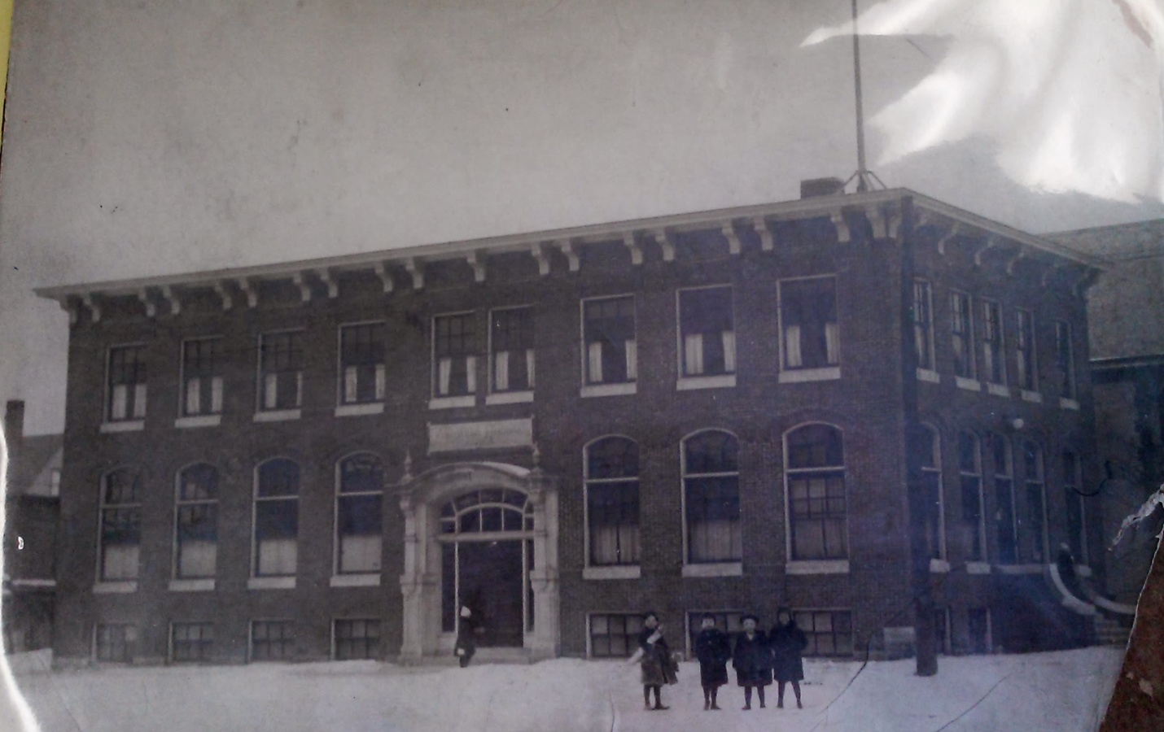
The Settlement House, about 1900. Source: Lizzie Black Kander Papers.

The Settlement House first opened its doors, formally, in 1900. The original Settlement House was located on North 5th Street, in the Second Ward (see map). The Settlement combined two organizations – Milwaukee Jewish Mission and the Sisterhood of Personal Service -- both of which Kander took part in. In an article celebrating the fifteenth anniversary of The Settlement The Evening Wisconsin stated in an article that the “pitable conditions” of the recent immigrants “touched the sympathies of Mrs. Simon Kander and of a little band of women who constituted a west side study circle.” For many years Kander headed the Board of Directors of the Settlement House (and later the Board of Directors of the Abraham Lincoln House). The Settlement was funded in most part by the Federated Jewish Charities. In the fiscal year of 1927 – several years after The Settlement became the Abraham Lincoln House – the Settlement had $16,500 in the coffers from the Federated Jewish Charities. Another $1,000 came from other donations, drives, and funds from the sale of The Settlement Cook Book. Most of the budget paid for the salaries of The Settlement’s eleven employees.
The Settlement first took shape in the years following the largest movement of Jewish immigration from Eastern Europe. While Philip Seman didn’t write specifically about The Settlement in his article, he did see the same phenomenon in growth of the philanthropic Jewish community centers that The Settlement was seeing. There must have been some foresight with Kander and the others who joined forces to open The Settlement, as Jewish philanthropic organizations would become more important as the immigrant population grew.
The Settlement House took and interesting approach to “Americanization.” The programs that The Settlement House had very practical purposes; the cooking class that Kander managed, for example, served the purpose of teaching young girls, many no older than fourteen, proper cooking techniques and nutrition. During the first year the class was taught, an article appeared praising the work that Kander and Alida Pattee, the actual teacher of the classes. The title of the article perhaps explains the program best: “Only Kosher Cooking School in West: An interesting class of Jewish girls are being taught to cook by the Milwaukee Jewish Mission – Miss Alida Pattee is the teacher, but she finds it difficult to observe the Kosher laws.” The class attempted to continue with the Kosher tradition, as many, if not all, the students attending were Eastern European immigrants themselves, or children of recent immigrants. The article states that “the Jews of the lower class … are as particular in their observance of the ‘kosher’ laws as high caste Brahmin.” The language of the article is a good example of the distinction of assimilated German Jews and the recent “unassimilated” east European immigrants. Stressed in the classes was cleanliness – an idea that forms the basis of The Settlement’s process of Americanization.
What is interesting about the Settlement House Cookbook is that there is no mention of kosher restrictions in its pages. While the book was also intended for cooks who were not Jewish women, it seems interesting to leave out what would have been an important part of a new Jewish immigrants lifestyle. It’s a curious thing that this was left out, and most likely shows the attitudes of Kander and her coauthors to assimilation of the Russian-Jewish immigrants.
Even McKay thought that the best way for The Settlement to Americanize immigrants was through nutrition and cleanliness. She stated in her 1922 report that The Settlement would benefit with the introduction of nutrition classes. “Nutritional work is not being carried on a extensively in Milwaukee as elsewhere,” McKay states. “The Settlement should always act as a stimulus, and should organize work which will later be taken over by the public school.” Education, and the education of girls and women in particular, played a large role in the Americanization of families. There was the idea that if the women of the immigrant family were educated and assimilated, then the entire family would be.
Susan A. Glenn mentions in Daughters of the Shtetl that throughout Jewish history, women played an economic role in and outside of the household. After immigration, however, the mothers of the household were pressured by American standards to remain at home, while daughters tended to work. Eventually any work outside the home that had been considered valuable was discredited. “Those who sought to identify themselves with upwardly mobile, assimilated Americans insisted that a wife should devote herself exclusively to her domestic obligations.” The Settlement House was at the forefront of this and sought to drive domestic programs for the young girls and women in immigrant households.
All in all, Kander, The Settlement, and even McKay believed that the family, and the assimilation of the family, was good for the community. “After all, the family is the prime factor for good or ill in the life of the community, and it is the family as a whole, with which we must work,” McKay finished her report.
Twelve years after initially opening the doors of The Settlement House, the organization moved to a new location: The Abraham Lincoln House. With an expanding Jewish community, The Settlement moved to a larger location, but the mission remained more or less the same. In her speech to the Building Committee of the Furnishing Committee of the Ways and Means Committee and to Donors when accepting the keys to the Abraham Lincoln House, Kander stated that The Settlement never sought to “uplift” those that they helped, but instead stated “our problem is the normal human being. To work with him and for him that he may remain normal. The problem is that the immigrant who most in the shortest time learn our language, our laws, our customs, in order to obtain suitable work and become an honorable, selfrespecting (s.i.c) citizen.” Kander and her colleagues at the Settlement House believed wholeheartedly that the work they were performing was not to help the downtrodden immigrant. However, if Kander and her colleagues were to take a closer look they would realize this was precisely what they were doing. By attempting to take the “normal human being” and keep him normal, they were pushing Americanization on the immigrants through programs that (almost exclusively) taught young women and children proper cooking, cleaning, and social skills. Skills different from those they knew in Eastern Europe. The Abraham Lincoln House newsletter, The Lincoln News took interviews in late 1922 on what the community thought of The Settlement. While these were naturally biased coming from a publication of The Settlement, they do show a slice of public opinion. Jacob Goldberg, a local druggist, stated “the services which the Abraham Lincoln House renders to newcomers in English and Americanization classes especially, are unparalleled, The Children’s Welfare Station has taught many mothers to raise strong, healthy children.” It seemed to be that The Settlement was needed by the community as a whole.
End of an Era
By the mid-1920s The Settlement was once again outgrowing its home at the Abraham Lincoln House. The reason, however, was not because of an excess of immigrants, but because of the growth of recreational groups. Up until McKay’s report in 1922 it wasn’t the norm for specifically Jewish organizations to be included at The Settlement. But as we can see in table 4, two Zionist organizations had amassed a decently sized enrollment by 1928.

Table 4 Enrollment of Lincoln House Clubs, 1928
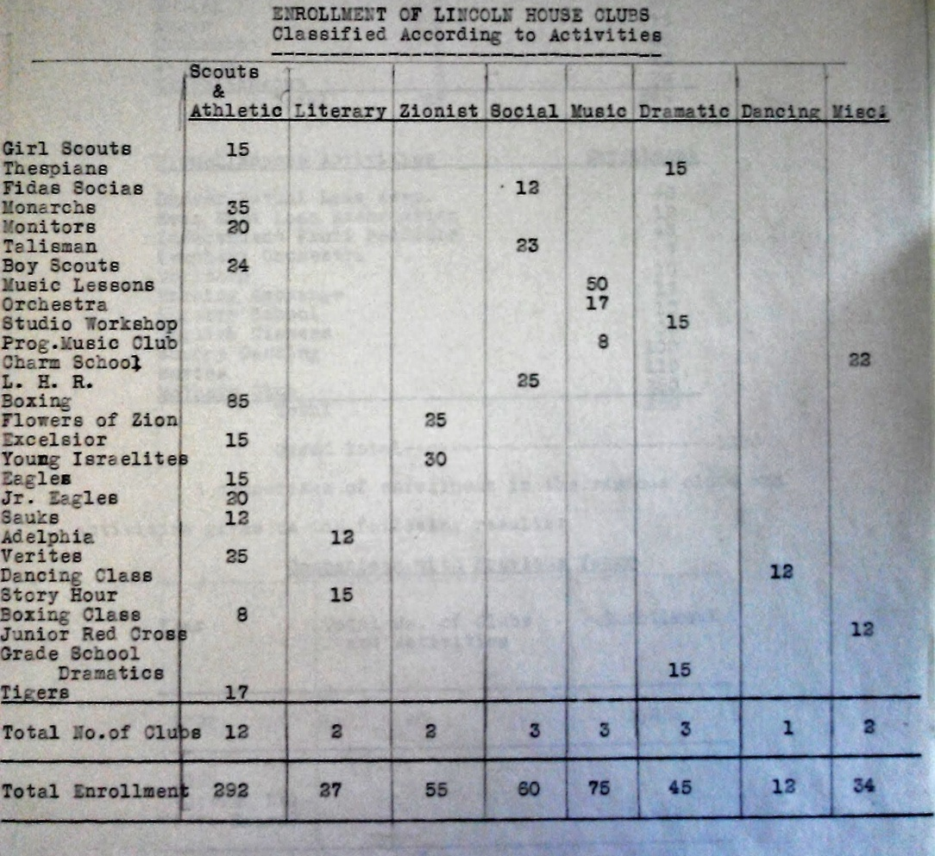
Source: Benjamin Glassberg, Recreational Survey of the Jewish Community of Milwaukee, July 3, 1928.

The Settlement experienced a change in the 1920s and 1930s – rather than a focus on assimilation and Americanization, there was a focus on community outreach. In his survey, Benjamin Glassberg noted that the largest number of organizations present at The Settlement were athletic and social societies. This was a shift from the once abundant charity clubs and cooking classes. Abraham Lincoln House was turning into a community center, a direct reflection of the path other settlement houses in the United States were taking. The Settlement served more as a meeting area rather than a teaching arena. This change was bound to come, as immigration slowed, and more and more Jewish children were second generation immigrants.
Then, in 1940, Lizzie Black Kander died suddenly from a heart attack. It’s from the memorial articles in Milwaukee newspapers that we begin to understand the mark The Settlement and Kander had on immigration. The programs that Kander put together at The Settlement were remembered for bringing the community together, and essentially making it a better place. “There are thousands of men and women in this community who are better citizens and better Jews for having come under the influence of the institutions of social betterment founded by Mrs. Kander,” one memorial article stated. Assimilation and Americanization of the Russian Jewish immigrants was a long process, but it ultimately worked, and knit the Jewish community of Milwaukee together.

Works Cited

Primary:

Lizzie Black Kander Papers, 1975-1960. Wisconsin Historical Society, Madison.

“Mrs. Kander,” Wisconsin Jewish Chronicle, July 26, 1940.

“Need Creates Organization of The Settlement.” The Evening Wisconsin (Feb. 15, 1915).

“Only Kosher Cooking School in West …” Feb. 5, 1898.

Photo of Lizzie Black Kander, The Milwaukee Sentinel. (Feb. 1948).

U.S. Census Bureau, Table 6. Mother Tongue of the Foreign-Born Population: 1910 to 1940, 1960, and 1970. Mar. 9, 1999. Accessed Feb. 27, 2013.

Seman, Philip. “The Jewish Community Center: It’s Past, Present and Future Possibilities.” The Wisconsin Jewish Chronicle. (Oct. 4, 1929).

Weiss, Joseph. “What They Say of Us,” The Lincoln News, Vol 1. , no. 2. (Sept. 8, 1922).

[ … ing Wisconsin], “Mrs. Kander Again President,” March 18, 1903.

Secondary:

Chicago Historical Society, “Settlement Houses.” The Encyclopedia of Chicago. http://www.encyclopedia.chicagohistory.org/pages/1135.html (accessed May 1, 2014).

Fritz, Angela. “Lizzie Black Kander and Culinary Reform in Milwaukee, 1880-1920.” Wisconsin Magazine of History, vol. 87, no. 3 (Spring 2004): 36–49

Glenn, Susan A. Daughters of the Shtetl: Life and Labor in the Immigrant Generation. Cornell University Press, New York: 1991.

Goldberg, Idana. “‘Sacrifices Upon the Altar of Charity’: The Masuclinization of Jewish Philanthropy in Mid-Nineteenth Century America.” Nashim: A Journal of Jewish Women’s Studies and Gender Issues 20 (Fall 2010): 34-56.

Hirschman, Charles. “Immigration and the American Century.” Demography 12, no. 4 (November 2005): 595-620.

Jewish Mass Settlement in the United States: Documents and pictures from the Yivo Archives on Eastern European Jewish Immigration in the Past Hundred Years. Arranged by Zosa Szajkowski. Yivo Institute for Jewish Research.(New York: 1966).

Kander, Lizzie Black; et al., “The Settlement” Cook Book: The Way to a Man’s Heart. 1903. Reprint, Carlisle, Mass.: Applewood Books.

Ledarhendler, Eli. “The New Filiopietism, or Toward a New History of Jewish Immigration to America.” American Jewish History 93, no.1 (March 2012).

Power, Sharon. “Yiddish Theatre Actresses and American Jewish Identity.” Shofar: An Interdisciplinary Journal of Jewish Studies 30, no. 3 (Spring 2012): 84-107.

Rabin, Shari. “‘The Advent of a Western Jewess’: Rachel Frank and Jewish Female Celebrity in 1890s America.” Nashim: A Journal of Jewish Women’s Studies and Gender Issues 22 (Fall 2011): 111-135.

Schreier, Barbara. “Becoming American: Jewish Women Immigrants, 1880-1920.” History Today (1994).

University of Wisconsin- Milwaukee. “1901: Map of Milwaukee.” Map, UWM Libraries.

Mildred E. McKay, “Report to Madame President and Members of the Board of Abraham Lincoln House,” in Lizzie Black Kander Papers, January 14, 1922.
The term Russian usually encompassed all Eastern European immigrants. While many Russian Jewish immigrants were actually from Russia, and specifically the “Pale” of Western Russia, the term was usually all encompassing.
Mildred E. McKay, “Report to Madame President and Members of the Board of Abraham Lincoln House.”
Ibid., 8.
Mildred E. McKay, “Report to Madame President and Members of the Board of Abraham Lincoln House,” 7.
U.S. Congress. House. An Act To regulate the immigration of aliens to, and the residence of aliens in, the United States. HR 10384. 64th Cong., 2nd sess.
U.S. Congress. House. An Act To limit the immigration of aliens into the United States. HR 4075. 67th Congress., 1st sess.
U.S. Census Bureau, Table 6. Mother Tongue of the Foreign-Born Population: 1910 to 1940, 1960, and 1970. Mar. 9, 1999. Accessed Feb. 27, 2013.
U.S. Census Bureau, Table 6. Mother Tongue of the Foreign-Born Population: 1910 to 1940, 1960, and 1970. Mar. 9, 1999. Accessed Feb. 27, 2013.
Chicago Historical Society, “Settlement Houses,” The Encyclopedia of Chicago, http://www.encyclopedia.chicagohistory.org/pages/1135.html (accessed May 1, 2014).
Sharon Power, “Yiddish Theatre Actresses and American Jewish Identity,” Shofar: An Interdisciplinary Journal of Jewish Studies 30, no. 3 (Spring 2012), 87.
Shari Rabin, “‘The Advent of the Western Jewess’: Rachel Frank and Jewish Female Celebrity in 1890s America,” Nashim: A Journal of Jewish Women’s and Gender Issues 22 (2011), 112.
Eli Ledarhendler, “The New Filiopietism: or Toward a New History of Jewish Immigration to America,” American Jewish History 93, no. 1 (2007), 6.
Ibid.
Ibid.
Eli Ledarhendler, “The New Filiopietism,” 7.
Idana Goldberg, “‘Sacrifices Upon the Altar of Charity’: The Masculinization Philanthropy in Mid-Nineteenth Century American,” Nashim: A Journal of Jewish Women’s and Gender Issues 20 (Fall 2010): 35.
Idana Goldberg, “‘Sacrifices Upon the Altar of Charity,’” 39.
Ibid.
Idana Goldberg, “ Sacrifices Upon the Altar of Charity,” 35.
Idana Goldberg, “Sacrifices Upon the Altar of Charity,” 36.
Idana Goldberg, “Sacrifices Upon the Altar of Charity,” 46.
Idana Goldberg, “Sacrifices Upon the Altar of Charity,” 42.
Idana Goldberg, “Sacrifices Upon the Altar of Charity,” 35.
Idana Goldberg, “Sacrifices Upon the Altar of Charity,” 37.
Idana Goldberg, “Sacrifices Upon the Altar of Charity,” 37.
Shari Rabin, “The Advent of the Western Jewess,” 113.
Shari Rabin, “The Advent of the Western Jewess,” 119.
Shari Rabin, “The Advent of the Western Jewess,” 117.
Sharon Power, “Yiddish Theatre Actresses and American Jewish Identity,” 84.
Ibid.
Sharon Power, “Yiddish Theatre Actresses and American Jewish Identity,” 88.
Barbara Schreier, “Becoming American: Jewish Women Immigrants, 1880-1920,” History Today (1994), 26.
Charles Hirschman, “Immigration and the American Century,” Demography 42, no. 4 (November 2005), 600.
Charles Hirschman, “Immigration and the American Century,” 595.
Ibid.
Louis J. Swichkow and Lloyd P. Gartner, The History of the Jews of Milwaukee (Philadelphia: The Jewish Publication Society of America 1963), 11.
See Table 3: Russian-Born Population of Milwaukee County.
Swichkow and Gartner, The History of the Jews of Milwaukee, 69.
Susan A. Glenn, Daughters of the Shtetl: Life and Labor in the Immigrant Generation (New York: Cornell University Press, 1991), 55.
Susan A. Glenn, Daughters of the Shtetl, 57.
Ibid.
Philip Seman, “The Jewish Community Center: It’s Past, Present and Future Possibilities,” The Wisconsin Jewish Chronicle, Oct. 4, 1929, 1.
Philip Seman, “The Jewish Community Center: It’s Past, Present and Future Possibilities,” 3.
Jewish Mass Settlement in the United States: Documents and pictures from the Yivo Archives on Eastern European Jewish Immigration in the Past Hundred Years. Arranged by Zosa Szajkowski. Yivo Institute for Jewish Research.(New York: 1966), 6.
Ibid.
Jewish Mass Settlement …, 8.
Susan A. Glenn, Daughters of the Shtetl, 47.
Susan A. Glenn, Daughters of the Shtetl, 44.
[ … ing Wisconsin], “Mrs. Kander Again President,” March 18, 1903.
Budget: 1926-1927, Lizzie Black Kander Papers.
Lizzie Black Kander, “Cooking Lesson Book,” in Lizzie Black Kander Papers, 1901.
Ibid.
Fritz, Angela. “Lizzie Black Kander and Culinary Reform in Milwaukee, 1880-1920.” Wisconsin Magazine of History, (vol. 87, no. 3: Spring 2004), 1.
Lizzie Black Kander, “O Ye Parliamentary Hour,” The Social Science Tatler, March 5. 1917.
“Need Creates Organization of The Settlement,” The Evening Wisconsin, Feb. 15, 1915.
Budget: 1926-1927, Lizzie Black Kander Papers.
Philip Seman, “The Jewish Community Center: It’s Past, Present and Future Possibilities,” 1.
“Only Kosher Cooking School in West: An interesting class of Jewish girls are being taught to cook by the Milwaukee Jewish Mission – Miss Alida Pattee is the teacher, but she finds it difficult to observe the Kosher laws,” (Feb. 5, 1898), 1.
Ibid.
Lizzie Black Kander, et al., “The Settlement” Cook Book: The Way to a Man’s Heart (1903; repr., Carlisle, Mass.: Applewood Books).
Mildred E. McKay, “Report to Madame President and Members of the Board of Abraham Lincoln House,” 9.
Susan A. Glenn, Daughters of the Shtetl, 48.
Susan A. Glenn, Daughters of the Shtetl, 77.
Mildred E. McKay, “Report to Madame President and Members of the Board of Abraham Lincoln House,” 10.
Lizzie Black Kander, “Speech accepting keys to Abraham Lincoln House,” in Lizzie Black Kander Papers, (1912).
Joseph Weiss, “What They Say of Us,” The Lincoln News, Sept. 8, 1922.
Chicago Historical Society, “Settlement Houses.”
“Mrs. Kander,” Wisconsin Jewish Chronicle, July 26, 1940.

