“They’ll never get me. I’m too good.”
Lee Lue’s life, time, and impacts on the Secret War in Laos, 1967-1969

Jackson Yang
History 489: Research Seminar
Fall 2018

Copyright for this work is owned by the author. This digital version is published by McIntyre Library, University of Wisconsin Eau Claire with the consent of the author.

Contents

Dedication Page ii

Abstract iii

Figures iv

Introduction 1

Historiography 4

Biography of Lee Lue 12

War Participation and Impact 14

Death of Lee Lue 17

Conclusion 20

Critical Self-Reflexivity 21

Bibliography 23

To my ancestors,
my parents, Teng and Pa Nhia,
and
the future generation of Hmong youth.

Abstract

Lee Lue was one of the few Hmong fighter pilots selected to fly T-28 fighter planes during the Secret War. His incredible skills as a fighter pilot has marked him as a heroic ace pilot. Contrary to his skills and heroic status, there is little known about his life and time since his demise in July of 1969. The purpose of this research is to study his life, time, and impacts on the Secret War in Laos. Lee Lue’s importance not only showed the impact of Hmong pilots in Laos but also proved a symbol of Hmong resistance against the North Vietnamese Army.

Figures

Figure 1: Map of Udorn Air Base in Thailand 5

Figure 2: Map of military regions in Laos 8

Figure 3: Map of Muong Soui, Laos 9

Figure 4: Chaophakao Red holds a sign that says “1000 T-28 Combat Missions” 10

Figure 5. Map of Xieng Khouang Province, Laos 12

Figure 6: Lee Lue poses with his T-28 14

Figure 7: Red (Left) and Lee Lue (Right) pose together 19

Introduction

On July 12, 1969, Lee Lue piloted his T-28 into enemy territory as anti-aircraft guns rained bullets towards the sky. With the design of the T-28’s as low flyers and Lee Lue’s courage, he took his low flying T-28 and dropped several hundred pounds of bombs just a few feet off the ground on the enemy near Muong Soui, Thailand just east of the Plain of Jars. His first bomb landed exactly on the enemies’ anti-aircraft gun, while his second bomb landed about 10 meters short. Not far trailing behind him was his comrade, Chaophakhao Red or Kham Phiou Manivanh, as he witnessed Lee Lue’s plane begin to drift strangely as he pulled upwards. As Chaophakhao Red recalls, “I saw at least 4 tracers hit his plane from nose to tail, his plane went straight up trailing white smoke instead of normal left pattern”. Following, Lee Lue and his co-pilot Lor Neng, drifted east in a ball of fire where eventually they struck ground near Muong Soui. As Lee Lue’s T-28 was engulfed with flames, the enemy on the ground celebrated by firing red flares in joy as they radioed each other that they have taken down the Hmong ace pilot, Lee Lue.
Why would the enemy cheer as his plane crashes? Did the enemy cheer when they shot down other pilots? What kind of impact did Lee Lue make for this kind of reaction? What made him an ace pilot? These are some of the questions which hint at some extent of the tremendous impact Lee Lue had on the Secret War. The historical issue surrounding Lee Lue is the quantity of sorties he flew during his active duty from 1967-1969. It is believed that he flew more than 5,000 missions over two years. There is controversy because 5,000 missions is cumbersome compared to pilots during the Vietnam War. In one comparison to Karl L. Polifka, a U.S. Air Force Forward Air Controller during the Vietnam War, he flew a total of 798 combat missions from 1968-1969 and 1972-1973. As a U.S. Air Force Raven, he had flown 400 missions and had taken no hits.
Narratives concerning disagreement against Lee Lue flying 5,000 missions was that he did not speak English, nor did he understand how a machines function. Stereotypes such as Hmong people being “backwards” or “primitive” have set the expectations that Hmong people are not capable of flying machines, especially flying 5,000 sorties. This number is controversial because when Lee Lue is compared to White pilots, they are automatically privileged to be assumed as “civilized” meaning that they are the only ones who could possibly fly that many sorties. The man who selected Lee Lue to fly, supposedly over 1000 sorites, was General Vang Pao.
One of the leaders of the Secret War was General Vang Pao (GVP). Given his strategic abilities and knowledge of the land, GVP was recruited by the French to assist in fighting the Viet Minh at the age of eighteen. For western nations, they viewed GVP as a resource for victory while Hmong people viewed him as a leader. As an example of GVP’s leadership characteristics, Jean Hamilton-Merritt describes an experience of GVP encountering a Hmong couple farming in the fields. GVP was searching for Viet Minh troops and stumbled upon the Hmong couple and engaged in a four to five-hour conversation without mentioning his objective. He apologized for missing their wedding and gave them gifts of aspirin and silver. After the conversation, he then finally asked if the couple had seen the Viet Minh troops to which the wife tells him where they were.
GVP had skills of negotiation and compromise such as when he spoke with the Hmong couple. To obtain his goal of an air force, he used his negotiating skills with the American military officials and the Lao government to which they opposed him for a long time. During discussions of allowing Hmong pilots to fly between General Vang Pao and the Americans, the latter argued that “these primitive tribesmen who had only a few years of schooling were not capable of handling planes, certainly not sophisticated equipment such as the T-28.” Tribal people are stereotyped as monolithic. This means that American generals saw Hmong people as a homogenous group of people who were illiterate, unskilled, and not capable of handling machines. But in reality, Hmong people are diverse in language, culture, knowledge, and skills. Such as Lee Lue. Regardless of stereotypes influencing American generals to not allow Hmong people to fly, Lee Lue defied the narrative of Hmong people as “primitive” and “tribal” by being the first Hmong fighter pilot to ever fly a plane. But not only did he fly a plane, he did it with a chip on his shoulder; “They’ll never get me. I’m too good.”

Historiography
The Secret War in Laos was only secret towards the rest of the world while the ones actually fighting the war knew well that this was no secret. Hmong people have historically been an oral culture meaning that much of history is passed down through stories, or in the Hmong language, dab neeg. Stories in which western culture often deems as not credible. But as the Hmong people who fought the Secret War in Laos transitioned from refugee camps to the U.S., and all over the world, access to books, articles, and films have been able to document the many oral stories of Hmong people’s experiences during the Secret War. To hone in on the specificity of Lee Lue, there still lacks an incredible amount of knowledge. Scholars who have written about Lee Lue and the combination of the Secret War includes Christopher Robbins, Keith Quincy, Jane Hamilton-Merritt, and Paul Hillmer.
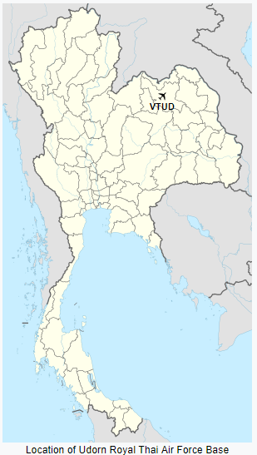
Paving the way for written works on Lee Lue is Christopher Robbins book, The Ravens. Generally speaking, the title of Robbins book was a radio term meant for any pilots flying covertly under the CIA operations in Laos. For Lee Lue, he flew under General Vang Pao’s personal air force. Originally, there was resistance against General Vang Pao’s request of his own air force. The reasons being was because the U.S. believed that the Hmong people were unable to fly due to their “stone age” like technology. In opposition to the arguments from the U.S. government, GVP argued that he needed his own air force because the Lao military were “lazy and corrupt”. Meaning that he did not trust the Lao Air Force pilots to fight when he needed them to fight. The program to train Hmong, Thai, and Lao people to fly was called Waterpump, which was located in Udorn, Thailand on the northwestern end (refer to figure one below with the airplane as the marker of Udorn). As a cousin, Lee Lue was handpicked by GVP to attend training in 1967. Many comrades of Lee Lue praised him for his boldness, courage, and recklessness. For example, on a slow day, Lee Lue would show his recklessness by driving is T-28 and firing rockets into the hillside to entertain Hmong troops and show off his accuracy as a pilot. When fighting became intense he would prove his marksmanship by flying low and dropping bombs right on target. As described by an American fighter pilot, Art Cornelius, he stated, “The first time I worked with Lee Lue he came right down the chute with two seven-hundred-and-fifty-pound bombs---which most of the Lao would not carry. He got down so low that he was never going to miss by far. But this was unbelievable---jut spot on target.” Robbins was not the only scholar in which they spoke highly of Lee Lue and his aerial skill.
Jane Hamilton-Merritt writes similarly to Robbins analysis of Lee Lue in their book Tragic Mountains: The Hmong, the Americans, and the Secret Wars for Laos, 1942-1992. In their analysis, Hamilton-Merritt contributes another argument to why GVP wanted his own air force. The reason was because the Lao government was afraid of allowing a non-Lao general the power of air force, especially fighter jets like T-28’s. T-28’s was introduced during the 1950’s and were actively used during the Vietnam war for counter insurgency missions. The machines were docile and easy to maneuver in air. They could be safely spun at low altitudes and quickly recover. T-28’s was able to carry an array of weapons which included napalm, bombs, and rockets. Usually they operated in hunter and killer teams while escorting A-26 attack aircrafts and helicopters.
Figure 1: Map of Udorn Air Base in Thailand
Source: Wikipedia https://en.wikipedia.org/wiki/Udorn_Royal_Thai_Air_Force_Base
A factor in which contributed to allowing GVP to have his air force was Vang Chou. He was a backseat pilot for American pilots flying missions in Laos, mostly reconnaissance, to scout the land for potential enemy locations. Since 1963, Vang Chou has flown almost every day given his vast amount of knowledge of the land. Even American pilots who flew with Vang Chou called him “General Direction”. As described by Jim Lemon, Raven 41/49 says, “I would fly to the assigned location where I would pick up a passenger/sidekick who could talk via radio to the Hmong ground troops. Since my sidekick usually did not speak English the languages we used were Lao/Thai and French. It worked surprisingly well and we had many successful missions.”
To further the conversation, Hamilton-Merritt says that Vang Chou walks in on the conversation with the SKY Chief (Colonel Billy) and GVP and said, “I told him that since early 1963, I’ve flown almost every day. There’s blood in my urine and still I fly. I spend my life in the air and I’m always so tired. As a back seater, I’ve smelled T-28 gasoline far too long.” With Vang Chou’s knowledge of the land and his personal testimony, Lao and U.S. government allowed GVP his desired air force.
Interestingly, as a pioneer of Hmong pilots, Vang Chou’s brother-in law is a pioneer for Hmong people in the field of education as well. He married into a military and Catholic family to Mai Yang whose father fought with the Meo Maquis during the fall of Dien Bien Phu. Vang Chou was scrutinized for marrying into a family who practiced Catholicism. Eventually, the connection with Catholicism allowed Mai Yang’s brother, Dao Yang to study in France and become the first Hmong person to hold a PhD, commonly known today as Dr. Yang Dao.
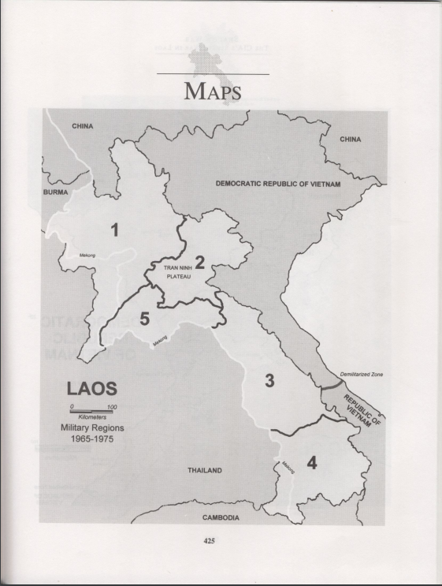
For Paul Hillmer and his analysis of GVP’s air force, the reason being why there was so much resistance against him was because the Lao government thought that GVP “represented a threat, ‘cause he had a lot of military power,...a good chunk of geography under his control, and the ear of the Americans...It was a delicate thing that they were doing.” Whereas for the United States, Colonel Harry C. “Heinie” Aderholt, commander of the 1st Air Commando Wing in Florida relayed the message from the CIA stationed in Udorn Air Base in Thailand, “Aw, hell, those people (the Hmong)...never saw anything more than the ass end of a buffalo. They can’t fly.” Knowingly, GVP still got approved for his air force and launched two major operations called “Raindance” and “Off-Balance” in order to protect and gain advantage over the North Vietnamese Army. Operation Raindance was a three-week aerial attack which began in March 1969 and ending in April of 1969, dropping over eighty strikes a day in Military region 2 (refer to figure 2 for Military regions in Laos). Successful to an extent in Operation Raindance, GVP launched Operation Off-Balance in July 1969 to recapture North Vietnamese Army base in Muong Soui. This operation would be crucial to the morale of GVP’s air force and the Ravens because it was the operation that led Lee Lue to prove that he was mortal.
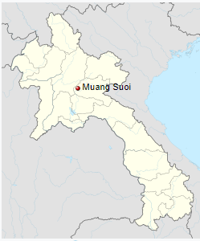
Stating before Hillmer’s analysis, Keith Quincy describes the situation in which led to Lee Lue’s death to detail in their book Harvesting Pa Chay’s Wheat: The Hmong & America’s Secret War in Laos. Operation Raindance was a joint operation between the Neutralist Lao and the Hmong. Lao was considered neutral territory which considered their military neutral to the war. Due to the instability nature of Laos, the Neutralists were supposed to move out of Muong Soui and attack the enemy base in southern Muong Soui from the north while the Hmong attacked from the east. The Neutralists failed to attack from the north and fled back to Muong Soui while the Hmong continued to attack from the east. Not long after, the North Vietnamese Army attacked Muong Soui and captured the Neutralist base (refer to figure 3 on page 9). Capturing Muong Soui base in June 1969 meant that the North Vietnamese Army had access to Route 7 which allowed for easier transportation of weapons and good to Southern Vietnam. Losing Muong Soui forced GVP to launch Operation Off-Balance which utilized T-28’s to try and recapture the lost base. Initially, GVP thought that the Neutralist would assist with this operation, but the results included them abandoning the Hmong people on the ground fighting in Muong Soui. Braving the bad weather, Hmong pilots, which included Lee Lue, flew their T-28’s to attack the North Vietnamese Army in order to help the Hmong people isolated in the hills who were abandoned by the Neutralist. The puzzle piece of Lee Lue’s death would be inserted under the section “Death of Lee Lue” later in the paper.
Figure 2: Map of military regions in Laos
Source: Kenneth Conboy and James Morrison, Shadow War: The CIA’s Secret War in Laos (Boulder, CO: Paladin Press, 1995) 425.

Figure 3: Map of Muong Soui, Laos
Source: Wikipedia https://en.wikipedia.org/wiki/Muang_Soui
Contrary to the belief of Christopher Robbins, Keith Quincy, Jane Hamilton-Merritt, and Paul Hillmer analysis of Lee Lue and the Secret War, specifically the amount of sorties Lee Lue flew, Kenneth Conboy and James Morrison stated a different number of missions Lee Lue flew. As previously stated, Lee Lue supposedly flew over 5000 sorties from 1967-1969. As for Conboy and Morrison who writes in their book Shadow War: The CIA’s Secret War in Laos, Lee Lue only flew 1000 sorties over a span of 18 months.
From most of the authors, there was a lack of justification for the number of sorties. For Conboy and Morrison, they conclude that Lee Lue flew up to twelve missions per day whereas Robbins wrote that Lee Lue flew an average 120 combat missions a month or sometimes up to ten sorties per day. For Quincy, his words states that Lee Lue flew nonstop for ten hours every day. Thus, arises the questions between the number of sorties and hours Lee Lue flew as a fighter pilot from historian’s perspectives.
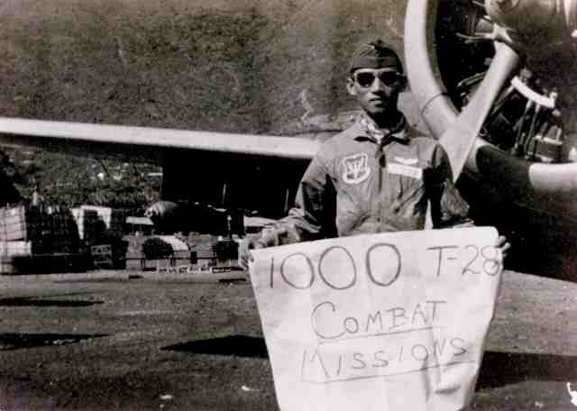
Regardless of the controversy, both numbers, 1000 and 5000, was still an impressive amount of missions flown in Lee Lue’s time as a fighter pilot. In addition to Lee Lue, his Lao comrade, Chaophakao Red, also flew 1000 sorites.

Figure 4: Chaophakao Red holds a sign that says “1000 T-28 Combat Missions”
Source: Kham Phiou Manivanh, “‘The Day we Lost Lee Lue’ Hmong Ace Pilot Serving in the Secret War,” accessed September 20, 2018, http://www.geocities.ws/koratmahknut/warinlaos/hmonglao/theday.htm.

In consideration of the different numbers of sorties Lee Lue flew, most authors still praised Lee Lue’s flying abilities and impact in the Secret War by using words such as “legendary”, “ace”, and “courageous”. But given the analysis of some of the leading scholars in studying Lee Lue and the Secret War, descriptive languages such as the above masks all other aspects of humanity in a person like Lee Lue. This paints a picture of heroism but nothing else about Lee Lue’s life. What were his impacts before the war? Besides the chip on his shoulder in the war, what were other aspects of his personality? Where are the voices of his wife, children, and loved ones? What other identities did Lee Lue have besides a pilot?
Besides Jane Hamilton-Merritt’s analysis, most authors did not include many other aspects of Lee Lue’s life before the war, nor did they include his family’s perspectives. There could have been a lack of primary sources given the oral history of Hmong people, but the analysis still glorifies Lee Lue and places him on a pedestal of heroism simply in the aspect of his war contributions. For people who study Lee Lue and Hmong people, this paints a dangerous story of a single narrative. This is dangerous because single narratives skew naïve readers to think of Hmong people in one dimensional instead of multidimensional. Poet and author Chimamanda Ngozi Adichie spoke in her Ted talk video of stereotypes and single narratives of a people or country. Her argument was when reading about a group of people or a country, there must be numerous perspectives first. Without accurate and abundant sources, naïve readers will only believe in one perspective which is why there is a “danger of a single story.”
The stereotypes in which the American generals had about Hmong people during the Secret War could be perpetuated again by readers of Lee Lue and Hmong people creating a narrative that Hmong people were and are “primitive” or “backwards”. Not only do these stereotypes persist, but the only image of Lee Lue would be a hero. It is not necessarily bad to be remembered as a hero, but it is also not good either to only be remembered as a hero. The analysis of Lee Lue from authors like Robbins, Quincy, or Conboy and Morrison fixates Lee Lue’s life as only from 1967-1969, leaving Lee Lue in a permanent position as a human being. In the next section, utilizing Hamilton-Merritt’s analysis of Lee Lue and his life and time, I hope to expand upon the biography of Lee Lue.
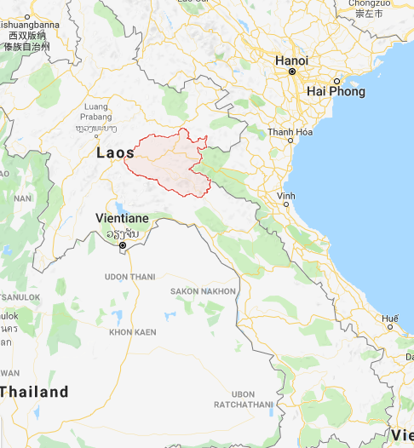
Biography of Lee Lue
Lee Lue was born to Ntxoov Ntxawg Lis (Chong Ger Lee) and Paj Vaj (Pa Vang) in December 1935 in the village of Phou Pheng in Xieng Khouang Province, Laos (refer to figure 4’s shaded region or red region). Fifteen years later, Lee Lue married his wife and enrolled in teacher training school. By 1953, he was one of the few Hmong teachers teaching Hmong boys in a town called Lat Houang whose population was close to 1,000. As the talk of the North Vietnamese Army invading Laos and the Xieng Khouang province from the elders of the village, Lee Lue continued teaching while one of his students, Lao Ma observed his respected teacher for any traces of fear. During this time of invasion into Xieng Khouang province in 1954, GVP noticed the importance and value of education because he did not want the Hmong to follow Touby Lyfong to Vientiane. Touby Lyfong was one of the first Hmong political leaders who assisted the French during WWII. His political views aligned with the French which caused GVP to question his loyalty to Hmong people. Due to the political rivalry, this was the reason for GVP to value education for Hmong people to support him and his efforts. There was a joint effort between Pop Buell, a humanitarian aid worker, GVP, and Prince Sia Kham of Laos to promote education for all Hmong students, including boys and girls. In 1963, they selected Moua Lia who studied in France to lead the push for education for all. In the whole province of Xieng Khouang, only 1,200 students enrolled and all of them were boys. Education for girls at this time was limited given the lack of opportunities and patriarchal structure of Hmong families and the education system. Only a few girls attended what were called makeshift schools. They were poorly ran, funded, and only temporary. The struggle for Moua Lia to recruit students was the continuous threat of the North Vietnamese Army in 1963.
Figure 5: Map of Xieng Khouang Province, Laos shaded in light red
Source: Google Maps https://www.google.com/maps/place/Xiangkhouang+Province,+Laos/@19.4267825,103.4706265,9z/data=!3m1!4b1!4m5!3m4!1s0x312fe135c0fed4f3:0x698eaca74dc84387!8m2!3d19.6093003!4d103.7289167
As the fight for education persisted in 1963, Lee Lue and Lo Ma volunteered to fight for the Royal Lao Army as infantrymen against the threat of the North Vietnamese Army in their province. Shortly after, Lo Ma enrolled in school again where he studied English in a US sponsored Second language program. Whereas Lo Ma reentered school, Lee Lue was selected for a different mission.
After being approved for an air force, GVP selected Lee Lue and Vang Toua to attend flight training school in Udorn, Thailand in February 1967. One of the final tests performances Vang Toua and Lee Lue had to show off their skills to the VIP’s. Colonel Aderholt invited GVP, Ambassador William Sullivan, Colonel Paul Pettigrew, the Air Attaché, and Colonel Billy. Upon completion of training, each Hmong fighter pilot was given his wings, a photo of himself dressed in a U.S. Air Force suit standing next to a T-28, and a celebration party. Lee Lue stood proudly with his left leg propped upon the entrance of the cockpit of a T-28 and his helmet held firmly on his right hand. With that said, Lee Lue and Vang Toua passed with Colonel Aderholt who mentioned that “Ly Lue would become a great fighter pilot.”

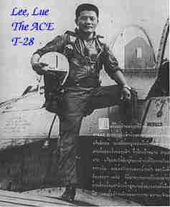

Figure 6: Lee Lue poses with his T-28
Source: Kham Phiou Manivanh, “‘The Day we Lost Lee Lue’ Hmong Ace Pilot Serving in the Secret War,” accessed September 20, 2018, http://www.geocities.ws/koratmahknut/warinlaos/hmonglao/theday.htm.

War Participation and Impact

The Geneva Accords were signed in 1954 and 1962 stating Laos was a neutral nation. This meant that no other nations were to involve themselves in any of the affairs in Laos. During this time, Laos had two different military operations competing for power. The first were the neutralist controlling the Royal Lao Army eventually called Force Armees du Royaume (FAR) and the communist Pathet Lao which allied with the North Vietnamese Army. Fearful of the domino effect, the US established the Southeast Asia Treaty Organization which brought Cambodia, Laos, and Thailand under US protection. This meant that US took over French equipment left from the French colonization in Laos for training. Other forms of protection US offered were economic assistance in order for US to open an operating mission in Vientiane (Southwest region of Laos). With the United States foot in the door to prevent communism from spreading to the rest of Southeast Asia, this allowed CIA Bill Lair to recruit Hmong soldiers provided by GVP to stop the North Vietnamese troops on the Ho Chi Mihn trail in 1960.
Enter Lee Lue, the “bold”, “fearless”, and “reckless”. Combined with the Hmong pilots mentality of “Fly till you die” (Hmong pilots had no breaks from flying like how America soldiers were required) would cause Lee Lue to be a forced to reckon with. The tactics employed from Hmong pilots were effective in destroying anti-aircraft guns. GVP’s air force let the two best Hmong pilots circle above as a distraction while another pilot would come down and use his bombs dropping them on enemy anti-aircraft guns. Hmong fighter pilots like Lee Lue would be the main runners of dropping bombs. Sometimes he would get so close to the ground while dropping bombs that there would be North Vietnamese soldier’s blood on his tail after his mission. T-28’s allowed Lee Lue to fly very low to the ground. Stated by one of the first fighter pilots of the CIA Ravens program, James F. Lemon said, “The steep approach and low release allowed the T-28’s to fly the bomb very close to the target and achieve excellent accuracy. They were very good pilots. Some of them had over 1000 combat missions before the war ended.”
Lee Lue gained much respect from non-Hmong pilots and Hmong pilots. In recognition, John Mansur said that Lee Lue “was the best fighter-bomber pilot I have ever encountered, that includes Americans or anybody.” General Former CIA detailee in Laos, General Richard Secord said as he rode in the back of Lee Lue’s T-28, “I’m an instructor pilot in the air force, I have never seen better bombing runs’. That enabled us to get the others into the program.”
As for Lee Lue’s Hmong pilots and family, they highly respected him as an ace pilot. After ten hour days of fighting, small groups of Hmong would gather around the plane. Some would massage his neck and shoulders, others would lift him out of the cockpit, and some would walk around with him to revive circulation in his cramped legs. As seen from an American perspective, this felt like a religious sight, which was moving to see. As an insider of the Hmong culture and religion, this reminds me of when Hmong shamans perform ceremonies in which they transcend into the ancestral and spiritual world and descend back into the human world after communicating with the ancestors or spirits. After their trance is finished, there would be people to assist the Shaman by massaging their backs, neck, legs, and arms as a gesture of respect and courtesy after a long journey from the human world to the ancestral/spiritual world to back in the human world. Status wise, Shamans are highly valued given their abilities to communicate, negotiate, and heal in the community. Given this conversation, could it have been that Lee Lue was a Shaman himself? When he flew in T-28’s, was that his form of trance? Lee Lue could have been arguably given Shamanic status in the context of GVP’s air force. Given the limited number of primary documents, it is difficult to assume this status, but it is okay to question and offer a different narrative. Despite Shamanic status or not, Lee Lue became a symbol of Hmong resistance for Hmong people’s morale in fighting the Secret War. With his skills and status urged many higher officials to pull him back to Udorn to teach younger Hmong pilots to fly. Among the officials were Colonel Heinie Aderholt (Wing Commander of the Air Commandos) who agreed with taking Lee Lue out of combat to be a teacher. The opposition from GVP was that he was too valuable and skilled to be pulled out of combat. Lee Lue also agreed and did not want to stop flying. This decision made by GVP would be one of his greatest regrets during the Secret War.

Death of Lee Lue
With Operation Off-Balance in session, GVP relied upon his trained T-28 fighter pilots to recapture what was lost in Muong Soui. Off-Balance was named this because the operation was a joint effort between Hmong and Neutralist ground soldiers. The objective was to pinch the Communist army at Muong Soui on both ends of cardinal directions, north being the Hmong and south being the Neutralist. This idea was to throw the Communist army off-balance by attacking them from both directions. Whereas for Lee Lue and GVP’s Air Force, their objective was to attack from the air to eliminate anti-aircraft guns to support the ground troops carry out their operation.
Lee Lue’s comrade, Chaophakao Red radioed Chaophakao Lee Lue asking if he wanted to join him in attacking anti-aircrafts guns.
“Chaophakhao Red, Chaophakhao Lee Lue”
“Red, go ahead”
“I got some AAA target, want to joint us”
“What’s your position and target?”
“Passing the dam heading to Xieng Det”
“Okay proceed over 20A I will arm and join you as # 4”
“Rodger, Red”
GVP radioed in, whose call sign to his air force pilots was “White Star”, who asked, “Chaophakhao from White Star did you see the target?” In replied Lee Lue who says, "I got the target, I see them and gonna get them.” Lee Lue dived in fast and low and dropped two bombs on the anti-aircraft guns. The first bomb hits straight on to gun. The second lands almost twenty meters from the gun. As stated in the introduction, Chaophakhao Red radios to Lee Lue yelling at him, “Lue you got hit, bailed out, bailed out now.” Following Red’s call, GVP radioed to Lee Lue, “Lee Lue Head South and bail out. Lue you on fire bail out, bail out.” As Red described, “Lee Lue’s head was slummed forward to the dash and his co-pilot Lor Neng was leaned back with his head leaning to one side and I can see red fluid splashed all over the canopy.”
Lee Lue flew low, “almost hand-delivering bombs” to the enemy, and was killed when a 12.7 -mm anti-aircraft gun honed in on his plane taking him out of the sky. His plane shot up in flames and dropped straight to the ground as described by Jer Xiong Yang, who was a part of the Operation Off-Balance and one of the witnesses of Lee Lue’s death along with Red. Posed below was Lee Lue’s comrade, Chaophakao Red, who both leaned on a propeller plane, most likely to be an O-1 plane. Given that GVP’s Air Force and CIA Ravens program mixed together, O-1 planes were usually the planes Ravens piloted.
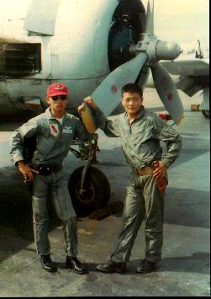

Figure 7: Red (Left) and Lee Lue (Right) pose together
Source: Kham Phiou Manivanh, “‘The Day we Lost Lee Lue’ Hmong Ace Pilot Serving in the Secret War,” accessed September 20, 2018, http://www.geocities.ws/koratmahknut/warinlaos/hmonglao/theday.htm.

Distraught and saddened, GVP declared for three days a “no fly” to remember Lee Lue and Lor Neng. To GVP, losing Lee Lue felt like it was losing a son. His loss was something he could have prevented only if he had considered Colonel Aderholt’s suggestion of letting Lee Lue teach Hmong youth to fly in Udorn. GVP officiated Lee Lue’s three day funeral. Impacts of his death and legacy spread throughout the Hmong refugee camps and country as top Royal Lao Army officials attended Long Cheng for his funeral. Hmong people in nearby villages mourned with GVP and the rest of the Hmong pilots and Ravens. Even thirty plus years later after the Secret War was over, GVP still reminisced about Lee Lue on his ranch in Montana when he and his family initially immigrated to the US. When hunting for elk, he would draw in the sky with his finger the patterns of how Lee Lue would fly and attack the enemy.
Conclusion
Given the primary and secondary sources available, Lee Lue’s life, time, and impacts on the Secret War remain limited and narrow. Lee Lue’s legacy will remain a hero in readers’ eyes which will lock his identity into a state of immovable perception of his humaneness leaving no room to delve deeper into his personality and immediate family’s perception. Questions of his number of sorties during 1967-1969 will remain locked until further research is established, or different primary accounts are sought for. Whereas his impacts on the Secret War will remain in the hearts of GVP, GVP’s T-28 fighter pilots, American pilots who flew with him, and Hmong people who suffered through the long and arduous journey towards a new home land.
Critical Self-Reflexivity
As a novice researcher in my undergraduate career, there has been limited space for me to critically reflect upon my process of thought during my investigation. “Lovely to Me”: An Immigrant’s Daughter’s Critical Self-reflexivity Research Journey by Dr. Anjela Wong define critical self-reflexivity as acknowledging and dismantling “the power structures that exist in both research and the larger society and examine how might one’s identities and actions influence and impact the research process.” When I think about this quote deeper, I realize the importance of reflecting as a researcher. Critical self-reflection is a way where you see yourself outside of yourself in relation to larger society or the research project.
Given the cumbersomeness of this paper, critical self-reflection is needed. The idea of this project started out this summer when I visited the Hmong Cultural Center in St. Paul, Minnesota. The historian had mentioned while he pointed to Lee Lue’s picture saying he was one of the first Hmong fighter pilots to the students who attended. It piqued my interest, but I put it in the back of my mind until this project. When brainstorming potential ideas for my capstone, I thought this would be a perfect research project.
As I began researching, I realized the limited amount of primary and secondary sources writing about Lee Lue. Not only were sources limited but sources from non-white researchers were close to non-existent. This intimidated me in diving deeper into this project because of the small amount of information on Lee Lue. But in reflection, despite the lack of sources, my perspective as a Hmong American needed to contribute to the existing knowledge of a historical Hmong person. Not only will my perspective contribute to the literature, but create change in narratives of how dominant society perceives Hmong people and Hmong heroes.
In honesty, I do acknowledge my bias while reading and writing about Lee Lue. This has been my first time digging deep into a perceived Hmong hero. I have been drained of heroes who looked like me for my whole life and to finally be able to read about one for myself was so difficult in critically analyzing Lee Lue. My heart felt like it was battling between two contradictory concepts. Reading about Lee Lue and the Secret War ignited heartfelt emotions that are connected to my Hmongness, which is why I dedicated this project to my ancestors, parents, and Hmong youth. All the sources I had read put Lee Lue on a pedestal of war heroes but failed to attempt to recognize him as a human being. I did not want to lower Lee Lue’s status as a hero, particularly because he was the first Hmong hero I have encountered; but in a critical lens, I needed to in order to try and understand the humanness of Lee Lue outside of his hero status. But like I said it was difficult to do so given the limited sources, and the emotional connection to Lee Lue and the Secret War.
Apart from that, I definitely found different pieces of my own history slowing beginning to form as I recall my parents’ stories fleeing from the Secret War. It felt empowering! My hope is that Hmong youth continue to search for who they are and where they come from.
Thank you for taking your time to read Lee Lue’s life, time, and impacts on the Secret War along with my critical self-reflexive thoughts.

Works Cited

Primary Sources

Fuller, John H., and Helen Murphy, ed. 2016. The Raven Chronicles: In Our Own Words from the Secret War in Laos. Lexington, KY: Chronicles Project Inc

Manivanh, Kham Phiou. “”The Day We Lost Lee Lue”: Hmong Ace Pilot Serving in the Secret War.” Geocities.ws. http://www.geocities.ws/koratmahknut/warinlaos/hmonglao/theday.htm (accessed September 28, 2018).

Polifka, Karl L. 2013. Meeting Steve Canyon...And Flying with the CIA in Laos. Lexington, KY: N/A.

Secondary Sources

Conboy, Kenneth, with James Morrison. 1995. The CIA’s Secret War in Laos: Shadow War. Boulder, CO: Paladin Press.

Hamilton-Merritt, Jane. 1993. Tragic Mountains: The Hmong, the Americans, and the Secret War for Laos, 1942-1992. Bloomington and Indianapolis, Indiana: Indiana University Press.

Hillmer, Paul. 2010. A People’s History of the Hmong. St. Paul, MN: Minnesota Historical Society Press.

Nga-Wing Wong, Anjela. ““Lovely to Me”: An Immigrant’s Daughter’s Critical Self-Reflexivity Research Journey.” Journal of Critical Thought and Praxis 6, 2 (2017): 84-94, accessed November 6, 2018, https://lib.dr.iastate.edu/jctp/vol6/iss2/5/.

Robbins, Christopher. 1987. The Ravens: The Men who flew in America’s Secret War in Laos. New York, NY: Crown Publishers Inc.

Quincy, Keith. 2000. Harvesting Pa Chay’s Wheat: The Hmong & America’s Secret War in Laos. Spokane, WA: Eastern Washington University Press.

Staaveren, V. Jacob. 1993. Interdiction in Southern Laos 1960-1968. Washington D.C.: Center for Air Force History.

"T-28 Trojan." National Naval Aviation Museum. Accessed November 28, 2018. http://www.navalaviationmuseum.org/attractions/aircraft-exhibits/item/?item=t-28_trojan

YouTube. “The Danger of a Single Story.” Ted. Last modified October 7, 2009. Accessed November 5, 2018. https://www.youtube.com/watch?v=D9Ihs241zeg&t+493s.

Kham Phiou Manivanh, “‘The Day we Lost Lee Lue’ Hmong Ace Pilot Serving in the Secret War,” accessed September 20, 2018, http://www.geocities.ws/koratmahknut/warinlaos/hmonglao/theday.htm.
Chaophakhao is defined as Lord White Buddha which was the name given to all T-28 pilots who were Hmong and Lao
Manivanh, “The Day we Lost Lee Lue”, http://www.geocities.ws/koratmahknut/warinlaos/hmonglao/theday.htm.
Christopher Robbins, The Ravens: The Men who flew in America’s Secret War in Laos (New York: Crown Publishers Inc., 1987), 180.
Karl L. Polifka, Meeting Steve Canyon...And Flying with the CIA in Laos (Lexington, KY: N/A, 2013), located on back cover page.
Ibid., 194.
Jane Hamilton-Merritt, Tragic Mountains: The Hmong, the Americans, and the Secret Wars for Laos, 1942-1992 (Bloomington and Indianapolis: Indiana University Press, 1993), 52.
Ibid., 141.
Robbins, The Ravens, 181.
Robbins, The Ravens, 65.
Ibid., 64.
Robbins, The Ravens 155.
Ibid., 66.
Hamilton-Merritt, Tragic Mountains, 141.
"T-28 Trojan," National Naval Aviation Museum, accessed November 28, 2018, http://www.navalaviationmuseum.org/attractions/aircraft-exhibits/item/?item=t-28_trojan.
Hamilton-Merritt, Tragic Mountains, 141.
John H. Fuller & Helen Murphy, editor. 2016. The Raven Chronicles: In Our Own Words from the Secret War in Laos. (Lexington: KY: Chronicles Project, Inc.), 66.
Hamilton-Merritt, Tragic Mountains, 141.
Meo Maquis was the name for Hmong supporters organized by the French to fight the Viet Mihn during the 1940-1950’s.
Hamilton-Merritt, Tragic Mountains, 141.
Paul Hillmer, A People’s History of the Hmong (St. Paul, MN: Minnesota Historical Society Press, 2010) 130.
Ibid., 4.
Keith Quincy, Harvesting Pa Chay’s Wheat: The Hmong & America’s Secret War in Laos (Spokane, WA: Eastern Washington University Press, 2000) 314.
Kenneth Conboy and James Morrison, Shadow War: The CIA’s Secret War in Laos (Boulder, CO: Paladin Press, 1995) 214.
Robbins, The Ravens, 180.
Quincy, Harvesting Pa Chay’s Wheat, 314.
“The Danger of a Single Story,” YouTube video, 0:22, posted by “Ted,” October 7, 2009, https://www.youtube.com/watch?v=D9Ihs241zeg&t+493s.
Hamilton-Merritt, Tragic Mountains, 82.
Hamilton-Merritt, Tragic Mountains, 125.
Ibid., 153.
Jacob V. Staaveren, Interdiction in Southern Laos 1960-1968. (Washington D.C.: Center for Air Force History, 1993), 1-2.
Robbins, The Raven, 65.
Hillmer, A People’s History, 130.
Quincy, Harvesting Pa Chay’s Wheat, 315.
John H. Fuller & Helen Murphy, The Raven Chronicles, 67.
Robbins, The Ravens, 66.
Hillmer, A People’s History, 119.
I use “family” because Hmong ways of addressing other Hmong people are usually threw familial ties and connections.
Robbins, The Ravens, 180.
Kham Phiou Manivanh, “‘The Day we Lost Lee Lue’ Hmong Ace Pilot Serving in the Secret War,” accessed September 20, 2018, http://www.geocities.ws/koratmahknut/warinlaos/hmonglao/theday.htm.
Kham Phiou Manivanh, “‘The Day we Lost Lee Lue’ Hmong Ace Pilot Serving in the Secret War”.
Quincy, Harvesting Pa Chay’s Wheat, 315-316.
Hillmer, A People’s History, 136.
Kham Phiou Manivanh, “‘The Day we Lost Lee Lue’ Hmong Ace Pilot Serving in the Secret War,” accessed September 20, 2018, http://www.geocities.ws/koratmahknut/warinlaos/hmonglao/theday.htm.
Quincy, Harvesting Pa Chay’s Wheat, 316.
Ibid., 317.
Anjela Wong, “Lovely to Me”: An Immigrant’s Daughter’s Critical Self-Reflexivity Research Journey,” Journal of Critical Thought and Praxis, 6 no. 2 (2017): 84-94. Accessed November 6, 2018. https://lib.dr.iastate.edu/jctp/vol6/iss2/5/

