PRAVDA
Portably Reformat Audio and Video
to Digital from Analog
HOW-TO GUIDE

a project of the

Table of Contents
Table of Contents 2
Unpacking PRAVDA 3
The PRAVDA Inventory 5
Connecting PRAVDA up 6
Audio 6
Video 8
Digitizing audio 10
Adjusting the Tascam audio interface 10
Starting Audacity 10
Recording 10
Post-processing (optional) 11
Saving your audio to a file 11
Digitizing VHS and VHS-C 13
Attaching the external hard drive 13
VHS-C (Compact) tape preparation 13
Digitizing the tape 13
Delivery option 1: Burning a DVD 14
Delivery option 2: Saving a file 14
Capturing mini-DV 16
Attaching the external hard drive 16
Inserting the tape 16
Capturing the tape 16
Saving the video 17

Unpacking PRAVDA
When you open PRAVDA, you will see:
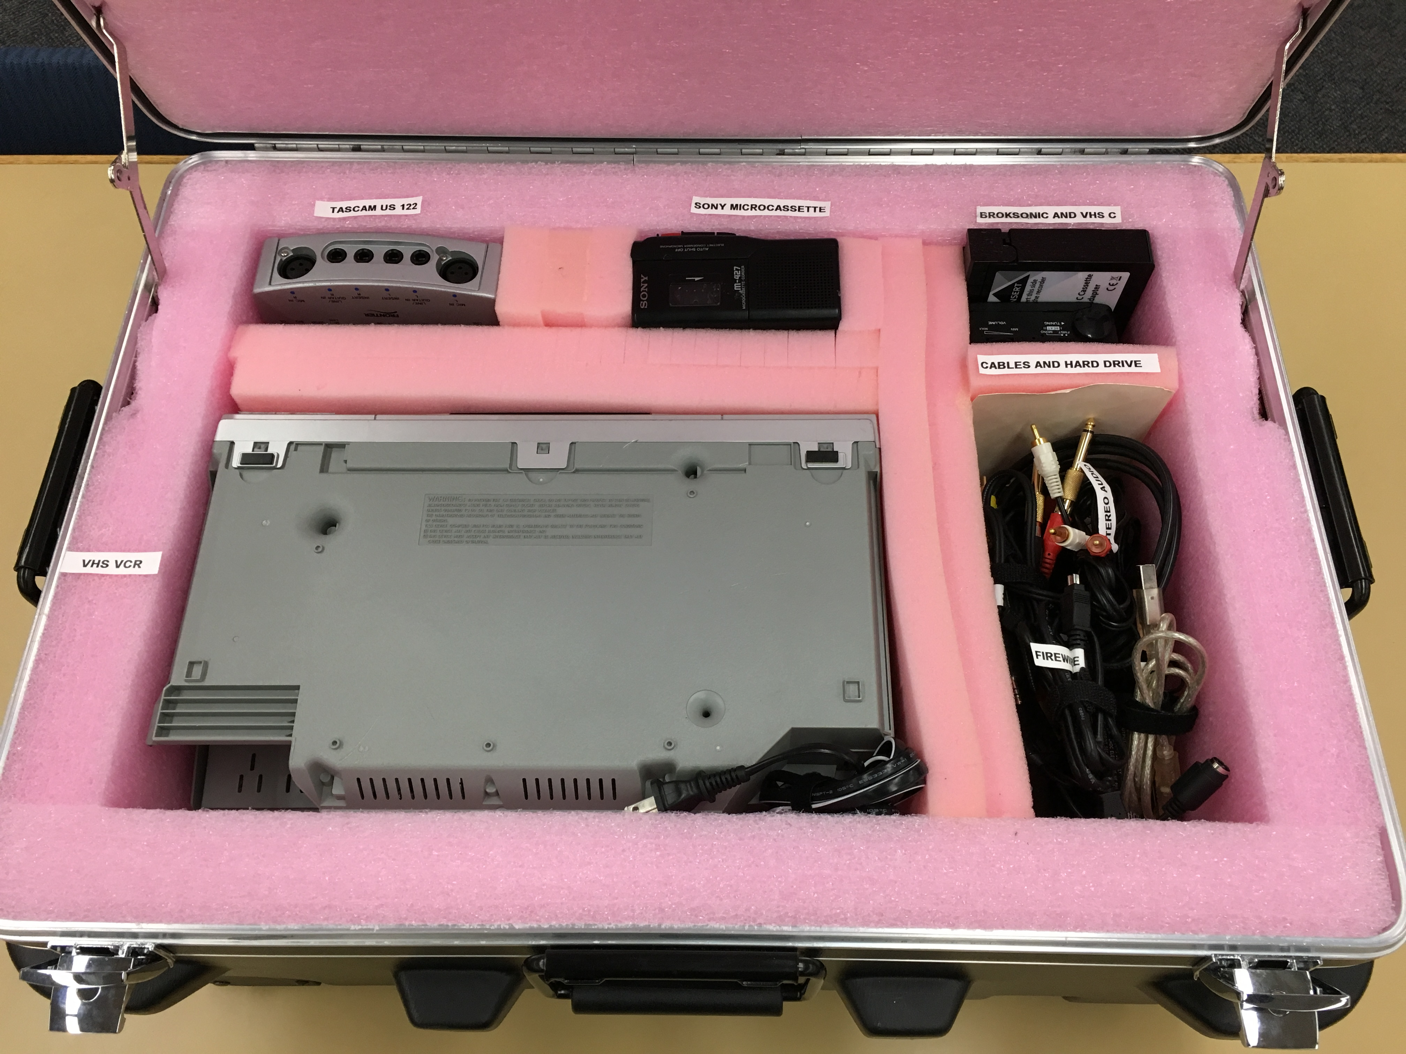
Most of the packing foam is glued in (exceptions noted below). Do not try to remove glued-in foam! You will damage the box!
Starting at top left and moving clockwise, the five visible pockets contain:
- TASCAM US-122 audio interface
- Sony microcassette player
- VHS-C videotape adapter AND Broksonic cassette player
- All necessary power cords and connector cables
- VHS videocassette player
The Sony microcassette player and the VHS player have other PRAVDA components underneath, padded with unglued foam. Remove them and the foam layer underneath them to find:
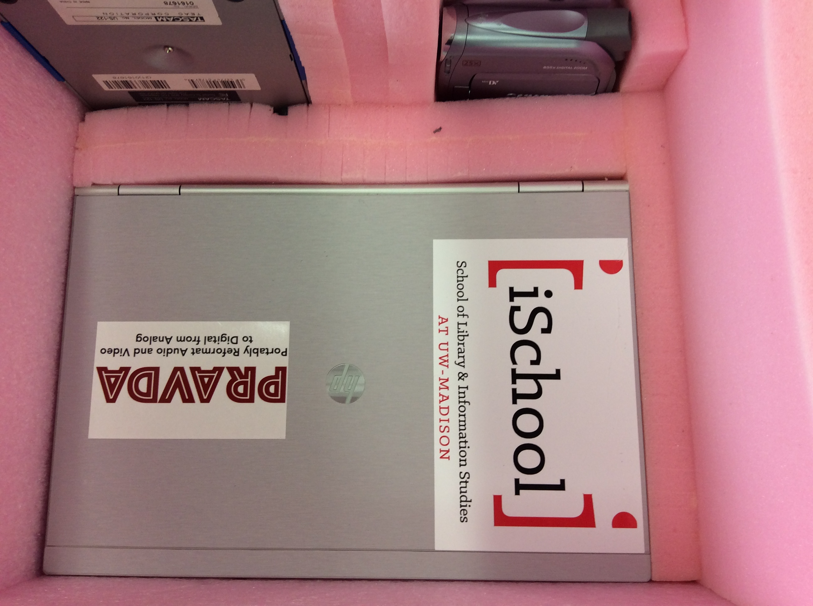
- (top right, under the microcassette recorder) Canon mini-DV camcorder
- (bottom, under the VHS player) HP laptop
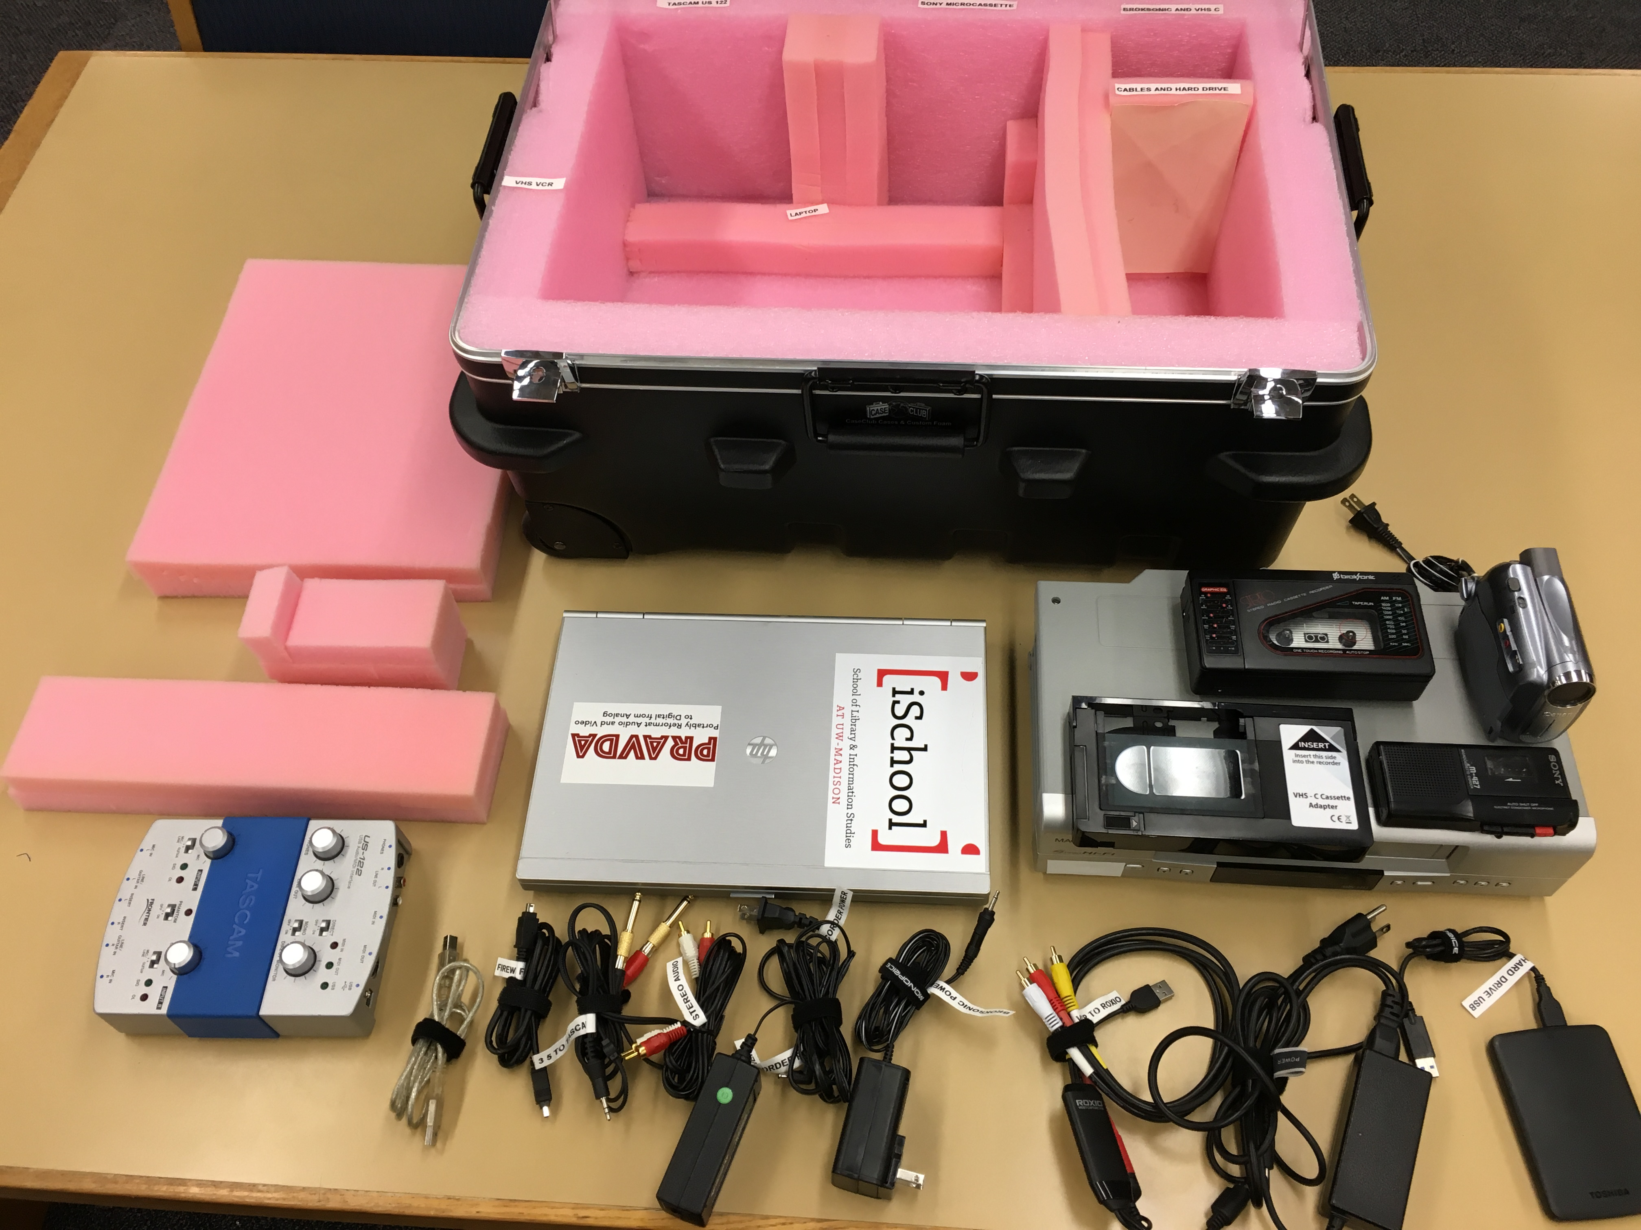
Once you remove the equipment you need, leave the unglued foam pieces inside the box so they don’t get lost. All items will be inventoried on the next page.

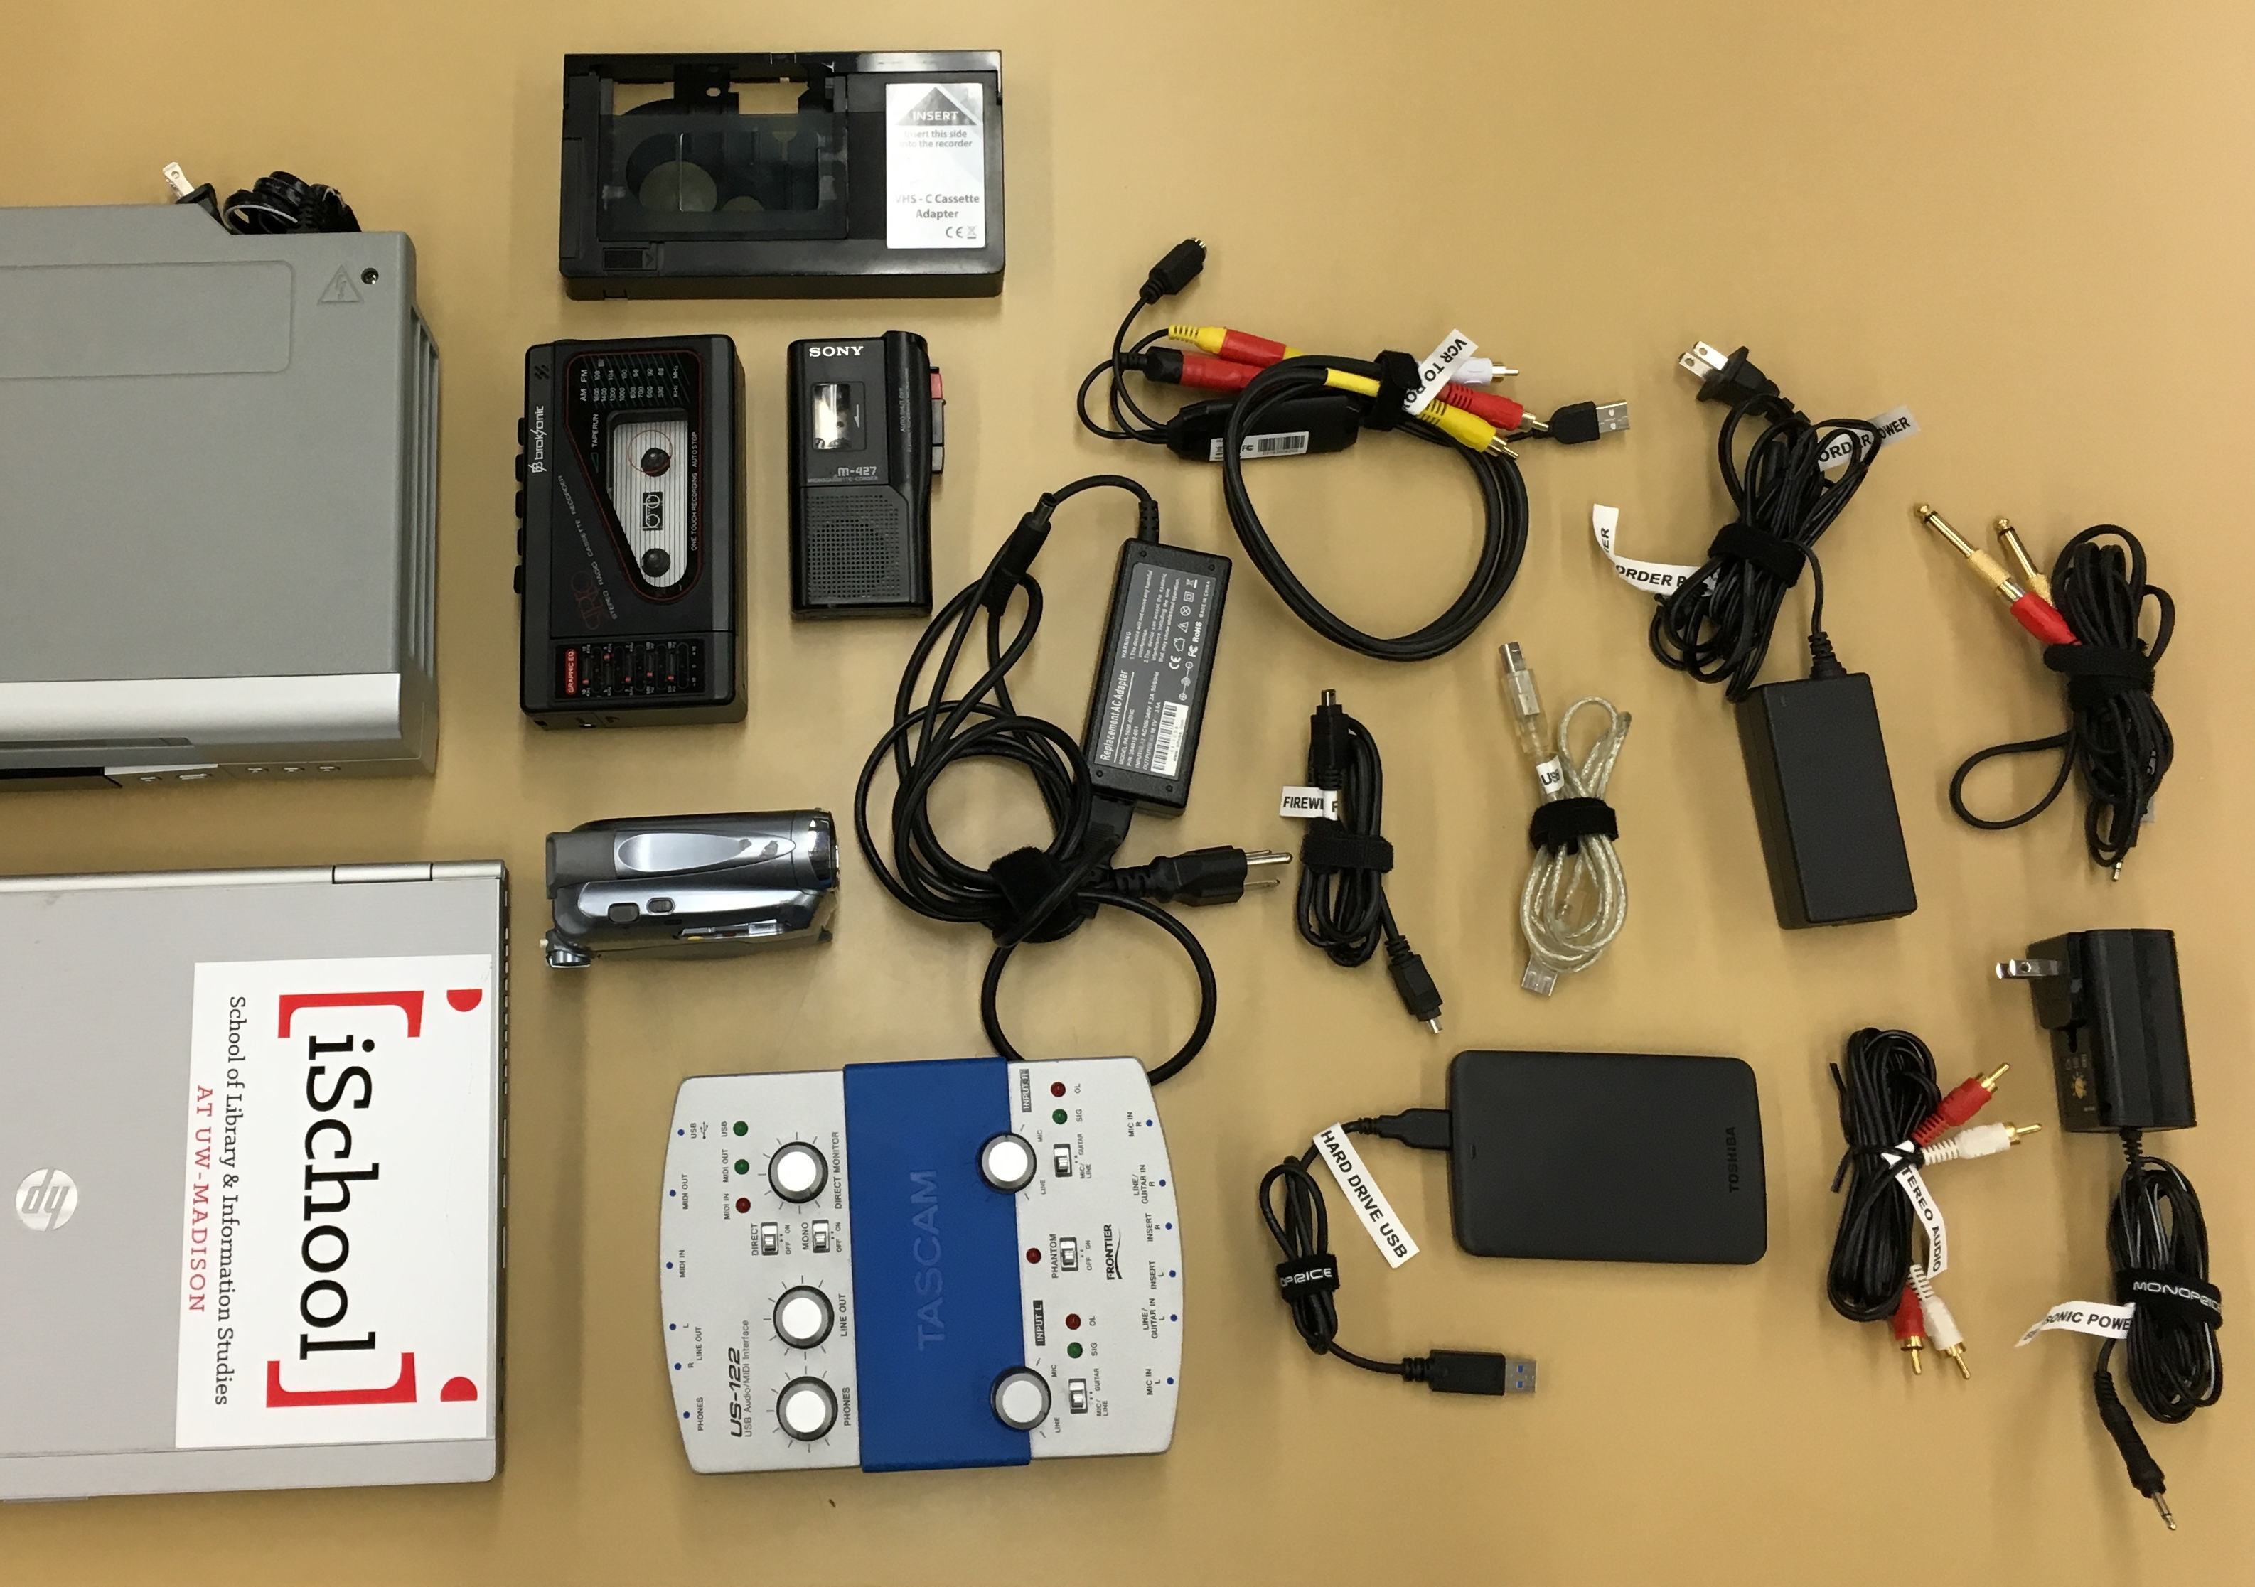

The PRAVDA Inventory
1

2
3
4
5
6
7
9
11
8
13
14
12
15
16
10

1. VHS videocassette player
2. Broksonic cassette player
3. VHS-C videotape adapter
4. Sony microcassette player
5. Composite red/white/yellow cable with Roxio dongle
6. Camcorder’s power cord
7. 3.5mm to RCA composite cable (with gold-colored audio adapters)
8. USB cable

9. Firewire cable
10. Laptop power cord
11. Canon mini-DV camcorder
12. HP laptop
13. Tascam audio interface
14. Toshiba hard drive with USB connection
15. Stereo audio cable
16. Broksonic’s power cord

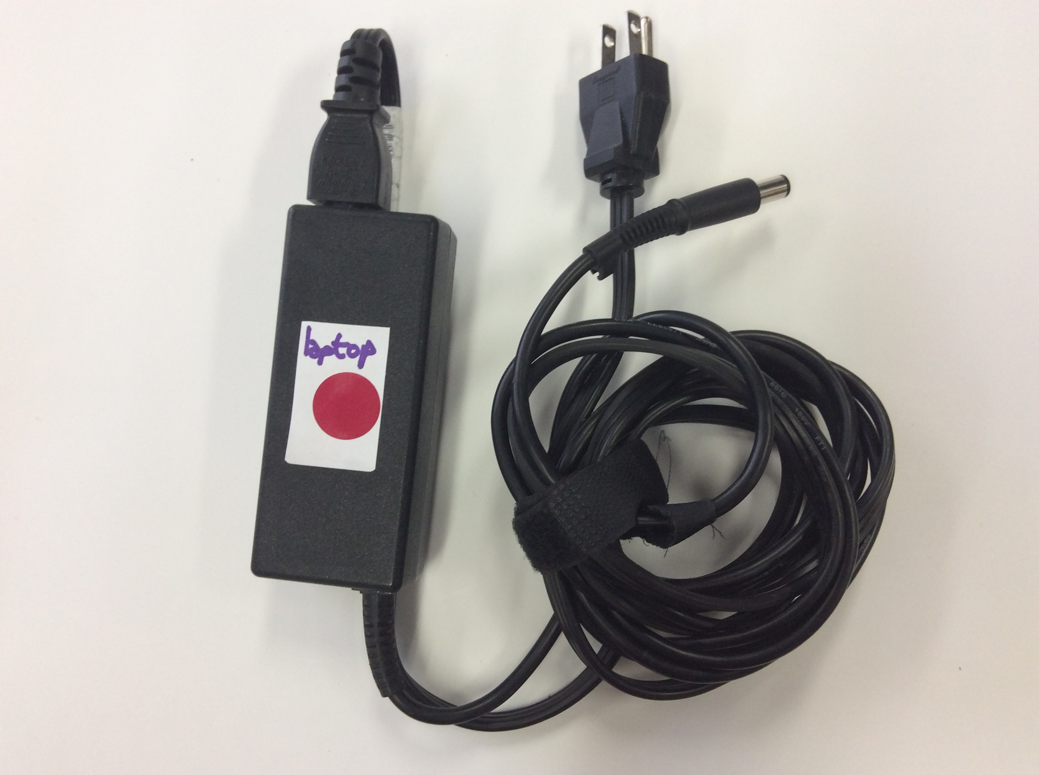
Connecting PRAVDA up
1
All PRAVDA cords and cables have tape labels to help you match them with the machines they belong with.

Audio
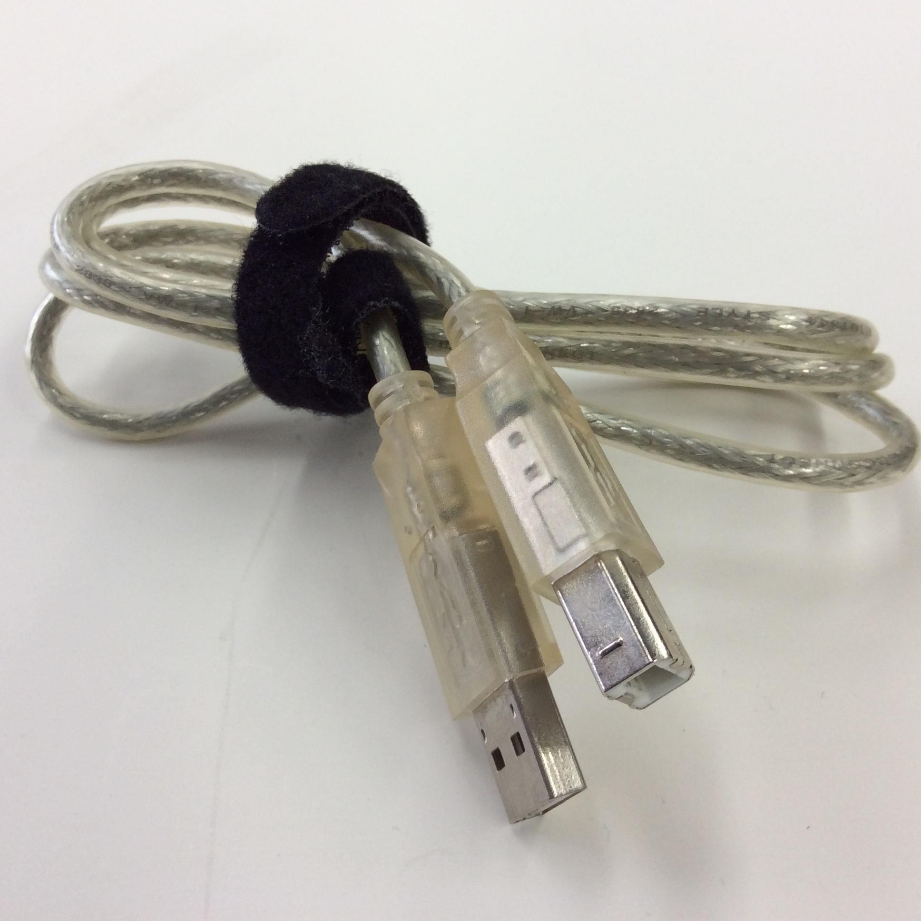
You will need:
2
- HP laptop and its power cables (1)
- Tascam US-122 audio interface (box, top left)
- USB cable (2)
- 3.5mm to RCA composite cable (3)
- Gold-colored audio adapters (in 5)
- Playback device:
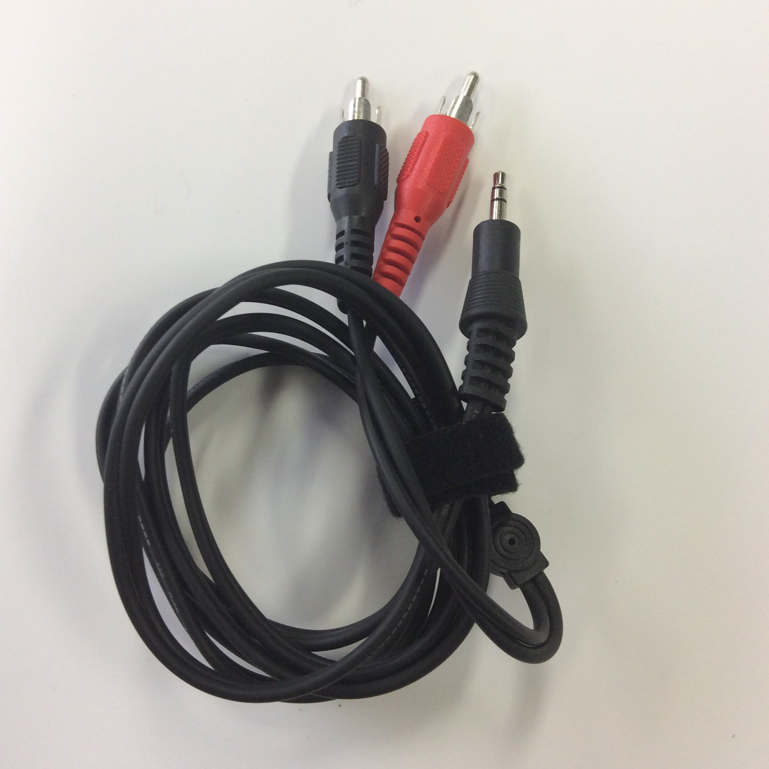
- Broksonic cassette player OR
3
- Sony microcassette player OR
- Other device you have in-house
Power connections:
- Connect the HP laptop’s power cable to its socket on the left side near the hinge (4). Plug it in.
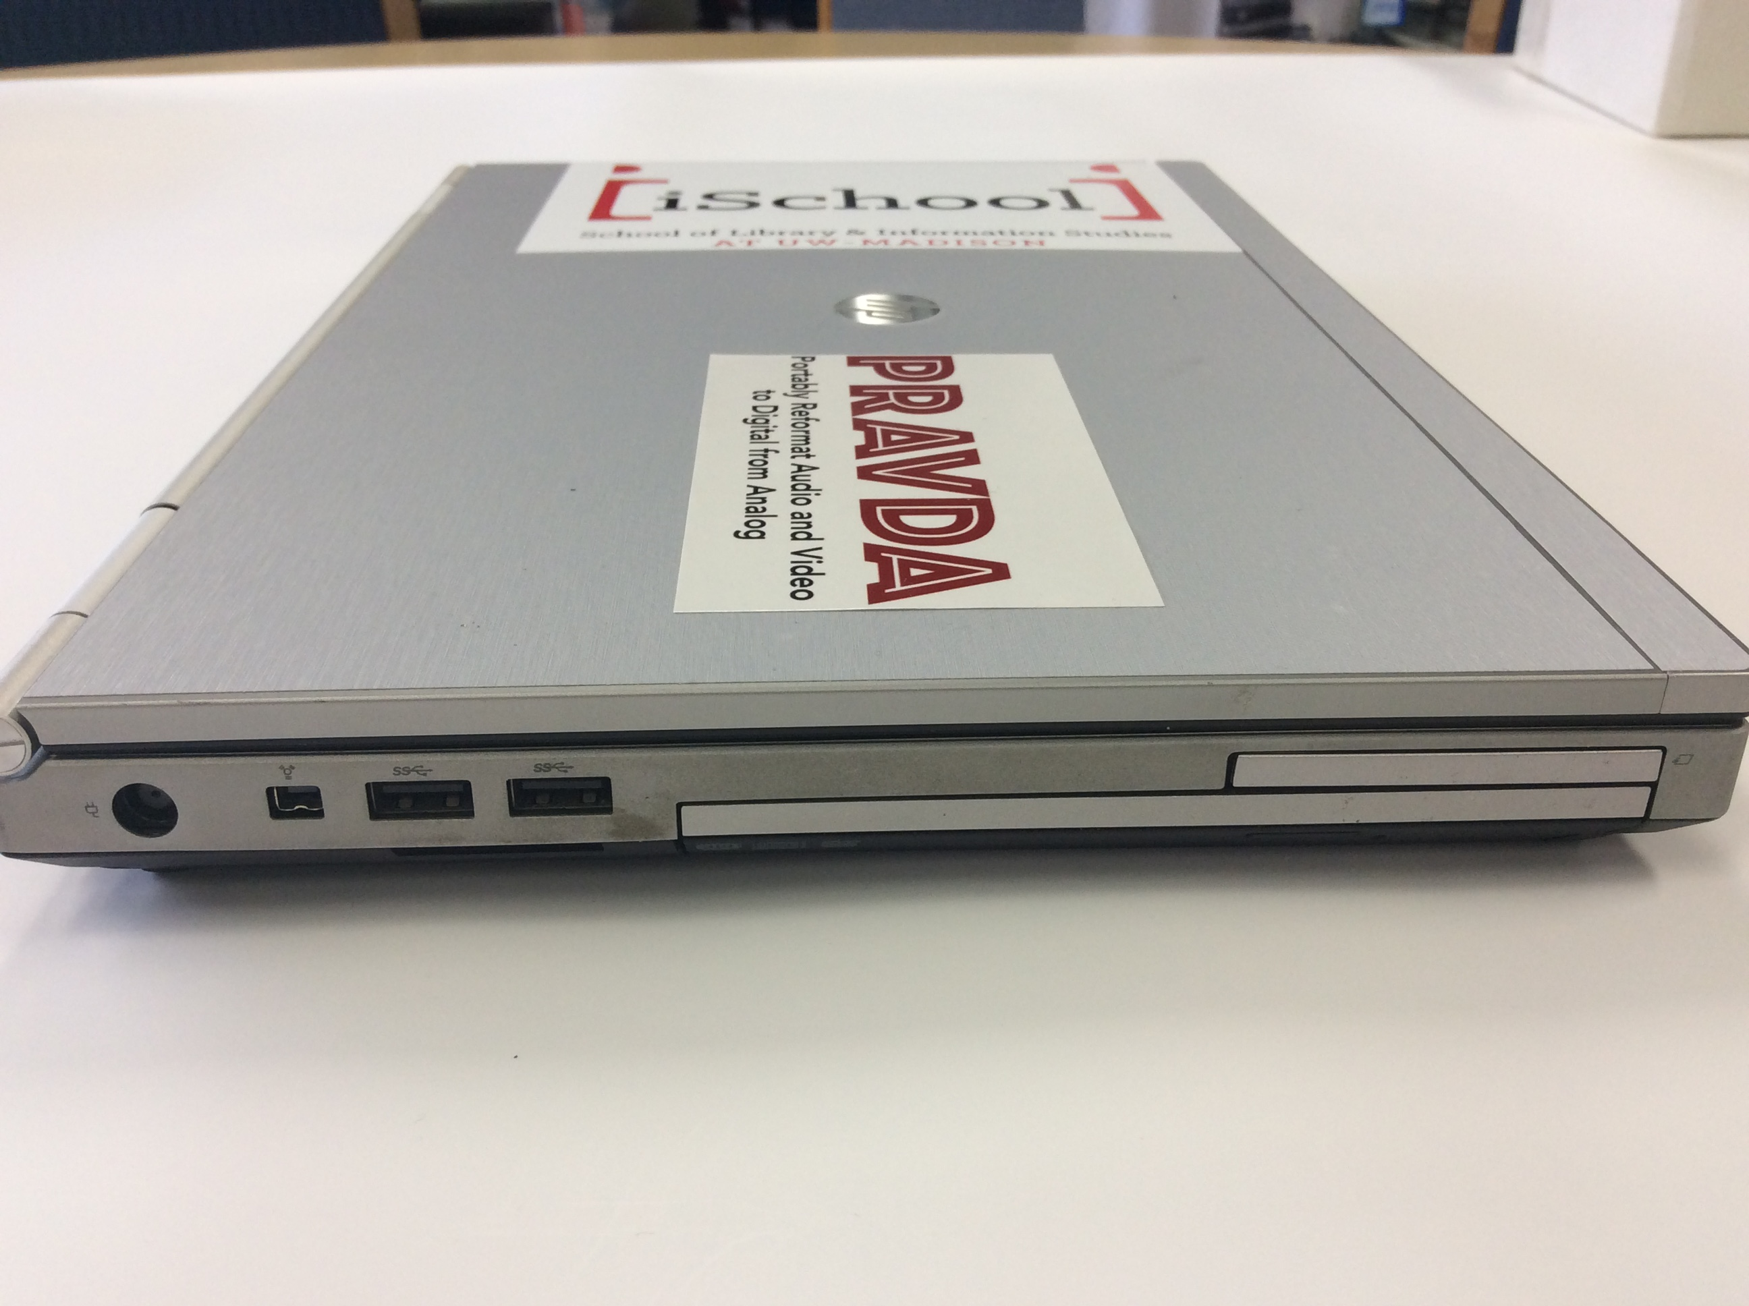
- Sony microcassette player: Runs on two AA batteries; no power cord.
Power socket
4
- Broksonic cassette player: Connect the power cord shown in 5 to its socket.
Laptop connections:
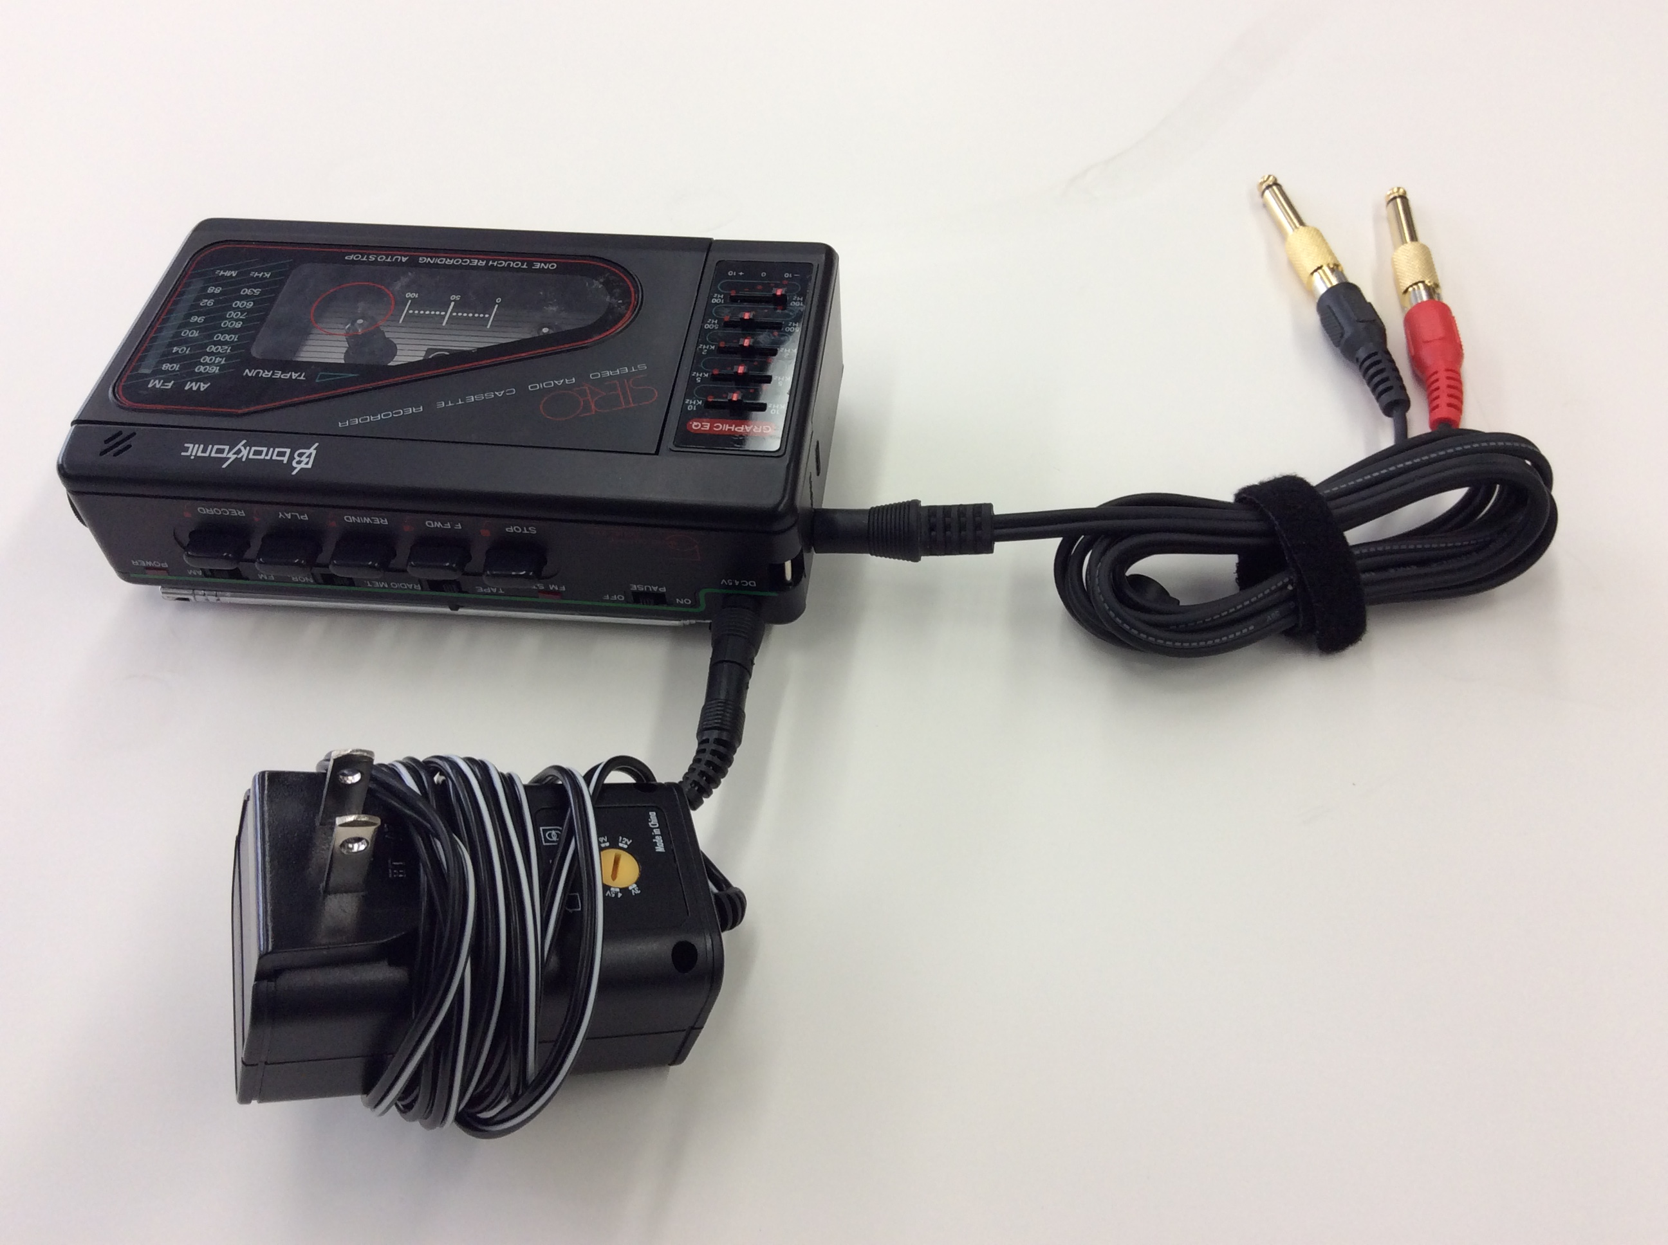
- Connect the Tascam audio interface to the laptop with the USB cable (2). Plug the square end in the USB port at top right of the Tascam, rectangular end in the laptop.
5
- Connect either the Broksonic or the Sony to the Tascam with the cable in 3 and the two gold adapters (5). The gold adapters plug into the Tascam’s “Line/Guitar In” ports (6).
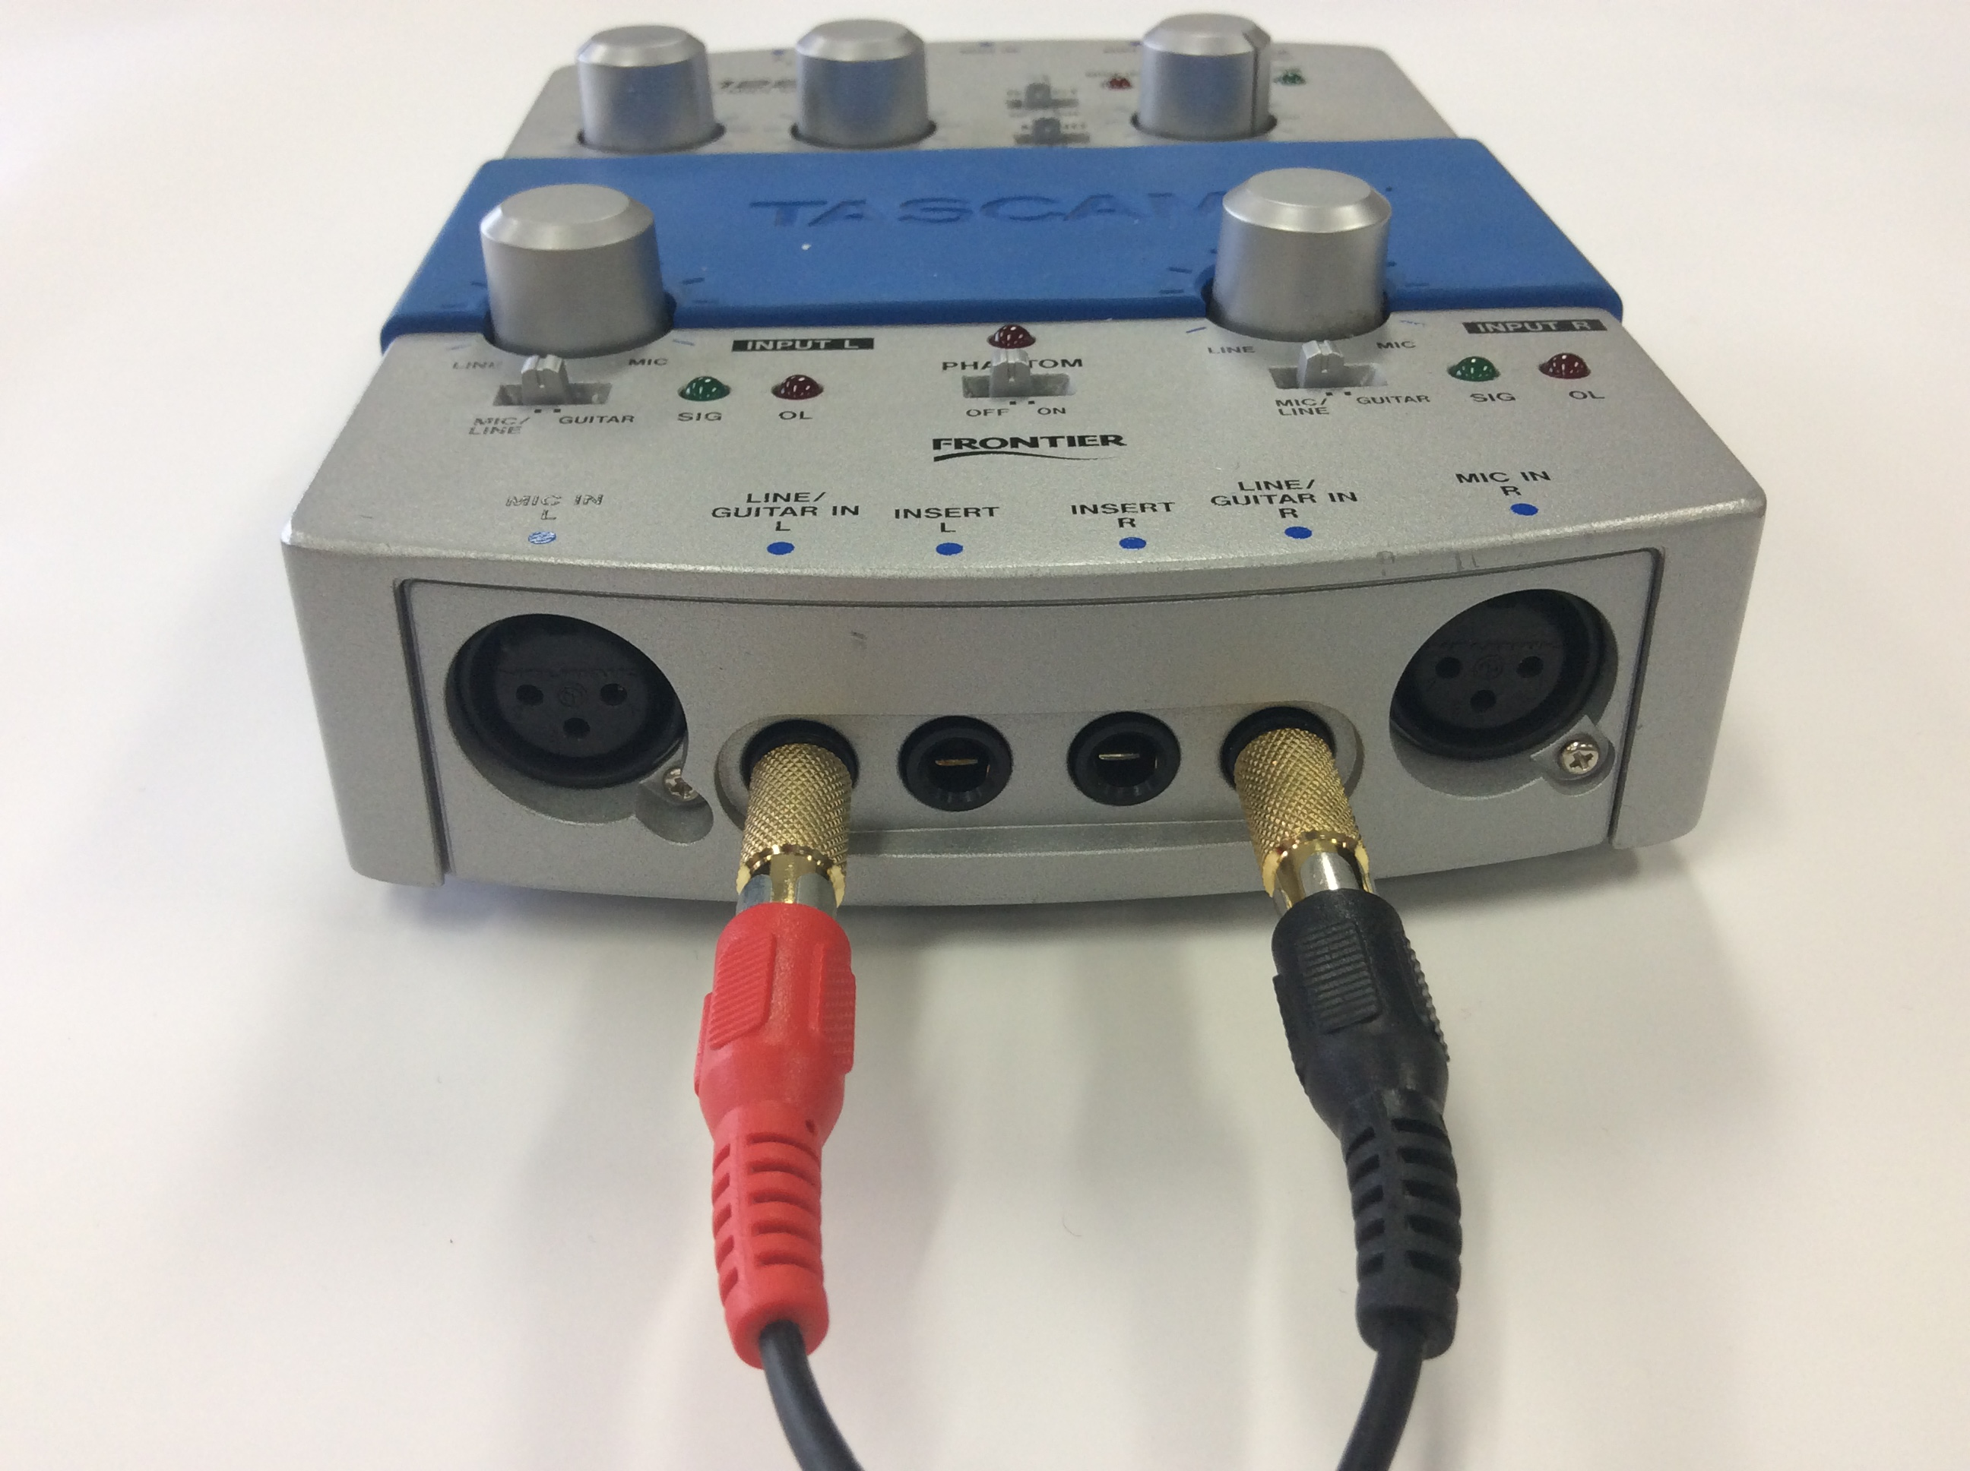
If you have your own playback machine:
6
- Your goal is to connect it to the Tascam. It probably has one of three types of plugs/sockets:
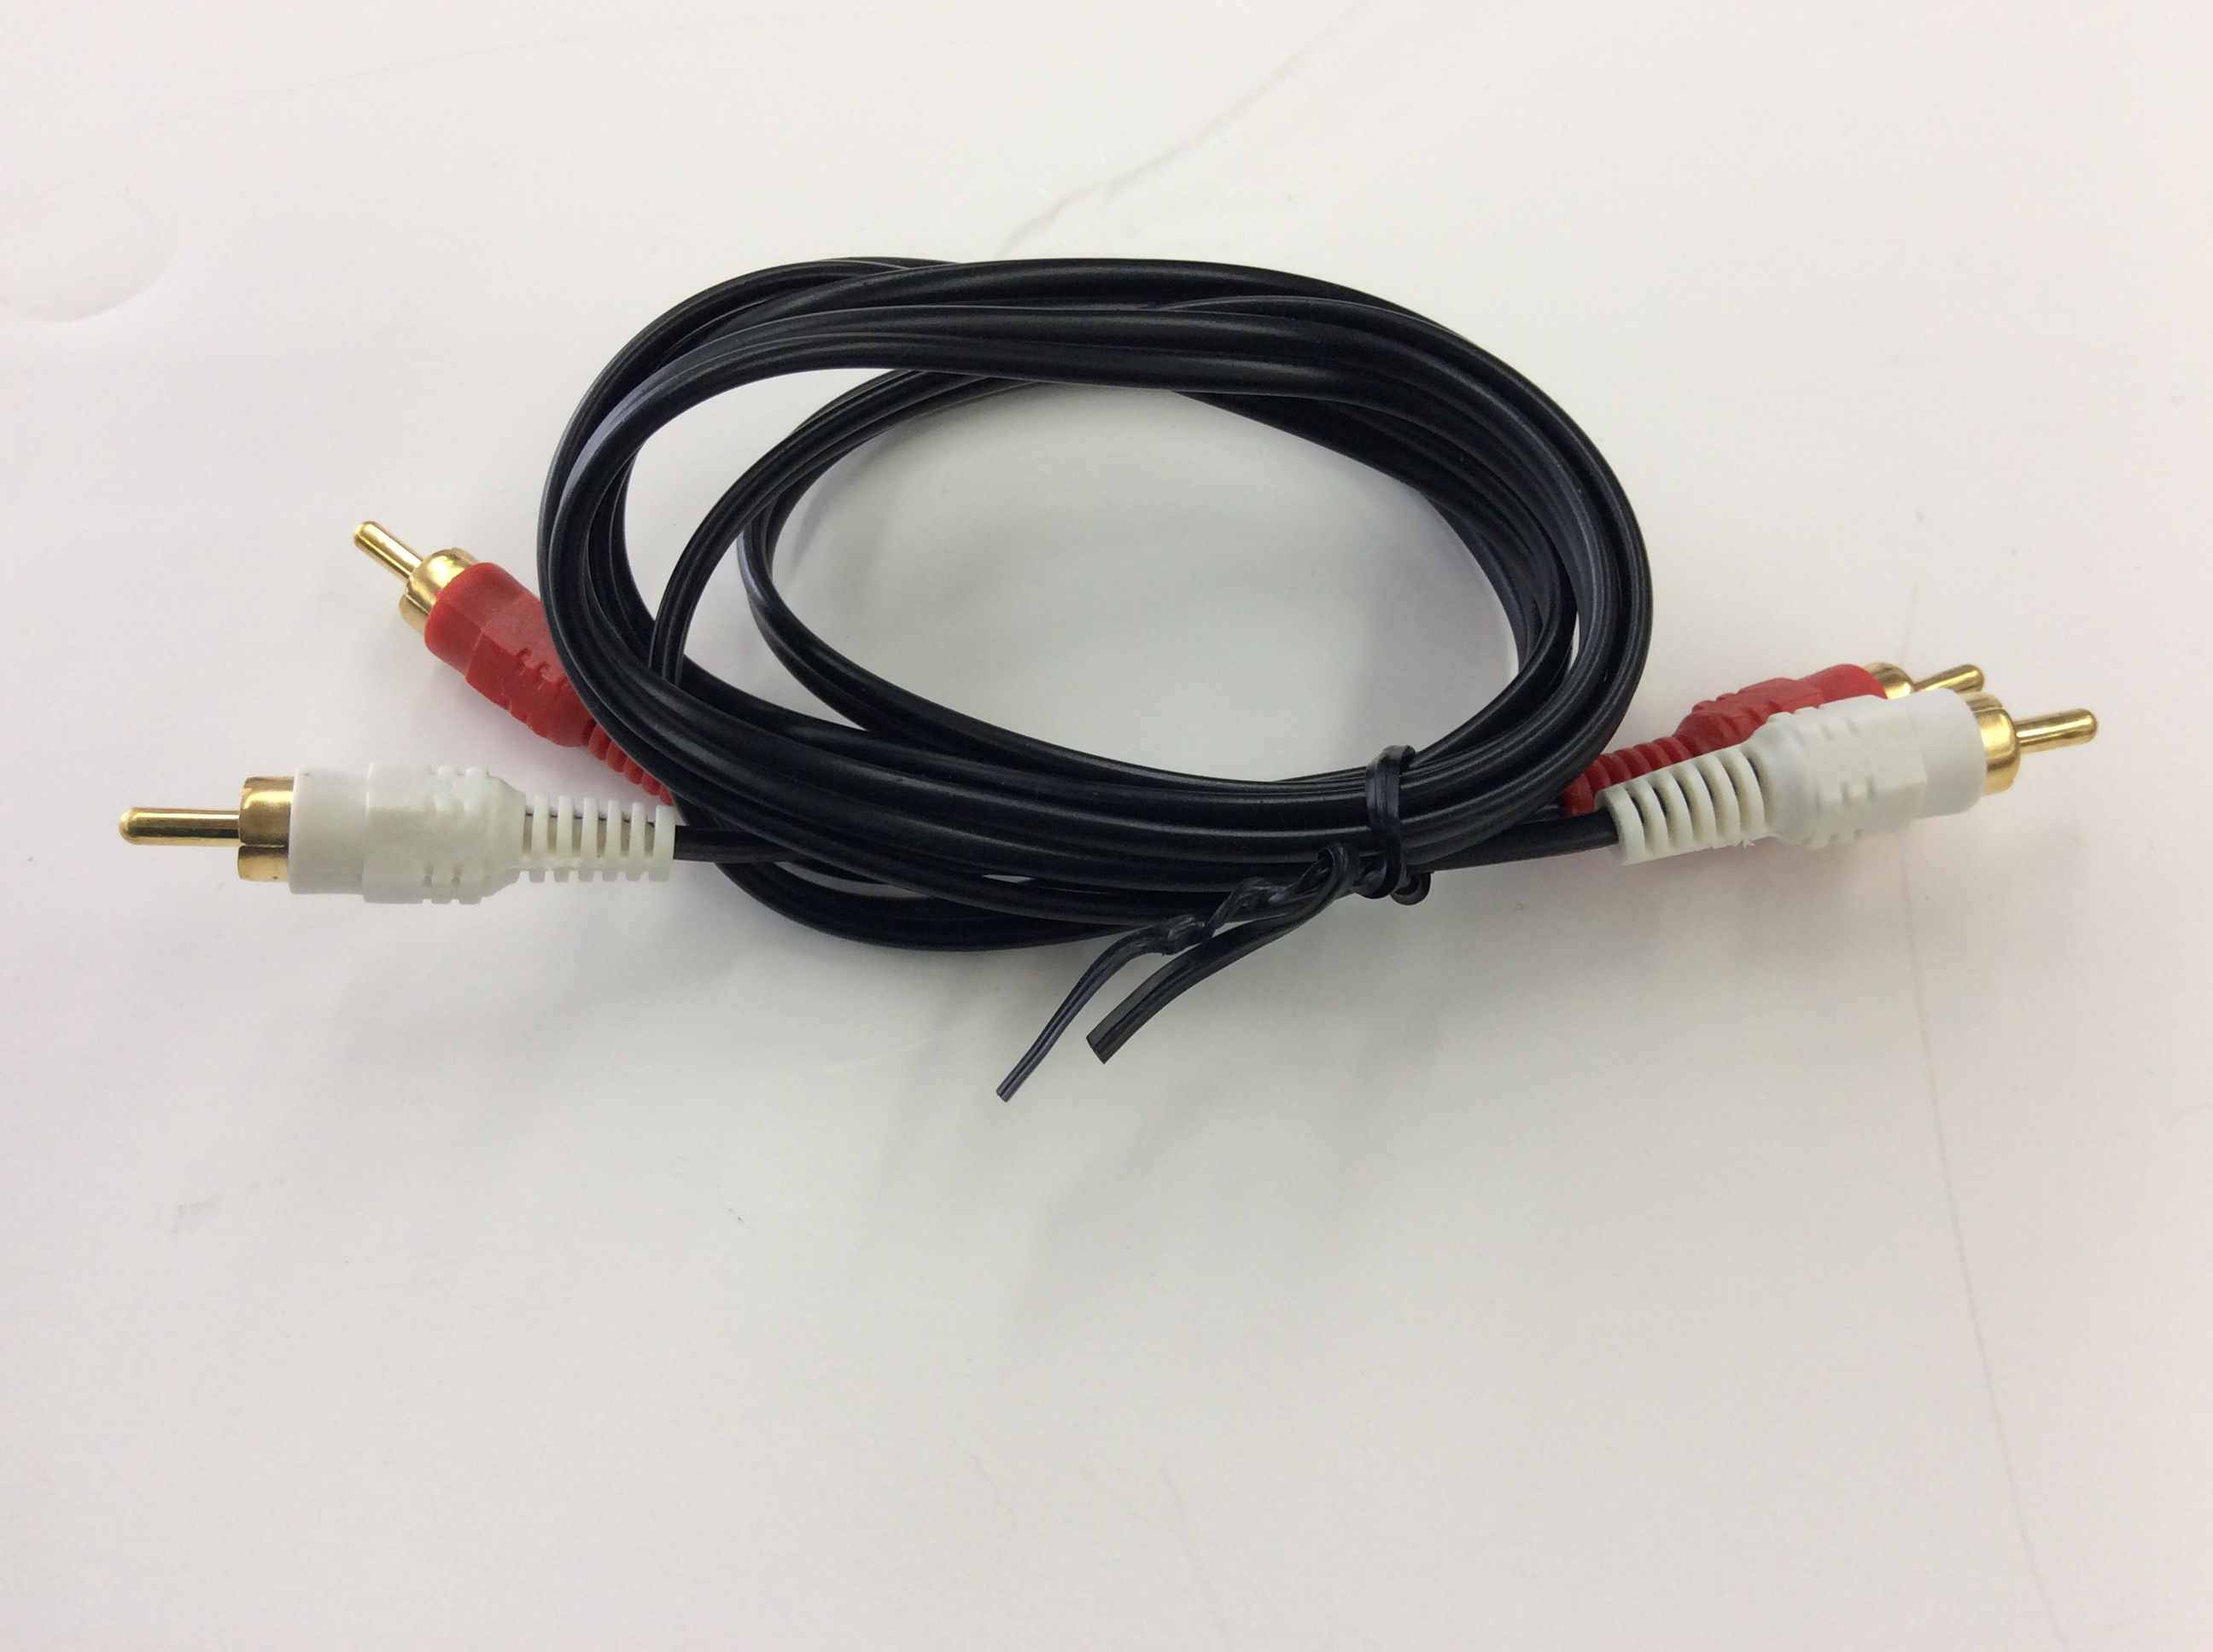
- 1/4-inch. Some open-reel machines and turntables have these. This is the same plug size as the gold Tascam adapters, and these devices almost always come with their own cable and plugs. Plug these directly into the Tascam’s “Line/Guitar In” ports (6).
7
- Composite stereo. If the machine has its own cable, its plugs will be the same size/shape as the plugs in 7. (One plug may be black instead of white; this is fine.) Add the gold adapters to the plugs and plug them into the Tascam’s “Line/Guitar In” ports (6).
- If instead it has composite sockets (often lined in black and red OR white and red), you will need the composite cable (7) and the gold adapters. Plug one side of the composite cable into your device. Add the gold adapters to the other side of the cable and plug them into the Tascam’s “Line/Guitar In” ports (6).
- If it has only one composite socket, it will only play mono. Digitizing with this device is not recommended, unless you are absolutely sure that the medium is mono (as many open-reel tapes are).
- 3.5mm. This is the same size as the plug that goes into the Broksonic and the Sony; use the same cable (3) and the gold adapters.

Video
1
You will need:
- HP laptop and its power cables (1)
- For VHS and VHS-C, VHS VCR along with:
- Roxio capture dongle (2)
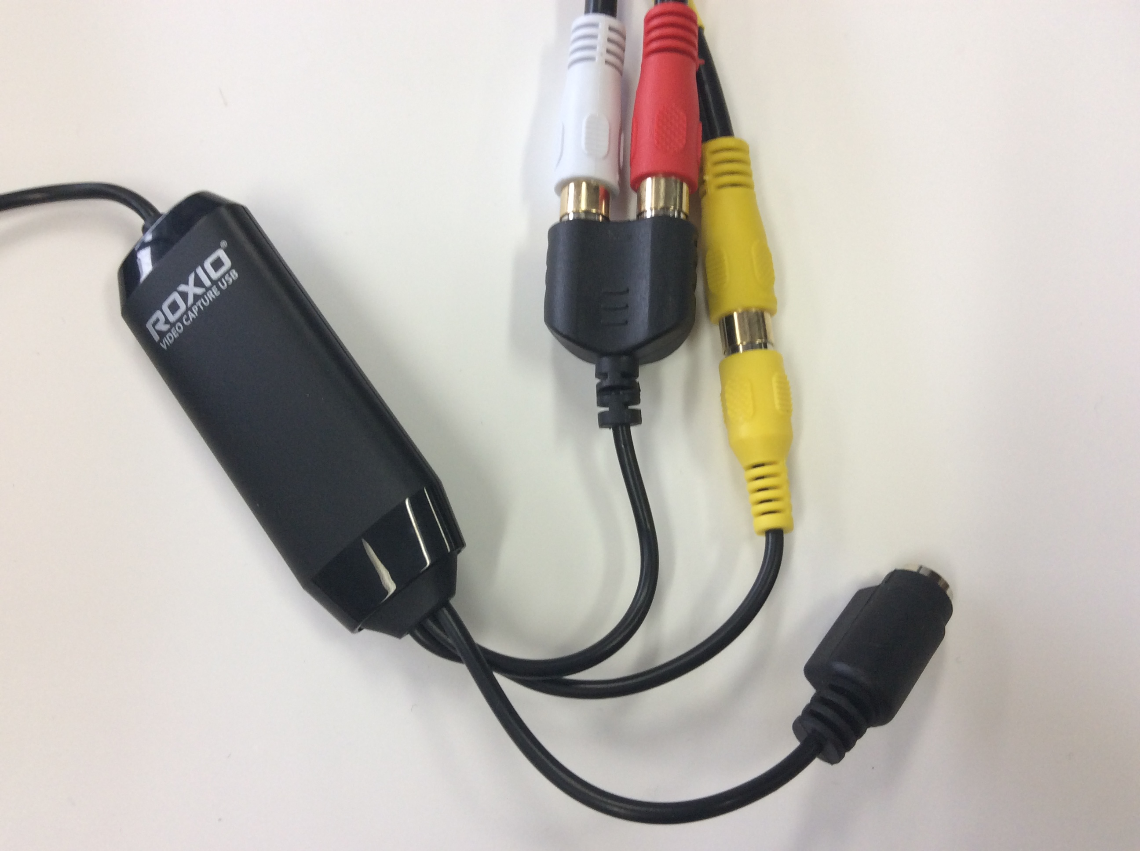
- VHS-C adapter (box, top right) for any VHS-C tapes
2
- Composite video cable (3)
- For mini-DV, Canon camcorder along with:
- Its “Wasabi” power cable (4)
- Firewire cable (5)
Power connections:
- Connect the HP laptop’s power cable to its socket on the left side near the hinge (6). Plug it in.
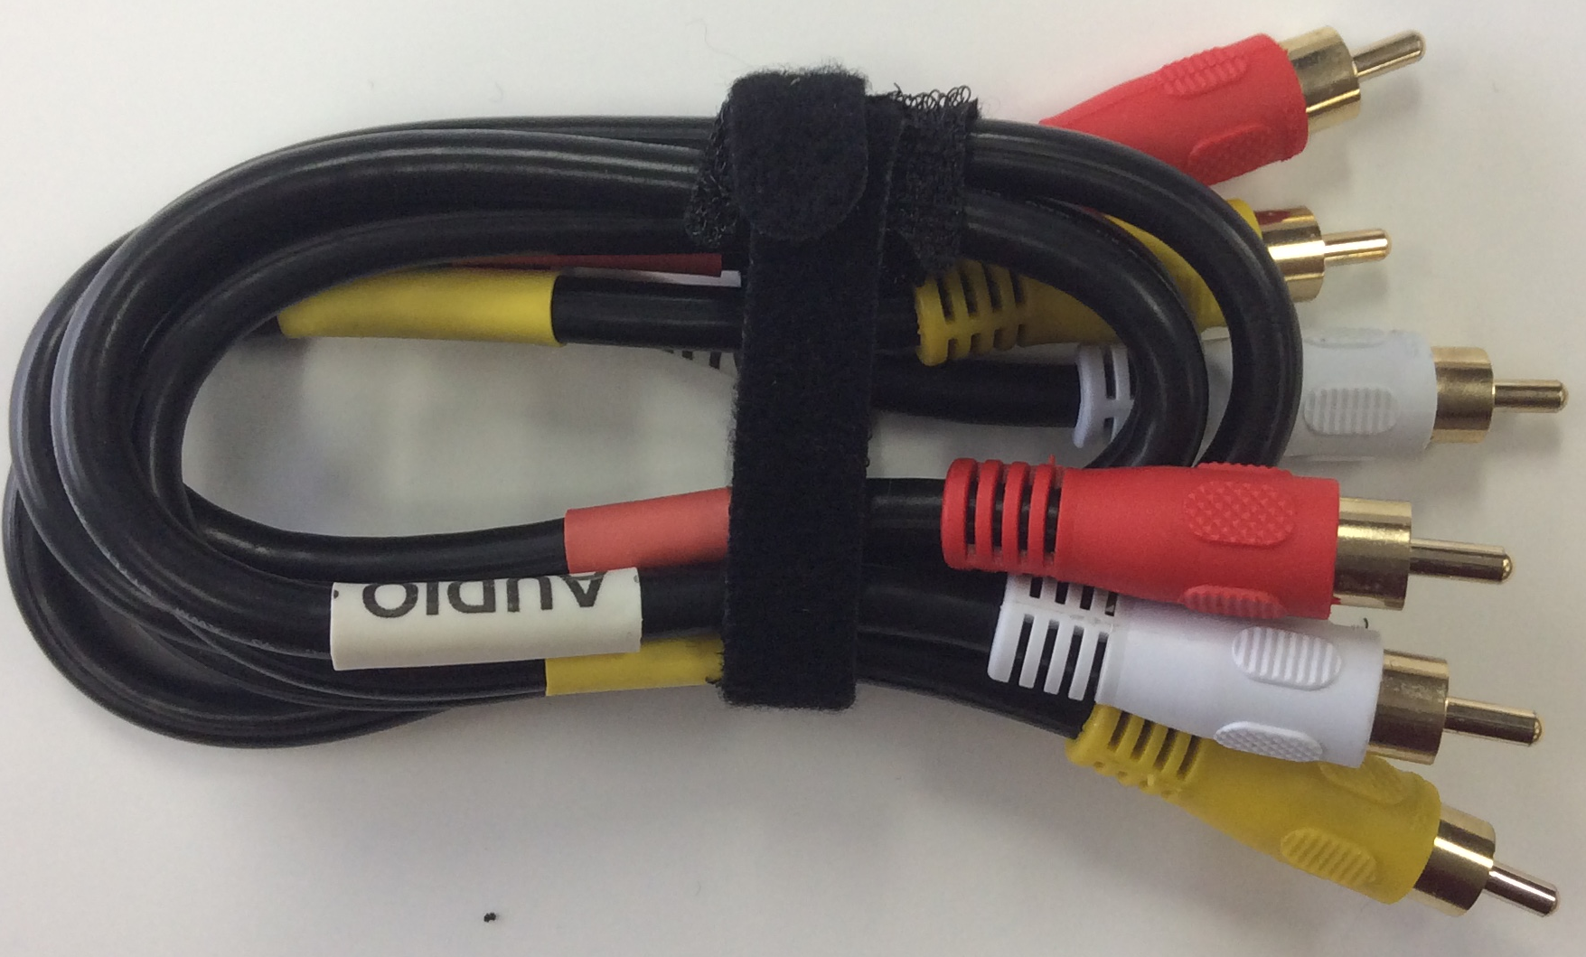
- Connect the Canon mini-DV camcorder’s power cable to its socket on the machine’s bottom back (7). Plug it in.
- Plug in the VHS VCR.
3
Connecting VHS VCR to laptop:
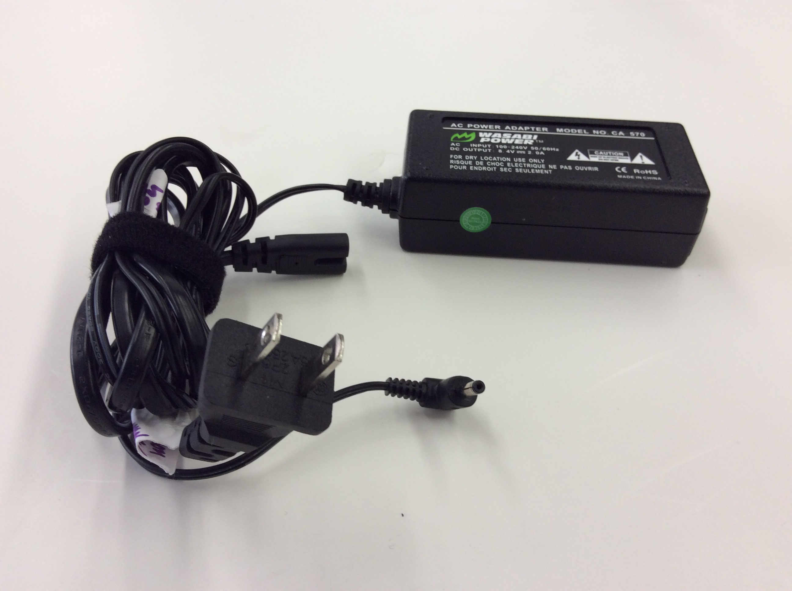
- Connect the Roxio capture dongle’s USB cable to a USB port on the laptop (8).
4
- Connect one set of plugs on the composite video cable to the Roxio capture dongle, matching plug colors to socket colors.
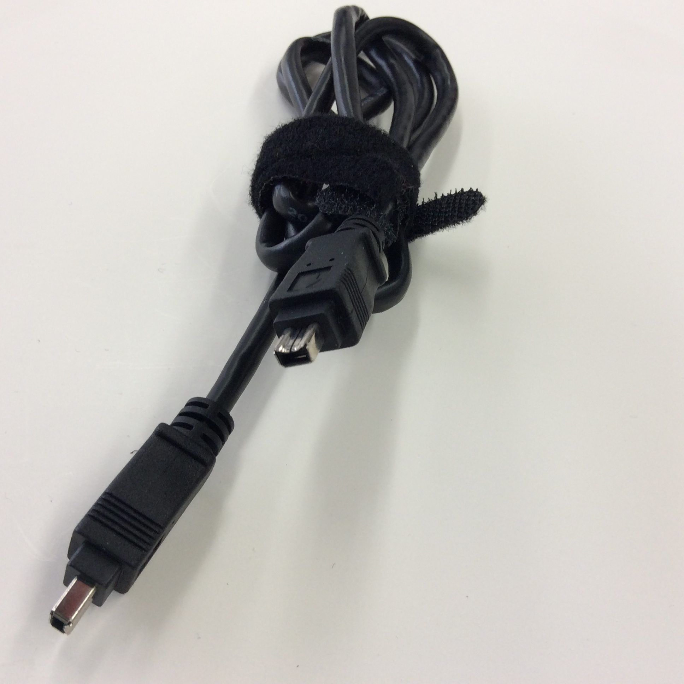
- Connect the other set of plugs of the composite video cable to the sockets at back right of the VHS VCR, again matching plug colors to socket colors. (The input sockets you shouldn’t use have been taped over.)
5
Power socket
6

Connecting Canon mini-DV camcorder to the laptop:
- Connect one end of the Firewire cable to the Firewire port on the left side of the HP laptop (8).
- Connect the other end of the FireWire cable to the port on the right side of the camera (9).

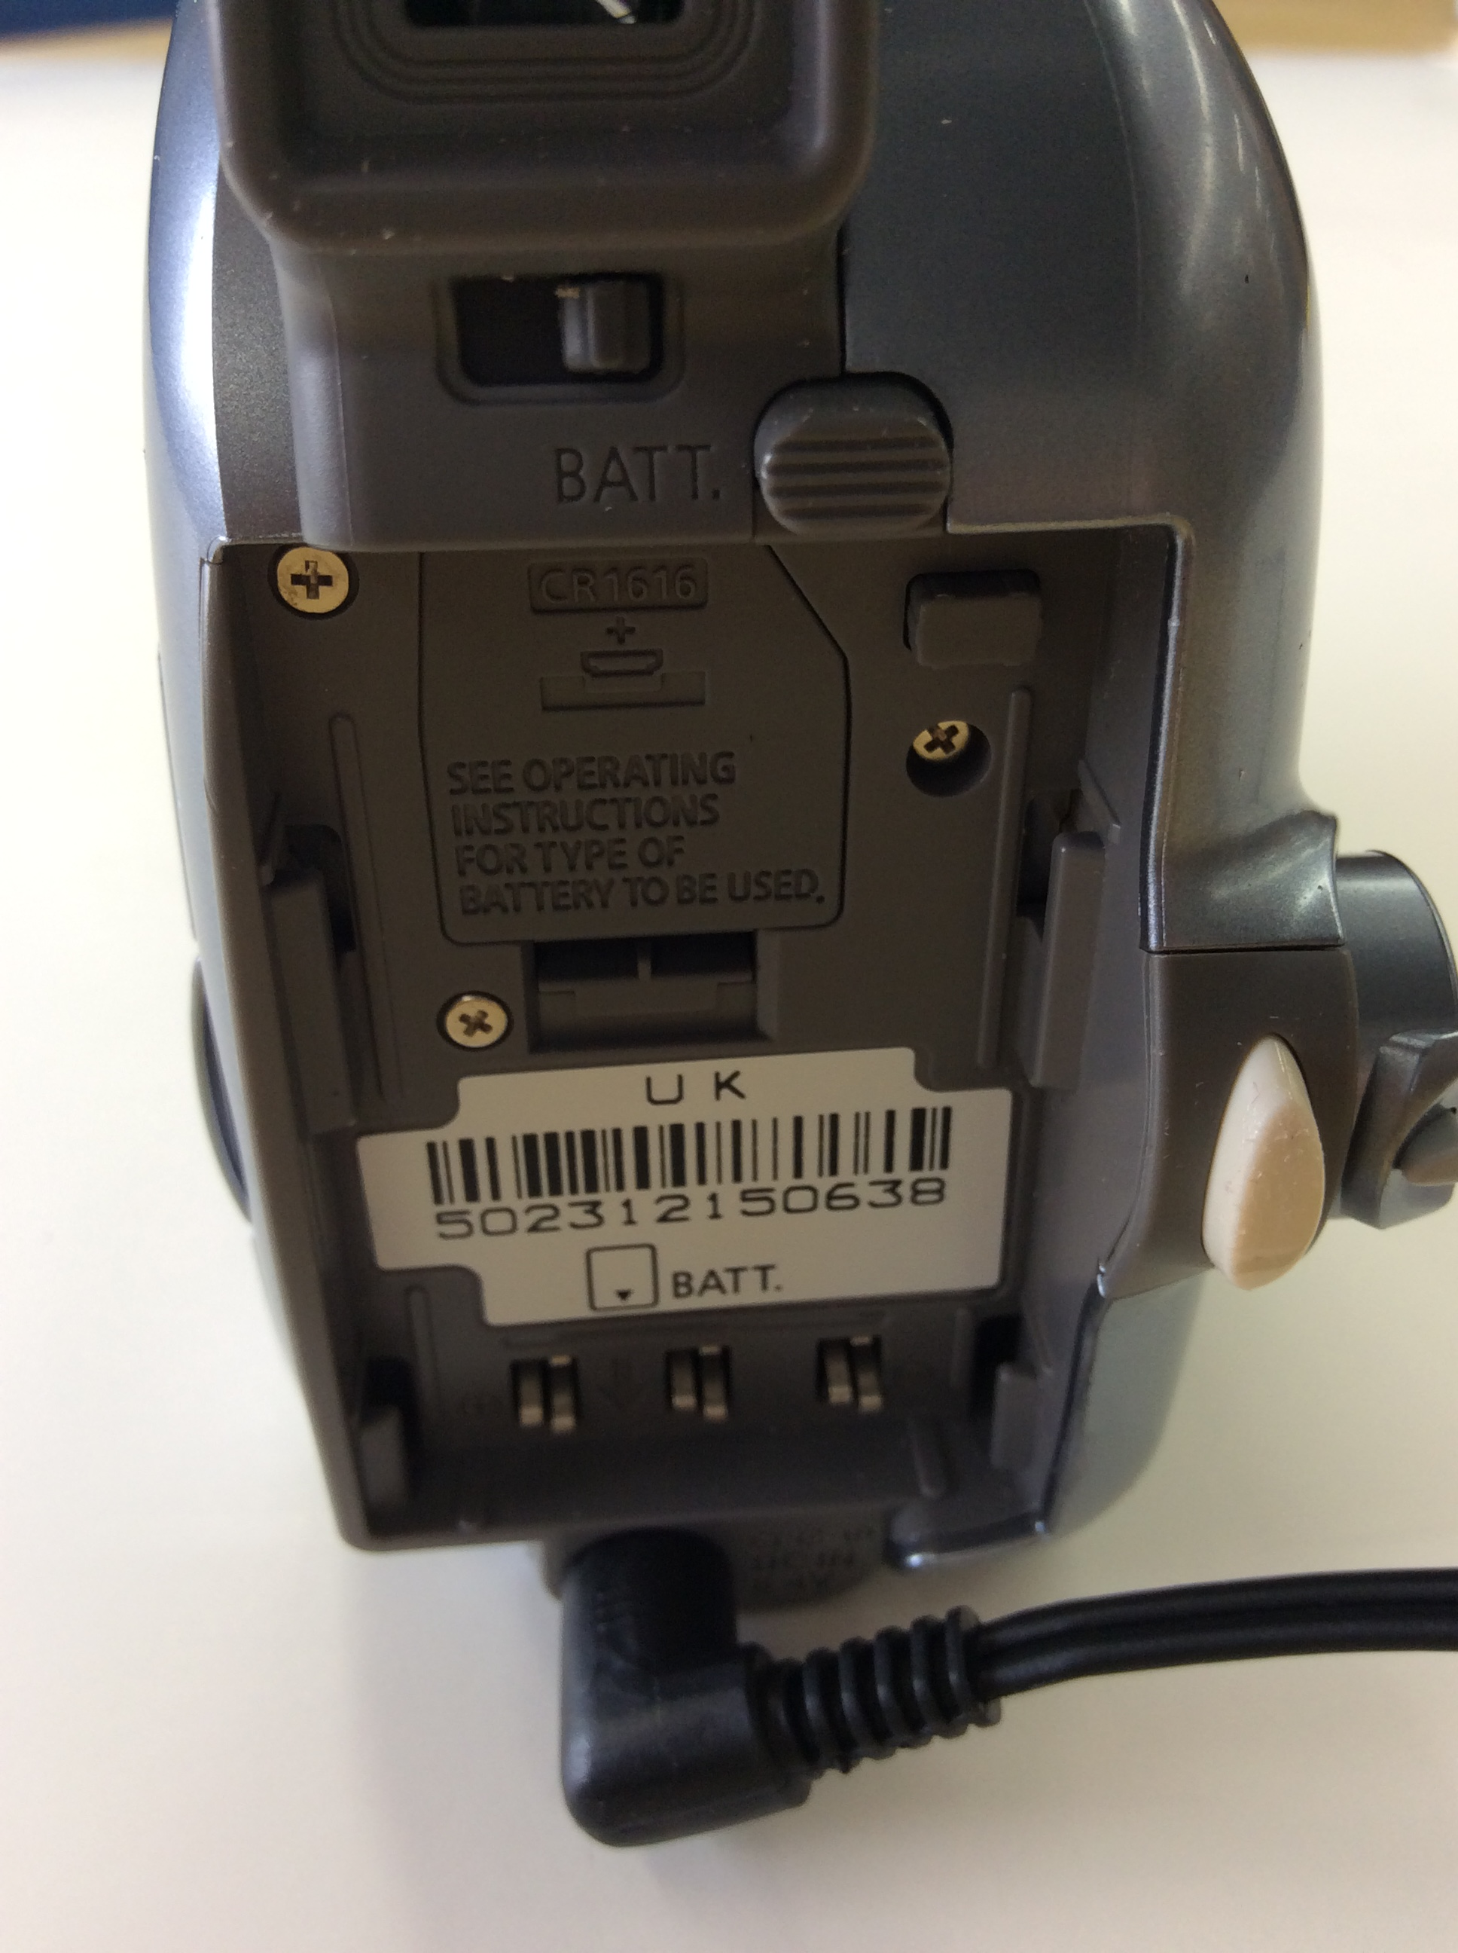
7
Firewire port
8

USB ports
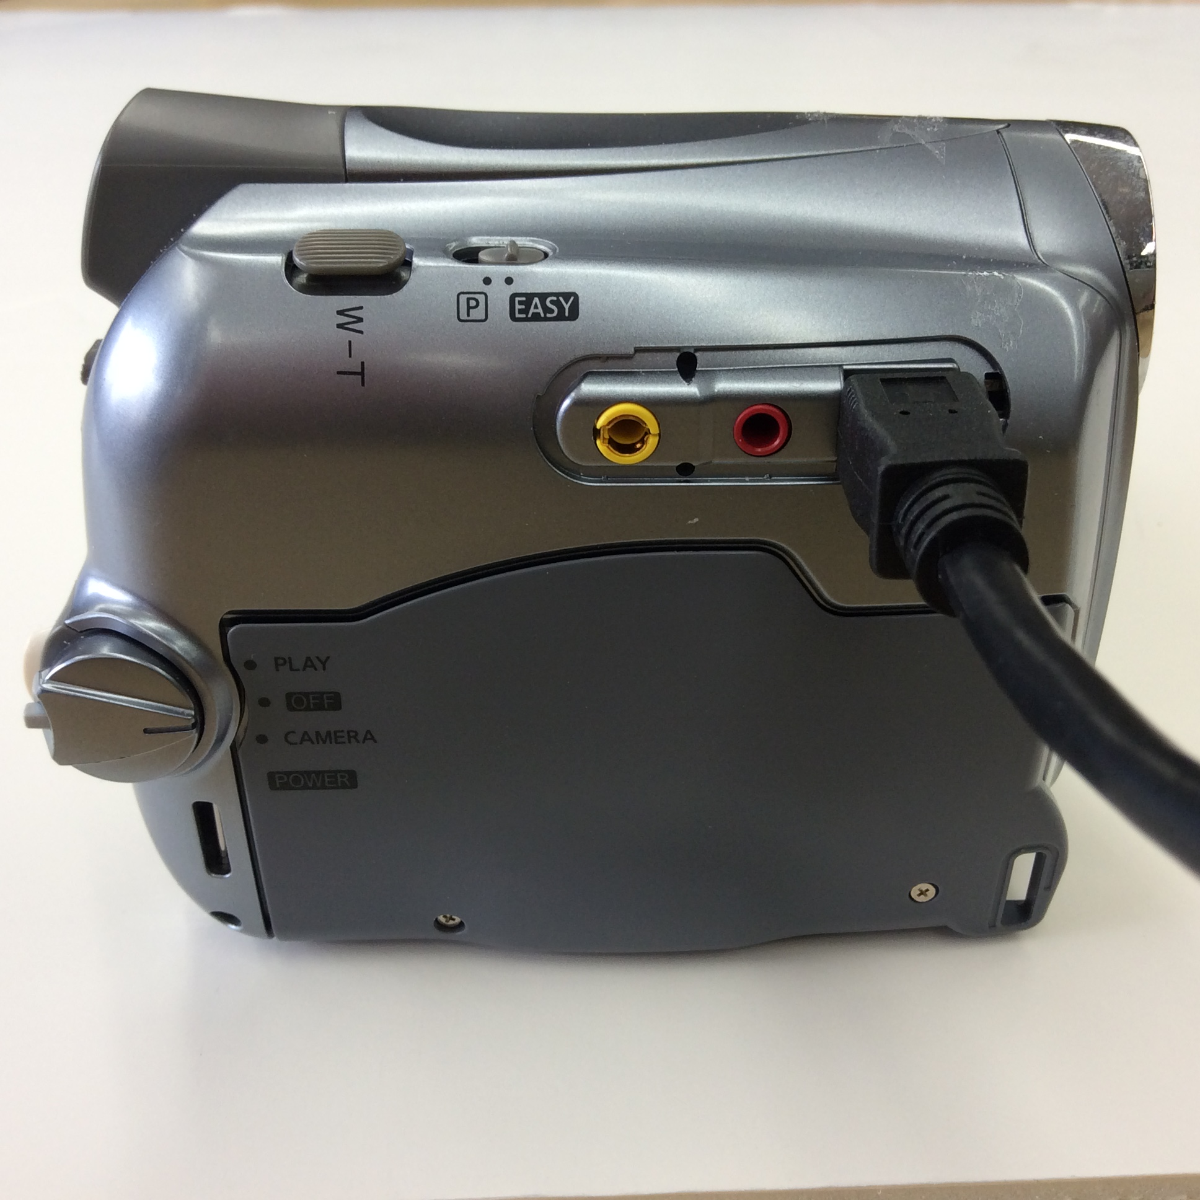
9

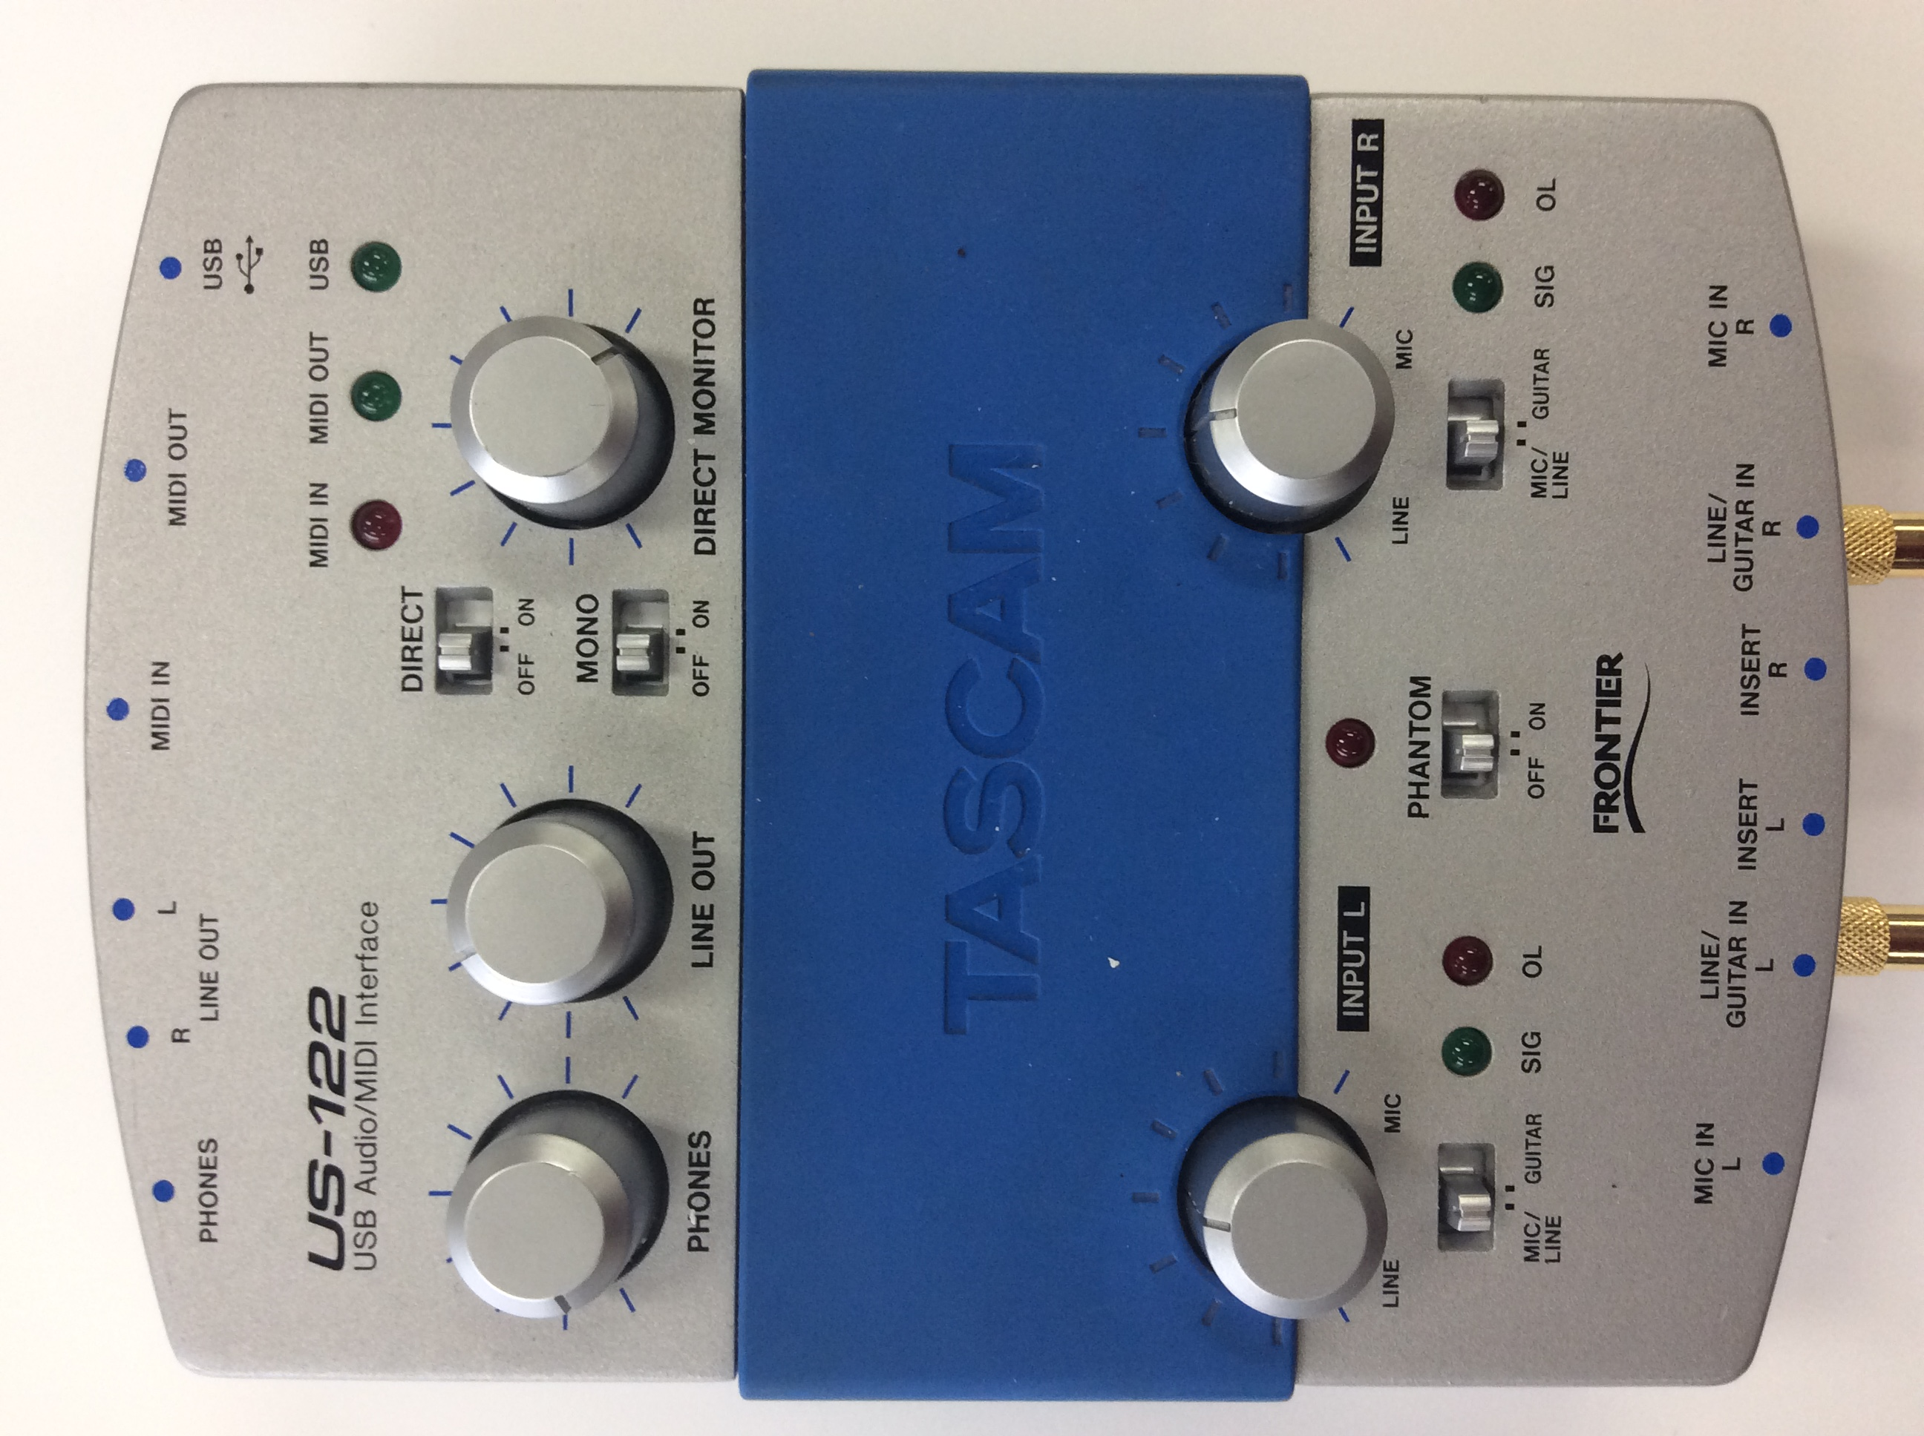
Digitizing audio
1
Once you have connected your playback device, the Tascam audio interface, and the laptop, the procedure is the same no matter which playback device you are using.

Adjusting the Tascam audio interface
- Adjust the INPUT L and INPUT R knobs (1, circled in red) so that the etched line points directly topward. Be careful—the knobs are a bit loose.


Starting Audacity
Click on the Audacity icon in the bottom bar of the screen.
- Make sure that Audacity’s dropdowns at top are set to:
  - Windows Direct Sound
Audacity icon

  - US-122 A:B (3- US-122 WDM)
  - Stereo
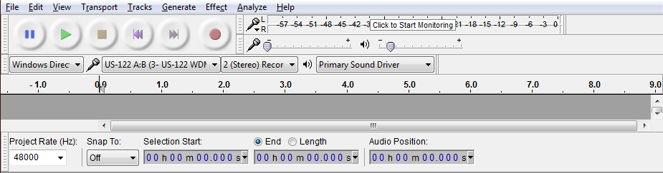
- At bottom left, make sure that Project Rate (Hz) is set to 48000 Hz. If it is particularly excellent audio, you may wish to raise this to 96000 Hz.


Recording
- Click the round red button to start Audacity recording.
- Start your player.

  - Watch Audacity’s levels in the negative-number bar next to the small microphone icon at top. If the green bars get close to 0, turn the INPUT L and INPUT R knobs on the Tascam down (to the left) a bit.
Audacity “Record” button

  - On the other hand, if the audio track is barely visible in the main Audacity window, turn the knobs on the Tascam up (to the right) a bit.
  - Either way, stop playback, quit/restart Audacity without saving, and re-record!
Audacity “Stop” button

- When playback is complete, click the square yellow button to stop Audacity recording.

Post-processing (optional)
- To remove unwanted silence, click-and-drag over it and choose “Delete” from the Edit menu.
- Audacity can reduce tape hiss and other noise:
  - Click and drag to select a few seconds of the audio that are nothing but noise.
  - In the Effects menu, choose “Noise Reduction.”
  - Click the “Get Noise Profile” button.
  - Close the Noise Reduction window.
  - Select the whole audio track (Ctrl-A).
  - Choose “Noise Reduction” again. Click OK.
- Choosing “Normalize” from the Effects menu is a good idea, once you are done with other editing. Audacity’s default values are fine.

Saving your audio to a file
- DO NOT USE AUDACITY’S “SAVE PROJECT” FUNCTION unless you are planning to do further audio editing in Audacity. No other program or device plays back Audacity’s native project format!
- To save an archival master copy:
  - Choose “Export” from the File menu.
  - Choose “WAV (Microsoft) 32-bit float PCM” as the file type.
  - Give the file a filename. (Do not use spaces or punctuation in the filename.)
- To create a use/access copy:
  - Choose “Export” from the File menu.
  - Choose “MP3 Files” as the file type.
  - Give the file a filename.
  - Optionally, add appropriate metadata about the audio file (title, creator, etc) in the metadata pop-up window.

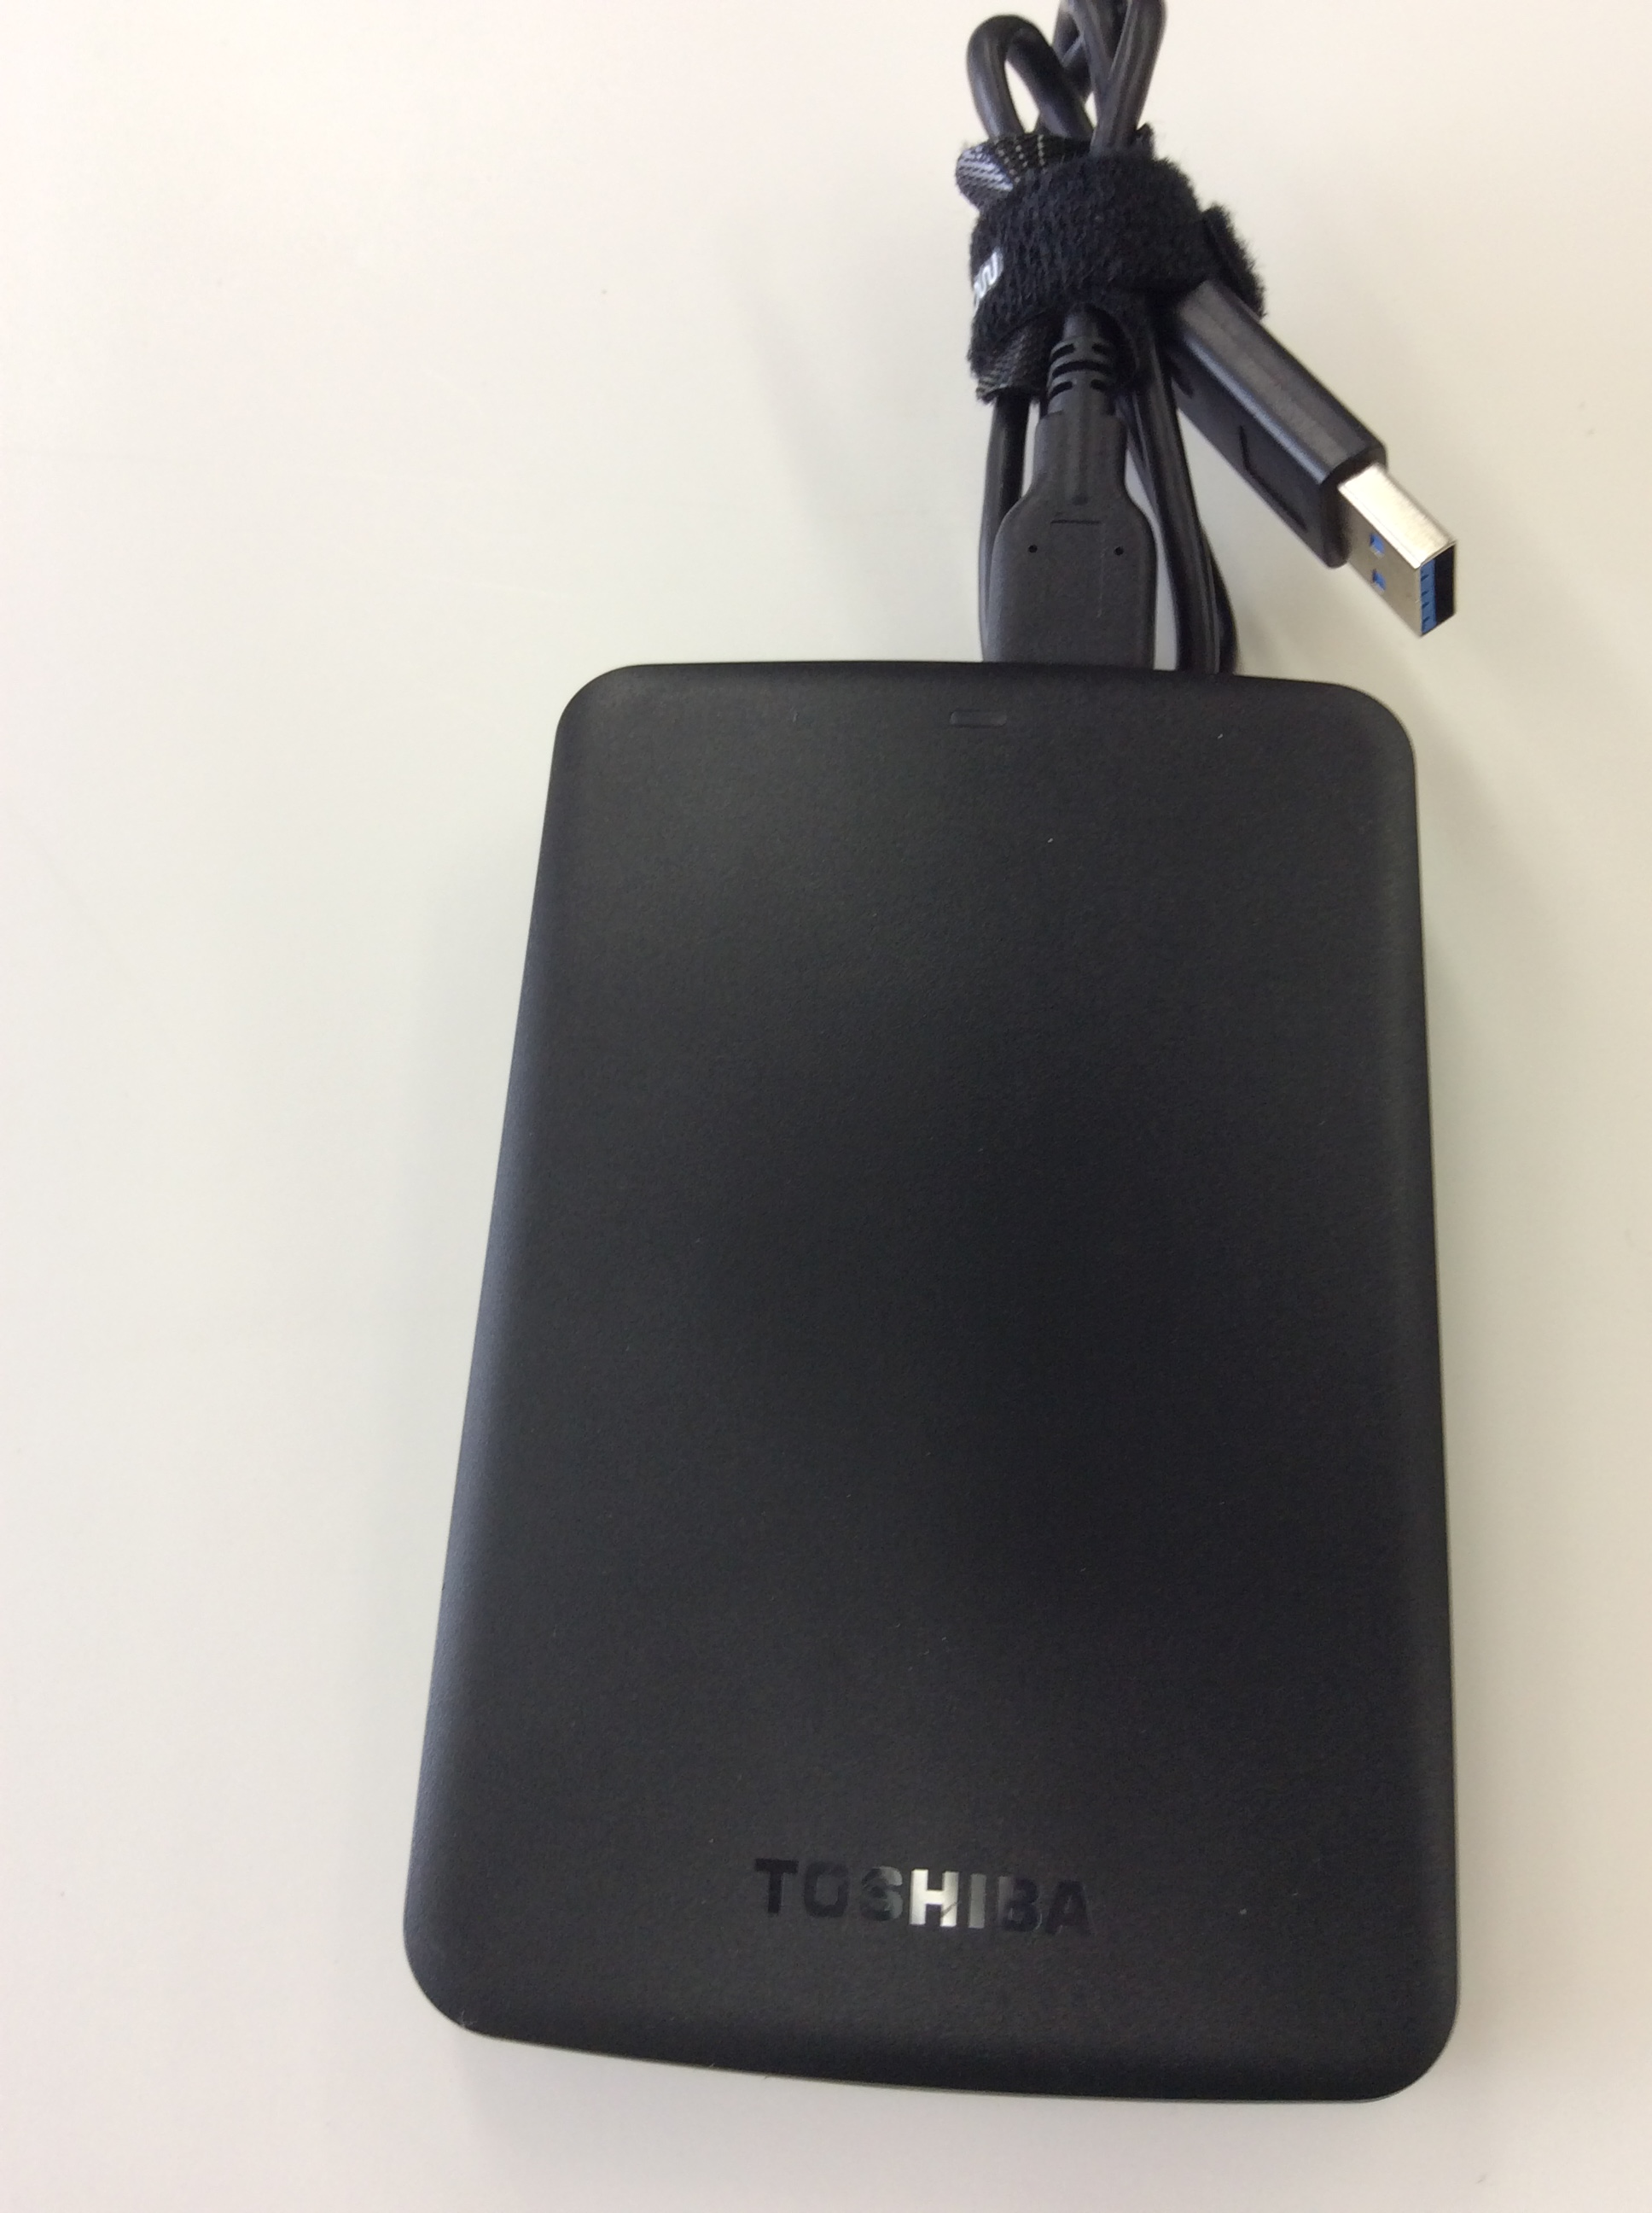
Digitizing VHS and VHS-C
1

Attaching the external hard drive
PRAVDA’s external hard drive (1) is with the cables in the lower right compartment of the box. Connect it to one of the USB ports on the laptop.

VHS-C (Compact) tape preparation
If your tape is regular VHS, skip this section! If you’re not sure, compare the size of your tape to the size of the VHS-C Cassette Adapter. If they’re the same size, it’s a regular VHS tape.
If the tape is significantly smaller but still says VHS:
- Get the VHS-C Cassette adapter from the upper right corner of the box.
- Hold the adapter so that the text on the white label is right-side-up. Move the switch at the bottom left to ON. The cover should flip open after a moment’s whirring.
  - If it doesn’t, replace the AA battery (left side).
- Put the tape into the adapter, tape surface away from you.
- Close the lid, and let the adapter whir a bit more.
- Slide the adapter with the tape into the VCR.

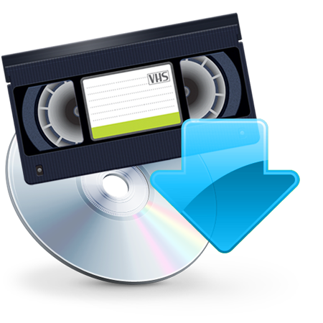
Digitizing the tape
Roxio Easy VHS to DVD icon

- The VCR’s power button is on the left.
- Slide the tape into the VCR, label side upward.
- Click on the “Roxio Easy VHS to DVD” icon from the bottom taskbar.
- From the opening menu, always choose “Record, Edit, and Save,” even if you plan to burn a DVD. (You have the choice to burn a DVD after digitization is finished.)
- Click “Start a new Project”
- Type a project name.
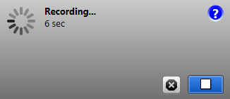
- Click the blue-and-red Record button in the lower right-hand corner of the Roxio window.
- Press the Play button on the VCR.
- When the tape is finished, click the same Roxio button (now blue with a white square) to stop Roxio digitizing.
- Click the “Next” button at lower right.
Lower right corner of Roxio recording screen, with white-on-blue “Stop” button

Delivery option 1: Burning a DVD
- From the horizontal slider, choose “DVD.”
- The laptop’s optical drive is at its front left as you look at the screen. Press the drive door button lightly to open it.
- Insert a blank DVD-R or DVD-RW into the drive.
- Under “DVD Title,” type a name for the DVD.
- If you wish, unclick “Add Menu” or explore the “Change Menu” options.
- Leave “AutoFit” checked.
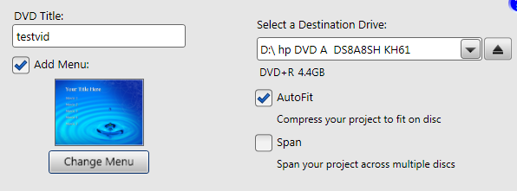
- If Roxio tells you that it must span your video across DVDs, and this is unacceptable to you, consider saving a file (below) instead of burning a DVD.

Delivery option 2: Saving a file
- From the horizontal slider, choose “Computer.”
- Change the default settings:
  - Click the “…” button beside the file path to change it to someplace you can find again (like the desktop, or the Toshiba hard drive).
- Click the small plus button to expand the Advanced Settings options
  - Change the “Compression” dropdown to “H.264.”
  - Consider changing the “Quality” slider to “Best.”
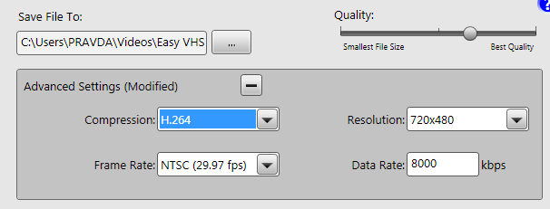
- Click the “Export” button in the lower right
  - Depending on how long the video is, it may take anywhere from a few minutes to an hour to process
- When it is finished, click done.

Capturing mini-DV
1

Attaching the external hard drive
PRAVDA’s external hard drive (1) is with the cables in the lower right compartment of the box. Connect it to one of the USB ports on the laptop.

Inserting the tape
- On the bottom of the camcorder slide the “Open/Eject” switch to the right to open the tape compartment.
- Insert the Mini-DV cassette label-side up and gently shut the compartment, which will retract into the camcorder. (Do not push the compartment down into the camcorder! This will break the camcorder!)

Capturing the tape
- Move the dial on the side of the camcorder to “Play”.
- Choose the Windows Movie Maker icon from the task bar of the laptop.
- Once the application is open, click on the drop-down menu in the upper left corner.
- From the expanded menu, chose “Import from device”.
- From the pop-up window, choose the camcorder it shows you and click “Import”.
- Chose a place to save the video by clicking ”More options”.
- IMPORTANT: Click “Browse…” next to the ”Import to” bar and choose the Toshiba External hard-drive (usually drive F:). If you don’t, you may lose the video capture when the laptop’s internal hard drive runs out of space!
- Type a name for your video file and select whether you would like to Import the entire video or choose parts of the video. If your Mini-DV tape is only partially full, you may want to choose parts of the video to import. Click Next.
- To choose part of the video, you can control the tape in the camcorder by rewinding or fast-forwarding to the point at which you would like to start importing. Click the “Import” button to begin.
- When it has completed importing what you want, click the ”Stop” button followed by the ”Finish” button in the lower right.
- You can locate your video where you chose to save it and “Open with” Movie Maker to make edits to your video.

Saving the video
The .avi file that Windows Movie Maker creates is your archival master copy.
To make a use/access copy:
- Choose the Handbrake icon from the bottom task bar.
- Navigate to the .avi file Windows Movie Maker created by clicking on the “Source” tab.
- Under Source Selection, choose the second option to open a single file.
- Navigate to the Toshiba external hard drive and open the video you imported earlier.
- Before we convert the file to a smaller format, we have to choose a destination for this file to save as well. Next to the “File Destination” bar, choose “Browse”.
- You can also save this file to the Toshiba external hard drive. You should name this file differently from the first.
- Click “Save”.
- You may change presets if you like, but the defaults are acceptable for most purposes.
- Click “Start.”
- Your smaller, use/access file is now saved to the external hard drive.

SCRATCH Page

Why? If a DVD is inserted into the computer, Roxio delays recording to test whether the DVD works. This can prevent capture of video at the start of the tape.

