An Analysis of FPGA-based Architectures and Algorithm Implementations
for the
Compact Muon Solenoid Experiment
Regional Calorimeter Trigger Phase-I Luminosity Upgrade

By Anthony E. Gregerson

A Thesis submitted in partial fulfillment of
The requirements for the degree of
Master of Science
Electrical and Computer Engineering
at the
UNIVERSITY OF WISCONSIN-MADISON
May 2011

This thesis is accepted in partial fulfillment of the requirements for the degree of Master of Science.

________________________
Date

________________________
Prof. Katherine Compton
Thesis Advisor

________________________
Prof. John H. Booske
Department Chair

Contents
Contents iii
List of Tables v
List of Figures vi
Acknowledgements viii
Abstract i
Introduction 2
1.1 Motivation 3
1.2 Thesis Outline 3
2. Data Acquisition Systems in High-Energy Physics 4
2.1 Introduction to High-Energy Physics 4
2.2 The Compact Muon Solenoid Experiment 7
2.2.1 Physics Research at the CMS Experiment 8
2.2.2 Sensors and Triggering Systems 10
2.2.3 The Super Large Hadron Collider Upgrade 14
2.3 Characteristics of High-Energy Physics Applications 15
2.3.1 Technical Characteristics 16
2.3.2 Characteristics of the Development Process 19
2.3.3 Evolving Specifications 21
2.3.4 Functional Verification and Testing 22
2.3.5 Unit Modification 23
2.4 Techniques for Managing Design Challenges 23
2.4.1 Managing Hardware Cost and Complexity 24
2.4.2 Managing Variable Latency and Variable Resource Use 26
2.4.3 Scalable and Modular Designs 29
2.4.4 Dataflow-Based Tools 30
2.4.5 Language-Independent Functional Testing 32
2.4.6 Efficient Design Partitioning 33
3. A Brief History of Triggering Systems in High-Energy Physics 34
3.1 Early Trigger Systems 35
3.2 Trigger Systems of the 1980s 36
3.2.1 Axial Spectrometer Experiment at the Intersecting Storage Rings (1971-1984) 36
3.2.2 The CDF Experiment at the Tevatron (ca. 1987) 37
3.2.3 The DELPHI and L3 Experiments at the Large Electron-Positron Ring (ca. 1989) 38
3.3 Trigger Systems of the 1990s 40
3.3.1 The SLD Experiment at the SLAC Linear Collider (ca. 1991) 40
3.3.2 The NA48, WA98, and NOMAD Experiments at the SPS (ca. 1992-1997) 42
3.3.3 The BaBar Experiment at the PEP-II Collider (ca. 1999) 44
3.4 Trigger Systems of the 2000s 47
3.4.1 The PHENIX and STAR Experiments at the Relativistic Heavy Ion Collider (ca. 2000) 47
3.4.2 The H1 Experiment at the upgraded-luminosity HERA Accelerator (ca. 2001) 50
3.4.3 Upgrades to the CDF Experiment for Tevatron Run-II (ca. 2001) 52
3.4.4 The CDF Upgrade for Tevatron Run-IIb (ca. 2005) 54
3.4.5 The ATLAS, CMS, and LHCb Experiments at the Large Hadron Collider (ca. 2009) 56
3.5 Trends in Future Trigger Design 58
4. Trends in FPGA-based Design for High-Energy Physics 60
4.1 Introduction 60
4.2 FPGA Hardware Trends 61
4.2.1 Performance 62
4.2.2 Resource Capacity 64
4.3 Design Complexity 65
4.3.1 Collaborative Design 66
4.3.2 Methodology 67
4.3.3 High-Level-Language Tools 73
4.4 Hardware Verification and Debugging 79
4.4.1 Integrated Logic Analyzers 80
4.5 FPGA Trends for HEP – Conclusion 81
5. Algorithms for Phase-I CMS Regional Calorimeter Trigger 82
5.1 Input and Output Data 83
5.2 Tower Filtering 84
5.3 Channel Transverse Energy 85
5.4 Clustering 85
5.5 Electron/Photon Identification 86
5.7 Cluster Overlap Filtering 87
5.8 Particle Isolation 89
5.9 Particle Identification 90
5.10 Cluster Energy Weighting 91
5.11 Jet Reconstruction 92
6. Analysis of the Implementation of RCT Phase-I Algorithms on an FPGA Platform 92
6.1 Modifications to the Jet Reconstruction Algorithm 93
6.1.1 Jet-Finding Using Tower Primitives 96
6.1.2 Reduced Jet Sizes 97
6.1.3 Region-Based Jet Finder 97
6.1.4 Analysis of FPGA Hardware Costs based on Proposed Jet Finder Modifications 99
6.2 Active-Size Partitioning for the RCT Algorithm 100
6.2.1 Active-Size-Based Partioning 101
6.2.2 Definition of Terms in Active-Size Partitioning 102
6.2.3 Algorithm for Computing the Required Number of Chips Based on Active Size 102
6.2.4 Algorithm and Heuristics 103
6.2.5 Results of Preliminary Active-Size Partitioning Experiments 105
6.3 Implementing Large Look-Up Tables for Electron/Photon ID 107
6.3.1 The Electron/Photon ID Algorithm 108
6.3.2 Implementation of the Algorithm 110
6.3.3 EPIM Implementation Strategies 112
6.3.4 Experimental Results 116
6.3.5 Electron/Photon ID Implementation Conclusions 121
7. Future Work 122
8. Conclusion 124
Appendix A: Illustration of Active-Size Partitioning 125
Appendix B: List of Acronyms 128
Works Cited 130

List of Tables
Table I: Percent Resource Utilization for a Single EPIM Module in a Xilinx Virtex-5 TXT240 117
Table II: Maximum Grid Sizes for Different EPIM Designs, With and Without I/O Grid Size Constraints 117
Table III: Static Table Synthesis Times (seconds) 117
Table IV: EPIM and RCT Frontend Resource Utilization for 10x10 Grid (Using Dynamic Partial Tables) 121

List of Figures
Fig. 2-1: A simulated particle collision demonstrates the data collected by the CMS experiment. Image Copyright CMS Experiment at CERN. 5
Fig. 2-2: A cross-section of the CMS detector during assembly. Image Copyright CMS Experiment at CERN. 10
Fig. 2-3: The CMS Trigger and Data Acquisition System. The Level-1 Trigger controls which events are sent from the CMS detector to CERN’s farm of computers and determines which events to discard. Image Copyright CMS Experiment at CERN. 12
Fig. 2-4: Data and triggering rates for HEP experiments have increased by orders of magnitude over the past few deacades. The LHC experiments ALICE, ATLAS, CMS, and LHCb produce exceptionally high rates (Note that both axes use a log scale and data rate increases radially from the origin). 16
Fig. 2-5: Accelerator collision energies have been increasing at an exponential rate. Consequently, many technical parameters of trigger systems, such as their rejection rate, throughput, and processing latency have become much more stringent. 18
Fig. 2-6: One of 126 ASIC-based boards in the CMS Trigger’s Electron ID subsystem. These boards will be replaced by FPGA-based boards in the SLHC upgrade. 25
Fig. 3-1: One of the many L1 processing boards from the L3 experiment [28] 40
Fig. 3-2: DELPHI's Tree-based Look-up Table [65] 41
Fig. 3-3: Tracking sensors used in the NA48 experiment [70] 42
Fig. 3-4: Architecture of the NA48 trigger [70] 43
Fig. 3-5: High-level diagram of the BaBar Trigger and DAQ system [29] 46
Fig. 3-6: BaBar L1 trigger algorithms [29] 47
Fig. 3-7: Event rates in the PHENIX experiment for different ions [31] 49
Fig. 3-8: Data acquisition in the STAR experiment [48] 49
Fig. 3-9: Segment reconstruction scheme in the H1 at HERA [72] 52
Fig. 3-10: Level-1 and Level-2 trigger architecture for the CDF experiment [33] 53
Fig. 3-11: Event processing times for different processor architectures in CDF Run-IIb [52] 55
Fig. 3-12: The CMS trigger architecture (left) compared to a traditional architecture (right) [78] 57
Fig. 4-1: FPGA maximum frequencies and process size (1998-2009) 62
Fig. 4-2: FPGA serial link bandwidth (1998-2009) 63
Fig. 4-3: FPGA resource trends for high-end devices [log-scale] (1998-2009) 65
Fig. 6-1: Algorithm dependency graph for Jet Reconstruction 94
Fig. 6-2: The processes of Clustering, Overlap Filtering, and Jet Finding reduce a 10 x 10 input grid to a 1 x 1 output grid of jet objects. The 10x10 grid of towers (T) is reduced to a 9x9 grid of clusters (C), which is further reduced to a 7x7 grid of filtered clusters (F), that are then used to determine if a single location (J) contained a jet. 95
Fig. 6-3: Effect of input bandwidth on jet padding overhead 95
Fig. 6-4: Padding due to successive Clustering (left) followed by Overlap Filtering (right). The dark regions represent the output grid at each step. 96
Fig. 6-5: Comparison of Jet Reconstruction hardware cost for 8x8 jets. 98
Fig. 6-6: Comparison of Jet Reconstruction methods that can be implemented in a single chip level 99
Fig. 6-7: A graphical representation of the computation of the output active grid for a sample node 104
Fig. 6-8: Comparison of the number of chips needed to implement the Particle-based datapath of the RCT algorithms after adding sequential partitioning based on the Active-Size Partitioning scheme. 106
Fig. 6-9: Towers from the cylindrical CMS detector’s calorimeter towers are mapped on to a 2-dimensional Cartesian grid. 108
Fig. 6-10: Block diagram of the early stages of the Phase-I RCT algorithms. The block marked ‘EPIM’ (Electron/Photon ID Module) contains the large look-up table that determines whether a particles energy composition characterizes it as electromagnetic. 110
Fig. 6-11: A Dynamic Full Table, requiring 1 Mbit of memory per table 115
Fig. 6-12: One possible topology for a Dynamic Partial Table. This topology uses 34 kbits of memory per table/hash combination. 116

Acknowledgements

Portions of this work were supported by the National Science Foundation, under grant #0824040. Any opinions, findings, and conclusions or recommendations expressed in this material are those of the authors and do not necessarily reflect the views of the NSF.
Additional support was provided by the European Center for Nuclear Research (CERN) and the Topical Workshop on Electronics for Particle Physics (TWEPP).
I am grateful to the Xilinx University Program and Wireless Systems Engineering Group for providing tools and FPGA boards used in some of the experiments presented in this thesis.
I would also like to thank my collaborators at CERN, the University of Wisconsin – Madison, and the University of Maryland – College Park.

Abstract
The Large Hadron Collider's (LHC) Compact Muon Solenoid (CMS) is a high-energy physics experiment designed to observe and analyze particle collisions at a rate of one billion collisions per second. The CMS experiment relies on a high-performance system of custom processing elements (collectively known as the CMS Trigger) to perform real-time pre-processing of collision data and select the most interesting data for further study. Portions of the CMS Trigger are due to be upgraded in several phases over the next ten years to meet three requirements:
• Planned increases to the LHC beam luminosity will require an overhaul of the existing Trigger system including new algorithms and system architecture.
• New algorithms will increase resource requirements; yet reducing the number of devices in the system is critical, as the need for data-sharing between devices is a primary cause of system design complexity
• As researchers use the system, they may discover they require new functionality in the Trigger. Thus the Trigger design must be flexible (reprogrammable) yet still meet tight performance constraints. Changes made to the system must result in a minimal amount of down-time.
The upcoming upgrades to the LHC and its associated experiments will require a significant redesign of its triggering electronics, including the implementation of new algorithms in the Regional Calorimeter Trigger (RCT). In this thesis, I provide an analysis of historical trends in trigger systems and their implementation platforms, formulate a mathematical description of the triggering algorithms proposed for the Phase-I upgrade to the RCT for the Compact Muon Solenoid experiment at CERN’s Large Hadron Collider, describe the unique challenges of designing electronics for particle accelerators, and explore two aspects of the implementation of the RCT upgrade: (1) The algorithmic tradeoffs available and their effect on the hardware implementation cost and (2) the impact of different using existing chip partitioning schemes compared to an algorithm-aware partitioning scheme developed for the RCT. These results are analyzed for a range of modern Field-Programmable Gate Array (FPGA) implementation targets.

Introduction
The LHC [1], located near Geneva, Switzerland, is a singularly ambitious scientific instrument built to study the physics of fundamental particles in high-energy domains. It is theorized that previously unobserved particles and phenomena may be observed by inducing particle collisions with energies greater than a Tera-electron-volt (TeV), producing conditions believed to be similar to those just after the Big Bang. To achieve these conditions, the LHC accelerates two beams of protons to nearly the speed of light, and then collides the beams.
The high-energy physics collisions in the LHC are studied using several complex detectors. One of these is the Compact Muon Solenoid (CMS) [2], a multi-purpose detector designed to identify physical phenomena that might appear in the previously-unexplored TeV energy domain. LHC experimenters also intend to use the system to search for evidence to support theories such as the Standard Model Higgs Field, Supersymmetry, Extra-dimensional Space, Dark Matter, and Quark Compositeness [3] [4]. Many of these theories rely on the existence of theoretical particles, such as the Higgs boson [5], which have never been experimentally observed.
The rare particles that physicists hope to generate through the high-energy collisions in the LHC are predicted to be unstable and to rapidly decay into more stable particles. The number, type, and energy of the post-decay particles form a signature, used to identify their source [5]. The CMS system collects data to construct these signatures through a multi-level detector. A tracker observes deflection and measures momentum of particles in a strong magnetic field, and hadron and electromagnetic calorimeters (HCAL and ECAL) [6] measure particle energy deposits. Special detectors identify muons—weakly interacting particles, that may otherwise be undetected.
The LHC is one of the largest and most complex scientific instruments ever created and the design of its high-energy physics experiments represents many unique engineering challenges, including data acquisition and computational problems. The LHC performs beam collisions, referred to as 'bunch crossings', within the CMS system up to once per 25 ns, leading to a peak proton-proton collision rate of 109 events per second. However, recording each event requires approximately 1MB of storage, and data can only be written to archival media for later analysis at a rate of 102 events per second. Furthermore, the majority of raw events represent glancing collisions unlikely to produce particles of interest. This leads to a two-fold challenge: (1) reduce the rate of events being passed to the computational grid and (2) retain the events deemed most worthy of further study. This data acquisition and selection problem is managed by a hybrid hardware-software system called the CMS Trigger. The current CMS Trigger requires a series of upgrades, such as the addition of new hardware and software algorithms, to accommodate ongoing increases in the system’s beam luminosity.

Motivation
The LHC is scheduled for a multi-phase upgrade processes (tentatively referred to as the ‘Super Large Hadron Collider’ (SLHC) upgrade). The purpose of these upgrades is to increase the beam luminosity – a measure related to a particle accelerator’s efficiency at producing particle collisions – by an order of magnitude. Supporting this higher luminosity will require significant changes to the existing electronics that support the experiments.
Phase I of the upgrades requires an overhaul of the triggering systems. The CMS Regional Calorimeter Trigger will implement a new set of algorithms required to achieve the necessary physic performance at higher luminosities [7]. Additionally, the upgraded RCT will be transitioned from the current implementation system, composed of crates of Application-Specific Integrated Circuit (ASIC)-based boards [8], to a platform based on Field-Programmable Gate Arrays (FPGAs) connected by optical communication links. The electronics in the existing system are large, complex, and expensive. Therefore, it is necessary to carefully examine the new algorithms, their adaptation to the new FPGA-based platform, and the efficient algorithmic partitioning and system topology.

Thesis Outline
This thesis details research in adapting high-luminosity RCT algorithms to an FPGA-based platform. In Section 2, I describe the details of the digital signal processing systems for high-energy physics experiments and outline the unique technical challenges involved in designing trigger systems. In Section 3, I provide a look at the history of trigger systems for high energy physics over the past four decades. In Section 4, I discuss trends in FPGA technology and the impact of such trends on trigger design. In Section 5, I formulate a programmatic model for the new algorithms that will be introduced during the Phase-I upgrade of the CMS experiment’s Regional Calorimeter Trigger. In Section 6, I present my analysis of key components of the new algorithms and propose implementation strategies and algorithmic modifications to make the new trigger system smaller, cheaper, and simpler.

Data Acquisition Systems in High-Energy Physics
High-energy physics (HEP) applications represent a cutting-edge field for signal processing systems. HEP systems require sophisticated hardware-based systems to process the massive amounts of data that they generate. Scientists use these systems to identify and isolate the fundamental particles produced during collisions in particle accelerators. This chapter examines the fundamental characteristics of HEP applications and the technical and developmental challenges that shape the design of signal processing systems for HEP. These include huge data rates, low latencies, evolving specifications, and long design times. It covers techniques for HEP system design, including scalable designs, testing and verification, dataflow-based modeling, and design partitioning.

Introduction to High-Energy Physics
For decades, the field of high-energy particle physics has served as one of the drivers that has pushed forward the state-of-the-art in many engineering disciplines. The study of particles and the search for the principles governing their behavior and interaction has existed for nearly 3000 years; as a result, most of the low-hanging fruit of particle physics have already been picked. As technology progressed, particle physicists moved beyond the search for commonly-occurring particles and towards the search for rare and elusive particles that might only be created from energy sources much greater than those that naturally occur on Earth. The search to uncover previously undiscovered particles and understand particle interactions at high energy levels led to the evolution of modern particle physics, commonly known as high-energy physics (HEP). Although the search for these particles may appear esoteric, the discovery of certain high-energy particles could provide key insights into theories at the frontier of our current understanding of matter, energy, forces, and the nature of the Universe.
A number of HEP experiments make use of natural sources of high-energy particles, such as neutron stars and supernovae. However, most experiments are built around particle accelerators --- colossal machines designed to accelerate particles to near-light speed. When these particles collide with high enough energy, a `collision event' occurs. Collision events produce short-lived, unstable particles that rapidly decay into common, stable particles [9]. This process is depicted in Fig. 2-1. Regardless of the source of the high-energy particles, HEP experiments that study the high-energy collision events present substantial signal processing challenges. These experiments use large sets of sophisticated sensors that measure properties, such as the quantity and composition of energy, electromagnetic properties, trajectory, and propensity for interaction and absorption with other materials. The unstable particles created in high-energy interactions are incredibly short-lived; for example, the elementary particle known as the Z-boson has an average life of less than 10⁻²⁴ seconds [10]. This particle would not have been observed if not for a particle accelerator. Even though it was theorized to exist in the late 1960s, it took 15 years before scientists were able to discover a Z-boson at CERN's Super Proton Synchrotron accelerator. The short life and rarity of high-energy particles means that HEP experiments must collect data very rapidly if they are to capture important events. Thus, the experiments' sensors may produce huge quantities of raw data that must then be processed - often in real time - to identify and characterize the particles produced in the collisions.
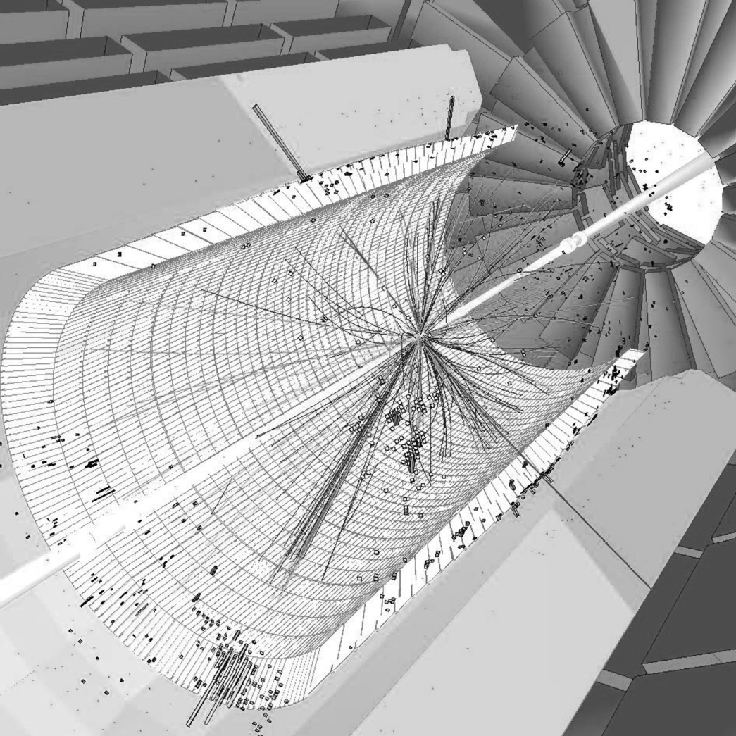
Fig. 2-1: A simulated particle collision demonstrates the data collected by the CMS experiment. Image Copyright CMS Experiment at CERN.
In general, the major signal processing topics for HEP applications can be divided into four areas:

- Control and Synchronization - Particle colliders are accelerate two beams of atomic or sub-atomic-scale objects to relativistic speeds and successfully colliding the objects in these two beams. This requires highly sophisticated control over the superconducting magnets responsible for guiding and accelerating the beams [11]. Achieving high collision rates can require GHz-scale sampling rates and a dynamic range of 100 dB [12]. Control systems are also necessary to monitor and calibrate the experiments. Furthermore, particle collisions are extremely short-lived events; great care must be taken to ensure proper timing and clock synchronization of all systems to ensure that these events are properly sampled and processed [13] [14].
- Detector Sampling and Signal Conditioning - HEP systems feature huge quantities and varieties of sensors, such as crystals, photodiodes, cathode strips, drift tubes, resistive plates, scintillators, Cerenkov counters, charge-coupled devices, and other materials. A single experimental system may contain many of these sensor types. Each group of sensors must be sampled and reconstructed using techniques suited to the particular technology deployed. To properly isolate the data of individual particles, the signals coming from the sensors must also be carefully filtered to remove background energy noise and phase-adjusted to compensate for non-linear amplification effects [15].
- High-Speed Communications - The large number of sensors required in HEP systems and massive amount of data these sensors produce may require thousands of high-bandwidth, low-latency data links. They may also need complex communication systems to transport the experimental data to external computing resources for analysis. These systems may bridge electronic and optical links, cross clock domains, handle compression and error detection, and act as translators between protocols. The communication links may also be radiation-hardened to compensate for higher levels of background radiation from the accelerator [16].
- Triggering and Data Acquisition - The quantity of data recorded by most HEP systems exceeds the capabilities of general-purpose computing systems. Dedicated signal processing hardware is required for low-resolution processing of the raw data to determine which data should be acquired for complex analysis and which data should be discarded. This generally amounts to a pattern-recognition problem; the sensor data must be analyzed to identify and isolate the particles produced in collisions. The hardware must then decide, for each set of data, whether or not it will be recorded for further analysis. This process is called `triggering'.
Although the topics of control, signal conditioning, and high-speed communication present substantial challenges, their basic characteristics are not significantly different in HEP applications than in other applications. The main focus of this chapter is instead on triggering, the low-resolution processing that analyzes the raw sensor data and identifies and sorts particles produced by the collisions, as this is a unique challenge of HEP applications. The particle recognition problem is compounded by the nature of HEP systems, whose large scale, high cost, and specialized function make each system unique. There are only a handful of HEP systems operational at a given time, and each is generally designed for different types of experiments. This means that new systems must typically be designed from scratch and customized to meet the special needs of the new experiments.
Beyond the technical challenges inherent in measuring and identifying short-lived sub-atomic particles, the creation of systems for HEP applications also offers significant challenges to the design process. The giant size of the systems, combined with the diversity of knowledge needed to create systems for advanced theoretical physics, necessitates large, distributed development teams. Ensuring efficient collaboration and producing reliable, maintainable, cost-effective, and high-quality designs is a major challenge that requires the use of new tools and techniques.
In this chapter, I characterize the key features and most significant challenges of designing DSP systems for HEP. This includes a description of modern HEP systems, the important problems these systems are attempting to solve, and the role of DSP in achieving these goals. In Section 2.2, I introduce the CMS experiment and describe some of the important features of its data acquisition and triggering systems. In Section 2.3, I outline the key technical and developmental characteristics common to HEP applications and discuss the technical challenges of designing HEP systems. In Section 2.4, I cover the tools, techniques, and technology needed to efficiently manage the development process.

The Compact Muon Solenoid Experiment
High-energy physics experiments are performed throughout the world, from Stanford's SLAC National Accelerator Laboratory to the Super-K observatory in Japan. In the future, HEP applications may extend beyond the Earth to space-based observatories, such as the proposed Joint Dark Energy Mission [17]. The largest and most prominent HEP application at the time of this writing is CERN's Large Hadron Collider, near Geneva, Switzerland. The LHC is the highest-energy particle accelerator ever created and among the largest and most massive man-made machines ever built. The ring-shaped main accelerator track is over 27-km in circumference. It is capable of accelerating protons to over 99.999999% of the speed of light and generating collision energies exceeding 10 Tera-electron-Volts (TeV). The LHC hosts a number of major experiments, each of which consists of collision chambers with thousands of sensors and associated hardware for processing the sensor output data.

Physics Research at the CMS Experiment
The Compact Muon Solenoid detector is one of the main experiments at the LHC. CMS is considered a general-purpose experiment because it is used to search for a variety of different high-energy phenomena and may be adapted for new experimental searches in the future. Earlier accelerators, such as the Tevatron, have shared some of these goals. However the higher energy collisions produced by the LHC allows its experiments to investigate physics phenomena over a much larger energy range [4]. CMS is one of two complementary experiments, the other being ATLAS. Because CMS and ATLAS share the same experimental goals, many of the technical characteristics of CMS are also found in ATLAS.

The Higgs Boson
The Standard Model of particle physics is the closest scientists have come to a `holy grail' of science: the creation of a Grand Unified Theory that describes all of the particles and forces in the Universe using a single set of consistent rules. The Standard Model has been in development since the 1960s, and is currently an accepted theory that is taught to students of physics. The Standard Model accounts for all fundamental forces, except for the gravitational force. Moreover, 23 of the 24 fundamental particles predicted by the Standard Model have been observed by scientists. The only particle that has been predicted, but not yet observed, is the Higgs Boson. The Higgs Boson is a very significant particle in the Standard Model, as it is the sole particle responsible for giving mass to matter, through a phenomenon known as the Higgs Field. Previous searches for the Higgs at lower energy levels have not been successful, but scientists believe that the TeV-scale energy at the LHC is high enough that they should be able to find the Higgs if it exists [5]. Evidence of the Higgs would solidify the Standard Model. Perhaps more interestingly, if scientists fail to find any evidence of the Higgs, it would suggest a significant flaw in the long-accepted Standard Model and stimulate scientists to explore alternate theories.

Supersymmetry
Supersymmetry (SuSy) represents one of the most actively-studied potential extensions to the Standard Model [18]. SuSy theorizes that every known particle also has a ‘superpartner’ - that is, a corresponding particle with complementary properties, but a much larger mass. The existence of superpartners could provide solutions to several major unsolved problems in physics. For example, superpartners could be the components of dark matter, and explain why the Universe appears to have significantly more matter in it than scientists have observed. Another benefit of discovering superpartners is that SuSy would synthesize the strong nuclear force and electro-weak force into a single unified force. SuSy is also a component of several other modern theories, such as String Theory. There is a possibility that the high-energy collisions at the CMS experiment will generate evidence of the existence of superpartners.

Extra Spatial Dimensions
Some theorists have argued that some of the apparent unanswered problems in physics, such as dark matter [19], can be resolved through the existence of additional dimensions beyond the four space-time dimensions that we perceive. The existence of extra dimensions is also an essential facet of String Theory. A joint experiment between the LHC's CMS and TOTEM systems could potentially detect the effects of gravity from a 5th dimension [20].

Quark Compositeness
On several occasions throughout the history of particle physics, physicists have believed they had found the most basic building blocks of the Universe, only to discover that those blocks were in fact made up of even smaller and more basic pieces. Scientists found that atoms were made up of protons, neutrons, and electrons; later they discovered protons were made up of quarks, which are currently considered to be elementary particles. Some physicists have hypothesized that quarks may themselves be composite structures made up of even smaller particles called ‘preons’ [21]. Part of the CMS experiment includes measurements that could be used to find evidence of preons.

Sensors and Triggering Systems
To enable the search for new phenomena, the cylindrical CMS particle detector consists of several layers of highly complex sensors. In total, the layers are nearly seven meters thick, and each layer takes unique measurements designed to identify different classes of particles. The innermost section of the cylinder is a silicon-based particle tracker that is capable of measuring the deflection of particles subjected to a strong magnetic field. It is used to calculate the charge-to-mass ratio of the particles produced in collisions and reconstruct their trajectories. Beyond the tracker are the Electromagnetic and Hadron Calorimeter layers. These sensors absorb electromagnetic particles and hadrons - two types of fundamental particles - and measure their energy. The calorimeters are surrounded by many layers of muon absorption chambers, designed to capture muons - a class of weakly interacting particles - that pass through the calorimeters [6]. An image of the CMS detector as it was being assembled is shown in Fig. 2-2.
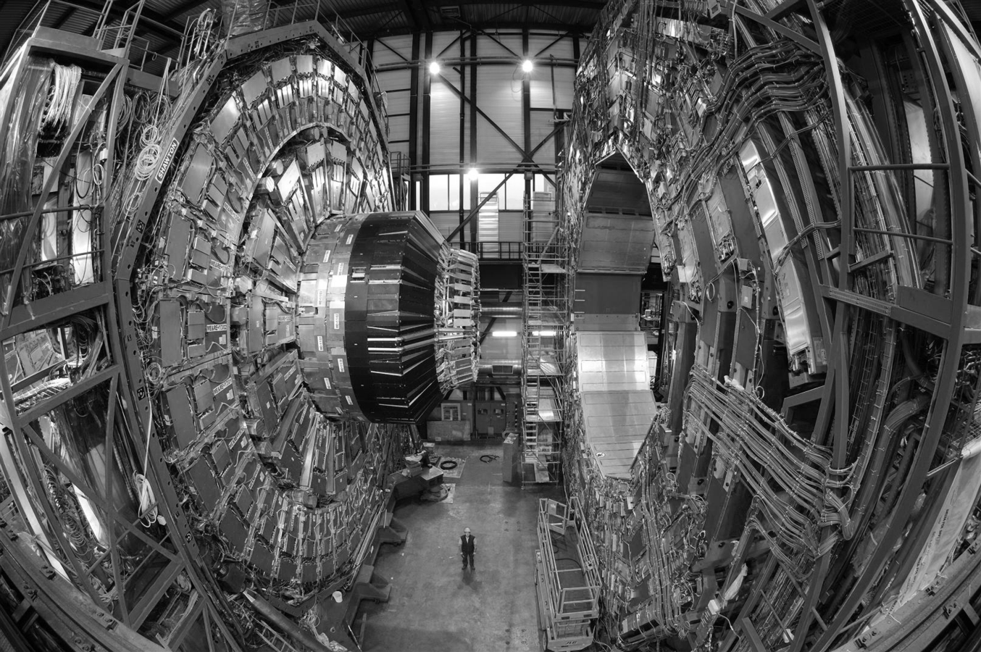
Fig. 2-2: A cross-section of the CMS detector during assembly. Image Copyright CMS Experiment at CERN.
Handling the data produced by these sensors presents significant challenges. The tracker monitors particle trajectories by detecting particles passing over micrometer-scale semiconductor strips. If the tracker's silicon detectors are viewed as analogous to a camera sensor, the CMS tracker has a resolution of 66 megapixels, with each pixel representing a detector with its own data channel. Unlike a typical digital camera, which can take at most a few shots per second, the CMS sensors take a new snapshot of particle collision data at a rate of up to 40 million times per second. The tracker, however, only provides part of the sensor data that must be processed; the two calorimeters each provide an additional 4096 data channels, with each channel producing an 8-bit energy measurement. In total, the accelerator is capable of producing collisions at a peak instantaneous event rate of about one billion collision events per second. Each event produces approximately 1 Megabyte of data from the tracker and calorimeters, resulting in a peak data rate of 1 Petabyte per second (PB/s). To put this data rate in perspective, it would take over 10 million modern hard disk drives working in parallel in order to achieve a high enough write speed to store all of this data. If all of the data could be written to archival media, there are barriers preventing analysis by general-purpose computers. Even if a computing cluster with 1-Gigabit-per-second (Gb/s) Ethernet links was available, it would require tens of thousands of links to transport the data to the computers.
Clearly the ultra-high data rates produced by the CMS detector make the prospect of archiving the data for offline processing infeasible using today's technology. In order to make the problem tractable, the data rate from the experiment's sensors must be significantly reduced before the sensor data is stored. At first, it might seem appealing to simply slow the rate of collisions. After all, millions of collisions each second may seem unnecessarily high. However, there are two key concepts about HEP applications that make such high collision frequencies necessary. First, if the particles and phenomena searched for in the CMS experiment actually exist, they are extremely short-lived and difficult to observe. It may require a tremendous number of collisions to first produce and then successfully observe the phenomena. Second, even with some of the most advanced controls and technology in the world, the task of colliding two protons head-on at nearly the speed of light is incredibly difficult. The vast majority of collisions occurring in the experiment are low-energy glancing collisions that are unlikely to produce interesting data. Indeed, one of the common goals of HEP system designers is to maximize the accelerator's luminosity, a measure of the efficiency with which collision events occur each time the accelerator causes its particle beams to cross. Beams are not continuously distributed streams of particles, but are in fact made up of a series of spaced particle clusters. The rate at which these clusters impact the clusters in the opposing beam is referred to as the bunch crossing rate. Together, the luminosity and bunch crossing rate determine the collision event rate, and consequently the processing throughput needed to analyze the events that are produced.
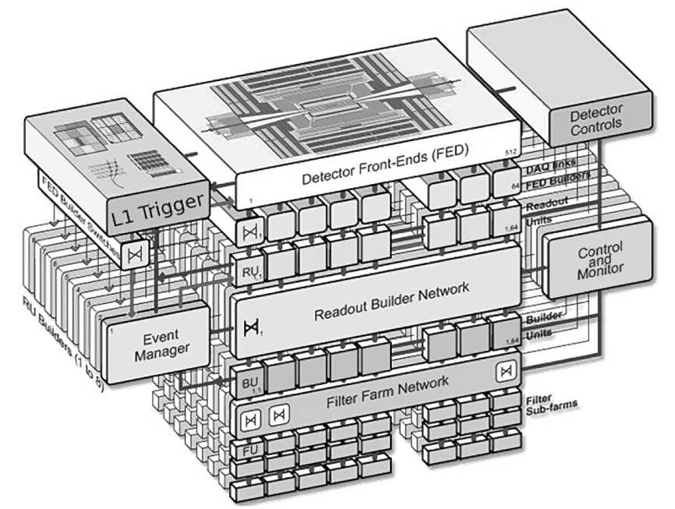
Fig. 2-3: The CMS Trigger and Data Acquisition System. The Level-1 Trigger controls which events are sent from the CMS detector to CERN’s farm of computers and determines which events to discard. Image Copyright CMS Experiment at CERN.
The ideal solution to this problem is to create a signal processing system that can specifically identify and isolate the data produced by scientifically interesting collisions and discard data from low-energy collisions. The system then relays only the potentially interesting data to archival storage. In HEP systems, this process is called triggering. CMS accomplishes its triggering function using a complex signal processing and computational system dubbed the Triggering and Data Acquisition Systems, or TriDAS [8]. TriDAS is a two-level, hybrid system of signal processing hardware and physics-analysis software. The frontend Level-1 Trigger is custom, dedicated hardware that reduces the peak sensor data rate from 1 PB/s to 75 Gigabytes per second (GB/s). The backend High-Level Trigger is a software application running on a computing cluster that further reduces the data rate from 75 GB/s to 100 Megabytes per second (MB/s). At 100 MB/s the data rate is low enough that it can be transferred to archival storage and analyzed offline with sophisticated algorithms on high-performance workstations. A diagram of the CMS TriDAS is shown in Fig. 2-3.
To decide which data to keep versus discard, triggering systems must identify discrete particles and particle groups created by the collisions. A perfect system would record data from only those collisions that exhibit the physical phenomena that are being studied in the experiment. However, due to practical constraints on how quickly the data can be analyzed and how much data can be economically stored, it is not feasible to create perfect triggering systems for experiments with high collision rates. In real systems, designers manage hardware cost by placing a threshold on the number of particles or particle groups that will be retained from any one event. The system sorts particles and groups by their energy levels. Data for the top candidates (up to the threshold) is retained; the remaining data is discarded.
The CMS Level-1 Trigger is actually made up of multiple specialized hardware systems designed to identify specific particle types, such as photons, electrons, taus, muons, and high-energy particle groups called jets. Once particles are identified and classified, each type is separately sorted and the highest-energy members of each class are sent to the High-Level Trigger software for further processing.
The triggers for the LHC system have some interesting features that differentiate them from those of previous accelerators. The LHC's luminosity and bunch crossing rate are both very high. At peak rate, there is a bunch crossing every 25 ns. Each bunch crossing generates about 20-30 collision events. This translates to a collision event rate approaching 1 billion events per second. In comparison, the Tevatron's D0 experiment performed bunch crossings every 3 µs in 1989 [22], and the Large Electron Positron-II's L3 experiment produced bunch crossings every 22 µs in 1998 [23]. Not only does the LHC's high collision rate produce much higher data bandwidth, the length of processing time between groups of data is on the order of one thousand times less than that of previous large particle accelerators.

The triggering systems for each of these accelerators do have some features in common. They each use multi-level triggering systems where the first level(s) are composed of high-performance dedicated DSP hardware and the later level(s) are composed of software running on general-purpose hardware. As time has passed and hardware has become faster, new technologies have been integrated into the hardware levels of more recent system designs. For decades, early triggers relied primarily on fixed-function Application-Specific Integrated Circuits (ASICs), discrete memories, and occasionally custom DSP processors [24] [25] [26] [27]. Around the mid-1990's, triggers began incorporating programmable logic into their triggers. Today, ASICs still play an important role in the most performance-critical functions, but more-flexible Programmable Logic Devices (PLDs), such as Field-Programmable Gate Arrays (FPGAs) have become pervasive in trigger logic [28] [29] [30] [31] [32].

The Super Large Hadron Collider Upgrade
To understand many of the motivations behind design decisions in HEP systems, it is important to evaluate them in the context of the projects' massive size and cost. While it is difficult to get an exact number, publicly released figures put the cost of designing and building the Large Hadron Collider at more than $5 billion as of 2009. The time from project approval to project completion spanned over 10 years, despite the reuse of facilities from LHC's predecessor, the Large Electron-Positron Collider. These high costs and long design times provide a firm motivation to design the LHC to be as flexible as possible for future needs to ensure that the useful life of the experiment can be extended, even after the initial experiments have run their course.
The cost and time of constructing a new accelerator, coupled with difficult economic conditions that have contributed to funding cuts to many scientific institutions, have provided strong motivation to adopt flexible systems that can be upgraded and kept in use as long as possible. For example, Fermilab's Tevatron, the highest-energy particle accelerator prior to the LHC, stayed in operation for over 20 years and had several major upgrades to extend its lifetime. To this end, the Level-1 Trigger hardware of the LHC's CMS system is designed to strike a balance between the high-performance of fully dedicated custom hardware and the flexibility needed to ensure that the systems can adapt to changes in experimental parameters and research goals. Triggering decision thresholds are fully programmable. Particle identification algorithms are currently implemented in RAM-based look-up tables to allow adjustment or even full replacement of the algorithms. For most of the history of trigger design, RAM-based look-up tables were the primary means for incorporating reprogrammability in triggering algorithms, however the potential for using them was limited due to their high relative costs. Modern systems, like the CMS Level-1 Trigger, increase flexibility further by replacing many fixed-function ASICs with reprogrammable FPGAs [8]. The adoption of FPGA-based platforms is a broad trend in the development of HEP systems and one of the key characteristics in the design of modern systems [33] [34] [35]. The specific impacts of the use of FPGAs in HEP systems are discussed in depth in Chapter 4, and several FPGA-driven modifications to the CMS RCT algorithms are presented in Chapter 6.
Although the initial CMS Level-1 Trigger used some programmable hardware, at the time it was designed performance considerations limited many components to using fixed-function electronics [36]. The flexibility provided by the limited amounts of programmable hardware should allow for some modifications to the system over the initial LHC's planned lifetime. However, a significant proposed LHC upgrade, known as the Super Large Hadron Collider (SLHC), requires a redesign of the triggering systems for the experiments. This redesign will replace most of the remaining ASICs with reconfigurable hardware, increasing system flexibility.
The purpose of the SLHC upgrade is to boost the LHC's luminosity by an order of magnitude, with a corresponding increase in collision rate. This could allow the accelerator to continue to make new discoveries years after the original experiments have run their course [37]. Naturally, increasing the collision event rate places significant strain on the triggering system, since this system is responsible for performing the first-pass analysis of the event data. The existing Level-1 Trigger hardware and algorithms are insufficient to handle the SLHC's increased luminosity, and must thus be upgraded [38] [39]. The design problems of this upgrade provide examples of the challenges of modern system design for HEP applications.

Characteristics of High-Energy Physics Applications
Although every HEP system is different, many of them share certain high-level technical and design-oriented characteristics. Understanding the unique features of HEP applications is key to designing signal processing systems for these applications.

Technical Characteristics
Many of the technical challenges of HEP systems derive from their extreme scale. This scale gives rise to several important technical characteristics of HEP applications, discussed here using concrete examples from the CMS Trigger introduced in Section 2.2.

Number of Devices
The thousands of sensor data channels in HEP experiments require that they use very large quantities of signal processing devices. The CMS Level-1 Trigger, for example, requires thousands of FPGAs and ASICs for its particle identification, isolation, and ranking functions, which in turn represent a great expense for construction, installation, and fault testing. Furthermore, the large device count makes it difficult to ensure reliability due to the numerous potential points of failure.
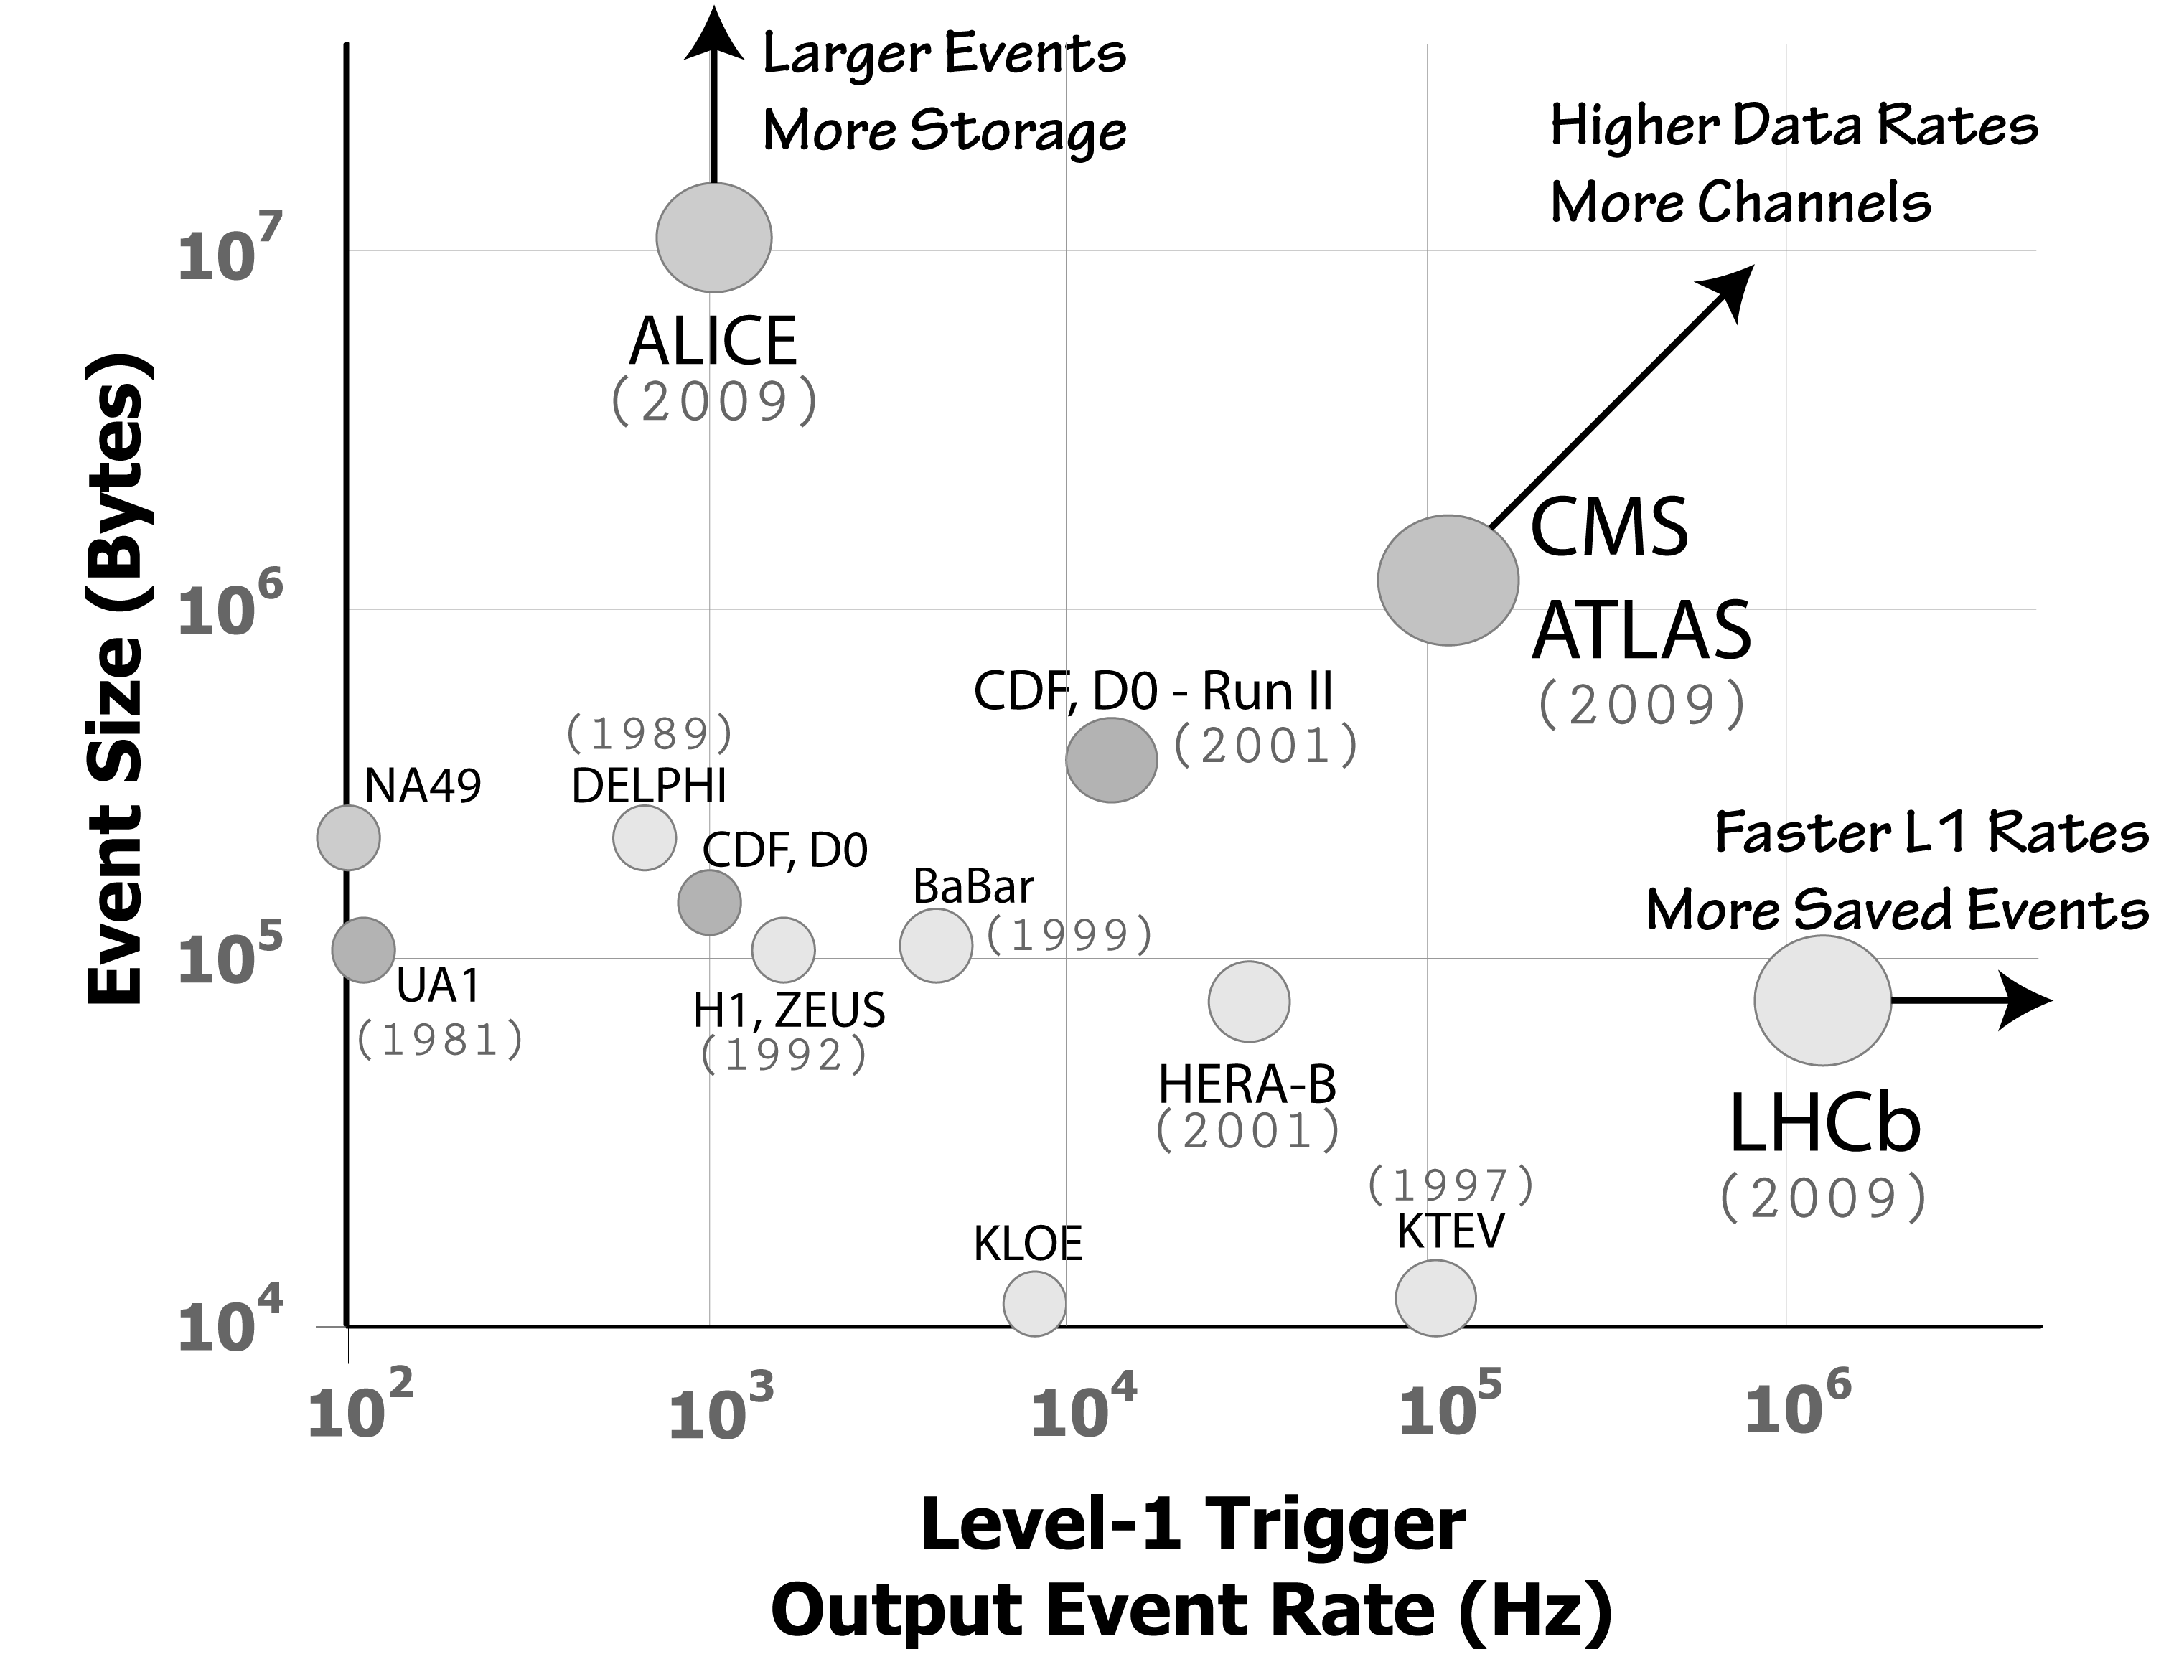
Fig. 2-4: Data and triggering rates for HEP experiments have increased by orders of magnitude over the past few deacades. The LHC experiments ALICE, ATLAS, CMS, and LHCb produce exceptionally high rates (Note that both axes use a log scale and data rate increases radially from the origin).

Data Rates
Colliding billions of particles per second and recording the resulting data requires tremendous bandwidth to transport sensor data to the processing systems. It also requires large amounts of temporary storage to hold collision data while waiting for triggering decisions. As new systems are created with higher luminosity and increasingly sensitive detectors, data rates produced by HEP applications have rapidly increased [40], as shown in Fig. 2-4. The Tevatron's CDF-II experiment, for example, produced a raw data rate of up to 400 GB/s [41]. The CMS detector, on the other hand, can produce a peak data rate approaching 1 PB/s. This data is held in temporary buffers until the trigger system determines what portion to send to archival storage, which is limited to a rate of 100 Mb/s. The huge amount of raw data is compressed, but still results in an input data rate of hundreds of GB/s to the CMS Level-1 Trigger. The SLHC upgrade will further increase that data rate by both adding new sensors and increasing the luminosity (event rate) [38].

Interconnection
Systems that make global decisions based on thousands of sensors must necessarily feature a large amount of interconnection. Because the triggering algorithm needs to sort and rank particles, it must obtain global information from across all of the Trigger subsystems. Each of these subsystems must connect to the global sorting system, requiring high fan-in. This global processing, combined with a need for internal data sharing within subsystems, creates a tremendous amount of interconnection within the triggering system. This interconnection adds to the cost and complexity of the system and can make testing and modification more difficult.

End-to-End Latency
The extremely high amounts of data produced by HEP sensors can quickly overwhelm the storage capabilities of the temporary data buffers. The LHC, for example, performs a new group of particle collisions every 25 ns at its peak rate, producing up to 1 Petabyte of data per second. In a general HEP system, the detectors that produce this data can be grouped into two categories: fast-readout and slow-readout. Fast-readout detectors can be fully read for each bunch crossing. Data from the fast-readout detectors is used in the first-level triggering decisions. Slow-readout detectors can only transfer a portion of their total data for each bunch crossing. Data from these detectors is stored in local buffers until a triggering decision is made. The first-level triggering decision is used to decide which portion of data from the slow detectors should be acquired and which should be discarded. Thus, triggering systems must make their decision as to which data to discard within a very short window of time to prevent the size of the data buffers from becoming prohibitively costly and to be able to select the data to read from the slow detectors before it is overwritten by data from the next bunch crossing. This means that these systems must be able to perform all of their processing in a matter of milliseconds to microseconds. The CMS Level-1 Trigger, for example, must provide triggering decisions within 3.2 µs of the collision event. Network transport delays occupy a significant portion of this time, leaving a computation window of less than 1 µs. Thus, the Level-1 Trigger must accept new data every 25 ns and must identify, isolate, and rank the particles contained in that data within 1 µs of receiving it. These tight latency requirements, combined with the high bandwidth requirements, are the primary technical constraints that require the Level-1 Trigger processing to be done in hardware rather than as software on commodity processors.
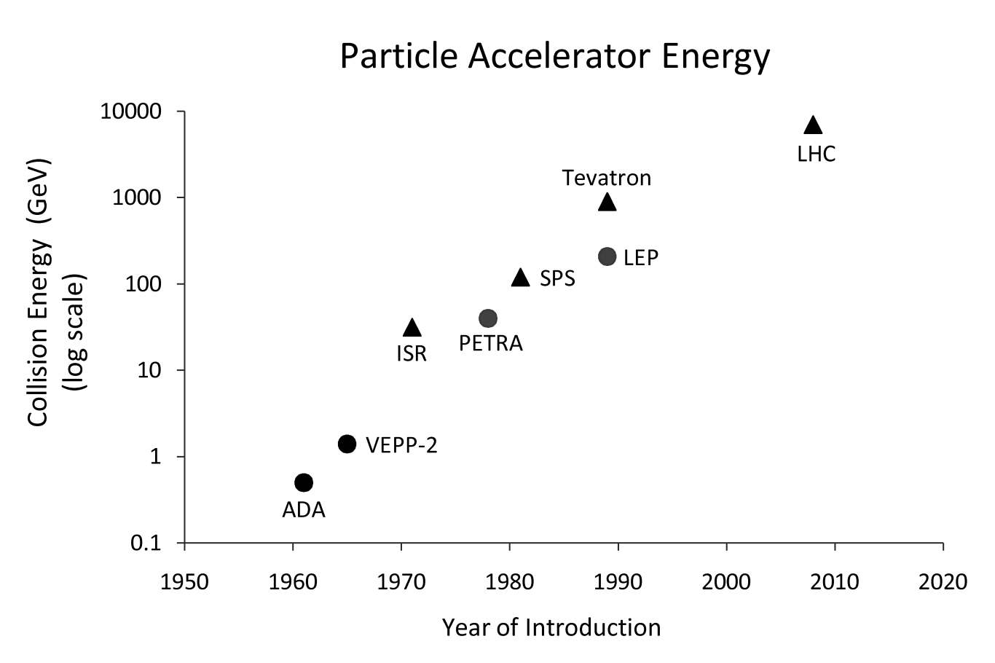
Fig. 2-5: Accelerator collision energies have been increasing at an exponential rate. Consequently, many technical parameters of trigger systems, such as their rejection rate, throughput, and processing latency have become much more stringent.
Because the processing requirements of triggering systems are motivated by detector read-out constraints, the low-latency and high-bandwidth challenges are inter-related, and both are directly affected by the rate of collision events being produced in the experiments. The level of collisions being produced at different particle accelerators is by no means the same, and is driven by the type of accelerator and the goals of the experiments. Experiments that produce collisions at very low rates - those studying neutrino interactions for example - typically have relaxed requirements for their triggering systems [42]. However, the largest, most complex, and most expensive accelerators that have been built are proton-anti-proton, electron-positron, or heavy-ion colliders, such as the LHC, the Tevatron, the Large Electron Positron Collider, and the Relativistic Heavy Ion Collider. These accelerators have historically required triggering systems with low-latency and high-bandwidth requirements that pushed the limits of the technology available at the time of their design [33] [43] [31].
Looking toward the future, the technical requirements of the LHC upgrades and post-LHC accelerators are likely to pose even more significant challenges. Historical trends show that particle accelerator collision energies have been increasing at an exponential rate [44], as seen in Fig. 2-5. Higher energy collisions may correlate to even shorter-lived particles and higher rates of interesting collision events. These higher collision rates will likely be necessary, as even with extremely high collision rates, some high-energy phenomena still occur very rarely. For example, despite producing one billion collisions per second at the LHC, it is still predicted that a Higgs boson, if it does exist, will only be produced at a rate of 0.1 Hz [45]. Higher collision rates will put more pressure on the detector's local buffers, making it unlikely that advances in memory density will eliminate the need for low-latency triggering systems. Overall, higher collision rates also require more bandwidth to trigger systems and mandate a higher rejection ratio, that is, the ratio of events that are discarded to events that are kept. As rejection ratios increase, it becomes more critical that the trigger select the right candidate events to save. This motivates more complex algorithms and processing of data in the trigger. Overcoming the technical signal processing challenges may be one of the key aspects of making new accelerators feasible.

Characteristics of the Development Process
It may be tempting to focus exclusively on the technical specifications of HEP applications as the primary source of complexity in HEP system design. However, it is important not to overlook the challenges in the development process itself, which may also be a significant factor in the development time, cost, quality, and maintainability of a system. For example, during the initial design of the CMS experiment, the development and testing of firmware for programmable logic devices proved to be a major bottleneck. These development challenges stem from several distinguishing features of the HEP system design process.

Wide-Scale Collaboration and Disparate Design Styles
Most HEP systems are too large to be created by a single institution. For example, the design of the CMS Trigger system was the product of the CMS Collaboration, made up of over 3000 scientists and engineers from nearly 200 universities spread across 38 countries. Although this collaboration supplies the great breadth and diversity of knowledge needed for HEP engineering projects, managing large groups across multiple languages and time zones is a formidable task. The existence of numerous, separate design teams may also give rise to multiple design approaches, some of which may not be compatible. One of the consequences of the diversity of the collaborative development teams and the large scale of the system design is that the CMS Trigger subsystems have been designed by many groups from different organizations and different countries. Because the firmware designers come from a variety of backgrounds, it is natural that they produce a variety of disparate design styles using their favored hardware design languages and methodologies. A famous example of the problems that can arise from these differences is the loss of the Mars Climate Orbiter probe in 1999 [46]. One group of designers assumed that all measurements would be made in Imperial units whereas another group assumed they would be made in metric units. Because of these differing assumptions, the probe's thrusters fired at the wrong time, and it crashed through the atmosphere.

Frequent Adjustments and Alterations
Despite significant simulation and theoretical modeling, the experimental nature of HEP and the unprecedented energy of the LHC mean that it is inevitable that some aspects of the system and the algorithms it implements will need to be adjusted after the system comes online and starts collecting real collision data. It is not cost-effective to replace hundreds of devices each time an algorithm is changed, so designers must anticipate which portions of the system may require adjustment after deployment and design those sections with reconfigurable logic to provide the needed flexibility.

Periodic Upgrades
The economics of particle accelerators make it likely that it may be decades before the LHC is replaced. During this time, the LHC will be subject to a periodic series of large technology upgrades to allow for new experiments and the expansion of existing experiments. Other particle accelerators have followed a similar pattern of large-scale upgrades to extend their useful lifetimes. The Tevatron, for example, originally finished construction in the early 1980's, but continued receiving major upgrades until the turn of the century, allowing it to continue operation through 2010. The proposed SLHC upgrade is 10-year project, and will consist of a series of several incremental upgrades to the existing LHC systems.

Long Development Lead Times
Each new particle accelerator is designed to be larger and higher-energy than its predecessors to facilitate new experiments that were not possible with previous accelerators. The design and construction of a new particle accelerator is therefore a monumental project. The Large Electron-Positron Collider took 13 years from the beginning of its design in 1976 to the start of experiments in 1989 [47]. The LHC project was approved in 1995, and it was not until 2008 that the first beams were circulated in the accelerator.

Evolving Specifications
The LHC had a 10-year initial development cycle, and it is predicted that its eventual successors may require design times measured in decades. Because of the high costs of constructing new accelerators, scientists try to prolong the lifetimes of existing accelerators through long-term upgrade projects. These upgrades may keep the development process active for many years after the initial construction. Long design windows and frequent upgrades mean that designers must grapple with continuously evolving sets of specifications. Major design specifications, including the hardware platform and interface, may undergo several changes during the initial design period, and often these changes may be dictated by system-wide decisions beyond the subsystem designers' control. Hardware engineers must take care to create scalable, adaptable designs to deal with potential changes. However, this can create conflicting design goals. On one hand, designers should try to exploit specific hardware features as much as possible to obtain the best performance, meet the strict requirements of the HEP project, and reduce the cost of their systems. On the other hand, any designs that are tied too closely to specific hardware may require significant and time-consuming redesigns if design specifications or the hardware platforms change. Because of the extremely long development cycles, engineers may even wish to plan ahead and create designs that surpass today's technology with the expectation that by the time the system is ready to be built, technology will have advanced sufficiently to implement the designer's vision.

Functional Verification and Testing
As the scale and complexity of hardware designs increase, the difficulty of verifying correctness and diagnosing bugs tends to increase at a super-linear rate. In addition to the large scale of HEP systems, there are a number of other facets of the development process that make the testing process formidable.
In the initial design stage, algorithms implemented in hardware must be verified to be equivalent to the original physics algorithms that were developed and tested in high-level software simulators. Providing equivalent testing is often a complex process. Although the software and hardware are essentially implementing the same algorithm, the form of the computation differs. Software is typically easiest to write in a sequential fashion whereas high-performance hardware systems are created to be explicitly parallel. The hardware and software simulators may produce similar end results, but the difference between parallel and sequential simulation can cause mismatches at intermediate points of the computation. This means that it is difficult to share and reuse the same modular testing infrastructure between both the hardware and software.
In the construction stage, the actual hardware must be tested to ensure that it operates identically to the pre-verified simulated hardware design. If there are bugs or performance glitches, they must be detected and properly diagnosed so that they can be repaired. Because triggering systems require global decisions across thousands of sensors, there is a significant amount of interconnection between subsystems. Large amounts of interconnect can make it difficult to isolate bugs to individual subsystems. In the design stage, a hardware engineer may need to simulate large subsections of the overall design and track bugs across numerous subsystems to find their source. The bug tracking process is slowed by the fact that individual subsystems are likely designed by different teams, using different design styles and potentially different design languages. These subsystems may use different hierarchal structures and require different internal testing interfaces.
Despite rigorous testing, it is inevitable that any complex system will exhibit bugs and performance issues even after the first assembly is complete. Particularly in a complex system such as the CMS Trigger, which requires high-speed communications and tight latency deadlines, it is difficult to ensure proper timing and synchronization between subsystems.

Unit Modification
In addition to bug fixes, regular modifications to the experimental physics algorithms can be expected. As physicists begin collecting real data, they will be able to better tune their algorithms to meet the characteristics of the experiment. These modifications may require frequent changes to the Trigger firmware. To accommodate the need for algorithmic changes, the original CMS L1 Trigger design used re-programmable FPGAs wherever possible, provided they could meet the strict performance requirements. The CMS L1 Trigger upgrade extends this approach even further by replacing almost all fixed-function ASIC hardware with modern high-performance FPGAs. However, while FPGAs may allow for rapid, low-cost modifications to the physics algorithms, there is no guarantee that after the changes, the original hardware timing will be maintained. Changes in timing could affect other parts of the system. For example, FPGA firmware modifications could increase device latency. If the latency change is severe enough, the system may now fail to meet the timing requirements of the system. Other parts of the system may then require modification to once again meet timing constraints. Localized changes thus have a potential system-wide impact.
Moreover, changes to the algorithms implemented on an FPGA may also affect resource utilization of each device. If in initial designs, hardware designers try to maximize the resource utilization of each FPGA to minimize the total number of required devices (and consequently the cost and complexity of the system), they may find that there are not enough free resources remaining to implement needed algorithmic changes. On the other hand, if designers leave the FPGAs under-utilized to reserve space for future modifications, they may end up needing an excessive number of devices and needlessly increasing the cost and complexity of the system.

Techniques for Managing Design Challenges
The challenges of system design for HEP applications can be managed by adopting strategies and techniques geared towards the unique properties of such applications. In this section, I outline several techniques that may be applied to improve the development process.

Managing Hardware Cost and Complexity
Cost and complexity concerns factor into all of the major design challenges mentioned. However, one aspect that is particularly worth focusing on is the choice of technology platform, as this choice has far-reaching effects on the system cost. The technical features of HEP, particularly the very high data rates and low latencies required for the triggering systems, make it infeasible to implement these systems purely in software running on commodity computers. This is somewhat unfortunate; the high degree of flexibility provided by software implementations of algorithms, in conjunction with the fact that physics algorithms are originally developed and simulated in software, would make a software-based system very attractive in terms of designer productivity.
On the other end of the spectrum is the use of custom, fixed-function triggering circuits. ASIC-based systems of this sort were prominent from the advent of particle accelerators in the 1930s up to the present. ASICs provide the highest possible performance, which is often a requirement for the high data rates of particle accelerators. However, designing custom ASICs is very expensive, and circuits designed for HEP applications are necessarily very low-volume since there are only about 20 active particle accelerators worldwide. ASICs are also generally inflexible, and making large changes to ASICs is likely to require replacing the chips after a lengthy and expensive redesign and re-fabrication process. Furthermore, as custom parts, there is potential for significant delays if there are quality-control problems during fabrication.
Occupying a space somewhere between ASICs and general-purpose computers are programmable logic devices, particularly FPGAs. These devices give some of the performance advantage of ASICs while allowing for greater flexibility through hardware-based programmability. In theory, a re-programmable device can have its function modified quickly and frequently by revising and reloading its firmware on-site. This avoids the costly and time-consuming process of designing and fabricating a completely new device. FPGAs also have the advantage of being commodity parts, meaning that the cost of fabrication and device testing is amortized across all customers for the particular device, and not borne solely by the particular HEP system.
One of the key trends in HEP systems over recent years is due to the rapid progression of semiconductor technology. FPGAs, although still slower than ASICs, are now fast enough and have enough communication bandwidth to handle most of the HEP-related functions that previously required ASICs. This has led to a trend of converting the high-performance hardware frontends of HEP triggering systems from rigid ASIC-based systems to more flexible FPGA-based systems. Whereas the original CMS Level-1 Trigger was a mixture of ASICs and FPGAs, the Trigger re-design for the SLHC upgrade will eliminate most remaining ASICs in favor of FPGAs. One of the Trigger subsystems that is to be converted is the Electron ID system described in Sections 5.5 and 6.4, and shown in Fig. 2-6. This system contains over 700 ASICs and thousands of RAM chips that will be converted to FPGAs.
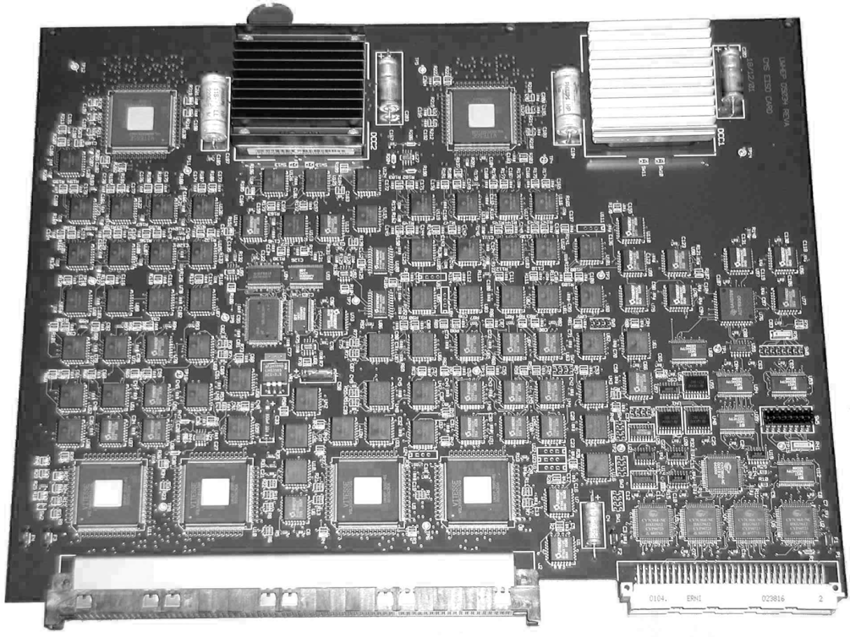
Fig. 2-6: One of 126 ASIC-based boards in the CMS Trigger’s Electron ID subsystem. These boards will be replaced by FPGA-based boards in the SLHC upgrade.
Though FPGAs provide more flexibility than ASICs, they are not the solution to every problem. Some algorithms are simply better suited for software than hardware --- for example, those that require recursion, traversal of complex data structures, or scheduling of operations with non-deterministic execution times or resource requirements. Therefore, most triggering systems feature both a hardware-based frontend and a software-based backend. These hybrid systems provide appropriate levels of control and flexibility while still meeting performance constraints. In the past, software-based trigger levels were commonly implemented in DSP processors, however the trend in modern systems is toward general-purpose processors [30] [29] [48] [33] [49] [50]. This is primarily motivated by the higher degree of expertise needed to create software for DSP processors and the growing complexity of trigger software [51] [52].

Managing Variable Latency and Variable Resource Use
As described in the previous sections, FPGA technology has been widely adopted in the CMS Trigger to allow flexible system modifications and upgrades. However, modifying the algorithms implemented on FPGAs has the potential to change the circuits' latency and resource use. In some cases, this could mean that algorithmic changes either cannot fit on the existing chips or cannot meet timing constraints without lengthy and expensive modifications to the rest of the system. Thus, it is important that FPGA-based designs follow a modular approach, in which functional modules are self-contained and ideally can be modified without impacting other modules.
Each of the techniques for controlling the latency and resource use of a design incurs some costs. Therefore, when choosing techniques to use, it is important to identify which portions of the subsystem's functionality are actually likely to change. Some functions, such as the generation and calculation of input primitives, are essential enough to the Trigger's functionality that they can be assumed to be fixed and may be implemented using fast and efficient direct implementations. The original Level-1 Trigger uses high-performance ASICs to perform functions such as generating energy sums from the calorimeter-based sensors and sorting the energy values of the isolated particles. Other functions, such as jet reconstruction (described further in Sections 5.10 and 6.2), may require frequent changes to adapt to the performance of the accelerator.
This section presents three approaches to minimize the impact of algorithmic changes on latency and resource use; resource reservation, worst-case analysis, and fixed-resource and fixed-latency structures. A designer may use one or more of these approaches to accommodate future changes to FPGA-based modules without creating system-wide disruptions.

Resource Reservation
Resource reservation is a fairly passive approach to handling variable latency and resource usage. This technique simply sets aside a portion of the device resources and targets a lower latency limit than the actual limit during the initial design process. The purpose is to provide room for new features or algorithmic changes within the reserved resource and latency bounds. If end-to-end latency is a concern, modules can be designed to be capable of running at a higher-than-expected operating frequency and even to contain empty stages - pipeline stages that do not perform any computations and are reserved for later use. Resource reservation has several advantages. First, as the percentage of committed resourced on an FPGA increases, the likelihood that the addition of new logic will negatively affect the latency of the existing logic also increases. More logic means more routing congestion within the FPGA. Signals that used to be routed efficiently may now use a longer path to reach their destination, increasing the path delay.
Typically, FPGA designers may aim for around 80% utilization. In HEP systems, the target utilization may be much lower due to the expected algorithmic changes and demanding performance specifications. For example, the CMS Level-1 Trigger upgrade plans currently mandate no more than 50% device utilization. As a final point, resource reservation does provide some additional degree of flexibility to the design. Whereas the unused resources are originally intended to accommodate necessary updates to the triggering algorithms, it is possible that some of these resources could instead be used to add new features that were not even envisioned in the original design, or to fix bugs that were not detected until system assembly.
The resource reservation approach, however, also clearly has negative aspects. Since the Level-1 Trigger is a massively parallel system, leaving large portions of device resources unused results in an increase in the total number of devices required to implement the system. In addition to the increased device cost, this also means more interconnection between devices and greater complexity in the Trigger's architecture - aggravating the complexity problem that plagued the original Trigger design. Second, there is no easy way to determine exactly what percentage of resources should be reserved. Reserving too much adds to the cost and complexity of the system, and reserving too little may cause problems when trying to modify the algorithms. Without reliable predictions of the future resource needs, resource reservation frequently is inefficiently skewed towards being either too conservative or too aggressive.

Worst-Case Analysis
Worst-case analysis aims to determine the upper bounds on the resource utilization and latency that a given algorithm may exhibit for use with resource reservation. By only reserving enough resources to deal with the worst-case permutation of the algorithm, the designer can avoid setting aside too many resources, needlessly increasing the cost and complexity of the system. To understand the technique, consider an algorithm with a fixed number of inputs and outputs. Any such algorithm can be expressed as a table of result values indexed by the input values. In other words, the particular input values are used to look up the answer in the table. This type of computation structure is thus called a look-up table. In many cases, a table such as this is optimized using Boolean algebra to create hardware far more efficient than implementing the complete table. Two different algorithms will have two different tables, each of which may be optimized differently, potentially to a different degree. To explore how algorithmic changes could affect the optimized implementation, one could use the following technique. First, randomly generate a large collection of lookup tables with the needed input and output data sizes. Next, use Boolean reduction and optimization techniques to generate an FPGA-based implementation. Then, synthesize this implementation and record its resource use and latency. After a large number of random tables have been processed, the data can be formed into a histogram, and statistical analysis can determine the expected percentage of all possible permutations that are covered by a given resource and latency allocation.
This technique provides more information to the designer to help in choosing the amount of resources to reserve, however it still relies on a certain amount of intuition and probability. The results from randomly generated permutations may contain high-resource or high-latency outliers that may represent permutations that would never actually be used in the design. The system designer may wish to restrict the resource allocation to cover less than 100\% of the permutations in order to reduce cost or because the number of inputs makes full coverage infeasible. On the other hand, the future modification themselves may be outliers that are not captured by this approach. An alternate method is to provide further restrictions on the generated permutations, such that they do not represent an arbitrary algorithm that would never be used for that system. For example, if the value of a specific input will always be within a certain range, then any permutations for inputs that fall outside this range can be discarded. Doing so, however, requires high levels of insight into the functions and needs of the physics algorithms.

Fixed-Resource and Fixed-Latency Structures
Fixed-resource and fixed-latency structures are alternative approaches that guarantee the ability to accommodate arbitrary changes to the physics algorithms without unreliable guesses about the amount of resources to reserve and without introducing potential problems due to FPGA routing. The basic concept is simple: build logic structures that, given a specific number of inputs and outputs, can implement any possible algorithm in that structure. As in the worst-case analysis, this approach may use a look-up table to store the output results for all possible input combinations; the inputs index into that table to look up the output. However in this case, the table is not optimized, and is instead placed as-is into a memory structure. The size and performance of such a table is invariant to its contents, and changes to the algorithms can be made simply by loading new output data into the table. In fact, if the tables are stored in a writable memory, it may be feasible to alter algorithms dynamically as needed, avoiding the costly system down-time introduced by re-synthesis of logic and re-verification. This technique is already used for certain algorithms in the original CMS Level-1 Trigger design, such as the algorithm that performs electron and photon identification. In that case, the system uses discrete RAM modules to store the algorithm's look-up tables.
It is important to note that fixed structures such as look-up tables are not appropriate to use in every situation. The number of entries in such tables is 2^{k}, where k is the number of input bits. Each entry is as wide as the number of output bits. If a specific physics processing algorithm has six 48-bit inputs and outputs a 1-bit value, the amount of memory needed for that table would exceed the estimated number of atoms in the observable Universe by several orders of magnitude. Even for massive scientific instrumentation, this algorithm would not be feasible to implement as a complete look-up table. Table compression or pre-hashing of inputs can reduce the cost of such tables, provided that this does not have a detrimental impact the accuracy of the algorithm. However, in most cases, directly implementing the optimized logic for an algorithm is significantly less expensive than using a look-up table structure. Such structures should be reserved for algorithms that may be subject to frequent, extensive, or difficult to anticipate changes or in cases when latency invariance is critical.

Scalable and Modular Designs
A consequence of the lengthy design periods and large number of groups collaborating on HEP projects is that the specific hardware platforms used to implement designs may change several times over the course of the development process or may not be concretely specified until later stages of the process. These changes may result from budget-related issues or simply the advance of technology over the course of the design period. When designing ASIC-based modules, this may mean a change between different fabrication process technologies, such as 90 nm versus 65 nm or silicon-based versus gallium arsenide-based. For FPGA-based modules, it may mean changing between different FPGA vendors, chip families, chip sizes, or speed grades.
By using a few basic techniques and tools, a designer can create scalable designs that can be quickly and efficiently adapted to device changes. First, designs should aim for internal modularity, dividing the basic pieces of functionality into isolated components that could potentially be moved to separate chips without loss of correctness. This type of modularity is particularly important when changes in device technology result in a different ratio between the bandwidth and logic resources available on the chip. Due to the very high data rates of HEP applications, the partitioning of the sensor grid across hardware devices is primarily based on the off-chip bandwidth available to each device. If a particular device offers a high ratio of logic to bandwidth, the designer can pack many different processing modules onto the same device. If the design parameters are revised to use a different device that features a lower ratio of logic to bandwidth, the number of instances of the processing modules may need to be reduced or some of the module may even need to be moved to other chips. Maintaining modularity in the design affords these options.
Second, modules should be created in a parameterized fashion. Hardware description languages (HDLs) such as Verilog and VHDL support parameterized hardware descriptions. These allow the designer to use variable parameters to specify the bit-width of signals and support parameter-based auto-generation to easily vary the number of times a module is replicated on the same chip. Using parameterized designs and auto-generation of design units is valuable because it allows much more rapid adaption to different sized chips. Changing the number of module instances by manually instantiating the new quantity needed for a system with thousands of sensors is not only very time-consuming and tedious, but also much more error-prone. Fully parameterized designs also afford the ability to explore the design space and rapidly examine the hardware efficiency using a variety of different chips, each of which may have a different resource limit. This can help the designer make intelligent decisions about the potential performance of the system on future devices as well as provide concrete data to help guide the device selection process. When attempting to convince a project manager to adopt a particular device, the argument becomes much more potent if one can demonstrate that a change to that device would result in a halving of the total number of chips needed to implement the design.

Dataflow-Based Tools
Although creating modular and parameterized designs adds some automation and efficiency to hardware updates due to technology changes, there are some challenges that these techniques cannot solve. For example, in systems with a large amount of interconnection and very high data rates between devices, it can be difficult to efficiently balance computation and communication, and to choose the optimal number of devices to prevent bottlenecks or under-utilization of data links. This type of problem has been well-studied in the field of graph theory, but most HDL implementations are not well-suited to rigorous mathematical analysis. On the other hand, dataflow-style design strongly correlates to graph structures, allowing use of graph theory. However, this style is not necessarily well-suited to direct translation to high-performance, low-latency hardware. Researchers are working to create automatic tools that bridge the gap between dataflow languages and HDLs. One such example is the Open Dataflow (OpenDF) project, which features open-source tools for conversion between the CAL dataflow language and VHDL/Verilog [53].
Dataflow-style descriptions can also serve as an intermediary to help bridge the divide between software and hardware development for HEP systems. Dataflow descriptions are particularly compatible with functional programming languages. These languages may be an attractive option to physicists, as they are a convenient means of clearly expressing mathematical algorithms. If physics algorithms are developed using functional languages, it may be possible to quickly and automatically convert the algorithms into dataflow descriptions, calculate the optimal number of each of the hardware modules needed to implement the algorithm, and convert the dataflow-based designs into efficient HDL implementations that can be synthesized and implemented in hardware.
The idea of a fully automated process to translate physics algorithms into high-quality hardware designs is not yet feasible. Some algorithms are inherently sequential, or are not easily translated to functional languages and dataflow descriptions. Current translation tools do not yet achieve the level of quality and efficiency required to meet the strict constraints imposed by HEP systems. However, as these tools mature, this design flow may become more and more attractive; if not for the final hardware design, then potentially at least for intermediate design exploration. Reducing the need for expert hardware designers could go a long way towards eliminating some of the firmware-design bottlenecks in the process of developing new hardware-based physics algorithms.
High-energy physics (HEP) is a field of theoretical physics that studies particle interactions at high energy levels. Some of the primary work in the field has been in the discovery of fundamental particles and the development of theories that explain the fundamental forces that govern particle interactions.

Language-Independent Functional Testing
HEP applications have many architecturally challenging characteristics. As an engineer, it is tempting to focus most of the effort on the design of the hardware and to devote less effort on testing those designs. However, for the large-scale, complex systems used in HEP, the time it takes to test a design and verify that it properly implements the original physics algorithms can be at least as time-consuming as the design phase. An effective testing methodology is a crucial step in guaranteeing the quality of the system design.
The most significant challenges in functional verification of HEP system hardware derive from the fact that separate frameworks are developed to test the original software-based algorithmic description and the hardware-based implementation of those algorithms. If the physicists designing software and the engineers designing the hardware each develop their tests independently, there is a risk that differences in the test suites may result in differences in the tested hardware. For example, the tests may not have equivalent coverage, the corner cases in software and those for hardware may differ, or one implementation may make assumptions that do not hold for the other. A better approach is to attempt to develop a single testing framework that can be used to test the software and hardware implementations side-by-side, using identically formatted test sets. Although this may seem like a simple concept, it is complicated by the fact that the software and hardware implementations use different languages (C/C++ versus Verilog/VHDL) and different simulators (sequential-step versus parallel/event-driven simulators).
One approach to overcoming these issues is to use a language-independent testing framework. Hardware and software systems may take their input and provide output in differing formats; this difference can be accommodated by adding a translation layer into the testing flow. Inputs and outputs can be specified in text files using a standard, unified format. Scripts can translate this standard input format into the format appropriate for the particular hardware or software unit under test, automatically invoke the appropriate simulator to generate the output, translate that output into a standard format, and write it to a text file. Another script can compare these text files and identify differences that indicate if the hardware and software implementations are not equivalent. Research tools such as the DICE framework [54] use this approach.
HEP systems are often mission-critical components of expensive experiments. At times it may be desirable to use more rigorous formal verification methods. However, formal verification for electronic circuits is infeasible for very large systems due to high computational complexity. For example, the commonly used Model Checking technique is NP-Complete [55]. Formal methods also typically require that all portions of the design are described in a common synthesis language and format. This presents a problem for HEP system that, due to their collaborative design process, are often a hybrid of VHDL, Verilog, and proprietary IP cores that use a mixture of structural, RTL, and behavioral descriptions. An approach to overcoming this problem is to convert the multiple synthesis languages into a dataflow description. Control data-flow graphs can be used to represent high-level synthesis languages [56]. By converting the hardware design and system specifications into dataflow graphs using a language-independent format such as the Dataflow Interchange Format [57], it might be possible to perform formal verification by proving the equivalence of the two graphs.
Of course, if any of these techniques are used to transform tests or implementations from one format to another, it is important to ensure that these transformations are lossless; that is, none of the diagnostic information from the original tests is lost in the conversion between formats.

Efficient Design Partitioning
For signal processing applications that may need hundreds or thousands of devices for implementation, it is critical to efficiently partition the application across those devices. One of the key characteristics of HEP applications is their huge data rates that generally exceed the bandwidth of any one device in the system. Thus, even if the computation could fit on a single device, partitioning across multiple devices may be needed simply to meet bandwidth requirements. During the partitioning of processing modules across many devices, it is important to consider how the partitioning affects the required interconnection and bandwidth between devices. A common approach is to minimize the cut-size - that is, the number of data connections or cross-sectional bandwidth - between partitions. This helps to mitigate bottlenecks in the inter-device communication systems.
Techniques for automated design partitioning on FPGA devices have been studied by several research groups. Some tools, such as SPARCS [58] use graph-based partitioning methods that may be complementary to some of the dataflow-based design techniques discussed in Section 2.4.4. These methods are effective at bandwidth-driven partitioning. Since HEP triggering systems often have tight end-to-end latency constraints, performance-driven partitioning algorithms [59] may be preferable in some situations.

A Brief History of Triggering Systems in High-Energy Physics
High-energy physics (HEP) is a field of theoretical physics that studies particle interactions at high energy levels. Some of the primary work in the field has been in the discovery of fundamental particles and the development of theories that explain the fundamental forces that govern particle interactions.
To test HEP theories, physicists must be able to make measurements and observations of particle behavior at high energy levels – often higher than those that occur naturally on Earth. While some HEP experiments are based around the study of high-energy particles produced from sources elsewhere in the galaxy, such as cosmic rays, most are based around particle accelerators. These accelerators are huge machines that accelerate small particles to very high speeds, collide them with other particles, and observe the results on sophisticated groups of sensors and detectors.
Data from the detectors is used to reconstruct information about what happened during and shortly after the collision process. High-energy collisions may produce rare, unstable particles that rapidly decay into lower-energy, more-stable particles. To understand the production and decay of these rare particles, physicists must use the detector data to locate, isolate, count, measure, and identify the post-decay particles, and reconstruct tracks of their trajectories. Almost all collider experiments have detectors that absorb particles to measure their energy (calorimeters) or detect the passage of a particle through a particular location in order to reconstruct its trajectory (scintillators, Cerenkov rings, silicon trackers, multi-wire chambers, muon chambers).
Over the course of HEP experiments, theories that are testable at low energy levels are exhausted first, and further progress requires even higher energy collisions to produce even rarer particles or physical phenomena. Successfully collecting enough data to test theories based on rare phenomena requires the production of a very large number of collisions and more accurate and sensitive detectors. The need for high collision rates and high-resolution detectors has led to a situation in which experiments produce far more data than it is reasonable to store and process. For example, experiments at the recently activated Large Hadron Collider accelerator, discussed later in the paper, are capable of producing millions of Gigabytes of data each second.
To deal with this problem, the data acquisition (DAQ) systems of the experiments employ ‘triggers’: high-performance, real-time embedded processing systems that are responsible for identifying a small subset of data that is most likely to produce to represent the rare phenomena that scientists are trying to discover. Data from the trigger systems guide the DAQ to save a small, manageable fraction of the total data and discard the rest. Because the trigger system is responsible for determining what data is actually recorded, the effectiveness and efficiency of the algorithms they employ is critical to the success of an experiment. At the same time, the extremely high data rates that must be handled by trigger systems means that they must be large, parallel systems with high processing performance and fast response times. Meeting these strict requirements has led trigger system designers to rapidly exploit technological advances and employ complex systems that are often a hybrid of high-performance embedded hardware and software designs. This paper will examine the architecture of trigger systems at a variety of different accelerators and experiments spanning that past three decades.

Early Trigger Systems
Compared to today’s HEP systems, early accelerators had lower luminosities and smaller event rates; therefore the amount of data being handled by the DAQ systems was much lower than in modern systems. However, the ability to store experimental data for offline analysis was limited both by the slow speed of archival data tapes and by the high expense of computing resources. For these reasons, the development of trigger systems was still important. Trigger system for particle accelerators have existed in some manner since the early development of accelerators in the 1930’s and 1940’s. Prior to the development of fast, high-density integrated circuit technology, accelerators relied on analog devices and signaling to trigger their DAQ systems. A common technique in the 1950s was to use plastic scintillation counters capable of detecting neutrons, gamma rays, and other ionizing particles emitted in collisions [60]. Scintillators are materials that luminesce when hit by an ionizing energy. When paired with a photodetector, which emits electrons when exposed to light, scintillators can be used to form simple counters of high-energy particles. These counts were used to guide triggering decisions. The early origins of modern trigger systems can be traced to the early 1970s when multi-wire chambers began being used at the ADONE electron-positron collider at Frascati National Laboratory [24]. These systems applied the concept of track finding that was originally developed in the form of the ‘spiral reader’ [61] for bubble physics. This system featured on-line processing using software running on computers. The introduction of computer-based track reconstruction formed the basis of modern triggering systems.

Trigger Systems of the 1980s
The 1980s was an important decade for the development of digital electronics, and the advancements of the decade are reflected in the triggering systems of the era. Although Application-Specific Integrated Circuits(ASICs) and RAM-based triggering systems were most prevalent at the hardware level, microprocessors, introduced in the early 1970s, began to work their into trigger design. Near the end of the decade, the invention of FPGAs started to make ripples in trigger architectures.

Axial Spectrometer Experiment at the Intersecting Storage Rings (1971-1984)
CERN’s Intersecting Storage Rings (ISR) was the first particle accelerator to achieve proton-proton collisions by colliding separate beams [62]. Previously, colliders had used a single beam and a fixed target. The development of colliding beam accelerators had several impacts on trigger and DAQ systems that increased the background event rate that the trigger systems had to handle. First, the presence of multiple beams made the likelihood of beam-gas interactions higher. With more circulating particle beams, the odds that collision events might occur between a particle beam and molecules of a contaminant gas increase. Such “background events” do not have high enough energy to produce interesting physical phenomena and can therefore be considered similar to noise. Second, the higher collision energy provided by two beams also allowed for scaling to high luminosities.
The Axial Field Spectrometer (AFS) was a multi-purpose experiment at the ISR that was designed to study the behavior of proton-proton and proton-antiproton collisions characterized by high transverse momentum (pT) and transverse energy (ET) [26]. The experiment used a large number of detectors including multiple calorimeters, multi-wire chambers (MWCs), a drift chamber, central detector, and Cerenkov counter. The presence of a large number of detectors and an interaction rate greater than 800 kHz made an efficient online trigger system vital to operations.
The AFS Trigger system uses two levels of processing. The first level (L1) has a latency deadline of 1µs. It uses simple processing based on ‘coincidence counting’ and pre-computed RAM look-ups [63]. Signals from the MWCs, scintillators, and barrel counter are checked for matched hits. Each wire is assigned an address. If there are enough hits from the corresponding detectors, the wire address is used to index into the RAM-based look-up-table (LUT) that holds pre-computed momentum thresholds. The process of passing through barrel counters, coincidence counting, and passing the LUT thresholds filters out many of the less interesting events. This reduces the event rate from 700 kHz to 10 kHz.
Events that pass the first trigger level are passed to the second level (L2), composed of ESOP processors. ESOP is a custom, 16-bit programmable DSP processor designed in-house at CERN for use in triggering applications [25]. The 80-MHz ESOP processor has a 250-µs deadline to reduce the 10-kHz event rate to a few Hz. ESOP uses a cache-less Harvard architecture with multiple ALUs and hardware support for zero-overhead loops to achieve high-speed, deterministic stream processing. ESOP’s primary purpose is track finding, an algorithm that takes a set of time-stamped interaction points in 3D space and attempts to construct them into linear and lines flight paths that point back to the beam collision point. Each potential input event is described by 24 bytes of data. For a 10-kHz input event rate, the ESOP processors must handle a data rate of 240 kB/s.

The CDF Experiment at the Tevatron (ca. 1987)
CDF is an experiment at Fermilab created to study the behavior of high-energy proton-anti-proton collisions. It was designed for the first run of the Tevatron collider. CDF used a 3-level trigger system, with hardware-based L1 & L2 triggers and a software-based L3 running on a computer farm [27]. One of the important goals of the design of CDF’s trigger and DAQ were to provide flexibility to allow the systems to be modified after construction. This proved to be a valuable strategy, as the Tevatron has remained in use through various upgrades for over 20 years. To meet the goal of flexibility, the CDF trigger system was designed with modularity in mind, and individual trigger functions were implemented on separate circuit boards.
The L1 trigger generated triggering decisions based on 5 components:
• Electromagnetic (ECAL) energy, hadronic (HCAL) energy, and total ET sums
• Imbalance in energy between ECAL and HCAL
• The existence of non-deflected particle tracks and muons
• Presence of beam-beam or beam-gas interactions
• Hits recorded in small-angle silicon counters
Most of the L1 systems were implemented using emitter-coupled logic (ECL) ASIC technology. The exception was for the adder circuitry. Because calculation of sums was a time-critical step, adders were implemented using analog designs, which were capable of lower latency at the time. The results of the various L1 components were used to index an LUT that provided the final L1 decision. The L1 system had a deadline of 3.5 µs.
The L2 trigger system was based on a group of Mercury processors connected via a shared processor bus. Unlike the ESOP processors, the Mercury modules were generally non-programmable, fixed-function ASICs, however modules could be swapped or added to extend the function of the trigger. The L2 added track-finding processing to its algorithms and had an extended time budget of 10 µs.
An important aspect of CDF’s trigger and DAQ architecture was its communication bus. CDF’s DAQ system was based on FASTBUS, an IEEE standard bus technology developed in the mid-1980s. FASTBUS was built on a segmented serial architecture and used high-speed ECL logic rather than CMOS or TTL. FASTBUS was a significant advancement in DAQ bus architecture for several reasons. First, the use of segmentation allowed for scaling to higher frequencies, meaning faster data acquisition and higher resolution detectors were possible. Second, the segmentation made the bus modular, allowing for future expansion as needed for the experiment and its upgrades. Finally, the use of a standard bus interface rather than a proprietary design made it easier to reuse communication electronics in other experiments.

The DELPHI and L3 Experiments at the Large Electron-Positron Ring (ca. 1989)
The Large Electron-Positron storage ring (LEP) was a particle accelerator built at CERN in the late 1980s to study electron-positron annihilations at center-of-mass energies between 80 and 200 GeV. LEP hosts four experiments, ALEPH, DELPHI, OPEL, and L3. Each of these experiments were designed to investigate similar physics, however each uses a different set of detectors. Because all the experiments use the same accelerator and have similar goals, their trigger systems have many similarities, therefore not all aspects will be discussed in depth. Each of them have a 45 kHz bunch crossing rate, each features a segmented processing with parallel hardware systems set up to process different physical segments of the detector, and each has a trigger architecture with 3 or 4 levels before DAQ readout. The frequency and properties of background events caused by beam-gas interactions and off-momentum collisions with the vacuum chamber were not well known prior to the start of real experiments, therefore the designers of the trigger systems needed to incorporate a great deal of flexibility so they could readjust the trigger parameters after collecting the first experimental data without having to completely redesign the trigger [64].
The L3 experiment’s charged particle trigger was composed of three stages. Due to the nature of the L3 experiment’s trigger and DAQ system, it had very stringent latency deadlines for its L1 trigger decision. Total computation time was less than 1 µs. The charged particle trigger incorporated LUTs and FPGAs that were used to perform track finding and counting of co-planar tracks, making it one of the earlier systems to incorporate FPGA technology in trigger processing [28]. A picture of a FASTBUS-based L1 trigger board from the L3 experiment is shown in Fig. 3-1.
The L1 trigger in the DELPHI experiment was primarily based on RAM-based LUTs. To help reduce the amount of memory needed to implement primary processing in LUTs, the DELPHI system arranged LUTs into a tree structure and multiplexed access to RAM modules [65]. A diagram of this configuration is shown in Fig. 3-2. The use of multi-stage look-ups as a means to reduce LUT size is a technique that is still used in modern systems [34]. The L1 trigger was responsible for reducing the event rate from 90 KHz to 700 Hz in 3.2 µs [43]. DELPHI implemented three more trigger levels: an L2 trigger based on simple Boolean equations applied to the results of the L1 decisions from each detector. The L3 and L4 triggers were based the Motorola 68020 processor, also discussed in the description of the trigger for the SLD experiment [66].
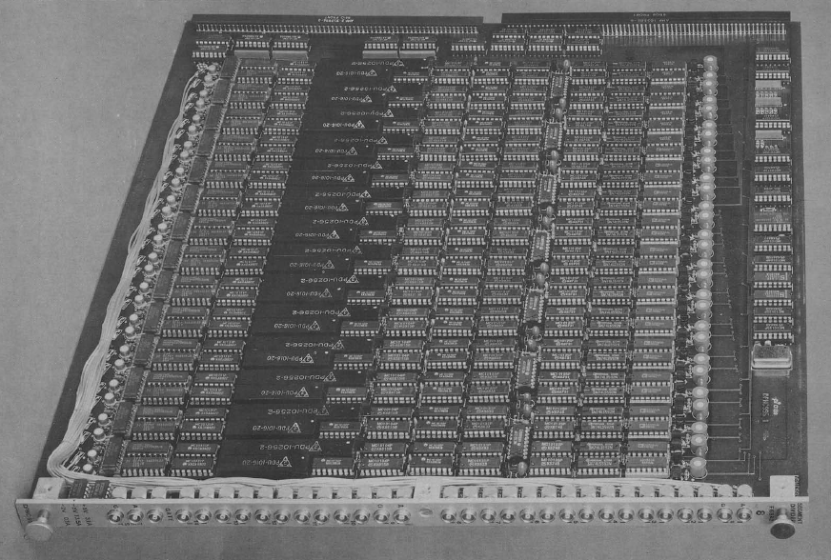
Fig. 3-1: One of the many L1 processing boards from the L3 experiment [28]

Trigger Systems of the 1990s
Improvements in processing power in the 1990s allowed for increased event rates and higher resolution detectors. Many triggering systems began adopting standard, off-the-shelf components as the capabilities of digital signal processing (DSP) chips increased.

The SLD Experiment at the SLAC Linear Collider (ca. 1991)
The Stanford Large Detector (SLD) was the main detector at SLAC’s Linear Collider (SLC), built to detect Z bosons created in electron-positron collisions. The SLD had a few interesting features that impacted the design of its DAQ process. It was the first detector to implement track finding using a large-scale CCD-based vertex detector in a particle accelerator [67]. Instead of using multi-wire chambers or scintillators to detect particle flight, vertex detectors use charge-coupled devices (CCDs). CCDs accomplish a similar task as scintillators-photodetector counters; when a particle contacts a CCD, it leaves behind a charge in its wake, allowing hit points to be directly digitized. CCDs are the same technology implemented in many cameras and imaging devices. The transition to CCDs allowed for faster response times and higher resolution. The SLD’s vertex detector was capable of producing a 120 Mega-pixel image for each bunch crossing. However, this higher resolution also means more data to process and higher bandwidth in the trigger and DAQ.
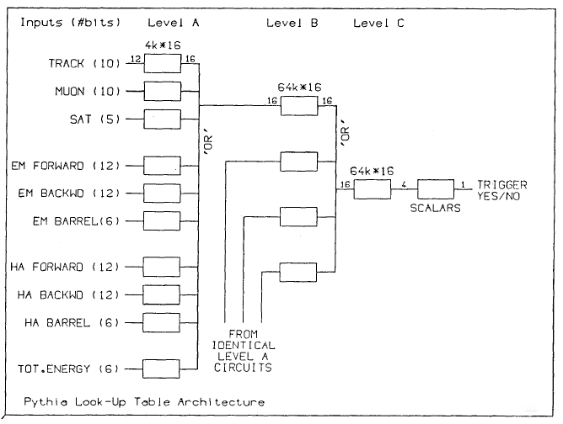
Fig. 3-2: DELPHI's Tree-based Look-up Table [65]
The SLC featured an unusually slow bunch crossing rate of 180 Hz, but events were considered to span the entire detector. A single event thus required a readout of the full detector, which featured an 8000-wire drift chamber, a Cerenkov ring, and multiple calorimeters in addition to the large vertex detector. Despite the low bunch crossing rate, the resulting data for each event were 89 MB (65% of which comes from the vertex detector), producing a maximum data rate of 16 GB/s in the DAQ. These features resulted in atypical trigger architecture. Rather than having a hardware-based L1 trigger to reduce the event rate, the SLD’s ASIC-based hardware is only used for data compression and pre-scaling. The primary trigger was implemented in software, a design that was only possible due to the low event rate.
The SLD’s primary trigger used an array of commercial-off-the-shelf (COTS) Motorola 68020 processors, part of the popular 68K series of 32-bit general-purpose processors. Processing time on in the primary trigger was non-deterministic and depended on the degree of particle deposition and pile-up in the detector. In some cases, trigger processing does not finish in time to record the next bunch crossing and misses it, resulting in dead time for the DAQ;, however this is limited in practical application to less than 10% [68]. Final trigger processing is done on a farm of micro-VAX processors Each event required an average of 2100 MIPS (Millions of Instructions Per Second) to process, thus the trigger would need to be capable of 378,000 MIPS to completely prevent trigger-induced dead time in a worst-case scenario. Given that high-performance VAX computing systems of the time were capable of ~40 MIPS per processor [69], this required a large computing farm.

The NA48, WA98, and NOMAD Experiments at the SPS (ca. 1992-1997)
The Super Proton Synchrotron (SPS) is a proton-anti-proton accelerator located at CERN. Unlike many other accelerators which are built for a small number of permanent experiments, the SPS was home to nearly 200 experiments before it was subsumed in the Large Hadron Collider (LHC). Most of SPS’s experiments were designed for a single purpose and only operated for a span of several months to a few years. As a result, flexibility was less of a concern for most SPS triggers, though architectures of previous experiments were sometimes re-used to reduce development time [70].
The WA98 experiment was designed to measure the behavior of photons and charged particles in heavy ion reactions. It used a slightly modified version of the system created for the WA93 experiment. Compared to most of the other trigger systems discussed in this paper, its logic was quite simple, and used only ASIC-based hardware modules. An interesting facet of the WA98’s system is the inclusion of a Pulse Trigger module. The Pulse Trigger was a module that could be used to generate test signals to calibrate the rest of the trigger by stimulating the detectors using LED, LASER, radioactive, and electronic sources.

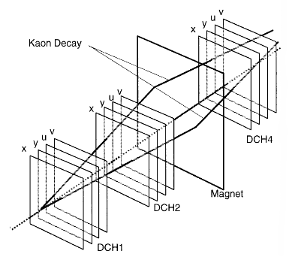
Fig. 3-3: Tracking sensors used in the NA48 experiment [70]
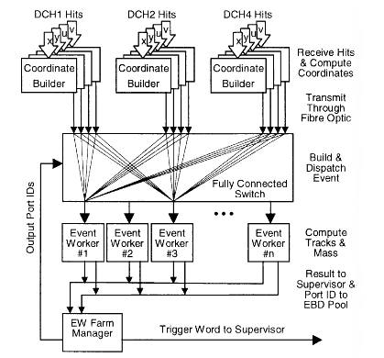
Fig. 3-4: Architecture of the NA48 trigger [70]
NA48 was an experiment designed to study CP violation in a decay mechanism of a kaon into a pair of pions. The most interesting aspect of NA48’s trigger architecture is its level-2 trigger. The L2 trigger must reduce the event rate from 100 kHz to 10 Hz with a latency of 100 µs. Its decision process is based on the reconstruction of data from eight parallel sense wire planes to track the decay of the kaon into pions in 3-dimensional space. The sensor system used for this is shown in Fig. 3-3. The L2 trigger reconstructs these paths based on hit data in drift chambers DCH1, DCH2, and DCH4. The architecture of the trigger is shown in Fig. 3-4. Data from the drift chambers is first passed to FPGA-based Coordinate Builders which collect data from neighboring wires, calculate the time-of-flight, and use this data to index into a LUT that provides a coordinate value. This data is placed in FIFO queues and sent over a fully connected optical crossbar to the first available Event Worker node. Transmission of event data between the queues was done using a standard Xon/Xoff producer-consumer communication protocol. This asynchronous communication takes advantage of the fact that event arrival times follow a Poisson distribution, allowing the processing to be spread out evenly in time, rather than over-provisioning the hardware.
Event worker nodes are based on the Texas Instruments C40 DSP processor, with up to 16 nodes supported in the system. The C40 processor was selected based on its MIMD capabilities, however when it was proposed that the event rate of the experiment was doubled, requiring upgrades to prevent the system from being overwhelmed with dead time due to insufficient processor resources, the designers argued that RISC-based CPUs would provide a more attractive platform for upgrades [51]. Their primary argument was that the programming model for a MIMD DSP made development of the L2 software too difficult and time-consuming. This move towards more programmable processors and concern for software complexity has been a consistent trend in trigger designs.
Unlike the experiments discussed so far, the NOMAD experiment was not based on electron-positron or proton-anti-proton collisions. Instead, its physics were based on interactions of a neutrino beam passing through a 3 ton target. Neutrinos rarely interact with other matter, therefore the event rates (both desired events and background events) tend to be quite low. In practice, NOMAD generated just 500,000 events per year [71]. As a result, trigger systems for neutrino-source experiments tend to be relatively simple. NOMAD also had a bunch crossing rate of only two injections every 14 s. Because of the large amount of time between bunch crossings, NOMAD is able to cope with a single-level trigger [42]. This trigger is built using programmable logic devices (PLDs) and programmable array logic (PALs) from Altera’s MAX series. PALs provide some of the flexibility of FPGAs with lower device size and cost. PLDs and PALs were sufficient since the NOMAD trigger was primarily based on Boolean combinations of “veto” bits generated from the detector primitives.

The BaBar Experiment at the PEP-II Collider (ca. 1999)
BaBar was an experiment designed to study CP violation at the PEP-II electron-positron collider at SLAC. Compared to other accelerators, it had an exceptionally high bunch crossing rate of 238 MHz [29], delivering continuous data to the trigger and DAQ system. Accommodating this high continuous collision rate puts a lot of pressure on the L1 trigger system. The trigger systems were also designed to operate at up to 10x their nominal event rates, anticipating the potential for upgrades to the experiments luminosity. A high-level diagram of the BaBar trigger is shown in Fig. 3-5. The L1 trigger is a parallel, pipelined system based on FPGA hardware, designed to operate with less than 10% dead time. A trigger primitive generator (TPG) compresses data from the electromagnetic calorimeter and drift chamber and serves as the input to the L1 in the form of compressed calorimeter tower energy sums and drift chamber track segments. Data from the ECAL is formed into clusters around energy deposits representing isolated particles. The ECAL data is partitioned in segments of 5x5 calorimeter towers to the L1 FPGAs. Each L1 processor forms clusters by calculating all 2x1 tower sums within its partition. Data from the drift chamber is used to reconstruct simple particle tracks. Track reconstruction is performed by linking track segments together to form linear tracks that span the drift chamber. These processes are illustrated in Fig. 3-6. After the initial processing, the L1 performs track counting, p_{xy} cuts, energy cuts, and track-cluster matching to make the L1 decision. The L1 trigger produces a 2 kHz event rate with a latency of 11-12 µs. Space is reserved for an optional L2 trigger to further reduce the rate of events that must be acquired by the DAQ. This optional trigger may perform more advanced track reconstruction based on a silicon vertex tracker (SVT).
Data that has been filtered by the L1 (and optionally the L2) is read out into an event builder that formats the data. Before the events are written to mass storage, they are further filtered by the L3 DAQ processor farm. Because it can take a long time to fully read out events from the detectors, the if no dedicated L2 trigger is in place, L3 system is capable of performing a fast L2 filtering while readout is still taking place, provided that L3 event rates are low enough. This fast filter operates using data from the SVT to perform primary vertex position cuts. The L3 also performs slower filters regardless of the L2 trigger mechanism based on full event data from the detector read-out.
The L3 trigger/DAQ farm is built with 10 64-bit PowerPC processors that are capable of communicating via a token-ring architecture. When designing the L3 trigger, PowerPC processors were chosen over DSPs for two main reasons: the large data cache available in the PowerPC processor is useful for the data formatting and feature extraction processes that must be performed, and the multipliers available in the processor are capable of single-cycle integer and floating point multiplication, valuable in the reconstruction algorithms.

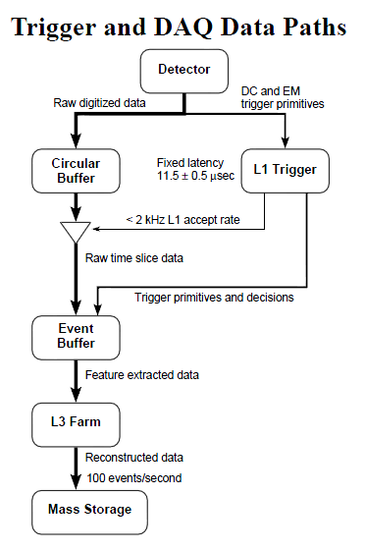
Fig. 3-5: High-level diagram of the BaBar Trigger and DAQ system [29]
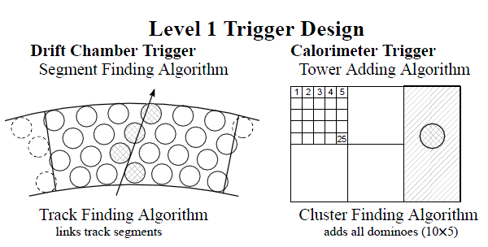
Fig. 3-6: BaBar L1 trigger algorithms [29]

Trigger Systems of the 2000s
As physicists strove to discover more rare phenomena, the event rates needed for their experiments (and correspondingly, the data throughput of their trigger systems) increased substantially. At the same time that FPGAs were being adopted in greater numbers, ASICs were still needed to cope with the tremendous data rates. These data rates also put a greater focus on the interconnection systems used in triggers. Software triggers were being pushed from application specific instruction processors (ASIPs) and DSPs to general-purpose processors, driven by a goal of improving programmability.

The PHENIX and STAR Experiments at the Relativistic Heavy Ion Collider (ca. 2000)
PHENIX and STAR are the two largest detectors located at the Relativistic Heavy Ion Collider (RHIC). As its name suggests, RHIC is an accelerator that performs physics based on the collisions of ions. It supports many different modes of operation based on the ions being used, which can range from simple hydrogen ion (proton) collisions up to gold ion collisions. The RHIC operates at a bunch crossing frequency of 9.4 MHz. The event rate and amount of data generated per event depends heavily on the type of collisions. This is illustrated in Fig. 3-7. Heavier ions produce fewer collisions, however these heavy ions also have higher energy and more mass. Therefore, when heavy ions collide, they produce a very large number of post-collisions particles that must be tracked and identified. This unique feature of heavy ion colliders is reflected in the design of the PHENIX and STAR triggers.
The PHENIX experiment was designed to study the transition of ordinary matter into a special state known as quark-gluon plasma. Although the RHIC has a bunch crossing rate of 9.4 MHz, the interaction event rate ranges from only 500 Hz to a few kHz. The PHENIX trigger is designed in a flexible way to handle events from different types of ion collisions. The L1 trigger has a latency of 36 µs, which is much longer than the L1 latencies in most proton-anti-proton and electron-positron colliders. The L1 is pipelined, allowing for dead-time-free operation for most collision types and up to 5% dead time at peak luminosity [31]. The L1 modules are built on VME boards using a mixture of ASICs and Actel and Xilinx FPGAs. The L1 is broken into two levels: a local L1 that receives data from the detectors on 8 1.2 Gb/s fiber channels per board and performs compression on this data, and a global L1 that generates the triggering decisions based on the compressed data from the local L1. The global L1 implements its algorithms by indexing into pre-programmed SRAM-based LUTs that can be accessed via a programmable crossbar. SHARC 21062 DSPs were also used for data transmission.
An interesting aspect of the PHENIX trigger is that it kept copies of its decision data from each pipeline stage in the L1 trigger in a FIFO register system. These registers could be read out from any stage to analyze the trigger output and detect errors due to hardware failures. Data could also be pushed into the registers to perform testing of downstream portions of the trigger. This functionality is very similar to the concept of register scan chains used in the field of Design for Testability. Because of the long latency of the trigger, these FIFOs held data for 1024 separate bunch crossings at any one time, which probably made this implementation costly in terms of FPGA resources.
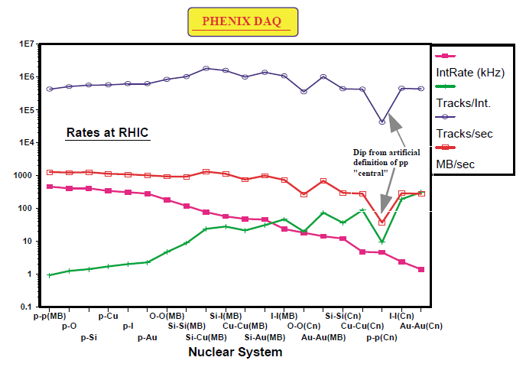
Fig. 3-7: Event rates in the PHENIX experiment for different ions [31]
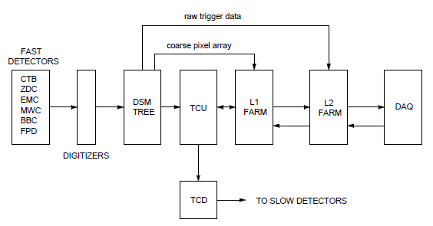
Fig. 3-8: Data acquisition in the STAR experiment [48]
The STAR detector is another experiment at the RHIC. The number of events per bunch crossing in STAR is very low – an average of just one event per crossing. Because of the low event rate, the STAR trigger is able to implement an atypical token-based triggering system [48]. The STAR detectors are split into two groups: fast read-out and slow-readout. It is not possible to read the slow detectors on every bunch crossing because it takes too long to extract the data. The STAR trigger analyzes data from the fast detectors and uses it to estimate which slow detectors, if any, should be read out for that bunch crossing. By selectively reading the slow detectors, dead time is reduced. The process works as follows: An L0 Data Storage and Management (DSM) board performs initial computation on digitized detector data from the fast trigger. This processing is implemented in pipelined ASICs that add the number of hits in the central trigger barrel and in multi-wire counters. Output from the DSM is fed to the Trigger Control Unit (TCU) which uses a 256K-entry LUT to select which of the slow detectors to activate, and sends a 4-bit encoded trigger command that starts readout from those detectors (if the DSM does not recognize any event, none of the detectors are selected). While amplification and digitization of the slow detector data is taking place, the L1 trigger uses a coarse pixel array from one of the trackers to attempt to determine whether the event sensed by the DSM is a real physics event or the result of a beam-gas interaction. If the latter, it can send a veto signal and abort readout of the slow detectors. The L1 makes its veto decision within 100 µs. In the next 5 ms, the L2 trigger performs reconstruction on a fine pixel array. A diagram showing the data flow in the STAR trigger is shown in Fig. 3-8.
The L1 and L2 are both based on Motorola 2306 VME processors running the VxWorks real-time OS. To ensure that there is enough processing resources available to finish event reconstruction within the latency deadline, a token-based processor arbitration method is used. When the TCU issues a trigger command, it also assigns a token to the event associated with the command. The TCU has a limited number of tokens that can be active at any one time to avoid overloading the L1 and L2 triggers, and tokens are returned after an event has been reconstructed in the L2.

The H1 Experiment at the upgraded-luminosity HERA Accelerator (ca. 2001)
H1 was a detector used in proton-lepton collision experiments at the HERA accelerator at DESY. It was a general-purpose device that consisted of silicon vertex trackers, liquid argon and scintillating fiber calorimeters, jet chambers, and muon detectors. In 2001, HERA was upgraded to increase its beam luminosity by a factor of 5 [30]. To deal with the higher event rates, H1 was upgraded with a track-based trigger system called the Fast Track Trigger (FTT). The purpose of the FTT was to create high-resolution 3-dimensional tracks to aid in the efficiency of triggering on charged particle events [72]. To accomplish this, it needed to match the existing trigger’s L2 latency of 22 µs. The FTT was integrated into the existing triggers 3-level trigger system. This trigger used L1 & L2 levels to select events for readout. After the L2 decision, data readout starts from the detectors. The L3 trigger operates in parallel with readout and is only capable of aborting the acquisition of L2 events.
The L1 portion of the FTT creates rough track segments based on hit data from a wire chamber. An illustration of the segment reconstruction process is shown in Fig. 3-9. In this figure, the vertical dashed lines represent the detector wires and the horizontal cells are shift registers. Hit data is shifted into the registers. The system then tries to find a line that passes through multiple hit points in the registers if the register cells were to be placed in 3-dimensional space according the location of the associated wire and the time the hit was shifted in. An example of a diagonal track is shown in the figure. Because it would be computationally expensive to try to calculate all possible tracks, reconstruction is done by reading out the shift register data and matching it against pre-defined hit patterns. In many other trigger systems this type of operation would be done by forming the data into an address and indexing into a LUT. A disadvantage of this approach is that it may require very large memories to hold the LUT. The FTT system instead uses content-addressable memories (CAMs). In a CAM, a data word is given instead of an address, and the memory either returns a bit to indicate that the data matched a word in memory (un-encoded mode) or returns a list of addresses that contain that data (encoded mode). This operation is useful for pattern matching applications that often appear in track finding algorithms. The FTT uses an Altera-based FPGA that featured embedded CAMs.
A higher resolution track reconstruction algorithm is performed in the L2 portion of the FTT. Each parallel board in the L2 system an APEX FPGA and SRAM-based LUT to perform initial filtering, then sends the filtered track candidates to a set of four TI 320C DSP processors. A load-balancing algorithm is used to distribute work between the four DSPs. These DSPs try to fit track candidates into planes using polar coordinate-based processing. After the L2 system signals the DAQ to acquire events, data from the L2 is passed to a processor farm of up to 16 COTS processors in the L3 trigger farm. The L3 trigger is given up to 100 µs to perform fine analysis of the L2 tracks and abort the acquisition of any tracks that are not deemed to be worthwhile.
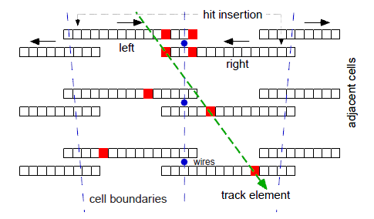
Fig. 3-9: Segment reconstruction scheme in the H1 at HERA [72]

Upgrades to the CDF Experiment for Tevatron Run-II (ca. 2001)
The CDF trigger system, originally commissioned in the late 1980s, was discussed earlier in the paper. In order to continue providing new physics data, the Tevatron underwent a series of upgrades to improve its beam power and luminosity. Here I will discuss some of the changes to the CDF trigger system to illustrate the evolution of trigger architecture between the start of the experiment and the Tevatron’s ‘Run-II’ operations.
The upgraded accelerated featured a bunch crossing rate of 7.6 MHz. The L1 trigger system was built on FPGA technology and its latency deadline was extended to 5.5 µs. The trigger was upgraded to a dead-time-free design, helping to ease the latency constraint. Dead-time-free operation was achieved by fully pipelining the trigger hardware. The L1 ran at the same clock speed as the bunch crossing rate and featured a 42-stage pipeline [33]. This meant that the DAQ system had to be capable of buffering data from at least 42 separate bunch crossings before event readout. Whereas the original L1 trigger had an output event rate of a few kHz, the upgraded L1 trigger had an output rate of 30-50 kHz. This meant that the upgraded L1 and L2 triggers needed to process an order of magnitude greater event rate than their predecessors. The upgraded L1 used a hierarchal design with separate Muon, Track, and Calorimeter Trigger modules processing data from separate detectors in parallel, then feeding their detector-specific decisions to a Global Trigger that made the final L1 decision. A block diagram of the L1 and L2 trigger architecture is shown in Fig. 3-10.
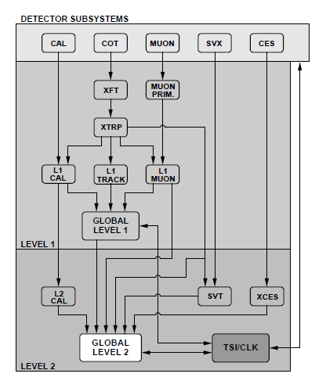
Fig. 3-10: Level-1 and Level-2 trigger architecture for the CDF experiment [33]
The L2 trigger uses FPGA-based pre-processors to filter L1 trigger primitives. The L2 features a second-level calorimeter trigger and a trigger for the silicon vertex tracker (SVT). The SVT tracker is placed in the L2 level because, like most trackers, it takes a long time to be able to dump data from the tracker due to the large quantity of data produced by CCD-based detectors. Data from these two L2 triggers as well as data from the L1 trigger are collected in the L2 Global Trigger. The L2 Global Trigger is based on a DEC Alpha processor. The processors are connected with a custom MAGICBUS interface. A general-purpose processor was desirable in the L2 because it could allow for the addition of additional triggering algorithms during Run-II that were not considered before the start of the experiment.
After events pass the L1 and L2 triggers, the DAQ sends the triggered events to the L3 event builder that consists of a farm of 48 COTS processors and is responsible for formatting the event data for transfer to mass storage. Since this does not require significant processing power, a portion of the event builder processors can be used to implement the full offline reconstruction algorithms on a small subset of the events received from the L2. Performing full online reconstruction of a small number of events can be a good way to provide rapid feedback to the operators of the accelerator and detectors to help them calibrate the experimental parameters and trigger algorithms. COTS general-purpose processors are effective in the L3 event builder because they inexpensive and flexible. Another advantage is that processor farms are easily expandable; the processing power of the L3 could be increased simply by adding more processors until the bus bandwidth becomes the limiting factor.

The CDF Upgrade for Tevatron Run-IIb (ca. 2005)
Just a few years after upgrading the CDF trigger system for Run-II, the L2 trigger (which had remained largely the same since the mid-1990s) received further upgrades. The motivation for these upgrades was only for performance to meet the higher luminosity of Run-IIb, but also to improve maintainability. The designers wanted to eliminate the obsolete DEC Alpha processor and move away from custom bus interfaces to standard-based interfaces. The MAGICBUS protocol was replaced with S-LINK and the DEC Alpha was replaced by a combination of AMD Opteron and Intel Xeon processors. The experimenters found that these new processors were able to reduce the mean event processing time from 13.6 µs for the Alpha to 1.3 µs for the Opteron – a significant improvement that could either allow for more complex reconstruction algorithms, processing of more events at the L2 level, or a reduction in the amount of buffering needed in the DAQ. A histogram comparing the event processing times for the Opteron, Xeon, and Alpha are shown in Fig. 3-11. Despite the fact that the Xeon has a higher frequency than the Opteron, the Opteron provides significantly higher performance. This is attributed to better inter-processor communications buses, showing that data transfer into and out of the CPUs is a bottleneck to performance for when using modern CPUs. Another interesting change comes at the L2 software level. Whereas previous software triggers had used stripped down real-time operating systems to ensure that software met hard deadlines, the CDF designers found that the Linux 2.6 kernel provided good enough real-time scheduling to be used in their L2 [52]. Movement to Linux may have been beneficial since it provides a robust programming and debugging environment for the development of the L2 software.
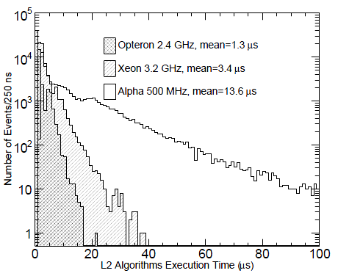
Fig. 3-11: Event processing times for different processor architectures in CDF Run-IIb [52]

The ATLAS, CMS, and LHCb Experiments at the Large Hadron Collider (ca. 2009)
At the time of this writing, CERN’s Large Hadron Collider (LHC) is the most powerful particle accelerator in the world, and its experiments have some of the most demanding performance parameters for any trigger systems. The LHC is home to four major experiments –ATLAS, CMS, LHCb, and ALICE. ATLAS and CMS are complementary experiments designed with the goal of discovering the Higgs boson and studying theories that go beyond the Standard Model of particle physics. The trigger systems for these experiments have similar parameters and general architectures. LHCb is an experiment designed to study CP-violation in interactions of particles containing beauty quarks. ALICE is an experiment designed to study the physics of heavy-ion collisions, similar to the STAR and PHENIX experiments discussed earlier in this paper.
ATLAS and CMS are characterized by event rates that dwarf other experiments. Both run at a 40 MHz bunch crossing rate and pick up 20-30 events per crossing, for an average event rate of 1 billion per second. In ATLAS the event size is 1.5 MB and in CMS it is 1 MB, giving them each a data rate of over 1 Petabyte per second [73]. Both ATLAS and CMS feature a hardware-based L1 Trigger and software-based High-Level Trigger (HLT) (ATLAS divides this into a separate software-based L2 trigger and event builder). In CMS, the L1 trigger has a decision latency of 3.2 µs – however because there are significant transmission times to get data from the detector to the trigger, the actual computation time is less than 1 µs. The L1 output event rate is about 100 kHz, and the hardware is primarily based on FPGAs (Virtex-II Pro and Virtex-4 connected by 2 Gb/s data links [74] [32]) and high-speed ASICs for addition, sorting, and table look-up. Use of RAM-based LUTs and FPGAs with programmable firmware was favored because as general-purpose experiments, the trigger algorithms may need to be changed over the course of operation. The ATLAS L1 trigger is also FPGA and ASIC-based and has an output event rate of 75 kHz. Both of the experiments have unusually high input and output event rates. This is largely due to the fact that production of the Higgs boson is predicted to be very rare, limited to about 1 in every 10 billion events [45]. As a result, the systems must process and keep a large number of candidates. The L1 triggers are also fully pipelined to ensure that no rare events are missed due to dead time. The high data rates and large number of events to be processed by the hardware systems required very large scale systems, spanning thousands of FPGAs and ASICs. In order to cope with this hardware complexity, CMS and ATLAS use a variety of software to monitor and configure the triggers [75] [76]. Because fully testing such large systems in the field is very difficult, the experiments also rely on detailed software-based emulators to test the efficiency of trigger algorithms [77].
The high output event rates from the L1 put a lot of pressure on the software-based triggers. ATLAS uses a more conventional architecture with a software-based L2 trigger followed by a switching network connected to more software-based event builders (sometimes called L3 triggers). CMS uses a less conventional approach, with the L1 trigger directly feeding the switching network, which is then connected to a unified HLT as shown in Fig. 3-12. The CMS designers argue that this gives more flexibility to upgrade CMS’s L1 trigger hardware, since it has a flexible interface through the switching network rather than a fixed interface to an L2 trigger [78]. Both experiments have huge software systems based on general-purpose COTS processors. ATLAS has approximately 80 server racks comprising 2300 nodes. Each node uses a 2.5 GHz quad-core Intel CPU with hyperthreading, for a total of 18,400 active threads. CMS’s HLT uses approximately 1000 dual-core CPUs [49].
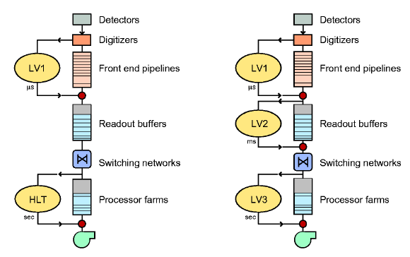
Fig. 3-12: The CMS trigger architecture (left) compared to a traditional architecture (right) [78]
LHCb has somewhat different parameters from the two general-purpose experiments. It has a lower interaction rate of 10 million events per second. It also has a much lower event size of 35 kB, however the output event rate of its L1 trigger is 1 MHz – significantly higher than any other experiment. To reduce the amount of internal trigger data from so many events, LHCb uses an L0 system of FPGA-based readout boards that perform zero-suppression and simple compression to reduce the data rate by a factor of 4-8 [79]. Even after compression it still requires 5,000 optical and analog links with a max bandwidth of 160 MB/s each. Because of the high event rate reaching its HLT, LHCb also needs a very large computing system. The HLT is composed of about 8,000 3-GHz-equivalent CPU cores [50] [80].

Trends in Future Trigger Design
The design of trigger systems is influenced by two primary factors: the physics properties of the accelerator and experiment (bunch crossing rate, background interaction rate, types of particles that must be identified, etc) and by the engineering requirements and available technology (bandwidth, latency, computational throughput, flexibility, design time, cost).
Examination of trigger systems in this chapter shows that the physics requirements are highly dependent on the type of accelerator and experiment. In general, the strictest requirements are placed on general-purpose experiments, such as ATLAS, CMS, and CDF, because they must have great flexibility to handle multiple experimental goals. ATLAS and CMS are already gearing up for a process of upgrades to the LHC’s luminosity, dubbed the Super LHC (SLHC). These upgrades will require several changes to the trigger systems [39]. Higher luminosity means a larger raw event rate from the detectors. Increasing the number of events per bunch crossing will produce greater pile-up and make it more difficult to isolate individual particles. One of the proposed solutions would be to integrate data from the silicon tracker into the L1 level of the trigger. Since trackers produce more data than most other detectors, this will increase the bandwidth requirements of the L1 hardware. It will also make it necessary to perform some coarse-grained track finding in hardware – a task which has previously been done in software. This upgrade is only one part of a planned series of upgrades to the LHC. As has been touched upon already in discussions of the CDF upgrades at Fermilab, the process of upgrading systems after they have already been deployed is a common occurrence. As the scale and cost of particle accelerators has grown very high, it is reasonable to expect that there will be even more desire to upgrade existing accelerators over longer periods of time rather than undertaking the extremely costly process of building new accelerators. This will further motivate the trend of designing flexible trigger systems. It will also encourage the use of modular architectures, such as the one described in the CMS experiment [78]. Modularity allows systems to be more easily upgraded and replaced, whether that is done to meet the needs of new physics experiments or to take advantage of faster and higher density hardware.
From a hardware perspective, one of the most prominent trends has been the move away from custom designs to off-the-shelf components. FPGAs are rapidly replacing ASICs in L1 triggers. The use of FPGAs not only grants greater flexibility due to the programmable nature of FPGA firmware, but also avoids the costly and time-consuming process of verifying and validating the fabrication of a small-run custom ASICs. Some modern FPGAs now provide embedded RISC processors. Although this technology does not seem to be in current use in trigger systems, the ability to run simple high-level algorithms on high-throughput hardware could be an advantage for systems that need to integrate some form of high-level algorithms into their L1 architecture (like the previously mentioned CMS and ATLAS upgrades). Standard bus technologies, particularly VME, are rapidly replacing custom buses, allowing for more modular technology. Some efforts are in place to further modularize systems by using standardized boards and crates to house the electronics.
General-purpose CPUs are also replacing domain-specific processors and DSPs in the software-based triggers. A primary driving force in this transition has been a desire to reduce the time it takes to design and verify the software, which can sometimes be the most time-consuming step in an upgrade process [51] [52]. General-purpose CPUs can speed the development process because they use more familiar architectures, have mature tool-chains, and may have more robust OS and infrastructure support. Another advantage is that general-purpose computing farms can be used for other tasks when the experiment is not operational. Although the prevailing trend is towards general-purpose CPUs, there are some arguments to be made for the use of more domain-specific processors. The CMS HLT, for example, spends a large fraction of its CPU time on muon processing using a Kalman filter kernel [49]. Since that the software triggers in LHC experiments each consist of 1000s of cores, there is potential for significant hardware reduction if the most expensive kernels can be accelerated through some means. Given that trigger processing is highly-parallel and tile-based on some detectors, an argument could be made that the application might map well to a GPU-like architecture, however the current complexity of GPU programming models serves as a high barrier to adoption.

Trends in FPGA-based Design for High-Energy Physics
The continual improvement of semiconductor technology has provided rapid advancements in device frequency and density. Designers of electronics systems for high-energy physics (HEP) have benefited from these advancements, transitioning many designs from fixed-function ASICs to more flexible FPGA-based platforms. Today's FPGA devices provide a significantly higher amount of resources than those available during the initial Large Hadron Collider design phase. To take advantage of the capabilities of future FPGAs in the next generation of HEP experiments, designers must not only anticipate further improvements in FPGA hardware, but must also adopt design tools and methodologies that can scale along with that hardware. In this section, I outline the major trends in FPGA hardware, describe the design challenges these trends will present to developers of HEP electronics, and discuss a range of techniques that can be adopted to overcome these challenges.

Introduction
High-energy physics systems have a history of pushing the boundaries of technology. The electronics in HEP systems often require extremely high bandwidth and computational throughput, precise timing, and tight real-time processing constraints. These stringent performance specifications historically demanded the use of custom ASIC solutions [36] because in the past, programmable hardware such as FPGAs were inadequate to the task. Although ASICs are capable of achieving the highest possible performance, they suffer from two major shortcomings for HEP applications. First, they are very expensive to produce in low volumes because the costs of fabrication are not well-amortized. Second, they are rigid, fixed-function devices that offer very limited flexibility for adjustment to new experimental parameters or algorithms. Early designers were forced to cope with these shortcomings, as ASICs were the only technology capable of meeting key performance requirements of HEP systems. However, as time has passed, continual advancements in the semiconductor industry have produced major improvements in the density and speed of electronics. Consequently, FPGAs have also improved in capacity and performance. Modern FPGAs are able to achieve performance levels suitable for many HEP applications and provide attractive properties such as re-programmability and smaller low-volume costs. The result of these trends has been a rapid adoption of FPGAs in HEP electronics. A large proportion of the electronics in the Compact Muon Solenoid Level-1 Trigger, for example, are based on FPGAs, and many of the remaining ASICs are scheduled to be replaced with FPGAs in proposed upgrades [8].
Improvements in FPGA technology are not likely to end soon. Today's high-density FPGAs are based on a 40-nm silicon process and already contain an order of magnitude more logic than the FPGAs available at planning stage of the Large Hadron Collider's electronics. 32 and 22 nm silicon process technologies have already been demonstrated to be feasible; as FPGAs migrate to these improved technologies their logic density and performance will continue to increase. With the next generation of HEP designs, the question has changed from ‘When will programmable hardware be good enough to meet our needs?' to 'How can we take maximum advantage of the advancing density and performance of programmable hardware in our designs?' The answer to this new question is not as simple as it may seem. Faster, higher-density devices may enable more complex algorithms, greater functionality, and higher-resolution processing – but only if the methods of designing, testing, implementing, and verifying these systems adapt to meet the needs of these new levels of complexity. As devices continue to improve, the importance of using the right combination of tools and methodologies to enhance developer productivity and create maintainable designs will become increasingly critical. Relying solely on established hardware description languages (HDLs) may not be sufficient to meet the challenges of future system design. In this paper, I examine recent trends in FPGAs and the implication these trends have on the adoption of new software tools, techniques, and methods for the design of HEP systems based on future generations of FPGAs.
The rest of this chapter is organized as follows. In Section 4.2, I cover the major trends in FPGA hardware. In Section 4.3, I describe the problem of managing increased design complexity and describe a series of tools and techniques that can be used to create scalable design processes. In Section 4.4, I describe the effects of FPGA trends on the problem of hardware verification and debugging and present tools and techniques for managing this problem. Finally, in Section 4.5, I provide my conclusions about the impacts of FPGA trends on the future of electronics design for high-energy physics applications.

FPGA Hardware Trends
I divide FPGA hardware trends into two different categories: trends in performance and trends in resource capacity. In this section I examine performance and resource capacity trends for high-end FPGAs from Xilinx over the past ten years [81] [82] [83] [84] [85] [86] [87]. HEP applications often rely on cutting-edge technology to meet their stringent requirements. Therefore, I will present composite data based on the largest and highest-performance device available from either vendor at a given point in time.

Performance
There are two aspects of FPGA performance that have a strong impact on HEP designs: maximum operating frequency and I/O bandwidth.
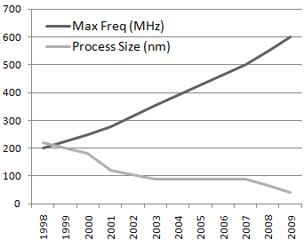
Fig. 4-1: FPGA maximum frequencies and process size (1998-2009)
Operating frequency is directly related to the computational capabilities of a device. Higher frequencies allow calculations to be completed faster. This is important because computational latency is one of the key constraints of many HEP designs. A graph of the maximum frequency and silicon process technology of high-end commercial FPGAs is shown in Fig. 4-1. Frequency has scaled linearly with time. It is also notable that at 600 MHz, modern FPGAs are still operating at relatively low frequencies compared to high-end ASIC-based chips, such as microprocessors. Whereas ASICs have experienced many challenges in continuing to scale up their frequency, such as power density concerns and pipeline scaling, FPGAs still have some headroom before they encounter these problems. As indicated in the graph, frequency is closely related to the silicon process size used to manufacture devices. Smaller processes can produce transistors with lower latencies (and correspondingly higher frequencies). As of 2009, high-end FPGAs are being manufactured on a 40-nm silicon process. Intel has already demonstrated viable 32-nm and 22-nm processes [88]. Therefore, I expect that FPGA frequencies will continue to follow increasing trends through the near future.
The second key performance parameter of FPGA devices is their total I/O bandwidth. One of the key distinguishing characteristics of particle physics applications are the tremendous data rates produced by HEP experiments. The electronics involved in triggering, data acquisition, compression, and other real-time data processing need very high bandwidth to handle copious amounts of experimental data. Often, the amount of data that can be processed by each device in these systems is limited by device bandwidth rather than by logic resources or computational speed. Such systems require many duplicate devices to handle all the data.
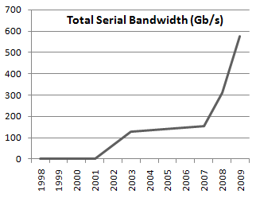
Fig. 4-2: FPGA serial link bandwidth (1998-2009)
As discussed later in Section 4.2.2, although the total number of I/O pins on FPGAs has not experienced significant growth in recent years, total device bandwidth has rapidly improved due to the introduction of high-speed serial transceivers. Fig. 4-2 shows the trend in total serial I/O bandwidth over the past decade. I/O bandwidth has managed to maintain an exponential growth rate in recent years, allowing it to keep pace with the growth of logic resources (see Section II.B). The matching growth of bandwidth and logic is a key trend for HEP system designers. If FPGAs continue this trend in the future, devices will maintain consistent resource ratios, making it easier to consolidate distributed, multi-device systems into a smaller number of devices. If, on the other hand, bandwidth growth falls behind logic growth, designers will need to consider ways they can use extra logic to improve the quality of their systems. This might mean increasing the precision of computations or adding redundant error correction. Both Xilinx and Altera have recently introduced 11-Gb/s transceivers, but have not yet integrated these transceivers on all serial I/O pins. Moreover, the number of pins dedicated to high-speed serial I/O could be increased; serial I/O is currently only available on a small fraction of available pins. Therefore, it is feasible for total I/O bandwidth to continue to grow.

Resource Capacity
In addition to FPGA performance, resource capacity is also a major concern. The quantity of logic resources available to developers restricts the amount of functionality and precision of computation that can be incorporated into each device. Unlike the monolithic silicon wafers used to implement ASIC designs, modern FPGAs have a heterogeneous design substrate. They include look-up-tables (LUTs), flip-flops, high-density block RAM (BRAM), optimized multiply and accumulate chains (DSP blocks). Since FPGAs are packaged chips, it is also worthwhile to consider the total number of I/O pins available. Graphs of the growth of each of these resource types, normalized to the resource capacity of one of the highest capacity FPGAs from 1998, are shown in Fig. 4-3. Note that the DSP blocks were not introduced into Xilinx FPGAs until 2001, so DSP multiplier growth is normalized to this later device.
There are several key relationships to be observed from these trends. All logic resources (LUTs, flip-flops, BRAM, and DSP blocks) have exhibited exponential growth. This can be attributed to advancements in silicon process technology, and thus is likely to continue in the near future. In particular, sequential state (BRAM and flip-flops) makes up a larger percentage of the total logic resources. The total number of I/O pins, however, has not shown sustained growth due to physical limitations. The package size of the device, the number of pins that can fit in that space, and the feasibility of board-level routing for those pins are significant limiting factors. In fact, pin count has shown a downward trend in recent years; I/O bandwidth has only managed to increase due to the introduction of high-speed serial transceivers on a subset of the remaining pins.
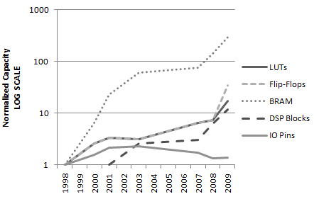
Fig. 4-3: FPGA resource trends for high-end devices [log-scale] (1998-2009)

Of most importance are the ways in which these trends interact to impact the design process. As the amount of logic and bandwidth to each device increases exponentially, the size and complexity of designs possible on a single device increases dramatically. I discuss design methods and software advances that can be used to manage this challenge in Section III. Logic is growing at a much faster rate than the number of I/O pins. The rapidly increasing ratio of device state to I/O pins will make it more difficult to rely on the use of external logic analyzers to perform hardware verification and debugging for complex sequential circuits. I discuss FPGA-centric verification and debugging tools in Section 4.4.

Design Complexity
New FPGA generations will continue to bring increases in device resources and performance. Future architectures will have significantly more logic and bandwidth available on each chip than what is available today. Designers can leverage these improvements to enable higher levels of system integration, more nuanced algorithms, robust error correction and reliability, and higher-resolution processing. However, these design enhancements come at a price; as designs become larger and more capable, they also become more complicated. If it already takes several person-months to properly design, simulate, debug, and verify the firmware of an FPGA with tens to hundreds of thousands of logic cells, how long will it take to do the same for FPGAs with tens of millions of cells?
Before designers can take advantage of larger devices, they must ensure that they can meet three main objectives. First, we must make sure we can control the design costs. The logic density of FPGAs may double every few years, but the budgets of scientific research organizations do not. Second, to maintain a reasonable pace of advancement of HEP systems, the design time for these circuits cannot simply increase proportionally with the growth of logic capacity. Third, ensure the collection of valid scientific results and protect the operation of critical experimental systems, the number of bugs and defects in these circuits must be held to a very low level. To achieve these three objectives, we must increase the productivity and effectiveness of the design and testing of systems. In some cases this can be achieved by adopting new software tools and technologies. In other cases it may mean that developers must transition from ad hoc design practices to more formal and rigorous methodologies.
In this section I cover three concepts for increasing productivity for complex designs: collaborative techniques, scalable design methodology, and high-level-language tools.

Collaborative Design
One approach to managing larger, more complex designs is to tap into a larger pool of design talent and expertise. On a global system-wide scale, HEP projects already rely on large-scale collaborative efforts from many research and design groups. However, collaboration can also employed at the level of individual designs. This sort of collaboration can be implemented on varying scales.
On a small scale, each design group could institute a policy of seeking peer review of their work to ensure that it is of the highest quality. Presenting design decisions for external review not only provides the benefit of outside expert experience and insight, but also helps the group to systematically explore, justify, and document their design choices. Such a review could be regularly applied at multiple levels, including specifications, major design decisions, and actual firmware code.

On a larger scale, related groups within HEP projects could implement infrastructure for sharing firmware code with each other. Although the LHC collaboration has access to a spectacular range of expertise from numerous universities and labs, teams often work in isolation until it is time to begin integrating their systems. Although each group has its own set of goals, constraints, and platforms, it is reasonable to expect that some design work could be shared between teams. For example, many systems may need to decompress zero-suppressed data transmissions, calculate parity and apply error correction, or sort sets of data. If many groups replicate the same design process needed to implement these functions, time and money are being wasted.
On the largest scale, firmware source code published and made open to public scrutiny after the initial internal design. Studies suggest that the average defect rate for open source software is significantly lower than that of proprietary software [89]. It may be possible to achieve similar improvements with open source firmware. Moreover, opening the code up to the public for comment could allow review by hundreds of external designers at very low cost.

Methodology
One of the most crucial components to managing complex projects is adherence to a structured design methodology. The topic of design methodology is too broad to be thoroughly covered in a single paper. Therefore, rather than attempting to provide an exhaustive summary, I will focus on a few concepts that are particularly useful to the design of complex digital systems for HEP applications.

Specification
The first step in the design of any reasonably large system is the development of that system’s design specifications. The specifications include the performance requirements of the design - which may include aspects such as latency, throughput, I/O bandwidth, error correction capabilities, and other factors – a description of the algorithms to be implemented, and input and output data formats. At a higher level, the specifications may also include factors such as the monetary and time budgets. Development of a robust and well-documented set of specifications for each major portion of a design should be performed early in the design process, possibly before the first line of firmware code is written. Clear and early communication of these requirements helps to avoid the errors and incompatibilities that arise when teams work from a set of incomplete or unclear specifications. Moreover, the development of the specifications may itself yield insight into the strategies to take during the firmware development process, guide resources to the most challenging aspects of the design, and uncover potential problems before a major engineering investment has been made.
For systems that implement physics algorithms, such as trigger systems, the specifications for the physics and the electronics components are typically kept separate. For example, the algorithms are developed in order to meet the physics requirements and verified via simulation and mathematical models. Then, these algorithms are used to develop specifications for the electronics. This methodology makes sense when considering that the physics performance is the first concern of an experiment. However, the problem with this method of developing electronics specifications is that it may constrain the ability of engineers to evaluate alternate designs. For example, making slight alterations to a triggering algorithm might have minimal impact on the triggering efficiency (the physics) but yield major savings in the complexity of the hardware (the electronics). With limited budgets and more stringent hardware requirements, it may become prudent to view the development of the hardware systems that support the experiments as a first-class concern. Efforts should be made to integrate the physics and electronics specifications and form multi-disciplinary teams to evaluate the impact of algorithmic modifications in both the physics and electronics domains.

Design Practices
When designing firmware code for complex systems, there are a variety of techniques that can be used to help manage large projects. One of the most basic of these is the concept of modular design. Modular design uses a 'divide and conquer' approach to break up big projects into smaller parts that are easier to design, test, and verify. Systems are partitioned into a group of interconnected modules that each implement a basic function, and these can be combined (perhaps hierarchically) into the required larger structure. Ideally the system should be partitioned in such a way that modules have few interdependencies and each module's function can be analyzed and understood in isolation. Furthermore, modularity provides the benefit of module reuse. For example, a 32-bit-wide adder module could be hierarchically designed, composed of several 8-bit-wide adder modules.
Modular design offers several important advantages over monolithic design. Building a system up by starting with smaller modules allows the developer to test and debug the firmware code in small pieces. This makes it easier to identify and isolate bugs in the code. Modular design also allows developers to perform synthesis on basic computational modules and obtain early performance estimates to guide later development. Building up a library of modules that implement basic functions also allows code re-use, avoiding duplicate coding work and reducing the testing burden. Such modules could also be shared across different projects using a collaborative firmware repository as described in Section 4.3.1.
For the development of HEP systems, it may be beneficial to use parameterization to further increase design re-use beyond what would be possible with modularity alone. Parameterization is a powerful construct available in all major HDLs. It allows a designer to use computations on constants to determine design features such as the size of registers and width of buses. Modifying parameterized features requires simply changing the parameter value in the code, then re-compiling the HDL code into a new (modified) hardware structure. By parameterizing modules, one could, for example, use the same parameterized adder code to create multiple adders of different bit-widths without having to alter the firmware (which might potentially introduce new bugs). Parameters can also be used to rapidly explore the impact of different design decisions. For example a developer could study the effect that varying the precision of a multiplication unit has on its maximum frequency.
When parameterized modules are combined with code generation constructs available in HDLs, they give designers a powerful tool for exploring large-scope considerations, such as the number of design units that can fit on a given FPGA model. This analysis can be especially useful in large-scale HEP systems where a design may need to be partitioned across multiple devices. The use of fully-parameterized designs enables a rapid evaluation of various partitioning schemes and the ability to gauge the tradeoffs of using different models. It also allows the HDL code to be quickly adapted to different FPGAs; this can be a very valuable trait in HEP designs where the long development process may mean that the target device is not finalized until well into the development cycle. Moreover, it allows the design to be gracefully adapted to larger FPGAs if the hardware is upgraded in the future.

Firmware/Emulator Co-Design
Designing firmware is generally a more time-consuming process than writing software using a high-level language. As such, it is common practice to first create an emulator for a HEP hardware system in software, use it to explore and test new algorithms, then design the hardware to match the function of the emulator. This approach is effective for rapidly testing algorithmic changes, but often leaves a large implementation gap between the emulator and the hardware. Algorithms that are easy to implement and achieve high performance in software do not necessarily share those properties in hardware. This may lead the software designers to describe algorithms that are very difficult for the hardware designers to implement efficiently. Also, the high-level code that implements the emulator may have a much different structure and interface than the HDL code that implements the firmware, making it difficult to share the same testing infrastructure between the two.
In the future, it may be advantageous to move to a methodology that focuses on firmware/emulator co-design rather than a sequential process of creating the emulator and then creating the firmware or vice versa. The concept of co-design is to allow systems to be developed in tandem, allowing rapid transmission of feedback and implementation of changes. Better communication between firmware designers and algorithm developers should lead to the adoption of algorithms that both meet the needs of the experiment and are well-suited to hardware. Moreover, a co-design process would encourage the use of similar structural hierarchies in the emulator and firmware. This would allow the use of a unified test framework, making it much easier to pinpoint bugs in either implementation.
One of the most important aspects of a co-design methodology is to ensure that the speed of firmware design does not impede the software design. Therefore, rather than directly going between a high-level language, such as C/C++, and an HDL, it may be beneficial to use a hardware verification language (HVL) such as SystemVerilog [90] or SystemC [91] to help bridge the gap.

Testing Practices
As projects migrate functionality from high-level languages to firmware implementations or collaboration begins via a co-design methodology, a wide gap separates hardware system and software emulator design approaches. Each has their own programming models and development environments. The original software application description can range from general imperative languages like C, to object-oriented languages like C++ or Java, to domain-specific approaches like MATLAB. Firmware may be developed in SystemVerilog or SystemC during the early design exploration phase and in VHDL or Verilog in the implementation phase. This multitude of languages and programming environments makes the design time lengthy and error prone, as developers must often manually transcode between different languages and environments. Many 'best practices' are utilized in industrial and academic environments to help this process, such as automatically generating documentation (e.g. Javadoc), auto-configuration, adherence to interface specifications, and unit testing.
In particular, unit testing facilitates productive design by integrating testing early into the design flow to catch erroneous or unexpected module behavior earlier in the design cycle, when it is cheaper and easier to alter the design or specifications. Such techniques have proven effective for many languages and platforms, but for design projects that involve transcoding and retooling for the final implementation, existing tools still leave many manual, error-prone steps in the process. This leads to longer design times with lower-quality implementations.
Typically when software designers employ unit testing, they use frameworks that are language-specific [92]. More than just a syntactic customization, such frameworks are often tied to fundamental constructs of the language, such as checking that methods exhibits the proper form of polymorphism in an object-oriented language. Furthermore, these language-specific approaches work well when designers are using only a single language or a single platform for both development and final implementation. But when designers must move between languages with different constructs (such as when moving between an emulator coded in C++ and firmware written in VHDL), the existing tests must be rewritten. This consumes extra design time and creates a new verification challenge to ensure that the corresponding unit tests between these two languages are, in fact, performing the same test.
A new testing approach is needed that is language and platform agnostic. Such an approach is possible by leveraging model-based design for projects that integrate heterogeneous programming languages and by applying and integrating different kinds of design and testing methodologies. With model-based development, automatic testbench creation is possible, improving the ease with which designers can create cross-platform tests.
One tool that has been developed to manage this aspect of the design process is the DSPCAD Integrative Command Line Environment (DICE) [54]. It provides a framework for facilitating efficient management of the test and development of cross-platform design projects. In order to accommodate cross-platform operation, the DICE engine provides a collection of utilities implemented as bash scripts, C programs, and python scripts. By using free and open source command-line interfaces and languages, DICE is able to operate on different platforms, such as Windows (equipped with Cygwin), Solaris, and Linux.

Design Verification
To improve the quality and performance of hardware designs while reducing their development time, a cross-platform design environment is needed that accommodates both early design exploration and final implementation tuning. One could make effective use of the initial higher-level application specification to create a functionally-accurate, language-independent design model. This model could be used in the development and validation of both the emulator and hardware.
The Dataflow Interchange Format (DIF) is tool for model-based design and implementation of signal processing systems using dataflow graphs [93] [94]. A designer starts by translating the high-level design specification into a platform-independent description of the application in the DIF format. This structured, formal application description is an ideal starting point for capturing concurrency and optimizing and analyzing the application. Because the application description in DIF exposes communication as a first-class citizen, DIF descriptions are suitable for targeting hardware design, where modules must be interconnected by wires. After creating the initial DIF description, a designer can use it to perform side-by-side development and validation of optimized hardware or software implementations. One of the main advantages of using the DIF format is that it is dataflow-based description that allows the use of sophisticated analysis techniques that have been developed for dataflow languages.
A formal model such as dataflow can improve the test quality and provide information and tools that can be used to optimize a design. Dataflow models have proven invaluable for application areas such as digital signal processing. Their graph-based formalisms allow designers to describe applications in a natural yet semantically-rigorous way. Such a semantic foundation has permitted the development of a variety of analysis tools, including tools for balancing input and output buffers and for efficiently scheduling multiplexed operations [95]. As a result, dataflow languages are increasingly popular. Their diversity, portability, and intuitive appeal have extended them into many application areas and target platforms.
A typical approach involves specifying the application in DIF. Such an application specification typically defines the underlying modules and subsystems, along with their interfaces and connections. This specification is complete in terms of ensuring a correct functional behavior and module interfaces. The DICE framework can be applied to test each of the individual modules for its correctness, or extended to a larger subsystem or the entire application.
Any transcoding or platform-specific enhancements are accommodated by DICE via its standardized build and test framework. This allows designers to utilize the same testing framework at inception as they do at final implementation. Software developed jointly with DIF and DICE uses a single, cross-platform framework to handle design validation throughout each phase of development. The amount of time required to perform validation can be reduced through the direct reuse of unit tests in DICE. Model-based development can allow automatic testbench creation, improving the ease with which designers can create cross-platform tests.

High-Level-Language Tools
Several tools have been developed to enable designers to specify algorithms using high-level languages and/or graphical user interfaces and automatically map those algorithms into an HDL. The resulting HDL code can be simulated to ensure correct performance and synthesized, placed, and routed to produce an ASIC or FPGA implementation. These tools facilitate rapid design-space exploration and for certain classes of algorithms lead to efficient implementations. In addition to generating HDL, several of these tools also generate testbenches, hardware interfaces, and synthesis scripts. However, the HDL produced by these tools is often difficult to read and debug. Furthermore, for certain tools and algorithms, the original high-level language code may require significant modifications to yield acceptable results and various high-level language constructs cannot be converted to synthesizable HDL. With some tools, the generated HDL instantiates components that are specific to a particular FPGA family, which can make it difficult to port to other platforms.

C-to-HDL Tools
Numerous companies and universities have developed tools that convert C code to Verilog or VHDL. These tools typically take a program written in C, along with a set of design constraints or guidelines, and produce functionally-equivalent Verilog or VHDL. They may also produce accompanying C code (if not all of the original C code is meant to be synthesized), testbenches, synthesis and place-and-route scripts, and interfaces to the resulting hardware designs. With many of these tools, only a subset of the C language is supported, since constructs such as library calls, dynamic memory allocation, function pointers, complex data structures, and recursive functions cannot be easily implemented using synthesizable HDL code. Some of these tools provide extensions to the C language to allow the designer to specify operand lengths, hardware interfaces, timing-related information, and the desired level of parallelism in the resulting HDL. In the remainder of this section, I provide several examples of C-to-HDL conversion tools and then discuss their strengths and weaknesses.
The Impulse CoDeveloper Toolset from Impulse Accelerated Technologies provides a C-based development framework for FPGA-based systems. It includes the CoDeveloper C-to-FPGA Tools, the CoValidator Test Bench Generator, and the CoDeveloper Platform Support Packages [96] [97]. Collectively, these tools allow designers to (1) specify their hardware designs with Impulse-C, which supports a subset of C plus some extensions, (2) profile their Impulse-C code to determine potential performance bottlenecks, (3) if desired, partition the code such that certain code sections are run on an FPGA and other portions are run on a programmable processor, (4) use interactive, graphical tools to specify design constraints and perform optimizations, (5) map selected Impulse-C code into either VHDL or Verilog, (6) generate hardware interfaces for specific FPGA platforms, and (7) create HDL testbenches and simulation scripts to test the resulting designs. The Impulse CoDeveloper Toolset can be used to generate either standalone hardware designs or hardware design that interface with an embedded or external processor. They also provide several optimizations to improve hardware efficiency and parallelism including common sub-expression elimination, constant folding, loop pipelining, and loop unrolling. The Impulse CoDeveloper Toolset has been used to develop FPGA-based solutions for a wide range of applications including image and video processing, security, digital signal processing, and scientific and financial computing.
Pico Express FPGA from Synfora takes an algorithm written using a subset of the C programming language and a set of design requirements, such as clock frequency and target throughput, and creates register transfer level (RTL) and SystemC implementation models [98]. It also generates testbenches and an application driver program. PICO Express FPGA includes design space exploration capabilities that, based on user-specified design parameters, create multiple implementations and provide FPGA resource and performance estimates for these implementations to allow design tradeoffs to be evaluated. To achieve efficient designs and provide accurate performance and resource estimates, PICO Express FPGA utilizes several device-independent optimizations and also optimizes the resulting RTL for a particular Xilinx FPGA family. PICO Express FPGA has been used to design FGPA-based hardware for a wide range of systems including video, audio, and image processing, wireless communication, and security.
The C2R Compiler from Cebatech provides an automated mechanism for converting structured C source code, along with a small set of compiler directives, to Verilog and SystemC [99] [100]. Internally, the C2R Compiler creates a control dataflow graph and then uses allocation and scheduling algorithms to produce Verilog that is functionally equivalent to the C source code. Consequently, the original C code can be used to perform functional verification of the resulting Verilog. The C2R design flow allows designers to instrument the C source code with various compiler directives and explore the design space of the resulting architectures. The compiler directives can be used to specify state machines for control, create interfaces to the resulting Verilog code, bind arrays to specific FPGA resources, specify the degree of pipelining to be used to implement loops, control variable bit widths, and enable clock gating of registers in the resulting design . C2R has been used to implement hardware designs for security, data compression, and floating-point arithmetic.
The Catapult C Synthesis Tools from Mentor Graphics synthesizes C++ source code without extensions to SystemC, Verilog, or VHDL [101]. Catapult C provides a graphical user interface that lets the designer specify area, performance, and power constraints, apply a variety of optimizations including loop merging, loop unrolling, and loop pipelining, specify operand bit widths, generate hardware interfaces, evaluate design tradeoffs, and identify bottlenecks and inefficiencies in the generated design. Catapult C also provides options for clock-gating to reduce power consumption, takes advantage of optimized FPGA resources such as block RAMs and DSP blocks, and provides automated equivalence checking to formally prove that the original C++ code and the generated HDL are functionally equivalent. Catapult C has been successfully used to generate complex hardware designs for wireless communication and image and video processing. By the end of 2008, over 100 million ASICs had shipped with hardware designed using Catapult C [101].
Several other tools for C-to-HDL conversion have been developed. These include (but are not limited to):
- The Nios II C-to-Hardware Acceleration Compiler from Altera [102]
- The C-to-Verilog Automated Circuit Design Tool from C-to-Verilog.com [103]
- The Trident Compiler from Los Alamos National Laboratory [104] [105]
- The No Instruction Set Computer (NISC) Technology and Toolset from the Center for Embedded Systems at the University of California at Irvine [106]
- The Riverside Optimizing Compiler for Configurable Computing (ROCCC) Toolset from the University of California at Riverside [107]
- The SPARK Toolset from the Microelectronic Embedded Systems Laboratory at the University of California at San Diego [108] [109]
- The GAUT High-level Synthesis Tool from the Laboratory of Science and Technology Information, Communication and Knowledge [110]
In general, the C-to-HDL tools discussed in this paper help simplify the design process, especially for people not familiar with HDLs. They allow the designs to be specified using a subset of C, sometimes with extensions. These tools also facilitate design-space exploration by allowing the designer to specify design constraints, bitwidths, and desired levels of parallelism and then evaluate design tradeoffs based on these specifications. Several of the tools generate additional resources including C support code, test benches, hardware interfaces, and synthesis and place-and-route scripts.
The C-to-HDL tools, however, also have several limitations. Only a subset of the C language is generally supported, and for several tools, extensions to the C language are needed to enable correct synthesis. In order to generate efficient code, it may be necessary to rewrite the original C code to adhere to tool-specific guidelines. Furthermore, the generated code is usually difficult to read and debug. Code that is not well written or too complex can result in designs that are much less efficient than hand-coded HDL designs. On the other hand, it is expected that the tools will continue to improve so that in the future several of these limitations may not be as severe.

AccelDSP and System Generator
Xilinx's AccelDSP Synthesis Tool is a high-level MATLAB-based development tool for designing and analyzing algorithmic blocks for Xilinx FPGAs [111]. Although MATLAB is a powerful algorithm development tool, many of its benefits are reduced when converting a floating-point algorithm into fixed-point hardware. For example, quantization errors and the potential for overflow and underflow are introduced into the algorithm due to floating-point to fixed-point conversion. Consequently designers may need to rewrite the code to reduce the impact of these errors and analyze the results produced by the fixed-point code to ensure they are acceptable. To facilitate this, AccelDSP provides the capability to replace high-level MATLAB functions with fixed-point C++ or Matlab models and automatically generates testbenches to facilitate fixed-point simulations. The tool automatically converts a floating-point algorithm to a fixed-point C++ or MATLAB model. It then generates synthesizable VHDL or Verilog code from the fixed-point model, and creates a testbench for verification. During the HDL generation process, it performs several optimizations including loop unrolling, pipelining, and device-specific memory mapping. A graphical user interface allows the user to specify the bitwidths used in the generated code and to guide the synthesis process.
The AccelDSP Synthesis tool provides several advantages. It is a tightly integrated component of the Xilinx XtremeDSP Solution and the MATLAB toolset, which allows it to utilize MATLAB's mathematical modeling and data visualization features. To improve the design's efficiency, it automatically utilizes Xilinx IP cores and generates code blocks for use in Xilinx System Generator, which is described below. AccelDSP also provides capabilities to replace high-level MATLAB functions with fixed-point C++, MATLAB, or HDL code by specifying the target Xilinx FPGA model, intermediate data precision, and desired resource distribution. HDL test benches are generated automatically from the corresponding fixed-point C++ or MATLAB model and these testbenches can be used to verify functional equivalence between the higher-level model and the resulting HDL. Furthermore, overflow and underflow that occur in the fixed-point code are reported by the AccelDSP simulation tool to help designers find potential errors that occur due to the floating-point to fixed-point conversion process. AccelDSP also provides a set of graphical tools, including probe functions, design reports, and plots to visualize and analyze the system. AccelDSP allows designers to define constraints and control resource usage and timing. For example, the user may choose to expand a "for loop" into multiple parallel hardware blocks or a single hardware block that is reused for several iterations. The user may also provide timing constraints that result in a pipelined design.
AccelDSP also has several limitations. For example, it cannot convert all MATLAB files. Rather, the MATLAB file has to be written in a specific way, and only a limited subset of MATLAB can be used. AccelDSP only works with Xilinx FPGA chips so designs cannot easily be ported to FPGAs from other vendors. Furthermore, the generated HDL can be difficult to read and debug. For many algorithms, the amount of resources required by designs generated using AccelDSP is greater than the amount of resources required by designs generated using hand-coded HDLs.
Xilinx's System Generator is a high level design tool that utilizes MATLAB Simulink and enables designers to develop DSP hardware designs for Xilinx FPGAs [112]. It provides over 90 parameterized DSP building blocks that can be used in the Matlab Simulink graphical environment. The design process with Simulink and System Generator is simply selecting DSP blocks, dragging the blocks to their desired location, and connecting the blocks via wires. These blocks and their communication links can be converted from Simulink to Verilog, VHDL, or FPGA bit files. System Generator can also utilize blocks generated by AccelDSP.
System Generator has several strengths. In particular, it is a useful tool for designers with no previous experience with FPGAs or HDL design. In addition to directly generating VHDL and Verilog code, it also provides a resource estimator that quickly estimates the FPGA resources required by the design prior to placement and routing. System Generator can create a hardware simulation model, and integrate with a Simulink software model to evaluate complete applications including analog signals. For example, Simulink can be used to create a sine wave with pseudo-random noise that serves as an input to a System Generator hardware model, which writes it outputs to a file. The complete Simulink model, which includes the System Generator model, can then be used to simulate the entire system and generate a testbench for the hardware module.
System Generator also has several limitations. It requires experience with Simulink to create efficient designs The Simulink tool uses an interactive graphical environment and a parameterized set of block libraries, which may not be convenient for programmers who are more familiar with high-level program languages, such as C++ or Java. Furthermore, although the blocks provided by System Generator are very useful for certain types of signal processing applications, these blocks may not meet the needs of other types of applications. Similar to AccelDSP, the HDL code produced by System Generator only works with Xilinx FPGA chips and can be difficult to read and debug.

Hardware Verification and Debugging
As I have discussed, FPGA hardware trends show rapid increases in the number of logic resources on each device. In particular, the number of registers on each devices has increased at an especially fast pace recently. The growth trends in registers and in on-chip RAM contribute to an overall trend of increasing state in FPGAs. Increasing the amount of state in a device can prove particularly troublesome during hardware verification-the process of confirming that a circuit built in hardware is consistent in behavior and performance with the circuit as it performed in simulation. Differences between the simulation results and the performance of the real hardware may result from hardware defects that went undetected by the manufacturer, inaccuracies in the models used for hardware simulation, variation from nominal environmental parameters, or unexpected operating conditions such as mutual inductance or capacitive coupling from other systems, clock jitter, power supply noise, etc. Such issues become more important for high-performance systems with tight tolerances, since they are more susceptible to problems arising from variations in the timing of internal signals. Additionally, for large, interconnected system, such as those used in HEP, full system simulation may be very costly or simply infeasible. This further motivates the importance of thoroughly testing the hardware.
Hardware verification is performed by subjecting hardware to a series of test patterns and comparing the performance to the expected results. When an error occurs, it is important to find the source of the error to determine an appropriate way of correcting it. The process of locating the source of errors becomes much more difficult as the quantity of state in a device increases. This is because faulty values may contaminate the state and may propagate to different parts of the state and may take many cycles before they generate an observable error. At the same time, the number of pins on FPGAs is growing at a much slower rate than the internal state. It will become more difficult to observe internal state using external logic analyzer as the ratio of state to pins increases. This is particularly concerning because it means that designers must use much longer and more elaborate tests to verify their hardware. However, in physics applications, it is crucial to identify and eliminate any such bugs before the start of experimentation to ensure confidence in experimental results.
The problem of verifying and debugging circuits with large amounts of state is not unique to FPGAs, and has been extensively studied in the integrated circuit domain [113]. Today, engineers use a set of design techniques known as design for testability (DFT) and built-in self-test (BIST) to automatically apply tests internally and more easily probe the contents of state registers [114]. While these techniques are useful, they come with a cost; adding DFT and BIST consumes chip resources, may require extended design time, and often results in reduced operating frequency. However, because FPGAs are reprogrammable, they have the unique ability to be able to potentially use these techniques without reducing the performance of the final design. In the remainder of this section, I will describe the software tools available for performing BIST on FPGAs in a fast and efficient manner.

Integrated Logic Analyzers
Major FPGA vendors have provided tools to alleviate the problem of hardware verification. Xilinx's ChipScope Pro [115] and Altera's SignalTap II Embedded Logic Analyzer [116] enable designers to probe and monitor an FPGA's internal signals in real-time. These tools considerably cut verification time and effort in order to eliminate hard-to-detect bugs. The tools help equip a design with embedded hardware logic analyzers that sample data and transactions on selected signals and nodes. ChipScope Pro further provides the ability of forcing internal signals to specified values. Any internal signals in the design can be selected for monitoring. The sampled data are stored in the FPGA's embedded Block RAMs. Data are sent to a personal computer using the JTAG interface, the same interface used in FPGA programming, to give a visualized demonstration of the internal signals. Designers can easily observe and analyze transactions on internal signals of the design in real-time by means of a Software Logic Analyzer installed on a PC. Data sampling is triggered at runtime by a set of predefined conditions that can be set using a graphical user interface. The data sampling lasts for the number of clock cycles specified by the designer.
This approach of utilizing integrated logic analyzers removes or reduces the need for specific external hardware. These tools provide relatively complete observability to designers. They are especially useful for large designs, which often have a myriad of signal and data variations to verify. Designers are able to control the value of internal signals with ChipScope Pro. This is especially valuable in complex sequential circuits where it may take a long sequence to external inputs to change certain internal signals. In addition, signal monitoring is done by on-chip configurable logic analyzers, while the FPGA is working under standard operating conditions. This eliminates the need to purchase expensive external logic analyzers and chip testers. Hence, these tools provide an easy, yet powerful approach for FPGA design verification that lowers project costs, saves design time, and helps find bugs early in the implementation process.
Although this approach supplies the designer with new verification capabilities, it has some drawbacks and limitations. The number of observed signals and sampled time depend upon the free Block RAMs available on an FPGA, and since this approach uses FPGA resources, it might have negative timing impact on a design. Furthermore, defining a proper trigger condition that leads to bug detection might be challenging. Finally, embedded logic analyzers are not able to capture signal glitches and to test clock signals, because data is sampled at the hardware's clock frequency and thus cannot perform clock super-sampling.

ChipScope Cores
ChipScope is composed of a set of cores to promote the design verification process. The Integrated Logic Analyzer (ILA) core, as the most common core, is used for signal monitoring. The Integrated Bus Analyzer (IBA) core simplifies system bus monitoring. The Integrated Controller (ICON) core is used to set trigger conditions and send data from Block RAMs to the PC via the JTAG interface. The Agilent Trace Core 2 (ATC2) core provides an interface between the embedded logic analyzer and the Agilent FPGA trace port analyzer. The virtual input/output (VIO) core provides the designer with signal controllability along with signal monitoring. The internal bit error ratio tester (IBERT) core allows the designer to detect bugs hidden in RocketIO serial I/O designs.

FPGA Trends for HEP – Conclusion
The trends in FPGA hardware show exponential increases in device logic, on-chip memory, and I/O bandwidth over recent years. Process technology is in place to allow FPGA manufacturers to maintain this growth in the near future. This improvement in FPGAs could allow future HEP systems to incorporate more intricate and flexible algorithms, implement higher-resolution processing, and perform system integration. Achieving these goals will require larger, more complex designs on each FPGA. To manage increasingly complex designs while still working within constrained cost and time budgets, system developers must adopt a more scalable design methodology. This methodology must extend across the entire design process, from specification and design exploration to testing and hardware verification. In this chapter, I have presented core design concepts and emerging software tools that can serve as the foundation for a design methodology that can scale to meet the next generation of FPGA-based HEP systems.

Algorithms for Phase-I CMS Regional Calorimeter Trigger
Modern high-energy physics (HEP), the study of particle interactions at high energy levels, relies heavily on high-throughput, real-time DSP systems that are used to process data from experiments conducted using particle accelerators. A critical function of such systems is to perform triggering, a process that is used to reduce the large amounts of data produced by HEP experiments to a manageable level. Trigger systems achieve this goal by rapidly processing sensor data in real time and selecting which data to save and which to discard. This process typical involves analysis of raw sensor data and the reconstruction, identification, and sorting of particles and jets.
The triggering systems at the Large Hadron Collider (LHC) have stringent requirements in terms of both throughput (100s of GB/s) and real-time processing deadlines (sub-µs). To achieve these goals, the existing trigger systems are large-scale, consisting of tens of thousands of ASICs and FPGAs [8]. The Regional Calorimeter Trigger (RCT) for the Compact Muon Solenoid (CMS) experiment alone requires approximately 300 printed circuit boards (PCBs) containing several thousand ASICs. The RCT is due to be redesigned and upgraded to meet the needs of the Super Large Hadron Collider Phase I upgrade project [117] [38]. These upgrades may require new algorithms with higher resolution jet reconstruction and particle isolation [118] [119]. These algorithms are described in more detail throughout this chapter.
Analysis of the implementation and partitioning of the new RCT algorithms is important for several reasons. First, the existing system is already very large scale, complex, and expensive, therefore reducing the hardware implementation cost through algorithmic implementation choices and design partitioning is an important priority. Second, the current implementation is partitioned in a way that requires a significant amount of inter-chip communication. This high level of inter-chip communication proved to be a significant challenge in the commissioning of the hardware [120]. Third, the nature of hardware triggering algorithms lends itself to algorithmic modification cost-benefit analysis. Triggers are not tied to exact, fixed algorithms; rather they must achieve satisfactory trigger efficiency – a measure related to the percentage of physics objects that are correctly identified and saved by the trigger algorithm. By providing the physicists with several possible implementation choices and their associated hardware costs, they are better able to judge the tradeoffs of targeting different efficiency levels.
Additionally, as part of the upgrade process, the RCT implementation platform will shift from the custom ASICs used in the original system to a new FPGA-based platform that will provide greater future flexibility. Due to the different nature of ASICs and FPGAs, some implementation approaches used in the previous system may no longer be efficient in the new system [35].

Input and Output Data
The RCT algorithm produces two groups of outputs:
• An array of 4096 Particle objects. Each object is composed of a particle type (2 bits), particle energy (11 bits), center of energy (4 bits), and valid bit (1 bit).
• An array of 4096 Jet objects. Each object is composed of a jet energy (15 bits) and valid bit (1 bit).
Both jets and particles have an additional 12 bits of position information; however this information is 'encoded' into the hardware – i.e. associated with specific wire locations – throughout most stages of the algorithm.
The RCT algorithm has three groups of inputs:
• A 2-dimensional array of 4096 electromagnetic energy readings, ECAL[1..n][1..m]. Each element is 8 bits.
• A 2-dimensional array of 4096 hadronic energy readings, HCAL[1..n][1..m]. Each element is 8 bits.
• A 2-dimensional array of 4096 finegrain bits, fg[1..n][1..m]. Each element is 1 bit.
The input arrays have identical dimensions and are spatially related. Together the overlapping elements from the three arrays can be combined to form an array of 4096 elements, towers[1..n][1..m], where each tower is a 17-bit element composed of one ECAL one HCAL, and one fg. The RCT algorithm contains several computation stages. These stages are described in pseudocode and mathematical notation in the sections that follow.

Tower Filtering
Tower filtering is applied to all input elements. This operation zeros out each tower whose ECAL and HCAL elements do not meet a programmable threshold value.
for(i = 1 to n) do
for(j = 1 to m) do
if((ECAL[i][j] > ECAL_threshold) &&
(HCAL[i][j] > HCAL_threshold))
{
ECAL_filtered[i][j] = ECAL[i][j];
HCAL_filtered[i][j] = HCAL[i][j];
fg_filtered[i][j] = fg[i][j];
}
else
{
ECAL_filtered[i][j] = 0;
HCAL_filtered[i][j] = 0;
fg_filtered[i][j] = 0;
}
Code Listing I: Tower Filtering Algorithm

Channel Transverse Energy
The sums of ECAL and HCAL for each input location are computed. The sum of ECAL and HCAL over a given area is known as the transverse energy (ET).
for(i = 1 to n) do
for(j = 1 to m) do
channel_et[i][j] = ECAL_filtered[i][j] +
HCAL_filtered[i][j];
Code Listing II: Channel Transverse Energy Calculation

Clustering
Clustering is the process of forming groups of 2x2 adjacent towers, which are then called “clusters”. Note that clusters overlap each other and that they wrap around the array, reflected in the use of the modulus operation. Each cluster is characterized by its total electromagnetic energy, total hadronic energy, and a “veto” bit, used in the Particle ID algorithm described in Section 5.8. Note that the modulus operator is used in the code below because the tower grid is mapped to a cylindrical detector barrel, so the towers wrap around the grid. A photograph of the cylindrical detector is shown in Fig. 2-2, and the tower/detector geometry is discussed further in Section 6.4.1.
for(i = 1 to n) do
for(j = 1 to m) do {
i1 = (i + 1) % n;
j1 = (j + 1) % m;
ECAL_cluster_sum[i][j] =
ECAL_filtered[i][j] +
ECAL_filtered[i1][j] +
ECAL_filtered[i][j1] +
ECAL_filtered[i1][j1];
HCAL_cluster_sum[i][j] =
HCAL_filtered[i][j] +
HCAL_filtered[i1][j] +
HCAL_filtered[i][j1] +
HCAL_filtered[i1][j1];
fg_veto[i][j]= fg_filtered[i][j] |
fg_filtered[i1][j] |
fg_filtered[i][j1] |
fg_filtered[i1][j1];
et_clusters[i][j][0][0] = channel_et[i][j];
et_clusters[i][j][0][1] = channel_et[i][j1];
et_clusters[i][j][1][0] = channel_et[i1][j];
et_clusters[i][j][1][1] = channel_et[i1][j1];
}
Code Listing III: Clustering

Electron/Photon Identification
The ratio of electromagnetic energy to total energy in a cluster is computed and compared to a threshold to determine if a cluster is 'electron/photon-like'.
for(i = 1 to n) do
for(j = 1 to m) do
if((ECAL_cluster_sum /
(ECAL_cluster_sum + HCAL_cluster_sum) >
egamma_threshold)
egamma[i][j] = 1;
else
egamma[i][j] = 0;
Code Listing IV: Electron/Photon ID Algorithm

It is important to note that this portion of the algorithm is designed to be configurable. If a different algorithm for identifying electromagnetic particles is needed, it must be possible to reconfigure the system to use the new algorithm. The implementation cost of different methods for providing this configurability is discussed further in Section 6.4.

Cluster Overlap Filtering
Because clusters overlap, the data from a given tower element appears in four different clusters. The Overlap filter ensure that channel ET data shows up in only one ET cluster and assigns data in a way to create clusters with high total energy. After filtering, it compares the remaining energy in the cluster to a threshold value and zero's it out if it doesn't pass. This is the particle energy output. If no data is removed from a cluster, the valid output is set.
for(i = 1 to n) do
for(j = 1 to m) do
et_cluster_sum[i][j] =
et_clusters[i][j][0][0] +
et_clusters[i][j][0][1] +
et_clusters[i][j][1][0] +
et_clusters[i][j][1][1];
for(i = 1 to n) do
for(j = 1 to m) do
{
Ip1 = (i + 1) % n;
Im1 = (i - 1) % n;
Jp1 = (j + 1) % n;
Jm1 = (j - 1) % n;
if(
(et_cluster_sum[Im1][j] > et_cluster_sum[i][j]) |
(et_cluster_sum[Im1][Jp1]> et_cluster_sum[i][j]) |
(et_cluster_sum[i][Jp1] > et_cluster_sum[i][j]))
trim0[i][j] = 1;
else
trim00[i][j] = 0;
if(
(et_cluster_sum[i][Jp1] > et_cluster_sum[i][j]) |
(et_cluster_sum[Ip1][j] > et_cluster_sum[i][j]) |
(et_cluster_sum[Ip1][Jp1]> et_cluster_sum[i][j]))
trim10[i][j] = 1;
else
trim10[i][j] = 0;
if(
(et_cluster_sum[Im1][j] > et_cluster_sum[i][j])|
(et_cluster_sum[Im1][Jm1]> et_cluster_sum[i][j])|
(et_cluster_sum[i][Jm1] > et_cluster_sum[i][j]))
trim01[i][j] = 1;
else
trim01[i][j] = 0;
if(
(et_cluster_sum[i][Jm1] > et_cluster_sum[i][j]) |
(et_cluster_sum[Ip1][j] > et_cluster_sum[i][j]) |
(et_cluster_sum[Ip1][Jm1]> et_cluster_sum[i][j]))
trim11[i][j] = 1;
else
trim11[i][j] = 0;
}
for(i = 1 to n) do
for(j = 1 to m) do
{
valid[i][j] = 1;
if(trim00[i][j])
{
et_cluster_sum[i][j][0][0] = 0;
valid[i][j] = 0;
}
if(trim10[i][j])
{
et_cluster_sum[i][j][1][0] = 0;
valid[i][j] = 0;
}
if(trim01[i][j])
et_cluster_sum[i][j][0][1] = 0;
valid[i][j] = 0;
}
if(trim11[i][j])
et_cluster_sum[i][j][1][1] = 0;
valid[i][j] = 0;
}
sum = et_cluster_sum[i][j][0][0] +
et_cluster_sum[i][j][0][1] +
et_cluster_sum[i][j][1][0] +
et_cluster_sum[i][j][1][1];
if(sum > et_cluster_threshold)
particle_energy[i][j] = sum;
else
particle_energy[i][j] = 0;
}
Code Listing V: Cluster Overlap Filtering Algorithm

Particle Isolation
To determine if a given cluster is 'isolated', meaning that it is a compact energy deposit without much energy in adjacent towers. The algorithm examines a 7x7 region partially-centered around each cluster. (Note that a 7x7 region of overlapping clusters is physically equivalent to an 8x8 region of towers, because each cluster represents a 2x2 grouping of towers). Each of the 49 clusters surrounding the cluster being checked for isolation is compared against two thresholds, a tau threshold and an electron/photon threshold. The number of clusters that pass each threshold are counted; if the counts are high enough, the corresponding isolation bits are set.
for(i = 1 to n) do
for(j = 1 to m) do
{
if(particle_energy[i][j] > tau_threshold)
tau_map[i][j] = 1;
else
tau_map[i][j] = 0;
}
for(i = 1 to n) do
for(j = 1 to m) do
{
tau_count = 0;
eg_count = 0;
for(x = -3 to 3) do
for(y = -3 to 3) do
{
tau_count += tau_map[(i+x)%n][(j+y)%m];
eg_count += eg_map[(i+x)%n][(j+y)%m];
}
if(tau_count > tau_iso_threshold)
tau_iso[i][j] = 1;
if(tau_count > tau_iso_threshold)
eg_iso[i][j] = 1;
}
Code Listing VI: Particle Isolation Algorithm

Particle Identification
Particle Identification uses several bits generated in previous stages to identify the particle type detected within each cluster. Particles are classified as 'electron/photon', 'isolated electron/photon', 'tau', or 'isolated tau'. These four types are encoded as a 2-bit particle type.
for(i = 1 to n) do
for(j = 1 to m) do
if(egamma[i][j] & ~fg_veto[i][j])
if(~eg_iso[i][j])
particle_type[i][j] = 'e/p';
else
particle_type[i][j] = 'iso e/p';
else
if(~tau_iso[i][j])
particle_type[i][j] = 'tau';
else
particle_type[i][j] = 'iso tau';
Code Listing VII: Particle ID Algorithm

Cluster Energy Weighting
This algorithm produces a weighted position of the energy within a cluster, with sub-tower resolution. Currently the algorithm uses 16 position points (4x4) because this allows implementation without a hardware multiplier (multiplication and division by powers of two are simple to implement in hardware). The algorithm computes a 2-bit x-axis position, ‘far left’, ‘near left’, ‘near right’, or ‘far right’ and a 2-bit y-axis position, ‘far bottom’, ‘near bottom’, ‘near top’, ‘far top’. These two values are concatenated to form the 4-bit output center of energy.
for(i = 1 to n) do
for(j = 1 to m) do
{
diff_y = (et_cluster_sum[i][j][0][1] +
et_cluster_sum[i][j][1][1]) –
(et_cluster_sum[i][j][0][0] +
et_cluster_sum[i][j][1][0]);
diff_x = (et_cluster_sum[i][j][0][0] +
et_cluster_sum[i][j][0][1]) –
(et_cluster_sum[i][j][1][0] +
et_cluster_sum[i][j][1][1]);
if(diff_y >= 0)
if(diff_y > (particle_energy[i][j]/2))
y_pos = ‘far left’;
else
y_pos = ‘near left’;
else
if(diff_y < (particle_energy[i][j]/2))
y_pos = ‘far right’;
else
y_pos = ‘near right’;
if(diff_x >= 0)
if(diff_x > (particle_energy[i][j]/2))
x_pos = ‘far bottom’;
else
x_pos = ‘near bottom’;
else
if(diff_x < (particle_energy[i][j]/2))
x_pos = ‘far top’;
else
x_pos = ‘near to’;
center_of_energy[i][j] = {x_pos,y_pos};
}
Code Listing VII: Cluster Weighting Algorithm

Jet Reconstruction
Jet Reconstruction computes the sums of all 7x7 regions of clusters (8x8 towers) that have already been filtered by the overlap filter.
for(i = 1 to n) do
for(j = 1 to m) do
for(x = -3 to 3) do
for(y = -3 to 3) do
jet_energy[i][j] +=
particle_energy[(i+x)%n][(j+y)%m];
Code Listing IX: Jet Reconstruction Algorithm

Analysis of the Implementation of RCT Phase-I Algorithms on an FPGA Platform
One of the principle reasons that the existing RCT system requires so many chips is due to the high data rates produced by the sensors. Most chips are bandwidth constrained, and early work suggests that this will also be the case with the FPGA-based system [34]. In particular, the algorithms for Particle Isolation and Jet Reconstruction (described in Section III) may require a significant amount of bandwidth overhead based on the initial reference implementations, described in Chapter 5. To explain why this is the case, it is important to make a few points.
First, it is not possible to process the full input array on a single chip. The reason for this is the data rate of the inputs. The LHC produces new data sets every 25 ns. Each tower consists of 17 bits of data. To read the full grid of 4096 towers on a single chip would require an input bandwidth of over 2.5 Tb/s, without considering any communication overhead. In comparison, the FPGAs that will be used in RCT upgrade are projected to have a bandwidth of 100-200 Gb/s. Therefore, it will be necessary to divide the input array into blocks and process these blocks on separate chips. This is also true of the existing RCT hardware.
Second, if the input grid is divided into blocks, then the output blocks are smaller than the input blocks. This is because several operations, such as Clustering, Cluster Overlap Filter, Particle Isolation, and Jet Reconstruction, require data from surrounding elements. For example, the Particle Isolation algorithm (introduced as part of the Phase-I upgrades and described in Section 5.7) operates on an 7x7 region of clusters to determine the result for the center cluster. If the input cluster grid to the particle isolation stage is 9x9, the output grid will only be 2x2. This is may seem similar to image processing algorithms like an 8x8 convolution-interpolation, however in image processing this type of problem is often dealt with by generating a padding region around the inputs (such as zero padding, mirroring, etc). In the RCT algorithm, generating such padding through computation is not allowed, as it has a significant impact on the algorithm’s physics efficiency. Instead, any padding elements must come from real input data that is duplicated between blocks.
In this chapter, I propose new Isolation and Reconstruction algorithms that require higher resolution than in the previous RCT, so new approaches are needed to deal with the input padding issue. I evaluate two different approaches for implementing these changes: modifications to the Jet Reconstruction specification and Active-Size-Based Chip Partitioning. I also analyze different methods of implementing the large LUTs needed for the Electron/Photon ID algorithm on modern FPGA platforms.

Modifications to the Jet Reconstruction Algorithm
The concept of using jet summary cards was originally used in the existing RCT design [8]. However, that design did not evaluate the relative cost of multiple region sizes or the cost of implementing the high-resolution non-region-based Jet Reconstruction used in the RCT’s SLHC upgrade.The original specification for the SLHC Jet Reconstruction algorithm is expensive to implement due to the large amount of padding elements required. A block diagram showing the data flow for the Jet Reconstruction portion of the algorithm is shown in Fig. 6-1.
Clusterization requires one row and column of padding. Cluster Overlap Filtering requires a further two rows and columns of padding elements. Finally, Jet Reconstruction requires an additional 6 rows and columns of padding elements. Together, it takes 9 rows and columns of padding for the full path. Following the Jet data path results in an input block size of (n x m) being reduced to an output block size of (n – 9) x (m – 9). The reduction of output block size for a 10 x 10 input block is shown in Fig. 2. As an example, if n = m = 15 (a reasonable block size given bandwidth constraints), then for every 225 input elements, only 64 output elements are produce; in the ideal case one output would be produced for every input. Thus, 71% of the input bandwidth is consumed by padding elements, and if the system is bandwidth limited this would require 4 times as many chips as in the ideal case.
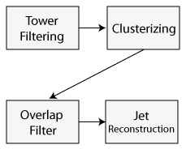
Fig. 6-1: Algorithm dependency graph for Jet Reconstruction
Fig. 6-3 shows the relative hardware overhead (in terms of the amount of resources consumed by padding elements) when using the reference jet algorithm with a range of chip input bandwidth. This data is based on a mathematical model for hardware use, assuming that each chip is bandwidth-limited. Padding overhead is much more significant as the chip bandwidth decreases, since this means that each chip can support a smaller input block size while the padding size remains fixed. However, even for very high bandwidths, padding overhead remains significant. I will describe and evaluate several different modifications to the Jet Reconstruction algorithm’s specifications designed to reduce the hardware implementation cost.
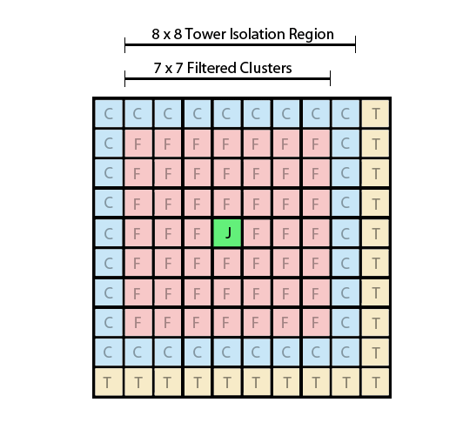
Fig. 6-2: The processes of Clustering, Overlap Filtering, and Jet Finding reduce a 10 x 10 input grid to a 1 x 1 output grid of jet objects. The 10x10 grid of towers (T) is reduced to a 9x9 grid of clusters (C), which is further reduced to a 7x7 grid of filtered clusters (F), that are then used to determine if a single location (J) contained a jet.
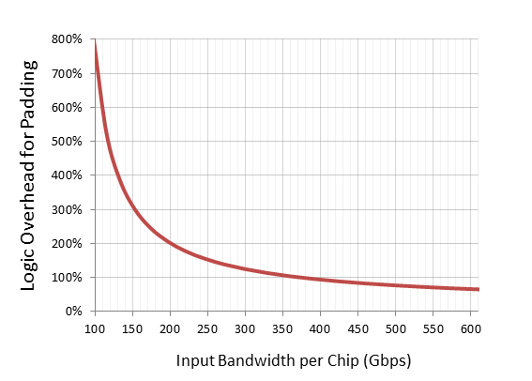
Fig. 6-3: Effect of input bandwidth on jet padding overhead

Jet-Finding Using Tower Primitives
The reference Jet Reconstruction algorithm uses filtered clusters as its primitive inputs. This means that the input towers must first pass through the Clustering and Overlap Filtering stages, incurring a padding loss of 3 towers in each direction, as shown in Fig. 6-4. Alternatively, it is possible to create jets by using filtered towers rather than filtered clusters. This approach simply bypasses Clustering and Overlap Filtering, reducing the amount of padding required and slightly improving the computational latency for the jet datapath. However since a grid of 8x8 towers is needed to cover an equivalent jet size as 7x7 clusters, the amount of padding is only reduced by 2 in each direction rather than 3. The potential drawback of this approach is that it may lead to different physics results that the reference version. This is because the Overlap Filter is responsible for removing energy deposits that may be large enough to pass the tower threshold but are completely localized to a tower, and therefore might not pass the cluster threshold. At this time it has not been fully investigated as to whether this change will produce a significantly negative result in the overall algorithm. Therefore, I will consider the approach and offer implementation results but leave the choice of whether or not to implement the changes to the physicists who will use the algorithm.
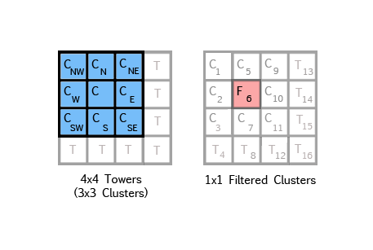
Fig. 6-4: Padding due to successive Clustering (left) followed by Overlap Filtering (right). The dark regions represent the output grid at each step.

Reduced Jet Sizes
The reference Jet Reconstruction algorithm builds jets from a 7x7 filtered cluster regions (geometrically equivalent to an 8x8 tower region). The padding required for the Reconstruction step is (J-1) in each direction, where J is the size of the jet search region. Reducing the jet size will therefore reduce the padding overhead. I examined the result of varying the jet size from a tower equivalent of 6x6 to 8x8. Clearly this will approach may affect the physics performance of the algorithm as it restricts jets to a narrower spread. As with other changes, I will present the implementation costs and leave the evaluation of the tradeoffs of the physics impacts on specific experiments to the physicists.

Region-Based Jet Finder
The reference Jet Reconstruction algorithm has a positional resolution of one tower; that is, for every input tower to the RCT, it computes the energy that would be contained in the jet if it were centered on that tower. The concept of region-based jet finding is to reduce the positional resolution of each jet so there is less overlap between adjacent jets. For example, instead of having one jet for each 1x1 tower region, there might only be one jet for a 2x2, 3x3, or 4x4 region.
At first it might not be evident why a region-based approach would be beneficial to implementation. The key is that region sums are computed on one chip (Jet Builder) and the jet sums (sums of all regions in a jet) are computed in a separate chip (Jet Summary). Jet Reconstruction normally operates on blocks of filtered particle energy, and its input block size is constrained by the input bandwidth of the chip that computes particle energy. Jet region sums require fewer bits to cover a comparable region of the input grid. For example, a 4x4 block of particle energy values requires 16 * (11 bits) = 44 bits. Furthermore, building a 4x4 block of particle energy requires a 5x5 block of input towers, requiring 25 * (17 bits) = 425 bits. In contrast, a 4x4 region sum can be represented using 11 + log(16) = 15 bits . Thus, if we assume that chips are bandwidth constrained on their inputs, a Jet Summary chip could cover an equivalent block size 25 times larger than in the non-region-based approach. By significantly reducing the number of chips needed to perform jet sums, the total number of chips in the system can be reduced despite the addition of the Jet Summary chips.
Increasing region size will allow the algorithm to be implemented with less, however larger region sizes also give lower positional resolution for the jets. For example, with a 4x4 region size the algorithm produces 16 times fewer jets than it does when using a 1x1 region size. The implications of this on the physics efficiency are not immediately clear. Therefore, I analyze the relative hardware costs for implementing region sizes ranging from 1x1 to 4x4. This analysis will provide physicists with the detailed information they need when attempting to make cost-benefit decisions on various region sizes.
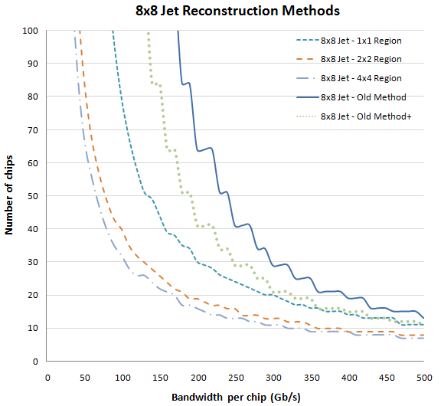
Fig. 6-5: Comparison of Jet Reconstruction hardware cost for 8x8 jets.

Analysis of FPGA Hardware Costs based on Proposed Jet Finder Modifications
To evaluate the implementation tradeoffs of the different Jet Reconstruction parameters, I created an analytical model to compute the number of chips needed to implement the Jet Reconstruction portion of the algorithm. The model is based on the assumption that the chips containing the Jet Finder processing logic are bandwidth-limited rather than logic-limited. I have assumed that the chips would have an equal amount of input and output bandwidth and plotted the number of chips needed in to implement each form of Jet Reconstruction as the chip bandwidth varies.
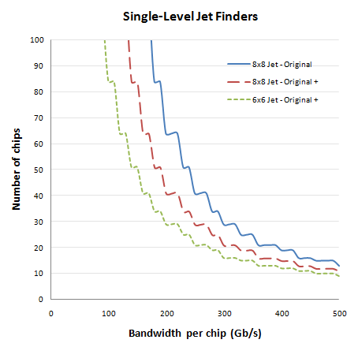
Fig. 6-6: Comparison of Jet Reconstruction methods that can be implemented in a single chip level
Fig. 6-5 shows a plot of the different chip requirements for the originally specified Jet Reconstruction method (Old Method), the original method operating on filtered towers instead of filtered clusters (Old Method +), and region-based Jet Reconstruction with region sizes of 1x1, 2x2, and 4x4. The jet size is fixed at an 8x8 tower equivalent in this plot. The results show that the different Jet Reconstruction methods require significantly different amounts of hardware depending on the maximum input bandwidth available to each chip. Region-based Jet Reconstruction produces the largest reduction in hardware of the alternate schemes. The differences are most pronounced at lower chip bandwidths, reflecting the fact that the fixed bandwidth overhead of padding elements is most costly when the total bandwidth is low and consistent with the padding overhead results shown in Fig. 3. It is interesting to note that the use of 4x4 regions provides little advantage over the use of 2x2 regions. Since 2x2 regions provide four times the position resolution as 4x4 regions, this suggests that 4x4 method is probably only worthwhile in cases where the chip bandwidth is very low.
Fig. 6-6 shows a plot comparing the original Jet Reconstruction, Jet Reconstruction using filtered towers, and Jet Reconstruction using a 6x6 jet size instead of 8x8. Unlike the region-based approach, these methods can all be implemented without requiring the Reconstruction algorithm to be sequentially partitioned into different chip levels. Therefore, these approaches might yield better end-to-end latency than the region-based approach. Like the previous plot, this data shows that the implementation differences are most pronounced when the available chip bandwidth is lower. Reducing the jet size shows considerably lower implementation cost at low bandwidths compared to the original specification, however not as low as the 2x2 or 4x4 region-based approach.

Active-Size Partitioning for the RCT Algorithm
Modifications to the Jet Reconstruction algorithm may provide a solution to the problem of jet padding; however it does not address the cost of padding in other parts of the algorithm, most notably in the Particle Isolation stage.
The amount of padding needed at the output of a chip is additive; for example, the amount of padding in producing particle objects is the sum of the padding required for Clustering, Overlap Filtering, and Particle Isolation. However, the ratio of the block size of the output, which I will refer to as the active size to the input block size, is:
where p is the amount of padding. The key is that this ratio has a 2nd-order non-linear relationship with the padding amount. For example, if the current active size is 20x20 and an algorithm requires padding of 5 elements in both dimensions, the ratio of the output to input block sizes is 0.56. However if the active size is instead 10x10, the ratio becomes 0.25.
Partitioning is known to be a computationally complex problem [124]. The purpose of partitioning algorithms is make this problem tractable by generating relevant partitioning rules and heuristics and performing partitioning based on those rules and heuristics. In this way we can achieve a high-quality solution to the partitioning problem with significantly less computing time. Using computationally inexpensive methods allows for rapid exploration of the design-space. As the name suggests, active-size partitioning uses the concept of the active grid size as a key component in its partitioning heuristic.
Partitioning methods based on cut-size metrics have been well-studied [121] [122] [123]. Active-size-based partitioning provides a partitioning metric tailored to the specific features of HEP algorithms. Since the RCT algorithm is assumed to be IO-bound, it is trivial to determine parallel partition slices. Active-size partitioning sequentially partitions these parallel slices of the algorithm between multiple sequential chips. These partition boundaries allow the active size to change based on the input bandwidth limitations of chip and the cross-sectional bandwidth of the algorithm at the partition point. Manipulating the active area by creating partitions at specific points significantly reduces the relative overhead of input padding and results in a greatly reduced number of chips.

Active-Size-Based Partioning
Active-size partitioning divides an algorithm into a directed dataflow graph where discrete computational units are represented by nodes and communication links between nodes are represented by edges. It is designed to operate on directed graphs that do not contain recursive loops; any recursive loops should be grouped within an opaque node. It is up to the algorithm designer to determine the granularity of the nodes. Each edge is annotated with three pieces of information: the actual active size of the grid sub-block at that edge – a measure of the total number of elements that are transmitted along the edge, the effective active size of the block – the equivalent active size of the input primitives, and the size of each element in the block in bits. The current version of the algorithm assumes that all blocks are square; therefore the active size is a scalar value representing the length of the block in elements. In future it may be necessary to support non-square blocks by using a 2-tuple to represent the active size.

Definition of Terms in Active-Size Partitioning

Algorithm for Computing the Required Number of Chips Based on Active Size
The number of chips needed to implement the algorithm is driven by the number of chip levels and the number of outputs produced by chips in each level (the output active grid size). Assuming that the active grid size is limited by either the input or output chip bandwidth, the number of chips can be computed using the following equations:

The term
Is the grid shrinking function between nodes e_{i} and e_{j}, and will be described further in the next section.
It is important to note that one of the limitations of this formulation is that it considers that there is a single active size per chip. This is an artificial constraint; since some portions of the algorithm operate in parallel, it would be possible for one chip to contain parallel computational paths that output different grid sizes. However, it was chosen to restrict each chip to a single grid size to reduce the complexity of system interconnection. The algorithm formulation also assumes that active grid is square. Future work may examine non-square grids and multiple grid sizes per chip.

Algorithm and Heuristics
Although the equations in the previous section provide an exact means of computing the number of chips given a specific group of cut sets, the equations do not give any information on how to determine those cut sets. The method of determining these cut sets is at the heart of the partitioning problem.
A key characteristic of the active-size algorithm is the computation of the active grid size at every edge in the dataflow graph of the algorithm. Computing the active size at a given edge is an iterative process. First the input active size at the beginning of a cut set (which is initially the entire graph) is computed based on the bitwidth of the inputs at the edge of the cut set and the input bandwidth of the chip, which must be specified by the user. The active grid sizes are then forward propagated to the rest of the edges in the cut set by recursively applying the grid shrinking function. For convenience, the grid shrinking function over a single node with a padding amount R is shown in Fig. 6-7.
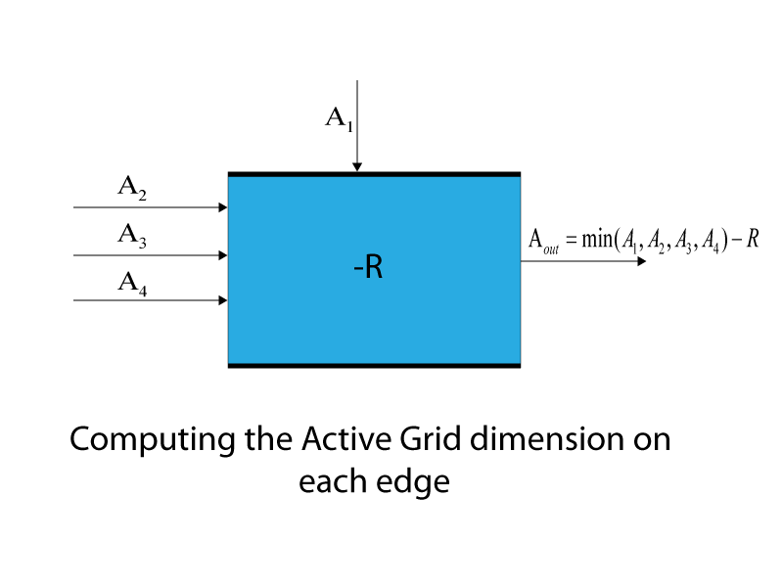
Fig. 6-7: A graphical representation of the computation of the output active grid for a sample node
The active grid size value computed in this process is known as the input-bound or forward active size, and is denoted AG’. Based on the forward active size, the cross-sectional bandwidth of each edge is computed as the product of the forward active size and the bidwidth at each edge. Based on the forward active size and the cross-sectional bandwidth, preliminary choices for the first cut can be made. Cut sets are selected to achieve two objectives:
- Maximize the forward active grid at the cut (the minimum of all the forward active grids at any edge being cut)
- Minimize the total cross-sectional bandwidth at the cut (the sum of the cross-sectional bandwidth of all edges being cut).
Since the cross-sectional bandwidth is directly proportional to the forward active size, these are opposing conditions; therefore some rule must be imposed to arbitrate between the two. Currently I use a simple precedence rule in which I first collect n cut sets with the highest forward active size, then select m < n sets by filtering out those with lower ratios of forward active size to cross-sectional bandwidth. However, many other schemes could be used and future work might be done on determining which scheme to use in different scenarios.
Once the preliminary candidates for the first cut set are selected, the algorithm computes the number of chips needed for each of the candidates using the algorithm given in the previous section. This algorithm also requires us to compute the output-limited or reverse active grid size, A_{G}’’. The reverse active grid size computation is needed because the active grid supported by our input bandwidth limit may require a cross-sectional bandwidth at the cut point that is greater than the output bandwidth of the chip. After the reverse active size is computed, the total number of chips is computed for each of the candidate cuts, and the cut that produces the fewest chips is selected.
After making a cut, we have two resulting directed graphs: a graph that contains edges leading from the input to the cut and a graph leading from the cut to the output. The former is now considered finished, however the latter graph is now subjected to the same partitioning process. The forward active size is recomputed for all the edges based on the new inputs to the cut and the partitioning algorithm proceeds as before. This process continues iteratively until none of the candidate cut sets produce graphs which require fewer chips than the current graph. At this point partitioning is finished.

Results of Preliminary Active-Size Partitioning Experiments
Since the development of the active-size portioning method is still in an early state, the main goal of this portion of the study was to evaluate whether the concept of sequential partitioning could effectively reduce the number of chips needed to implement operations with large amounts of padding overhead and determine whether the active size heuristic was effective at finding good partition points for the RCT algorithm. To evaluate these questions, I applied the active size partitioning method to a dataflow graph made up of the Particle data path of the RCT algorithm. A block diagram of the Particle data path is shown in Fig. A.1 in Appendix A. This data path contains the Particle Isolation function, which requires similar amounts of padding elements as the original Jet Reconstruction algorithm. Unlike Jet Reconstruction, Particle Isolation requires very fine positional resolution and cluster filtering, so the alternate techniques proposed for Jet Reconstruction could not be applied to Particle Isolation.
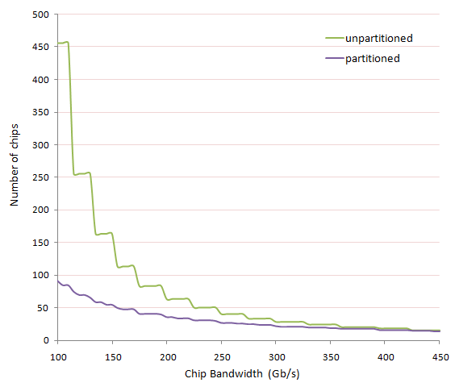
Fig. 6-8: Comparison of the number of chips needed to implement the Particle-based datapath of the RCT algorithms after adding sequential partitioning based on the Active-Size Partitioning scheme.
To evaluate the effects of active-size partitioning on the Particle data path, I applied the active-size partitioning algorithm to the dataflow graph, computed the total number of chips needed to implement the partitioned algorithm, and compared this to the number of chips needed to implement the non-sequentially partitioned algorithm. Fig. A.2 in Appendix A shows the algorithm graph after annotation of edge bitwidths and computation of the active size (in terms of the input active size N) for each edge. Fig. A.3 in Appendix A shows the same graph with a partition cut selected. Note that a new active size (based on a new input active size M) has been computed for each edge in the second half of the graph. Since both the partitioned and unpartitioned graphs must produce a total of 4096 particle outputs to cover the full detector, the number of chips for the non-sequentially partitioned graph can be approximated as:
and the number of chips in the sequentially partitioned graph can be computed as:
Note that this is simply an approximation since it does not account for the geometry of the detector and towers that may need to be processed from the forward region of the calorimeter, but it provides a good first-order approximation of the total number of chips needed.
The values of N and M depend on the input bandwidth of the chips. Fig. 6-8 shows a plot of the number of chips for the partitioned and non-partitioned versions of the graphs for a range of bandwidth values. This data shows that sequential partitioning of the Particle path produces a very large reduction in the number of chips needed when chip bandwidth is relatively low. The advantage decreases with increasing chip bandwidth, and when bandwidth exceeds 300 Gb/s per chip, the partitioned and non-partitioned versions require a comparable number of chips. It is worth noting that this analysis assumes an ideal case use of chip bandwidth. It does not model and error correction or other communication overhead. The addition of such overhead would shift the plot to the right, increasing the advantage of sequential partitioning over a larger range of bandwidths.

Implementing Large Look-Up Tables for Electron/Photon ID
As mentioned in Chapter 3, Look-Up Tables (LUTs) are a common method of implementing triggering algorithms. LUT-based implementations have the advantages of low, fixed latency and easy adaptability should the parameters of the algorithm change. However, the size of LUTs scale exponentially with the number of inputs. Therefore, as higher precision is required in HEP algorithms, scaling LUTs up to large sizes may pose a challenge. Moreover, in the case of the LHC, with its extremely tight latency requirements [8], the access time required to store LUTs in external RAM may be too costly. In this section, I examine different methods of implementing the new Electron/Photon ID algorithm in FPGAs. I also compare the cost of these LUTs to implementing the logic for the algorithm directly (i.e. without a LUT).

The Electron/Photon ID Algorithm
The L1 Trigger upgrade will implement a new Clustering Algorithm [7] to analyze calorimeter data and identify particles produced by collisions. 4096 fixed-position calorimeter towers measure the energy of electrons and photons (ECAL) and hadrons (HCAL). Although the towers are arranged in 3D space (a tube), their locations can be mapped to a 2D grid formed by "cutting" the tube down its length and flattening it as shown in Fig. 6-9. The HCAL wraps around the ECAL, and overlapping HCAL and ECAL towers are mapped to the same cell on the 2D grid. The different grid positions represent the different towers, projected back onto the actual detector geometry. Each tower is a primary input, providing 17 bits of calorimeter data. The tower’s physical position on the detector can also be calculated based on its location in the grid. The data includes 8 bits representing the HCAL transverse energy, 8 bits representing the ECAL transverse energy, and an additional 'finegrain' ECAL bit. The Electron/Photon ID Algorithm’s purpose is to logically group towers with related energy deposits and characterize the type of particle(s) that created the deposit as being either an electromagnetic particle or non-electromagnetic particle. This classification is later used in the Particle ID algorithm introduced in Section 5.8.
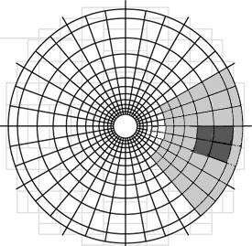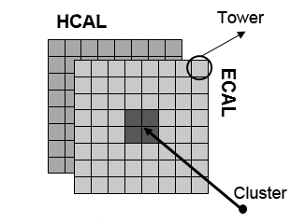
Fig. 6-9: Towers from the cylindrical CMS detector’s calorimeter towers are mapped on to a 2-dimensional Cartesian grid.
The L1 Trigger is used to identify 3 major classes of post-decay particles: (1) photons and electrons, which are confined to two adjacent towers and consist primarily of ECAL energy, (2) tau leptons, which are approximately confined to a 2x2 grouping of adjacent towers and consist of narrow ECAL and HCAL energy deposits, and (3) jets, which consist of collections of particles that spread across large groups of adjacent towers and consist of both ECAL and HCAL deposits. The Electron ID Algorithm is used for the isolation and identification of photons and electrons, with tau and jet isolation performed in later stages.
In the algorithm, we first form grid towers into overlapping 2x2 tower clusters. The ECAL and HCAL data for each tower is compared against reprogrammable threshold values to filter (zero out) detector noise and data from low-energy collisions. Because particle collisions have already been extensively studied in lower-energy domains, such data is assumed to be unlikely to show the effects of the new phenomena that may be possible in higher-energy domains. For each 2x2 cluster, the threshold filter also creates a 4-bit pattern bitmask indicating which towers in the cluster meet the threshold energy. This pattern (the "shape" of the detected energy confined to that cluster) is compared against a collection of preset patterns. If it does not match a desired pattern, the pattern filter zeroes out the cluster data. This filtering prevents small, isolated energy deposits from being duplicated by overlapping clusters.
In the next stage of the algorithm, the composition of a cluster’s energy is analyzed to determine if it matches the photon/electron class. Since photons and electrons are electromagnetic particles, a cluster that contains one or more of these will exhibit high ECAL energy and low HCAL energy. The first version of the electron/photon identification algorithm sums the ECAL and HCAL energies for the 2x2 cluster, and then evaluates the inequality given in (1).
$\frac{ECAL}{(ECAL+HCAL)}>EGamma_Threshold$ (1)
EGamma_Threshold is chosen as 0.9 in current simulations and algorithmic evaluations; however the threshold value and algorithm may be revised based on experimental data. If the inequality is true, the cluster contains a photon or electron, and the cluster’s EGamma bit is set. Other cluster outputs include the OR of the filtered towers’ finegrain bits and the 9-bit sums of the ECAL and HCAL energy for each tower. These outputs are used in the other portions of the RCT algorithms described in Chapter 5. A block diagram of the early stages of the algorithm leading up to Electron/Photon ID is shown in Fig. 6-10.
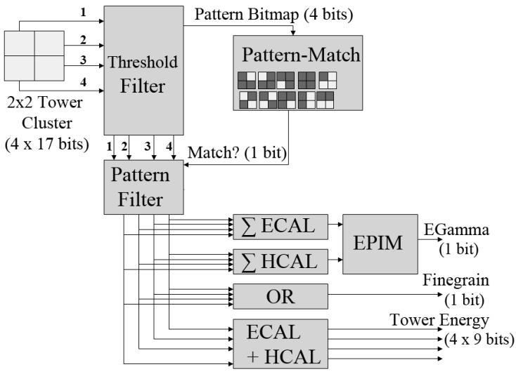
Fig. 6-10: Block diagram of the early stages of the Phase-I RCT algorithms. The block marked ‘EPIM’ (Electron/Photon ID Module) contains the large look-up table that determines whether a particles energy composition characterizes it as electromagnetic.
.

Implementation of the Algorithm
In this section, I present an overview of issues and design considerations related to the FPGA implementation of the Electron/Proton Identification Module (EPIM) portion of the new RCT Algorithm.

Grid Partitioning
The existing CMS detector uses 4096 towers, and the SLHC upgrade is expected to increase this number by an additional 25%. With 17 bits of data per tower per crossing and a bunch crossing rate of 40MHz, the current input data rate to the Calorimeter Trigger is approximately 3 Terabits/second, and it will increase significantly with the upgrade. This data rate prevents any one computing device from examining the full grid; the tower grid is split into overlapping partitions spread across many FPGA cards. Supporting as many towers as possible per FPGA reduces the number of required FPGAs (and therefore system size, cost, and maintenance issues). For perspective, the existing Regional Calorimeter Trigger has 18 crates containing over 1,000 FPGA cards total, and encompasses only part of the L1 Trigger’s functionality. Also, having more towers per FPGA reduces off-chip communication required to combine data in tasks such as particle isolation and jet reconstruction. Much of the overall system complexity is due to inter-crate communication. Unfortunately, the best grid partitioning to balance cost and performance cannot be determined before analyzing algorithm effectiveness and design tradeoffs for other L1 Trigger components and finalizing the target FPGA. A mechanism for efficiently determining partition size and location is discussed elsewhere in Section 6.3. Early estimates based on proposed Virtex-5 and Virtex-6-family FPGAs [86] [87] suggest that the desired grid partition sizes for the EPIM stage will range from 9x9 to 17x17 towers per partition.

FPGA Platform and I/O Considerations
A major design challenge for the L1 Trigger is its high data throughput. For my analysis, I selected the Xilinx Virtex-5 TXT240 [86] as my target FPGA for its large number of high-bandwidth serial data links; it features 48 RocketIO GTX full-duplex serial transceiver links, each with a maximum transmission rate of 6.5 Gbps. The 6.25 Gbps Serial RapidIO protocol uses an 8/10-bit de-serialization scheme [125], giving an effective data rate of 5 Gbps per link. The device has a maximum aggregate bandwidth of 240 Gbps. With a 20% overhead for error detection and framing, the I/O bandwidth restricts the partition size to a maximum of 17x17 towers per chip. The TXT240's logic resources consist of 37,440 logic slices (each with four lookup tables (LUTs) and four flip flops), 96 DSP blocks with dedicated arithmetic hardware, and 11,664 Kb of block RAM (BRAM) organized into 324 36-Kb blocks or 648 18-Kb blocks.

Implementing the Front-End of the RCT Algorithms
To meet throughput requirements, the implementation of the Clustering Algorithm is an aggressively-pipelined multistage module. The tower energy filtering, pattern-matching, and electron/photon identification (EPIM) modules, shown in Fig. 6-10, are time-multiplexed to reduce resources. The pattern-matcher, tower energy filter, finegrain OR function, and energy adder are all easily mapped to LUT-based logic. The EPIM, discussed in the next section, is more interesting than the other modules because it requires high flexibility, consumes the most resources, and offers several implementation options with varying tradeoffs.

Implementing the Electron/Photon Identification Module
The most significant design choices for the Clustering Algorithm lie in the EPIM. This module inputs the ECAL and HCAL cluster energy sums (10 bits each) and outputs a Boolean decision as to whether these energies represent an electromagnetic particle. This decision is made for each (overlapping) 2x2 cluster on the grid. Due to this overlap, an n × n square grid containing n² towers contains (n - 1)2 clusters. The existing Trigger system performs a similar form of particle identification using external RAM-based look-up tables of decision data [8]. To provide a clear distinction, I refer to this type of look-up table as a 'logical LUT' and refer to the hardware look-up tables that make up an FPGA's structure as 'physical LUTs'. Despite high cost, these RAM-based logical LUTs allowed easy algorithm modifications during experimentation and upgrades. Likewise, this functionality could be implemented as a 1-Mbit logical LUT per decision within the FPGA. Each logical LUT contains the same decision data, so they can be time multiplexed between multiple clusters, but because all clusters must be processed within the 25 ns before the next beam crossing, some replication of logical LUTs is required. However, replicating 1-Mbit logical LUTs may consume considerable FPGA resources and limit the maximum grid size supportable by a single FPGA. Therefore I also explore alternative implementation options.

EPIM Implementation Strategies
The base EPIM algorithm identifies electromagnetic particles by checking the inequality given in (1), where ECAL and HCAL are the 10-bit sums of the electromagnetic calorimeter energy and hadron calorimeter energy for each tower in a 2 x 2 cluster, and the EGamma_Threshold is a constant value between 0 and 1, with a granularity of at least 0.1.
My implementation approaches can be classified into four major groups: Multipliers, Static Tables, Dynamic Full Tables, and Dynamic Partial Tables. Multipliers directly implement an algebraically-optimized version of (1) that transforms division into multiplication. Static Tables are read-only logical LUTs indexed by the concatenated ECAL and HCAL values. They contain decision data based on offline computations of the EPIM algorithm. Dynamic Full Tables are conceptually similar to Static Tables, but the contents can be updated at run-time. Thus, these designs cannot be optimized based on table contents. Dynamic Partial Tables apply hashing algorithms to ECAL and HCAL in order to compress the size of the data tables.

Multipliers
- DSP-Block Multiplier: Virtex-5 FPGAs contain DSP48E blocks, which each provide a 25 x 18 two’s complement multiplier, a 48-bit 3-input adder, and additional logic [20]. Utilizing simple algebra, the clustering division can be reformulated into addition, multiplication, and comparisons operations, as shown in (2).
$ECAL >EGamma_Threshold×(ECAL+HCAL)$ (2)

I implement this design as a 4-stage pipeline. Only one DSP48E slice is needed for the multiplication. The comparison and addition logic is trivial and is mapped to LUTs. The threshold is not hard-coded, and can be adjusted at run-time without reconfiguration. However, the function itself is fixed, and cannot be altered without redesigning the hardware implementation and reprogramming the FPGA.
- LUT-Based Tree Multiplier: As an alternative to the DSP multiplier, I also implemented a multiplier in LUTs, using an adder-tree-based design with a 4-bit threshold precision. An advantage of the LUT-based multiplier is that the designer has much greater control over the number and placement of pipeline registers. I achieved the best results using a 6-stage pipeline. The number of times this multiplier can be replicated is limited by LUT resources rather than DSP blocks.
- Hybrid Tree Multiplier: To achieve a compromise between the DSP and LUT-based multipliers, the design can be structured as an adder-tree-based multiplier like the LUT-Based Tree Multiplier, but with the four adder units in the tree instead mapped to DSP blocks. The exchange for greater control of pipeline register placement is an increase in resource requirements. In particular, because each DSP block contains the same number of multipliers and adders, this design uses 4 times as many DSP resources as the purely-DSP based implementation. This design also utilizes a 6-stage pipeline, with four of the stages corresponding to the adder-tree multiplication block.

Static Tables
- LUT-Tree Static Table: One of the natural approaches to implement the EPIM algorithm on an FPGA is to map the table directly to physical LUTs. The EPIM algorithm can be expressed as a 2²⁰ x 1-bit table, and that table can be divided across a set of 6-input LUTs. A tree of 2:1 multiplexers in the Virtex-5 slices assembles the LUTs together, and the multiplexer selects the table index inputs. Such an implementation requires 2^{(a–6)} 6-input LUTs, where a is the width of the table index. Since each slice in the Virtex-5 FPGA has four 6-input LUTs, at least 2^{(a-8)} slices are needed if they are fully packed. We can also opt to implement multiple smaller trees, then multiplex the result using LUTs. This provides a tradeoff between LUT and multiplexer resources. In my tests, a 2¹³x2⁷-bit organization (7 trees, each implementing a table with a 13-bit index) yielded the best resource usage, frequency, and synthesis times. I created a script to instantiate the necessary 6-input LUT leaf-nodes and initialize their contents. If the table must be changed, the FPGA must be reconfigured with the new values. Although this approach can implement any modifications to the base algorithm, all alterations, including simple changes to the threshold value, necessitate at least a partial re-synthesis and reprogramming of the FPGA, increasing initialization and setup time.
- Optimized Static Table: If the table values are static, the synthesis tool can optimize the table as it would any truth table. If the data in the table is very regular, this can result in a dramatic reduction in the logic resources necessary to implement the table. To test this implementation method, I directed the Xilinx XST synthesis tool to infer a “distributed ROM” architecture XST optimizes the logic equation of the table and maps it to FPGA logic. A disadvantage of this method is that any modification to the table contents requires recompilation and reconfiguration.

Dynamic Tables
- Dynamic Full Table: Xilinx Virtex-5 FPGAs include integrated 36-Kbit, dual-port Block RAMs (BRAMs) that operate at up to 550 MHz. The BRAMs can be configured with different widths and depths from 2¹⁵ x 1-bit to 2⁹ x 72-bits, and can be cascaded to form larger memory arrays [126]. A 1-Mbit table can be implemented in 32 BRAMs, each configured as 2¹⁵ x 1-bit structures and cascaded with intermediate multiplexing. If one RocketIO port is reserved to load new data into the BRAM-based tables (broadcast to each), the table can be loaded in less than 1 ms, minimizing Trigger downtime during algorithm modification. The Dynamic Full Table can accommodate not only changes in the threshold of (1), but also a complete redesign of the EPIM algorithm itself. Unfortunately, a single 1-Mbit table consumes nearly 10% of the total BRAM, limiting the practicality of the Dynamic Full Table for large grid sizes. The input and output of the Dynamic Full Table is illustrated in Fig. 6-11.
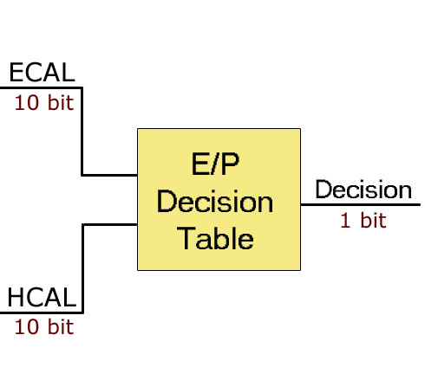
Fig. 6-11: A Dynamic Full Table, requiring 1 Mbit of memory per table
- Dynamic Partial Table: The goal of the Dynamic Partial Table is to achieve a sufficient degree of flexibility, while using fewer resources than a Dynamic Full Table. To do so, the ECAL and HCAL values are passed through a lossy compression function and then concatenated to index into a smaller dynamic table. To further increase flexibility, compression functions can also be implemented as dynamic tables, resulting in a multi-level table structure. The first level of tables contains HCAL and ECAL compression data, and the second level contains the EPIM decision data. This design does not provide the full range of flexibility of the Dynamic Full Table; instead, the size of its algorithm design space depends on the degree of compression applied to each input. Physicists associated with the experiments suggested an architecture that compresses each energy value by half (two 10:5 compressor tables), followed by decision table indexed by the 10-bit concatenation of the compressed energies. I therefore configure two Virtex-5 BRAMs as 2k x 9 bits for the first level that compresses the 10-bit ECAL and HCAL inputs to 7 bits each. I configure one BRAM as 16k x 1 bit for the second level that accepts the 14-bit concatenation of the two compressed inputs. Using 10:7 compressor tables provides a finer degree of algorithmic representation than was suggested by the physicists, and uses only 6.3% of the BRAM used by the Dynamic Full Table. This topology is shown in Fig. 6-12. In my experiments, a 6-stage pipeline gave the best clock frequency for this design.
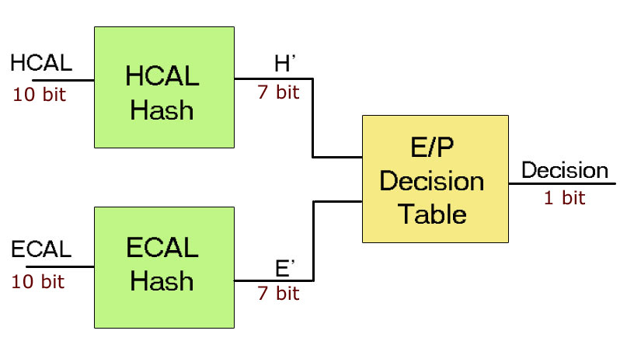
Fig. 6-12: One possible topology for a Dynamic Partial Table. This topology uses 34 kbits of memory per table/hash combination.

Experimental Results
Designs were synthesized to a Xilinx Virtex-5 TXT240 [86] using Xilinx ISE version 10.1.03 (NT), Application Version K.39, with an Optimization Goal of SPEED and an Optimization Effort of HIGH. Synthesis times are based on a 2 GHz Core 2 Duo-based system with 2 GB of memory.

Summary of Results
Table I shows a breakdown of slice logic, BRAM, and DSP resource utilization for each proposed EPIM. The grid-size-limiting resource (excluding I/O) for each design is highlighted. Percent utilization is based on the total resources of the TXT240, a device that features higher serial I/O bandwidth at the expense of fewer BRAM and DSP resources compared to other Virtex-5 models [86].
Table II shows the estimated maximum grid partition sizes supported per FPGA for the various EPIM designs. These estimates are based on the number of times each EPIM design can be duplicated within the TXT240 resources and the number of clusters that can share each EPIM within a bunch crossing, based on the module’s performance. I capped logic slice utilization to 80% to facilitate efficient mapping and routing on the device. Even if the EPIM design allows a maximum grid size above 17x17 towers, the I/O constraints impose that limit.
Table I: Percent Resource Utilization for a Single EPIM Module in a Xilinx Virtex-5 TXT240
Type |  | Slice % | BRAM % | DSP %
Multiplier | DSP | 0.02% | --- | 1.0%
Multiplier | LUT | 0.08% | --- | ---
Multiplier | Hybrid | 0.01% | --- | 4.2%
Static Tables | LUT Tree | 14.6% | --- | ---
Static Tables | Optimized | 0.12% | --- | ---
Dynamic Tables | Full | 0.02% | 9.8% | ---
Dynamic Tables | Partial | 0.02% | 0.62% | ---

Table II: Maximum Grid Sizes for Different EPIM Designs, With and Without I/O Grid Size Constraints
Type |  | Freq.  (MHz) | Grid  (w/o I/O) | Grid  (w/ I/O)
Multiplier | DSP | 370 | 22x22 | 17x17
Multiplier | LUT | 440 | 73x73 | 17x17
Multiplier | Hybrid | 320 | 11x11 | 11x11
Static Tables | LUT Tree | 88 | 4x4 | 4x4
Static Tables | Optimized | 270 | 57x57 | 17x17
Dynamic Tables | Full | 390 | 8x8 | 8x8
Dynamic Tables | Partial | 450 | 29x29 | 17x17

Table III: Static Table Synthesis Times (seconds)
Type | Synthesis | Map | Place & Route
Optimized | 179 | 161 | 291
LUT-Tree | 2131 | 2516 | 1996

Module frequency results are based on post-place and route measurements. In all cases except the LUT-Tree Static Table, system frequency was limited to 220 MHz by the filtering and pattern-matching modules, then rounded down to 200 MHz to match an integer multiple of the 40 MHz bunch crossing rate. For the LUT-Tree, the system frequency was set to 80 MHz. Table III shows the synthesis, mapping, and place & route CAD times for the Static Table implementations on my test system. These times are most significant for Static Tables because they must be re-synthesized to make any change to their contents.

Resource Utilization
The resource requirements of the EPIM implementations play an important role in their viability. Resource-efficient designs allow larger grid partition sizes. Increasing partition sizes reduces the number of FPGAs necessary to implement the Clustering Algorithm, yielding improved cost, size, and reliability. In the ideal case, the resource-usage of an EPIM design would be low enough to support the maximum grid size possible based on I/O constraints or other parts of the system, while leaving as many device resources free as possible. These free resources could be used to consolidate functionality from other parts of the Calorimeter Trigger system into the same FPGAs that handle Clustering. This would provide further reductions in the number of required devices and less of the Trigger's allocated total latency would be lost to inter-chip communication.
Grid partition size is controlled by two factors: the resource utilization of a single instance of the EPIM and the number of clusters that can share each EPIM per bunch crossing. The latter is based on the operating frequency of the EPIM design and the bunch crossing rate. The maximum grid partition sizes for each implementation are shown in Table II. Maximum grid sizes are listed both independently of I/O restrictions, and including I/O restrictions. The theoretical maximum grid size allowed by the FPGA I/O is 17x17. In the majority of cases, I/O limits grid size.
Beyond the number of resources, the type of resources used for each EPIM implementation is also important. Ideally, we should conserve resources that are needed for other parts of the system, or that may be most important for future modifications. Without knowing this information in advance, it may be best to conserve highly-flexible logic slices, or potentially to conserve each resource type equally.

Flexibility
One of the challenges of designing high-energy physics systems for the LHC is that the systems are operating at previously unexplored energy levels and searching for as-yet-unobserved phenomena. While theoretical models and simulators can make predictions about the data that will be collected, they cannot be fully validated until real experimental results can be analyzed. For this reason, it is necessary to build flexibility into the systems.
The base algorithm in the EPIM identifies photons or electrons by evaluating (1). Changes to this algorithm might take two basic forms: simple changes to the constant threshold values or more complex changes to the algorithm itself, such as the introduction of special cases or a change to the form of the equation.
Changing threshold values is most seamless with the Multiplier designs; because they directly implement the arithmetic operations of the algorithm, the threshold can be changed at run-time simply by shifting a new threshold value into the threshold register. The Dynamic Full Table and Dynamic Partial Table designs can also alter their threshold values at run-time, but the complete table data may need to be regenerated for the new threshold before shifting it into the table(s). Changing the threshold is most time-consuming for the Static Table designs. Static Tables can only be changed through reconfiguration; the structure must be re-synthesized and re-incorporated into the top-level modules. Time spent updating the design for a new threshold represents a potential loss of valuable Collider time during which the experimenters may not be able to collect data. Changing the content of the Static Table presents another challenge; since its structure is dependent on its contents, changes in table data may result in changes in resource use or operating frequency, and therefore changes in the supportable grid size. Since the supportable grid size dictates the number of required resources and the connections between them, an algorithm modification that changes the size of a Static Table may not be allowed.
After early experimental tuning, major base algorithm changes should be infrequent during normal operation. The Dynamic Full Table and Static Table both allow the most flexibility in changing the algorithm or adding special cases. However, the non-deterministic frequency and resource use of the Optimized Static Table could become problematic if the complexity of the algorithm increases. The Dynamic Partial Table provides the advantage of fixed resource use, but places restrictions on the range of implementable algorithms. The Multiplier-based designs, as more direct implementations of the base algorithm, provide no flexibility for changing the algorithm (apart from the EGamma_Threshold value) without a hardware redesign. Although FPGAs permit such redesigns, they may require the intervention of design experts, whereas a script-enabled process of generating and programming new table data for the Dynamic Partial Table would not require specific design expertise.

Comparison of Design Metrics
To evaluate the relative suitability of the proposed designs and narrow the candidates to the top choices, I first consider tradeoffs within groups of similar implementations.
Among the Multipliers, the Hybrid Tree Multiplier is the poorest candidate due to its high DSP block usage. Between the DSP-Block Multiplier and the LUT-Based Tree Multiplier, the latter supports larger grid partition sizes due to the greater abundance of logic slice resources compared to DSP blocks on the Virtex-5 TXT240 and a higher achievable frequency. However, both of these can support partition sizes that far exceed the limits imposed by I/O. Therefore, I base the decision between these two implementations primarily on whether we should conserve logic slice or DSP resources. Since logic slices can be used for a larger variety of purposes than DSP blocks, I recommend using the DSP-Block Multiplier.
Between the two Static Table implementations, there is little contest. The Optimized Table supports significantly larger grid sizes than the LUT Tree due to the Boolean reduction optimizations the synthesis tool can perform on the Optimized Table. Furthermore, the LUT Tree has significantly higher synthesis times, which are unacceptable for a design that must be re-synthesized in order to alter the EPIM algorithm and threshold value.
Of the Dynamic Tables, The Dynamic Full Table offers the greatest flexibility, however its resource requirements significantly limit the maximum grid size compared to most of the other designs, and uses up a large proportion of the FPGA BRAMs. The Dynamic Partial Table is significantly smaller than the Dynamic Full Table, reduces the resource usage of the Dynamic Full Table, and is also faster. Although it limits the implementable identification algorithms, it is believed to be sufficiently flexible.
Next, I compare the top candidates from each category: the DSP-Block Multiplier, the Optimized Static Table, and the Dynamic Partial Table. Each of these designs has its own set of tradeoffs. Among these, the Multiplier primarily consumes DSP blocks, the Static Table only consumes logic slices, and the Dynamic Partial Table primarily consumes BRAM. In all cases, however, a single instance of each of these designs consumes 1% or less of the respective resource, as shown in Table I.
When comparing these designs, we must consider that the SLHC upgrade is a multi-phase process. A good approach, therefore, is to provide a high level of flexibility in the initial phase, and switch to a smaller and more efficient design later when the algorithms become more static. The initial, flexible design allows experimenters to easily adjust the algorithms based on early experimental data. In later upgrade phases, after algorithm maturity, flexible designs can be replaced by more resource-efficient ones. This change would free some FPGA resources for bug-fixes or additional features in other parts of the L1 Trigger. Therefore, I recommend using the Dynamic Partial Table design in the first phase of upgrades. It can be quickly and easily modified to implement changes to the EPIM algorithm without requiring a hardware redesign, re-synthesis, and verification.

Full-System Synthesis
I next evaluate the resources remaining for the integration of future Calorimeter Trigger functionality. I synthesized the full algorithm with the Dynamic Partial Table EPIM for a 10x10 tower grid partition size, which contains 81 2x2 clusters. This implementation requires no DSP blocks; however some BRAM is used as a frame buffer for the RocketIOs. The design uses 24 EPIMs, each shared by four clusters. Table IV shows the resource utilization for this full design. With the 10x10 grid, well over 90% of the slice logic resources, 80% of the BRAM resources, and 100% of the DSP resources remain free for future consolidation of Trigger functionality. Slice logic utilization scales approximately linearly with the number of towers per grid. The BRAM overhead of the RocketIO buffers is fixed, and EPIM BRAM scales linearly with the number of clusters per grid.
Table IV: EPIM and RCT Frontend Resource Utilization for 10x10 Grid (Using Dynamic Partial Tables)
Resource | EPIMs-Only | EPIM+Frontend
Slice FFs | 5.1% | 8.9%
Slice LUTs | 4.1% | 6.4%
BRAMs | 14.8% | 18.5%

Electron/Photon ID Implementation Conclusions
Increases in device density, along with their hardware flexibility, have made FPGAs an attractive platform for planned upgrades to the L1 Calorimeter Trigger of the Large Hadron Collider's Compact Muon Solenoid. FPGAs achieved success in the world of prototyping due to their ability to quickly and inexpensively implement design changes. The same properties make FPGAs attractive in applications like the CMS, which operate on the cutting edge of high-energy physics. The hardware that implements the L1 Trigger requires both the extreme performance to handle Terabits of data per second, but also significant flexibility to permit modifications based on experimental results and to meet new challenges introduced by the Collider’s on-going upgrades. However, the L1 Calorimeter Trigger is not a prototype system; it is a mission-critical part of the CMS experiment, and its operation impacts a great deal of important scientific research.
I have presented an FPGA hardware implementation for the Front-End and Electron/Photon Identification algorithms to be introduced as part of the Phase-I RCT Trigger updates. For the electron/photon identification module (EPIM), I presented a several designs with different resource, performance, and flexibility tradeoffs. Based on my analysis of the EPIM implementations, I believe that the best initial design choice to implement the required functionality is a multi-level Dynamic Partial Table. I then implemented the the Front-End and Electron/Photon ID algorithms using the Dynamic Partial Table EPIM for a sub-grid of 10x10 detector towers. This implementation avoids use of any DSP blocks, and uses less than 20% of BRAMs and less than 10% of the slice LUTs, providing significant available resources for other aspects of the L1 Trigger to be implemented within each FPGA.

Future Work
Shortly after finishing the study of Jet Reconstruction implementation tradeoffs presented in this thesis, a new proposal for modifications to the Jet Reconstruction algorithm was created by the physics group developing the RCT Phase-I algorithms. These changes call for an additional stage of filtering after reconstruction which is designed to ensure that data is not duplicated between overlapping jets (a similar function is already implemented in the Overlap Filter, but on a smaller scale). These changes will require even more padding for the base jet algorithm, making the implementation advantages shown in this paper even more important. Once the new filtering specification is created, I will examine possible new implementation optimizations and re-evaluate the relative tradeoffs of the approaches described in this thesis.
Although the active-size partitioning method described in this paper showed promising results and proved that active size is a worthwhile partitioning heuristic, the design of the algorithm is still in a preliminary phase. Extra features like non-square block sizes and multiple active grids per chip may be added, and the performance of the algorithm will be compared against other partitioning schemes. The algorithm focuses solely on reducing the number of chips; however other factors, such as the complexity of the interconnection between chip levels and the total latency of the algorithm are critical factors in the design of the system. In the future, I will investigate methods of modeling and incorporating these constraints into the algorithms cut heuristics.
Since both the Jet Reconstruction and partitioning results are both highly dependent on chip bandwidth, it is worthwhile to ask what the expected chip bandwidth will be for the RCT algorithm. Although final chip selection will not be made until 2011 or 2012, the available chip bandwidth is constrained not only by ASIC and FPGA technology, but also by the capabilities of the existing fiber-optic communication links, throughput of transmitter and receiver boards, the number of links that can be fit on each board, and the difficulty of handling synchronization and maintaining signal integrity multiple for high-bandwidth signals on a single board. Based on these considerations and input from engineers designing the communication system, we are currently targeting a chip bandwidth of at most 200 Gb/s. At this bandwidth, both modified Jet Reconstruction and sequential partitioning based on active size offer significant potential benefits.
Overall, both modifications to the Jet Reconstruction algorithm and changes to sequential partitioning based on the active-size partitioning scheme demonstrated that they could significantly alter the implementation cost of the upgraded Regional Calorimeter Trigger algorithm for the CMS experiment. Many of the proposed changes have potential impacts on the physics performance of the algorithm. It is not the goal of this work to select a specific set of modifications that should be adopted; rather this study has provided a description of many different alterations that could be made to the algorithm and analyzed the relative implementation costs of each of the alternatives. I hope that by presenting these parameters and tradeoffs, I have provided a better understanding of the hardware costs associated with achieving different algorithmic performance to the physicists who will ultimately select which algorithmic parameters to use in their experiments.

Conclusion
In this thesis, I have provided a uniquely comprehensive outline of the state of FPGA-based design of Triggering systems for high-energy physics.
- I have introduced the topic of real-time processing systems for high-energy physics experiments and detailed the special challenges of designing trigger systems – including both the technical barriers and challenges to the design process.
- I have outlined the history of the development of trigger systems for high-energy physics while highlighting the salient trends that will influence modern and future trigger design.
- I have charted trends in the capabilities of FPGAs and contextualized these trends through their potential impact on the design of triggering systems, emphasizing the new opportunities and challenges these technologies will afford the designers of such systems.
- I have provided a uniform mathematical formulation of the new Phase-I algorithms for the Super Large Hadron Collider upgrade of the Regional Calorimeter Trigger of the Compact Muon Solenoid and demonstrated how alterations to jet-based algorithms can significantly reduce the implementation costs of these algorithms.
- I have analyzed several different methods of adapting the large Look-Up Tables commonly found in trigger systems to FPGAs. My Dynamic Partial Tables significantly reduce the resource cost of implementing large tables, making it possible to do so without the use of external RAM chips. This provides significantly better latencies needed for high-luminosity experiments.
- I have outlined Active-Size Partitioning – a new partitioning method geared toward the algorithms used in calorimeter-based triggers – that provides a means of determining sequential algorithm partition points that can drastically reduce the number of FPGAs needed to implement the system.
I believe that this work will be of great use both in the continued development of the Phase-I algorithms for the RCT and also in the development of future FPGA-based triggering systems.

Appendix A: Illustration of Active-Size Partitioning
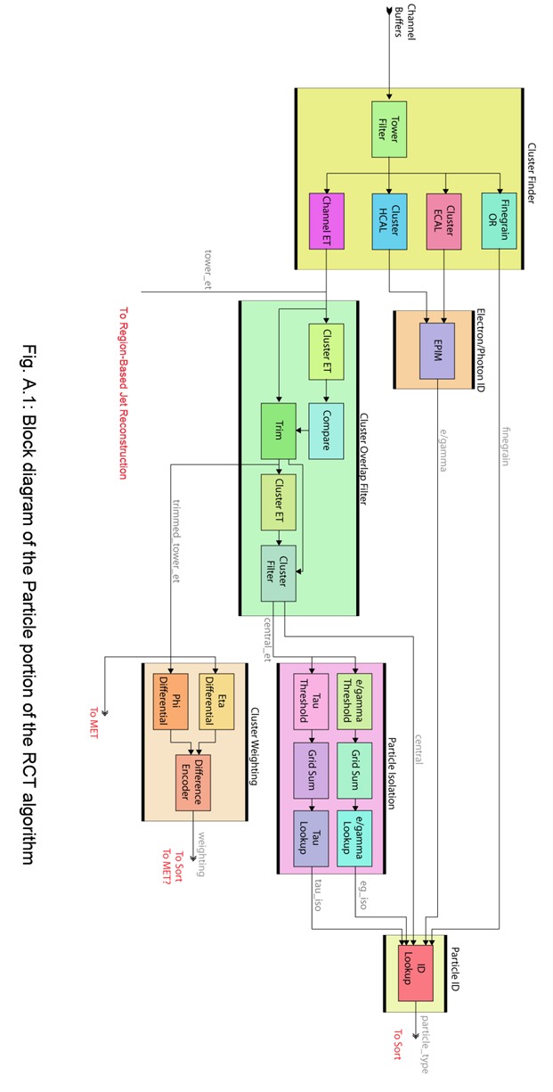
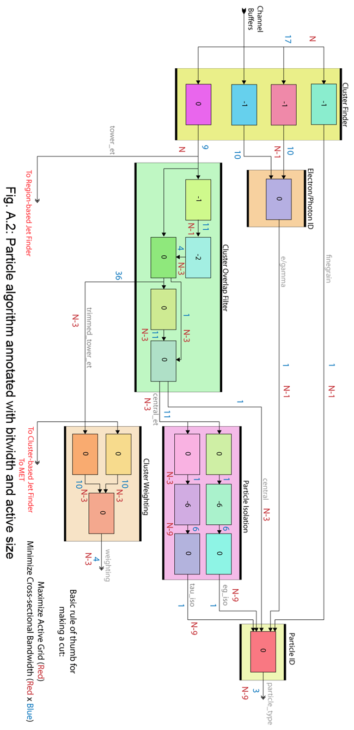
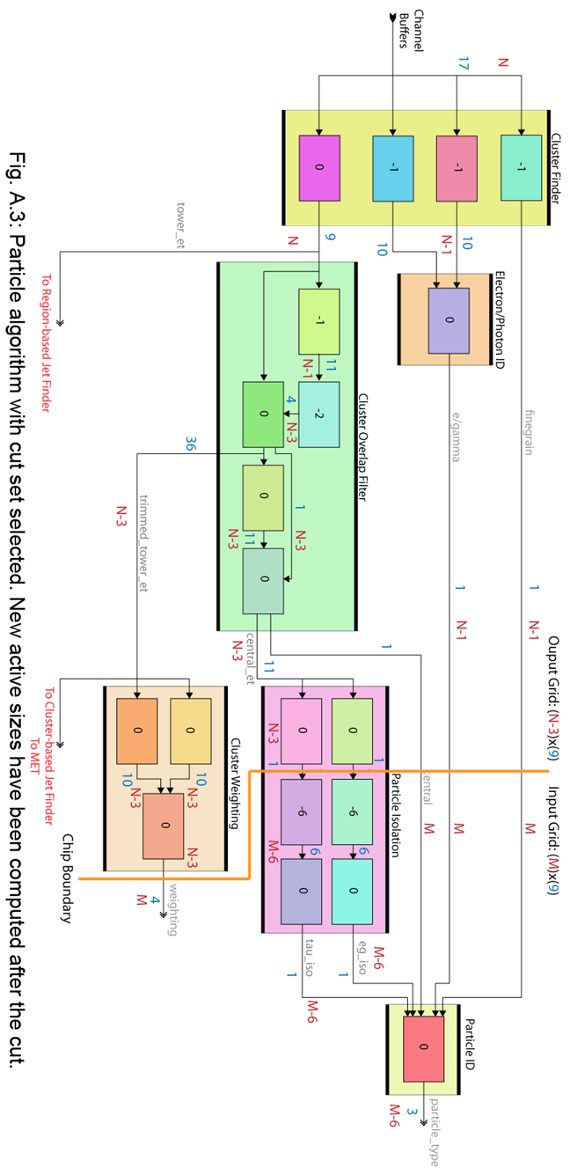

Appendix B: List of Acronyms
Acronyms
AFS: Axial Field Spectrometer 36, 37
BRAM: Block RAM 64
CAD: Computer-Aided Design 117
CCD: Charge-Coupled Device 40, 54
COTS: Commercial-Off-The-Shelf 41, 51, 54, 57
CPU: Central Processing Unit 44, 57, 58, 59
DFT: Design For Testability 80
DICE: DSPCAD Integrative Command-line Environment 32, 72, 73
DIF: Dataflow Interchange Format 72, 73
DSM 50
DSM: Data Storage and Management 50
DSP: Digital Signal Processing passim
ECAL: Electromagnetic Calorimeter passim
ECL: Emitter-Coupled Logic 38
EPIM: Electron/Photon ID Module passim
ET: Transverse Energy 36, 37, 85, 87
FIFO: First-In, First-Out 43, 48
FPGA i
FTT: Fast Track Trigger 51
GB: Gigabyte 12, 17, 41, 82
GPU: Graphics Processing Unit 59
HCAL: Hadron Calorimeter passim
HDL: Hardware Description Language passim
HEP: High-Energy Physics passim
HLT: High-Level Trigger 56, 57, 58, 59
I/O: Input/Output passim
ISR: Intersecting Storage Rings 36
LEP: Large Electron-Positron storage ring 38
LUT: Look-Up Table passim
MB: Megabyte 13, 41, 56, 58
MIMD: Multiple-Instruction, Multiple-Data 44
MIPS: Millions of Instructions Per Second 41
MWC: Multi-Wire Chamber 36
PAL: Programmable Array Logic 44
PB: Petabyte 11, 12, 17
PLD: Programmable Logic Device 14
RAM: Random-Access Memory passim
RHIC: Relativistic Heavy Ion Collider 47, 48, 50
RISC: Reduced Instruction Set Computer 44, 59
RTL: Register Transfer Level 33, 75
SRAM: Static RAM 48, 51
SVT: Silicon Vertex Tracker 45, 54
TCU: Trigger Control Unit 50
TeV: Tera-electron-Volt 2, 8
TriDAS: Triggering and Data Acquisition System 12

Works Cited

[1] | C. LeFevre, "LHC: The Guide," CERN Communication Group, Geneva, 2008.
[2] | CMS Collaboration, "CMS: The Story of the Universe. Particle and Forces: The Compact Muon Solenoid," CERN, Geneva, 1998.
[3] | H. Baer, C. Chen, F. Paige, and X. Tata, "Signals for minimal supergravity at the CERN Large Hadron Collider: Multijet plus missing energy channel," Physical Review D, vol. 52, pp. 2746-2759, 1995.
[4] | G. Kane and A. Pierce, Perspectives of LHC Physics.: World Scientific, 2008.
[5] | L.R. Flores-Castillo, "Standard Model Higgs Searches at the LHC," Nuclear Physics B, vol. 177-178, pp. 229-233, 2004.
[6] | P. Busson, "Overview of the new CMS Electronic Calorimeter Electronics," in 8th Workshop on Electronics for LHC Experiments, 2003, pp. 324-328.
[7] | M. Bachtis, S. Dasu, K. Flood, and W.H. Smith, "SLHC Calorimeter Trigger at Phase 1," in SLHC Upgrade Workshop, 2008.
[8] | CMS Collaboration, "CMS TriDaS Project: Technical Design Report; 1, The Trigger Systems," CERN, Geneva, 2000.
[9] | H. Wiedemann, Particle Accelerator Physics.: Springer Verlag, 2007.
[10] | C. Amsler, "Review of Particle Physics, 2008-2009. Review of Particle Properties, 2008-2009.," Phys. Lett. B, vol. 667, 2008.
[11] | J. Varela, "CMS L1 Trigger Control Systems," CERN, Geneva, CMS Note 2002.
[12] | F. Caspers, "The 4.8 GHz LHC Schottky Pick-up System," CERN, Geneva, LHC Project Report 1031, 2007.
[13] | J. Varela, "Timing and Synchronization in the LHC Experiments," CERN, Geneva, CMS Note 2000.
[14] | P. Messmer, V. Ranjbar, D. Wade-Stein, and P. Schoessow, "Advanced Accelerator Control and Instrumentation Modules Based on FPGA," in IEEE Particle Accelerator Conference, 2007, pp. 506-508.
[15] | P. Baudrenghien, W. Hefle, G. Kotzian, and V. Rossi, "Digital Signal Processing for the Multi-Bunch LHC Transverse Feedback System," CERN, Geneva, LHC Project Report 1151, 2008.
[16] | P. Moreira et al., "G-Link and Gigabit Ethernet Compliant Serializer for LHC Data Transmission," in 47th IEEE Nuclear Science Symposium and Medical Imaging Conference, 2000.
[17] | JDEM, The Joint Dark Energy Mission, May 2011, Online: http://jdem.gsfc.nasa.gov.
[18] | G. Azuelos, "The Beyond the Standard Model Working Group: Summary Report," 2002.
[19] | S. Pal, S. Bharadwaj, and S. Kar, "Can Extra-Dimensional Effects Replace Dark Matter?," Physics Letters B, vol. 609, pp. 195-199, March 2005.
[20] | A.V. Kisselev, V.A. Petrov, and R.A. Ryutin, "5-dimensional Quantum Gravitiy Effects in Exclusive Double Diffractive Events," Physics Letters B, vol. 630, pp. 100-105, December 2005.
[21] | J. Dugne, S. Fredriksson, and J. Hansson, "Preon Trinitiy - A Schematic Model of Leptons, Quarks, and Heavy Vector Bosons," Europhysics Letters, vol. 57, p. 188, 2002.
[22] | M. Abolins, D. Edmunds, P. Laurens, J. Linnemann, and B. Pi, "A High Luminosity Trigger Design for the Tevatron Collider Experiment in D0," IEEE Trans. Nuclear Science, vol. 36, pp. 384-389, February 1989.
[23] | J.J. Blaising, "Performance of the L3 Second Level Trigger Implemented for the LEP II with the SGS Thomson C104 Packet Switch," IEEE Trans. Nuclear Science, vol. 45, pp. 1765-1770, August 1998.
[24] | P. Waloschek, "Fast Trigger Techniques," Physica Scripta, vol. 23, pp. 480-486, 1981.
[25] | D.A. Jacobs, "Applications of ESOP, a fast microprogrammable processor, in high energy physics experiments at CERN," Computer Physics Communications, vol. 22, no. 2-3, pp. 261-267, 1981.
[26] | H. Gordon et al., "The Axial-Field Spectrometer at the CERN ISR," in 1981 INS International Symposium on Nuclear Radiation Detectors, Tokyo, 1981.
[27] | D. Amidei et al., "A Two Level FASTBUS Based Trigger System for CDF," Enrico Fermi Institute, Chicago, FERMILAB-Pub-87/187-E, 1987.
[28] | P. Bene et al., "First-level Charged Particle Trigger for the L3 Detector," Nuclear Instruments and Methods in Physics Research, vol. A306, pp. 150-158, 1991.
[29] | C.T. Day, R.G. Jacobsen, J.F. Kral, M.E. Levi, and J.L. White, "The BaBar Trigger, Readout and Event Gathering System," in CHEP95, 1995.
[30] | T. Fuljahn et al., "Concept of the First Level Trigger for Hera-B," IEEE Transactions on Nuclear Science, vol. 45, no. 4, pp. 1782-1786, August 1998.
[31] | S.S. Adler et al., "PHENIX On-line Systems," Nuclear Instruments and Methods in Physics Research A, vol. 449, pp. 560-592, 2003.
[32] | M. Stettler et al., "The CMS Global Calorimeter Trigger Hardware Design," in 12th Workshop on Electronics for LHC and Future Experiments, Valencia, 2006, pp. 274-278.
[33] | T. LeCompte and H.T.Diehl, "The CDF and D0 Upgrades for Run II," Annu. Rev. Nucl. Part. Sci., vol. 50, pp. 71-117, 2000.
[34] | A. Gregerson, et al., "FPGA Design Analysis of the Clustering Algorithm for the CERN Large Hadron Collider," in FCCM '09, Napa, 2009, pp. 19-28.
[35] | A. Gregerson et al., "Advances in Architectures and Tools for FPGAs and their Impact on the Design of Complex Systems for Particle Physics," in Topical Workshop on Electronics for Particle Physics, Paris, 2009.
[36] | W.H. Smith, P. Chumney, S. Dasu, M. Jaworski, and J. Lackey, "CMS Regional Calorimeter Trigger High Speed ASICs," in Proceedings of the 6th Workshop on Electronics for LHC Experiments, 2000, pp. 2000-2010.
[37] | F. Gianotti, M.L. Mangano, and T. Virdee, "Physics Potential and Experimental Challenges of the LHC Luminosity Upgrade," European Physical Journal C, vol. 39, p. 293, 2005.
[38] | W.H. Smith, "Trigger and Data Acquisition for the Super LHC," in Proceedings of the 10th Workshop on Electronics for LHC Experiments, 2004, pp. 34-37.
[39] | F. Parodi, Upgrade of the Tracking and Trigger System at ATLAS & CMS, 2009.
[40] | R. Stamen, The ATLAS Trigger, 2005.
[41] | Y.S. Chung et al., "The Level-3 Trigger at the CDF Experiment at the Tevatron Run II," IEEE Transactions on Nuclear Science, vol. 52, no. 4, August 2005.
[42] | J. Altegoer et al., "The Trigger System of the NOMAD Experiment," CERN, Geneva, CERN-EP 98-202, 1998.
[43] | V. Canale et al., "The DELPHI Trigger System at LEP200," CERN, Geneva, DELPHI 99-7 DAS 88, 1999.
[44] | E.J.N. Wilson, An Introduction to Particle Accelerators. Oxford: Oxford University Press, 2001.
[45] | F. Pastore. (2009, October) ATLAS Trigger: Design and Commissioning. Presentation Slides for ICCMSE Symposium: Computing in Experimental High Energy Physics.
[46] | D. Kopec and S. Tamang, "Failures in Complex Systems: Case Studies, Causes, and Possible Remedies," SIGCSE Bull., vol. 39, no. 2, pp. 180-184, 2007.
[47] | P. Darriulat, "The Discovery of the W and Z Particles, a Personal Recollection," The European Physical Journal C - Particles and Fields, vol. 34, no. 1, pp. 33-40, May 2004.
[48] | F.S. Bieser, et al., "The STAR Trigger," Nuclear Instruments and Methods in Physics Research A, vol. 499, pp. 766-777, 2003.
[49] | R. Covarelli, "The CMS High-Level Trigger," in CIPANP '09, 2009.
[50] | A.P. Navarro and M. Frank, "Event reconstruction in the LHCb Online cluster," CERN, Geneva, LHCb-CONF-2009-018, 2009.
[51] | S. Anvar et al., "The Charged Trigger System of NA48 at CERN," Nuclear Instruments and Methods in Physics Research A, vol. 419, pp. 686-694, 1998.
[52] | K. Anikeev et al., CDF Level 2 Trigger Upgrade, 2005.
[53] | S.S. Bhattacharyya et al., "OpenDF - A Dataflow Toolset for Reconfigurable Hardware and Multicore Systems," in Proceedings of the Swedish Workshop on Multi-Core Computing, 2008, pp. 43-49.
[54] | S.S. Bhattacharyya et al., "The DSPCAD Integrative Command Line Environment: Introduction to DICE Version 1," University of Maryland - College Park, Tech Report UMIACS-TR-2009-13, 2009.
[55] | A. Yadgar, G. Orna, and S. Assf, Parallel SAT Solving for Model Checking, 2002.
[56] | R. Ang and N. Dutt, Equivalent Design Representations and Transformations for Interactive Scheduling, 1992.
[57] | C. Hsu, F. Keceli, M. Ko, S. Shahparnia, and S.S. Bhattacharyya, "DIF: An Interchange Format for Dataflow-based Design Tools," , 2004, pp. 423-432.
[58] | I. Sriram, S. Govindarajan, V. Srinivasn, M. Kaul, and R. Vemuri, An Integrated Partitioning and Synthesis System for Dynamically Reconfigurable Multi-FPGA Architectures, 1998.
[59] | W.J. Fang and A.C.H. Wu, "Performance-Driven Multi-FPGA Partitioning Using Functional Clustering and Replication," in Proceedings of the 35th Design Automation Conference, 1998.
[60] | F.D. Brooks, "A Scintillation Counter with Neutron and Gamma-Ray Discriminators," Nuclear Instruments and Methods, vol. 4, no. 3, pp. 151-163, 1959.
[61] | G.R. Lynch, "Remarks on the use of the Spiral Reader," U.C. Berkeley Lawrence Radiation Lab., Berkeley, CONF-661208-4, 1967.
[62] | K. Johnsen, "The ISR in the time of Jentschke," CERN Courier, June 2003.
[63] | S. Cairanti et al., "The Microprogrammable Processor ESOP on the AFS Trigger System," in Topical Conference on the Application of Microproccessors to High-Energy Physics Experiments, Geneva, 1981.
[64] | The ALEPH Collaboration, "ALEPH: A Detector for Electron-Positron Annihiliations at LEP," European Organization for Nuclear Research, Geneva, CERN-EP/90-25, 1990.
[65] | S. Quinton et al., "An Overview of the First and Second Level Trigger of DELPHI," IEEE Transactions on Nuclear Science, vol. 36, no. 1, pp. 390-394, February 1989.
[66] | V. Bocci et al., "Architecture and Performance of the DELPHI Trigger System," CERN, Geneva, CERN-PPE/94-141, 1994.
[67] | G.D. Agnew et. al., "Design and Performance of the SLD Vertex Detector, a 120 MPixel Tracking System," Stanford Linear Accelerator Collaboration, Stanford, SLAC-PUB-5906, 1992.
[68] | D.J. Sherden, "The Data Acquisition System for SLD," in Intl. Conf. on Advances in Experimental Methods for Colliding Beam Physics, Stanford, 1987.
[69] | R. Longbottom. (2009, December) Computer MIPS and MFLOPS Speed Claims 1980 to 1996. [Online]. http://www.roylongbottom.org.uk/mips.htm
[70] | Y.Y. Lee, "Trigger System for WA98," CERN, Geneva, WA98/94-01, 1994.
[71] | (2009, December) The NOMAD Experiment at CERN. [Online]. http://www.uniurb.it/Phys/NOMAD
[72] | A. Baird, "A Fast High Resolution Track Trigger for the H1 Experiment," IEEE Transactions on Nuclear Science, 2000.
[73] | T. Kubes, Data Processing in ATLAS, 2009, Poster presented at Symmetries and Spin '09.
[74] | J. Brooke et al., "Performance of the CMS Global Calorimeter Trigger," in Technology and Instrumentation in Particle Physics, Tsukuba, 2009.
[75] | P. Bell et al., "The Configuration System of the ATLAS Trigger," CERN, Geneva, ATL-DAQ-PUB-2009-005, 2009.
[76] | A. Sidoti. (2009) Trigger Monitoring at ATLAS. Presentation Slides for ICATPP09.
[77] | V.M. Ghete, "The CMS L1 Trigger Emulation Software," in CHEP09, Prague, 2009.
[78] | C. Seez, "The CMS Trigger System," Eur Phys J C, vol. 34, no. 01, pp. 151-159, 2004.
[79] | F. Alessio et al., "LHCb Online event processing and filtering," Journal of Physics: Conference Series, vol. 119, 2008.
[80] | H. Ruiz, "The LHCb Trigger: Algorithms and Performance," in TIPP09, Nima, 2009.
[81] | Xilinx, Inc., "Virtex 2.5 V Field Programmable Gate Arrays," Data Sheet DS003-1 v2.5, 2001.
[82] | Xilinx, Inc., "Virtex-E 1.8V Field Programmable Gate Arrays," Data Sheet DS022-1 v2.3, 2002.
[83] | Xilinx, Inc., "Virtex-II Platform FPGAs: Complete Data Sheet," Data Sheet DS031 v3.5, 2007.
[84] | Xilinx, Inc., "Virtex-II Pro and Virtex-II Pro X Platform FPGAs: Complete Data Sheet," Data Sheet DS083 v4.7, 2007.
[85] | Xilinx, Inc., "Virtex-4 Family Overview," Data Sheet DS112 v3.0, 2007.
[86] | Xilinx, Inc., "Virtex-5 Family Overview," Data Sheet DS100 v5.0, 2009.
[87] | Xilinx, Inc., "Virtex-6 Family Overview," Data Sheet DS150 v2.0, 2009.
[88] | Intel Corp., Intel Developer Forum 22nm News Facts, 2009, Press Release.
[89] | Coverity, Inc., "Scan Open Source Report," 2009.
[90] | IEEE, "System Verilog: Unified Hardware Design, Specification, and Verification Language," IEEE Standard 1800-2005, 2005.
[91] | IEEE, "Open SystemC Reference Manual," IEEE Standard 1666-2005, 2005.
[92] | P. Hamill, Unit Test Frameworks, 2009.
[93] | C. Hsu, M. Ko, and S.S. Bhattacharyya, "Software Synthesis from the Dataflow Interchange Format," in Int. Workshop on Software and Compilers for Embedded Systems, 2005, pp. 37-49.
[94] | W. Plishker, N. Sane, M. Kiemb, K. Anand, and S.S. Bhattacharyya, "Functional DIF for Rapid Prototyping," in Rapid System Prototyping, 2008, pp. 17-23.
[95] | E.A. Lee and D.G. Messerschmitt, "Synchronous Dataflow," in Proceedings of the IEEE, 1987, pp. 1235-1245.
[96] | Impulse Accelerated Technologies. (2009) Impulse CoDeveloper. [Online]. http://www.impulseaccelerated.com/products.htm
[97] | D. Pellerin, "Impulse C-to-FPGA Workshop," in Fourth Annual Reconfigurable Systems Summer Institute, 2008.
[98] | Synforma. (2009) PICO Express FPGA. [Online]. http://www.synfora.com/products/picoExpressFPGA.html
[99] | Cebatech. (2009) Cebatech Technology. [Online]. http://www.cebatech.com/technology
[100] | S. Ahuja, S.T. Gurumani, C. Spackman, and S.K. Shukla, "Hardware Coprocessor Synthesis from an ANSI C Specification," IEEE Design and Test of Computers, pp. 58-67, 2009.
[101] | MentorGraphics. (2009) Catapult C Synthesis. [Online]. http://www.mentor.com/products/esl/high_level_synthesis/catapult_synthesis.html
[102] | Altera Corp. (2009) Nios II C-to-Hardware Acceleration Compiler. [Online]. http://www.altera.com/products/ip/processors/nios2/tools/c2h/ni2-c2h.html
[103] | (2009) The C-to-Verilog Automated Circuit Design Tool. [Online]. http://www.c-to-verilog.com/
[104] | (2009) Trident Compiler. [Online]. http://sourceforge.net/projects/trident/
[105] | J.L. Tripp, M.B. Gokhale, and K.D. Peterson, "Trident: From High-Level Language to Hardware Circuitry," IEEE Computer, pp. 28-37, 2007.
[106] | Center for Embedded Systems. (2007) NISC Toolset User Guide. [Online]. http://www.ics.uci.edu/~nisc/toolset/Quick-Guide.pdf
[107] | The University of California at Riverside. (2009) The Riverside Optimizing Compiler for Configurable Computing (ROCCC) Toolset. [Online]. http://www.cs.ucr.edu/~roccc/
[108] | Microelectronic Embedded Systems Laboratory. (2004) SPARK: A Parallelizing Approach to the High-Level Synthesis of Digital Circuits. [Online]. http://mesl.ucsd.edu/spark/
[109] | S. Gupta, R.K. Gupta, N.D. Dutt, and A. Nicolau, SPARK: A Parallelizing Approach to the High-Level Synthesis of Digital Circuits.: Kluwer Academic Publishers, 2004.
[110] | LABSTICC. (2009) The GAUT High-level Synthesis Tool. [Online]. http://www-labsticc.univ-ubs.fr/www-gaut/
[111] | Xilinx, Inc. (2009) AccelDSP Synthesis Tool. [Online]. http://www.xilinx.com/tools/acceldsp.htm
[112] | Xilinx, Inc. (2009) System Generator for DSP. [Online]. http://www.xilinx.com/tools/sysgen.htm
[113] | A. Ghosh, S. Devadas, and A.R. Newton, "Test Generation and Verification for Highly-Sequential Circuits," , 1991, IEEE Trans. on Computer-Aided Design of Integrated Circuits and Systems, pp. 652-667.
[114] | L.T. Wang, C.W. Wu, and X. Wen, VLSI Test Principles and Architectures: Design for Testability., 2006.
[115] | Xilinx, Inc., ChipScope Pro 11.3 Software and Cores, 2009.
[116] | Altera, Corp., Design Debugging Using the SignalTap II Embedded Logic Analyzer, 2009.
[117] | I. Dawson, "The SLHC prospects at ATLAS and CMS," Journel of Physics: Conference Series, vol. 110, 2008.
[118] | M. Bachtis, SLHC CMS Calorimeter Trigger dataflow and algorithms, 2008.
[119] | M. Bachtis, SLHC Calorimeter Trigger algorithms, 2009.
[120] | W.H. Smith, , 2009, Personal Communication.
[121] | Y.C. Wei and C.K. Cheng, "Ratio cut partitioning for hierarchical designs," Computer-Aided Design of Integrated Circuits and Systems, vol. 10, pp. 911-921, 1991.
[122] | L. Hwang and A. El Gamal, "Min-cut replication in partitioned networks," Computer-Aided Design of Integrated Circuits and Systems, vol. 14, pp. 96-106, 1995.
[123] | B. Krishnamurthy, "An improved min-cut algorithm for partitioning VLSI networks," IEEE Transactions on Computers, vol. 100, pp. 438-446, 1984.
[124] | A. Bulatov and M. Grohe, "The complexity of partition functions," Theoretical Computer Science, vol. 348, no. 2, pp. 148-186, December 2005.
[125] | Xilinx, Inc., "Virtex-5 RocketIO GTX Transceiver User Guide," Data Sheet rev. 2.1, 2008.
[126] | Xilinx, Inc., "Virtex-5 FPGA User Guide," rev. 4.4, 2008.

The particle beams in an accelerator are not are not uniformly distributed. Rather, the beams contain separated groups of tightly packed particles – or ‘bunches’. The bunch crossing rate refers to the frequency at which bunches from one beam collide with bunches from another beam. The product of the bunch crossing rate and the number of collisions per bunch (determined by luminosity) gives the collision rate of the accelerator.
Large sprays of particles caused by the same collision or decay
In fact, due to quantization in the Cluster Overlap Filter stage, it is actually possible to represent a 4x4 jet energy sum using only 14 bits, with some information loss.

