THE LONG-DELAYED PARTY REALIGNMENT:
EXAMINING POLITICS FROM 1932-1960 IN THE BADGER STATE

Benjamin P. Dunning
History 489
April 24, 2012

Copyright for this work is owned by the author. This digital version is published by McIntyre Library, University of Wisconsin Eau Claire with the consent of the author.

For my Grandfather, Richard Faltin

CONTENTS

ABSTRACT iv
INTRODUCTION 1
Factor Analysis and the Realignment Theory 1
The Nation’s Critical Election 6 The Progressive Party’s Influence on Wisconsin’s Political Period 8
Republican Party Gains Momentum 14
Two Party Wisconsin 16
Looking at a Political Period 18
CONCLUSION 20
APPENDIX 22
WORKS CITED 27

Abstract
The objective of this research is to use factor analysis to create and find characteristics of the 1936-1960 Presidential election period in the state of Wisconsin. Including both time and space within this project helps create a more solid picture of the patterns that occurred during this period. Voting results were collected for each county in each election during this time period from the Wisconsin Blue Book. T-Mode analysis calculated time periods and S-Mode analysis found the electoral regions in Wisconsin. In addition to these quantitative results, many qualitative sources from political geography, political science, history and other disciplines were studied to demonstrate electoral patterns through time and space in Wisconsin. The period of 1936-1960 will be emphasized in this presentation because of the important shift that occurred during this timeframe. The results of this study add to the existing literature of how history and geography can be used to understand politics in the Badger State.
Introduction
Present day politics in the United States of America showcase two dominating political parties debating and arguing for which ideology is the best way to run the country. While the Republicans and Democrats are extremely powerful today, the country has not always experienced this trend and especially not the state of Wisconsin. Within Wisconsin’s history lies a different party that heavily influenced the first half of the 20th century. With the use of quantitative analysis, the state’s presidential history can be broken down into specific regions of space and periods in time. Factor analysis will be used as a quantitative method to breaking down the extensive history of Wisconsin elections, and in coordination with qualitative research, the state’s political history can be better understood. Since Wisconsin’s political realignment occurred at a later date than the rest of the nation, results found from factor analysis will be tested against national secondary literature in regards to the New Deal era. This paper looks to find patterns in Wisconsin’s Presidential elections throughout its history. With the use of factor analysis, voting results, and qualitative analysis, the electoral history of the state can be further identified.
Factor Analysis and Realignment Theory
Since 1881, the Wisconsin Legislative Reference Bureau has published The Wisconsin Blue Book every other year. This document is an almanac that contains information regarding Wisconsin’s economic, demographic and for the purposes of this paper electoral data from the following years. This consistently thorough publication has allowed easy access to a lot of Wisconsin’s historical data. The Wisconsin Blue Book presents an incredible data source that allows researchers to study elections historically. Since the election results from every Presidential election are available in the Wisconsin Blue Books, gathering this information to find similarities and differences amongst each election could be achieved. In order to better understand these patterns within this dataset, factor analysis was an integral part of understanding the quantitative data.
Factor analysis is a statistical technique that when applied to a dataset, can find similarities and differences between variables. When variables are found to be correlated with one another and separate from others, they are then part of a factor. With the use of factor analysis, large data sets can be broken into subgroups to further examine characteristics of the data set. In this research the large data sets were the presidential election results by county for the state of Wisconsin from 1900-2008.
In order to grasp a much clearer understanding of a specific timeframe, it became important to break down these twenty eight elections into periods. Using the process of factor analysis on large sets of election data to find periods is also known as a t-mode analysis. This form of calculation was essential to this research because it set a foundation to the area of study. Once a t-mode factor analysis has been completed each election year will be given a factor loading which leads to the creation of election periods. Table 1 illustrates the factor loadings for each election. For this study, a factor loading above .6 meant that it belonged within that period. For example, all of the elections within the 1936-1960 period have a strong factor loading to the related column, as do the elections with the 1908-1928 period, the 1964-1988 period and the 1992-2008 period. When looking at the election of 1936 for instance, it only has a high enough factor loading to belong to one proposed electoral period, 1936-1960, and is then placed in said period. While repeating this methodology to all of the elections, quantitative results can provide proposed electoral periods for the state of Wisconsin.

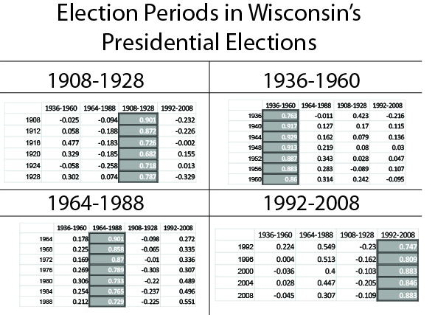
Table 1. Election Periods in Wisconsin’s Presidential Elections

Source: Wisconsin Blue Book, in the State of Wisconsin Legislative Reference Bureau. http://legis.wisconsin.gov/lrb/pubs/bluebook.htm

Out of the twenty eight elections, only one election in 1932, did not have a high enough factor loading to necessarily belong to a period by this tests standard. While it is clear that 1932 played a pivotal role in the nation's political history, it was a precursor to the proposed period of 1936-1960 for Wisconsin. Wisconsin was a state that frequently elected politicians from the Republican Party through the majority of its early history. Before 1932, the last Presidential candidate to receive the most votes from the Democratic Party was Woodrow Wilson, 20 years prior, and he did not receive a majority vote. Additionally before 1932 the last time Democratic Presidential candidates carried the state of Wisconsin in consecutive elections was in 1848 and 1852. With only four Democratic candidates to be voted for President from Wisconsin from 1848 until 1932, the Democratic Party obviously carried supporters, because it was able to exist, but was unable to defeat the Republican Party on a frequent basis.
The realignment theory, created in part by political scientist V.O. Key, states that a critical election occurs when, “results of the voting reveal a sharp alteration of the pre-existing cleavage within the electorate. Moreover, and perhaps this is the truly differentiating characteristic of this sort of election, the realignment made manifest in the voting in such elections seems to persist for several succeeding election.” When studying any presidential election, it is extremely difficult to capture the full story without looking at past elections. A presidential election is not a single event in time stacked up against a previous election, but rather a continuation of that society’s electoral history. Single elections can dramatically change a political scene however, and usher in a new wave of different thought than recent elections.
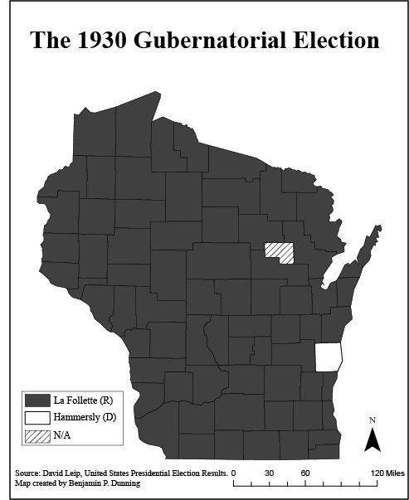
In terms of the nation, many historians and political scientists agree that the election of 1932 realigned the United States to the Democratic Party. In the 20th century, until the election of 1932, aside from Woodrow Wilson, every President had come from the Republican Party. After Roosevelt’s victory in 1932, the presidency was held by a member of the
Figure 1 and 2. From Republicans to Democrats 1930-1932
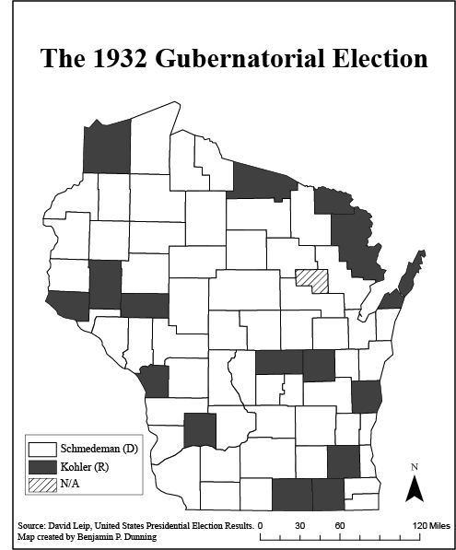
Democratic Party for 20 years. Additionally, after this important election, the Democratic Party elected a President in seven of the next nine elections. At the national level in 1932, almost 13 million adults were either unemployed or underemployed. With poor conditions in the United States as a result of the Great Depression, the Democratic Party was confident that although losing the previous three elections and only narrowly being victorious in 1916, this was their year to elect a Democratic president. Figures 1 and 2 present gubernatorial elections in Wisconsin. Gubernatorial elections are essential to this research because they present the strength of political parties at the state level. The means by which Roosevelt’s platform planned to stop the Great Depression was to lower tariffs; increase federal programs, both of which were completely different than the Republican platform; and reform financial and banking systems. These were all part of the “New Deal.” As Roosevelt carried all states but seven: Maine, New Hapshire, Vermont, Connecticut, Pennsylvania and Delaware, his landslide victory was the introduction of a Democratic president for 20 years.
Source: David Leip, United States Presidential Election Results
While it remains clear that the United States had a critical election in 1932, this study specifically examines the state of Wisconsin. It is indisputable that 1932 was an important election for the state, but was 1932 the first election in a long string of similar elections or simply a precursor to a new election, as found by the t-mode analysis?
The Nation’s Critical Election
In 1928, Herbert Hoover, a Republican, became the President of the United States. One of the most pressing issues his administration faced was the Great Depression. While his handling of these events helped strengthen the National Democratic Party in the elections of 1930, that was not the case in the state of Wisconsin. Even with the Great Depression hanging over the nation, the state of Wisconsin heavily voted Republican. As was the tradition, in 1930 Republican Phillip La Follette won in every county but one. In the following gubernatorial election, which ran concurrent to the Presidential election, Democrat Albert G. Schmedeman collected the most votes. This drastic shift was related to the popularity of the Democratic Party’s Presidential candidate Franklin Delano Roosevelt.
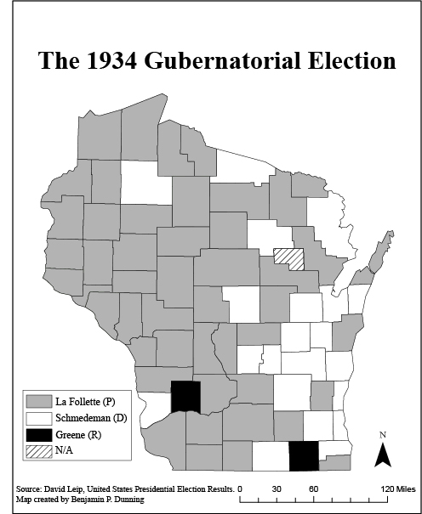
In 1932, the Presidential Election would showcase that the Democratic Party was stronger in Wisconsin. With victories in both the Presidential and gubernatorial elections, it became clear in its support of the Democrats at the national level or Progressives at the state level that Wisconsin had moved away from electing the Republican Party for the next couple election cycles. While the Democratic Party was victorious in 1932 in both Presidential and gubernatorial levels in Wisconsin, by 1934 a new set of ideals became available for Wisconsin Voters as seen in Figure 3. In 1934 Wisconsin, the ideology of liberalism was carried by the newly created Progressive Party. This political thought was increasingly favored throughout many parts of Wisconsin during this time and it shows in the gubernatorial election of 1934 in which ex-Republican turned Progressive Party leader Phil La Follette won. During this time, the Progressive Party slowed the Democratic Party’s ability to be the most liberal party in Wisconsin.
Source: David Leip, United States Presidential Election Results
Figure 3. The Progressive Party’s Victory

The Progressive Party’s Influence on Wisconsin’s Political Period
In the summer of 1934, a mid-term election year, President Roosevelt traveled throughout the northern part of the nation promoting candidates from the Democratic Party. One of the final stops made during this trip was to Green Bay, Wisconsin. Roosevelt found himself in an interesting bind in determining who to support. The easiest choice for Roosevelt in the Senate race was Bob La Follette Jr., a Progressive Republican turned Progressive Party candidate who had openly supported Roosevelt and his administration for many years. Even though these men were from different parties, La Follette commonly fought against the other strongly conservative members of the Senate. Unfortunately for Roosevelt, supporting La Follette would mean abandoning the Democratic Party. Members of the Democratic Party would have been extremely critical of this move. Supporting a Democrat would leave La Follette unsupported and in not returning the favor for all of the support he had once received.
In the gubernatorial election, Roosevelt’s decision on which candidate to support would be equally as difficult. Before 1932, in which Democrat, Albert G. Schmedeman became Governor of Wisconsin; the last Democrat Governor had been in 1892. This had occurred because for the most part the major difference for Wisconsin gubernatorial candidates was whether the Republican candidate was a Progressive Republican or a Conservative Republican. With this Republican supremacy occurring for so long in Wisconsin, the state’s Democratic Party was unorganized and to Roosevelt’s dismay, quite conservative. Roosevelt’s administration was much more akin to a group of Progressive Republicans or the Progressive Party of Wisconsin than Albert G. Schmedeman’s Democrats. One example of how different these men led their constituencies, Schmedeman had sent in the National Guard on striking farmers and plumbers in 1933 and 1934, while Roosevelt on the other hand continuously worked for the betterment of those workers. Supporting Schmedeman would have meant supporting someone he did not agree with, and supporting a non-Democrat would have upset Democrats nationally. Figure 4. solidifies the situation in which Roosevelt was in, as Albert G. Schmedeman stands next to a banner waiting for Roosevelt’s approval.
Figure 4. Schmedeman’s Political Banner

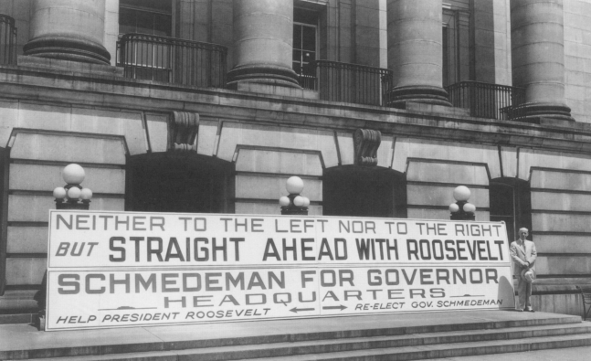
Source: Jonathan Kasparek, Old Friends.
In an address to thousands of people in Green Bay, Roosevelt enforced the idea that the state’s progressive and innovative political history was built upon people who “sought a life less fettered by the exploitation that selfish men set up in governments that are not free.” Roosevelt heavily emphasized his support of the state’s historical ties to Progressivism without naming current candidates. While many awaited whether the President would support particular candidates or along party lines, Roosevelt embraced the history of the state and did not formally endorse any candidate, but enforced ideas of cooperation, and thanked his supporters. Although the President was able to avoid complete criticism from one set of people, he did receive slight criticisms from many groups. Some Democrats were discouraged from his address that he did not formally endorse any Democrats but merely thanked them. Some Progressives were disappointed that Roosevelt had not taken this time to take a stand against the conservative Democrats and fully support the La Follette’s party. The elections of 1934 in the state of Wisconsin brought forth a new wave of Progressive party candidates. Phil La Follette was elected Governor, his brother, Robert Jr., became a senator, and a new majority was held by Progressive Party members in the state assembly.
The 1930s present an example of a political atmosphere extremely different than what present day politicians and voters may experience. FDR’s visit to Wisconsin is an instance in which a President of the United States from the Democratic Party visited Wisconsin to covertly support a formerly Progressive Republican turned Progressive Party candidate, Bob La Follette Jr., for Senate. Roosevelt’s reacted to this difficult situation by speaking vaguely enough as to not explicitly support Democrat Albert G. Schmedeman, for the conservative actions his Wisconsin Democratic Party of the last two years had supported, but also not supporting Progressive Party candidate Phil La Follette because of personal and political reasons, all while remaining a supportive Democrat.
While the presence, and approval, of the Progressive Party was evident in the gubernatorial and Congressional elections for the State of Wisconsin, the state was still voting along two party lines for the 1936 Presidential election. In the gubernatorial Election, the Progressive Party continued its success with a 46% victory over the Republican Party (29% of total votes) and the Democratic Party (21% of total votes). With no Progressive Party candidate to vote for in the Presidential election, voters would be forced to choose between the incumbent Democrat FDR and Republican Alfred Landon in 1936.
As Hoover’s conservative platform failed in 1932, the Republican Party nominated progressive Republican Governor from Kansas, Alfred Landon to run against FDR in the following election. Similar to Roosevelt, Landon’s strategy was to sustain the increased government programs and monitoring corruption of big businesses, both used by FDR in his first term, but was critical of the New Deal characterizing it as inefficient. In 1936, Roosevelt heavily won both the United States and Wisconsin for his first election as the incumbent Presidential candidate. While many Americans remained in poverty throughout Roosevelt’s first term, it is clear that the majority of voters trusted his tactics to get the country out of the Great Depression. In Wisconsin, FDR collected 63% of the total vote, creating a landslide victory. While at the Presidential level, citizens of Wisconsin carried strong support for the Democrat, while at lower levels of government a different party was clearly the front runner.
The Wisconsin Progressive Party remained a very strong entity for the first two elections. In both 1934 and 1936, Wisconsin had a Progressive Party governor, senator and a majority in the assembly. However, 1938 was a much more difficult year for leftist politicians than 1936. During May of 1937, the United States encountered another recession that lasted over a year. On a national and state level, many voters started to react to this new recession by voting away from the left. The Progressive Party of Wisconsin would be hit extremely hard in the elections of 1936. In the senate, Bob La Follette Jr. was not up for re-election, but Republican Alexander Wiley defeated Democrat F. Ryan Duffy. In the U.S. House of Representatives, five of the seven Progressive Party candidates lost their seats to Republicans, who now held a majority in the state. At the gubernatorial level, a Republican, Julius Peter Heil, defeated Phil La Follette, and not a single county elected a Democratic candidate. This election was incredibly important because before the 1930s the state had a significantly Republican history, whereas for most of the 1930s it was a liberal state backed by the Progressive Party, the election of 1938 changed that.
Even though Phil La Follette had lost his reelection for Governor of Wisconsin, he decided to create the National Progressives of America Party in 1938. While the La Follettes had supported Roosevelt on the Presidential level in 1936, creating a new Party to challenge his large approval rating around the U.S. was a bold move. Many progressives in the state, including Bob La Follette Jr., disapproved the notion of a third party with goals separate from FDR’s. The party would never reach the opportunity of going against FDR in the election of 1940, because both the Republicans and Democrats of Wisconsin heavily criticized the Progressives in the elections of 1938. The party was disorganized, had an unclear ideology to most, and possessed a flag and salute ritual that many opponents compared to the Nazi’s, which hurt their image. With the obvious misstep of wanting to create the NPA and the shift to the right by voters because of economic reasons, the Progressive party was drastically hurt by the elections of 1938 and their influence would never be the same. Bob La Follete Jr. was able to continue a successful career in politics, but his brother Phil would never ran for public office again.
Figure 5. Phil La Follette and the National Progressives of America
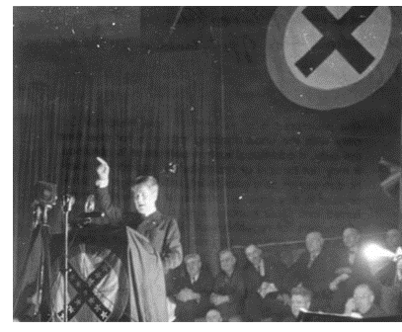
While this study’s initial goal was to focus on patterns of Presidential elections, it is impossible to ignore the fact that in Wisconsin, the presence of the third party changed the outlook of their political atmosphere. Even the Democratic Party in Wisconsin had different goals than the nations Democratic Party. As the power of the Progressive Party slowed down in the late 1930s, the Republican and Democratic Party’s characteristics would also change.
Source: Alice, Honeywell, La Follette and His Legacy.

Republican Party Gains Momentum
The 1940 Presidential election was reflective of the Wisconsin elections of 1938 in that voters started to shift right, but not enough to defeat the incumbent Democrat. FDR was elected for his third consecutive election, but by a smaller margin than that of 1932 and definitely 1936. One region that shifted its votes dramatically was the Midwest. In both 1932 and 1936, no Midwestern state voted to elect a Republican candidate as a whole, but in 1940, North Dakota, South Dakota, Nebraska, Iowa, Kansas and Colorado all voted for Republican Wendell Willkie. While Roosevelt still held a majority of the popular vote and a heavy lead in the number of electoral votes, the nation, specifically the Midwest had an increase in Republican voters (44.8% total vote) that had not reached that point since 1928 (58.2% total vote). In 1940 Wisconsin, as a state, voted for FDR, but the margin of his victory was less than 2% total vote and more counties as a whole voted for Willkie than the President.
The largest group of people in Wisconsin to change their support of FDR from 1936 to 1940 was German Americans in rural Wisconsin. This is an explanation for Willke’s victory in the number of counties, many were rural and not as populated, but his loss in total votes. This occurred mainly because of the assumption that if FDR remained President, the United States would go to war against Germany. Many of these farmers, especially the German ones, which had supported Roosevelt for creating programs that benefited their lives, were now being shifted to disapproval and a more right leaning political thought. Appendix 3, 4 and 5 clearly demonstrate that in general the counties with high numbers of rural farm populations shifted their Democratic votes in 1936 to Republican ones in 1940. The major regions that Roosevelt was able to hold onto were highly populated cities, such as Milwaukee and Madison, and the north. As illustrated by the ‘Rural Farm Population in 1940’ map, the north has a much smaller farm population than most of the state. This mentality of large cities voting for Democrats while rural regions voted Republican began to repeat itself after this election and into the 21st century.
The 1940s electoral atmosphere of Wisconsin politics showcased a growing influence of Republican ideology. While FDR received the most votes in his 3rd election for President, the margin of victory was much smaller. In 1942, a Progressive Party candidate, Orland Loomis, was victorious in the gubernatorial election, but died before acting as Governor, so the head of the state remained in the hands of a Republican. The State Assembly held a majority of Republicans. In 1944, during FDRs fourth election for President, the state of Wisconsin voted to elect a Republican, Thomas Dewey. Starting in 1946 the Republican Party of Wisconsin dominated the political scene at every level, except for the state’s voting for Democrat Harry S. Truman for President in 1948, until the end of the 1950s. One telling political defeat that cemented this theory was Bob La Follette Junior’s defeat in the primary for Senate in 1946. As the Wisconsin Progressive Party disbanded earlier that year, La Follette decided to run as a Republican, only to disappointingly lose the nomination. Having held a senate seat for either the Republican Party or the Progressive Party since 1925, his absence from the actual race must have been surprising. As the Progressive Party had influenced the state of Wisconsin to vote in a Progressive way, which at the Presidential level was voting for a Democratic, its demise would set in motion the realignment of the Democratic Party of Wisconsin.

A Two Party Wisconsin
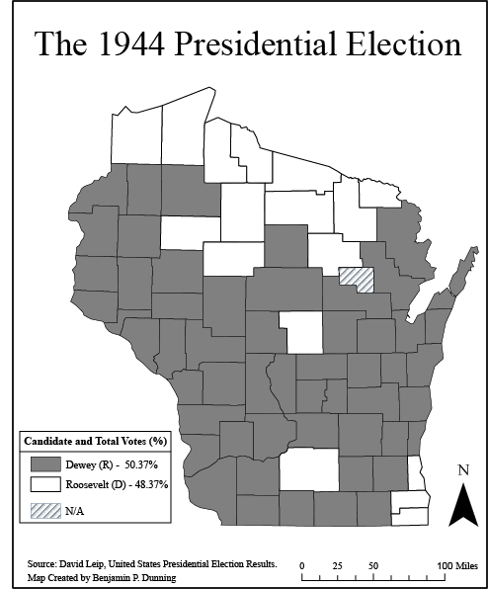
In the mid-1940s, the state of Wisconsin underwent a drastic political change because of the end of World War II and the Progressive Party’s declining influence. In the wake of the Progressive Party’s decline in political power many politicians and voters of the Progressive Party moved to the Democratic Party, (as seen by figure 7) but not all. The Democratic Party was more similar to that of todays, focusing on economic and social liberalism while the Republican Party remained focused on conservative values. The Republican Party’s ideology in Wisconsin was similar before and after the Progressive Party, but the Democrats ideology was shifted after gathering many of the ex-Progressive Party politicians. This new Democratic Party had a recent history of many conservative Democrats, but after World War II and the breaking up of the Progressive Party made a large shift into being liberal. A large majority of the formerly Progressive Party voters turned Democrats were young and lived in urban areas. While the large cities of Wisconsin were voting for Democrats, much of the support in rural areas was for Republican candidates. In 1948, a large group of young citizens of Wisconsin created the Democratic Organizing Committee. This committee consisted of liberal minded Democrats and ex-Progressive Party activists. The Democratic Organizing Committee set out to move the Democratic Party of Wisconsin left, and fade out the conservative ideology of the old Democratic Party. The actions of the DOC, and the leftward moving ideology of the Democratic Party as a whole created the parties that exist today in Wisconsin. While the actions of this new Democratic Party increased votes throughout the state within the party, especially in the Presidential election of 1948 in which Truman was elected, most of the positions in Wisconsin at is time were held by Republicans.
Figure 7: Wisconsin Republicans Resurgence in 1944
David Leip, United States Presidential Election Results.
Besides Truman's victory in 1948, the Republican Party of Wisconsin continued to dominate the state at almost every level during the 1950s. Throughout the entire decade, the governor of Wisconsin was either Walter J. Kohler Jr. or Vernon W. Thomson, both Republicans, the positions of Wisconsin Senators were held by either two Republicans or one, William Proxmire a Democrat who was voted into the Senate during the end of the 1950s, and at the Presidential level, Wisconsin elected Dwight D. Eisenhower in both terms and voted for Richard Nixon in 1960.
Transitioning from the end of the 1950s, a decade in which the Republican Party was strongly supported in Wisconsin, into the 1960s the Democratic Party started to gain a much higher presence at the state level. In 1960, the Democrats were able to gain two seats in the House of Representatives showcasing an even split amongst parties from Wisconsin as opposed to the seven-three split the year before. Gaylord Nelson, a Democrat, was the first of his party since Schmedeman, to become the Governor of Wisconsin since 1935. The post 1960 political scene in Wisconsin was not dominated by one party. At the Presidential level, aside from Lyndon B. Johnson in 1964, Republicans were frequently elected to become President until decades later, but the Governor’s seat was held by a Democrat in the beginning half of the 1960s whereas a Republican held the seat for the rest of the decade. In the Senate, both seats were held by Democrats after the growing strength of the Democratic Party of the 1960s. The Democratic Party would hold both seats of the senate for nearly 20 years. In the U.S. House of Representatives, Wisconsin sent an equal amount or one from it of both Republicans and Democrats until the end of the 1960s.
Looking at a Political Period
Factor analysis was a tool used in this research to find where distinct electoral periods began and ended in Wisconsin. This multivariate tool takes large data sets and places factors scores to create groups. In the t-mode factor analysis the large data set was the collection of 28 Presidential elections broken down into four political periods. Since that dealt with a temporal pattern the specific quantitative method is known as a t-mode analysis. Another form of factor analysis is known as an s-mode analysis, used to find spatial patterns. In the same way voting results are calculated to find where elections match up with one another in a t-mode analysis, an s-mode analysis is the same type of calculation, but it deals with how counties voted.
Appendix 1 showcases the groups that come as a result of the s-mode analysis of Wisconsin Presidential elections from 1936-1960. The factor analysis finds what the route of each counties voting history along a percent Democratic vote. A line graph of an s-mode analysis would label how a single county voted in presidential elections within a given timeframe. For this study, the elections provided are the ones in the 1936-1960 period. Every county has been placed within an s-mode group, which means that the counties within a given s-mode group voted in a similar way during this period.
To avoid a cluttered and unclear line graph, Appendix 1 showcases the counties that most reflect the route at which its s-mode group voted during this time. This form of analysis does not simply state which group was the most conservative, or liberal, or moderate, but rather it shows how each county reacted to political changes over time. For example, in Group 1, when you look at the counties of Vilas and Oneida, they are at much different levels of supporting the Democratic party, but the routes at which the county experienced this timeframe is extremely similar. Appendix 2 illustrates the placement of these s-mode groups in order to place a better geographic understanding of the types of voters throughout Wisconsin.
One region that clearly stands out in this figure is that the Northern region of Wisconsin is heavily aligned with s-mode Group 1 voting types. This is understandable because many of the counties that voted for a Democratic candidate in this time period were not living on farms, and often lived in urban areas. When looking at the rural farm population in 1940, as seen on page 21, the lowest number of rural living people was in the North. Much of that region voted Democratically in Presidential elections, especially before the Republican rise in the late 1940s and early 1950s. Additionally, when looking at the counties with the largest cities in Wisconsin: Milwaukee, Dane, Brown, etc. they are voted as s-mode Group 1. While these areas were known to vote for Democrats in the early part of this period, the rise of the Republican Party's influence in the latter part of the 1940s and into the 1950s as shown in Appendix 1. The downward slope of these counties in Group 1 until the election of 1960 confirm the characteristic that even the counties that were often more liberal than conservative began to lean away from the left during this time.
One distinct characteristic that is noticeable for Group 2 is the dramatic decrease in Democratic support from 1936 to 1940. This could be attributed to the fact that more rural farm populations exist in the region, but more importantly many of the citizens of Wisconsin with German heritage live in the Eastern half of the state. The disapproval of FDR in 1940 in this area and by these counties is certainly a result of the possibility of the U.S. entering World War II. While this s-mode group is more volatile in terms of voting, after 1936 it remains a supporter of the Republican party, at varying levels until the end of the period. The s-mode analysis is a quantitative way to further confirm analysis of a political situation. For example, the election in 1948, in which Harry S. Truman surprised the nation with his victory, was clearly an outlier for s-mode Groups 2-4 with tendencies of having been more conservative than liberal in the years surrounding that election. Finally, the end of the 1936-1960 period showed the beginnings of a move back towards the left. Group 1 clearly shows an increase in the percent vote Democrat from 1956 to 1960. From 1952 to 1960 there is an increase in Group 2 and 3’s support of candidates from the Democratic Party. Group four only consists of two counties and neither county follows the trend of a rise in Democratic influence, but the majority of Wisconsin counties had that occur.
Conclusion
The 1936-1960 period within Wisconsin’s history poses a time in which new ideologies flourished and diminished, and old ideologies were subject to huge changes. During this timeframe, the nation dealt with incredibly difficult events such as the Great Depression and World War Two. For the state of Wisconsin, the political atmosphere was changing frequently with the birth of the Wisconsin Progressive Party in 1934 to its separation in 1946. The Democratic Party's ideology as a whole transformed from conservative tactics until its realignment after the Progressive Party disbanded. With the use of factor analysis, both temporal and spatial patterns can be examined through the use of t-mode and s-mode analysis. An examination of Wisconsin's presidential voting history would be impossible without factoring in the states individual politics.

Appendix 1
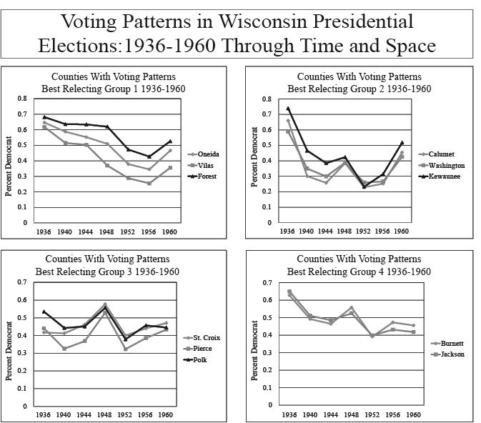
Source: Howard Ohm and Leone G. Bryhan, The Wisconsin Blue Book, 1937-1961.

Appendix 2
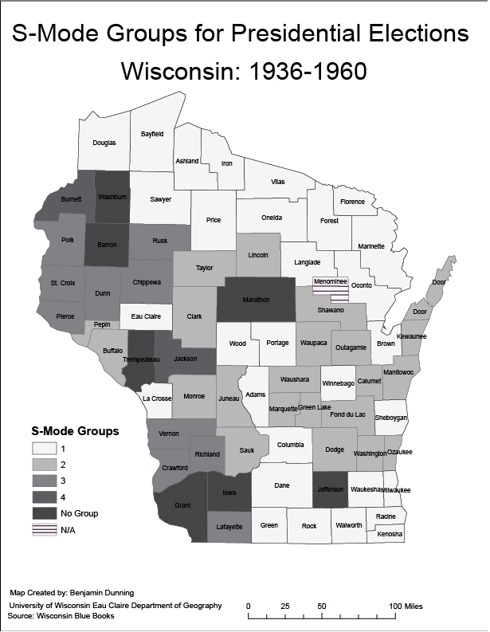
Source: Howard Ohm and Leone G. Bryhan, The Wisconsin Blue Book, 1937-1961 and Source: David Leip, United States Presidential Election Results

Appendix 3
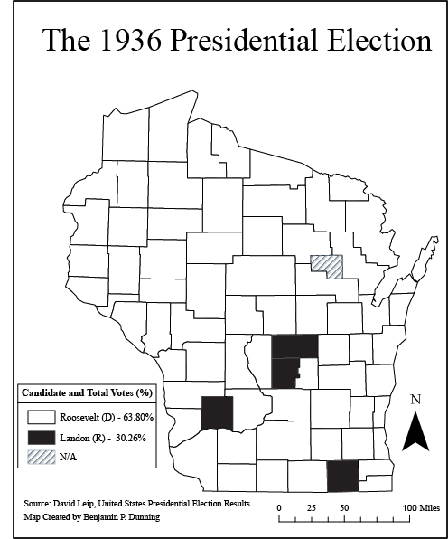
Source: Howard Ohm and Leone G. Bryhan, The Wisconsin Blue Book, 1937-1961 and Source: David Leip, United States Presidential Election Results

Appendix 4
Source: Howard Ohm and Leone G. Bryhan, The Wisconsin Blue Book, 1937-1961 and Source: David Leip, United States Presidential Election Results

Appendix 5
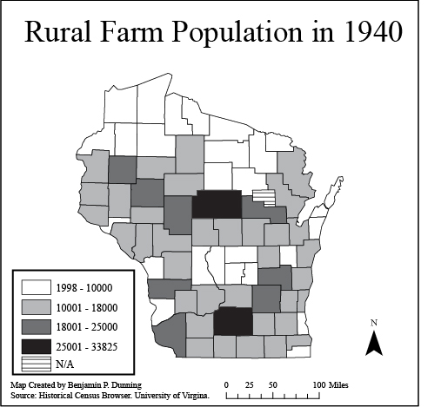
Source: Historical Census Browser. University of Virgina.

Works Cited
Primary Sources
- Leip, David. United States Presidential Election Results. 2012. http://uselectionatlas.org/RESULTS/index.html (accessed April 3 2012).
- Ohm, Howard and Leone G. Bryhan. The Wisconsin Blue Book. Madison: Democrat Printing Company, 1935.
- Ohm, Howard and Leone G. Bryhan. The Wisconsin Blue Book. Madison: The State of Wisconsin, 1937.
Secondary Sources
- Archer, J. Clark, Stephen J. Lavin, Kenneth C. Martis, and Fred M. Shelley. Historical Atlas of U.S. Presidential Elections. Washington D.C.: CQ Press, 2006.
- Archer, J. Clark. Section and Party: A Political Geography of American Presidential Elections, from Andrew Jackson to Ronald Reagan. Chichester: John Wiley & Sons Ltd., 1981.
- Campbell, James. “Party Systems and Realignments in the United States, 1868-2004.” Social Science History, (2006): 359-365.
- Fowler, Robert Booth. Wisconsin Votes: An Electoral History. Madison: The University of Wisconsin Press, April 1 2008.
- Haney, Richard C. “The Rise of Wisconsin's New Democrats: A Political Realignment in the Mid-Twentieth Century.” The Wisconsin Magazine of History 58 (Winter 1974): 90-106.
- Honeywell, Alice. “La Follette and His Legacy,” (Madison: The University of Wisconsin-Madison, 1995):
- Kasparek, Jonathan. “FDR’s ‘Old Friends’ in Wisconsin:Presidential Finesse in the Land of La Follette,” The Wisconsin Magazine of History 84 (2000-2001):16-25.
- Key, V.O. “A Theory of Critical Elections.” The Journal of Politics 17, (Feb 1955): 3-18.
http://www.lafollette.wisc.edu/publications/otherpublications/LaFollette/LaFLegacy.html. (Date Accesed: April 13, 2012).
- State of Wisconsin Legislative Reference Bureau, Our History (Madison, WI: Legislative Reference Bureau, 2012) http://legis.wisconsin.gov/lrb/history/index.htm (accessed March 27, 2012).
- Tabachnick, Barbara G. and Linda S Fidell. Using Multivariate Statistics. Boston: Allyn & Bacon, 2008.

State of Wisconsin Legislative Reference Bureau, Our History (Madison, WI: Legislative Reference Bureau, 2012) http://legis.wisconsin.gov/lrb/history/index.htm (accessed March 27, 2012).
Barbara G. Tabachnick and Linda S. Fidell, Using Multivariate Statistics (Boston: Allyn & Bacon, 2008), 607-610.
J. Clark Archer and Peter J. Taylor, Section and Party: A Political Geography of American Presidential Elections, from Andrew Jackson to Ronald Reagan (Chichester: John Wiley & Sons Ltd., 1981), 215-222.
David Leip, United States Presidential Election Results. 2012. http://uselectionatlas.org/RESULTS/index.html (accessed April 3 2012).
V.O. Key, “A Theory of Critical Elections.” The Journal of Politics 17, no. 1 (Feb 1955): 3-18.
James Campbell, “Party Systems and Realignments in the United States, 1868-2004.” Social Science History, (2006): 359-365.
J. Clark Archer, Stephen J. Lavin, Kenneth C. Martis, and Fred M. Shelley, Historical Atlas of U.S. Presidential Elections (Washington D.C.: CQ Press, 2006), 112-113.
Jonathan Kasparek, “FDR’s ‘Old Friends’ in Wisconsin:Presidential Finesse in the Land of La Follette,” The Wisconsin Magazine of History 84 (2000-2001):16-25.
Robert Booth Fowler, Wisconsin Votes: An Electoral History (Madison: The University of Wisconsin Press, April 1 2008), 142-145.
Kasparek, Old Friends, 16-20.
Kasparek, Old Friends, 16-20.
Ibid.
Ibid., 20-24.
Ibid.
Leip, United States Presidential Election Results. http://uselectionatlas.org/RESULTS/index.html
Clark et al., Historical Atlas of U.S. Presidential Elections, 114-115.
Howard Ohm and Leone G. Bryhan, The Wisconsin Blue Book (Madison: Democrat Printing Company, 1935), 565-630. Howard Ohm and Leone G. Bryhan, The Wisconsin Blue Book, (Madison: The State of Wisconsin, 1937), 367-434.
Leip, United States Presidential Election Results. 2012. http://uselectionatlas.org/RESULTS/index.html. Fowler, Wisconsin Votes, 144-150. Alice Honeywell, “La Follette and His Legacy” (Madison: The University of Wisconsin-Madison, 1995). http://www.lafollette.wisc.edu/publications/otherpublications/LaFollette/LaFLegacy.html. (Date Accesed: April 13, 2012).
Fowler, Wisconsin Votes 144-150 and Honeywell, “La Follette and His Legacy.”
Fowler, Wisconsin votes, 144-150.
Clark et al,. Historical Atlas of U.S. Presidential Elections. Map 39 and 116-117.
Fowler, Wisconsin Votes, 150-160.
Ibid., 155-162.
Richard C. Haney, “The Rise of Wisconsin's New Democrats: A Political Realignment in the Mid-Twentieth Century,” The Wisconsin Magazine of History 58, No. 2, (Winter 1974): 90-106.
Leip, United States Presidential Election Results. http://uselectionatlas.org/RESULTS/index.html
Leip, United States Presidential Election Results. http://uselectionatlas.org/RESULTS/index.html
Archer and Taylor, Section and Party, 215-222.

