The National Museum of African American History and Culture:

A Museum 100 Years in the Making

Sarah J. Beer
History 489: Research Seminar
December 9, 2016

Contents

Abstract…………………………………………………………………………………………………...iii
Introduction………………………………………………………………………………………………..1
Congressional History of the NMAAHC: 1916-1930……………………………………………………2
Early Reviews of NMAAHC……………………………………………………………………………...6
Contents of the Museum…………………………………………………………………………………10
History Gallery: Slavery and Freedom, 1400-1877………………………………………………12
History Gallery: Defending freedom, Defining Freedom: The Era of Segregation, 1876-1968…15
History Gallery: A Changing America: 1968 and Beyond……………………………………….18
Culture Galleries, Community Galleries, and More……………………………………………...21
Personal Review and Critique of NMAAHC…………………………………………………………...22
Conclusion………………………………………………………………………………………………...25
Works Cited………………………………………………………………………………………………27
Works Consulted…………………………………………………………………………………………28

Abstract:

The Smithsonian Institution has been making headlines in recent news for one momentous reason: the opening of a new museum commemorating African American history. Beginning in 1916, several bills, resolutions, and hearings have taken place in Congress to introduce legislation that would create a museum, but none would be successful. John Lewis picked up the fight by introducing legislation immediately after becoming a Georgia congressman in 1986. It took Lewis almost twenty years, but in 2003 President George W. Bush finally signed the law to create the National Museum of African American History and Culture. My capstone paper studies the congressional history, early reviews, and content of the museum while also including my personal review: as a public history student, I pay close attention to how the museum presents the content and narrative, as well as the content and narrative themselves. I am able to do this because a research grant through the Office of Research and Sponsored Programs gave me the opportunity to visit the museum in early November. Through this experience I found the museum to be overwhelming and lacking in organization and logical layout, though it does offer the visitor glimpses at priceless pieces of history and a unique narrative. The stories in the museum are important to tell because they help confront a somber history that is inextricably tied to the American experience. But the story of NMAAHC is also important to tell because those involved have overcome every possible obstacle to bring these stories to us.
Introduction:

Millions of black men and women built this country through hard labor, sacrifice and suffering, through creativity and ingenuity, sheer willpower and enduring faith. They have fought in every war and defended the principles of democracy knowing they would not share in the victory. They did this not because they anticipated any benefit, but because they believed in something greater than themselves. That faith in the unseen and their ability to make a way out of no way is a demonstration of the character it took to build this nation, and that is why this museum deserves a prominent space among the memorials to the founders of this country.

Civil rights activist and Georgia congressman, John Lewis, wrote these words as part of his article for The Washington Post to celebrate the opening of the National Museum of African American History and Culture. Lewis is famous for his contributions to the Civil Rights Movement, but he also played a key role in the creation of the new Smithsonian museum that opened on the National Mall in Washington, DC. One of the first bills John Lewis introduced as a congressman was H.R. 5305. Though Lewis first introduced a bill to build a museum dedicated to African Americans in 1988, it took fifteen more years for legislation to be passed and the 100 year dream to become a reality.
In 1916, a struggle for recognition began. The plans for a monument were proposed in order to commemorate the “negro soldiers and sailors who fought in the wars of our country.” Little would come of the bill and it would be another three years before a hearing took place in the House of Representatives on the same subject. Fast forward to the next hearing in 1924, this time to discuss a “monument or memorial building to the memory of negro soldiers and sailors.” It was not until the late 1920s that any significant action took place, when in 1928 the Senate passed a joint resolution to “create a commission to secure plans and designs for and to erect a memorial building for the National Memorial Association...as a tribute to the negro’s contribution to the achievements of America.”
Close to sixty years without action took place before John Lewis would struggle in the 1980s and 1990s to bring back the fight that was lost long before his time. His perseverance and dedication to merely an idea of what should be done allowed for the passing of H.R. 3491 in 2003. It then took Lonnie Bunch III and teams of others thirteen years to create what we see today. But after all this hard work, how has the NMAAHC been reviewed? What is it they’ve been working towards all this time? After a brief historiography of the museum I will be examining the press reviews of the museum and looking at how it has been dissected by professionals. Then I will be giving an overview of the six floors that exhibit the history and culture of African Americans before giving my own review.
The history of the NMAAHC is important because it is an inextricable part of the museum. By learning about this history and the struggle to create it, we can better appreciate the finished product. It also adds another piece to the African American narrative because we can see that there was a time, the tumultuous period between the Civil War and the Civil Rights Movement, that the services and contributions of the African Americans to our country were not only recognized but also appreciated.
It is important to take a close look at the NMAAHC because this museum stands as the national view on African American history. The Smithsonian is a government institution, so the narrative the museum produces is saying to those who view it, “This is what the United States is recognizing as African American history. This is what we want you to see.” It is also important because Americans are not the only ones coming to see the NMAAHC: people from across the world are seeing these objects, reading these panels, and taking in this narrative. Therefore, it is important to analyze what is presented because what the museum chooses not to recognize is just as important as what they do recognize.

Congressional History of the NMAAHC: 1916-2003
The NMAAHC has a rich, complex history. In 1916, Republican congressman L.C. Dyer took the first legislative step to introduce a memorial in the nation’s capital, but it took many more to finally reach fruition. While there is as complex a history behind the scenes as there is in congress, only the congressional path of the museum will be covered here. Each of the pieces of legislation came at an important time in the United States, and the current events of each period help contribute to the reasons why further steps were not being taken.
On December 12, 1916, World War I was raging on in Europe, though the United States had yet to enter the fight. It was on this day that L.C. Dyer introduced H.R. 18721 to the House of Representatives, which created a commission of seven men known as the National Memorial Commission. The commission would be in charge of gathering “artists, sculptors, architects, and others as it shall determine to be necessary” in order to create a monument for “the negro soldiers and sailors who fought in the wars of our country,” though the location had yet to be determined. The location would have to be approved by Congress and the construction of the monument or memorial would need to be “entered upon as speedily as practicable” once all aspects had been approved by Congress. On the surface this sounds as if the government was more than willing to build such a monument, but there is one more historical factor to take into account: “The Birth of a Nation.” This propaganda film by the KKK from 1915 was shown at the White House where “thirty-eight U.S. Senators and about fifty members of the House of Representatives” viewed the film. While the language of H.R. 18721 seems to support the monument to “Negro soldiers and sailors,” when you look closer you see that the possibility of a Congress approving such an act, where a large number of them were watching “The Birth of a Nation,” is fairly dismal.
Thus we move to October 14, 1919, when the United States had just come out of World War I and was entering the Jazz Age, and when the House of Representatives held a “hearing before the Committee on the Library.” The hearing addressed H.R. 5131, a bill introduced on June 6, 1919 to “further provide for the celebration of the victory of peace and to create a commission to secure plans and designs for a monument or memorial to the memory of the negro soldiers and sailors who took part in the late European conflict and who fought in the wars of the United States of America.” When reading the hearing, the reader finds that the 1916 H.R. bill created what is referred to as the “National Memorial Association” and not a commission. In this hearing the contributions and sacrifices of black troops were honored and spoken of in the highest regard, both by those fighting for the bill and those receiving its request. This hearing was forty-three pages of talking about how patriotic black people were and how deserving they were of a monument of some sort to honor the fact that they were always there for their country. However, there was another hearing on May 28, 1924, addressing H.J. Res. 245, which asked for the same commission to be created so it is apparent that nothing ever came of H.R. 5131.
April 18, 1928 brought the introduction of S.J. Res. 132, a resolution that went further than any of its predecessors:
That a commission is hereby created… to be known as National Memorial Commission, to procure and determine upon a location, plans, and designs for a memorial building suitable for meetings of patriotic organizations, public ceremonial events, the exhibition of art and inventions, and placing statues and tablets, for the National Memorial Association (Incorporated), in the city of Washington, as a tribute to the negro’s contribution to the achievements of America.

This resolution made it through the Senate and went to the House of Representatives, but the untimely nature of the infamous 1929 Stock Market Crash stopped this piece of legislation before it could reach the President. The financial situation in the United States at this time would not allow the government to create such a monument and it would not allow the “colored people throughout the Nation” to pay for it. In the last paragraph of S.J. 132 it said that “it is expected that the 12,000,000 of colored people throughout the nation will subscribe these funds to the erection of this building. The only expenses entailed up the Government is the $50,000, to pay for the site and the plans and designs,” but they would not pay such funds until the National Memorial Association was able to collect $500,000. The last victory came on May 29, 1930 when, regardless of the financial provisions, the resolution was amended and passed the Senate as S.J. 171.
Though S.J. 171 was able to get further than its predecessors, due to war and racial tensions it would take fifty-six years for the museum to gain another voice: this voice was John R. Lewis. In 1986, Lewis was elected as a Georgia Congressman, just twenty-one years after he was famously beaten on Bloody Sunday for trying to lead a march from Selma, Alabama to the capital building in Montgomery. In 1986, he sponsored a resolution with three other men that would once again begin the fight for a museum in Washington D.C. Then on September 14, 1988 John Lewis introduced H.R. 5305, and would continue to introduce legislation every year afterwards. A significant and contested introduction came in 1989 with H.R. 1570. This was the first significant piece of legislation Lewis introduced for the museum, and this bill would start the discussions among Congress, the Smithsonian, and various others invested in an African American museum. While this bill was not enacted, it helped put matters in motion for what would become the NMAAHC.
After years of battling with not only other congressmen but also with the Smithsonian, in 2001 S. 829 and H.R. 1718 were introduced on May 3. These bills were to “establish the National Museum of African American History and Culture within the Smithsonian Institution” and would eventually lead to the enacted bill, H.R. 3491 in 2003. H.R. 3491 was introduced on January 7, 2003 and detailed: why the museum was necessary, the purpose of the museum, the establishment of a council whose duties were to assist with the creation of the museum and act as a “Board of Regents,” the director and staff, educational and liaison programs, the building of and site for the museum, the Congressional budget, and the authorization of appropriations. This passed the House and Senate on November 19, was presented to President George Bush on December 5, and on December 20, 2003, he signed it into law. After the signing, it would take teams of professionals to design, construct, and gather materials for the NMAAHC. From 2003 to 2016, Lonnie Bunch III and his teams would work around the clock to fulfill the dream of a museum that would tell the story of African American history and culture, and on September 24, the museum finally opened to the public.
Early Reviews of NMAAHC
An important part of properly reviewing a museum is to take into account what others are saying about it. Studying the reviews gives the reviewer a sense of what to look for and also the chance to agree or disagree. Even if the reviews do not match your personal opinion, they hold merit and help to fill important gaps.
The museum allowed the press in to see the museum and write their reviews before it opened, and even before it was finished. To this day, parts of the museum are still under minor construction, like its Oprah Winfrey theater, but the people involved were still working up until the day it opened. Press reviews for the NMAAHC were published more than a week before the grand opening of the museum. The Washingtonian, National Public Radio, the Los Angeles Times, the New York Times, the Guardian, the Wall Street Journal, and the Washington Post all contributed their thoughts on such a popular and long-anticipated project. While each one offers their own narrative, some similarities carry through.
The article put forth by the Washingtonian is less of a review and more of an overview. It gives its reader a list of “11 Exhibits You Need to See at the Smithsonian’s African American History Museum.” According to the article the reader is given these eleven exhibits because the whole museum can’t possibly be viewed in one day, but if one day is all you have, this is what you should see. In fact, the Washingtonian almost goes out of its way to avoid offering their opinion. It isn’t until the final few sentences that you get a sense of what the writer was thinking: “These are just a few slices of the museum, which may be the Smithsonian’s best in terms of detail, narrative, and historical scope, but also its most challenging. It’s a collection devoted to recounting the country’s history, with some of its biggest warts on full display, and also celebrating some of its richest culture.” National Public Radio starts off much like this capstone does, and gives a brief history of how the museum came to be. It then goes on to talk about the square footage, the design, and the themes. This review could have been written without having gone to the actual museum, and in fact, it is unclear whether or not the writer for NPR actually did because they offer no insight into the space or their opinions, and much of their information seems to come from an interview with one of the architects. The Los Angeles Times devotes its review to the design and architecture of the building rather than its content. The architectural critic for the Los Angeles Times, Christopher Hawthorne, describes how, “The building embraces memory and aspiration, protest and reconciliation, pride and shame,” as well as how the museum fits into the Mall compared to the surrounding buildings. Hawthorne goes into further detail, describing the latticed, “bronze-coated aluminum” panels are based off of the “ironwork made by slaves.” The distinct shape of the museum comes from a headdress of a similar shape which is part of a wooden sculpture by Yoruba artist, Olowe of Ise. An important detail Hawthorne discusses is the cutouts in the facade which support director Lonnie Bunch’s many declarations that the museum is simply a tool to view American history through “an African American lens.” When standing inside the museum, the visitor can look through the glass wall, through the cutouts, and gaze out at certain significant buildings in the surrounding area-- such as the Washington Monument. Hawthorne finishes his review of the architecture by making a bold statement about not just the design of the building, but its overall intent:
As becomes clear once you step inside, the whole thing is a vitrine. It is a place less to celebrate America and its place in a Western lineage -- the central ambition of the Mall as a whole -- than to put the fundamental contradictions of the national experiment under glass and give them a hard look. The building itself is perhaps the most powerful display of all, a careful, strategic and sometimes defiant exploration of the relationship between black culture and government prerogative.

What Hawthorne says here is that the Mall is all about celebrating America’s history and achievements: there are memorials for the wars we have fought, there are memorials for significant people, and there are museums to memorialize our history. The NMAAHC is different from the rest of the Mall because it is not trying to stand as another cold memorial, it is challenging us to question the history we think we know and confront the history we have been avoiding. The New York Times is the first review that really focuses on the content and narrative of the NMAAHC. Though it starts by giving a brief description of the design, it also makes a critical statement about Lonnie Bunch. The article’s author, Holland Cotter, mentions how the opposition the museum faced while in Congress in the 1990s may have an impact on how Bunch is advertising the museum. He references one of Bunch’s quotes that are on the museum’s website talking about how American the museum is. He then says the quote isn’t necessarily bad, but it is “too close to being a piece of feel-good Smithsonian-speak. And taken as such, it rings hollow to many at a time when violence is hammering African-Americans.” This is the only article that mentions the current events happening in the country, which is surprising since the museum is meant to confront the uncomfortable parts in our history and spends a considerable amount of time interpreting racial violence. After this comment, the author goes on to describe the different parts of the museum and the emotions evoked while viewing each one. He admits that the museum is confusing but “history is confusing. If it isn’t, it’s not history.” Cotter also says that the museum does lack information about certain important issues, like AIDS.
While the previous four articles have been congratulatory, or at least neutral in opinion, the final three articles are a bit more critical, and aren’t afraid to call out the NMAAHC for its mishaps. The Guardian, for example, compares the cutouts in the bronze panels to “defensive arrow-slit windows” that give the facade a “forbidding air.” The author also shows his lack of enthusiasm for the panels, by saying they make the building look like an “exotic mothership, ready for takeoff” and the fact they are only bronze-coated and not entirely bronze “lend the building a slight cheapness.” This feeling of “cheapness” only gets stronger when you go inside, according to the author, because of the likeness to an airport-- he also calls certain aspects of the design “half-baked.” He contradicts himself in his last sentence, however, almost in a vain attempt to make up for the slaughter by saying that “despite some clunks” the museum is a “welcome rebuke to the world of white marble monuments to dead white men.”
The Wall Street Journal, a typically conservative newspaper, focuses less on criticizing the design of the building and more on criticizing the narrative of it. Edward Rothstein introduces his readers to a new type of museum: the Identity Museum. This genre of museum has become popular in the last 15 years and is “devoted to recounting the struggles and triumphs of a people whose place in the larger society is, at first, barely tolerated. They arrive without resources or language; face hostility or worse; then gradually carve a place for themselves--discovering their identity.” While this may not sound like a bad thing, to Rothstein it only weakens a museum because by focusing on the identity of the people they are trying to represent they are lessening the role of history, creating a celebratory narrative, and simplifying any history they do present. Rothstein also makes the point that “advocacy clouds terminology” because the museum chooses to talk about events in which African Americans were the victims and softens the terminology of events where they were culprits. The example Rothstein gave was the “riots of the late 1960s that destroyed the urban life of many American cities” and how they are referred to as “urban rebellions” in the museum.
The final, and perhaps most critical review of NMAAHC comes from the Washington Post. While the previous article held contentions with the story told in the museum, author Philip Kennicott seems to have more of a problem with how the story is told. He says it is “disconnected and episodic” and even points out problems with how words are printed onto glass, making them hard to read. Kennicott calls the lower levels of the museum “bloodless and dispassionate” which he later contributes to the lack of technology and visual aids. He says the digital components make you feel like “history has come alive” and “this is inevitably more gripping than studying a bill of sale for human chattel or a rendering of a slave ship. The author goes on to further criticize the museum by saying it is “aimed at the cellphone-video-iPad generation,” it “slights history,” only presents “flash-card facts,” and concludes with, “It feels like history processed by a film director who has made a too-jarring cut from one scene to another. Modern museums aren’t just repositories of material objects and facts, but...emotional journeys. Sometimes this journey feels over-thought, and too contrived. The result...is that the true misery of much of the African American experience is better communicated through fiction.”

Contents of the Museum
In 2016, 100 years after the first attempt to create a museum dedicated to the African American, a researcher can compile immeasurable amounts of information, on any subject, within a matter of minutes. But knowing the square footage, the number of artifacts, and the origins of the design leave something to be desired. No matter how hard a researcher tries, unless they experience it firsthand, they cannot attain a certain level of understanding that comes with standing in front of their subject. Someone who dedicates their life to World War II can know every piece of data, hear every narrative, and absorb countless images, but they will never know what it was like to be on the battlefield. So after extensive research and detailed planning, it was time to go to my battlefield.
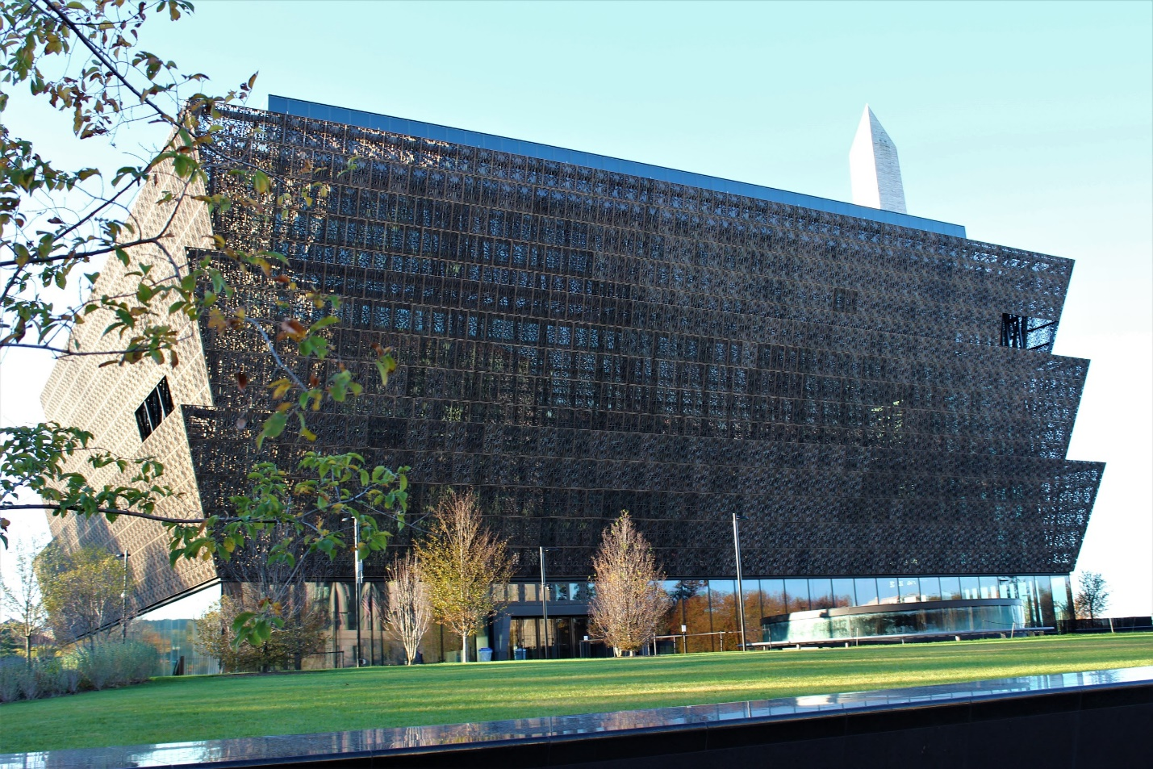
Figure 1. The National Museum of African American History and Culture- Exterior. Photograph by author.

When being driven towards the National Museum of African American History and Culture, I knew what to look for: the distinct pyramidal tiers, the bronze-colored aluminum. But it wasn’t until turning onto Constitution Avenue that I appreciated its magnitude-- and it wasn’t until I had spent two hours staring at it that I appreciated the fact I was only looking at half of it. It stands as a huge, dark spot among a sea of marble and stone, and the phrase “beauty is in the eye of the beholder” cannot be more applicable here. The people standing next to me in line, who shall remain unnamed, felt the building was “ugly” and stood out too much from the other Smithsonian museums, while I personally felt that though it was certainly unique, it was beautiful. The distinct shape of not only the building but also the panels that covered it, were more interesting and appealing than any other museum I had ever seen.
The individuality of the NMAAHC’s exterior foreshadowed the individuality of the interior. After waiting in lines for more than four hours and going through what can only be compared to TSA level security, I finally got into the building. Upon entering the ground floor, I was met with gray walls, wide open spaces, and intricate art not just covering the walls, but also hanging from the ceiling. After I received a map from the central desk and heard the attendants’ lecture about how many floors there are and what each one offers, they directed me to the elevators. Once our elevator was full the attendant told us to look through the glass walls as we began our descent. On the black elevator shaft were dates, written so that as we got further from the ground level, we also strayed further from the present time. It wasn’t until we reached the year 1400 that we got off the elevator and began our journey through African American history, starting with the Transatlantic Slave Trade.

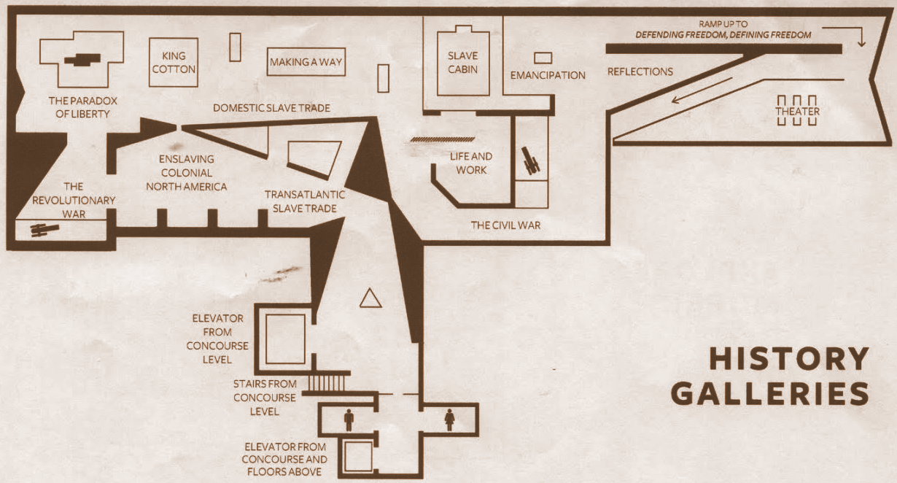
History Gallery: Slavery and Freedom, 1400-1877
Figure 2. Map of “Slavery and Freedom” History Gallery. Photograph by author.

The Transatlantic Slave Trade occupied a significant portion of the lowest floor’s narrative, and rightfully so since it was the “largest forced migration of people in world history” according to one of the exhibits many panels. An introductory panel explained the justifications of the slave trade and how it eventually became purely race based. The savageries of the trade were talked about as well as the specifics of it: which ships were used, what they were like, routes, traded goods, and timelines. In the many areas dedicated to the slave trade, a common theme was the conditions in which the slaves were transferred from Africa to America. One of the more memorable spaces was a small room that was barely lit, but held bits of a slave ship and had quotes like, “The deck...was so covered with blood and mucus...that it resembled a slaughterhouse” or “There is no Spaniard who dares to stick his head in the hatch without becoming ill…. So great is the stench, the crowding and the misery of the place…” It was obvious the purpose of these quotes was to give the reader a sense of disgusted bewilderment. Yet it was when we read about a captain becoming angry with a woman for singing sad songs because it was hurting his feelings that it was likely intended to invoke angry bewilderment. As I saw all the quotes from white people saying how sad it all was and how horrible the conditions were, I could not help but think to myself, “Yet no one on the ship tried to change anything?” This was undoubtedly the museum’s intent, not just here but other instances as well, and they excelled in every way.
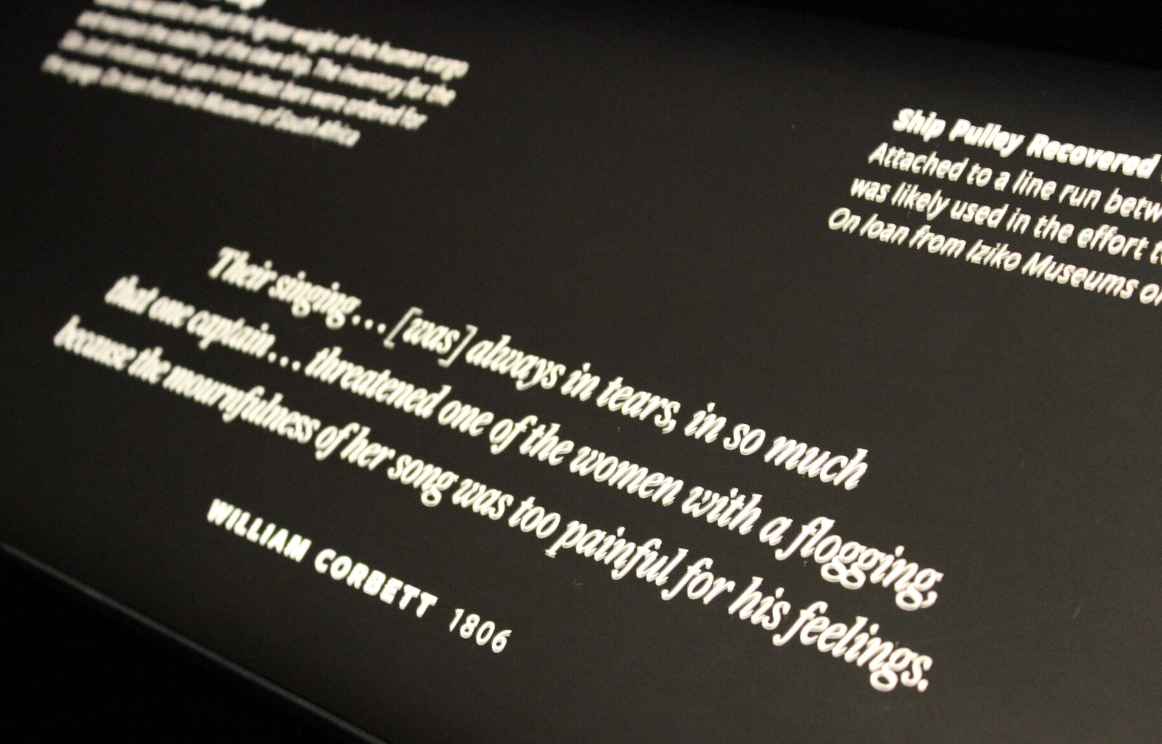
Figure 3. 19th Century Quote on Panel in front of Ship Pulley. Photograph by author.

While making my way through the maze of slave era relics, I came into a small clearing only to be confronted by a statue of Thomas Jefferson. The larger-than-life, bronze-colored monument stood on a large black platform with several of his personal belongings at his feet. The accompanying text described how the founding father may have helped to build our nation, but he was still a slave owner and fought to keep slaves from the very freedoms he promoted to other Americans. Given this, I couldn’t understand why the museum decided to designate such a large area to him. I was shocked further by the tools placed at his feet and the placard noting that these were the tools he used to help inequalities thrive. Thomas Jefferson was not the only founding father with this sort of story, and even if he was, why was this here? It did not escape my notice that there was a large portion of panels in the slave trade areas that gave the perspective of the slave owners or Europeans. Wouldn’t it have been a better idea to leave some of these out? After all, we’ve been hearing these same things in every other museum that exhibits slavery, isn’t this one supposed to step away from that and present the less heard narrative?
Amazingly enough, the Civil War and Reconstruction were also included on the same floor, though surprisingly they did not receive much attention. There were two uniforms on display that were worn by black soldiers, which are accompanied by photographs exemplifying this. Abraham Lincoln and Frederick Douglass were mentioned, but given how significant the Civil War was in African American history there was little homage paid to it.
Still, there were the jarring moments that distinguish the NMAAHC from other museums. For instance, standing in front of a large, wooden whipping post with a case next to it containing a whip that owners used to lash slaves, while a slave's story about being beaten is playing on a speaker behind you, is not something visitors are likely to forget. Or walking up to a wooden cradle with iron shackles hanging above it that you know were too small for an adult.
Several artifacts were on display on the bottom floor that cannot go unmentioned, including: Frederick Douglass’ cane, a shawl given to Harriet Tubman, Nat Turner’s Bible, and grenades believed to be from Bacon’s Rebellion, as well as a slave cabin from the mid-1800s.
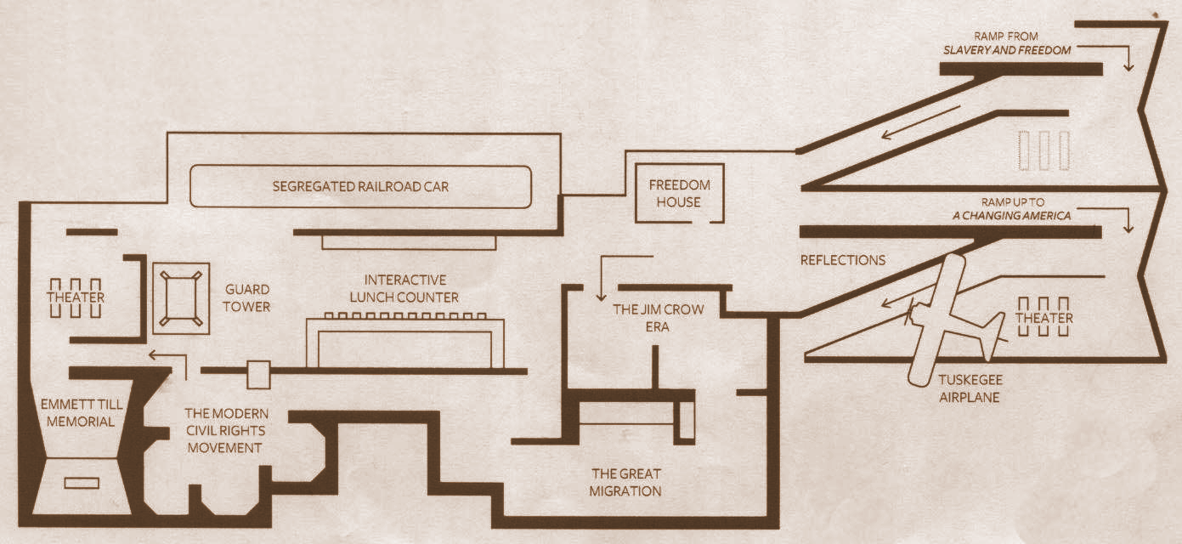
History Gallery: Defending Freedom, Defining Freedom: The Era of Segregation, 1876-1968
Figure 4. Map of “Freedom” History Gallery. Photograph by author.

A ramp connected the bottom floor to the middle one, symbolizing how history connects seamlessly and the events within it cannot be separated. The first object I encountered when reaching the end of the ramp is the Jones Hall Sims House. This post-civil war house was preserved by covering its walls with glass, though this is no way diminishes its effect upon the visitor. Walking into the house and seeing the peeling paint on the walls and artifacts from the owners, offered an experience the slave house did not, since it was roped off and you could only peer through the doorway. The next significant section to talk about is dedicated to stereotypes. The University of Wisconsin- Eau Claire offers several courses about African American history, in which you discuss the vital importance of racial stereotypes not just in the era in which they were created but also today; these are often neglected topics in museums. The panels in this section described how such stereotypes were created, what images they produced, and what each image stood for. Different figures accompanied the text, such as dolls, puppets, advertisements, and illustrations, as well as a quote, which did an excellent job of explaining why stereotypes were such a negative influence: “The whole idea of a stereotype is to simplify. Instead of going through the problem of all this great diversity-- that it’s this or maybe that-- you have this one large statement; it is this.”
As I moved further into the exhibits, I saw a wall dedicated to “The Black Press,” before being presented with topics like black churches, schools, and social institutions from the late nineteenth and early twentieth centuries. It was here that we began hearing about the spread of riots and violence and we were introduced to the KKK, which is represented by a red robe belonging to an officer of the Klan known as a “Kleagle.” The Klan was a segway from Reconstruction to the 1920s. In this section, the New Negro Movement was represented by sections on Marcus Garvey and the Black Star Line and Elijah Muhammad and The Nation of Islam. Once again, there was a section dedicated to the “enduring stereotypes” which discussed how the stereotypes from the era of slavery carried on and evolved after World War II. I found this to be important enough to mention here, because it showed that the stereotypes were not only in the 1800s, that they continued to oppose blacks as they fought for their country.
The next significant displays were dedicated to the Civil Rights Movement, which as can be seen in Figure 4 above, covered most of the middle level. One of the centerpieces of this was the interactive lunch counter, which was too full at the time for me to participate, that lets the visitor address how they would have reacted in such situations and get to choose on a touch screen what topics to learn about regarding segregation in the South. Across from the counter were iconic signs like “Colored Section” or “Waiting Room for Whites Only- By Order of the Police Department.” We saw seats from a real lunch counter, panels discussing nonviolence, panels about the KKK’s resistance to the movement, the dress Rosa Parks was wearing when she famously refused to give up her seat on the bus, and shards of glass from the bombing of the 16th Street Baptist Church, where four little girls died in 1963. Malcom X was given credit in the Civil Rights area, and the beginning of the Black Power movement was introduced, though neither were given quite as much attention as they perhaps should have. One of the last displays that was out in the open was a guard tower from the Louisiana State Penitentiary in Angola, the hard labor prison famous for its brutality. The tower was tucked away and even the sign with its description was hiding behind it, making it difficult to read. Even though this tower was a fascinating and unexpected piece of history, little attention was payed to it because, in the room next to it, was the coffin of Emmett Till.
Perhaps every student in America is taught about or knows of the lynching of Emmett Till- the before and after photos, the photo of his mother weeping at his coffin and her quote saying, “There was no way I could describe what was in that box. No way. And I just wanted the world to see.” In order to give you context and prepare you for seeing “that box” the NMAAHC set the story for Emmett Till’s life. Photos from his childhood, newspaper clippings, quotes, timelines, and everything they could possibly acquire and say about Till were set up in the front half of a partitioned room. They want you to not only know his story, but get into the right mindset. Out of respect, no photos were allowed inside the room, a request at least two museum workers made sure was carried out. After carefully observing everything that was laid out before me, I finally entered the other half of the room. The casket was set back in the room, on a pedestal, roped off, with a light shining down on it. Next to it were pictures, one of which was the iconic photo of Mamie Till but as you got closer to the coffin you realized there was a photo you missed-- the photo of Emmett Till’s ravaged body-- inside the coffin. While I can’t say I agreed with the museum’s decision to place his photo inside the coffin, it didn’t necessarily detract from the experience, because there were still men and women, author included, openly crying with each other.
The last exhibition before ascending to the final history gallery was a railcar belonging to the Southern Railway. It was fascinating to see the car and look into it, but what was more impactful was hearing two older black women discuss their experiences. While looking at the car I couldn’t help but overhear that they had to endure segregation like this, they had ridden in the “colored” cars, and they were comparing what they had compared to whites. It was in this moment that the NMAAHC became more than just a museum, it became real.

A Changing America: 1968 and Beyond
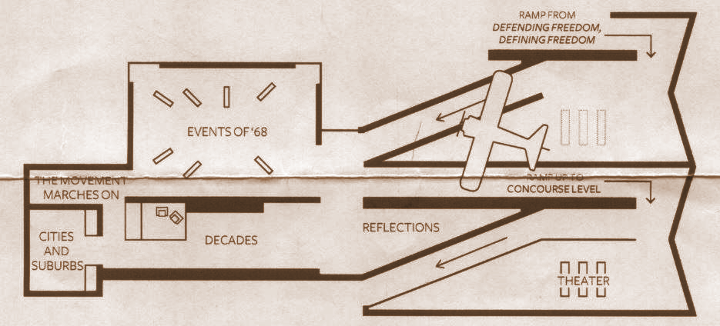
Figure 5. Map of “Changing America” History Gallery. Photograph by author.

When climbing the ramp to advance to the third and final level of the history galleries, you face a wall dedicated to the women of the Civil Rights Movement. I found it interesting that, according to the text, women played a “critical role” and were the “backbone of the movement,” yet their role was limited to a sixty-seven-word blip on a wall that was not even included in the actual Civil Rights exhibition. It was caught in between the two levels, and felt too much like an afterthought, though ironically the text on the wall admits the role the women played “has not received enough recognition.”
After moving these thoughts to the back of my mind, I pushed on and made my way up into the gallery all about the post-Civil Rights era. Immediately upon entering the new space you are confronted with the assassination of Dr. Martin Luther King Jr. and the role his death played in ending one movement and propelling another. While preparing to go to the NMAAHC I was questioning how much of the Black Power movement would be included in the narrative, since other museums often neglect it; this was not the case here. A majority of the third floor was dedicated to the Black Power movement and other movements and issues that stemmed from it: Black Liberation and the Vietnam War, Black Feminism, Black Beauty, Black Electoral Politics, Black Arts Movement, Film and Television, Popular Culture, and the Black Museum movement, were all given a panel in the opening space of the third floor. By far the most visually appealing level, the walls were covered with murals, art, color, and powerful images. Nevertheless, behind this colorful and bright section was the dark corner where the trouble was confronted: Job Loss, Poverty, the Urban Housing Crisis, Incarceration, and Baxter Terrace were all topics covered in this area. While you must commend the NMAAHC for including such topics and not simply skipping them in order to keep a “happy ending” feeling, they didn’t necessarily cover everything they could have, and they certainly didn’t spend a lot of time talking about the topics they did bother to mention.
The “Decades” section of the third floor covered the 1970s through the present day, talking about the light and the dark. However, what drew the viewer in was a large wall of screens depicting scenes from different decades, all coordinated with each other. These scenes showed images of moments of celebration, success, protest, loss, and heartbreak. 9/11, Hurricane Katrina, Halle Berry and Denzel Washington at the Oscars, Barack Obama, Black Lives Matter, Michael Brown and Trayvon Martin, Venus and Serena Williams, and so many more were displayed on these screens with voice-overs and songs highlighting different experiences. This wall evoked deep, mixed emotions and left the viewer mesmerized, forcing them to watch it several times over, just to catch everything at least once. Personally, one of the most powerful moments for me was when a video of Halle Berry winning an Oscar played, because it was a triumphant and emotional tone, but John Legend’s “Glory” was playing in the background. The combination was deeply moving and even though you were watching a joyous moment, you were still thinking of all the hardships you just absorbed.
On the map of the third floor, there was a section marked “Reflections.” This consisted of a small, triangular space with benches facing screens on a wall, and opposite that wall was a small room called Share Your Story in which the museum gave its visitors a chance to “contribute your voice” and “record your thoughts about African American history and culture.” These videos may then be used by the museum to play on the screens or put onto their website. This was a place for everyone to stop, sit with each other, and reflect on what they had just experienced together. Since we had all just seen three levels of a museum to honor those from the past who have since become famous for their contributions to history, it was a touching tribute to those in the present who are not famous, but the common person.
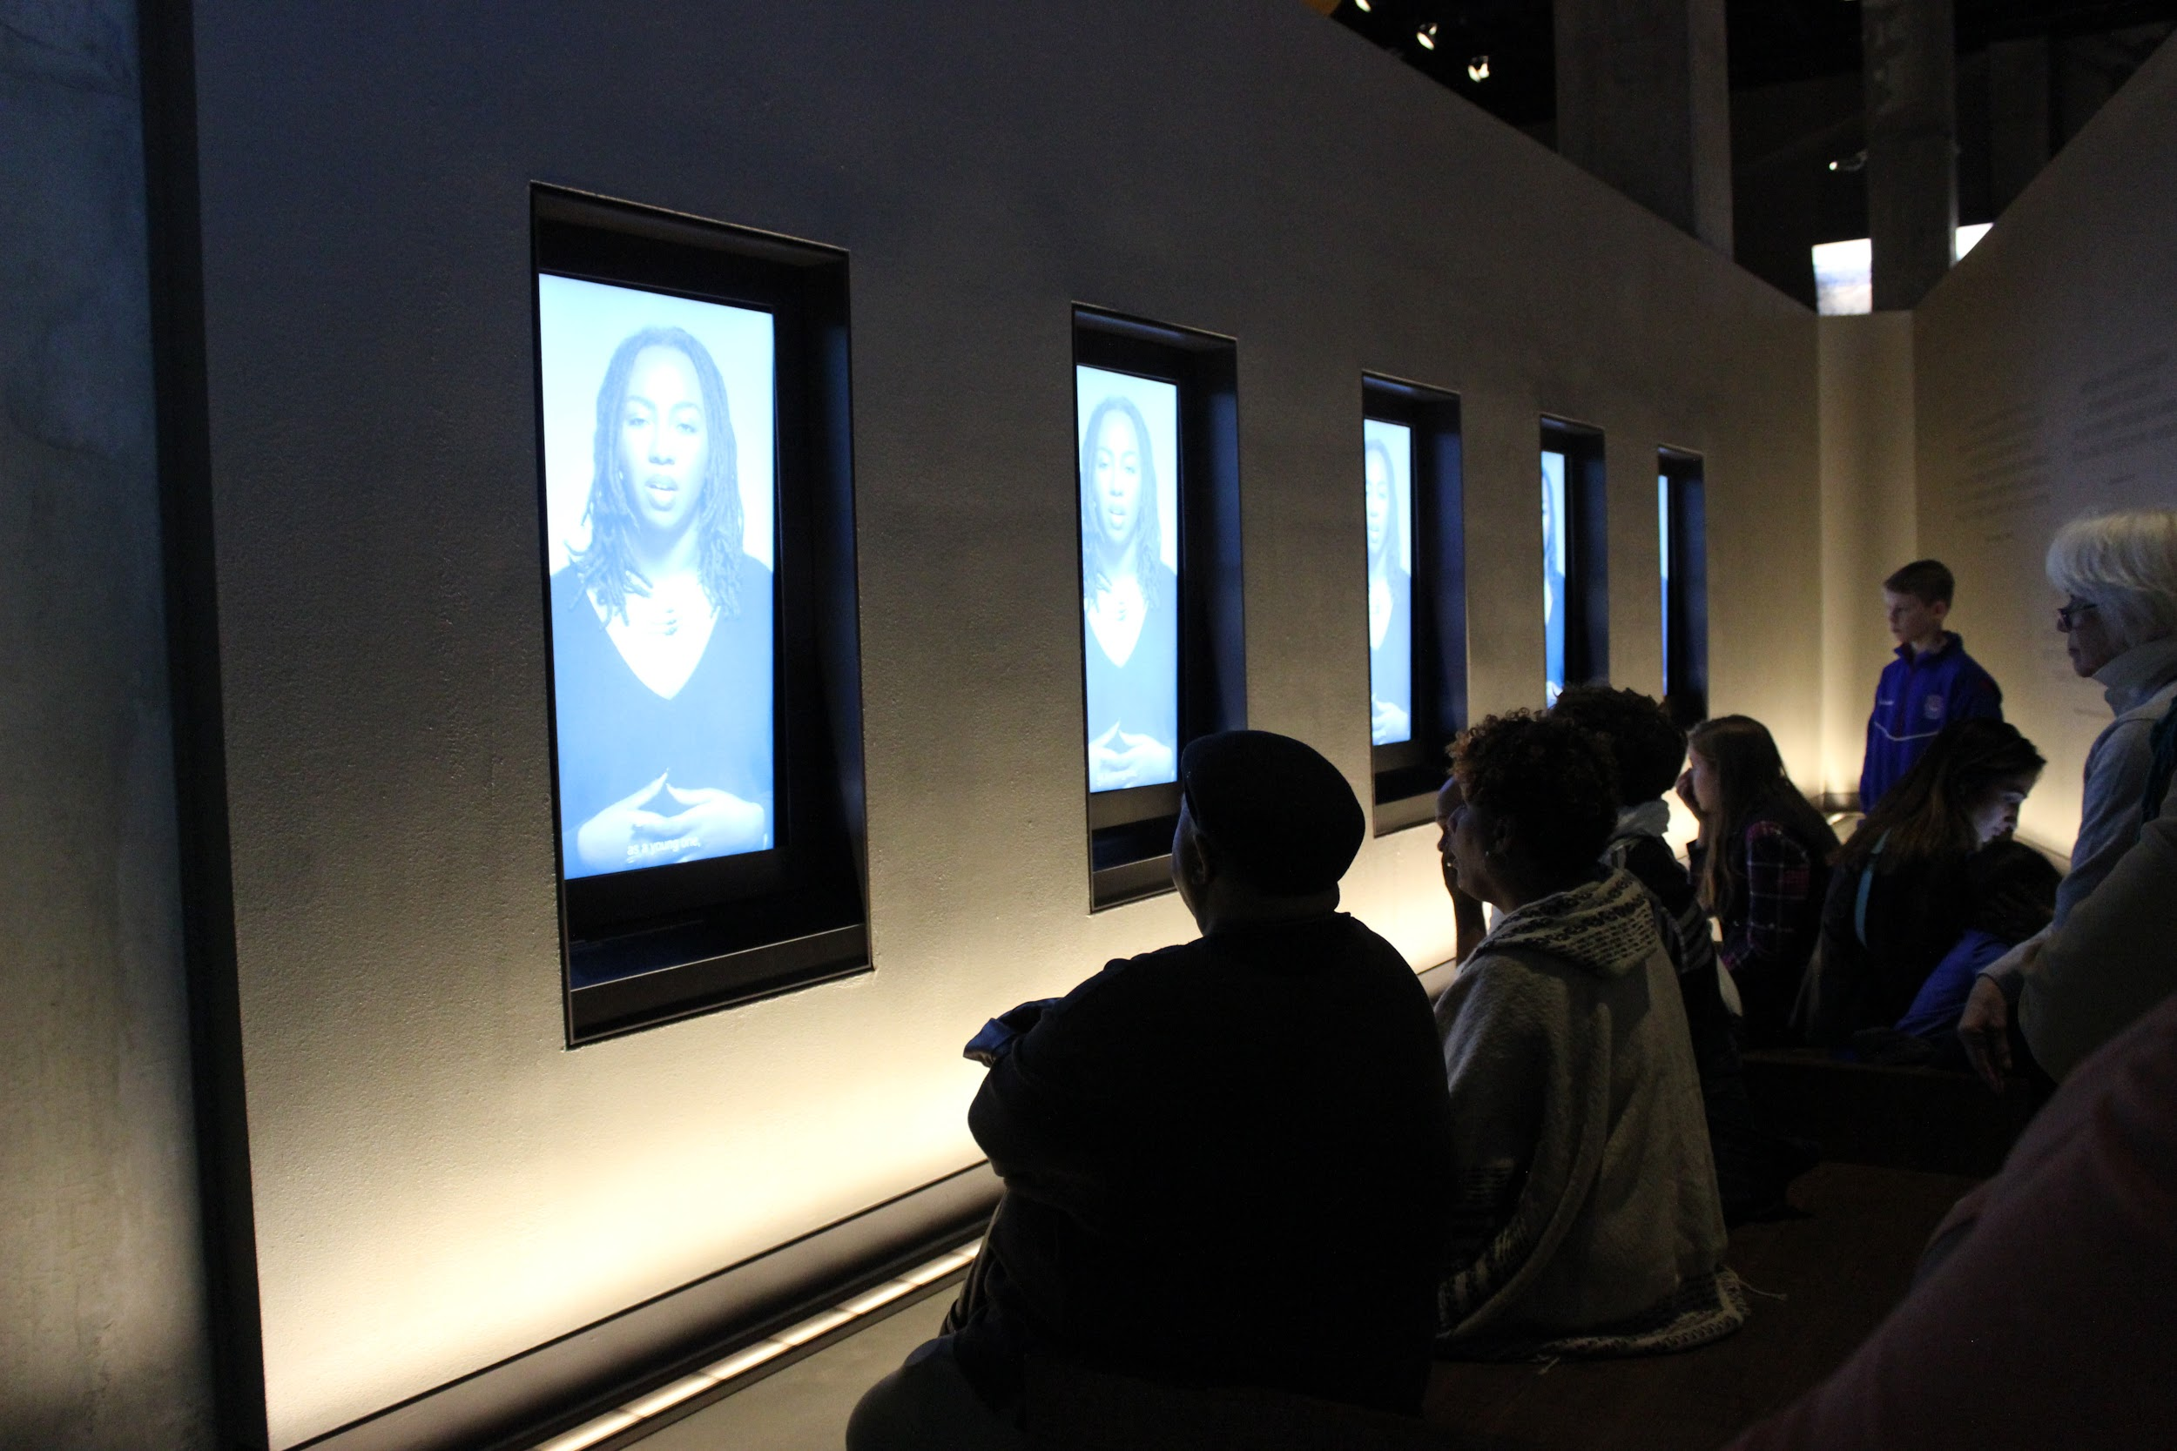
Figure 6. Reflections. Photograph by author.

Culture Galleries, Community Galleries, and More

If one was to label the aboveground and belowground levels in order to distinguish them, the belowground would be the objective half of the museum, while the aboveground would be the celebratory half. The “Explore More!” level of the NMAAHC was the first level above the ground floor. This level contained the archives for the museum as well as a classroom. The Robert Frederick Smith Explore Your Family History Center was a resource for African Americans wishing to learn more about or preserve their past and do genealogical research. Since this level was more research oriented, I did not spend much time here.
While walking through the history galleries, I made the observation that blacks’ military service was merely brushed over with one, maybe two panels and a few artifacts. This was deeply concerning to me, since African American military contributions is what started the movement for a museum in Washington D.C. in the first place. When I reached the “Community Galleries,” however, my fears were assuaged: roughly one-third of this level is dedicated to “The African American Military Experience.” Individual people and their stories are studied, the larger context and impact was studied, and numerous artifacts linking African Americans to each United States’ war was on display. Another large portion was dedicated to sports in a section entitled “Sports: Leveling the Playing Field.” Here, you had notable artifacts representing major contributions to sports from African Americans, like Muhammad Ali’s robe, gloves, and punching bag (still with the duct tape holding it together on it), although Ali had an entire room dedicated to him. The final piece to the Community puzzle was “The Power of Place” in which the museum studies ten different places in the United States which are particularly significant to the African American experience.
The final floor of the NMAAHC was dedicated to African American culture in the “Culture Galleries.” Here, we had the biggest sense of celebration and achievement. There were Creole cookbooks in an entire section dedicated to foods and cooking. There was a section focused on dancing and another sports display. But what grabbed the visitor’s attention was the “Cultural Expressions” in the center of the level. In this oval-shaped setting, there were large screens high above the visitors that showcase art, sports, music, dancing, clothing, and language. There were videos showing Gabby Douglas competing in the Olympics on one side, and a woman reading poetry on the other: this was the place in the museum where I felt a true sense of accomplishment. After working my way through exhibitions on slavery, segregation, violence, protests, and various movements, coming to this section gave me a sense that the country has come a long way, and that African Americans have come a long way. While I was standing in the center of this oval, a thought crossed my mind: If Martin Luther King were here, what would he think? How would he feel if he were looking at the same screens I was looking at? He lived during a time of hatred, when blacks could not sit at the same lunch counter as whites, and here we all are, a group of so many different cultural backgrounds, staring up at a huge screen that is celebrating African American culture, in a national museum for African Americans.

Personal Review and Critique of NMAAHC
After doing so much research and getting to intimately know NMAAHC, I needed to be careful not just in writing my review, but in the way I viewed the museum while there. I was concerned with remaining unbiased and completely objective towards a museum I had dedicated so much time, energy, and resources to. However, I was also conscious of keeping the press reviews and their critiques out of my mind. I contemplated whether or not to even read the reviews before seeing the museum for myself, because while they could contribute to my understanding and help me look for what I might otherwise miss, they could also give too much influence to my experience.
Being a student of public history, I tried to approach the museum from an analytical standpoint in order to determine not just which history they presented, but how they presented it. This being said, the problem with the NMAAHC isn’t necessarily the ‘which’ but the ‘how.’ The Washington Post made a comment about how covering so many years of history and culture in one space, despite how large the space may be, is quite a feat, and I couldn’t agree more. This brings my mind back to the saying, “Just because you can do something, doesn’t mean you should.” This museum was so long anticipated and under such a careful watch, that it felt like they were afraid to leave anything out, so instead they tried to fit everything in. The problem with this is that in their attempt to cover every topic, they have limited themselves to superficial content. In the bottom floor alone they cover more than four hundred years of history. If these four hundred years were simple and didn’t have such a large impact it would be acceptable to limit them to one floor, but these were the formative years of African American history. These first four hundred years laid the foundation for the future of not just African Americans, but all Americans.
One might ask, “Yes, they put so much history in one floor, but isn’t it a large space?” The answer is yes, it is a large space, but that does not help matters. Despite how much room there is, the visitor cannot help but be overwhelmed by the experience. An example of how mismanaged it is was when I was on the bottom floor, and I missed the slave cabin. I knew it was there because I read about it, but all of a sudden I turned around and it was there and I actually asked myself, “When did that get there?” There is no logical layout to the bottom two history floors or the upper culture floors, which leaves the visitor to wander or take it upon themselves to make an efficient route to everything. However, with so many things to see, not to mention hundreds of people surrounding you, this is almost impossible. You and those around you have either had your tickets for months or have stood out in the cold for four hours, so there is a certain feeling of obligation to make sure you have reached every point and read panel, but you also feel rushed. Not to mention there are seven different levels to the museum, six of which have this same, overpowering aesthetic. The argument can be made that if so many people weren’t there then it would be easier to navigate, which is most likely true, but it is a Smithsonian museum. It will never not be busy and teeming with people.
I have tried to answer the question, “What does the NMAAHC tell us that other African American museums do not?” and each time I come up short. The slave trade, slavery, the Civil War, Reconstruction, the Great Migration, the Civil Rights Movement, Black Power, Barack Obama—these are all topics covered in museums across the country. The NMAAHC may go into more depth, but it is still talking about the same topics. The only thing that separates this museum from all the rest is that it’s telling the story with more powerful objects. We have seen intact slave cabins, but we have not seen a whipping post, a whip, and chains all set in front of the slave cabin. We have seen pictures of lynchings, but we have not seen Emmett Till’s coffin. This African American museum feels like the master key to all the rest—it is unlocking all the same doors, but it is still superior to all the rest.
The lack of female narrative in the “Defending Freedom, Defining Freedom” floor is also concerning. Where is the wall dedicated to Ida B. Wells, an icon of the Reconstruction era, and her writings or her journeys to England to get international attention turned towards lynching? Why isn’t there more on Diane Nash, one of the main activists responsible for Selma in the 1960s, and by extension the passing of the Voting Rights Act of 1965? Why is there just one wall dedicated to women in the Civil Rights Movement? And why is this wall separate from the main narrative and put at the end of a ramp leading to the next floor? The NMAAHC missed a huge opportunity to educate visitors about the female activists of the Civil Rights Movement, who have gone largely unnoticed even though their contributions were pivotal, and if this museum will not do it, then who will?
It is worth mentioning that maybe the museum is simply breaking pattern. We have been so trained to walk into a museum, read quick facts on a wall, and leave within an hour. Is the NMAAHC really making such a mistake by challenging us to take our time and read a few sentences? After going to the National Museum of American History (NMAH) two days later, I was shocked by how child-oriented it was. It felt like it had been dumbed down and if I didn’t want to read the text I didn’t have to-- I just needed to look at the pieces on display. The interesting part of this is that if we get a museum like NMAH we want something more, but when we get what we ask for we say that it is too much. How can we possibly expect museums to satisfy our demands if our demands contradict each other? One of the main criticisms in the press reviews is that NMAAHC cannot be viewed in one day. Is this really such a bad thing? Entry into a Smithsonian museum is free so the argument cannot be made that forcing people to stay longer or come back a second time is a money making scheme. I think before we rush to criticize a museum for its quantity, we must first question what we consider to be quality.
Despite these critiques, I do feel the museum has achieved a rather commendable accomplishment. One way they truly make the museum a museum of the people, for the people, and by the people is when they show who donated each artifact. When Lonnie Bunch III was hunting for pieces to fill the museum he went around the country setting up scenes much like “Antiques Roadshow”, where people could bring any interesting pieces they had, have them appraised, and if they were desirable they were either donated or bought. So for each object collected, on the text panel that accompanies it proper dues are given. Other museums have collected artifacts from external donors, but not to this same magnitude. This allows the NMAAHC to bring more voices into the museums’ narrative and get pieces of history from the common person and not just those who played active roles in history.
Perhaps the more important accomplishment is bringing people together to view African American history, but most importantly—to discuss it. Thousands of people—people from all over the world—are visiting the museum every day and even if there are flaws in it, this is getting people talking. When they leave the museum they will better appreciate the struggles African Americans have faced, they may remember the stereotypes they read about and use that to challenge common perception, or they may look at Black Lives Matter differently. This museum causes us to not only look back at African American history, but look at the present as well.

Conclusion
It is important to realize that just because a museum has a long and impressive history, does not mean it is going to be the “perfect” museum. The National Museum of African American History and Culture is not perfect—it makes mistakes—but it is still exceptional. The concept of the “perfect” museum is illusive and unobtainable, so at what point do we accept a museum for getting close enough? The NMAAHC brings in history from a previously untapped resource—common, everyday people. It strove to find remarkable objects that would leave an impression on its visitors, which is exactly what it did. But the question to ask is at what point does it become too far from perfect? Does its lack of organization and direction, its “been done” topics, lack of female recognition, and sheer size outweigh its accomplishments? I will be continuing my research by submitting such questions to the NMAAHC. I will be taking points from my review and turning them into questions in the hopes that I will get a deeper understanding of why certain decisions were made. I will be delving into the fundamentals of the museum, such as its creation and design, its artifacts, and using these results to form a presentation for the National Conference of Undergraduate Research and/or the Celebration of Excellence in Research and Creative Activity. In these presentations I will be filling the gap in my paper and focusing on what happened with the museum between 2003 and 2016. This will be where my research into the National Museum of African American History and Culture will conclude, but my further call for research goes to my reader. I urge my audience to visit the museum for themselves to not only form their own opinions, but challenge mine.

Works Cited

Primary

Lewis, John. “John Lewis spent 15 years fighting for the museum -- now the dream is realized” The Washington Post, September 15, 2016. Accessed October 13, 2016. https://www.washingtonpost.com/lifestyle/magazine/john-lewis-spent-15-years-fighting-for-the-museum--now-the-dream-is-realized/2016/09/14/eeb0ca10-64bb-11e6-96c0-37533479f3f5_story.html

US Congress. House. 64 Bill Profile H.R. 18721 (1915-1917). HR. 18721. 64th Cong., 2d sess.

US Congress. House. Negro Soldiers’ and Sailors’ Memorial: Hearing before the Committee on the Library. 66th Cong., 1st sess. October 14, 1919.

US Congress. House and Senate. Monument or Memorial Building to the Memory of Negro Soldiers and Sailors: Hearing before the Joint Committee on the Library Congress of the United States. 68th Cong., 1st sess. May 28, 1924.

US Congress. Senate and House. 70 S.J. Res. 132 Introduced in Senate. S.J. Res. 132. 70th Cong., 1st sess.

US Congress. Senate and House. 71 S.J. Res. 171 Introduced in Senate. S.J. Res. 171. 71st Cong., 2nd sess.

US Congress. House. National African- American Heritage Museum and Memorial Act. H. R. 5305. 100th Cong., 2nd sess.

US Congress. House. Establishment of an African- American Heritage Memorial Museum: Hearing held before the Subcommittee on Libraries and Memorials of the Committee on House Administration. 101 Cong., 1st sess., September 21, 1989.

US Congress. Senate. National Museum of African American History and Culture Act of 2001. S. 829. 107th Cong., 1st sess.

US Congress. House. National Museum of African American History and Culture Act of 2001. HR. 1718. 107th Cong., 1st sess.

Secondary

Smithsonian Institute. “Many Lenses: Three Museums, Three Objects, Many lenses.” National Museum of African American History and Culture. Last modified 2016. Accessed December 3, 2016. https://nmaahc.si.edu/explore/manylenses

Smithsonian Institution Archives. “National Museum of African American History and Culture.” Last modified 2015. Accessed December 8, 2016 http://siarchives.si.edu/history/national-museum-african-american-history-and-culture

Stokes, Melvin. D.W. Griffith’s The Birth of a Nation: A History of the Most Controversial Motion Picture of all Time. New York: Oxford University Press, 2007.

Wilkins, Robert L. Long Road to Hard Truth: The 100-Year Mission to Create the National Museum of African American history and Culture. Washington, DC: Proud Legacy Publishing, 2016

Works Consulted

US Congress. House. 105 H.R. 773 Introduced in the House. HR. 773. 105th Cong., 1st sess.

US Congress. House. 106 H.R. 923 Introduced in the House. HR. 923. 106th Cong., 1st sess.

John Lewis, “John Lewis spent 15 years fighting for the museum -- now the dream is realized,” Washington Post, September 15, 2016, accessed October 13, 2016, https://www.washingtonpost.com/lifestyle/magazine/john-lewis-spent-15-years-fighting-for-the-museum--now-the-dream-is-realized/2016/09/14/eeb0ca10-64bb-11e6-96c0-37533479f3f5_story.html
64 H.R. 18721 (1915-1917), H.R. 18721, 64th Cong., 2d sess.
Hearings before the Joint Committee on the Library, H.J. Res. 245, Monument or Memorial Building to the memory of Negro Soldiers and Sailors 68th Cong., 1st sess., May 28, 1924.
70 S.J. Res. 132 Introduced in Senate, S.J. Res. 132, 70th Cong., 1st sess.
64 H.R. 18721 (1915-1917), H.R. 18721, 64th Cong., 2d sess.
The author would like to say that there were many pieces of legislation introduced, in both the House and the Senate, which cannot possibly be included in this historiography. While there are some that are simply repetitive, there are a few that go unmentioned that did lend support to the NMAAHC, especially in the 1990s.
64 H.R. 18721 (1915-1917), H.R. 18721, 64th Cong., 2d sess.
Ibid.
Ibid.
Ibid.
Melvin Stokes, “D.W. Griffith’s The Birth of a Nation: A History of the Most Controversial Motion Picture of all Time,” (New York: Oxford University Press, 2007), 112.
Hearing before the Committee on the Library, H.R. 5131, Negro Soldiers’ and Sailors’ Monument, 68th Cong., 1st sess., October 14, 1919.
Ibid.
Hearings before the Joint Committee on the Library, H.J. Res. 245, Monument or Memorial Building to the memory of Negro Soldiers and Sailors 68th Cong., 1st sess., May 28, 1924.
70 S.J. Res. 132 Introduced in Senate, S.J. Res. 132, 70th Cong., 1st sess.
Ibid.
Ibid.
71 S.J. Res. 171 Introduced in Senate, S.J. 171. 71st Cong., 2nd sess.
“National Museum of African American History and Culture,” Smithsonian Institution Archives, 2015, accessed December 7, 2016, http://siarchives.si.edu/history/national-museum-african-american-history-and-culture
National African- American Heritage Museum and Memorial Act, H.R. 5305. 100th Cong., 2nd sess.
Hearing held before the Subcommittee on Libraries and Memorials of the Committee on House Administration, H.R. 1570, Establishment of an African-American Heritage Memorial Museum, 101st Cong., 1st sess., September 21, 1989.
Robert L. Wilkins, Long Road to Hard Truth: The 100 Year Mission to Create the National Museum of African American History and Culture (Washington D.C.: Proud Legacy Publishing, 2016), Ch. 6.
National Museum of African American History and Culture Act of 2001, H.R. 1718, 107th Cong., 1st sess.
National Museum of African American History and Culture Act, Public Law 108-184, US Statutes at Large 117 (2003)
Ibid.
Benjamin Freed, “11 Exhibits You Need to See at the Smithsonian’s African American History Museum,” Washingtonian, September 15, 2016, accessed December 1, 2016, https://www.washingtonian.com/2016/09/15/11-exhibits-need-see-smithsonians-african-american-history-museum
Ibid.
Christopher Hawthorne, “D.C.’s new African American museum is a bold challenge to traditional Washington architecture,” LA Times, September 13, 2016, accessed December 3, 2016, http://www.latimes.com/entertainment/arts/la-et-cm-nmaahc-architecture-review-20160913-snap-story.html
Ibid.
Ibid.
“Many Lenses: Three Museums, Three Objects, Many Lenses,” National Museum of African American History and Culture, accessed December 3, 2016, https://nmaahc.si.edu/explore/manylenses
Christopher Hawthorne, “D.C.’s new African American museum is a bold challenge to traditional Washington architecture”
Holland Cotter, “Review: The Smithsonian African American Museum Is Here at Last. And it Uplifts and Upsets,” New York Times, September 15, 2016, accessed December 3, 2016, http://www.nytimes.com/2016/09/22/arts/design/smithsonian-african-american-museum-review.html?_r=0
Holland Cotter, “Review: The Smithsonian African American Museum Is Here at Last. And it Uplifts and Upsets”
Oliver Wainwright, “‘A welcome rebuke to dead white men’: The Smithsonian’s African American museum finally arrives,” Guardian, September 16, 2016, accessed December 4, 2016, https://www.theguardian.com/artanddesign/2016/sep/15/smithsonian-national-museum-african-american-history-washingon-architecture-review
Ibid.
Ibid.
Edward Rothstein, “National Museum of African American History and Culture Review: A Moving but Flawed Accounting of History,” Wall Street Journal, September 14, 2016, accessed December 4, 2016, http://www.wsj.com/articles/national-museum-of-african-american-history-and-culture-review-a-moving-but-flawed-accounting-of-history-1473893066
Edward Rothstein, “National Museum of African American History and Culture Review: A Moving but Flawed Accounting of History”
Ibid.
Ibid.
Philip Kennicott, “The African American Museum tells powerful stories-- but not as powerfully as it could,” Washington Post, September 14, 2016, accessed December 4, https://www.washingtonpost.com/entertainment/museums/the-african-american-museum-tells-powerful-stories--but-in-a-disjointed-way/2016/09/14/b7ba7e4c-7849-11e6-bd86-b7bbd53d2b5d_story.html?utm_term=.30556cd955fd
Ibid.
The author would like to note she in no way shares this opinion and in fact strongly disagrees with it. It is only being included to maintain the integrity of the paper in which it is being quoted.
The author would like to note that she is largely discussing only the main features of each level. To discuss each and every fascinating item or every step taken through the museum would be far outside the reach of a capstone paper.
The author would like to note that she did not explore “The Power of Place” well enough to provide a detailed account or review to her readers.
Kate Taylor, “The Thorny Path to a National Black Museum,” New York Times, January 22, 2011, accessed December 6, 2016, http://www.nytimes.com/2011/01/23/us/23smithsonian.html

