Valuable People:
The Rise and Fall of the Lake Pepin “Half-Breed Tract”

Allison C. Bender
History 489: Research Seminar
Fall Term 2016

Contents
Abstract………...……….……………………………...…………………………………………iii
Introduction and Historiography…………………………………………………………………..1
Race as a Social Construct.....……………………………………………………………………..5
Treaty of Prairie du Chien 1825…………………………………………………….......................7
Understanding the Treaty of Prairie du Chien 1830......................................................................10
The Lake Pepin “Half-Breed” Tract..............................................................................................16
Franklin Steele and the Fort Snelling Internment Camp...............................................................18
Call for Further Research………………………………………………………………………...22
Conclusion……………………………………………………………………………………….24
Works Cited.………………………………………………………………….………………….27

Abstract

This paper focuses on the Dakota nation during the early nineteenth century while discussing the various tribes within the Midwest during that time. These tribes include the Ojibwe, confederated Sacs and Foxes, Ho-Chunk, Menominee, Ioway, Ottowa, and Potawatomi. As intertribal warfare disrupted the peace between these tribes, it also disrupted the plans of many European settlers who had wanted to live, farm, hunt, mineral mine, and trade in the Midwest. One can see evidence of this disruption by visiting treaties from the early nineteenth century as well as accounts from various Indian Agents from this time. Several treaties attempted to halt intertribal warfare and open up the Midwest for the settlement of its land. This paper will focus on the 1825 and 1830 treaties of Prairie du Chien to show how eager the US government was to stop the warfare and settle on Midwestern land. One may notice in the 1830 Treaty of Prairie du Chien that the Dakota tribal representatives set aside a tract of land for the “Half-Breeds,” or the mixed-race population. This paper will attempt to discuss the rise and fall of the tract of land, why the Dakota people requested this separate tract, and whether or not it was successful.

Introduction and Historiography

Before the nineteenth century, the lands belonging to the Dakota extended from western Wisconsin to the expansive prairies today known as North and South Dakota. The French settlers, who were the first to create forts and trade with the people within the Midwest, began to intermingle with the Dakota and other tribes to create positive relationships between them and the Native Americans. Modern historians, such as Mary Lethert Wingerd, discuss this idea of cohabitation and the new generation of people that came from it,
Throughout the Great Lakes region and Canada, from the time of first contact, intermarriage was common between Indian women and French traders and voyageurs. Over generations these mixed-ancestry people, known as Metis, developed an identifiable culture that was different from either European or Indian ways, though it incorporated elements of both.

However, people during the nineteenth century would usually describe the mixed-race people of Dakota and French decent as mixed-blood rather than Metis. These people of mixed ancestry were able to move with ease between their Native and white families, sometimes living among whites, other times with their tribal ancestors. Because of this connection to both cultures, the two groups of people used biracial people as cultural brokers or interpreters. French men who married Dakota women acquired special privileges of both groups of people and created strong relationships with their Native family members.
Some early historians, such as Frank Fiske romanticize this era, stating that the Europeans lived peacefully amongst the various tribes within the Midwest and did little to attempt to change the lifestyle of the indigenous people. However, European settlers, as well as tribal members, faced harsh competition for resources and land. Settlers took advantage of the opportunity to marry indigenous women in order to create ties with tribal groups and to develop new trading partners. As Europeans began to discover lead in Wisconsin in the early nineteenth century, many white settlers flocked to the Michigan Territory to claim profits. By 1829, more than 4,000 miners worked in southwestern Wisconsin.
The Michigan Territory was a tract of land created by President Thomas Jefferson in 1805 and included modern-day Michigan. Later in 1818, the territory expanded to include modern-day Wisconsin. Then, in the 1830s, the territory stretched even farther to include parts of present-day Minnesota (See Fig. 1). After the formation of the Erie Canal in 1825, settlers were eager to acquire land within Michigan Territory and take advantage of the abundant natural resources in the area. However, it was not until tribes relinquished their property rights to the US government that the settlers could legally use the land. Despite this, pioneers often settled on tribal lands without the permission of the tribal members, which also increased tensions between Native Americans and settlers.

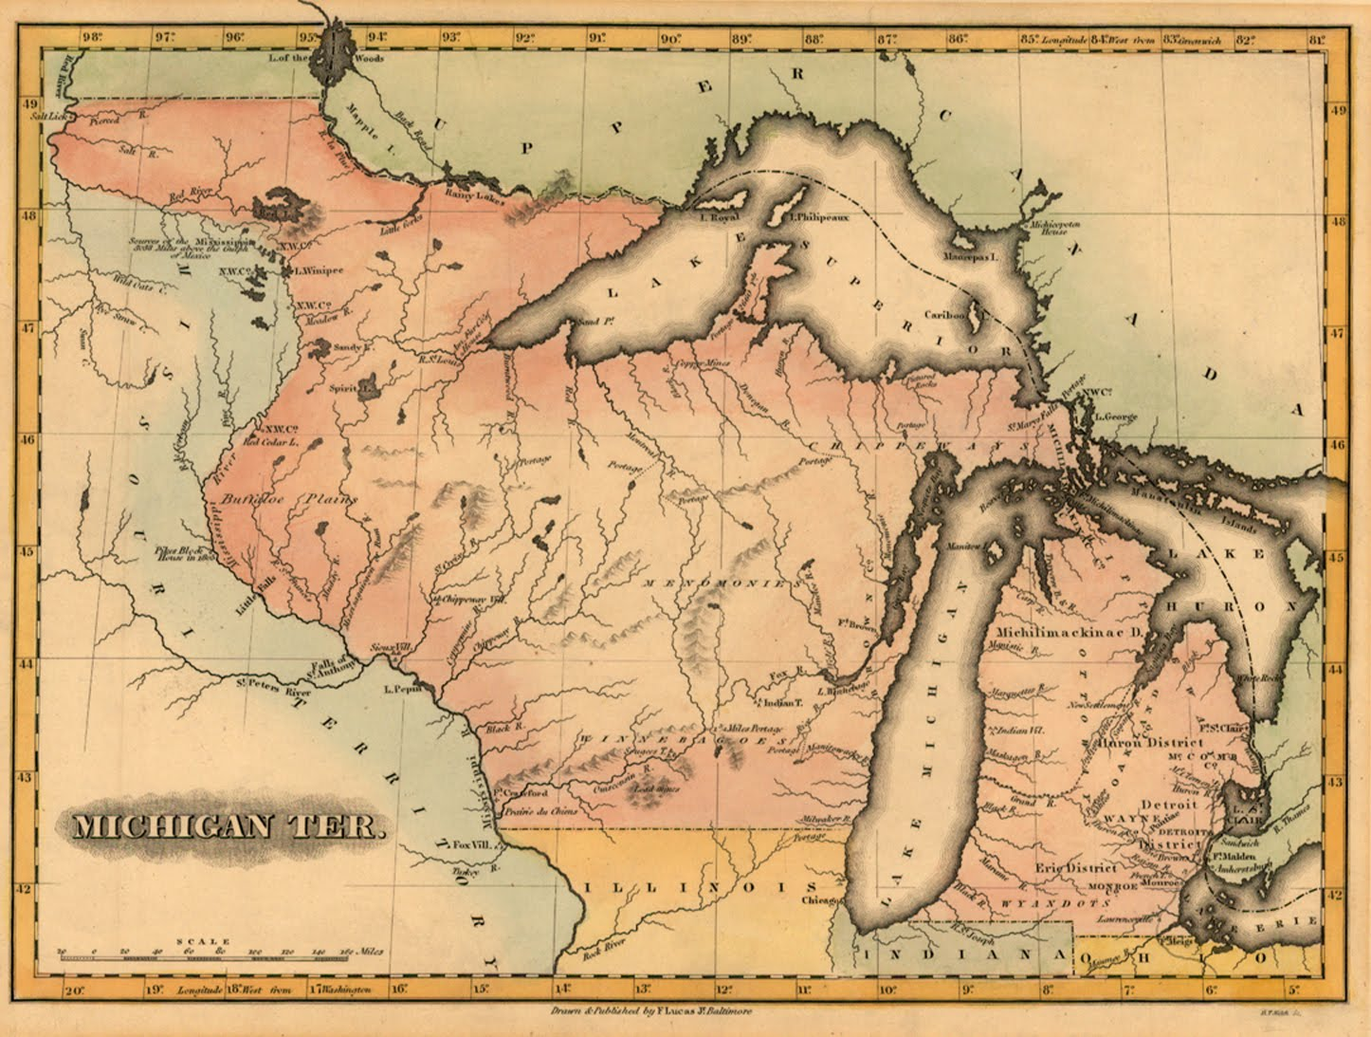
Fig 1. Michigan Territory, 1818-1833

Source: “Michigan Territory,” accessed December 16, 2016, http://antiqueprintsblog.blogspot.com/2011_12_01_archive.html.

In 1825, other white settlers became peacemakers amongst the tribes in the Wisconsin area. During the council and signing of the Treaty of Prairie du Chien on August 19, 1825, various tribes from the Wisconsin and Minnesota area attempted to put aside their feuds and negotiate peace. As boundary lines were drawn, the United States government hoped to end the wars. However, after the signing of this treaty, warfare continued between various tribes such as the Dakota, Sacs and Foxes, Menominee, and the Ho-Chunk.
Many accounts of intertribal warfare disrupted trade among Native Americans and European settlers. Not only this, but it instilled fear into the minds of the white people living among tribes such as the Dakota. Indian Agents like Thomas Forsyth—the Agent for the confederated Sac and Fox nation—wrote about these wars and about the fear that many white settlers felt. In a letter to William Clark in St. Louis, Forsyth discussed how the Sac war party took a cattle trail owned by a white man so that they could arrive at the Dakota campsite. Forsyth wrote about how the war party had hunted the cattle, which undoubtedly caused trouble between the tribe and the settlers.
Historians of the early twentieth century described the intertribal warfare between the Dakota and Ojibwe tribes as being a source of amusement. In a racist depiction of the early Dakota tribe, Frank Fiske states that,
The hostility of these tribes served more as a source of entertainment than for any other purpose. They seldom did each other much damage, while the continual state of warfare kept the young men keyed up to a high degree of fighting efficiency, and made life interesting for all members of the tribes. It must be remembered that this was in the days before the motion picture shows and it was necessary that the redmen of the woods and plains be furnished with some kind of amusement.

One can imagine that the residents of the Midwest during the early nineteenth century did not agree with this statement. Indian Agents during this time wrote many letters to the President of the United States informing them of the actions of the tribes in the Midwest. In other letters to William Clark in St. Louis, Thomas Forsyth discussed the prominence of intertribal warfare between the confederated Sacs and Foxes and the Dakota tribes. This warfare played such a leading role amongst the lives of Native Americans and white settlers that the United States government decided to intervene in 1830.
At the council and signing of the 1830 Treaty of Prairie du Chien, President Andrew Jackson threatened an invasion and trade embargo if warfare continued. Tribes who had extended their battles after the 1825 Treaty of Prairie du Chien promised not to continue fighting and made peace with each other. The government officials at the council of this treaty moved land boundaries once again and the United States ceded some land to use as neutral ground. Dakota tribal leaders also discussed the idea of giving land to the “half-breeds” (or, biracial people) of their tribe. This land would be set aside for the mixed-race population of the Dakota nation and was located near present-day Red Wing, Minnesota. There are many reasons why the Dakota nation asked to have land set aside for their mixed-race population. Much of this paper focuses on the 1830 Treaty of Prairie du Chien, particularly Article 9, which discusses the “Half-Breed Tract,” in hopes of discovering why the Dakota nation thought it necessary to request land for the biracial people of their tribe. Although one cannot tell by reading the treaties of the early nineteenth century, the largest reason for this request from the Dakotas was greed.

Race as a Social Construct

Perhaps the social construction of race during the early nineteenth century had something to do with the attitude of Dakota tribal leaders as they made the decision to request the “Half-Breed” Tract. Theda Perdue describes this construction when discussing Andrew Jackson in 1816 as he attempted to negotiate a secession of land deal with the Chickasaws who had resided in the Southeastern United States. After facing resistance from this tribe, he blamed the designing of “half-breeds” and the “renegade white men” who had settled on their land. By making such a statement, Jackson concluded that their behavior directly correlated to their ancestry. This changed the attitudes about race all over the country where, a few years prior, a small amount of people would have believed the idea that there was a direct correlation between one’s race and one’s behavior. Government leaders, such as Andrew Jackson used this concept of race to justify the treatment of Native Americans during the Indian Removal Act.
If this idea of race had instilled itself in the minds of tribal leaders, perhaps they grew to distrust the mixed-race people on their land. Having a French father and a Dakota mother could be very confusing for a child, especially when trying to shape their identity. When Native women married French men, they did it as a way to increase ties between two groups of people. Susan Sleeper-Smith discusses this notion through the study of French and Dakota people in eighteenth and nineteenth centuries.
Native women who married fur traders successfully incorporated their French husbands into their communities. These women were important links in the exchange process. They did not “marry out” of the villages in which they were raised and they ensured that exchange remained defined by kinship behaviors.

This created complex and complicated kinship groups within the Midwest.
The notorious Dakota chief, Taoyateduta (or, “Little Crow”) was quickly able to make such ties with people who had married into his family. Joseph Renville, a mixed-race trader was a descendant of a French voyageur and Miniyuhe, a member of Little Crow’s family, created an extensive kinship network with his Dakota relatives. This allowed him to use his relatives as hunters and laborers to develop a commercial empire at Lac qui Parle in present-day Minnesota. Marriages between French men and Dakota women were often political choices of the men to increase economic opportunities.

The 1825 Treaty of Prairie du Chien

As soon as 1825, Dakota tribal leaders, as well as those from other tribes surrounding Wisconsin, signed a treaty with the United States in an attempt to halt intertribal warfare. The first Treaty of Prairie du Chien brought nine tribes together to negotiate peace and establish land boundaries. Representatives from the Dakota, Ojibwe, Sacs and Foxes, Ioway, Ho-Chunk, Ottawa, and Potawatomi nations, as well as the United States, attempted to end the hostilities between the tribes and settlers. The treaty began by stating that the United States government had observed the intertribal warfare between various tribes in the Midwest area and was fearful of the warfare spreading to other tribes around other areas of the United States. In order to halt the warfare and promote peace, land boundaries were established.
Article One of this treaty states that, “There shall be a firm and perpetual peace between the Sioux and Chippewas; between the Sioux and the confederated tribes of Sacs and Foxes; and between the Ioways and the Sioux.” This article describes how active the Dakotas were in intertribal warfare and how they competed for resources with other tribes. At the beginning of the 1800s, their land extended through modern-day Wisconsin, Minnesota, Iowa, South Dakota, and North Dakota. However, in almost twenty-five years, and after signing the 1825 Treaty of Prairie du Chien, this land began to diminish.
The United States government was insistent on establishing land boundaries, however, the Native American delegation members explained that the animals they hunted for food did not recognize boundaries and that the arrangement would cause more problems than it solved. Because of this, the treaty became a compromise. These boundaries were set and written on paper; however, the treaty recognized that the tribes would sometimes ignore them. The US government had a specific purpose in developing land boundaries, however, because within three years of the treaty, they began purchasing land within the boundaries. By designating tracts of land to specific tribes, it made it easier for the government to purchase land legally from specific groups of people.
As over 150 people signed the historically unprecedented treaty and over 3,000 people attended the council, this event truly became monumental as so many tribes came together to negotiate peace. A painting by James Otto Lewis depicts the massive amount of people present in Prairie du Chien during the council and signing of this treaty (See fig. 2). In this figure, Native men sit in the grass at the front of the crowd while white men in blue suits are sitting in neat rows behind the tribal members. This painting is somewhat reflective of the relationship between the tribal members and the Indian Agents of the Midwest. It is interesting that the tribal members sit in front of the white men, it seems that this is done out of respect for the tribal leaders.

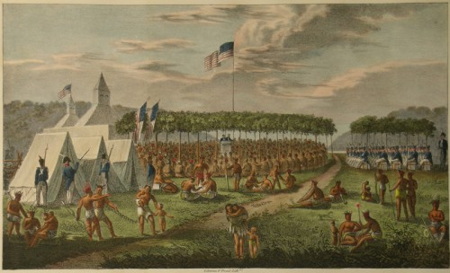
Figure 2. View of the Great Treaty Held at Prairie du Chien, 1825

Source: “Dakota and Ojibwe Treaties,” accessed October 16, 2016, http://treatiesmatter.org/treaties/land/1825-1830-Multinational

Because the western frontier was on the minds of so many government figures during the early eighteenth-century, this treaty played an enormous role in the livelihood of the tribes and settlers in the early Midwest, even if for only a few years. However, as predicted, the lines on a map did not freeze the tensions between these tribes. Unfortunately, intertribal warfare quickly resumed and the United States government, along with tribal leaders, met for the council of another historical treaty to restore peace.
Understanding the 1830 Treaty of Prairie du Chien

On July 15, 1830, members of the Sac and Fox, Dakota, Omaha, Ioway, Oto, Ho-Chunk, Menominee, and Missouri gathered once again at Prairie du Chien to discuss peace. The council began on the first day with all tribal leaders and government officials passing around the “Great Pipe of Peace.” Soon after, General William Clark, the Superintendent of Indian Affairs from St. Louis at that time, rose and delivered an introductory speech, thanking the Great Spirit for blessing their council with a clear sky. He then read a speech written for him by President Andrew Jackson. Jackson described his sadness when he read letters from several Indian Agents about how the various tribes had not been keeping the peace they negotiated in 1825 just a few years earlier. He discussed how they had “buried the tomahawk” only for it to be used again. Ironically, soon after discussing his sadness over warfare, he threatened the tribes who had not kept their promise of peace with an invasion as well as a trade embargo.
Chiefs and Warriors! The white people do not go to war until they have fully deliberated. When they strike, they strike down whole nations!
I now address myself to the Sacs and Foxes, to the Sioux, to the Winnebagos, and Menominee who have had recent difficulties with each other.

Chiefs and Warriors! I am directed by the President, your Great Father to say to you that you must hereafter submit all your differences to myself at this place, or to your Father at St. Louis. If you do this, your Great Father gives you his word that he will see ample and speedy justice done to you. Rest upon to the word of your Great Father; that word is sacred, he will exactly perform all his engagements to you.

This statement left many tribal leaders frightened and nervous for their people. Tribal leaders who had not participated in battles were eager to speak to their Great Father and explain why they did not want be punished for the actions of other tribes. However, Clark directed the tribal members to go back to their camps to eat, smoke, and reflect upon what they had heard from their Great Father.
The next day, the council resumed and William Clark informed the tribal leaders were informed by William Clark that if at any time the tribes could come to a friendly understanding, they should make it known to their commissioners and they would have treaties ready for them to sign. Next, Chief Keokuk of the Sac tribe and Chief Wabasha of the Dakota speak of the wrongs that were done to them by the other. Chief Wabasha exclaims,
Fathers! The Sacs and Foxes, the Sioux and all these nations around us were formerly as one. They ate out of one dish and with one spoon, they sat around the same fire. But things are since greatly altered. Five times have the Sacs and Foxes hurt us, and each time I turned my head aside, and would not see out. I wish you, my fathers, to let our Great Father know this.

Possibly out of fear of going to war with the United States army, many tribes explain their situations and plead with the Great Father not to invade. Chief Wapalaw of the Fox tribe explained how he believed the white men had “meddled in our peace.” This caused some tension with the government officials and William Clark states,
My object in trying to make this peace have been made known to several of you. It was to cause those who are now at war to be at peace, and make them interested in preserving a peace. My wish was that you should make peace among yourselves. It appears you have, as far as the representation among you has enabled you to do so. You have broken the treaty which you entered into last as this peace, and it is necessary you should make a new one.
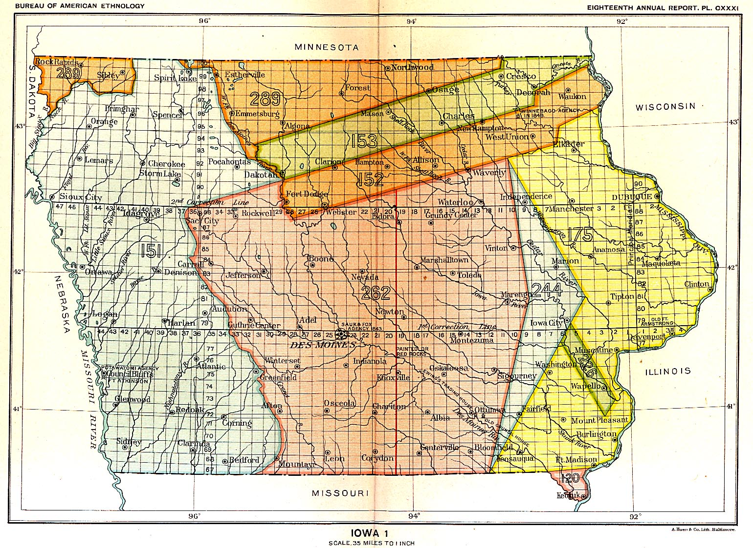
Figure 3. Land Cessions in Iowa
Source: “Iowa 1, Map 24,” accessed December 18, 2016, http://usgwarchives.net/maps/cessions/ilcmap24.htm.

After this discussion, William Clark read the aloud for all tribal members to hear. Article 1 and 2 discussed the cession of tribal land by the U.S. government. The treaty stated that the Sacs and Foxes, as well as the Dakota would, “cede and relinquish to the United States forever, a Tract of Country twenty miles in width, from the Mississippi to the Demoine River, situated north, and adjoining the line mentioned in the preceding article.” The US government meant to use this forty-mile tract of land as a buffer between the Dakota and the confederated Sacs and Foxes so that they would discontinue their warfare. The Ho-Chunk people, who had also lost a large area of land, would occupy the tract. One can see the land ceased by the US government in the 1830 Treaty of Prairie du Chien by looking at a copy of a map created by Charles Royce (See Fig. 3). Royce labeled the tract of land that the Ho-Chunk occupied after the signing of the treaty with the number “152.” Section “151” represents the tract of land discussed in Article 1 of the 1830 Treaty of Prairie du Chien and extends into southwestern Minnesota.
The United States government promised the Dakotas two thousand dollars and allowed for one blacksmith to provide necessary tools and instruments for agricultural purposes. The government also agreed to set thousands of dollars aside each year in order to educate the children in all tribes and bands involved in the treaty. The Indian Agents involved in this treaty were very insistent on assimilating the people of these tribes into Euro-American culture. By the US government teaching the Dakotas how to farm rather than hunt and fish for food, the tribes would take up much less space within the Midwest.
One particularly interesting aspect of the 1830 Treaty of Prairie du Chien was the decision of the Dakota to provide separate land to the mixed-race population of their tribe. Article Nine of the treaty states that,
The Sioux Bands in Council having earnestly solicited that they might have permission to bestow upon the half breeds of their Nation, the tract of land within the following limits, to wit: Beginning at a place called the barn, below and near the village of the Red Wing Chief, and running back fifteen miles; thence in a parallel line with Lake Pepin and the Mississippi, about thirty-two miles to a point opposite Beef or O’Boeuf River; thence fifteen miles to the Grand Encampment opposite the River aforesaid; The United States agree to suffer said half Breeds to occupy said tract of country; they holding by the same title, and in the same manner that other Indian Titles are held.

The tract of land discussed in Article Nine became known as the Lake Pepin “Half-Breed Tract.” After the Dakota made the decision to provide this land to the mixed-race people of their tribe, other tribes decided to follow their example. The Omaha, Ioways, and Ottoes also requested to have a tract of land dedicated to the mixed-race members of their tribe.

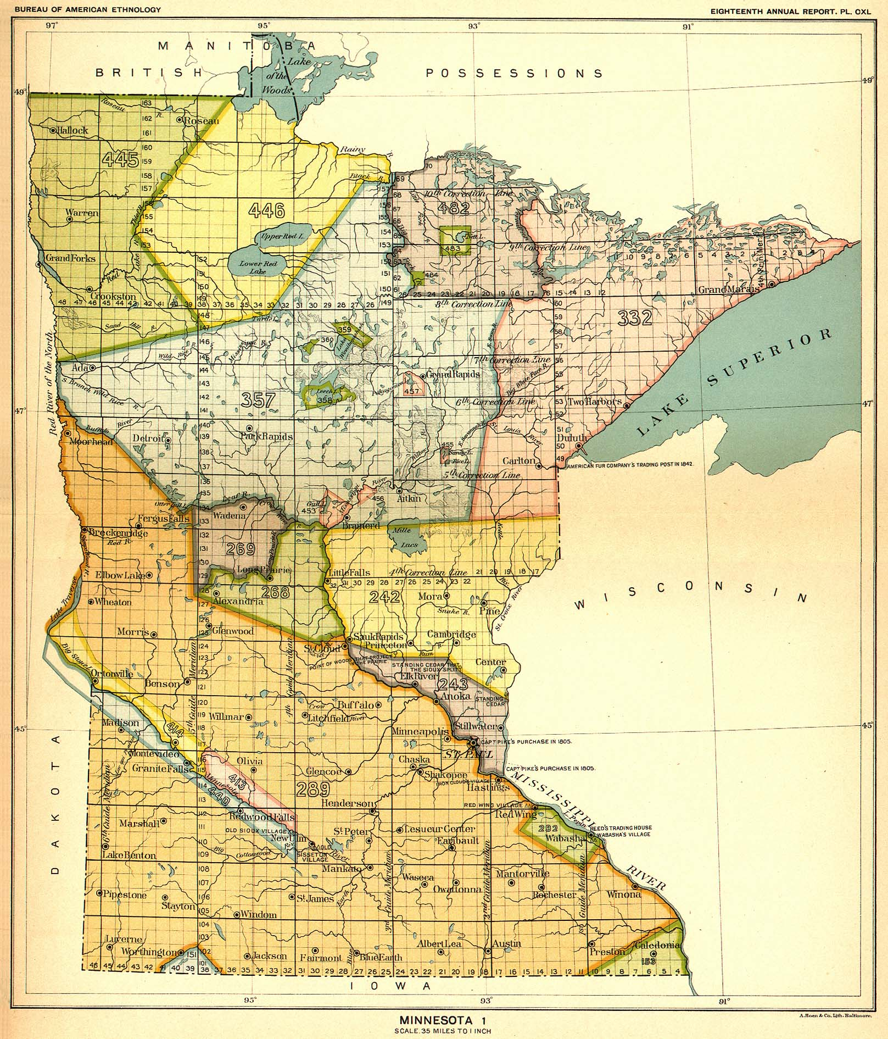
Figure 4. Minnesota Land Sessions

Source: “Minnesota, Map 33,” accessed December 17, 2016, http://usgwarchives.net/maps/cessions/ilcmap33.htm

One can see the placement of the “Half-Breed” Tract in this map of Minnesota created by Charles Royce (See Fig. 4). On the map, Royce designated the number 292 to the tract and it is in the shape of a rectangle. It is located in the lower right-hand corner of the state with the town of Wabasha centered within it.
By reserving land for the mixed-race population of these tribes, it is clear that society considered these people to be their own race. Mixed-race people were neither native tribal members nor white settlers; however, they were their own race formed by the social order of race during the nineteenth-century. Authors such as Theda Perdue have recognized this idea while studying the history of mixed-race people in the South during the 1800s. “Leadership roles increasingly fell to men with white ancestry. Many had skills that changing circumstances demanded. A number of these new ‘mixed-blood’ leaders—but certainly not all—spoke English, and some had received a formal education.” There is no question that mixed-race people were their own unique population. Having cultural ties to two prominent groups of people may open more opportunities for a biracial person, however, in the early nineteenth-century they were considered outcasts. With this conception of race, it may be possible to interpret this decision for the “Half-Breed” Tract ad an attempt by tribal leaders to get rid of their mixed-race population out of fear.
One could consider this so-called “Half-Breed Tract” of Lake Pepin as an attempt to separate the mixed-race people in the Midwest from their racial ancestors. There are several reasons for attempting to segregate this part of land based on racial identity. Perhaps the Dakota—as well as other tribes—were not ready to compete with this new race of people. After all, this population of people had a cultural identity with both white and indigenous people. This could mean that the biracial population was more willing to adapt to Euro-American culture and the idea frightened many tribal elders who were ready to sacrifice their lives in order to save their culture and their land. One could use these ideas to understand the reason for separating these racial groups better. However, it is noticeable when reading the notes from the Treaty council that the “Half-Breed” Tract was the idea of the mixed-race population themselves. Instead of Dakota tribal leaders attempting to “get rid” of their biracial population, there were reasons for biracial people to want their own land.

Lake Pepin “Half-Breed” Tract

Although the “Half-Breed” Tract was an important element of the 1830 Treaty of Prairie du Chien, the land west of Lake Pepin remained largely unoccupied by mixed-race people for about two decades. It remains unclear why the mixed-race population never occupied the tract. In the “Schedule of Indian Land Cessions,” the United States attempts to explain why the mixed-race population never settled on the tract of land that was set aside for them. The document states that, “the half-breeds refused to occupy this tract and the U.S. purchased their claim to it for $150, 00, by the treaty of Aug. 5, 1851.” The land promised to this population of the Dakotas became populated by white settlers who had rushed into Minnesota Territory after the signing of 1851 Treaty of Traverse des Sioux when the United States repurchased the tract. Article Two of this treaty discusses the cession of lands to the US, “the said See-see-toan and Wah-pay-toan band of Dakota or Sioux Indians, agree to cede, and do hereby cede, sell, and relinquish to the United States, all their lands in the State of Iowa; and, also all their lands in the Territory of Minnesota.”
This treaty allowed the US government to “establish roads, military and other posts, within their respective territories.” The Dakota people sold most of their land to the US government in exchange for approximately twelve cents per acre. This land cession was justified by commissioners who believed that the land was necessary to keep up with the amount of people migrating west. Because the Dakota ceded all of their land within the Minnesota Territory to the United States government, the “Half-Breed” Tract was also lost. Traders worked to get their mixed-race relatives a $150,000 cash settlement in exchange for their tract rights, but failed.
In July 1854, Henry Rice, a Minnesota territorial delegate, convinced the U.S. Senate to offer the mixed-race people who had rights to the tract a settlement. Each claimant would receive a scrip of 640 acres of unsurveyed federal land if they gave up their claim to the “Half-Breed” Tract. In 1857, eligible people received these land scrips after they arrived in Minnesota. However, according to Frederick Johnson, “although the sale of scrip was supposedly prohibited, land speculators bought as much of it as they could. Typically, it was cheap.” Settlers even attempted to stop them from claiming their land by placing two armed guards in front of the land office that would keep scrip holders away. Because of this, by 1867, speculators who used them to purchase valuable land in the American West had bought most of the “Half-Breed” scrips.

Franklin Steele and the Fort Snelling Internment Camp

William Millikan discussed the idea of white settlers growing rich by buying or stealing land scrips that had belonged to the mixed-race people of the Dakota nation. Millikan reports on the life of Franklin Steele, the man who the population of Minnesota celebrates as the person who built the towns of St. Anthony and Minneapolis. Steele came from Pennsylvania in 1837 and quickly gained power in the Midwest. Owning half the waterpower at St. Anthony falls, Steele obtained military permission to settle on parts of the Fort Snelling military camp. He was then able to purchase the rest of the camp in 1857 with the help of his friend Henry Rice, who was able to push a bill through the senate to legalize the purchase. The purchase of Fort Snelling began to pay off beautifully as Steele housed 1,000 volunteers of the Union Army at the fort. He received money from the government to pay for having the soldiers. However, this payment was nothing compared to what he received during the US-Dakota War of 1862.
After battles, the US Army captured Dakota prisoners of war who also needed a place to live and Steele offered the Fort Snelling camp to keep them. On November 9, the largest mass execution in US history took place when the government hanged thirty-eight Dakota men for war crimes in Mankato, Minnesota. Another 1,600 women, children, elders, and “friendly” men began their dangerous journey to Steele’s camp. Mixed-race families also joined this group after receiving death threats from Dakota and white settlers. This group of people travelled for six days from the Lower Agency to Fort Snelling under the protection of Lieutenant Coronal William R. Marshall who told the press before leaving the agency that he would risk his life for the men and women he was helping because they were not guilty of any war crimes.
With mixed-race families joining the prisoners, very valuable documents entered the camp. In 1857, each eligible person had received a land scrip representing up to 640 acres of valuable unsurveyed land anywhere in United States territory. Many mixed-race people still had their scrips, as they were unable to use them during wartime. Because he had connections with Henry Rice, Franklin Steele was aware of the arrival of these valuable documents and was ready to take advantage of them.
According to Millikan, Chief Wabasha—the Dakota speaker at the council of the Treaty of Prairie du Chen in 1830—who was, “heavily indebted to local trader, Alexis Bailly, agreed to talk about a land cession only after the United States agreed that the Sioux could ‘give a small piece [of land] to our friends the half breeds.’” The 1830 treaty also gave the president power to assign 640 acres to each eligible mixed-race person. Because Bailly and other traders like him, had mixed-race or Dakota wives, he could potentially obtain thousands of acres of land through this treaty. However, the 1851 Treaty of Traverse des Sioux ceded southern Minnesota from the Dakota nation and refused to pay for the “Half Breed” Tract. In 1854, Henry Rice introduced the idea of issuing land scrips to the mixed-race people and in 1857, they arrived in Wabasha, Red Wing, and other places near the tract where government offices distributed them appropriately.
Publicly, Rice introduced the scrips and claimed that the law protected scrip holders and that no transfer of the scrip to a non-mixed-race person would be valid. However, privately, Rice informed his friends in Minnesota that the scrips would create opportunities for considerable profits. This created the foundations for a large scandal within the West. Many scrip holders would sell them for cash to wealthy men in the Midwest who bought up unsurveyed land in Minnesota. Steele purchased tens of thousands of acres to buy land in areas of Minnesota that were potential spots for railroads or towns. Minnesota businesmen quickly used the scrips to purchase Minnesota land, however purchasers of the scrips also used to them to buy land in the American West. Many mixed-race people incarcerated at Fort Snelling were unaware of the value of their land scrips and sold them for much less than they were worth because they were desperate for money or supplies while at the camp.
Stephen Riggs, a Presbyterian missionary, who lived amongst the Dakota beginning in the year 1837, did not take advantage of the unawareness of the mixed-race people; rather he tried to help them. With the trust of the prisoners at the camp, Riggs took care in purchasing land for the scrip owners so that they could keep the land promised to them by the US government. This frustrated Steele and other businessmen as they attempted to keep buying the land scrips up until the prisoners were moved to Crow Creek Reservation. Steele’s war profits continued to diminish after the banishment of Dakota from Minnesota. However, by the fall of 1863, Steele and his partners Chapman and Welles had collected approximately 15,000 acres of land through the purchase of land scrip.

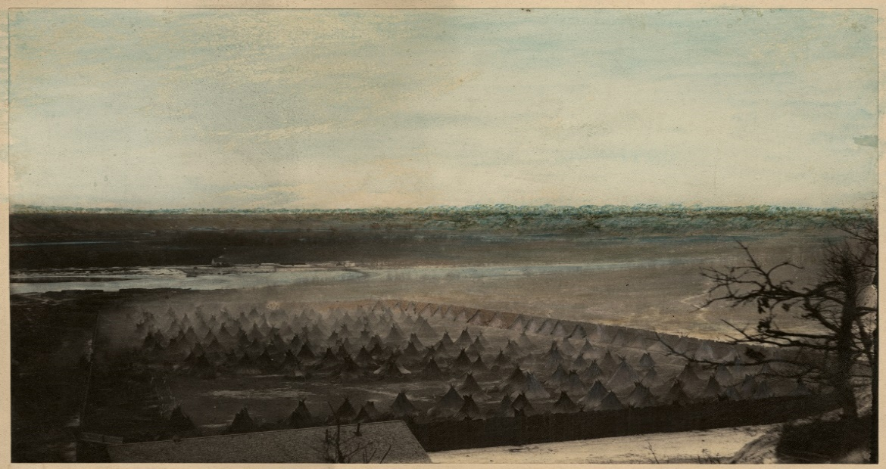
Figure 5. The Dakota Internment Camp at Fort Snelling

Source: “US-Dakota War of 1862,” accessed October 18, 2016, http://www.usdakotawar.org/media-room.

What Steele and his partners paid for these prisoners’ scrips remains unknown. Millikan poses the question of whether or not some prisoners traded their scrip for freedom from Fort Snelling. Although Steele received funds from the U.S. government to keep the prisoners at his camp, it was ravaged with smallpox and the incarcerated faced grotesque living conditions that often resulted in death. A photo of the camp depicts how crowded the area was where hundreds of Dakota prisoners were contained (See Fig. 5). The Dakota spent the Minnesota winter at the camp and it is estimated that up to three-hundred people died over the almost six months of living at the camp. By studying this information about the scrips and the people incarcerated at Fort Snelling, it is easy to believe that there was a scandal taking place at the fort that involved many businessmen such as Stephen Riggs and Henry Rice.
Call for Further Research

It is no doubt that the US-Dakota War of 1862 was devastating for the Dakota people in Minnesota. After the war, the Minnesota government banished tribes who had once called Minnesota their home. The treaties between the US government and the Dakota before the War of 1862 play an enormous role in Minnesota and United States history. It is important that people continue to study these events and documents in order to understand this time in history. It is pertinent for students in Minnesota and surrounding states to learn about the effects of the War and the treaties before it.
Act 31 in Wisconsin requires public schools to teach students about American Indian history. Wisconsin is filled with Native American history and culture that could be taught in classrooms. However, many children and adults within Wisconsin and Minnesota know little to nothing about the history of the Dakota War of 1862 and have absolutely no idea about the horrific abuse Dakota people faced at Fort Snelling. Although the largest mass execution of people took place in Mankato, Minnesota; textbooks in American schools fail to recognize this event.
Because the United States has built itself upon Native American land, it should be more important for teachers to recognize Native American history. Before the arrival of Europeans, tribal groups had already created a complex and massive network of nations and settlements. However, many history books today still depict the settlement of North America as white men “discovering” land that was fresh and unsettled. This land did not need to be discovered, it already was. A few hundred years after Europeans arrived in North America they destroyed many of these settlements and killed thousands of Native American people. Although disease and intertribal warfare contributed to many of these deaths, the US government contributed to the mass killings of tribal members and to the extinction of some tribes because of competition for land.
The United States government relocated many tribes more than once and the process was extremely dangerous for their people. I believe that the United States and the education system have no excuse for teaching false information about Native American people. The US can do better and needs to do better for their citizens. I believe that the place to start is in the education system. Students should learn about the corruption involved with the “Half-Breed” land scrips and how Fort Snelling was once used as a concentration camp. Rather than the people of Minnesota praising Franklin Steele for being the founding father of Minneapolis and St. Anthony, they should recognize him for his mistreatment of incarcerated Dakota people and for stealing millions of acres of land from the mixed-race people at his camp.
Although this information may be shocking to many people who understand a different history of Minnesota and the men who settled it, they deserve to know the truth. This information may change perspectives of historians who study the settlement of Minnesota and the American West. Much of Minnesota was settled with the use of corruption. Henry Rice took advantage of his position as a United States Senator in order to supply his friends with land scrips so they could purchase unsettled land in the American West cheaply. This caused men such as Franklin Steele to grow rich and powerful off of the pain of mixed-race Dakota people. There is nothing noble about the actions of Franklin Steele, or the other men who took advantage of the land scrips. This is a story of the American West that should be included in textbooks.

Conclusion

For white, wealthy men such as Franklin Steele, the prospect of the American West was a dream. After moving from Pennsylvania, and in just a few short years, he gathered tremendous wealth. After purchasing Fort Snelling, he was able to quarter soldiers during the American Civil War and house prisoners during the US-Dakota War of 1862. He quickly became one of the wealthiest men in Minnesota and has a legacy that lasts to the 21st century. However, the idea for a Dakota man was quite the opposite.
Dakota men, women, and children faced harsh discrimination during and after the year of 1862 and were removed from Minnesota completely in 1863. In a few short years, the Dakota nation went from owning lands from western Wisconsin to modern-day North and South Dakota to owning no land in Wisconsin and Minnesota and being banished to reservations in the Dakotas. The story of European settlement in Minnesota was extremely different for tribes who had once called Minnesota their home than the Europeans who were acquiring the lands.
The story of the “Half-Breed” Tract is a prime example of this difference. Once the United States began their attempt in ending intertribal warfare between tribes of the Midwest, these tribes began losing their land. The 1825 Treaty of Prairie du Chien caused these tribes to set up land boundaries with the idea that they would halt warfare. With these boundaries set, government officials and land speculators knew exactly what land was reserved for specific groups of people. As predicted, these land boundaries did almost nothing to stop the warfare that had been taking place. As tensions rose, Indian Agents and President Andrew Jackson decided to write a new treaty, this time going as far as to threaten tribes who continued to fight with one other. In addition to this threat, they also ceded land from several tribes and created neutral ground where European settlers and other tribes could hunt.
The Dakota speaker Wabasha negotiated with the government officials in order to set up a tract of land reserved for the mixed-race population of their tribe. However, this was not a pure decision based on the good of the mixed-race population. Rather it was an opportunity for a man to profit from the lands as he had married mixed-race or Dakota women. This trend of greed and desire for land continued into the mid-19th century when US government ceded thousands of acres of land from the Dakota nation in the Treaty of Traverse de Sioux in 1851. This treaty gave the United States most of southern Minnesota and European settlers began settling on the “Half-Breed” Tract.
In 1854, Henry Rice convinced the Senate to approve giving land scrips for the tract rather than continuing to reserve the land for mixed-race Dakota people. This idea was also presented out of greed and desire for land, which contributed to white settlers benefiting from the scrips by manipulating the population to sell them for very low costs. Franklin Steele benefitted greatly from these land scrips because of his position as the owner of Fort Snelling and became one of the leading frontiersmen in the American West.
It is important that the history of Minnesota is rewritten to include the stories of the mixed-race people who lost their lives and their land out of the greed of European settlers. The concept of race during the nineteenth century contributed to the racial tension between tribal groups and European settlers during the settlement of Minnesota. This commonplace of greed and desire for land was the foundation of the American West and it should not be ignored in the writing of its history.

Works Cited

Primary Documents:
Clark, William. Documents Relating to the Negotiation of Ratified and Unratified Treaties with Various Tribes of Indians, 1801-69. Washington: Government Publications Department, year. Reel 494, roll 1, frames 723-729. Microfilm. Accessed December 12, 2016, University of Wisconsin-Eau Claire McIntyre Library.
Forsyth, Thomas. Letters Received by the Office of Indian Affairs, 1824-1880. Washington: National Archives and Records Service, 1966, reel 696, frame 21-22. Microfilm. Accessed on October 11, 2016, University of Wisconsin-Eau Claire.
Kappler, Charles J., Treaty with the Sioux, etc., 1825, vol. 2, Treaties. Government Printing Office, 1904: 250. Accessed December 12, 2016. http://digital.library.okstate.edu/Kappler/vol2/treaties/sio0250.htm.
_______, Treaty with the Sauk and Foxes, etc., 1830, vol. 2, Treaties. Government Printing Office, 1904: 306, accessed December 12, 2016, http://digital.library.okstate.edu/kappler/Vol2/treaties/sau0305.htm.
_______, Treaty of Fort Laramie with Sioux, etc., 1851, vol. 2, Treaties. Government Printing Office, 1904: 594. Accessed December 12, 2016, http://digital.library.okstate.edu/kappler/Vol2/treaties/sau0305.htm.
Riggs, Stephen. Mary and I: Forty Years with the Sioux. Minneapolis: Ross and Haines, Inc., 1969.

Secondary Documents:
American Memory. “A Century of Lawmaking for a New Nation: U.S. Congressional Documents and Debates, 1774-1875.” U.S. Serial Set, Number 4015, 56th Congress, 1st Session, Page 727 and 728. Accessed December 12, 2016. http://memory.loc.gov:8081/cgibin/ampage?collId=llss&fileName=4000/4015/llss4015.db&recNum=168.
Clayton Anderson, Gary. Little Crow: Spokesman for the Sioux. St. Paul, Minnesota: Minnesota Historical Society Press, 1986.
Fiske, Frank. The Taming of the Sioux. Bismark, ND: Frank Fiske, 1917.
Johnson, Frederick. “’Half-Breed Tract’ and Scrip.” MNopedia (January 2016). Accessed October 16, 2016. http://www.mnopedia.org/event/half-breed-tract-and-scrip.
Michigan In Brief, “About Michigan: 1761-1836,” Michigan In Brief (April 2002): 2, accessed December 16, 2016, http://www.michiganinbrief.org/edition07/Chapter1/Chapter1.htm.
Millikan, William. “The Great Treasure of the Fort Snelling Prison Camp.” Minnesota Historical Society (Spring 2010). Accessed October 9, 2016. http://collections.mnhs.org/MNHistoryMagazine/articles/62/v62i01p004-017.pdf.
MNopedia. “Forced Marches and Imprisonment.” Minnesota Historical Society. Accessed October 10, 2016. http://usdakotawar.org/history/aftermath/forced-marches-imprisonment.
Perdue, Theda. “Mixed-Blood” Indians: Racial Construction in the Early South. Atlanta: The University of Georgia Press, 2005.
Peterson, Teresa and Walter LaBattle, “The Land, Water, and Language of Minnesota’s First People,” MNopedia (April 2016), accessed October 12, 2016, http://www.mnopedia.org/land-water-and-language-minnesota-s-first-people.
Susan Sleeper-Smith. Indian Women and French Men: Rethinking Cultural Encounter in the Western Great Lakes. Amherst, MA: University of Massachusetts Press, 2001.
Treaties Matter. “Relations: Dakota and Ojibwe Treaties,” Minnesota Humanities Center accessed October 20, 2016, http://treatiesmatter.org/treaties/land/1825-1830-Multinational.
Wingerd, Mary Lethert. North Country: The Making of Minnesota. Minneapolis, Minnesota: University of Minnesota Press, 2010.
Wisconsin Historical Society. “Lead Mining in Southwestern Wisconsin.” Turning Points in Wisconsin History. Accessed December 13, 2016, http://www.wisconsinhistory.org/turningpoints/tp-026/?action=more_essay.

Gary Clayton Anderson, Little Crow: Spokesman for the Sioux (St. Paul, Minnesota: Minnesota Historical Society Press, 1986), 9.
Mary Lethert Wingerd, North Country: The Making of Minnesota (Minneapolis, Minnesota: University of Minnesota Press, 2010), 126.
Wisconsin Historical Society, “Lead Mining in Southwestern Wisconsin,” Turning Points in Wisconsin History, accessed December 13, 2016, http://www.wisconsinhistory.org/turningpoints/tp-026/?action=more_essay.
Michigan In Brief, “About Michigan: 1761-1836,” Michigan In Brief (April 2002): 2, accessed December 16, 2016, http://www.michiganinbrief.org/edition07/Chapter1/Chapter1.htm.
Frederick Johnson, “’Half-Breed Tract’ and Scrip,” MNopedia (January 2016), accessed October 16, 2016. http://www.mnopedia.org/event/half-breed-tract-and-scrip.
Thomas Forsyth, Letters Received by the Office of Indian Affairs, 1824-1880 (Washington: National Archives and Records Service, 1966), reel 696, frame 21. Microfilm. Accessed on October 11, 2016, University of Wisconsin-Eau Claire.
Frank Fiske, The Taming of the Sioux (Bismark, ND: Frank Fiske, 1917), 32.
William Clark, Documents Relating to the Negotiation of Ratified and Unratified Treaties with Various Tribes of Indians, 1801-69, (Washington: Government Publications Department, year), reel 494, roll 1, frames 0723. Microfilm. Accessed December 12, 2016, University of Wisconsin-Eau Claire McIntyre Library.
Theda Perdue, “Mixed-Blood” Indians: Racial Construction in the Early South (Atlanta: The University of Georgia Press, 2005), 70.
Perdue, “Mixed-Blood” Indians, 71.
Susan Sleeper-Smith, Indian Women and French Men: Rethinking Cultural Encounter in the Western Great Lakes (Amherst, MA: University of Massachusetts Press, 2001), 5.
Anderson, Little Crow, 41.
Charles J. Kappler, Treaty with the Sioux, etc., 1825, vol. 2, Treaties. Government Printing Office, 1904: 250, accessed December 12, 2016, http://digital.library.okstate.edu/Kappler/vol2/treaties/sio0250.htm.
Kappler, Treaty with the Sioux, 250.
Teresa Peterson and Walter LaBattle, “The Land, Water, and Language of Minnesota’s First People,” MNopedia (April 2016), accessed October 12, 2016, http://www.mnopedia.org/land-water-and-language-minnesota-s-first-people.
Treaties Matter, “Relations: Dakota and Ojibwe Treaties,” Minnesota Humanities Center, accessed October 20, 2016, http://treatiesmatter.org/treaties/land/1825-1830-Multinational.
Treaties Matter, “Relations.”
Ibid.
Clark, Documents Relating to the Negotiation of Ratified and Unratified Treaties with Various Tribes of Indians, 723.
Ibid, 724.
Clark, Documents Relating to the Negotiation of Ratified and Unratified Treaties with Various Tribes of Indians, 0728.
Ibid, 728.
Ibid, 729.
Charles J. Kappler, Treaty with the Sauk and Foxes, etc, 1830, vol. 2, Treaties. Government Printing Office, 1904: 306, accessed December 12, 2016, http://digital.library.okstate.edu/kappler/Vol2/treaties/sau0305.htm.
Kappler, Treaty with the Sauk and Foxes, 307.
Theda Perdue, “Mixed-Blood” Indians, 45.
Frederick Johnson, “’Half-Breed Tract’ and Scrip.”
American Memory, “A Century of Lawmaking for a New Nation: U.S. Congressional Documents and Debates, 1774-1875. U.S. Serial Set, Number 4015, 56th Congress, 1st Session, Pages 727 and 727, accessed December 12, 2016, http://memory.loc.gov:8081/cgibin/ampage?collId=llss&fileName=4000/4015/llss4015.db&recNum=168.
Charles J. Kappler, Treaty of Fort Laramie with Sioux, etc., 1851, vol. 2, Treaties. Government Printing Office, 1904: 594, accessed December 12, 2016, http://digital.library.okstate.edu/kappler/Vol2/treaties/sau0305.htm.
Treaties Matter, “Relations: Dakota and Ojibwe Treaties.”
Frederick Johnson. “’Half-Breed Tract’ and Scrip.”
Ibid.
Ibid.
William Millikan, “The Great Treasure of the Fort Snelling Prison Camp,” Minnesota Historical Society (Spring 2010), accessed October 9, 2016. http://collections.mnhs.org/MNHistoryMagazine/articles/62/v62i01p004-017.pdf.
MNopedia. “Forced Marches and Imprisonment.” Minnesota Historical Society. Accessed October 10, 2016. http://usdakotawar.org/history/aftermath/forced-marches-imprisonment.
Frederick Johnson, “‘Half-Breed Tract’ and Scrip.”
William Millikan, “The Great Treasure of the Fort Snelling Prison Camp,” 8.
William Millikan, “The Great Treasure of the Fort Snelling Prison Camp,” 9.
Stephen Riggs, Mary and I: Forty Years with the Sioux (Minneapolis: Ross and Haines, Inc., 1969), xxxviii.
MNopedia. “Forced Marches and Imprisonment.”

