Department of History
University of Wisconsin—Eau Claire

The Birth of American Football, the Death Sentence to Rugby in America

By:

Jeremy Swick

History 489
Research Capstone
Professor: Dr. Oscar Chamberlain
Cooperating Professor: Dr. Louisa Rice

Copyright for this work is owned by the author. This digital version is published by McIntyre Library, University of Wisconsin Eau Claire with the consent of the author.

Table of Contents
Table of Contents….………………………………………………………………………………1
Abstract……………………………………………………………………………………………2
Introduction and Historiography…………………………………………………………………..3
Origin of Rugby…………………………………………………………………………………...9
Rugby Comes to the United States………………………………………………………………11
Football Equipment………………………………………………………………………………13
Early Football and Rugby Rules…………………………………………………………………14
The Violence……………………………………………………………………………………..15
Theodore Roosevelt: Football’s Unlikely Savior………………………………………………..17
American Football Rule Changes………………………………………………………………..18
Rugby Rule Changes – Post 1874………………………………………………………………..23
Rugby in the West………………………………………………………………………………..26
Rise of Rugby in the West……………………………………………………………………….28
Rugby Decline in the West………………………………………………………………………33
Football, America’s Emerging Pastime.…………...……...………………..................................35
Rugby in the Olympics…………………………………………………………………………..36
Conclusion ……………………………………………………………...……………………….38
Appendices………………………………………………………………………………………40
Annotated Bibliography…………………………………………………………………………42

Abstract
This research attempts to discover why American football took a prominent hold in the United States and rugby did not. American football rose in popularity while rugby never was able to grasp a lasting stronghold on the United States not due to one specific event but to a multitude of different factors. Early rugby was considered too dangerous to be played, the rules were changed thus giving birth to American football. Rugby in Europe also made changes to adopt a more acceptable game. Once these early rules were changed football in America began to rise in popularity, the Eastern and Midwestern parts of the United States opted to adopt American football. Not satisfied with these rules changes the Western parts of the United States opted to adopt the English rugby style of play, as the early rugby game had been reformed in Europe as well. Despite initial success in the West, it was clear the United States was not on the same playing field in rugby as the rest of the world. Many saw football as America’s emerging pastime and believed all of the United States should play the same contact sport. The final death sentence for rugby in the United States was the 1924 Olympics. Despite the United States defeating the host nation France the aftermath following the gold medal game sealed the fate for rugby in America in the 20th century.

Introduction and Historiography
American football has become one of the most popular sports in American culture, but how did a sport directly descended from English rugby become distinctly American? The reason American football rose in popularity while rugby was never able to grasp a permanent stronghold on the United States was not because of one single event but multiple events that were interwoven. To answer this question it must be approached from multiple facets which need to be investigated. The first is that although football stemmed from rugby it became a unique game. The early style of rugby football was nearly banned for its violence in the United States, the rules were restructured in a way that crated a new game which would be known as American football. Second, American football became possible and more popular, in part from President Theodore Roosevelt. Roosevelt helped American football transform and grow in the Midwest and on the East Coast. Third, on the West Coast, many college officials were not satisfied with the rule changes that Roosevelt had helped enact and opted to adopt the reformed English version of rugby. Initially Western teams flourished and even began to play rugby internationally against top teams such as Australia and the New Zealand All Blacks. However, as great as the initial success was it was short lived as teams in the West scheduled opponents that were too skilled and many began to believe that the United States could never compete with the international teams in rugby. At the same time the teams on the West Coast were no longer relevant in American football and this posed a problem as football was emerging as America’s new pastime. Finally, the death sentence for rugby in the United States was the 1924 Olympics and the aftermath that followed.
There is a large amount of secondary literature on the history of American football. The historiography of the creation of American football dates back to the 1950s making it nearly sixty years old. The initial secondary literature was produced by pioneering players of American football who later became historians of the game. One of the most prominent early histories on the beginnings of American football was created by Alexander Weyand who was the captain of the West Point football team in 1915. This monograph chronicles football’s mediocre rise beginning in the early 1870s. Although this early rugby version of football did not appear similar to American football as it is known today it is an important stepping stone in the sports long and turbulent history. With this being one of the first books to critically look at the rise of American football it is considered a classic work on the history of football in America.
There are multiple sources of secondary literature regarding the idea of early rugby being far too dangerous to be played. The first book is John J. Miller’s The Big Scrum: How Teddy Roosevelt Saved Football, which analyzes how Theodore Roosevelt saved football from being completely eliminated because of its perceived violence and the crucial role he played in making sure the game would continue despite its many criticisms. This book is considered to be groundbreaking as it highlights and focuses on the role that president Theodore Roosevelt had. It discusses how Roosevelt brought together top officials from many of the top colligate football programs and worked with them to create rule changes that would make the game safer for young men to play. The primary documents that were utilized throughout this book were newspapers especially the New York Times, and varying historical papers from men such as Woodrow Wilson, Walter Camp, and Theodore Roosevelt. This book also gives a detailed history to how football was perceived leading up the change in rules and how Roosevelt was instrumental in keeping the game alive in its infancy.
Another important book is Allison Danzig’s The History of American Football which looks at the history of early football in America and how it came to the United States. It focuses on some of the pivotal people who helped move the game forward, including pioneers such as Walter Camp, Fielding Yost, Alonzo Stagg and Knute Rockne. By examining the contributions that these important pioneers made to the game of football helps demonstrate how football had the support of influential people within the American athletic community. This book used multiple primary documents in order to convey its message which included newspapers, NCAA Rulebooks, historical papers from Harvard, Walter Camp, Fielding Yost, Alonzo Stagg, and Knute Rockne. This account of early football and its rise was printed in the early 1950s and is one of the earliest studies of the subject. With football beginning to take root in the United States it became more popular in American culture.
Another pivotal secondary source was Alexander Weyand’s 1955; The Saga of American Football. The central argument of this book is that after the rule changes in 1905 football began to radically shift away from the early rugby style of play. These new rules were completely revolutionary and distinctly created a new, truly Americanized sport. Based on those rule changes it allowed teams to begin to implement the forward pass. It discusses Notre Dame’s popularization of the forward pass which made it a powerhouse in early college football. Another important issue the book discusses is the fact that football which started in the East, spread to the Midwest and teams began to play each other under the new rules. Many did not consider football in the Midwest on the same level as Eastern football. This began to change when these teams began to compete against each other. The Hawkeyes of Iowa defeated the Fighting Irish of Notre Dame with a score of ten to seven. This book demonstrated that since Midwestern and Eastern teams began to play each other there was little attempt to try to convert the West to stop play under the English rugby rules.
Another important book that investigates the popularity of the American football is Good Clean Violence: A History of College Football by Ivan N. Kaye. It examines not only the infancy of football but also the rise of football in the West. Football already maintained popularity in the Eastern and Midwestern parts of the United States. As rugby in the West was beginning to die out in the second decade of the 20th century football was ready to take its place as the focal physical sport that would be played on college campuses. It discusses how former rugby powerhouses in the West such as Stanford and the University of California Berkeley were able to pick up playing football rather quickly. This monograph helps to uncover how football was able to be adapted rather seamlessly in the West when rugby had been played for an extended period of time. Since many of the rules were similar to football teams like Berkeley’s Gold Bears were able to excel. Part of this success was due to West Coast teams initially inviting weaker opponents to play their schools in football during the 1910s. Upon major victories over the Eastern teams it began to build teams like Stanford, Oregon and Berkeley’s confidence. In 1920 the tide truly began to shift to demonstrate what the West Coast was there to stay on the gridiron. Teams from the West began to beat teams that many skeptics thought were superior East coast teams. This helps strengthen the argument that the West Coast was able to adapt to playing football despite playing rugby because they started at reasonable pace. Rather than inviting international teams such as the New Zealand All-Blacks as the early rugby teams did, the football teams first invited teams that were beatable helping to bolster the new football programs confidence. With many of these victories in American football men started seeing themselves in a new light. American football provided some factor that rugby simply did not.
Alan Bairner’s Sports, Nationalism, and Globalization: European and North American Perspectives as it examines American football and its role in becoming a national pastime. Football possessed something distinctly unique, it may have been born out of English rugby but following the rule changes pushed by President Roosevelt it became a sport that was distinct to America. It was a sport built to entertain and excite fans in the United States. This helps to argue the idea that American football helped create a new national pastime, much as baseball had done in previous decades. This was only furthered by the United States competing in the Olympic Games and the fall out following the victory.
The final secondary source looks at rugby and its role in the Olympics. In comparing the rise of football there is a plethora of secondary literature on football’s birth from rugby but not a vast amount of literature on rugby itself in the United States. Mark Jenkins’ article “An American Coup in Paris”, argues that despite the United States being able to field a rugby team in time for the 1924 Olympics it still would be the end of rugby in the United States. He argues that even though the United States was able to upset the heavily favored French seventeen to three it did little to change the outlook of rugby in America. Due to the lack of interest by the international rugby community and little coverage of the Olympics during 1924 even the United States winning the gold medal against host country France did not improve the outlook for rugby in America. This article is strengthened by its use of interviewing players such as Norman Cleaveland who was a Stanford All-American halfback in the 1920s and part of the 1924 United States Olympic team. The article also mentions the use of media affecting rugby’s future in America which is supported by another article regarding rugby and the Olympic Games.
The article by Mark Dyson, “Scripting the American Olympic Story-Telling Formula.” discusses the main beliefs Americans had about the Olympics in the 1920s. It argues that the media made American athletes into protagonists whose struggle was to win Olympic medals over other nations, often rather than the sports themselves. Other countries were often portrayed as villains against the United States trying to vanquish them from their disserving glory. An example of this idea in particular which builds to the argument is after the United States beat France in the championship game the French reacted poorly by booing and making insults during the Star Spangled Banner. American newspapers began to commend the American rugby team for its actions and behaviors during the outburst by unruly fans. French newspapers also negatively portrayed the American rugby players causing the desire for Americans to harness a game of their own rather than play a European sport.
In summary, the central ideas of the existing secondary literature sources on the topic argues that once football’s rules were changed to make it less like rugby and more like modern football it allowed the sport to become distinctly American. The goal of this was to make the game safer for the young men to play. It allowed for the game to become unique and gain the attention and support of the American people. Teams from the East, Midwest and eventually the West began to compete and play each other. This made it a nationwide game that created dynamic rivalries that captured the attention of the country. Rugby became a fleeting memory following the dismissal of it as an Olympic sport following 1924. These arguments have been made before, however, not in combination with each other. Each of the arguments and events are separate strains of a bigger picture that fits together as a jigsaw puzzle which has not been put together. This research will contribute to the existing historiography of the issue of the rise of football being the death sentence to rugby in America by looking at these separate events as one and the role they played in changing American sport culture.
Origin of Rugby
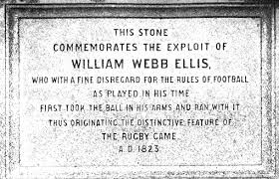
For thousands of years, different variations of what is known in the United States as soccer has been played all over the world. Although the exact year these games began to be played is unknown the game known as rugby has a concrete origin. It was 1823, at the now famous Rugby School in the town of Rugby in Warwickshire, England the sport was born. Similar to schools across England, soccer or as it was called association football, was played using the foot and running with the in hand ball was prohibited. At Rugby School all games were required to end at the stroke of the five o’clock bell. A student by the name of William Webb Ellis received the ball which had been kicked by the opposing team. Instead of kicking the ball for a free kick as was tradition, Ellis tucked the ball under his arm and ran for the score to beat the last ring of the bell. The others players on the field were astonished and confused at his disregard for the traditional rules. Eventually his peers realized that Ellis had developed something revolutionary and contrary to the established order of how most ball games were typically played during this period of time. Thus the game of rugby was born. Still to this day at Rugby School a plaque remains to honor William Webb Ellis and the founder of rugby. In December 1862 the London Football Association was created by clubs playing association football. Not more than ten years later in January, 1871 rugby players formed their own governing body known as the Rugby Football Union. Thus creating a body of government developed from a school yard game, which would eventually become an internationally renowned sport. However, rugby was still in its infancy and was yet to face its own set of trials and tribulations. As rugby grew in popularity and tradition it migrated with British colonists to the seaside providences of Canada and began to expand west.
Figure 1. William Webb Ellis plaque at Rugby School in Warwickshire, England.

Source: http://www.wesclark.com/rrr/wwe_marker.jpg

Rugby Comes to the United States
In 1827, at Harvard the sophomore-freshman game which was a nothing more than a rush between the classes had developed into a well-established tradition. The first Monday of the fall semester when the classes usually clashed was known as “Bloody Monday.” Bloody Monday was a battle between the freshmen and sophomore classes. Although all four classes participated, the seniors siding with the sophomores and juniors siding with the freshmen. The opposing sides met on what was known as the “Delta”, now Memorial Hall, in fa pseudo scrimmage where the opposing teams would stop at nothing in order to tackle the opposing side using any means necessary. John L. Sibley, the longtime librarian at Harvard described Bloody Monday as, “the ball is thrown down among [the players] and the object of each class is to kick the other and bark their shins as much as a possible.” Many of the students took a great enjoyment in competing in the violent confrontation. One student wrote a poem of the events of the melee that annually occurred on the Delta, “Of the shins we’ve cracked, And noses we’ve whacked, And the eyeballs we’ve blackened’ And all in fun!”
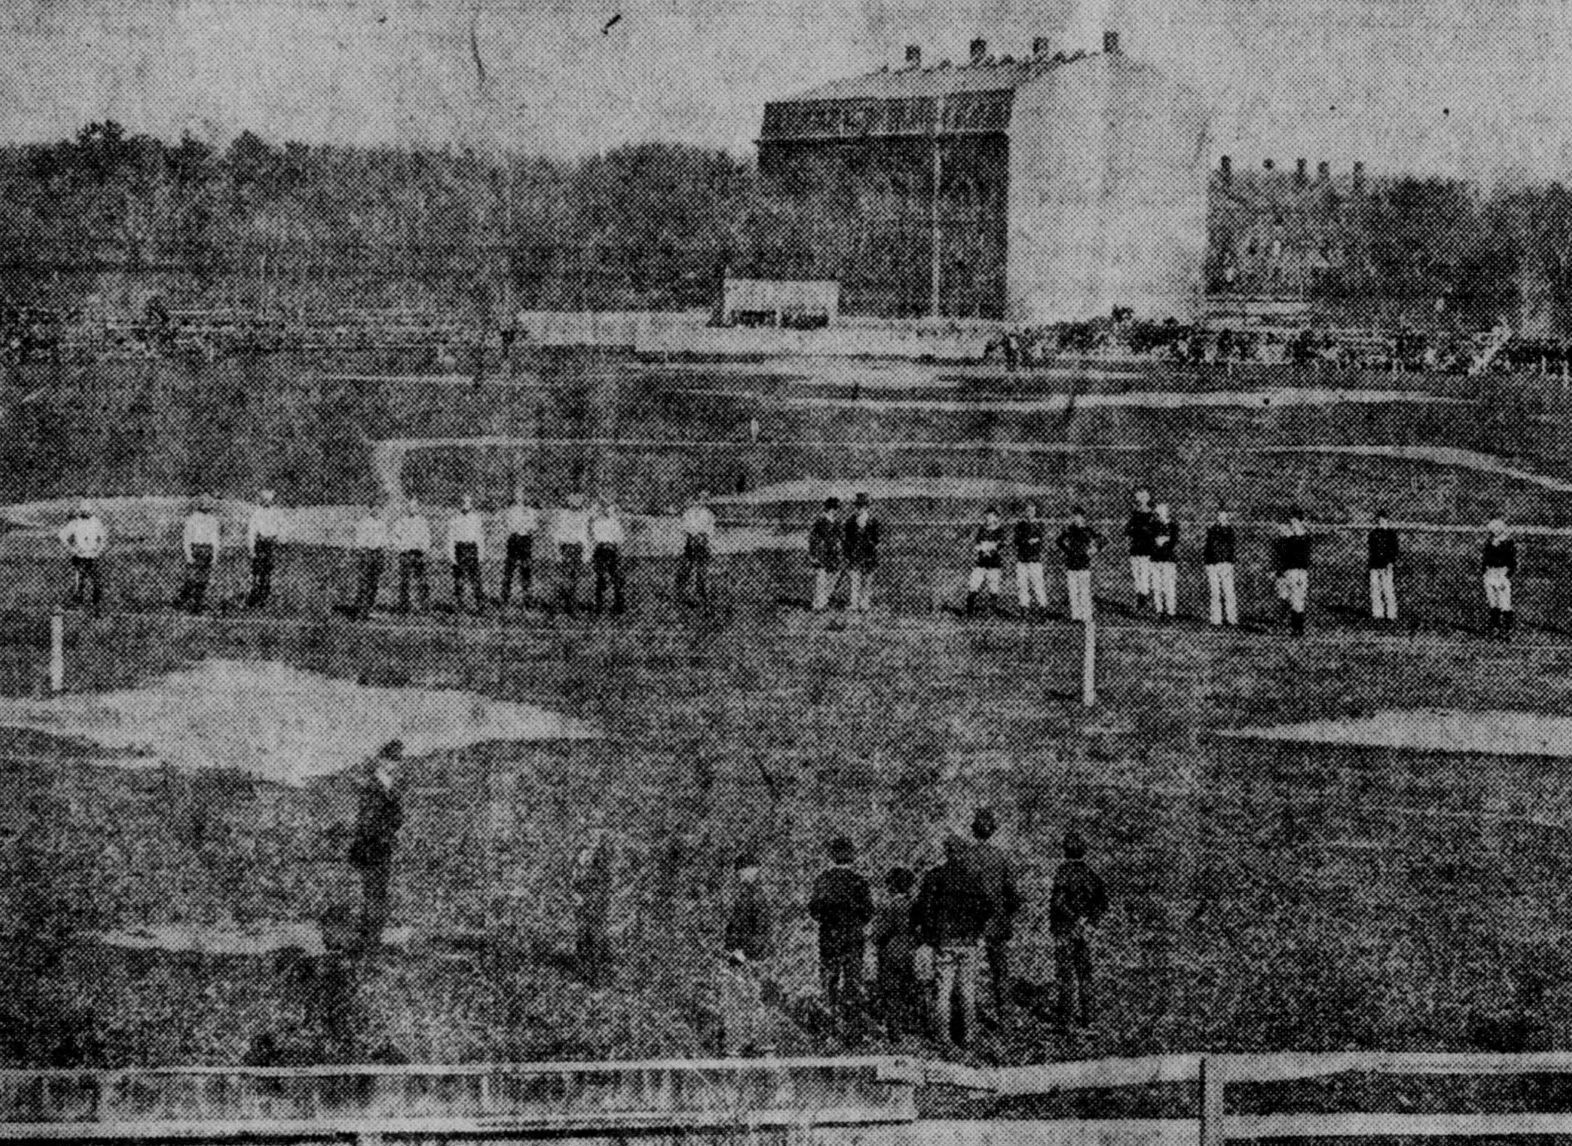
This “game” the students referred to was abolished in 1860 by faculty citing the excessive amounts of violence and brutality. The same year a boy by the name Gerrit Smith “Gat” Miller attended Epes Sargent Dixwell’s Private Latin School and began playing a game with sixteen on a side and distinctive enough from the traditional game of soccer to give it the name the “Boston Game”. One of the most distinct rules of the Boston Game was that a player could run with the ball as long as they were being pursued by an opponent. As this game was created in the secondary level of schooling it was only a matter of time before it leaked on the college campus. On April 12th, 1872 the freshmen and sophomores met in an organized game, using the Boston Game rules, different than the Bloody Monday games of the past. By December of that year the Harvard Football Club was created. This to the first intercollegiate game on May 14th, 1874 between Harvard and McGill University of Canada. The first match between the two teams was played under Boston Game rules and Harvard won easily. The second match the two schools played resulted in a tie under McGill’s Canadian Rugby rules, which uniquely allowed the players to run with ball regardless if they were being chased by an opponent. This game marked the first intercollegiate game of rugby played in the United States. From that point on the game that would eventually be known as American football took its basis in the fast paced movement of running with the ball as in rugby rather than kicking it with the feet as association football. Although early rugby football and English rugby were closely related they began to drift away from each other. Equipment and rules began to be unique to their given sport.
Figure 2. First Rugby Football Match - March 14th, 1874 Game Harvard vs. McGill University

Source: Boston Sunday Post, May 17, 1914.

Football Equipment
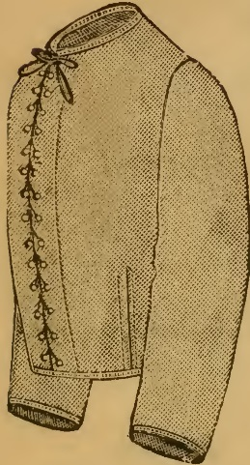
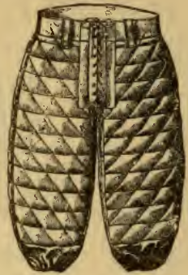
In order to understand how monumental of a shift early rugby football and what would be known today as American football had it is vital to first understand the rules, regulation and gear that were incorporated in the game. Rugby football as it was played in the late 1870s to early 1900s was much different than the game that is known as American football today. An early feature of rugby football was the incorporation of innovative protective gear. Jackets which appeared in rulebooks as early as 1888 were made of a canvas material that was meant to be durable and last throughout a season. Pants were also designed to give players added comfort and most importantly more protection while competing on the gridiron. This is one of the earliest examples where American football and rugby began to split into two separate sports. Another example of this can be found in the protective head gear that became standard in football. The two most notable forms of protective head gear were a padded helmet that protected the ears and skull, the second was a nose protector to keep the participant from receiving direct hits to the nose.
Figure 5. Early football protective helmet.
Figure 6. Early football protective nose guard.
Source: Nose guard and helmet – Spalding’s Official Football Guide 1899, 212 – 213.
Figure 3. Early football protective jersey.
Figure 4. Early football protective pants.
Source: Jersey - 1888 Foot-Ball Rules and Referee’s Book, 29. Pants – Spalding’s Official Football Guide 1899, 214.
Early Football and Rugby Rules
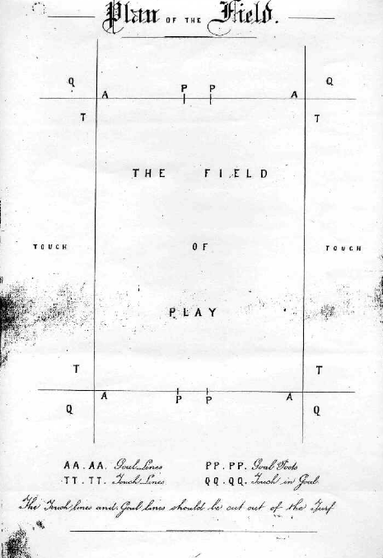
Early football evolved from rugby and other games such as the Boston Game, as early as the 1880s rules began to be organized to allow intercollegiate teams to be able to play each other. A majority of the laws and rules were directly taken from previous rugby rules, making them dangerous. One of the more distinguishable differences from rugby and early football was the number of players who were on the field. In rugby, fifteen to twenty men played on each side in a game. Rather in early football the number was reduced the eleven men on the field. The size of the early football fields were 330 feet in length and 160 feet in width. Two goal posts would be erected on each goal line which were 18½ feet in height. The “In Touch” line marked where the ball or player with the ball would be marked out of bounds. The dimension and size of the fields were similar to rugby fields of this time. Throughout both rugby and football’s history the scoring has been continually changed over the years, often from one year to the next and is too difficult to break down on a year by year statistic.
Figure 8. Early rugby field.

Source: http://www.rugbyfootballhistory.com/resources/Laws/Full/1871laws.pdf

Figure 7. Early football field.

Source: 1888 Foot-Ball Rules and Referee’s Book, 2.
There was also no permanent set positions at this time in either sport, often causing mob like play, leading to dangerous outcomes. The fact that early rugby and early rugby football were nearly identical meant American teams adopted many of the early rugby rules. They also supplemented rules from games such as the Boston Game and with the memory of Bloody Mondays of the past it created a cesspool for violence in sport in the United States.
The Violence
From the beginning of the inclusion of rugby football as part of collegiate life an important question arose, was the game too dangerous for young college males to play? Reports throughout the country of healthy young men being killed while playing college rugby football or dying shortly after their arrival to the hospital from their injuries became widespread. This increase in fatalities caused many schools to call for the banning of college football unless the rules were modified in a way that was safer for the players to play the game. The uproar caused many top football schools to suspend their football programs.
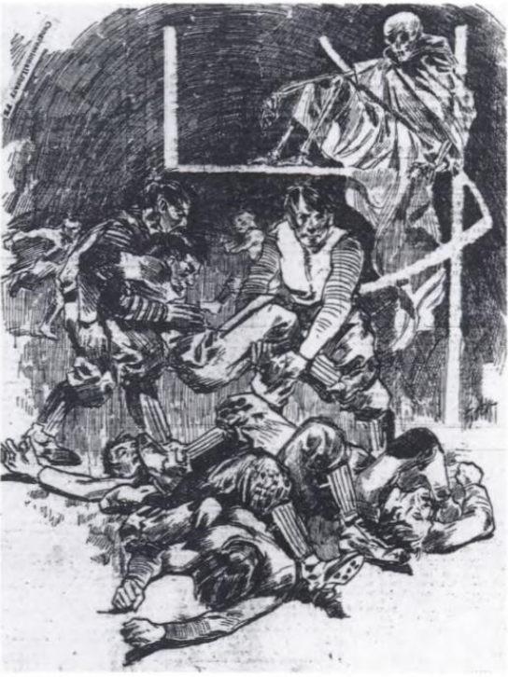
From 1900 to 1905 there were a reportedly forty five deaths from football related injuries. In 1905 alone, nineteen of those deaths occurred by October. On October 4th of that year, Garfield Weede, a college player for the University of Pennsylvania was tackled so hard while running, his leg was brutally broken. In another case, Howard C. Montgomery, a player at Hampden-Sidney College was injured while playing in a practice game as his team prepared to play Virginia Military Institute. He died at the age of twenty one from a broken neck after he was unsuccessfully operated on. Shortly after this the Hampden-Sidney College decided to make the movement to disband as a team citing, “the sad death of young Montgomery, who was injured on the football field, was the cause of this movement.”
Figure 9. Grim reaper atop the goal post.

Source: College Football: History, Spectacle, Controversy, 98.
Reports of death ran rampant throughout the country due to football related fatalities. In 1905, Columbia’s Committee on Student Organizations passed resolutions to abolish football at the university, stating that the “Game is dangerous to human life.” This decision came after another death from football came from a youth who was killed playing in Sedalia, Missouri. The image on the right displays the abundant anti-football sentiment that was present during this tumultuous era. It pictures the grim reaper, the bringer of death, perched calmly on top of a football goal post as if waiting to claim its next victim.
Theodore Roosevelt: Football’s Unlikely Savior
One of the most influential in insuring football survived but transformed in the United States was President Theodore Roosevelt. As a young child Roosevelt was habitually unhealthy, whether it be colds, fevers, or coughs. Despite these ailments Roosevelt loved the outdoors and enjoyed playing and running outside. Roosevelt began making daily visits to Wood’s Gymnasium a prominent gym close to his house. The owner of the gym John Wood had worked with some of New York’s most prestigious families as well as athletes from Columbia. This lit the fire for Roosevelt’s desire to be physically fit well into his adult life. He picked up the sport of boxing, learning how to work the ring. Once admitted to Harvard, Roosevelt became a nearly instant supporter of Harvard’s football team. He recalled his first game as a freshman against Yale despite Yale winning the contest he relished the passion the Harvard fans had.
During the summer of 1905, Roosevelt had one his most prominent roles as a negotiator in his presidency. Roosevelt had negotiated and mediated a peace accords between two of the most powerful countries in the world, Japan and Russian. This may seem like an issue notably different but Roosevelt met, “football coaches with the same energy and directness with which he greeted Count Witte and Barron Komura.” Roosevelt took this issue much like he would any other political exercise during this time. He was described in one paper as, “that sturdy lover of peace, has started a series of conferences designed to prevent mutilation, bloodshed, and murder on the football gridiron.”
Figure 10. Injured Theodore Roosevelt Jr.

Source: Salt Lake Herald, October 15, 1905.
On October 9th, 1905 Roosevelt called a meeting between the football powerhouses; Harvard, Yale and Princeton to work towards creating rules that would be more acceptable. During these proceedings Roosevelt also suddenly had more personal stake in the football controversy. His son, Theodore Roosevelt Jr., was injured playing football, “when the pile was disentangled he was bleeding profusely from a cut over his eye.” The stakes were raising to solve the football controversy that was facing the nation.
American Football Rule Changes
American football began to take a more recognizable form following the Roosevelt’s administration decision to set up the meeting between the top college football experts. The rules worked to make the game safer for the players, aiming to reduce the alarming number of injuries and deaths while on the field. The rule changes also morphed American football into a uniquely American sport.
Roosevelt was selective in who he had attend the meetings to decide on the rule changes. He a Harvard man wanted the discussions between Princeton, Harvard and Yale to be balanced and fair. He invited John B. Fine and Arthur T. Hildebrand of Princeton. Fine was the dean at Princeton and Hildebrand was their coach. From Harvard, Edwin H. Nichols and William T. Reid. Nichols was the team physician and Reid was their coach. From Yale, Walter Camp and John E. Owsley. Camp was their coach and Owsley was an assistant coach. Clearly each of the men had a genuine interest in saving the game, they were set to have the initial meetings that would revolutionize football.
Arguably the most prominent men he had at the meetings was Walter Camp. Today Camp is considered “The Founding Father of American Football.” Walter Camp, was a player at Yale from 1887-1882, being named captain of the team in 1878, 1879, and 1881. Camp posted a highly respectable record as a player with twenty five wins, one loss and six ties. This meant Camp had been on the frontlines of the gridiron and was able to give valuable insight into the state of the game during this time. By this time Camp was the coach at Yale and desperately wanted the game he loved to remain. He set to develop rules such as the forward pass that would help make the game safer for the players involved.
It was still a while before these men among others in the colligate football world agreed to terms on what rules would be used in the 1906. Following another death from football between Union College and New York University it was apparent to Henry MacCraken the chancellor at NYU that football needed to be abolished or reformed. MacCraken reached out to Harvard knowing their assistance and prestige could be helpful. Harvard threatened to ban football as the president of the school, Charles Eliot, believed there was no place in high educations for violent sports such as football to be played. Eliot refused MacCraken’s request. MacCraken created his own committee, although it did not have the most prestigious football schools he did have the quantity, sixty-eight institutions attended. Harvard maintained that if Walter Camps committee and MacCraken’s committee could not compromise Harvard would not have football.
The two committees were finally able to willing to merge and began work on setting the rules that would reform football. The game would have a referee, two umpires and a linesman, each would serve a role on the field to insure that all the new and former rules were being followed by the players. This was created to help reduce the likely hood of players cheating the rules and not being punished. More eyes on them meant there was less the players could get away with. Another change that was implemented was the amount of game time that would occur. It was reduced from two forty minute halves to two thirty minute halves.
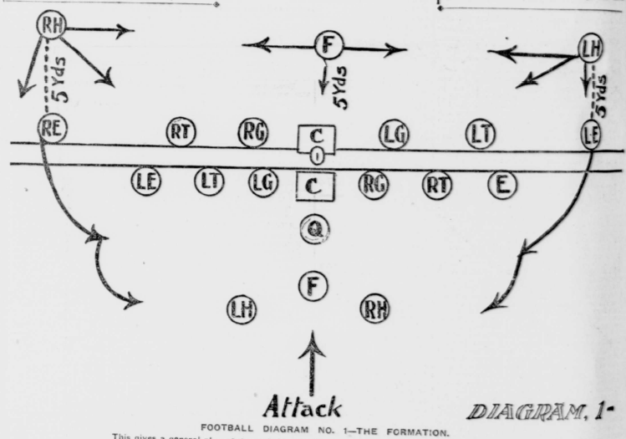
The next set of rules that were issued primary focused on player’s safety. The line of scrimmage was developed, each team’s line of scrimmage was an imaginary parallel line to the goal line and passed through the point of the ball nearest to the teams own goal line. Thus there were two lines of scrimmage and the teams were separated by the length of the ball. The line of scrimmage was created to separate the teams from fighting for the ball following the end of a play. This brought more control to the players aiming to reduce big collisions of momentum. Players also were required to line up on the line of scrimmage and were not allowed to move before the ball was snapped back to the quarter back, creating offensive and defensive lines. These “linesmen” would be able to pursue each other once the ball was snapped. One of the most famous rule changes was the invention of the forward pass. The forward pass was designed to be used once a play, and the pass had to pass the line of scrimmage and at least five yards. The reasoning behind this was because it caused the defense to spread out to cover the various receivers and the players on defense would not be able to bunch up to one side of the field.
Figure 11.”How to Play Football under the New Rules.”

Source: New York Daily Tribune, September 23, 1906.
Additionally, players who were attempting to make a fair catch had to raise their hand above their head while advancing towards the ball. Both these rules worked toward stopping the big hit, by having players on both the offense and defense at the same distance from each other it cut down on one side gaining too much momentum. The fair catch rule allowed players to safely catch the ball without fear of being drilled by the opposing team when kicking off.
Another major set of rules that looked after player’s safety was the rules regarding foul play. It amplified and specifically covered rules against, “striking with the fists, elbow, kneeing, kicking, meeting with the knee by any player, or striking with the locked hands by linemen when they are breaking through," Additionally, defensive players were, “forbidden to strike in the face with the heel of the hand an opponent who is carrying the ball.” These specific rules against followed play gave officials the ability to penalize players who disobeyed the foul play rules. Also, the penalty for committing these fouls increased as well. Players could not only be ejected based on the severity of the infraction but the offending team could also receive a loss of yards half the distance to its own goal line. Tripping or tackling the runner when obviously out of bounds, piling up on a player after the referee had declared the play over, hurdling, and other acts of unnecessary roughness would be punishable by a fifteen yard loss of yards. Tackling below the knee of a player with the ball would result in a five yard loss. Unsportsmanlike conduct, abusive or insulting language to opponents or officials was punishable by suspension for the remainder of the game. The rules also stated that all officials were required to penalize offensives enumerated under unnecessary roughness, unsportsmanlike conduct and disqualification.
These set of rules made it clear what players could expect if they disobeyed the rules and continued to play football the same way they had done previously. It also looked to keep officials accountable to follow the new rules that would be implemented on the gridiron. In turn the new set of rules created a game that was unique to other ball games that had been played previously. It would take a few years for all the rule changes and ideas to be implemented in every aspect of the game. However, once these rules became ingrained in the minds of the players, coaches’ officials and fans it would change the sport forever.
Although many applauded the new rules and were more than willing to change to the newly Americanized style, not everyone agreed with the decision. Many were suspicious of this untested new Americanized version of the game. This sparked many teams on the West Coast to rebel against the Eastern part of the country’s decision to adopt the new rules creating an East – West divide that lasted through out the early part of the twentieth century
Rugby Rule Changes – Post 1874
Not unlike early rugby football in the United States, early rugby in Europe went through a great deal of change following the first McGill Harvard game played in 1874. Since rugby was originally created at the prestigious Rugby School in England many middle and upper class members of society partook in the game. It was not long before many wanted to begin to create a set of unified rules for rugby.
Following the creation of the Rugby Union in 1871, young men got to work attempting to develop a universally accepted game. The trouble with this noble plan was the fact that in the nearly forty years since rugby’s first inception in 1823 the game had spread throughout the country of England, including its many colonies. Only in roughly 1845 had slightly codified rules been created. This meant that teams across the globe and England for that matter had developed their own loose rules and traditions of gameplay.
Rugby Union rules although adjusted from time to time have predominately remained the same since the games formalization after 1890s. Following the formation of the Rugby Union there was controversy surrounding the amateurism versus professionalism of the athletes playing rugby at the time. The “Great Rugby Schism” occurred in 1895, this separated the once united Rugby Union into Rugby League and Rugby Union. The Rugby Union rules is what the United States adopted as their guide to play rugby.
Some of the positions had changed in name but have maintained similar functions. This game consisted of two teams with fifteen players on each side, these teams were divided into forwards and backs. Both groups had different styles of play, the forwards were typically the huskier players and predominately play more with their feet as they work the ball to get it out to the backfield. The backfield or backs typically pass more often and their aim is to beat the opposing team to the outside in order to score.
The forwards consisted of two front players known as “hookers” as they would hook the ball back in set plays. The next man was the “lock” who would hold the formation together. Next to the lock were the two “side-rankers” who helped hold the lock in place and were the first to break away. The next positions were the “rear-rank” and “wing forward” who were part of the scrum. The “halfback” would receive the ball and pass it out to the rest of the backs. Of those backs there were the “inside five” who received the ball from the halfback who would pass the ball out “outside five”. Finally the players who were the slightest and quickest on the field were the “wings” who were the main scorers.
Another piece that was used was the “line-out”. In general, when the team with the ball would be brought out of bounds by their opponent the opposing team would have the ability to throw the ball in bounds. Again, the two teams would face off, this time two players from the same side would hoist another teammate in the air and that player would fight for position against their counterpart. A player would then throw the ball straight in the air and the players would attempt to maintain the position. Similar to the “scrum” the backs would have the same formation once the ball was received.
The main penalties that would occur were offside which occurred when a man was ahead of a teammate who played the ball. If this occurred the team would be forced ten yards back from where the infraction occurred. A scrum would be called in the event of a forward pass or the ball was dropped forward. The scrum consisted of the forwards who would organize in a specific pattern against the other team. Depending on the team and style of gameplay there were different combinations these forwards could organize in. Typically in the early 1900s many teams used the 2-3-2 combination as previously mentioned. Rugby had grown and developed since its early unorganized days when McGill and Harvard first faced off.
Rugby in the West
Despite the conversion to the new football rules imposed by Roosevelt in the East and Midwestern states not all areas were willing to comply. Many colleges recommend that their schools model their game play off of English rugby rather than American football. The reasoning behind this was the English version of rugby was already well tested and well received. This was a bit of a change as many of the schools had used the rugby football rules of the late 19th century.
On the West Coast an important decision was made shortly following the new rules on football were released. The idea to play English rugby was decided by a joint athletic committee of the University of California at Berkeley and Stanford University. In this meeting in which both President Benjamin Ide Wheeler of the University of California at Berkeley and President David Starr Jordan of Stanford made their stand to play rugby. The two major colleges were fiercely opposed to switching to the new football rules. In May of 1906 a conference was held between R.W. Barrett the treasurer of the Stanford student body and members of the California intercollegiate athletic committee. At the committee meeting they unanimously declared that they would not accept the new football rules and if it came down to it would have no games at all, and this was both supported by the varsity players themselves and the student body. There were many different ideas suggested to replace the college football season of 1906. Some of these ideas included holding a track meet between the two schools as well as other typically spring sporting events as many of the ones in spring were canceled due to the devastating earthquake that hit the region. In addition, both schools were in need of financial assistance with their spring seasons being cut short in order to pay expenses of training and coaching that they owed. There continued to be much debate over what sport, if any would replace college football.
As the English rugby seemed to be the game that was likely played if any in the fall some in athletic community began to make plans to assist their programs. In order to grasp a better understanding of the game of rugby the head football and baseball coach at Stanford, James F. Lanagan, departed for Canada to be trained by many of the enthusiasts of the game of rugby. Upon his return to the United States Lanagan had positive reviews of modeling the school’s game play after that of English rugby. He noted one of the most distinct features of the new gameplay was the absence of interference for the man with the ball, which made it necessary to have the ability to skillfully kick and pass the ball without error while on a dead sprint. This was a positive push for rugby to be continued in the West as many former football players had agreed they would come out and play the game in the fall. By the end of August 1906, it was apparent that rugby would be the game played on the West Coast rather than football.
What added to the boost in enthusiasm by many supporters of both Stanford and UC Berkeley athletics was the commitment by many key players willingness to play rugby rather than football. The speculation of putting together a winning team was a highly commented topic. Coach Lanagan who explained, “I feel confident that Stanford has the material for a winning team. We had a light and fast varsity last year and that is just the kind of team that can play Rugby”. Shortly after it was decided by a joint committee that between Stanford and UC Berkeley rugby would be the sport that would be played in the fall. Those opposing rugby were allowed to make their final appeals against rugby, however, the committee ultimately informed the protestors that rugby would be given a two year trial. Despite protests by some students in the first year under playing rugby rules both schools stood strong in supporting rugby. In an address to students President David Starr Jordan of Stanford reiterated his stance on rugby. Until the schools in the East made substantial rule changes to the way football was played the school would continue to support rugby. Once the rules of rugby had been adopted by the universities on the West Coast and experimented with over a few seasons teams began to gain recognition on not only a national scale but a globally as well.
Rise of Rugby in the West
Following the West’s somewhat harsh split from American football, some newspapers in the East began to warm up to rugby once again. The New York Sun looked favorably upon rugby and described it as a “beautiful, speedy and non-dangerous sport, offering plenty of excitement without the chance of serious injury, and giving the spectator, be he expert or tyro a far better chance to see what is coming off and to get his money’s worth.” The praise of rugby was a surprise coming from an Eastern newspaper where they played exclusively American football. In addition, the paper also praised the rivalry that Stanford and UC Berkeley had developed with each other while playing rugby. “Organized cheering, songs and movements are kept up unceasingly by the cheering sections of the respective universities, and it is this feature as much as the game which attracts such an enormous gate to the Stanford-California game each year.” The rugby that was being played in the West also began to gain global attention as teams from around the world began to agree to play matches against universities in the West.
One of the first major rugby style contests between an American team and an international team took place in October of 1912, between then World Champion Australia and Stanford University. Stanford was able to defeat the Austrian team by a final score of thirteen to twelve. This was the first time a rugby powerhouse team came to the United States to play a match against a college team. As many newspaper described the event as the best rugby game ever played in Stanford. It took expert precision by the Stanford team to hold pace and ultimately defeat the heavily favored Australian team. Despite the loss the Australian team gave the Stanford team credit for beating them and took their loss as a tool to learn from while still admiring Stanford’s resilient play in a closely contested match. This opened the door for American rugby to be on display to the rest of the world and would not be the last international match played on the West Coast. Many believed that “within five years the Rugby playing nations of the world will have to take off their hats to America and acknowledge a team composed of players developed in California to be without a peer.” It appeared rugby was here to stay.
Figure 12. Stanford defeating Australia 13-12.

Source: San Francisco Call, October 17, 1912.
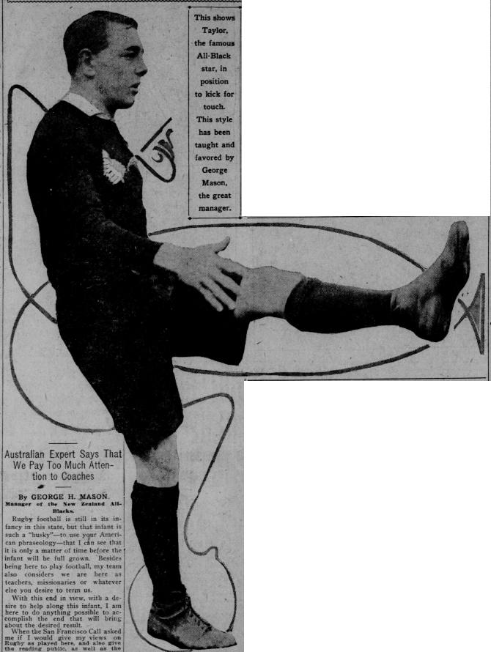
Not long after the Australian team finished their tour in the United States plans were being made for a strong English Rugby team to tour was being made. This tour was designed to incorporate a combination of Oxford and Cambridge players to showcase their talents to the United States. For this tour the visiting British team would make a tour from Eastern Canada to the west and then eventually head southwards towards to California. Eventually the idea of creating an all-star team of Western rugby players to play the English in Eastern cities in the United States was developed in order to introduce the Eastern teams to the possibilities that rugby could bring. Although this did not materialize as planned it did develop the desire for the United States and Canadian teams to play more international matches which would help promote rugby. In addition to a team from England to tour the area, the New Zealand All-Blacks were set to be part of a tour of the West Coast in the fall of 1913. New Zealand a powerhouse in the rugby world were always willing to accept new challengers. Throughout the month of October, New Zealand were set to university teams Stanford, UC Berkeley as well as many of California club teams in a month long tour. Upon accepting the invitation to tour the United States the New Zealand rugby team began their selection process in searching for the best players they believed they had to make the journey. They began their selection by playing matches against the All-Australia team in order to determine the most qualified players. With only a month before the New Zealand rugby team was set to visit the United States they made an additional request to have two more players added to their roster increasing the number of traveling players from 21 to 23. Naturally the California Rugby Union who was hosting them allowed them to bring the players under the condition that they would not be expected to be held under one roof when visiting Stanford and UC Berkeley. Upon agreeing to these terms the stage was set for a monumental series of games that would deeply impact American rugby.

Figure 13. Taylor of the All-Blacks kicks for touch.

Source: San Francisco Call, October 28, 1913.
There was much anticipation for the New Zealand rugby team to arrive in the United States. Newspapers documented nearly every step the New Zealand team took even prior to arriving on the shores of the coast via on the Willochra the Union Steamship’s company liner. Upon their arrival they were greeted by rugby union and city officials describing them as the, “greatest exponents of the game on the other side of the broad Pacific”. Once the pleasantries were over the New Zealand team began to do what they had set out to do, play rugby, at an extremely high level. One of the first major games they played on their tour was against Stanford University. New Zealand dominated every aspect of the game, handing Stanford their worst lost ever with a final score of 54-0. The New Zealand team demonstrated a mastery of the game and demonstrated the importance of running with the ball and having support to pass the ball off before or while the ball carrier was being tackled. This constant pace of the game wore down the defense of Stanford team who despite their best efforts were out matched. New Zealand’s dominant play continued throughout the tour regardless of playing conditions. When playing Saint Mary’s on red adobe the ill weather had made the field into a muddy mess. Despite this disadvantage the All-Blacks prevailed 26-0. In the midst of the New Zealand tour Stanford and UC Berkeley were set to play their yearly highly contested rugby match. Images of the players that were set to complete lined the sports sections of all major newspapers and a reported 18,000 spectators would be in attendance. Stanford ended up victorious, following the classic matchup between Stanford and UC Berkeley the All-Blacks were set to make their final appearance on tour. Naturally the All-Blacks heavily defeated the last team they played, leaving the United States with a remarkable record of thirteen games played and thirteen games won, all by huge margins of victory. Following the New Zealand All-Blacks tour much was to be decided about the future of rugby in America.
Figure 15. Bill Darsie, Stanford’s captain.

Source: San Francisco Call, November 7, 1913.
Figure 14. Sterling Peart UC Berkeley’s captain.

Source: San Francisco Call, November 7, 1913.
Rugby Decline in the West
Following the humiliation handed down by the New Zealand rugby team there was controversy surrounding what would become of rugby in the West. Many called for an abolishment of the rugby game following the hardy defeats handed to the American teams. One of the most prevalent arguments for the ending of rugby was the fact that it was clear the United States could not truly contend with the rugby superpowers of the world.
Since Australia came to the United States the year prior and did not have as many decisive margins of victory and a loss many wondered how much better New Zealand was than Australia. This answer could be easily solved, days before New Zealand was set to travel to the United States they defeated the same Australian team 30-5.
In December of 1913 a competition between rugby football and American football was set to take place to determine what sport was superior. The game would be played under the new college football rules with eleven to a side. The ruggers heavily outweighed their competition and as one newspaper reported, “opened the game with a rush that threatened to wipe the others off the field.” Despite the initial hard runs the team of rugby players were defeated by the American football players by a final score of twenty four to two. This defeat signaled the turning point from the West Coast being in favor of rugby to beginning to start to seriously consider switching to American football. The first major college in the West to switch to football was the University of Southern California. After three years of rugby participation the school decided unanimously to return to their former conference relations. This began the discontent for rugby to be publicly mentioned.
Many at the University of California at Berkeley voiced criticisms of rugby. An outspoken critic of rugby was student manager William Donald who felt rugby was too limited. He believed that UC Berkeley should be competing against teams such as Michigan and other Eastern schools. He believed that with the University of Southern California dropping rugby the field would continue to be narrowed until rugby no longer qualified as a major sport. Many shared his feelings and wished to see American football in the West. In addition, the argument was made that since California had never developed a team good enough to compete with first class English teams demonstrated that students never put their full spirit behind rugby. Despite Donald’s claims, officials at Stanford blocked any attempt to get rid of rugby in favor of American football. Both sides weighed in on whether football or rugby would be played in 1915. Although initially UC Berkeley did not officially admit they would turn to American football, by 1915 they made the decision along with the State of Washington’s college team. By the end of the 1914 season UC Berkeley had decided to return to American football. Although Stanford continued to play rugby for the next three years UC Berkeley’s exit sealed rugby’s fate in the West.
With the rugby style of gameplay out of the picture following Stanford University and the University of California at Berkeley’s decision to adapt American football it allowed the game of football to take center stage across the nation. With teams across the country all playing the same game once again, football fell center stage in the United States at the time.
Football, America’s Emerging Pastime
By the 1920’s American football was clearly the most popular contact game played in the United States. Not only was college football being watched on fields across the country the next step in football was arriving. In 1919, the first professional football teams were beginning to develop organized schedules and games. These were the building blocks which would propel American football into the 20th century and beyond.
Professional football teams began to spring up throughout the Midwest and East. Even though college football was being played in the West at this point the lack of quality and rapid transportation was not there. Professional teams in the Midwest and East started to develop fierce professional rivalries that only built to the excitement of football in the America.
Professional football teams began to spread like wildfire. Although many of these teams were underfinanced and often folded within the year it was still evident the idea of professional sports was here to stay. As baseball had done in the previous decades football was becoming one of the nation’s national pastimes. The United States had fully adopted the rules and regulations for the American football game and were content with playing their sport. Although rugby had not been played for a few years in the West, when the Olympic committee inquired to the U.S. about fielding a team there were still willing participants.
Rugby in the Olympics
Although the Olympics were not as highly publicized or covered in the media as they are today, the games still represented a chance for countries to show their power globally in sports. The United States were willing to enter their name on any sport that had two countries, and were even willing to be the second entry necessary for any country’s special or favorite game. The American Olympic Committee even decided not to enter their names in events such as diving or walking events because they believed that they would easily have won those contests without competition. According to G.T. Kirby the president of the American Olympic Committee, “Our desire is to enter teams in every event, tho in many of them we haven’t a chance to win.”
This set the scene for the United States to enter their name on the ballot to play rugby in the 1920 Olympics. Although teams no longer played rugby in the United States it was not too hard to begin to look for rugby talent. The U.S. compiled a team that would compete for the U.S. out of players from the University of California at Berkeley and Stanford University. Shortly after this decision was made the newly formed Olympic team went to British Columbia and defeated three all-star rugby teams. The games were played in Vancouver and Victoria which were considered as the greatest Rugby centers in Canada. Impressively the United States was able to defeat France by a final score of eight to zero. Following these Olympics there was much debate of what games would continue to be held in the 1924 Olympics in Paris, France.
Initially it was decided that rugby along with the tug-of-war, the three thousand meter walk, grass hockey, archery and golf would be removed from the Olympic program. However, this was short lived and rugby was quickly reinstated within a month of its initial deletion from the Olympic program.Eventually the program dates were set and rugby would be played from May 3rd through the 18th in Paris, France. By the end of 1923 it was decided that the United States would once again enter a team in the Olympics for rugby. As the United States prepared to square off against teams in the Olympics many thought that a slight revival of rugby was being created. Nearly four thousand fans witnessed a game in San Francisco that would help determine the final roster spots for the Olympic team. Three teams would end up playing for supremacy of rugby in the Olympics, which included France, the United States and Romania. Since only there were only three teams in the field for rugby teach team would play each other once. Both the French and United States teams were expected to beat Romania and their matchup on May 11th would be the final game.
Prior to arriving on French soil, problems for the United States began to occur. The American Olympic Committee was severely depleted on funds and had to work to raise nearly the 350,000 dollars required to send the men and women in the various sports to Paris. Once they were able to raise the funds they were headed to Paris. Upon arriving there was a disagreement about the U.S. taking their own photographs against Romania which were to be used for documentary and training purposes. The French Olympic Committee had maintained that the exclusive contracts for photographic work to French firms throughout the Olympics. On top of this the U.S. rugby team was also robbed of nearly five thousand francs, several hundred dollars, watches and other valuables. The stage was set for an epic rugby contest between host country France and defending Olympic Champion United States.
The United States played in a hard fought match against the French team defeating them seventeen to three. Following the game a fight broke out between celebrating Americans and angry French fans. Gideon Nelson of DeKalb, Illinois was stuck in the head with a cane and was hospitalized from the melee on the field that ensued following the ending of the game. The media back in the United States portrayed the French negatively. Following the bad blood that followed the game many in the United States questioned why America even bothered with the game of rugby, as it only attracted three teams. It had, “failed as a sporting event.” Following the United States victory over France and the removal of rugby from the Olympic Games, American rugby disappeared into the abyss.
Conclusion
As with most aspect of history there is never a simple answer to any question, but typically multiple factors involved. American football is no different. Football rose in popularity, while rugby was not able to hold strong, not because of one specific event but several events that shaped both sports outcomes. Without early rugby being shared by McGill University in 1874 Harvard never would have created a rugby football team. With the rules of early rugby being so brutal and violent there would be a call for reform both in Europe and in the United States. With the backing of President Theodore Roosevelt American football was born. Despite football being created many did not agree with it rules and sought another source, English rugby. Although rugby sought initial success and even had a few brief golden years due to outside competition and internal strife it was not able to maintain its presence. Football became America’s new national pastime and despite the ability to field a winning Olympic rugby team it was still not enough to keep rugby relevant in American culture in the 20th century.

Appendices
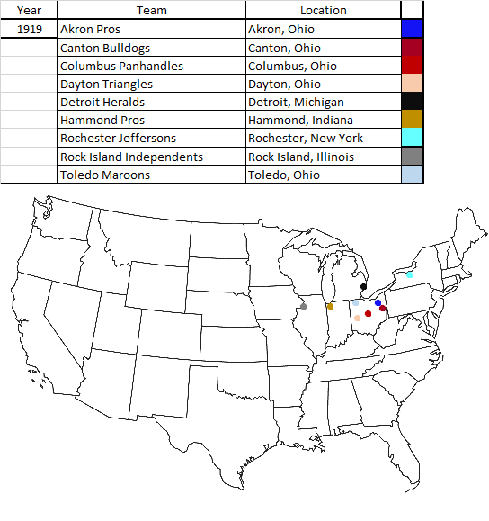
Professional Teams 1919 – 1924
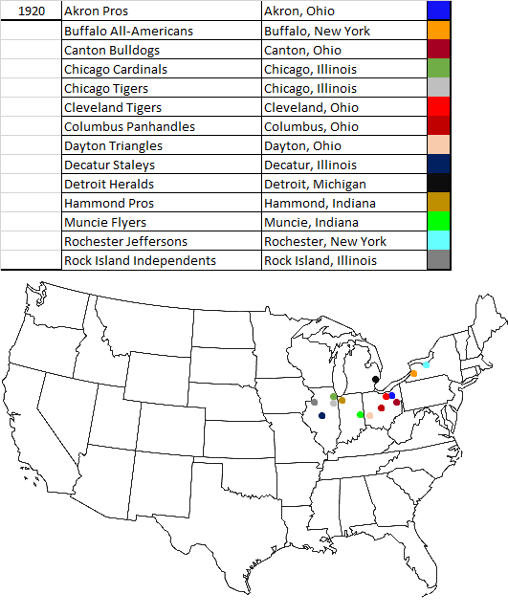
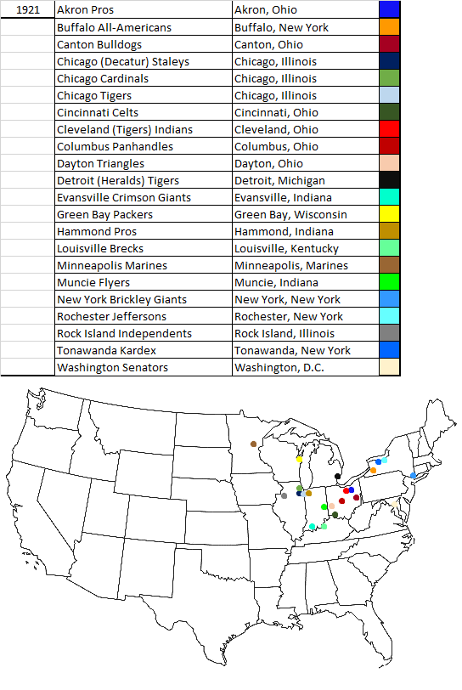
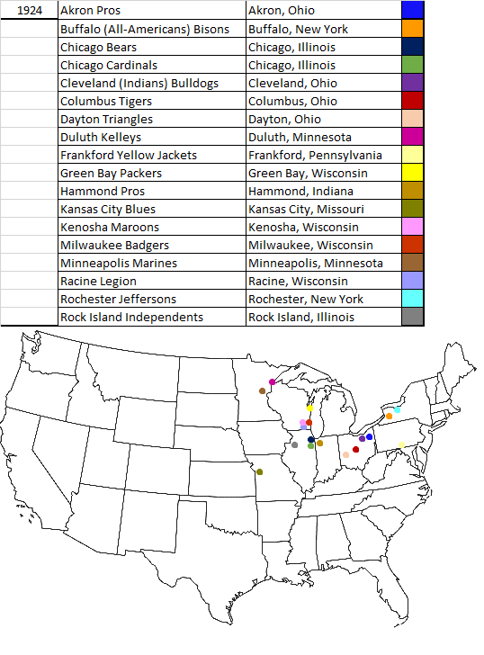
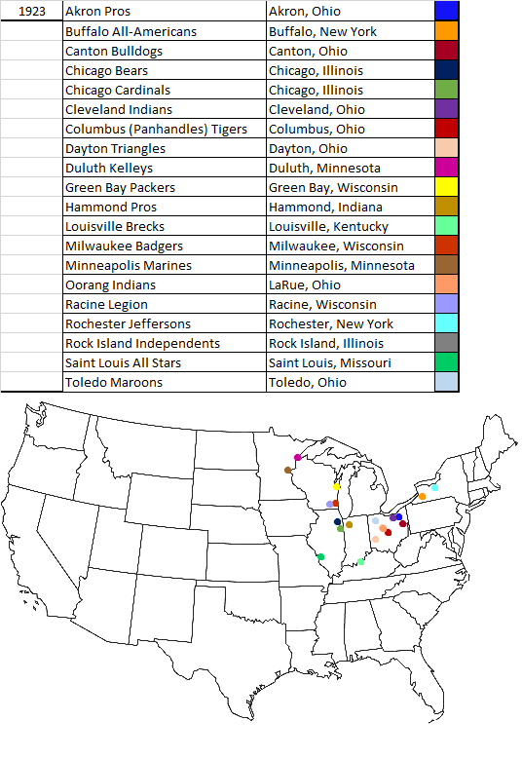
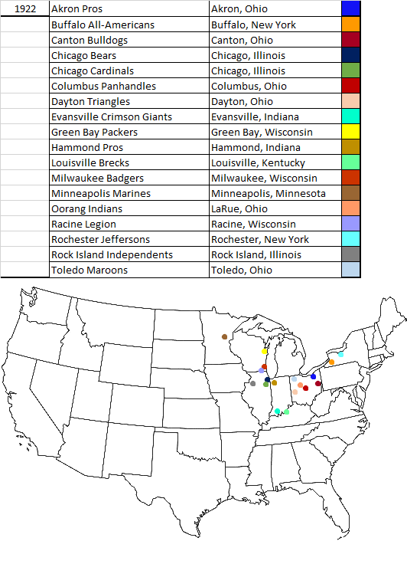
Annotated Bibliography
Primary Sources
Daily Californian. Newspaper. 1905-1907
This collection of newspapers helps chronicle the rise of rugby in the West. It discusses how coaches from the West to Europe and Canada to learn more about the rules of English rugby.
Oakland Tribune. Newspaper. 1913-1923
This was a collection of newspapers from the Oakland are which chronicled rugby’s rise in the West as well as marked its decline during the 1910s-1920s. It was an important resource to demonstrate how rugby was fairly popular on the West Coast. It also is over a ten year span which helps mark it was a gradual decline once it became popular. It also covers the defeat of Australia and discusses how New Zealand ended up playing the United States in rugby. These papers also discuss the destruction New Zealand caused by dominating the United States.
San Francisco Call. Newspaper. 1905-1917
This was an important collection of newspapers from San Francisco. It helped to demonstrate the rise in popularity rugby had once the West had decided not to play the reformed version of football. It also discusses the defeat of Australia and how the United States desire to compete in rugby was high in the West Coast. It also covers the defeat New Zealand gave to the United States and discussed how that may impact America’s future with the game of rugby.

Walter, Camp, Spalding’s Athletic Library Official Football Guide for 1906 (New York:
American Sports Publishing Company,1906).
This book was the first rule book issued following the 1905-1906 decision to reform football in the United States. Created by Walter Camp along with the others in the committees to reform football this was the first guide to interpreting and understanding the rules that were implemented for the 1906 season.

Washington Post. Newspaper. 1905.
This collection of newspapers from 1905 helped to demonstrate the national outcry football was receiving due to its violence nature. The papers were used to list the various accidents that had occurred during the 1905 season of football. It helps show that this had become a national issue and Roosevelt would ultimately have to step in to deal with this tense situation.

Secondary Sources
Danzig, Allison. “The history of American football: its great teams, players, and coaches,” Englewood Cliffs, New Jersey: Prentice-Hall., 1956.
This manuscript gives an early history of how football became the distinct game it is. It looks at how through rugby, American football began to develop. This helped look at how football took off in American culture and rugby was never able to secure permanent footing.
Dunning Eric & Sheard, Kenneth. “Barbarians, Gentlemen and Players: A Sociological Study of the Development of Rugby Football,” New York: New York University Press., 1979.
This book was utilized to demonstrate the desire for codified rules following rugby’s inception at Rugby School in England. It also provided context into the events leading up to “The Great Schism” that separated Rugby League and Rugby Union in England.
Dyson, Mark. “Scripting the American Olympic Story-Telling Formula: The 1924 Paris Olympic Games and the American Media,” Third International Symposium for Olympic Research, 1996. http://library.la84.org/SportsLibrary/ISOR/ISOR1996j.pdf (accessed February 25, 2014).
This article discusses how media may have helped end rugby in the Olympics. This was useful because it discussed the ill will the French newspapers had towards the United States during the 1924 Olympic Games. It also discussed the fight that ensued following the game and how despite a powerful country like the United States winning the Olympic Gold it was still removed as an IOC sanctioned competition.
Jenkins, Mark. “An American Coup in Paris U.S. Rugby Team at 1924 Olympics,” American Heritage, 1989. http://www.americanheritage.com/content/american-coup-paris?nid=56516 (accessed February 24, 2014).
This article discusses the events of the 1924 Olympic Games when rugby was an IOC sport. It talks about how the United States beat host country France in the gold medal game of the 1924 Olympics in Paris. This article argues that despite the United States winning the gold and rugby selling more tickets than track and field it was removed by the IOC because of Frances poor sportsmanship and lack of international interest. This helped to investigate why rugby fell off in the United States despite winning the Olympic gold.
Kaye, Ivan N.. “Good Clean Violence: A History of College Football,” New York: J.B. Lippincott Company. 1973.
This book looks at the history of college football and how it diverged from rugby. This book was used to see the roots of American football and how its early impacts may have caused it to become more popular than rugby. It looks at key figures such as Walter Camp, who is the “Father of American Football” along with other important figures in American football’s early stages.
Smith, Ronald A. “Commercialized Intercollegiate Athletics and the 1903 Harvard Stadium,” New England Quarterly, 2005. http://www.jstor.org/stable/1559707 (accessed December 4, 2014).
This article written by Ronald Smith discusses the violence that came with the Harvard game known as “Blood Monday.” It gave context to the sheer
Watterson, John Sayle. “College Football: History, Spectacle, Controversy,” Baltimore: The John Hopkins University Press. 2000.
Annotate
This was an important book because it was filled with images and newspaper drawings of the early 20th century. It helped to explain the national opinion of football and how it was viewed by most as a very dangerous and unnecessary evil in American culture.

Alexander M. Weyand, The Saga of American Football (New York: Macmillan, 1955).
Ibid.
Ibid., 5.
John J. Miller, The Big Scrum: How Teddy Roosevelt Saved Football (New York: HarperCollins Publishing, 2011).
Ibid., 234-242.
Ibid.
Allison Danzig, The History of American Football (Englewood Cliffs: Prentice-Hall, 1956). 153-206.
Allison Danzig, The History of American Football (Englewood Cliffs: Prentice-Hall, 1956).
Alexander M. Weyand, The Saga of American Football (New York: Macmillan, 1955).
Ibid., 104.
Ibid., 129.
Ivan N. Kaye, Good Clean Violence: A History of College Football (New York: J.B. Lippincott, 1973). 71.
Ibid., 104-105.
Ibid., 105.
Ibid. 105.
Alan Bairner, Sports, Nationalism, and Globalization: European and North American, 105.
Mark Jenkins, “An American Coup in Paris,” American Heritage 40 no. 5 (August 1989), http://www.americanheritage.com/content/american-coup-paris?nid=56516 (accessed April 16, 2014).
Mark Dyson, “Scripting the American Olympic Story-Telling Formula: The 1924 Paris Olympic Games and the American Media,” Third International Symposium for Olympic Research (October 1996), http://library.la84.org/SportsLibrary/ISOR/ISOR1996j.pdf (accessed April 20, 2014).
Ibid., 55.
Ibid., 62.
Allison Danzig, The History of American Football (Englewood Cliffs: Prentice-Hall, 1956). 4.
Ibid., 5.
Alexander M. Weyand, The Saga of American Football (New York: Macmillan, 1955). 9.
“Harvard’s Bloody Monday,” Boston Evening Transcript, October 6, 1891.
Ibid.
Ronald A. Smith, “Commercialized Intercollegiate Athletics and the 1903 Harvard Stadium,” New England Quarterly 78 no. 1 (March 2005), http://www.jstor.org/stable/1559707 (accessed December 4, 2014).
Ibid.
Ibid.
Ibid.
Ivan N. Kaye, Good Clean Violence: A History of College Football (New York: J.B. Lippincott, 1973). 21.
American Intercollegiate Association. The American Inter-Collegiate Foot-Ball Rules for 1882 (Trenton, MacCrellish & Quigley, 1882). 5.
American Intercollegiate Association. Foot-Ball Rules and Referee’s Book 1888. (Boston, Wright & Ditson, 1888). 2.
Nigel Trueman, “Laws,” Rugby Football History, http://rugbyfootballhistory.com/laws.htm (accessed December 4, 2014).
“Nineteen Killed on Gridiron,” San Francisco Call, November 27, 1905.
“Deaths From Football Playing,” Washington Post, October 15, 1905.
“Weede Breaks Leg In Game,” Washington Post, October 5, 1905.
“Student’s Back Broken,” Washington Post, October 6, 1905.
“Neck Broken at Football,” Washington Post, October 10, 1905.
“Hampden-Sidney Team to Disband,” Washington Post, October 11, 1905.
“Columbia Bars Football,” New York Tribune, November 29, 1905.
Ibid.
John Sayle Watterson, College Football: History, Spectacle, Controversy (Baltimore: The John Hopkins University Press, 2000). 98.
John J. Miller, The Big Scrum: How Teddy Roosevelt Saved Football (New York: HarperCollins Publishing, 2011). 19.
Ibid., 23.
Ibid., 56.
Ibid,. 66.
“Football Reform,” Washington Post, October 11, 1905.
Count Witte was the Chairman of the Committee of Ministers in Russia and Barron Komura was the Minister of Foreign Affairs in Japan.
“Brutality as a Science,” Washington Post, October 12, 1905.
“Hears Football Men,” Washington Post. October 10, 1905.
“Teddy Roosevelt Jr. Hurt on Football Field,” The Salt Lake Herald, October 15, 1905.
John J. Miller, The Big Scrum: How Teddy Roosevelt Saved Football (New York: HarperCollins Publishing, 2011). 185.
Walter Camp Football Foundation, “History, http://waltercamp.org/history/ (accessed December 8, 2014).
Ibid.
John J. Miller, The Big Scrum: How Teddy Roosevelt Saved Football (New York: HarperCollins Publishing, 2011). 199.
“Football Unfit Game Says President Eliot,” New York Times, February 3, 1906.
John J. Miller, The Big Scrum: How Teddy Roosevelt Saved Football (New York: HarperCollins Publishing, 2011). 202.
John Sayle Watterson, College Football: History, Spectacle, Controversy (Baltimore: The John Hopkins University Press, 2000). 78-79.
“Football Is Prohibited By Harvard Overseers,” New York Times, January 16, 1906.
“Football Coalition Is Finally Secured,” New York Times, January 13, 1906.
Walter, Camp, Spalding’s Athletic Library Official Football Guide for 1906 (New York: American Sports Publishing Company,1906). 93.
Ibid., 93.
Ibid., 93.
Ibid., 93.
“New Football Game Not Yet Completed,” New York Times, February 11, 1906.
Walter, Camp, Spalding’s Athletic Library Official Football Guide for 1906 (New York: American Sports Publishing Company,1906). 93
Ibid., 95-96.
Ibid., 96.
Ibid., 96.
Ibid. 96.
Eric Dunning, Kenneth Sheard, Barbarians, Gentlemen and Players: A Sociological Study of the Development of Rugby Football (New York: New York University Press, 1979). 105.
Ibid., 112.
For more information on “The Great Rugby Schism” visit http://www.rugbyfootballhistory.com/Schism.html
“Rugby Rules and Their Interpretation,” Oakland Tribune, October 12, 1914.
Ibid.
Ibid.
Ibid.
“Recommend Rugby Game,” Daily Californian, December 13, 1905.
Ibid.
“Old Game or None at All,” Daily Californian, May 21, 1906.
Ibid.
Ibid.
“Has Good Word for Rugby,” Daily Californian, July 25, 1906.
Ibid.
“Old Stanford Men Back,” Daily Californian, August 25, 1906.
Ibid.
“Universities to Play Rugby,” Daily Californian, August 30, 1906.
“Rugby Here to Stay Says Jordan,” Daily Californian, January 19, 1907.
“New York Sun Shines Up to Rugby,” San Francisco Call, December 18, 1912.
Ibid.
“Cardinal Cuts Loose and Plays Open Game, Beating Them on Their Own Style,” San Francisco Call, October 17, 1912.
Ibid.
“Visitors Offer No Excuses; Defeat Take Philosophically,” San Francisco Call, October 17, 1917.
“What’s the matter with Australians?” San Francisco Call, October 18, 1912.
“British Rugby Players Coming to San Francisco,” San Francisco Call, January 17, 1913.
Ibid.
“Real Steps Taken to Bring British Ruggers,” San Francisco Call, March 19, 1913.
“Bright Outlook for the Ruggers,” San Francisco Call, July 16, 1913.
“New Zealand Rugby Men to Visit Coast,” San Francisco Call, June 4, 1913.
”New Zealand to Send Rugby Team,” San Francisco Call, July 22, 1913.
“New Zealanders Coming in Force,” San Francisco Call, August 6, 1913.
“Liner on Her Maiden Voyage Due Tomorrow,” San Francisco Call, October 1, 1913.
“Famous Ruggers Here for Action,” San Francisco Call, October 2, 1913.
“All Blacks Toy With Stanford,” San Francisco Call, October 16, 1913.
Ibid.
“All-Blacks Shut Out St. Mary’s,” San Francisco Call, November 6, 1913.
“18,000 Out to Cheer Football Classic,” San Francisco Call, November 8, 1913.
“All-Blacks Depart After Making Some Football History,” San Francisco Call, November 17, 1913.
Ibid.
“Ruggers Give Old Game A Trial,” Oakland Tribune, December 25, 1913.
”Ruggers Are Beaten By Yanks,” Oakland Tribune, December 30, 1913.
Ibid.
“U. of S. C. Decides to Abandon Rugby Football Relations,” Oakland Tribune, April 8, 1914.
“Donald Stirs U. C. Campus; Rugby Is Too Limited,” Oakland Tribune, May 9, 1914.
Ibid.
“Movement Against Rugby Blocked,” Oakland Tribune, May 17, 1914.
“Supports of American Game Think U. C. Will Desert Rugby,” Oakland Tribune, June 19, 1914.
This can be demonstrated by the charts and maps in the appendices. The charts represent the professional football teams that were developing and the maps display their location from 1919 – 1924.
“Yankees Sports”, Lima Daily News, March 19, 1920.
Ibid.
Ibid.
“Official Program for Olympics Out,” Fitchburg Daily Sentinel, December 16, 1919.
“Form Rugby Team on Pacific Coast for Olympic Games,” Madison Capital Times, March 15, 1920.
Ibid.
USA Rugby, “History,” http://usarugby.org/about-usarugby/history (accessed December 8, 2014).
“Four Entrants and Four Starters Will Be Limit of One Nation in Olympics,” Olean Evening Herald, June 7, 1921.
“Marathon Deleted From the Olympics,” Lebanon Daily Reporter, July 11, 1921.
“Full Schedule for Olympics is Announced,” Oakland Tribune, March 22, 1922.
“America to Enter In Rugby Contest,” Oakland Tribune, December 13, 1923.
“Sports Told In Paragraphs,” Bakersfield Californian, February 3, 1924.
“Three Nations in Rugby Football Games at Olympics,” Daily Kennebec, March 31, 1924.
Ibid.
“Need Great Sum to Send Olympics Team to Europe,” Helena Daily Independent, April 17, 1924.
Ibid.
“Olympic Stars Robbed,” Charleston Gazette, May 10, 1924.
“Americans Injured in Fighting After Winning Ball Game,” Chronicle Telegram, May 19, 1924.
“Too Many Events in Olympic Games,” Piqua Daily Call, July 29, 1924.

