The Bird is the Word: The Origins of BLU THE Blugold (2016 ed.)
by Lark Keating-Hadlock, hadlocca@uwec.edu
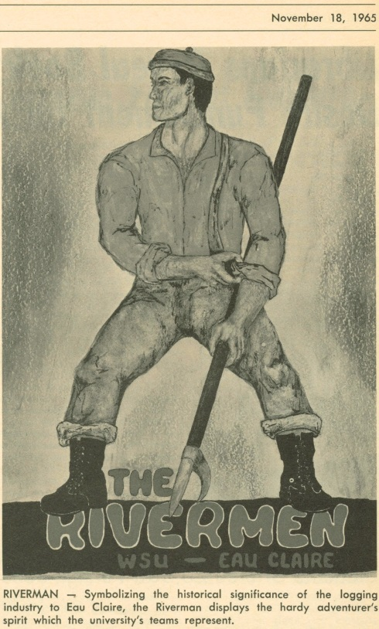
Throughout the history of the University of Wisconsin-Eau Claire, the question has been asked: What is a Blugold? Over the years, there has been much speculation on the origin of the Blugold. Research shows that the term simply evolved from the phrase “the Blue and Gold.” The first use of the term “Blugolds” that this researcher found occurred in a Spectator article in the fall of 1935. The Blugolds defeated Winona Teachers College football team and the writer shortened the combination of the school’s colors, blue and gold, into a single word. The term “Blugold” stuck!
When the Eau Claire State Normal School was dedicated in October 1916, the student body had already chosen the school colors of blue and gold. The first references to the UWEC basketball team labels the team as the Eau Claire Normals. Throughout the 1920s, the football and basketball teams were referred to by many names: the Blue and Gold football artists, the Blue and Gold warriors, the Blue and Gold gridders or gridirons, the Normalites, the Normal, and simply the Blue and Gold team. In 1928, W. L. “Bill” Zorn came to Eau Claire State Normal School to coach football and basketball. During his 40 year tenure, the Eau Claire teams were commonly referred to as the Zornmen, the Zornadoes, and the Golden Zornadoes. However, the moniker the Blue and Gold was used regularly throughout the history of the University of Wisconsin-Eau Claire.
In a quest for what some view as an embodiment of school spirit and a source of pride, the debate over a school mascot has periodically surfaced. Since the 1940s, students have tried to define a “Blugold.” In 1945, the Spectator sponsored both a banner contest for the newspaper and a nickname contest with the hope of finding a more “distinctive and original nickname” than Blugold. The judges were the Spectator staff and the athletic committee. Not a single entry was turned in for the banner contest. Since there is no mention of the nickname contest after the announcement, presumably there was no entry for that contest either.
In 1956, the Art Club sponsored a mascot contest. The mascot was to be voted on by the student body and subject to the approval of the alumni. Though almost one third of the student body voted in that contest, and “Buster Bulldog” won first place with 82 votes, no record has been found that authorized the mascot.
In 1965, a mascot committee held a Blugold mascot contest with a monetary prize of $50 in bookstore merchandise, in addition to a $40 cash prize, for the best three suggestions. Entries were judged by a panel of 10 judges with a vote conducted among students. This contest resulted in 26 entries, pairing a symbol with the Blugold name. Five finalists were chosen: the Blugold Beaver, the Norse god Odin, the Blugold Eagle, the Golden Eagle, and the Eau Claire Rivermen. Students and faculty were encouraged to vote for the Blugold mascot from these five. The University Senate rejected all election results “due to the fact that the students were not given the choice of a ‘no’ vote.”
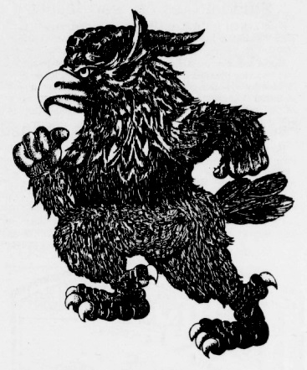
In 1985, students were again asked to vote for a mascot; however, the Student Senate chose not to support the winner: the horned bird that the bookstore was using on some of its merchandise. A student stated in The Spectator that a mascot was unnecessary, saying “We don’t need a mascot because there can’t be one. A Blugold is not anything.”
When asked “What is that thing we call a Blugold” in 1989, students said “It’s just that bird thing…a mythical creature that symbolizes the finer elements of UW-Eau Claire.” But one student suggested that “It’s Bulldog spelled wrong”! The mascot issue resurfaced again in 1995 and 1999 but nothing ensued even though some students felt that a visual image was needed to “help students identify with the university” and increase loyalty and school pride.
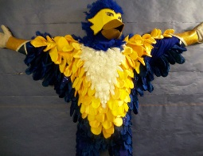
In February 2006, Senior Aaron Olson, then-president of the Student Senate, authored a resolution to recommend that the chancellor form a committee to review the need for “redefining” a Blugold. In 2007, undergraduate Casey Driscoll, also known as “Momentum Monday Man”, petitioned the university administration for the creation of an official Blugold mascot. Driscoll even went so far as to design and construct his own Blugold suit of a mythical bird that he called Chip. E. Wa, that he sometimes wore around campus. According to Driscoll, the E. was for Excellence, embracing UWEC’s slogan: “Excellence. Our measure, our motto, our goal.” His broader goal was to “create a community that shares a common identity.” One of the inspirations that Driscoll pointed to for the creation of his suit were the birds in the James Newman Clark Bird Museum, housed in Phillips Science Hall.
In the fall of 2008, Chancellor Levin-Stankevich was asked to appoint a committee to research the mascot issue. A survey asked the university community if they wanted a mascot, resulting in 7,000 respondents. Students, faculty, staff, alumni, and donors responded favorably with 69 percent of the vote; however, by 2010, controversy continued. A contest was held with 29 options presented to the committee. Another survey was then sent to about 40,000 students, faculty, staff, alumni and community members with 3 mascot options to choose from: a blue ox, a voyageur, or having no mascot." More than 12,200 responded with the blue ox just barely winning out over no mascot. Many were upset that the bird wasn’t an option. A Facebook group, “All we are saying, is give The Bird a chance”, was quickly created by a University staff member. Within days, the group had 1,600 members. After more than 1,180 students petitioned for a new survey with the bird option, Student Senate approved a resolution to form a Blugold mascot task force and administer a new survey. Many students credited Driscoll with galvanizing enthusiasm for the bird. When another survey was administered in April 2010, 79 percent answered yes to “Do you think UWEC needs a mascot?” Three options provided to the yes respondents were the bird, the ox, and no mascot. The bird won a decisive victory with 69 percent of the vote.
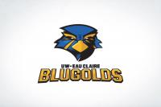
In 2013, a request was sent to all university students, faculty, staff and alumni for image submissions of a mascot. A committee selected four finalists. A survey then requested that the four images be ranked in order of preference. The image chosen was created by alumnus Ben Stroinski, class of 2004, and represents only the student body, not the university itself. “The hope is that over time the University will also adopt the student mascot as its own representation and as the official mascot of the University of Wisconsin-Eau Claire.” That same year, Student Senate voted 24-2 to have two mascot costumes created. The costumes, at the cost of about $4,500 each, were funded by students from a special reserve account surplus. Every time a mascot product is purchased from the bookstore, a portion of the sales goes back into the Student Senate account and should cover future mascot expenses.
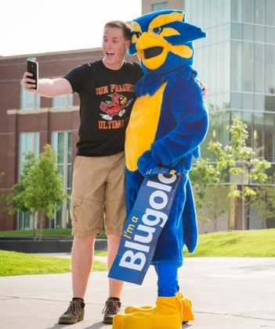
Currently, there is an online form on the Student Senate web page for applicants to apply to be Blu the Blugold. It states that “We are all Blugolds, and Blugolds are what make UW-Eau Claire great. Blu the Blugold, our student body mascot, is UWEC’s biggest fan, number one student supporter, and proud to call our campus home.” One of the requirements is the physical height of 5 feet 9 inches to 6 feet 4 inches to fit the suit. Mascot training must also be completed and a code of conduct is to be followed. Some feel that the sense of identity created by Blu is important for keeping students involved with events on campus.
Why has it been so difficult to agree on an official Blugold mascot? Some felt that the UW-Eau Claire should join the ranks of the other UW System schools and have their own mascot to instill school spirit while others maintain that a mascot is unnecessary or that the mystique of an ambiguous Blugold is preferred. In the 100 years since the founding of UW-Eau Claire, the feelings about having an official mascot have ebbed and flowed. While the issue may seem trite to some, the enthusiasm that Driscoll brought to campus in the late 2000s is undeniable. “I really am emotionally invested in this campus, in my life and in other people’s lives…This is something I believe in and something I want other people to believe in too.” The university has embraced an official banner with the historic Council Oak tree incorporated into the seal. The slogan “Excellence. Our measure, our motto, our goal” has been endorsed as an official tag line, as has “The Power of [AND]”. Though the student body now has an official mascot named Blu, university administration has not adopted an official university mascot. There are many schools with an unofficial mascot and as long as the student body is happy, perhaps it doesn’t matter. As former Chancellor Brian Levin-Stankevich stated, “The word Blugold embodies a certain spirit. It’s a state of being rather than a thing.”

“Blugold Defeats Winona Teachers for Initial Win,” The Spectator (University of Wisconsin--Eau Claire), 18 October 1935, p. 3.
Hilda R. Carter and John R. Jenswold, The University of Wisconsin-Eau Claire: A History, 1916-1976 (University of Wisconsin-Eau Claire Foundation, Inc., 1976), 9.
“Editorials” and “Let’s Junk ‘Blugolds’,” The Spectator, 5 December 1945, p. 2.
“Mascot Contest is Sponsored by College Art Club,” The Spectator, 6 December 1956, p. 1.
“Buster Bulldog Selected Mascot,” The Spectator, 28 February 1957, p. 4.
“Deadline Nears in Competition for Mascot Contest Prizes,” The Spectator, 4 November 1965, p. 9.
Student Senate Resolution and Motions, 1963-2016. Box 1, Folder Resolutions/Motions, folder 1, resolution 15, 06 December 1965. AS337. Special Collections & Archives. McIntyre Library. University of Wisconsin-Eau Claire. Eau Claire, Wisconsin.
“To Be…or Not to Be: Mascot Fate,” The Spectator, 28 February 1985, p. 5.
Periscope, 1989 (University of Wisconsin-Eau Claire), p. 2.
“New Mascot Would Only Have to Meet Approval by the University,” The Spectator, 3 May 1999, p. 14.
Ibid.
“Senate Analyzes Mascot: Student Leaders Consider a Resolution to Re-define the ‘Blugold’ Symbol,” The Spectator, 16 February 2006, p. 3.
“Not Another Manic Monday: Student Creating Buzz About ‘Momentum Monday,’ Official Blugold Mascot,” www.spectatornews.com, 12 April 2007.
Casey Driscoll. The Big Picture: A Look at Yesterday and Tomorrow. Self-published “My Thesis* not an actual thesis”, 2007, p. 6.
“University Wants a Mascot, Survey Says,” The Spectator, 24 November 2008, p. 1A.
“Blugold Mascot Options Are Absurd,” www.spectatornews.com, 04 March 2010.
“Ox Takes First in Mascot Survey,” The Spectator, 11 March 2010, p. 1A.
“Mascot Survey Gets Second Chance,” The Spectator, 25 March 2010, p. 1A, 4B.
“Blugold Identity: On Survey, Bird Option Garners Most Votes,” The Spectator, 13 May 2010, p. 1A.
www.weau.com/news/headlines/UW-Eau_Claire_Student_Body_Selects_Mascot_122207, 18 October 2013.
“Bringing the Bird to Life: Student Senate Approves $9,000 for Two Blugold Mascot Costumes,” www.spectatornews.com, 17 March 2013.
www.uwec.edu/StudentSenate/commissions/Blu-the-Blugold.htm.
“Training Program Required Before Eau Claire’s Mascot Can Suit Up,” www.spectatornews.com, 29 October 2015.
“Not Another Manic Monday: Student Creating Buzz About ‘Momentum Monday,’ Official Blugold Mascot,” www.spectatornews.com, 12 April 2007.
“History of…The Blugold,” The Spectator, 10 May 2007, p. 2B.

