Device Thermal Control for Three Phase Three Level
Neutral Point Clamped Inverters

by
James E. Brandt

A thesis submitted in partial fulfillment of
the requirements for the degree of

Master of Science
(Electrical and Computer Engineering)

at the
UNIVERSITY OF WISCONSIN-MADISON
2013

APPROVED
By
Advisor Signature: __________________________________
Advisor Title: __________________________________
Date: __________________________________

Abstract
______________________________________________________________________________
Efficiency, lifetime, and reliability are important factors in the selection of a particular power converter to meet today’s industrial needs. There have been many recent advances in power converter topologies and power converter semiconductor devices which have allowed for higher efficiency, smaller converter sizes, and improved output voltage and current characteristics which reduce the stresses on the motors being driven. Multilevel converters have been researched extensively and their benefits over traditional two level converters are well-known. A drawback of multilevel inverters is the potential for unbalanced semiconductor losses and thermal stress at particular operating points. These imbalances lead to decreased overall converter lifetime which is based on the most stressed device.
This work presents two algorithms, one open loop and one closed loop, along with high bandwidth junction temperature estimation to more equally balance the balance the losses for each semiconductor device in a Three-Level Neutral Point Clamped inverter to reduce the overall average device stresses and to increase the overall converter lifetime at particular operating points. These algorithms are simulated and compared with calculated system device stresses to validate the effectiveness of the proposed strategies in increasing the overall converter lifetime.

Acknowledgements
______________________________________________________________________________
I would like to first thank my research and academic advisors Professors Giri Venkataramanan and Professor Thomas Jahns respectively. Their direct and indirect support throughout the duration of my distance learning experience was invaluable.
I would also like to thank the other members of the University of Wisconsin Distance Learning program with whom I had the great fortune of meeting and working with including Helene Demont, Professor Neil Duffie, Professor Donald Novotny, and Daryl Haessig. The ability to complete this program while working full time seemed to be an insurmountable task at times, but the help of those individuals and the support given to me by my employers and co-workers allowed me to accomplish more than I thought I was capable of.
Lastly, I would like to thank everyone who was impacted by my involvement in this program including my friends who understood my limited availability, my family who encouraged me to set lofty goals, and especially my wife Shannon who provided continuous support from the beginning to the end of the program, and my daughter Audrey who is a constant reminder of what is important in life and why I must always strive to do my best.

Table of Contents
______________________________________________________________________________

Abstract i
Acknowledgements ii
Table of Contents iii
List of Figures v
List of Tables viii
Chapter 1 Introduction 1
1.1 Research Objectives 2
1.2 Thesis Organization 2
Chapter 2 Background 4
2.1. Multi-Level Converters 5
2.2 Semiconductor Device Considerations 20
Chapter 3 Modeling and Control 25
3.1 Semiconductor Losses 25
3.2 IGBT/Diode Thermal Models 30
3.3 Junction Temperature Estimation 33
3.4 Three-Level Electrical Model 39
3.5 Temperature Control Schemes 45
Chapter 4 Simulation Results 48
4.1 Junction Temperature Estimation 48
4.2 Simulated vs. Calculated System Losses 59
4.3 Open -Loop Temperature Control 66
4.4 Closed-Loop Temperature Control 72
4.5 Simulation Conclusions 76
Chapter 5 Conclusions 78
5.1 Recommendations for Future Work 79
Bibliography 80
Appendix A 83

List of Figures
______________________________________________________________________________

Fig. 2-1. Two-Level Variable Frequency Drive Block Diagram 4
Fig. 2-2. The NPC-PWM Inverter [1] 5
Fig. 2-3. A Standard Two-Level Inverter 6
Fig. 2-4. Three-Level Voltage Vector Diagram [5],[8],[10],[2] 8
Fig. 2-5. Two-Level Voltage Vector Diagram[2] 8
Fig. 2-6. Three-Level NPC with 12-Pulse Input Rectifier [2] 10
Fig. 2-7. Back to Back Three-Level NPC Rectifier and Inverter Topology 11
Fig. 2-8. Multiple Carrier Sine-Triangle PWM Generator 13
Fig. 2-9. Second type of NPC-PWM Inverter [1] 14
Fig. 2-10. Capacitor-Clamped Three-Level Inverter 14
Fig. 2-11. The Active Neutral-Point Converter 15
Fig. 2-12. Schematic of the power circuit of the Vienna Rectifier [4] 17
Fig. 3-1. 4th Order Cauer Thermal Model 31
Fig. 3-2. 4th Order Foster Thermal Model 31
Fig. 3-3. State Space Model Block Diagram 35
Fig. 3-4. Open Loop Observer Block Diagram 36
Fig. 3-5. Closed Loop Observer Block Diagram 37
Fig. 3-6. Simplified Three-Level NPC 40
Fig. 3-7. Sine Triangle Waveforms with Common Mode Offset 42
Fig. 3-8. Balanced Three-Phase Passive Load 43
Fig. 4-1. Case Temperatures vs. Time – Simulation Results 49
Fig. 4-2. Junction Temperatures vs. Time – Simulation Results 50
Fig. 4-3. Case Temperatures vs. Time – With Parameter Deviation 51
Fig. 4-4. Junction Temperatures vs. Time – With Parameter Deviation 52
Fig. 4-5. Junction Temperature Estimates vs. Time – Various Error Gains 53
Fig. 4-6. Junction Temperature Estimates vs. Time – Stable Gain Selections Only 54
Fig. 4-7. Case and Junction Temperatures vs. Time For Closed Loop Observer Model 55
Fig. 4-8. Closed Loop Input Rejection Performance 56
Fig. 4-9. Closed Loop Observer Model with 60Hz Noise Injection 57
Fig. 4-10. Closed Loop Observer Model with 1Hz Noise Injection 58
Fig. 4-11. Three-Level Neutral Point Clamped Inverter Voltage and Current Output, M = 1 59
Fig. 4-12. Calculated vs. Simulated Losses Modulation Index = 1 61
Fig. 4-13. Calculated vs. Simulated Losses Modulation Index = 0.5 62
Fig. 4-14. Calculated vs. Simulated Losses Modulation Index = 0.25 63
Fig. 4-15. Calculated vs. Simulated Losses, Modulation Index = 0.04 64
Fig. 4-16. NPC Simulated Output Currents, Modulation Index = 0.04 65
Fig. 4-17. NPC Simulated Output Voltage and Output Currents, Modulation Index = 0.25 66
Fig. 4-18. NPC Device Losses for Various Common Mode PWM Offsets 67
Fig. 4-19. NPC System Losses for Various Common Mode PWM Offsets 68
Fig. 4-20. NPC Simulated Junction Temperature, One Fundamental Cycle 69
Fig. 4-21. NPC S11 and S14 Simulated Junction Temperature with Parameter Differences 72
Fig. 4-22. Open Loop vs. Closed Loop S11 and S14 Temperature Balance 73
Fig. 4-23. Closed Loop PWM Common Mode Offset 74
Fig. A-1. Thermal Network Block Diagram 83
Fig. A-2. Three-Level NPC Top Level Block Diagram 84
Fig. A-3. Three Level T1, T2, and T4 Thermal Models 85
Fig. A-4. Three-Level NPC Multiple Carrier PWM Generator Model 85
Fig. A-5. Triangle Wave Reference Generator for PWM Generation Block 86
Fig. A-6. Three-Level NPC Loss Calculation Model 86

List of Tables
______________________________________________________________________________

Table 2-1. - NPC Converter Switch State Logic 13
Table 2-2. Device Count Summary by Converter Topology 20
Table 4-1. Cauer Thermal Parameters 48
Table 4-2. Parameter Deviation Cases 51
Table 4-3. Steady State Parameter Deviation Results 52
Table 4-4. SK30MLI066 Device Parameter Values 59
Table 4-5. Loss Balancing Total System Losses vs. PWM Offset 69
Table 4-6. S11 and S14 Loss Balancing Results 70
Table 4-7. S12 and S13 Loss Balancing Results 70
Table 4-8. Inner vs. Outer IGBT Loss Balancing Results 71
Table 4-9. Closed-Loop Temperature Balance Gains 73
Table 4-10. S11 and S14 Temperature Balancing Results 75
Table 4-11. Lifetime Improvement Factors 76

Introduction
___________________________________________________________________________

Power electronic devices are widely used throughout many industries to achieve highly reliable and efficient control of manufacturing processes. Variable frequency drives, which convert fixed amplitude and fixed frequency input into variable amplitude and frequency output, are used to precisely control manufacturing variables such as position and speed regardless of the load or changes in system loading at efficiencies greater than 95% for low voltage, high power applications.
Advances in system topologies and semiconductor devices have helped to improve many performance indices of variable frequency drives. Multi-level inverters, in particular, have advantages over the traditional two-level inverter including reduced system harmonics, reduced passive filter volumes, and increased system power densities based on higher operating voltages due to the decreased voltage blocking requirements for individual semiconductor devices connected in series. The reduced system harmonics of the multi-level inverter are especially advantageous in reducing operating stresses on motors resulting in increased system reliability and lifetime.
While multi-level inverters do have many advantages compared with two-level inverters, the increased device count of multi-level inverters adds many complexities to the design of the system including operation, packaging, reliability, and lifetime. The reliability and lifetime of semiconductors are especially sensitive to the thermal stresses applied to each device. In a multi-level drive, the temperature stresses of each semiconductor device may differ greatly resulting in decreased overall system reliability and lifetime based on the failure of a single device.

Research Objectives
To introduce an algorithm to balance the losses in the Three Level Neutral Point Clamped inverter to minimize the average junction temperature of the most stressed devices thereby improving the overall converter’s lifetime. The theoretical and analytical background will be developed and provide the basis for the algorithm which will be validated using simulation.

Thesis Organization
This thesis is organized into the following chapters:
Chapter 2 provides an overview of key operating principles for inverters including different drive topologies and the tradeoffs among the different topologies. The semiconductor devices which provide the realization of the idealized switch and their associated operating considerations are also discussed.
Chapter 3 provides the theoretical basis for the operation of the inverter and the electrical and thermal models required for the inverter and Insulated Gate Bipolar Junction Transistor (IGBT) respectively. The control algorithms for the inverter’s electrical and thermal considerations are also introduced.
Chapter 4 contains the simulation results for the theoretical system introduced in Chapter 3. The thermal performance of the devices with dynamic thermal modeling and the operation and loss characteristics of the inverters with and without thermal control are presented.
Chapter 5 contains the conclusions of the thesis and provides additional areas to be explored which were not covered.

Background
___________________________________________________________________________

This chapter outlines common power electronic operating principles, system topologies, and semiconductor devices. The history of the three level neutral point clamped (NPC) converter and its tradeoffs with a two-level converter are discussed as well as considerations for semiconductor selection based on the electrical and thermal stresses during operation of the converter.
The basic three-phase, two-level Variable Frequency Drive (VFD) with a passive rectifier converts an AC input voltage to an intermediate DC voltage, referred to as the DC Link, and inverts the DC voltage into an AC output waveform as shown below in Fig. 2-1.
Fig. 2-1. Two-Level Variable Frequency Drive Block Diagram

Multi-Level Converters
The Neutral-Point Clamped (NPC) multi-level inverter was introduced by Nabae in 1981 as an improvement over the conventional two-level inverter with respect to motor efficiency and system harmonics [1]. The most common variation of the NPC inverter that was introduced is shown below in Fig. 2-2.
Fig. 2-2. The NPC-PWM Inverter [1]
This inverter topology is realized with 12 IGBTs (S₁₁ , S₁₂, … S₃₄) and 6 discrete diodes (D₁₁ , D₁₂, … D₃₂). Commercial IGBT packages include the freewheeling diodes which are not explicitly labeled in Fig. 2-2 above. This topology has twice as many IGBTs (12) and 6 additional diodes compared with the inverter realization of a standard two-level inverter shown in Fig. 2-3 below.
Fig. 2-3. A Standard Two-Level Inverter
Fig. 2-2 and Fig. 2-3 show only the inverter section of the power converter and assume a stiff DC source, Ed, as opposed to the grid-connected passive rectifier shown in Fig. 2-1.
Multi-level converters have found wide usage in high-power, medium-voltage industry applications due to the increased power demand of the connected equipment, and the multi-level converter’s topologies that allow for reduced voltage stresses on existing semiconductor devices [2]. Some of these field applications include inverters to drive high power pumps, fans, and compressors [2], as well as in utility applications for active filters and in flexible ac transmission systems (FACTS) to provide the inverter topology for Static Compensators, Unified Power Flow Controllers, and Static Synchronous Series Compensator [3]. Multi-level converters are also used as active rectifiers for the inverter applications listed above and are discussed in detail in [4], [5], and [2].
Multi-level converters have also found use in specific aerospace applications instead of two-level converters where it is required to minimize power converter current harmonics so as to not interfere with sensitive equipment on the same grid [4], [6], and to reduce overall system weight which is a function of the converter’s total losses [6].

Voltage Vectors and Redundant States
The NPC three-level inverter has 27 total possible switch states with 19 unique states as shown in the vector diagram given in Fig. 2-4. This is an additional 12 states than the two-level vector diagram given in Fig. 2-5. The center point of the hexagon and the inner hexagon vectors are available to be achieved via 3 or 2 redundant states respectively. The ability of the drive to use intelligently select among the redundant states provides a degree of freedom to regulate specific system quantities.
Fig. 2-4. Three-Level Voltage Vector Diagram [5],[8],[10],[2]
Fig. 2-5. Two-Level Voltage Vector Diagram[2]
Some examples of system quantities that can be manipulated with the redundant states include balancing the DC link capacitor neutral point voltage which is discussed in [7] and [5], reducing common mode voltage generation which leads to reduced common mode currents which in turn cause premature motor bearing failures, electromagnetic interference (EMI), and false tripping of ground current protection relays presented in [8], and to selectively distribute device losses among the inverter’s silicon devices. The motivation for this last item, the regulation of device temperatures, is given in [6] and [9] and is discussed in detail in [10]. The regulation and attempt to equalize the device temperatures by intelligent selection of the redundant states is the focus of this paper.

Voltage Balancing
Balancing the voltage across capacitors C1 and C2 of Fig. 2-2 is essential in minimizing the overall level of output current total harmonic distortion (THD) for a balanced three-phase load. An unbalanced DC link will cause an uneven voltage distribution that may lead to premature failure of the semiconductor devices in the converter [5], and is caused by parameter variations in the semiconductor devices, gate drives with unequal delay times, dynamic load changes, and unbalanced loads [10].
Voltage imbalance may also be caused or corrected by the modulation algorithm that is chosen. It was shown in [6] that a particular space vector modulation strategy that achieved a null average current through the midpoint to balance the DC link voltages was possibly with a slight increase in the overall system losses as compared with a sine-triangle Pulse Width Modulation (PWM) scheme that does explicitly attempt to balance the DC link. Sine-triangle PWM schemes may also be used to balance the DC link by adding a common mode voltage offset to the three-phase reference waveforms to vary the power drawn from each of the DC buses as presented in [7].
DC link capacitor voltage balancing can be done by either the input rectifier [5], [2], the output inverter [5], [2], or by external voltage balancing circuitry such as a DC chopper [2]. Voltage balancing by the rectifier may be passive or active. An example of a passive three level input rectifier is shown in Fig. 2-6. This topology has limitations which include the unbalanced voltages due to capacitor value mismatches due to manufacturing tolerances which may be on the order of +/- 5% [5], and currents with potentially sizable inter-harmonic frequency content that arise from the irrational turns ratio of the input transformer [2].
Fig. 2-6. Three-Level NPC with 12-Pulse Input Rectifier [2]
Active Front End (AFE) topologies may also be used to achieve balanced capacitor voltages and consist of the same topology of the NPC three-level inverter of Fig. 2-2 connected to the grid through an appropriate filter instead of the motor load. This configuration is shown in Fig. 2-7 and has the advantage of being able to use one three-level converter to regulate the DC link, and the second three-level converter to regulate another system quantity of interest.
Fig. 2-7. Back to Back Three-Level NPC Rectifier and Inverter Topology

Losses
Power converter losses are a primary concern due to their impact on a system’s efficiency, size, and lifetime. Multi-level converters, in general, and three-level converters, specifically, have advantages over two-level inverters due to the lower voltage ratings of their semiconductor devices and the reduced number of switch transitions per device [6]. The lower voltage rating is based on the semiconductors only needing to block half of the full DC link voltage potential for the three-level NPC topology of Fig. 2-2, and these lower voltage rated devices have the benefit of lower turn-on, turn-off, diode reverse recovery, and dynamic resistance as compared with higher voltage rated devices [6].
For the sine-triangle with multiple carriers PWM algorithm shown in Fig. 2-8, the logic for the device states of one phase leg are shown in Table 2-1. This leads to large imbalances in the losses among the devices for loads with a high power factor due to the outer devices switching at the peak of output current as compared with the inner devices which commutate at much lower levels of current [6].

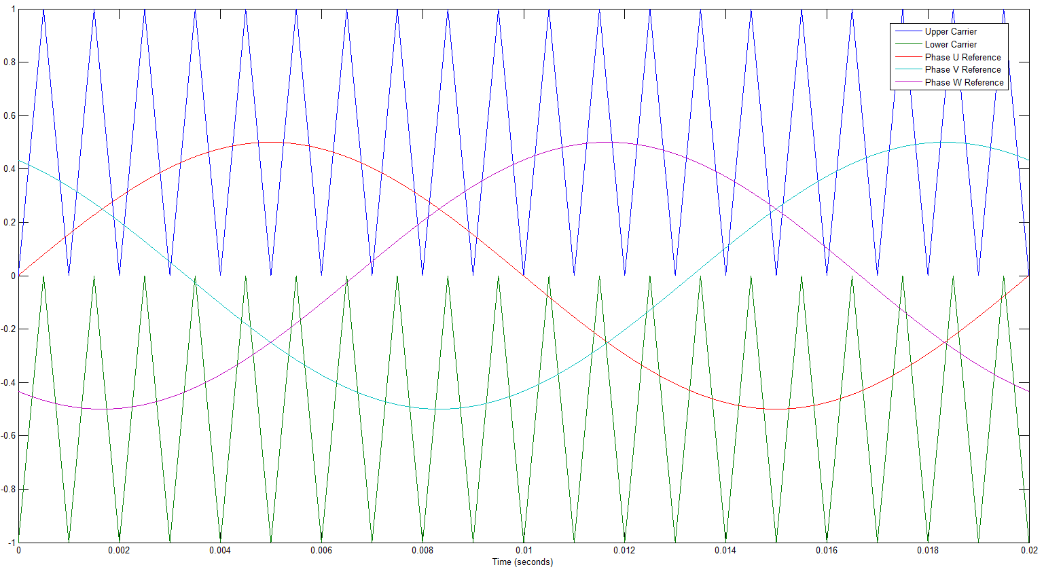
Fig. 2-8. Multiple Carrier Sine-Triangle PWM Generator

Table 2-1. - NPC Converter Switch State Logic
Voltage State | Condition | S11 | S12 | S13 | S14
+ | Phase Reference > Upper Carrier | On | On | Off | Off
0 | Phase Reference < Upper Carrier  And  Phase Reference > Lower Carrier | Off | On | On | Off
- | Phase Reference < Lower Carrier | Off | Off | On | On
Many papers have investigated losses in two-level and three-level inverters and have focused on the losses analytically as in [11] and [3] for two-level and three-level converters respectively, via simulation as in [6] and [10], and on hardware prototypes as presented in [10] and [11].

Additional Three-Level Topologies
Many additional multi-level topologies exist in addition to the NPC topology of Fig. 2-2 including, but not limited to, a second NPC topology introduced in [1] and shown in Fig. 2-9, the Capacitor-Clamped three-level inverter shown in Fig. 2-10, and the Active Neutral-Point Clamped (ANPC) inverter shown in Fig. 2-11.
Fig. 2-9. Second type of NPC-PWM Inverter [1]
Fig. 2-10. Capacitor-Clamped Three-Level Inverter
Fig. 2-11. The Active Neutral-Point Converter
Each topology has its own advantages and disadvantages. The second neutral-point clamped inverter of Fig. 2-9 has the same number of active and passive devices as the more common three-level NPC topology of
Fig. 2-2Fig. 2-2 with the primary difference being the voltage stresses applied to the IBGTs. The second topology requires the IGBT to block the full DC link voltage level whereas the first NPC three-level inverter IGBTs only block half of the DC link voltage. This allows the first NPC three-level inverter to have an output kilovolt-ampere (KVA) twice that of the second diode-clamped three-level inverter for similarly rated IGBT devices [1].
The capacitor-clamped three-level inverter shown in Fig. 2-10 replaces the 6 discrete diodes with 3 capacitors commonly referred to as flying-capacitors. The flying-capacitor size is inversely proportional to the chosen switching frequency and for high power, low switching frequency applications; the diode-clamped topology is the most common due to the cost tradeoffs between the flying-capacitors and the diodes [10]. The capacitor-clamped topology adds additional complexity in having additional capacitor voltages which must be balanced to yield the proper output waveforms. It has been shown in [13] and repeated in [2] that the capacitor-clamped topology is unsuitable for reactive power compensation due to the fact that the flying-capacitors will not self-balance in applications where no real power is involved. Capacitor voltage balancing for the flying-capacitor converter is more easily achieved in dc/dc conversion applications for which the capacitor-clamped structure was originally proposed [2], [14].
Multi-level converters are also used as rectifiers as previously stated in section 0. The topologies listed above may all be used as a rectifier. Because the rectifier is grid-tied and because some applications only require unidirectional power flow, a reduced-switch count topology, referred to as the Vienna Rectifier may also be used. This topology is shown in Fig. 2-12 and contains 18 diodes and 3 IGBTs. This particular topology operated with unity power factor control may be controlled without current sensors as presented in [4].
Fig. 2-12. Schematic of the power circuit of the Vienna Rectifier [4]

Tradeoffs
There are multiple tradeoffs that must be made when designing power converters including converter topology, filter size, switching frequency, cooling strategy, etc.. Many of these tradeoffs are inter-dependent. For example, the chosen switching frequency impacts the losses of the switching devices, the THD of the output current, and the size of the output filter. The losses of the switching device in turn impact the size of heatsink that must be selected to remove the amount of heat needed to keep the switching device operating within its thermal limits. A higher switching frequency will result in increased switching losses and decreased system efficiency but will allow for lower output current THD and an output filter with smaller size and weight [15].
The analysis carried out in [6] examined the tradeoff in topologies and PWM algorithms and their impact on the losses and the THD of two-level and three-level converters. For equal THD for the two-level and three-level converters, the three-level converter’s switching frequency was 20% less than that of the two-level converter. Another analysis presented in [6] was an equal power loss basis for both converter topologies. For this case, the three-level THD value was four times less than the two-level for a switching frequency of 37.5kHz compared with the two-level’s 20kHz switching frequency. This demonstrates the three-level converter’s ability to obtain lower THD performance with less system losses as compared with a standard two-level inverter which makes it very attractive to the aerospace industry where high efficiency and low THD are important [6].
The choice of the modulation strategy is another tradeoff for each converter topology. The same types of modulation strategies are available for two-level and three-level converters with the common algorithms being the sine-triangle reference PWM mentioned in section 2.1.3, sine-triangle with third-harmonic injection which adds a sinusoidal component at three-times the fundamental frequency with an amplitude of 1/6th, and space-vector modulation. The THD for the space vector modulation was found to be approximately 2% lower than the sine-triangle algorithm for the two-level inverter and 7% lower for the three-level converter but with slightly higher losses [6]. All types of PWM schemes are covered extensively in [16] for both two-level and multi-level converters and the weighted total harmonic distortion metric is used to analytically evaluate each strategy.
Another substantive tradeoff is the mechanical packaging of the converters. Three-level converters contain many more power circuit components than the standard two-level converter as mentioned in previous sections and as summarized in Table 2-2 below and which add complexity to the mechanical design compared to the two-level inverter. Multi-level inverters, especially for larger power sizes, require careful considerations to minimize the parasitic inductance of the DC bus structure which can cause voltage overshoots on IGBT devices, as well as effective thermal designs for each semiconductor device to ensure that the devices are operating within their thermal limits. Both of these design considerations are made much more complex for the higher number of components of the multi-level converters.

Table 2-2. Device Count Summary by Converter Topology
Converter Topology | No. of IGBTs  (Includes Freewheeling Diodes) | No. of  Diodes | No. of  Capacitor Voltages
Two-Level Inverter | 6 | 0 | 1
Two-Level Passive Rectifier | 0 | 6 | 1
Two-Level Active Rectifier | 6 | 0 | 1
Three-Level NPC Inverter | 12 | 6 | 2
Three-Level 12-pulse Passive Front End | 0 | 12 | 2
Three-Level NPC Active Front End | 12 | 6 | 2
Three-Level Vienna Rectifier | 3 | 18 | 2
Three-Level Capacitor Clamped Inverter | 12 | 0 | 5

Semiconductor Device Considerations
The IGBTs and diodes of each of the presented power converters provide the realization of the ideal switch that is the basis for the inversion of DC voltage to AC voltage. The careful application of these devices in power electronic converters is required to achieve the proper power output, converter size, and acceptable converter lifetime and reliability. Each device within a converter must be kept within its safe operating limits and is often derated, or used below its stated capabilities, in order to achieve particular levels of lifetime. The discrete power diodes are fairly robust and being a passive, or uncontrolled, self-commutating device their application is more straightforward than the IGBT. This is not to say that the proper application of the clamping diode is of any less importance than IGBT, but the extent of the tradeoffs in the selection of the diode is not as wide-ranging as the IGBT, and the diode has not been the subject of as many papers as the IGBT.

IGBT Thermal Considerations
IGBTs are sensitive to their operating temperature and thermal cycling as these items are the cause of many IGBT failure modes and reductions in lifetime. Common IGBT failure modes include breakdowns in the devices electrical and physical wire-bonding between its different layers brought about by thermal cycling [17], [18], and excessive vibration, and degradation of electrical parameters such as leakage current, threshold voltage, and an inability to turn off the device due to excessive device temperature [19]. The inability to turn off an IGBT will result in a catastrophic failure when its complimentary switch is turned on creating a “shoot-through” condition which places a low impedance fault across the DC link resulting in high levels of current which destroy the device.
The temperature of the IGBT also impacts the design of the power converter’s heatsink or other cooling means which then impacts the overall size of the power converter. The target maximum operating temperature of the IGBT dictates how much device cooling is required and what type of cooling will be employed such as forced air cooling with a heatsink or heatsink with heat pipes [2], or liquid cooling which increases the complexity of the cooling system due to the need for an additional hydraulic system to cycle the cooling liquid.
Many of an IGBT’s key operating parameters such as its turn-on, turn-off, and conduction losses are dependent on the temperature of the device [11] and careful design over the entire expected temperature range for a power converter must be done to ensure proper functionality in all operating conditions.

Device Temperature Measurement and Estimation
The critical temperature that is used for semiconductor selection is the junction temperature of the device. Due to the physical layout of the IGBT it is not possible to measure the junction temperature directly. Many commercial IGBT packages contain a Negative Temperature Coefficient (NTC) thermal sensor that will give a delayed feedback of the junction temperature with an offset that can be calculated. Due to the lag in the temperature measurement, using the NTC to detect short circuits or providing safety functionality for short term overloads is not recommended [20].
There are many different approaches, both offline and online, used to define the allowable operating conditions for particular power converters which result in acceptable device temperatures and converter lifetimes. Offline calculation and simulation approaches include closed-form analytical calculations of device losses and device temperatures for particular steady-state levels of voltages and currents presented in [3] and [11], time-based simulations using equivalent circuit models, or fast Fourier analysis based approach presented in [21] which uses thermal equivalent circuit models to greatly reduce simulation time compared with time-based simulation. The thermal equivalent circuit models are often provided on the manufacturer’s datasheet for a particular device and may be found through experimentation or by Finite Element Analysis (FEA) as described in [22] and [17].
Online calculation and estimation of device junction temperatures include using the same thermal models as state estimators in either open-loop or closed-loop observers presented in [12] and [18], or using measured in situ electrical quantities such as the ringing of the turn-on voltage spike to estimate the device temperature based on measured parameters which vary with temperature as presented in [22]. The in-circuit measurement strategy provides for high bandwidth junction temperature estimation and may perform better than observers which are highly sensitive to the parameters of the thermal model [22] but do require additional high speed voltage measurement circuitry to capture the ringing waveforms where the closed –loop observer obtains reasonably accurate measurements with sufficient bandwidth using the embedded NTC temperature sensor of the commercial device and very little additional computation in today’s digitally controlled converters.

Thermal Control
As will be shown in Section 3, the losses of the IGBT and its equivalent thermal model determine the dynamic thermal performance of the device. The losses and temperature of the devices are dependent on many factors including the switching frequency of the converter [3], the selected cooling strategy of the converter [2], the power factor of the load [3], the devices electrical and physical characteristics [11], and the gate drive circuitry of the IGBTs. Designers of power converters may incorporate offline and passive thermal designs which only include selected components which remain static over the course of the converter, or active thermal designs in which the converter alters its operation and performance based on measured system values, or a combination of both methods.
An example of a hybrid thermal design which includes both passive and active considerations contains a particular choice of heat sink to accommodate the peak steady state losses based on the selected IGBTs and their gate drive circuitry and the selected base switching frequency, a correctly sized fan to provide enough cooling air to dissipate those losses, as well as actively controlled logic which changes the switching frequency during the operation of the converter to keep the maximum junction temperature and the delta junction temperature of the converter within acceptable limits. This active approach is detailed in [17] and uses a high bandwidth estimate of the junction temperature and allows the converter to adapt to dynamically changing operating conditions over the lifetime of the converter where the passive thermal design only accounted for nominal load profiles and sufficient safety margins.
The remainder of this paper focuses active online thermal control of the three-level NPC using high-bandwidth estimated junction temperatures of the NPC’s silicon devices and the redundant states of the three-level NPC to equalize junction temperatures and minimize delta junction temperatures to reduce the thermal mismatch between devices and to increase the converter’s overall reliability and lifetime.

Modeling and Control
___________________________________________________________________________

This chapter provides the theoretical and analytical foundations for the IGBT and three-level NPC modeling as well as the implementation details for the operation of the converter and the control schemes that will be evaluated as they pertain to the converter’s output capabilities and lifetime.

Semiconductor Losses

IGBT Losses
IGBT losses include conduction losses due to its finite saturation voltage and the current passing through the device, the switching energy required during turn-on and turn-off transients, as well as secondary losses including the leakage current in its blocking state and gate driver circuit losses. The conduction, turn on, and turn off losses are the most substantial losses and dominate the thermal operating characteristics of the device and will be the only IGBT losses calculated in this report.
Conduction losses in semiconductor device are typically calculated for particular time-averaged, steady state cases using Root Mean Square (RMS) values of voltages and currents, and the turn-on and turn-off losses are calculated as a function of the inverter’s switching frequency scaled from a base operating point. The common equations for losses appear in numerous papers including [3], [9], and [11], and in most manufacturer’s application notes and are calculated using datasheet values for a given operating point.
The instantaneous conduction losses are a combination of the collector current and the collector-emitter voltage, v_{ce}, which is dependent on the collector current, i_{c}, its zero-current collector-emitter voltage, v_{ceo}, and its collector-emitter on-state resistance, r_{c} as follows:
$v_{ce}\left(i_{c}\right)=v_{ceo}+r_{c}*i_{c}$ (1)
Using (1), the instantaneous conduction loss for an IGBT as a function of time is given as:
$P_{cond,IGBT}\left(t\right)=v_{ce}\left(t\right)*i_{c}\left(t\right)=v_{ceo}*i_{c}(t)+r_{c}*i_{c}^{2}(t)$ (2)
From (2), and using the average and rms values of the IGBT current, the average losses are:
$P_{cond,IGBT,rms}=v_{ceo}*i_{c,ave}+r_{c}*i_{c,rms}^{2}$ (3)
The values for v_{ce}(i_{c}) and r_{c} are given on most manufacturer’s datasheets [3] along with the energy required for each turn-on and turn-off event at a base level which is used to calculate the switching losses for the device presented in [3] and given as:
$E_{i,igbt}=\frac{E^{R}}{V^{R}I^{R}}v_{i}i_{i}$ (4)
For (4), E_{i} is the energy in the i'th switching event and E_{r}, V_{r}, and I_{r} are the base values and this energy is scaled by the actual operating point voltage and current under the assumption that the energy is linearly dependent on these values. E_{r}, V_{r}, and I_{r} have different values for the turn on and turn off energies. For the total switching losses, all switching events in a cycle are summed, or may be approximated as an average by multiplying the turn-on and turn-off losses by the switching frequency as follows:
$P_{sw}=f_{sw}*(E_{on}+E_{off})$ (5)
The difference in switching losses for the two-level versus the three-level based on (5) for particular modulation strategies is due to the effective switching frequency for each inverter. Using the multiple-carrier sine triangle modulation, each switch only switches during ½ of the fundamental period for the three-level inverter in contrast with the switches for the two-level inverter where each device switches during the entire cycle. For this modulation scheme, this allows each IGBT of the three-level inverter to have effectively one-half the switching losses compared with a two-level inverter.

Diode Losses
Diode losses are characterized as conduction losses which have the same form as the IGBT’s conduction losses, and reverse recovery losses which have the same form as the IGBT’s turn-on or turn-off losses. These equations are:
$P_{cond,diode,rms}=v_{on,diode}*i_{d,ave}+r_{d}*i_{d,rms}^{2}$ (6)
$E_{rr,diode}=\frac{E_{rr}}{V_{rr}I_{rr}}v_{i}i_{i}$ (7)
$P_{sw,diode}=f_{sw}*E_{rr}$ (8)

Total Losses for Three-Level NPC
Due to the structure of the three-level NPC, the inner and outer switches, the inner and outer free-wheeling diodes, and the clamping diodes all experience different levels of average and rms current over a fundamental cycle. Based on this, each set of devices have their own closed-form loss equations which are functions of the operating modulation index, M, and power factor, φ, and the peak level of current, $\hat{I},$ and which were summarized in [23] and repeated here as follows:
- T1 &T4:
$P_{cond,T1\&T4}=\frac{M\hat{I}}{12π}\left\{3v_{ce0}∙{\left[\left(π-φ\right)∙\cos\left(φ\right)+\sin\left(φ\right)\right]+2r}_{ce}\hat{I}∙[1+\cos\left(φ\right)]^{2}\right\}$ (9)
$P_{sw,T1\&T4}=f_{sw}E_{sw}(\frac{\hat{I}}{I_{ref}})^{K_{I}}∙(\frac{V_{cc}}{V_{ref}})^{K_{V}}∙(\frac{1}{2π}\left[1+cos⁡(φ)\right])∙G_{I}$ (10)

- T2 & T3:
$P_{cond,T2\&T3}=\frac{\hat{I}}{12π}\left\{v_{ce0}∙{\left[12+3M\left(φ\cos\left(φ\right)-\sin\left(φ\right)\right)-3Mπ\cos\left(φ\right)\right]+r}_{ce}\hat{I}∙[3π-2M(1-\cos^{2}\left(φ\right)]\right\}$ (11)
$P_{sw,T2\&T3}=f_{sw}E_{sw}(\frac{\hat{I}}{I_{ref}})^{K_{I}}∙(\frac{V_{cc}}{V_{ref}})^{K_{V}}∙(\frac{1}{2π}\left[1-cos⁡(φ)\right])∙G_{I}$ (12)
- D1 & D4:
$P_{cond,D1\&D4}=\frac{M\hat{I}}{12π}\left\{{3v}_{f0}∙{\left[-φ\cos\left(φ\right)+sin⁡(φ)\right]+2r}_{f}\hat{I}∙[1-cos\left(φ\right)]^{2}\right\}$ (13)
$P_{sw,D1\&D4}=f_{sw}E_{sw}(\frac{\hat{I}}{I_{ref}})^{K_{I}}∙(\frac{V_{cc}}{V_{ref}})^{K_{V}}∙(\frac{1}{2π}\left[1-cos⁡(φ)\right])∙G_{I}$ (14)
- D2& D3
$P_{cond,D2\&D3}=\frac{M\hat{I}}{12π}\left\{{3v}_{f0}∙{\left[-φ\cos\left(φ\right)+sin⁡(φ)\right]+2r}_{f}\hat{I}∙[1-cos\left(φ\right)]^{2}\right\}$ (15)
$P_{sw,D2\&D3}=0$ (16)
- D5 & D6
$P_{cond,D5\&D6}=\frac{\hat{I}}{12π}\left\{v_{f0}∙{\left[12+3M[\left(2φ-π\right)\cos\left(φ\right)-2sin⁡(φ)]\right]+r}_{f}\hat{I}∙[3π-4M(1+\cos^{2}\left(φ\right)]\right\}$ (17)
$P_{sw,D5\&D6}=f_{sw}E_{sw}(\frac{\hat{I}}{I_{ref}})^{K_{I}}∙(\frac{V_{cc}}{V_{ref}})^{K_{V}}∙(\frac{1}{2π}\left[1-cos⁡(φ)\right])∙G_{I}$ (18)
For equations (9) – (18), V_{ce0}, r_{ce}, V_{f0}, r_{f}, K_{I}, K_{V}, G_{I}, V_{CC}, V_{ref}, and I_{ref} are device specific parameters and are commonly found in vendor datasheets.
The total losses for each device are the sum of the conduction and switching losses for the IGBTs and the sum of the conduction and reverse recovery losses for the diodes.
$P_{igbt}=P_{cond,igbt,rms}+P_{sw,igbt}$ (19)
$P_{diode}=P_{cond,diode,rms}+P_{sw,diode}$ (20)

IGBT/Diode Thermal Models
Thermal models for semiconductor devices are common and are usually presented in one of two different forms, the Cauer Model and the Foster Model, also referred to as the T-model and π-Model respectively [24]. The models, shown in Fig. 3-1 and Fig. 3-2, both accurately represent the junction temperature, Tj, of the device with respect to the ambient temperature, Ta. The primary difference between the two models is that the Cauer model represents the exact physical makeup of each layer of the device whereas the Foster model is an approximation based on measured values and curve fitting with a particular order system.
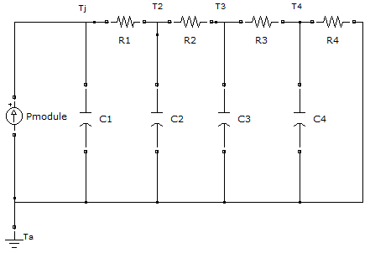
Fig. 3-1. 4th Order Cauer Thermal Model

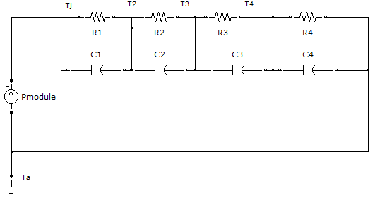
Fig. 3-2. 4th Order Foster Thermal Model
The main benefit of the Cauer model is the representation of the temperature for each physical layer of the device shown as Tj, T2, T3, and T4. This is important in the event that each layer has its own maximum temperature or delta-temperature stress requirements. The Cauer model is more difficult to obtain than the Foster model and is typically done with the help of Finite Element Analysis (FEA) simulation tools [17]. Another benefit of the Cauer model is the series connection of additional Cauer models for thermal interface materials and heatsinks for a complete thermal design.
Manufacturers typically provide datasheet values for Foster thermal models, not Cauer models, where the temperatures T2, T3, and T4 only represent intermediate values of the model with no correlation to any actual physical temperature. This is again due to the ease in obtaining the Foster model based on simple lab measurements. While it is possible to transform a Foster Model to a Cauer Model or vice-versa, the transformed models are not unique and the connection of a transformed model to a heatsink model may result in significant errors [25]. Errors in the dynamic, non-steady state values also occur for the series connection of Foster models. These errors are greatly reduced at steady state.
Because IGBTs contain free-wheeling diodes (FWDs) in the same package which are mounted on a single heatsink, the total module losses are a combination of the two devices’ losses and detailed thermal analysis would take into account the thermal cross-coupling of this thermal design. For the purpose of this paper, however, each device, including the FWD’s, will be assumed to be discrete and independent devices with their own models.

Junction Temperature Estimation
Because the Cauer and the Foster thermal models contain energy storage devices they can be converted into State-Space Models of the following form:
$\dot{x}\left(t\right)=Ax\left(t\right)+Bu\left(t\right)$ (21)
$y\left(t\right)=Cx\left(t\right)+Du\left(t\right)$ (22)
The x and u vectors for both models are the same and is given in (23):
$x=\left[\begin{matrix}Tj \\ T2 \\ T3 \\ T4\end{matrix}\right]$,$u=\left[\begin{matrix}P\end{matrix}\right]$ (23)
Tj, T2, T3, and T4 are the temperatures at each node, and P is the input power to each device.
The A matrices for the Cauer and Foster models are given (24) and (25) respectively:
$A_{Cauer}=\left[\begin{matrix}\frac{-1}{C1*R1} & \frac{1}{C1*R1} & 0 & 0 \\ \frac{1}{C2*R1} & \frac{-1}{C2}\left(\frac{1}{R1}+\frac{1}{R2}\right) & \frac{1}{C2*R2} & 0 \\ 0 & \frac{1}{C3*R2} & \frac{-1}{C3}\left(\frac{1}{R2}+\frac{1}{R3}\right) & \frac{1}{C3*R3} \\ 0 & 0 & \frac{1}{C4*R3} & \frac{-1}{C4}\left(\frac{1}{R3}+\frac{1}{R4}\right)\end{matrix}\right]$ (24)
$A_{Foster}=\left[\begin{matrix}\frac{-1}{C1*R1} & 0 & 0 & 0 \\ 0 & \frac{-1}{C2*R2} & 0 & 0 \\ 0 & 0 & \frac{-1}{C3*R3} & 0 \\ 0 & 0 & 0 & \frac{-1}{C4*R4}\end{matrix}\right]$ (25)
The B matrices for the Cauer and Foster modesls are given in (26) and (27) respectively:
$B_{Cauer}=\left[\begin{matrix}\frac{1}{C1} \\ 0 \\ 0 \\ 0\end{matrix}\right]$ (26)
$B_{Foster}=\left[\begin{matrix}\frac{1}{C1} \\ \frac{1}{C2} \\ \frac{1}{C3} \\ \frac{1}{C4}\end{matrix}\right]$ (27)
The C matrices for the Cauer and Foster models to yield a single output which is the junction temperature, Tj, are given in (28) and (29) respectively:
$C_{Cauer}=\left[\begin{matrix}1 & 0 & 0 & 0\end{matrix}\right]$ (28)
$C_{Foster}=\left[\begin{matrix}1 & 1 & 1 & 1\end{matrix}\right]$ (29)
The D matrix is 0 for both models.
A block diagram representation of the state space model is given in Fig. 3-3 below:
Fig. 3-3. State Space Model Block Diagram
The necessity for modeling the thermal behavior is due to the available temperature feedback being nonexistent or only being present as a case temperature from on on-board NTC temperature measurement which is far away from the critical measurement of the junction temperature with much lower dynamics. By applying a thermal model, the junction temperature can be estimated using open or closed loop temperature observers depending on what feedback signals are available.
The general block diagram of the open loop observer is given in Fig. 3-4. In this diagram, any quantity with a “^” is an estimated quantity.
Fig. 3-4. Open Loop Observer Block Diagram
Using observers is an attractive option for thermal models because they provide “zero lag” tracking properties [12] which allows a system to estimate highly dynamic quantities, in this case the junction temperature, without the measurement lag of the NTC temperature sensor. A drawback of the open loop observer is its sensitivity to parameter errors which leads to magnitude and issues with low frequency stability [12].
Using the closed loop observer shown in Fig. 3-5 allows for all the traditional benefits of closed loop control systems such as zero steady state error, disturbance rejection, and compensation for parameter errors as well as benefits of “sensor replacement” which uses the filtered, estimated states as the system feedback to eliminate sensor noise issues [12].
Fig. 3-5. Closed Loop Observer Block Diagram
Disturbances may include unequal cooling for particular devices located on discrete heatsink due to fan failures, blocked air filters, or unequal loss distribution due to unbalanced circuit parasitics as a function of the converter’s mechanical packaging. Parameter estimation errors may be due to differences from device to device based on their manufacturing tolerance, the application of thermal grease and differences in the semiconductor devices’ thermal conductivity to the heatsink, and parameter drift due to aging as the converter is used over the course of its lifetime. The closed loop observer is able to compensate for these disturbances and parameter estimation errors where the open loop observer cannot.
Closed loop observers are typically only applied to those systems which pass the observability test which states that the rank of the observability matrix must equal the number of system states. The observability matrix, O, for a 4th order system is given in (30):
$O=\left[\begin{matrix}C \\ CA \\ CA^{2} \\ CA^{3}\end{matrix}\right]$ (30)
Closed loop observers can only be properly formed for systems which have at least one state feedback parameter available. In the case of a typical IGBT this may be an NTC temperature. If the NTC temperature feedback is not available, this may also be an external sensor that measures the case temperature of the device, or a sensor embedded in the heatsink of each device, or an ambient temperature sensor or a combination of all of these depending on the level of acceptable thermal model complexity for the converter application. In an industrial drive, nuisance trips due to failed sensors may cause negative opinions of a unit’s perceived reliability and tradeoffs are made to ensure proper and robust converter functionality and minimizing the occurrence of nuisance faults.
The controller gains matrix L for the closed loop observer may be determined using traditional pole-placement techniques or by using a two-step trial and error process described in [12] in which tunes the open loop path to obtain zero lag tracking and the second step in which disturbances are injected into the system and the controller is tuned to yield sufficient disturbance rejection bandwidth.
The Cauer model will be used as the physical model for the formation of the temperature observer based on the fact that it is observable according to the observability test and because its feedback temperature is one of the system’s state variables. The Foster model does not pass the observabilty test as its observability matrix rank is 0 and not 4. The Foster model also does not have a measured feedback state with physical meaning to close the loop on the observer. The Foster model is suitable to be used as an open loop observer but it will have the drawbacks listed above as compared with the closed loop observer.
Because the system will use a single temperature feedback for the case temperature, the error gain matrix will have a single element. This is referred to as a “Reduced Order Observer” in which not all state variables are available measured quantities. The effects on the estimated junction temperature for different values of the error gain L must be investigated thoroughly to appropriately reject system and measurement disturbances.

Three-Level Electrical Model
The focus of this paper is on the ability of a temperature controller to manipulate device temperatures using a three-level NPC and not other typical converter considerations such as minimization of THD, sizing of passive filter components, DC link balancing, or common mode current minimization. To simplify the analysis, the model shown in Fig. 3-6 will be used.
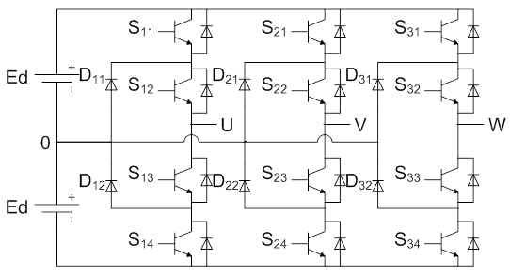
Fig. 3-6. Simplified Three-Level NPC
This model replaces the passive LC filter of Fig. 2-2 with two balanced, stiff DC sources. This removes the complexity of balancing the DC link by way of the controller and eliminates erroneous results based on improper selection of the LC filter.

Electrical Control Principle
The control of the output voltage will be an open loop fixed Volts/Hertz (V/F) output. This algorithm has a fixed modulation index and output frequency regardless of system loading. This control scheme is commonly referred to speed open loop operation. Due to the rated slip of most induction machines being on the order of a few percent at rated load, the output speed is very close to the commanded speed from no load to full load. To achieve constant torque output, a constant ratio of output voltage per output frequency is maintained from ~zero speed to rated speed.

PWM Generation
There are many PWM generation techniques that are used for power inverters as described in other sections of this paper. The multiple carrier technique of Fig. 2-8 will be used to regulate the temperature of the upper or lower devices with the appropriate selection of offset signal which sets a ratio between the upper and lower devices. This method is commonly used to regulate the DC link where the current paths are selected based on net current flow in or out of the two DC links in order to balance their steady state voltages. For the purpose of temperature control, while it will not be the case that all upper or lower devices will share the same temperature differences in all cases, 2 common causes of temperature imbalance due to DC link imbalance and low frequency operation can be alleviated with appropriate selection of the offset signal. This algorithm can operate at a different frequency than the PWM generator with the tradeoffs being additional switching losses if the temperature algorithm runs faster than the voltage generator algorithm and a larger junction temperature ripple for slower temperature control.
An illustration of the PWM common mode carrier offset is shown in Fig. 3-7.
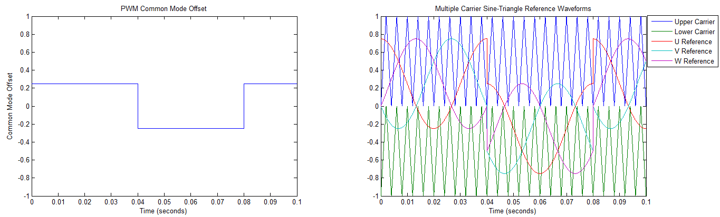
Fig. 3-7. Sine Triangle Waveforms with Common Mode Offset
The plot on the left shows the common mode offset signal and the plot on the right shows the resultant sine wave reference waveforms. This strategy results in no change to the differential output voltage or output current.
A second option would be to use a modified space vector technique which uses temperature measurements to select the redundant states which will be used. This algorithm would run at the switching frequency and would not result in any additional switching losses over the base case. This space vector algorithm will not be used in this thesis.

Electrical Loading
The thermal behavior of the power converter semiconductor devices is the main focus of this paper and not dynamic electrical performance of the converter or its load. With this in mind, the three-level NPC will be operated under different output current conditions and power factors using a calculated passive balanced three-phase RL load as shown in Fig. 3-8.
Fig. 3-8. Balanced Three-Phase Passive Load
This R-L load is selected for a given peak current value, I_{peak}, Modulation Index, M, power factor, cos(φ), DC link level, V_{DC}, and output frequency, f_{Power}, as defined in the equations below:
$V_{out}=\frac{\sqrt{3}}{2*\sqrt{2}}M*V_{DC}$ (31)
$Z=\frac{\sqrt{2}*V_{out}}{\sqrt{3}*I_{peak}}$ (32)
$R=Z*cos⁡(φ)$ (33)
$L=\frac{\sin\left(φ\right)*Z}{2*π*f_{Power}}$ (34)

Loss Modeling
The equations for the losses for each type of device are provided in section 3. For the purposes of simulating the losses, the current magnitude and direction and the state of each IGBT must be known. Most industrial drives use either one or two DC output current sensors or two or three AC output current sensors. The choice of the number of current sensors is a tradeoff between cost and fault detection. In a balanced three-phase system, all three phase currents sum to 0. Based on this fact, only 2 current sensors are necessary with the third phase current being able to be calculated from the other two. This works in theory for balanced three-phase loads with no earth faults. In practice, most drives have output current sensors on all three phases such that they provide higher dynamic performance and to detect output short circuits and ground faults. In this paper, it is assumed that the current magnitude and direction in each device is known. The state of each IGBT is also known as it is a commanded value.
The modeling of the device losses for this report will assume a static forward voltage drop and on-state resistance for each device that is not dependent on device current or temperature. This is not true for actual semiconductor devices as evidenced by any component’s datasheet. Because a closed loop observer is used, any errors in the thermal model, including errors in the model’s input, are compensated for which reduces the complexity of the input loss calculation implementation considerably. A possible option to implement the non-linear behavior would be a lookup table derived from the datasheet that would take into account device temperature and current. The losses for the upper devices will be calculated on a step-by-step basis using the current magnitudes and device parameters. The losses for the lower devices will not be explicitly modeled to improve simulation time and are assumed to be identical to the upper devices due to the symmetry of the converter topology and current outputs.

Temperature Control Schemes
Two temperature control schemes will be investigated, one open loop, and one closed loop. The open loop algorithm will use a square wave with a 50% duty cycle at a particular control frequency to shift the operation of the converter between the upper and lower devices. This algorithm will make a tradeoff between increased switching and conduction losses in the outer devices to attempt to minimize the conduction losses of the inner devices. Based on the equations of section 3.1.3, the losses for the inner and outer IGBTs become more and more imbalanced for smaller and smaller modulation indexes. For these smaller and smaller modulation indices, there is a larger and larger degree of freedom to move the common mode reference for the 3 carrier waveforms to the upper or lower carrier band. For modulation indices less than 0.5, the operation can be moved entirely into the upper or lower band without impacting the differential voltage output.
To maximize the topology which is really two two-level converters in one, the common mode reference will be pushed the upper and lower boundary conditions. In this case, the common mode carrier signal will have a predefined value of:
$CM\left(t\right)=\left\{\begin{aligned}1-M, for t<\frac{nT}{2} \\ -1+M, for t>\frac{nT}{2}\end{aligned}\right.$ (35)
This is similar to a recommended possible strategy presented in [10], with the distinction that the strategy in [10] has the offset centered at +/- 0.5 and the signal alternating between the upper and lower bands at half the fundamental frequency. The strategy provided in [10] does not take full advantage of the NPC topology for modulation indices less than 0.5 and at very lower frequency operation, alternating between the lower and upper carrier bands at half the fundamental frequency does not effectively distribute the losses before the IGBTs reach their thermal steady state. The proposed strategy in (35) will be done at 1/10th of the switching frequency to more effectively distribute the losses on average without impacting the differential output voltage with minimal additional switching losses.
The second temperature control scheme will be a closed-loop approach and will use the measured temperatures of the devices to adjust the level of the DC offset in the carrier waveform signals to attempt to balance the average temperatures of the outer devices. For the outer devices, it can be shown that for a modulation index of 0.5 or less the upper or lower outer IGBTs can be made to have no conduction or switching losses due to never being turned on. This is not possible for the inner devices which must be turned on to provide the proper bidirectional voltage and current semiconductor configuration. This strategy is only valid for common mode carrier waveform offsets that do not exceed the triangle carrier waveforms (neglecting over-modulation). For most operating points this is sufficient due to very small offsets in the common mode signal leading to large temperature differences. For a particular converter, it is unlikely that the unit will operate at maximum output for any length of time due to sizing converters for some amount of short term overload.

Simulation Results
___________________________________________________________________________

This chapter presents the results for the temperature estimation and loss and temperature balancing algorithms.

Junction Temperature Estimation
The generic 4th order Cauer thermal model given in Fig. 3-1 was used for junction temperature estimation for all devices and has the R and C thermal coefficients given in Table 4-1.
Table 4-1. Cauer Thermal Parameters
Resistor | R Value | Capacitor | C Value | Tau (seconds)
R1 | 0.8 | C1 | 0.001 | 0.0008
R2 | 4 | C2 | 0.0032 | 0.013
R3 | 13.2 | C3 | 0.0038 | 0.05
R4 | 1.5 | C4 | 0.4 | 0.6

Open Loop Observer
The results of the open-loop state space thermal model for the junction temperature observer were compared with a Simulink circuit model with the same parameters for a step input of 5 Watts. The results for the case and junction temperatures with respect to ambient are given in Fig. 4-1and Fig. 4-2 below.
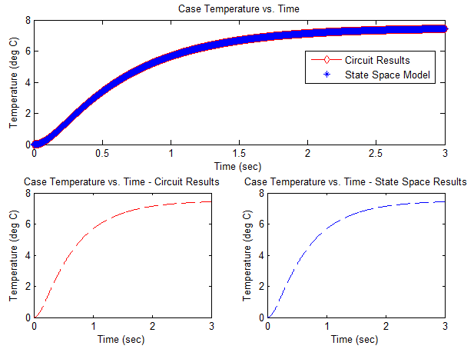
Fig. 4-1. Case Temperatures vs. Time – Simulation Results
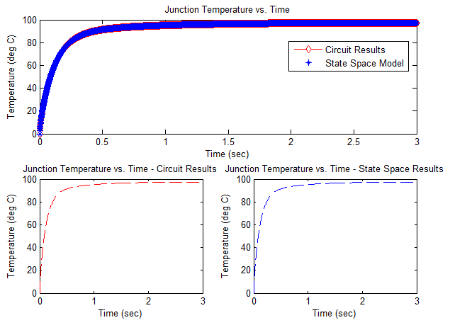
Fig. 4-2. Junction Temperatures vs. Time – Simulation Results
Both figures show that the circuit thermal model and the state space thermal mode yield identical results. Because the results are identical, it is hard to discern the results and the individual outputs for each model are provided for additional clarity that the models are identical.

Open Loop Estimations with Parameter Deviations
Due to manufacturing, aging, heatsink performance, and thermal interface materials it is not true that the thermal performance of each model will always be the same for the lifetime of the module. To demonstrate the possibility for 10% variation in the resistance and capacitance values of the model the results for four separate cases defined in Table 4-2 are obtained and compared with the nominal baseline case as shown in Fig. 4-3 and Fig. 4-4.
Table 4-2. Parameter Deviation Cases
Case | R Values | C Values
1 | -10% | -10%
2 | -10% | +10%
3 | +10% | -10%
4 | +10% | +10%
Fig. 4-3. Case Temperatures vs. Time – With Parameter Deviation
Fig. 4-4. Junction Temperatures vs. Time – With Parameter Deviation
The high frequency transient responses for each system are relatively similar but the steady state values show large variations in the output. These steady state variations are summarized in Table 4-3 and are closely tied to the variation in the thermal resistance whereas the high frequency differences are more dependent on the thermal capacitance variations.
Table 4-3. Steady State Parameter Deviation Results
Case | Case Temp Max  [deg C] | % Baseline Deviation | Junction Temp Max  [deg C] | % Baseline Deviation
Baseline | 7.43 | 0% | 97.41 | 0%
1 | 6.73 | -9.42% | 87.72 | -9.94%
2 | 6.69 | -9.96% | 87.67 | -10%
3 | 8.18 | 10.09% | 107.16 | 10%
4 | 8.07 | 8.6% | 107.02 | 9.87%

Closed Loop Observer Tuning
To correct for the steady state errors in the observer output, an error gain can be added to close the loop on the observer. Because there is only one measured state, there is only a single gain value to be tuned. This gain can be varied using trial and error until an appropriate system response is found. The closed-loop estimator response for various gains is shown below in Fig. 4-5.
Fig. 4-5. Junction Temperature Estimates vs. Time – Various Error Gains
The results in Fig. 4-5 show that a gain of 65 makes the system stable but oscillatory. A gain of 75 pushes the system into instability. Fig. 4-6 shows the same results with removing the semi-stable and unstable cases.
Fig. 4-6. Junction Temperature Estimates vs. Time – Stable Gain Selections Only
The gain of 10 shows an over-damped response while the gain of 0.1 yields a large steady state error similar to the open loop case. The gain of 1 is selected as an intermediate result with suitable high frequency response and limited steady state error.
For this single input, single output system, an integrator could be added to the error path to yield zero steady state error. This integrator should have an appropriate gain to yield suitable response time approximately one order of magnitude longer than the proportional gain. Too high of an integral gain may yield unstable behavior with poor disturbance rejection properties while too low of a gain will yield poor dynamic response with large steady state error.
An integral gain of 0.5 is selected based on the considerations above. The final response to a step input for the case and junction temperatures is given in Fig. 4-7.
Fig. 4-7. Case and Junction Temperatures vs. Time For Closed Loop Observer Model

Input Disturbance Rejection
As described in the theoretical background section, the closed-loop observer helps eliminate steady state error due to model parameter deviations as well as helping to eliminate input disturbances based on current measurement or device physical property estimation errors. Fig. 4-8 shows the case and junction temperature response for a step change of 10% to the physical model but not to the estimator model simulating an input disturbance. The closed loop observer is able to reject this disturbance to maintain zero steady state error for the case and junction temperatures with zero steady state error.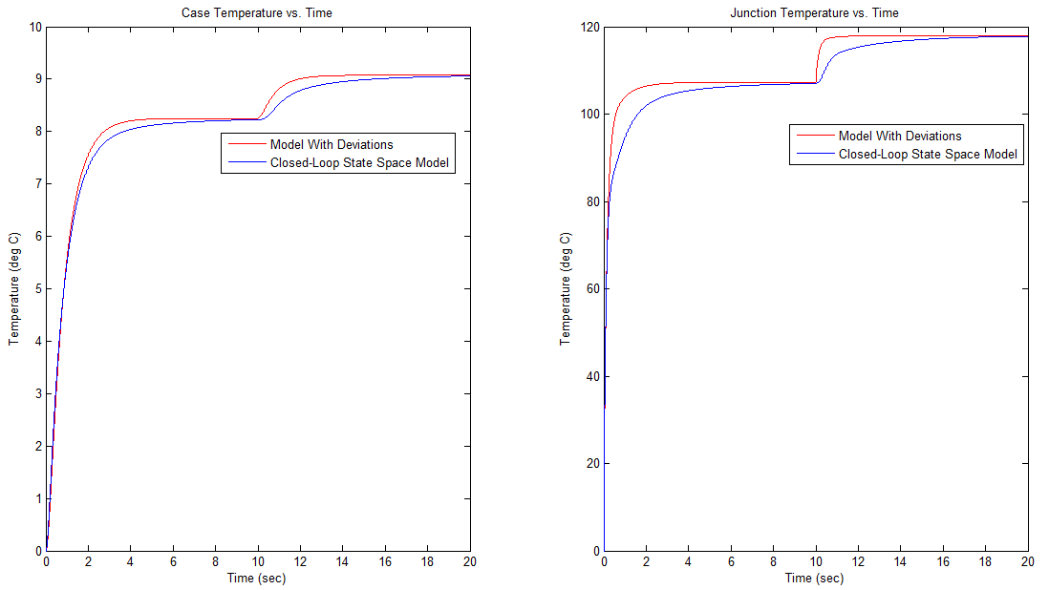
Fig. 4-8. Closed Loop Input Rejection Performance

Measurement Disturbance Rejection
Some care must be taken to ensure that any noise within the bandwidth of the error estimator is removed as this noise will be passed through the system and amplified with respect to the junction temperature measurement. Higher frequency noise is filtered out by the model and the resulting case temperature reading may be used as the available variable. This is typically done to provide an accurate filtered measurement for states which aren’t already measured or filtered.
Two cases to illustrate these points are presented in Fig. 4-9 and Fig. 4-10. Both cases inject a sine wave with 0.25 amplitude on the case temperature measurement. The first is a 60 Hz signal, the second a 1 Hz signal.
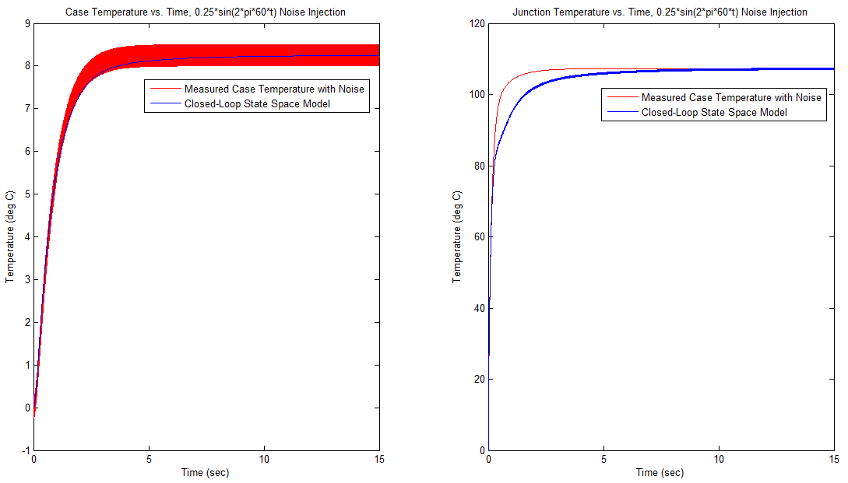
Fig. 4-9. Closed Loop Observer Model with 60Hz Noise Injection
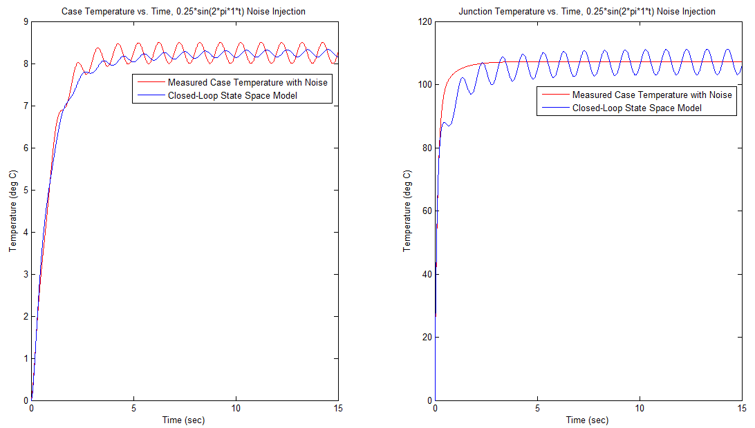
Fig. 4-10. Closed Loop Observer Model with 1Hz Noise Injection
These results show that for the given closed-loop observer, high frequency measurement noise is effectively filtered out, but low frequency measurement noise is actually amplified by the system. The same issues arise for a steady-state measurement error which may cause the estimated junction temperature to be well above its actual temperature. All of these considerations must be taken into account when deciding on using the open versus closed-loop observer and in the tuning of the observer gains.

Simulated vs. Calculated System Losses
MATLAB and Simulink were used to simulate the system losses for various operating points to validate the three-level NPC device loss equations in section 3.1.3. The simulated model is shown in Appendix A. The output voltage and current for the baseline operating point with a modulation index of 1, output frequency of 50Hz, and peak current amplitude of 10 Amps at a 0.8 lagging power factor are given in Fig. 4-11 below. The full DC link voltage for this converter was 653 Volts and the switching frequency was 7.5 kHz.
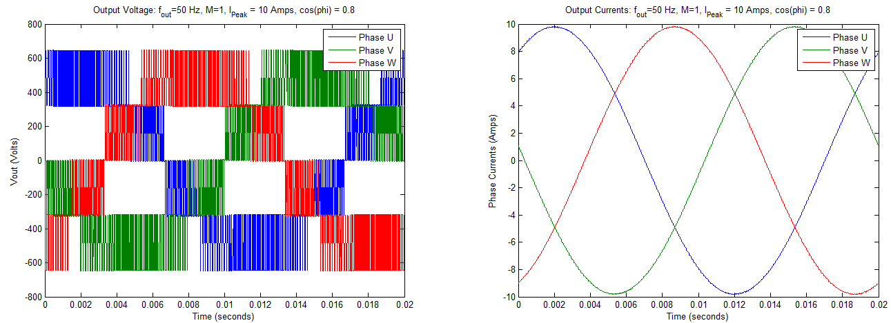
Fig. 4-11. Three-Level Neutral Point Clamped Inverter Voltage and Current Output, M = 1
The three level NPC device that was selected was the Semikron SK30MLI066 module. This module includes all IGBTs, free-wheeling diodes, and clamping diodes for a single phase leg. The three-level NPC that is simulated would use three of these modules.
Table 4-4. SK30MLI066 Device Parameter Values
Device Parameter | Parameter Value
Kv_igbt | 1.4
Kv_diode | 0.6
Ki_igbt | 1
Ki_diode | 0.6
Vce0 | 1
Rce | 1.15
Vf_fwd | 1.65
Vf_clamp | 27e-3
rf_fwd | 1
rf_clamp | 20e-3
Esw_igbt | 2.74e-3
Esw_fwd | 0.26e-3
Esw_clamp | 0.26e-3
Vcc_igbt | 0.5*Udc
Vref_igbt | 300
Iref_fwd | 30
Vcc_clamp | 0.5*Udc
Vref_clamp | 300
Iref_clamp | 30
Esw_on_igbt | 0.97e-3
Esw_off_igbt | 1.77e-3
The calculated losses using these values were compared with the simulated loss values for modulation indices ranging from 1 down to 0.04. A constant Volts/Hz ratio and approximate peak current output were maintained for each operating point. The losses for the first case for a modulation index of 1 and output frequency of 50 Hz is shown below in Fig. 4-12.

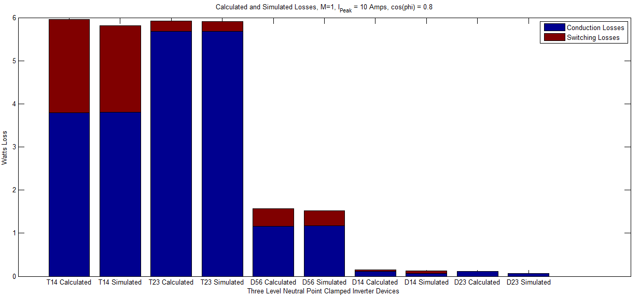
Fig. 4-12. Calculated vs. Simulated Losses Modulation Index = 1
Fig. 4-12 shows nearly identical results for the calculated and simulated loss results for all components with only slight discrepancies in the switching losses for the outer IGBTs. In this figure and the following calculated vs. simulated loss figures T14 refers to the outer IGBTs S11 and S14, T23 refers to the inner IGBTs S12 and S13, and D56 refers to the clamping diodes D1 and D2. The losses in the free-wheeling diodes D1-D4 are minimal due to the 0.8 power factor and will not be mentioned further. For this case, the output current and switching frequency were adjusted to yield nearly identical total losses for all IGBTs to help demonstrate the imbalance caused at other operating points.
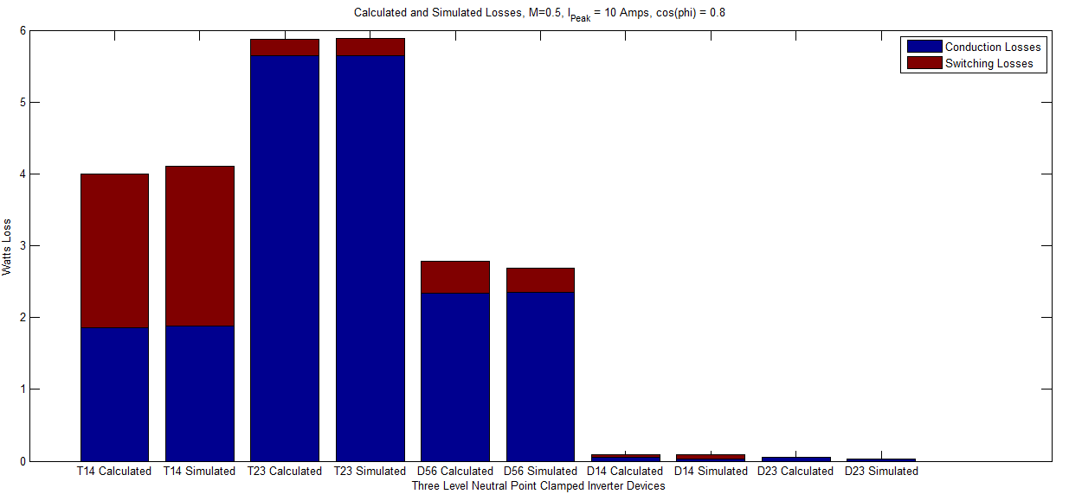
Fig. 4-13. Calculated vs. Simulated Losses Modulation Index = 0.5
Fig. 4-14 again shows the nearly identical results between the calculated and simulated values. For this case, the modulation index and frequency have been reduced by a factor of 2 (M=0.5, f=25Hz) and the imbalance between the inner and outer IGBTs is becoming apparent. For the same peak output current, the losses of the inner IGBTs remains nearly constant as in the M=1 case, but the losses in the outer IGBTs has dropped by approximately 33%.

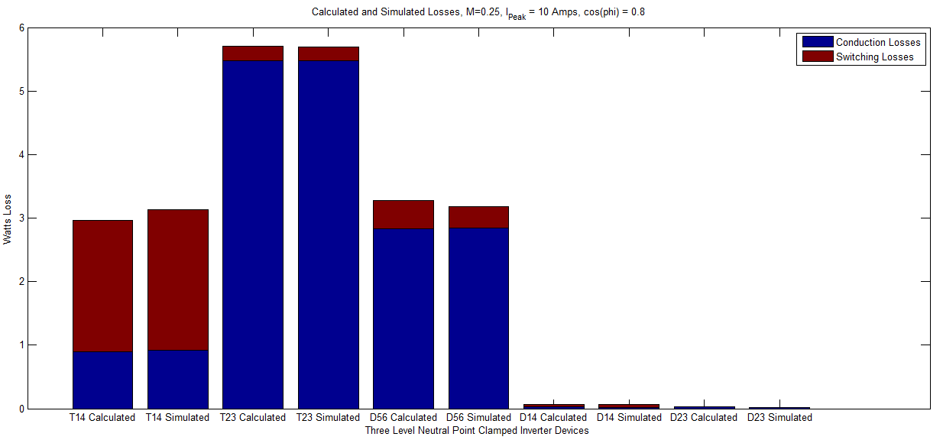
Fig. 4-14. Calculated vs. Simulated Losses Modulation Index = 0.25
A further reduction by a factor of 2 (M=0.25, f=12Hz) with approximately the same peak current yields additional imbalance in the device losses where the inner IGBT losses remain approximately constant while the outer IGBT losses are reduced by approximately 50% versus the M=1 case. The output current for this case was slightly lower than the baseline case due to the way semiconductor devices were modeled as non-ideal switches with nominal forward voltage drops and internal series resistances. The impact of the non-ideal and uncompensated behavior of the converter becomes very apparent for the case of a modulation index of 0.04 as shown in Fig. 4-15.
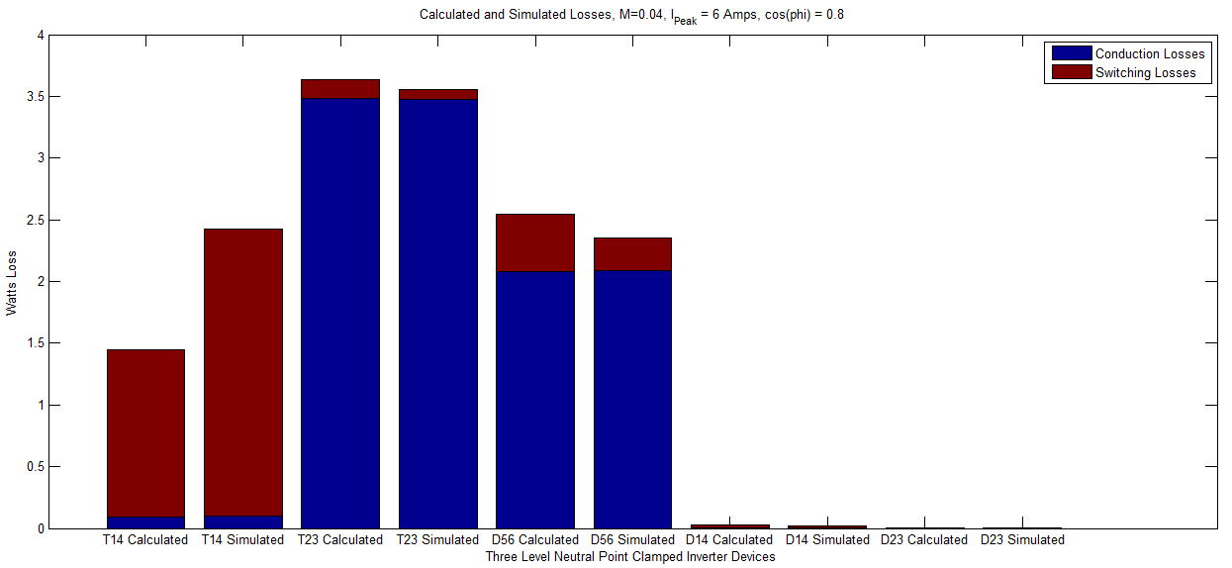
Fig. 4-15. Calculated vs. Simulated Losses, Modulation Index = 0.04
Fig. 4-15 appears to show that the switching losses are no longer closely correlated. This is due to the non-ideal output current waveforms at low modulation indices. These output currents are shown in Fig. 4-16 below. The conduction losses are still nearly identical but this is due to the fact that the peak current from the simulation is used in calculated values. Due to the loss of correlation at this very low modulation index and the very long continuous, fixed-time simulations required to capture multiple fundamental cycles, the majority of the analysis will be performed for a modulation index of 0.25.

Fig. 4-16. NPC Simulated Output Currents, Modulation Index = 0.04

Open -Loop Temperature Control
The open loop temperature control algorithm will be evaluated for a single operating point with a modulation index of 0.25 and a fundamental frequency of 12.5Hz. This operating point allows for a large variation in the common mode offset to demonstrate the benefits of the chosen open loop temperature control algorithm. The output voltage and current waveforms for one fundamental cycle are shown in Fig. 4-17 below.
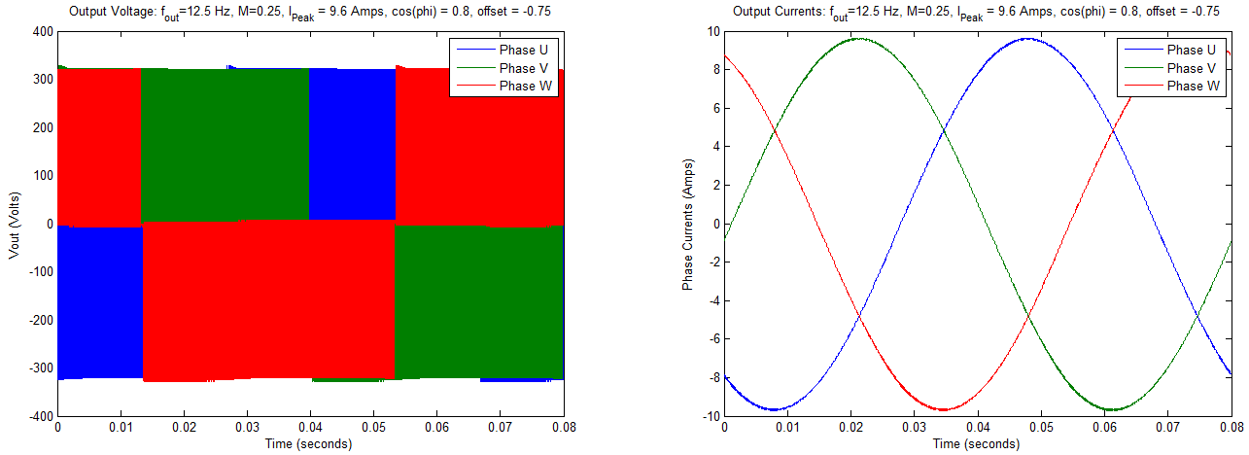
Fig. 4-17. NPC Simulated Output Voltage and Output Currents, Modulation Index = 0.25
For this operating point, the losses of the outer IGBTs, S11 and S14, and clamping diodes, D1 and D2, are approximately one of the losses of the inner IGBTs, S12 and S13 for a common mode offset of 0. These losses are shown in Fig. 4-14 and repeated along with the device losses for multiple common mode offsets ranging from -0.75 to 0.75 in Fig. 4-18 below for both the upper and lower devices.
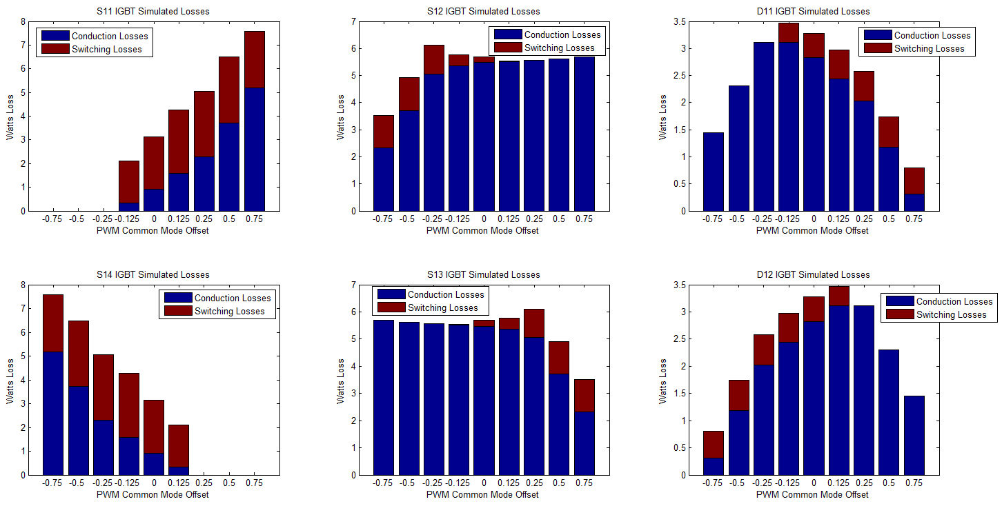
Fig. 4-18. NPC Device Losses for Various Common Mode PWM Offsets
Fig. 4-18 shows the ability of the three level NPC to distribute converter losses to different devices by selecting a particular common mode offset signal which does not impact the output voltage of the converter. The outer IGBTs are able to have no losses if the negative offset is greater than the modulation index. The inner IGBTs losses are approximately constant for most modulation indices but do drop off considerably at the edge of the acceptable range which is area where the algorithm has its greatest impact. For the clamping diodes, the losses are minimized towards the edges of the acceptable common mode carrier offsets. The sum of the losses for all major devices (neglecting the free-wheeling diodes) is shown in Fig. 4-19.
Fig. 4-19. NPC System Losses for Various Common Mode PWM Offsets
Fig. 4-19 shows a reduction in overall system losses for the largest acceptable common mode offsets. At these operating points, there is the largest imbalance between each inner and outer device, but, by varying the offset between these values at some quick frequency with respect to the fundamental cycle, the losses can be effectively averaged. The numerical loss reductions for the baseline case, the algorithm proposed by [10], and the open loop loss balancing proposed in this paper are summarized in Table 4-5 below.

Table 4-5. Loss Balancing Total System Losses vs. PWM Offset
Case | PWM Offset | Losses  [Watts] | % Difference From Baseline
Baseline | 0 | 24.2 | 0%
1 | +/- 0.5 | 21.1 | -12.8%
2 | +/- 0.75 | 19.1 | -21.1%
The difference in losses translates to a large difference in the average temperature between the inner and outer IGBTs. The delta junction temperature in the context of the following figures is the difference between the maximum and minimum temperatures for one fundamental cycle. The junction temperatures for the inner and outer IGBTs for the baseline case are shown in Fig. 4-20.
Fig. 4-20. NPC Simulated Junction Temperature, One Fundamental Cycle
The PWM common mode offset frequency must be high enough to effectively average the losses to take advantage redundant voltage states. For the algorithm proposed in [10], varying the offset at half of the fundamental cycle yielded poor results based on the dynamics of the thermal model. An additional case is presented which increases the frequency of the common mode offset for the strategy proposed in [10] to yield better results. The average and delta junction temperatures for the two outer and two inner devices are provided in Table 4-6 and Table 4-7 respectively.
Table 4-6. S11 and S14 Loss Balancing Results
Case | PWM Offset | Offset Frequency  [Hz] | S11/S14 |  | % Difference From Baseline
Case | PWM Offset | Offset Frequency  [Hz] | Avg. Temp.  [deg. C] | Delta Temp.  [deg. C] | Avg. Temp.  % | Delta Temp.  %
Baseline | 0 | 0 | 65.27 | 30.36 | 0 | 0
1 | +/- 0.5 | 25 | 84.47 | 50.98 | 29.4 | 67.9
2 | +/- 0.5 | 750 | 69.86 | 30.14 | 7.0 | -0.7
3 | +/- 0.75 | 750 | 82.23 | 36.06 | 26.0 | 18.8
Table 4-7. S12 and S13 Loss Balancing Results
Case | PWM Offset | Offset Frequency  [Hz] | S12/S13 |  | % Difference From Baseline
Case | PWM Offset | Offset Frequency  [Hz] | Avg. Temp.  [deg. C] | Delta Temp.  [deg. C] | Avg. Temp.  % | Delta Temp.  %
Baseline | 0 | 0 | 118.43 | 49.00 | 0 | 0
1 | +/- 0.5 | 25 | 117.67 | 51.02 | -0.6 | 4.1
2 | +/- 0.5 | 750 | 110.22 | 47.27 | -6.9 | -3.5
3 | +/- 0.75 | 750 | 96.61 | 41.81 | -18.4 | -14.7

The largest benefit occurs in the reduction of the average and delta junction temperature of the inner IGBT for the proposed loss balancing algorithm shown in Case 3. While this benefit does come at the expense of an increase in the temperature of the outer IGBTs, the overall lifetime of the inverter as a whole is determined by the most stressed device which for all cases are the inner IGBTs. These device temperatures were lowered by over 18%. The difference in inner versus outer IGBT temperatures for each case is summarized in Table 4-8.
Table 4-8. Inner vs. Outer IGBT Loss Balancing Results
Case | PWM Offset | Offset Frequency  [Hz] | Inner vs. Outer Temperature Difference
Case | PWM Offset | Offset Frequency  [Hz] | Avg. Temp.  [deg. C] | Delta Temp.  [deg. C]
Baseline | 0 | 0 | 53.16 | 18.64
1 | +/- 0.5 | 25 | 33.20 | 0.04
2 | +/- 0.5 | 750 | 40.36 | 17.13
3 | +/- 0.75 | 750 | 14.38 | 5.75

Closed-Loop Temperature Control
The results of the previous section showed the ability to nearly independently shift losses between the upper and lower outer IGBTs for modulation indices less than unity. Using the average estimated junction temperatures for the outer IGBTs, a closed loop regulator which works minimize the difference in those temperatures can be easily implemented. For this test case, the upper outer IGBT, S11, thermal model was left at its nominal value, whereas the lower outer IGBT, S14 had its thermal model parameters reduced by a factor of 0.9. This created the steady state junction temperatures for one fundamental cycle shown below in Fig. 4-21.
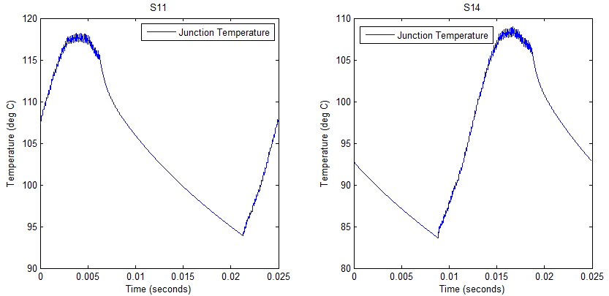
Fig. 4-21. NPC S11 and S14 Simulated Junction Temperature with Parameter Differences
By again using a trial and error method to tune a representative controller, the following PI gains given in Table 4-9 were chosen.

Table 4-9. Closed-Loop Temperature Balance Gains
Gain | Value
Proportional Gain | 0.05
Integral Gain | 1
The difference in the average delta junction temperature for the open versus the closed loop cases is shown below in Fig. 4-22. The closed loop case effectively balances the average junction temperatures with the integral control providing essentially zero steady state error.
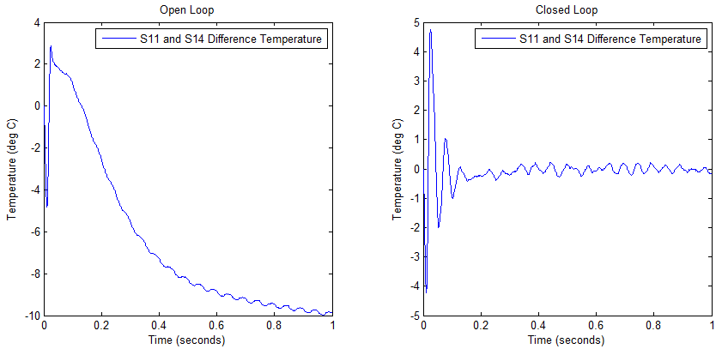
Fig. 4-22. Open Loop vs. Closed Loop S11 and S14 Temperature Balance
The controller sets the common mode offset signal for the three-phase sine wave signals. The offset for the closed loop control case is shown in Fig. 4-23.
Fig. 4-23. Closed Loop PWM Common Mode Offset
The amount of offset that may be added is limited by the modulation index of the commanded operating point, but, even for a 10% parameter deviation between the two devices, only a minimal common mode offset signal is needed to balance the losses. The summary of the average and delta temperatures for both the open and closed loop cases are provided in Table 4-10 below.

Table 4-10. S11 and S14 Temperature Balancing Results
Case | S11 |  | S14
Case | Avg. Temp.  [deg. C] | Delta Temp.  [deg. C] | Avg. Temp.  [deg. C] | Delta Temp.  [deg. C]
Open Loop | 105.0 | 24.3 | 95.1 | 25.3
Closed Loop | 100.7 | 24.14 | 100.6 | 26.5

Simulation Conclusions
The test cases in this section showed a large improvement in temperature balancing for both the open loop loss balancing algorithm and the closed loop temperature balancing algorithm. A summary of these results are provided in Table 4-11.
Table 4-11. Lifetime Improvement Factors
Case | Device | Improvement Type | Temp. Improvement  [deg. C] | No. of Cycles to Failure Improvement Factor
Open Loop Temperature Balancing Algorithm | Inner IGBTs | Average Temperature | 22 | ~4.5
Open Loop Temperature Balancing Algorithm | Outer IGBTs | Delta Temperature | 17 | ~10
Closed Loop Temperature Balancing | Outer IGBT | Average Temperature | 5 | ~1.5
Using the average temperature improvements and the delta temperature improvements and a number of cycles to failure plot similar to the one given in [17], an improvement in lifetime can be approximated. In this case, the delta temperature improvement is not the delta temperature for one fundamental cycle, but a load cycle parameter. For the open loop case the assumption is made that the load cycles between a modulation index of 1 and 0.25 over the course of seconds. In this case, the outer IGBT would cycle between its full output average temperature and the reduced value at the lower modulation index. For the baseline case, it is assumed that the full load output temperature would be approximately the same as the inner IGBTs at approximately 118 deg. C. The baseline case with the largest imbalance had the outer IGBT average temperature reducing to 65 deg. C with the open loop algorithm reducing the temperature to 82 deg. C. This was a 17 deg. C reduction in the delta junction temperature cycling value and provides an improvement even though the average temperature of this device will be higher for this case. Using the load cycles to failure data and the average and delta junction temperatures, the lifetime limiting device in the converter can be determined.

Conclusions
___________________________________________________________________________
The results presented in this paper demonstrated the ability of the Three-Level Neutral Point-Clamped converter and the proposed open and closed loop temperature balancing algorithms to improve the overall lifetime of the converter for operating points less than full output by adding a common mode signal to the multiple carrier PWM generation waveforms. It was also demonstrated that by using open or closed loop observers, it is possible to make online estimates for the junction temperature which can be used to provide real time junction temperature control without relying on embedded device temperature sensors which have significant lag and magnitude errors due to the location of the sensor. By using a closed-loop observer, disturbances and discrepancies in the input and measurement signals can be eliminated providing filtered and accurate temperature measurements.
The simulated loss values for each device showed very close agreement with the calculated loss values with the exception of low modulation indices due to non-ideal switches being used in the simulation with no appropriate compensation. Similar work to balance the junction temperatures have been explored for other converter topologies which have additional active devices which increase the complexities of these converters significantly. By appropriately selecting silicon devices to provide balanced losses at the maximum operating point, the average and delta junction temperatures of the Three-Level NPC can be effectively managed using the presented temperature balancing algorithms.

Recommendations for Future Work
Opportunities exist to expand upon the work presented here including:
- Updating the conduction and switching loss equations for each device as a function of the common mode offset signal to provide a solid analytical basis for the results provided here.
- Extending the algorithm to much lower modulation indices to allow direct comparison with the Active Neutral Point Clamped loss balancing scheme presented in [10].
- Validation of the results of this paper with hardware prototypes.
- Extending the thermal models to higher order systems to include the impacts of different heatsink and device cooling properties.
- Development of a Space Vector Modulation scheme to equally distribute losses with no additional switch state transitions.

Bibliography
___________________________________________________________________________

[1] Nabae, A., Takahashi, I., & Akagi, H. (1981). A new neutral-point-clamped PWM inverter. Industry Applications, IEEE Transactions on, (5), 518-523.
[2] Rodriguez, J., Lai, J. S., & Peng, F. Z. (2002). Multilevel inverters: a survey of topologies, controls, and applications. Industrial Electronics, IEEE Transactions on, 49(4), 724-738.
[3] Mancilla-David, F., & Venkataramanan, G. (2008, November). Analytical modeling of semiconductor losses in three level inverter for FACTS applications. In Industrial Electronics, 2008. IECON 2008. 34th Annual Conference of IEEE (pp. 3219-3226). IEEE.
[4] Wang, B., Venkataramanan, G., & Bendre, A. (2007). Unity power factor control for three-phase three-level rectifiers without current sensors. Industry Applications, IEEE Transactions on, 43(5), 1341-1348.
[5] Klabunde, M. C., Zhao, Y., & Lipo, T. A. (1994, October). Current control of a 3-level rectifier/inverter drive system. In Industry Applications Society Annual Meeting, 1994., Conference Record of the 1994 IEEE (pp. 859-866). IEEE.
[6] Papastergiou, K. D., Wheeler, P. W., & Clare, J. C. (2008, June). Comparison of losses in multilevel converters for aerospace applications. In Power Electronics Specialists Conference, 2008. PESC 2008. IEEE (pp. 4307-4312). IEEE.
[7] Bendre, A., Venkataramanan, G., Rosene, D., & Srinivasan, V. (2006). Modeling and design of a neutral-point voltage regulator for a three-level diode-clamped inverter using multiple-carrier modulation. Industrial Electronics, IEEE Transactions on, 53(3), 718-726.
[8] Loh, P. C., Holmes, D. G., Fukuta, Y., & Lipo, T. A. (2003, February). A reduced common mode hysteresis current regulation strategy for multilevel inverters. In Applied Power Electronics Conference and Exposition, 2003. APEC'03. Eighteenth Annual IEEE (Vol. 1, pp. 576-582). IEEE.
[9] Bruckner, T., & Bernet, S. (2007). Estimation and measurement of junction temperatures in a three-level voltage source converter. Power Electronics, IEEE Transactions on, 22(1), 3-12.
[10] Bruckner, T., Bernet, S., & Guldner, H. (2005). The active NPC converter and its loss-balancing control. Industrial Electronics, IEEE Transactions on, 52(3), 855-868.
[11] Blaabjerg, F., Pedersen, J. K., Sigurjonsson, S., & Elkjær, A. (1996, October). An extended model of power losses in hard-switched IGBT-inverters. In Industry Applications Conference, 1996. Thirty-First IAS Annual Meeting, IAS'96., Conference Record of the 1996 IEEE (Vol. 3, pp. 1454-1463). IEEE.
[12] Lorenz, R. D. (2002). Observers and state filters in drives and power electronics. Journal of Electrical Engineering, 2(2), 4-12.
[13] Yuan, X., Stemmler, H., & Barbi, I. (1999). Investigation on the clamping voltage self-balancing of the three-level capacitor clamping inverter. In Power Electronics Specialists Conference, 1999. PESC 99. 30th Annual IEEE (Vol. 2, pp. 1059-1064). IEEE.
[14] Meynard, T. A., & Foch, H. (1995, November). Multilevel converters and derived topologies for high power conversion. In Industrial Electronics, Control, and Instrumentation, 1995., Proceedings of the 1995 IEEE IECON 21st International Conference on (Vol. 1, pp. 21-26). IEEE.
[15] Shi, B., Venkataramanan, G., & Sharma, N. (2005, May). Design considerations for reactive elements and control parameters for three phase boost rectifiers. In Electric Machines and Drives, 2005 IEEE International Conference on (pp. 1757-1764). IEEE.
[16] Holmes, D. G., & Lipo, T. A. (2003). Pulse width modulation for power converters: principles and practice (Vol. 18). Wiley-IEEE Press.
[17] Murdock, D. A., Torres, J. E. R., Connors, J. J., & Lorenz, R. D. (2006). Active thermal control of power electronic modules. Industry Applications, IEEE Transactions on, 42(2), 552-558.
[18] Ginart, A., Ali, I. N., Barlas, I., Kalgren, P. W., Roemer, M. J., & Goebel, K. (2010, March). Observer based junction temperature estimator in thermoelectrical aging. In Aerospace Conference, 2010 IEEE (pp. 1-9). IEEE.
[19] Patil, N., Das, D., Goebel, K., & Pecht, M. (2008). Failure precursors for insulated gate bipolar transistors (IGBTs).
[20] Infineon Technologies AG. (2013). Industrial IGBT Modules Explanation of Technical Information.
[21] Nelson, J. J., Venkataramanan, G., & El-Refaie, A. M. (2006). Fast thermal profiling of power semiconductor devices using Fourier techniques. Industrial Electronics, IEEE Transactions on, 53(2), 521-529.
[22] Bendre, A., Venkataramanan, G., Rosene, D., & Srinivasan, V. (2006). Modeling and design of a neutral-point voltage regulator for a three-level diode-clamped inverter using multiple-carrier modulation. Industrial Electronics, IEEE Transactions on, 53(3), 718-726.

[23] Semikron. (2012). Application Note – AN-11001.

[24] G. Venkataramanan, “Solid state power conversion – course notes for ECE712 at
the university of Wisconsin – Madison”, the university of Wisconsin – Madison,
Fall 2009 semester.
[25] ABB. (2011). Application Note - Thermal Design and Temperature Ratings of IGBT Modules.

Appendix A
___________________________________________________________________________
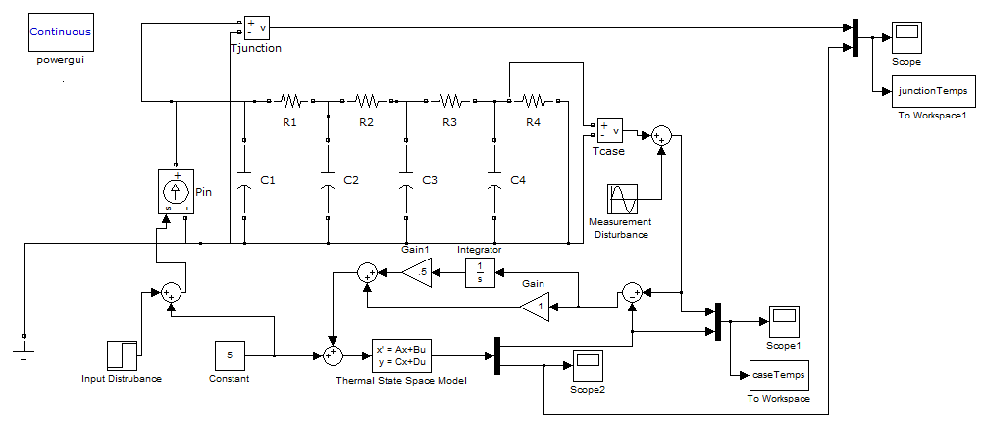
Fig. A-1. Thermal Network Block Diagram

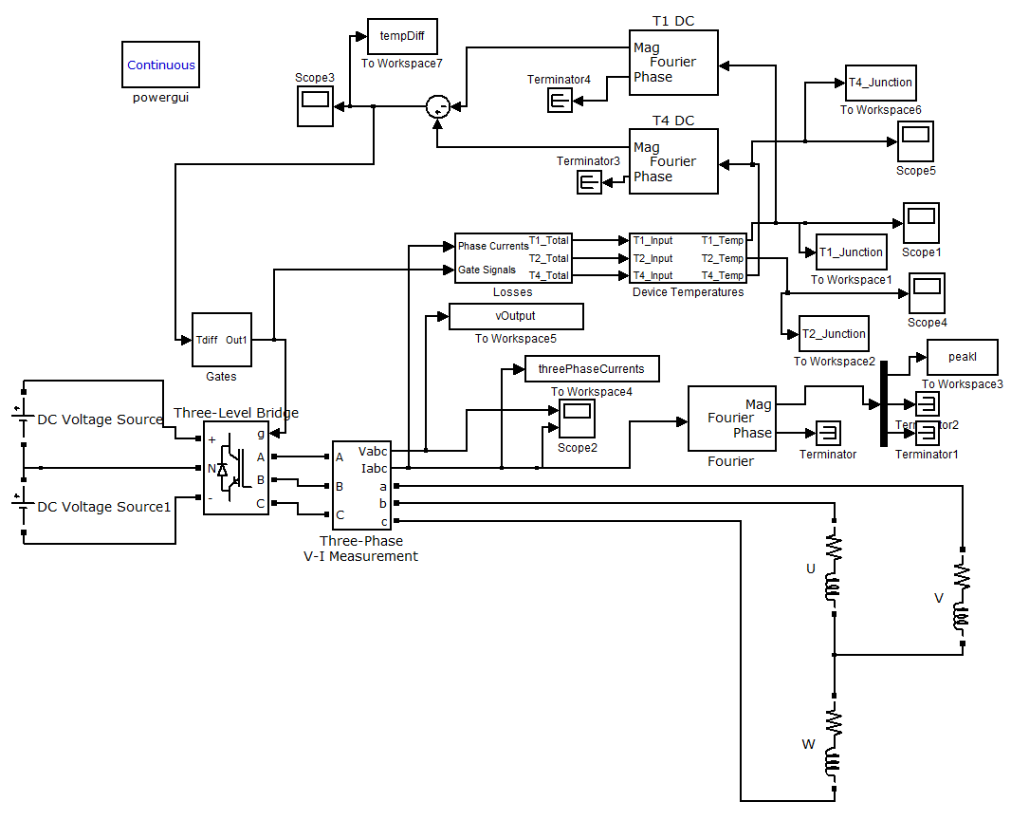
Fig. A-2. Three-Level NPC Top Level Block Diagram

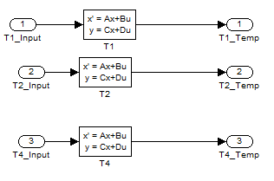
Fig. A-3. Three Level T1, T2, and T4 Thermal Models

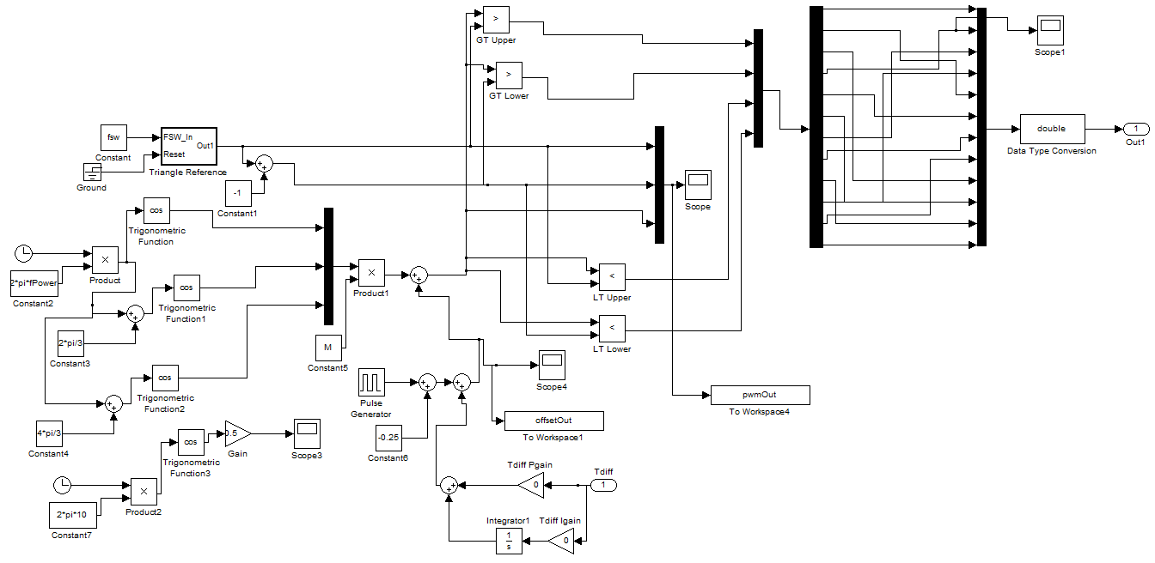
Fig. A-4. Three-Level NPC Multiple Carrier PWM Generator Model

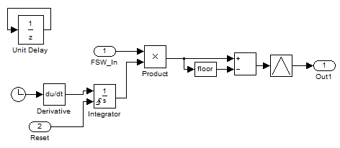
Fig. A-5. Triangle Wave Reference Generator for PWM Generation Block

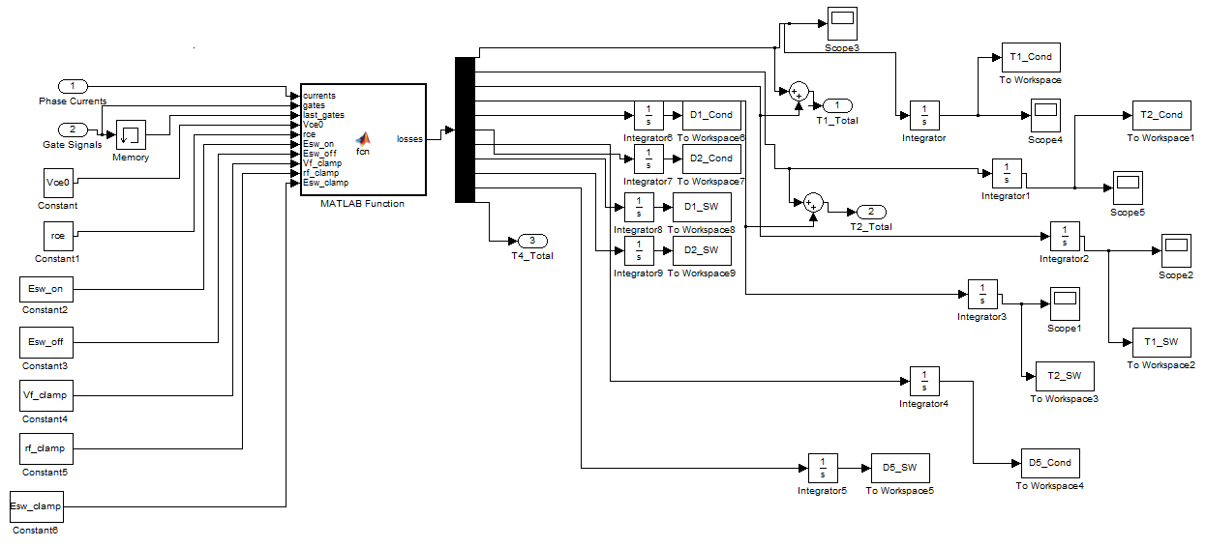
Fig. A-6. Three-Level NPC Loss Calculation Model

function losses = fcn(currents, gates, last_gates, Vce0, rce, Esw_on, Esw_off, Vf_clamp, rf_clamp, Esw_clamp)
%#codegen for Three-Level NPC Loss Calculations as a function of device parameters
T1_sw = 0;
T1_cond = 0;
T2_sw = 0;
T2_cond = 0;
D1_cond = 0;
D1_sw = 0;
D2_cond = 0;
D2_sw = 0;
D5_cond = 0;
D5_sw = 0;
T4_cond = 0;
T4_sw = 0;

if currents(1)>0
%T1 and T2 conduction losses
%if switch is on and current is positive, there are conduction losses in T1
if gates(1)>0
T1_cond = currents(1)*Vce0+currents(1)^2*rce;
end

%if switch is on and current is positive, there are conduction losses in T2
if gates(2)>0
T2_cond = currents(1)*Vce0+currents(1)^2*rce;
end

%D5 conduction losses
if gates(1) == 0 && gates(2)>0
D5_cond = currents(1)*Vf_clamp + currents(1)^2*rf_clamp;
end

%D3 and D4 Conduction loss
%{
if gates(1) == 0 && gates(2) ==0
D3_cond = currents(1)*Vf_clamp + currents(1)^2*rf_clamp;
D4_cond = D3_cond;
end
%}
%T1 and T2 switching losses
%if gate signal changed, there were switching losses
if gates(1)~= last_gates(1)
if gates(1)>0
T1_sw = (1.08833)^1.4*Esw_on*1e6/pi/2;
D5_sw = 1.15*(1.08833)^0.6*Esw_clamp*1e6/pi;
else
T1_sw = (1.08833)^1.4*Esw_off*1e6/pi/2;
end
end

%T2 switching losses
%if gate signal changed, there were switching losses
if gates(2)~= last_gates(2)
if gates(1)>0
T2_sw = (1.08833)^1.4*Esw_on*1e6/pi/6;
else
T2_sw = (1.08833)^1.4*Esw_off*1e6/pi/6;
end
end
%capture d1 and d2 cond loss
else
if gates(3) == 0 && gates(4) == 0
D1_cond = -currents(1)*Vf_clamp + currents(1)^2*rf_clamp;
D2_cond = D1_cond;
end

%capture d1 sw loss each time current is negative and lower switches go
%from both off to either on
if (last_gates(3) ==0 && last_gates(4) ==0) && (gates(3)==1 || gates(4)==1)
D1_sw = 1.15*(1.08833)^0.6*Esw_clamp*1e6/pi/2;
end

%T4 conduction losses
%if switch is on and current is positive, there are conduction losses in T1
if gates(4)>0
T4_cond = -currents(1)*Vce0+currents(1)^2*rce;
end

%T1 and T2 switching losses
%if gate signal changed, there were switching losses
if gates(4)~= last_gates(4)
if gates(4)>0
T4_sw = (1.08833)^1.4*Esw_on*1e6/pi/2;
else
T4_sw = (1.08833)^1.4*Esw_off*1e6/pi/2;
end
end
end

T4_total = T4_cond+T4_sw;

losses = [T1_cond T2_cond T1_sw T2_sw D1_cond D2_cond D5_cond D1_sw D2_sw D5_sw T4_total];

