“War Is Old Men Talking and Young Men Dying:”

The Story of Dennis Lee Klimpke

Garrett M. Cropsey

History 489: Research Seminar

Spring 2017

Copyright for this work is owned by the author. This digital version is published by McIntyre Library, University of Wisconsin-Eau Claire with the consent of the author.

Contents

Figures iii
Abstract iv
Introduction 1
Historiography 4
Letters Home 10
Basic Training 11
The Eve of Battle 15
“Humping the Bush” 17
Reaction from the Home Front 23
The Transformation 25
Conclusion 27
Works Cited 30

Figures

Figure 1. Vietnam Located on a Map of Asia. 1

Figure 2. Map of Vietnam Divided by the 17th Parallel during the Vietnam War. 2

Figure 3. Dennis Lee Klimpke in the US Army. 10

Figure 4. Fort Campbell, Kentucky US Army Base. 11

Figure 5. The Island of Guam in Relation to Vietnam on a Map of the South Pacific. 17

Figure 6. The Province of Binh Duong Located on a Map of Vietnam. 22

Figure 7. The City of Colby Located on a Map of Wisconsin. 23

Abstract

This paper focuses on the letters sent and received by a solider fighting in Vietnam. Dennis Lee Klimpke, a 20-year-old from the small town of Colby, Wisconsin, reported for induction on August 7, 1967, at 1:45 pm. He was shipped out immediately thereafter to basic training at Fort Campbell, Kentucky. Five months later, Dennis found himself "humping the bush" and fighting to stay alive in the middle of the Vietnam jungle. In less than four months of enduring the hot and humid battles of the war, on April 15, 1968, he was killed in action. The 16 letters sent back and forth between Dennis and his mother and siblings are a powerful illustration of what it was like for the average infantryman during the Vietnam War. An incredible transformation takes place from his first letter to his last. He is fighting the Vietcong while also dealing with problems back home. This is a story of one man's experience in Vietnam, but relates to many, many more.

Introduction

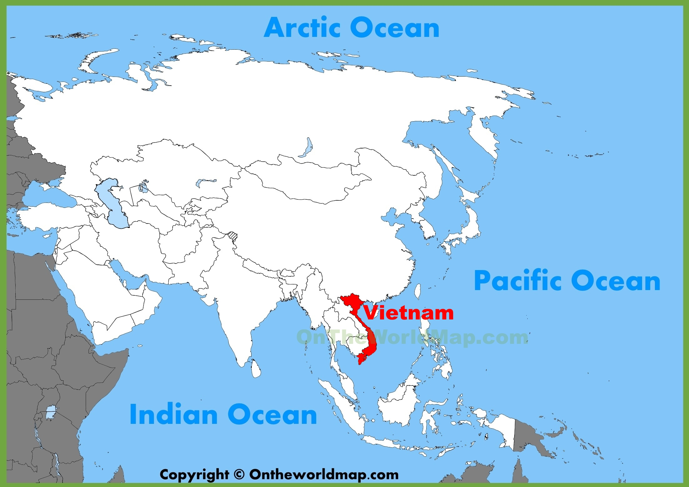
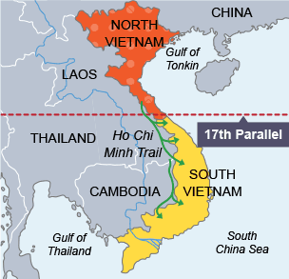
“It would be really nice to get back to civilization again, but everybody is so damn tired nobody cares much anymore what they do. We do the same thing every day, try and stay alive.” This was written by 20-year-old Vietnam soldier, Dennis Lee Klimpke, in a letter to his mother. He sent this just weeks before he was killed in combat, but it explains just how he felt about the war and fighting in Vietnam. The backdrop of the 1960’s was experiencing youthful rebellion and an emerging drug culture. At the same time, the military in Vietnam mirrored each movement. This decade is one of the most tumultuous of American history. This decade was filled with the social turmoil of sex, drugs, and rock ‘n’ roll, and also the political turmoil brought on by the height of the Civil Rights Movement which engendered division, the Cuban Missile Crisis which produced fear, the Cold War that dragged on, the assassinations of President John F. Kennedy and later Martin Luther King Jr., and finally ending with the technological miracle of putting the first man on the moon. During this decade of political and social change, on top of incredible technological advancements, the United States saw four different presidents: Dwight D. Eisenhower, John F. Kennedy, Lyndon B. Johnson, and finally Richard Nixon, all of whom are remembered for vastly different reasons.
Figure 1. Vietnam Located on a Map of Asia.
The French first colonized the area known as Indochina at the height of European colonialism in the 1800’s. Ever since then there have been problems in that area, heating up right after the end of World War II in 1945, with conflict between the native people of Indochina and the French colonizers. Indochina in this context refers to the present-day areas of Vietnam, Cambodia, and Laos. In the early 1950’s, the president of the United States at the time, Harry S. Truman, decided to financially support the French in Indochina. The factor that drove this decision was the fear of the spread of communism that was prevalent in China at the time. The Vietnam Conflict, as it was originally called, began in 1954 when the communist North Vietnamese started helping the rebel South Vietnamese fight South Vietnamese troops.
Figure 2. Map of Vietnam Divided by the 17th Parallel during the Vietnam War.
The United States did not step foot in Vietnam until 1961, when President John F. Kennedy began sending military advisors overseas. As the war began to escalate, President Kennedy increased the number of advisors. August 2, 1964, marked the beginning of full-scale U.S. intervention in Vietnam. The war was primarily fought between communists and anti-communists. The communists consisted of the South Vietnamese guerrillas known as the Viet Cong (VC) and the North Vietnamese Army (NVC). The anti-communists, among others, consisted of the United States, members of the SEATO (Southeast Asia Treaty Organization) and the Republic of South Vietnam.
Hovering over all of the other tumultuous events of the 1960’s, the Vietnam War began to spawn controversy throughout the country. Attitudes toward the war began to shift, as more and more troops were sent to Vietnam. Young American boys were being shipped overseas, only to go through a dramatic transformation of self that often resulted in their bodies being shipped back in coffins. Frustration on the American home front rose toward the end of the decade and many anti-war groups sprang up around the peak of the war in 1969. American troops were pulled out by 1973 as an "indirect" result of this. April 30, 1975, marked the end of the Vietnam Conflict when South Vietnam surrendered. The total number of American deaths was more than 58,000. In Vietnam, they call the war the American War because the US had the largest number of foreign forces fighting in their country. The story of a Wisconsin soldier, Dennis Klimpke, does not only tell his story and that of his family, but it tells the story of many young American boys across the country that endured the same transformation of self during the Vietnam War. This war changed Klimpke, a typical kid from Wisconsin, and his family, as illustrated through his letters sent up until his death. The Vietnam War was the longest war in the history of the United States until the war in Afghanistan started in 2002. Today, Vietnam is a communist country, and the war is commonly referred to as "the only war America ever lost."

Historiography

The Vietnam War has been heavily overshadowed in history by World Wars I and II, as well as the more recent War on Terror in the "Middle East,” but is still a war that has enjoyed extensive study by historians. Analyzing the many works written about the Vietnam War, the focus has been more on the social aspects of the war along with the life of the typical American infantryman within the war, rather than the actual war itself. This is the history needed to get a better understanding of where Dennis Lee Klimpke fits in among other Vietnam soldiers. Three different historians, James Ebert, Bernard Edelman and Theodore Nadelson proved to be extremely competent scholars in this regard.
Bernard Edelman, in his book Dear America: Letters Home from Vietnam, took actual letters sent home from soldiers in Vietnam and created a book based on those letters. He served as a Marine lieutenant in Vietnam, where he commanded a platoon in the mountains west of Da Nang in 1969. He does a masterful job of incorporating his own experiences from Vietnam into his novel, which adds more credibility to it. In Edelman’s own words, the main point of his book is that, “Like the young Americans who wrote them, these letters are variously naïve and wise, sentimental and bitter, frightened and boastful, noble and ordinary.” This very broad description of the young Americans who fought in the Vietnam War could just as well be used today to describe young Americans, and I believe that is the point. This is to help the reader, scholar, average American, and even the average human relate to the young soldiers within the book. Based on his experience, he points out that a soldier's mail in Vietnam was the most important thing to them, with the exception of maybe their rifle. Letters home were their lifelines to the World, as they called it, and naturally, holidays were very tough on them. He incorporates a lot of slang terminology that soldiers frequently used. Infantrymen, or foot soldiers, were called grunts in which they were said to have “humped the boonies.” Edelman describes the foot soldiers’ experience vividly with the following excerpt: “The infantryman finds himself slogging through foot-gripping mud with water lapping at his armpits, or enveloped in a cloud of dust, or stumbling across craggy mountains.” He describes how infantrymen felt and quotes a letter from a soldier to his mother: “The guns don’t bother me – I can’t hear them anymore. I want to hold my head between my hands and run screaming away from here….”
For many soldiers, but not all, the war could be summed up in two words: body count. This is how some soldiers regulated and measured victory. If they killed more Viet Cong than they lost on any given day, then it was a victory, a moral one at least. This was only some soldiers’ view, for most were simply frustrated to be there in the first place. As the war dragged on, this became more of a commander's idea of victory, for many soldiers did not see a high body count as being successful. This was due in part to the major transformation that the majority of soldiers went through during their time in action. Edelman shares many excerpts from soldiers’ diaries saying just that: that they have changed fundamentally and that nobody left Vietnam the same person… if they left. Toward the end of the 1960’s, soldiers no longer had any interest in going to war or fighting communism. Soldiers knew the exact date they arrived in Vietnam and the exact date they were scheduled to leave.
James R. Ebert wrote the book A Life in a Year: The American Infantryman in Vietnam, 1965-1972 in order to explain what life was like for American infantrymen. He states that of the 2.8 million Americans in Southeast Asia, fewer than 10% served in the “bush” as infantry soldiers, but 83% of casualties in the war were infantrymen. This statistic is very similar to the percentage of casualties in World War II. The main point of Ebert's book is to help readers better understand the life of infantrymen during the Vietnam War, but also to explain how these soldiers’ experiences mirrored the various events happening on the home front. He wrote, "As the 1960’s gave rise to civil rights, youthful rebellion, and a substantial drug culture, the military in Vietnam mirrored each movement." This is to say that the majority of these soldiers were just kids, many of them most likely fresh out of high school and even younger, as the war dragged on. Ebert shares a quote from James Raysor, enlisted at age 18, in which he admits "I was not into watching the news. I would rather watch ‘Leave it to Beaver' or reruns of ‘The Honeymooners.' I just wasn't involved with what was going on in Vietnam and didn't give it much of a thought." This explains why basic training came as a huge shock to most of these young men at first, but then became a sort of adventure for them that added much excitement to their lives. He notes that there was even a transformation throughout basic training whereas “almost every recruit gained confidence as the training cycle progressed.” Just before going overseas, soldiers were able to go home for a few days to say their goodbyes. The confidence they gained from basic training, along with their ignorance of what they were about to face, led to an idealized version of war as well as how they viewed themselves. Ebert describes this phenomenon as,
Directly influencing the conduct of many young soldiers on leave was a profound self-confidence and machismo, side effects of their training, which encouraged thousands of young soldiers to take to the streets of their hometowns feeling lean and mean and ready to take on the world – or at least as many of its experiences as they thought they might reasonably get away with.

This feeling would soon be stripped away once they boarded that plane. Although these planes were packed full of soldiers, they were all headed into battle alone; for each soldier was unfamiliar with war and the new landscape that was Vietnam, and their only way out was through their own mental sanity and strength. Just as Edelman describes, Ebert also finds that soldiers did not want to go to war, but they felt they had to do it for the men who came before them. No knowledge or history of where they were going or whom they were fighting was given to the soldiers, which would contribute to the failure that was the Vietnam War.
Theodore Nadelson wrote Trained to Kill: Soldiers at War to better understand the Vietnam soldier on a personal level. He starts by stating, “The myth of maleness is a prominent shaper of our culture.” Give a boy the opportunity to be aggressive and he will do so, but give a group of boys that opportunity and the individual aggression increases. Nadelson’s title is ironic, almost a joke. These boys, many whom were straight out of high school, were not trained to kill. There was no way of preparing them for what they were about to face and how to handle the first time they shot and killed someone. His main point is that the patriarchal society creates an illusion of what men and women should be. This preconceived idea engrained in these young soldiers’ brains stayed with them into battle but did not last long. Those who returned from war were forever changed. In an interview with Paula Zahn from CNN, former president of the United States George H. W. Bush said, "I was a little boy made into a man." Some boys even enlisted for the sole reason of becoming a man, for they were certain that war would do that. This idea has been passed down from generation to generation in male-dominated societies dating back to the Neanderthals all the way to American society in the 1960’s. Even technology can be blamed for contributing to this idea: “The movies have celebrated the idea of physical dominance, the myth of the warrior, from its flickering images.” Nadelson explains how veterans of war get very upset with such images. They blame such images for pushing them to war but in no way did those images help them once they were in the midst of battle. Nadelson also explains how soldiers often get frustrated with their families back home, for their families are unaware of what they are actually going through. “The soldier learns that his family has difficulty understanding him in his transformation.” These soldiers are expected to kill and not show emotions, for that would be feminine. Nadelson explains how this fact was very hard for many soldiers and the truth is that as soldiers lie on the ground about to die, they cry out for their mothers. “The soldier’s privilege to kill is unlike anything most other individuals have ever experienced, and the soldier who kills is permanently changed, fixed to the death he has made.” No human ever experiences the freedom to kill at will unless they have been to war. Even for those who have been to war, there is not enough training in the world to prepare them for the incredible atrocities of war.

Letters Home

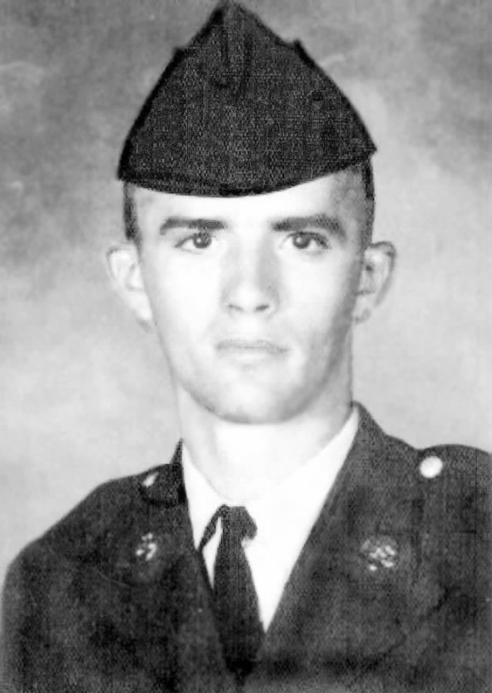
Dennis Lee Klimpke was born on October 17, 1946. He was raised by a working-class family in the rural Wisconsin town of Colby and was one of thirteen children. The majority of enlisted soldiers during the Vietnam era came from working-class families; in fact, nearly "80 percent of soldiers were from working-class families," so Klimpke enlisting in the army was hardly unusual and was actually very common. He was ordered to report for induction into the Army on August 7, 1967, at 1:45 pm. His enlistment was scheduled to end in August of 1969, which would have been a total of two years. During his enlistment, he was in a very serious relationship with a woman named Janice Carol Krause. Throughout his enlistment, he constantly wrote and received letters to and from his mother and siblings, but surprisingly there weren’t any from Janice. These 16 letters that began on August 27, 1967 and ended on April 11, 1968 provide the foundation for this academic work.
Figure 3. Dennis Lee Klimpke in the US Army.

Basic Training

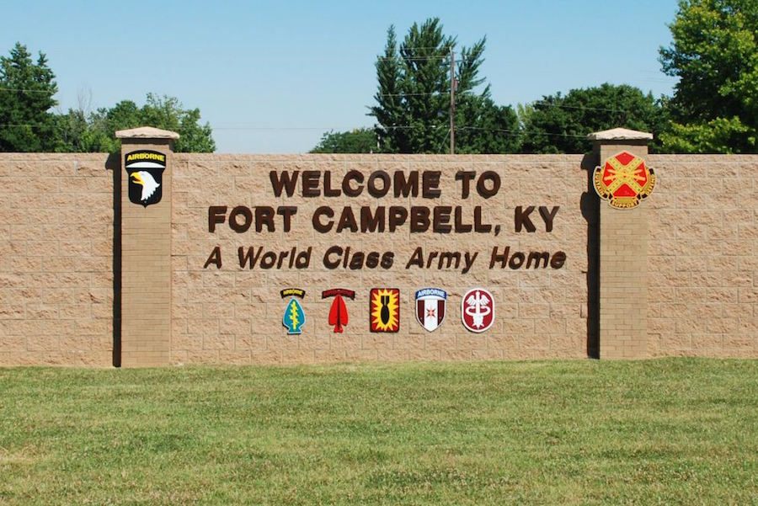
Dennis Klimpke was 20-years-old with a girlfriend, Janice, who was the love of his life. However, even Janice could not stop him from volunteering to join the Army. He was stationed at Fort Campbell in Kentucky, where he completed his basic training for the United States Army. His emotional state during this training can best be described as moderately happy, lonely at times, very homesick at other times, and generally frustrated with all of his personal problems that were occurring back home. Between his parents constantly fighting and his girlfriend questioning his loyalty, in addition to having to train for the Vietnam War, Klimpke had his work cut out for him mentally and physically. Through it all however, he stayed faithful to his religion and attended church quite regularly.
On Sunday, August 27, 1967, Klimpke wrote for the first time from Fort Campbell. Near the outset of the letter he observed that “they keep me very busy.” He mentioned that he had gone to church earlier that morning and had been writing letters ever since, for Sundays were the only days he had time to write. He seemed to be in a very good mood, for he made a few jokes and even said, “I wish I could smell a glass of beer.” He was upset that the only substance they were able to drink was water and that they could not even eat candy. Just days into his training he already wanted “a leave” so that he could go back home; however, in contrast, Klimpke also said just “how much fun you can have in the army.” Lucky for him, over “60 guys from Wisconsin” were stationed with him. As Klimpke progressed through basic training, he seemed to like it more. He mentioned that “it was lonesome the first couple of weeks;” however, by September 21, 1967, he talked about shooting a rifle competitively. This signifies that he was having a difficult time adjusting to his new military lifestyle away from his parents, family, friends, and most importantly his girlfriend, but that he was making the most of it. He stated that he was set to graduate on Friday, October 13, and jokingly hoped that no one in his unit was superstitious. He was upset that they put him in the airborne division. According to him, “riding in a plane was bad enough let alone jumping out of one.” They later put him through eight weeks of Advanced Individual Training (AIT) School and then five weeks of jump school, about which he was happy, as it would delay his departure date to Vietnam. Processing what it was going to be like in Vietnam proved to be difficult for Klimpke so any delay in that “adventure” was a positive thing in his mind. To add to his worries, 95 percent of the men at Fort Campbell were going overseas, according to his sergeants. “Why can’t I be one of the five percent that won’t go over there?” he wondered. But then he added that “I might be stupid” but he thought he wanted to go overseas because it would be “a lot different for a change” and because “you can make rank faster over there.” There was evidence of a sense of some fear when he wrote that he thought he could become a sergeant when he came back, as he added, “If I come back.” He showed some positivity toward the end of this letter when he said that if he had to be in the army for two years, he wanted to at least get something out of it. He also showed some ambivalence in his emotions, for he expressed that he really did not want to go to Vietnam in one sentence and then in the next he thought he wanted to go. An internal conflict seemed to be growing within him, for he wanted a new adventure in life, but he did not necessarily agree with going overseas.
Figure 4. Fort Campbell, Kentucky US Army Base.
Klimpke was awarded a sharpshooter badge with a rifle bar shortly after his last letter on September 26, 1967, during his basic training at Fort Campbell. His next letter was written more than a month later, on October 27, when he complained extensively about his girlfriend, Janice. During the stretch of time between letters, it appeared that he really struggled with his relationship with her. According to his letter, she thought he was going out with other girls, but if “she could see this hell of a place” he knew that she would change her mind. He became very homesick because of his relationship struggles, but expressed the sentiment that if they broke up he would rather sign up for three more years in the Army than “come back home to nothing.” He seemed to forge a plan to reassure her of his commitment. He planned to get her an engagement ring when he went home next, which would be around Christmas time.
Not only did his girlfriend question his commitment, but it was clear in the letters that he had a few family issues as well. He wrote that he was happy for his sister Connie on her wedding day, but he really “wants to get back for it.” He also wrote that he knew it “isn’t ma’s fault” but he asked if the “old man was starting to drink more again?” On top of all of that, he was upset that he had only received two letters from his mom up until that point. He wrote that he had “two weeks down and seven weeks to go.” Klimpke wrote with some animosity and this clearly meant that he was counting down the days until he was able to go home. His many struggles with his life at home while away at boot camp would only get worse when he actually left the country to fight overseas in Vietnam. Due to his struggles, he began to write with less care and formed a more relaxed attitude, but was still very homesick. In a letter from November 11, he wrote, “I miss them [his parents] more now than I did before.” He wrote that when he came home in December he might propose to Janice and that he “has the rings already,” but he thought her parents would be angry about it. He contemplated whether or not he should wait until he returned from Vietnam to ask her, but stated, “I do not know what might happen over there.” He really did not want to jump out of planes, so he eventually built up enough courage and told his company commander that he was not going airborne. The commander’s response was, “you better be ready for Vietnam” after his leave in December. This signified that he would be shipped to Vietnam immediately after his leave, but seemed cynical of his commander to say for he knew Klimpke was not prepared for what he was going to face. He wrote with less care when he said he would be glad to “get it over with (going to Vietnam) so I can get back home again.” He jokingly followed that with “if it gets too rough over there I will have to find a big rice patty to hide under ha-ha.” He wrote that he was glad to be going to Vietnam but he also hated to think about going over there at all. He ended the letter very upset about people within his family disliking Janice. He wrote that he was “good and mad.” He wrote in his postscript (PS) to “tell Uncle Tom he can kiss my ass.” This implied that Uncle Tom disliked Janice the most.
His experience during basic training took a toll on Klimpke in all facets of life. He was mentally and physically drained by the time he was able to visit home for Christmas. It was evident in his letters that he tried to make the most of his time in training, for he made some friends and even won a rifle-shooting award. However, the shock of the military lifestyle he was unfamiliar with, away from his family, friends, and girlfriend, weighed heavily on his character. This was a young man who had only known Colby, Wisconsin, and then he voluntarily found himself trying to adapt to a new lifestyle in an unfamiliar place. The first stage of his adventure was over, but the worst was yet to come.

The Eve of Battle

In the blink of an eye, it was 1968. Another year went by, and the slate was clean. This year brought some major baggage for Dennis Klimpke, for it brought an even crazier adventure than the last. All of those long hours he spent training in Kentucky…would they prove to have paid off? A plethora of thoughts similar to this ran through Klimpke’s mind as he was on the verge of entering hell. He roughly spent four months in Vietnam, “humping the bush,” as previously mentioned that Infantrymen were said to do. During those four months, he experienced many things most humans could not even imagine and he wrote only a fraction of what he actually went through. His emotions, embedded in his letters, spoke volumes of what it was like. However the average American can only experience war through images in their own minds; no one could ever fully understand the horrors unless they actually experienced them.
Klimpke surprisingly seems somewhat comfortable when he first arrived in San Francisco, California sometime around January 13, 1968. This was his last stop before going overseas. He sounded very optimistic and positive, but in all honesty, that was the only attitude that could have helped him survive thousands of miles away from home. When he first wrote from California, he said that he finally got to his company and it was supposed to "be a real good company, they are a bunch of real nice guys. They are called the Wolfhounds and they are really good from what I have heard.” This was where he seemed to show optimism, but then his tone got a little more doubtful when he wrote that “they burn every village they go to and kill every man, woman, and child in each village and then they will stick a crest into foreheads of some of the Viet Cong to let them know who was there. They say the Vietcong are really afraid of them.” No amount of training could have prepared Klimpke to commit the atrocities his company committed. This must have given him some confidence, knowing the Vietcong were really afraid of his company, but it definitely scared him even worse. His words said that he was happy to be with this company, but they also belied his fear of what he would be doing when he arrived in Vietnam. He wrote that a good thing about this unit was "when they go out they go in battalion-size units, which is very big. The bad thing is they stay out for three to four months before coming back to base camp.” He finished by warily stating that he only had one week of training before they headed out to the field on the first of February.

“Humping the Bush”

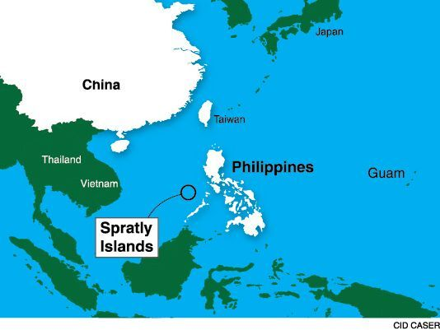
Scared, alone, and hopeless. These three words best describe the feelings that ran through Dennis Klimpke while he was stationed on the Island of Guam, just under 2,500 miles from Vietnam, on January 27, 1968, as expressed in his letters. He was just days away from heading to war, but the optimism he maintained back in San Francisco was gone. He wrote, "I have been away for 14 days but it seems like a lifetime." He compared his basic training to his time in Guam, but said that it is twice as bad because of the weather, terrain, and living conditions. His company was scheduled to head out on the first or second of February, and his sergeant told him that he would be accompanying them. The anti-war sentiment that was spreading rapidly back home on the American home front seemed to have made the trip with the soldiers, for he wrote “nobody cares if they fight or not.” The patriotic commitment to stopping communism that resonated at the start of the war now seemed to have been transformed into a feeling of apathy and resentment. Klimpke wrote “I wish that I would get injured twice, having to stay in the hospital 72 hours each time so I could go home, but I don’t think I will get that lucky.” He inferred that getting injured and going home would make him lucky. He continued on this tirade where he wrote, “anybody will do just about anything to get out of the field.” This made him question a lot about life, which made him miss Janice even more. A downward spiral best describes Klimpke’s mind and attitude since arriving in Vietnam. On February 2 he wrote from Saigon and said that they moved in there the night of January 31. With an angry tone, he stated that "Charlie (a slang term for the Viet Cong) has been raising hell lately. A couple guys were wounded when they came by choppers to the air force base. It was quiet during the day, but at night was when Charlie liked to fight." On a positive note, he described liking it in Saigon better than in the jungle, but then added that over 2,000 Viet Cong had been killed since January 29, but "they seem to get more every day." He did not think the war would ever end, but left the letter on a positive note where he stated, and “I will never forget February 1 because I shook hands and talked with General Westmoreland.” This was extremely significant, for General Westmoreland is famous in United States history. He was in charge of the famous battle, the Tet Offensive, which began just a few days earlier on January 30. This offensive continued the entire time that Klimpke fought and it would ultimately take his life in Vietnam. Westmoreland eventually became the Chief of Staff of the United States Army. Klimpke never thought he would ever get to see him, so he was in good spirits about that. He finished by writing that he would see everyone in 348 days. His letters turned into a lifeline to the life he once knew, for he was overcome with excitement when he received his parents’ letter. In his response, he wasted no time with small talk, like in his previous letters, and got right to the point. On February 21, Klimpke wrote that a lot had happened lately and it seemed every time they went out they got hit. He said he would never forget February 10 because “I shot a person and it wasn’t very pretty. When I went up to the person, it was just a young kid and I broke out into tears.” This effected Klimpke greatly, for it was the first person he had ever killed, but what’s more is it was only a young boy. He continued with another date he would never forget, February 14. On that day “I saw my squad leader get shot in the face and it was terrible to see.” Similar to the first person he killed, seeing the gruesome horrors of war firsthand had a profound impact on Klimpke. These two events, in which happened only days apart, would change Klimpke profoundly. He wrote about how one soldier got shot in the hand, lost a finger and got to go to The World (This is the term that soldiers used in reference to the United States). In a very pessimistic tone, he wrote that they should not worry if they heard he got shot in the hand and lost a finger because "I probably shot it off myself to get out of this hell." This was not the first time Klimpke wrote something like this, for he constantly referred to the fact that soldiers would do just about anything to get out of Vietnam. He mentioned that he and another soldier got credit for killing 13 Viet Cong the day before when "we got hit by Charlie." His commanding officer put their names in for a promotion to fourth-grade Specialist (SP4). "I really want the promotion because I need the money now that I'm getting married." He talked about being glad to hear that things at home were going well because he got very worried when his parents fought a lot. He ended the letter on a happy note when he said, "I wish you could see me because I'm growing a mustache. I want to find a camera to take some pictures." He finished when he said that he had to go to church and "God bless you all."
Figure 5. The Island of Guam in Relation to Vietnam on a Map of the South Pacific.
The following month, sometime in March of 1968, Klimpke was hit in the arm with some shrapnel. There was no letter from him that directly stated that, but his records declared it and his family asked him about it in their most recent letter. Also, Klimpke’s mother had not been doing well, health wise, since she almost died giving birth sometime before March 5. When he found out about her near-death experience in the hospital, on March 13, he angrily wrote, “I wish you would have got in touch with the Red Cross so I could have come home. Then I could get out of this hell and see you guys. It would be really nice to get back to civilization again.” He continued his depressing letter where he explained that they were not getting in many fights so they moved to the Hobo Woods where they fought every day. Their day-to-day activities, he wrote, was to simply "survive." He told them that his company had been out in the field for 43 days at that point and they would not go in until the end of March. "Everybody is so damn tired that nobody cares much anymore what they do." The way Klimpke was talking, his morale was clearly down and I assume the rest of his comrades in his division felt the same. According to George McArthur of the Eau Claire Daily Telegram, however, that was not the case. He was reporting out of Saigon in Vietnam, and on March 19, 1968, he stated, “For three years of ever intensifying warfare in Vietnam, the morale of the American fighting man has never flagged.” This means that the American people on the home front were receiving false news about how their troops were doing in Vietnam. This could have contributed to the many opposed feelings to the war at the time, as well as years after the war had ended. Klimpke ended the letter by reassuring his mother that his arm was pretty good and only hurt if he hit it, but that they never got that piece of metal out.
Not knowing that it would be his last, Klimpke wrote his final letter home on April 11, 1968. He clearly was at the end of his wits when he wrote this letter and his peace of mind seemed to have unraveled. He began by apologizing for his last letter: “I was just so mad at everything over here and then I went and got drunk.” He explained that his company was out in the field for 62 days straight with no rest before they were finally able to return to base camp. He also told a story of one of the nights at base camp when they were ambushed when he was on night patrol. “Only one of us was wounded and we killed seven of them.” He wrote about moving down to the Mekong Delta and about how bad it was there. “It’s just water, mud and plenty of VC (Viet Cong). Last night on ambush patrol we got two people killed and four wounded. Charles (Viet Cong) mortared our base camp and killed a guy and wounded three more.” He ended his final letter by again referencing how nobody cared what happened. This seemed to be a premonition for what was to come. Things were getting worse and Klimpke seemed to have known something bad was going to occur.
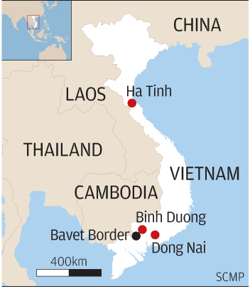
Klimpke would die four days later in Binh Duong, South Vietnam on April 15, 1968. The Tet Offensive was well underway and a part of that offensive was the Battle of Saigon. Another part of that offensive, which I speculate Klimpke was killed in, was Operation Toan Thang I. Klimpke was killed just outside of Saigon, which is where this operation took place. The cause of his death was categorized as a ground casualty due to artillery, a rocket, or a mortar. The sad thing about his death, is he knew exactly what was coming for him. He saw many people on both sides of the war killed in horrific ways in much of the same way he was killed. His premonition, when he described moving to the Mekong Delta in his last letter, proved to be correct. He endured basic training, waited for what felt like an eternity on the eve of battle, and suffered through the horrifying experiences that the Vietnam War had to offer. He was awarded the Purple Heart for his actions on February 27, 1968, for wounds he received in connection with military operations against a hostile force. He died fighting next to his brothers in Company B, 2nd Battalion, of the 27th Infantry, within the 25th Infantry Division otherwise known as the Wolfhounds.
Figure 6. The Province of Binh Duong Located on a Map of Vietnam.

Reaction from the Home Front

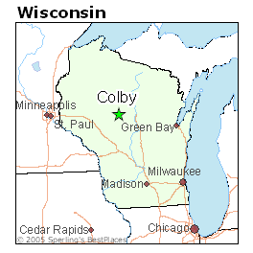
Helpless and ignorant are two words that best describe Klimpke’s family back home in rural Colby, Wisconsin. For this hardworking, working-class family, Colby was all they had ever known. If they had traveled elsewhere, it definitely did not stretch past the confines of Wisconsin’s borders. Their 20-year-old son enlisted in the United States Army, and nobody within the family had any prior military experience, so they were ignorant on the matter. Their son managed to get through basic training and immediately after was shipped to Vietnam, a country which they could not even find on a map. As Dennis wrote home about his experiences during basic training, on the eve of battle and finally “humping the bush” in the jungles of Vietnam, his mother (the primary writer) tried her best to keep her letters light and uplifting. She constantly described what was happening at home and tried to keep Dennis up to date. How else was she to react to such unfamiliar stories and to such horrifying experiences? She, along with the rest of the family, was helpless and ignorant but did the best they could with the knowledge they had.
Figure 7. The City of Colby Located on a Map of Wisconsin.
Each letter always began with happy talk about what was going on in Colby. Then they turned to the many negative pieces of information, such as someone getting sick or getting into a fight. The letters ended with deep concern for their son. In their February 23, 1968, letter, his mother began with light and happy small talk about what was happening in Colby. The tone got more serious when she wrote “I hope you are ok over in that hell. It turns my stomach just thinking of seeing those men get shot." After his mother learned about him getting wounded, in her March 5 letter she expressed her deep concern: "I worry about you and now I have to tell the bad news at home." She followed that with bad news about Dennis’ baby brother dying after birth and how the baby "almost took his mother with him." She added that ever since then, she had been in and out of the hospital, but she reassured him that she would be ok. She stressed that she had good days and bad days. She told him to take care of himself and said "it was the shock of you getting hurt that made me feel so rough today." In her final letter to him on April 9, 1968, she spent over half of it talking about the latest drama back home. She finally added, “I hope your arm is ok. I think the reason I get so sick is from worrying so much about you. Every time I hear somebody getting killed over there I worry even more. I don’t know what I’ll do if you really get hurt.” Little did she know, her little boy was not the same boy who left her home eight months earlier in August. Little did she know, her little boy was not so little anymore and was no longer a boy. Little did she know, her son had transformed into a skeleton of what he once was and that he would be killed in action, just six days later.

The Transformation

“I feel different now after seeing some horrible things, and I’ll never forget them. I can’t say what I mean, but some of the things you see here can really change a man or turn a boy into a man. Any combat GI that comes here doesn’t leave the same.” Private First Class George Robinson, who was wounded in action while on an operation with the 1st Infantry Division in Vietnam, made this claim. It is evident that Dennis Klimpke experienced a similar and profound transformation of self and character in the relatively short period of time of about eight months in the military. He arrived at Fort Campbell, Kentucky for basic training a boy and died in the jungles of Vietnam a skeleton of what he once was. His letters began as an account of his adventures for his friends and family. It was lonely at times, but nothing he could not handle. Once overseas, however, he slowly, but surely, drifted toward becoming a person he could barely recognize, while his family continued to see him as he was before he left, instead of as the person he had become. This only added to his many frustrations. The tone of his letters, his attitudes and opinions, and his values quickly worsened. The worst part of it all was that he had voluntarily submitted himself to this change, and for what? Knowing the truth about what was in store, nobody would voluntarily choose to be in Vietnam in the first place, fighting a war the US did not need to be in. There was no part of him that wanted to become an unrecognizable person from the one he used to look at in the mirror every day and the person his family knew and loved.
The title sums up this feeling concisely, which is the famous quote from former president of the United States, Franklin D. Roosevelt, “War is old men talking and young men dying.” His attitude towards the war and his opinion of the very country he was fighting to “protect” became very pessimistic and he wrote with much animosity. Before the war, Klimpke had everything going for him. He was a fit young man with a girlfriend that he would one day marry. Just as he was ready to take on the world, the Vietnam War delayed that challenge and ultimately put an end to his life.
Who did Dennis Lee Klimpke become? Well for one, the Vietnam War turned him into a monster or a killer on the outside, but most likely he was just a scared kid. He shot a young boy, who was most likely in his young teenage years. This war also changed his thoughts and attitude towards war in general. World War II is viewed by the general public as an extraordinarily honorable war to have fought in. Klimpke must have had that in mind when he signed up to volunteer for the war, but was quickly convinced otherwise by the horrors of Vietnam. Ultimately, the war turned him into a cold-hearted, pessimistic and negative human being. His first few letters demonstrated his laid back attitude and his humor. He would joke about drinking beer or poke fun at his siblings. Towards the end of his letters, everything he said was negative with no emotion in his words. He ended his letters not caring what happened to him. Wars are said to change boys in to men, but whether or not he became a man cannot be determined. What can be determined is his character and the person he was before going to war transformed dramatically.
“No eighteen-year-old kid went to Vietnam thinking ‘Oh boy, now I’m going to be evil.’ But most of them met their darkest sides face to face in that war.” This excerpt, along with the excerpt that began this section, demonstrates that Klimpke was not the only one who underwent a transformation of self. In fact, every account of the experiences of a Vietnam soldier read by the author has mentioned some sort of change or transformation of self and character. Klimpke’s story is tragic, but not any different than any other average American soldier during the Vietnam War. “The war was like a machine, a machine to do one thing and do it very effectively; destroy people…it didn’t just chew up flesh; it chewed up human will.” Klimpke’s story is tragic, but not very different from that of any other average American soldier during the Vietnam War. “The war was like a machine, a machine to do one thing and do it very effectively; destroy people…it didn’t just chew up flesh; it chewed up human will.” Klimpke, along with many other soldiers, underwent a transformation that was unexpected, uninvited, and unwanted, but a transformation nonetheless. Sadly, 60,000 soldiers or so were unable to witness the full effects of the change, as they lost their lives in Vietnam. What is as sad or perhaps sadder is that an even larger number of soldiers were able to witness the lifelong effects of such transformations, along with their friends and families. Many soldiers suspected that they would not come out of the war alive and examining their last letters home is extremely troubling and sad. “They [soldiers] did, however, go home sooner than they had imagined, and not as they had hoped.”

Conclusion

The Vietnam War, the Indochina War, the American War or the only war America ever lost. Whatever one calls it, it is a war that will never be forgotten despite having been overshadowed. Marion Lee Kempner, a Marine Lieutenant killed in Vietnam in 1966, wrote to his great aunt about a red flower and how “It reminded him of Vietnam, ‘a country of thorns and cuts, of guns and marauding, of little hope and of great failure. Yet in the midst of it all, a beautiful thought, gesture, or even person can arise among it waving bravely at the death that pours down upon it.’” How could a beautiful red flower remind him of something so ugly and violent? The unique quality of some human beings is that they tend to always see the good in all circumstances, something Dennis Lee Klimpke was able to do in a past life. Many wars have occurred in American history since the Vietnam War, which have allowed doctors, scientists, and even the general public to better understand the effects of war on individuals. But the only benefit of knowing, is to create room for sympathy, for many changes go unseen and for the many who have never and will never step foot in a war, the true understanding will never be there. Dennis Klimpke, among the others the author has read about, has given the author a greater appreciation for the many men and women who have fought and served in the military for our country. Among all United States wars, Vietnam will remain an outlier. The majority of Americans did not think we should have been there in the first place, so the appreciation for soldiers such as Klimpke, volunteers or not, was never rightly there. The basic necessities and freedoms the citizens of the United States take for granted on a daily basis would not be possible without people like Dennis Klimpke, regardless of what the Vietnam War actually meant to the U.S. “They gave no less than their ancestors at Gettysburg, Normandy, or Iwo Jima. Who knows what they might have accomplished, the families they might have had, the lives they might have led?” One can dwell on what might have been, but that will only cause more harm. Unlike the aforementioned wars, Vietnam was a criminal war instead of heroic. But by recognizing a man like Dennis Klimpke and other soldiers like him, we are able to develop a better understanding just how much the Vietnam War took from them.

Works Cited

Primary Sources:
Dennis Klimpke Collection, 1965-2002. UHC292. Special Collections & Archives. McIntyre Library. University of Wisconsin—Eau Claire. Eau Claire, Wisconsin.

Eau Claire Daily Telegram. March 19, 1968. Accessed May 4, 2017. https://access-newspaperarchive-com.proxy.uwec.edu/us/wisconsin/eau-claire/daily-telegram/1968/03-19/page-2?tag=vietnam+war&rtserp=tags/vietnam-war?psi=103&pci=7&ndt=bd&pem=5&py=1967&pm=8&pey=1968&psb=relavance&pc=8486.

United States, Vietnam War Military Casualties, 1956-1998. Accessed May 10, 2017. http://search.ancestrylibrary.com/cgi-bin/sse.dll?_phsrc=AvM3&_phstart=successSource&usePUBJs=true&gss=angs-g&new=1&rank=1&msT=1&gsfn=Dennis%20Lee&gsfn_x=0&gsln=Klimpke&gsln_x=0&catbucket=rstp&MSAV=0&MSV=0&uidh=xf6&pcat=ROOT_CATEGORY&h=5610&recoff=5%206%207&dbid=3095&indiv=1&ml_rpos=1.

Wisconsin Tribune – Phonograph. Abbotsford and Colby, Wisconsin. October 6, 1966 – June 27, 1968.

Secondary Sources:
Anderson, David L, and John Ernst, eds. The War That Never Ends. Lexington: University Press of Kentucky, 2007.

Appy, Christian G. Patriots: The Vietnam War Remembered From All Sides. New York: Penguin Group, 2003.

Baker, Mark. Nam: the Vietnam War in the Words of the Men and Women Who Fought There. New York: Quill, 1982.

Beesley, Stanley W., ed. Vietnam: the Heartland Remembers. Norman: University of Oklahoma, 1987.

CNN. "Vietnam War Fast Facts." CNN Cable News Network. Last modified April 18, 2016. Accessed March 27, 2017. http://www.cnn.com/2013/07/01/world/vietnam-war-fast-facts/.

Ebert, James. A Life in a Year: An Infantryman in Vietnam. Novato, CA: Presidio, 2004.

Edelman, Bernard. Dear America: Letters Home from Vietnam. New York: Norton, 2002.

Guilmartin, Jr., John F. Review of Working-Class War: American Combat Soldiers and Vietnam, written by Christian G. Appy. Reviews in American History 22, no. 2 (June 1994): 322-27. Accessed March 27, 2017. http://www.jstor.org/stable/2702905.

HistoryNet. "Vietnam War." HistoryNet. Last modified February 2017. Accessed March 27, 2017. http://www.historynet.com/vietnam-war.

Isard, Walter, ed. Vietnam: Some Basic Issues and Alternatives. Cambridge, Massachusetts: Schenkman Publishing Company, 1969.

Lewy, Guenter. America in Vietnam. New York: Oxford University Press, 1978.

Lifton, Robert Jay. Home from the War: Vietnam Veterans: Neither Victims nor Executioners. New York: Simon and Schuster, 1973.

Longley, Kyle. Grunts: The American Combat Soldier in Vietnam. Armonk, NY: M.E. Sharpe, 2008.

Nadelson, Theodore. Trained to Kill: Soldiers at War. Baltimore: Johns Hopkins University Press, 2005.

Powers, Thomas. The War at Home: Vietnam and the American People, 1964-1968. New York: Grossman Publishers, 1973.

Santoli, Al, ed. To Bear any Burden. New York: Dutton, 1985.

Stevens, Michael E., ed. Voices from Vietnam. Madison: State Historical Society of Wisconsin, 1996.

Zeinert, Karen. The Valiant Women of the Vietnam War. Brookfield, CT: Millbrook Press, 2000.

Dennis Klimpke Collection, 1965-2002, Box 1 Folder 1, Special Collections & Archives. McIntyre Library. University of Wisconsin-Eau Claire. Eau Claire, WI.
James R. Ebert, A Life in a Year: The American Infantryman in Vietnam, 1965-1972 (Novato, CA: Presidio Press, 1993), 2.
"Vietnam War Fast Facts," CNN Cable News Network, last modified April 18, 2016, accessed March 27, 2017, http://www.cnn.com/2013/07/01/world/vietnam-war-fast-facts/.
Guenter Lewy, America in Vietnam (New York: Oxford University Press, 1978), 3.
“Vietnam War Fast Facts.”
“Vietnam War Fast Facts.”
“Vietnam War Fast Facts.”
"Vietnam War," HistoryNet, last modified February 2017, accessed March 27, 2017, http://www.historynet.com/vietnam-war.
“Vietnam War.”
Bernard Edelman, Dear America: Letters Home from Vietnam (New York: Norton, 2002), 9.
Ibid., 9.
Edelman, 9.
Ibid., 235.
Ibid., 57.
Ibid., 57.
Ibid., 12.
Ebert, 1.
Ibid., 2.
James A. Raysor, interview by Thomas C. Magedanz, Pierre, S.Dak., 15 December 1985, South Dakota Vietnam Veterans’ Oral History Project, VNP-33, Vietnam Veterans Association Inc. and The Robinson Museum, Pierre, quoted in Ebert, 2.
Ebert, 39.
Ibid., 62.
Theodore Nadelson, Trained to Kill: Soldiers at War (Baltimore, MD: Johns Hopkins University Press, 2005), 3.
Nadelson, 6.
Ibid., 9.
Ibid., 11.
Nadelson, 37.
Dennis Klimpke Collection, Box 1 Folder 1.
John F. Guilmartin, Jr., review of Working-Class War: American Combat Soldiers and Vietnam, written by Christian G. Appy, Reviews in American History 22, no. 2 (June 1994): 322-27.
Dennis Klimpke Collection.
Dennis Klimpke Collection.
Dennis Klimpke Collection.
Dennis Klimpke Collection.
Dennis Klimpke Collection.
Dennis Klimpke Collection.
Dennis Klimpke Collection.
Dennis Klimpke Collection.
Dennis Klimpke Collection.
Dennis Klimpke Collection.
Eau Claire Daily Telegram, March 19, 1968, accessed May 4, 2017.
Dennis Klimpke Collection.
Edelman, 103.
"A Quote by Franklin D. Roosevelt." Goodreads. Last modified March 15, 2017. Accessed March 30, 2017. http://www.goodreads.com/quotes/853787-war-is-young-men-dying-and-old-men-talking.
Mark, Baker, Nam: The Vietnam War in the Words of the Men and Women Who Fought There (New York: Quill, 1982), 189.
Stanley W. Beesley, ed., Vietnam: The Heartland Remembers (Norman: University of Oklahoma, 1987), 57.
Stanley W. Beesley, ed., Vietnam: The Heartland Remembers (Norman: University of Oklahoma, 1987), 57.
Edelman, 277.
Edelman, 11.
Edelman, 14.

