
Ancient Egyptian Burial Practices the Connection to Religious Beliefs & Government
Religious Studies Confrence 2016
By: Samantha Cook

Multiple factors can be expressed through burial and religious practices; be it social status, territorial or governmental stability or cultural beliefs related to the afterlife. This idea is connected to Binford & Saxe hypothesis eight, how a government’s use and control over resources directly relates to how structured the burial sites are. These ideas and concepts are seen in almost every culture throughout the world, and how they can change over time. Ancient Egypt is a perfect example of this, but to go over all of it in such a short paper would be impossible. So focusing on dynasties one through five which is early pre-dynastic and the Old Kingdom can express this idea perfectly. The burial practices from dynasty one through five changes dramatically, in just the aspects of the burial structures. This paper looks at how these burial practices connect to the Ancient Egyptians religious beliefs. Also going over the sizes and materials of the mortuary structures and mummification from dynasties one through five; and how they have the ability to show a certain level of control over resources; reflecting a structured government and conflicts between these dynasties.
First thing that mush be addressed within this paper is the fact that the Egyptians religion is based on having multiple gods, which is called polytheism. The reason that this is important is that both the burial practices of mummification and tombs reflect the Egyptian’s religious beliefs of the afterlife. Both of these practices help the peoples souls reach the afterlife and in the cause of mummification a completely necessary practice for someone’s soul to journey and reach the afterlife. The other things that needs to be addressed about the ancient Egyptian beliefs is that very person had two souls the Ka that is a identical twin of the person; that stays with the body even after the person had pasted away. Then the Ba the human headed falcon soul that is inside the body until the person died. Then would leave the body and travel to the afterlife. Also both pyramids and mummification had been first introduced and perfected in the Old Kingdom (David 1998:53,66).
Now the act and process of mummification is seen mainly as a religious practice. Each step that is taken and carried out is to help the body; Ka and Ba after the person had died. In the beginning of the Old Kingdom mummification in many cases ended up be a natural process that occurred due to how the bodies were buried, but around the third or forth dynasties the practice of mummification became something that was chemically and artificially accomplished (David 1998:63). Mummification is the act of persevering the body for the afterlife. The way that the Ancient Egyptians would do this is first to cut into the human body and remove the organs that had the most water or fluid the brains, liver, stomach, intestines, and lungs.
Then the organs and body expect for brain were covered in natron to desiccate them for preservation and journey to the next life. Then the Egyptians would place the four organs in canopic jars that were in the shape and protected by the sons of Horus. Which then would be placed in a canopic shrine that was one of the many forms of burial equipment placed within the tomb. Then the body would be wrapped with multiple layers of cloth. Placing various talismans and amulets into the layers to help the Ba journey to the afterlife, and protect the body in its resting place. One of the final steps in the mummification process that is needed for both souls and the body to enter the afterlife is the Ceremony of Opening the Mouth. The reason that this was a necessary a ceremony was first so the Ba could leave the body and travel to the underworld; and secondly was so that the body, Ka and Ba could speak, consume food and water in the afterlife (David 1998:67). These were all steps that had to be taken so that the Body, Ka, and Ba could properly get to and be comfortable in the afterlife. All of the steps in mummification and burial equipment were ideas that would help the body, Ka, and Ba in passing the judgment of the gods; and make the afterlife more pleasant for the person that had passed on.
Now mummification was not the only burial practice that reflected the religious belief system of the Ancient Egyptians. Tombs and pyramids were also a major burial practice that helped the body and souls for the afterlife. John Baines stated that the death of Egyptians was one of the most ritualized practices within ancient times and that their tomb and resting place was the first step and destination into the afterlife (Baines 1991:144). The practice of building tombs also really takes off in dynasties one through five, evolving and changing how they help the body and soul in the next life. But with every form or shape of resting place it was associated with the place of creation. This is seen in Rosalie David’s book when she states,
“From earliest times, the site of the grave was marked with a mound of sand or stones, and this mound may have become associated with the mythological ‘Island of Creation’ where … the first god had become alighted and life had come into existence… It is clear that this mound was of considerable importance to the tomb, for it was later incorporated in the superstructure of the brick mastaba… From step pyramids, there developed the true pyramid of the later dynasties, an the pyramid could therefore be regarded as the culmination of the mound, symbolizing the Island of Creation” (David 1998:56-57).

Another aspect of the pyramids that also comes about after the creation of the true pyramid are the soul chambers and pyramid texts. The soul chambers are thought to help the deceased soul to leave the tomb and reach the underworld. This can be seen as a reasonable explanation supported by the fact the Ancient Egyptians word for Pyramid ‘Mer’ means the place of ascension (David 1998:57). Which could be talking about the soul chambers giving the Ba a way to ascend to the next life. Where the pyramid texts show the religious beliefs in a much more direct manor they give the departed meticulous instructions on what to do to reach the next life and pass any trials that could be put forth by the gods. Religious beliefs isn’t the only thing that these burial practices show us, pyramids can also reflect how stable each of the dynasties were. Mummification really cannot because of how the tombs were robbed and in many cases the mummies were taken and used as firewood, destroyed or made in to a paint called mummy brown.
Now dynasties one and two have burial practices that are similar to one another in that they both use mastabas to bury their kings and royalty. These mastabas were structures that consisted of a single layer of mud-brick using a palace-façade over a mound that covered the burial chamber or pit. “The palace-façade was a main characteristic of large mastabas from the first dynasty that was used on the exterior of the building”(Spencer 1982:92). The burial lies under this structure, and the chamber would contain the person that had passed away; and some sort of grave goods like pottery, food, and jewelry. The differences seen between the two dynasties mastabas were that; within a burial chamber of the first dynasty; one it could be just a pit covered by a mound or mud-brick structure as shown in David's book (1982: Fig.1 a,b,56). The chambers could also be wood or brick lined covered by the mound or mastaba; then as we go into the second dynasty the burial chambers began to be lined with limestone (Clayton 1994). We also see that from dynasty one to two the mastabas more or less get smaller, "in the 2nd Dynasty there is a much greater variety of tomb size… from tombs as large as those of the 1st Dynasty too quite small ones" (Bard 2008: 116). The variation in tomb size shows a conflict that has seen between northern and southern Egypt, and the short break in the unification between North and South in the late second dynasty. Then they are reunited right at as the second dynasty ends, starting the next dynasty with a quite different type of burial practice and stronger rule.
With in the third dynasty we start to see the structures of mastabas becoming bigger and more elaborate, within the same dynasty we see the evolution and construction of the very first pyramids ever, developing from what would have been a very large mastaba. Djoser's step design was thought to be based on mastabas because of the multiple stages to its construction and layers that looked like a mastaba. That is correlated in The Buried Pyramid when stated that the original mastaba under Djoser’s step pyramid used horizontal courses to continue the stability of the structure for the other layers (Zakaria 1956:53). Here we see a change in the material used to build the structures going from mud-brick to solid stone. Starting with Djoser’s as stated in the Location of the Old Kingdom Pyramids I Egypt (Barta 2005:179).
We see that the third dynasty was relatively short compared to the others only 73 years total, within that time the rulers that were able to rule around 20 years were able to finish their burial structures (Clayton 1994:32-41). At this time, we only have two finished and two that were never completed that we have been able to study from the third dynasty. The two main ones being Djoser and Huni step pyramids both structures were much larger the previous two dynasties had created. We can assume that this change in material and size of these monuments is linked to this new hold over the kingdom and ability to use materials from the south that the kings had gained control over.
By the end of the third dynasty when Huni was building his pyramid something happened to have two different kings from two different dynasties doing construction on the same pyramid. There are two possibilities that have been brought to light over time of just this idea. The first idea that many people have thought this could have happened is a hostile takeover by Snefru and not wanting to leave evidence of him. The second theory was that Huni was Snefru's predecessor, and he helped to finish the pyramid, since having three pyramids has been unheard of and made more sense to some (Clayton, 40, 1994). Could this show an unstable government and need to change whose is in power or the pervious king having no sons; so a new family line had to take over. This leads right into the fourth dynasty and their burial structures.
The fourth dynasty shows another change in their burials in two different ways. The first is that the true pyramid shape starts to be used, and the size increases to the largest burial structures of the old kingdom. The second is that the pharaoh or Royal was buried in a chamber that was designed to house their body, sarcophagus and grave goods instead of a simple pit chamber with the body and minimal grave goods under the structure. These structures were the largest burial structure from the earliest dynasties one through five. They were also completely made from stone, so they are some of the most intake burial structures from this period. Showing the ability to re-allocate supplies, manpower, and the materials to create these massive structures Peter Clayton says this best in his book Chronicle of the Pharaohs.
"With such an obvious command of resources and manpower to be
able to build two pyramids for himself and complete a third for his
predecessor, Snefru had clearly consolidated the kingdom to such an
the extent that he was able to leave a strong inheritance to his son, Khufu.
Khufu was to take his father's achievements even further, to the very
Apogee of pyramid-building on the Giza plateau" (Clayton 1994: 45).

In this, it showed that people thought of the massive pyramids from the fourth dynasty as something great for their time and amount of time they had to accomplish it in. The fourth dynasty was only 115 years with the four main kings ruling between 24and 29 years apiece. As Clayton stated for any one king to have a part in three pyramids and still leave the resources for five more kings is astonishing. They also show an ability to spend a decent amount of time and materials to build the structures and the other aspects around them such as the sphinx, pits for solar boats, and mortuary and valley temples. As well as their orientation Belmonte states that only a hand full of the 60 pyramids are orientated correctly Giza being the best example (Belmonte 2001:1). Now we see mastabas still being used by royalty, queens and other important people within that dynasty as seen in a tomb layout of Giza (Figure 1). 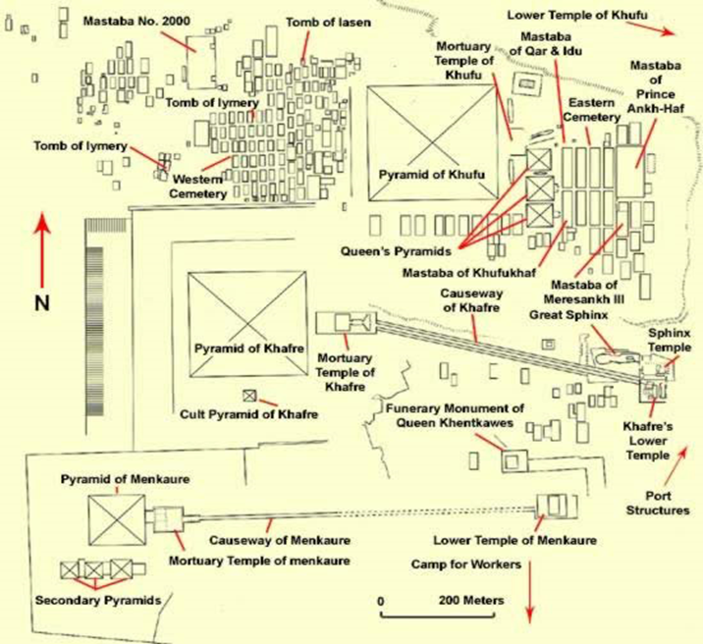
Figure 1. Giza Plateau

All of this can reflect that this dynasty's government was the most stable out of the five. Ann Roth praises the level of government structure that planned Giza’s structure.
“The rows of Mastabas in organized ranks that surround the pyramid
of Khufu at Giza have often been cites as a clear visual expression
of the highly developed government administration of Egypt in the
forth dynasty” (Roth 1988:201).

From this point, we see a massive change in the construction of the burial structures going into the fifth dynasty. Even with the last king of this going back to a mastaba tomb that was only a little bigger the fifth dynasty pyramids.
The fifth dynasty has a few different changes that take place over the course of 153 years. The first way that these burial practices change is that the sizes of the pyramids change dramatically becoming smaller as shown in table 1 outlining the volume in cubic meters of dynasties three – six five having the smallest figures (Barta 2005:180). The second thing that changed was the material to build all of the structures. They had gone back to mud-brick foundations to build them, which could mean that they didn't have enough money, manpower and time to build the large structures that the third and the fourth dynasties created. A factor that could have attributed to this is the number of kings that they went through, which also shows the stability of the government beginning to decline within the Old Kingdom. Another reason we can see the possibility of a decline in the fifth dynasty is that not ever king that we know ruled during that dynasty had made a tomb that was finished. They were also in shambles because of their poor construction leaving little to be seen. There is not a lot of information about the kings and their rule during this time. Clayton's representation of the fifth dynasty is only four pages long and does not even mention each King (Clayton 1994: 60-63).
The burial practices size and material from dynasties one to five from Ancient Egypt has the ability to reflect the stability of the government or rule of the kings and dynasties are as a whole; also reflecting the religious beliefs of the Ancient Egyptians. This is accomplished by looking at the both mummification and tombs while analyzing the state of affairs, size, and materials used in each dynasty. Also looking at the average reign of the kings in each dynasty can help to see how much power is passing from hand to hand; and whether or not they were able to build a tomb or even finish it.
From the research that I conducted I was able to see that each time some kind event upset the state of affairs in a dynasty or kings reign the tombs changed or evolved. This can be seen through looking at both mummification and pyramids we can see that religious beliefs influence burial practices and a dynasties stability can influence the practices even more making them become more or less elaborate in connection to the government. When the government is strong and has a good amount of control over the kingdom the burial structures got bigger and used better materials. On the other hand when the hold weakened the material declined and so did the size of the burial and quality of work.

Reference: Cited
Baines, John
1991 Religion in Ancient Egypt GODS, MYTHS, AND PERSONAL PRACTICE. Cornell University Press.
Bard, Kathryn A.
2008 The Introduction to the Archaeology of Ancient Egypt. Oxford: Blackwell Publishing.
Bárta, Miroslav
2005 Location of the Old Kingdom Pyramids in Egypt. Cambridge Archaeological Journal 15:177-191.
Belmonte, Juan Antonio
2001 On the Orientation of Old Kingdom Egyptian Pyramids. Journal for the History of Astronomy Supplement 32:1.
Clayton, Peter A.
1994 Chronicle of the pharaohs. London: Thames and Hudson.
David, A. Rosalie
1984 The Ancient Egyptians Religious Beliefs and Practice. London, England: Routledge & Kegen Paul Ltd.
Roth, Ann Macy
1988 The Organization of Royal Cemeteries at Saqqara in the Old Kingdom. Journal of the American Research Center in Egypt:201-214.
Spencer, A. J.
1982 Death in Ancient Egypt. London, England: Penguin Group.
Image
Giza Plateau, 2015, November 9, http://www.touregypt.net/featurestories/giza.htm

