Department of History
University of Wisconsin-Eau Claire

“The Winning Personality”:
President Harvey Schofield, the Eau Claire State Teachers College, and the Great Depression

By Jennifer Barth

History 489
Research capstone
Professor: Dr. Oscar B. Chamberlain
Cooperating Professor: Dr. Robert Gough

December 9, 2014

Copyright for this work is owned by the author. This digital version is published by McIntyre Library, University of Wisconsin Eau Claire with the consent of the author.
Abstract
During the Great Depression, funding for all government supported programs decreased, but perhaps none was more affected by the stock market crash than education, particularly higher education. Colleges and universities across the nation struggled to keep their heads above water in the midst of the vast financial crisis. However, teachers colleges fought especially hard to stay afloat. Catering to the least wealthy sectors of society, these schools and the degrees they granted were the only chance that working- and lower-middle-class children had to get a job during the financial havoc of the Depression, whether they planned on becoming teachers or not. President Harvey Schofield of the Eau Claire State Teachers College understood this. He knew the sacrifices his students’ families were making for their education, having grown up on a farm and worked his way up the educational ladder. At once a warmhearted and obstinate man, his dynamic character navigated his unusually embattled school through the toughest time in its history. During the Great Depression, President Harvey Schofield realized that the Eau Claire State Teachers College and its students both depended on one another for survival; and using every tool at his disposal—including his statewide reputation as an educator, money out of his own pocket, and, most importantly, his powerful personality—he ensured the longevity of his school into the present day.

Author’s Note
This paper mentions four different educational institutions. The distinctions are as follows:
Eau Claire and other current UW-System campuses (other than Madison) began as state normal schools. Normal schools were two-year teacher training institutions that granted diplomas rather than degrees. In addition to Eau Claire, other normal schools in Wisconsin were located at Platteville, Whitewater, Oshkosh, La Crosse, Superior, Stevens Point, and River Falls. (Colleges at Green Bay, Parkside, and others had not yet been established.)
All of these schools became state teachers colleges in 1927. Teachers colleges had the ability to grant four-year degrees. They became Wisconsin State Colleges in 1951, Wisconsin State Universities in 1964, and joined the University of Wisconsin (Madison) in 1971 to create the UW-System.
The University of Wisconsin was, at the time, an entirely separate institution from Eau Claire and other normal schools/teachers colleges, with its own Board of Regents and student base. As the one centralized university in Wisconsin, it was prestigious, but inaccessible to many.
University of Wisconsin-Extensions made a university education more available on a small scale by offering the first two years of a University extension at institutions across the state. While advantageous to those planning to continue their education in Madison, these institutions were smaller than teachers colleges, limited in extracurricular activities available to students, and carried the University’s expensive tuition costs. They also could not grant degrees.
Table of Contents
Abstract…………………………………………………………………………………………………………………………..2
Author’s Note………………………………………………………………………………………………………………….3
Table of Contents…………………………………………………………………………………………………………….4
Introduction and Historiography……………………………………………………………………………………..5
“Dad”: Harvey Schofield and the Eau Claire State Teachers College……………………………….12
With A Little Help From My President: Paying for College………………………………………………21
“Showdown”: The University of Wisconsin Extension Division……………………………………….27
Just When They Thought it was Over: The Heil Administration………………………………………33
The Changing of the Guard: Schofield, Davies, and the End of the Era……………………………44
Conclusion………………………………………………………………………………………………………………………53
Appendix A: Important Names……………………………………………………………………………………….56
Appendix B: Timeline of Harvey Schofield’s life………………………………………………………………57
Bibliography……………………………………………………………………………………………………………………58
Introduction and Historiography
“It takes money to make dreams come true.”
—President Harvey Schofield
The November 1, 1929 issue of the Spectator, the student newspaper of the Eau Claire State Teachers College, bore no trace of the stock market crash that had finally bottomed out the Tuesday before. While traders milled around the floor of the Stock Exchange in a panic, activities at Eau Claire carried on as normal. President Harvey Schofield, the dynamic president of the small Midwestern college, hosted members of his faculty at his family’s cottage in Chetek. Another member of the faculty, physics teacher Benjamin Bridgman, became secretary of the Northwestern Wisconsin Teachers’ Association. English teacher Arthur Murray took a trip east. Sports pages, editorials, and social columns looked the same as they always had. There was no reason for them not to; it was highly unlikely that any of the students—mostly from working and lower-middle class backgrounds—had felt any direct effects of Wall Street’s plunge yet. For the time being, at least in the scope of the teachers college, the beginning of the Great Depression did not warrant mention.
As time went on, it must have become quickly obvious that things were changing. Students’ families were increasingly unable to scrape together money for tuition. The Board of Regents of Normal Schools (the governing body for the teachers colleges in Wisconsin) found it difficult to procure sufficient funding from the legislature as appropriations were fractioned. The colleges themselves tried to serve the increasing number of students flocking to their doors on the budget they were allotted, with varying degrees of strain and success. Over the next decade, the teachers colleges of Wisconsin would experience the spreading chill of the Depression’s effects. Eau Claire shared in the common experience, with a few instances that would have been devastating if not for the powerful personality of its president, Harvey Schofield.
Schofield was a dynamic character, and in some ways a contradiction to himself. Just as he could be generous with his own money and his advice, he could also be tightfisted and inflexible. He was alternately described as warmhearted and bullheaded; kind and rigid; a concerned father figure and an iron-fisted administrator. Indeed, Schofield was not a man of weak temperament. When crossed, his responses could be blistering, sometimes to the point of overreaction. He was free with his opinions, whether positive or negative. But when students were involved, his chief concern was for their wellbeing. By the time he retired from the Eau Claire State Teachers College in 1940, he had seen twenty-four years of ups and downs, from surging enrollments to abolishment attempts, none more dramatic than during the economic crisis of the 1930’s. Financially strapped students came to him for an education that would give them a shot at making it in the real world, and he could not fail them. During the Great Depression, President Harvey Schofield realized that the Eau Claire State Teachers College and its students both depended on one another for survival; and using every tool at his disposal—including his statewide reputation as an educator, money out of his own pocket, and, most importantly, his powerful personality—he ensured the longevity of his school into the present day.
In many ways, Eau Claire State Teachers College’s experience was not much different from other colleges of its day. Like the majority of teachers colleges in the United States, it had started out as a normal school, a two-year diploma institution for the purpose of training teachers. Unlike universities, which were centralized and whose student bodies were predominantly male, normal schools were spread out across the state and educated mostly women. Christine A. Ogren, author of The American Normal School: An Instrument of Great Good, points out that Wisconsin is the archetypal normal school state, with nine scattered Normals established from the mid 19th to the early 20th century and one major state university. The atmosphere at the Normals was one of comradeship, sometimes described as being akin to an extension of high school. However, Ogren points out that normal schools suffered from being “only slightly recognized as institutions of higher education.” That would change in the 1920’s.
When normal schools became teachers colleges throughout the 1920’s, they not only gained the ability to grant four-year degrees, but also a certain amount of prestige among the educational world. A student could attend a teachers college without the intention of going into teaching; just the degree itself held the key to a better job than perhaps their uneducated father had, or at least a better job than they could have gotten otherwise. In fact, many students attended teachers colleges not because they aspired to educate, but because they aspired just to have a job. According to David O. Levine, in his book The American College and the Culture of Aspiration, the enrollment demographic of such institutions was mostly lower-middle class. Wisconsin was no exception. Because teachers colleges were distributed more or less evenly throughout the state, students who could not afford the University’s tuition or could not travel took advantage of these local, relatively inexpensive schools for training. When describing the Eau Claire a cappella choir, President Schofield described them as “a good cross-section of the poorer and middle classes in the great northwest. There was not one young person in the choir who came from parents with wealth.” Despite that lack of wealth, every one of them was able to attend an institution of higher learning.
What these teachers colleges offered, in effect, was a democratization of education. It was a topic that Schofield and his colleagues nationwide would often praise. Education at the university level was for the elite and the moneyed, but publicly-supported teachers colleges offered an education to anybody who could pay the nominal tuition fee, wealthy or not. It was not just educators associated with these low-cost, tax-funded schools who extolled their virtues. Even the president of the University of Illinois, David Kinley, said, “No man has any right under a government like ours to…determine that only a few shall be permitted to get an education of higher grade. In a democracy the only proper course is to keep proper standards and welcome all who can meet them. In saying this, of course, I am speaking of a publicly supported institution.” Teachers colleges were widely recognized as a good place to get a cheap education. It was never more relevant than in the years following Black Tuesday, 1929.
When the Depression began and layoffs destroyed financial security, a desperate public sought jobs that would pay enough to cover basic expenses: food, clothing, and shelter. While adults struggled to find money in a new world where there was practically none to be had, the younger generation had an advantage: an opportunity for education. That opportunity, in many cases, would not be fulfilled by the prestigious universities—the responsibility for educating the offspring of the working class would fall largely on the shoulders of the teachers colleges. The advantage of sending young people to college was twofold: it would give the next generation a fighting chance in a job market that had become somewhat of a rat race, and it would keep them off the job market just long enough for more experienced workers to get their bearings again. The increase in enrollment was both a boon and a curse. On one hand, it put teachers colleges on the map as worthwhile institutions that granted valuable degrees. On the other hand, it stretched already tight budgets nearly to the breaking point.
Legislative support for higher education during the Depression was dismal and continued to worsen as the 1930s wore on. By mid-decade, states had cut public education’s portion of their budgets by nearly half. Such cuts hit the faculty hard. In pre-Depression Wisconsin, teachers college faculty made more than their public school counterparts, but plummeting funding resulted in a massive 15% salary reduction. Students’ families’ finances were also spread thin, leading some students to withdraw from school. Had this still been the early 1920’s, this would not have presented as much of a problem: normal schools had not charged tuition, whereas teachers colleges did. However, the colleges recognized a mutual need: both the students and the colleges depended on one another for survival. Scholarships, loans, and IOUs were distributed as widely as possible, but hopes for an education were nevertheless dashed en masse. Often, the most talented students were the ones who were forced to drop out of school. Those who scraped together enough money to pay tuition were sometimes found to be starving. Officials at Kansas University discovered that one student was surviving on one quart of milk and one sweet roll per day.
Students searched frantically for any part-time job that would provide the much-needed money to stay in school. The National Youth Administration (NYA), a Works Progress Administration program designed to help students find work, alleviated unemployment for thousands of students across the nation. This government intervention guaranteed an education for poor students, whose involvement in Federal Emergency Relief Administration programs actually boosted their achievement in the classroom as well. It also ensured the longevity of the teachers colleges who depended on student enrollment for survival. Despite the looming threat of fiscal catastrophe, very few colleges actually shut down. Between 1934-1936, fewer than 2% of colleges and universities were forced to close; it is uncertain how many of these were teachers colleges. Many more than this found themselves in danger of closing, but were saved for a variety of reasons. Eau Claire State Teachers College would have been on this list.
Eau Claire’s situation, in many ways, was typical of its kind. Just like other teachers colleges in Wisconsin and across the country, it faced monetary hardships. IOUs were extended to indigent students. Salaries were cut across the board. The NYA took root on the college campus and employed many students who would otherwise have had to turn out their pockets and leave empty-handed. But very few other schools were actually threatened with abolishment not just during the Depression, but also several times throughout its history. In addition, very few other schools had an influential leader like Schofield. While he was emblematic of his occupation in accepting IOUs, he was extraordinary in the way he dealt with them, as will be discussed in a later section. Although the number of widely accessible biographies of college presidents is limited, Schofield’s actions seem to make him stand out.
Like scholarship about individual college presidents, scholarship about higher education during the Depression is scarce. David O. Levine’s book, The American College and the Culture of Aspiration, 1915-1940, proves to be one of the very few exceptions. He explores the effects of the Depression on private universities and publicly-funded institutions alike, and reveals that the experience was similar in more ways than it was different. In terms of the Eau Claire State Teachers College (now the University of Wisconsin-Eau Claire), the definitive source of information is currently The University of Wisconsin-Eau Claire: A History, 1916-1976, by Hilda Carter and John Jenswold. Carter and Jenswold go into detail about the Depression years on campus, and the methods the school employed to overcome the difficulties of the time. As far as secondary material goes, this is also the only source on Schofield. Occasional rays of his personality shine through, but first and foremost, he is an administrator and a figurehead.
As a result, much of the scholarship here is original, from primary sources. For insight into Schofield as a person, the best source is as close to the man as anyone can get: his correspondence, stored with that of the other chancellors at the University of Wisconsin-Eau Claire Special Collections and Archives. Beginning in 1936, the same year he fell seriously ill for the first time, Schofield’s letters document the opinions, feelings, administration, and general character of a man whose era was coming to an end. His letters, which were usually dictated to his secretary, sometimes took the cantankerous tone that he is best known for now, but others show the president as a gentler soul, grateful for his faculty’s able help and affectionate toward alumni and friends. Letters in his confident handwriting are personable and humorous. Each one had as its footer, “Very sincerely yours, H. A. Schofield.” It was true not only toward the recipients of his letters, but also his school. Just as Eau Claire State Teachers College belonged to him, he wholeheartedly belonged to his college.
“Dad”: Harvey Schofield and the Eau Claire State Teachers College
“I do not think so fair an outward, and such stuff within,
Endows a man but him.”
--Stevens Point yearbook, the Nautilus
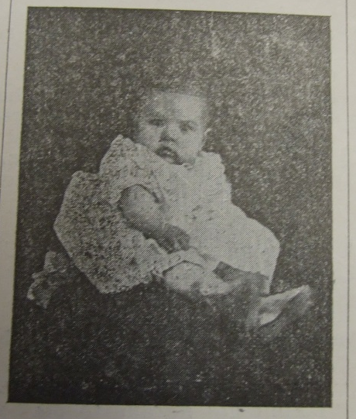
Although his career would take him throughout Wisconsin and across state lines, Harvey Schofield’s story began only twenty miles west of where his college in Eau Claire would stand. Born on March 28, 1877, likely on the family farm outside of Augusta, Schofield was the progeny of men and women who counted themselves among the pioneer farmers of Eau Claire County. His sights were not set on the same vocation his father and grandfather had taken, however. When he was eighteen, he took a teacher certification exam. He passed with flying colors. Following graduation from high school, he took a job in a one-room schoolhouse only a few miles away from the one he had attended as a child. Thirty-five years on, he recalled that time as “one of the most pleasant of my life.”
Harvey Schofield, ca. 1878. Source: Spectator, May 3, 1929.
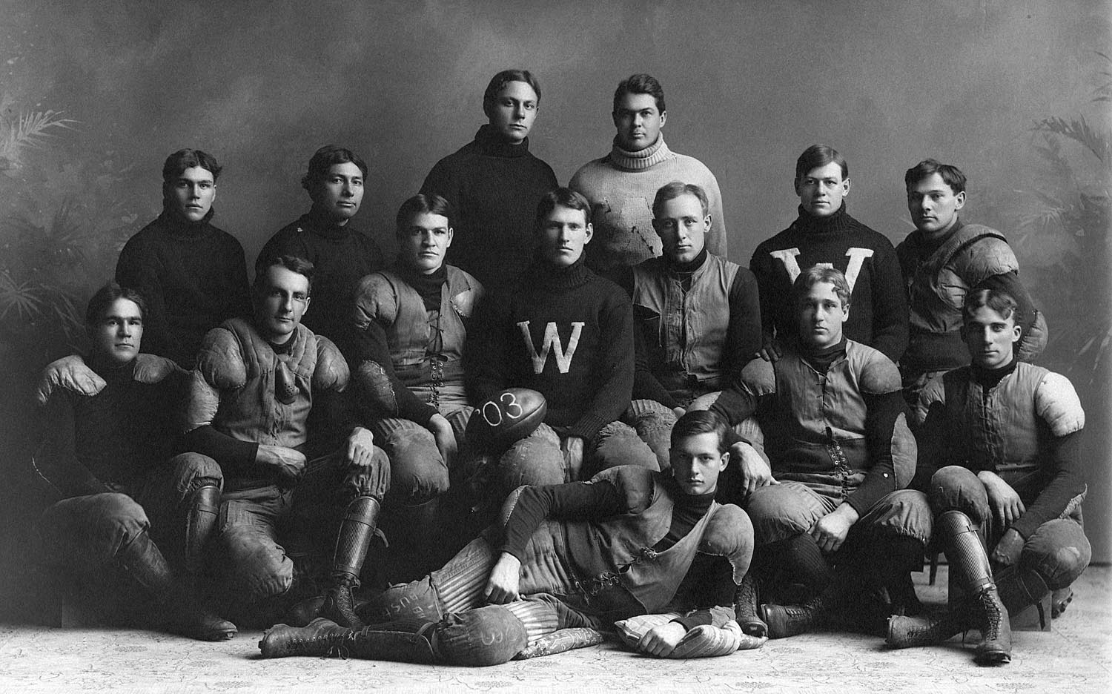
After two years of teaching, Schofield made the decision to become a student again, at Stevens Point State Normal School, one of six state teacher training institutions in Wisconsin. It was an inexpensive education—there was no tuition cost, although other nominal fees applied—and the resulting diploma was the only way that a rural school teacher could advance in the educational field, a benefit that ambitious Schofield seized on. He thrived at Stevens Point. In addition to earning a diploma in teaching high school English, he found outlets for his assertive personality, including holding leadership positions in the school oratorical societies and excelling in athletics. The latter especially defined his time there. As one of the tallest members of the basketball team, manager (and star kicker) of the football team, part of the executive committee of the athletic association, and winner of events such as standing long jump and hammer throw, he gained a reputation as a gifted athlete. The opening of the football season in 1900 was described as when “Schofield begins to kick.” In addition to making a name for himself on the field, he also earned a nickname for himself among his peers: “Dad.” It was a nickname that would characterize him to friends and students alike for years.
Harvey Schofield as fullback on the 1905 University of Wisconsin varsity football team. Courtesy of UW-Madison.
His stellar athletic career also helped to define his two years at the University of Wisconsin a year later; in fact, it was the reason he enrolled, having been recruited for his talent. While he was playing in championship football games and earning letters, he was also coaching football at his alma mater, Stevens Point Normal--and may have been playing professional baseball under an assumed name. According to the Janesville Daily Gazette, it was a well known fact that Schofield had played professional baseball “for years” during the summer. Because this was so widely known among other colleges, he played part of a football season as the pseudonym John Harvey, to conceal his identity. Another reason he played under an assumed name was to hide from his parents: they apparently did not approve of him spending so much time playing football. A rumor then began to spread that Schofield had signed a contract to play baseball under the same pseudonym for Milwaukee. If that had been the case, it would have wrecked his eligibility to play for the University. While this cannot be substantiated, his possible defiance of the University (and definite defiance of his parents) were typical of Schofield’s independent personality.
This personality led the way to his career as an administrator after graduating from the University with his Ph.B, a degree in philosophy. Besides Humboldt Grade School in Wausau, which had Schofield as principal briefly following his graduation from Stevens Point Normal, Ellsworth was the first school district where Schofield served as an administrator, acting as both superintendent and principal. Two years later, he served in the same capacity in Neillsville; the passing of another two years found him departing for Superior, where he worked his way up from the principalship of Nelson Dewey High School to that of Superior Central High. From there, he accepted the position of principal at Central High School in St. Paul. He stayed in no one place for more than three years. Along the way, he kept up with athletics, taking the time to coach at the high schools he presided over. He also did not suffer fools lightly, as the boys on the nascent Neillsville football team discovered when they asked “big, raw-boned young” Schofield to coach them. After several practices, he told them bluntly that they were not cut out for football: “All you want to do is keep out of each other’s way.” Schofield’s judgment marked the end of Neillsville’s football team.
During his “job-hopping” across the state, Schofield earned a reputation as a champion for education, a dynamic speaker, and a capable administrator. Part of it was the reputation he carried with him beginning from his time at Stevens Point; the local newspaper there regularly reported on the happenings of its former student celebrity, even going so far as to report on the Milwaukee Journal’s report of Schofield’s hiring at Eau Claire. Along with his administrative duties at his schools, he was involved in other educational organizations, including the Northwestern Wisconsin Teachers Association (NWTA), of which he was president and head of the convention planning committee.
When Schofield appeared on the list of speakers at an event, it was noteworthy. As part of an “unusually helpful and inspiring program” at a Western Wisconsin Teachers’ Association meet, Schofield was lauded by the La Crosse Tribune as one who “those who know him will not be willing to miss, and those who [do] not know him cannot afford to miss. His experience as an educator has been so wide and his success so marked that his [message] is sure to be of great value to his listeners.” He spoke at every opportunity about the value of education for society before a wide variety of audiences, from educational conferences to women’s club meetings. In an address entitled “The Teacher’s Part in the Educational Crisis,” he claimed that “If America is to be a leader among nations, it is through the public schools.” He pushed for a longer training time for teachers than just the two years that normal schools offered, arguing against the exact way he had gotten into education in the first place: taking a simple test and beginning teaching without any further training. “By doing so,” he told members of the NWTA, “we will be doing a greater service to the young; we will incidentally better ourselves.” Between the serious talks were also moments of Schofield’s healthy sense of humor: he kept students at Stevens Point Normal in stitches by insinuating that he had some interesting stories to tell about some of their teachers, who had been classmates of his in college. Before long, he would have college students of his own to entertain.
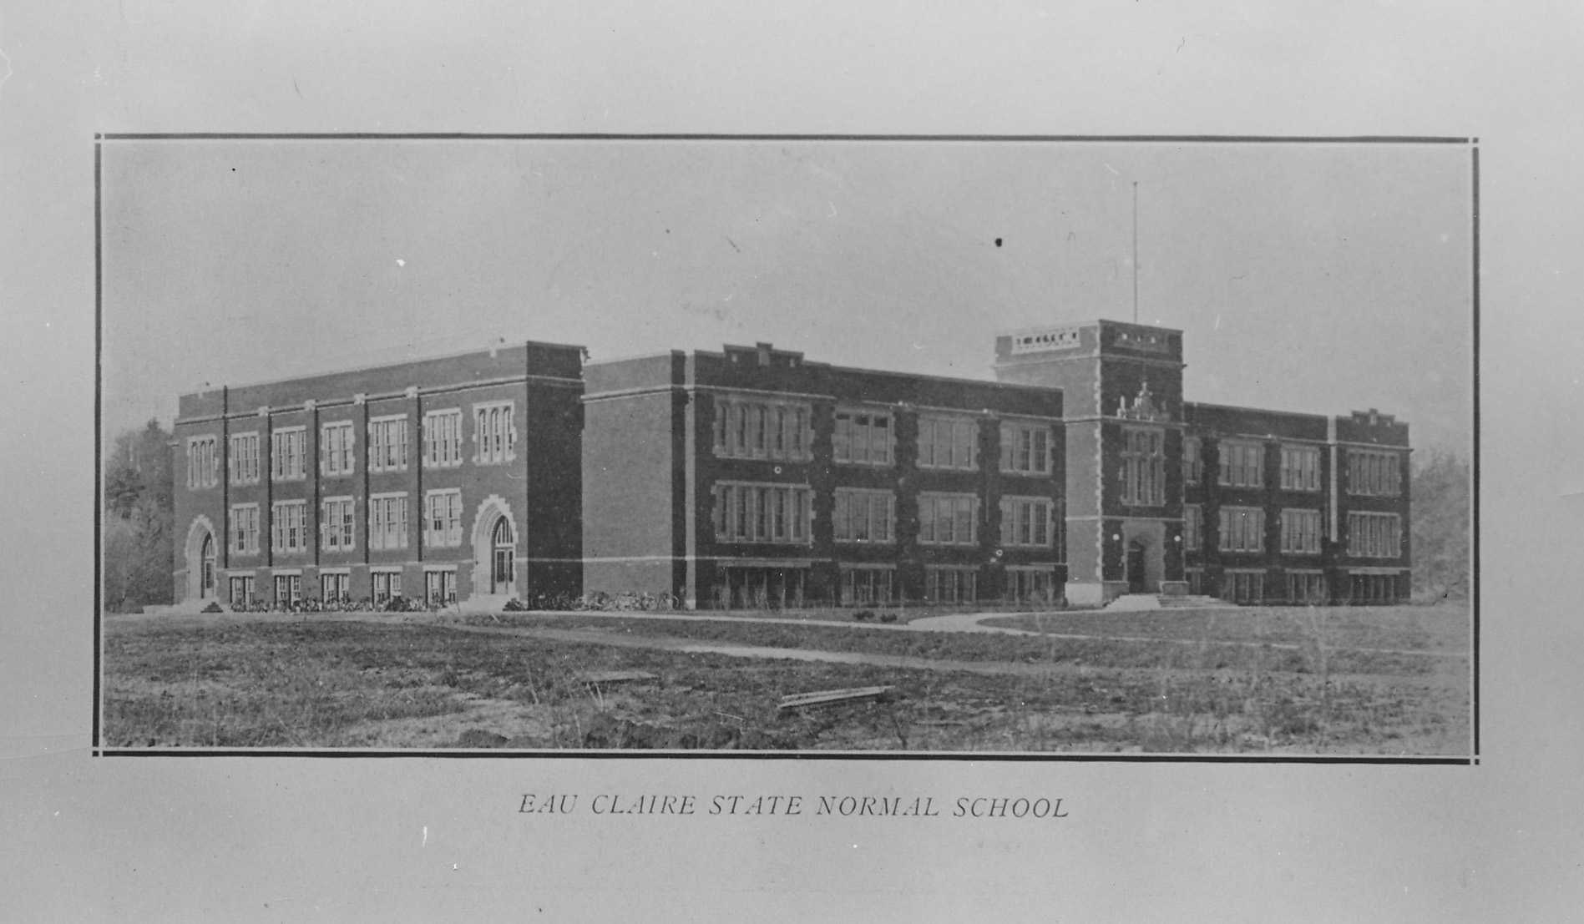
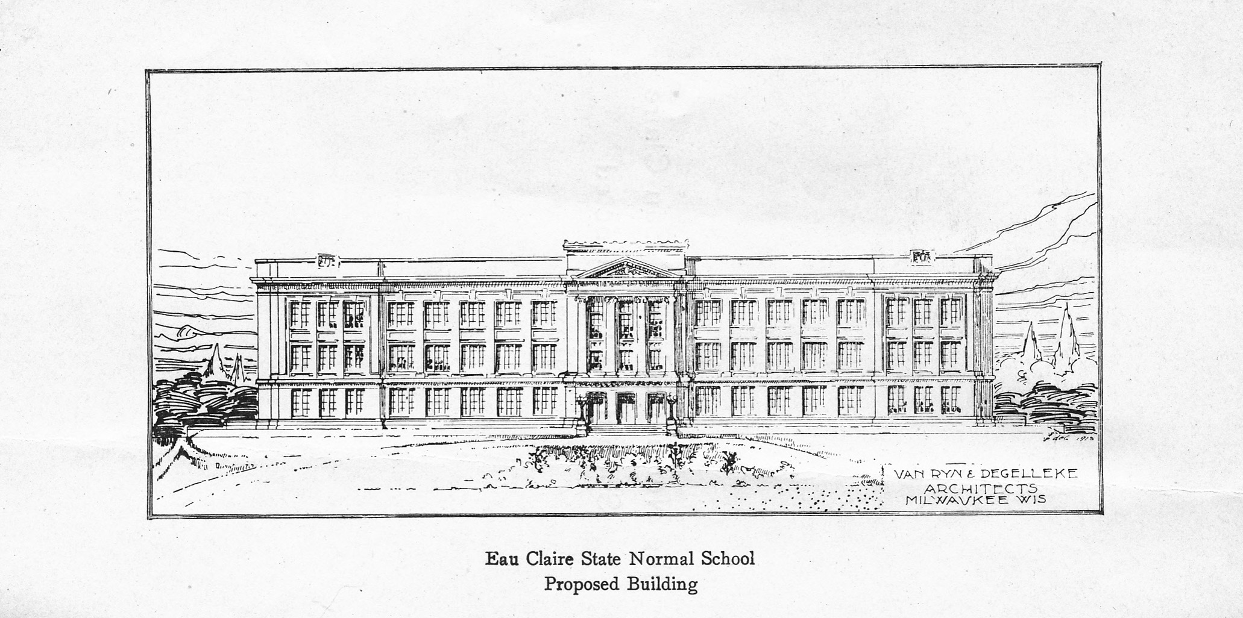
Newspapers across the state reported on March 11, 1916 that the Board of Normal School Regents had elected Harvey Schofield as the first president of the Eau Claire State Normal School. It was the culmination of a twenty-five year long struggle by the city to convince the Board of Regents that Eau Claire would be a prime location for construction of a new Normal. Following three failed attempts at this—including one which involved a delegation travelling to Madison, to pressure the Regents into rebuilding the recently burned River Falls Normal in Eau Claire—an opening appeared on the Board of Regents. Eau Claire quickly filled it by petitioning the governor to appoint local manufacturing magnate Emmet Horan in 1908. At first, the other regents regarded Horan as somewhat of a joke; Eau Claire had no school, and no bill had been passed to construct one, yet he was making decisions for currently extant Normals. Nonetheless, his persistence paid off the following year: the legislature passed a bill securing Eau Claire’s place as the site of the next State Normal School. The city selected a scenic plot of land along the Chippewa River for the new school, partially ringed by a tract of woods named after its former owner, H. C. Putnam. Construction began in 1915 at a cost of $225,000. While workers put the finishing touches on the collegiate gothic structure, the Regents searched for a president worthy of leading the infant institution through its formative years. They selected Harvey Schofield for the job.
The proposed design of the normal school vs. the actual design of the normal school. Top photograph: from pamphlet “Why the Normal School in Eau Claire Should be Constructed NOW”. Bottom photograph: University Photograph Collection, box 5, folder 12.
Schofield jumped into his new position as Eau Claire Normal’s president without a second’s hesitation. In fewer than six months, he moved his family to Eau Claire (where his daughter Betty Lou was born in May), hand-picked twenty faculty members to teach the first class of fewer than 200 students, and managed to give speeches before a number of different audiences. The doors opened in September to the first class of students to walk through the school’s halls, although the building was not quite finished; the 1917 Periscope reported the whack of wrenches resonating through the walls during the first month, and the official opening of the school’s cafeteria in October. Despite a somewhat rocky beginning, the first school year was a success. Enrollment for summer school was larger than enrollment for the regular school year had been, and the trend continued year after year as students kept coming. By 1924, with 496 students, its enrollment had exceeded that of either Platteville, the oldest Normal in the state, or River Falls, who Eau Claire had tried to replace in the late 1890’s. With its west-central location, it served a region of the state that up until then had been hungry for just such an institution.
As his school gained popularity, so too did its president. Schofield became a regarded member of Eau Claire society, active in groups such as the Kiwanis Club and the Freemasons; he was also elected to the YMCA Board of Directors in 1923. During World War I, he was part of the Eau Claire County Defense Council and gave talks about the war , including one to his own students, which included a “masterly array of facts” about the reasons behind the conflict. His presidency only served to solidify his good reputation around the state, which the tarnished Superior school district surely had in mind when it offered Schofield, a former principal of both its high schools, the superintendency in 1925. Although it meant a significant increase in pay, Schofield chose to remain where he was, because he “had enjoyed his years in Eau Claire…and did not wish to leave”. Eau Claire had faith in its Normal president as a leader in more areas than just education, and Schofield was more than happy to involve himself wherever he could.
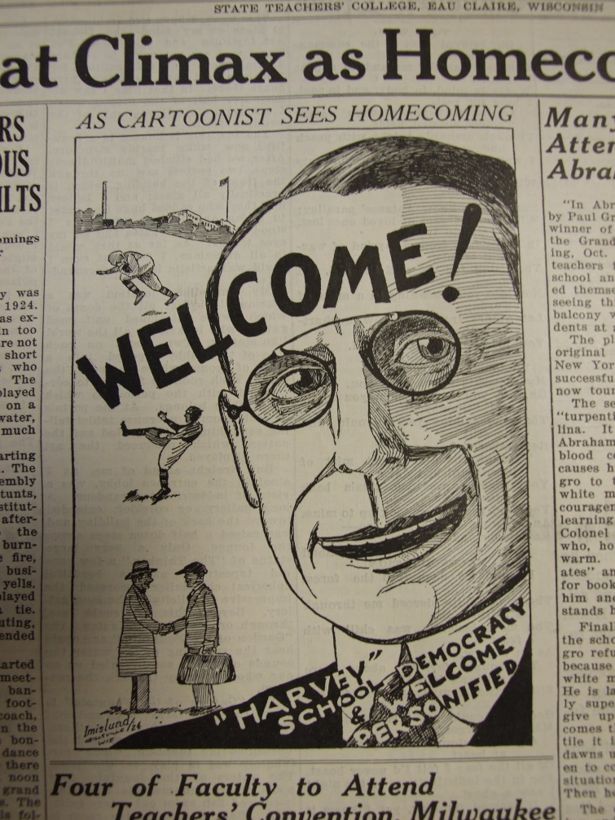
But his school was where he devoted the majority of his time and energy. Much of his life revolved around his students, just as a good deal of student life came to revolve around him. In the early years, while the student body was still of a manageable size to do so, he hosted the graduating class at his own home on S. River Street (now Graham Avenue). He rarely missed an opportunity to socialize with his students, whether it involved him singing at a Normal party or playing the “romantic young prince” in a production of “The Winning of the Princess” at a student-faculty mixer. Even as he neared fifty years of age, he scored the most points in the annual faculty-student basketball game, a few years after he had refereed a match between the Normal and high school coaches with a six-shooter in his pocket. He knew many students on a personal basis, which would be quite a feat at today’s universities but was entirely feasible at the smaller, more intimate normal schools. But “Prexy”, as his students called him, was still their president and resident disciplinarian, and took charge where he felt necessary, sometimes to an extreme: for example, especially during the early years of his presidency, he was famous for “embarrassing” young couples in their stairwell love affairs. The 1922 “Senior Will” bequeathed the shade of a butternut tree to young couples, and bequeathed those young couples to the tender mercies of Mr. Schofield.
Cartoon by Clarence Imislund, representing President Schofield as “School Democracy and Welcome Personified.” Source: Spectator, November 2, 1928.
Just as Schofield took a deep interest in his students, his students reciprocated the affection. The Spectators and Periscopes are filled with references to him: cartoons, caricatures, and jabs at Schofield demonstrate the close relationship that students at the Normal had with their president. His birthday became an annual event, where students would bake him elaborate cakes. They had various nicknames for him: Prexy (a then-common diminutive of “president”), Dad, and even just Harvey, when referring to him in the third person. His impact was such that, only a year into knowing their president, the editors of the 1917 Periscope yearbook dubbed him “The Winning Personality.” Witty alumnus Clarence Imislund described the student body’s feelings toward Schofield in the issue of the Spectator that came out the day before Halloween, 1925:
And ”Harvey” to me represents the spirit of our school: democratic to the core, sociable ninety-nine percent of the time, and righteously indignant in the remaining fraction; friendly always, and generous with his cordiality; treating the alumni alike, whether they shine in the world’s work or return “unwept, unhonored, and unsung”. “Harvey” makes school spirit a living thing, “full of the milk of human kindness” that makes the old alma mater a home for her absent children.
And we who have gone out sort of catch his spirit. We always have a hearty hand clasp for each other, and in our hearts there glows a warm affection for Eau Claire Normal. Such, in my mind, is the spirit of Eau Claire Normal. I count it a privilege to have spent a few years there; a greater privilege to have come under the influence of President Schofield; an honor to suggest his personality as the spirit of our school.
By the time the Depression slammed America and the world at large, the Eau Claire State Teachers College (a moniker it acquired when all Wisconsin state normal schools became teachers colleges in 1927), the surrounding community, and educational circles in the state had gotten to know and trust Schofield. Whenever a threat to his school surfaced, he stood up and took charge. Whenever his students needed help, he did his best to satisfy their needs. The stock market crash of 1929 set off a chain of events that shook the most remote corners of the country to their core, including Eau Claire, where the college faced difficulties like it had never seen before. At a time when his college needed his powerful, yet compassionate guiding force the most, he did not disappoint.

With A Little Help From My President: Paying for College
“Our prexy has spent a considerable amount of his own money to afford a little diversion and recreation for the men. Most of us appreciate it.”
--the Spectator, February 3, 1933
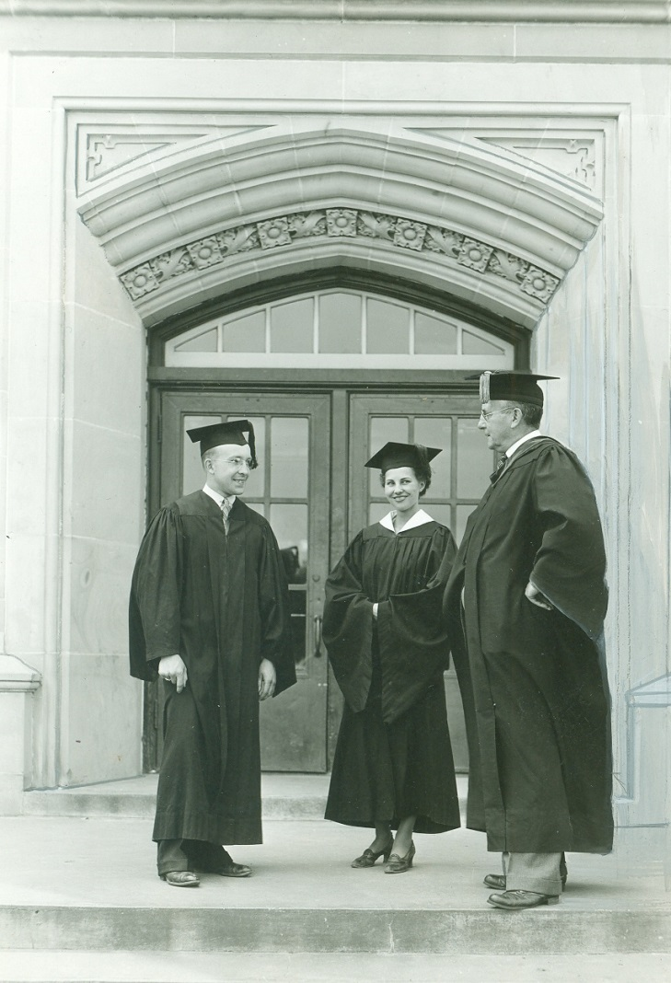
The above quote refers to the padlocking of the new men’s clubroom in the basement of the college. The concept of a student union was still nearly a decade in the making on Eau Claire’s campus, but already the ladies had their own “rest room,” a place where women could relax in the company of their own sex. The men had commandeered the tunnel between the main college building and its heating plant as a smoking spot. In early 1932, Schofield decided to give the males their own official space. He personally paid to furnish the new lounge. As the Spectator stated, most of the students appreciated it; but a few appreciated it to the point of taking it for granted, and less than a year later, vandalism and general disorder prompted Schofield to padlock the door.
Schofield with students, ca. 1936. Source: University Photograph Collection, UWEC Archives.
The creation of the clubroom demonstrates a trait of Schofield’s that is currently not well documented: his generosity. Even at the time, he was known for his frugality with the school’s money. Former secretary Geraldine Wing, who served three presidents beginning with Schofield, recalled that he “ran a tight ship.” Chancellor Leonard Haas described him as “really tight fisted in terms of the budget,” which made him popular with Board of Regents president Edward Dempsey. He also preferred to make all decisions himself when possible, whether financial or otherwise, because, as Wing remembered, he was “the supreme being” who “ruled his faculty with an iron hand.” However, nearly in the same breath, she also said that he was easy to work with, soft-hearted, and generous. Schofield, ever the contradiction unto himself, was an iron-fisted administrator because he was soft-hearted; he performed in the administrative style he felt was best for his school. His concern, first and foremost, was for the college and for the people who inhabited it on a daily basis.
As the machine of the Great Depression cranked up to full steam, that concern must have turned to full-blown worry. Not only was legislative support dropping, but a bank with which the teachers college held an account had failed, leaving Schofield unsure of whether he could recover the $2,700 contained within it. As a result, not only was state funding less than what it had been, Eau Claire had fewer reserves to fall back on than it had expected. Faculty salaries were slashed across the board, including for those at the bottom of the income scale. For secretaries who were paid only $75 per month, the cut was especially painful. When Schofield announced a 15% salary reduction, one secretary burst into tears; it meant that she would have to postpone her marriage. The president’s own salary had shrunk about the same amount.
Although Schofield took the same reduction in pay that everybody else was forced to accept, his own financial affairs seemed not to have worried him. Even with two teenaged children at home and an ailing wife, he could still survive. The welfare of his faculty, especially the lower-paid ones, occupied his mind more. When writing up budgets, he regularly requested that cuts be restored to teachers and staff receiving the least amount of pay. The official reports he sent to the Board of Regents took on a begging tone at times, explaining in detail why members of his staff needed the money: one secretary had worked for three years at the college at the equivalent of minimum wage for her job; another was a single mother with two children. “In fact,” he said, “all of my office force should either be raised or the waiver dropped if possible.” But at no point in these budgets does he ask for his own pay cut to be restored; he only put in such effort for his faculty.
Helping his students was a different matter. The only way he could offer assistance to the people who worked for him was through pleading with the legislature and the Board of Regents; otherwise, there was little else at his disposal. He recognized, however, that his students depended on the school in a way that the teachers did not. Of course, those employed by the school depended on their job for a living, but the students depended on their education to change the course of their lives. If granted the chance, they would work hard for their degree, and Schofield had complete faith in their abilities, even if they seemed initially unpromising. He argued against expelling freshmen who had three failures in their first year; to prove his point, he went through academic records with the help of his secretary and discovered that most of those students ended up being some of the school’s strongest by the end of their academic career. These students would succeed, if given the chance; but that chance depended on money. Knowing that students’ families were struggling just to get by, much less pay their children’s college tuition, Schofield offered to his “kids” what he had at his disposal: his own money.
Schofield’s generosity toward his students was not limited to the necessity of the Depression; rather, it spanned his whole tenure at Eau Claire. Even during the economic boom of the 1920’s, sometimes young people needed a little aid, and Schofield was glad to provide it, whatever form it took. Mildred Grill attended the normal school in 1925 and again in 1929 after it had become a teachers college. In a letter she wrote to the university nearly sixty years after her time at the Eau Claire State Teachers College, she described how she was twice a recipient of Schofield’s kindness. She was placed under quarantine at the home where she worked for room and board, after a child she was working with contracted scarlet fever. Schofield personally delivered her assignments to her. Because he went the extra mile, she was able to graduate with excellent grades. When she wished to return for a summer class in 1929, she knew where to go for help affording her schooling; and Schofield agreed to hire her in his own home to help his wife Dorothy, who seems to have been in perpetually feeble health, take care of the house and the children. “The family treated me like a human being,” she remembered, and “Mrs. Schofield always managed so that I would have ample time to study during the early evening hours and on Sat. and Sun.” In the same spirit of generosity that Schofield had shown her, she attached with her letter a check for $300. “I hope that in some small way I can return the good that has been done to me and that some needy student will be assisted in getting an education,” she said.
Schofield could not employ everyone personally, but beginning in 1934, he was able to employ a significant number of students through the National Youth Administration. To secure a chapter of the NYA in Eau Claire, Schofield had to complete an application certifying in part that his school was “of a collegiate nature”, and that all fees—including registration laboratories, and tuition—would be waived for students working for NYA funds. With a monthly salary check of between 10 and 20 dollars, it provided more than enough money for students to survive on. One of the criteria by which students would be selected for NYA employment was “character and ability to do college work,” which Schofield, being as close to his students as he was, was specially suited for. The NYA was one duty that he shared with other members of the faculty, especially in the later years of his administration, in order to use the program to its full capability. Students worked both on campus and out in the community. In 1934, the government allowed the Eau Claire college to employ 63 students; by the next year, the number had ballooned to 185. Those receiving NYA funding had come to rely so heavily on it that, if such employment became unavailable, they would likely have to drop out. In order to keep that from happening, Schofield was paying NYA recipients more than what federal standards decreed. How he was able to do this is unknown, but it fits Schofield’s personality: if he felt that even the government was not doing an adequate job supporting his “kids,” he would step around the boundaries to go the extra mile.
He sidestepped the government in another way as well, one which could have had drastic consequences: accepting gold coins as payment. Following the crash of the stock market, hundreds of banks across the country failed. In the days before the FDIC existed to insure accounts, families were left wondering if they would ever recover the money that had disappeared with the bank itself. The one backup that many had left was gold coinage kept in their homes, but that security would soon fail them as well with the enforcement of Executive Order 6012 in 1933. The “Gold Confiscation Order,” as it came to be known, was an effort by President Franklin D. Roosevelt to rejuvenate the power of the paper dollar. It prohibited “hoarding” of gold coins, requiring anybody—whether individual or corporation—to surrender their coins in exchange for monetary compensation not for the face value of the piece, but for the value of its weight in gold. In some cases, this would have been less than what the coin had been worth when minted. Failure to comply could result in imprisonment.
With little to no money, and their family treasure in gold their best method of payment, the Eau Claire State Teachers College began receiving offers of gold coinage as payment for things ranging from tuition to copies of the Periscope yearbook, even before Roosevelt issued the executive order. Schofield accepted them, and likely continued to do so even into 1933 and beyond. As long as the combined face value of coins collected did not exceed $100, it was legal to keep them; the only stipulation was that any gold accepted as payment after April 28, 1933 had to be exchanged within three days of receipt, under penalty of law. This was a stipulation that Schofield chose to ignore. For whatever reason, he asked that the coins be retained. Such an act of defiance could have caused the school to incur a fine, or Schofield to be arrested. Nonetheless, he kept them, and they remain in the possession of the University to this day. At the end of the year, however, he must have had to balance the budget somehow and prove that he had accepted tuition money from every student in his school. It raises the question: how was he able to do it? No evidence survives to confirm the suspicion, but the possibility exists that he was making up the difference out of his own pocket.
The fact that Schofield was not shy about kicking in a little bit of money here and there was no secret. The furniture in the men’s clubroom was supplied entirely by him, as was some of the furniture in the ladies’ lounge. He offered to purchase copies of the Periscope for students who could not afford one of their own. In addition, according to Leonard Haas, he was also paying students’ tuition. This is not officially documented anywhere; apparently it was done under the table, on an individual basis. Haas recalled that Schofield would advance the fees for students until they were able to pay the full amount themselves, but it would not have been out of character for him to cover costs for especially promising students, and call it square. Whatever the case may have been, his benevolence changed lives, not just for those who benefited directly from his generosity, but also their families and descendants. For many, it meant the difference between spending their lives as a salaried professional or a low-paid wage worker. The old principle still applied: the school depended on its students just as the students depended on the school. In 1937, though, the school counted on its alumni more than ever.

“Showdown”: The University of Wisconsin Extension Division
“I am sick and tired of kowtowing to the University staff.”
--President Schofield to La Crosse president George Snodgrass, February 7, 1938
On April 23, 1937, the citizens of Eau Claire picked up their issues of the Leader from their stoops, opened them to the second page, and found the title blasting across the top: “’U’ Extension School May Replace College Here.”
This had come out of nowhere, at a time when enrollments at the Eau Claire State Teachers College were skyrocketing. It had also come at a time when teachers colleges’ competition with the University of Wisconsin was beginning to chafe at the university’s own pride. Being the centralized, expensive school in the state, it was not as attractive a prospect as it once had been, with local teachers colleges granting perfectly effective bachelor’s degrees at a much lower cost. Perhaps as a result, the university sent delegates out to high schools to encourage students to consider their school for their higher education. Schofield felt this was ludicrous. “[T]he spectacle of the great University of Wisconsin going about the state with a fife and drum corps drumming up students for that institution is one to be deplored,” he complained. “We always, in some way, get our share of students…and until I have to fight fire with fire I will let things take their course.” With the prospect of the abolition of the teachers college, it appeared that the university was taking Schofield up on his offer.
The story was not so simple. Bill no. 873 A was introduced into the Joint Finance Committee of the legislature not by anybody at the university, but by an Eau Claire lawyer named Lawrence J. Riley, on behalf of an unnamed group of Eau Claire residents. It laid out the process of transformation: the Board of Regents would turn the college campus at Eau Claire over to the university; the name would change to “University Extension School at Eau Claire”; and the current faculty of the teachers college would “be given due consideration for positions” at the new UW-Extension. It all boiled down to the one stark sentence that finished off section one of the bill: “The Eau Claire State Teachers College is abolished.”
It was not the first time the school at Eau Claire had felt the threat of abolishment. As the “baby” among the normal schools, it was the first one considered for closure when citizens or politicians felt there were too many teacher training institutions. The first abolishment attempt occurred in 1923, as a method of retaliation: lack of support to combine all governing educational agencies into one centralized State Board of Education led members of the existing, less powerful Board of Education to introduce a bill to the assembly committee on education, intending to turn the Eau Claire Normal into a high school. A delegation which included President Schofield went to Madison to protest, armed with a petition bearing thousands of signatures to keep the Eau Claire Normal intact. Schofield spoke at some length before the legislature, citing Eau Claire’s high enrollment and rebutting an argument that there was a surplus of teachers produced by the state Normals. About a month afterwards, the bill died without further consideration. A bill introduced in 1927 to abolish three Wisconsin normal schools was taken less seriously; Schofield indicated that the Eau Claire Normal building would be used as a school for female juvenile delinquents, on the slim chance that the bill made it through to passage. It did not.
This new threat to Eau Claire in 1937 surfaced while the university was experiencing difficulties of its own. While its hardships during the Depression had not been dissimilar to those of the teachers colleges, it had a unique problem in 1937. Its president, Glenn Frank, had recently been ousted on charges of mismanagement of the university’s funds (including charging personal purchases to university accounts), having a hand in scandals, and violating the terms of his contract. It had been a controversial move, and the university was left reeling.
The Eau Claire State Teachers College was itself left reeling in the wake of the UW-Extension bill. Passage of the bill entailed an increase in all fees, a sharp decrease in allowed enrollment, and abolishment of the training school, which two hundred school-age children in the area attended. The curriculum would have been cut down to just the first two years of college work, with the understanding that students completing those would transfer to the university in Madison for their junior year. In essence, the entire purpose of the teachers college would disappear with it: students who had chosen to study there in the first place had done so because they needed to earn their four-year degree at a local institution, not at the distant university.
Opposition to the bill was massive. A mass meeting at the college featured speeches from faculty members, including Schofield, and resulted in a petition with over 400 signatures from students. The president also squashed a proposed demonstration in downtown Eau Claire in favor of more moderate displays of opposition. If he had allowed it to happen, though, the citizens of Eau Claire at large likely would have joined in; the city threw its support behind the college, demanding answers from state legislators who could only reply that the bill did not have much backing in the assembly, either. The papers were filled with opinions from school officials, including Schofield, whose vociferous nature came out in an article bearing a typically colloquial title, “Should City Go University or Be College.” The speech he gave at the local conference on recently introduced legislative bills calmly outlined the reasons why Eau Claire’s teachers college should be left as it was—convenience of location, variety of educational opportunities, healthy enrollment statistics—but behind it was a protective spirit. He had built this college up to where it was, for the sake of local kids who could not afford Madison’s distance or inflated fees. He would not face this danger sitting down.
In the end, the Alumni Association turned out to save the day. Headed by a former student who was himself enrolled at the University of Wisconsin, the Association hired an attorney, Otis Linderman, to represent them at a hearing in Madison. Linderman reached an agreement with Lawrence Riley, who had introduced the bill, that the Eau Claire teachers college would begin “beneficial reorganization of the administration,” in exchange for withdrawal of the bill. Just like that, the crisis was over, less than a week after it had begun. It was due in large part to the Alumni Association’s actions that the bill was withdrawn; however, Schofield’s take on it was a little different. “I got busy on the bill, as soon as I discovered it, and I think the sponsors of the bill have withdrawn it,” he wrote a former student who had offered help. “When we got the facts before them the sponsors of the bill saw that they were up against a tough proposition, and decided that the only thing to do was get out from under.”
Schofield perhaps took a little too much credit for striking down the bill that would have “practically wrecked this school” and “been a big set-back to the people of Eau Claire.” But when the UW-Extension division antagonized all teachers colleges the following year, Schofield was the president to oppose it. Perhaps still irritated from the loss of a potential new Extension in Eau Claire, UW president Clarence Dykstra and Extension division director Frank Holt began placing pressure on all of the teachers colleges. UW-Extensions were venturing into the rural school teaching field, which had previously been the jurisdiction of the county Normals and state teachers colleges. They also attempted to force teachers colleges to accept credit for work at the Extensions, although the university and the teachers colleges were entirely separate entities, ruled by separate Boards of Regents. Most outrageous of all, Extension division officials were pressuring the teachers colleges to grant a two year diploma for only a few summer sessions’ worth of study.
The teachers college presidents were irate. “No respectable college is expected to grant a diploma or certificate on less than one year of resident work,” president Jim Dan Hill of Superior pointed out—so how could extensions try to force teachers colleges to do it? Although the presidents were upset, there was little that any of them was willing to do. The University of Wisconsin was still a mighty force to be reckoned with. At a presidents’ meeting in early May, by making himself “obnoxious” in voicing his opinions against the university, the heads of the colleges were reminded that they also had their own mighty force to be reckoned with: Harvey Schofield.
Schofield had had a run-in with the people at the UW-Extension in Rice Lake in April, which had evidently not ended the way the Extension folks would have liked it to: “In my very modest way,” Schofield sarcastically told his colleagues, “I told them where they could go.” He anticipated having a “showdown” with President Dykstra. He did not think any more highly of the Extension division director. “Frank Holt has already grabbed the earth and wishes to foreclose his mortgage on the moon.” By May, the time had come for that “showdown” to happen. It took men with “intestinal stamina” to take on Clarence Dykstra, according to Stevens Point president Frank Hyer. In his eyes and the eyes of the other presidents, Schofield was the only one who could. It was his responsibility to “appoint a committee…whose responsibility shall be the briefing of the case of the state teachers college vs. the extension division”. Letters arrived on Schofield’s desk from nearly all the teachers colleges in Wisconsin, urging him to head the committee.
Very little material with regard to this matter survives outside of Schofield’s personal correspondence, and even what remains is somewhat scattered. The long-term outcome of the “showdown” is unclear. Two things, however, are certain. One is that, in a time of crisis, the presidents of the State Teachers Colleges of Wisconsin knew they could turn to Schofield for advice and for action. Even against the powerful University of Wisconsin, Schofield, one of its alumni, was unafraid of the consequences. If quality of education was threatened, he would do what it took to protect it. The second certainty of this matter is that the “showdown” produced at least one mutually beneficial result: by 1940, Eau Claire State Teachers College offered one UW-Extension course.

Just When They Thought it was Over: The Heil Administration
“I do not think we have much to fear from the new governor as I feel that he will be willing to treat us as fairly as he can.”
--State Superintendent John Callahan, December 17, 1938
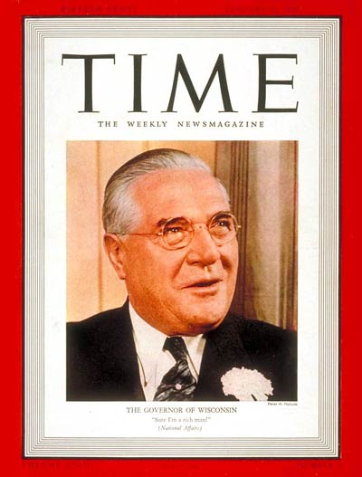
The Wisconsin gubernatorial election of 1938 resulted in the ousting of Philip La Follette from the governor’s mansion. La Follette, son of famous progressive crusader Robert La Follette, had run on a similar platform for the Wisconsin Progressive Party. From the teachers colleges’ perspective, having a governor in office whose platform echoed the traditionally education-friendly Wisconsin Idea was, to say the least, comforting. Despite the endless scramble for what little funding was available, they must have felt that a progressive state government would do its best to carry their institutions through the Depression. The election of Republican candidate Julius P. Heil changed that.
“Julius the Just” on the cover of Time Magazine, January 16, 1939. Source: Time Magazine, http://content.time.com/time/covers/0,16641,19390116,00.html.
Heil, a wealthy businessman, was a jolly fellow with a propensity for describing himself as an erstwhile “peasant” from humble beginnings, and describing average taxpaying citizens as “Ma and Pa.” His campaign in 1938 was built on saving “Ma and Pa” millions of dollars in taxes by cutting excessive government spending and consolidating departments. He was certainly a likeable man; his readiness to laugh was part of his overall personable nature, as was his tendency to address acquaintances by their first names. When he got to the capitol, however, he wasted no time in getting down to work. Less than a month into his first term, Heil had dedicated himself to “wiping off the books” every trace of Philip La Follette’s progressive legislation. Funding was slashed for a number of programs, including such controversial progressive measures as the Wisconsin Development Authority, which was involved in bringing electricity to rural homes and communities. The amount of money allocated for salaries in the Heil Administration was only part of what it had been under La Follette. But while many state institutions lost capital, higher education felt the cuts most.
Board of Regents secretary Edgar Doudna had predicted this. As a representative for the teachers colleges who was always in Madison to keep the presidents informed, he had an early indication of how bad the situation was. In November of 1938, he informed Schofield that the budget hearings with the new governor did not look favorable to state higher education. What the papers reported was “mild compared to what the gentleman is actually saying…[the] hearings yesterday pretty nearly paralyzed the people who made appearances.” He finished by warning that “we can expect a good cut.” When he asked his friend to attend a subsequent budget meeting, Schofield readily agreed. “I hope to get some slants on the attitude of the new Governor toward education,” he said. “Up-to-date all of the slants that I have had have been of a rather dubious nature.” He, Doudna, the Board of Regents, and the other presidents knew that Heil’s budget was not going to be friendly to them. It was only in February of 1939, when the new proposed state budget was made public, that they realized how deep the cuts would be.
According to Schofield’s calculations, the allotment for higher education was 17.7% of the total budget under La Follette. However, Heil’s proposed plan placed 39% of the total cuts on what totaled up to less than twenty percent of the former budget. In the new plan, higher education—the teachers college, Stout Institute, and University—experienced financial losses three times greater than those of other state departments and activities. $20,000 was to be cut from the general operation budget. “The question before the house seems to be; why was higher education picked out to bear the brunt of [Heil’s] savings,” Schofield lamented to Senator Erle Ingram. “We cannot live on the budget as set up.”
The blow of Heil’s cuts came after a short period in which taxpayer support for Wisconsin teachers colleges was beginning to recuperate. La Follette’s administration had brought some relief by slowly increasing the amount of tax dollars to go to the colleges from the time he took office in 1935 (for the second time) to the time he was denied reelection. Although circumstances prevented the colleges from receiving the kind of taxpayer support that they had enjoyed in the 1920’s, the small increase was something. Just when all the teachers college presidents were perhaps beginning to think the crisis was coming to an end, Heil’s austerity measures assured them that it was not. In fact, the proposed budget stripped away half of the salary amounts that had been restored to teachers under La Follette’s policies.
Schofield was furious. Various measures had always been available to the teachers colleges when help was necessary: the NYA had helped students find employment to pay for their education; emergency funding sources had usually been available in some form or another in a pinch. Schofield had also been able to rely on his friends on the Board of Regents, especially secretary Edgar Doudna and president Edward Dempsey, when advice was needed. Now it was Dempsey’s turn to write Schofield, the trusted dean of the presidents and long-time educator, for advice as to how to handle this new crisis. Schofield wrote back that Heil’s budget was “utterly impossible.” The teachers’ salaries account would lose $150,000, a total that Schofield was at a loss as to how to overcome. “In regard to…Teachers Salaries I do not know what to advise,” he admitted. “If this budget has to stand, we are back where we were four years ago, only in worse shape.”
With this thrift-minded governor in office, he and the other college presidents suffered from a new helplessness. The security nets had always been in place, however ratty they may have become as time went on, but now they felt as if they had been snipped out from under them altogether. President C. M. Yoder of Whitewater confessed everyone was so shocked that “our immediate reactions may not be altogether sound.” He began preparing a letter to send to six of his faculty members who would be the first to be laid off if the need arose. President Asa Royce of Platteville, whose budget was already the smallest out of all of the teachers colleges, was in desperate need of funding to repair his overstuffed, structurally unsound library. He wrote to Edward Dempsey in a state of distress: “As I study the recommendations of the Governor and try to apply them to Platteville I find constantly that I do not see how the recommendations could be applied without seriously handicapping the work which we are now doing.”
Likewise, Schofield was now facing the prospect of operating his school on insufficient funding, but with a new question weighing on his mind: would he be able to support all his students? In the past, the students’ inability to afford their schooling had been one of his chief concerns, and one that he had been able to rectify on his own. Now it wasn’t a matter of his students being able to afford college; it was a matter of his college being able to afford its students. "We might exist on [the new budget],” he said, “but the quality of the work would be poorer, unless educational opportunities were denied to the people of this section.” The possibility of having to lay off teachers and limit enrollments meant that he might have to turn children away. Denying any deserving student an education must have been wrenching for the president, who had gone so far as to pay out of his own pocket to make sure as many kids were educated as possible. For many of the young people who walked through the halls of his college, the degrees they graduated with were the only chances they had at being able to make it through the rest of the Depression, however long it was going to last. Schofield must have been keenly aware of this.
In an effort to recoup some of the losses proposed by Heil, Schofield wrote to Dempsey on behalf of all the teachers colleges, well in advance of when the teachers colleges were to appear before the finance committee. “At risk of being obnoxious in writing regarding the budget,” he laid out the points that he felt should be emphasized to the committee. “We realize that some savings…must be made. Higher education, as represented by us, at least, is willing to meet the legislature half way on these matters. …We are willing to take our appropriate share of the economies.” Beyond voicing his opinion, which in the past had often been effective in getting what he wanted, he could now only sit and watch as the Regents asked for an inadequate amount of money, in the knowledge that it was all they would receive. It did not ingratiate them with the legislature, who still did not give the teachers colleges the same consideration that other state departments got.
In the wake of the devastating budget’s passing, letters were fired off in all directions, wondering what the next move should be. Dempsey was forced into damage control after statements appeared in the newspapers from Heil’s financial secretary, who said that “intensive propaganda” claimed teachers would earn "starvation wages". Schofield called a meeting of the presidents to discuss the best way to handle these measures, whether through increased fees or reducing salaries, but the decisions reached at this meeting are unknown. Whatever the case, they must have realized that there was very little help for them now. President Jim Dan Hill of Superior suggested they make a more “vigorous presentation in the legislature for more adequate funds.”
The faculties of these colleges followed his advice. A delegation of teachers drove to Madison to protest the passing of the budget, issuing a statement which insinuated that the governor either misunderstood what kind of money it took to operate a teachers college, or that “there was a definite effort to cripple the nine institutions” across the state. They had an ally in Senator Kenneth White, a Republican from River Falls, who was equally alarmed as the colleges themselves that Heil had chosen to wreak havoc on the “poor man’s university”. The appeal he made to Heil was diplomatically phrased—“I feel that you do not wish to curtail in any way the opportunities of the boys and girls of the poorer families of our state”—but behind it was an undercurrent of shock. How could Wisconsin have done this to its children?
But Heil had promised to cut taxes, and he continued to attack higher education in order to make it happen. The University of Wisconsin became a thorn in the teachers colleges’ side once again, although their funding had also been slashed, when Heil announced his support for a measure that would provide one year of University training at the smaller colleges, in another attempt “to save money for Ma and Pa.” By August, the Emergency Board, which had been a fairly consistent backup plan in the past, was no longer reliable for relief. Obtaining releases for purchases from the governor’s office had become an exercise in patience—and prayer. A promise in May to restore a 5% cut in the budget bill—a larger sum than it appears on the surface—provided some hope but seemed empty. The expense of the teachers colleges was for the good of the citizens of Wisconsin, Heil assured Dempsey: “[A]nd if you will work with me, I am sure we will be able to rehabilitate our people.”
Less than a year into his governorship, however, the people were feeling less rehabilitated and more disillusioned. In addition to the assault on teachers colleges, he had also taken action against labor unions, among other institutions. The governor they had elected in hopes of reform had betrayed large swaths of the lower classes—the “Ma and Pa” he had promised to protect. Public support for his policies sank so low that an editorial in Rhinelander published a political obituary. “[T]he Heil Crusade is now in so anemic a condition,” it told readers, “that most expert[s] cannot detect any political life.” It had reached such a fever pitch that articles had begun appearing in other parts of the country with titles such as, “Heil’s Antics Jolt Wisconsin.” It was now a national matter, a political spectacle that people across the country could follow.
While some in the state must have been embarrassed, Schofield remained indignant. To him, Heil’s administration had taken on the quality of a circus. He likened Heil to the latter half of comedy duo “Amos and Andy”, as someone whose big ideas never accomplished anything worthwhile. “Our troubles are due, largely, to a Governor who has no idea of what is right and what isn’t in a state government,” he asserted. While the legislature debated in Madison over the teachers college cuts, Schofield injected himself into the politics however he could from Eau Claire, “helping to kill a lot of unwise legislation.” It was at least some measure of action he could take in his own defense, and in defense of his colleagues and their schools. For the most part, though, Schofield could do nothing but wait and see what decisions were made. Until he knew just how badly the teachers’ salaries would be cut, he made the suggestion to his faculty that they not spend all of their paychecks, just in case. Even if students had not been able to afford their tuition, he had always been able to pay his faculty. Now even that was uncertain. Everything was falling apart, and Schofield, for once in his entire time at Eau Claire State Teachers College, was largely powerless to do anything about it. As always, though, he was free to express his opinions, and he freely did so. Letters to friends and associates were peppered with insults about the governor. He wrote a colleague in Iowa, “This is my twenty-fourth year as president of this teachers college, and in all that time there has never been such a ‘mess’, as we have here in Wisconsin.”
However, a light shone at the end of the tunnel, although it may have initially seemed dim. In October, Dempsey wrote to Schofield and told him, among other things, that the State Treasury was facing bankruptcy and that college operating budgets would have to be amended; but at the end, he revealed that the “budget people”—members of the Joint Finance Committee—were regretting the decisions that they had made earlier in the year. Just the day before, the Emergency Board, a legislative committee organized around providing emergency funding for education, had notified the Regents that unallotted appropriations for the last two quarters of the 1939-1940 fiscal year may have to be reduced by as much as 25%. The Regents were at somewhat of a loss. When La Crosse State Teachers College requested funding to hire an additional training school janitor, they were granted permission to do so—when (or, perhaps, if) the funds became available. Just over a week later, La Crosse’s finances were in such dire straits that they closed their cafeteria.
Conditions continued in the same pessimistic vein across the state into November, when Secretary Doudna figured out that, if worse came to worse, salaries might have to absorb a 20% cut because no other account had enough funding to be cut at all. He described the situation as “critical.” In a last attempt to save the budget, and conceivably the teachers colleges of Wisconsin, the regents requested another hearing before the Emergency Board. To help them make their case, they called upon prominent figures whose influence, they felt, might hold weight. They again requested the help of Senator White, who had taken up the cause after the legislature had passed the first budget.
Dempsey also made sure to request the help of President Schofield. Money was so tight at that point that the regents could not justify holding one last meeting before they met with the Emergency Board. Schofield could not meet with the rest of the presidents for the same reason. But even if the two levels of governing bodies among the colleges could not meet amongst themselves to talk the matter through, Dempsey asked Schofield to attend the hearing. “Use your own judgment relative to having a committee of the presidents present,” he said, but he made no move to invite the other presidents himself. As powerless as he had been before to do anything about the money draining away from the colleges, Schofield still had one thing left at his disposal: his reputation. Over forty years’ worth of experience in education had made him known across the state. Dempsey knew it, and knew that those responsible for the budget in the legislature knew it. Schofield knew it as well. Even if he did not plan on speaking before the board, his presence alone would have influence not only for the benefit of his own college, but for all the colleges across the state who had depended on him in the past. He consented. “We will all hope for the best,” he said.
The appearance before the Emergency Board took place on December 6. Schofield was the only college president there. Dempsey spoke before the Board and the Governor, pointing out once again that the teachers colleges were carrying a disproportionate amount of the financial cuts in the state. When he went into detail about the appropriations for the six different financial accounts the teachers colleges operated on, Governor Heil seemed to have trouble keeping track; it was another senator on the Board who had to explain it to him. Along with explaining the accounts, Dempsey asked that the promise that had been made in May—the restoration of the 5% cut—be kept. The hearing closed with Dempsey’s request granted. While other measures still stood, meaning that salaries would have to be reduced somewhat during the spring semester, and some ambiguity remained, the Board’s concession had lifted a burden off the shoulders of the teachers colleges. Those in attendance agreed that the outcome was satisfactory. It was also a small token of reconciliation between Heil and the teacher training institutions of his state, even if general good will toward the governor was starting to fade.
As early as May of 1939, there were predictions that the governor’s actions against the teachers colleges would take a divot out of his chances for reelection. Winter Everett, columnist for the Madison Wisconsin State Journal, expressed the opinion that areas with teachers colleges would be much less likely to vote for Heil during the next election. While that turned out to not necessarily be the case—he won reelection to another term in 1940—his jovial persona increasingly proved to mask an unsatisfactory governor. Years of poor administration and antagonistic policies (including those dealing with labor) led to disenchantment among all factions of Wisconsin voters, and “Ma and Pa” voted him out in 1942. When his opponent, governor-elect Orland Loomis, died before he could take office, Heil was not allowed to continue in his position; the court ordered lieutenant governor Walter Goodland to assume the position of acting governor, despite Heil’s protestations.
To those who had endured the teachers’ college crisis of 1939, it was a major victory. Schofield would undoubtedly have had some choice words to offer on Heil’s failure to win reelection. However, fate had other plans.

The Changing of the Guard: Schofield, Davies, and the End of an Era
“If I had my life to live over again, I would not choose any other occupation. I have enjoyed my contact with young people, and I have had a very happy time of it.”
--President Schofield to J. W. Crabtree, August 6, 1937
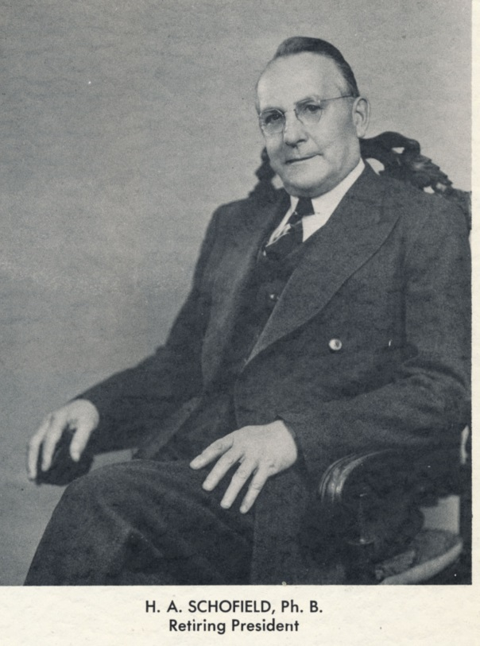
On October 9, 1940, over twenty-four years after they had appointed Harvey Schofield as president of the new Eau Claire Normal, the Board of Regents received his notice of resignation. The meeting that day was attended by all regents and many of the college presidents, including Schofield himself. The regents expressed appreciation for his long service to the college and regret about the reason behind his resignation: failing health. For the first time in a quarter century, the Board of Regents mounted a search for a new president for the Eau Claire State Teachers College. As tenacious as Schofield was, even he had to recognize when it was time to pass the torch to a younger, healthier man. He admitted to Oshkosh president Forrest Polk: “I feel that my needs are now greater than those of the state.”
Source: 1940 Periscope.
While Schofield’s retirement may have been regretted, it was certainly not unexpected. It was well known among friends and colleagues that he had been sick for quite some time. A long-time affliction with incapacitating hay fever had for years sent him north to his cottage in Bayfield to escape the worst of the season, causing him to miss the beginning of each school year. This was a yearly event that the faculty of his school expected, and they were fully prepared to temporarily take over the administration of the school until he could return. It helped them prepare for the episode that marked the beginning of the end of Schofield’s tenure.
On October 11, 1936, Schofield suffered a heart attack that confined him to bed for months. Whether it meant to deliberately mislead the student body or not, the Spectator reported that Schofield was absent due to another attack of hay fever, noting that he had rarely taken sick days. The student body soon learned the truth, however, as did his colleagues and his friends. Less than three weeks after his heart attack, the school rerouted the homecoming parade to march past his house, so he could watch from his bedroom window. The Spectator published regular updates on his condition and ended the year by extending Christmas wishes toward the invalid president. Letters poured in from the presidents of the other teachers colleges, wishing Schofield a speedy recovery, offering advice on how to get back on his feet again as quickly as possible—and warning him to take it slow. Platteville president Asa Royce, who was appointed president at the same time Schofield was and with whom Schofield shared a close friendship, apparently had been similarly ill in the recent past. He bolstered his friend with sympathy and humor. “I didn’t think you had any sentiment in your system,” he teased Schofield, after he had expressed gratitude for Royce’s kindness. “You are such a hard old dictator that it is a delightful surprise to find that you really have a little heart and actually some sentiment. Good for you, old man!!”
However much of a “hard old dictator” he might have been, Schofield’s sentimental side came out in the responses he gave to well-wishing friends. For active Schofield, who had never had need to slow down, accepting his new weakened condition was an upsetting battle of wits between his brain and his aging body. Eventually, he resigned himself to the fact that he would never be the same. “It was a hard blow to have to go to bed, and stay there for an indefinite period,” he confided in Royce. “I have always been active, and it was hard to reconcile myself to the inevitable.” As difficult as his situation was to swallow, it was made easier by the hosts of people rallying around him to offer sympathy and help, even if from across the state. His faculty took on the day to day operation of the school, and the Board of Regents offered whatever help they could, if it meant that he would not worry about the college while he was ill. Schofield was immensely grateful to them all. “Everybody has been exceedingly kind to me,” he wrote to Stevens Point president Frank Hyer. Part of this kindness was the firm reminder from all sides that in order to recover, he had to become his own top priority. School matters had to be set aside for someone else to take care of. Asa Royce must have elicited a chuckle from Schofield when he chided him, “Now, Harvey, you be good.”
But being good was not Schofield’s goal; his goal was to run his school, and to take care of things as best he could with the diminished energy at his disposal. He still held onto many of his old administrative duties, dictating official letters from bed. He was back in the office, albeit for limited amounts of time, fewer than three months after his heart attack. After that, he seems to have made very little effort to slow his pace. In 1937, he was back to his old fighting spirit, more than ready to take on the University of Wisconsin.
Things had changed, though. The president, who up until then had been the sole “emperor” of the college, was no longer the only one taking charge of the school; and for the first time, the possibility of retirement reared its head. While still sick, Schofield had broached the subject to Royce, if only to suggest that he would not nag his hypothetical successor on how to run the school. Outside observers noticed a change in him, too; while talking about the UW-Extension bill, the formerly punchy president was described as speaking “as one who might retire soon.” The most telling sign of the slow transfer of power away from Schofield is a cryptic note from Eau Claire vice president Charles Brewer to Board of Regents president Edward Dempsey, possibly concerning the nascent UW-Extension bill: “As I told you in my former letter, my chief concern is to keep this whole proposition away from Schofield at this present time.” The faculty was keeping potentially major secrets from him.
Then, in February of 1940, Schofield was admitted to the hospital. Although the exact nature of his illness is unknown, it was severe enough to hospitalize him for nearly a month and strip about twenty-seven pounds of weight from his frame. His second wife, Frances, proclaimed that it was an improvement: “[She says] that I am so much more handsome, that she is falling in love all over again.” In reality, his physical condition was deteriorating. When he finally returned to work in April, he was unable to climb the two flights of stairs to his second-floor office, necessitating the move to temporary quarters on the more accessible first level. The 1940 Periscope applauded the president’s return and declared him “well on the way to recovery.” The accompanying picture, meant to reassure everyone that he was diligently back at work, is a candid depiction of a man who has fallen prey to his age. It is one of the only pictures where Harvey Schofield looks truly elderly. The following September, he tendered his resignation to the Regents.
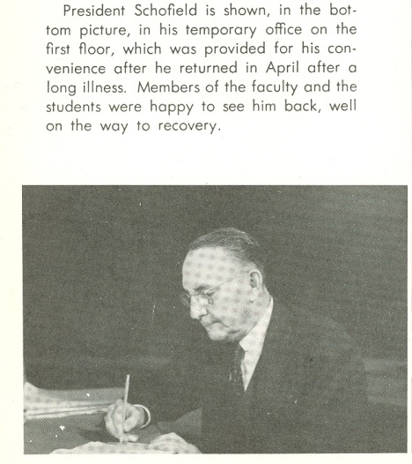
Schofield made the most of his remaining time as president of the school he had built from the ground up. The defining characteristic of his administration, his concern for his students, dominated its waning months. He was free with his personal money, as he often had been in the past; and he had no qualms about purchasing significant parting gifts for the student body. The new student union, for which he personally selected the furniture, received as a gift a grand piano. He also spent some time tracking down a painting, “Pioneer Farm” by Sevald O. Lund, which he had likely fallen in love with while it had been hanging in the lobby of the Eau Claire Hotel. It had since been sold, and Schofield was able to contact its owner, a Milwaukee resident named Edwin Uihlein, to ask if he might purchase it. To him, it was more than a painting: it was a meaningful gift, and it was a part of his legacy. “As I started the school off from the beginning in 1916 it is, in a way, my life work,” he wrote Mr. Uihlein. “As a parting gesture to the college I would appreciate the opportunity of acquiring this picture for the student body of some seven hundred young people.” Ever generous, he added, “I would be willing to pay whatever is necessary if it is within our means.” Mr. Uihlein consented to sell the painting. It remains in the university’s possession to the present day. The students showed their appreciation of the retiring patriarch with a farewell banquet, where the Student Life Committee unveiled a portrait of Schofield and Leonard Haas gave a speech about Schofield’s accomplishments as president.
Source: 1940 Periscope
Schofield accepted his own health-enforced resignation with a surprising amount of grace. To every congratulatory letter on his retirement, he invariably sent back a reply that it was time to pass the torch. “It seems a little peculiar to realize that after fussing around here for nearly a quarter of a century that I am now moving out,” he told Edgar Doudna. “However, I am sure that it is for the best as far as my health is concerned. I will be glad to turn some of the worries over to a younger man.” The younger man whom the Regents selected to turn Schofield’s worries over to was named William Davies.
Davies, like Schofield, was an administrative alumnus of Superior, having been superintendent of the Superior School District for some ten years prior to his appointment as second president of Eau Claire State Teachers College. He was approachable and highly capable. Most importantly, Schofield approved of him. “I like Mr. Davies very much,” Schofield told Doudna, “and I think they made a good selection. I had the pleasure of introducing him to the student body just before we closed for Christmas vacation; and he also met the faculty members.” Laura Sutherland, a long-time teacher and campus historian, described the moment: “He appeared young, vigorous, and genial. The response was immediate. The students were confident that the new president would be friendly.”
In fact, when Schofield relinquished the position on January 1, 1941, the beginning of the Davies administration marked a noticeable switch in the campus atmosphere. Davies proved to be a much more diplomatic figure than Schofield had been. Instead of stepping into his new role and taking charge, Davies chose instead to sit back and watch how the school operated, without imposing himself too heavily. He was easygoing, naturally suited for public relations, and believed in school democracy, eventually allowing the foundation of an effectual Student Senate among other organizations.
Schofield, on the other hand, had gained a curmudgeonly reputation. His occasionally overbearing interest in his students’ decency had led him in 1937 to ban a swing dance called “the Big Apple”, prompting the Manitowoc Herald Times to quip that “if educators, so-called, paid more attention to the intellectual development of their students and less to pseudo morality…perhaps morals would take care of themselves.” A mother’s complaint about the cafeteria food had received an irritable response that insinuated that “there may be something wrong with your children, if they cannot eat what these seven hundred people eat.” His lack of concern for the public’s opinion of him in his later years, according to secretary Geraldine Wing, was exemplified by his favorite phrase: “the public be damned.” When he had fired a teacher named Miss Bruce in 1938, a group of Eau Claire citizens had protested by writing the Regents that Schofield was “bullheaded.” “Things quieted down when they found that I was within my rights,” he had told Royce. Apparently he had been through a number of such fights with the public. The college president who had been so highly respected had become, in the eyes of many, just a crabby old man. The time had come for a change; and just as Schofield had been the right man to start the school in 1916, Davies was the right man to take over in 1941.
Schofield had written Royce when he was recovering from his heart attack, “I feel that when I retire I want to retire. …I do not want my successor to feel…that he has to consult me and take my advice about running the school.” When the time came, however, Schofield found it difficult to let go. Before he embarked on his southern sojourn, he wrote a letter to Davies that shows how deeply involved he still was in the school’s affairs. He sent along a number of official receipts and expenditures lists, but also offered suggestions as to what he would do about certain matters if he were still responsible for making major decisions. “This is only suggestions. You may do as you desire in these matters,” he gave his permission.
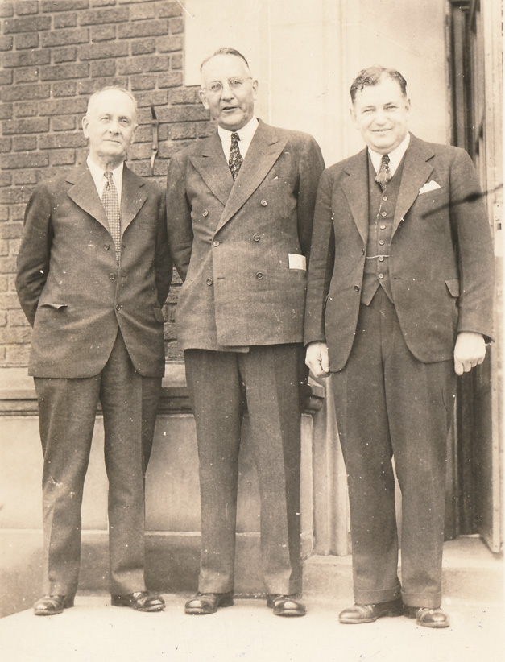
When Schofield and his wife Frances toured the South after his retirement, he satiated his need for academia in Florida by becoming acquainted with the students and faculty at Florida Southern College, even attending their Founder’s Week events. Perhaps because of this new connection, Frances declared, “He has shed school responsibilities better than we expected.” More than anything, without the cold Northern climate and the stress of the college in Eau Claire, Schofield’s health seemed to improve. “[Our travelling] has been worth it, for Mr. Schofield is so fine here,” Frances said. Indeed, in a photograph of the 1941 Eau Claire State Teachers College commencement that May, where he stands between President Davies and Ripon College president Silas Evans, he does not look quite like the elderly fellow who had been unable to climb to his second floor office. He stands tall and confident, with friendly humor in his face. With his vigor returned, Schofield and his wife made long-term plans to make their permanent home at his cottage in Chetek, then head north to escape the yearly hay fever. They never made it.
1941 Commencement. From l to r: Silas Evans (Ripon College), Schofield, Davies. Source: UWEC Special Collections and Archives.
On August 3, 1941, Schofield came back into the house from his yard and told his wife that he felt tired. It must have been clear that something was wrong. It was only one o’clock in the afternoon, and he had only been out in the yard for a little while; whatever he had been doing, it should not have been enough to exhaust him so thoroughly. He slumped down onto a sofa. Frances, perhaps fearing the worst, ran to get him a glass of water. She came back to find her husband dead. Harvey Schofield was 64 years old.
When the Spectator’s presses fired up again in September, the death notice appeared front and center, among articles about high graduate job placement due to the war and the success of “Freshman Week.” But it did not belong to just Schofield: Monroe Milliren, the former dean of men, had also died during the summer. His picture was the one to accompany the double obituary. A short blurb entitled “College Grieves Over Deaths of Former President and Dean” on the second page described Schofield as “an important factor in determining the democratic traditions of the school, and lived to see the college grow in enrollment and prestige to a very creditable position in the educational world.” The Spectator had very little else to say about him. Overshadowed by the war that would soon yank the United States into the fold, and the more inclusive administration of William Davies, Schofield was just another dead past faculty member.
Outside the school, the memorials were longer. The Board of Regents passed a resolution honoring Schofield, whom they deemed “a fine leader and friend. His administrative ability and sound counsel were for over a quarter of a century a contribution to Education in Wisconsin and to this Board.” Newspapers across the state reported his death. His hometown newspaper, the Eau Claire Leader, published a lengthy obituary. The next day, the newspaper’s morning edition paid eloquent tribute to a man who had “devoted the best years of his life to developing and enlarging [the teachers college]”:
That the college has been a big factor in the progress of Eau Claire and surrounding territory is apparent to all. Hundreds of its graduates are now engaged in business and professions in the city and adjoining communities and to all of these Mr. Schofield was more than a personality. He helped mold their lives and they help mold the life of the community.
Although Mr. Schofield had retired from active duties in the educational field after 40 years of service[,] his influence continued and will continue for many years to come.

Conclusion
“I know you must be busy with all of these troubles, and some times they pile up and look pretty bad. Usually, however, if one goes ahead and saws wood things clear up.”
--President Schofield to Edgar Doudna, June 21, 1937
In 1960, the building on the Wisconsin State College-Eau Claire’s campus that had once contained the entire school was rededicated to the memory of President Harvey Schofield. The renaming took place at an Alumni Day banquet, along with the naming of other buildings on campus, such as the William R. Davies College Center and two residence halls named after Regent Emmet Horan and former teacher Katharine Thomas. With the adjournment of the event, these figures who had been instrumental in the development of the school became to future generations what their names had been attached to: buildings.
As the memory of those identities faded through time, Schofield’s accomplishments for the school also receded into the back of campus consciousness. His name is now identified almost entirely with the building. If students or faculty of UWEC know anything of Harvey Schofield the man at all, it is usually that he was a dictatorial old man who retired long after his time should have been up. Such is the perception of the university’s first president, who is also our longest-standing. What has been lost in translation over the years is how deeply he cared about his job, his school, and his students.
From the moment the Board of Regents appointed him president of the Eau Claire State Normal School, Harvey Schofield did everything within his power to ensure that not only the school would succeed, but that its students would too. He understood that his school was the only chance that sons and daughters of the Chippewa Valley and the surrounding area had to improve their lives, to prosper in a way that their parents could not. To be sure, running the college at Eau Claire was not always an easy task. Especially during the Depression, Schofield had to muster all the determined spirit he possessed to fight for what he believed in, but his dedication paid off. The multifaceted personality of the president—caring, yet pugnacious; soft-hearted, yet aggressive—is the reason why thousands of students were able to go into the world with a fighting chance, and why thousands of students have been able to attend his school ever since. His influence not only touched those who met him, but generations who came afterwards. We at UWEC still enjoy the fruits of his labor to this day.
For those who experienced his generosity firsthand, Harvey Schofield was remembered as an administrator, but also as a benefactor. Clarice Chase Dunn, a 1937 graduate, stood before Schofield Hall during her visit in 1980 and recalled the man to whom she owed her success. Although she only had $1.30 to her name, which would have bought fewer than two weeks’ worth of lunches, he admitted her anyway. It changed the course of her life. If he felt she was worth taking a risk on, what reason did she have to doubt herself? She said of the president:
What Harvey Schofield did for me he had done for an entire generation of youth, the offspring of working class parents. Four times he had saved the one building school from being abolished or turned into a high school, reformatory, or other facility. A genial, mild mannered man, he had fought valiantly that this “Poor Man’s University” might survive and serve those who could not afford to go elsewhere. Is it any wonder that we revere his memory?

Appendix A : Important Names
Ames, Jesse H. | President of River Falls State Teachers College, 1917-1946
Baker, Frank | President of Milwaukee State Teachers College, 1924-1946
Brewer, Charles | Head of teacher training department/vice president of Eau Claire State Teachers College, 1916-1937
Davies, William | President of Eau Claire State Teachers College, 1941-1959
Dempsey, Edward | President of the Board of Regents, regent to  Oshkosh
Doudna, Edgar | Secretary to the Board of Regents; former faculty member of the Eau Claire State Normal School
Dunn, Clarice Chase | Author of “From Minnie Creek to UW” (alumni remembrance)
Dykstra, Clarence | Chancellor of the University of Wisconsin, 1937-1945
Grill, Mildred | Student at Eau Claire State Normal School/Teachers College in the 1920’s, employed at Schofields’ home to pay for tuition
Heil, Julius | 30th governor of Wisconsin, 1939-1943
Hill, Jim Dan | President of Superior State Teachers College, 1931-1964
Hyer, Frank | President of Central State Teachers College (Stevens Point), 1930-1938
La Follette, Phillip | 27th and 29th governor of Wisconsin, 1931-1933, 1935-1939
Polk, Forrest | President of Oshkosh State Teachers College, 1931-1959
Royce, Asa | President of Platteville State Teachers College, 1916-1942
Schofield, Dorothy | First wife of Harvey Schofield, died 1931
Schofield, Frances | Second wife of Harvey Schofield, former accountant at Eau Claire State Teachers College
Schofield, Harvey | President of Eau Claire State Teachers College, 1916-1940
Snodgrass, George M. | President of La Crosse State Teachers College, 1927-1939
Uihlein, Edwin | Former owner of “Pioneer Farm” painting purchased by Schofield in 1940
White, Kenneth | State senator (R-River Falls, elected 1936), legislative champion for education
Wing, Geraldine | Office assistant at Eau Claire State Teachers College, hired 1931
Yoder, Claude M. | President of Whitewater State Teachers College, 1930-1946
Appendix B: Timeline of Harvey Schofield’s life
Year | Place | Other
March 28, 1877 | Town of Lincoln, EC County (family farm?) | birth
1883?-1891 | Lincoln Valley school (rural EC County, Augusta school district) | student
1891-1896 | Augusta High School | student
1896-1898 | Scotts Valley School (rural EC County, Augusta School District) | teacher
1898-1899? | Humbird schools | 7th and 8th grade teacher
1899-1901 | Stevens Point Normal School | student
1901-1902 | Humboldt Grade School (Wausau) | principal
1902-1905 | University of Wisconsin (Madison) | student
1903 | Stevens Point Normal School | Football coach (while attending classes in Madison)
1905 | Madison High School | Teacher (US history), coach
1905-1907 | Ellsworth schools | Superintendent? Principal?
1907-1909 | Neillsville schools | Superintendent, Principal
August 20, 1908 | 1046 Ellis St., Stevens Point, Wisconsin | Marriage to Dorothy Burnham Packard
1909-1910 | Nelson Dewey High School (Superior) | Principal
1910-1913 | Superior Central High School | Principal
1913-1916 | Central High School (St. Paul) | Principal
1916-1940 | Eau Claire State Normal School, Eau Claire State Teachers College | President
July 22, 1931 | Eau Claire, Wisconsin | Dorothy Schofield dies
1934 | Eau Claire, Wisconsin | Marriage to Frances Jagoditsch
August 3, 1941 | Chetek, Wisconsin | death

Bibliography
Primary Sources
Alumni Association Records. University of Wisconsin-Eau Claire Special Collections, Eau Claire, WI.
There appears to have been a major movement in the 1960’s to collect remembrances and letters from alumni and retired faculty before these were lost forever, and the information contained within them is well worth reading. Some of the fondest words were reserved for President Schofield, especially during times of economic hardship. One student was employed in the Schofields’ home as a maid and nanny to pay for her schooling, and spoke of the kindness that the whole family showed her. Another was the recipient of Schofield’s influence when he arranged for this student to have the position of pastor in the Methodist church in Altoona (Schofield himself being a Methodist). A woman named Clarice Dunn, who graduated in 1937, wrote a longer reminiscence that includes memories of many faculty members whose names are still well-known today, such as Katharine Thomas, Brewer, Murray, Schneider, and Hilda Belle Oxby. She finished her memoir with praise for Schofield, who chose to admit her despite her lack of money: “Is it any wonder that we revere his memory?”
“Appeal to Heil to Prevent Teachers’ Pay Cuts.” Wisconsin Rapids Daily Tribune. Wisconsin Rapids, Wisconsin. April 20, 1939.
In April of 1939, after Governor Heil’s budget cuts became law, Senator Kenneth White, a Republican from River Falls, appealed to Heil to prevent any more damage from being done to the teachers colleges. He became a major legislative voice in favor of higher education, and one who attended the budget hearing at the end of the year, where some of the money was restored to the colleges. This article details his arguments in favor of restoring cuts made to education.
Chancellor’s Correspondence. 1936-1941. University of Wisconsin-Eau Claire Special Collections, Eau Claire, WI.
The University possesses very little president’s/chancellor’s correspondence from prior to 1936; what little that survives is scattered throughout other collections in the archives. 1936 is also the year that Harvey Schofield’s health began to decline, which shows not only in letters to friends about his condition, but also in the apparent change in his mood and his decisions. The existing correspondence is still an essential resource in understanding Schofield’s character, his devotion, and the way he interacted with friends, colleagues, alumni, and those who became recipients of his “righteous indignation”. Existing letters show that, even as he sat in bed at home following a major heart attack, or while he was up north in Bayfield attempting to avoid the hay fever that incapacitated him further south, he still took care of his duties as president as best he could; and his friends in the field of education wrote him letters of encouragement and well wishes. The correspondence also documents his increasing dependence on his faculty to take on administrative responsibility while he was ill. Most importantly, the year 1936 is still right in the middle of when Schofield was struggling to keep and prove his institution viable during the Depression. As such, his letters often discuss dealings with the University of Wisconsin, the financial difficulties that the teachers colleges experienced, and correspondence between himself, other presidents, and the Regents about how to solve problems created by the Depression. Due to the wide range of topics contained within it, the Chancellor’s Correspondence is almost like several sources in one.
Dempsey, Edward J. Papers. 1933-1949. Wisconsin Historical Society, Madison, Wisconsin.
Edward Dempsey, a lawyer from Oshkosh, was for many years the president of the State Board of Normal School Regents. As such, he regularly exchanged letters with teachers college presidents, others associated with education across Wisconsin, state officials, and concerned citizens. Within the timeline that his correspondence covers, every major event that affected the state teachers colleges is detailed in the words of those who experienced it. It not only affords invaluable insight into the condition of colleges around the state, but touches on topics for which Schofield’s correspondence leaves no paper trail. The widespread devastation of the Heil administration is represented from all sides here.
Eau Claire Leader (and Daily Telegram). Eau Claire, Wisconsin. 1896-1941.
As one of the two major newspapers of the time, the Eau Claire Leader is one of the best sources for learning about local happenings and important people, and one of the latter was definitely Harvey Schofield. The Leader made frequent mention of him in a variety of contexts, such as: Kiwanis Club events he was involved with, speeches he gave at a multitude of different occasions, opinions on local issues (which were usually quite strong), and Normal School/State Teachers’ College news. The fact that he appeared so regularly in the pages of the local newspaper shows that he was not only an important figure within the realm of the school, but also an important figure within the community. 1896 marks the date when he was first mentioned in the Telegram (which was then a separate newspaper) as part of the Augusta High School commencement; 1941 marks the year his obituary was published in the Leader. Mention of Schofield following 1941 would be considered secondary source material more than primary.
U. S. President. Executive Order no. 6102 (Gold Confiscation Order). Published online at The American Presidency Project (http://www.presidency.ucsb.edu/ws/?pid=14611).
This is the order that President Franklin Delano Roosevelt issued in 1933, in which all gold coinage accepted as payment had to be surrendered to the government in exchange for compensation in cash. Failure to do so could result in heavy fines or imprisonment. Despite the potential consequences, Schofield accepted gold coins as payment in the knowledge that his students had no other way to pay.

“Gold: But Where Did it Come From?” The View (January 1979). University of Wisconsin-Eau Claire alumni publication. Alumni Association records, box 4, folder 6.
This is one of the only records of the gold coinage that Schofield illegally accepted as payment. The coins were rediscovered in 1978, and it was only through the recollection of office assistant Mabel Chipman that the mystery of their origin was solved. Since no official record of this form of payment survives in the university’s collection, this article provides one of the very few glimpses into how students paid for college with family treasure.
Haas, Leonard, and Pifer, Rick. An Oral History of the University of Wisconsin-Eau Claire: A 75th Anniversary Publication. Eau Claire: Special Collections , McIntyre Library, 1991.
While this is not technically an officialy published book, it is cited as such here because the oral histories contained within the collection span two informally bound volumes. These interviews were conducted over a number of years from the mid-eighties to 1991, so there were very few people surviving who had anything to say about Schofield. Of especial interest, however, are the interviews with Geraldine Wing and Leonard Haas. Wing was one of Schofield’s secretaries, and was close to him on a daily basis; she remembered him as kind and “warm-hearted.” Haas’ perspective is interesting because he was both a student at the Teachers College during Schofield’s administration and one of Schofield’s successors as president/chancellor. He was also one of the few people who expressed dissatisfaction with him.
Janesville Daily Gazette. Janesville, Wisconsin. 1904-1916.
Janesville, while within reach of the college hubs of Madison and Whitewater, itself had very little to do with education. Nevertheless, it is the only newspaper who reported on Schofield’s stint as a professional ball player, and apparently the only trace of this time in Schofield’s life that survives. The Daily Gazette also made mention of major events that affected the state normal schools, such as when Schofield was hired as president of Eau Claire State Normal School.
La Crosse Tribune. La Crosse, Wisconsin. 1916-1939.
Itself a college town, La Crosse’s Tribune made sure to cover major events and decisions affecting not only La Crosse State Teachers College, but other colleges around the state. Its coverage is not dissimilar to that of the Eau Claire Leader.
Madison Wisconsin State Journal. Madison, Wisconsin. 1939-1942.
Whether the State Board of Normal School Regents or the state legislature were meeting, Madison was and continues to be the decision-making center of the state of Wisconsin. The State Journal made regular political reports on both legislative and educational fronts. Of especial interest is its coverage of various aspects of the Heil administration, from the governor’s initial blitz of policy changes to the more gradual changes in attitude toward “Julius the Just.”
Miller, Jeanette Gaffney. Papers. 1925-1930. University of Wisconsin-Eau Claire Special Collections and Archives. Eau Claire, WI.
Jeanette Gaffney Miller was a student at the Eau Claire State Normal School, before becoming a teacher there briefly after its transition into a state teachers college. This collection contains a letter from Schofield to Gaffney, in reply to inquiries about salary and contracts. In the latter case, Schofield informed her that he was not accustomed to writing up contracts. Considering that he occasionally fired teachers under public protest, it is a telling statement.
National Youth Administration records, 1934-1939. Special Collections and Archives, University of Wisconsin-Eau Claire. Eau Claire, Wisconsin.
The National Youth Administration was a New Deal program designed to help students find employment in order to pay for their schooling. The Eau Claire State Teachers College gained a chapter of the NYA in 1934. While Schofield took care of much of this program’s duties on his own, much of the administration of it was left to other faculty members.

New York Times. New York City, New York. 1939-1942.
The New York Times took a surprising interest in the Heil debacle following his election in 1938. While Wisconsin newspapers may have been hesitant to voice too many negative reactions against the governor, or perhaps to emphasize too heavily what changes the governor was enacting, the Times felt no qualms about releasing editorials and articles about Heil’s administration with titles such as “Heil’s Antics Jolt Wisconsin.”
Periscope. Eau Claire State Normal School yearbook. 1917-1941.
A chronicle of social life, academic life, and humor on campus, the Periscope was created by students for students’ enjoyment. It contained not only photographs of individuals and clubs, but also literary compositions, caricatures, jokes, remembrances, dedications, and a calendar of school events from that year. Schofield was often the subject of all of these features, in one form or another. The 1917 Periscope is where his students first bestowed the epithet “The Winning Personality” upon him.
“Peterson Points Out Savings Made by Heil.” Oshkosh Daily Northwestern. Oshkosh, Wisconsin. August 9, 1939
This is an article defending Heil’s budget cuts, in the midst of when they were wreaking havoc on the teachers colleges. Such positive voices are important for the purpose of this paper to show both sides of the issue, even if the information contained within the article may serve to strengthen the argument against Heil’s decisions.

Spectator. Eau Claire State Normal School newspaper. 1923-1941.
Written by students for students, the Spectator is the best resource for learning about student life and school events. Schofield’s close relationship with his school and his students is documented throughout his time as president, as shown by articles and cartoons that celebrated (and occasionally teased) him. Reports on his birthday parties were annual features; other examples include alumni remembrances and his involvement with school activities such as parties or sporting events. The Superior school district’s offer to him of the Superintendent position is documented here, as are the school’s and city’s reactions and his subsequent refusal of the offer. Administrative decisions, trips to Madison to meet with the Board of Regents, commencement speeches he gave at other schools and his opinions on various topics are also recorded.
“State Press” (Heil obituary mention). Rhinelander Daily News. Rhinelander, Wisconsin. October 31, 1939
This is a tongue-in-cheek political obituary for Governor Julius Heil following his sweeping budget cuts that had not only slashed salaries and funding for education, but also slashed his popular support.
Stevens Point Daily Journal. Stevens Point, Wisconsin. 1903-1923.
As the local newspaper of Stevens Point, Harvey Schofield’s alma mater, the Journal regularly reported on what their one-time celebrity student was up to, no matter where in the state he happened to be. His marriage to Stevens Point native Dorothy Packard, his hiring at Eau Claire, and any visit he made to town warranted mention here.
Stevens Point State Normal School. Nautilus yearbook. Stevens Point: Press Association of Stevens Point Normal, 1901.
The first edition of the Nautilus was published just in time to capture Harvey Schofield’s last year at Stevens Point Normal. It shows him as a student not merely going through the motions, but involved in any extracurricular activity he could get his hands on. In addition to athletics, especially basketball and football, he also took part in oratory and debate, and was on the Nautilus “art board”. As he would be later as president of Eau Claire State, he was the subject of jokes and remembrances.
Teacher exams, 1886-1904. Eau Claire County (Wis.) Superintendent of Schools records, 1873-1990. Box 14. University of Wisconsin-Eau Claire Special Collections and Archives. Eau Claire, WI.
Among the small ledgers that comprise this collection are scores for tests that individuals in the county took in order to become teachers. Schofield’s exam scores survive here, from when he took the test at eighteen years of age. In all fields except grammar, his scores are exceptional. Also contained within the collection are test scores for Blanche James, a future teacher at Eau Claire Normal, and Schofield’s sister Edna.
University of Wisconsin System Board of Regents minutes and committee minutes. 1874-2008. University of Wisconsin-Eau Claire Special Collections and Archives. Eau Claire, WI.
Regents’ meetings provide a valuable look into the workings of the system “behind the scenes.” For the purpose of this paper, resolutions recognizing Schofield’s retirement and death are most important.

Secondary Sources
Carter, Hilda R., and Jenswold, John R. The University of Wisconsin-Eau Claire: A History, 1916-1976. Eau Claire: University of Wisconsin-Eau Claire Foundation, 1976.
As of right now, this is the definitive starting point and reference for anybody researching UWEC’s history. The only obvious limitation to it is that, the current year being 2012, a good 36 years are missing in the interim. For my purposes, though, this book is perfect the way it is. Schofield’s years are described, his personality is celebrated, and—oddly enough—it is the only source I have found, besides the actual obituary, that gives his date of death. The Depression years and the difficulties that ECSTC faced during them are covered in some detail, alongside the bibliography from which I gleaned several important primary sources.
Forrester, George, ed. Historical and biographical album of the Chippewa Valley, Wisconsin, including ancestral records, biographies, and portraits. Chicago: A. Warner, 1892.
This massive tome outlines the history of the Chippewa Valley and some of its prominent citizens, including Harvey Schofield’s parents and grandparents. Other than the information contained within this book, material relating to Schofield’s ancestry is somewhat scarce. The fact that they warranted mention in a regional history indicates a certain amount of status within the area.
Levine, David O. The American College and the Culture of Aspiration, 1915-1940. Ithaca: Cornell University Press, 1986.
This book is extremely useful to my research on several levels. The most obvious is that the years Levine covers are almost exactly the same as Schofield’s tenure at Eau Claire: 1916-1940. There is also an entire chapter devoted to the Depression and higher education, which discusses the shift from the private sector to the public sector, government intervention in education, and other difficulties that higher education in general faced. Levine is one of the few authors who takes some time to discuss the teachers colleges’ hardships, and also advantages, during the 1930’s. He pays attention to the socioeconomic differences between institutions and the way that the Depression affected each.
Ogren, Christine A. The American State Normal School: An Instrument of Great Good. New York: Palgrave Macmillan, 2005.
As stated in the prospectus, this is the only book about Normal Schools, lauded on the back cover as “a much-needed reexamination” of a much-ignored institution in American history. And, to be sure, it is a wonderful source on a topic that very few people have ever written about in any detail. Ogren weaves a tapestry of educational history that has as its main focus several select Normals from around the country, including the one in Oshkosh, Wisconsin. She pays special attention to women’s empowerment as a result of the education they received from the Normal Schools, and the gender equality within these institutions, which must have been an idea that was not lost on Harvey Schofield during his time at Stevens Point Normal and then as president of Eau Claire Normal.
Zink, Steven D. “Glenn Frank of the University of Wisconsin: A Reinterpretation”. Wisconsin Magazine of History 62 (Winter 1978-79), 90-127.
Zink’s article on President Glenn Frank of what is now UW-Madison paints a picture of a man who came to his position during a period of weakness for his institution; as the article says, the Board of Regents, while searching for a new president, wanted “a personality”, much as Schofield became for the Eau Claire State Normal School. Unlike Schofield, though, his appointment as president seems to have caused some unhappiness among his faculty, and after a tenure as UW President that was alternately beneficial and controversial, a slurry of political and administrative problems culminated in his ousting. It depicts an institution whose problems during the Depression were not unlike those of the teachers colleges, despite the antagonism between the two.

Spectator, May 8, 1931.
Spectator, November 1, 1929.
Christine A. Ogren, “Where Coeds were Educated: Normal Schools in Wisconsin.” History of Education Quarterly 35 (1), 2-4.
David O. Levine, The American College and the Culture of Aspiration. Ithaca: Cornell University Press, 1986, p. 167.
Schofield to Mr. and Mrs. H. A. Willard, May 27, 1939. Box 3, folder 5. Chancellor’s correspondence. Archives Series 1. Special Collections and Archives, University of Wisconsin-Eau Claire.
Levine, 164.
Ibid, 180.
Ibid, 187.
Leonard Haas and Rick Pifer. An Oral History of the University of Wisconsin-Eau Claire: a 75th Anniversary Publication. Interview with former secretary Geraldine Wing, transcription page 7.
Normal schools did charge nominal fees for courses such as manual training, but the costs did not stack up to the amount charged for college tuition.
Levine, 189.
Ibid, 194.
Ibid, 199. The NYA began as part of FERA in 1934 before becoming its own autonomous program.
Ibid, 186.
Hilda Carter and John R. Jenswold, The University of Wisconsin-Eau Claire: A History, 1916-1976 (Eau Claire: University of Wisconsin-Eau Claire Foundation, 1976).
Stevens Point Normal School. Nautilus yearbook. Stevens Point: Press Association of Stevens Point Normal, 1901, p. 14.
George Forrester, ed., Historical and biographical album of the Chippewa Valley, Wisconsin, including ancestral records, biographies, and portraits. Chicago: A. Warner, 1892.
Teacher exams, 1886-1904. Box 14. Eau Claire County (Wis.) Superintendent of Schools records, 1873-1990. EC Series 7. Special Collections and Archives, University of Wisconsin-Eau Claire. Eau Claire, Wisconsin. Schofield earned a score of 100 in five subjects, one of which was U. S. history, which he would later teach for a year in Madison. His worst subject was grammar, where he scored 71.
Spectator, 2/6/31; “H. A. Schofield, Retired Head of State Teachers College Here, Dies Suddenly at Chetek Home”, Eau Claire Leader, 8/5/41.
Nautilus yearbook, p. 73.
“Professional or Amateur Player?” Janesville Daily Gazette, July 18, 1904.
“Normal Notes.” Stevens Point Daily Journal, September 5, 1903.
“Professional or Amateur Player?” Janesville Daily Gazette, July 18, 1904.
Robert Gough, “Harvey Schofield: Tramp Athlete?” Unpublished manuscript.
This was a common degree for educators at the time to have.
Clark County History Buffs, “Lowe, Herbert ‘Tubby’, Neillsville, Clark County, Wisconsin Records.” http://www.usgennet.org/usa/wi/county/clark/4data/84/84165.htm
“Shows Cut of Schofield.” Stevens Point Daily Journal, March 25, 1916.
“Superior Nine on Program.” Eau Claire Leader, October 19, 1911.
“Big Names Upon Speaker List in Teachers’ Meet.” La Crosse Tribune, October 13, 1916.
“’Make Democracy Safe for World’ Urges W. A. Clark.” Eau Claire Leader, April 11, 1920.
“Longer Training for Teachers is Schofield’s Plea.” Eau Claire Leader, October 22, 1921.
“Schofield Talks at Normal.” Stevens Point Daily Journal, April 22, 1916.
“Two Normal School Appointments Made.” Janesville Daily Gazette, March 11, 1916. These articles also announced the appointment of Asa Royce to the presidency of Platteville Normal. Royce and Schofield would become good friends and remain so until Schofield’s death.
Emmet Horan, “History.” Periscope yearbook, 1917. In 2014 dollars, the cost of construction would total over 5.2 million (according to the inflation calculator at http://data.bls.gov/cgi-bin/cpicalc.pl). This building was rededicated in 1960 as Schofield Hall.
Ibid, about page 74 (not paginated).
“Eau Claire Normal Sets Record in Enrollment.” La Crosse Tribune and Leader Press, October 3, 1924. Enrollment statistics for Platteville and River Falls were not included.
“A. J. Keith to Remain Head of ‘Y’ Board.” Eau Claire Leader, June 24, 1923.
“Organize Eau Claire City Defense Council.” Eau Claire Leader, April 29, 1917; “Hunt’s College Notes.” Eau Claire Leader, February 18, 1918.
“H. A. Schofield Rejects Offer From Superior.” Eau Claire Leader, March 6, 1925. However, the choice was a month in the making. He seriously considered accepting the position, partially due to frustration over lack of legislative support for the normal schools.
“Commencement Week at Normal.” Eau Claire Leader, June 3, 1917. After the graduating classes outgrew the capacity of his house, they held parties in the school gymnasium.
“Group V Entertains.” Eau Claire Leader, May 21, 1920; Periscope yearbook, 1920, p. 61.
Spectator, April 1, 1925; 1919 Periscope, p. 53.
University of Wisconsin-Eau Claire Memorabilia, 1927-2000. UW-Eau Claire Special Collections and Archives, McIntyre Library, UWEC. Eau Claire, Wisconsin. Years on, when a former student teased him about having interrupted some relations between him and his future wife, Schofield replied, “I have forgotten just how I embarrassed you in your love affair but presume that I did as I had that habit years ago.” (Schofield to Harold Gewald, July 17, 1939. Chancellor’s correspondence, box 3, folder 5.)
Clarence Imislund in the Spectator, October 30, 1925.
Spectator, March 18, 1932.
Spectator, February 3, 1933. It would be padlocked at least once more, in 1936.
Haas/Pifer interview with Geraldine Wing, transcription page 3. Although Schofield and Dempsey had a close professional relationship, curiously little from the Eau Claire president survives in Dempsey’s correspondence. One possibility is that Schofield was routing most of his concerns to Board of Regents secretary Edgar Doudna, who was a personal friend and a former teacher at the Eau Claire Normal. However, a letter dated May 18, 1933 from Dempsey to Doudna presents another possibility: “I have destroyed [Schofield’s] correspondence. I do not think he has anything to worry about.” (Edward Dempsey papers, 1933-1949. Wisconsin Historical Society, Madison, Wisconsin).
Ibid.
Dividends were paid to the college in the years following the bank’s failure, but, by Schofield’s estimation, they would only be able to recover half of the amount originally deposited. Secretary Mabel Chipman to Board of Regents secretary Edgar Doudna, January 14, 1937. Chancellor’s correspondence, box 1, folder 9.
Haas/Pifer interview with Geraldine Wing, transcription page 7.
“Brief, Setting Forth The Needs of the State Teachers College, Eau Claire, Wis. 1936-1937.” Chancellor’s correspondence, box 1, folder 9.
Schofield to Doudna, March 11, 1938. Chancellor’s correspondence, box 2, folder 8.
Mildred Grill to UWEC Foundation, April 16, 1981. Box 6, folder 5. University of Wisconsin-Eau Claire Alumni Association records, 1917-2005. Special Collections and Archives, University of Wisconsin-Eau Claire.
Federal Emergency Relief Administration (FERA) to state emergency relief administrators, February 2, 1934. Box 1, folder 1. National Youth Administration records, 1934-1939. Special Collections and Archives, University of Wisconsin-Eau Claire.
Ibid., box 1, folders 1 and 3.
NYA questionnaire. Ibid., folder 2.
Spectator, November 28, 1934.
Executive Order no. 6,102 (Gold Confiscation Order.) Published online at The American Presidency Project (http://www.presidency.ucsb.edu/ws/?pid=14611).
“Gold: But Where Did it Come From?” The View (January 1979). University of Wisconsin-Eau Claire alumni publication. Alumni Association records, box 4, folder 6.
Spectator, February 9, 1934. In fact, one of the gold coins Schofield accepted was for a copy of the Periscope in 1932, for a student who had her poetry and fiction published in it. (Isadore Brothers to the editors of The View, January 15, 1979. Alumni Association Records, box 6, folder 5.)
Schofield to President George Snodgrass (La Crosse), February 7, 1938. Chancellor’s correspondence, box 2, folder 7.
Eau Claire Leader, April 23, 1937.
Schofield to Principal I. C. Painter (Wausau), November 18, 1936. Chancellor’s correspondence, box 1, folder 8.
Wisconsin State Assembly, bill no. 873 A (April 22, 1937). Chancellor’s correspondence, box 1, folder 4.
Carter et al, p. 18.
“Claim Normals Producing Too Many Teachers.” Stevens Point Daily Journal, May 18, 1923.
Carter et al, p. 19.
Carter et al, p. 20.
Steven D. Zink, “Glenn Frank of the University of Wisconsin: A Reinterpretation,” Wisconsin Magazine of History 62 (Winter 1978-79): 119.
“Which is Preferable?” Chancellor’s correspondence, box 1, folder 4. Also published in the Spectator, April 28, 1937.
Spectator, April 28, 1937.
“Opposition to College Plan Growing Here.” Eau Claire Leader, April 27, 1937.
“Should City Go University or Be College.” Eau Claire Leader, April 25, 1937.
“Will Withdraw Bill for Abolition of College; Other Changes Sought.” Eau Claire Leader, April 28, 1937. The exact meaning of the phrase “beneficial reorganization of the administration” is unknown; it is uncertain what changes were made, if any.
Schofield to Chris Steinmetz, April 30, 1937. Chancellor’s correspondence, box 1, folder 9.
Ibid.
Schofield to the presidents, April 28, 1938. Chancellor’s correspondence, box 2, folder 12.
The University of Wisconsin System would not unite the university in Madison with the former state teachers colleges until 1971.
Frank Hyer (president, Stevens Point) to Schofield, April 28, 1938. Chancellor’s correspondence, box 2, folder 12.
Jim Dan Hill to the presidents, May 13, 1938. Chancellor’s correspondence, box 2, folder 12.
Forrest Polk (president, Oshkosh) to Harvey Schofield, May 2, 1938. Chancellor’s correspondence, box 2, folder 12. Polk was also a strong-willed character, making himself obnoxious right alongside Schofield at the same meeting. Just before his retirement, Schofield told Polk that he had always admired his spirit.
Schofield to the presidents, April 28, 1938. Chancellor’s correspondence, box 2, folder 12.
Hyer to the presidents, May 9, 1938. Chancellor’s correspondence, box 2, folder 12.
Schofield to Doudna (?), December 4, 1940. Chancellor’s correspondence, box 5, folder 3.
Callahan to Edward Dempsey, December 17, 1938. Dempsey Papers, reel 3.
“Heil’s Antics Jolt Wisconsin.” New York Times, June 4, 1939.
“Wisconsin Begins a Full Turnabout.” New York Times, January 22, 1939.
“Wisconsin ‘TVA’ is Killed: Heil Signs Bill Withdrawing Financial Support.” New York Times, March 19, 1939.
“Peterson Points Out Savings Made by Heil.” Oshkosh Daily Northwestern, August 9, 1939.
Doudna to Schofield, November 29, 1938. Chancellor’s Correspondence, box 3, folder 7.
Schofield to Doudna, December 7, 1938. Ibid.
Schofield to Senator G. Erle Ingram, February 8, 1939. Chancellor’s Correspondence, box 3, folder 5.
Schofield to Edward Dempsey, February 3, 1939. Chancellor’s Correspondence, box 3, folder 6.
Schofield to Ingram, February 8, 1939. Chancellor’s Correspondence, box 3, folder 5.
Philip La Follette served two non-consecutive terms as governor of Wisconsin: first, from 1931-33; then from 1935-1939.
Vernon van Patter to Schofield, February 16, 1939. Chancellor’s Correspondence, box 3, folder 5.
Doudna to presidents, March 20, 1939. Chancellor’s Correspondence, Box 3, folder 7.
Schofield to Dempsey, February 3, 1939. Chancellor’s Correspondence, box 3, folder 6.
Yoder to Dempsey, February 2, 1939. Dempsey papers, reel 4.
Yoder to faculty members, February 10, 1939. Dempsey papers, reel 4.
Royce to Dempsey, February 4, 1939. Chancellor’s Correspondence, box 3, folder 6.
Schofield to Ingram, February 8, 1939. Chancellor’s Correspondence, box 3, folder 5.
Schofield to Dempsey, February 11, 1939. Chancellor’s Correspondence, box 3, folder 6.
Dempsey to Schofield(?), April 14, 1939. Ibid.
Dempsey to Charles A. McKeown (financial secretary to Governor Heil), March 22, 1939. Dempsey papers, reel 4.
Doudna to presidents, April 17, 1939. Chancellor’s Correspondence, box 3, folder 7.
Hill to presidents(?), April 18, 1939. Chancellor’s Correspondence, box 3, folder 6.
“Appeal to Heil to Prevent Teachers’ Pay Cuts.” Wisconsin Rapids Daily Tribune, April 20, 1939.
Doudna to Schofield(?), May 15, 1939. Chancellor’s Correspondence, box 3, folder 7.
Dempsey to Doudna, August 28, 1939. Dempsey papers, reel 4.
Doudna to Dempsey, August 29, 1939. Dempsey papers, reel 4.
Heil to Dempsey, March 30, 1939. Dempsey papers, reel 4.
La Follette had lost support among constituents and the legislature for what some called his “dictatorial” style of governing. One example is his unpopular “Reorganization Act,” which restructured departments in a way that he found ideal. Following his failure to win re-election after three terms in office, Senator White (R-River Falls), who was such an ally to education, proposed a constitutional amendment aimed at La Follette to prevent any governor for serving more than three terms. (“Wisconsin Begins a Full Turnabout.” New York Times, January 22, 1939.)
“State Press (Obituary Mention: Heil)”. Rhinelander Daily News, October 31, 1939.
New York Times, June 4, 1939.
Schofield to President O. R. Latham (Cedar Falls Teachers College, Iowa), November 24, 1939. Chancellor’s Correspondence, Box 4, folder 4.
The exact nature of the action he took in this regard is unclear.
Schofield to Minna Hansen, August 12, 1939. Chancellor’s Correspondence, box 3, folder 5.
Schofield to President O. R. Latham (Cedar Falls Teachers College, Iowa), November 24, 1939. Chancellor’s Correspondence, Box 4, folder 4. Latham and two other Iowa state teachers college presidents had received significant salary raises earlier that month. (“Iowa Increases Educators’ Pay.” Dubuque Telegraph Herald, November 5, 1939. Dempsey papers, reel 4.)
Dempsey to Schofield, October 7, 1939. Dempsey papers, reel 4.
Proceedings of the Board of Regents of Normal Schools meeting, October 11, 1939. Dempsey papers, reel 4.
“Close Cafeteria at State College.” La Crosse Tribune and Leader Press, October 20, 1939. Dempsey papers, reel 4.
Doudna to regents and presidents, November 27, 1939. Dempsey papers, reel 4.
Dempsey to Regent Jay Grimm (River Falls), November 25, 1939. Dempsey papers, reel 4.
Dempsey to Schofield, November 29, 1939. Dempsey papers, reel 4.
Schofield to Hill, December 4, 1939. Chancellor’s Correspondence, box 4, folder 8.
Dempsey to Schofield, November 29, 1939. Dempsey papers, reel 4.
Schofield to Dempsey, December 2, 1939. Dempsey papers, reel 4.
N. O. Reppen (president of Association of Wisconsin Teachers Colleges) to AWTC members, December 9, 1939. Dempsey papers, reel 4.
“Around the Statehouse.” Madison Wisconsin State Journal, May 29, 1939.
“The Record is Clear.” Madison Wisconsin State Journal, November 6, 1942.
“Goodland Governor by Wisconsin Ruling.” New York Times, December 30, 1942.
Chancellor’s Correspondence, Box 2, folder 7.
Board of Regents of Normal Schools proceedings, October 9, 1940. Unnumbered box (dates ranging from 1916-1951). University of Wisconsin System Board of Regents minutes and committee minutes, 1874-2008. AS 146. Special Collections and Archives, University of Wisconsin-Eau Claire.
Schofield to President Forrest Polk (Oshkosh State Teachers College), December 21, 1940. Chancellor’s Correspondence, box 5, folder 4.
This is documented in various places, including the Spectator and chancellor’s correspondence. Around August, before he would have to make his escape north, he would direct recipients of his letters to send replies to Bayfield.
Schofield to Frank Hyer (Stevens Point), December 15, 1936. Chancellor’s correspondence, box 1, folder 11.
Spectator, October 14, 1936.
Haas/Pifer interview with Geraldine Wing, transcription page 10.
Spectator, December 16, 1936.
Royce to Schofield, December 28, 1936. Chancellor’s correspondence, box 1, folder 18. Royce sent a number of such humorous letters to him during this time.
Schofield to Royce, November 13, 1936. Chancellor’s correspondence, box 1, folder 18.
Schofield to Hyer, Decemer 15, 1936. Chancellor’s correspondence, box 1, folder 11.
Royce to Schofield, November 9, 1936. Chancellor’s correspondence, box 1, folder 18.
The secretary taking dictation in this case was his wife Frances, who had formerly been the school’s financial manager.
Schofield to Royce, November 28, 1936. Chancellor’s correspondence, box 1, folder 18.
“Should City Go University or Be College.” Eau Claire Leader, April 25, 1937.
Brewer to Dempsey, March 26, 1937. Dempsey papers, reel 2. No other letters regarding the same matter survive to confirm the nature of this correspondence, but the date suggests that it concerns the UW-Extension bill to abolish ECSTC.
Schofield to Doudna, March 6, 1940. Chancellor’s correspondence, box 4, folder 6.
1940 Periscope, p. 124.
It is unclear whether he personally paid for the furniture, but entirely possible.
Carter et al, p. 36.
Schofield to Uihlein, December 6, 1940. Chancellor’s correspondence, box 5, folder 6.
As of writing, it hangs outside the Special Collections and Archives.
Carter et al, 36.
Schofield to Doudna, December 31, 1940. Chancellor’s Correspondence, box 5, folder 3.
Schofield to Doudna, December 31, 1940. Chancellor’s correspondence, box 5, folder 3.
Carter et al, p. 38.
There had been a Student Council under Schofield’s administration, but it served less of a governmental purpose and more of a social purpose. Carter et al, p. 10.
“No More Truckin’.” Manitowoc Herald Times, December 10, 1937.
Schofield to Mrs. C. E. Smith, September 19, 1940. Chancellor’s correspondence, box 5, folder 6.
Leonard Haas and Rick Pifer. An Oral History of the University of Wisconsin-Eau Claire: a 75th Anniversary Publication. Interview with former secretary Geraldine Wing, transcription page 3.
The ease with which he fired Miss Bruce was likely a result of his never writing up contracts. He told Jeanette Gaffney, a new teacher and former student, “As far as contracts are concerned, we do not usually make out contracts. My word is usually as good as my bond.” Chancellor’s correspondence, box 2, folder 12; Jeanette Gaffney Miller papers, box 1, folder 3. University of Wisconsin-Eau Claire Special Collections and Archives.
Schofield to Royce, November 28, 1936. Chancellor’s correspondence, box 1, folder 18.
Schofield to Davies, January 7, 1941. Chancellor’s correspondence, box 5, folder 6.
“Letters Received from Schofields by Two Groups.” Spectator, March 12, 1941.
“H. A. Schofield, Retired Head of State Teachers College Here, Dies Suddenly at Chetek Home.” Eau Claire Leader, August 5, 1941.
Spectator, September 24, 1941.
Upon Davies’ death in 1959, the Spectator published an entire issue devoted to his memory.
Resolution 757. Board of Regents of Normal Schools Proceedings (insert date here). Unnumbered box (dates ranging from 1916-1951). University of Wisconsin System Board of Regents minutes and committee minutes.
“H. A. Schofield, Retired Head of State Teachers College Here, Dies Suddenly at Chetek Home.” Eau Claire Leader, August 5, 1941.
“Harvey Axford Schofield.” Eau Claire Leader morning edition, August 6, 1941.
Chancellor’s correspondence, box 1, folder 9.
When the Zorn Arena/Campus School complex was constructed in 1952, the original building became known colloquially as “Old Main.” Prior to that time, the building itself had had no official name aside from that of the college.
Carter et al, p. 83.
Clarice Chase Dunn, “From Minnie Creek to UW: The Buildings Tell the Story.” Alumni Association Records, box 6, folder 6.

