A CRESCENDO INTO OFFICIAL SIGNIFICANCE:
HISTORICAL FOUNDATIONS OF THE MUSIC DEPARTMENT
AT THE UNIVERSITY OF WISCONSIN – EAU CLAIRE, 1916-1952

Teila Jo Luchterhand
History 489
April 6, 2012

Copyright for this work is owned by the author. This digital version is published by McIntyre
Library, University of Wisconsin Eau Claire with the consent of the author.
ABSTRACT
In discussing the historical developments of music education throughout the United States, and on college and university campuses across the nation, this paper will explain how the early importance of music and music organizations to the students and the limited number of music faculty at the University of Wisconsin – Eau Claire led to college’s granting of the Bachelor of Music degree in 1952 which represented the colleges crescendo into the first significant “official” validation of music education on the Eau Claire college campus.

CONTENTS

INTRODUCTION 1
Historical Roots of Music Educations in the United States 3
Normal Schools, Wisconsin, and Music Education 6
Music at Eau Claire State Normal School, 1916-1926 10
Eau Claire State Teachers College and the Depression Years, 1927-1939 19
World War II, The G.I. Bill, and the Growing Importance of Music, 1939-1952 29
CONCLUSION 39
APPENDIX 41
WORKS CITED 42

Introduction

Music is the universal language. Upon the first note, an audience can become entranced, exuberant or scared, confused or in utter understanding. It is no wonder then that music is such a collective medium. Even the most non-musical person can get completely taken in. For those who are lucky enough to perform it, music becomes an emotional release. It provides a time of day when the troubles of the world can melt away. If one intends to be great, it also requires discipline and hard work, two fundamental values in the United States. As such, music education, organizations, and programing in high schools, colleges, and universities across the country have become an expected norm. However, music in the college classroom was not always widely accepted and the prestige of musical teaching and learning in the United States grew gradually over time. This trend can be seen at the national as well as the local level across the country.
This paper will examine the history of music education in the United States and link this history to the creation of the music department at the University of Wisconsin – Eau Claire in 1952. The importance of music education had a somewhat slow beginning in the United States but by the late 1700s singing-schools and singing societies had become widespread. By the late 1800s, most primary and middle schools were teaching children music. As a result, the normal schools, which primarily trained future primary and middle school teachers, began offering music classes to their students.
The University of Wisconsin – Eau Claire opened in 1916 as the Eau Claire State Normal School. While the school did not offer a focus in music education initially, the school required music education to be taught to those students who planned to become teachers at the primary or grammar grade levels. Despite the fact that music was not officially emphasized within the curriculum, music did play an important role at the school. With a rich history of community music in Eau Claire and across the country prior to the schools opening, four different music organizations were created within the first year of classes at the Eau Claire State Normal School. More would follow soon after, leading to nine music organizations by 1929. Even though the number of music organizations would not become much greater in the following years, the prestige of the organizations and the number of students who took part significantly increased, solidifying music’s importance at the college. The ever increasing prominence of the music organizations on campus led to an expansion of the music course offerings and the number of faculty members teaching music during the late 1930s and into the late 1940s. The Bachelor of Arts and Sciences in Music was offered at the Wisconsin State College at Eau Claire for the first time ever in 1952.
The creation of a music department and the granting of the music degree represented the crescendo of the college’s official stance on the importance of music education. Prior to 1952, music on campus was mainly promoted by the students. While the faculty helped the music organizations, students were the people who kept the organizations running and through their actions and participation proclaimed that music was important. It was perhaps mainly through their interest and excellence in music that the college officially took notice of the importance of music education. The creation of a music department and the granting of the Bachelor of Music in 1952 represented the first major endorsement of music and music education at the college and its crescendo into official significance.

Historical Roots of Music Education in the United States
While music education today is commonplace in schools and colleges across the country, this was not always the case. The development of music education in the United States had a slow and strenuous beginning. While the origins of music in North America began with Native Americans, much of their musical tradition was largely ignored upon the arrival of the first Europeans and as a result their musical tradition has had little influence on music education as it is taught today. The musical tradition of today had its roots largely in the ecclesiastical tradition of the Christian church.
The first peoples to espouse music education in the America’s were the Spanish Franciscan friars of the Catholic Church. Throughout the 1600s the Spanish friars spread education from Florida through Texas and New Mexico and into southern California with the first school starting at St. Augustine, Florida “as early as 1603.” The Franciscans used music as a way to “civilize” Native Americans. However, while it was reported in 1630 that “approximately 60,000 Indians were being educated,” Indian rebellions and a lack of funding from Spain considerably hampered the Franciscan’s efforts at education throughout the rest of the seventeenth century.
The arrival of the English to Jamestown in 1607, the Pilgrims to Plymouth in 1620, and other subsequent English groups further hampered music and its education in America. Many of these groups were Protestant. “Where the Franciscan and Catholic education embraced music as an indispensable part of their liturgical service, the English did not permit music in any form during their church service.” Longing to be rid of anything linking them to “old world” practices, many Protestant religious groups were suspicious of music believing it to have a secularizing force. The Protestants brought only one music book to America, a book of psalms.
The lack of emphasis on music in the 1600s ironically led to its initial reawakening in the 1700s. Besides the religious implications, for those colonists simply trying to adapt and survive in a foreign land, music was not a high priority. Furthermore, music was taught by “lining out.” The pastor would sing out a line and the congregation would repeat it. This led to an utterly deplorable state of singing. One reverend said that it ‘is with great difficulty that this part of worship is performed, and with indecency in some congregations for want of skill. It is to be feared, singing must be wholly omitted in some places, for want of skill, if this art is not revived.’ It was due to the “dreadful state of singing in the churches” that the first singing-schools began.
The first singing-school opened in 1717 in Boston and “represented the first step towards a systematic form of music education.” Also beginning in the early 1700s were singing societies, the first institutions to offer musical training to layman. While both institutions focused on music education, singing-schools focused more on “teaching people how to read music,” whereas singing-societies were “primarily concerned with performance.” “By 1800 the singing-school and society had found its way from Maine to the Carolinas and Georgia.” The further awareness of music caused by these institutions helped lead to other significant musical developments. By 1830, musical learning by note, the “professional private music teacher,” “America’s first native self-taught composer” (William Billings), church choirs, a limited amount of secular music, and the beginning of musical conventions for teachers to exchange teaching ideas, all furthered the cause of music education.
Added to this, an increasing number of community musical societies, orchestras, and choirs were founded during the early part of the 1800s. “The founding of the Boston Phil-Harmonic Society, a community orchestra (1809); the Handel and Haydn Society, a community chorus in Boston (1815); the German Singing Society in Philadelphia, the glee club (1835)…all figure prominently in the musical history of the United States.” “The New York Philharmonic was founded in 1842.” Smaller communities across the states were also beginning their own musical organizations. As professional musicians began to appear, the importance of music education was further stressed.
Yet despite this growth in community music, music in the “school curriculum was not popular in the early nineteenth century” and few children “in American public schools…experienced systematic vocal music instruction before 1838.” Most school officials felt that music was an unnecessary extra expense. Meanwhile, religion still played an important role in stigmatizing music education in schools. Yet despite the expense and religious implications, and due to some steadfast advocates of music education, music was beginning to be taught. “In 1837 Boston’s Lowell Mason became the first public school music teacher in the United States.” While it would take until the 1860s for music education in the public schools to take hold throughout the states, most major cities were teaching music in their schools by the late 1840s.

Normal Schools, Wisconsin, and Music Education
Prior to the nineteenth century children were often taught at home by their parents, by a private tutor, or at schools that parents would pay for. Around 1825 discussion began about free, state-funded public schools. “By 1850 free public schools would become realities in most of the northern states” and would follow soon thereafter in many southern states. This meant that the primary education system was in dire need of educated teachers to handle the influx of new students. To handle this problem, “normal schools” specifically designed to educate teachers began appearing across the country.
“The first state-funded school intended to train prospective general education teachers opened in Lexington, Massachusetts, in 1839.” Upon opening, the Lexington Normal School began offering music instruction. “It is singularly important that only one year after the official introduction of vocal music in the Boston Public Schools, that the first normal school in America…offered vocal music.” In this way, curriculum at normal schools followed on the trends of the curriculum offered at public schools in order to properly prepare future teachers. Upon the opening of the first normal school, normal schools east of the Appalachian Mountains began opening in many states. The first normal school to be opened west of the Appalachian Mountains was the Michigan Normal School, opening its doors in 1853. One year later the normal school began offering music instruction. By the 1860s and 1870s most of the normal schools in the country offered some form of music instruction.
Music education in Wisconsin seemed to follow the national trend. Free primary education was first offered at Southport, Wisconsin (now Kenosha) in 1845. By 1850, two years after becoming a state, “Southport was opening its school each morning with scripture and vocal music.” “That same year the primary department of the Geneva Public Schools” offered music instruction to students and in 1864 the Milwaukee Board of School Commissioners “announced that in all departments singing was a daily exercise.”
Despite public primary schools opening in the late 1840s, the first normal school in Wisconsin did not open until 1866. This may be simply due to the fact that a plethora of colleges opened in Wisconsin in the late 1840s and early 1850s including Milton College in 1844, Beloit and Carroll College in 1846, Lawrence University in 1847, the University of Wisconsin – Madison in 1849, and Ripon College in 1851. The presence of a number of colleges most likely reduced the initial direct need for opening normal schools in the state.
However, it did not eliminate the need for normal schools as the population grew and the Platteville Normal School was the first of its kind to be opened in Wisconsin in 1866. Music instruction in the Wisconsin normal schools began quickly after or upon opening their doors. In Platteville, “by the beginning of the third year” a “Mr. A.M. Sanford was engaged to teach vocal music.” Three more normal schools were opened in the immediate subsequent years at Whitewater (1868), Oshkosh (1871), and River Falls (1874). At Oshkosh, a “Miss Martha Hazard was in charge of penmanship, drawing, music, and calisthenics” when the school opened. Though music may have been taught earlier, reports show that at the River Falls and Whitewater normal schools, music was taught by 1877. One year earlier the University of Wisconsin – Madison “started to recognize a place for music teachers on its faculty.” The next normal schools to open in Wisconsin were located in Stout (1891), Superior (1893), Stevens Point (1894), and La Crosse (1909). It may be assumed that music was taught at each of these institutions upon opening as music education in other normal schools in the state was ingrained into the programs. At the University of Wisconsin – Madison, the School of Music opened in 1894, demonstrating how important music education had become in the state.
The Eau Claire State Normal School was the last of the nine normal schools to be opened in Wisconsin although Eau Claire “had long sought a normal school.” The first primary school in Eau Claire opened in 1856 with fifteen students. By 1870 a primary school opened in east Eau Claire with 800 students. The steady growth in population in Eau Claire and the Chippewa Valley demonstrated a growing need for educated primary school teachers and Eau Claire greatly wanted an established normal school. “They had bid for the fourth that was established in River Falls in 1874 and the sixth that went to Stevens Point in 1894, and had made an effort to get River Falls Normal relocated (to Eau Claire) when it burned in 1897.” However, it would still be another nineteen years before a normal school at Eau Claire would open.

Music at Eau Claire State Normal School, 1916-1926
By the opening of the Eau Claire State Normal School in 1916, the people of Eau Claire had shown their own interest in music. Pictures in the book Eau Claire and the Valley: Where Rivers Meet, Volume 1 show the Germania Singing Society circa 1880, the Juvenile Band of 1905 picturing twenty-eight young male members, and the Rhinehart Band which played at different events around Eau Claire. The Eau Claire Opera House was built in 1879 “on the west side of Barstow street” and “operated as a theater to some of the best plays, musicals, and solo performances” into the 1930’s. The Eau Claire Philharmonic Orchestra began holding annual festivals at the Opera House in 1910 and had a huge ensemble of musicians by 1914. Furthermore, a Conservatory of Music was opened in 1912 and “was still advertised at the same address in 1919.” The faculty consisted of Mr. Edwin Howard and Mrs. Clara Hunt Howard, both of which who had worked with the Metropolitan Opera in New York, Sigurd Rishovd, a violinist from Christiania, Norway, and “Richard Kaiser, a cellist from Vienna.”
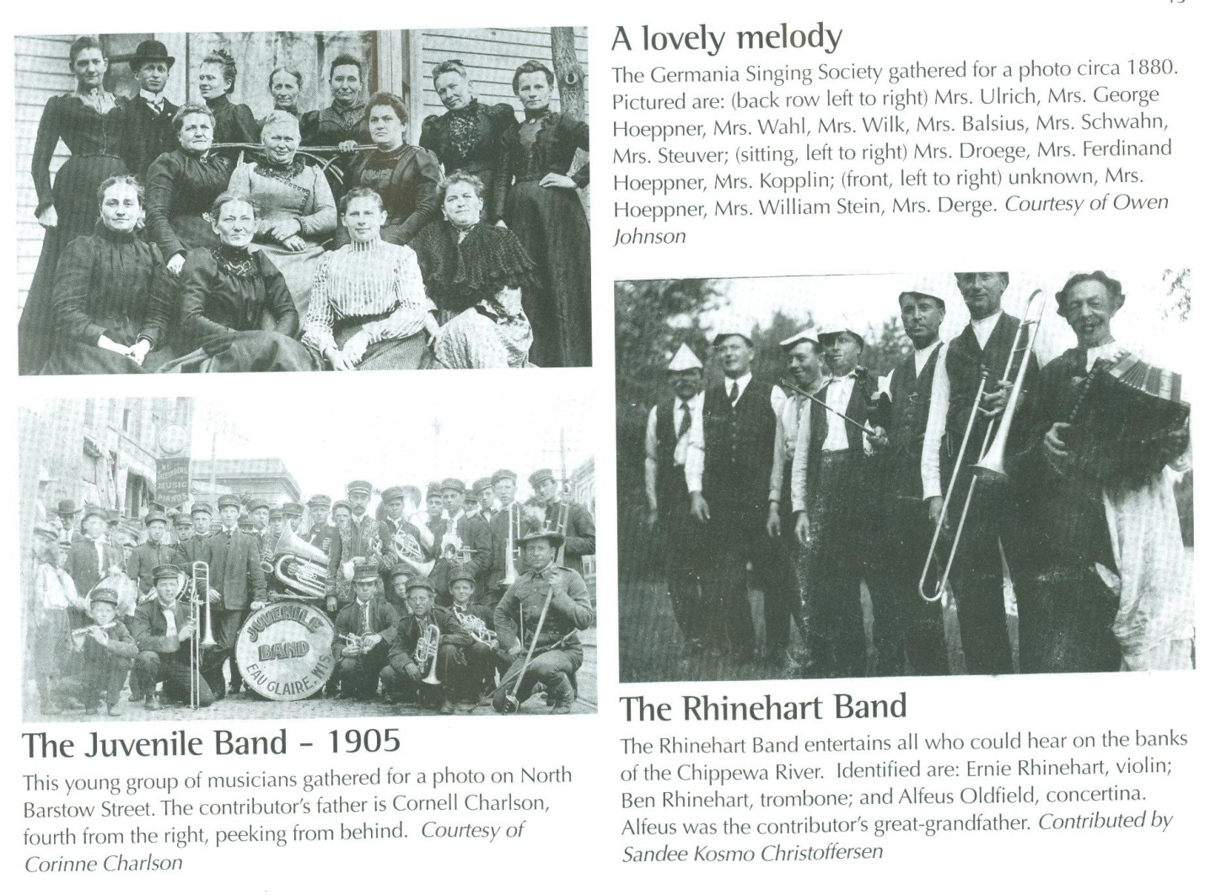
Figure 1. Eau Claire Musical Groups, Late 1800s – Early 1900s.
Source: Leader-Telegram, comp., Eau Claire and the Valley: Where Rivers Meet, Volume 1 (Eau Claire, Wisconsin: Eau Claire Press Company, Commercial Printing Division, 1997), 13.

With the obvious community interest in music it is no surprise then that music organizations showed up on campus at the Eau Claire State Normal School upon the schools opening. The Periscope, the schools year book, shows four music organizations in 1917 including the Cecilian Glee Club, the Men’s Glee Club, the Men’s Quartet, and the Mandolin Club. At the beginning of the school’s first year, 159 students were enrolled on campus including “141 ladies and 18 men.” Of those students, forty-seven or almost thirty percent of the student population were involved in music organizations.
Astoundingly enough, of the eighteen male students on campus, fifteen were involved in the vocal music organizations of the Men’s Glee Club and the Men’s Quartet. In other words, eighty-three percent of all the male students on campus were involved in vocal music organizations in 1917. In comparison, only twenty-two percent of all female students took part in music organizations (ninety percent in the vocal music organization, the Cecilian Glee Club, and eighteen percent in the instrumental music organization, the Mandolin Club). So while some of the societal norms over the past few decades have condemned vocal music as unmanly “sissy stuff,” vocal music had been a regular male activity historically here at Eau Claire and around the country. From the very beginning, the United States had a rich tradition of male participation in music with the Franciscan friars in the 1600s, to the founding of many of the musical organizations in the 1800s, and into the early 1900s with male participation in many smaller community bands and singing groups like that of the Juvenile Band and the Rhinehart Band of Eau Claire.
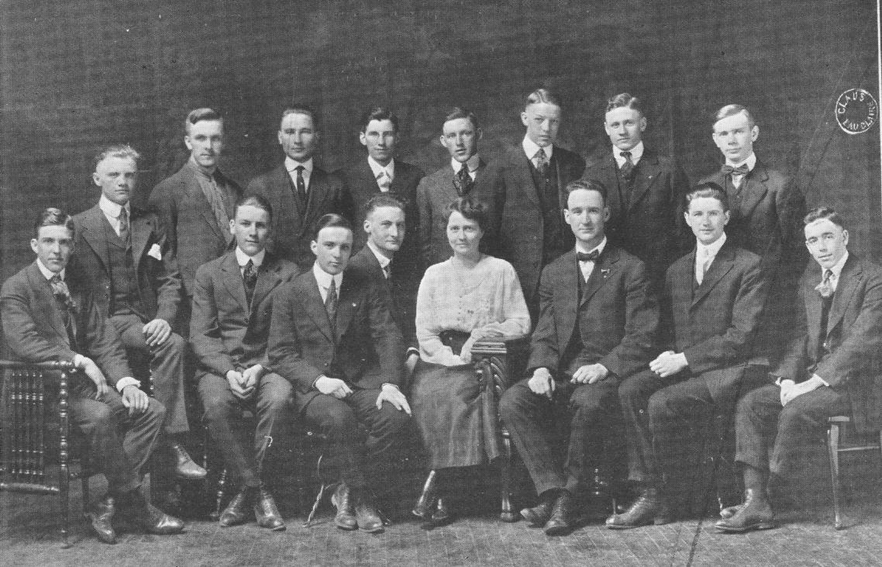
Figure 2. Men’s Glee Club, 1917.
Source: University of Wisconsin – Eau Claire, “The Periscope, 1917.”

The first music teacher at the Eau Claire State Normal School was Miss Grace Gail Giberson. She was trained at the Mount Pleasant Normal School and Thomas Normal Training School in Michigan and was one of only a few other teachers on campus who had not been trained at a state normal school in Wisconsin. The Periscope states that she received additional training at the American Institute of Normal Methods Siegelmeyer School of Music in Chicago by 1920. Although the Periscope does not list the actual classes that were required under the different one year or two year teaching course offerings until the 1919-1920 Catalogue, it can be reasonably assumed that the same standards existed during 1916 in the school’s first year of operation. Those students in the primary grades course were required to take music in the first quarter of their second semester, those in the grammar grades course were required to take a full semester of music, and those in the two year rural course had to take either music or an elective during their first semester.
Between 1917 and 1921 interest in music slowly increased. Upon the opening of the school it was thought that the school should have a song. “Carol William Forest, class of 1917, wrote the words and music for the school song, which remained the official song for” the next “50 years.” As for the organizations, the Mandolin Club and the Men’s Glee Club did not survive after 1917. In 1918 the only two music organizations listed in the Periscope were the women’s Cecilian club and the new Choral Club. Thirty-five women joined the Cecilians in 1918, while the Choral Club had sixteen members, eight women and eight men. These were the only eight men involved in music organizations on campus in 1918 due to the United States’ recent entry into World War I and the fact that many men had enlisted and been sent overseas leaving only small numbers of men left on campus during that year.
In 1918 “Eau Claire hosted the state oratorical contest, with rooters and orchestras from Superior and La Crosse and a 20-piece band from Milwaukee descending on the school.” The oratorical contest may have helped spur musical interest as between 1919 and 1921 the Men’s Quartet joined the two other organizations on campus, in 1919 “resident Schofield chaperoned Eau Claire’s orators, choral club, and men’s quartet on the Soo Line train to Oshkosh for the state contest,” and in 1921 the Cecilians had the highest number of members they would have within the next ten years with a chorus of forty-four women.
However, it was not until 1921 that the school was first recognized for its musical accomplishments. It was in this year that the Eau Claire State Normal School’s Male Quartet was “pronounced the best music organization” at the state oratorical contest in Platteville. After their performance “they were asked by officials from other Normals in the state to come to their respective schools and give concerts later in the spring.” While they were musically considered the best group there, the men also managed to prove “their ability to get themselves into ‘trouble.’” In the 1920 Periscope it was stated about Miss Giberson that ‘to make the students mind the rule, there could be none better in any school.’ Yet somehow the Quartet managed to begin the performance late due to one of its member’s intrigues and students would go on to tease members of the Quartet for quite some time afterward about their behavior toward some of the women at the contest.
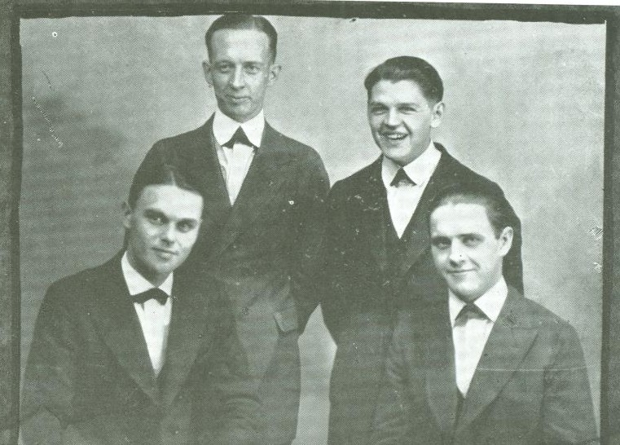
Figure 3. The Male Quartet, 1921.
Source: University of Wisconsin – Eau Claire, “The Periscope, 1921,” 54.

The next few years saw some changes to the music program at Eau Claire. In 1922 Miss Giberson left Eau Claire “for a similar position in the San Diego (Calif.) Normal” and was replaced by Gladys Eisenhart. At the same time that Miss Giberson left, the Choral Club and the Men’s Quartet organizations also ended, and the Cecilians club’s membership dropped from forty-four members down to thirty-three. Whether these changes were strictly due to circumstances at the time, rebellion at the fact that a “very popular music teacher” had left, or perhaps a mixture of both is up for debate. No matter what the reasons for the loss of two choral programs and a drop in membership in the Cecilians chorus, Eisenhart heartily encouraged the beginning of the first enduring school band.
The early 1920s represented the beginnings of the “band movement” in the United States. “Military and community bands began competing in the Midwestern United States during the late nineteenth century.” One of the first band contests in the Midwest took place in “Portage, Wisconsin in 1876.” In 1917 “Jim Europe, a black American”, formed “an army band in 1917, which assisted in bringing about the ‘Big Band’ movement” on a national level. “Contests specifically for school bands originated around World War I when these ensembles began appearing in numerous public schools throughout the United States.” Whereas one of the earliest state and general high school contests took place in Kansas in 1914, similar events were “organized in Chicago, Illinois in 1919; Michigan, Oklahoma, and Wisconsin in 1920; and in Iowa in 1923.” The first National School Band Tournament took place in Chicago in 1923. Locally, the Eau Claire Municipal Band was “established in 1902” and, as stated earlier, the Juvenile Band was pictured in 1905 and the Opera House began presenting festivals by the Eau Claire Philharmonic Orchestra beginning in 1910.
So at the time Eisenhart arrived on the Eau Claire State Normal School campus the band movement in the United States had just begun to get into full swing. Along with community member Mr. Alfred E. Mayer, who became the bands director, and the agriculture and biology teacher Mr. Slagg, Eisenhart helped to form the first school band in 1922. As the Cecilians and the band were now the only two music organizations on campus, the band now represented the only opportunity for men to take part in a musical endeavor and they certainly took advantage of it. Between the Choral Club and the Men’s Quartet only six men were involved in musical organizations on campus in 1921. With the formation of the campus band in 1922, twenty-three men were now taking part in musical endeavors.
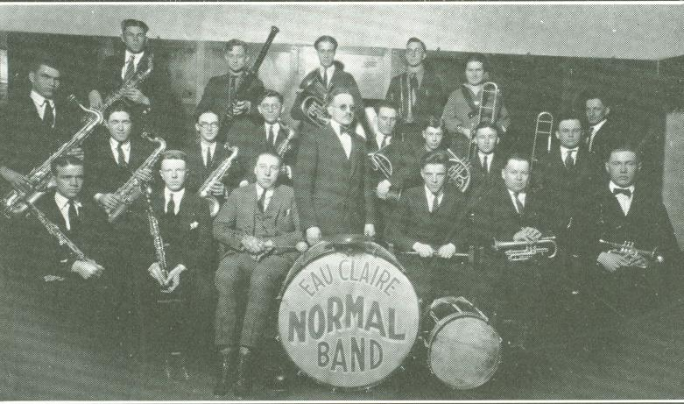
Figure 4. The First Eau Claire Normal School Band, 1922.
Source: University of Wisconsin – Eau Claire, “The Periscope, 1922,” 75.

Eisenhart only remained on campus for two years and in 1924 Clara Mae Ward became the first long-term music teacher to work on campus, teaching there until 1947. During the first year of her teaching career, the Normal Orchestra was established with nineteen initial members, increasing to twenty-seven members the following year. “The increasing popularity of school bands had given added vitality to music programs throughout the nation, although some music supervisors believed that the increased prominence of bands in the schools was a threat to long-established choral programs.” However, under Ward’s instruction, this did not appear to be an issue at Eau Claire. In 1923 the Men’ Glee Club was reestablished with twenty new members and while the organization is not listed in the 1924 Periscope, in 1925 it had twenty-six members and would continue in existence throughout the late 1920’s and into the 1930’s. In 1924 the Men’s Quartet would be reestablished from 1921 and in 1925 a Girl’s Quartet was added to the music organizations on campus.
Eau Claire State Teachers College and the Depression Years, 1927-1939
In 1927, the bachelor’s degree in teacher education was offered for the first time on campus and the name of the Eau Claire State Normal School was changed to the Eau Claire State Teacher’s College. In April of 1925 President Schofield of the Eau Claire campus explained to the Wisconsin state legislature that “Wisconsin was one of only twelve states, and the only one in the Midwest, which did not grant the bachelor of education degree upon completion of a four-year course in teacher education.” In July the legislature “authorized the granting of the degree and designated the normal schools teachers colleges,” however it was not until 1927 that the changing of the name and the granting of the bachelor’s degree was offered at Eau Claire. According to the resolution, effective September 1, 1926 Milwaukee (normal school) was authorized to offer the degree of Bachelor of Education in Art and Music.
At Eau Claire music still did not have its own department as music courses were labeled under fine arts, however this did not hinder the student’s interest in music and in 1928 a second Girl’s Quartet and an A Cappella Choir was added to the music organizations, followed soon thereafter by a third Girl’s Quartet in 1929, a Blue and Gold Colegians band in 1930 (which apparently only survived one year), and a second Boy’s Quartet in 1931. In 1927 the Periscope reported that the Girl’s Glee Club (formerly the Cecilians) had “grown so large that it has become necessary to limit the number of members” and that consequently many girls were put “on the waiting list.” It must have been a long waiting list because between 1927 and 1928 the limit was raised from thirty to forty members and in 1929 forty-two women were listed as members of the organization.
In 1929 the American stock market crashed and the Great Depression began. Millions of people lost their job all over the country. Within four years the unemployment rate skyrocketed from a meager three percent in 1929 to an all-time high of almost twenty-five percent by 1933. Musicians were not immune from the Depression’s devastating effects. “According to one estimate, between 20,000 and 22,000 professional theater musicians lost jobs across the country between 1928 and 1930.” “The American Federation of Musicians estimated that seventy percent of all musicians were unemployed and many others could not live on their musical income.” One would think that this hardly produced an atmosphere where musical programs on college campuses would be appreciated and expanded upon.
However, the Depression “marked a great boom in junior college enrollment” and at four-year colleges that provided higher education closer to home. A college education was seen as the only way to provide upward mobility in a failing economy and in junior colleges across the country “from 1929 to 1939, enrollment jumped from 56,000 to 150,000.” The Eau Claire State Teachers College followed this same trend. “First-semester figures grew steadily from 450 in 1929, to 625 in 1934, and to 735 in 1939.”
While some of the music programs on campus had an initial decline in membership and two organizations were dropped between 1929 and 1930, most of the music programs rebounded by 1931 and one of the dropped organizations was reinstated. The most marked decline in membership among the music organizations between 1929 and 1930 was that of the Girls Glee Club. It’s membership dropped by almost half, from forty-two members in 1929 to twenty-three members in 1930. The women’s second and third Quartets were also dropped in 1930 which meant that eight more students were no longer participating in small group musical organizations. The only music organizations that did not see a marked decline in numbers were the A Cappella Choir, the Orchestra, and the Band. Both the Orchestra and the Band each gained five members in 1930.
During the 1930s the band movement was still in full swing. Although attendance had dropped with the onset of the Depression, bands and orchestras were still very popular. Due to the high numbers of musicians across the country who were out of work yet still in demand, the government began offering federal funding for “relief programs in the arts” beginning in the mid-1930s. These programs offered support “for artists, writers, theatre people, and musicians” and helped fund numerous community concerts across the country. Seemingly it helped. Whether due to federal funding or not, “between thirty thousand and forty thousand musicians would find work playing” big band “swing music after 1935.” Whether or not federal funding had any effect at the Eau Claire college is unknown, but the band and the orchestra stayed popular on the Eau Claire campus and in 1936 the campus hired the first paid bandmaster, Mr. Charles Harris. This was the first time that two music teachers were hired to work on the Eau Claire campus at the same time.
Scholars debate whether the advent of the radio helped decrease or ultimately increase the number of people who attended public concerts. Arthur R. Jarvis speculated that the “combined effects of radio music, synchronized film sound tracks, and the Great Depression” led to the high unemployment rate of musicians in the thirties. However, “in 1930 George Engles stated that the radio has ‘not lessened but immeasurably increased’ opportunities for the professional musician.” He went on to state that:
Over the networks of the National Broadcasting Company alone more than six thousand appearances are made every month, more than are made in public concerts in any four of our largest cities during an entire concert season. Three-fourths (3,750) of these appearances are by musicians. One may realize, therefore, what tremendously greater possibilities radio, in conjunction with individual concert appearances, offers in the furthering of the careers of musicians than would (result if there were) concert appearances alone.
Go into any community, no matter how small or how isolated, and you will find, not one or two, but dozens (of persons) who have heard of Ganz, Lhevinne, Chemet, Kochanski, Schumann-Heink, Giannini, Iturbi, and many others, who know the music they are best fitted to interpret, who know their technical limitations, and who are anxious to see them in the flesh on the concert stage.

So while the radio allowed people the comfort of enjoying music in their own homes, it also served as an added advertisement for musicians and greatly increased musical awareness among those citizens of the United States who would not have normally gone to a concert and learned about the different musical traditions. Radio also helped create “a national popular culture extending over boundaries of geography, ethnicity, and class.” And while some scholars contend that radio may have hindered the public’s likelihood of going to see a live performance, it is important to remember that the quality of radio broadcasts in the 1920s and 1930s was much lower than nowadays and it is probably safe to assume that the public knew that a live performance would outmatch a radio broadcast any day.
The first radio broadcast to be heard in Eau Claire was in B.W. Bridgman’s physics class in 1922 at the Eau Claire State Normal School. The General Electric radio set “brought in voices from beyond the Rockies and the east coast”, “the first time a message from west of the mountains was ever heard in Eau Claire.” Ten years later in 1932, Roy C. Judd began a radio club for students and in 1936 the radio club and Judd:
Established radio station W9WND, which during the following year was hooked
up in the college auditorium with the new Eau Claire station WEAU, so that broadcasts
could be made direct from the college. Speech, drama, and music from the teachers
college went out over the air waves.

As college concerts of the band, orchestra, and singing groups went out over the air, those in the local community who had not previously been aware of the musical programs on campus now had much greater access to the happenings there. Once they had the opportunity to hear these concerts over the radio it is likely that people were more willing to see the musical organization’s concerts in person. It may be partially due to concerts over radio broadcasts that the Eau Claire A Cappella Choir would become as widely known as it was.
According to James A. Keene, ‘probably the first college a cappella choir in this country’ was formed in 1906 at Northwestern University in Illinois. While a cappella had its roots in the United States with the Franciscan friars in the early 1600s, it would take another three hundred years before non-instrumental a cappella choirs would become largely popular. Accordingly, although a cappella groups were prevalent, studies suggest that the a cappella movement had its true “beginning in the 1930s.” During this time choral directors began to focus more on “choral sound rather than interpretation” and serious interest in vowel pronunciation and repertoire became the priority.
The A Cappella Choir at the Eau Claire State Teacher’s College was first organized in 1928 and would become one of the most, if not the most, prestigious musical organization on campus during the Depression years. While other musical organizations were losing members or being discontinued, the A Cappella Choir gained in membership every year from 1928 when the group started with eighteen members until 1932 when a forty member limit was initiated. They also quickly began to show their merit. After performing at oratorical contests and before the Northwestern Wisconsin Teachers’ Association convention in 1929, the group was asked to perform at the State Teacher’s Convention in Milwaukee in 1930. The group was unable to attend due to the expense of the trip, but the request in itself showed that the group was making an impression.
The group’s high esteem only increased throughout the 1930s. In 1930 the choir was awarded third place at the state oratorical contest in Platteville. In 1933 they were the “guests of the National Federation of Music” in Minneapolis and on October 14, 1934 they performed “at the World’s Fair in Chicago” as guests of the Illinois Federation of Music Clubs. The next day they gave a fifteen minute performance over the World’s Fair system. “The radio critic of the Chicago Daily News placed this program first in his ‘Pick of the Air.’” Later in the year the choir performed for the District Federation of Music Convention in Menominee.
The year after the World’s Fair was a busy one for the group. During the year they gave “concerts at Durand and Bloomer, broadcasts over WTAQ, and programs for the Eau Claire Rotary Club, the Training School P.T.A., the Eau Claire Women’s Club, the Eau Claire Kiwanians, and the Presbyterian, the Congregational, and the Grace Luthern Churches, and the Luthern hospital.” In 1936 they again attended music conventions in Chicago and Minneapolis but perhaps the greatest honor for the group occurred in 1939 when the A Cappella Choir performed before Mrs. Eleanor Roosevelt in the White House in Washington D.C.
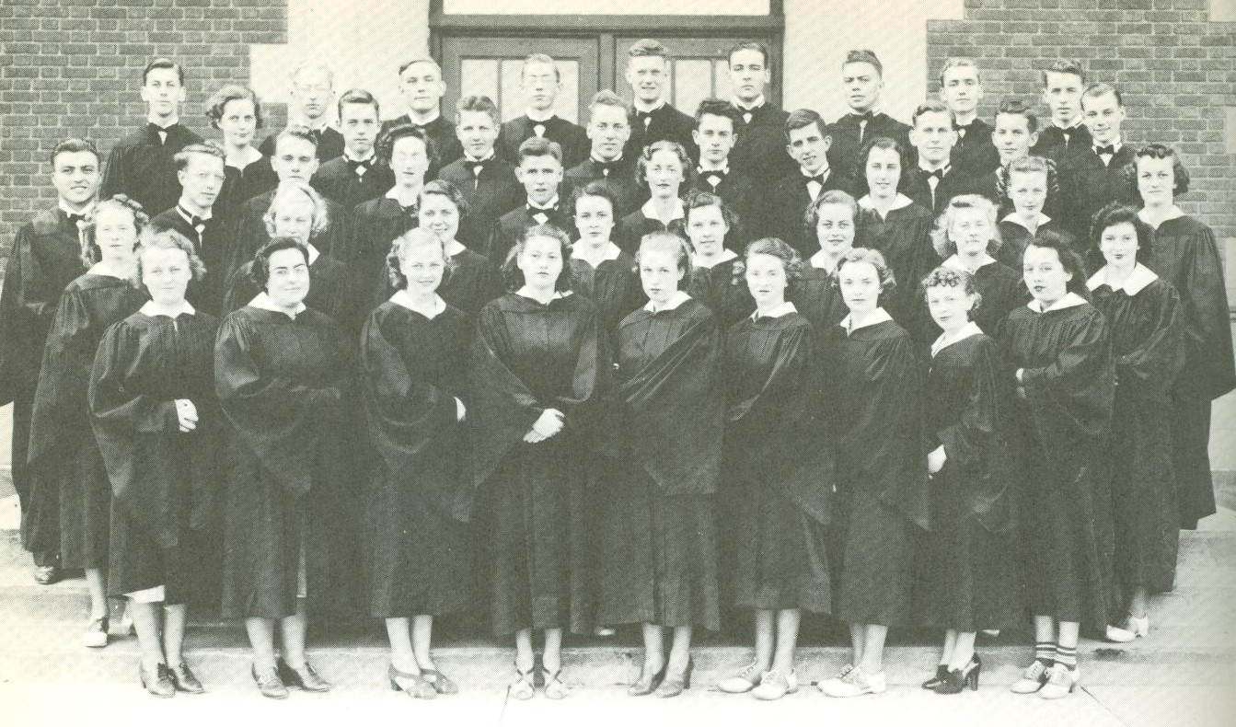
Figure 5. A Cappella Choir, 1939.
Source: University of Wisconsin – Eau Claire, “The Periscope, 1939,” 102.

As more music organizations were formed on campus and began to grow in prestige during the late 1930s, the music curriculum that was offered to students began to expand. In the 1934-1935 academic year, three teacher training programs including those for teachers of primary grades, upper grades, and rural schools, each required two semester credit hours in music courses except for the rural school program which required only one semester credit hour. Descriptions for the three music classes offered at the school are as follows:
C 106. Primary Grade Music
This course is devoted to the study of material and methods for Public School
Music. It includes a study of the elements of music, rote singing and sight singing, an
acquaintance with songs suitable for each grade, a study of intervals and modulations,
ear-training rhythm, time subdivisions, part singing, major and minor scales, the
elements of musical composition, and training in musical analysis. The different tonal
and rhythmic problems as they are taken up in successive years, the treatment of
monotones and out-of-tune singers, song interpretation, and problems found in public
school music are presented.

C 107. Grammar Grade Music
Same as above except that emphasis is placed upon problems of teaching music
in Upper Grades.

C 108. Rural School Music
This course is organized around the topics of rote songs; the care, development and classification of children’s voices; the development of rhythm through marching, clapping and folk dances; elementary reading of syllables and appreciation of music.
The importance and value of music in the life of the school is emphasized.

The same three classes were offered in the 1935-1936 academic year, however students were now required to take three semester hours in whichever program they were in or two semester hours for the rural schools program and for the first time, over the summer of 1935, a two semester credit course was offered in music directing.
In the 1935-1936 academic year, the Bachelor of Education could be taken with a field of advanced study in either Advanced Applied Music or Art for the first time. As a direct result, in the following years a number of new courses were offered. In the summer of 1936 a music appreciation course was offered for one semester credit. In the following year the music directing course began to be offered on a regular basis during each normal academic year afterward. Over the summer of 1937 the music appreciation course was changed to also include music history and in the 1937-1938 year was offered as a three credit class. The summer afterwards, a band tactics class was added for two semester credits. In the 1938-1939 year, three new classes were added. The Music Directing class was split into two courses, one for vocal music directing and the other for instrumental music directing, and an Instrumental Class Instruction class was added to the curriculum. By the summer of 1939, the Rural School Music class and the music for upper grades classes were dropped and in the following academic year Instrumental Music Directing was dropped, but a second Instrumental Class Instruction class, an instrumentation class, an Instrumental Group Conducting class, and a Harmony class were all added to the curriculum.
World War II, the G.I. Bill, and the Growing Importance of Music, 1939-1952
In the 1930s the influence of the totalitarian regimes of Germany, Italy, and Japan were progressively expanding. While many in Europe were worried about their increasing militarization, the American public tried to ignore it. “Some citizens believed the causes of the Great Depression could be traced back to the nation’s involvement in World War I, and they felt that staying clear of all foreign problems was the way to future security.” However, when World War II began after the Germans invaded Poland in 1939, President Franklin D. Roosevelt urged the Congress and the American public to see reason. In 1940 the Congress appropriated “$2.5 billion for military equipment and installations” and “the country’s first peacetime military draft” was enacted. However, it was not enough to prevent the worst. On December 7, 1941, the American naval base at Pearl Harbor was attacked by the Japanese and “the United States declared war, first on Japan and then on Italy and Germany.”
The effects of the war on music education would be monumental. Whereas prior to the war music instructors used music as a way to “expand the international perspectives of their students” and taught music as “a morally elevated art”, after the start of the war, educators were urged to use music to build national solidarity and to boost morale. In 1941, the National Association for Music Education (MENC), the Music Teachers National Association (MTNA), and the National Association of Schools of Music (NASM) “collectively pledged to support an American Unity Through Music program that encouraged the playing and singing of songs that ‘best embody the spirit and ideals of our United States.’” Even President Roosevelt called on music educators for “‘more bands, more parades, more flag waving’ to build national spirit.” Suddenly music was no longer an art, but an American duty. It comes as no surprise then that the first marching band at the Eau Claire State Teachers College was formed in 1940 and would remain popular over the next few years. It was noted also that the 1942 Christmas program of the A Cappella Choir “was quite different from the Choir’s Yule programs of previous years,” focusing more on the “social side rather than the religious” side of the holiday.
But the war would have a far greater, destabilizing effect on the music organizations on campus. Between 1939 and 1943 enrollment at the college dropped from 735 students to a wartime low of 340. “As they were called into service, male students declined in number from 272 in the fall of 1941 to a low of 60 in 1943, and recovered only slightly to 63 in 1944 and 77 in 1945.” Accordingly, the male chorus was dropped in 1942. It was revived in 1943 with fifteen members, but once again had to be dropped in 1944 due to a lack of male students.
The war would also have an ultimately devastating effect on the A Cappella Choir. From 1939 through 1941 the group had sponsored and brought some highly esteemed music professionals to campus including Jessica Dragonette, a “famous lyric soprano of radio and the stage,” Dorothy Maynor, a soprano and music educator of African American and Native American descent, and James Melton, a famous operatic tenor. The group tried to sponsor a fourth guest soloist in 1942 but was unable to due to the “difficulty in obtaining singers and wartime restrictions.” While the Periscope did not describe the nature of these “wartime restrictions,” A History of Music Education states that travel restrictions had “eliminated the regional and national competitive events” and may partly explain their difficulty in bringing a fourth guest to campus in 1942. However, it was the lack of students on campus that ultimately devastated the A Cappella Choir the most and in 1943, after fifteen years of outstanding service to the Eau Claire campus, the group would hold its last concert.
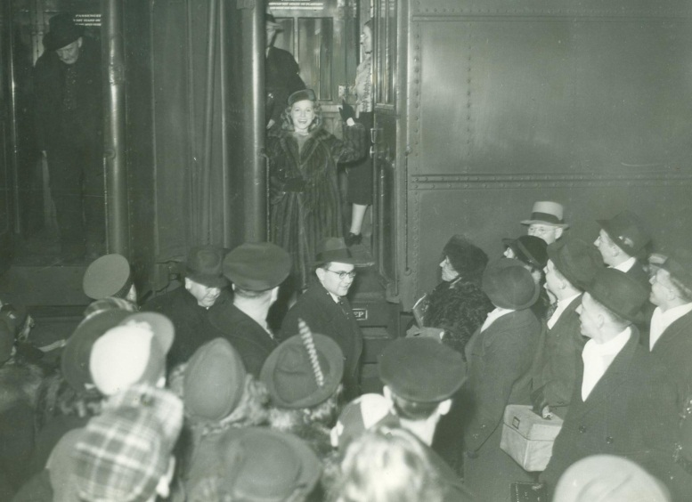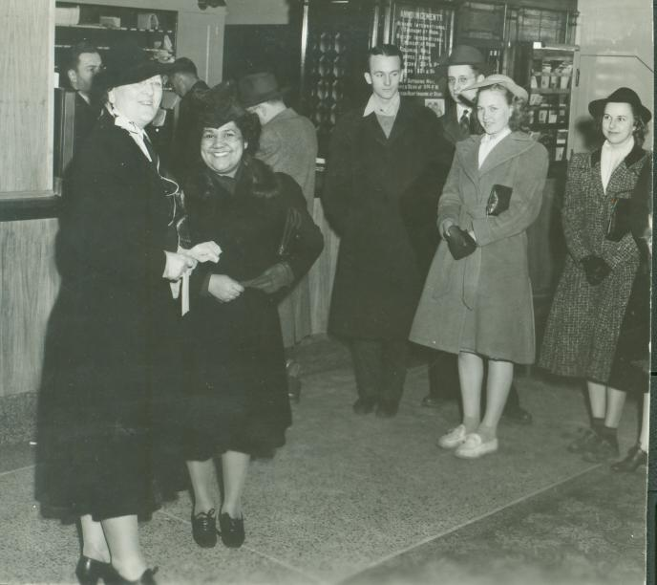
Figure 6. Jessica Dragonette Arriving in Eau Claire, 1939.
Figure 7. Dorothy Maynor in Eau Claire, 1940.
Source: University Archives Photograph Collection, 1916-2000, AS279, Special Collections & Archives, McIntyre Library, University of Wisconsin--Eau Claire, Eau Claire, WI, box 19, folder 6.

Other musical organizations shifted in and out of existence in the mid-1940s. A Mixed Chorus of thirteen members and a Girls Glee Club of thirty-two members would take the place of the A Cappella Choir in 1944. Despite the high popularity of bands during the 1940s neither the orchestra nor the band were listed in the Periscope in 1944 and in 1945 only the band was pictured. The male chorus was revived once more in 1945 however only thirteen men took part. Meanwhile, the Girls Glee Club was dropped, the chorus held twenty-two members, and a number of small group music organizations tried to make up for the lack of larger organizations. In 1946, “for the first time since the outbreak of war…the vocal music department did not have a mixed choir,” opting instead for a Coed Chorus which had nearly sixty members and a Men’s Chorus.
In 1945 Germany and Japan surrendered and the war finally ended bringing about huge changes for colleges and universities across the country. In 1944 President Roosevelt signed the G.I. Bill which provided those honorably discharged military veterans with expense paid college education. “The expanded horizons of millions of ex-servicemen and women created a…surge of college enrollment.” At the Eau Claire State Teachers College enrollments more than doubled from 366 students in 1945 to 787 in 1946 and would rise further to 905 students by 1949.
Based on the expansion of music course offerings in the 1940s, it appears that Eau Claire college officials foresaw the future rapid growth in student enrollment. At the beginning of the war, course offerings stagnated. Nothing was significantly changed or added from 1939 through 1941. However, in 1942 a plethora of classes emerged. For the first time there were so many music courses that they were broken down into vocal music and instrumental music classes. New vocal music classes included three courses each in Ear Training, Choral Ensemble, Harmony, History and Appreciation of Music, Music Education in the Elementary Grades, and Music Education in the Junior and Senior High Schools, two courses of Rural Music classes, and one course of Choral Conducting and Sight Reading. Instrumental music classes included three courses each of “Ear Training, Sight Reading, Dictation,” Harmony, Elementary Orchestra and Band, and Advanced Orchestra and Band, and one course each of Instrumental Conducting and Principles of Teaching and Supervision of Instrumental Music. The Principles of Teaching and Supervision of Instrumental Music course covered everything from wind and percussion instruments to problems of intonation, balance, interpretation, special maneuvers of marching bands, organizing a library of music, planning and conducting a concert, public school supervision, and care of management.
For the next few years the course offerings stayed the same until, in 1947, another new plethora of music courses began being offered in the instrumental section. For normal course offerings, students could now take an Applied Music class, a three credit Theory – Fundamentals class, or a four credit Practice Teaching class. However, the main new additions to the course offerings came in the form of specialist courses. Musicians could now take Brass Instrument Methods, Wood-Wind Instrument Methods, Percussion Methods and drum-majoring, Violin Methods, Cello Methods, or a Related Instruments (Viola and Double Brass) course. The only additional course that was added in 1949-1951 was Arranging in which students would learn “the range and transposition of all of the instruments,” then make practical arrangements for the instruments, and finally complete the “arrangements for the band and orchestra.”
With the immense numbering of new course offerings, it is surprising that the faculty could handle it all. Clara Mae Ward worked as a music instructor and as a director in many of the music organizations until she retired in 1947. Charles Harris was hired in 1938 to work with the band and orchestra, but for unknown reasons, whether they had to do with the war or not, he left the campus in 1943. Gretchen Grimm was the next teacher hired on the campus as an art and music teacher in 1941, but only remained on campus until 1946. The two other music teachers to be hired in the late 1940s were Robert Gantner and Caldwell Johnson, both of whom would be long-term, prestigious professors on campus. Caldwell Johnson would succeed Clara Mae Ward and work at the campus for twenty-four years. Robert Gantner would start the prestigious marching band, which is still in existence today, before 1962 and would go on to become one of seven music department chairs. It is important to remember that throughout the entire 1940s, despite a huge increase in the number of course offerings, never during any year were there more than three music teachers working on campus at one time.

Table 1. Music Faculty at the Eau Claire State Normal School and Eau Claire State Teachers College, 1916-1952.
Source: Created by author using data from the Periscope, 1916-1952.
After 1946 the format of the Periscope significantly changed and seemingly underreported the music organizations that were henceforth active. While chorus and band were pictured through 1952, no other smaller music organizations were written about except for an A Cappella Choir and the Men of Note in 1947 and the Scherzo Club from 1950 to 1952. The Scherzo Club was organized with “the objective of becoming affiliated with the national music sororities and fraternities, and to provide knowledge and wholesome entertainment for enthusiasts.” They also brought guest speakers to campus, studied different types of music and composers, and took trips to Minneapolis to hear symphonies and operas.
When many people think of musical training in the United States, they usually first think of the Julliard School which was established in New York in 1905, however the first Bachelor of Music education degree ever to be offered in the United States was given at the Oberlin Conservatory in 1922. While colleges around the country would follow their example, it would not be until the early 1960’s that most colleges and universities around the country would begin offering bachelor’s degrees in music and music education.
By 1952 the name of the Eau Claire college changed to the Wisconsin State College at Eau Claire and the Wisconsin Board of Regents finally authorized the school to offer the Bachelor of Arts and Sciences in liberal arts. With this authorization the Wisconsin State College at Eau Claire began offering the bachelor of music degree. This was the first time that a bachelor’s degree in music was offered on campus and represented the first major “official” validation of music’s importance at the University of Wisconsin – Eau Claire. While music education was encouraged on campus prior to the bachelor’s degree as shown by the various course offerings and the faculty members involvement in the different organizations, there was never an official music department prior to the granting of a bachelor’s degree in music. Once music education was officially endorsed by the college, music programs would now have more funding opportunities, more incentive to hire faculty members and to build new music facilities, and would dramatically expand over the next sixty years into the vibrant and successful program it has become today.
Conclusion
In many respects the early history of the University of Wisconsin – Eau Claire’s music department follows many of the national trends of music programs in the United States from the early 1920s through the 1940s. A strong early choral history over an instrumental history, the schools prestigious A Cappella Choir coming to prominence in the 1930s, a Marching Band starting in 1940, and the devastating effects of World War II on the music programs of the campus all represent examples of subsequent national trends. However, the large portions of students in music programs at the beginning of the music program and the teachers and students strict determination to keep the programs alive as witnessed by the struggle of creating new groups each year during World War II may be unique. Also, the early initiation of the Bachelor of Music degree at Eau Claire presents a strong legacy of the high importance of music on the campus throughout the years.
So while music was always important on the Eau Claire college campus since the opening of the school in 1916, music education was not significantly endorsed in an official capacity until the granting of the bachelor’s degree in music and the creation of the music department in 1952. It was the continued interest, participation, and persistence in creating and maintaining music organizations demonstrated by the students and the small number of music faculty members that brought music to the forefront and established the need for a bachelor’s degree in music on the Eau Claire campus. Without their support and consistent perseverance the formation of a bachelor’s degree in music may never have been realized and the atmosphere of the campus today may have been radically different.
In the years following the 1952 adoption of the Bachelor of Music, the music department at the University of Wisconsin – Eau Claire has grown to be highly prestigious in certain areas. The creation and prominence of the yearly Jazz Festival, the Marching Band, and the Singing Statesmen, a male choral ensemble who have so handsomely followed in the footsteps of the original Men’s Glee Club of 1916, were all directly impacted by the campus’s official validation of the music program in 1952 which led to greater funding and more faculty members. Due to the expansion of the music program over time, today the department is broken down into six different sections including that of choral and voice, keyboard, music education, wind and percussion, strings, and theory, composition, and music history and currently has a forty member faculty instructing hundreds of students each year. It is therefore obvious that the historical foundations of the University of Wisconsin – Eau Claire’s music department have helped it to become one of the most prominent university music programs within the University of Wisconsin system; all of which was made possible by the initial crescendo into official significance.

APPENDIX
Music Faculty Members at UWEC, 1916-1952

Figure 8. Grace Gail Giberson, 1917.
Source: University of Wisconsin – Eau Claire, “The Periscope, 1917,” no page numbers.

Figure 9. Gladys Eisenhart, 1922.
Source: University of Wisconsin – Eau Claire, “The Periscope, 1922,” 74.

Figure 10. Clara Mae Ward, 1925.
Source: University of Wisconsin – Eau Claire, “The Periscope, 1925,” 20.

Figure 11. Charles Harris, 1938.
Source: University of Wisconsin – Eau Claire, “The Periscope, 1938,” 12.

Figure 12. Gretchen Grimm, 1950.
Source: University of Wisconsin – Eau Claire, “The Periscope, 1950,” no page numbers.

Figure 13. Robert Gantner, 1946.
Source: University of Wisconsin – Eau Claire, “The Periscope, 1946,” 22.

Figure 14. Caldwell Johnson, 1948.
Source: University of Wisconsin – Eau Claire, “The Periscope, 1948,” 9.

Figure 15. Mrs. Meggett, 1950.
Source: University of Wisconsin – Eau Claire, “The Periscope, 1950,” no page numbers.

Figure 16. Kathleen Olson, 1951.
Source: University of Wisconsin – Eau Claire, “The Periscope, 1951,” 16.
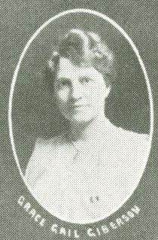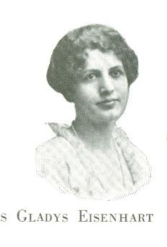

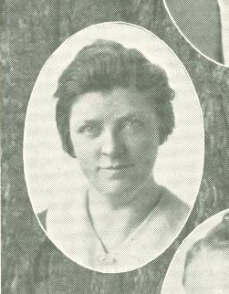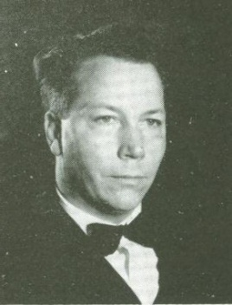
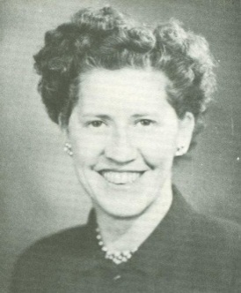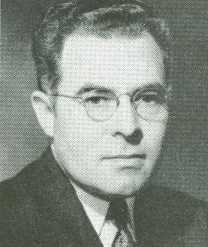
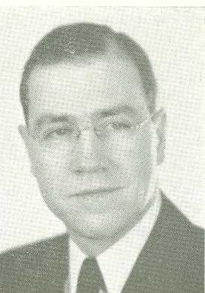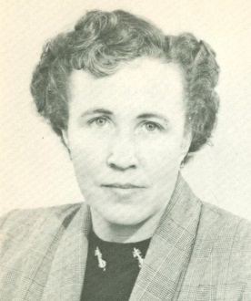
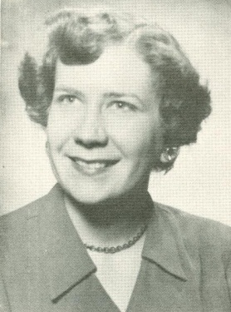
WORKS CITED
PRIMARY SOURCES:
Barland, Lois. Sawdust City. Stevens Point, Wisconsin: Worzalla Publishing Co., 1960.
Barland, Lois. The Rivers Flow On, A Record of Eau Claire, Wisconsin from 1910-1960. Stevens
Point, Wisconsin: Worzalla Publishing Co., 1965.
MENC: The National Association for Music Education. “Personals.” Music Supervisors’ Journal 8,
no. 1 (October 1921).
University of Wisconsin – Eau Claire Catalogs, 1917-2011. AS 067. Special Collections &
Archives. McIntyre Library. University of Wisconsin – Eau Claire. Eau Claire, WI.
University of Wisconsin – Eau Claire. “The Periscope, 1917-1995.” Loc. Hist. LD 6090 .A58.
Special Collections & Archives. McIntyre Library. University of Wisconsin – Eau Claire.
Eau Claire, WI.
SECONDARY SOURCES:
Broudy, Harry S. “The Role of Music in General Education.” Bulletin of the Council for Research
in Music Education, no. 105 (Summer 1990).
Carter, Hilda R., and John R. Jenswold. The University of Wisconsin – Eau Claire, A History, 1916-
1976. Stevens Point, Wisconsin: University of Wisconsin – Eau Claire Foundation, Inc.,
1976.
Drury, Richard L. “Community Colleges in America: A Historical Perspective.” Inquiry 8, no. 1
(Spring 2003).
Eastern Michigan University: a historic tour of EMU. “A Brief History of EMU.” Eastern Michigan
University. http://www.emich.edu/walkingtour/hist.htm (accessed March 31, 2012).
Eastern Michigan University: Music & Dance. “Historical Highlights of the EMU Department of
Music 1854 – present.” Eastern Michigan University. http://www.emich.edu/music/ab
out/history.html (accessed March 31, 2012).
Eau Claire Municipal Band. “About the Band.” Eau Claire Municipal Band. http://people.uwec.e
du/RICHARRW/ECMBpg2.htm (accessed April 1, 2012).
Goble, J. Scott. “Nationalism in United States Music Education During World War II.” Journal of
Historical Research in Music Education 30, no. 2 (April 2009).
Gonzo, Carroll. “Research in Choral Music: A Perspective.” Bulletin of the Council for Research in
Music Education, no. 33 (Summer 1973).
Hash, Philip M. “History of the Illinois School Band Association: 1924-1941.” Journal of Historical
Research in Music Education 30, no. 1 (October 2008).
Jarvis, Arthur R. “Philadelphia’s Depression Orchestras: Contrasts Between the WPA Civic
Symphony Orchestra and the Philadelphia Orchestra, 1935-1942.” Pennsylvania History
66, no. 3 (Summer 1999).
Krikun, Andrew. “Popular Music and Jazz in the American Junior College Music Curriculum
During the Swing Era (1935-1945).” Journal of Historical Research in Music Education 30,
no. 1 (October 2008).
Leader-Telegram, comp. Eau Claire and the Valley: Where Rivers Meet, Volume 1. Eau Claire,
Wisconsin: Eau Claire Press Company, Commercial Printing Division, 1997.
------. Eau Claire and the Valley: Where Rivers Meet, Volume 2. Eau Claire, Wisconsin: Eau Claire
Press Company, Eau Claire Leader Printing, 2007.

Leglar, Mary A., and David S. Smith. “Community Music in the United States: An Overview of
Origins and Evolution.” International Journal of Community Music 3, no. 3 (November
2010).
Keene, James A. A History of Music Education in the United States. Centennial, Colorado:
Glenbridge Publishing Ltd., 1982.
Mark, Michael L., and Charles L. Gary. A History of American Music Education. New York City,
New York: Schirmer Books, 1992.
Microsoft Encarta Encyclopedia 99, CD-ROM (Microsoft Corporation, 1993-1999).
Mintz, Steven. “Learn About the Great Depression.” Digital History. http://www.digitalhistory.u
h.edu/modules/great_depression/index.cfm (accessed April 4, 2012).
Spurgeon, Alan L. “MSNC Comes of Age: George Oscar Bowen and the 1928 Conference.”
Journal of Historical Research in Music Education 27, no. 1 (October 2005).
Sunderman, Lloyd Frederick. Historical Foundations of Music Education in the United States.
Metuchen, New Jersey: The Scarecrow Press, Inc., 1971.
Tobin, R. Nicholas. “A Chronicle of the First Degrees: Music Teacher Training from Normal
School to State College.” Journal of Historical Research in Music Education 27, no. 2
(April 2006).
Wyman, Walker D., editor. History of the Wisconsin State Universities. River Falls, Wisconsin:
River Falls State University Press, 1968.
YouTube. “Marian Anderson, 1950.” YouTube. http://www.youtube.com/watch?v=UfLvusKNU7
U (May 10, 2012).

------. “Marian Anderson Sings at Lincoln Memorial.” YouTube. http://www.youtube.com/watch
?v=mAONYTMf2pk (May 10, 2012).

Lloyd Frederick Sunderman, Historical Foundations of Music Education in the United States (Metuchen, New Jersey: The Scarecrow Press, Inc., 1971), 8.
Ibid.
Sunderman, Historical Foundations, 9-10.
Ibid., 10.
Ibid., 13.
Ibid., 17.
Mary A. Leglar and David S. Smith, “Community Music in the United States: An Overview of Origins and Evolution,” International Journal of Community Music 3, no. 3 (2010): 345.
Sunderman, Historical Foundations, 21.
Sunderman, Historical Foundations, 23.
Ibid., 19.
Ibid., 27.
Leglar and Smith, “Community Music,” 346.
James A. Keene, A History of Music Education in the United States (Centennial, Colorado: Glenbridge Publishing Ltd., 1982), 287.
Sunderman, Historical Foundations, 202-203.
R. Nicholas Tobin, “A Chronicle of the First Degrees: Music Teacher Training from Normal School to State College,” Journal of Historical Research in Music Education 27, no. 2 (2006): 85.
Michael L. Mark and Charles L. Gary, A History of American Music Education (New York City, New York: Schirmer Books, 1992), 156.
Sunderman, Historical Foundations, 202-203.
Tobin, “A Chronicle”, 85.
Sunderman, Historical Foundations, 230.
Eastern Michigan University: a historic tour of EMU, “A Brief History of EMU,” Eastern Michigan University, http://www.emich.edu/walkingtour/hist.htm (accessed March 31, 2012).
Eastern Michigan University: Music & Dance, “Historical Highlights of the EMU Department of Music 1854 – present,” Eastern Michigan University, http://www.emich.edu/music/about/history.html (accessed March 31, 2012).
Sunderman, Historical Foundations, 234.
Ibid., 120.
Sunderman, Historical Foundations, 120.
Walker D. Wyman, editor, History of the Wisconsin State Universities (River Falls, Wisconsin: River Falls State University Press, 1968), 26.
Ibid., 99.
Sunderman, Historical Foundations, 235.
Sunderman, Historical Foundations, 244.
Ibid., 246.
Wyman, History of the Wisconsin State Universities, 11.
Lois Barland, Sawdust City (Stevens Point, Wisconsin: Worzalla Publishing Co., 1960), 105.
Ibid., 106.
Wyman, History of the Wisconsin State Universities, 11.
Leader-Telegram, comp., Eau Claire and the Valley: Where Rivers Meet, Volume 1 (Eau Claire, Wisconsin: Eau Claire Press Company, Commercial Printing Division, 1997), 13.
Lois Barland, The Rivers Flow On, A Record of Eau Claire, Wisconsin from 1910-1960 (Stevens Point, Wisconsin: Worzalla Publishing Co., 1965), 327.
Leader-Telegram, comp., Eau Claire and the Valley: Where Rivers Meet, Volume 2 (Eau Claire, Wisconsin: Eau Claire Press Company, Eau Claire Leader Printing, 2007), 104.
Barland, The Rivers Flow On, 321.
University of Wisconsin – Eau Claire, “The Periscope, 1917-1995 (1917),” Loc. Hist. LD 6090 .A58, Special Collections & Archives, McIntyre Library, University of Wisconsin – Eau Claire, Eau Claire, WI.
Wyman, History of the Wisconsin State Universities, 304.
University of Wisconsin – Eau Claire, “The Periscope, 1917.”
University of Wisconsin – Eau Claire, “The Periscope, 1917”.
University of Wisconsin – Eau Claire, “The Periscope, 1920”, 13.
University of Wisconsin – Eau Claire Catalogs, 1917-2011 (1916-1920), AS 067, Special Collections & Archives, McIntyre Library, University of Wisconsin – Eau Claire, WI, 14-15, 21-22, 26.
University of Wisconsin – Eau Claire Catalogs, 1919-1920, 21-22, 26.
Hilda R. Carter and John R. Jenswold, The University of Wisconsin – Eau Claire, A History, 1916-1976 (Stevens Point, Wisconsin: University of Wisconsin – Eau Claire Foundation, Inc., 1976), 23.
Ibid., 7.
University of Wisconsin – Eau Claire, “The Periscope, 1919-1921,” 59, 48, 54.
Carter and Jenswold, The University of Wisconsin – Eau Claire, 7.
University of Wisconsin – Eau Claire, “The Periscope, 1921-1931,” 52, 74, 108, 108, 118, 90, 76, 82, 90, 116, 119.
University of Wisconsin – Eau Claire, “The Periscope, 1921,” 54.
Ibid.
University of Wisconsin – Eau Claire, “The Periscope, 1920,” 13.
University of Wisconsin – Eau Claire, “The Periscope, 1921,” 54.
MENC: The National Association for Music Education, “Personals,” Music Supervisors’ Journal 8, no. 1 (1921): 32.
University of Wisconsin – Eau Claire, “The Periscope, 1922,” 13.
Ibid., 74-75.
Carter and Jenswold, The University of Wisconsin – Eau Claire, 10.
Philip M. Hash, “History of the Illinois School Band Association: 1924-1941,” Journal of Historical Research in Music Education 30, no. 1 (2008): 4.
Ibid.
Leglar and Smith, “Community Music,” 347.
Hash, “History of the Illinois,” 5.
Ibid.
Ibid., 4.
Eau Claire Municipal Band, “About the Band,” Eau Claire Municipal Band, http://people.uwec.e du/RICHARRW/ECMBpg2.htm (accessed April 1, 2012).
University of Wisconsin – Eau Claire, “The Periscope, 1922,” 15, 75.
University of Wisconsin – Eau Claire, “The Periscope, 1921,” 53-54.
University of Wisconsin – Eau Claire, “The Periscope, 1922,” 75.
University of Wisconsin – Eau Claire, “The Periscope, 1924, 1948,” 18.
University of Wisconsin – Eau Claire, “The Periscope, 1923-1924,” 107, 107.
Alan L. Spurgeon, “MSNC Comes of Age: George Oscar Bowen and the 1928 Conference,” Journal of Historical Research in Music Education 27, no. 1 (2005): 3.
University of Wisconsin – Eau Claire, “The Periscope 1923, 1925,” 109, 117.
University of Wisconsin – Eau Claire, “The Periscope, 1924-1925,” 111, 119.
Wyman, History of the Wisconsin State Universities, 308.
Ibid.
Wyman, History of the Wisconsin State Universities, 308.
Ibid., 14.
University of Wisconsin – Eau Claire Catalogs, 1934, 29-30.
University of Wisconsin – Eau Claire, “The Periscope, 1928-1931,” 81/85, 89, 117, 118.
University of Wisconsin – Eau Claire, “The Periscope, 1927,” 76.
University of Wisconsin – Eau Claire, “The Periscope, 1927-1929,” 76, 83, 90.
Steven Mintz, “Learn About the Great Depression,” Digital History, http://www.digitalhistory.uh.edu/m odules/great_depression/index.cfm (accessed April 4, 2012).
Arthur R. Jarvis, “Philadelphia’s Depression Orchestras: Contrasts Between the WPA Civic Symphony Orchestra and the Philadelphia Orchestra, 1935-1942,” Pennsylvania History 66, no. 3 (1999): 421.
Ibid.
Richard L. Drury, “Community Colleges in America: A Historical Perspective,” Inquiry 8, no. 1 (2003): 4.
Ibid.
Wyman, History of the Wisconsin State Universities, 309.
University of Wisconsin – Eau Claire, “The Periscope, 1929-1931.”
University of Wisconsin – Eau Claire, “The Periscope, 1929-1930,” 90, 116.
Ibid., 88-89, 113.
Ibid., 112.
Jarvis, “Philadelphia’s Depression Orchestras,” 422.
Ibid.
Andrew Krikun, “Popular Music and Jazz in the American Junior College Music Curriculum During the Swing Era (1935-1945),” Journal of Historical Research in Music Education 30, no. 1 (2008): 41.
Carter and Jenswold, The University of Wisconsin – Eau Claire, 31.
Jarvis, “Philadelphia’s Depression Orchestras,” 421.
Sunderman, Historical Foundations, 259.
Ibid.
Krikun, “Popular Music and Jazz,” 41.
Barland, The Rivers Flow On, 324.
Ibid.
Carter and Jenswold, The University of Wisconsin – Eau Claire, 28.
Spurgeon, “MSNC Comes of Age,” 8.
Sunderman, Historical Foundations, 8.
Carroll Gonzo, “Research in Choral Music: A Perspective,” Bulletin of the Council for Research in Music Education, no. 33 (1973): 22.
Gonzo, “Research in Choral Music,” 22.
University of Wisconsin – Eau Claire, “The Periscope, 1928,” 85.
University of Wisconsin – Eau Claire, “The Periscope, 1928-1932,” 85, 94, 117, 116, 58.
University of Wisconsin – Eau Claire, “The Periscope, 1929-1930,” 87, 113.
University of Wisconsin – Eau Claire, “The Periscope, 1930,” 113.
Ibid.
University of Wisconsin – Eau Claire, “The Periscope, 1933,” 88.
Carter and Jenswold, The University of Wisconsin – Eau Claire, 31.
University of Wisconsin – Eau Claire, “The Periscope, 1934,” 100.
Ibid.
Ibid.
University of Wisconsin – Eau Claire, “The Periscope, 1935,” 94.
University of Wisconsin – Eau Claire, “The Periscope, 1936,” 86.
Carter and Jenswold, The University of Wisconsin – Eau Claire, 31.
University of Wisconsin – Eau Claire Catalogs, 1934-1935, 15-16, 30.
University of Wisconsin – Eau Claire Catalogs, 1934-1935, 30.
University of Wisconsin – Eau Claire Catalogs, Summer 1935, 1935-1936, 10, 18-21.
University of Wisconsin – Eau Claire Catalogs, 1935-1936, 10.
University of Wisconsin – Eau Claire Catalogs, Summer 1936, 12.
University of Wisconsin – Eau Claire Catalogs, 1936-1937, 38.
University of Wisconsin – Eau Claire Catalogs, Summer 1937, 1937-1938, 12, 40.
University of Wisconsin – Eau Claire Catalogs, Summer 1938, 12.
University of Wisconsin – Eau Claire Catalogs, 1938-1939, 42.
J. Scott Goble, “Nationalism in United States Music Education During World War II,” Journal of Historical Research in Music Education 30, no. 2 (2009): 104.
Ibid.
Ibid., 109.
Ibid., 103.
Ibid., 106.
Mark and Gary, A History, 296.
University of Wisconsin – Eau Claire, “The Periscope, 1940-1943,” 103, 104, 110, 100.
University of Wisconsin – Eau Claire, “The Periscope, 1942,” 113.
Carter and Jenswold, The University of Wisconsin – Eau Claire, 157.
Ibid., 42.
University of Wisconsin – Eau Claire, “The Periscope, 1941-1942,” 104-109, 108.
University of Wisconsin – Eau Claire, “The Periscope, 1943-1944,” 105, 42-43.
Dorothy Maynor performed in Eau Claire on April 7, 1940. The Spectator wrote a story about her on the front page of every paper between January 17 and March 19 before her performance which totaled to five newspaper covers and continued to write two more front page stories about her in the following two papers after her performance. On October 25, 1939 The Spectator announced that Miss Marian Anderson, a famous African American soprano who was nationally known and had sung at the Lincoln Memorial in Washington D.C. on April 9, 1939, was being sponsored by the A Cappella choir to sing in Eau Claire on January 26, 1940. Despite Miss Anderson seemingly being as popular as, if not more popular than, Dorothy Maynor, The Spectator never mentioned Miss Anderson or her performance in any of the following papers from what this researcher could find. Therefore, it is unknown to this researcher if her performance was cancelled and The Spectator simply did not report the cancellation, or if she did perform and The Spectator chose to ignore her. Should this be the case, I would recommend further work to discover what made The Spectator so much more interested in Dorothy Maynor as compared to Miss Marian Anderson as they were both seemingly equally popular. It may be interesting to know if race played a role in this decision. As Miss Anderson was African American and Dorothy Maynor was both African American and Native American, one has to wonder whether or not the Native American heritage possibly gave Dorothy Maynor more appeal to the American public at the time. Of course, without doing further research, this is purely hypothetical and may have no bearing whatsoever on what actually happened. “Choir To Sponsor Negro Contralto,” The Spectator, October 25, 1939, front page; “Dorothy Maynor, Concert Soprano, To Sing Here Week of April 7,” The Spectator, January 17, 1940, front page; “Conductor Praises Dorothy Maynor,” The Spectator, February 7, 1940, front page; “Miss Maynor’s New York Concert Is Highly Praised,” The Spectator, February 21, 1940, front page; “Dorothy Maynor Lauded By Several Music Critics In Recent Magazines,” The Spectator, March 6, 1940, front page; “Tickets Going Fast For Maynor Concert,” The Spectator, March 19, 1940, front page; “Dorothy Maynor, Accompanist Visit School Friday Morning,” The Spectator, April 10, 1940, front page; “Choir To Be Host Of Music Groups,” The Spectator, April 24, 1940, front page; YouTube, “Marian Anderson Sings at Lincoln Memorial,” YouTube, http://www.youtube.com/watch?v=mAONYTMf2pk (accessed May 10, 2012); YouTube, “Marian Anderson, 1950,” YouTube, http://www.youtube.com/watch?v=UfLvusKNU7U (accessed May 10, 2012).
University of Wisconsin – Eau Claire, “The Periscope, 1939-1941,” 104, 105, 109.
University of Wisconsin – Eau Claire, “The Periscope, 1943,” 104.
Mark and Gary, A History, 297.
University of Wisconsin – Eau Claire, “The Periscope, 1944,” 42-43.
University of Wisconsin – Eau Claire, “The Periscope, 1944-1945,” 42-43, 44.
University of Wisconsin – Eau Claire, “The Periscope, 1945,” 47.
University of Wisconsin – Eau Claire, “The Periscope, 1945,” 44-47.
University of Wisconsin – Eau Claire, “The Periscope, 1946,” 56.
Mark and Gary, A History, 299.
Carter and Jenswold, The University of Wisconsin – Eau Claire, 157.
University of Wisconsin – Eau Claire Catalogs, 1939-1940/1940-1941/1941-1942, 49-51, 49-51, 49-50.
University of Wisconsin – Eau Claire Catalogs, 1942-1943, 47-49.
University of Wisconsin – Eau Claire Catalogs, 1942-1943, 47-48.
Ibid., 48-49.
Ibid., 48.
University of Wisconsin – Eau Claire Catalogs, 1947-1948, 52-53.
Ibid., 53.
University of Wisconsin – Eau Claire Catalogs, 1949-1951, 80.
University of Wisconsin – Eau Claire, “The Periscope, 1947-1948,” 25, 5-7
University of Wisconsin – Eau Claire, “The Periscope, 1938, 1943-1944,” 12, 50, 16-20.
University of Wisconsin – Eau Claire, “The Periscope, 1941, 1946-1947,” 50, 22, 5-7.
University of Wisconsin – Eau Claire, “The Periscope, 1946, 1948,” 22, 9.
Robert Gantner would become a long term, distinguished professor on campus, however he is not listed in either the 1951 or the 1952 Periscope; For pictures of all the music faculty members see the Appendix.
University of Wisconsin – Eau Claire, “The Periscope, 1946-1952,” 56-59, 27-28, 48-49, no page numbers, no page numbers, 90-91 and 96, no page numbers.
University of Wisconsin – Eau Claire, “The Periscope, 1950.”
Harry S. Broudy, “The Role of Music in General Education,” Bulletin of the Council for Research in Music Education, no. 105 (1990): 41.
University of Wisconsin – Eau Claire Catalogs, 1952-1954, 108-109.
Ibid.

