THE UNIVERSITY OF WISCONSIN-EAU CLAIRE

WHITE RIVER VALLEY: ENVIRONMENTAL HISTORY

DEPARTMENT OF HISORY

BY
AMANDA MAUEL

SUPERVING PROFESSOR: JOSEPH ORSER
COOPERATION PROFESSOR: DAVID SOLL

EAU CLAIRE, WISCONSIN
DECEMBER 2013

Copyright of this work is owned by the author. This digital version published by McIntyre Library, University of Wisconsin-Eau Claire with the consent of the author.

CONTENTS
Abstract…………………………………………………………………………………………………………………………… ii
Introduction……………………………………………………………………………………………………………………. 1
Historiography……………………………………………………………………………………………………………….. 3
Section I: Lumber Industry…………………………………………………………………………………………….. 5
Section 2: Fire………………………………………………………………………………………………………………. 13
Section 3: White River Fishery Area…………………………………………………………………………….. 18
Conclusion…………………………………………………………………………………………………………………… 24
Bibliography………………………………………………………………………………………………………………… 25

Abstract
This paper is about how the lumber industry affected the environment of the White River Valley. The White River is located in Bayfield and Ashland County. The argument of the paper is lumber industry practices changed the White River Valley, causing devastating fires and altering the natural course of the White River. For secondary sources I used books. For primary sources I used autobiography, newspaper articles, research, maps, pictures and a poem.

Introduction
Looking out in the world today we see an environment that took hundreds, millions and billions of years to make. We never stop to take the time to think about what this place looked like a hundred years ago but sometime we see remnants of things past whether it may be manmade mounds to protect a city or house that has succumbed to the environment. Looking in the woods someone sees that there is a perfect leveled line going through the trees. They wonder who made it and why because it does not look natural to the environment. Throughout history people use what the environment gave them to make a living. About a hundred years ago here in the Midwest lumber was the industry where the jobs were at. The White River Valley in North Wisconsin was just one of many areas that were being logged off. With the cutting down of trees came mills to turn the trees in lumber. With mills came people and towns. Then railroads were built to move people but also the lumber to the market. For many people lumber was a way of life. In Nels Olson’s Time in Many Places, he stated, “It was in August 1919… My goal was Odanah. There I thought I might get a job in the lumber yard, possibly driving a ram-horse to haul lumber around the mill yard for piling.”
Lumber industry practices changed the White River Valley, causing devastating fires and altering the natural course of the White River. Before and during this time in history Wisconsin was still logging off the forest and sending the logs to mill by river, trains and sleighs. The lumber industry changed the environment around them to get the logs to the mill and market. Some of the changes we see today are created lakes which people use today for recreation. While other areas are trying to change the river back to bring back fish that were once in the river. Many lakes and rivers are the way they are due to logging and what they had to do to get the logs to the mill. Many other things affect the environment like forest fire that destroyed whole towns and mills. The environment is always changing whether it is due to natural or man-made causes. Some people are ahead of their times when it comes to putting ideas out there that everyone does not agree with.
White River Valley has small towns and villages. Many of these towns and villages were founded by lumber mills. Towns were close to the mill that way people could go work at the mill. Workers mostly worked during the summer months when the mill pond was open. Unless a mill had a hot mill pond then the mill could be open year round. It was during the winter months that the tree would be cut down and moved to the mill if they were close enough to be pulled by horses. If it was too far it was brought to the river so when spring came it could flow down to the mill. Now many of those towns and villages are gone or are even smaller. Mason was just one of those towns; not much is left there today. Many of the houses were sold and transported to Superior. The mill was taken down, the machines went to other mills and metal was used as scraps. The only thing left is the foundation of the generator house where a huge wheel would spin to run the mill.

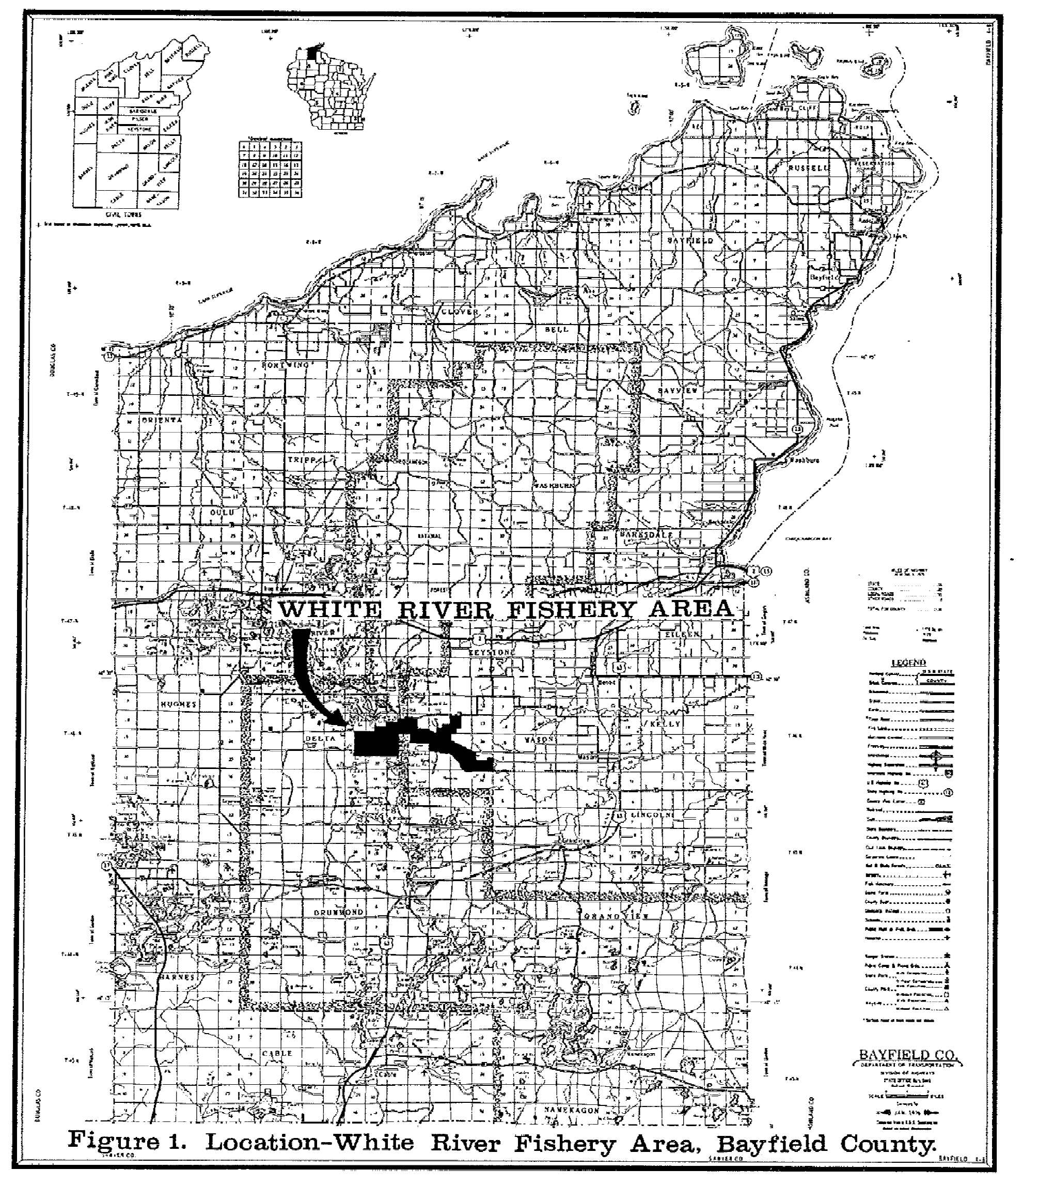
The White River starts at Delta’s cement bridge. The river is fed by the Chain of Lakes also know as Upper and Lower Pike Lake. The river flows through Bibon Swamp and empties into Bad River near Lake Superior. There are two forks to the river West Fork and South Fork. West Fork is fed by Spirit and Basswood Lake, and South Fork is fed by Spring Lake.

Historiography
As explores found Americas they were met by massive forest. The Great Forest by Richard G Lillard tells the story of people who destroy the forest. I mostly use this source to learn about the Lumber Baronies. I focused on the story of Frederick Weyerhaeuser. Weyerhaeuser was an immigrant from Mainz. He immigrated into the US at the age of eighteen. He fought the people of the Chippewa Falls and Mississippi Logging political. He got Wisconsin legislature to let him build a log boom at Beef Slough. Beef Slough is where Chippewa River joins the Mississippi. Then a whole legal battle ensues over Beef Slough. Beef Slough end up closing due sand build up. In the early 1890s Weyerhaeuser and Edward Hines joined together In the Virginia and Rainy Lake Company, Minnesota. By the 1900s Weyerhaeuser holding made him the “Pine Land King” of the Northwest. He was president or de facto head of more than twenty lumber and railroad companies. After the pike in 1907 Weyerhaeuser could see the future of lumber like in Europe with the conserving forest. He anticipated that time would come to America when the forest would begin to give out. He co-operated with Federal forest in planning fire prevention for his Minnesota pines.
The next two sources have to deal with the Forest Service. The first is The U.S. Forest Service: A History by Harold Steen. This is about how the Forest Service was founded and how it has change over time up until the 1970s. The Forest Service is under Department of Agriculture. Forest service has three division National Forest Administration, State and Private Forestry, and Research. The second source is The Forest Service by Michael Frome. This source
is more about what the Forest Service dose with history mix in it. It more of what happening in the mid 1980s and how it is up to us human to save and keep the forest we have.
In “The Human Impact on Northern Forest Ecosystems” by Clifford E. and Isabel Ahlgren talks about how there is constant conflict between human desire to save ecosystems and the need to destroy or disturb them for products, space and recreation. They also talk about major species in the northern forest and how they germinate. They also talk about the effect that logging had in the forest. Logging caused stress on the reproductive potential the white and red pine. After big pine trees were logged off other species took their place like Aspen. Then it goes into forest management. It talks about reestablishing of forest and effect it had on the ecosystem. We have to balance are need for timber and forest with careful consideration for the impact that would to done to the area.

Section 1: Lumber Industry
For many people the forests of North America were something to fear. As immigrants came here and stated to push into the Midwest they shared that same view. A poem by Mrs. Anna Brownell in 1838 Jameson describes it best:

A Canadian settler hates a tree
Regards it as his natural enemy,
Is something to be destroyed, eradicated
annihilated by all and any means.

It may have been what the forest held that made people scared of it. The forest and the unsettle area in the Midwest was where Native were being pushes was more people moved west. The Chippewa was just one tribe that lived and currently living in Wisconsin. They lost their land with treaties in 1837 and more in 1842. The treaties were made to get land to supply white pine for logging.
Most of the time trees were cut down to make way for farming and firewood during the winter. In Wisconsin clearing bees were set up to cut down trees. Clearing Bees is where neighbors came together when a new person or newcomers came to the area and would clear a piece of land for them. Many things were done to kill trees whether it was cutting them down or choking them to death by stripping the bark off the tree girding. People were not against the cutting down of trees for lumber but the fact that they were not getting their share of profits from it made many people angry.
In the early days many lumbermen did not get rich but went bankrupt due do their inexperience, lack of capital and forest fire. By the 1880s most of the small mills were taken over by big stock companies who could take bigger risks with the less gain. The men who became rich from this were known as Lumber Baron by muckrakers. The term Lumber Baron was use to suggest that men got rich at the expense of other. The Lumber Baron views were different when it came to what to do with the land after all the trees were gone. Most barons just moved on to next place but one Edward Hines pushed for Nation Forest. He thought that the Nation Forest could be use for logging in future when trees ran out. He also pushed for replants trees that you could cut down later.
Edward Hines brought the White River Lumber Company from John Humbird in 1905. Most of the men who got rich here in Wisconsin stay in Wisconsin. In the early days all the pine trees no matter how small were cut down because it was lumberman privilege to cut them down. Some the trees were barely big enough to make a two-by-four. It was until 1927 that a law was put in place to be more selective about which trees to cut down. Lumber camps and mills gave many jobs to semi-skilled and unskilled workers who were willing to work twelve hour shifts. Most of these working were immigrants or first generation Americans. The lumber barons started small towns and some of those towns grew into the cities we know today like Eau Claire well other die off.
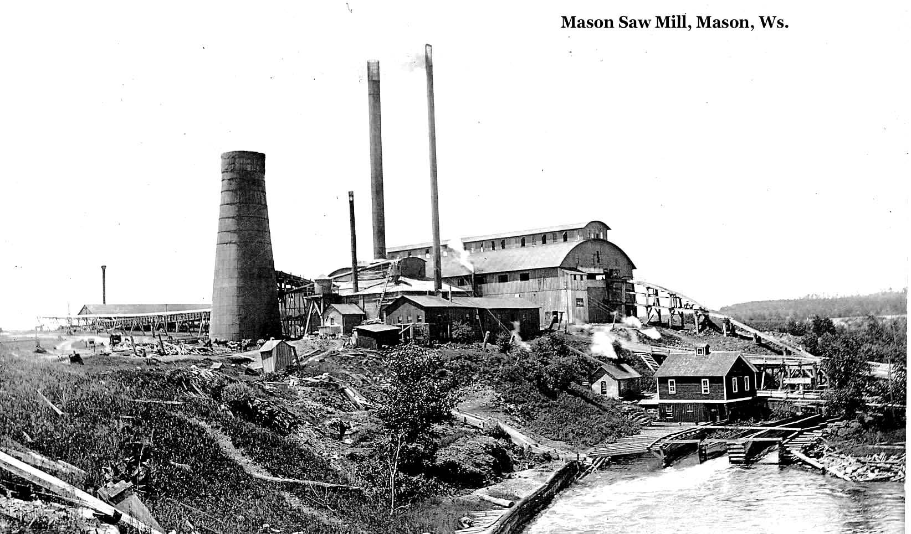
This is a picture of White River Lumber Company Mill at Mason 1900, Mason Area Historical Society.

The White River Lumber Company Mill was located near the city of Mason which was just one small town that was along the White River. The logs would be unloaded from train cars. The logs then would go into the mill pond, on the other side of the mill. The mill pond for Eau Claire was Half Moon Lake in Carson Park. The logs were placed in the pond to make it easier for the machine to take the bark off the trees. The logs would be pulled in to mill by the bull chain. In order to make the mill pond the river had to dam up. With the river dam power was made to help start the machinery. All of the machines were run by steam power. After the mill closed in 1914 the dam was taken down and flow has been return “normal” flow. Part of the dam is still in the river today which causes faster flow that has to make a full rotation before turn which is causes erosion of hill side.
To get the logs that were cut down to mill for processing the logs that were closet to mill were taken there by sleds. When two sleds were hooked together to carry an entire log was called a bobsled. Around 1875 bunk was added to top beam that held the sleigh runners together to become a sleight. To move the sleigh water would be added to trails which would freeze to make ice. Hay would be added to help slow the sleigh down. Using sleigh and sleds did not charge the environment. If hill was too step to go up they would zigzag up or find a different route. Here in the Lakes States it became a competition to see who could deck the most logs on a sleigh. This was all done during the winter months.
Once spring came logs would be send down river. Before the raft of could be sent down the river had to cleared of low hanging trees, rocks and stumps. On smaller river like White River dams were use to make the river suitable for rafting log down river. Dams were use to raise water level along shallows parts of river. The dams would also have sluiceways or gates to let the logs run though the dam. With dams came water reservoirs call ponds or flowages. The log would have to stay there until that water was high in order to make all the way down the river or to the next flowages.

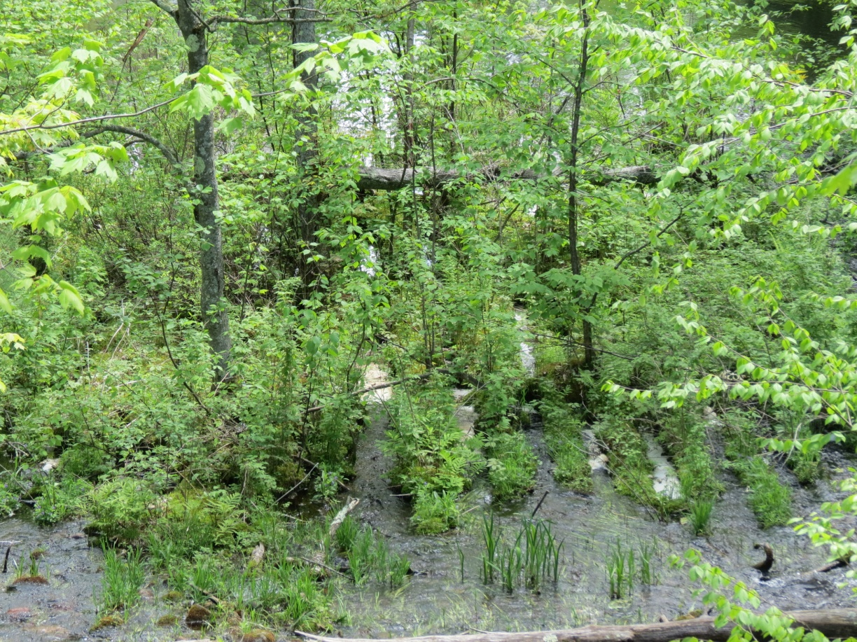
The remains of Hay Lake Outlet flume logs. A watertight log flume is constructed to transport logs down to sawmill by using water flow. They would be shape in V to free jammed log with rising water. Flumes made it easier to move log down a smaller rivers or a mountains.

Many of the dams that were built during the logging days are still there today because they make lakes that many people enjoy and they do not want to be taken away. From Delta to Pike River there were seven sluice ways. The sluice ways were used to back up water in the winter. When spring came around the gates were open to float the logs down the river to mill at Mason. After the mill was closed many of dams stay in place in place because they made lakes that were not there before. As the picture shows many of logs that were used to make sluice way have been left in placed and are now part of the river.
The last way logs made to the mill or to market was by railroads. Railroads reached different parts of the state at different times. The railroads did not reach the White River Valley until the late 1870s. There were six different railroads that went through the White River: Chicago, St. Paul, Minneapolis and Omaha; Duluth South Shore and Atlantic Railroad; White River Railroad; Superior and Southeastern Railroad; Drummond and Southwestern Railroad and Minneapolis, St. Paul and Ashland Railroad. Each one of these company built and place their own track. The trees would be cut down, placed on trains and be taken to the mill pond. Trains were also used to get the finished lumber to the market. With the use of railroads people were able to go deeper in the forest for logging wood. They would be two different kinds of spurs, standard and narrow gauge that would come off a main line. Sometime they would use a limey because it was impossible for engines car into some area. A limey is locomotive with a boiler off to one side, the pistons were veridical alongside the boiler and a crankshaft ran horizontally and was geared to the drive wheels. Limeys were used to pull cars of logs out to the mail line. The only thing you see that left of railroads is the old railroad grades that run through the trees. They look out of place because it is perfect level line the running though the trees. Old railroad grades are now use as snowmobile trails during the winter months. While other railroad grades get a coat black top to turn them in bike and walking trails. One example of this is Lake Wobegon Trail in central Minnesota, but the Railroad grades in the White River are unpaved and use as part of snowmobile trail and for people to walk on. This is done through Recreational Trails Aids Program (RTA) and Knowles-Nelson Stewardship.
With the cutting down of all trees something needed to done to bring all those tress back. Forest management planting was done to bring back pine trees. Seventy-four percent of trees planted have been red pine and sixteen percent of been white spruce. Now the trees in the White River valley are aspen, white birch, red oak with swamp conifers in low landing areas. Some of the land that was clear by logging was use for farming by not so much today because the soil changes from sandy loam soil to clay rich soil.
This show that the lumber industry practices of clear cutting changed the forest from a pine rich forest to a pine poor forest. Clear cutting cause forest fire. Damming the river cause the flow to change.

Section 2: Fires
The lumber that White River Lumber Company cut down was white pine. White pine was used because it could float down the river and in the mill pond. At the turn of twenty century all trees were cut down no matter how small there were. Famer in that area would cut down trees to make way for farming. The farmers would have dig up the tree stumps before they could start tilling the land. The lumberjacks would just leave the tree stumps because it took too much time to dig them out. The tree stumps were a fire hazard. Picture below shows what White River look with all the trees gone from logging. The picture is taken from the mill looking at trestle bridge that goes over the White River and the mill pond. With all the trees gone and dry lumber around, fires were the main concern for people in the hot dry summers. There were many fires that when through the White River area but two major ones that cause a lot of damage.
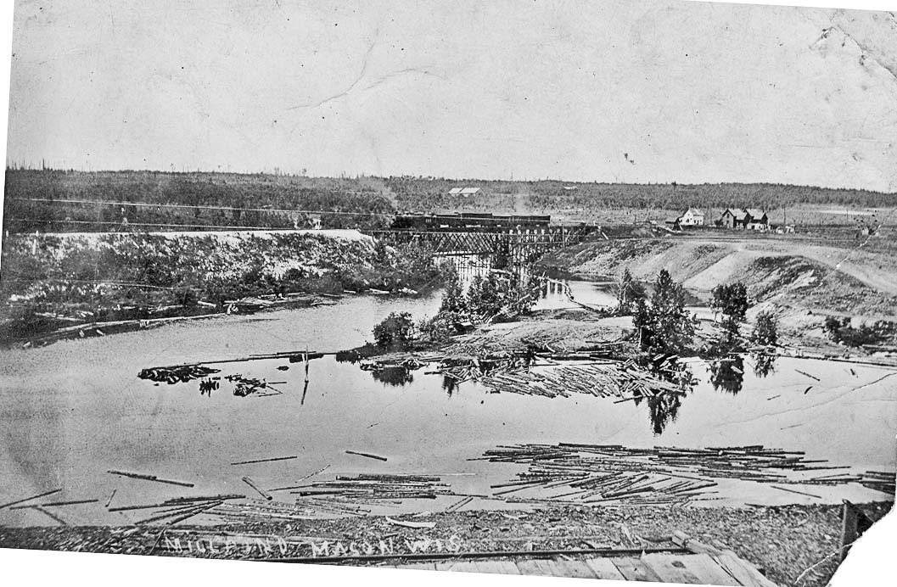
This is a picture of Railroad Trestle from the White River Lumber Company Mill. This shows the mill pound where logs would sit before going into the mill.

The first fire was in 1984. The fire started on Omaha line south of Mason at two o’clock. As the trains came in Mason they would dump coal on either side of the river in the hope that the hot coals would go into the river and not start a fire. In the fire of 1984 the White River Lumber Company mill was destroyed along with 40,000,000 feet of lumber. The Omaha line bridge was lost. The total loss for Omaha railroads at Mason was $1,000,000. At this point no one had been killed but people were trying to fleeing homes. The town of Mason was wiped by fire. The fire destroyed the original mill and buildings the only thing left was smoke stack. This fire would burn for two months and caused a loss of three million dollars for the state of Wisconsin. The White River Lumber Company lost $200,000. The fire was so bad that it burn railroads. The Wisconsin Central and Omaha lines were burned for miles and fright cars were lost in fire.
The next major fire came through in 1910. The fire was threatening the standing pines in Bayfield County which was the largest track of standing pines in the state. The land was owned by Edward Hines and Rust-Owen Lumber Company. People would stay in their homes and ride out the fire. As Nels Olson said,

“The aftermath of forest fires was fire bands. Like ghosts in the night, they flared up if there were a wind, and scattered sparks to ignite other fires. Our farm was surrounded by these and we used to sit outside and watch them. They were beautiful to look at, but what a hazard!”

This quote shows that many people stay in the area when there was a forest fire and would only leave if things got worse. Most people stayed because their house and what was it was all was all they had. They would do anything to protect it.
The mill would try to prevent forest fire by burning all the dust and scraps that way it was not laying around to start a fire. With burning scrap came the potential for fires to start if an ember hit the dry lumber. They would build a smoke stack that was tall and wide that way the embers cool and fall back down. Later on the mill added a wire dome around the stack to try stop embers from getting out.
Once a fire broke out, there was very little anyone could to stop the fire. People would dump water on their homes to help protect them from the fire. The fire would be left until it burned itself out or it succumbs to the weather. Unlike today when a forest fire breaks out people are to fight to put it out. They are dropping gallons of water from the air. The cost of fight the fire is rising. There are other costs of fighting fire like the human cost this year only thirty firefighters lost their life. As August 22 total spending for this year topped one billion dollars and 2012 bill was over $1.9 billion. That number has grown and will continue to grow. Once a fire is out the environment is affected.
It only has been about the last forty years that research has gone into the affect of forest fires have on the environment. The affects that the fires would have on the area would have been when it would rain the runoff would have increased because there would a decreased of plants taking up that rain water. It also causes greater snow accumulation and fast snowmelt. The historical impact of fires is to use data collected from meteorological stations to assess the rate of recovery. Areas that have been logged off are burn more severely than areas that have not been. This may be due to the fuel that is left behind after logging. Adding fertilization that are nitrogen and sulfur rich many help accelerate plant growth for the first two seasons. There is also the debate whether tinning and prescribed fire can help to reduce forest fire. United State Forest Service believes that limited thinning and burning will prevent catastrophic wild fires. Prescribed burns can be useful in the reestablishment of jack pine and aspen but not with red or white pine due to removal of seed source and introduction of disease. In a research paper by Mark Williams and William Baker in Global Ecology and Biogeography, show that prescribed burning maybe a bad thing for the environment by moving forest outside their historical range of variability. That if you want the forest to return to what it was they need to be a rage of forest fire from low severity to high.
This shows that wild fires were cause by the lumber industry practices of dumping coal and burning scraps. With wild fire came the need to fight them to protect people homes, industry and products. Wild fires cause a change to environment whether it is erosion or different plants blooming because of the fire.
Section 3: White River Fishery Area
In 1981 the Wisconsin Department of Natural Resources came out with a master plan for the White River Fishery Area. The goal of the master plan was

“To obtain land control and to manage, preserve and protect and make available for public use the White River Fishery Area in Bayfield County. To enhance fishing for brook and brown trout while perpetuating or restoring the scenic and aesthetic qualities of the area and providing compatible outdoor recreational educational opportunities.”

The Wisconsin DNR had annual objects to meet their goal. There were other benefits that went along with making fishery area. The Wisconsin DNR wanted to provide hiking, nature study and habitat for indigenous and transient animals.
The fishery was established in 1961 to manage and protect trout stream and watershed. In January of 1962 the state of Wisconsin purchased 1,602 acres that encompassed the headwater of the South Fork. This is just one of the main tributary to the White River. There were three lakes there, Nanagosh Lake, Lake Two and Lake Three. In 1963 the main dam at Nanagosh Lake outlet was removed to return the stream it natural flow channel and to improve the water temperatures of the stream. Trout need lakes and rivers that are cold, well-oxygenated and free of pollutants if there are to survive. When the dam was removed the water level in Lake Two dropped and it eliminated Lake Three and Nanagosh. The average mid-summer temperatures were reduced by over five degrees Fahrenheit. During July and August of 1962 temperatures were from 70 to 75 degree and in July of 1978 temperature did not exceeding 70 degree with the similar air temperature. The average water temperature during 1978 was 67 degree Fahrenheit. The dissolved winter oxygen level were at critically low level of less than 5 part per million before draining. All this shows that taking out one dam along the river helped improve conditions for Trout in the river.
From 1962 to 1964 Fish Management raised Trout at South Fork but due to the clay soil the practice was discontinued. Downstream at Sajadak Spring a state cold water fish hatchery was proposed but was also drop due soil conditions and the high cost of road construction.
In 1969 a stream habitat improvement project was completed in the area below Lake Two. The project was done to improve Trout habitat and stabilize eroding stream banks. Many of the spring ponds and the headwaters of the South Fork were deeply silted from the dam hold back sediments. The channel through Lake Two and three ponds were dredged to remove silt, from 1971 to 1973. Dredging was done to improve water temperature, expose Trout spawning beds and to have living space for the Trout.

This is a map of the White River Fishery Area showing existing and planned development for the river and land.

There are eighteen different species of fish that inhabit the springs and streams of the White River. Brown and Brook Trout are the main species that are sought by anglers. Other big game fish species include Northern Pike, Largemouth Bass, Yellow Perch, and Bluegill. There is also Shorthead Redhorse, White Suckers and Minnow Species that live in the White River. There is no endangered to threatened species in the river. Before the dam was taking down it was mostly White Suckers, Yellow Perch, Blacknose Shiners and Golden Shiners there was very little Brook Sticklebacks, Mudminnows, Rainbow and Brown Trout. After the removal of the dams, the river is now a class 1a Brook and Brown Trout Stream. Class 1 means that there is natural reproduction to maintain a populations of wild trout at or near carry capacity. That means that these streams to do not need to stock with fish.
The hydrology, study of the movement distribution and quality of water on the Earth, of the White River is as followed. Water from precipitation, rain, snow, etc, moves downs through the porous soil of the headwaters rapidly and does not leach a great amount of minerals until it reaches clay soil soils of the flat lowlands near Pike’s Bridge. Pike’s Bridge is picture on figure 3 on the next page near on the line of section twenty-one and twenty-two. This means the minerals are not being dissolved by water until there in a change in soil and rock condition after Pike’s Bridge. The spring water goes from a colorless, low dissolved solids and nutrients upstream to a highly mineralized spring near Sutherland Bridge section twenty-nine, thirty. Further downstream the river becomes a grayish-green to reddish, tinged with suspend clay particles due to higher runoff. The springs the feed the river have a year round temperature of forty-four degree Fahrenheit which means that the river remains open throughout the year. There are three main headwater sources of the White River are South Fork, West Fork, which merges with the South Fork upstream of the town of Delta. The East Fork joining the South and West Forks below Delta to form the mean stream of the river. The spring flow in the West and East Fork has been recently reclassified as Class 1 waters. The West and East Forks are warm water fisheries due to the number of lake which they flow through.
The river has a total gradient or slope of 135 feet descending from the South Fork spring pond to Sutherland Bridge. The part of the river accessible to canoes is limited to spring pond and connecting stream of Lake Two and the main river from Pike’s bridge to Sutherland.
As stated before the water temperature has stabilized with the removal of the dam, the drainage of Lake Nanagosh and dredging of spring pond and stream channel of Lake Two. The habitat improvement has extended the Brown Trout population downstream to as far as the power dam in Ashland County. The Brook Trout population has also been expanded downstream to Pike’s Bridge.
The aquatic vegetation in the springs and streams of the river is moderately abundant. In the more open area like Lake Two and lower gradient stream the vegetation is more abundant. Where the gradient is higher and more tree canopy there is less vegetation. The types of vegetation that grow in the river are Elodea or Canadian Water Weed, Potamogeton Pondweed, Water Buttercup or Longbeak Buttercup and Filamentous Green Algae. Elodea and Buttercup plants are Native to the lower forty-eight states. There are sixty-three different species of Pondweed some of them are Native well other species were introduced. The different kinds of vegetation are going to affect where and what types of fish are going to live in the river.
This shows that the dams that lumber industry put in place had an effect on the White River by raising the temperature which causes the Trout population in the river to go down. With low a Trout population people were not willing to go up to north Wisconsin to fish for Trout. It also show that you can remove dams that were put in place and after a while the river can return back to a normal cycle. If there is too much damage to environment or ecosystem it may be hard to get thing back.

Conclusion
Now as we look at the environment we live we should always think about what it was like before we came here and started to change thing. Change can happen all at once or slow over time. If it was it for the logging industry towns like Eau Claire and Mason would not be here. The forest that we see would be made up the huge white and red pine trees. The diameter of pine trees would free across and would be hundreds of feet in the air. Nels Olson tells it best

“…we have witnessed breath-taking beauty in fields, mountain, hills, lakes, streams, valleys, homes, cities, villages and remote PLACES. TIME is like a winding road we travel, and along this we find some of the discarded ambitions of the pioneers, and lingering in the debris, we find the pattern to try for more useful and better tomorrow.”

The thing that lumber industry did many have made a better tomorrow for awhile. The thing they did also had negative effect on the environment like raising the water temperature which aloud for Trout population to drop. The lumber industry also causes huge fire that wiped out towns. The flow of the rivers would be unchanged. The fishing live in those river would be threaten by warmer temperature and other fish species. Humans will always change their environment to suit their needs but we to find a balance between destroy it and preserving it.
As time moves on the environment will continue to changes. What remains today will be gone tomorrow. That will continue has it done in the past but we only have to look to see if we can find anything that remains.
Bibliography
Primary
Jameson, Anna Brownell. Winter Studies and summer Rambles, 1838.
Meyer, Shirlene and Carol Wennecke. The History of Delta, Wisconsin. Brule, WI Meyer, 1974.
Olson, Nels. Time in Many Place. St. Cloud, MN North Star Press, 1980.
Peterson, Dave W. US Forest Service, “Understanding Fire Effects on the Environment:
Fertilization After Wildfires can Accelerate the Development of Plant Cover and Help
Reduce Soil Erosion Hazards,” (2004) http://www.fs.fed.us/pnw/research/fire/fire
effects.shtml (accessed 25 September 2013).
Robbins, Jim. “Forest Fire Research Question the Wisdom of Prescribed Burns,” New York Time
17 September 2012 http://www.nytimes.com/2012/09/18/science/earth/forest-survey
questions-effect-of-prescribed-burns.html?_r=1& (accessed 28 October 2013).
The Duluth News Tribune, Duluth, MN 28 July 1984.
The Duluth News Tribune, Duluth, MN, 10 May 1910.
The New Haven Evening Register, New Haven, CT, 28 July 1984.
The New Haven Evening Register, New Haven, CT, 30 August 1894.
Schoen, John W. “Cost of Western Blazes Spreads like Wildfire,” NBCnews.com, 22 August 2013,
http://www.nbcnews.com/business/cost-western-blazes-spreads-wildfire-6C10974725,
(accessed 4 November2013).
Spies, Thomas A. US Forest Service, “Understanding Fire Effects on the Environment: Re-burn
Severity Differs Depending on Management History of Forrest Vegetation,” (2004)
http://www.fs.fed.us/pnw/research/fire/fire-effects.shtml (accessed 25 September 2013).
Williams, Mark A. and William L. Baker, “Spatially Extensive Reconstructions show Variable
severity Fire and Heterogeneous Structure in Historical Western United State Dry
Forests,” Global Ecology and Biogeography, 21, 2012, 1042-1052.
Wisconsin DNR Master Plan White River Fishery Area 1981.
Woodsmith, Richard D. US Forest Service, “Understanding Fire Effects on the Environment: Fire
Effects on Watershed Processes May Last for Decades,” (2004)
http://www.fs.fed.us/pnw/research/fire/fire-effects.shtml (accessed 25 September
2013).
Woodsmith, Richard D. US Forest Service, “Understanding Fire Effects on the Environment:
Historical Data Reveal Long-term Effects of Wildfire on Watershed Processes,” (2004)
http://www.fs.fed.us/pnw/research/fire/fire-effects.shtml (accessed 25 September
2013).
Picture
Page 3
Wisconsin DNR. Master Plan White River Fishery Area, Figure 1.
Page 8
White River Lumber Company Mill at Mason 1900, Mason Area Historical Society.
Page 10
Remains of Hay Lake Outlet, June 2013. Picture taken by Dick Rewalt.

Page 13
Railroad Trestle from the White River Lumber Company Mill, Mason Area Historical Society.
Page 20
Wisconsin DNR. Master Plan White River Fishery Area, Figure 3.

Secondary

Ahlgren, Clifford and Isabel. “The Human Impact on Northern Forest Ecosystems,” in The Great
Lakes Forest: An Environmental and Social History, ed. Susan Flader. Minneapolis, MN:
University of Minnesota Press, 1983.
Frome, Michael. The Forest Service, 2nd ed. Boulder, CO: Westview Press, 1984.
Lillard, Richard. The Great Forest. New York: Alfred A Knopf, Inc., 1947.
Minnesota, DNR, Lakes Managed for Stream Trout,
http://www.dnr.state.mn.us/fish/trout/management.html (accessed 3 December 2013).
Rosholt, Malcolm. The Wisconsin Logging Book 1839-1939. Amherst, WI: Palmer Publications
Inc., 1980.
Satz, Ronald. Chippewa Treaty Rights: The Reserved Rights of Wisconsin’s Chippewa Indians In
Historical Perspective. Madison, WI: Wisconsin Academy of Sciences, Arts, and Letters,
1994.
Steen, Harold. The U.S. Forest Service: A History. Seattle: University of Washington Press, 1976.
USDA United State Department of Agriculture, Natural Resources Conservation Service, Elodea
Canadensis Michx. Canadian Water weed,
http://plants.usda.gov/core/profile?symbol=ELCA7 (accessed 14 December 2013).
USDA, Natural Resources Conservation Service, Ranunculus Iongirostris Grod. Longbeak
Buttercup, http://plants.usda.gov/core/profile?symbol=ralo2 (accessed 14 December
2013).
Wisconsin DNR, Recreation Trails Aids (RTA) Program, http://dnr.wi.gov/aid/rta.html (accessed
15 November 2013).
Wisconsin DNR, Trout Stream Classifications,
http://dnr.wi.gov/topic/fishing/trout/streamclassification.html (accessed 14 December 2013).
Wisconsin DNR. White River Fishery Area (Bayfield and Ashland Counties),
http://dnr.wi.gov/topic/lands/fisheriesareas/2850whiteriverbayfield.html, (accessed 15
October 2013).

Nels Olson, Time In Many Places, (St. Cloud, MN North Star Press,1980), 65.
Anna Brownell Jameson, Winter Studies and summer Rambles, 1838.
Malcolm Rosholt, The Wisconsin Logging Book 1839-1939, (Amherst, WI: Palmer Publications Inc., 1980), 8.
Rosholt, The Wisconsin Logging Book 1839-1939, 8.
Muckrakers: to seek out and publicize misconduct by prominent people.
Rosholt, The Wisconsin Logging Book 1839-1939, 42.
Deck to place log on sleigh in a stack.
Shirlene Meyer and Carol Wennecke, The History of Delta, Wisconsin. (Brule, WI Meyer, 1974), 7.
Rosholt, The Wisconsin Logging Book 1839-1939, 67.
Nels Olson, Time In Many Places, 68.
Wisconsin DNR, Recreation Trails Aids (RTA) Program, http://dnr.wi.gov/aid/rta.html (accessed 15 November 2013).
Clifford and Isabel Ahlgren, “The human Impact on Northern Forest Ecosystems,” in The Great Lakes Forest: An Environmental and Social History, ed. Susan Flader (Minneapolis, MN: University of Minnesota Press, 1983), 44.
The Duluth News Tribune (Duluth, MN) 28 July 1984, p 1.
The Duluth News Tribune (Duluth, MN) 28 July 1984, p 1.
The Duluth News Tribune (Duluth, MN) 28 July 1984, p 1.
The New Haven Evening Register (New Haven, CT), 28 July 1984, p 1.
The New Haven Evening Register (New Haven, CT), 30 August 1894, p 1.
The New Haven Evening Register (New Haven, CT), 30 August 1894, p 1.
The Duluth News Tribune (Duluth, MN) 10 May 1910, p 2.
Nels Olson, Time in Many Places, 11.
John W. Schoen, “Cost of Western Blazes Spreads like Wildfire,” NBCnews.com, 22 August 2013, http://www.nbcnews.com/business/cost-western-blazes-spreads-wildfire-6C10974725, (accessed 4 November2013).
Schoen, “Cost of Western Blazes Spread like Wildfire.”
Richard D. Woodsmith, US Forest Service, “Understanding Fire Effects on the Environment: Fire Effects on Watershed Processes May Last for Decades,” (2004) http://www.fs.fed.us/pnw/research/fire/fire-effects.shtml (accessed 25 September 2013).
Richard D. Woodsmith, US Forest Service, “Understanding Fire Effects on the Environment: Historical Data Reveal Long-term Effects of Wildfire on Watershed Processes,” (2004) http://www.fs.fed.us/pnw/research/fire/fire-effects.shtml (accessed 25 September 2013).
Thomas A. Spies, US Forest Service, “Understanding Fire Effects on the Environment: Re-burn Severity Differs Depending on Management History of Forrest Vegetation,” (2004) http://www.fs.fed.us/pnw/research/fire/fire-effects.shtml (accessed 25 September 2013).
Dave W. Peterson, US Forest Service, “Understanding Fire Effects on the Environment: Fertilization After Wildfires can Accelerate the Development of Plant Cover and Help Reduce Soil Erosion Hazards,” (2004) http://www.fs.fed.us/pnw/research/fire/fire-effects.shtml (accessed 25 September 2013).
Jim Robbins, “Forest Fire Research Question the Wisdom of Prescribed Burns,” New York Time 17 September 2012 http://www.nytimes.com/2012/09/18/science/earth/forest-survey-questions-effect-of-prescribed-burns.html?_r=1& (accessed 28 October 2013)
Clifford and Isabel, “The Human Impact on Northern Forest Ecosystems, 44.
Mark A. Williams and William L. Baker, “Spatially Extensive Reconstructions show Variable-severity Fire and Heterogeneous Structure in Historical Western United State Dry Forests,” Global Ecology and Biogeography, 21, 2012, 1042-1052.
Wisconsin DNR Master Plan White River Fishery Area, Section 1, 1981.
DNR WI, White River Fishery Area (Bayfield and Ashland Counties), http://dnr.wi.gov/topic/lands/fisheriesareas/2850whiteriverbayfield.html, (accessed 15 October 2013).
Master Plan, p 5.
Minnesota, DNR, Lakes Managed for Stream Trout, http://www.dnr.state.mn.us/fish/trout/management.html (accessed 3 December 2013).
Master Plan, p 5.
Master Plan, p 5.
Master Plan p 10.
Wisconsin DNR, Trout Stream Classifications, http://dnr.wi.gov/topic/fishing/trout/streamclassification.html (accessed 14 December 2013).
Master Plan, p 7.
Master Plan, p 7.
USDA United State Department of Agriculture, Natural Resources Conservation Service, Elodea Canadensis Michx. Canadian Water weed, http://plants.usda.gov/core/profile?symbol=ELCA7 (accessed 14 December 2013).
USDA, Natural Resources Conservation Service, Ranunculus Iongirostris Grod. Longbeak Buttercup, http://plants.usda.gov/core/profile?symbol=ralo2 (accessed 14 December 2013).
Nels Olson, Time in Many Place, vii.

