Notes of Nostalgia:
Engaging with the Past at the Shake, Rattle, and Roll Music Festival: 1987-1993

Elizabeth Schmidt
HIST 489: Research Seminar
Fall 2018

Copyright for this work is owned by the author. The digital version is published in McIntyre Library, University of Wisconsin – Eau Claire with the consent of the author.

Contents
Figures iv
Abstract v
Introduction 1
Historiography 2
The Festival Phenomenon 4
Entertaining Eau Claire 7
Shake, Rattle, and Roll 9
The Music of Shake, Rattle, and Roll 13
Vehicles to the Past 19
Conclusion 27
Bibliography 31

Figures
Figure 1: An unknown band performing at Shake, Rattle, and Roll 5

Figure 2: Dancers at Shake, Rattle, and Roll 12

Figure 3: "Surfin Bird" shirts 14

Figure 4: Elvis impersonator that performed at Fanny Hill 18

Figure 5: Cars from the "Rod and Custom Car Show" 21

Figure 6: class reunion tent at the 1993 Shake, Rattle, and Roll. 26

Abstract

In the late 1980s, at the beginning of a nationwide music festival craze, Eau Claire music promoter, Larry Barr, saw the opportunity to create a small music festival built on Rock and Roll culture. This music festival featured live music from original artists, a classic car show, and many high school reunions. These events were effective at evoking nostalgia among the festival attendees through bringing multiple communities of Rock and Roll era enthusiasts together to reminisce. Shake, Rattle, and Roll, was a smash hit and is still one of the Eau Claire’s favorite music festivals! Shake, Rattle, and Roll’s high energy entertainment captivated the audience and sparked the festival culture in Eau Claire.

Introduction

“It was the energy behind it, it was the fun music era, it was the old cars we brought in, it was easier to have fun.” –Larry Barr
The hot summer sun beats down on the back of thousands already burned necks as crowd moves in unison. None of it bothers anyone anymore: the sun, the crowd, the sharp pangs in the balls of feet, or the lighter wallets. It is just them and the sweet sound of rock and roll. For three days a year from 1987 to 1993, Eau Claire, Wisconsin was the nation’s headquarters for rock and roll music. From the wail of the guitars, to the rev of the vintage engines, Shake, Rattle, and Roll was a magnet for music enthusiasts near and far. In just seven years the festival grew from 1,000 attendees to over 30,000. What drew thousands of people to a field in Northeast Wisconsin? Shake, Rattle, and Roll used a combination of popular tropes of the Rock and Roll era to create an environment of nostalgia and historical imagination. The festival featured music from artists who were hot during the Rock and Roll era. Reminding people of the physical past, Shake, Rattle, and Roll featured a “Rod and Custom Car Show,” which included 300 pristine vintage cars. For many, the festival brought back old faces through the inclusion of numerous high school reunions. Shake, Rattle, and Roll brought in a unique intersection of people: music enthusiasts, car collectors, and local high school alumni. As a result, Shake, Rattle, and Roll created and reunited communities for which participants could imagine (or remember) themselves being in the ‘golden age of rock and roll.’ Although Shake, Rattle, and Roll was not meant to be a destination for heritage connection, that is what it turned into.

Historiography
Connecting music festivals to heritage tourism is not the sleekest of connections, however, there are a number of sources that accomplish this task.
Performing Nashville: Music Tourism and Country Music’s Main Street by Robert Fry provided an excellent template in which to examine how musical tourists interact with music. He provided the concept of festival goers seeing musicians as an artifact to gaze upon, which was foundational for the formation of this paper. This book also provided an avenue to understand the way tourists connect with the history behind the music. As the performers at Shake, Rattle, and Roll were in the limelight during the Rock and Roll era, the festival becomes a place that attendees can attend both a concert and a museum, as the comes from the original source, the music is the pinnacle of artifacts. Combined with other sources, Performing Nashville helped to grapple the idea of tourists seeking authenticity within their experience.
Working in unison, Heritage Tourism by Dallen Timothy and Stephen Boyd and Music and Tourism: On the Road Again by Chris Gibson and John Connell provided insight on many of the concepts in this paper. Importantly, Heritage Tourism offered clear explanations for heritage tourism and its various forms. Particularly, Timothy and Boyd provided a framework for thinking about heritage tourism and authenticity. They argue that tourists seek authentic experiences and in turn, destinations strive to maintain an aura of authenticity. Historic authenticity, however, is not the same tourist authenticity. While the former concerns details that are supported by primary sources, the latter concerns an environment that evokes emotional connection to the past. Shake, Rattle, and Roll creates a such an environment of authenticity that draws tourists to the festival. Music and Tourism provided useful thoughts in regards to the intersection of music and tourism, particularly in terms of authenticity. Gibson and Connell provided a bridge between Fry’s on non-festival concerts and Timothy and Boyd’s non-music tourism to arrive at music festivals. Music and Tourism puts authenticity and music tourism into the same context, looking at how music, and the festival more broadly, can be viewed as authentic or inauthentic. This solidified the place of the “Rod and Custom Car Show” and the class reunions as a reinforcement of the authenticity.
Lastly, Lin and Theodore Humphrey provide the connection that communities are valuable to creating nostalgia within a festival. In their journal article, they connect class reunions to festivals as a place to find a community. Through these communities, a satisfaction through nostalgia is created. Naturally, this is connected to the presence of class reunions at Shake, Rattle, and Roll and the shared past they hold. This idea of communities creating nostalgia was further extended into the music festival as multiple communities, music enthusiasts, car collectors, and local high school alumni, interacting to share an experience of nostalgia.

The Festival Phenomenon
When most people think of the genesis of music festivals in the United States, minds may jump to the summer of love and the Woodstock Festival of 1969. However, the first open air music festival was in Newport Rhode Island. In 1953, the Newport Jazz Festival debuted to the white collar audience at the Newport Casino. As the festival attracted more Jazz aficionados, its location jumped from seaside mansion to mansion until it settled at its own open field. Generations of Jazz artists have graced the stage of Newport causing a Washington Post reporter to remark: “Newport has summarized an art form - the art of jazz.” Sprouting off the festival includes a separate Newport music festival dedicated to folk music, starting in 1959 and an organization that promotes the music education through these music festivals.
Standing in stark contrast to the Newport Jazz festival, Woodstock’s muddy affair would best be described as full of sex, drugs, and rock and roll. Despite the beyond-packed venue, the overrun sanitation services, and the soggy weather, the festival goers were absolutely entranced (with or without the assistance of hallucinogenic drugs) by the festival. The iconic performers included Janis Joplin, The Who, and Jimi Hendrix. Woodstock became the milestone event that defined the hippie generation. Despite postdating Newport Jazz by sixteen years, the Woodstock music festival has more or less served as a template for many outdoor music festivals to follow.
While Woodstock defined the hippie generation, Coachella defined the millennial generation. Set in the California desert, the Coachella Valley Music and Arts Festival took the stage in 1999 with a unique eye for contemporary music. After the first year, the event’s producers had lost so much money, that they thought the end was near. But, they stuck it out for a few years and proved to be a massive success. Along with its contemporary music, Coachella emphasizes a “California chill vibe” that draws people back to the valley every year.
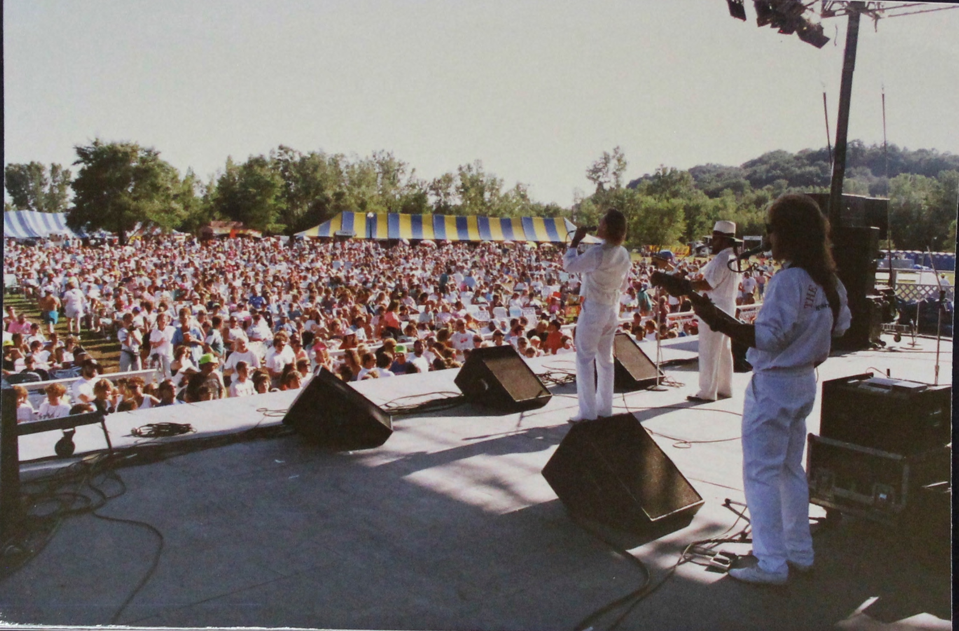
Figure 1: An unknown band performing at Shake, Rattle, and Roll
Source: Unknown, “Photos: Customers at Shake, Rattle, and Roll,” Sounds of Eau Claire, accessed November 17, 2018, https://soundsofeauclaire.omeka.net/items/show/539.

Many people grumble that you can listen to the same music at home, for a lot less money, and without the sunburn or the muddy shoes; and that is true. People are not attracted to music festivals because of the music, they are attracted to the entertainment. It is the live aspect of the show, combining the aspects of the music, lights, and crowd that stirs in the hearts of festival goers for three days.
The music itself moves beyond the auditory and becomes an artifact for the tourist gaze, which further authenticates the music, the performer, the place, and the overall tourist experience. The appeal of music tourism, therefore, is the heightened emotional experience realized through the performative act of physically being a part of the music process, a democratic performance that is increasingly lacking in the current modes of musical production and consumption.

Music festivals fill that missing link that humans have been engaging regularly with until the late 20th century. “Until recording, music did not exist without someone playing it, and as a result music listening was necessarily social. There was no way to hear a musical group without other people being present.” With the invention of portable music players and now access to virtually every song recorded through a smartphone, rather than being a social interaction, music has become a method to disconnect from the world. Music Festivals brought back together and it created a place where a community of people, connected by the music, could share an experience. With the introduction of music festivals in the 20th century, it reconnects music lovers with the social interaction that music has brought for generations.

Entertaining Eau Claire

Local businessman and entrepreneur Larry Barr has left his mark on Eau Claire’s music scene, whether he’ll take credit for it or not. Born and raised just 60 miles from Eau Claire in Greenwood, Wisconsin, Barr spent his formative years on his family’s cattle and mink ranch. Under the watchful eye of his father, Barr learned leadership at a young age by directing the workers of the farm. In his 20s, Barr’s father wanted to transition out of the ranch and looked to his son for ideas. “...To own a bar sounded real exciting to me at that time since I had been working in a small town and didn’t have a real high social life in a town of only a thousand.” In November of 1969, Barr and his father opened up a bar called “The Barr” in Eau Claire. However, it was not the business side that attracted Barr, it was the entertainment that drew the moth to the flame. “To be honest the idea on it was to book music right from the beginning. That was what it was built around. Even though I worked hard, I partied hard when I was a youngster. Probably too hard. So once I got into the bar business I didn’t stick to the business rather than the party side of things.” While the other establishments were booking local bands, Barr saw an opportunity to bring in outside entertainment. Calling it “big city entertainment,” Barr began to book bands from Minneapolis and Chicago which brought a new flavor of music to the scene. Entertainment became a huge emphasis for Barr, rather than book bands that stood and sang, he sought high energy acts that drew in his young targeted crowd. From R&B and rock and roll, to big bands, as long as they put on a show, Barr booked them. While Barr experienced some bumps along the way, his first venture remained a moderate success.
Everything changed in 1973 when the State of Wisconsin raised the drinking age from 18 to 21. As he recalls in his oral history, Barr lost the majority of his business virtually overnight! After a few months of trying to save “The Barr,” he resolved that the location had to change. So, in the fall of 1973 Barr obtained a premises on Water Street and opened up a liquor and beer bar called “Shenanigans.” At first, Shenanigans was not supposed to have music but his love for entertainment drew him back to show business. In 1975, he expanded Shenanigans to include another bar, Papa Bear’s, now called Lucky’s. This expansion included the addition of Eau Claire’s first disco. It was the success of this expansion that inspired him to create a mobile disco called: “The SAMM-The Sound Around Music Machine.” This portable disco included a sound system with coordinated lights. Barr brought the SAMM to colleges, vocational schools, and high schools and created a portable party. Within a couple hours, the gymnasium was transformed into an energized club where participants could bunny hop and chicken dance to their heart's delight! The success of the SAMM lasted only a few years, but Shenanigans remained consistently successful. “In the twenty some years that I was in Shenanigans which would have been from 1969 to 1992 I don’t ever remember a down year. Never.” Although Barr does not run the bar anymore, Shenanigans and Lucky’s remains one of the most popular bars on Water Street.
The creation of Shenanigans was not the only big event that 1973 brought Barr. Looking to target an older audience than the college students, Barr established Fanny Hill. This restaurant was a huge learning curve for Barr. “It was a hard lesson. I always say the first week when I opened up I would have been better off if I had paid every customer to go eat somewhere else.” With some work and flexibility, Barr turned the restaurant around. In about twenty years, Larry Barr had revolutionized the entertainment scene in Eau Claire by bringing in something for all ages. From high energy live music and discos to Vegas-style supper clubs, Barr knew how to entertain Eau Claire. But, by 1987 something new had caught his eye: Music Festivals.

Shake, Rattle, and Roll
In the late 1980s employees of Barr were enthusiastically describing a motorcycle tour in northern Wisconsin. Barr thought that it would be a worthwhile venture to create a motorcycle tour that ended at Fanny Hill. To celebrate the end of the tour, he did what he has always done best: create an environment of entertainment. Barr brought in a rock and roll band and set it up in the parking lot outside the restaurant. With 300 bikes and 700 party goers, the music quickly became more popular than the bike tour. After two years, Barr realized that it would be more successful and less trouble to cancel the bike tour and focus on the music. Blazing a new trail, Barr combined the experience he had gathered with The Barr and Fanny Hill and created a music festival. In 1987, Barr held the first Shake, Rattle and Roll music festival in the parking lot of Fanny Hill. In preparation for the Barr built a 60 by 30-foot stage on the property of Fanny Hill, the little supper club he had created could now accommodate up to 5,000 eager rock and roll fans. While the core of the Shake, Rattle, and Roll attendees were between twenty-five and forty five years old, by 1991, the Leader Telegram reported that an increasing number of young people in attendance. In 1987, the festival had 1,000 people shaking and rolling on the newly built space. However, by 1990, Barr once again found himself in need of more space. Consequently, he rented a piece of land from the Remington family to create the “Fanny Hill Festival Grounds.” That year he moved the whole operation to the new grounds. Fans of the festival remarked of the improved efficiency of the larger grounds: “This has got that [the Fanny Hill parking lot] beat pretty good. This rolls together much more smoothly. It really goes together well.” These improvements were put to good use in the following years as the festival grew to expect between 20,000 and 30,000 people. In the year after the first Shake, Rattle, and Roll at the new grounds, Barr added a campground. This allowed tourists to park their trailers and set up tents for a whole weekend of rock and roll. The improvement did not stop there, the ground itself was also reshaped to create a partial slope toward the stage. Additionally, Barr added box seats to the festival. For $300 attendees could enjoy exclusive amenities such as private parking, complimentary hot meals, and beer and soft drinks. Barr continued to perfect his music paradise into 1993 by adding new fences and walkways.
Just has he had done with his bars and discos, Barr created an environment of high energy entertainment. Although some people liked to just sit and enjoy the music, most people danced and grooved to the entertainment. Barr even recalls a couple of young women dancing on table tops one year. “It was the energy level. The crowd that was in it was continuously dancing and moving.” By its apex in 1993, Shake, Rattle, and Roll was an immersive experience for its attendees. Festival goers spent the whole weekend, secluded in the woods, listening to rock and roll music, dressed in fifties style clothing, and watching ‘oldies’ cars wind around the festival grounds. Through this experience they could imagine (or remember) themselves being in the ‘golden age of rock and roll.’ This historical imagination is problematic because events such as Shake, Rattle, and Roll do not include the unsavory portions of history. Nevertheless, the responses from the public that Shake, Rattle, and Roll received was overwhelmingly positive. A local restaurant in Eau Claire, The Mandarin Club, and radio station, Z100FM even hosted a pre party in 1991. This one night only event, urged eager festival goers to “get pumped for the Shake, Rattle, and Roll Music festival!”
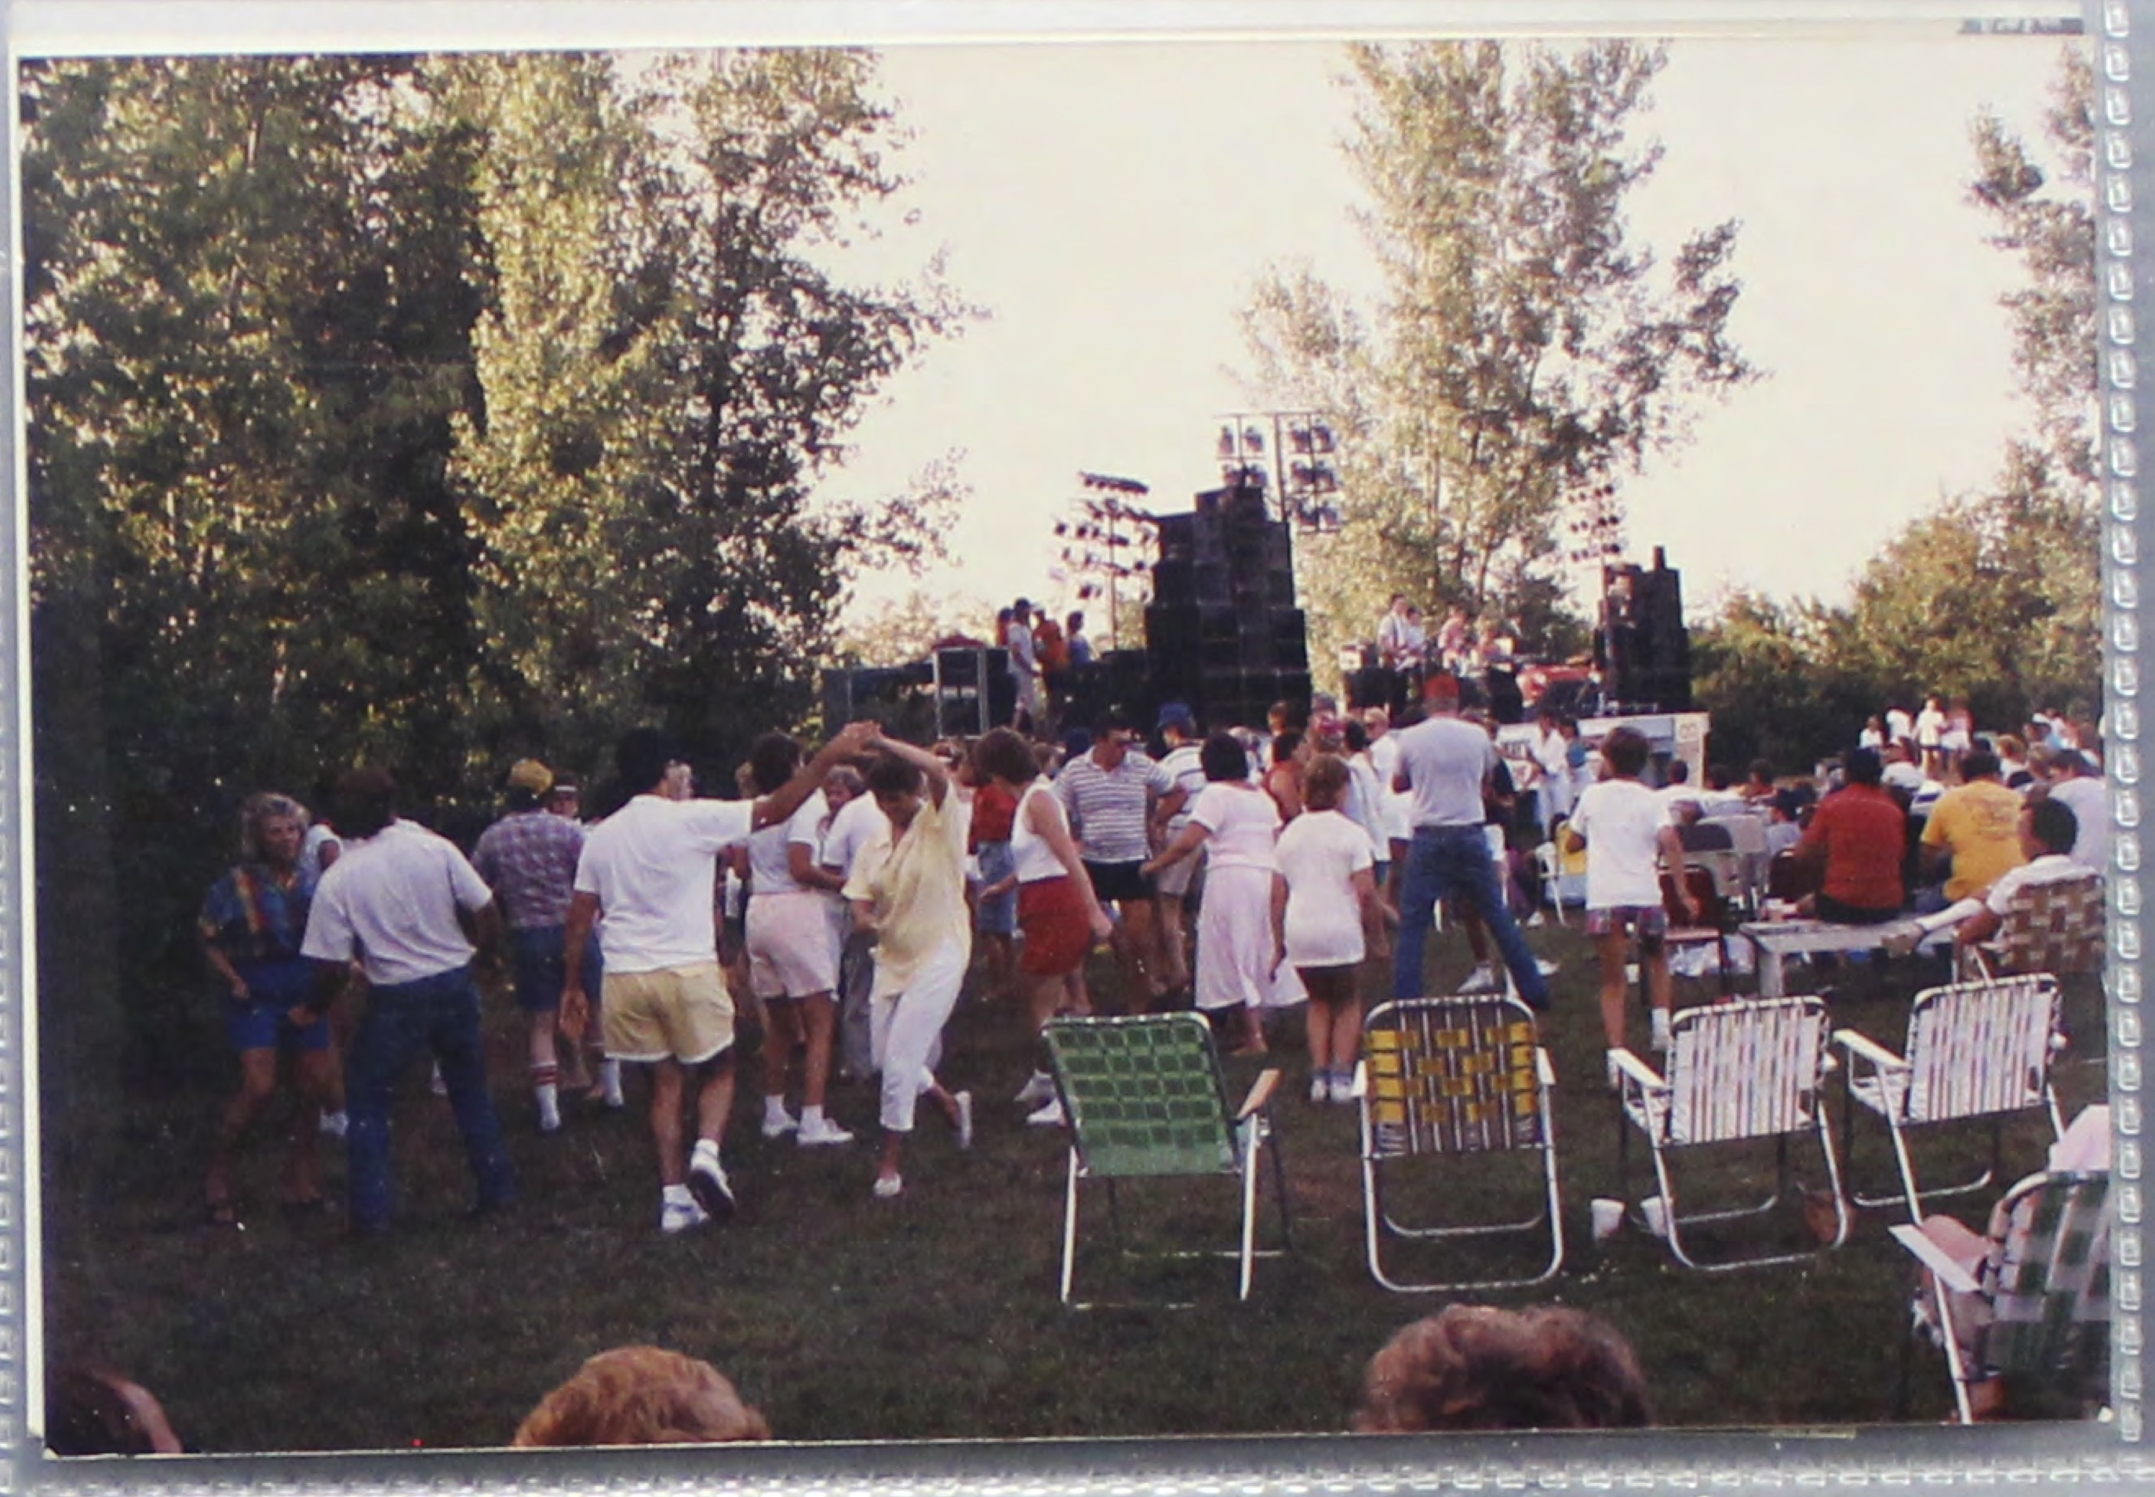
Figure 2: Dancers at Shake, Rattle, and Roll
Source: Larry Barr, “Scrapbook: Shake, Rattle, and Roll,” Sounds of Eau Claire, accessed November 15, 2018, https://soundsofeauclaire.omeka.net/items/show/315.

While Barr created an attractive energy filled environment, he also created an atmosphere of rock and roll authenticity. A sense of authenticity in tourism is an element that visitors expect. When tourists of any kind reach their destination, they want to experience something that is natural. Whether that is a visit to an Italian art gallery or a rural village in the mountains of Nepal, they find meaning in real experiences. For example, although Hawaii is full of luaus that tourists can attend, some tourists dismiss the hotel’s affair for an event that is more true to the culture. However, everyone has a different standard of ‘authentic.’ While one person might be satisfied with the hotel’s luau, another might not be satisfied until they find the ‘locals only’ gathering. Festival goers are no different. Participants in Shake, Rattle, and Roll see the music, dancing, and vintage cars as an authentic representation of the Rock and Roll era.
I had two senior citizens with me there and I asked them why they were in the VIP section. They said that it was cheaper than going down to Nashville and they could see all of this entertainment and eat with it and enjoy it. They wanted to mix with it. So the $800 they spent was cheaper than flying down to Nashville and would not have been able to see [or mix] hardly anybody.

Why spend thousands of dollars to travel across the country to hear the same music at home? Since most of the artists originate from the Rock and Roll era, the artists from the festival stand as an authenticity authority, verifying the festival is a true representation. This couple certainly found the value not only in purchasing the VIP tickets but they saw it as more valuable than traveling to Nashville, which would typically be thought as a more “authentic” music experience. Larry Barr, however, had created an environment for a community of rock and roll music lovers to enjoy and reminisce in the music from the ‘good ole days.’

The Music of Shake, Rattle, and Roll
The festival features classic bands from the 1960s, blaring the songs from the old jukebox. Many of these artists hit their peak popularity during the 1960s, the years treasured by the attendants, and were engaging in “greatest hits” type tours in the 1990s. Although these artists are far past their peak, many of the bands only having one remaining original member, the nostalgia associated with their music is still strong.
The Trashmen performed at Shake, Rattle, and Roll in 1987 projecting fans back to 1960s. Despite their distinct “surfer” genre that is often associated with California bands such as The Beach Boys, The Trashmen hail from Minneapolis, Minnesota. In 1964 their single “Surfin Bird” soared in the charts and has been stuck in the head of fans ever since. The fast tempo and wacky lyrics provides the perfect earworm for any idle listener.

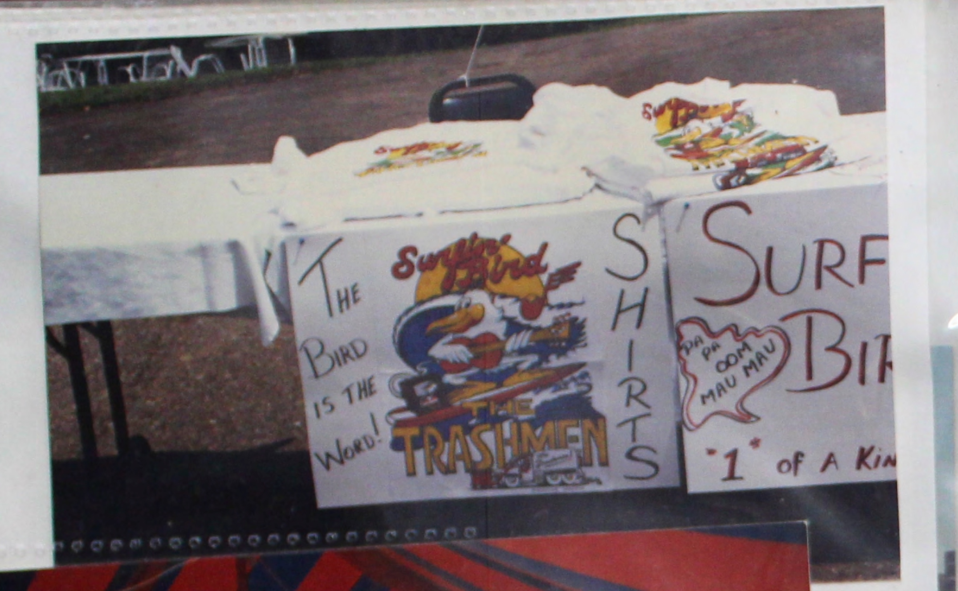
Figure 3: "Surfin Bird" shirts
Source: Larry Barr, “Scrapbook: Shake Rattle N' Roll, 1987,” Sounds of Eau Claire, accessed November 15, 2018, https://soundsofeauclaire.omeka.net/items/show/307,8.

Although the Trashmen released subsequent songs after “Surfin Bird” such as “King of the Surd” and “Kuk,” they did not stick as well their first smash hit and the group disbanded. “Surfin Bird” remained a commonly covered song, most famously by the punk band The Ramones in the 1970s. Notably, in 2008, “Surfin Bird” was used in an episode of the animated sitcom Family Guy and became a running joke on the show. In the 1970s, the band reunited and began touring, rehashing their old album, stopping at Shake, Rattle, and Roll in 1987. Just a couple years after performing at Shake, Rattle and Roll, their drummer and singer, Steve Wahrer, died, rupturing the band once more. Despite this tragedy, the Trashmen returned once more with new members and they toured until their retirement in 2016. Regardless of their one notable hit and their midafternoon timeslot, The Trashmen were welcomed at Shake, Rattle, and Roll with enthusiasm. Festival goers eagerly bought shirts bearing the famous surfin bird and waited for the hook: “PA PA OOM MAU MAU!”
Another iconic group to grace the stage of Shake, Rattle, and Roll was The Temptations. Starting in 1963, The Temptations were one of the most successful groups to come out Motown Records. Berry Gordy created the Detroit based company in 1959 and curated what would to be known as the “Motown Sound.” This blues oriented sound blazed a trail for minority artists, giving them a platform to perform. The Temptations signed with Motown records in 1961, after merging two Detroit based groups to form the ensemble. The five-man vocal group is famous for its perfect blend of voices accompanied by smooth choreography. The Temptations rocket into stardom with smash hit “My Girl” in 1965. In stark contrast to The Trashmen, The Temptations have thirty-seven top forty hits to their name. What makes The Temptations particularly unique is that they are more of a brand rather than a group. Over the past fifty years of their existence the group has had over twenty members. Rather than being famous for its members, The Temptations is famous for its sound and reputation. The Temptations headlined the Friday show of Shake, Rattle, and Roll in 1993.
Bobby Vee, 1960s teen idol, was another blast from the past to perform at Shake, Rattle, and Roll. Bobby Vee’s beginning was actually a tragic end for some of rock and roll’s greats. On February 3, 1959, a light plane carrying Buddy Holly, Richie Valens, and The Big Bopper crashed in an Iowa field, killing everyone on board. A crowd in Moorhead, Minnesota had been eagerly awaiting their next performance that would not come. The show promoters decided to continue the show but were in need of additional talent. Out of the woodwork, fifteen-year-old Bobby Vee found the spotlight. Scarcely five months later, his first single “Susie Baby” hit number one within the Midwest. Bobby Vee’s popularity surges between 1959 and 1970 when he churns out thirty-eight top one hundred hits. He continued to produce music into the 1970s but his popularity waned, as did his teen features, over the decade. Bobby Vee returned to the scene in the 1990s, to revive his rock and roll, stopping by Shake, Rattle, and Roll in 1987 and 1991. In addition to reviving old hits for the Wisconsin crowd, he also served as a host for the festival, introducing acts.
Another element of Shake, Rattle, and Roll that brought people back in time was the presence of Elvis Presley impersonators. According to Barr, “Back in the shake days you had to have one [Elvis impersonator] all the time!” Often referred to as the “King of Rock and Roll,” Elvis is considered to be the core of rock and roll music and has become an icon not only for the 1960s and 1970s but for America more generally. Elvis took the United States by storm in 1956 when he performed “Hound Dog” on the Ed Sullivan Show. The performance featured a sultry Presley whose gyrating hips sent the teenage girls of the United States into an absolute frenzy. Many parents disapproved of Elvis claiming that he was too sexual. To more modern standards, Elvis’ famous performance would be considered quite tame. Nonetheless, the disproval of the adult figures instilled a sense of rebellion in the hearts of many young girls causing them to cling closer to “The King.” Elvis continues his steady climb to the top in the 1960s as he provides the public with music such as “Jail House Rock,” and “Love Me Tender”, movies including “Blue Hawaii” and television appearances like: “Elvis: Aloha from Hawaii.” The form of Elvis that is most commonly impersonated at events such as Shake, Rattle, and Roll is the “Vegas Elvis.” This new Elvis consisted of a larger than life persona, glittered jumpsuits, and astounding stage shows. Even before his early death in 1977, people impersonated Elvis for fun and profit.
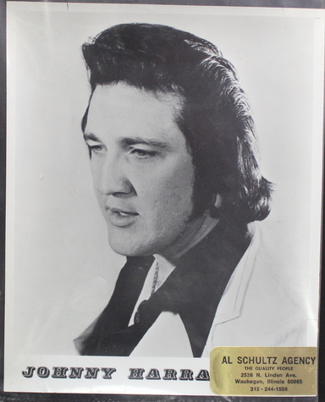
Figure 4: Elvis impersonator that performed at Fanny Hill
Source: Unknown, “Photo, Johnny Harra,,” Sounds of Eau Claire, accessed November 15, 2018, https://soundsofeauclaire.omeka.net/items/show/310.

Even before Shake, Rattle, and Roll, Fanny Hill hosted an Elvis impersonator Johnny Harra who performed in 1977. The practice has grown since the death of “The King,” Elvis impersonator conventions and even a hall of fame have popped up to memorialize these Elvis commemorations. Since Elvis is such an icon for the Rock and Roll era, the presence of Elvis at Shake, Rattle, and Roll is not only unsurprising but expected. The Elvis impersonator was so important that it was an Elvis named Dave Hodges who closed the 1993 Shake, Rattle, and Roll.

Vehicles to the Past
Other than music, Shake, Rattle, and Roll features other means for the attendees to connect with the past and awaken nostalgia. The events serve as transport to the past through memories or imagination.
Playing off of the nostalgia, Shake, Rattle and Roll also featured a “Rod and Custom Car Show.” As festival goers strolled in the field behind Fanny Hill, they could admire the 200 pre-1969 cars that had been revved and polished for the show. Car enthusiasts could also interact with other owners and car lovers and exchange remarks and quiz each other on the details. To properly show off the blinding chrome on these classic automobiles, the car show also included a parade that wound around the festival grounds. Combined with the rock and roll music, Shake, Rattle, and Rollers could feel that they were immersed into the Rock and Roll era. The cars themselves became a direct link between the past and present, that in which the public can physically interact.
Another cultural aspect of the cars that underpins a significant portion of their appeal is how they are direct representations of a particular era. For older users, this may directly evoke a sense of nostalgia, and for those who did not actually experience the cars when they were new, they experience a peculiar sort of imagined, remote, and transferred nostalgia. Again, the significance of the cars is rooted in the cultural and social context of the original period. The cars exist as particularly powerful artifacts of the period in question because they have been plucked, “verbatim,” if you will, from another period. In this respect, the cars become a way to re-experience the past, or in the case of younger users like myself, experience the past through a primary artifact.

This interaction evokes the power of the senses, strengthening the connection to the past. The most rudimentary sense is sight, enthusiast can see the vehicle, and can admire the aesthetics: the angle of the body, the color scheme, and the overall attractiveness. Touch, being a very physical connection to the past, is an important engaging experience for the enthusiast. Especially when they can sit in the car, for a fleeting moment they are back in time. Smell is also a very powerful evoker of memory, often bringing to the surface clear recollections. Cars have a variety of distinct scents from gas and oil to leather and that new car smell. Lastly, sound is also a descriptive portion of the experience, especially because many elements of the vehicle’s health and power are determined by the rev or idle of the engine.
The collection and showing of classic cars started not long after the genesis of automobiles. In the beginning of the car’s history, however, once a car broke down or became unusable, they would be scrapped. In the 1910s, people began to see the value of old cars, particularly as modes to remember the past. Early car shows were often held new car exhibitions in order to contrast the out dated with cutting-edge. Such an exhibition was held Pittsburgh in 1911 where a reward was given for the oldest car to arrive at the show “on its own power.” A fondness toward older vehicles only grew into the 1920s and 1930s which resulted in the creation of associations such as the Antique Automobile Club of America. With their release of articles and other auto related material, clubs like the AACA started a nationwide conversation about car collection and restoration that resulted in a rise in interest in classic cars.
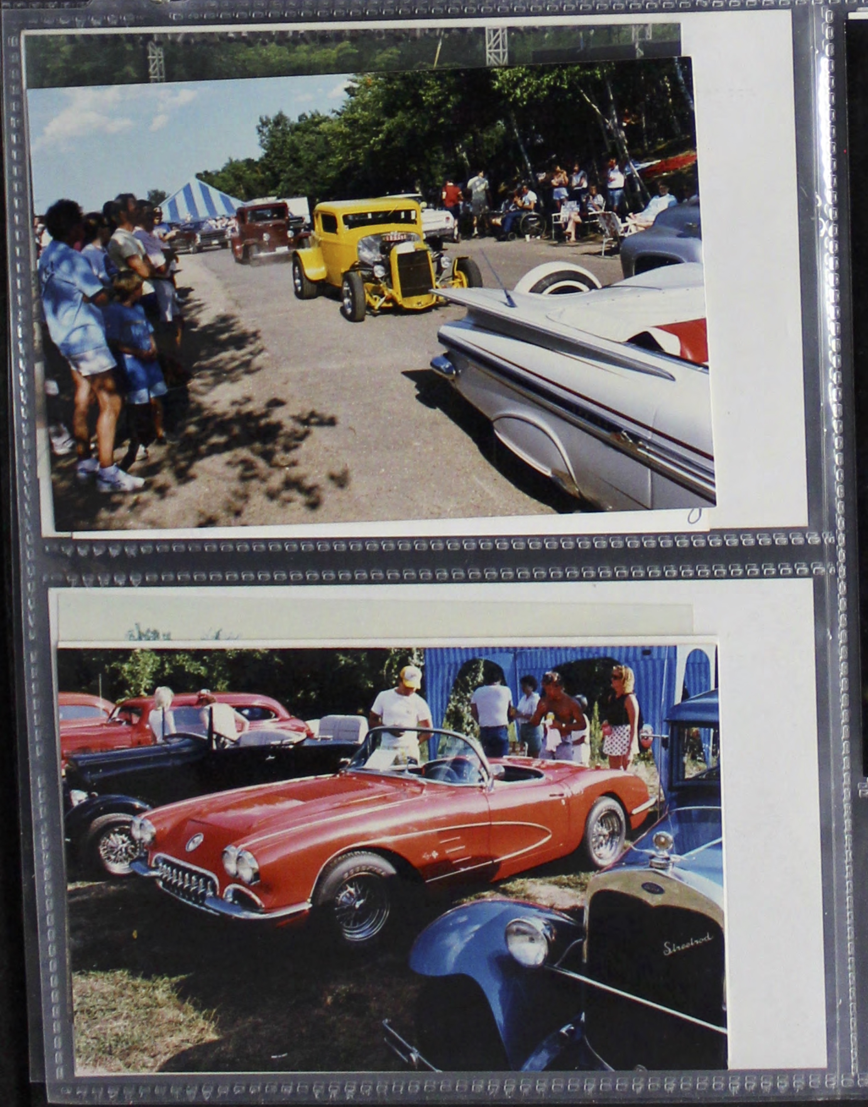
Figure 5: Cars from the "Rod and Custom Car Show"
Source: Larry Barr, “Scrapbook: Shake, Rattle, and Roll,” Sounds of Eau Claire, accessed November 15, 2018, https://soundsofeauclaire.omeka.net/items/show/315.

Another aspect of the car show culture is the preceding collection, restoration, and preservation of these vintage cars. The lifespan of objects, especially cars, often leads to the abandonment in junkyards, and barns across America. Many enthusiasts partake in what historian David Lucsko called a “junkyard jamboree.” Enthusiasts search the vehicle graveyards searching for the treasure to restore and bring back to life. This practice can be best summarized in the popular television program American Pickers. In the show, the two guys drive across the United States in a van searching dank basements, decrepit barns, and overgrown properties, searching for anything from vintage signs, and toys, to cars that are full of potential. While the show’s stars Mike Wolfe and Frank Fritz intend to sell the hidden gems for a profit, other “pickers” are not looking for financial gain, but seeking treasures of nostalgic value. Restorers employ similar tactics to find their next project, often taking a dusty, decrepit vehicle that has been abandoned and restore it to show room standards. The act of restoration differs from refurbishment in the sense that while refurbishment seeks to heighten the appeal of the vehicle, restoration seeks to restore it to its original look and feel. Restoring cars is a huge commitment both physically and financially. Restorers spend years and thousands of dollars perfecting the look and feel of these vehicles These restored cars have key intrinsic sentimental or historic value to the enthusiast. Not only do the restorers have the satisfaction of completing a project, but they have also become agents in preserving history. They faithfully preserve their treasures and, in turn, bring them to events such as “Rod and Custom Car Show” to share with others. Here Shake, Rattle, and Roll is a gathering place for a community of vehicle enthusiasts to show off their treasures and regale in its stories. This interaction between members of the car collector community can be done at any car show or swap meet. Rather, this was done at a music festival where the community could interact other communities which broadens the opportunities for reminiscence and nostalgia.
Another vehicle to the past at Shake, Rattle, and Roll is the presence of high school class reunions. In 1991, Barr reported to the Leader Telegram that six different high school classes would be celebrating their reunions at Shake, Rattle, and Roll, totaling in over 1,000 attendees. These festival goers were double dipping in nostalgia, once in the nostalgia of Rock and Roll culture and another in the nostalgia of their adolescent years. The main purpose of high school reunions is to reconnect with classmates with whom contact has been lost and reminisce about the good ole days. There is no formula for a class reunion, rather the class has the liberty to dictate when, where, and who. Reunions are naturally a voluntary activity and the frequency in which a one held depends on several factors. One such factor is the “closeness” of the class, if the members of the class share a particular affinity they may begin reunions as early as five years following graduation. In the case of my mother’s class, they enjoyed their thirtieth reunion so much, that they hosted another just three years later calling it “The class of ‘83 turns 50.” Reunions also depend on volunteers to organize the event, months perhaps years in advance. Often, class officers are in charge of such events but, often those who are the most enthusiastic about the reunion take leadership. Although the question of who to invite to class reunions may seem like an obvious but it is a little convoluted. Relationships in high school do not remain strictly within the cohort.
Ray Walker did not actually graduate with the class of ’42 but he considers himself and considered by others to be a member of the class. Mr. Walker was crushed when he was not invited to the twentieth-year reunion, so the committee members made certain to invite him this time, and have made him even more “official” by adding his name retroactively to the class prophecy.

Classes such as the Elm High School Class of 1942, adapted their history to include their outside friend. Adding to the complexity is the inclusion of spouses. One of the main ambitions for attending a reunion, besides catching up, is to see how the individual ranks after all that time. Consequently, showing off one’s spouse is a part of that tradition. However, over the years, the spouses become part of the class by forming relationships and making memories at the reunions themselves.
In the case of reunions at Shake, Rattle, and Roll, where the reunion is held becomes important. In a general sense, class reunions tend to host their reunions in their hometown; high school gym, local watering hole, or another location important to the class. This makes sense for multiple reasons. First, it makes sense logistically, everyone is likely to know where the venue is located and they likely already have family in the area they can visit. Deeper, meeting in a meaningful location evokes a sense of place and nostalgia.
When we recall places, we recall emotions and activities and not merely the physical setting. The memory of a place becomes a language through which we recall our past social networks and emotions. We remember places as the settings for past social experience, and these places, as we remember them, can have even more emotional impact on us than our experience of them at the time.

Since reminiscence is such a significant part of the class reunion, using the location as a catalyst for is an important element. Mr. Walker’s adopted class used the same logic when choosing the location for both their twentieth and fortieth reunions. At twenty, they chose the hotel ballroom where they held their senior prom. Twenty years later, upon discovery its derelict condition, they moved the venue to a country club where many of the class worked the summers as caddies. The choice was effective as returning memories from high school. Rather than using a place that is historically associated with their high school the reunions at Shake, Rattle, and Roll used the environment created by Larry Barr to connect to their history.
This choice to hold the class reunion at Shake, Rattle and Roll becomes increasingly more interesting when the ages of the participants. In figure 6, the tent of “Memorial High School class of ‘78” is shown. This is curious as they would have grown up outside of the height of the Rock and Roll era, which ended in the early 1970s. In the same year, the Strum class of 1988 also attended the Shake, Rattle, and Roll festival, just five years after they graduated. Both classes grew up looking fondly back at the Rock and Roll era rather than being a participant. By attending Shake, Rattle, and Roll, and listening to the music while perusing the rows of classic cars, they can imagine themselves into the Rock and Roll era. This suggests that they are drawn the festival because of the tropes that prompt nostalgia.

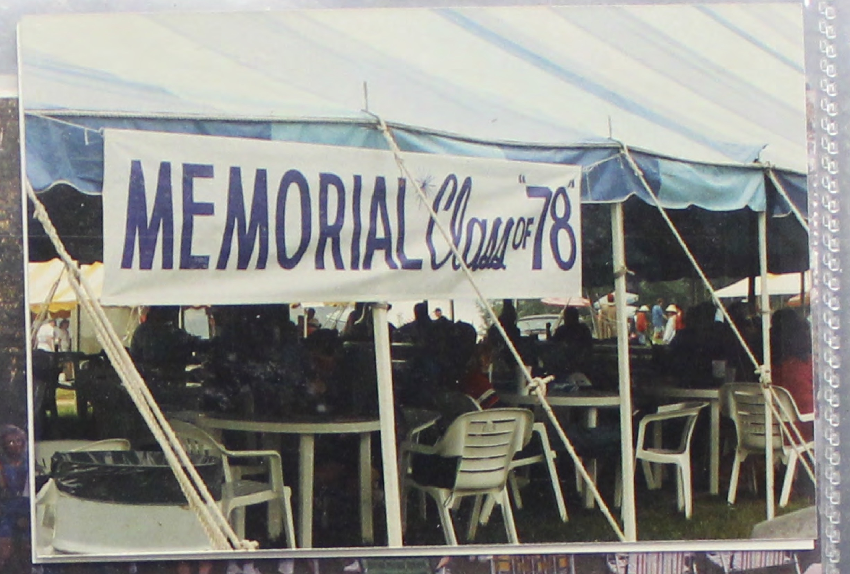
Figure 6: class reunion tent at the 1993 Shake, Rattle, and Roll.
Source: Larry Barr, “Scrapbook: Shake, Rattle, and Roll,” Sounds of Eau Claire, accessed November 15, 2018, https://soundsofeauclaire.omeka.net/items/show/315.

At the core of reunions is the quest to find a lost community and a lost identity. This community only exists as a result of a that group a people growing up in the same particular time and geographical space and once they leave school the community disbands, losing contact. Yet, many communities choose to reconnect approximately every ten years, only seeing each other during those times. People may go to high school reunions to flaunt their success to their old friends and flames or just see have changed in the preceding decades, which can include characters such as: the popular jock with a beer gut, the serial divorcee, and the one who blew them all away. For the weekend, they reconnect with their high school identity and become immersed in their past, where they can relive memories or perhaps reimagine flounders. Whatever the reason for attending, attendees leave with a sense of satisfaction that comes from nostalgia. For those groups that hold their class reunions at Shake, Rattle, and Roll, they receive nostalgia from their community of classmates but also from the community of rock and roll enthusiasts. While reunited into their high school community, they are immersed into broader pop culture trends of their adolescence. This combination of personal and national nostalgia gave them a truly authentic feeling experience. Attendees of these reunions experience an intersection of nostalgia: the rock and roll atmosphere combined with the presence of their high school classmates result in a glorious flashback of memories.

Conclusion
Riding off of the sensation of Shake, Rattle, and Roll, Larry Barr created a country music festival in Eau Claire. In the preceding years, Barr had been observing the rise of country music stars such as Garth Brooks and Alan Jackson as well as the success of the neighboring Country Fest so, in 1990 he held the first Country Jam USA. Barr intended Country Jam to be much slower paced, describing it as a place to sit and listen rather than get up and dance. Country Jam, as well as the subsequent Eau Claire festivals, lacked the elements of nostalgia that were present in Shake, Rattle, and Roll. The lack of nostalgia did not damage Country Jam’s success, it grew to add nine million dollars into the Chippewa Valley economy per year.
In 1993, Larry Barr sold his share in Shake, Rattle, and Roll as well as the festival that branched off of it, Country Jam USA to pursue other interests. Without his influence, the new owners decided to stop Shake, Rattle, and Roll and almost moved Country Jam out of Eau Claire. Besides financial, the biggest reason for the discontinuation of Shake, Rattle, and Roll was the attachment to booking original acts. As Shake, Rattle, and Roll customarily booked acts that were famous during the Rock and Roll era, the new owners wanted to continue that tradition. However, after consideration they saw that this was not feasible because of the increase of bands retiring or playing without their original members. This realization resulting in a ‘quit while we’re ahead’ mentality. Larry Barr, however, thought that they could have gone a different route. “People say the artists are going to be too old and the artists can’t keep on with this. It’s not the artist, it’s the music. The music is still going today. It’s probably even higher energy and more show than it was back then. So that festival still could have gone on.” The decision to end Shake, Rattle, and Roll was contested by the shareholders not for creative reasons but for sentimental. In the Eau Claire Leader Telegram, the chair shareholder, Pat Bichsel expressed sadness in the loss of the festival and lamented in the sentimental feeling towards the region’s first festival. When Shake, Rattle, and Roll left, it resulted in a loss of almost three million dollars to Eau Claire’s tourism industry and the thought of losing Country Jam’s seven million was a frightening thought for many in hospitality. However, Country Jam USA remained in Eau Claire, in fact, in the same grounds that Barr relocated to in 1990.
Shake, Rattle, and Roll was a trailblazer for music festivals in the Chippewa Valley. Over the next twenty years the region produces five major music festivals, bringing in over thirty two million dollars yearly to the economy. Shake, Rattle, and Roll, however, remained the only festival to evoke such powerful nostalgia. Its closest relative, Country Jam, along with neighbors Country Fest, and Rock Fest, evolved to emphasize the party atmosphere. Newcomers to the Eau Claire festival scene, Eaux Claires and Blue Ox emphasize an arts and family, respectively, atmosphere. Each have captivated a corner of the music market, drawing people from different background into their gates.
For Eau Claire, festivals and music more broadly have become central to a new adapted identity. In 2015, local magazine Volume One dubbed Eau Claire the “Music Capital of the North.” Whether or not this is a suitable title for the region is another discussion, however, the fact that they self-identified themselves as “The Music Capital of the North” speaks volumes to how they see themselves and how they want to be viewed. Since then, The City of Eau Claire has centered its downtown revitalization upon music with the construction of amphitheaters and performance spaces in local parks, and a vast theater that dominates the landscape. In December of 2018, Eaux Claires announced that they were going to take a hiatus to reshape the festival with discussions of moving it out of the woods and into downtown Eau Claire. Through Shake, Rattle, and Roll’s introduction of music festivals and Country Jam’s economic boost, both have become major influencers on shaping the identity of Eau Claire.
In the twenty-five years since the last Shake, Rattle and Roll, people are still asking about it. “I’m pretty well known around town and every place I go someone always asks me if I’m going to do it again but I’m not, even though I like to think I might.” Even if Eau Claire never sees a Shake, Rattle, and Roll revival, they will still recall the festival fondly, as they have done for the past twenty-five years.

Bibliography

Primary Sources

Barr, Larry. 2017. Interview by William DeBlaey and Isaiah Steig. Eau Claire, WI. October 24.

——. 2018. Interview by Author. Eau Claire, WI. October 11.

——. 2018. Interview by Karyssa Guilsh. Eau Claire, WI. April 16.

——. “Scrapbook: Shake, Rattle, and Roll,” Sounds of Eau Claire, accessed November 15, 2018, https://soundsofeauclaire.omeka.net/items/show/315.

Secondary Sources

Carnegie, M. D. "Generation Sax: The Newporters--40 Years of a Jazzy Alternative." The Washington Post, Aug 16, 1994. https://search.proquest.com/docview/408198939?accountid=14790.

Coffey, Frank. 1997. The Complete Idiot’s Guide to Elvis. New York, N.Y.: Penguin Group [USA], Inc. 23. http://proxy.uwec.edu/login?url=https://search.ebscohost.com/login.aspx?direct=true&AuthType=ip,uid&db=nlebk&AN=8985&site=ehost-live&scope=site.

Fry, Robert W., Performing Nashville. London, UK: Palgrave Macmillan, 2017.

Gibson, Chris, Connell, John, and Connell, J. Music and Tourism on the Road Again. Aspects of Tourism ; 19. Clevedon: Channel View Publications, 2005.

Glassberg, David. Sense of History : The Place of the past in American Life. Amherst: University of Massachusetts Press, 2001.

Hillstrom, Kevin, and Hillstrom, Laurie Collier. Woodstock. Detroit: Omnigraphics, Incorporated, 2012. Accessed November 6, 2018. ProQuest Ebook Central.

Hughes, Howard L. Arts, Entertainment and Tourism. Oxford: Butterworth-Heinemann, 2000.

Humphrey, Lin T., and Humphrey, Theodore C. "The High School Reunion: A Traditional Festival?" Journal of Popular Culture 19, no. 1 (1985): 99-106.

Ikeda, Keiko. A Room Full of Mirrors : High School Reunions in Middle America. Stanford, Calif.: Stanford University Press, 1998.
Lucsko, David N. ""Junkyard Jamboree": Hunting for Automotive Treasure in the Twentieth Century." IA. The Journal of the Society for Industrial Archeology 39, no. 1/2 (2013): 93-111. http://www.jstor.org.proxy.uwec.edu/stable/43958429.

Massimo, Richard. I Got a Song : A History of the Newport Folk Festival. Music:interview. Middletown, Connecticut: Wesleyan University Press, 2017.

Robinson, Roxy. Music Festivals and the Politics of Participation. Ashgate Popular and Folk Music Series. London: Routledge, Taylor & Francis Group, 2016.

Rosenberg, Neil V. Transforming Tradition : Folk Music Revivals Examined. Publications of the American Folklore Society. New Series (Unnumbered). Urbana: University of Illinois Press, 1993.

Tam-Scott, Derek. 2009. "Rationalizing The Lunatic Fringe: Bases Of Classic Car Enthusiasm." Intersect (Stanford, CA: Stanford University Press) 104-125, 121.

Timothy, Dallen J., and Boyd, Stephen W. Heritage Tourism. First ed. Themes in Tourism. Harlow, England ; New York: Pearson Education, 2003.

Waddell, Ray. 2013. "The Big Four." Billboard 125 (14) (Apr 13): 32-33. https://search.proquest.com/docview/1349624043?accountid=14790

Wald, Elijah. How the Beatles Destroyed Rock 'n' Roll an Alternative History of American Popular Music. Oxford ; New York: Oxford University Press, 2009, 22.

Wynn, Jonathan R. Music City : American Festivals and Placemaking in Austin, Nashville, and Newport. Chicago ; London: University of Chicago Press, 2015.

Larry Barr, Interview by Author, Eau Claire, WI. October 11, 2018.
The era emphasized at Shake, Rattle, and Roll was 1958-1969, therefore, this work uses this timeframe when referring to the “Rock and Roll” era.
Robert W. Fry, Performing Nashville. (London: Palgrave Macmillan. 2017)
Dallen J Timothy, and Stephen W Boyd. Heritage Tourism. First ed. Themes in Tourism. (New York: Pearson Education. 2003)
Chris Gibson, John Connell. Music and Tourism on the Road Again. Aspects of Tourism ; 19. (Clevedon, England: Channel View Publications, 2005.)
Lin T Humphrey, and Theodore C Humphrey. "The High School Reunion: A Traditional Festival?" Journal of Popular Culture 19, no. 1 (1985): 99-106.
In this context, nostalgia can be understood to be a sentimental interaction with the past.
Fry, 58.
Elijah Wald,. How the Beatles Destroyed Rock 'n' Roll an Alternative History of American Popular Music. (Oxford : Oxford University Press, 2009), 22.
Larry Barr, 2017. Interview by William DeBlaey and Isaiah Steig. Eau Claire, WI. October 24.
Ibid.
Larry Barr. Interview by William DeBlaey and Isaiah Steig.
Larry Barr. Interview by William DeBlaey and Isaiah Steig.
Steve Kinderman. “Permanent Outdoor Stage Built at Fanny Hill.” Leader-Telegram. (Eau Claire, WI.) June 25, 1987.
William Foy. “Campground, Box seats are new this year.” Leader-Telegram (Eau Claire, WI.) July 10 1992.
Dan Reiland. “Sit, Sweat, & Enjoy”. Leader-Telegram. (Eau Claire, WI), July 25, 1987.
Larry Barr describes the festival grounds have since been renamed the “Country Jam USA Grounds.” In addition to holding the Country Jam Festival, it also holds the Eaux Claires Festival, and the Blue Ox Bluegrass Festival.
Dan Holtz. 1991. “Shake, Rattle Enthusiasts Return for More.” Leader-Telegram. (Eau Claire, WI.) July 12, 1991.
Foy, “Campground, Box seats are new this year.”
Larry Barr. Interview by Author.
The Mandarin Club, "Pre-Festival Dance Party," advertisement, Leader Telegram (Eau Claire, WI), July 10, 1991.
Larry Barr. Interview by Karyssa Guilsh. Eau Claire, WI. April 16, 2018.
The Trashmen. “THE TRASHMEN - OFFICIAL PAGE.” Facebook, 2011. Accessed November 17, 2018. www.facebook.com/pg/TheTrashmenBand/about/?ref=page_internal.
Leader Telegram Staff. “Fanny Hill Readies for Oldies Rock Fest.” Leader-Telegram. (Eau Claire, WI), July 23, 1987.
Leader Telegram Staff. “Chicago, Jones Headline Shake Fest.” Leader-Telegram. (Eau Claire, WI), April 21,1993.
Leader Telegram Staff. “Fanny Hill Readies for Oldies Rock Fest.”
Larry Barr. Interview by Karyssa Guilsh
Frank Coffey. “The Complete Idiot’s Guide to Elvis.” ( New York, N.Y.: Penguin Group, Inc. 1997) 23. http://proxy.uwec.edu/login?url=https://search.ebscohost.com/login.aspx?direct=true&AuthType=ip,uid&db=nlebk&AN=8985&site=ehost-live&scope=site.
Leader Telegram Staff. “Chicago, Jones Headline Shake Fest.” Leader-Telegram. (Eau Claire, WI), April 21, 1993.
Derek Tam-Scott. 2009. "Rationalizing the lunatic fringe: bases of classic car enthusiasm." Intersect Vol. 2. no 1. (Stanford, CA: Stanford University Press )104-125, 121.
1890-1900.
David N Lucsko. ""Junkyard Jamboree": Hunting for Automotive Treasure in the Twentieth Century." IA. The Journal of the Society for Industrial Archeology 39, no. 1/2 (2013): 93-111, 101. http://www.jstor.org.proxy.uwec.edu/stable/43958429.
Lucsko. 105.
Lucsko. 100.
Keiko Ikeda. A Room Full of Mirrors : High School Reunions in Middle America. (Stanford, CA: Stanford University Press, 1998) 55.
Ikeda, 125.
David Glassberg. Sense of History: The Place of the past in American Life. (Amherst: University of Massachusetts Press, 2001.) 115.
Humphrey, and Humphrey, 105.
Based in Cadott, Wisconsin, about thirty miles from Eau Claire.
Larry Barr. Interview by Author.
"Music Capital of the North - Our Growth." Volume One. 2015. Accessed November 18, 2018. http://volumeone.org/musiccapital/growth.
Larry Barr, 2018. Interview by Author.
Thomas Pfankuch. Shake Festival Scrapped. Leader-Telegram. (Eau Claire, WI.) January 19, 1994.
"Music Capital of the North - Our Growth." Volume One.
Nick Meyer, Luong Huynh, and Branden Nall. "Eaux Claires: Organizers Set Sights on 2020 Reboot Right in the Heart of the City." Volume One. December 10, 2018. Accessed December 16, 2018. http://volumeone.org/news/1/posts/2018/12/10/20803_eaux_claires_organizers_set_sights_on_2020_reboot?fbclid=IwAR2ETcO0FycU9lk-gUX7HdrA0WhCmC_gs_qcHHnNhaWex2Gmy11odToVXYM.
Larry Barr, 2018. Interview by Author.

