The Sandy Lake Tragedy: Too Long Forgotten, A Delayed Commemoration

Mariah J. Ring
History 489: Senior Thesis
November 2015

Copyright for this work is owned by the author. This digital version is published by the McIntyre Library, University of Wisconsin – Eau Claire with consent of the author.

Contents

Abstract iii
Maps and Images iv
Introduction 1
History of the McGregor Lakes Region 3
The Tragedy 7
Important Treaties 11
What Happened Next 14
Commemoration 17
Conclusion 23
Works Cited 26

Abstract
The Sandy Lake tragedy was essentially a Chippewa Trail of tears, when the attempted forced removal of Ojibwe Indians from Upper Michigan and Wisconsin were sent to Sandy Lake Minnesota to collect their annuity payments leading to the deaths of some 400 Ojibwe men women and children. This event that long went without Commemoration. For 150 years it went forgotten by many, and is still not something widely discussed or known about today. This paper outlines the history of the McGregor lakes region, the treaties that transpired before and after the tragedy, and the tragedy itself. Through a description of the memorial and interviews of both white and Native American cultural groups, this paper analyzes sentiments towards the memorial, the history of the event, and the general public’s knowledge of what happened there prior to the memorial.

Figures

Figure 1 – Map of Sandy Lake 4
Figure 2 – Map of Minnesota Showcasing Aitkin County 7
Figure 3 – Alexander Ramsey 8
Figure 4 – Zachary Taylor 9
Figure 5 – Map of Ceded Territories from Treaties 11
Figure 6 – Chief Buffalo and his Accompaniment to Washington 15
Figure 7 – Chief Buffalo 15
Figure 8 – Mikwendaagoziwag Memorial 18
Figure 9 – Map of Sandy Lake with Location of Memorial Marked 19

“They made us many promises, more than I can remember, but they never kept but one; they promised to take our land, and they took it.”
- Chief Red Cloud

Introduction:
Long before the sounds of speedboats, jet skis, and children splashing in the water, before the echoes of axe falls and the moving of timber, there were the sounds of ceremonies, battle cries, trade, and treaties. Sandy Lake, Minnesota was an epicenter of trade, tribal conflicts, and life. In 1782 the village at Sandy Lake became nearly depopulated by the ravages of smallpox. Though they recovered and repopulated this would not be the only tragedy causing mass deaths to befall the Ojibwe in this region. Around the year 1800 the village at Sandy Lake was again cut down bringing their “inhabitants nearly to a man,” by a Sioux attack. Again they would rebuild and press on. There would be more battles fought with the Sioux, and the United States Government would also be a cause of loss and mass heartache for the Ojibwe people spreading across the upper Midwest from Minnesota to Michigan with the Sandy Lake Tragedy. This great tragedy is one that was too long forgotten, and only recently remembered. The Sandy Lake Tragedy, or Wisconsin Death March happened in 1850, but was only recently commemorated 150 years later in 2000 with the Mikwendaagoziwag (We remember them) Memorial. This memorial along with a marker is placed in view of the lake that has a rich Native American history, though at times not always a happy one. It is hard to believe that on the lake that so many, including myself, love and find so much happiness, there could have been so much sadness. What is even harder to believe is that so few know about the events that transpired there. In this paper I will attempt to outline the history of the region, the tragedy itself, and its commemoration. I will also look at the way the tragedy has been remembered within both Native American culture, and dominant cultures.
The history of the lake is not a particularly new one to tell. It has been a loved destination for many, including my family over the years. The history that has seldom been told, and is little known by those that frequent Big Sandy’s waters, is that of the tragedy. One source that I looked at discussed the history of the region but gave no mention to the tragedy at all. It tells merely the stories of battles and the infiltration of the white man. Another source that I considered was set on telling the “highlights” and claims “its only purpose is to reveal in part the colorful past of this romantic region of Minnesota’s Arrowhead, that you who visit this scenic playground can in a measure visualize and appreciate what has gone before.” Here in lies the problem. History of oppression in America has too long been hidden. We recognize our greatness and try to hide our flaws when we can. We teach our children that it is okay to make mistakes because it helps you to learn, but history often does not own up to them. Why does it take 150 years to recognize those who have died as a result of oppression and illegal attempts at removal? Is it because the history was too painful to experience? Is it because we are too ashamed in this country to remember what we have done wrong?

History of the McGregor Lakes Area:
The Ojibwe presence in the Sandy Lake region can be traced back to the 1700’s. Prior to this the area was inhabited by the Sandy Lake Sioux. This group of Sioux was determined to stop the advancement of the Chippewa into their territory. The Chippewa wanted to claim the area for their own, and both groups it would seem wanted to put an end to the other. The lake’s current inhabitants have told many “legends” around the lake about the battles waged between the Ojibwe and the Sioux in that region and the cause is mostly a speculation. The real reason however was a conflict for the land inhabited by the tribes there and it’s shift between the Sioux and the Ojibwe. They would come together in the winter as a sort of truce while they hunted in the same areas. The Chippewa took over the Sioux village and the Sioux left licking their wounds by 1748, and would never again be “in possession of their old homes.” There were many notable battles that were fought after this, in which the Sandy Lake Chippewa were all involved. One of these confrontations and the one most known by those who enjoy the lake today is that of Battle Island. The rumor goes that the fight was on the island itself, and that the waters on the lake were red with blood.
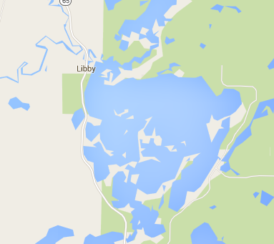
KEY
1 - Battle Island
2 - General location of the
former fort and the
memorial
3 - Mississippi River
1
2
3
Figure 1, Map of Big Sandy Lake
Source: accessed Nov. 3, 2015, https://www.google.com/maps/place/Big+Sandy+Lake,+Minnesota+55760/@46.7556806,93.3065801,13z/data=!3m1!4b1!4m2!3m1!1s0x52b1aae960b27baf:0xd3ccecdab5c53853

While it is a location where many arrowheads can be found, it is now a preserved land area that is not to be landed upon or explored by anyone. The real story is that the island was used to harbor the women, children, and the elderly while the Chippewa prepared for a battle with the Sioux. This battle, contrary to the arrowheads found on Battle Island, was fought with rifles and not bows and arrows. They were instructed to wait until the Sioux were well within range to fire. After the first shot all but two of the Sioux war party were killed. They were sent back to their tribe with amputated ears and told “’Return to your people and tell them that we wish to be left alone.’” This account is relayed by an Indian woman whose father was a boy at the time of the battle, her name was Aundaig (Crow), and she is the granddaughter of the Rice Lake Band chief Ayabedwaywedung,(Returning Echo). This didn’t put an end to the rivalry but it did suppress it for a time.
Through this tumultuous time between the tribes, French fur traders were ever present. They used the Savanna Portage, which was “the shortest carrying distance between the Great Lakes and the Upper Mississippi” and would be the main thoroughfare between the points for around 200 years. Indians, fur traders, and explorers used this portage alike. For many years the French “voyagers” dominated the trade routes here. They married into Indian tribes, and occasionally adopted aspects their culture. Following the end of the Seven Years War in 1763, the British came in, took over Canada and the trade. Trade was not as good for them unless they implemented the voyageurs that had been “left” behind, because they did not treat the Indian in the same manner as the French had. Enter big business.
The Northwest Trade Company was established in 1783 by a group of British traders and brought bartering to its most elevated success. This company would be the first competition for the Hudson Bay Company that had been the leader in this area since the late 1600’s. The first Northwest Company fort on Sandy Lake would be soon to follow. It was established in 1794, and run by a man named Charles Bousquet; this post would be sold in 1812 to the American Fur Company. The fur trade held on for a while longer, but eventually collapsed. It was at this time that the Ojibwe (and the Dakota) would cede some of their lands to the United States for the lumber industry in the Treaty of 1837. However lumbering really wouldn’t come to the Aitkin County region until about thirteen years later.
This was the same time the tragedy occurred on the lake. Lumbermen from the upper Mississippi visited Henry M. Rice’s trading post near the mouth of the Crow River and he assured them that he could buy White Pine from the Ojibwe chief at that time, Hole-in-the-Day. This led to the spread of logging through out the McGregor Lakes Region, which also encompasses Big Sandy Lake. This industry would last in the region until the 1900’s. In 1919 Marcus Nelson using the steamer Lee would make the last steamer trip hauling logs on Sandy Lake. The Homesteaders followed around ten years after the lumbermen. They followed the Northern Pacific railroad, which made land more accessible and lumber easier to transport south to the Twin Cities region. Most notably was McGregor. It was a logging town and later a place to vacation with good hunting, fishing, trails, and lake resorts. Its location is just 14 miles from the source of the tragedy transpired just 53 years before its incorporation. Figure 2 below shows the location of Aitkin County in Minnesota in red.
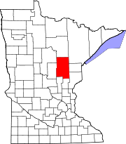
Figure 2. Aitkin County Map,
Source: accessed on Nov 3, 2015,, http://publicrecords.onlinesearches.com/MN_Aitkin.htm

The Tragedy:
The cite of annual annuity payments for the Lake Superior and other bands of Chippewa from the Wisconsin, Minnesota, and Upper Michigan, had long been La Pointe, Wisconsin on Madeline Island. This was due largely to the fact that it was both sacred ground and for the majority of tribes, a convenient place to gather. That is until events were set in motion that would move the 1850 annuity payment location to Sandy Lake, a location about 150 miles west, and about a two days journey on foot. The secret hope was that by moving the location of the annuity payments, the Ojibwe would be forced to stay in Minnesota and then compelled to take up permanent residence there. Governor Alexander Ramsey (seen in figure 3), who was also the Superintendent of Indian Affairs, and his subordinate John Watrous, were intent on increasing their own Minnesota Territory Native American population in hopes of gaining more government money flow. 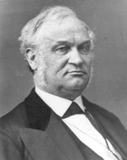
Figure 3. Governor Alexander Ramsey,
Source: accessed Nov 3, 2015, http://bioguide.congress.gov/scripts/biodisplay.pl?index=r000026

They hoped that the addition of more Native Americans to the northern part of the future state would mean that the annuity payments would be spent in their territory, thus helping the economy, and that the government would provide the territory with money to build schools, agencies, and farms that would provide their constituents and supporters with jobs. Their ulterior motive was to break the spirit of the Ojibwe who had long been thwarting and rebuffing efforts to move them to Northern Minnesota for years. Thus they applied pressure to President Zachary Taylor (seen in figure 4), who was already known for his endorsement of moving Indians and who had already endorsed the removal of Wisconsin Indians in the past to issue an executive order to move Indians East of the Mississippi, west to unceded lands. 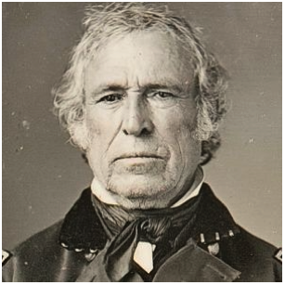
Figure 4. President Zachary Taylor,
Source: accessed November 3, 2015, http://www.biography.com/people/zachary-taylor-9503363

He had already signed an illegal removal order in 1848 that required the immediate removal of the Ojibwe Indians from Michigan and Wisconsin to land west of the Mississippi River in Minnesota. This order was in contrast to promises that had been made to the Ojibwe in the Treaties of 1837 and 1842. In these treaties the Ojibwe ceded land with valuable resources to the United States government. In return they received the right to stay on their homelands, along with goods, annuity payments, and usufructuary rights, or the rights to hunt, fish, and gather on the lands that they had ceded to the government. These rights were assured to them so long as they maintained peace with their white neighbors, and in the event that they did not, the president could take these rights from them. In an effort to support this order and with the pressure from Alexander Ramsey and others like John Watrous, Taylor agreed to move the annuity payment site from La Pointe, Wisconsin to Sandy Lake, Minnesota. Only 5,500 Ojibwe agreed to make the journey because winter was soon to come. They set out arriving in October to find that they were going to have to wait for their provisions and money. They were told the payments had been delayed but were sure to come soon. Soon was not soon enough, as they waited for six weeks for the payments winter had set in. One hundred and fifty of their population had perished from starvation, disease, and exposure to the elements. While they waited they were given moldy flour and rotten meat. Many burned their canoes for warmth. When their payments arrived they were much smaller than promised and anticipated. It was at this time that Ramsey and Watrous’ scheme backfired. Tired, hungry, and vastly disappointed on December 2 the Ojibwe broke camp and headed for their homes. A number stayed because they were too sick to travel just yet or were taking care of their sick loved ones. On the long walk home, without canoes, which would have been useless in the frozen waterways, they trudged through snow and ice. Many used what little money they had been given to feed their starving children. On this trek home another 250 would perish resulting in the loss of 400 Ojibwe men, women, and children.

Important Treaties:
There are 3 major treaties that are important to this story, the Treaty of 1837 or the White Pine Treaty, the Treaty of 1842 or the Copper Treaty, and the Treaty of 1854 or the Ojibwe Land Cession Treaty (which will be discussed later). The figure below shows the lands that were ceded in each of these treaties.
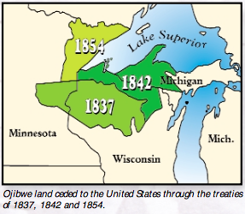
Figure 5. Ojibwe Ceded Teretories Map,
Source: accessed on Nov 3, 2015, http://www.glifwc.org/publications/pdf/SandyLake_Brochure.pdf

Prior to the influx of American military and civilians into what would become the territory and then state of Minnesota, the Ojibwe economy was in a boom. The influx of these nonnative peoples in the 1800’s cause a devastating blow to the Ojibwe economy and way of life. They quickly went from controlling large tracts of land to only occupying small portions of it. This was a move of necessity however. The Ojibwe had to sign treaties “selling” portions of their empire to the government in order to sustain their people, the fur trade went through a period of collapse and rebuild then prices hit rock bottom. In came the United Staes with a proposition, they could buy the land from the Ojibwe, and to them it seemed like a pretty reasonable bargin. They native peoples could maintain hunting, fishing, and trapping access to the land in exchange for money from the government to sustain their villages and families. This led to the first of the Treaties to be signed by the Minnesota Ojibwe, the White Pine Treaty of 1837.
The White Pine Treaty was an agreement between the Dakota, and the Ojibwe peoples to cede their land to the government for the use of its lumber. They did this in return for a large sum of money to be paid in annuity payments, and another sum of money to be credited towards their past debts. In the treaty they also maintained the usufructuary rights to fish, hunt, and gather on their newly ceded lands so long as they maintained peaceful relations with the white people living in the area. The Treaty included clauses that promised this to the Ojibwe and the Dakota who signed it.
The White Pine Treaty was just the beginning of what would be a vicious cycle for the Ojibwe people in Minnesota. They would sign a treaty giving their land to the government and it would become flooded with white settlers and cut them off to the access that they had been promised in cession. Then they would need more money to support their people so they would bargain and sign another land cession treaty with the government for more money. The money that they gained from these treaties was short lived and again their economy would falter, “the short-term benefits of the treaties never compensated for the long-term loss of the land.” This permanently altered life for these native people and soon poverty would be commonplace among their nation.
Another treaty signed to try to bolster the economy of the Ojibwe was the Copper Treaty of 1842. In this treaty they ceded lands in northern Wisconsin and Michigan to the government who were excited about the copper deposits that were there. Again this treaty allotted them usufructuary rights, and money, along with the right to stay there once again at the pleasure of the president. This means that as long as they were not disturbing the peace or going against the treaty promises they could stay on this land. However if at any point they were seen to be in conflict with the white population, or were warring for some reason, the president could take away their rights and maintain the land.

What Happened Next:
Following the tragedy that transpired at Sandy Lake and on the journey home, the Ojibwe had had enough. Tribal leaders agreed that some form of action needed to be taken, especially to prevent a bloody uprising. Chief Buffalo, his undercheif O-sha-ga, Benjamin Armstrong, and four braves (pictured in figures 6 and 7 below), set out for Washington DC from Madeline Island in April, 1852, to talk to President Fillmore in an effort to curb any upheaval.
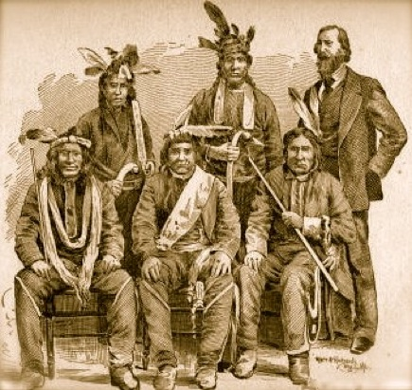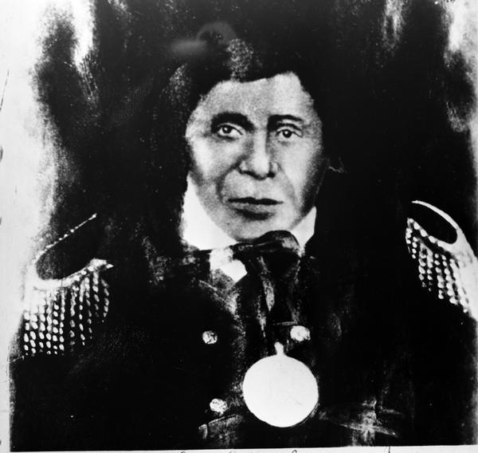

Figures 6 and 7 The Group and a photograph of Chief Buffalo
6 Source: accessed Dec. 18, 2015. http://chiefbuffalo.com/buffalo/Home_Page.html as taken from Benjamin Armstrong’s Book
7 Source: accessed Dec. 18, 2015. http://freepages.history.rootsweb.ancestry
.com/~jmh4/nativeamerican/chippewa/chiefbuffalo.htm

They arrived on June 22, where they were told to go home by government officers and Indian Affair Bureau members alike. They had not asked to travel to the capital and thus their journey was considered to be illegal, because tribes had to ask their representatives out west for permission to travel east, something that had not been done by this party. Despite the discouragement and roadblocks that were continually set in their way, they ended up with a chance meeting that brought them to an interview with President Fillmore. Later Chief Buffalo, O-sha-ga, Armstrong, Senator Briggs, and President Fillmore would pass the peace pipe together at their meeting. The Chief and his underchief explained their grievances, asked their questions, and presented the petition they had collected before leaving that outlined the opposition of Indian removal from much of Wisconsin. They explained that they were confused by President Taylor’s removal order and denial of their usufructuary rights. The chiefs went away and the president instructed that the government would cover their bills. The next day the chiefs were again called to an interview. Armstrong explains it going as such in his book:
“The second day following this Senator Briggs informed me that the President desired another interview that day, in accordance with which request we went to the White House soon after dinner and meeting the President, he told the delegation in a brief speech that he would countermand the removal order and that the annuity payments would be made at La Pointe as before and hoped that in the future there would be no further cause for complaint. At this he handed to Buffalo a written instrument which he said would explain to his people when interpreted the promises he had made as to the removal order and payment of annuities at La Pointe and hoped when he had returned home he would call his chiefs together and have all the statements therein contained explained fully to them as the words of their great father at Washington.”

Following this in 1854 would come the Ojibwe Land Cession Treaty. This treaty came about when the United States decided that they wanted the Arrowhead region in Minnesota. This region was rich in many minerals that were desirable. The conditions that came with this treaty came the creation of reservations that guaranteed Ojibwe Indians allotted lands within their ceded homelands. They also maintained their hunting, gathering, and fishing rights.
After this treaty there would be a series of treaties from 1854-1867 that would eventually strip the Ojibwe of Minnesota. They signed over their lands and settled on reservations. Reservations would change their way of life, and the government would officially take over and control the various aspects of their lives. In a quote by Anton Treuer from Ojibwe in Minnesota he outlines this alteration in Ojibwe life:

Reservations permanently changed and eroded the sovereign power of the Ojibwe people. Tribal chiefs were denied the right to govern their own people. Instead, the Ojibwe were governed by bureaucrats called Indian agents. These agents took over the power—previously held by chiefs—to decide who received treaty monies and where and when monies would be distributed.

This is how the Ojibwe would be forced to live. They would also have limited access to the usafructory rights promised to them in the treaties that they had signed. This restricted alloawance would lead to a lwsuit that would be brought to the supreme court and resolve in favor of the Native Americans in 1999.

Commemoration:
The Mikwendaagoziwag Memorial is located in the Sandy Lake Recreation Area just a stone’s throw from the dam. It is a large red Granite stone that has been cut on the bottom to allow it to stand on its mount. Surrounding the stone are nineteen plaques that have the names of the annuity bands that journeyed to the lake in 1850. The other twelve plaques list the successor bands of the Ojibwe today. The 400 small stones found on the marker around the base represent those who died due to the tragedy and the injustice of government officials. Ojibwe reservation communities in Wisconsin, Minnesota, and Upper Michigan selected the stones. Figure 6 below show the Mikwedaagoziwag memorial in the winter time with snow covering the base.
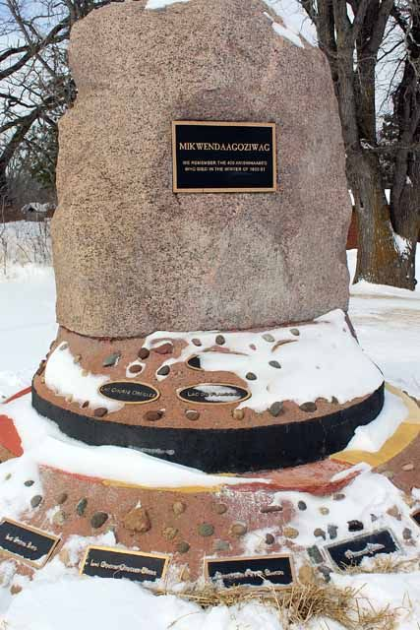
Figure 8. The Mikwendaagoziwag Memorial at the Sandy Lake Recreation Area.
Source: Photo by Jeanne Schram. Accessed Dec 17, 2015. http://www.messagemedia.co/aitkin/community/features/this-memorial-stands-at-the-sandy-lake-dam-commemorating-a/image_94d919ae-ccda-11e4-998c-9b014acd1c12.html

The memorial was officially dedicated in July of 2001, but the Ojibwe held their own ceremony there on December 2, 2000, one hundred fifty years to the day that the Ojibwe left Sandy Lake and headed back to their homes. It is located on the north side of the lake within the Sandy Lake Recreation area as shown by the map in Figure 7 below:
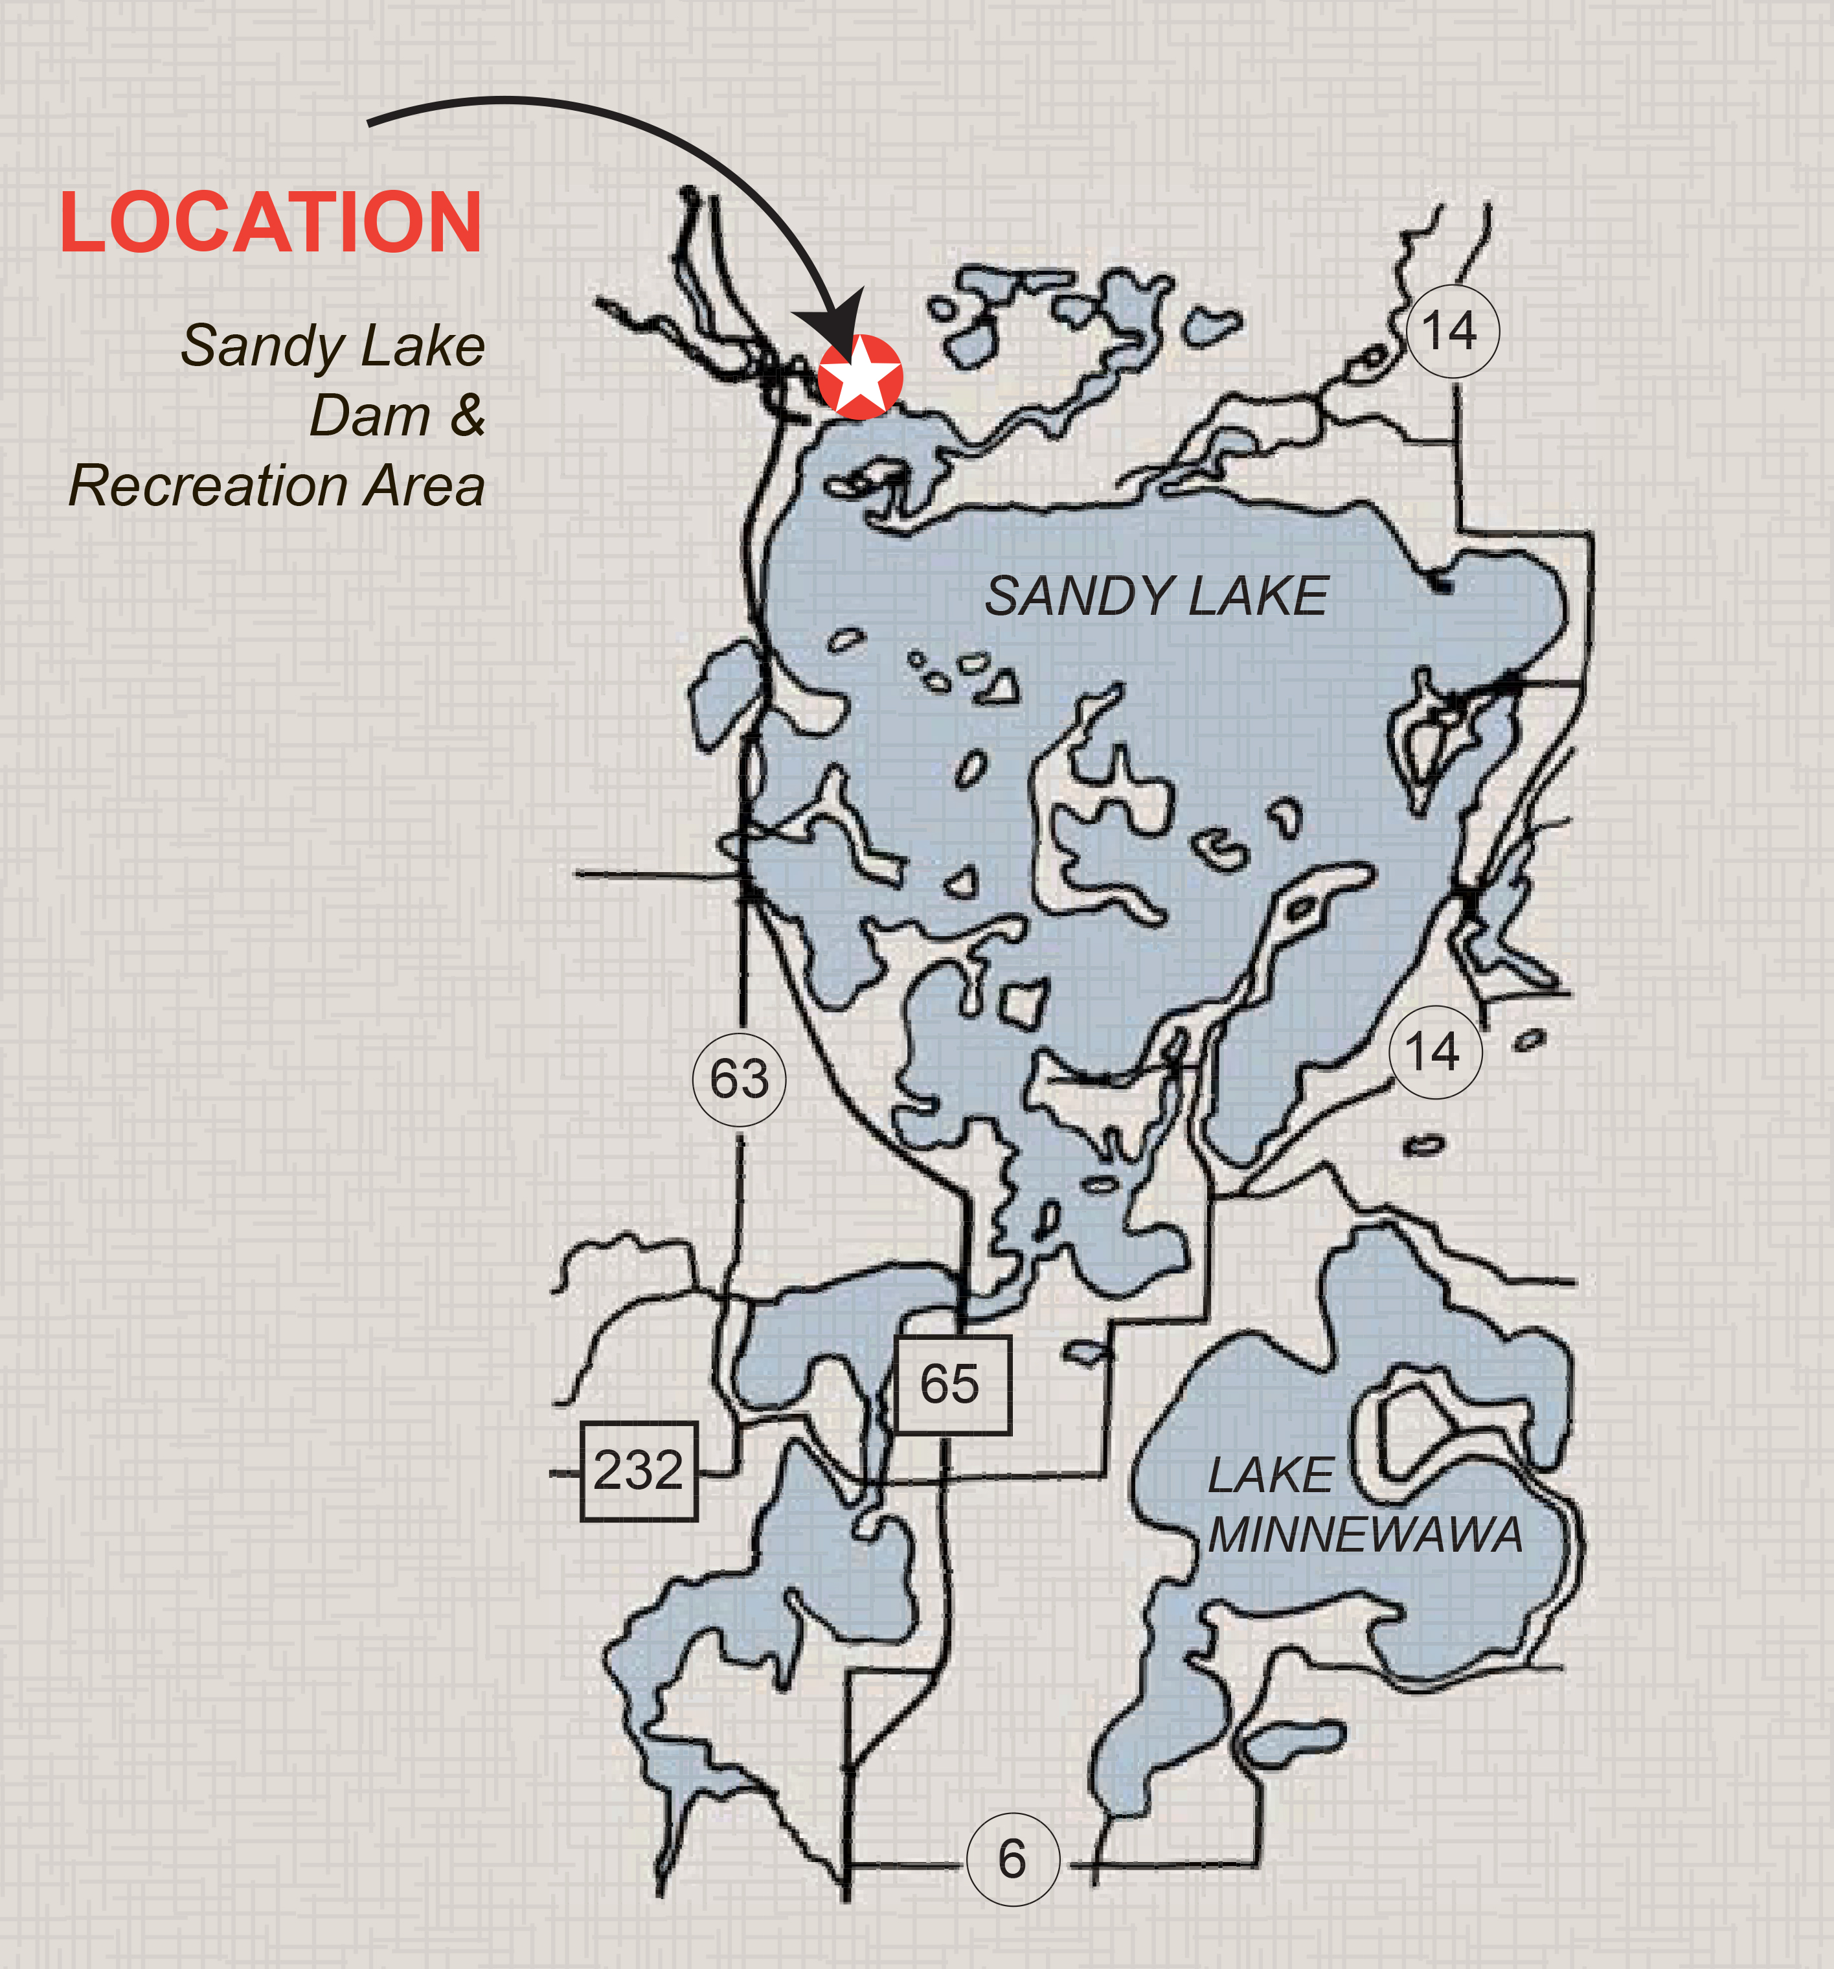
The image at left shows the location of the Sandy Lake Dam and Recreation Area with an Arrow and a red star. This is also the location of the stone marker put in place as the Mikwendaagoziwag Memorial.

This is also very near to the cite of the first Northwest Trading Post location.

Figure 9. Sandy Lake Map Recreation Area Marked
Source: accessed Nov 3, 2015, http://www.mvp.usace.army.mil/Missions/Recreation/SandyLake.aspx

A memorial is defined as being “something, especially a structure, established to remind people of a person or event.” The purpose of this memorial is to remind the country of the event that happened at Sandy Lake and also to commemorate the tragedy. By definition commemoration is “remembrance, typically expressed in a ceremony.” When this memorial was dedicated there was a ceremony to honor it, additionally the Ojibwe people have a yearly gathering to keep this past alive and pay homage to their history. The yearly gatherings and ceremony are open to the public to help promote an understanding of the event for all, and also to allow non-natives to participate in another culture. It is hard then to know why the Sandy Lake tragedy is so little know. In John E. Bodnar’s book Remaking America: Public Memory, Commemoration, and Patriotism in the Twentieth Century, he states that “public memory speaks primarily about the structure of power in society because that power is always in question in a world of polarities and contradictions and because grounded in the material structure of society itself.” This is to say that public memory can often be linked to the power structure in a country. In this country that power structure is headed by the government and dominant culture with the Native American’s, among other minorities, at the bottom. With this hierarchy in place it is easy to have the events that took place within the history of a minority covered up, especially when it was cause by the government. This may be why it has taken so long for the memorial to be established and why so few people know about it.
I have interviewed several of my friends, family, and neighbors who have cabins on Sandy Lake, or grew up in Minnesota and Wisconsin to find out what their knowledge of the Sandy Lake Tragedy is. The general response, “That’s the memorial down by the dam right?” or “Is that in relation to one of the lake’s big floods?” When asked if they knew about the memorial, especially when asking those who have been on the lake for a while; the answers are mixed. Some knew the memorial was there but hadn’t looked at it or into it, some didn’t know about it at all, and some knew no more than what little they could remember from the plaque. It is sad when it takes a memorial to let people know that something happened in a place, but even sadder when it does no more to educate them.
My next question was why they all thought it took so long to commemorate the event, and if they thought it was an effective means of educating the public. My aunt, Joan West-Talbot replied that it was only effective “if people take the time to look at it. We need these memorials for the people that were affected, but we also need people to take the time to look.” My mother, Lisa West, replied to both questions stating that she feels that the amount of time that it took for the memorial to be commemorated was probably due to “Government red tape. Another situation of government red tape, in which they tried to cover up the story and not admit to the history because they didn’t want to admit to what they had done, yet again, to the Native American people.” She went on to say that she felt that a memorial was effective, “ It may not reach a large scale of people, but people are curious, when they see a roadside marker, or a memorial with a plaque they are curious and will stop to at least look,” she went on to say that people want to know the history of an area, it’s part of what makes it appealing to them, even if it is a sad history.
I had a hard time finding people who would talk to me about the event that happened at Sandy Lake. Some tribes that I reached out to simply never returned my calls or e-mails, others respectfully declined. I did talk briefly to one man about the tragedy but he did not want to talk about it either. When I approached Dick Mindykowski I simply wanted to ask him what the most politically correct way of addressing his people within my paper would be. We quickly began to talk about the subject matter of my capstone and he became slightly agitated. “That topic is still too painful and I will not talk about it.” He liken the tragedy and the pain that is related to it as being felt in the soul and the heart and still too fresh for some like the aftermath of the boarding schools. “You’re going to have a hard time finding someone who will talk to you about it I would imagine.” Of course his words of warning were definitely shown by my lack of other interviews. Having more voices to speak about the memorial here or even the tragedy and how they have commemorated it within their culture would have been very enriching and helped me to meet my goal of presenting a well-rounded two-sided analysis of the commemoration of this 165 year old tragedy. The lack of response to my outreach and the feelings of Dick Mindykowski could be analyzed themselves however. Perhaps it is still too painful. Perhaps they simply did not want to peak to an outsider or have another white person or some one of the dominant cultures telling their story for them (something that Dick mentioned in our talk). Here I can only speculate. The memorial did help to provide some spiritual closure for those that were affected by the tragedy and those people who live on today. But I did wonder how do they felt about something like that being used to educate the public?

Conclusion:
Since the arrival of the first ship to the new world Native populations have had a hard go at survival and maintaining their way of life. They have combatted disease, the European, other tribes, settlers and the government. They have sold their land to the government to in an attempt to maintain their culture and way of life, and they have pressed through the death caused to their cultures and tribal structures by reservations. The Ojibwe history is one that is told, like the other tribes of the United States, with blinders on. Like Bodnar says in his book on Commemoration in the quote above, public memory is often based in the structure of power. This could be the very reason why it took so long for anyone outside of the Ojibwe culture to know about the tragedy other than scholars and historians.
This paper has allowed me to look at the Sandy Lake Tragedy in more depth than I have been able to before. In addition to that I have also been able to look at the ways in which commemoration of an event can be effective in some way, and how it can also instigate questions. I agree with my mother, people are curious, they do look at historical markers, but do they absorb the information? Do they remember it later? Or does it just turn into one sign among many that they might read and forget about later. I think that it is important to have these markers that provide closures and educate the unknowing public. It is at least a step in the right direction. The Sandy Lake Tragedy commemoration brings this long “forgotten” event into the spot light even if it is only with the lake locality, or those who go there to pay their respects.
Many things progressed through time between the tragedy and the commemoration. New treaties were enacted, wars were fought overseas, and other memorials and museums were established. Through this time the Ojibwe people were fighting for their usufructuary rights, and what was promised to them in the treaties that their ancestors had made with the government years before. They reached a trial victory in a lawsuit fighting for these very rights in 1999. It makes one wonder if it took the court decision upholding the treaties for them to feel now was the time to remember those lost due to government officials’ desire for more money and to keep pushing the Native American populations ever westward. The next step is to get more history of our native populations into the school systems so that we know about the whole history of country. Too much of our history, good and bad is lost in translation and too much of our countries history is forgotten.

Works Cited
Primary Sources:

Armstrong, Benjamin G. Early Life among the Indians: Reminiscences from
the Life of Benj. G. Armstrong; Treaties of 1835, 1837, 1842 and 1854; Habits and Customs of the Red Men of the Forest; Incidents, Biographical Sketches, Battles, &c. Compiled by Thos. P Wentworth. Ashland, Wisconsin: Press of A. W. Bowron, 1892. 31-32.

Greer, Clifford and Hazel Sorenson. Twelve Poses West: A History of the
McGregor Lakes Region and Savanna Portage Sate Park. McGregor,
(Minnesota: O.L. Johnson, 1967).

Warren, William W. History of the Ojibway People. Reprint ed. St. Paul,
Minnesota: Minnesota Historical Society Press, 1984.

Kent Krezowski, interviewed by author, September 23, 2015

Dick Mindykowski, interviewed by author, October 14, 2015.

Robert Ring, interviewed by author, October 24, 2015.

Lisa West, interviewed by author, October 29, 2015

Joan West-Talbot, interviewed by author, October 17, 2015.

Secondary Sources:

Armstrong, Travis. "The 1852 Journey to Washington." Chief Buffalo and
Benjamin Armstrong. Accessed November 7, 2015. http://chiefbuffalo.com/buffalo/1852_Journey_to_Washington.html.

Clifton, James A. "From the History Books - Wisconsin Death March:
Explaining The Extremes in Old Northwest Indian Removal." News From Indian Country 21, no. 3 (2007). http://search.proquest.com/docview/367627632?accountid=14790.

Hart, Irving H. The Site of the Northwest Company Post on Sandy Lake.
Cedar Falls, Iowa: Iowa State Teachers College, 1926.

Nelson, Orvis M., and Mamie B. Nelson. Historical Highlights of Big Sandy
Lake and the Savanna Portage in the Minnesota Arrowhead. Tamarack, Minnesota: [NP], 1945.

Rassmusen, Charlie Otto. Ojibwe Journeys: Treaties, Sandy Lake, & the
Waabanong Run. Odanah, (Wisconsin: Great Lakes Indian Fish and Wildlife Commission Press, 2003),

Sandy Lake Tragedy. Directed by Lorraine Norrgard. Odanah Wisconsin:
GLIFWC (Great Lakes Indian Fish & Wildlife Commission), 2007. Film.

Satz, Ronald N. Chippewa Treaty Rights: The Reserved Rights of Wisconsin's
Chippewa Indians in Historical Perspective. Madison, Wisconsin: Wisconsin Academy of Sciences, Arts and Letters, 1991.

Treuer, Anton (2010-06-25). Ojibwe in Minnesota (People Of Minnesota)
(Kindle Location). BookMobile. Kindle Edition.

Webster's New Collegiate Dictionary. Springfield, Massachusetts: G. & C.
Merriam, 1973.

William W. Warren, History of the Ojibwe People. Reprint ed. St. Paul, Minnesota: Minnesota Historical Society Press, 1984. 344.
Warren, History of the Ojibway People. 344.
Orvis M. Nelson, and Mamie B. Nelson. Historical Highlights of Big Sandy Lake and the Savanna Portage in the Minnesota Arrowhead. Tamarack, Minnesota: [publisher Not Identified], 4.
Clifford Greer, and Hazel Sorenson. Twelve Poses West: A History of the McGregor Lakes Region and Savanna Portage Sate Park. (McGregor, Minesota: O.L. Johnson, 1967), 26.
Greer, Twelve Poses West, 28.
Greer and Sorenson, Twelve Poses West, 32.
Ibid, 37.
Greer and Sorenson, Three Poses West, 56.
Greer and Soreson, Three Poses West, 65.
Greer and Sorenson, Three Poses West, 95.
Charlie Otto Rassmusen. Ojibwe Journeys: Treaties, Sandy Lake, & the Waabanong Run. (Odanah, Wisconsin: Great Lakes Indian Fish and Wildlife Commission Press, 2003), 17
Clifton, "From the History Books - Wisconsin Death March: Explaining The Extremes in Old Northwest Indian Removal." News From Indian Country 21, no. 3 (2007). 1.
Sandy Lake Tragedy. Directed by Lorraine Norrgard. Wisconsin: GLIFWC (Great Lakes Indian Fish & Wildlife Commission), 2007. Film.
Rassmusen, Ojibwe Journeys, 16.
Sandy Lake Tragedy. Directed by Lorraine Norrgard. 2007. Film.
Rassmusen, Ojibwe Journeys, 18-19.
Anton Treuer. Ojibwe in Minnesota (People Of Minnesota) (Kindle Location 378). BookMobile. Kindle Edition.
Ibid.
Treuer. Ojibwe in Minnesota (People Of Minnesota) (Kindle Location 389).
Treuer. Ojibwe in Minnesota (People Of Minnesota) (Kindle Location 388-394).
Treuer. Ojibwe in Minnesota (People Of Minnesota) (Kindle Locations 399-401).
Satz, Chippewa Treaty Rights, Madison, Wisconsin: Wisconsin Academy of Sciences, Arts and Letters, 1991.33.
Travis Armstrong. "The 1852 Journey to Washington." Chief Buffalo and Benjamin Armstrong. Accessed November 7, 2015. http://chiefbuffalo.com/buffalo/1852_Journey_to_Washington.html.
Rassmusen, Ojibwe Journeys, 20.
Benjamin, G. Armstrong, Early Life among the Indians: Reminiscences from the Life of Benj. G. Armstrong; Treaties of 1835, 1837, 1842 and 1854; Habits and Customs of the Red Men of the Forest; Incidents, Biographical Sketches, Battles, &c. Compiled by Thos. P Wentworth. Ashland, Wisconsin: Press of A. W. Bowron, 1892. 31-32.
Treuer, Ojibwe in Minnesota (People Of Minnesota) Kindle Locations 430-433.
Treuer, Ojibwe in Minnesota (People Of Minnesota), Kindle Location 389.
Rassmusen, Ojibwe Journeys, 60-61.
Webster's New Collegiate Dictionary. Springfield, Massachusetts: G. & C. Merriam, 1973.
Webster’s Dictionary
John E. Bodnar, Remaking America: Public Memory, Commemoration, and Patriotism in the Twentieth Century, (Princeton: Princeton University Press, 1992), 15.
Kent Krex, interviewed by Author, October 17, 2015.
Robert Ring, interviewed by author, Nov 4, 2015.
Joan West-Talbot, interviewed by author, October 17, 2015
Lisa West, interviewed by author, November 1, 2015.
Dick Mindykowski, interview by author, October 14,2015.
Ibid.
Bodnar, Remaking America, 15.

