From Celebrated to Contested:
Public Perceptions of Mount Rushmore’s Meaning on the American Landscape

Jessica L. Trampf
History 489: Senior Thesis
December 18, 2015

Copyright for this work is owned by the author. This digital version is published by McIntyre Library, University of Wisconsin-Eau Claire with the consent of the author.
Contents

Abstract iii
List of Figures and Tables iv
Introduction 1
A Brief History of Mount Rushmore 3
A Brief History of the Black Hills and the Lakota 9
Historiography 15
Mount Rushmore Publications and Public Perceptions 23
Mount Rushmore National Memorial Commission Publications 25
Public Perceptions: 1924-1941 31
Public Perceptions: 1974-1991 36
Conclusion 41
Appendix 47
Works Cited 48

Abstract

Although most Americans will quickly recognize Mount Rushmore as a national symbol, many are not aware of its history. The memorial has a direct connection to American expansionism in the Black Hills, land that originally belonged to the Lakota. Historians have thoroughly analyzed the history of Mount Rushmore, the history of the Lakota in the Black Hills, and Mount Rushmore’s symbolism as a contested sacred space. However, the public perceptions of Mount Rushmore in relationship to Mount Rushmore’s meaning on the American landscape have not been thoroughly considered. Thus, this paper uses the New York Times and the Madison Capital Times to understand how Mount Rushmore was discussed by the American public outside of South Dakota both during its carving, from 1924 to 1941, and fifty years later, from 1974 to 1991. With consideration of the Mount Rushmore National Memorial Commission publications, this paper uncovers how public perceptions sometimes reflected the patriotic rhetoric of Mount Rushmore’s presentation, the monument’s development as a national and popular culture symbol, and a tendency for Americans to question its legitimacy.
List of Figures and Tables

Figure 1: Mount Rushmore Prior to Carving 5
Figure 2: Borglum’s Model 8
Figure 3: “The Black Hills Are Not For Sale” Poster 14
Figure 4: “Wilson’s Name Not There” 34
Figure 5: “Errorgrams” 36
Figure 6: “South Dakota Invites You!” 36
Figure 7: Ronald Reagan on Mount Rushmore 40

Table 1: Mount Rushmore Visitor Counts from 1941-1991 44

Introduction
Only history can determine Mount Rushmore’s true significance.
– Gilbert C. Fite, Mount Rushmore

On a road trip through the plains of South Dakota today, a traveler may be surprised by the sheer number of billboards that line the highway. Amongst the billboards that advertise “1880 Town” or the roadside attraction Wall Drug, are billboards that advertise a site that nearly all Americans will recognize. Mount Rushmore, the “Shrine of Democracy,” is a permanent sculpture of the heads of Washington, Jefferson, Lincoln and Theodore Roosevelt carved into the Black Hills. The first time I visited this monument was in 2000, and that kindergarten experience left an everlasting impression on my memory. On the road for nearly twelve hours, the trip with my family took me through the plains of South Dakota to visit such roadside attractions as the Corn Palace and Wall Drug. These were the build-up to our final destination – the Mount Rushmore National Memorial. I remember walking up to the monument through the Avenue of Flags, peering over the balcony despite my fear of heights, and not really thinking twice about the great men who were carved into the mountain.
Fifteen years later, in August 2015, I once again visited Mount Rushmore. This time, I had an idea that the great carving was not just a national memorial, but also a roadside attraction that many Americans put on their bucket list to visit when they had a family of four and a minivan. I also quickly recognized one important aspect of the monument: it seemed that the millions of people who visit Mount Rushmore, and the millions more who recognize it as an American symbol, do not know its history nor the history of the Black Hills in which it is carved. Mount Rushmore appears on t-shirts, on billboards, and in our favorite movies, but is often only taken at face value.
One should not stop their analysis of the monument as only a patriotic symbol. Truthfully, the history of Mount Rushmore’s carving is a history of just a few inspired men who decided to permanently mark the landscape with the faces of American exceptionalism and expansionism. Perhaps ironically, these men chose to ignore that the very hills in which they cut this national symbol were once owned by the Lakota, but were seized due to the American lust for natural resources and commercial gain. Historians have thoroughly analyzed the history of Mount Rushmore, but some have only discussed its patriotic significance, ignoring its symbolism as a mark of the devastating American imperialism that stripped the original inhabitants from the land. In more recent years, this pattern has appeared to change slightly, as historians and academics have recognized this controversial side of Mount Rushmore and have analyzed the ways in which its interpretation has changed to slowly incorporate this perspective.
However, the public’s perception of the monument outside of South Dakota has largely been ignored in the research of Mount Rushmore. As a result, this study juxtaposes the presentation of Mount Rushmore in its development years with the public perceptions of the American people outside of South Dakota. The New York Times, as a national newspaper, and the Madison Capital Times, as a local newspaper in Wisconsin, are used to understand how Americans discussed and thought about Mount Rushmore during its construction, in 1924-1941, and fifty years later, in 1974-1991. The New York Times and the Madison Capital Times are used as a window into how Americans were writing, reading, and thinking about Mount Rushmore during these times, providing insight into how it interested the public and what opinions were shared regarding its meaning.
Despite publications that presented a patriotic meaning of Mount Rushmore, public perception did not always grasp this same perspective. Within the American mind, the meaning of Mount Rushmore was not only an enshrinement of American values, but also took on meanings as a tourist attraction, popular culture icon, and a site that could be questioned from its first days to its 50th anniversary. The meaning and prominence of Mount Rushmore changed over this fifty-year period, from a celebrated, little-known vision of a patriotic national monument being built in the West, to a contested, ironic, and kitsch popular culture icon that holds a place in the American consciousness. How did these different understandings of Mount Rushmore develop and what caused this massive change?

A Brief History of Mount Rushmore

The original idea for a monument within the Black Hills of South Dakota manifested in the mind of the state historian, Doane Robinson, in 1923. The figures he originally wanted carved were not US presidents, but notable people that he considered western heroes such as Sacagawea, Lewis and Clark, or Red Cloud (a Lakota chief). Yet, the scale of his idea was always the same: “a patriotic statuary on a scale larger than that of the Sphinx would draw national attention and tourism dollars to South Dakota.” He wanted it big and he wanted it bold to boost the South Dakotan economy. To make this idea a reality, Robinson had to find people he knew could complete the job. Enter Peter Norbeck, a South Dakotan senator and self-made businessman. Robinson needed Norbeck’s influence and support, and after some explanation, was successful at getting him on board with the project. He was a crucial component in the later fight for federal funding. To set his plan into action, though, Robinson needed a sculptor, a task that Gutzon Borglum accepted in 1924.
Lincoln Borglum, the son of Gutzon, once wrote, “Mount Rushmore has been described as the dream of one man, made a reality by another.” It was G. Borglum who became immediately and enthusiastically inspired by Robinson’s idea and made his dream into a reality. Although he was known for his controversial character, Borglum had massive ideas. Historian Gilbert C. Fite characterizes him in the following statement: “He was born to command, not to obey; to lead, not to follow.” At the time of Robinson’s request, Borglum was carving Stone Mountain in Georgia, a massive sculpture of the Confederate figures Stonewall Jackson, Robert E. Lee, and Jefferson Davis. Threatened with a replacement sculptor after disagreements with the Stone Mountain commission in 1924, he quickly destroyed all of his sculptures and models so that such a project could not be completed by another. It was never finished.
For Borglum, Robinson’s project was not just a chance to redeem himself for the Stone Mountain fiasco, but also allowed him to take his passion for America and turn its grandeur into art on a massive scale. The story of Borglum’s expedition in 1925 to find the exact spot for such a sculpture is almost mythological. His son Lincoln, thirteen at the time, describes the event:

Setting out again with our guides and a group of eager South Dakotans, we had covered almost every rocky up-thrust of the Harney range when we came to the massive, gray peak known as Mount Rushmore. This was the monolith my father had been searching for: a gigantic mountain of solid granite, towering above the surrounding peaks and well separated from them… As he talked in that positive, mesmerizing way of his, I began to see in the great peak the colossal mountain sculpture he could create here.

Thus, the sculpture came to be named after the very mountain it was carved in. The picture in Figure 1 shows the untouched surface of Mount Rushmore before carving.

Figure 1: Mount Rushmore Prior to Carving
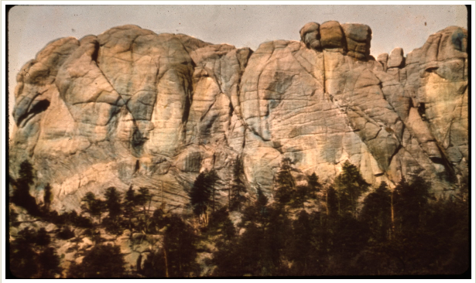
Source: Theodore Roosevelt Digital Library, accessed July 14, 2015, http://www.theodorerooseveltcenter.org/Research/Digital-Library/Record/ImageViewer.aspx?libID=o274934.

Although Robinson had his own ideas about the carving, a sculpture of western heroes was not Borglum’s preferred subject. He moved away from these original ideas, which included figures of Native American leaders who had lived in the Black Hills, and chose subjects that he believed represented the entire nation: four American presidents. He situated the reasoning for the choices of these four men within the idea of American expansion and exceptionalism; it was these four presidents who had done their best to make sure America reached from “sea to shining sea” and remained the greatest country in the world through their political prowess. As a symbol of American exceptionalism, Mount Rushmore was to express the belief that America was the greatest country in the world with a special, “manifest” destiny of leadership and power. Borglum chose Washington for his contributions to American independence and the Constitution; Jefferson for the Declaration, and his Louisiana Purchase that expanded the country to include the areas in the West like the Dakotas; Lincoln for his efforts that maintained the Union and expanded some American freedoms to African American slaves (even though this still didn’t include all Americans); and T. Roosevelt for his Panama Canal that fulfilled Columbus’ dream to find an easier trade route to Asia. It was with these ideas that Borglum undertook one of the largest sculptures of all time.
In order to complete such a large and work-intense project, Robinson and Borglum needed support. They turned to their comrade of influence, Senator Peter Norbeck, to gain state and federal backing. Over time, Norbeck, with the help of South Dakotan Congressman William Williamson, wrote and moved bills through both the South Dakota Legislature and Congress. First, they worked to create The Mount Harney National Memorial Association (MHNMA) in 1925, which oversaw the beginning process of the project. Next, in the same year, they wrote a bill to Congress requesting permission to use a portion of federal land considered the Harney National Forest for their project. Then, in 1929, they presented and passed an act to create the federal Mount Rushmore National Memorial Commission (referred to as the Commission in this paper) that took over for MHNMA. Finally, from 1929 to 1938, they created several acts that would secure federal funding to up to half the cost of the monument. As a side note, under Executive Order 6166 of President Franklin Delano Roosevelt in 1933, Mount Rushmore was placed under the jurisdiction of the National Parks Service, which oversaw all duties of the Commission after that time. With federal support and a commission to oversee private fundraising and the creation of the memorial, the Mount Rushmore National Memorial project was underway.
From 1927 to 1941, through the Great Depression and the beginning of World War II, Borglum and his crew sculpted the figures seen today. It took 400 workers, six years of construction (spaced out over fourteen years because of layoffs and lack of money), and the unwavering and determined character of Borglum to complete this project. However, there were portions of Borglum’s plan that were not completed. Along with a massive sculpture of the four presidents from waist to head, his plan shown in Figure 2, Borglum wanted an inscription that stretched the entire height of the mountain detailing the major events of American history. Borglum originally assigned President Coolidge the task to complete this inscription, but when his version was to Borglum’s dissatisfaction, Borglum chose to complete an artistic rewrite. This rewriting created a scandal and Coolidge died before it could be resolved. Over time, the idea fizzled out due to lack of funding.

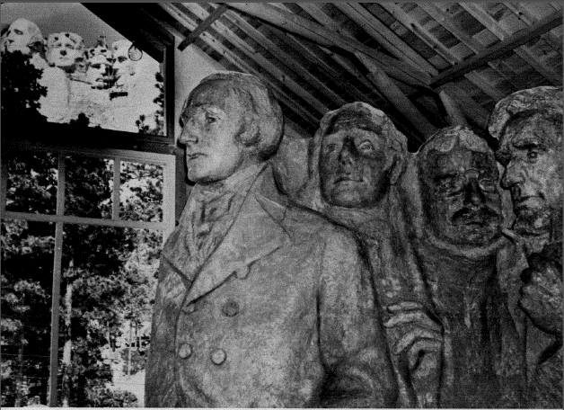
Figure 2: Borglum’s Model

Source: Photo from Mount Rushmore National Memorial Commission, Mount Rushmore National Memorial: A Monument Commemorating the Conception, Preservation, and Growth of the Great American Republic (Keystone, SD: Mount Rushmore National Memorial Commission, 1941), 11.

The second project that Borglum set out to complete was a Hall of Records, which would be carved into the stone behind the heads of the four presidents and contain an archive of such important materials as the Declaration, Constitution and presidential mementos. This project also screeched to a halt due to lack of funding. Sadly, Borglum was unable to see his project finished as on March 6, 1941, he died of a sudden heart attack. With the approaching United States involvement in World War II, his son Lincoln completed his work quickly, supervising what was only necessary to refine and complete the faces that were already underway. October 31, 1941 was the final day of carving.

A Brief History of the Black Hills and the Lakota

The above “A Brief History of Mount Rushmore” that I have provided intentionally ignored an important and crucial aspect of Mount Rushmore’s history. In many sources that discuss Mount Rushmore, the history of the original inhabitants of the Black Hills, the Lakota, is largely ignored. To the Lakota, the granite uplifts and majestic forests of the Hills, the later location of the carving of the American monument Mount Rushmore, were powerful, sacred, and the home of the bison, their most precious food source. According to Jeffery Ostler in The Lakotas and the Black Hills, anthropologists believe the Black Hills were the center of the Lakota’s world. “Vertically connecting all aspects of the Lakota cosmos…[the Hills] link the heavens to the earth’s surface, while the underground caves link the earth’s surface to the depths of the earth, the wellspring of humans and the bison.” This is the place where the seven directions (East, South, West, North, Above, Below, and Center) manifest themselves to the greatest degree.
In the nineteenth century, Lakotas differed in their response to U.S. expansion. Some Lakota believed in compromise with Americans to avoid bloodshed, while others were willing to take up arms to defend their land from encroachment. Following the gold rushes in California, Colorado, and Montana, and the movement of farmers to find fertile land on the west coast, more and more Americans migrated to the west, passing through the Lakota’s territory in the Dakotas. Some of them ultimately chose to stay. Those Lakota who chose to fight back against this expansion saw rather violent relations in the 1850s through the 1870s. Leaders like Sitting Bull, Crazy Horse, and Red Cloud worked together to defend the Black Hills and their hunting lands from invaders. It should be noted that Robinson’s original ideas for the monument included some of these figures as possible subjects. The Lakota resistance to expansion was often settled with US government treaties, especially those in 1851 and 1868 that defined Lakota reservations and specifically recognized the Black Hills as Lakota land.
However, the US government was concerned about the “warlike” Lakotas and in 1874, they sent an expedition to determine where to build a military fort and take account of the Black Hills’ natural resources. Lieutenant Colonel George Armstrong Custer led the expedition, followed by a substantial backing of cavalry, infantry, and artillery in case the Lakotas or Cheyenne decided to fight them. While scavenging the Hills for natural resources, Custer’s men found untouched supplies of timber, clean water, and gold. To seize these precious resources, the US government wanted to take the Black Hills from Lakota control. To remove the Lakota from the land, the United States sent troops, including Custer’s cavalry in 1876. Meanwhile, anticipating this removal, the Lakota and Cheyenne gathered from all around the Dakotas to resist, congregating to 7,000 at Little Big Horn. Custer’s cavalry met these numbers on June 25, 1876, and by June 26 all 210 men of the unit, including Custer, were defeated. Soon after, the United States sent more men to the Black Hills and surrounding area to negotiate and, if necessary, fight the Lakota to move to their reservation lands. This conflict and subsequent negotiations are known as the Great Sioux War or Black Hills War. Near the end of this conflict, some Lakota leaders realized, due to disease, hunger, and the lessening number of bison in the area, that they were dependent on government support. With the provision that they would receive compensation for the Hills, they reluctantly agreed to move to reservation lands, and Congress ratified the agreement on February 28, 1877. However, the Lakota did not receive said compensation. Eventually, the Lakota were separated onto six reservations in western South Dakota – Rosebud, Pine Ridge, Lower Brule, Cheyenne River, Standing Rock, and Crow Creek. The map in the appendix shows the original Great Sioux Reservation, as it was referred to in the treaty in 1868 that included the Black Hills, and the current reservations of the Lakota.
With the Lakota forced to live on small reservation lands, the US government implemented assimilation policies in the 1880s, suppressing their religion and language, promoting American education through boarding schools, and forcing families to privatize their land in allotments. Some Lakota resisted, both completely and selectively. The most notable form of resistance were the Ghost Dancers, a group of Lakota who believed a new ritualistic dance would “usher in a new world in which non-Indians would either be destroyed or removed.” The US government saw this new dance as a threat to their authority, and President Benjamin Harrison ordered a regiment to South Dakota in 1890, an order that led to the Wounded Knee massacre that killed approximately 300 Lakota who were peacefully fleeing to the Pine Ridge Reservation.
To prevent further loss of life and land as the twentieth century emerged, Lakota leaders used their American education to negotiate with the US government. They were still incredibly dependent on the aid the government gave them, as their attempts to embrace farming techniques and develop a cattle industry were unsuccessful. When the ideas for Mount Rushmore came around, the Lakota had very little employment opportunity on the reservation and had difficulties dealing with the structures of a capitalist economy. Some Lakota did travel off the reservation to the Black Hills, hunting, harvesting plants, trading, and bathing in hot springs. Yet, Ostler notes, “fewer Lakotas traveled into the Black Hills, and for those who did, American ownership of the land drastically altered their experience.” Since 1892, the Lakota had attempted to make strides for compensation; “since the Black Hills were generating considerable wealth for Americans, Lakotas believed the government had a moral obligation to provide current and future generations of Indians with a fair share of the wealth.” They signed petitions, sent representatives to Washington D.C. to discuss their rights, and, when they gained access to the Court of Claims in 1920, began to compile evidence to support the Lakota rights to the Black Hills. Claims filed in 1933 and 1954 were both rejected by the Court of Claims and the Indian Claims Commission (ICC).
While Lakota lawyers worked to gain compensation for the Black Hills throughout the mid-twentieth century, Lakotas worked to regain their land and claim to the Black Hills areas in other ways. In 1946, a man named Korczak Ziolkowski and several American Indian leaders took up a symbolic fight. They planned and designed the project of the Crazy Horse memorial, a mountain carving of Chief Crazy Horse only ten miles away from Mount Rushmore that was planned to be ten times bigger than the national memorial. To the designers of the project, carving a Lakota into the Hills would leave a permanent mark of their history and culture that the federal government had attempted to suppress and eliminate. To remain separate from the US government, the Ziolkowski family and those who supported the project progressed slowly through the carving with only private funding. The Crazy Horse memorial, although making slow progress, is still not completed at the time of this writing and is expected to be in progress for nearly one-hundred years to come.
Later on, in the 1970s, the Lakota and other American Indians in the American Indian Movement (AIM) fought for their rights in different ways. At Mount Rushmore, protesters demonstrated for the right to the Black Hills as well as the rights of other American Indian groups. For example, the first major protest at Mount Rushmore began on August 24, 1970 and continued for over a month as 150 protesters camped out at the foot of the monument demanding the return of 100,000 acres to the Pine Ridge Reservation that the U.S. government had used as a WWII bombing range and never gave back. At this protest, largely nonviolent, visitors of Mount Rushmore witnessed American Indians “expressing [their own] ideas about democracy, responsibility, and governance.” However, other protests were not always peaceful or respectful. A later protest involved AIM members’ attempts to deface the monument by pouring red paint over the faces. Then on July 3, 1975, a bomb detonated in the Visitor’s Center, just days after a deadly shoot-out occurred between FBI and AIM members in the Black Hills. The protests at Mount Rushmore continued through the 1970s and subsided in the early 1980s, with the goal to bring awareness to American Indian land rights.
In 1980, a final court case for the Lakota land claim reached the US Supreme Court. Beginning in 1957, the Lakota’s lawyers had requested that the claim from 1954 be reconsidered by the Indian Claims Commission. In 1974, twenty years later, the ICC came to the decision that the seizure of the Black Hills violated treaty rights. The case soon made it to the US Supreme Court, where the final ruling favored the Lakota and provided them with the compensation of $106 million. However, the Lakota have yet to accept this money. Lakota believe that the acceptance of compensation would “officially complete a transaction that some…claim should have never taken place.” They did not only want money for the wrong that the US government had done to them, but also wanted the entirety of the Black Hills to be once again under Lakota control. Today, the money remains in the US treasury, accumulating with interest at over $900 million. Some Lakota continue to protest for their land to be returned to them, as can be seen in the poster in Figure 3.
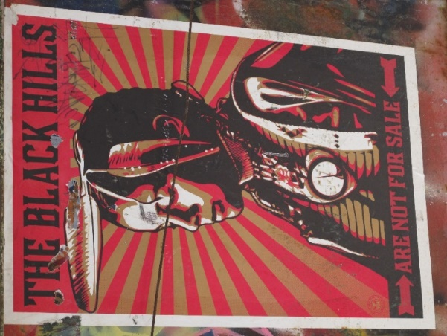
Figure 3: “The Black Hills Are Not For Sale” Poster

This picture of a protest sign was taken in Art Alley, Rapid City, South Dakota, an alley dedicated to street art and pictorial forms of protest. This poster shows that the Black Hills are still contested land. Source: Personal Photograph by Paul Kaldjian, June 28, 2013.
Historiography

There is no question that the conception, creation, and even symbolism of Mount Rushmore is a widely studied topic. Countless sources exist on its significant contributors its impact on the landscape, and its place in America’s heart. Secondary sources on the history of Mount Rushmore, no matter what period of publication, often discuss the sequence of events with patriotic undertones. However, sources on its symbolism, emerging in the 1990s, discuss the larger meaning of Mount Rushmore as a national memorial, analyzing its American expansionist ideals and discussing the ways in which the National Park Service has attempted to include evidence of Lakota history and culture in recent years.
The first official histories of the monument are contained within some of the first publications of the Mount Rushmore National Memorial Commission. Although these publications are primary sources because they were written at the time of the carving, here they are secondary sources, providing a history at some of the earliest stages of Mount Rushmore’s existence. These books, all by the name of Mount Rushmore National Memorial, were published in 1930, 1931 and 1941 and contain essays about the Mount Rushmore project and detailed information about memorial dedications. In the first book, the first essay “Origin of Plan and South Dakota’s Part in Memorial Project” is worthy of mention. This essay rightly names Doane Robinson, the state historian of South Dakota at the time of its carving, as the originator of the project, depicting his inspiration, his recruitment of Gutzon Borglum as the sculptor, and the process of passing acts through Congress for the funding and creation of Mount Rushmore as a national monument. Even at such an early stage in the sculpting of Mount Rushmore, the project was depicted as a national monument for the greater American public.
Likewise, in the second book from 1931, the essay, “The History of the Memorial” by Doane Robinson is of consideration in this historiography. Perhaps the most interesting characteristic of this short history is the openness in which Robinson writes about the controversies surrounding Mount Rushmore. “It was not received with notable enthusiasm in the state and the Black Hills residents generally were hostile… the Hills people thought that it meant cutting up the Needles along the highway,” he writes, referring to the spectacular granite needle-like formations in a section of the Black Hills. This the denunciation continued even after the first dedication by Coolidge in 1927. From this source, there is no question that Mount Rushmore’s presence has been contested from its very beginning.
The final Mount Rushmore National Memorial Commission book from 1941 contains a history as well, within the article “From the Beginning” by Mrs. Gutzon Borglum. Much like other essays before her, Mrs. Borglum parallels the work of the presidents of Mount Rushmore with the men who developed and created the sculpture, completing an exceptional and uniquely American work. “This is the history of Rushmore told in a few words,” the author began, “… two outstanding facts are that a few kindred souls, giants in their day, fostered a form of democratic government and established a great nation, and that a hundred and fifty years later another group of Americans realized the importance of making a record in the granite for all time.” The author described the works of the main players and organizations and G. Borglum’s choices of the four presidents, much like other histories before hers; however, she adds something new to the history of Mount Rushmore. For the first time, she compiled the detailed process of carving, the methods, tools, and precautions taken by G. Borglum and his men to produce the giants of Mount Rushmore.
Following the completion of Mount Rushmore in 1941, the very first source to depict a complete and detailed telling of Mount Rushmore’s history emerged in 1952. Author Gilbert C. Fite was known for his work as a Western historian and spent his lifetime as a history professor at both the University of Oklahoma and the University of Georgia in Athens, and as the president of Eastern Illinois University. Although he has written mostly on American farmers, Mount Rushmore is his most popular book, with a staggering eleven printed editions since its first publication. In fact, nearly all of my sources on Mount Rushmore cite Fite within their bibliographies.
Fite used documents from the Mount Rushmore National Memorial Commission, the National Parks Service, and the private papers of the actors involved in the history of Mount Rushmore including Doane Robinson, Gutzon Borglum, and Peter Norbeck to tell his history. This history is detailed, creating a narrative of the difficult journey from the conception of the monument to the final days of its carving. Fite delved into the many financial hardships that the project faced and the thoughts, processes, and goals that the main characters, especially Borglum, carried with them throughout the course of Mount Rushmore’s creation. Additionally, Fite used facts and interpretative liberty to present a history that is symbolically neutral. Fite attempted to discuss an American monument with main players that had intensely patriotic ideas in a more objective way than the Mount Rushmore National Commission books. His discussion of Borglum has been considered especially critical for his time, mostly because he was not described as a man with godly hands and a fantastic vision, but rather as a character with flaws and a controversial personality. In fact, approximately a third of Fite’s book talks about the conflicts that Borglum faced with the Commission, government officials, and Mount Rushmore critiques. “His [Borglum’s] strong individualism, crusading spirit, and confident and dominating manner were bound to bring conflict – and he flourished under conflict.” These stories make it clear that Mount Rushmore is not the pristine monument, untouched by controversy, but, instead, has been a contested project and site since its conception.
However, many books detailing Mount Rushmore’s history do not use neutral rhetoric to discuss Mount Rushmore. The next source exemplifies this trend, Mount Rushmore: The Story Behind the Scenery was written by Gutzon Borglum’s son, Lincoln Borglum, first published in 1977. Much like Fite’s work, the longevity of Borglum’s book is remarkable with ten printings, the newest published in 2006. The edition used for this paper is the very first. Next to majestic pictures of the in-progress and completed Mount Rushmore, Borglum presented his father as a heroic character, overcome with a colossal task that he took on to preserve and rectify the greatest men in American history. Although Borglum included all the processes, problems, and significant contributors like the histories before him, his telling is heavy with patriotic rhetoric. While evoking feelings of American patriotism and exceptionalism, Borglum explains the monument’s purpose:
It has been called a “shrine” of democracy. And it is a shrine [sic.]. One does not escape the spiritual quality of the experience here at Mount Rushmore…What is it about these faces carved in cold granite that can evoke such emotion?... Pride?... Pride that this was an accomplishment born, planned, and created in the minds and by the hands of Americans for Americans. Pride in the four great presidents whose faces reflect the dignity of the heritage that belongs to Americans. And pride in knowing that sons and daughters of generations uncountable will stand here in contemplation, just as we have done. An over-emotional, super-patriotic assessment? Perhaps. But something so inspiring, so uplifting as this monument must serve a lofty purpose – and it was this purpose for which it was in fact created.

As we have seen in some of the earliest histories and the history of the Lakota in the Black Hills, Mount Rushmore’s existence has been contested before it was even carved. As a response, academics and historians have begun to publish analyses of the meaning of Mount Rushmore on the American landscape. These studies especially became prevalent beginning in the 1990s, and in order to understand all perspectives of Mount Rushmore for context, it is important to consider these sources.
One of the first articles that analyzes Mount Rushmore’s symbolism in-depth is within American Sacred Space titled, “‘Alexander’s All’: Symbols of Conquest and Resistance at Mount Rushmore” by Matthew Glass. The book’s authors, David Chidester and Edward Linenthal define the sacred “as an uncanny, awesome, or powerful manifestation of reality, full of ultimate significance.” To them, sacred space does not only refer to cathedrals, graveyards, or battlefields, but also can be ritualized spaces with mythical orientations embedded with meaning. Beginning in the nineteenth century, this meaning has been linked to nationalism and “celebrating the ‘sacred nation’.” Often, sacred spaces encompass places that are contested, meaning different groups of people hold the site to different meanings, and may also be involved in a system of economic exchange such as tourism or consumerism.
Under all of these definitions, Matthew Glass argued that Mount Rushmore is one of the most perfect examples of a sacred space. To many Americans, Mount Rushmore is a pilgrimage site, highly ritualized by dedications, presidential visits, and holiday extravaganzas, which continually link the monument to patriotic morals and feelings. Americans use Mount Rushmore to mobilize patriotic sentiment, as in the instance when TV host and journalist Drew Pearson, “call[ed] upon the faith of the presidential figures” to guide the country during the intensely patriotic times of the Cold War in 1952. However, Glass also argues that Rushmore, as a contested sacred space, has been a launching pad for other forms of meaning for those who feel excluded and even victimized by its existence. As I explained in my brief history of the Lakota and the Black Hills, the American Indian Movement (AIM) used Mount Rushmore as their own symbol in the 1970s. “Mount Rushmore, the “shrine of democracy” erected on Lakota land, provided AIM with a powerful symbol of American spirit of conquest,” and the protesters used direct action tactics like reoccupation, public purifications, and sometimes vandalism and desecration in an attempt to reorient the public perceptions of the memorial. In these ways, the sacred patriotic space that Mount Rushmore symbolizes for many Americans was uncovered to be the once sacred and contested place of forsaken American Indian rights.
Other sources that analyze Mount Rushmore’s symbolism also focus on its sacred qualities. In American Civil Religion from 2014, Peter Gardella argues that Mount Rushmore is amongst the many monuments, texts, and images that encompass an American “civil religion.” This religion is unified by four values: “personal freedom (often called liberty), political democracy, world peace, and cultural (including religious, racial, ethnic, and gender) tolerance.” After explaining the characteristics of the religion in detail, Gardella argues that Mount Rushmore is the largest and most “hotly” contested monument of the religion. He argues that the very carving of four presidential heads in permanent granite is proof of the negative relationship between Americans and American Indians, as well as the natural world. Believers of American exceptionalism carved millions of tons of granite from the once sacred and natural land of the Lakota to claim and create their very own sacred space.
Like many others before him, Gardella used Jesse Larner’s Mount Rushmore: An Icon Reconsidered to understand this complex relationship between the Lakota and Mount Rushmore. Larner was perhaps the first historian to compile the trials of the Lakota at Mount Rushmore in full form, discussing the first days of white settlement in the Black Hills and the subsequent relationship they experienced with the US government in his book from 2002. Larner also discussed other controversies he believed had been hidden from the public’s knowledge, including Borglum’s affiliation with the Ku Klux Klan. However, Larner’s discussion of Mount Rushmore as a site of conquest is one of controversy itself. Critics of his work believe he only picked parts of Mount Rushmore that would make it look “evil” and advance his own hate for the monument. Larner’s voice is quite harsh when he uses statements such as: “Perhaps, in the fullness of time, Rushmore will become a purely commercial playground… bereft of ideology.” However, I believe Larner was only afraid that the Lakota story would continue to be swept under the rug next to the American nationalism of Mount Rushmore. He recognized that Mount Rushmore must confront its entire history, both its patriotic meaning and its meaning as a contested site, or “it will be a monument not to truth but to a part of a truth, not to America’s greatness but to the capacity for self-deception that a strong and successful people have developed out of necessity.”
Since Larner’s book, there has been more movement to include other perspectives amongst the history and meaning of Mount Rushmore. In fact, the National Park Service has made efforts, although small and insignificant at first, to incorporate diverse voices into their public presentation of the site. In Exhibiting Patriotism: Creating and Contesting Interpretations of American Historic Sites, Teresa Bergman explores the changing symbolism of Mount Rushmore through the twentieth and into the twenty-first century. Before 1963, the National Parks Service used Borglum and his ideals of American expansionism and patriotism as the only story and purpose of Mount Rushmore. Over time, however, orientation films, museum exhibits, and other forms of public presentation have evolved to include more than just the main players and main meanings. Exhibits and audio tours began to mention ordinary Americans who worked on the mountain and incorporated the story of the Lakota historical presence in the Black Hills.
Bergman’s book, one of the newest written about Mount Rushmore, explained the new changes that have begun to incorporate this historical presence. The official audio tour is now available in the Lakota language, and the installation of Heritage Village in 2007 made strides to incorporate the Lakota culture and history directly on the site of Mount Rushmore. This heritage village now contains two tipis and is the site of summer workshops that introduce visitors to Lakota culture and religion. The incorporation of American Indian culture at Mount Rushmore is fragile and contested by some who believe it does not belong there (one critic believed the exhibit didn’t “fit with the ‘theme’ of Mount Rushmore”), but it does show an effort to present sides of the Mount Rushmore story that have seemed to have been hidden for many years. The advice of many historians who study Mount Rushmore’s symbolism is this: allow Mount Rushmore to be a national monument of patriotic fervor, but do not ignore its other meanings. Studies like those I have just discussed help more Americans see this necessity for Mount Rushmore.

Mount Rushmore Publications and Public Perceptions

Are the complex understandings of Mount Rushmore’s symbolism truly reflected among American public perceptions of the monument? Or, have Americans chosen to see Mount Rushmore as one-sided, guided by the first official presentations of the monument through the Commission? An analysis of these first documents juxtaposed next to the public perceptions of Americans outside of South Dakota during the time of Mount Rushmore’s carvings (1924-1941) and fifty years later (1974-1991) reveals some fascinating and unexpected patterns. An analysis of some of Mount Rushmore’s earliest publications will help to uncover a thorough understanding of the interpretation Borglum, the Commission, and other rectifiers wanted the public to understand, and will uncover the true purpose of these publications – to rally American support and recognition.
Then, to understand the public interest and opinion of Mount Rushmore outside of South Dakota, an analysis of two newspapers, The New York Times and the Madison Capital Times will show how some Americans read and thought about Mount Rushmore in relationship to these early publications. This second part to this study will look at what types of wire-service reports, locally written articles, and opinion pieces reached the national and local Wisconsin news and, subsequently, the minds of Americans. Thus, looking at these newspapers in two different periods (1924-1941 and 1974-1991) will provide an analysis of the changes in tone and content of the articles about Mount Rushmore.
Why were the New York Times and the Madison Capital Times chosen for this analysis and how do they represent public perceptions through opinion and interest? The New York Times is a daily newspaper that has been continuously published from New York, New York since 1851. Since 1918, this newspaper has received 117 Pulitzer Prizes for excellence in journalism, more than any news organization in history. These awards speak to the exceptional quality of writing the Times has presented overtime. Additionally, The Times has the second highest circulation in the U.S. next to the Wall Street Journal with an average daily circulation of 1,865,318 copies in 2013. This nation-wide prominence has existed since it earliest days, and with such widespread circulation, this newspaper represents a source that has been accessible to American audiences. Likewise, the Madison Capital Times is a paper with a rich history. The choice of this specific paper for public perceptions of Mount Rushmore may seem arbitrary, but that is the purpose of this selection. In order to get an idea of public perception in a locale separate from South Dakota, the Madison Capital Times does this work. In 1917, William T. Evjue created the paper to support the World War I war effort, and, more broadly, “as a voice of everyday people whose livelihoods and lives were at the mercy of the powerful.” The Madison Capital Times works hard to maintain this legacy as a paper for ordinary Wisconsinites. Until 2008, it was printed six days a week. Thus, both of these newspapers provide excellent examples for this study of Mount Rushmore’s public perceptions.

Mount Rushmore National Memorial Commission Publications
To provide context, the acts that created the Mount Rushmore National Memorial Commission are worthy of mention. The “Act to Create the Mount Rushmore Memorial Commission and defining its powers and purposes” in 1929 and subsequent amendments in 1934, 1935, and 1938 uncover the vastly changing size of this project over time. On February 25, 1929, congress passed the first act to create this President-appointed, twelve-member commission to oversee the funding and sculpting of the monument. Their purpose was stated as such:
The purpose of the commission is to complete the carving of the Mount Rushmore National Memorial to consist of the heroic figures of Washington, Jefferson, Lincoln, and Roosevelt, together with an entablature upon which there shall be cut a suitable inscription indited by Calvin Coolidge, and to landscape the contiguous grounds and construct the entrances thereto.

This act also instituted the allocation of federal funds to pay for half of the memorial, not to exceed $250,000. Although the amendment of 1934 simply added a clause in the case of death of one of the Commission members, the amendment from August 29, 1935 added another $200,000 to the previous federal limit. The amendment of May 5, 1938 added even more, including the plans for the construction of a stairway and museum, Borglum’s Hall of Records; the designation of an area of the Harney National Forest of two thousand to four thousand acres as the bounds of the memorial; and an increase of $300,000 in federal funds. Together, by 1938 there was $750,000 allocated to the Mount Rushmore memorial, a total that amounted to nearly $12.3 million in 2015. With the addition of private funding, the memorial is estimated to have cost $990,000, nearly $16.2 million today. The cost of the project quickly tripled its size. But that’s not the only thing the sheer cost of the monument shows. Since the federal government only funded around 75% (an amount that surpassed the original pledge for less than 50%), that means the Commission had to raise 25% of the cost, thousands of dollars during some of the most difficult times in American history. Other sources, especially Fite, have discussed the financial difficulties the Commission faced, but still they managed to raise a significant amount. How did the Commission secure this much funding?
Perhaps the key to the American pocketbook was the rhetoric of patriotism. Americans needed to feel like they were involved in the process of sculpting Mount Rushmore and that it was their monument. Furthermore, in order for Mount Rushmore to be recognized as a national monument, the American people had to see it as such. Publications written by the Mount Rushmore National Memorial Commission reflect the efforts to make Americans think about the monument, make it theirs, and donate their much needed money. The publications from 1930, 1931, and 1941 were used to rally public support for the monument, containing articles written by such figures as Doane Robinson, Gutzon Borglum, and Senator Peter Norbeck. These books contained essays about Mount Rushmore’s meaning for Americans and their history, and pictures and stories about the carving process and major events. These books are a compound of patriotic rhetoric, allusions to the great republic of America akin to Greece and Rome, and a glorification of the greatness of each one of the four presidents. Looking at just a few examples, these stories helped to rally American support, financially and morally. Without the American people, there could be no Mount Rushmore.
The first book, titled Mount Rushmore National Memorial, is rich with patriotic sentiment and stories. The “Forward” written by Gutzon Borglum himself, is included in both the 1931 and 1941 publications as well and speaks to the overall tone of these books. “A monument’s dimensions should be determined by the importance to civilization of the events commemorated,” Borglum began, a memorial that he believed would preserve an “amazing history.” He continued:
We believe the dimensions of national heartbeats are greater than village impulses, greater than city demands, greater than state dreams or ambitions. Therefore, we believe a nation’s memorial should, like Washington, Jefferson, Lincoln and Roosevelt, have a serenity, a nobility, a power that reflects the gods who inspired them and suggest the gods they have become.

Following this “Forward,” the patriotic meaning of Mount Rushmore is echoed throughout the pages. In “First Survey and the Development of the Memorial Project,” Borglum urged the monument to succeed. Using the same patriotic language, he doesn’t so much present the sculpting of Mount Rushmore as tasked only to himself, his workers, and the Commission, but instead to the entirety of the American people. If the nation fails at recording the greatness of the men who would be depicted, then they had failed to recognize the opportunity to record “the significance of their civilization in reshaping the philosophy of politics and government throughout the world.” According to Borglum, Mount Rushmore’s completion was up to all Americans.
The Mount Rushmore National Memorial: Second Book, from 1931, and the Mount Rushmore National Memorial from 1941, were likely created with much the same goal in mind. In the 1931 edition, this focus began with a statement by President Herbert Hoover, capitalizing on Mount Rushmore as America’s contribution to art, and described America in the rhetoric of a masterpiece, created by the hands of the four men who would be carved in stone. Yet, just as America was not only created by these four men, the mountain was not so much carved “to commemorate these men themselves, but as physical records of the work and aspirations of the people they led, the people who founded, developed and preserved our great western republic.” Like Hoover, these books presented the American people with their important role, to preserve American history and government through Mount Rushmore.
“The Men of the Mountain” in the 1931 edition, recognized, yet again, the four presidents that Borglum was carving. “The Men of the Mountain do not belong to South Dakota, they belong to You,” the article opens, calling upon the trials of the four presidents who would be depicted on the mountain. The trials of these presidents were greater than those of the enshriners of Mount Rushmore, no doubt, but perhaps no less important. As the four presidents’ “memories will be cherished as long as, and wherever one drop of American blood beats in an American heart,” so too would Mount Rushmore, a task that would need all of Americans behind it to be completed.
The Commission complied the third publication, published in 1941 with the subtitle “A Monument Commemorating the Conception, Preservation, and Growth of the Great American Republic,” as the final marks of the chisel were being made on Mount Rushmore. Borglum’s sudden death was fresh in their minds, and this final publication memorializes the work of his mortal hands. Preceded by a full-page picture of the sculptor himself, the article “The Mighty Works of Borglum” compared Borglum to the creative masterminds of Shakespeare, Beethoven, and Michelangelo. “The heads stand up there against the clouds like cloud-gods. Yet they are not offered as gods, but as plain men who glorified the plain men.” Mount Rushmore is glorified as a masterpiece, rivaled by none other in history, and “only a great soul and a great artist could have conceived or achieved such a monument to them and to himself. His gifts of spirit and execution were, I feel, unsurpassed by anything of their kind in the history of the world.”
The rest of the 1941 book painted Borglum in the same light. Next to the pictures of the nearly completed monuments are those of other works by Borglum. In the history “From the Beginning” by Mrs. Gutzon Borglum she began, “A nation’s memorials are a record of its civilization and the artist who builds them is the instrument of his time. He is inspired by the same forces that influence the nation’s destiny – the greater the period, the greater the art.” After a brief comparison of Lincoln to Jesus of Nazareth, in the article “The Shrine of Democracy” the greatness of Borglum’s work is matched only to the accomplishments of the men on the mountain and the greatness of America itself. Yet, above all, author Judge Albert R. Denu described exactly the official purpose of Mount Rushmore as a shrine:
“The Shrine of Democracy” will ever serve to awaken this nation to a consciousness of its own powers and mission; that it will rekindle in the hearts of millions, from every corner of the globe, the passion for civil equality that glowed in Independence Hall and burst into flame in the tattered tents of Valley Forge, on the field of Gettysburg and on the Hill of San Juan; that it will proclaim with much eloquence, for unnumbered centuries, the eternal truth that the individual, and not the state, is the unit of value by the “Laws of Nature and of Nature’s God.

In this way, the third book of the Mount Rushmore National Memorial Commission glorified the sculptor, the sculpture, the men on the mountain and the country they all represented.

Public Perceptions 1924-1941
Even with such publications about the monument circulating, how did the American public discuss and think about the monument? Yes, newspaper articles from the New York Times and the Madison Capital Times during its years of creation sometimes reflected this patriotic rhetoric of an enshrining monument. However, there were other contexts in which the American public chose to situate the monument. Within the New York Times, a staggering 111 articles mentioned Mount Rushmore between 1924 and 1941. The first type of article did in fact reflect this patriotic symbolism of Mount Rushmore, describing the project that lay ahead for Borglum, portrayed within these articles as the ingenious sculptor. For example, a 1930 half-page spread titled “America’s Story on a Mountain Cliff,” showed two large pictures of Borglum’s model and the untouched surface of Mount Rushmore next to a lengthy description of the proposed sculpture and entablature. This article praised Borglum for his ingenious ideas and described his tireless methods in much the same patriotic style. Later, near the end of Mount Rushmore’s carving, another article in 1940 praised Borglum through his reminiscences of his grand work of art. Descriptions of the “four hundred thousand tons of rock” that had been stripped away from the mountain, and the only three tools that were used in its carving “air drills, dynamite, and hand chisels” were juxtaposed next to Borglum’s statements of, “Every nation, when it becomes truly great, builds its monuments in its own likeness,” and, most grandly, “I feel that the supreme accomplishments of men should be cut into, built into, the crust of this earth so that these records will have to be worn to dust and blown away before the record of the nation’s greatness shall perish.” Thus, much like the Commission publications, some articles within the New York Times described Mount Rushmore and Borglum in the most patriotic and noble ways possible.
In addition to these articles, it seems that announcements of every dedication and celebration at Mount Rushmore appeared in the New York Times. When the heads of Washington, Jefferson, and Lincoln, were unveiled in 1930, 1936, and 1937, respectfully, and even when a new road to Mount Rushmore was completed (1935), the news reached the American people through the New York Times. However, one pattern of these dedication announcements is striking. There is no final dedication for Mount Rushmore in 1941. After Gutzon Borglum’s death in March, the New York Times coverage of the memorial drops only to a few words of Lincoln Borglum’s work and completion on October 31.
Additionally, the discussion of Mount Rushmore in the New York Times was not always positive nor patriotic. After the first lines of the proposed entablature surfaced within the paper, citizens wrote letters to the editor concerned that the inscription was “garbling our history.” One writer explained how the entablature only included “the right to seek happiness” as an unalienable right, failing to include “enjoyment of liberty, equality and justice,” along with other fatal mistakes that would create misconceptions about our history. Later, when confirmation surfaced that it was not Coolidge who had made these mistakes but rather Borglum who had revised it, an article describing “protests” of a revision that “abrogates the supreme law of the land” appeared in ink. In fact, other criticism about Mount Rushmore within the New York Times directly involved Borglum. When the associate director of the National Parks Service described Borglum as a “very temperamental sculptor” after the Commission had a difficult time keeping him in line, Borglum’s retort reached the New York Times. Mount Rushmore was “no boy’s job,” he responded, and such difficult work required the work of an artist’s “judgement and understanding” which, Borglum believed, “neither he [the associate director] nor his Congressional listeners could understand.”
Citizens also wrote into the New York Times concerned with Borglum’s choices of the four presidents who were being carved on the Mountain. To some, Washington, Jefferson, Lincoln, and T. Roosevelt were not the best choices; perhaps a likeness of Woodrow Wilson, the great World War I president, should be considered for such an honor. One such editorial, which you can see in Figure 7, used sarcasm to express this concern. Thus, articles in the New York Times varied along a continuum, from the supportive and enthusiastic descriptions of the project, to the criticism of Borglum’s character and choices.

Figure 4: “Wilson’s Name Not There”
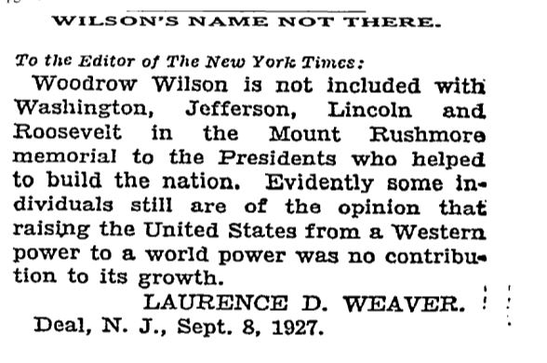

Source: Laurence D. Weaver, “Wilson’s Name Not There,” New York Times, September 8, 1927.

On a local level within the Madison Capital Times, there were only a few articles that mentioned Mount Rushmore at all. Between the years of 1924 and 1941, the first article appeared in 1930 and the memorial was only mentioned ten more times before 1942. Of course, some of the articles announced its construction. The first, on July 6, 1930, was a miniscule wire-serviced article from Rapid City, SD amongst the “world news” that mentioned the creation of “Gutzon Borglum’s mountain sculptures, a national memorial that he plans to complete by 1933. In the same year, on November 21st, a piece of Mount Rushmore was brought closer to home, as an article announced that Dr. Glen Frank, president of the University of Wisconsin – Madison, may soon have a hand in writing Borglum’s 300-word entablature of the United States history. These few small articles describing Mount Rushmore in the Madison Capital Times are in stark contrast to the half-page spreads within the New York Times.
Notably, there were other articles that mention Mount Rushmore within the Capital Times, especially within the “Answers to Questions” section where residents wrote in to have their questions about Mount Rushmore’s answered. These included anything from Mount Rushmore’s rock (“Upon what kind of rock is the Mount Rushmore Memorial carved?”) and for whom the mountain is named after (Charles E. Rushmore, a New York mining engineer). Mount Rushmore is even the subject of an “Errorgram” seen in Figure 5. However, the largest and perhaps most fascinating portions of the Capital Times that mention Mount Rushmore are tourist advertisements. Looking at a South Dakota advertisement from 1941 closer, shown in Figure 5, it is clear that Mount Rushmore is once again perceived through its patriotic meaning to attract American support in a different way – through tourism. “And as you look up at Gutzon Borglum’s majestic Shrine of Democracy on Mount Rushmore,” it read, “your American pride will tingle.” When this tourist ad was written in 1941, Mount Rushmore was close to completion but barely so. Such an ad speaks to its immediacy as a tourist attraction in American minds, a site to see as you experience the “Spirit of the West” in South Dakota. It is also notable that no news of the entablature controversy nor Borglum’s character or choices reached the Capital Times. Likewise, news of Mount Rushmore dedications were not included in this local newspaper.
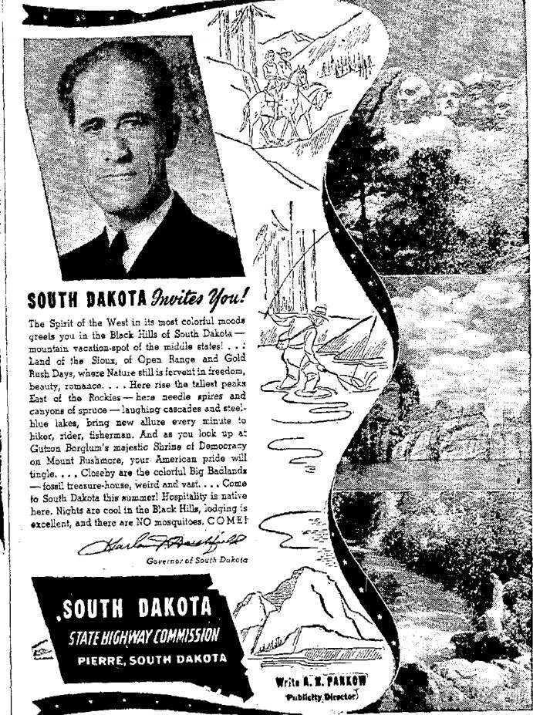
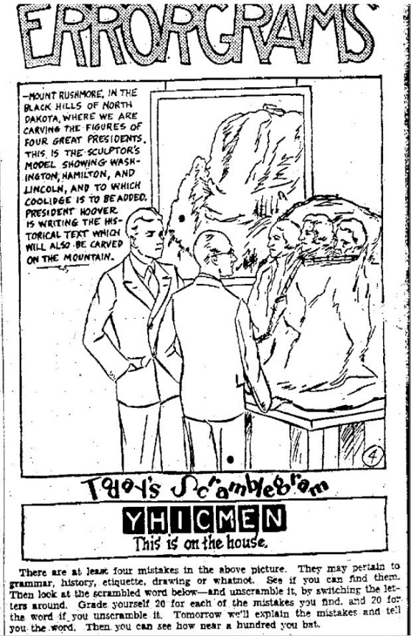
Figure 5: “Errorgrams” Figure 6: “South Dakota Invites You!”

Source: “Errorgrams,” Madison Capital Source: Harlan J. Bushfield, “South Dakota
Times, August 4, 1930. Invites You! Madison Capital Times, June 22, 1941.

Public Perceptions: 1974 – 1991

Did public perceptions and contexts in which Mount Rushmore were discussed change fifty years after its carving? According to the New York Times database, between the years of 1974 and 1991, fifty years after its conception and carving, there are 554 articles that mention Mount Rushmore. However, a significant amount of these, in fact hundreds, only mention Mount Rushmore in passing, as a national symbol or a pop culture icon. Of course, this fact alone is of note, showing how Mount Rushmore had become a symbol and landmark of common knowledge for nearly all Americans by the 1970s. “Mount Rushmore” was even the nickname for Minnesota Vikings coach Bud Grant during the 1970s and the idea was jokingly tossed around that a national lottery prize should be to “hold your wedding on Mount Rushmore”. In fact, just the words Mount Rushmore seem to have become synonymous with “monumental,” as one opinion writer describes a college dorm room’s piles of clothes as the “Mount Rushmore of rags.” Another article described how closely Mount Rushmore was associated with America: “Say “America” and a lot of images spring to mind. The Pilgrims, of course. Indians. The Great Plains. Mount Rushmore. Coca-Cola. Freeways. Malls.” It seems that fifty years after its carving, Mount Rushmore was engrained in everyone’s mind as national symbol.
Nevertheless, some of the New York Times articles speak directly to contexts and events related to Mount Rushmore. As I discussed above, Mount Rushmore was the site of AIM protests during the 1970s. Surprisingly, a scan through the articles of the New York Times from 1974 to 1991 (and even looking all the way back to 1970) yields only a few articles about these protests. When the bomb detonated at the visitor’s center in 1975, the New York Times published only a small article that briefly explained the incident and neither denied or accepted that the event was related to the shooting deaths in the Black Hills that had occurred a few days beforehand. Most other significant articles about American Indian protests at Mount Rushmore were printed before 1974, one in 1970 describing the protest of the acreage of the Pine Ridge Reservations that had been taken during WWI, and another, in 1971, that described the arrest of twenty protesters who camped on top of Mount Rushmore for the Lakota 1868 treaty rights to the Black Hills. In fact, there was no mention of the Lakota Black Hills case that reached the U.S. Supreme Court in the 1980s. A later article in 1987 described Senator Bill Bradley’s attempts to pass a bill that would return the Black Hills to the Lakota, but nearly no other mention was made.
Other articles that mention Mount Rushmore during this period refer to the celebrations of fiftieth anniversaries. One article by Robert J. Dunphy on June 29, 1980, “Travel Notes: A Fiftieth Anniversary for the Mount Rushmore Monument,” described the upcoming fiftieth anniversary of Washington’s unveiling, “an event that signaled its rise from obscurity to become one of America’s most popular sightseeing attractions.” This characterization alone – as a sightseeing attraction – exhibits how Mount Rushmore had become the target of many American road trips. Yet, surprisingly, other articles about 50th anniversary celebrations, even the final celebration in 1991, were only mentioned briefly in the New York Times. Of more interest was the “face lift” that Mount Rushmore would receive, funded by the minting of commemorative coins. Half of the proceeds for these five, one, and half dollar coins would be given to the Mount Rushmore Memorial society for improvement, estimated at up to eighteen million dollars.
The final type of article that appeared in the Times were those that discussed the idea to carve Ronald Reagan’s face next to the five presidents on Mount Rushmore. Much like the discussion to include Woodrow Wilson in the earlier years, these articles discussed conservative leaders’ ideas to enshrine the president. However, really no critical views of this subject surfaced in the New Yok Times. In fact, one article mentioned how Ronald Reagan himself may have “smiled on the project.”
In the Madison Capital Times there are significantly more articles and mentions of Mount Rushmore between 1974 and 1991 than during the sculpting years, 169 articles to be exact. This alone has significance; Madison residents were likely more aware of Mount Rushmore than during its sculpting years. However, much like in the New York Times, most of these articles only refer to Mount Rushmore, as a symbol and popular culture icon. Also like the New York Times, there were articles that merely described features of Mount Rushmore. One notable article from December 7, 1972 answers the question “Who Carved Mount Rushmore,” perhaps indicating that Gutzon Borglum was no longer closely associated with the memorial by the 1970s, at least in Madison, Wisconsin. Other articles mention the “face lift” around the 50th anniversary, and the minted coins that would be sold to pay for these repairs. Yet, also like the New York Times, much fewer articles than expected spoke of fiftieth anniversary dedications and celebrations.
The most prominent and fascinating articles about Mount Rushmore in the Madison Capital Times were of two specific themes. The first, which dominated the late 1980s mentions, were those that discussed the addition of President Ronald Reagan to the mountain. Yet, although this was also mentioned within the New York Times, authors within the Capital Times took a much more editorial approach to this topic. In fact, all of the articles reassured the readers of the Capital Times that such a memorial would never happen. Amongst drawings like the one in Figure 6, journalists explained how a new carving would compromise the structural integrity of the memorial, that history had not yet judged Reagan for his work as president, and, most strikingly, that “Reagan’s memorial should be something a tad more dramatic” not stuck in “the middle of nowhere.”

Figure 7: Ronald Reagan on Mount Rushmore
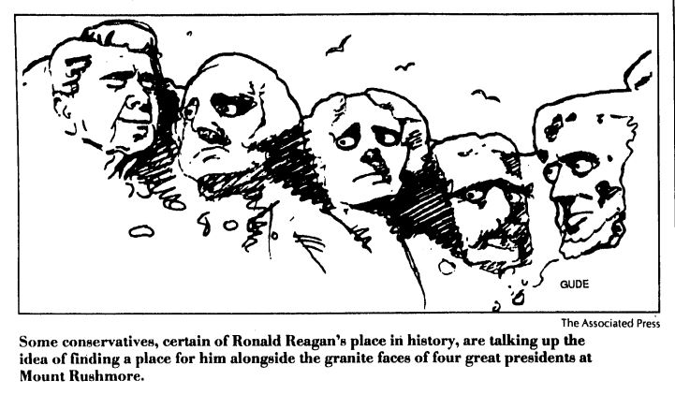

Source: Madison Capital Times, pictured above “Reagan on Rushmore” May 18, 1989.

If this jab to Mount Rushmore’s location was not enough of a criticism, the final theme of the articles in the Madison Capital Times were editorial critiques. One critique of the monument especially stands out. On July 29, 1974, John Stallard, a self-professed naturalist, claimed in his article “Mount Rushmore – no work of art” that visiting Mount Rushmore was much like “come[ing] way out here to see an artificial “pink flamingo,” one of those lifeless, machine-molded bird statues which grace some of the front lawns in Gary, Ind.” Located on the site of a broken treaty agreement, Stallard explains the unfortunate circumstances of the Lakota and then characterizes the carving as “the rape of a mountain, the desecration of natural beauty.” Referring to Borglum as just an engineer who did barely any work, Stallard bashed the federal government’s support of the project and defined it as one of their “great mistakes”. This is one of the only articles of its kind, but it speaks loudly. It marks the emergence of people around the country who became more aware of Mount Rushmore’s contested character and are not afraid to question its patriotic legitimacy.

Conclusion

What do the analyses of these newspapers tell about the American public perception of Mount Rushmore during its early years and fifty years after its carving, and what might have happened in the decades between (1942-1973) that caused such a change? Firstly, the difference in the scale of which Mount Rushmore is discussed in its early days when comparing the New York Times and the Madison Capital Times is striking. The New York Times followed every event at Mount Rushmore incredibly closely, following much closer to the patriotic rhetoric and overall goal of the Commission publications. The New York Times did its job to keep the public informed about the new national monument that was being erected as a testament to the nation’s history. However, the American public was not afraid to be somewhat skeptical about Borglum’s character and choices. Citizens recognized that his rewrite of the entablature script was fatally full of misconceptions and spoke out about the choices of the four presidents who were to be permanently carved in stone.
On the other hand, such criticism did not surface on the local level in the Madison Capital Times in these early years. Instead, the general impression the Capital Times offers about the average American in Madison, Wisconsin is that they knew the monument was being carved, but likely did not follow it closely (unless of course they read newspapers like the New York Times). Likewise, the Capital Times showed what Mount Rushmore would soon become – a popular and unique tourist attraction of South Dakota. Thus, it seems that on a national scale, Americans were aware of Mount Rushmore, but it was not yet the major national landmark that is engrained in American minds today.
As far as criticism about Mount Rushmore goes, the pattern observed in the early years seemed to flip fifty years after its carving. While the New York Times articles are largely neutral in their discussion of such things as the proposed addition of Ronald Reagan and even the American Indian protests at Mount Rushmore, the articles within the Madison Capital Times take a much more critical stance on some issues. Perhaps this pattern reflects the tendencies of the papers – the New York Times as nonpartisan and the Capital Times as slightly progressive – yet, it also uncovers a possible trend among the American people. While articles in the New York Times about controversial topics were largely written by journalists, the articles in the Capital Times were editorials. The American people were becoming more and more willing to question the patriotic narrative of Mount Rushmore.
However, this pattern does not transfer to the discussion of American Indian issues and the Black Hills in either paper. Articles about the Lakota US Supreme Court case and AIM protests at Mount Rushmore are very few in the New York Times and absolutely nonexistent in the Capital Times. Although it is likely some news of these events did surface to the American public outside of South Dakota, the fact that they were not associated with Mount Rushmore is concerning. Even fifty years after its carving and during a time when the Lakota and other American Indian groups attempted to bring their grievances into the public eye, the American public remained largely unaware of this controversial side of Mount Rushmore.
What can this tell us about the efforts of the National Parks Service to portray a perspective of Mount Rushmore that included American history? They seemed to not reach the public, at least up until 1991. Perhaps it was this lack of discussion that spurred the movement of historians to analyze Mount Rushmore’s symbolism more closely beginning in the 1990s. Perhaps they recognized the willingness of the American public to question Mount Rushmore, and their inability to grasp the entirety of the situation.
Finally, the analysis of these newspapers separated by a fifty-year span shows us another pattern. In the above analysis it is noted that both the New York Times and The Madison Capital Times had significantly more articles that merely mentioned Mount Rushmore in 1974-1991. In these articles, Mount Rushmore stood as a popular culture icon and a symbol that authors used as a descriptive metaphor. In the thirty years between 1941 and 1973, Mount Rushmore rose to the national attention that Robinson and Borglum had hoped for, but with a different twist. Instead of being spoke of with patriotic rhetoric, it became a symbol of irony or kitsch – “art, objects, or design considered to be in poor taste because of excessive garishness or sentimentality, but sometimes appreciated in an ironic or knowing way.” Instead of only being a patriotic symbol of American democracy as it was intended, Mount Rushmore became a clichéd and excessive piece of sculpture on the American landscape, and a roadside attraction akin to “America’s Largest Spool of Thread.”
One way to track the growing prominence of Mount Rushmore from 1942 to 1973 is to look at its visitor count over time. A quick look at the increase in visitors over this thirty-year period shows the progression of Mount Rushmore becoming a much more popular destination. The following table shows five-year intervals of visitor numbers from 1941 through 1991. Pay close attention to the in-between, thirty-year period.

Table 1: Mount Rushmore Visitor Counts from 1941-1991

Year | Number of Visitors
1941 | 393,000
1946 | 323,596
1951 | 740,499
1956 | 829,800
1961 | 1,030,400
1966 | 1,585,200
1971 | 2,281,200
1976 | 1,733,500
1981 | 1,604,991
1986 | 1,648,737
1991 | 2,011,522

Source: “Mount Rushmore: Park Statistics,” National Park Service, accessed December 17, 2015, http://www.nps.gov/moru/learn/management/statistics.htm.

Looking closely, the visitor numbers at Mount Rushmore over this fifty-year period show one interesting pattern: between the years of 1941 and 1971, the visitor number grows exponentially, especially throughout the 1960s, and levels off to an average of two million visitors a year (a trend that continues today). What could have caused this massive increase? Likely, Mount Rushmore was finally gaining momentum as a national symbol. Stamps, postcards, t-shirts and movies like Alfred Hitchcock’s 1959 North by Northwest made this possible; however, its meaning as a national symbol, perhaps as a result of this film, was far from the patriotic rhetoric of its early days. In North by Northwest an iconic scene shows the main characters, Roger O. Thornhill (played by Cary Grant) and Eve Kendall (played by Eva Marie Saint), dangling from Mount Rushmore, dangerously close to falling to the rubble below. “That movie was the biggest most unusual use ever made of the Memorial in film,” noted an article from Keystone, South Dakota in the Hutchinson News (Hutchinson, KS) in 1978. This newspaper, amongst others, notes the sudden rise to national symbolism of the monument as a result of its use in commercial advertisements and films like North by Northwest. “North by Northwest made such dramatic use of Mount Rushmore that it helped populize the Memorial,” said this article, “and helped establish its grandeur in the public mind. Rushmore now has instant recognition across the country, which has left to a multitude of uses of the Rushmore image.” Yet, this movie was not only a major catalyst for Mount Rushmore’s popularity, but also its new meaning as a kitsch icon. Michael R. Griffiths, in his analysis of the movie, believed that North by Northwest made Mount Rushmore an overworked idea that could be commodified and capitalized upon. Although it is, by creation, a patriotic icon, Mount Rushmore, by the 1970s, had become a popular culture icon as well.
With such a prominence in the American mind fifty years after its carving, it is a positive thing that the American population did not see it as the symbol of perfect patriotism that its creators intended, but as a contested and ironic national symbol. Analyzing these newspapers showed that Americans were willing to question Mount Rushmore’s prominence on our landscape. However, they also showed that even with this prominence, the American public’s perception of Mount Rushmore largely ignored the underlying history and grievances of the Lakota even fifty years later. As the National Park Service increases its efforts to include these perspectives, it is important for Americans to continue to question and try to understand the complex situation of Mount Rushmore. By doing so, Americans can begin to recognize that some of the most revered symbols of the United States hide a history that uncovers a side to American values that are rarely considered.

Appendix

Map Showing the Great Sioux Reservation of 1868 in Comparison to Current Lakota Reservations

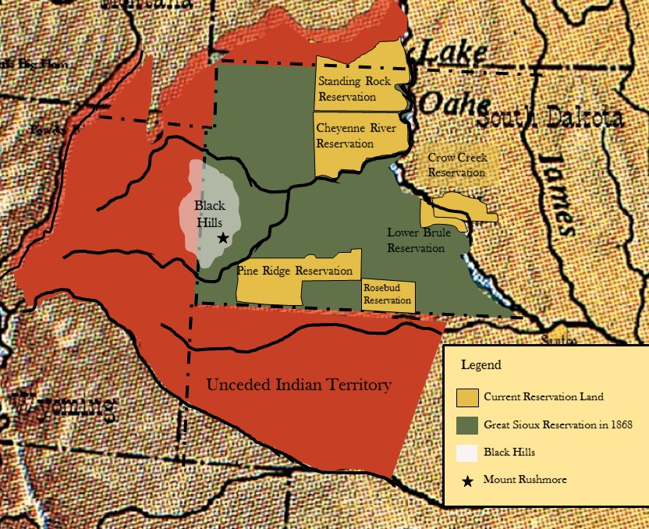

Source: Map made by Jessica Trampf, December 17, 2015. Base Map Source: Charles Royce, Indian Land Cessions in the United States, 1784-1894, US Serial Set 4015, accessed December 3, 2014, http://www.memory.loc.gov/ammem/amlaw/lwss-ilc.html.

Works Cited
Primary Sources
Mount Rushmore National Memorial Commission. Mount Rushmore National Memorial.
Keystone, SD: Mount Rushmore National Memorial Commission, 1930.

–——. Mount Rushmore National Memorial, Second Book. Keystone, SD: Mount Rushmore
National Memorial Commission, 1931.

–——. Mount Rushmore National Memorial: A Monument Commemorating the Conception,
Preservation, and Growth of the Great American Republic. Keystone, SD: Mount
Rushmore National Memorial Commission, 1941.

Secondary Sources
Alliance for Audited Media. “Average Circulation at the Top 25 U.S. Daily Newspapers.”
Accessed November 15, 2015.
http://auditedmedia.com/news/blog/top-25-us newspapers-for-march-2013.aspx.

Bergman, Teresa. Exhibiting Patriotism: Creating and Contesting Interpretations of
American Historical Sites. Walnut Creek, CA: Leaf Coast Press Inc., 2013.

Borglum, Lincoln and Gwenth Reed DenDooven. Mount Rushmore: The Story Behind the Scenery. Las Vegas, NV: KC Publications, 1977.

Chidester, David and Edward Tabor Linenthal. American Sacred Space. Bloomington, IN:
Indiana University Press, 1995.

Fite, Gilbert C. Mount Rushmore. 1952. Reprint, Keystone, SD: Mount Rushmore History
Association, 2014.

Gardella, Peter. American Civil Religion: What Americans Hold Sacred. Oxford: Oxford
University Press, 2014.

Griffith, T.D. America’s Shrine of Democracy: A Pictorial History. Keystone, SD: Mount
Rushmore History Association, 2004.

Griffiths, Michael R. “Production Values: Fordism and Formalism in North by Northwest.”
Postmodern Culture 20, no. 3 (May 2010): 2-17. Accessed December 17, 2015.
https://muse.jhu.edu/journals/postmodern_culture/v020/20.3.griffiths.html.

Larner, Jesse. Mount Rushmore: An Icon Reconsidered. New York: Thunder’s Mouth
Press/Nation Books, 2002.

The Cap Times. “The Cap Times Story – as Madison as it gets,” August 25, 2015. Accessed
November 15, 2015, http://host.madison.com/ct/the-cap-times-story-as-madison-as-it-
gets/article_d13f3bcd-3eee-509b-ace7-b7564c929023.html.

Mayer, Justin J. “Historical Memory of Mount Rushmore.” Master’s Thesis, University of
North Dakota, 2010.

New York Times. “Our History.” Accessed November 15, 2015.
http://www.nytco.com/who-we-are/culture/our-history/.

–——. “Pulitzer Prizes.” Last modified 2015. Accessed November 15, 2015.
http://www.nytco.com/pulitzer-prizes/.

Ostler, Jeffrey. The Lakotas and the Black Hills: The Struggle for Sacred Ground. London:
The Penguin Library of American Indian History, 2010.

Wolff, David A. “Review of Mount Rushmore: An Icon Reconsidered By Jesse Lamer & Great
White Fathers: The Story of The Obsessive Quest to Create Mt. Rushmore By John
Taliaferro.” Great Plains Quarterly 25, no. 2 (Spring 2005): 119-122. Accessed
November 28, 2015, http://digitalcommons.unl.edu/greatplainsquarterly/2475.

Gilbert C. Fite, Mount Rushmore (1952; repr., Keystone, SD: Mount Rushmore History Association, 2014), 266.
Fite, Mount Rushmore, 3-4.
T.D. Griffith, America’s Shrine of Democracy: A Pictorial History (Keystone, SD: Mount Rushmore History Association, 2004), 3.
Fite, Mount Rushmore, 4-6.
Lincoln Borglum and Gwenth Reed DenDooven, Mount Rushmore: The Story Behind the Scenery (Las Vegas, NV: KC Publications, 1977), 4.
Fite, Mount Rushmore, 27.
Ibid., 45-55.
Borglum and DenDooven, Mount Rushmore: the Story Behind the Scenery, 8.
Fite, Mount Rushmore, 59.
Mount Rushmore National Memorial Commission, Mount Rushmore National Memorial: A Monument Commemorating the Conception, Preservation, and Growth of the Great American Republic (Keystone, SD: Mount Rushmore National Memorial Commission, 1941), 10.
Fite, Mount Rushmore, 65-68.
T. D. Griffith, America’s Shrine of Democracy: A Pictorial History, 51.
Fite, Mount Rushmore, 245.
T.D. Griffith, America’s Shrine of Democracy: A Pictorial History, 44-47.
Fite, Mount Rushmore, 240-245.
T. D. Griffith, America’s Shrine of Democracy: A Pictorial History, 35.
Jeffery Ostler, The Lakotas and the Black Hills: The Struggle for Sacred Ground (London: The Penguin Library of American Indian History, 2010), 20.
Ostler, The Lakotas and the Black Hills: The Struggle for Sacred Ground, 26.
Ibid.
Ostler, The Lakotas and the Black Hills: The Struggle for Sacred Ground, 28-31.
Justin J. Mayer, “Historical Memory of Mount Rushmore” (master’s thesis, University of North Dakota, 2010), 6; Ostler, The Lakotas and the Black Hills: The Struggle for Sacred Ground, 58.
Ostler, The Lakotas and the Black Hills: The Struggle for Sacred Ground, 82.
Ostler, The Lakotas and the Black Hills: The Struggle for Sacred Ground, 82-99.
Mayer “Historical Memory of Mount Rushmore,” 72.
Ostler, The Lakotas and the Black Hills: The Struggle for Sacred Ground, 117-118.
Ibid., 119.
Ostler, The Lakotas and the Black Hills: The Struggle for Sacred Ground, 128.
Ibid., 130.
Ibid., 128-138.
Peter Gardella, American Civil Religion: What Americans Hold Sacred (Oxford: Oxford University Press, 2014), 243.
Jesse Larner, Mount Rushmore: An Icon Reconsidered (New York: Thunder’s Mouth Press/Nation Books, 2002), 278.
Ibid., 286-289.
Osler, The Lakotas and the Black Hills: The Struggle for Sacred Ground, 139-166.
Mayer, “Historical Memory of Mount Rushmore,” 72.
Gardella, American Civil Religion: What Americans Hold Sacred, 242.
Mount Rushmore National Memorial Commission, Mount Rushmore National Memorial (Keystone, SD: Mount Rushmore National Memorial Commission, 1930) IV – V.
Mount Rushmore National Memorial Commission, Mount Rushmore National Memorial Commission: Second Book (Keystone, SD: Mount Rushmore National Memorial Commission, 1931), 8.
Mount Rushmore National Memorial Commission, Mount Rushmore National Memorial: A Monument Commemorating the Conception, Preservation, and Growth of the Great American Republic, 9.
Ibid., 9-11.
Fite, Mount Rushmore, back cover.
Ibid., 289.
Fite, Mount Rushmore, 26.
Borglum and DenDooven, Mount Rushmore: the Story Behind the Scenery, 4.
David Chidester and Edward Tabor Linenthal, American Sacred Space (Bloomington, IN: Indiana University Press, 1995), 5.
David Chidester and Edward Tabor Linenthal, American Sacred Space, 15.
Ibid., 16.
Matthew Glass, “’Alexander’s All’”: Symbols of Conquest and Resistance at Mount Rushmore,” in American Sacred Space, ed. David Chidester and Edward Tabor Linenthal (Bloomington, IN: Indiana University Press, 1995), 161-162.
Ibid., 179.
Ibid., 171.
Gardella, American Civil Religion: What Americans Hold Sacred, 2.
Ibid., 3.
Ibid., 232-233.
David A. Wolff, “Review of Mount Rushmore: An Icon Reconsidered By Jesse Larner & Great White Fathers: The Story of The Obsessive Quest to Create Mt. Rushmore By John Taliaferro,” Great Plains Quarterly 25 no. 2 (Spring 2005): 121, accessed November 28, 2015, http://digitalcommons.unl.edu/greatplainsquarterly/2475.
Larner, Mount Rushmore: An Icon Reconsidered, 364.
Teresa Bergman, Exhibiting Patriotism: Creating and Contesting Interpretations of American Historical Sites (Walnut Creek, CA: Leaf Coast Press Inc., 2013), 165-171.
Ibid., 170.
“Pulitzer Prizes,” New York Times, last modified 2015, accessed November 15, 2015, http://www.nytco.com/pulitzer-prizes/.
“Average Circulation at the Top 25 U.S. Daily Newspapers,” Alliance for Audited Media, accessed November 15, 2015, http://auditedmedia.com/news/blog/top-25-us-newspapers-for-march-2013.aspx.
“Our History,” The New York Times, accessed November 15, 2015, http://www.nytco.com/who-we-are/culture/our-history/.
“The Cap Times Story – as Madison as it gets,” The Cap Times, August 25, 2015, accessed November 15, 2015, http://host.madison.com/ct/the-cap-times-story-as-madison-as-it-gets/article_d13f3bcd-3eee-509b-ace7-b7564c929023.html.
An Act Creating the Mount Rushmore National Memorial Commission and defining its purposes and powers, Public Law 805, 70th Cong., 2d sess. (February 25, 1929).
Ibid.
Ibid.
An Act to Amend the Act entitled “An Act creating the Mount Rushmore National Memorial Commission and defining its powers and purposes,” Public Law 471, 73rd Cong., 2d sess. (June 26, 1934); An Act to provide additional funds for the completion of the Mount Rushmore National Memorial, in the State of South Dakota, and for other purposes, Public Law 393, 74th Cong. 1t sess. (August 29, 1935).
An Act to Amend the Act entitled “An Act creating the Mount Rushmore National Memorial Commission and defining its purposes and powers,” Public Law 462, 75th Cong. 3d sess. (May 5, 1938).
Fite, Mount Rushmore, 245.
Mount Rushmore National Memorial Commission, Mount Rushmore National Memorial, I.
Ibid., VIII.
Mount Rushmore National Memorial Commission, Mount Rushmore National Memorial Commission: Second Book, 5.
Ibid, 37.
Mount Rushmore National Memorial Commission, Mount Rushmore National Memorial: A Monument Commemorating the Conception, Preservation, and Growth of the Great American Republic, 5.
Ibid., 5-6.
Ibid., 9.
Ibid., 19.
“America’s Story on a Mountain Cliff: Carved in Rushmore’s Stern Rock, It will Include the Figures of Four of Our Famous Presidents,” New York Times, February 23, 1930.
David Perlman, “Four for the Ages: Gutzon Borglum talks of his thirteen-year task of carving heroic figures on the side of a mountain,” New York Times, August 25, 1940.
“Washington’s Face Unveiled on Mt. Rushmore; Borglum’s 60-Foot Carving Visible for Miles,” New York Times, July 5, 1930; “President Praises Sculpture in Hills,” New York Times, August 31, 1936; “Lincoln Head Unveiled: 5,000 See Dedication at Dakota ‘Shrine of Democracy’,” New York Times, September 18, 1937; “Crowds See Big Stone Faces: Completion of a New Road to Mount Rushmore Aids the Visitor to View the Giant Carvings,” New York Times, July 21, 1935.
John Corbin, “Graven History: Danger of Perpetuating Misconceptions in a Proposed 500-Word Narrative”, New York Times, April 25, 1930; John Corbin, “Garbling our History: Mount Rushmore Inscription Seems in Need of Revision,” New York Times, May 5, 1930.
“Protests Changes in Coolidge History,” New York Times, May 25, 1930.
“Borglum is Stirred Over “Temperament”,” New York Times, May 13, 1937.
“Plan to Complete Memorial by 1933,” Madison Capital Times, July 6, 1930.
“Frank May Aid in Rewriting History On Mt. Rushmore,” Madison Capital Times, November 21, 1930.
Frederic J. Haskin, “Answers to Questions,” Madison Capital Times, December 19, 1930; Frederic J. Haskin, “Answers to Questions,” Madison Capital Times, November 23, 1941.
“Errorgrams,” Madison Capital Times, August 4, 1930.
Harlan J. Bushfield, “South Dakota Invites You!” Madison Capital Times, June 22, 1941.
Ibid.
William N. Wallace, “Unexpected Pass by the Vikings an Uncommon Show of Flair by Coach Grant: About Pro Football,” New York Times, October 23, 1977; Editorial, “Truly Uncle Sugar,” New York Times, August 22, 1986.
Caren S. Goldberg, “Connecticut Opinion: Sending Your Child to College: Grief or Relief?” New York Times, September 11, 1988.
“No Warning at Rushmore,” New York Times, June 28, 1975.
“Dakota Indians Ask Aid of Reservation For Protest Drive” New York Times, October 2, 1970; “20 Indians Seized In Treaty Protest At Mt. Rushmore” New York Times, June 7, 1971.
Wayne Kind, “Bradley Offers Bill to Return Land to Sioux” New York Times, March 11, 1987.
Robert J. Dunphy, “Travel Notes a Fiftieth Anniversary for the Mount Rushmore Monument,” New York Times June 29, 1980.
Jed Stevenson, “Coins: A striking national monument inspires three commemorative issues minted for its benefit.” New York Times, February 17, 1991.
“Washington Talk: Snapshot; No Rush Yet to Place Reagan on Mountain” New York Times, May 18, 1989.
“Who Carved the Faces on Mount Rushmore,” Madison Capital Times, December 7, 1972.
Patricia MacLaughlin, “It’s a nip and tuck for guys too, now” Madison Capital Times, July 9, 1990; “Senate Oks coins to honor Rushmore” Madison Capital Times, November 2, 1989.
“Reagan on Rushmore?” Madison Capital Times, May 18, 1989; Mike Royko, “Reagan’s memorial should be something a tad more dramatic,” New York Times, May 22, 1989.
John Stallard, “Mount Rushmore – no work of art” Madison Capital Times, July 29, 1974.
“Kitsch,” Oxford Dictionaries, accessed December 17, 2015, http://www.oxforddictionaries.com/us/definition/american_english/kitsch.
Mark A. Young, “Rushmore Grows as National Symbol,” Hutchinson News, Kansas, August 6, 1978.
Ibid.
Michael R. Griffiths, “Production Values: Fordism and Formalism in North by Northwest,” Postmodern Culture 20, no. 3 (May 2010): 10, accessed December 17, 2015, https://muse.jhu.edu/journals/postmodern_culture/v020/20.3.griffiths.html.

