Department of History
University of Wisconsin – Eau Claire

Similarities Through Differences: A Look at the Correlation Between Two Radically Different Civil Rights Campaigns in Albany and Birmingham

By:
Lucas Henderson

History 489
Research Capstone
Professor: Oscar Chamberlain
March 29, 2016

Title Page 1
Table of Contents 2
Abstract 3
Introduction 4
Background and Historiography 6
Comparing the Campaigns 11
Finding Significance in White Leadership 16
Conclusion 22
Annotated Bibliography 23

Abstract
In the early 1960’s two contrasting civil rights protests made very different impacts on the Civil Rights Movement as a whole. The Albany Movement, from 1961-1962, was a drawn-out campaign that struggled mightily to prevail against a pragmatic tactician while spreading activists too thin in their strategies. The Birmingham Campaign, in 1963, resulted in a violent reaction by a short-tempered white lawman, which in turn brought about a call to action by John F. Kennedy, sowing the seeds for Lyndon B. Johnson’s Civil Rights Act in 1964. One campaign kept the Civil Rights Movement at essentially a standstill, and the other gave the Movement momentum it needed to make a massive turnaround. However, I will be seeing how the two are actually more connected than one might originally assume, by analyzing the two movements side by side in an attempt to make a correlation.

Introduction
In July of 1962, the outlook was bleak for civil rights activists in Albany, Georgia. Hundreds of arrests were being made by Chief Laurie Pritchett’s police force, taking peaceful demonstrators off the streets and putting them in a number of different jails. In an effort to inspire and rally support for the campaign, Dr. Martin Luther King, Jr. and his dear friend Ralph Abernathy were arrested at a march. While in jail, he wrote “A Message from Jail.” This was written for all involved in the movement, and for those who may have been inclined to join the cause. In it, Dr. King writes the following:
I am writing this column from the Albany city jail… [we] were found guilty last Tuesday of ‘parading without a license’ and sentenced to either fines of $178 dollars each or the alternative of serving 45-day sentences… We chose the later (sic) and willingly deferred bond and waived appeal. Our course of action was decided after very careful soul searching… We chose to serve our time because we feel so deeply about the plight of more than 700 others who have yet to be tried.
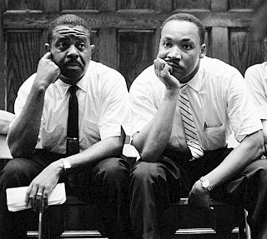
Soon after this was written, Dr. King and his associates left Albany with little headway made, and the movement was largely considered a failure. King’s biographer, David L. Lewis, would later say that this was in part due to “too little coordination, trust, and harmony during the movement.”
Ralph Abernathy (right) and Dr. Martin Luther King, Jr (left) sit at the Albany Courthouse. http://www.pophistorydig.com/topics/tag/martin-luther-king-freedom-riders/
This letter is little known, much in part to the fact that they were released so early. However, if one were to fast forward just over a year to August 1963, they would find a letter published all over history texts which was written by the same man:
We know through painful experience that freedom is never voluntarily given by the oppressor; it must be demanded by the oppressed... For years now I have heard the word ‘wait.’ It rings in the ear of every Negro with a piercing familiarity. This ‘wait’ has almost always meant ‘never.’ It has been a tranquilizing thalidomide, relieving the emotional stress for a moment, only to give birth to an ill-formed infant of frustration. We must come to see with the distinguished jurist of yesterday that ‘justice too long delayed is justice denied.’
This was written on the precipice of one of the greatest successes of the Civil Rights Movement; the letter was “A Letter from Birmingham City Jail,” and the movement was the Birmingham Campaign, shortly after which President Lyndon B. Johnson signed the Civil Rights Act of 1964, a monumental victory for the advancement of African-Americans.
This leads me to pose my thesis: What were the strategies, challenges, and accomplishments of the Albany Movement and how do they correlate with the Birmingham Campaign that followed? I will be comparing and contrasting the two movements, and will study the opposition to see if strategies white supremacists used in both campaigns also contributed to each result. In this we can study not only the history, but the sociological makeup of the tactics in both campaigns and the people behind them.
I hypothesize that my findings will prove that the Albany Movement was not a failure, but rather a success that was only seen as a failure when the whole picture was not complete. On the backdrop of the entire Civil Rights Movement, I will determine that the efforts of those in Albany in 1961 and 1962 were not in vain, but instead laid a foundation for the movements that followed. I believe that this study is significant for many reasons, the most general of which is that understanding the history of the Civil Rights Movement and its importance in how it has shaped our world cannot be understated. The Civil Rights Movement is one of the great undertakings of our world’s history, let alone that of the United States. I also believe that by delving into the sociological aspect we can develop a greater understanding of the people in that era and the way they viewed their circumstances.
Background and Historiography
The Albany Movement and its finer points haven’t been covered extensively, in part due to it being a low point in the bigger picture of the Civil Rights Movement. However, I’ve found articles by Michael Chalfen and Steve Barkan that reveal different perspectives on my topic.
Michael Chalfen’s article, “The Way Out May Lead In: The Albany Movement Beyond Martin Luther King, Jr.,” addresses and calls for the modern historian to broaden their view of civil rights protest movements, and uses the Albany Movement as an example:
Black protest continued in Albany long after August 1962, when its historiographical grave is traditionally marked. That protest included significant use of voter registration and election campaigns, desegregation lawsuits for schools and other public facilities, and economic boycott. This change of tactics from the mass marches for which Albany is famous suggests that historians should try to embrace the real, much broader parameters of local protest movements more fully than they often do.
As Chalfen states, “Describing movements’ peaks lends to drama but not depth to understanding them”(Chalfen, 561). The Albany Movement is widely recorded as ending in 1962, but the struggle for equality did not end with the departure of Dr. Martin Luther King, Jr., the figurehead of the entire Civil Rights Movement. In fact, little was accomplished by 1962.
The peaks are then described: they begin in November of 1961, when five students were arrested after sitting at a city interstate bus terminal, one which was supposed to be following the Interstate Commerce Commission’s order of desegregation, but did not. The following month, ten Freedom Riders were arrested. The community then began to participate, and in the following week 737 people were arrested. Martin Luther King, Jr. was also arrested and, as stated earlier, was released immediately. More mass jailings followed, but were not effective in spurring change and equality in the community. From here, in 1962, the Movement tails off, losing steam and money leading to Dr. King’s departure in the summer of 1962.
Chalfen urges historians to dig deeper, and find that there was deeper significance to the mass marches and mass arrests. He bases this on the positives left behind after 1962. There was much African American political growth in the years that followed. This was significant, because the youth saw where the difference is made, in the streets and in political action. This action was varied, which was a strong indicator of future success. There were strategies of economic boycotting, voter registration and education, self-help, and legal action that were in play, a multi-pronged approach to bringing about change that, according to Michael Chalfen, was “impressive.”
In the years that followed King’s departure, the movement reverted back to direct action. As Michael Chalfen stated, “The renewal of direct action had two spurs: a heightened sense of social and economic justice stemming from the Smith boycott and the bond vote; and a more active youth, sensitized by the Ware trial and invigorated by the arrival that month of a new wave of around twenty SNCC workers from northern universities who were staying with various families in town.” The “Ware trial” being referred to is the 1963 trial where Charlie Ware, a black man, charged that L. Warren Johnson, the Baker County sheriff, beat and shot him. A federal jury ruled in favor of the sheriff, causing outrage among the African-American community. Chalfen is making the point that much influence for action of any kind was a result of the presence of youth activism, just as elsewhere. SNCC (Student Nonviolent Coordinating Committee) was a heavy influence on direct action pursuits across the nation, especially when not clashing with the SCLC (Southern Christian Leadership Conference). Chalfen concludes his article stating that when you reconsider your parameters of the history of the Albany movement, it can lead to some very interesting and important discoveries. This absolutely applies to many other historical events, and remembering that the watershed moments in history are simply peaks, and what follows can be just as important.
Steve Barkan’s journal article does not necessarily contrast with Michael Chalfen’s, but it does approach the Civil Rights Movement from an entirely different angle. In Barkan’s article, “Legal Control of the Southern Civil Rights Movement,” he goes in-depth in terms of the strategies used by the white supremacists to combat the actions of the SCLC, SNCC, NAACP, and other activist organizations. Barkan references famous sociological theorists Emile Durkheim and Karl Marx within the first page, referencing social structures as the root of major social events due to Durkheim, but a “departure from traditional perspectives on social movements that focused on social psychological explanation.” Steve Barkan also makes a very fascinating hypothesis about the campaigns he examines (Montgomery, Albany, Danville, Birmingham, and Selma).
Two models of white response to civil rights protest can be distinguished in these cities. The first, used in Montgomery, Albany, and Danville, involved the frequent use of arrest, prosecution, and other forms of legal harassment to suppress dissent… in Albany and Danville its use eventually proved overwhelming, while the Montgomery campaign would have failed had not the U.S. Supreme Court handed down a favorable ruling at the last moment… The second model, characterizing Birmingham and Selma, is distinguished from the first by the use of police and civilian violence which undermined attempts by officials to use legal means to control dissent… Without white violence, moreover, the legal control of black protest in Birmingham and Selma might very well have defeated the civil rights forces.
From here Barkan continues, one campaign at a time, to explain his findings. In Montgomery, he comes to the conclusion that the movement lacked range; boycotting was essentially the only avenue of protest taken and the movement was somewhat fortunate to find success. In Albany, the movement’s downfall came in the shape of white law enforcement’s effectiveness. Birmingham, conversely was successful in large part due to the violence carried out by white law enforcement, combined with media coverage. The demonstrations that seemed to be the lengthiest were those in Danville, Virginia. However, these were unsuccessful, as white law enforcement followed Albany’s lead in their strategies. Finally, Selma found a similar result to Birmingham: nonviolent protest with a violent response, which resulted in an explosion of media coverage and uproar, therefore finding success.
Comparing the Campaigns
The Albany Movement, which took place from November of 1961 until August of 1962, was “one of the first concerted efforts in the South to desegregate bus and train terminals, lunch counters and restaurants, and other public facilities and accommodations,” as well as an effort to equalize voter registration for African Americans. The movement itself was headed by Dr. Martin Luther King, Jr., the leader of the SCLC and the face of the Civil Rights Movement. Hundreds of people came from around the nation to help the cause, and it was of interest to people around the United States, such as Reverend Frank Jones, who expressed concern to Dr. King about the level of segregation that still existed in Albany:
The situation in Albany, Georgia is of nationwide and foreign concern as well as of local concern. What is happening in Albany now makes all of us stop and question: Where is America’s theory of equality, the pursuit of liberty, life, and happiness for every citizen? Only one answer can refrain: America’s theory is hidden behind the shackles of segregation and discrimination. Many leaders in various states have not only discussed this situation, but they have given Dr. M. L. King, Jr. and the Albany people their moral support…”

The strategy implemented by the SNCC, SCLC and other groups was that of nonviolent disobedience, as writ in the Student Nonviolent Coordinating Committee’s Statement of Purpose:
…Through nonviolence, courage displaces fear; love transforms hate. Acceptance dissipates prejudice; hope ends despair. Peace dominates war; faith reconciles doubt. Mutual regard cancels enmity. Justice for all overcomes injustice. The redemptive community supercedes [sic] systems of gross social immorality.
African American of all ages would peacefully congregate in public areas reserved for “whites only.” According to key organizer and SNCC member Charles Sherrod, the police were doing what they could to dissipate the act without arresting them, but to no avail. “The police tried to scare them, they tried to cajole them, they tried all kinds of ways of getting them out of there, aside from arresting them. But the young people stayed.” The eventuality was the arrest of any African Americans on the premises, based on the grounds of a city ordinance which condemned disobeying the orders of law enforcement.
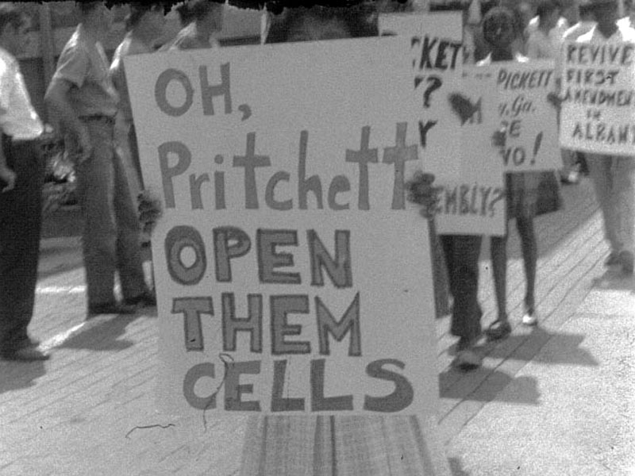
While the strategy used by the activists relied heavily on filling the jails if necessary, nothing prepared them for the legal system in place in Albany. As Steven Barkan stated, “The city’s most effective legal tactic involved a policy of continuous arrests by local police.” The approach was led by police chief Laurie Pritchett, who was “praised for his method of dealing with civil rights demonstrators.” Activists would sing freedom songs, pray in the streets, make their bodies limp and difficult to move, all to get a violent reaction from law enforcement. Instead, they were met with calm and orderly arrests. To prevent the local jails from filling up via the mass arrests, Pritchett had contacted other jailhouses within 100 miles of Albany, sending those arrested across the county to different lockups. These arrests caused a multitude of problems:
A protestor in Albany calls for the release of their fellow activists. http://www.georgiaencyclopedia.org/file/4589
Pritchett’s tactics burdened the local movement with huge legal costs and other difficulties and effectively depicted a police force that quickly, efficiently, and impartially dealt with protesters breaking the law, especially in contrast with the beatings of “Freedom Riders” the previous spring in several Southern cities… U.S. Attorney General Robert Kennedy sent Pritchett a telegram congratulating him for the peaceful arrests.
The result of the efforts of SNCC and SCLC by 1962 was essentially fruitless: desegregation was still in full effect, and voting registration had not changed significantly. As Michael Chalfen wrote, “…its objectives of total desegregation, biracial discussions at the city commission level, and better job opportunities ‘both public and private’ were not achieved by August 1962.”
However, as aforementioned, while that marks the end of Dr. King’s time in Albany, the movement itself was not over. Over the following months, Albany was not particularly prominent in the news, but it didn’t mean that the activism in the town had diminished. The economic boycott that had be going on since January was still in effect, and voter registration among the black community continued to grow. In February of 1963, there was a setback as the district court Judge Robert Elliot shockingly ruled that the segregation ordinances in Albany were not unconstitutional. But Albany’s leader of the movement, William Anderson, threatened the commission that they would again march if this wasn’t overturned. Incredibly, the commission caved to the demands of the activists. In 1965, over 150 black students integrated into Albany high schools, yet another achievement. By this time, African-American voter registration numbered in the tens of thousands, and by this time “: Most facilities in Albany had been desegregated, and black candidates for political office had made some mark.” As Chalfen wrote, “The political change generated by persistent Movement activity from 1963 to 1965 was significant, particularly in desegregating city facilities, in voter registration, and promoting black candidates for political office.”
The Birmingham Campaign, however, was massively successful and in a shorter span of time. Begun in April of 1963, King and the SCLC teamed up with Birmingham, Alabama’s local activist group, the Alabama Christian Movement for Human Rights (ACMHR). Birmingham, described at the time as “a blue collar city with a history of violence,” had a strong KKK presence and a community leader with a penchant for violence in Eugene “Bull” Connor. April 3^{rd,} the activists began their marches, which were in protest of the city’s segregation ordinances. However, it wasn’t until May that the police force responded with violence:
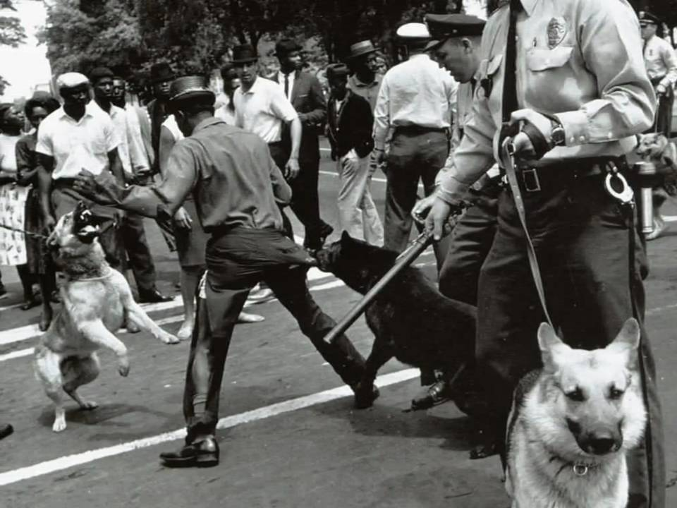
“Hell, there must have been three thousand, four thousand [demonstrators] out there,” recalled retired policeman Jack Warren, head of the Patrol Division in 1963. “I mean, it was just solid, the park [Kelly Ingram], every street around there west of 17th street. So they were coming up Fifth Avenue. And when they got there, their numbers, their attitudes, their mannerisms, what they were doing, they were going to City Hall. And the orders were, they can’t come. So, at that time, when it was obvious they were going to keep coming, that’s when the fire hoses and dogs were turned loose. If you’re a policeman… and 10 or 15 [policemen] are out at the intersection, and you’re aware of the fact that you’re going to get walked over, you’ve either got to do something or run. It’s a damn hard decision. But the orders were, they can’t come.”
A man gets attacked by dogs at Kelly Ingram Park. http://dashingdasher.blogspot.com/
The actions by Bull Connor and his men resulted in what the Movement desperately needed: media coverage. As Nunnely explains, “Following the Birmingham campaign, Pres. John F. Kennedy – mindful of his campaign commitment to civil rights – proposed an omnibus bill designed to bring minorities to positions of equality in American life, and Congress took the first steps toward his legislation.” This bill was a precursor to the Civil Rights Act of 1964, signed by Lyndon B. Johnson.
Finding Significance in White Leadership
One crucial factor in the difference between the two movements was the actions of those who upheld the law: Police Chief Laurie Pritchett of Albany and Commissioner of Public Safety Bull Connor of Birmingham. Pritchett was tactful and mindful of public perception. He was entirely prepared for whatever Dr. King threw at him. Bull Connor, on the other hand, was prone to violence and had a specific hatred for African Americans, leading to an entirely different result. Going into detail on these men will help us understand more about why where one campaign was nearly extinguished the other excelled.
Laurie Pritchett, according to “Inside Agitators: White Southerners in the Civil Rights Movement” by David L. Chappelle, was “the apex” of what was an “amazingly cohesive white community” in Albany. Having no real hatred towards African-Americans by any accounts, he was pragmatic in the way that he approached civil rights activists. According to Chappelle, “While many southern lawmen tacitly declared open season on civil rights workers, Pritchett saw to it that he would not have a martyr in his town, especially not a nationally prominent figure like Dr. King.” His efforts to protect King were unlike any other law enforcement leaders in the United States – to the length of providing the Baptist preacher an escort, as he stated in an interview:
“As soon as he’d leave Atlanta he’d tell me approximately what time he’d be coming into Americus, which was forty miles north of Albany. We’d meet him. One of my men would get in the car, he’d get in our car, and then they’d come in by two cars. And we took him everywhere. There was a plot down there to kidnap him, and we found out about this and got it stopped.”
Pritchett’s pragmatism didn’t stop there. From the moment Dr. Martin Luther King, Jr. began rising as a prominent figure in the Civil Rights Movement, Pritchett was studying him. He read Dr. King’s memoirs, and was well-versed in King’s non-violent ways inspired by Mahatma Gandhi by the time he set foot in Albany. As mentioned before, Pritchett made extensive preparations clearing out space in jails for the incoming waves of black protestors. Laurie Pritchett has also gone on the record explaining the in-depth training for his policemen to discourage violence: “For a period of four to five months, members of the Albany Police Department were indoctrinated to this plan of non-violence by the staff officers… At each roll call the members of the Albany Police Department were lectured and shown films on how to conduct themselves in this non-violent operation.” The police dogs in the department were “deactivated,” and Pritchett demanded there was to be “no bloodshed.”
Laurie Pritchett, while combating the nonviolent activism on the streets, also was approaching the situation from the angle of the press and public opinion. While media coverage in the north was in favor of the protestors, Pritchett managed to “defeat” a march upon Albany by 75 clergy members from the north who aimed to bring media attention to the city on Labor Day in 1962. The way he defeated this was by pointing out the effectiveness and peacefulness in which protest was being handled, and swaying media coverage to praise his city’s law enforcement instead of condemn it.
Pritchett built upon this in July of 1962, with what can be considered one of his most brilliant actions. There was a mass meeting outside of Shiloh Baptist Church on July 11th, and the undisciplined crowd began sowing the seeds of riot, throwing bottles and bricks at police. Instead of ordering retaliation or retreat, Pritchett began to walk through the tumultuous crowd, his deputy in tow. Movement leader Slater King was inside the church, trying to regain control of the mob:
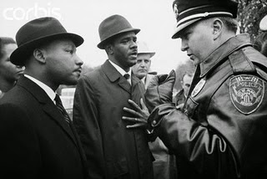
“…he suddenly caught sight of the white men at the back of the church. “I notice we have in our presence Chief Pritchett,” he [Slater King] called out. “No fear. Nothing here is secret. Would you like to say a few words?”…Pritchett took the pulpit. “I [Pritchett] appreciate the opportunity to be here… I have often been told I would be welcome. I didn’t know if I would be or not… I never have interrupted your peaceful assemblies before. All through this there has been no incident of violence. Many people misunderstand your philosophy of nonviolence, but we respect your policy. I ask your cooperation in keeping Albany peaceful. This business of throwing rocks is not good… throwing bottles is not good. We want you to see that nothing happens. We ask your cooperation. I know that you as citizens will respect and abide by our wishes that there be no disturbance. Go about your business the way we’ve had it.” Amens rang out, and applause. Then Pritchett and his deputy went back out to the bricks and bottles.”
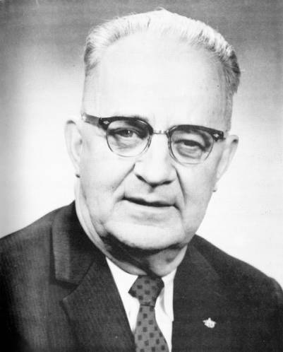
This galvanized Chief Pritchett’s reputation to the press as a strong and brave tactician and fair Police Chief. He even garnered respect from Dr. King, and “they corresponded with each other for a long time” after King left Albany. According to Chappelle, “Pritchett was still getting Christmas cards from Coretta Scott King” as of 1976.
Eugene "Bull" Connor, 1963. https://en.wikipedia.org/wiki/Bull_Connor
Dr. Martin Luther King, Jr (right) and Chief Laurie Pritchett (left) converse in Albany. http://gregsegroves.blogspot.com/2015/03/laurie-pritchett-and-albany-movement.html
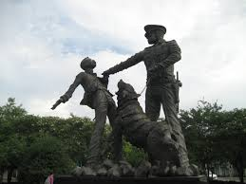
Bull Connor, according to William A. Nunnely, “was the quintessential segregationist; his instrument of enforcement was the last all-white police force in a U.S. city of more than 50,000, a department in which racism predominated and ‘blacks had no rights whatsoever’ according to Jack A. Warren,” who was previously mentioned. Connor was technically not just the Police Commissioner, but the “Commissioner of Public Safety,” which meant he ran both the police and fire departments. James C. Parsons, who was a part of the police department in Birmingham for 25 years, explained that “He [Connor] would brook no interference with his management of the police department… It was one of those dictatorial regimes where you liked it or you lumped it and got out. The chief, under Commissioner Connor, had no power. There was absolutely no one who would stand up to him.” This lends to the reasoning behind the violence that erupted in Kelly Ingram Park.
One of many statues at Kelly Ingram Park, in remembrance of what happened there in 1963. https://uamjw2013.wordpress.com/2013/06/21/the-running-of-the-bull-a-discussion-of-the-legacy-of-police-commissioner-eugene-bull-connor/
Bull Connor’s upbringing lends to his aggressive and bully-like demeanor. Born in the rural region of western Alabama, an area known for its hatred towards men of color, he was somewhat devoid of parenthood. His father, whose name was King Edward Connor, was rarely around as he worked the railroad lines and his mother, Molly, died of pneumonia when Bull (at the time known as Theophilus Eugene Connor) was eight years old. By this time he was living in Atlanta Georgia and had moved a number of times, as many railroad workers’ families did (Connor later claimed he lived in 36 US states at one time or another). Following the tragedy, Eugene lived with his aunt and uncle for a short time and, during that span, he became blind from a freak accident in which he peeked through a hole in a fence just as his friend shot an air rifle through the hole. A reckless man, he first ran for office in the Alabama House of Representatives “partly for the fun of it and partly to see how many friends I had.”
One way that the SCLC took lessons from Albany and applied them to Birmingham is that Martin Luther King, Jr. and the SCLC intentionally targeted Bull Connor. There are multiple references to this, and is why the Birmingham Campaign was labeled as ‘Project C…’ “In the wake of Albany, King sought to rekindle the anti-segregation struggle against a new target. He cast his eyes in the direction of Birmingham and its segregationist police commissioner Eugene “Bull” Connor. Project C, for “confrontation,” thus was born.” Once the SCLC met in Birmingham, Bull Connor was immediately breathing down their necks. When Reverend Fred Shuttlesworth attempted to convince store owners, such as department store owner Isadore Piztiz, to desegregate their stores, Bull swept in, “reminding store owners that the segregation ordinances were still on the books and threatening those who refused to obey them with loss of their business licenses.” According to Attorney David Vann, “the threat was made very clear that [the city] would arrest Mr. Piztiz and whoever else and put them in jail and hold them up to public ridicule and ruin their business.”Even more proof of Connor’s targeting is that the campaign was rushed, as there was the possibility that Connor was going to retire in the wake of his loss in a mayoral runoff election to Albert Boutwell. As Dr. King’s aide, Wyatt Tee Walker, stated in reference to the campaign, “We knew that when we came that Connor would do something to help our movement along… We didn’t want to march after Bull was gone.”
Conclusion
In conclusion, one can see a strong connection between the Albany Movement and the Birmingham Campaign – not only by their similarities, but by their stark differences as well. In terms of similarities, King stressed nonviolent direct action and a call to attention from the media. But in the differences, it could be argued that the multi-faceted strategy in Albany spread the activists too thin, leading to a more singular approach in Birmingham – and a targeted man in the ill-tempered Bull Connor following the impressive tactics of the level-headed Laurie Pritchett. Through these correlations, a pattern of learning and adaptation forms.

Annotated Bibliography
Primary Documents
King Jr., Martin Luther. Letter from Birmingham City Jail. 1963. Quoted in Staughton Lynd, Nonviolence in America: A Documentary History (New York, Bobbs-Merrill, 1966), 460-481.
In Dr. King’s famous letter, he explains and justifies strategies implemented in Birmingham, as well as turning an eye toward the future and what it may bring. He sheds light on the strategy based on Bull Connor’s disposition, which was a strategy born from the ineffective Albany Movement.
Shuttlesworth, F.L. and Smith, N.H. The Birmingham Manifesto. 1963. Quoted in Staughton Lynd, Nonviolence in America: A Documentary History. (New York, Bobbs-Merrill, 1966), 458-460.
The Birmingham manifesto was key in spurring demonstrations in the months that followed its release in 1963. In it we can glean the frustrations faced at the time, quite possibly in reference to the recent struggle in Albany and showing a learned patience.
SNCC. Student Nonviolent Coordinating Committee, Statement of Purpose (Raleigh, North Carolina, 1960) quoted in Staughton Lynd, Nonviolence in America: A Documentary History (New York, Bobbs-Merrill, 1966), 398-399.
The SNCC statement of purpose gives the reader a look into the beliefs and ideals of those in the Student Nonviolent Coordinating Committee.
The King Center. Archives. TheKingCenter.org. http://thekingcenter.org/archive
This archive holds a large number of documents, written to, from, or for Dr. Martin Luther King, Jr. Many are helpful in reading of strategies used and relationships between different civil rights organizations.
Secondary Documents
Barkan, Steven. “Legal Control of the Southern Civil Rights Movement,” American Sociological Review, Vol. 49, No. 4 (1984), 552-565.
Steven Barkan lauds and explains the effectiveness of the strategies used not only by Albany Police Chief Laurie Pritchett, but the City Commission as whole for working together to stall the Albany Movement in 1961-1962.
Chalfen, Michael. “The Way Out May Lead In”: The Albany Movement Beyond Martin Luther King, Jr.” Georgia Historical Quarterly Vol. 79, no. 3 (1995) : 560-598.
Michael Chalfen’s article goes into detail about the activism-related events that followed the leaving of Martin Luther King, Jr. and the SCLC when the Albany Movement stalled, widening the scope of the movement in Albany, GA.
Chappelle, David L. “Inside Agitators: White Southerners in the Civil Rights Movement.” (John Hopkins University Press, 1994), chapter 6.
Chappelle writes about different white southerners who made an impact on the Civil Rights Movement. In chapter 6, he references Laurie Pritchett, the Police Chief in Albany, GA during the Albany Movement.
Fayer, Steve and Hampton, Henry. “Voices of Freedom: An Oral History of the Civil Rights Movement from the 1950s through the 1980s.” (New York, Bantam Books, 1990), chapter 6.
Hampton and Fayer have collected a series of accounts from different facets of Movement, including a chapter on the events that transpired in Albany, GA.
Nunnely, William. “Bull Connor.” (The University of Alabama Press, 1991).
William Nunnely offers a closer look at the man behind the violence in Birmingham, Alabama during the Birmingham Campaign. Not only does Nunnely document the events of that campaign, but also gives us an in-depth analysis of Connor’s upbringing and life beyond the microcosm of the Civil Rights Movement.

King Jr., Martin Luther. A Message from Jail. 1962.
William A. Nunnely, “Bull Connor.” The University of Alabama Press, 1991. 1.
King Jr. Martin Luther. Letter from Birmingham City Jail. 1963.
Michael Chalfen, ““The Way Out May Lead In”: The Albany Movement Beyond Martin Luther King, Jr.” in The Georgia Historical Quarterly, Vol. 79 (Spring, 2015), 561.
Ibid.
Chalfen, “The Way Out, 561.
Ibid, 564.
Chalfen, “The Way Out,” 576.
Steve Barkan, “Legal Control of the Southern Civil Rights Movement.” American Sociological Review, Vol. 49, No. 4 (Aug. 1984), 552.
Barkan, “Legal Control,” 556.
Barkan, “Legal Control,” 556.
Jones, Frank. Letter from Frank Jones to MLK. The King Center Archives, thekingcenter.org. http://www.thekingcenter.org/archive/document/letter-frank-jones-mlk# date accessed 6 May 2016.
SNCC, Student Nonviolent Coordinating Committee, Statement of Purpose (Raleigh, North Carolina, 1960) quoted in Staughton Lynd, Nonviolence in America: A Documentary History (New York, Bobbs-Merrill, 1966), 398-399.
Henry Hampton and Steve Fayer, “Voices of Freedom: An Oral History of the Civil Rights Movement from the 1950s through the 1980s.” (New York, Bantam Books, 1990), chapter 6.
Barkan, “Legal Control,” 556.
Ibid, 556.
Chalfen, “The Way Out,” 565.
Ibid, 570.
Ibid, 595.
Ibid, 596.
Nunnely, “Bull Connor.” 3.
Nunnely, “Bull Connor.” 7.
David L. Chappelle, “Inside Agitators: White Southerners in the Civil Rights Movement.” John Hopkins University Press, 1994. 128.
Ibid.
Chappelle, “Inside Agitators,” 125.
Ibid, 129-130.
Chappelle, “Inside Agitators,” 131-132.
Ibid, 126.
Nunnely, “Bull Connor.” 4-5.
Nunnely, “Bull Connor.” 9,12.
Ibid. 2.
Ibid. 131-132.
Nunnely, “Bull Connor.” 7.

