The University of Wisconsin-Eau Claire

An Exploration in Representation and Reality:
The Divide in Women’s Portrayals During the French Revolution of 1789

Department of History

By
Becca Yahr

Supervising Professor: Joseph Orser
Cooperating Professor: Louisa Rice

Eau Claire, Wisconsin
December 2013

Copyright of this work is owned by the author. This digital version is published by McIntyre Library, University of Wisconsin-Eau Claire, with the consent of the author.

CONTENTS

Abstract……………..……………………………………………………………………………..3
Introduction: Representation and History………………………………………………………....4
Historiography...…………………………………………………………………………………..6
Historical Background...…………………………………………………………………………..8
Analysis of Creative Texts……………………………………………………………………….10
Conclusion: The Power of Representation………………………………………………………31
Bibliography……………………………………………………………………………………..34

Abstract:
This essay examines artistic representations of French women in the period contemporaneous to the French Revolution of 1789. Through the analysis of literary texts and visual art, a better understanding of the social perception of women in this time period can be achieved. Sources like novels, narratives, newspaper accounts, prints, etchings, and sculptures are used to show a distinct dichotomy in the portrayals of French women. In the artistic work from Britain, Ireland, Germany, and France, women who were active participants in the revolutionary proceedings were disparaged for being violent and ruthless, while women who were limited to the private sphere where glorified as mothers and moral anchors. Additionally, this essay argues that the inclusion of creative texts, such as these, is important for developing a more complete view of social ideas in historical periods.

Introduction: Representation and History
When discussing the French Revolution of 1789, it is safe to say that with the advent of the revolution the entirety of French society was forced into a period of drastic social change. Historians examine the revolution through many different lenses, like those of the origins of the revolution, the resulting politics, or the class issues that persisted throughout. It is also popular to investigate the events of the revolution from the angle of gender and gender equality. However, one manner of exploring the events of the French Revolution that is not common in the field of History is using artwork and creative texts, like novels and narratives, to make judgments about the social climate of the period.
In many ways, social changes, like those of revolution, offer catalysts for the creation of art. This happens because many artists and writers draw inspiration from the events and people around them. A revolution, such as the one in Eighteenth Century France, provides a new context for these artists that is rife with new ideas and material from which artists can be inspired. Artists and writers are able to use their work to focus on specific aspects of the world around them in great detail, which often leads to the art or text reflecting pieces of the social or political climate of the time. These artists and writers have unique experiences that influence their understanding of the world around them, and perceptions can be seen in the work that they do. By utilizing tools like symbolism, metaphor, and form, artists and writers are able to convey a message through their work, which indicates their individual interpretations of important themes in society.
Looking at a combination of works from the same time period can give a historian significant insight about the greater perceptions of society, because artists and writers work form within that society and are, therefore, directly influenced by the ideas of people around them. This approach is especially useful in understanding societal conceptions of certain groups. A wealth of new knowledge is available to the historian when examining works of art from an artistic perspective. Understanding written texts like novels and narratives from a literary perspective will yield rich contextual information about the culture in which it was written, because elements of that society become present in the textual portrayal. In addition to that, visual texts portray entirely different information from written texts because of their ability to incite in the viewer an intellectual or emotional response without the use of language. Artistic works can be seen as embodying their own language, therefore saying something totally unique about life and history.
Despite this wealth of information, historians rarely engage with literary or artistic readings of various forms of art. It is widely acknowledged that the explication of artistic works is a subjective process. This is because each person who examines a text gleans from it an individualized understanding of its meaning, which, oftentimes, serves to mirror their own sensibilities. Because of this stress on subjectivity, historians tend to discredit information observed in artistic texts. Historians argue that this dismissal occurs as a way to minimize bias, since subjective readings of art could be used to create a distorted version of the historical narrative. However, this idea begs a few questions. What is the “reality” of the historical narrative? How do we justify the dismissal of certain aspects of that narrative? How could our understanding of the historical narrative be improved and solidified by the addition of new information? Our understanding of events of the past, what influenced them, and how those events influenced the lives of people in that time period is constantly changing, and the addition of information formed through the process of in-depth art research would add to and shape that narrative.
It is the methodology of artistic evaluation that drives the argument of this paper. Through an analysis of artistic works contemporaneous to the French Revolution of 1789, aspects about the lives of women who participated in the revolution will be revealed. Looking closely at the messages of artwork in this time period, while focusing on the greater context and historical perspective of each artistic text, will allow for a deeper understanding of the perception of women during the revolution. Through this investigation, ideas about the social reception of women in this time period and the issues of gender equality they faced become clear. This analysis shows that social perceptions either reprimand and dismiss women who take active roles in the revolutionary proceedings, by admonishing them as ruthless and cruel, or use the idea of separate spheres and gender roles to pigeon-hole women in the place of “mother of the revolution,” by portraying women as safe and useful in a context specific to their femininity.
Historiography
Understanding the place of women during the French Revolution is an ongoing process. One important scholar who has discussed the place of women in France, especially in relation to the Revolution of 1789, is Joan B. Landes. Her two most pertinent works are Women and the Public Sphere in the Age of the French Revolution and Visualizing the Nation: Gender, Representation, and Revolution in Eighteenth-Century France. These monographs discuss the idea of artistic representation and the information which can be formed from that analysis, as well as the concepts of feminism and women’s roles in the French public sphere. This research relates directly to the methodological argument made in this essay for using artistic analyses to create a better understanding of social atmospheres. Landes’ work forms a foundation for this argument directly in relation to the women of the French Revolution, and this essay draws on her initial scholarship of textual analysis.
Other scholars have also examined the idea of artistic representation. Julie Koser authored an article entitled “Spectre and/or Ideal: Representations of Revolutionary Women in the German Press, 1789–1794.” This article discusses the portrayal of French women in the German press to be favorable when the women were peaceful and contained and negative when the women were actively engaged in the revolution. Koser’s argument is that the representations were framed in this way in order to discourage German women from acting in a revolutionary manner. The argument Koser makes is similar to the one made in this essay, but it utilizes only German sources, while this essay draws upon French and British representations, as well.
Another important contribution to this discussion comes from Melissa Hyde and Jennifer Milam, who edited a monograph entitled Women, Art and the Politics of Identity in Eighteenth-Century Europe. This book features articles that discuss the place of women in the art world throughout various European countries. Their analysis states that a major problem with portraying women in the Eighteenth Century comes from the fact that representations tended to present “generalized categories” into which women were placed, instead of depicting the individuality and uniqueness that women embodied. These two scholars have discussed the importance of placing art interpretations within the historical context, but do not deal directly with women involved in the French Revolution.
In his monograph Marianne into Battle: Republican imagery and Symbolism in France, 1789-1880, Maurice Agulhon illustrates the history of the French Republic’s representation as a woman, which is useful to the ideas presented in this essay, but does not directly address the analysis of artistic representation. Additional scholars like Jack R Censer and Lynn Hunt provide document based histories of the French Revolution, and distinguish categories of documents pertaining to the lives of women, but do not discuss women through their representations in these documents. While all of these scholars have discussed women in relation to the French Revolution in some way, the analysis of this essay delves more deeply into the dichotomy of women’s representations. Drawing on the work of these and other scholars is important for this analysis, and their work is helpful in creating an understanding of the contrast in women’s representations and contextualizing the analysis of creative texts for historical purposes. In this way, previous scholarship works with the insights in this essay to help inform historians of the importance and uses of art analysis as a way to develop a framework for social understandings and conceptions of important historical events, while also examining the lives of French women from this important perspective.
Historical Background
The French Revolution of 1789 is often compared to revolutions which proceeded it, mainly, the American Revolution in 1776. However, it can really be seen as something entirely different. While the American Revolution was a reaction against the increasingly oppressive force of the distant British government, the French Revolution was a war fought by the local people as a way to improve the quality of their liberty by removing a corrupt government. The Americans fought for a better standard of living, but the French fought for a new society that was to be built on better ideals for freedom and equality. In the years leading up to the revolution, France was in the hold of a financial crisis that seriously affected the common people, raising the prices of bread high enough to cause riots in 1775. These violent outbreaks were a prelude for the coming revolution. As the years went on, much of the opposition to the French government was focused on blaming the monarchy for the despotism it perpetrated, but it was still trying to affect change through the Estates-General, a nationally elected “representative body” meant to regulate the Crown, much like a parliament system.
The people of France were calling for reform, but did not want to find reform only by inviting more despotism into their lives. When the reform movement of 1787 and 1788 failed due to poor management, continued economic strain, and lack of recognized authority the pre-revolutionary atmosphere solidified. The citizens of France had had enough, and riots and other “popular disturbances” became more common. When the people stormed the Bastille on July 14th, 1789, it solidified the revolutionary spirit of the nation. The support of the populace offered the newly formed National Assembly the opportunity to formally abolish feudalism and take steps towards ridding France of the Ancien Régime. For the French people, abolishing the Ancien Régime, the title which the revolutionaries used to refer to the bygone monarchy, was the first symbolic step towards creating a society built on axioms of human and civil rights. These citizens were obsessed with extending the rights they felt they deserved to people around the world, and endeavored to do so with the drafting of “The Declaration of the Rights of Man and Citizens” by the National Assembly of France on the 26th of August, 1789.
Even after the Declaration was drafted, the revolution was made irrevocable by abducting the king and his family during the October March. The new government of revolutionaries was comprised of a ruling elite and was based on the language of the Declaration, but had no formal direction. To the dismay of the French citizens, the immediate outcome of the revolution was years of terror at the hands of the new ruling class. The group of sanculottes, or radical ruling citizens, formed the Convention, which was created to act in place of the monarchy. The aim of this group was using punishment as a form of retribution to persecute anyone who stood in the way of the revolutions’ ideals. Members of the aristocracy and Christianity were persecuted as perpetrators of mortal offenses, sending thousands into hiding and thousands more to their deaths. This time was a period of rapid deconstruction and rebuilding of all French social constructs, forcing upon French citizens of all standings major upheavals of identity and position.
Analysis of Creative Texts
The range of perspectives that are represented in art is highly varied, and relies on the personal experiences of both the artist and the viewer. In the case of the French Revolution, artists and writers portrayed different ideas based on their background with the events of the revolution. This means that English, Irish, or German artists would have different ideas than French artists because they were more removed from the reality of the revolution. Likewise, messages they attempted to portray through their creative works would be interpreted differently based on the experiences of the viewer. Despite these factors, revolutionary women were portrayed similarly in creative works of all three nations. Therefore, the idea of examining artistic works from all three countries that display women is useful because it helps to create an understanding of the overall perception of women in this time period.
As previously stated, one of the main problems with depicting the women of the Eighteenth Century is that they are displayed in highly categorized ways instead of being depicted as individual and unique. In this way, the representations of women are both highly selective and embellished, in order to present them in a specific way which reflects the artist’s personal opinion and intent. However, these depictions also present the problem of patronage, as artists were controlled by the will of the wealthy citizens who paid them for their works. This is important to the understanding of women’s representations around the time of the French Revolution of 1789, because it is logical that wealthy aristocrats, who were almost always male, would have paid and supported artists that depicted the violence and power of women as dangerous and vile, in order to try and subdue their influence and actions in the revolution. Likewise, as the members of the revolution became more established, they would have the money to play patron to artists which confined the image of women to the sphere of domesticity and motherhood.
For reasons such as this, it follows that analyzing the art of this time period is important. Especially because of the way that wealthy citizens would have control over much of the visual work that was created, the message portrayed in artistic works directly reflects the sensibilities of the ruling class. This means that examining creative works gives insight into the ideas held by powerful members of society, and shows how those ideas were able to trickle down through the classes and affect the women who were being portrayed. Additionally, at the beginning of the French Revolution, about 63 per cent of the population of France were illiterate. The fact that many citizens could neither read nor write highlights the importance of visual sources from this time period, as they would have been accessible to all citizens, not just those with the privilege of education. In this way, images could have been used to outline the function of gender in the revolutionary cause and provide boundaries for acceptable women’s participation and achievements in society. These ideas would be accepted by common citizens as legitimate sources for proper etiquette.
In the English speaking world, one of the most iconic images of the French Revolution is Charles Dickens’ A Tale of Two Cities. When composing The Tale of Two Cities almost 75 years after the events of the revolution, Dickens was concerned with portraying “the breakdown in social order” that accompanied it. In conjunction with that aim was his fear that a “metaphorical parallel” to that social collapse had resulted in a “breakdown of moral order.” Dickens said in the “Preface” to the novel that he hoped “to add something to the popular and picturesque means of understanding that terrible time.” This comes from the fact the Dickens was a proponent of the fact that “just as fiction might enhance the study of history, so too could history enrich the art of the novel.” Because of this, Dickens used his novel to explore the experience of both the French people and aristocracy, and make a statement about avoiding similar outbreaks of violence in the future.
Dickens’ novel also gave an in-depth portrayed of revolutionary women through the character of Madame Defarge. The novel describes her as aloof from the people around her, and explains that, at times, she can be ruthless and even cruel. She is self-described as an unyielding force of nature, saying, “tell the wind and fire where to stop… but don’t tell me.” Her reasons for being so severe are recognized in the novel, as she explains that her sister, brother, and father were all murdered by an aristocratic doctor. This portrayal of Madame Defarge and her life is indicative of the understanding of the hardships that women overcame, and their reasons for participating in the revolution. By creating a harsh portrayal of the storming of the Bastille and the effects of the guillotine, Dickens was able to remind his readers of the horrors that took place during the revolution, instead of representing a romanticized version focused on the liberties which were brought about.
Examining the visual representations of women is also crucial for building an understanding of the social atmosphere in which they lived. One early representation of women acting in the revolution comes in the form of a print originally published by Samuel William Fores in Piccadilly. Samuel Fores founded his print company in 1783, and he and his progeny maintained his business for the next 200 years. Because it was such a successful business, it can be assumed that they were printing pieces which were popular with the public. This is interesting when examining a print that was designed by Isaac Cruikshank in 1789 and entitled Le roi esclave ou les sujets rois/Female Patriotism. The print was subsequently published by Fores, Cruikshank’s patron, in the same year it was created.
Born in Edinburgh, Cruikshank was a prolific but vastly underappreciated artist, even in his own time. Creating satirical prints alongside England’s more famous James Gillray and Thomas Rowlandson, Cruikshank’s work remains relatively obscure. After starting his career as an artist in London in 1784, he tended to focus on French subjects even before the revolution. The events of the French Revolution drew Cruikshank’s attention, and solidified his position for “[interpreting] revolutionary subjects from the onset.” During his life, Cruikshank created hundreds of political caricatures, and used tools like humor and distortion to convey his messages. Additionally, Cruikshank deliberately used his work to discredit idealized or generalized visions of the events of the time. His reluctance to romanticize events, and his use of distortion to create a satirical point are both aspects of Cruikshank’s art that can be seen in Female Patriotism. In this particular print, Cruikshank depicts the French royalty being chased out of Versailles by the women who participated in the event better known as the October March.
Contextualizing this piece in the history of the revolution is important to understanding its meaning. When King Louis XVI ascended the throne in 1774, he kept up the tradition of his predecessors by leading a relatively secluded life at the palace of Versailles. By living at Versailles and spending time on the royal hunting grounds, making only infrequent trips into the city, Louis XVI was able to distance himself from the turmoil present in Paris. This opulent lifestyle served only to increase the tension between the Crown and citizens of France, which, in turn, increased the volatile situation of unrest in the city. Additionally, Louis XVI’s marriage to the Austrian princess Marie Antoinette four years earlier was also a cause for turbulence in the government. Not only were France and Austria traditional enemies, but the wedding inadvertently caused “a stampede in which 132 people were trampled to death,” after which the wedding festivities heartlessly continued at the palace. Marie Antoinette was also perceived by the people of France to be extremely frivolous and extravagant; these accusations which proved to be untrue were still widely believed, and created additional strife between the economically struggling citizens and the wealthy monarchs.
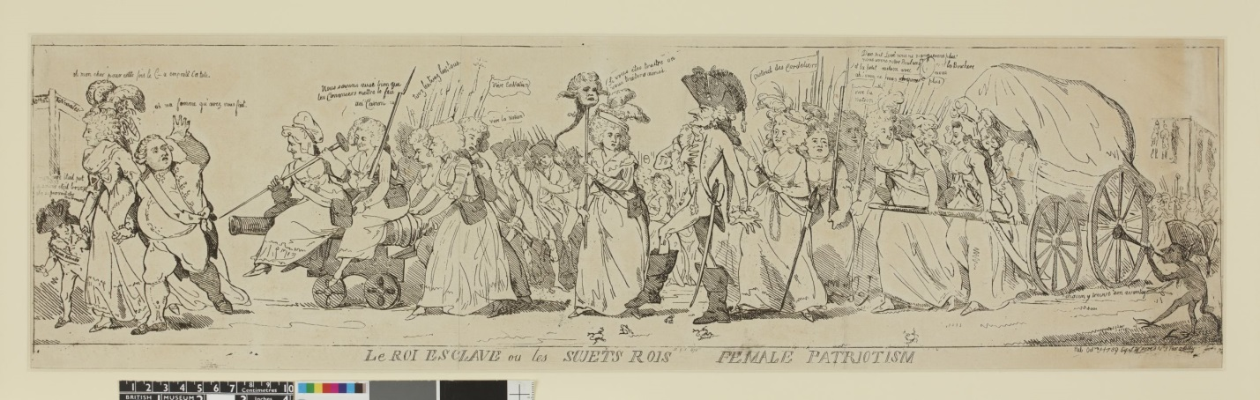
This tension continued to build over the years, and Louis XVI was not willing to compromise by reforming the government to the specifications of the revolutionary cause. In 1789 this volatile situation came to a head, initially, with the storming of the Bastille on July 14th. Skilled artisans, shopkeepers, and soldiers from a local regiment surrounded this medieval symbol of oppression as a backlash against the increasingly despotic government. This act immediately became a symbol of the revolution, and acted as a show of the power and camaraderie present in the combined revolutionary spirit. The king maintained a counter-revolutionary stance, and in October tensions erupted again. The public reaction to a “raucous banquet” at which the revolutionary flag had been purposely trampled was immediate. The women of Paris were the first to react to this October 5th occurrence. Enraged by this degradation of their cause and further fueled by the dismissal of the revolution by the courts, as well as elevated bread prices, these women armed themselves with cannons and marched to the royal palace. Arriving well into the night, the women ended up killing several palace guards before seizing the king and his family and forcibly marching them back to Paris, allowing the citizens of the city to influence political dealings more strongly and with more directness.
The print Female Patriotism (pictured left) depicts the events of this October March on Versailles. Women and collaborating soldiers can be seen with the severed heads of palace guards on pikes, violently egging the royal family on. These women, who are proceeded by Marie-Antoinette, Dauphin, and Louis XVI, have muskets, cannons, and pikes to threaten the royal family, and force their continued march back to Paris. Louis XVI is seen to be saying, “oh ma femme qu'avez vous fait,” which translates to “oh my wife, what have you done.” This is interesting because even the queen is condemned for being a woman, and blamed for the fall of her family. In this way, even though they are fighting against each other, it can be seen that women are all portrayed in similar ways, and used as scapegoats for the problems of society. Walking with the women is General Lafayette, whose body is caricatured as being skinny and weak. The women accuse him of being traitorous and state, “si vous êtes traitre on vous traitera ainsi,” or “if you are a traitor, then you will be treated.” Most notably, however, is the women’s cry of “Tuez les, tuez les tous,” meaning “Kill them, Kill them all,” and that of “Vive la Nation.”
This piece represents a very active portion of women’s lives in relation to the French Revolution. Female Patriotism is an extremely powerful piece because it displays the women of France taking action against the government they despise, and threatening other traitors to their cause. Showing the women to be so directly involved in violence is mildly surprising, because of the standard conception in the Eighteenth Century of women as passive, demure, and uninvolved. One realization this presents, however, is a confirmation of the participation of women in many of the violent acts attributed to the revolution. The passion and anger with which the women are portrayed clearly shows the idea of the women’s collective strength, and is used here as a message with propaganda-like qualities. The zeal shown by these women and their actions is indicative of the greater spirit of the revolution, and their determination to be a part of revolutionary events.
Female Patriotism depicts the fact that the women of France at this time were lashing out against the oppression which they, and their fellow citizens, were facing. The women in this print are clearly taking control of a situation, and are responding to the discomfort and disenfranchisement they feel because of the French royalty. It is interesting that the print does not just depict one class of women, but shows a range of women from different social classes all involved in threatening the royal family and General Lafayette. These women are depicted as violent through their speech, but the presence of the muskets, cannons, and pikes reinforces the true presence of that violence. It is interesting that even though the women are portrayed as particularly “belligerent,” they are also displayed as being less caricatured than the royal family or General Lafayette. The fact that the women are portrayed in this realistic manner shows that Cruikshank and his patron, Fores, believed that the women of France who were involved in the revolution were inherently violent. Because their depiction is less “ambiguous” than the others in the print, it underscores the perception of these women as belligerent and ruthless.
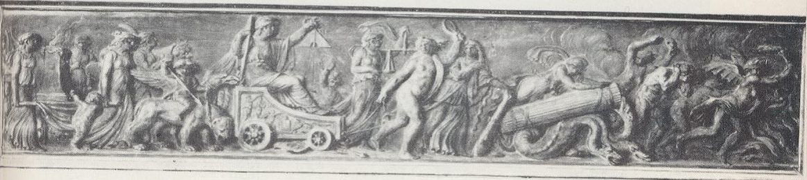
Additionally, the banner and cry of “Vive la Nation” solidify these women as actors of the revolutionary cause. The realism attributed to the women, with those in the upper class well dressed and coiffed and the lower class in “mobcaps,” shows the ability of revolutionary ideals to influence women across class boundaries. Coupled with this image of interclass cooperation is that of women with pronounced cleavage, which indicates that some of them may have been prostitutes. These depictions of the women create a “persistent emphasis on the attractive and seductive demeanor of these women which is combined with the threat of their violent potential.” The reality of their portrayal comes from deep seated anxiety on the part of the male artist and patron that the events of the revolution were corrupting women to be more politically and sexually independent. Showing women in this light clearly identifies the male need for women to be disparaged for their action, and attempts to discourage the women who see the print from acting in a similarly revolutionary manner.
Although Female Patriotism is an English print, similar depictions of the women’s march on Versailles can be seen in French artwork, as well. One such piece was created by Pierre-Paul Prud’hon, a French artist who is best known for his paintings. Prud’hon first gained public recognition in 1796 for his painting Truth Descending from the Heavens Led by Wisdom, which is now displayed in the Louvre. While he was most famous for his paintings, he also trained with engravers in Paris and was the 13th child of a stone mason. These facts account for the beautifully carved piece entitled Le Triomphe de la Révolution (pictured left) which Prud’hon created. Although the date of creation and the context of this piece are unknown, it is almost unmistakably a depiction of the October March.
Pictured in Prud’hon’s carved panel are the French revolutionary women, probably marching back to Paris from Versailles. This assumption can be made because the right side of the carving depicts creatures that seem to be fleeing from the following women. As with the depiction in Cruikshank’s print, these caricatures represent the fleeing royal family; in this case, the most visible figure is a male reminiscent of a gargoyle, and probably represents Louis XVI. The women who are forcing the march can be seen crushing hydras with a pillar, which shows that they were able to demolish part of the palace that they stormed. In addition to the destruction they caused, crushing the hydras is a metaphorical representation of crushing the despotic monarchy.
Some of the women are shown as naked or clothed in sheer garments. In this case, however, the nudity is probably representative of being natural and vulnerable, instead of Cruikshank’s depiction of women as morally depraved. One of these naked women, towards the center of the piece, is holding up a sickle. Her comrades are seen to be armed, as well, with swords and what appears to be boiling tar. These images of the women as prepared to fight shows their underlying violence, even though in this piece the belligerence of the women is not highlighted. In fact, two women in the center of the carving are shown to be holding a set of scales and a level, which are symbols of the justice and equality that the women are perpetrating. The woman seated on the chariot holds the level, and was probably placed in the carving as a representation of Liberty. Also, her chariot is reminiscent of Greek chariots, and could be a symbol for Greek ideals of democracy that the women of the revolution were trying to spread. Although none of the women in this piece seem to be ugly or vilified, they are still given characteristic undertones of violence and discontent. Prud’hon seems to have been much more subtle than Cruikshank in his depiction of violent women, even though both representations show the women to be powerful in a situation, which was not common for their sex.
Other French representations of the October March moderate these two views. One anonymous printmaker created a piece entitled A Versaille A Versaille du Octobre 1789 (pictured below). The women in this print are much more energetic and excited than those pictured in Prud’hon’s carving, but are more collected and cooperative than those in Cruikshank’s depiction. This print shows the procession to be “orderly…with the cooperation of all or most.” However, these women are still seen to be hunched over pulling a cannon and waving pikes, pitchforks, clubs, and spears in the air. Regardless of the fact that they are more demure than Cruikshank’s women, the women depicted in this print are shown to be strong and ready for violence. Presenting women in this manner works against the established social norms for women in the late-Eighteenth Century. In this way, women might have been discouraged from participating in revolutionary acts for fear of public degradation. By representing the women who were involved in the French Revolution as violent and belligerent, it would have reinforced the social norm of women as demure and passive. Through these representations, the women of France were relegated to certain spheres of acceptable behavior.
This was certainly one of the aims of Irish author Edmund Burke when he wrote his narrative Reflections on the Revolution in France. Though born in Dublin in 1730, Edmund Burke was an important contributor to British politics and is said to be the “founder of modern British conservatism.” Even though he was concerned with issues of Irish representation in history, he still endeavored to “draw a veil over his Irish background” so as not to affect his British political career. It is interesting to examine Burke’s perspective as it offers another dimension of national perception of the French Women. Additionally, Burke is “often portrayed as the arch-opponent of revolution” because he strongly favored aspects of “harmony, stability, and tranquility.” These ideas definitely influenced his perception of the French women, who, in his eyes, were working against these ideals of beauty and harmony.
When describing the plight of the royalty, Burke states that they were forced to march “amidst the horrid yells, and shrilling screams, and frantic dances, and infamous contumelies, and all the unutterable abominations of the furies of hell in the abused shape of the vilest of women.” Burke goes on to describe the royals with marked sympathy, saying “after they had been made to taste, drop by drop, more than the bitterness of death, in the slow torture of a journey of twelve miles, protracted to six hours, they were, under a guard composed of those very soldiers who had thus conducted them through this famous triumph, lodged in one of the old palaces of Paris, now converted into a bastille for kings.” Through such negative descriptions, the author’s intent is unmistakable, as he, himself, ruthlessly cuts down the actions of these women, purporting them to be harmful to both the cause of the revolution, and the safety and sanctity of femininity.
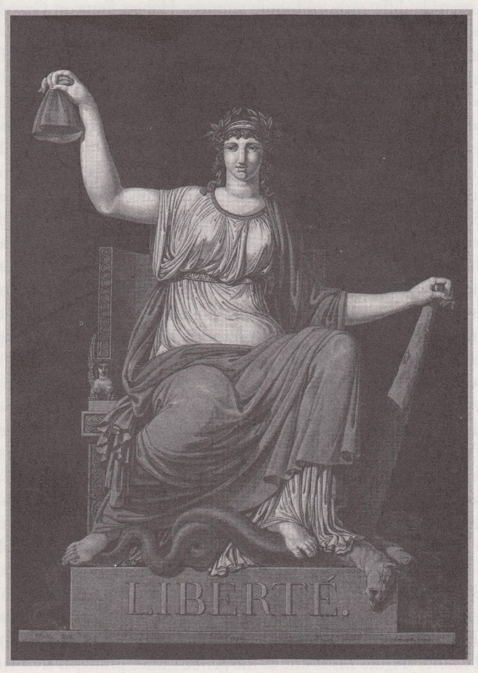
The language that Burke uses is decisively derogatory towards the women who are taking these actions, and describes the women as heinous creatures perpetrating inhumane acts. Portraying these powerful women as vile and horrid dehumanizes the women and devalues their actions in the eyes of Burke and his contemporizes. By portraying women in positions of power as the “furies of hell,” Burke casts them in an extremely negative light that dismisses any positive contributions or the positive steps they achieved for the revolutionary cause. In this way, he rejects them from respectable social circles and out of the ideas of acceptable behavior in polite society. When others read these interpretations they are subconsciously, by pejorative words like shrill and frantic, and overtly, through the present insults, caused to react to these women and their actions in negative ways. Readers of Burke’s work, and viewers of prints that feature women as violent or powerful, were encouraged to fear and hate the women that had taken part in the events of the French Revolution.
Other creative works place women directly opposite the violent and caustic characters that were portrayed. In favorable pieces, the French women were depicted as mothers of their nation and of the revolution. One example of these positive presentations is the print Liberty (pictured right) by Jean-François Janinet, which was completed in 1792. Janinet was a French printmaker, and he and his contemporary, Charles-Melchior Descourtis, were known for having mastered “complex multiple-plate color printmaking.” Although Liberty is created in a simpler style, it presents many interesting elements of symbolism. This piece depicts Liberty, one of the three fundamental virtues of the revolution, the other two being equality and fraternity. In the print, Liberty is depicted as a noble woman seated on what appears to be a marble throne holding a Phrygian cap in one hand and a club in the other. Her foot is seen crushing a hydra and there is a wreath of laurel leaves on her head.
Portraying Liberty as a woman who is both sensual and modest makes a statement about the state of the nation and the types of liberty the revolutionaries seek. Although fully clothed, when examined closely, Liberty’s breasts are visible through the slightly sheer fabric of her dress. This reveals the vitality of the Nation and the ability of Liberty to provide for it. The life-giving breasts are shown to symbolize the motherhood which Liberty represents, and creates the idea that the revolutionary cause birthed a new nation, conceived by the embodiment of Liberty. This depiction relates to the events of 1792 because the revolution was beginning to create new forms of government for the people. In the next year, the Constitution of 1793 was created and illustrating Liberty as a fertile and sensual woman shows her ability to care for the people of the new republic. The fact that her legs are slightly spread also gives faint allusions to motherhood, and reinforces the idea that it is Liberty who has given birth to the new nation of France. This presentation of Liberty also highlights the importance of family life in women’s roles during this time period, and encourages their place as mothers in polite society.
In contrast to the sensual allusions made by the presentations of her motherhood, Liberty’s full robes give her the illusion of modesty. This is symbolic of the virtuous nature Liberty embodies, and underscores her ability to stand up for the righteousness of the oncoming nation. However, the modesty of women is actually representative of the theme of sexual repression, especially in the late-Eighteenth Century. In this way, it could be that while Liberty is seen as the life-force and mother of the revolution, her place as a woman is still inferior to that of men. Placing the men fighting in the revolution above the depiction of Liberty, who supports them, shows clearly that the position of women in the revolution was meant to be passive. This oppression of women is characteristic of the time period, showing the ‘proper role of women’ in society. In spite of the potentially repressive portrayal, the representations of Liberty as female shows a slowly moving shift from the total subalternation of women’s ideas and involvement in the revolution to that of an increased acceptance and influence given to women who remain in the private sphere. Because of this, it can be seen that representations of women in relatively powerful positions, like that of the personification of Liberty, serve to increase women’s private involvement in the politics of the day. However, it ultimately limits them to the position of mother and nurturer, placing a responsibility on women to raise their male children as revolutionaries and repress aspirations of socially accepted power in their daughters.
Additionally, the imagery of this print is very reminiscent of Roman myth and culture. In this case, the hydra is a symbol for the oppression placed on the French citizens by the aristocracy. By crushing the hydra underfoot, Liberty shows the strength and vitality of the revolutionary cause and its ability to vanquish the despotism which had subjugated the French people. This is also associated with the defeat of slavery, as the Phrygian cap is associated with the emancipation of Roman slaves. The slaves wore Phrygian caps as a show of solidarity in their quest for liberty and emancipation, so the association is a very powerful symbol of inspiration for the revolutionary citizens. Furthermore, the laurel leaves which crown Liberty in the print can be seen as a symbol of “civic virtue.” When paired with the hydra monster, the club Liberty holds could be a reference to the club Hercules used to defeat the hydra in Roman legend, an allusion which again illustrates the strength and veracity of Liberty and the revolutionary cause.
The inclusion of Roman symbolism can be linked to the Neo-Classicism movement that was prominent during the late-Eighteenth and early-Nineteenth centuries. This movement focused on recalling representations of the golden days of Rome’s art, culture, and architecture, and incorporating them into Western culture. Because of this, the concept of Roman references fits with the time period, and allows for an understanding of the continued importance of tradition in the new republic. By incorporating Roman symbolism, the print highlights the significance of traditional values and ideas. Therefore, the Roman imagery can be seen as another element which reinforces the place of women in the home as mothers instead of as revolutionaries.
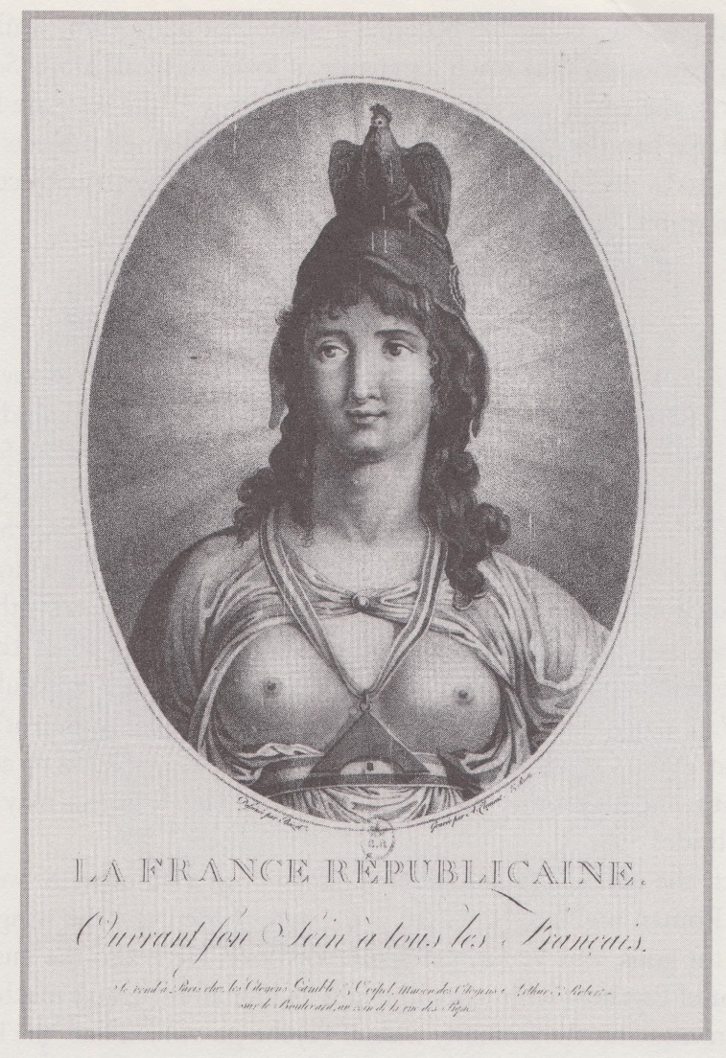
Another French artist who displayed women in this motherly fashion was Louis-Simon Boizot. Although Boizot was primarily a sculptor, he created an engraving entitled Republican France/Opening Her Breast to All the French (pictured right) in 1792. In the etching France is personified by a young woman. Depicted with the curly brunette hair, a faint smile, and a halo glow around her head, France is shown to be radiant and virginal. Perhaps her most prominent feature is her open breasts, as referenced in the title, which are exposed in a way that is both erotic and inviting.
Through her posture and presentation, it is clear that in this print France is placing herself as an offering for the cause of the revolution. France is portrayed as wearing two overt symbols of equality: a level around her neck and a Phrygian cap. Although her cap connects the imagery in this etching to that in Janinet’s depiction of Liberty, the focus on her breasts reduces France’s representation from that of equality to one of “sexual opportunity.” Even with her virginal appearance and the sexual overtones of the etching, a connection can still be made between France’s exposed breasts and the concept of her as the mother of the nation. The vitality represented by her youth and appearance underscore her position as a woman with the ability to care for the children of the revolution.
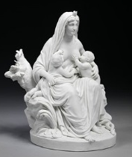
Boizot created another work with very similar themes two years after the etching, in 1794. This work is titled La Nature (pictured left) and is a ceramic sculpture, a type of work for which Boizot is better known. In this piece, Nature is portrayed as a mother, nursing her two children. The sculpture serves as another way for the artist to highlight equality in the French nation, as one of the children is White and the other is Black. Showing Nature to be breastfeeding is particularly significant because the act had come to symbolize the values of duty and equality in the new Nation. These two works by Boizot are extremely connected because both place women in a position of duty to and motherhood over the revolutionary nation. Correlating the implications of similar aspects of the two pieces helps to reinforce their meaning in both cases. The representation of breasts and breastfeeding solidifies the position of these two women as mothers or mother-like figures. Additionally, the qualitiy of sensuality, overt in the first work and implied in the second, highlights the vitality of the women and the fact that they were percieved as anchors for the strength and morality of the nation.
The German conception of French women during the revolution was also constructed in relation to the contrast between virtue and violence. Julie Koser wrote an article which tracks the dichotomy of women’s representations in the German press. Her article argues for the same divide in representations of women, and shows that the press in Germany depicted French women in the same way that the English and French did. This was done through both a visual and textual means, as the first German accounts of the French Revolution are seen in the form of travel reports and eyewitness accounts. The press was able to reach a wide audience, so both the visual and textual representations of women were played an “influential role in reinforcing gender roles” in Germany. Through the expressions of women in the press, Germans were able to continue the idea of women as the “weaker sex,” specifically by “[vilifying] the armed woman and [privileging] the patriotic mother and wife.”
In addition to these depictions of women, the German press was able to reinforce and control Eighteenth-Century myths of femininity by heavily regulating the material that was published. As they censored the image of women in the press, several archetypes were created for women that served to define all women along the terms of their political involvement. Additionally, revolutionary women were created as distinct from the men in similar situations, and the depictions of the two served only to further categorize the former as “cold and merciless.”
Examining the representation of revolutionary women in Germany is important because it helps to reinforce the idea of the way in which violent and revolutionary women were disparaged, while patriotic women were upheld as the standard for normalcy. Because of Germany’s proximity to France and its revolutionary ideals, the German elite was determined to portray the revolution as “unnatural” and “dangerous” in order to discourage a similar uprising in Germany. The press was very influential, and creating this contrast between the representations of revolutionary versus patriotic women had a large effect on the German population’s perception of the women of the French Revolution. Understanding the perspective of the German elite corroborates the ideas of the French and British aristocracies, as well. Since the dichotomy of women’s portrayals was transnational, it increases the overall importance of the difference that is presented in revolutionary women. Showing this divide as one that crosses borders highlights the overarching social perception of women, and shows that gender inequalities and anxiety about women’s influence on politics was not limited to one nation.
Conclusion: The Power of Representation
These contrasting portrayals give insight into the two opposing ends of the societal spectrum for female participation in revolutionary activities, ranging from the shocked degradation of active and powerful women to a quiet encouragement of the motherly representations of French ideals. Analyzing creative works that promote and disparage these different portrayals of women helps to construct an image of European society and their reception of the French revolutionary women. Within these representations, the events and figures being portrayed are manipulated in order to create a specific message. Examining both of these depictions of women is important because it strengthens the understanding of women’s roles in the French Revolution of 1789. In addition to explaining the role of women, creative texts are crucially indicative of the various conceptions society had of these women.
Furthermore, using creative works to boost the understanding of European culture and social perception helps to address questions central to the study of History. Determining what aspects of society fall into the “reality” of the historical narrative of a particular time period is challenging. Looking at creative texts, however, helps to outline important ideas in society and shows concepts that were propagated and preserved as acceptable. Because of this, creative works, instead of muddling the definition with subjectivity, actually serve to underscore significant features of society and can act as a guideline for further historical research. In this way, dismissing creative works, like the newspaper accounts, prints, sculptures, carvings, novels, and narratives addressed in this essay, destabilizes the Historian’s understanding of a time period. Adding new information to the perception of a historical period can only serve to strengthen the grasp Historians have on society and its ideals. Therefore, rejecting information gleaned from creative works on the grounds that they can be interpreted subjectively removes the Historian’s ability to reexamine facts about a society from a new perspective.
The use of symbolism and metaphor in the different forms of these artistic works creates a detailed picture of women in during the French Revolution. These women may have been represented in a capacity that limited their power and strength in the public sphere, but the fact that they were presented, even in a negative light, is significant because their influence was recognized. By banding together, these women were given a voice, and they forced society to accept their actions in a way in which an individual woman would not have succeeded. Their combined effort gave them the power necessary to accomplish their goal. When examined in this light, even an unfavorable portrayal of women is an extremely positive testimonial to the amount of change a group can incur through sheer will and collaboration. It is a call to arms for the men and women of France to act out against their degradation.
Finding this information in the form of creative works that perpetrate extremely sexist ideas and perceptions is interesting, and forces Historians to reexamine the position of women in Europe and the revolutionary cause. In a time when revolutionaries were proclaiming the rights of citizens and men, women were excluded, and they took the opportunities they could to try and rectify that situation. Seeing women portrayed in artistic works proves their determination, even in the face of dismissal and disparagement. The texts examined in this essay provide a representative selection of the written and visual depictions of French women, and show the clear dichotomy between favorable and negative perceptions of these women. Analyzing these portrayals increases the historical understanding of French women in the revolution, and the idea of exploring creative works that describe other historical periods can be used to enhance the conception of society in those times, as well.

Bibliography
Primary Sources:
Anonymous. A Versaille A Versaille du Octobre 1789. 1789. Musée Carnavalet.
Boizot, Louis-Simon. Republican France/Opening Her Breast to All the French. 1792. Bibliothéque national de France.
---. La Nature. 1794. Victoria and Albert Museum.
Burke, Edmund Reflections on the Revolution in France. Originally published 1790; New York: J. M. Dent and Sons, 1971.
Cruikshank, Isaac. Le roi esclave ou les sujets rois/Female patriotism. 1789. The British Museum.
Dickens, Charles. A Tale of Two Cities. Originally published in 1859; London: James Nisbet and Co, 1902.
Janinet, Jean-François. Liberty. 1792. Bibliothéque national de France.
Prud’hon, Pierre-Paul. Le Triomphe de la Révolution. Musée Carnavalet.
Secondary Sources:
Cain, William E., and Vincent B. Leitch. The Norton Anthology of Theory and Criticism. New York: W.W. Norton and Co., 2001.
Cameron, Vivian. “Gender and Power: Images of Women in Late 18th-Century France.” History of European Ideas 10, no. 3 (1989): 309-332.
Censer, Jack R., and Lynn Hunt, Liberty, Equality, Fraternity: Exploring the French Revolution. Canada: Pennsylvania State Universty Press, 2003.
Doyle, William. The French Revolution: A Very Short Introduction. New York: Oxford University Press, 2001.
---. Origins of the French Revolution. New York: Oxford University Press, 1980.
Easson, Angus. “From Terror to Terror: Dickens, Carlyle and Cannibalism.” In Reflections of Revolution: Images of Revolution, edited by Alison Yarrington and Kelvin Everest, 96-111. New York: Routledge, 1993.
Edwards, Ralph. “Isaac Cruikshank.” The Burlington Magazine for Connoisseurs 52, no. 301 (April 1928): 184-189.
Gibbons, Luke. “Edmund Burke.” In A Companion to Irish Literature: Volume 1, edited by Julia M. Wright, 226-242. Malden, MA: Blackwell Publishing, 2010.
Hunt, Lynn. French Revolution and Human Rights: A brief Documentary History. Boston: University of Pennsylvania Press, 1996.
Hyde, Melissa, and Jennifer Milam. Women, Art and the Politics of Identity in Eighteenth-Century Europe. Burlington, Vermont: Ashgate Publishing, 2003.
Koser, Julie. “Spectre and/or Ideal: Representations of Revolutionary Women in the German Press, 1789–1794.” German Life and Letters 63, no. 2 (April, 2010): 105-121.
Kromm, Jane. “Representations of Revolutionary Women in Political Caricature.” In The French Revolution Debate in English Literature and Culture, edited by Lisa Plummer Crafton, 123-136. Westport, Connecticut: Greenwood Press, 1997.
Landes, Joan B. Visualizing the Nation: Gender, Representation, and Revolution in Eighteenth-Century France. Ithaca: Cornell University Press, 2001.
“Neo-classicism.” In Philip's Encyclopedia. London: Philip's, 2008.
Popkin, Jeremy D. A Short History of the French Revolution. New Jersey: Pearon, 2010.
“Prud'hon, Pierre Paul.” In Chambers Biographical Dictionary. London: Chambers Harrap, 2011.
“Prud'hon, Pierre Paul.” In The Columbia Encyclopedia. New York: Columbia University Press, 2013.
Sorensen, David R. “‘The Unseen Heart of the Whole’: Calyle, Dickens, and the Sources of The French Revolution in A Tale of Two Cities.” Dickens Quarterly 30, no. 1 (March, 2013): 5-25.
Taws, Richard. “Material Futures: Reproducing Revolution in P.-L. Debucourt's Almanach National.” Art Bulletin 92, no. 3 (September, 2010): 169-187.
Trustees of the British Museum. “Le roi esclave ou les sujets rois/Female patriotism.” The British Museum. www.britishmuseum.org.
---. “S. W. Fores Biographical Details.” The British Museum. www.britishmuseum.org.

Melissa Hyde and Jennifer Milam, Women, Art and the Politics of Identity in Eighteenth-Century Europe (Burlington, Vermont: Ashgate Publishing, 2003), 2.
Jack R. Censer and Lynn Hunt, Liberty, Equality, Fraternity: Exploring the French Revolution (Canada: Pennsylvania State Universty Press, 2003); Lynn Hunt, French Revolution and Human Rights: A brief Documentary History (Boston: University of Pennsylvania Press, 1996).
William Doyle, The French Revolution: A Very Short Introduction (New York: Oxford University Press, 2001), 3.
William Doyle, Origins of the French Revolution (New York: Oxford University Press, 1980), 67.
Doyle, Origins, 66.
Doyle, Origins, 87.
Doyle, Origins, 96-100.
Doyle, Origins, 178.
Doyle Origins, 188.
Doyle, Origins, 191.
Doyle, A Very Short Introduction, 15.
Doyle, Origins, 204
Doyle, Origins, 212.
Doyle, A Very Short Introduction, 52.
Doyle, A Very Short Introduction, 55-5.
Hyde and Milam, Women, Art and the Politics of Identity, 2.
Hyde and Milam, Women, Art and the Politics of Identity, 2.
Hyde and Milam, Women, Art and the Politics of Identity, 102.
Doyle, Origins, 78.
Angus Easson, “From Terror to Terror: Dickens, Carlyle and Cannibalism,” in Reflections of Revolution: Images of Revolution, ed. Alison Yarrington and Kelvin Everest, (New York: Routledge, 1993), 101.
Easson, “From Terror,” 101.
Easson, “From Terror,” 101.
David R. Sorensen, “‘The Unseen Heart of the Whole’: Calyle, Dickens, and the Sources of The French Revolution in A Tale of Two Cities,” Dickens Quarterly 30, no. 1 (March, 2013): 5.
Charles Dickens, A Tale of Two Cities (originally published in 1859; London: James Nisbet and Co, 1902), 411.
Dickens, Tale of Two Cities, 411.
Trustees of the British Museum, “S. W. Fores Biographical Details,” The British Museum. www.britishmuseum.org.
Ralph Edwards, “Isaac Cruikshank,” The Burlington Magazine for Connoisseurs 52, no. 301 (April 1928): 184.
Edwards, “Cruikshank,” 184.
Jane Kromm, “Representations of Revolutionary Women in Political Caricature,” in The French Revolution Debate in English Literature and Culture, ed. Lisa Plummer Crafton, (Westport, Connecticut: Greenwood Press, 1997), 124.
Edwards, “Cruikshank,” 184 and 189.
Edwards, “Cruikshank,” 189.
Doyle, A Very Short Introduction, 22.
Doyle, A Very Short Introduction, 22.
Doyle, A Very Short Introduction, 22.
Doyle, A Very Short Introduction, 22.
Jeremy D. Popkin, A Short History of the French Revolution (New Jersey: Pearon, 2010), 31.
Popkin, A Short History, 32.
Popkin, A Short History, 42.
Popkin, A Short History, 43.
Popkin, A Short History, 43.
Isaac Cruikshank, Le roi esclave ou les sujets rois/Female patriotism, 1789, The British Museum.
Trustees of the British Museum, “Le roi esclave ou les sujets rois/Female patriotism,” The British Museum. www.britishmuseum.org.
British Museum, “Female patriotism.”
British Museum, “Female patriotism.”
Kromm, “Representations of Revolutionary,” 124.
Kromm, “Representations of Revolutionary,” 124.
Kromm, “Representations of Revolutionary,” 125.
Kromm, “Representations of Revolutionary,” 125.
Kromm, “Representations of Revolutionary,” 125.
Kromm, “Representations of Revolutionary,” 125.
“Prud'hon, Pierre Paul,” in The Columbia Encyclopedia, (New York: Columbia University Press, 2013).
“Prud'hon, Pierre Paul,” in Chambers Biographical Dictionary, (London: Chambers Harrap, 2011); The Colombia Encyclopedia.
Pierre-Paul Prud’hon, Le Triomphe de la Révolution, Musée Carnavalet.
Anonymous, A Versaille A Versaille du Octobre 1789, Musée Carnavalet.
Vivian Cameron, “Gender and Power: Images of Women in Late 18th-Century France,” History of European Ideas 10, no. 3 (1989): 320.
Cameron, “Gender and Power,” 326.
Luke Gibbons, “Edmund Burke,” in A Companion to Irish Literature: Volume 1, ed. Julia M. Wright (Malden, MA: Blackwell Publishing, 2010), 226.
Gibbons, “Edmund Burke,” 229.
Gibbons, “Edmund Burke,” 232.
Edmund Burke, Reflections on the Revolution in France (originally published 1790; New York: J. M. Dent and Sons, 1971) 69.
Burke, Reflections, 69.
Jean-François Janinet, Liberty, 1792, Bibliothéque national de France.
Richard Taws, “Material Futures: Reproducing Revolution in P.-L. Debucourt's Almanach National,” Art Bulletin 92, no. 3 (September, 2010): 170.
The idea of the subaltern was created by Gayatri Chakravorty Spivak in the 1980s. She uses this term to refer to people who are drastically marginalized. When one is made subaltern they are not only Othered, but their existence, and the existence of their dismissal, is ignore within the confines of an unaware society. (Vincent B. Leitch and William E. Cain, The Norton Anthology of Theory and Criticism {New York: W.W. Norton and Co., 2001} 2193.)
Joan B. Landes, Visualizing the Nation: Gender, Representation, and Revolution in Eighteenth-Century France (Ithaca: Cornell University Press, 2001), 41.
Landes, Visualizing, 39.
Landes, Visualizing, 41.
“Neo-classicism,” in Philip's Encyclopedia, (London: Philip's, 2008).
Louis-Simon Boizot, Republican France/Opening Her Breast to All the French, 1792, Bibliothéque national de France.
Landes, Visualizing the Nation, 151.
Landes. Visualizing the Nation, 151.
Louis-Simon Boizot, La Nature, 1794, Victoria and Albert Museum.
V&A Images, “La Nature,” Victoria and Albert Museum. http://collections.vam.ac.uk.
V&A Images, “La Nature.”
Julie Koser, “Spectre and/or Ideal: Representations of Revolutionary Women in the German Press, 1789–1794,” German Life and Letters 63, no. 2 (April, 2010): 106.
Koser, “Spectre,” 105.
Koser, “Spectre,” 107.
Koser, “Spectre,” 108.
Koser, “Spectre,” 111.
Koser, “Spectre,” 114.
Koser, “Spectre.” 105.
Koser, “Spectre,” 105.

