UNIVERSITY OF WISCONSIN-EAU CLAIRE
DEPARTMENT OF HISTORY

“THUNDER, INDIANS, AND MYTHOLOGICAL BIRDS: SCHOOL MASCOT CHANGES IN WESTERN WISCONSIN”

BY
JOSEPH AVERY
HIST 489
DR. ROBERT GOUGH

FALL 2012

Copyright for this work is owned by the author. This digital version is published by McIntyre Library, University of Wisconsin – Eau Claire with the consent of the author.

CONTENTS
----------------------------------------------------------------------------------------------------------Page
ABSTRACT ii

INTRODUCTION 1

CHAPTER ONE: MENOMONIE HIGH SCHOOL 3

CHAPTER TWO: OSSEO-FAIRCHILD HIGH SCHOOL 7

CHAPTER THREE: UNIVERSITY OF WISCONSIN – EAU CLAIRE 13

CHAPTER FOUR: CONCLUSION 17

SOURCES 19

APPENDIX 30

Abstract
In American society, people identify themselves not just with their creed, race, or ethnicity, but also their sports teams. This tightly knit identity creates a culture within itself that presents the beliefs, norms, and way of life of the people intertwined within it. While most prominent at NCAA Division I and professional levels, this identification also occurs at the local level, such as at high schools and smaller colleges. In some situations schools are forced to change their mascot or team name. This paper will examine an identity crisis at three separate schools in western Wisconsin during the second half of the twentieth and early twenty-first centuries and explain how the schools went about choosing a new mascot or team name. The three different case studies will examine controversial identities, lack of an identity, and popularity creating an identity

Introduction
In American society, sports have become a cultural phenomenon that creates cultures within themselves. These sport cultures have become paramount to many people as a way of determining “who you are” even more-so than religion or ethnicity. A result of this is that people will identify themselves with the team name or mascot. Examples of this include people from Ohio calling themselves Buckeyes or citizens of Texas calling themselves Longhorns. The team name sports fans support becomes the identifying culture name. Although these types of strong sports-related cultures are most prominent in professional and Division-I college athletics, they can also appear at a more local level. Consequently, sometimes mascots and team names change and evolve as community identities shift. However, the question arises that when a team name or mascot becomes so identifiable with a certain athletic program and community, how do school officials go about changing it if and when they are forced to?
In this paper, I will explore three case studies of sports programs that have undergone mascot or team name changes over the past 80 years in Western Wisconsin. Each case study explains reasoning behind the changing of the mascot. The first case study investigated relates to the role of popularity creating an identity and involves Menomonie High School in Menomonie, WI. Menomonie officially changed its name from the Maroons to the Indians and creating an Indian mascot in 1951. This change occurred due to popular demand to replace the name with Indians which had already become synomenous with the school and create an identity. The second case study investigated relates to controversial identity and involves Osseo-Fairchild High School in Osseo, Wisconsin which changed its mascot from the Chieftains to the Thunder in 2011 due to controversy over using Native American mascots in public schools. The third and final case study to a lack of identity for the school and involves the University of Wisconsin – Eau Claire creating a mythological bird mascot in 2010 due to a lack of a physical identity in its name, Blugolds. These specific schools have been chosen for this comparison for a number of reasons. First, each school discussed represented a different situation which allows the methodology to be compared. Second, each of these schools are located in close proximity to each other, meaning that the cultures of each of these cities and communities will most likely be very similar and will not affect the methodology used much. Third, each community represents a different social atmosphere. Osseo is a very rural community, Menomonie is a medium city community while being somewhat rural, and Eau Claire has a large city atmosphere. While these schools are in a close proximity to each other (see figure 1), each of these case studies has different circumstances and situations. However, even though these cases may be different, each of these schools changed their team name or mascot for a single reason, identity crisis. Different schools have changed their mascot or team name due to an identity crisis. The schools change for differing reasons; use differing methods; and choose differing new team names or mascots but they all choose a new mascot or team name to create a strong representation and identity for their students, school, and community.

CHAPTER ONE:
MENOMONIE HIGH SCHOOL
The first of the three case studies we will look at is Menomonie High School. Menomonie is a city located in Dunn County in west-central Wisconsin. The city is home to over sixteen-thousand people. Like Osseo-Fairchild last year, Menomonie High School endured a mascot change from a Native-American logo to the less controversial “Mustangs” in 2011. However, Menomonie had another mascot change in 1951 when public popularity caused the creation of a mascot. Prior to 1951 and starting in the early 1900s, the Menomonie High School athletic teams were known by a multitude of names, most popularly the Maroons, but also the knights and the Maroon Men. However, none of these names really stuck and were used interchangeably. The first records of the use of the “Indian” name show up in a 1934 news article from the Dunn County News where the writer referred to the boys’ basketball team as the Maroon Indians. Between 1934 and 1951, the use of Indians could be seen more and more in newspaper articles, yearbooks, and letters of correspondence. Eventually, in 1951 Menomonie High School formally changed the team name from the Maroons to the Indians (See figure 3). The progressive movement of popularity caused this change. This identity crisis of popularity created a new identity which related more to the new generation of students and community members than did the previous identity. This shows how time can change who people are and what they feel represents themselves most fittingly.
As stated previously, the change from Maroons to Indians was an identity crisis of popularity and changing cultures. Back in the 1910s, the Maroon name and mascot were very popular with that generation of students and community; however as time went on the name Maroon was construed and evolved. Names such as Maroon Men and Maroon Knights were interpretations of the Maroon name which were slowly degrading. Eventually, people began to use the name Maroon Men interchangeably with Maroons. Then Maroon Men became Indians and eventually the name Indians became so popular it overtook the previous official name, Maroons. This identity crisis is essentially popularity changing a mascot over a long period of time, which in this case encompasses approximately thirty-five years.
The reasoning behind the change is due to an evolving identity. The transition from Maroons to Maroon Men to Indians is indicative of the time period when “politically-correct” did not exist. As far as this writer can understand, this interpretation is similar to that of other Native American mascots of the time period. Team names such as the Washington Redskins or team logos such as the Cleveland Indians focused their logo on the color of a Native American’s skin (seen as red). Maroon is a variation of red and could possibly be used interchangeably with red. Therefore, this writer’s theory is that a switch from Maroon men to Indians was seen as a simple transition. Although the change occurred over a long period of time, in 1951, the students and the community did not feel well represented by the Maroons name, possibly due to the ambiguity of the name or current community members not identifying themselves specifically with the name as previously suggested. However, either way the name at that point was not a good fit anymore and a new similar name came along and became the new official mascot. Therefore, this identity crisis is a case of popularity creating a new mascot.
Similar to the topic discussed in the last paragraph is the different reasons why the mascot was changed at Menomonie High School. To put this into a nutshell with what was already discussed, the mascot name change occurred for the reason of popularity. The new name, Indians, had become more popular among students and community members than the old, previous name of Maroons due to having a physical interpretation of the name available (people can identify what an Indian much easier compared to a Maroon). However, this author cannot understand if the reasoning was based in the ambiguity of the name or simply in the population not feeling represented well by the old nickname anymore, but either way popularity did make the change. Later on in the paper we will discuss the case study at the University of Wisconsin –Eau Claire which had some similarities with popularity to this case at Menomonie. However the popularity in the Menomonie case caused the change itself whereas in the UW-EC case popularity merely chose the name without causing the change.
The methodology used to change the name was, itself, a lack of a methodology. The school merely “caved into” peer pressure by the students and the community and made the name change official (even though the team name had unofficially been the Indians for a number of years). This part of the case is incredibly different than the cases in Osseo-Fairchild and Eau Claire where the students voted on the mascot; Menomonie had no need to go about a vote to change the name, because the name had already been chosen by the students.
The mascot chosen, Indians, while controversial and stereotypical by today’s standards, gave the people of Menomonie something physical to root behind. Previously, the name Maroons had been something superficial and ambiguous, which may have caused much of the controversy. Now the student body could say we are Indians and get a mental picture in their head of what they cheered for. This was more definitive than saying we are Maroons and only creating more questions such as, “What is a Maroon?” What also caused Indians to take over for Maroons is the simplistic way that the change occurred. As stated earlier, the name of Menomonie evolved over time from Maroons to Maroon Men to Indians. People were able to interpret their old name into the new name and say, “we are still the same name only better defined” (interpreting that Maroons or Maroon Men as a representation of Native Americans based on skin color).
However, controversy would soon arise again in Menomonie in 2011. Throughout the nineties in Menomonie, debate had raged on concerning the Indian mascot. Many saw it depicting racial stereotypes; others said it honored Indians and that the tradition of the name was part of the town’s history. Through the years of the debate, the Indian logo had essentially vanished, being replaced with a “flying M” logo (see figure 4). However, after years of heated arguments, on June 19, 2011, the Menomonie School Board decided to end the controversy and rescind the use of the Indian logo and nickname. The decision was left to the students (similar to what will be discussed with Osseo-Fairchild) who chose the “Mustang” name from a school-wide vote (see figure 5).
This case study is very different from the other two in almost every way possible, although some small similarities are evident. The identity crisis was very much different as it was a case of popularity and the changing culture from one generation to the next, changing the mascot. The reasoning behind the change also differed greatly in that people could no longer identify themselves with the old name as well as the new “up and coming” Indians nickname. Essentially no methodology actually occurred as the name was essentially already changed; the school merely had to officially change the name. Finally, the new mascot name was chosen due to the view that it was similar to that of the old name in terms of interpretation as well as the growing popularity that had encompassed the Indians name. This case, although very different in terms of what happened, was very different on many levels in comparison to the other cases. While Menomonie would endure another mascot change sixty years after this one, the new name gave the people something they could cheer and physically endorse and interpret.

CHAPTER TWO:
OSSEO-FAIRCHILD HIGH SCHOOL
The second case study examined in this paper is Osseo-Fairchild High School, which changed its mascot from the Chieftains to the Thunder in 2011. The city of Osseo (where the school is located) is located in Trempealeau County in west-central Wisconsin. The city is home to 1,701 residents as of 2010. However, Osseo is a rural community and many of the students attending Osseo-Fairchild High School do not live inside the city limits of Osseo. Osseo-Fairchild High School was created in 1968 when the school districts of Osseo and Fairchild were combined. The school district decided to retain the mascot name, Chieftains which was originally Osseo’s mascot name (See Figure 6). It was not until 1992 that the roller coaster in public opinion about Osseo-Fairchild’s name began. Jim Doyle, Wisconsin’s Attorney General, stated that Native-American logos and nicknames in public schools violate state law regarding discrimination, which caused the Osseo-Fairchild school board to begin planning to gradually eliminate the Chieftain logo from school equipment and materials. However, this did not become a large issue to the school and community of Osseo-Fairchild until the 2001-02 school year. During the 2001-02 school year, a new gym was built for the high school without any depiction of the Chieftain head logo painted on or in the gym. However, the controversy got worse later in 2002 when the school board approved a recommendation submitted by a district committee to officially replace the Chieftain logo with a logo of “O-F”(see figure 7). While some believed that the logo was racial-stereotyping, there was a stronger majority that had a “connection” to the logo and felt that it was part of their own history. Those that wished to keep the Indian head logo were so infuriated, they petitioned for recall elections of the school board members who voted to change the logo. From these recall elections, four school board members were recalled and the new board members reinstated the Chieftain logo during a tumultuous meeting in which one protester was arrested. However, more complaints arose following the change and the board decided to modify the Chieftain logo from a Plains Indian (who do not reside in Wisconsin), to the image of a Ho-Chunk Indian which are more numerous in western Wisconsin. However, using a Ho-Chunk image for the new logo made the issue much more complex. The Ho-Chunk tribe had opposed the use of Native American mascots for many years. One member of the tribe stated, “…the school board has basically snubbed their noses at the Ho-Chunk Nation…”. Even students who were promised a say in the matter were disregarded, “(The board) made up their minds before listening to us,” said one student. However, many still praised the decision stating that it put the issue to bed once and for all. This logo stayed with Osseo-Fairchild for the next eight years until May of 2010 when then-Governor Doyle signed a bill allowing the superintendent of the Department of Public Instruction (DPI) to evaluate logos and nicknames and order districts to change. This new law came to Osseo-Fairchild on July 27, 2010 when the school was ordered to change its nickname and logo within a year. Many were relieved that the mascot would soon be changed, but others such as school board member Harold Mulhern believed the change would bring about adverse ramifications. Mulhern was quoted as saying, “There’s going to be a big disconnect between the people who graduated Osseo-Fairchild school as the Chieftains and those coming up….People who have been there will no longer be associated with the school and what’s going on,”. In order to keep the determination of the logo in the students hands, the school district held a preliminary vote to understand what mascots the students wanted to replace the Chieftain mascot with. The top choices that came from this vote were Bengals, Phoenix, Osprey and Dragons. In the weeks prior to the final vote by students over the four choices, Thunder emerged as a public favorite and eventually won as a write-in candidate on the student ballot (See Figure 8). The new mascot was announced in-between the JV and Varsity boys’ basketball games on Monday, November 28, 2011 at the Osseo-Fairchild High School gym. Although some bitterness still exists between those who opposed the change and those who supported it, Osseo-Fairchild will stay the Thunder for the time being.
What occurred at Osseo-Fairchild has happened more and more frequently, not just in Wisconsin but across the United States at both high schools and colleges alike. Native American mascots are and have been changed due to concerns about racial stereotyping. Therefore, the reasoning behind this mascot change at Osseo-Fairchild was due to a controversial mascot that was seen as stereotypical and the students, school, community, and state government did not want representing their culture and way of life as well as themselves personally. This identity crisis was essentially an expression of the desire to not be identified with a certain idea. Those from Osseo-Fairchild who did not support the Chieftain head and identified themselves with the school and/or sports program did not want them, their school, or community to be identified as supporting an idea that can be seen as racist and stereotypical; or they would risk being labeled as racist or intolerant themselves.
The change came about due to public outcry as well as force from the state government. Some in and outside the community already saw using a Native American mascot as immoral, and as public opinion began to sway in the direction of replacing the Chieftains mascot, more and more people began to come to the conclusion that “maybe using a Native American mascot is not ok”. This change in attitude was followed up by action at the state level by Governor Doyle, which solidified many people’s views on the issue and was the “dagger” that caused the Chieftain to be retired from Osseo-Fairchild.
When the time came that the Osseo-Fairchild school district decided that the mascot would be changed, this put the school board in a very difficult situation. After all, so many people with connections to the school firmly based their local culture on the mascot name of the high school. The school board proceeded by allowing the students to make the choice. All students were allowed to write-in names that they wanted as their new mascot. This way, the new name would be accepted by a larger number of students and community members in a quicker fashion. The school board with this decision essentially tried to create an identity that the students, school, and community all believed would be a strong, flattering, and accurate representation of them. Next, what the school district did as a means to keep the choice in the hands of the students and community was to select the top three choices and have a mass student vote that included alumni as well. The three choices listed earlier were given and students were allowed to choose one of the three preferred names or write-in a name they preferred. Giving students the choice allowed the school board to take no “flak” when the name would ultimately be changed and allowed the name to be accepted quickly by the community and students.
The name that was ultimately chosen was the Thunder, a write-in name on the final ballot. The school board eventually approved the name because it signified a multitude of attributes that the school board, students, and overall community wanted represented. One student was quoted as saying it was cool while another said that she thought it would be good. Personally, when the nickname Thunder comes to mind the adjectives that this writer associates with it are strength, power, honor, and tenacity, a very good compilation of attributes the community, school, and students would want to represent themselves. However, the mascot shows more than the strength or determination of the people it represents; it also gives the idea that the people are historically aware. The mascot for the new name, Thunder, is a Viking swinging a “Thor-like” hammer. While this is historically significant for many members of the community (thirty-nine percent of those living in Trempealeau county in 2000 were of Norwegian descent), it pushes the idea that the people represented by this mascot have a good awareness of world history and world cultures.
The Osseo-Fairchild mascot change did cause quite a stir both in the community and nation-wide, however the school board went about the change in a manner that created minimal problems after the mascot change actually came down. The school was forced to change due to ethical standards as well as legal obligations, which can create a very difficult situation for those involved, especially in trying to appease both those on both sides of the issue as well as the government. The school then put the issue in the hands of the students to keep it in the hands of those whom the nickname most represents as well as create minimal controversy in the community. A school-wide ballot allowed all students to share their views on the issue as well as their choice for mascot. Then the name Thunder created an identity that all people in Osseo-Fairchild could be proud of to reflect the people in a strong manner. Through this identity crisis, the school-board was able to find a mascot and nickname that justly identified the strengths and abilities of the community and school. They were able to achieve this while creating a mascot that was strong and honorable but did not create much contention in the long run or a great division throughout the school and community.

CHAPTER THREE:
UNIVERSITY OF WISCONSIN – EAU CLAIRE
The third case study takes place at the University of Wisconsin – Eau Claire (UWEC). The University is located near downtown Eau Claire, Wisconsin. The city is one of the largest cities in western Wisconsin, with 151,000 living in the metropolitan area. The University was founded in 1916 and as of 2012, holds nearly 12,000 students. The mascot debate at the University of Wisconsin-Eau Claire dates back nearly one-hundred years. The actual Blugold name dates back to the fall of 1935 when a Spectator author referred to the Eau Claire football team as Blugolds in a win over the Winona Teachers College. During the next forty-plus years the UW-EC athletic teams were known by a number of team names including the Normal, the Blue & Gold Warriors, and the Blue & Gold Artists. Names were even formulated from the head basketball coach of the time, Bill Zorn, with team names such as the Zornmen, the Zornadoes and the Golden Zornadoes. However, the search for an actual mascot began in 1945. The Spectator sponsored both a banner contest for the newspaper and a nickname contest with the goal of finding a more “distinctive and original nickname” than Blugold, however not a single entry was turned in. This search was tried again in 1956 when the University of Eau Claire Art Club sponsored a mascot contest in which students voted on a mascot, the choice being “Buster Bulldog”, although the University decided not to officially accept the mascot. Another vote was held in 1965, but the University Faculty Senate rejected the results because “students were not given the choice of a ‘no’ vote”. The mascot issue laid dormant for over forty-years until 2006 when it reemerged. The Student Senate authored a resolution to recommend that the chancellor form a committee to review the need for redefining a Blugold. In 2007, the University Faculty Senate petitioned for the creation of an official mascot to represent the Blugold name. The administration allowed students and alumni to speak and created a preliminary ballot. The top two choices that made the ballot were “The Voyageur” (a woodsman representing the regions legacy in French settlers and Native American tribes of the area) and “The Blugold Ox” (An oxen with golden horns and a yoke made from the Council Oak Tree) along with the choice of “no mascot”(See figures 10 & 11). The eventual winner was write-in candidate, “Mythical Bird”, which was soon adopted by the student council (See figure 12). However, the administration decided not to accept the bird interpretation of a Blugold for reasons this writer does not fully understand. Therefore, the student mascot was changed to the mythical bird while the actual University itself remained mascot less.
The Blugold mascot in itself is a crisis of a lack of identity. Since 1945 students, alumni, and even professors have wondered, “What is a Blugold?” This question has plagued the University of Wisconsin – Eau Claire campus and creates a division between those who believe one interpretation over another. The University has done much in order to support the creation of an identity and end this controversy; however these attempts have not completely ended the arguments as we still do not know what a Blugold actually is.
The University of Wisconsin – Eau Claire had a very simple reason for its many attempts to create its mascot to represent its university. It is because there was not one to begin with! This attempt by the school to find a mascot is to create an identity that can become synonymous with the school and students. It’s a symbol for what makes the University great and a good representation of the school, students, and its many alumni. While many would be perfectly fine and happy with identifying themselves as Blugolds, there are even more that would rather be identified with something tangible or something they can actually identify in saying, “that is what a Blugold is”. Therefore, this creating an identity is solely the reasoning behind this change/creation.
The methods the administration used at the University of Wisconsin – Eau Claire are very similar to how Osseo-Fairchild high school went about changing its mascot. Every time the school attempted to find a physical mascot, it looked to the student body. The last two times, the student body chose a physical mascot that they approved of representing not just the University, but themselves. The first time they selected a bulldog, the second time they selected a bird. However, both times, after the change passed the student council, it was shot down by the administration. This raises the question over why the University held a vote when they would not approve of the students decision. However, that is not the focus of the paper. The school held a preliminary vote on mascot suggestions and chose the top two choices for the whole student body to vote on. In this case, as in the Osseo-Fairchild case, a write-in candidate won as the mythological bird choice beat out the voyageur and the ox. However, different from the case in Osseo-Fairchild, the administration shot down the mythological bird interpretation of a Blugold and decided to identify the school with no mascot. Still, the bird mascot had passed the student council at that point, and the mythological bird interpretation became the official mascot of the student body instead of the school itself. This adoption of a mascot for the student body will appease some, but there will still be debate over what a Blugold is until the administration adopts the bird mascot as well.
While the Blugold mascot had not been chosen by the student body until recently, many prior students believed that a Blugold was indeed a mythological bird. I specifically remember every homecoming a student stood at the bottom of the hill on campus and gave high fives while wearing a yellow and blue bird costume. People referred to him as the Blugold bird. While I am not sure if the Blugold bird idea started with this student and exploded into something much bigger or got its start much earlier, I do know that the bird interpretation is THE interpretation of the students of UWEC even before it became the official mascot of the student body. This is not a case of students thinking the voyageur or ox didn’t really support the essence of what it is to be a Blugold, these students already knew what a Blugold was and voted for it to be a bird. Therefore, this case isn’t as much a lack of an identity as much it is a lack of a formalization of an identity.
The Blugold mascot that the students adopted can be seen on campus on shirts, sweaters, pants, and other apparel sold by the University; however there is still a lack of an officially recognized mascot for the University. On October 17, 2012 the student body vice-president of UWEC sent an email to all students asking for submissions in choosing a name for the new student-body mascot. While the student body has put all its support behind the newly adopted Blugold mascot of the student body, the administration is still to be persuaded to adopt such a mascot. Either way, the students have adopted this mascot and created an identity although it is not fully embraced by the University.

CONCLUSION:
Each of these three situations brought about difficulties for the students, school, and community involved. However, each situation was handled well and created minimal problems going forward. Prior to problems coming to an apex in each situation, some uneasiness or unrest seemed to exist for years in Menomonie, UW-Eau Claire, and Osseo-Fairchild concerning their mascot whether it was controversy, lacking an identity or popularity slowly changing an identity. However, each situation brought about change differently: Menomonie was brought to change through a slow metamorphism of identity from the Maroons to the Indians through popularity among students and within the community, Osseo-Fairchild was brought to change through controversy and political measures, and UW-Eau Claire was brought to change through the lack of an identity and the students finally saying enough is enough. While two of the schools discussed dealt with the mascot change in very similar manners, Menomonie had no way to go about the change since the new mascot already existed at a high popularity level. While there is some similarity between Osseo-Fairchild and Eau Claire here, each school chose equally dissimilar mascots and chose them for differing reasons. Osseo-Fairchild students chose Thunder because it represented strength, honor, and pride, an idea that had been formally lost during the years of division and fighting over the Chieftain nickname. UW-Eau Claire chose the bird interpretation of Blugold because it was already highly popular with students even before the official voting began. Menomonie chose the Indians because many already referred to the Maroons as the Indians due to differences in interpretation and because popularity had already shifted from the Maroons to the Indians.
For those wishing to expand this topic and take it further, I suggest comparing similar situations (i.e. only controversy) to communities and schools in different areas that may have different cultures and viewpoints on issues. In my bibliography I have included multiple sources I specifically did not cite but were of great value to me understanding the issue at hand and I believe they will help anyone looking to understand this topic or expand upon it.
While these schools have avoided any more controversy and are well on their way to having a strong sports culture reinvested in the community, my hope is that other schools take away from this paper insight into how other schools have gone about similar circumstances and come out of the fire. These schools which may be undergoing this process or even schools that are starting to experience an identity crisis in their school and community; whatever school may see turbulence or divisions beginning to appear. I also hope to make others who read this paper understand the culture within sports in small communities and understand that even small changes to a school’s athletic program’s identity may cause great problems and divisions within an otherwise tight-knit community.

BIBLIOGRAPHY
PRIMARY SOURCES
Anderson, Deb, “Logo is a no-go,” The Dunn County News, June 19, 2011.
This news article discusses the school board’s decision to get rid of the Indian logo and name from Menomonie High School. The article goes in-depth on the issue and discusses a brief history of the debate.
This article is important because it gives background information for the final area of the Menomonie section. This will give a little closure to the issue for those reading it.
Anderson, Deb, “Menomonie has new mascot name,” The Dunn County News, September
20, 2011.
This news article discusses the change from Indians to Mustangs for Menomonie High School. The article goes into depth on the format that the school went through to get a new mascot and some feedback from students is included as well.
This is important because it adds the the closure part of the Menomonie section discussing what eventually came from the switch from Maroons to Indians.
Carlisle, Brian. E-mail message to author, October 17, 2012.
This e-mail cumulates the end of my chapter on UW-EC. It discusses the attempt of the Student-Body to create a name for the Blugold mascot at the University and calls for students to submit names.
This article shows the University is still pushing towards the Blugold mascot and progressing towards refining the identity that has been created.

Georgia Pabst, “Menomonie Groups to Testify On Mascot Bill,” Milwaukee Journal
Sentinel, January 28, 1998.
This source is from a paper news article that appeared in the Milwaukee Journal Sentinel in January of 1998. The article covers the debate that resurged in Menomonie over the “Indian” mascot debate. The source is reliable as it uses many quotations and cites its sources from Menomonie Students and the School Board. I will use this source for two different aspects it presents. First, I will relate it to the problems that Osseo-Fairchild recently overcame with the changing of their mascot. Second, the source does discuss a little about the Maroons mascot which gives me a little insight to the switch from Maroons to Indians which covers the problem of “Identity”.

Joyce, Mike. “Menomonie High School Selects New Mascot.” WQOW TV: Eau Claire.
This source is an excerpt from a news broadcast by WQOW-TV in Eau Claire, WI. The source covers when Menomonie changed their mascot from the Indians to the Mustangs in fall of 2011. The source comes from a local television station and utilizes sources and quotes from those in the Menomonie School District at the time of the switch. What this source helps me understand in writing the essay is how schools choose their new mascot. In the case at Menomonie, the students, faculty, and alumni voted to narrow down the choices to three and the students had the final say.

Kuether, Taylor. “Thunder Picked as New Osseo-Fairchild School Mascot,” Eau Claire
Leader Telegram, November 28, 2011.
This source is an online excerpt from a paper news article from the Eau Claire Leader Telegram from November 28, 2011. The source is reliable as it takes an unbiased view of the change of mascot at Osseo-Fairchild High School in Wisconsin. The source cites sources from within the school district as well as quotes from the Superintendent of the Osseo-Fairchild school district as well as students. The only problem with credibility that I should be wary of is the possibility of the school district employees using their wording in their quotes to make the situation look more favorable for them. However, it could be favorable for them already. I will use this source much like the previous source from WQOW-TV in that I will use it to understand how the school district went about choosing their new mascot as well as what was eventually chosen and why.

Kuether, Taylor. “Write-in choice Thunder picked as Osseo-Fairchild schools’ nickname,”
Eau Claire Leader Telegram, November 28, 2011.
This article, while very similar to “Thunder picked as New Osseo-Fairchild School Mascot” does have some important differences. This article has more quotes from students and their feelings on the issue.
This article is important to this paper because it has a good amount of quotes from students in the school district of Osseo-Fairchild and has their reaction to the change.

Menomonie High School (Menomonie, Wis.). Menomin. Menomonie, Wis: Menomonie
High School, 1900. Special Collections & Archives. Robert S. Swanson Learning Center, University of Wisconsin - Stout. Menomonie, Wisconsin.
This source is a collection of past Menomonie High School yearbooks (Menomin). Although the only two years available at this time are 1914 & 1972, these two years were at times when the high school’s mascots were the Maroons (1914) and the Indians (1972). This source could also shed some light on the possibility of being a mascot prior to Maroons (Knights) as cited in a recently discovered secondary source by the Superintendent of the Menomonie School District.

Menomonie High School (Menomonie, Wis.). Records. 1914-1980. Special Collections
& Archives. Robert S. Swanson Learning Center, University of Wisconsin – Stout.
Menomonie, Wisconsin.
This source is a compilation of articles of the Menomonie High School newspaper, magazine, newspaper clippings, and other materials including school activities programs. This source I believe is reliable as it gives insight mainly to the students of Menomonie High School during the time in which the mascot change occurred. This will help me much like the “Sports Scrapbooks” source as it will give me a better understanding of the mascot change and possible insights to how the students felt when this occurred.

“Osseo-Fairchild revamping logo.” The Chippewa Herald, March 10, 2004.
This article gives information regarding the issues that occurred at Osseo-Fairchild high school regarding the mascot before the mascot change occurred. The article is written two years after the school board originally decided to repeal the logo and the school board recall elections occurred.
This article is important because it gives in-depth information prior to the change at Osseo-Fairchild that the newer newspaper articles only briefly discuss. It has quotes from those in the community as well as reactions to the decisions made by the school board.

“Osseo-Fairchild unleashes new logo.” Eau Claire Leader-Telegram, March 9, 2012.
This article gives a quick review of how the finalized logo was chosen for Osseo-Fairchild. The article also provided a picture of the newly chosen logo.
This is important to my paper because it gives just a final review of how the logo was chosen for the school. I was also able to use the logo in the appendix as well.

Nesser, Ingwold W., Amelia M. Nesser, and Richard Emmert. Sports Scrapbooks. 1904-
1966. Special Collections & Archives. Robert S. Swanson Learning Center, University of Wisconsin – Stout. Menomonie, Wisconsin.

This source is a collection of news clippings, brochures, programs, and handwritten notes by Ingwold Nesser related to schools in Dunn County (mainly UW-Stout & Menomonie High School). This source is mainly news articles from the local Menomonie newspaper with programs and brochures thrown in. However the handwritten notes from the author may give me a personal insight to the switch. This source can help me gain some insight into the Menomonie switch from Maroons to Indians which took place in 1939 and possibly the reactions from the community and possibly the author over the switch.

Rindo, Mike. “UW-Eau Claire mascot update.” September 29, 2010.
http://www.uwec.edu/newsreleases/10/sept/0929StudentMascotMM.htm
(accessed September 14, 2012).
This source is an email from the Executive Director of Communications and Special Assistant to the Chancellor at the University of Wisconsin – Eau Claire to the local media in the Eau Claire area. The source discusses the recent culmination of the debate over the UW-EC logo (Blugold) and it’s adaptation to a mascot. The source discusses how the University will officially not have a mascot, but the student body will recognize the bird representation of the Blugold name. This source is very reliable as it comes from the assistant to the Chancellor of the University and it speaks on behalf of the University to the local media. This will help my topic because it gives me more insight into what eventually happened with the Blugold debate as it has died down the past few years and will most likely rise up again in the near future. This will also help me understand the Universities take on the Blugold mascot debate as well.

Rupnow, Chuck. “Osseo-Fairchild Chieftains name to fade away.” Leader-Telegram, July
28, 2010.
This news article discusses the issues causing the change of the mascot at Osseo-Fairchild high school. The article briefly interviews a couple that helped spearhead the movement as well as a brief history of the issue up to the point the article was written. The article also discusses the political implications of the issue.
This article is important to my paper because it gives a more personal view of the issue on both sides of the issue. The history given at the end of the article

University of Wisconsin – Eau Claire Admissions Office, “About Us,” University of
Wisconsin – Eau Claire, http://www.uwec.edu/aboutus.htm (accessed December 4,
2012).
This site is an overview of the University of Wisconsin – Eau Claire. It posts information about the city of Eau Claire as well as information about the University itself.
This site is important because it allows me to give more information to the reader regarding Eau Claire. This lets me set up a background to the information I present later in that section of the paper.

U.S. Census Bureau, “U.S. Census Bureau Fact Finder,” U.S. Census Bureau, http://factfinder2.census.gov (accessed December 4, 2012).
The U.S. Census Bureau Fact Finder lets you search for information regarding the U.S. census. You can search by demographics, income, and a number of other filters.
This is important because it allows me to connect the Thor Thunder logo to the area of Osseo-Fairchild where there is a large amount of people who are decedents of Scandinavians.

UW-Eau Claire, “UW-Eau Claire narrows mascot options,” February 17, 2010.
http://www.uwec.edu/newsreleases/10/feb/0217BlugoldMascot.htm (Accessed
September 14, 2012).
This press release by the University released during the mascot change gives in-depth information on the process the University is going about the change as well as the choices and involvement students are a part of during the change.
This is important because it gives information directly from the University involving up to date information (at least at that time) of how they are going about the change and getting students involved.

UW-Eau Claire to Answer the Question 'what's a Blugold?', Wisconsin State Journal,
February 18, 2010.
This source comes from the Wisconsin State Journal and was written in February of 2010. The article was originally in paper copy, but is cited by myself in Full Text through the EBSCOHOST online database. The source is reliable as it comes from one of the biggest newspapers in the state of Wisconsin outside of the Milwaukee Journal Sentinel. However, I could not verify the author as the database did not list the author. I will use this source to explain the situation at UW-EC which is an area I want to cover in relation to the popularity of a mascot creating a change. I can also relate it to the Menomonie situation in creating an Identity.
I will use the following sources I have listed to help my argument for the specific area each essay discusses as well as relating it to the other areas as to give a full rounded view of the entire area of changing mascots. I will use my secondary sources as a means to set up my arguments and the primary sources as a means to promote and solidify my points.

“UWEC students select mascot.” Eau Claire Leader-Telegram, May 19, 2011.
This article gives a quick review of the results of the student vote over the Blugold mascot. It gives statistics of the vote as well as an overview of the other choices as well as their statistics.
This is important just to the history behind the Blugold mascot as it outright states the outcome as well as giving stats.

SECONDARY SOURCES

Armendariz, Jacqueline. 2011. Facebook Helping UTB Gather Feedback for New School
Mascot. McClatchy - Tribune Business News. n/a.
Discusses the process the University of Texas – Brownsville used to decide what to be the new mascot. This school in particular used the social media site “Facebook” as a means for students to voice their opinions and eventually vote on their choice.
This is important to my topic because it gives insight to unique ways schools can change their mascot by putting it in the hands of the students.

Baron, Frank. “James H. Lane and the Origins of the Kansas Jayhawk.” Kansas History
34 (2011): 114-127.
This source discusses the evolution of the mascot at the University of Kansas. The school originally started off with a Native American mascot, then switched to multiple other mascots over a period of many years, then finally switched to the Jayhawk. The author also goes into detail on reasoning why moving from one mascot to another was beneficial to the school...
This is useful because it relates directly to my topic. It goes into depth on changing mascots for a multitude of reasons which gives me a wide array of areas to look into.

Breshnahan, Mary Jiang and Kelly Flowers. “The Effects of Involvement in Sports on
Attitudes toward Native American Sports Mascots.” Howard Journal of
Communications 19 (2008): 1-17.
This article focuses on the use of Native Americans as mascots along with the viewpoint of sporting officials and team owners to the use of Native American mascots.
This article is as of now my basic Native American article. It talks about the issue in depth which gives me a good basis to cover this topic.

Cottingham, Marci D. “Interaction Ritual Theory and Sports Fans: Emotion, Symbols,
and Solidarity.” Sociology of Sport Journal 29 (2012): 168-85.
This article discusses the sociology, psychological, and spirituality behind sports fandom. It focuses on the fan base of the Pittsburgh Steelers and discusses the sociological, psychological, and spiritual norms, ways, and culture of this specific fan base.
This article is important because it underlines the issue of sports culture becoming equal to that of demographic and economic cultures.

Connolly, Mark R. “What’s in a Name?: A Historical Look at Native American-Related
Nicknames and Symbols at Three U.S. Universities.” Ohio State University Press 71
(2000): 515-547.
This article gives a historical overview of the use of Native Americans as mascots at three different Universities in the United States (Illinois, Miami-Ohio, Eastern Michigan). It focuses on the two schools that have changed their name (the two latter) and reasoning why Illinois has not as of yet.
This article gives reasons for and against the changing of mascots away from Native Americans. Therefore, I have a better view of the issue at hand.

Keating-Hadlock, Lark. “Origins of a Blugold” History 489 Paper, University of Wisconsin
– Eau Claire, 2009.
This paper written, by a UW-EC graduate, discusses the origins and history of the Blugold mascot up until just before the student vote came down in late 2009.
This paper is important because it gives me a better understanding of the background history of the Blugold mascot as early as the 1920s which I was not able to find anywhere else.

Hofmann, Sudie. “The Elimination of Indigenous Mascots, Logos, and Nicknames:
Organizing on College Campuses.” American Indian Quarterly 29 (2005): 156-177.
This source focuses on Minnesota college campuses and the issue of American Indian mascots. It focuses specifically on the approaches taken at schools to change their mascot such as at St. Cloud State University. It also discusses the opposition to these actions taken by some Universities.
This relates to my topic by the focus on Universities switching their mascot from Native American mascots. This relates to my question on political correctness.

King, C. Richard. The Native American Mascot Controversy: A Handbook. Lanham, Md:
Scarecrow Press, 2010.
This source is a collection of articles written on the topic of Native American mascots. Articles include those written by leaders of ethnic minority groups, professors, and U.S. government documents. The book in general supports the elimination of Native American mascots. This source gives a sociological and historical view of the Native American mascot controversy which will help me understand the debate from multiple views.

“Menomonie, Wisconsin: City-Data.” http://www.city-data.com/city/Menomonie-
Wisconsin.html (accessed November 30, 2012).
This site gives in-depth information about the city of Menomonie, Wisconsin. It gives population, demographic information, income information, and more.
This article is important because it allows me to give a little more in-depth information to the reader about the city of Menomonie.

Newman, Joshua I. “Army of Whiteness? Colonel Reb and the Sporting South’s Cultural
and Corporate Symbolic.” Journal of Sport & Social Issues 31 (2007): 315-339.
This article discusses the use of Colonel Reb as the mascot at the University of Mississippi. It goes into depth on the historical and cultural implications that surround the nickname as well as the current move to change the mascot.
This article helps because it gives me another “politically correct” area I can focus on that doesn’t involve Native Americans. This helps give me a diverse area to cover for “politically correct”.

“Osseo, Wisconsin: City-Data.” http://www.city-data.com/city/Osseo-Wisconsin.html
(accessed November 30, 2012).
This site gives in-depth information about the city of Osseo, Wisconsin. It gives population, demographic information, income information, and more.
This article is important because it allows me to give a little more in-depth information to the reader about the city of Osseo.

Smith, Grant. “School Team Names in Washington State.” American Speech 72 (1997):
172-182.
This article focuses on the different names different schools in Washington State use as their team name or mascot. It also somewhat focuses on how the names are meant and interpreted and their understanding by the author.
This article relates to the changing of mascots and their meaning. I can relate the meaning of the old mascots and new ones to what could have been the meaning to changing the mascot.

“The High School Mascot as Icon.” Journal of American Culture 1, no. 3: 569-73.
Humanities International Complete, EBSCOhost (accessed March 24, 2012).
This article focuses on the impact of the icon that is created by high school mascots. This effects what a school names its new mascot, because they want something that reflects the people of the community in a respectable way.
This is helpful to my topic because it directly covers the main idea of my paper which is that High School mascots are an icon and what a school decides to make its mascot is a direct reflection of the school district, students, and community.

Tourdot, W. “Changing a High School Mascot.” Diss., Humanities and Social Sciences.
Covers a Wisconsin high school which goes through the process of changing their mascot from a controversial mascot. The paper examines the social and economic problems that can arise from such a conflict.
This article is important to my topic because it follows the procedure a school used to select a new mascot and may give me insight to how schools decide new mascots.

Tovares, Raul. “Mascot Matters: Race, History, and the University of North Dakota’s
‘Fighting Sioux’ Logo.” Journal of Communication Inquiry 26 (2002): 76-95.
This article discusses the history behind the mascot at the University of North Dakota. It goes into the social aspect of why the mascot has become controversial plus the history behind the current movement to change the mascot along with complications to the movement.
This article gives me another source on Native American mascots. However, this one is different because of the economic implications surrounding the mascot and the sports facilities, creating a difficult decision for University officials.

William & Mary University. “A History of W&M mascots and nicknames.” William &
Mary University. http://www.wm.edu/about/mascot/background/history/index.php.
This article discusses the history behind the mascots at William & Mary University. It talks about the different mascots the school has had over the years as well as reasoning for the mascots changing multiple times.
This article gives me reasons to why the mascot was changed, giving me insight on why mascots can be changed for multiple reasons.

Woo, Stu. “Mascot Watch.” Chronicle of Higher Education 53, no. 6 (September 29,
2006).
This article covers information on multiple colleges in the United States that are currently going through mascot changes or possibly going through changes soon. Schools that are going through changes are related to suggestions given to the school on what the mascot should be changed to.
This article is important because it shows that different steps toward changing a mascot as well as reasoning behind why mascot changes occur.

APPENDIX
Figure 1: Geography of Case Studies
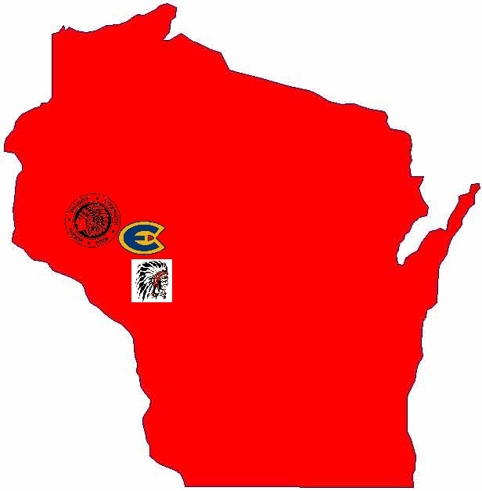

Figure 2: Menomonie Maroons Logo

http://coachesaid.com/Content/Mascots/mi-mimenomineehighschool-letter-150.png
note: this logo is not taken from Menomonie, but it is identical

Figure 3: Menomonie “Indian” Logo
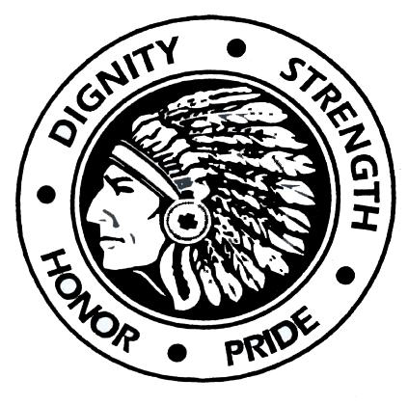
http://d3gnjjq3mhphne.cloudfront.net/uploads/image/post/0/2690/header/story/2690_32832_2a337b4c6e02eececd48f38017a8c6d3.jpg

Figure 4: Menomonie Flying “M” Logo

https://www.b2sports.com/catalog/images/FlyingM%20Proof.jpg

Figure 5: Menomonie Mustang Logo
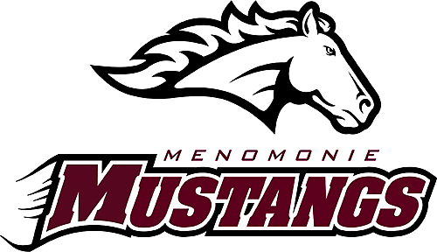
http://www.echopress.com/media/full/jpg/2011/12/20/menomoniemustangslogo.jpg

Figure 6: Osseo-Fairchild Chieftain Logo (Previous)
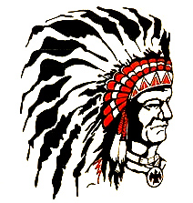
http://www.brandchannel.com/home/?tag=/Osseo-Fairchild+High+School+Chieftains
Figure 7: Osseo-Fairchild “O-F” Logo

http://media.mwcradio.com/mimesis/2009-09/21/osseo_gif_475x310_q85.jpg

Figure 8: Osseo-Fairchild Thunder Logo (Present)

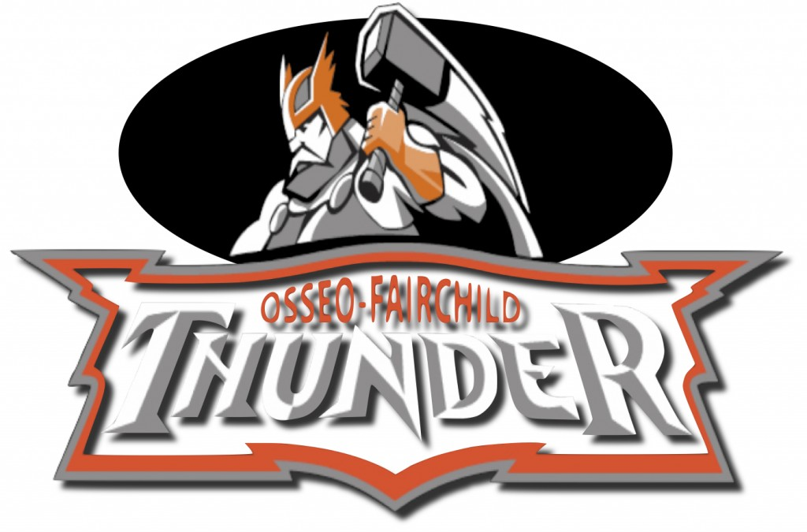
http://www.thepulsenews.org/?p=3203
Figure 9: University of Wisconsin – Eau Claire “Blugold” Logo (University)

http://www.blugolds.com/library/logos/ec_logo_full_color_no_words.jpg

Figure 10: University of Wisconsin – Eau Claire “Blugold Voyageur” Interpretation
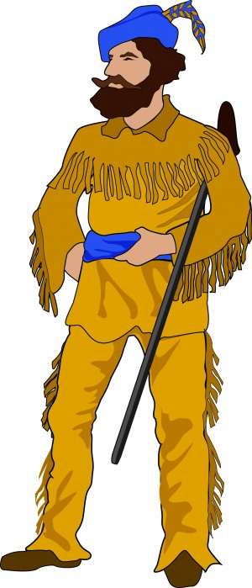
http://www.uwec.edu/newsreleases/10/feb/0217BlugoldMascot.htm
Figure 11: University of Wisconsin – Eau Claire “Blugold Ox” Interpretation
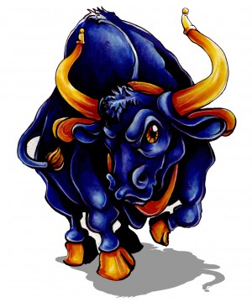
http://www.uwec.edu/newsreleases/10/feb/0217BlugoldMascot.htm
Figure 12: University of Wisconsin – Eau Claire “Blugold Bird” Logo (Student Body)

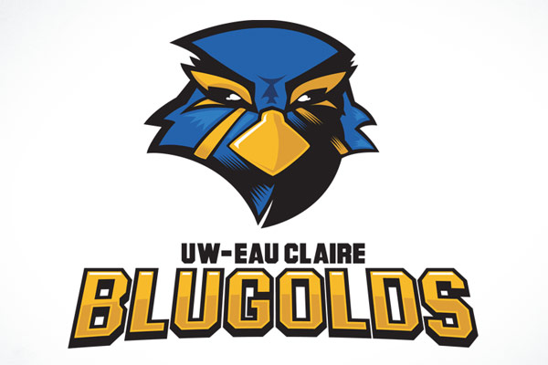
http://satellitesix.com/wp/?p=95

Marci D. Cottingham, “Interaction Ritual Theory and Sports Fans: Emotion, Symbols, and Solidarity,” Sociology of Sports Journal 29 (2012): 168-85.
Menomonie-Wisconsin: City-Data. http://www.city-data.com/city/Menomonie-Wisconsin.html (accessed November 30, 2012).
Nesser, Ingwold et al, Sports Scrapbooks 1904-1966. Special Collections & Archives. Robert E. Swanson Learning Center, University of Wisconsin – Stout. Menomonie, Wisconsin.
Ibid
Ibid
Menomonie High School, Records. 1914-1980. Special Collections & Archives. Robert S. Swanson Learning Center, University of Wisconsin – Stout. Menomonie, Wisconsin.
Ibid
Ibid
Deb Anderson, “Logo is a no-go,” The Dunn County News, June 19, 2011.
Deb Anderson, “Menomonie has new mascot name,” The Dunn County News, September 20, 2011.
Osseo-Wisconsin: City-Data. http://www.city-data.com/city/Osseo-Wisconsin.html (accessed November 30, 2012).
Ibid
Chuck Rupnow, “Osseo-Fairchild Chieftains name to fade away,” Eau Claire Leader-Telegram, July 28, 2010.
Ibid
Ibid
“Osseo-Fairchild revamping logo,” The Chippewa Herald, March 10, 2004.
Ibid
Ibid
Ibid
Ibid
Ibid
Rupnow. “Osseo-Fairchild Chieftains name to fade away”.
Taylor Kuether, “Thunder picked as new Osseo-Fairchild Mascot,” Leader Telegram, November 28, 2011.
Ibid
Tyler Kuethner. “Write-in choice Thunder picked as Osseo-Fairchild schools’ nickname,” Eau Claire Leader Telegram, November 28, 2011.
Rupnow. “Osseo-Fairchild Chieftains name to fade away”.
Kuether, “Thunder picked as new Osseo-Fairchild Mascot”.
Ibid
Ibid
Ibid
“Osseo-Fairchild unleashes new logo” Leader-Telegram, March 9, 2012.
U.S. Census Bureau Fact Finder. http://factfinder2.census.gov (accessed December 4, 2012).
About UW-Eau Claire. http://www.uwec.edu/aboutus.htm (accessed December 4, 2012).
Lark Keating-Hadlock, “Origins of a Blugold” (History 489 Paper, University of Wisconsin – Eau Claire, 2009).
Carter, Hilda & John Jenswold, “The University of Wisconsin – Eau Claire: A History: 1916-1976” (University of Wisconsin – Eau Claire), 1.
Keating-Hadlock, 2.
UWEC news release, “UW-Eau Claire narrows mascot options” February 17, 2010, http://www.uwec.edu/newsreleases/10/feb/0217BlugoldMascot.htm (accessed September 14, 2012).
Keating-Hadlock, 1.
Keating-Hadlock, 2.
UWEC news release.
“UWEC students select mascot,” Leader-Telegram, May 19, 2011.
“UW-Eau Claire mascot update,” September 29, 2010. http://www.uwec.edu/newsreleases/10/sept/0929StudentMascotMM.htm (accessed September 14, 2012).
Brian Carlisle, e-mail message to author, October 17, 2012.

