Food preferences of male and female Madagascar Hissing Cockroaches
(Gromphadorhina portentosa)

Alexandria Hammer, Biology
Dr. Edward Burkett, Department of Natural Sciences

ABSTRACT

Madagascar Hissing Cockroaches (MHCs) are sexually dimorphic and males and females have distinctly different reproductive roles. Male Madagascar Hissing Cockroaches (MHCs) engage in aggressive encounters with other males, while females are ovoviviparous and give live birth. Nutrition influences the development, reproductive output, and survival of many species of adult insects (Cooper, 1992; Erhardt, 1998; Carrel, 2002). The expectation is that males should require high energy carbohydrates in their diet whereas females should prefer protein and lipids in order to produce eggs and offspring. The purpose of this study is to determine if male and female MHCs have different food preference due to their differing nutritional and energy requirement associated with reproduction. Many of the experimental methods and anecdotal information was utilized from a research study by Carrel and Tanner (2002). Results showed an overall female preference for protein and no significant male preference for a specific food option. Pregnant females preferred carbohydrates whereas non-pregnant females preferred protein.

Introduction

Madagascar Hissing Cockroaches (Gromphadorhina portentosa) exhibit sexual dimorphism in that males have pronotal horns on their heads, whereas females lack pronotal horns and are 1.4 times heavier than males (Carrel, 2002). Males tend to be more active and participate in aggressive male-male dominance-based territorial disputes while females are generally calm and immobile (Carrel, 2002). Due to the tendency of male MHCs to fight, the expectation is that males should expend greater amounts of energy than females and therefor require a higher proportion of energy rich carbohydrates in their diet compared to females. In addition, male gametogenesis does not require large quantities of stored proteins or lipids, so the expectation is for males to prefer carbohydrate rich food sources, rather than lipids and proteins.
Female MHCs, on the other hand, have high energetic costs associated with the production of large oothecae (Carrel, 2002) that require large stores of both protein and lipids. It is therefore expected that in order for females to produce large oothecae they would require a diet rich in both protein and lipids.
Female MHCs are ovoviviparous in that when pregnant, there are different periods in which serotonin levels fluctuate and may influence the cockroach to feed on one type of food over another (Carrel, 2002). Dixon, et al. (2015) discovered that MHCs experience their environment primarily through chemical and mechanical reception, which explains the methodical feeding approach of a MHC. MHCs, like many other animals, are known to self-select an optimal diet to maximize probability of survival (Waldbauer, 1991). MHCs use their antennae to chemically detect nutritional qualities of food items by chemoreceptor information (Dixon, et al., 2015).
Nutrition of wild MHCs is not well known. Carrel and Tanner (2002) suggest female MHCs may be protein-hungry throughout most of their adult lives, as they repeatedly produce large oothecae, giving rise in them to a strong preference for foods rich in amino acids (proteins). Carrel and Tanner found that 80% of the female cockroaches they sampled preferred protein more than carbohydrates.
A potential flaw in Carrel and Tanner’s methods is that the protein source they used, Canine Carry-outs dog treats, were reported as having “high-protein/high-carbohydrate/high-lipid” content. They isolated the carbohydrate influence on food preference by including raw apple (high carbohydrate), but they did not provide evidence that the cockroaches were in fact choosing protein more than lipids because Canine Carry-out dog treats contained both.
Therefore, the following study was conducted to determine whether there are sex-specific food preferences for male and female MHCs when given choices between food items containing high-protein/high-carbohydrate/high-lipid content (dog treat), high-carbohydrate content (raw apple), and high-lipid content (Crisco vegetable oil). The prediction, similar to Carrel and Tanner’s predictions, was that if male and female Madagascar Hissing Cockroaches have different food preferences due to their respective reproductive costs, then it should be expected that females prefer a protein source and a lipid source significantly more than carbohydrates. It should also be expected that females prefer a protein source and a lipid source more than males prefer them.

Methods

Thirty adult MHCs (15 males, 15 females) were randomly chosen from the University of Wisconsin-Superior’s (UWS) research colony and placed into a new communal housing container. Cockroaches were housed in the UWS animal care facility and cared for following standard animal care protocols. In addition to determining the sex of each cockroach, female reproductive status was recorded as pregnant or non-pregnant. Pregnancy was determined by a thicker, widened abdomen, heavier recorded weight, and slowed movement. In preparation for the experiment, all cockroaches were food deprived for two weeks to control for hunger level during the experimental food choice trials. During the food deprivation period, water was provided daily.
Each test arena consisted of a 32 x 32 x 6 cm plastic container. A 32 x 32 cm white paper insert, marked with locations for food placement, was placed in the bottom of the test arena prior to conducting an experiment (see Figure 1). Red LED lights and a Logitech webcam attached to a computer were suspended 60 cm above the test area in order to record cockroach movements during the experiment. Prior to starting the experiment, the test arena was covered with a light-proof plastic enclosure to block ambient light.


Control
Food Option 3
Food Option 2
Food Option 1
Cockroach
Figure 1. Arena layout.

Food choices used for the experiment were Canine Carry-Outs dog treats (high protein/high carbohydrate/high lipid content), Crisco vegetable oil (high lipid content), and raw apple (high carbohydrate content). Prior to starting an experiment, 1 teaspoon of each food choice was placed in one of four designated locations on the white paper insert. Location of food choices was randomized prior to each experiment. One of the four available locations was left empty as a control.

Test for Preference

To begin an experiment, a new pair of disposable nitrile gloves were used to clean the test arena with 70% ethanol, place a paper insert in the bottom of the arena, and place 1 teaspoon of each food item in its randomly predetermined location. A cockroach was randomly chosen from the food deprived colony, weighed, and its sex and reproductive status was determined and recorded in a log book. The cockroach was then placed in the center of the test arena and covered with a clear plastic containment chamber (plastic cup) to limit its mobility. The light proof plastic enclosure was placed over the arena and the red LED lights were activated. After a three-minute acclimation period, the webcam was activated and the cockroach was released by removing the containment chamber. Cockroach movement and feeding was recorded for 10 minutes at which time the experiment was terminated. The video recording was saved to the computer and the cockroach was removed from the test arena and placed in an empty housing container and provided with food and water. The used paper insert and food items were disposed of, and this procedure was repeated for the remaining 29 cockroaches.

Video and Data Analysis

Videos were reviewed using the Windows Media Player program and data was extracted and entered into a data notebook. Data extracted from videos included which food item was chosen (determined by the cockroach’s head appearing above the food), length of time travelling to food items (from the start of the test period until the cockroach reached the food item), and time spent eating food items.
The data obtained through the video analysis were entered in an Excel spreadsheet. Excel was used to produce graphical representations of data, and conduct chi-square analysis, and perform t-tests.

Results

After the acclimation period when cockroaches were released from the cup, they generally moved their antennae to “smell” the food choices, and a majority of them decided quickly which food to eat. The few cockroaches that took their time choosing and/or didn’t choose a food item were pregnant females.

Figure 2. Frequency of Food Choice for Madagascar Hissing Cockroaches; N=30.

Figure 2 illustrates the frequency of food choice (apple, Crisco, and dog treat) for all MHCs (males and females combined; N=30). If food choice by MHCs was random, the expected selection frequency for each of the three food options would be 10 of 30 trials or 33.3% (Figure 2, Red line). Results of the 30 food choice trials indicate that MHCs chose dog treats (n = 14; 47%) more frequently than both apples (n = 8, 26.5%) and Crisco (n = 8; 26.5%), which were both selected with equal frequencies. Based on Chi Square analysis (X² = 2.4; p > 0.10) MHCs selected dog treats, apples, and Crisco randomly.

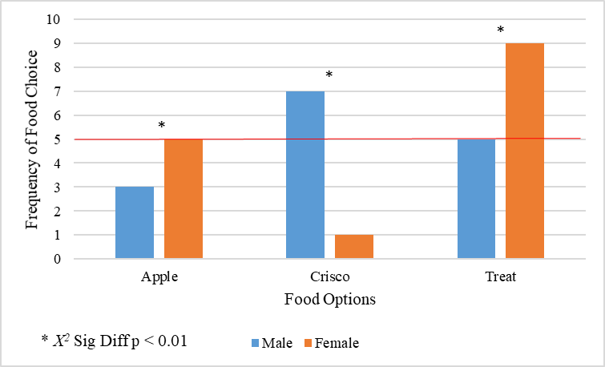
Figure 3. Frequency of food choice between male and female Madagascar Hissing Cockroaches; n=15 males, n=15 females.

Figure 3 illustrates the frequency of food choices for both male and female MHCs. If food choice by male and female MHCs was random, the expected selection frequency for each of the three food options would be 5 of 15 trials or 33.3%. Chi-square analysis (X² = 1.6; p > 0.10) of the 15 food choice trials for male MHCs indicate that males chose dog treats (n = 5; 33.3%), apples (n = 3, 20%) and Crisco (n = 7; 46.7%) randomly. Chi-square analysis (X² = 6.4; p < 0.05) of the 15 food choice trials for female MHCs indicate that females chose apples randomly (n = 5; 33.3%), Crisco less than expected (n = 1, 7%) and dog treats more than expected (n = 9; 60%).
In order to determine if males selected food items at a different frequency than females (Figure 3) a Chi Square test was performed to compare male and female frequency for each food item with the assumption that male food choice frequency was the expected frequency. Results of the chi-square analysis (X² = 9.676; p < 0.01) indicate males significantly chose apples less frequently, Crisco more frequently and dog treats less frequently compared to females.
Of the 15 female MHCs, nine were pregnant and six were non-pregnant. Female reproductive status was determined by weight. A t-test was conducted to determine if pregnant females weighed significantly more than non-pregnant females, and showed that this was the case (p = 0.044). Of the nine pregnant females 44.4% chose apple, 11.1% chose Crisco, and 44.4% chose the dog treat; whereas for the six non-pregnant females 25% chose apple, 0% chose Crisco, and 83.3% chose the dog treat. Results of the chi-square analysis (X² = 5.619; p < 0.10) indicate pregnant and non-pregnant female food choices were significantly different with non-pregnant females preferring protein-rich dog treats.
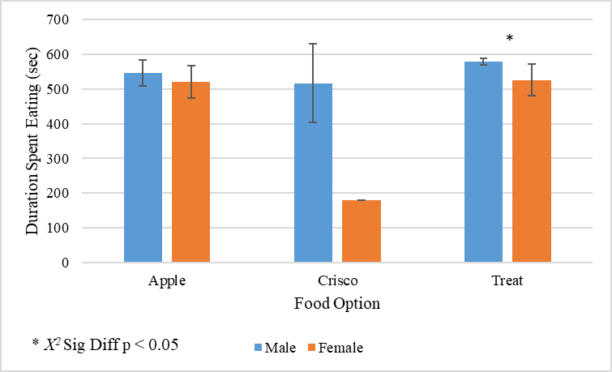
Figure 4. Duration of time spent eating the chosen food option for male and female Madagascar Hissing Cockroaches. Error bars represent a 95% confidence interval.

Figure 4 illustrates the length of time male and female MHCs spent eating the food item they chose. A t-test indicates that the duration of time spent eating apples was not significantly different between the two sexes (p > 0.05). Statistical comparisons of the duration spent eating Crisco was not possible to calculate due to only one female MHC choosing to feed on Crisco. Interestingly, there was a significant difference between the duration of time spent eating dog treats between male and female MHCs (t-test, p < 0.05). Males spent an average of 578.8 seconds eating the treat, whereas females spent an average of 525.1 seconds eating the treat; this indicates that males spent significantly longer times eating treats compared to females.

Discussion

The first interesting set of results from this experiment showed that MHCs randomly chose food. If there was no food preference difference in MHCs, this would be the expected result. Furthermore, this study did not initially support the prediction that males would prefer carbohydrates and females would prefer proteins and lipids. When compared to Carrel and Tanner’s experiment with MHCs choosing between raw apple and dog treats, their results depicted a strong food choice association with sex. Therefore, further tests were conducted.
In this study, the data showed that non-pregnant females ate treats more often than pregnant females did, which suggested the possibility that females eat protein prior to pregnancy due to a demand for protein storage in oothecae. The pregnant females chose apple more frequently than non-pregnant females did, which suggests the possibility that pregnant MHCs have a higher demand for carbohydrates as an immediate energy source rather than energy storage for young.
The final result indicated that male MHCs spend more time feeding on treats than female MHCs. This was not the case for apples or Crisco. This is interesting because it could lend support to an additional hypothesis that males are quicker to choose than females are in their choice of food, and therefore are faster because they choose randomly, not in preference to a certain food type. Females took more time to decide on a food option, but it is unclear whether the reason was because they were pregnant and moving more slowly than males, or because they were generally slower to choose.
As mentioned in the introduction, there was a potential methodological flaw in the Carrel and Tanner experiment; the protein option provided (moist Canine Carry-Outs dog treats) was reported as high-carbohydrate, high-lipid, high-protein and the only other option provided was raw apple (high-carbohydrate). Their methods allowed for preference for carbohydrates and protein, but not for preference for lipids. Furthermore, the dog treats may not have been the best source of protein for this study. To truly test whether there was a preference for the protein source rather than a dog treat that has some protein, some lipids, and some carbohydrates, it may be best to have a more proteinaceous food option than the dog treats. If replicated again in the future, this study could do well to include a larger sample size of MHCs to hopefully be able to test and gain more definitive results regarding the frequency of food choice and regarding Crisco vegetable oil for females.

Conclusion

This study was conducted to determine whether there were sex-specific food preferences between male and female Madagascar Hissing Cockroaches (Gromphadorhina portentosa) based on nutritional and reproductive demands. Many of the experimental methods and anecdotal information was utilized from research conducted by Carrel and Tanner’s (2002). The differences between the two studies involve the use of Crisco vegetable oil as a food option for the lipid macromolecule preference assessment and the difference in food preference between pregnant and non-pregnant females. The results of this study showed that females ate more apple/carbohydrates than males, less Crisco/lipids than males, and more treats/proteins than males. It was expected that males would choose apples more frequently than females, but the opposite was observed. Results of the pregnant/non-pregnant female test showed that non-pregnant MHCs chose treats more than pregnant females, which means the pregnant females most likely prefer protein sources prior to pregnancy to prepare for bearing young and carbohydrates post-pregnancy as a primary energy source. Lastly results indicate that males chose their food source faster than females, which suggests that females are either slower from pregnancy or they are “choosier.” If future research regarding this topic is conducted, the protein source should be a much purer form of protein, rather than a mix of the three tested macromolecules as in the dog treat food option.
Literature Cited
Carrel JE and Tanner EM. 2002. Sex-specific food preferences in the Madagascar Hissing
Cockroach Gromphadorhina portentosa (Dictyoptera: Blaberidae). J Insect Behav. 15(5): 707-714.

Cooper RA and Schal C. 1992. Differential development and reproduction of the German
Cockroach (Dictyoptera: Blattellidae) on three laboratory diets. J Econ Entomol. 85(3): 838-844.

Dixon M, et al. 2015. Stimulus preference and reinforcement effects of the Madagascar Hissing
Cockroach (Gromphadorhina portentosa): A case of reverse translational research. Psychol Rec. 66: 41-51.

Erhardt A and Rusterholz HP. 1998. Do Peacock butterflies (Inachis io L.) detect and prefer
nectar amino acids and other nitrogenous compounds? Oecologia. 117(4): 536-542.

Waldbauer GP and Friedman S. 1991. Self-selection of optimal diets by insects. Annu Rev
Entomol. 36: 43-64.

