DEPARTMENT OF HISTORY
UNIVERSITY OF WISCONSIN – EAU CLAIRE

INTERIOR ARCHITECTURE AND GENDERED SPACE OF THE APOSTLE ISLANDS LIGHT STATIONS

HISTORY 489: RESEARCH SEMINAR
PROFESSOR: DR. ERIN DEVLIN
COOPERATING PROFESSOR: DR. BARBARA KERNAN
EMMA FELTY
FALL 2014

ABSTRACT

The Apostle Islands are a chain of 22 islands that make up an archipelago in Lake Superior, off the Bayfield Peninsula in northern Wisconsin. These islands are unique for many reasons. They are exceptional examples of geological formations, have an abundance of wildlife and mining resources, and a long, detailed history. The Apostle Islands are home to the United States’ highest concentration of lighthouses in one geographic area. Five islands are home to these light stations, which were established in the mid-19th century with the flourishing trade in iron, timber, and other resources, which made shipping aids along Superior’s shores necessary. Lighthouses function as a family dwelling and government property simultaneously, which is an important intersection during the rise of domesticity in America. While women could control their domestic spheres on the mainland, lighthouse wives were under the influence of the lighthouse inspectors and had to shape their family lives to the US Light Service’s regulations.
INTRODUCTION
The Apostle Islands National Lakeshore is one of the most beautiful chains of islands in the world. They are environmentally relevant, but also historically important because of the light stations that guided boats through the channels to the docks of Bayfield, Washburn, and Ashland, Wisconsin. These lighthouses were set up by the United States Lighthouse Service, an agency of the government that was created for the maintenance of light stations in the United States. Lighthouse keeper’s families lived on the islands during the summer and would return to the mainland in September so the children could go to school and due to the impending winter weather. The families only lived together for three months, yet the houses are exceptionally decorative and sturdy to withstand harsh conditions. The Apostle Islands light stations were built to promote and protect Lake Superior commerce. While they are inherently government and economic property, they simultaneously function as domestic spaces for the lighthouse keepers and their families. Due to governmental regulations, domesticity in the hands of the light keeper’s wives was challenged, and it ultimately became an institutionalized ideal rather than a social necessity.
The construction of the lighthouses began in the mid 1800s. Founded by the United States Lighthouse Service, and Congress approved all of the lighthouses, though they did not all develop at the same time. The first lighthouse to be established on the Apostle Islands was on Michigan Island, although that’s not where it was supposed to be built. A call was put out to architects in the Midwest to draw up plans for the light station. Three architects from Milwaukee won the contract and went up to the Islands to begin the building process. The light was supposed to be built on Long Island, due to the traffic coming in from the east side of Lake Superior, however Long Island is very low and shallow. The architects believed they were sent to the wrong island, and the correct one was Michigan, which has a high and cliff-like surface. The architects build the lighthouse on Michigan in 1857, and it only became apparent the light station was built in the wrong place at the beginning of the season in spring 1858. The architects had drawn up plans for other lighthouses on the Apostles but their contract was broken with the major lighthouse mishap. Although the Michigan Light was the first to be built, Raspberry Island Light was the first to be lit.
This paper draws on sources from a wide range of fields. Literature on lighthouse families on the Apostles is paramount to this project. Unlike other papers, Historic American Buildings Surveys are equally important. There is limited discussion about domestic and the family sphere in accounts of lighthouse life. Lighthouses are in the unique position of being on the blurred edge between government property and private family dwelling. Despite being designed as a family domestic space, the structures also share a narrative with Great Lakes commerce. There is a lot of information about Great Lakes maritime history, but some of these narratives are anecdotal and mythological. The lighthouse keepers kept very detailed logs and diaries, although they are brief and lack great detail. Other historians have not commented on the interior space of the light stations and how they related to family life, although there is some discussion of family life. There is discussion of the time period during which the lighthouses were constructed, but also when they were most lived in, which is the early 20th century. This paper will draw connections between these two time periods to identify shifting ideas of domesticity over time, in the physical layouts of the structures and in the ways the dwellings were lived in by the families.
ESTABLISHING THE LIGHTS
In 1856, Henry M. Rice helped establish a settlement in Bayfield. Rice had founded the town of Superior a few year’s prior, but Rice saw that the natural harbor in Bayfield would make the area a great candidate as a port city comparable to Chicago. Rice guided the railroad into Bayfield, which allowed the area to grow quickly and become one of the “leading ports in the Chequamegon region.” Northern Wisconsin and Upper Michigan became large mining and lumber areas. Brownstone quarries opened in Washburn, Houghton, and even on several Apostle Islands like Stockton and Basswood. Due to the many ports developing on the shores of Lake Superior, the region’s shipping economy grew exponentially, which lead to a dire need of shipping navigation.
The Raspberry Island lighthouse was built in 1862, but was not in service until the following year. This lighthouse is unique for it’s location and it’s design. The Raspberry Island lighthouse was built as a two story wood structure with a four story light tower that split the duplex in the center and rose above the roofline. It was designed as a duplex, which is unusual for United States lighthouses. The living quarters for the light keepers were “simple, but by no means primitive” with the head light keeper taking the east wing, and the 1st assistant taking the west wing. When 2nd assistant Almond Cummings was hired to run the fog house in 1916, he was shocked to see that there were “no quarters for his family” After Cummings abrupt departure, the head light keeper and 1st assistant outfitted the structure into a triplex, with the west wing featuring a bachelors apartment upstairs. Before this fortunate interior change, bachelors or childless couples could ‘live’ in a shack-like structure next to the barn. A dwelling that Cummings would have not wanted for his family.
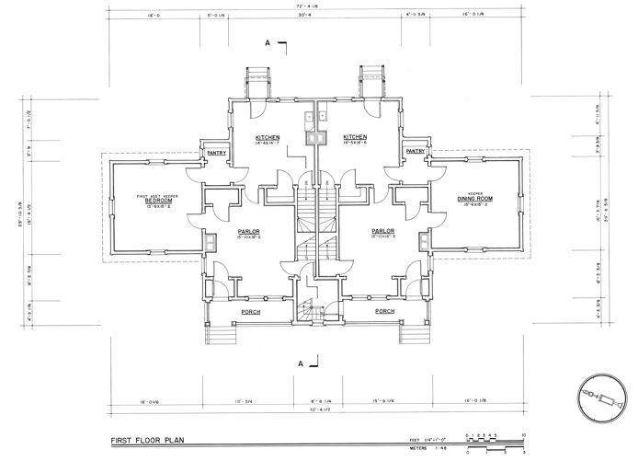

The first floor of the light station features two separate living areas, as depicted in the Historic American Buildings Survey above. The head lighthouse keeper’s apartments are on the right, and while the 1st assistant’s apartments are on the left. The difference between the two is the inclusion of a dining room on the outer wing of the head keeper’s side. The assistant at one point may have had a dining room as well, though this was changed when the light station became a triplex.
The light station on Outer Island was established in 1874 and lit the same year, more than a decade after the establishment of the Raspberry Island light. As one could tell from the name, Outer Island is the furthest away from the mainland to the northeast and the position of the light station is at the northern tip of the island. It was placed on this location to mark the turning point for vessels traveling to Ashland. The island is the third largest in the Apostle Islands, and offered fair farming land. At one point it supported a good-sized colony of farmers. The tower is attached to the domestic space, but not nearly as integrated as the Raspberry Island lighthouse.
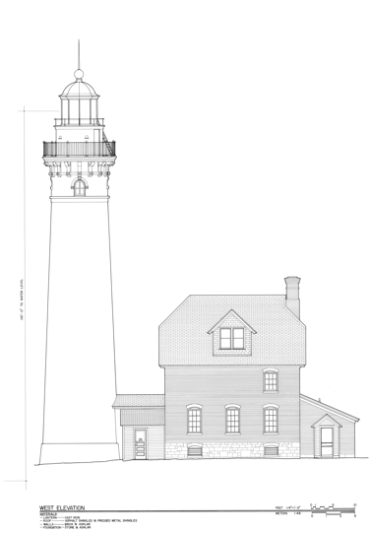
Devils Island has three unique structures on the property. Two large red brick, Queen Anne style homes are perched several hundred feet back from the cliffs on the edge of the island. The light tower is completely separated from the domestic spaces, and it was also the last light station to be built and manned on the Apostle Islands in 1891. These three light stations are representative of the ideological changes of lighthouse construction over time. Raspberry with a completely intact light tower, Outer with a semi-attached tower, and finally Devils with an independent tower display the technological changes related to working in the lighthouse service. As technology advanced, the light tower didn’t need to remain an integral part of the domestic space, however the duties related to maintaining the lantern did stay.
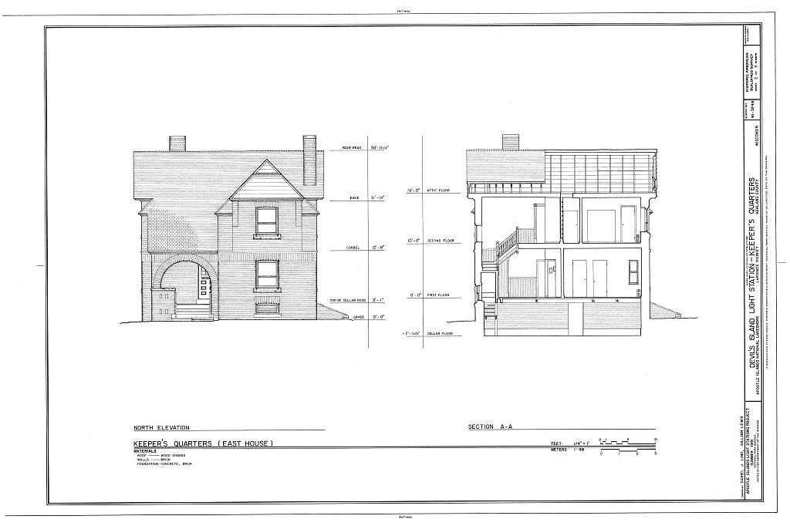
American housing design in the 19th century was believed to create order in society. Plan books like Gervase Wheeler’s Homes for the People of Suburb and Country (1855) and Orson Squire Fowler’s A Home for All (1856) emphasized that each room within a home should have a “clearly defined role and function.” Later plan books such as American Cottage Homes (1878) suggested fewer boundaries between genders in the interior segregation of the house by diminishing physical barriers, thus creating a more open plan. Social order was to be achieved via architecture, and in a lighthouse this was paramount. The entire operation was to function like a well oiled machine for the sake of safety and the continuation of Great Lakes commerce. At the time the light stations on the Apostles were being constructed, women did not have voting or property rights. A college education was becoming more accessible to women during this era, but more for the upper class. A women’s main role during the mid-1800s was maintaining the household and the private sphere of their comfortable dwellings. The opportunity to own a house and to have land to cultivate was an integral part of American ideology. A large portion of the American population going into the 20th century was centered around urban environments where this ideal could not be easily achieved. The ultimate American home would be small, made of wood, and would be outside of the big-city landscape. Lighthouses on the Apostles only hit one of those marks. “Brick and stone buildings can be too imposing for this visual and ideological ideal: Those materials connote wealth, industry, and, perhaps unconsciously for some, even institutions of containment.” The lighthouses are almost the antithesis of the American ideal – they are imposing, boastful structures, made entirely out of brick and stone, and their exterior and interior functions are essentially run by an institution. Raspberry light station is one of the exceptions, which is made out of wood, painted white, which situates itself in a middle ground between “home and the institutions of government.” The building is “expressive of its power because of its scale, yet its materials are comforting, conservative, and nostalgic” as opposed to the brash brick buildings that are situated on the other islands.

LIGHTHOUSE DOMESTICITY

I know of no other branch of the government in which the wife plays such an important part.
- Lighthouse superintendent to Commissioner of Lighthouses George Putnam

The Cult of Domesticity developed out of the 19th century in Great Britain and the United States, and was largely applied and emphasized by white, Protestant, middle class families. Women were considered the pious “light” of the home – which expanded from a new set of political, religious, emotional, and social values developing at the time. Women’s main role was in the home, developing a safe, private sphere, as opposed to the public sphere, which was dominated by men. The lighthouses were constructed during the Golden Age of Domesticity, but the families lived in them longest during the first part of the 20th century. The families had to resolve how to function in spaces that were not inherently designed for the social climate they were used to, and under a governmental institution that abided by these older standards of cleanliness and organization. Life on the islands was different than on the mainland, or anywhere else in the United States. Everything was dichotomized. The families lived with technologically advanced maritime equipment, yet they lived relatively simple lives. There were aspects of communal apartment-style living on a remote island. The families lived, played, and worked within their own small community yet they were apart of a much bigger process and a national institution. The ideology of separate spheres in the lighthouses is problematic because the family had to work as a unit to make the household run. While females might have done traditional female work, including cooking, cleaning the living areas, gardening, etc… the men had their own slew of chores as well, which was much more oriented to cleaning and maintaining order. While spheres existed, they were blurred, but yet still gendered. Cleaning was now a part of the man’s job, but only cleaning certain things in certain ways. Working within the domestic space was also encouraged, and often parts of the equally shared spaces became part office, part multipurpose room. The gendered space of the living environment within the lighthouses is complicated, and often doesn’t follow what is traditionally thought of as “domesticity” in popular culture.
Lighthouse life is usually attributed with a romantic connotation of loneliness, however life on Raspberry was not dull or lonely. With as many as three families living on the island, plus the occasional relatives and friends, “the stations were only lonely when school was in session and none of the keepers’ wives remained.” Wives and children joined the lighthouse keepers on the islands around the end of May and returned to Bayfield for the beginning of the school year in early September. While not living on the islands, lighthouse keepers and their families kept homes in Bayfield. Lighthouse wives had to maintain two domestic spaces almost simultaneously.
All lighthouse keepers in service received a rating based on numerous factors like skill and responsibility to the job, though cleanliness was a very important part of lighthouse life as well. Domesticity was essential to lighthouse life, even more so than on the mainland. In any other setting women’s cult of domesticity was just daily life, but now it was high stakes. If a light keeper and his wife cannot maintain a clean household they were removed from their post. “While the government does not expect the keeper’s wife to spend her time cleaning the machinery, polishing the brass pipes – that’s the man’s job – still, the spic and span-ness of the house – and that’s her province – has a lot to do with her husband’s official rating.” The general upkeep of the light itself was not under the wife’s authority, but at the peak of the shipping season her influence in the home was a crucial part of lighthouse function. One lighthouse keeper’s daughter remembered her father getting a demerit when she and her siblings filled the domestic role while their mother was ill. “About the middle of summer, an inspector came…And when that man came, well he was probably like the “second coming of the Lord” or something…. Sweep everything under the rug as quick as you could. He’d go right upstairs, through all the rooms. He’d go and rub across the chest of drawers to see if there was any dust on it.” Suburbia and society alone created a lot of domestic pressure, but on the islands there was no escape from chores and their supervisors. If the domestic space were to fall into ruin, certainly the light would too, which would be disastrous for the shipping economy. The inspectors certainly saw this trickle down effect, and therefore invested so much time into the house inspection. The cleanliness within the home parallels the cleanliness required to keep the light. From April to December, the light keepers job is to keep the brass work and glass of meticulously clean and to light the lamp in Fresnel lens each night.
Not all wives were pleased with lighthouse life. A 1931 newspaper article titled, “The Apostle Islands lighthouse stations do something to the wives of the light-house keepers,” details the experience of Mrs. Alexander McLean, whose husband served two tours of duty while on the Apostles. He served on Devils Island from 1901-1909 and on Raspberry Island from 1909-1916. She describes in the article about her time living on the islands. “I hate lighthouses. They are so lonely. When a woman marries a lighthouse keeper, she gives up everything else in the world. On the islands, we always had to keep up two homes, as women and children have to be off the islands Oct. 15 and when you have two homes to maintain, something has to be slighted. We slighted necessities. Luxuries – we had none of them. We gave up the things we needed. On Devils Island, in storms the spray used to dash against my living room windows, 600 feet from the cliffs, and ooze through the windows and flood the floor, so that I would have to take rags and sop it up. Such a mess it always made.” Anna Maria Carlson, another lighthouse bride, was born in Sweden came to the United States when she was a teenager. She married Robert Carlson, who was a newly appointed second assistant to Outer Island in 1891. She also had a very difficult time adjusting to lighthouse life. She describes her lonely experience to a Detroit newspaper in 1931. “I had three persons to talk to: my husband, who was assistant keeper, the head keeper, an old man with but one eye, and a fisherman who came that summer and lived in a shack down the shore. Oh! The loneliness of those days on Outer Island. There was nothing to see but water…. That was my life, day in and day out. Going ashore to the mainland, 40 miles away, meant riding in a sailboat, which always frightened me…. The old lighthouse keeper showed me how to cook, for I had never been used to much work. I have learned to do all kinds of housework since my marriage. A woman can learn to do anything if she sets her mind to it.” While women may have been new to working on the remote islands, their husbands struggled with their domestic work as well.
THE KEEPER’S LAMENT
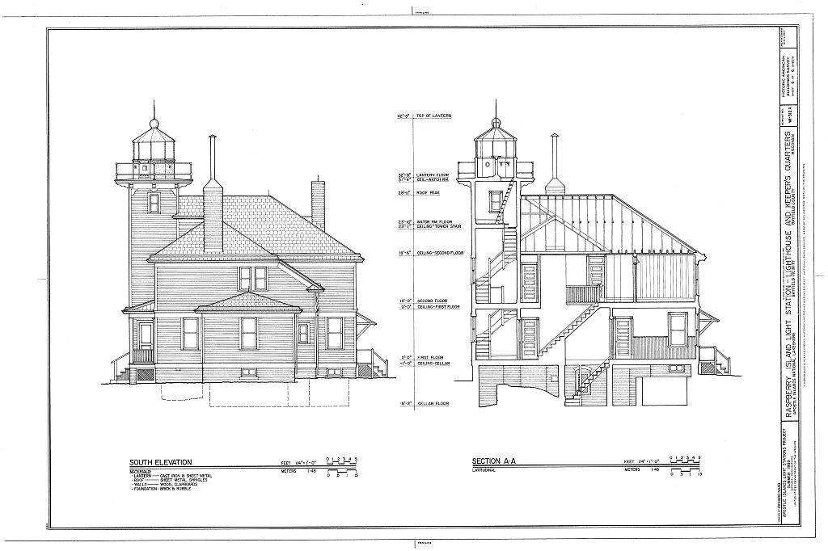
The physical function of the light in a lighthouse is almost identical to a clock. The mechanical structure that allows the lantern to turn is essentially a clock without hands and the face is a beehive shaped piece of intricate glasswork; the Fresnel lens. The lantern is the epitome of the lighthouse. It is the symbol, the main function, and the beating heart for the Keeper. Just as the light runs like clockwork, so does the entire structure and those that reside within. Clocks are one of the most important subparts to the household. Each light station would be provided one, if not several clocks, as they were necessary to keep the entire system running. When the clocks were off, so was the lighthouse operation. Vernon Barningham, a member of the lighthouse maintenance staff on the Apostle Islands in the 1930s remembers dealing with the clockwork system. “They (lighthouse keepers) had to wind up at twelve o’ clock. We had to make sure these lens didn’t stop…if we ran out of time we heard about it quick…We had to time that every day to be sure we had the right time.” Cleanliness was paramount and light keepers in the U.S. Lighthouse Service often spoke of the trouble they had keeping the brasswork polished at their stations. Walter Parker, Barningham’s coworker mentions the brasswork in his interview. “These old-time lighthouse keepers…brass, it wasn’t just polish now and let it go for a month or two…it was polished regularly at least once a week; every thing was gleam and polish.” The “Unofficial Poet Laureate of light keepers,” Fred Morong, responded with “Brasswork, or The Lighthouse Keeper’s Lament” a poem which describes their frustration:
The lamp in the tower, reflector and shade,
The tools and accessories pass in parade.
As a matter of fact the whole outfit is made
Of Brasswork.

From pillar to post, rags and polish I tote.
I’m never without them, for you will please note
That even the buttons I wear on my coat
Are Brasswork.

The machinery, clockwork, and fog signal bell
The coal hods, the dustpans, the pump in the well;
Now I’ll leave it to you mates, if this isn’t – well,
Brasswork.

Men in this line of work new their duties like the back of their hand, but it was work unlike any other job. While their contemporaries might be working in business or more public trades, lighthouse keepers worked in private. The only person who would care to see that these machines were gleaming was the occasional lighthouse inspector, but often the keepers came from military backgrounds and were used to the regimental line of work.

THE KITCHEN
The kitchen would have been a female dominated space in any household. Upper class or even middle class families would have had servants working in the kitchen, but on the islands the family sustained themselves. While the lighthouse keeper oversaw the care of the light tower and the Fresnel lens, the wives would have taken care of the kitchen just as meticulously and it became the center of their household. The wives spent much of the growing season on the Islands, and when they left the men would have to be able to sustain themselves for a few months. Canning and jarring was a popular during the late summer/early fall when the lighthouse keeper’s wives had to be off of the Islands. Women were primarily the cooks and bakers within the household as their husbands had to clean the lantern and perform the male domestic chores pertaining to their job. When they harvested the rest of the garden on before their departure for Bayfield, they canned tomatoes, strawberries, cucumbers, and other crops. The process included cleaning, cooking, straining, and draining the fruits and vegetables before they were transferred to glass jars. Canning and jarring was very important to lighthouse families and was necessary during this time period due to lack of grocery stores. If families didn’t preserve what they grew during the summer, the keeper’s would struggle during the late fall and early winter before returning to the mainland.
The kitchen in the Raspberry Island light station dates from 1906 and it served many purposes while lighthouse keepers lived on the Island. The kitchen would have been used to prepare meals and for dining as its main function. A back entrance is located off of the kitchen, which allows for access to the vegetable garden, outhouse, and wood storage for the wood-burning stove which was “black and silver like those wood stoves were, with a warming closet up above where you put the dishes in and keep the plates warm,” according to Christy McLean. Laundry would have done outside on Raspberry Island, but ironing would have been done inside so the irons could be heated on the stove. McLean, the daughter of former lighthouse keeper McLean, recalls Saturday nights in the kitchen being very eventful because it meant that it was bath time. “Every Saturday night my mother would get another big kind of rug… She’d put it on the kitchen floor and we had a great big tub, galvanized… and that’s how we took our bath. We got in that tub with a big bar of Ivory soap… It was fun.”
THE PARLOR
The parlor was originally designed to be the dining room, but when dwelling was remodeled in 1906 this space became the family area, or the “sitting room” as called by Keeper McLean in 1911. By 1928 most residents were calling it the parlor, although Keepers after this date began referring to this space as the “living room.” After the remodeling, the room is nearly 16’ wide and 13’ feet deep, featuring a bay that is framed by a rectangular archway. The windows in the alcove look out onto the front porch, and even further out on to Lake Superior. The lighthouse keepers and their families spent their lives traveling between two homes – one on the Islands and one in Bayfield. The women especially had to craft two domestic spheres simultaneously, which stretched them very thin. In the carefully crafted domestic sphere, the parlor was a haven for family members to return to from the outside world and provided a plush atmosphere for ultimate comfort. Having a stretched household and little money left the parlor space as something to be desired, although not entirely cold and uncomfortable. Keeper Benton and his wife kept an Edison Amberola VI phonograph in their parlor. Friend of the Benton’s, Evelyn Lutz Durocher visited in 1922 and recalls listening to “When the Bell in the Lighthouse Rings” and “The Lighthouse by the Sea” during her stay. She remembers the comfortable setting that Bess Benton cultivated in the parlor, which was heavily focused on music and entertainment.
Families spent their time relaxing in the parlor. It was intended to the be the private center of comfort and a hideaway from the world outside for immediate family, but on an island with few visitors and limited space, the parlor became a multipurpose room used by all. Parlors in the Victorian era were plush, filled with family portraits, religious imagery, and some entertainment items. Moving into the 20th century, the living room/parlor became a place to entertain guests and visitors, or even a spare bedroom for long-term guests. The emphasis on entertainment was incorporated on to the Islands because there was a lack of entertainment outside. The isolation of the islands leads to more time spent among family and friends in the home. Music, puppet shows, crafting, stereoscopes, were hugely popular during the turnover into the 20th century.

THE DINING ROOM
Dining rooms functioned as the second most formal room in the house in typical society, yet it often saw more people than the parlor. This is not the case on the islands, considering the dining room was as much of a multi-purpose room as the parlor, if not more. In middle class homes, the dining room would be a place for meals while kitchens were limited to cooking. Centered in the room would often be a large wooden table, at least one mirror on the wall, and a side table against another wall. The dining room was only used on Sundays, or on the occasion that there were visitors. Christy McLean describes her family’s use of the dining room while her father was keeper from 1909-1914. “Every Sunday at 10 o’ clock we’d go into the dining room and each of us would kneel at a chair and he would read the rosary and say some of the litanies…take about three quarters of an hour; keep us on your knees ‘til they were breaking off.”
While faith was often important to the families, so was business, and the lighthouse life was an occupation. The dining room functioned as a place to gather, for friends, faith, and for work. From 1941 to 1943, Keeper Carpenter utilized the dining room as his workspace. His daughter, Francis Carpenter Platske fondly remembers this room as “Dad’s office.” The proud oak roll-top desk was one of the only pieces of furniture that stood in the room and it was otherwise a “rather barren looking room” with no other comfortable details. Every night her father would “fill the journal by the light of an Aladdin lamp. I can remember seeing my dad sitting at that desk and seeing his shadow flickering in the light.” While on Outer Island, Platske’s father did have a watch room instead of a makeshift workspace. She describes this being an equally barren room, however this was one of her favorite spaces. She describes a secret closet on the right side that was probably originally intended to be a pantry, but she found a much better use. Platske describes that every year the lighthouse inspectors would come for a check up, which may have caused anxiety for her parents, but she was always thrilled. “They’d bring boxes of books to read and there was always the National Geographic magazine, they would be old ones.” She kept her beloved magazines in that closet, next to the polished brass governmental clock, complete with barometer. The dining room and parlor space became increasingly similar in function. Often times the two were interchangeable, which can be seen in this example. “The middle-class ideal home was minimizing the segregation of women and men by combining previously single-purpose, gender-type rooms into multipurpose, sexually integrated rooms, typically between living and eating spaces.”

THE BEDROOM
Bedrooms are the most private of all spaces within a domestic dwelling. Only members of the family were allowed to enter into those rooms, and it was virtually unheard of for anyone from the public sphere to go upstairs aside from servants. Aside from being separate from the staff, bedrooms were also separated from parents and children. Instead of opting to build larger, communal bedrooms, there are smaller ones that keep the family separated. These spaces were very personal and were often decorated with sentimental tchotchkes, pictures, quilts, and handmade items that were necessary due to lack of resources. The bedrooms are never intended to be seen by anyone outside of the family unit, which is why it is so unusual to have the lighthouse inspectors evaluate the cleanliness of the bedrooms on their routine visit.
The bedrooms at Raspberry Island were comfortable, yet small. The Keeper’s quarters had three bedrooms, including a front large bedroom that connected to the light tower for ease of access during night shifts, or so it would seem. Often it wasn’t the Keeper’s who slept in these rooms, but often the children. Francis Carpenter Platske, who lived there when her father was Keeper in 1941, stayed in the front bedroom while her parents stayed in the back bedroom, the second smallest room and furthest away from the light tower. She remembers the sound of the foghorn lulling her to sleep and “the quietness would wake me up.” In her interview in 1989, Platske also recalls having an iron bed and a dresser that were painted blue, that came with the family when they moved from Outer Island and “at the time all of the rooms were lit by coal lamps.” The reasoning behind staying in the back bedroom as opposed to the front may be what lies in the walls. The back bedroom sits over the kitchen, and the chimney goes up the west wall of the room, therefore making it one of the warmest rooms in the house. Especially so when a register was installed in 1931. Platske’s parents stayed in the back bedroom with their infant daughter Lucy at the time. Platske on occasion also stayed middle bedroom of the Keeper’s quarters, which often had the best view. She recalls “being in this room in a violent electrical storm and watching from her east-facing window a lightning fire over on Oak Island.” Three years prior to her family’s arrival on Raspberry Island, the middle bedroom suffered damages after a bolt of lightning struck and knocked plaster off of the room’s walls, and repairs couldn’t be made until the following November due to the lack of time and resources available while living out on the Islands.
The furnishings of the bedrooms often traveled with the occupants or they had to be resourceful as they went along. Edna Lane Saurer, daughter of Keeper Ed Lane who was stationed at Michigan Island from 1905 to 1929, remembers her parents making use of what they had available. “We had a dresser, and Dad used to take wooden boxes…and he would make a lid for them and hinge them, and Mother would pad the top with silkoline so it hid the legs. She made one of them for each of the bedrooms.” What did travel with the families were often times iron beds, homemade quilts, and rugs. As the occupants and technology became more modern however, so did the furnished details of these rooms. Floor coverings were laid in each room, over the painted floors. In the mid-1920s, Gold Seal Congoleum was installed in two bedrooms, the hall, and the kitchen, as it was easier to keep clean and very durable. The product was manufactured by the Congoleum Company and appeared much like inlaid linoleum, but much cheaper. As a bonus, the Congoleum would lay flat without being tacked down and wouldn’t warp. While some floors were completely covered, it was also offered by the roll as “art-rugs” with elaborate patterns and borders in imitation of woven rugs. Due to discoloration in the middle bedroom it is apparent that there was once an “art-rug” in place. The bedrooms were spaces of more creativity and decoration, and also required protection due to the cleanliness of the house. Art-rugs supplied both of these things, and they were easily removable when the family moved on to another lighthouse.

The families on the Apostle Islands lived lives that were surrounded by hardship, friendship, technology, simplicity, work, and play. From an architectural view, the lighthouses rooted themselves in the landscape, their brick and wood structures are imposing and a reminder of man’s meshing with the natural world. The interior spaces of these homes are beautifully crafted with hardwood and the views are spectacular, but the history isn’t as clear as Superior’s blue waters. The function as a domestic and a workspace is teetering on an edge, and although it is unusual, it is not uncommon. There are many examples of work/domestic spaces, and historically that’s how the American economy developed - through home industry. In the lighthouses, there are many more complications. A government overseer, who examined the ways in which the keeper’s and their families live, shifts the standard of living on the Apostle Islands. Control is taken out of the family’s hands and placed in the hands of a new entity, a third party, the United States Lighthouse Service. The puzzle of domestic life changed and the ways in which families’ function had to change as well. The lack of resources, the doubling up of mainland and island home, and the rigid enforcement of domestic duties pose questions of what domesticity really means. In one environment, it is a way of living and caring for a home and community; in another it becomes an occupation and a system that one cannot escape. While it is difficult to describe the influence living on these remote islands had in the long term to these families and the surrounding Bayfield community, it is evident that it was a very idiosyncratic experience that some may never understand. The overlap of work and life, at the intersection of public institution in a private sphere, is an edge of history that should continued to be explored – and it happened on a very unique chain of islands.

BIBLIOGRAPHY
Primary
Barningham, Vernon. “Light Maintenance in the 1930s,” interview, (APIS history files, Bayfield, WI), 1980s.

Champney, Stella M. “Four Days of Terror,” The Detroit News, May 17, 1931.

Ethan, Christy McLean, interviewed by David Snyder, APIS, July 19, 1989.
Historic American Buildings Survey. “Devil's Island Light Station, Keeper's Quarters, La Pointe, Ashland County, WI.” Measured Drawings. 1933. Library of Congress Prints and Photographs Division, Washington, D.C. USA. http://www.loc.gov/pictures/item/wi0306/.

Historic American Buildings Survey. “LaPointe Light Station, Tower, La Pointe, Ashland County, WI.” Measured Drawings. 1933. Library of Congress Prints and Photographs Division, Washington, D.C. USA. http://www.loc.gov/pictures/item/wi0314/

Historic American Buildings Survey. “Michigan Island Light Station, Keeper's Quarters & Lighthouse, La Pointe, Ashland County, WI.” Measured Drawings. 1933. Library of Congress Prints and Photographs Division, Washington, D.C. USA. http://www.loc.gov/pictures/item/wi0301.sheet.00001a/

Historic American Buildings Survey. “Outer Island Light Station, La Pointe, Ashland County, WI.” Measured Drawings. 1933. Library of Congress Prints and Photographs Division, Washington, D.C. USA. http://www.loc.gov/pictures/item/wi0250/

Historic American Buildings Survey. “Raspberry Island Light Station, Bayfield, Bayfield County, WI.” Measured Drawings. 1933. Library of Congress Prints and Photographs Division, Washington, D.C. USA. http://www.loc.gov/pictures/item/wi0237/

Historic American Buildings Survey. “Sand Island Light Station, Bayfield, Bayfield County, WI.” Measured Drawings. 1933. Library of Congress Prints and Photographs Division, Washington, D.C. USA. http://www.loc.gov/pictures/item/wi0238/

Parker, Walter. “Light Maintenance in the 1930s,” interview, (APIS history files, Bayfield, WI), 1980s.

Platske, Francis Carpenter interviewed by David Snyder, APIS, July 7, 1989.
Raspberry Island Light Station Journal, 1916.

Secondary

Aument, Lori and Wathne, John. “Cast-Iron-Plate Lighthouses and the Sakonnet Lighthouse Restoration,” APT Bulletin, Vol. 43, No. 2/3 (2012), pp. 3-11.

Busch, Jane C. “People and Places: A Human History of the Apostle Islands”, http://www.nps.gov/apis/historyculture/upload/Historic%20Resource%20Study.pdf
Bushman, Richard L. The Refinement of America: Persons, Houses, Cities. New York: Knopf :, 1992.
Clark Jr, Clifford, Edward. The American Family Home: 1800-1960, (North Carolina: The University of North Carolina Press, 1986).

Epstein, Barbara Leslie. The Politics of Domesticity: Women, Evangelism, and Temperance in Nineteenth-century America. Middletown, Conn.: Wesleyan University Press, 1981.

Feldman, Jim. “’What Do You Do up Here?": Tales of a Lake Superior Lighthouse Keeper,” Wisconsin Magazine of History, Vol. 84, No. 4 (Summer, 2001).

Green, Harvey. The Uncertainty of Everyday Life, 1915-1945. New York: Harper Collins Publishers, 1992.
Eleanor Knight, Tales of Bayfield Pioneers: A History of Bayfield, (Beedlow Media: Bayfield, WI, 2008), p. 20.
Lock, Vickie. “A Summer Place: Elizabeth Hull's Madeline Island Photo Album,” The Wisconsin Magazine of History, Vol. 85, No. 4 (Summer, 2002).

Matthews, Glenna. Just a Housewife: The Rise and Fall of Domesticity in America, (Oxford: Oxford University Press, 1987).

Miller, Allen, S. "The Lighthouse Top I See": Lighthouses as Instruments and Manifestations of State Building in the Early Republic, Buildings & Landscapes: Journal of the Vernacular Architecture Forum, Vol. 17, No. 1 (SPRING 2010), pp. 13-34.

Ogden, Annegret S. The Great American Housewife: From Helpmate to Wage Earner, 1776-1986. Westport, CT: Greenwood Press, 1986.

Palmer, Phyllis M. Domesticity and Dirt: Housewives and Domestic Servants in the United States, 1920-1945. Philadelphia: Temple University Press, 1989.

Rosenberg, Rosalind. Beyond Separate Spheres: Intellectual Roots of Modern Feminism. New Haven: Yale University Press, 1982.

Schlereth, Thomas J. Cultural History and Material Culture: Everyday Life, Landscapes, Museums. Ann Arbor, Mich.: UMI Research Press, 1990.

Spain, Daphne, Gendered Spaces, (North Carolina: The University of North Carolina Press, 1992).

Stipe, Robert E. A Richer Heritage Historic Preservation in the Twenty-first Century. Chapel Hill: University of North Carolina Press, 2003.

Sutherland, Daniel E. The Expansion of Everyday Life, 1860-1876. New York: Harper & Row, 1989.
Wallace, David H. Raspberry Island Historic Furnishings Report (Apostle Islands National Lakeshore, Bayfield, WI, 1989), p. 51.

Jane C. Busch, People and Places: A Human History of the Apostle Islands, A Historic Resource Study of the Apostle Islands National Lakeshore, (Omaha, 2008), p. 114
David H. Wallace, Raspberry Island Historic Furnishings Report (Apostle Islands National Lakeshore, Bayfield, WI, 1989), p. 16.
Raspberry Island Light Station, station journal, June 17 and 19, 1916.
Eleanor Knight, Tales of Bayfield Pioneers: A History of Bayfield, (Beedlow Media: Bayfield, WI, 2008), p. 20.
Daphne Spain, Gendered Spaces, (North Carolina: The University of North Carolina Press, 1992). p. 123.
Harvey Green, The Uncertainty of Everyday Life, 1915-1945. (New York: Harper Collins Publishers, 1992), p. 91.
Green, p. 92.
Rathbun Associates, “Special History Study: Light Stations of the Apostle Islands National Lakeshore,” prepared for the National Park Service, February 1988, p. 17.
Rathbun Associates, “Light Stations,” p. 69.
David Snyder, “Raspberry Island Light Station: A Lighthouse Odyssey,” The Keeper’s Log, Spring 1996.
Stella M. Champney, “Four Days of Terror,” The Detroit News, May 17, 1931.
Vernon Barningham, “Light Maintenance in the 1930s,” interview, (APIS history files, Bayfield, WI), 1980s.
Walter Parker, “Light Maintenance in the 1930s,” interview, (APIS history files, Bayfield, WI), 1980s.
David H. Wallace, Raspberry Island Historic Furnishings Report (Apostle Islands National Lakeshore, Bayfield, WI, 1989), p. 51.
Wallace, “Historic Furnishings Report”, p. 42
Christy McLean Ethan, interviewed by David Snyder, APIS, July 19, 1989.
Francis Carpenter Platske, interviewed by David Snyder, APIS, July 7, 1989.
Ibid.
Ibid.
Spain, p. 127.
Francis Carpenter Platske, interview, 1989.
Ibid.
Ibid.
Edna Lane Sauer, interviewed by Kate Lidfors, APIS, April 8, 1982.

