Department of History
University of Wisconsin—Eau Claire

The Light Ages: Medieval Architecture and the Not-So-Dark Ages
by
Jessica Ann Koser

History 489
Research Capstone
Professor: Dr. Oscar Chamberlain
Cooperating Professor: Dr. Gene Hood

May 2016

Copyright for this work is owned by the author. This digital version is published by McIntyre Library, University of Wisconsin Eau Claire with the consent of the author.

Contents

Introduction 1
Background of the Medieval Period and the “Dark Ages” 2
The Palatine Chapel at Aachen and the Carolingian Style 9
Durham Cathedral and the Romanesque Style 16
The Abbey Church of St. Denis and the Gothic Style 23
Conclusion 31
Bibliography 33

Abstract
The term “Dark Age” is frequently used when referring to the Medieval period. While many people use this label without realizing how it originated, people today still continue its usage. This paper will locate and gain an understanding of the origin and concept behind the utilization of the words “dark age” as well as the negative connotations associated with the phrase. Essentially, why did individuals from the Renaissance and until the recent past see the Dark Ages as dark? What were they seeing that was perceived as darkness? Additionally, the following paper will look at three architectural examples from the Medieval period, spanning the Carolingian, Romanesque and Gothic styles. The shining examples of these styles are the Palatine Chapel, Durham Cathedral and the Abbey Church of St. Denis, respectively. Also explored are the architectural elements and construction of these buildings to illustrate the complexity, level of talent, and intellect that was involved with producing these structures. By examining exemplary buildings such as these, one can come to the conclusion that the Medieval period was not a “dark age” but in fact a time of enlightened and talented artistic and architectural production and output that arguably shouldn’t have had any aspect of darkness attached to it.

List of Figures

Fig. 1 Giorgio Vasari Portrait ………………………………………………………………………………………………... p. 3
Fig. 2 Petrarch………………………………………………………………………………………………………………………. p. 6
Fig. 3 Exterior of the Palatine Chapel……………………………………………………………………………………. p. 9
Fig. 4 Image of Charlemagne………………………………………………………………………………………………. p. 10
Fig. 5 Plan of the Palatine Chapel……………………………………………………………………………………….. p. 12
Fig. 6 Octagon of the Palatine Chapel…………………………………………………………………………………. p. 13
Fig. 7 Exterior of Durham Cathedral……………………………………………………………………………………. p. 16
Fig. 8 Vaulted Ceiling of Durham’s Nave……………………………………………………………………………… p. 18
Fig. 9 Portrait of William the Conqueror……………………………………………………………………………… p. 19
Fig. 10 Plan of Durham Cathedral……………………………………………………………………………………….. p. 21
Fig. 11 Incised Columns and Piers of Durham’s Nave………………………………………………………….. p. 22
Fig. 12 Exterior of St. Denis…………………………………………………………………………………………………. p. 23
Fig. 13 Vaulted Ceiling of St. Denis’ Nave……………………………………………………………………………. p. 24
Fig. 14 Gothic Pointed Arches in St. Denis’ Nave………………………………………………………………… p. 26
Fig. 15 St. Denis’ Chancel Space…………………………………………………………………………………………. p. 27
Fig. 16 The Development of St. Denis………………………………………………………………………………… p. 27
Fig. 17 Portrait of Abbot Suger………………………………………………………………………………………….. p. 28
Fig. 18 Plan of St. Denis…………………………………………………………………………………………………….. p. 28
Fig. 19 Stained Glass Windows in Apse of St. Denis…………………………………………………………… p. 29
Introduction
Throughout history, the Medieval period has been viewed as a time of great social, political, and cultural upheaval. Kings took power, either by birthright or by conquest and lords presided over their land in the hierarchical feudal systems. Knights and minstrels adorned courts that were often centers of intrigue and discord. Women were inferior and subservient to their male dominators and daily life was structured around piety to God. What is often downplayed about the Medieval period is the majestic structures that arose during this time. While commonly referred to as the “dark ages”, often in reference to the lack of intellectualism and the pervasiveness of various illnesses, the term actually has origins in personal opinions concerning art and architecture from the Medieval period.
The purpose of this paper is to illustrate that architecture from the Medieval period (c. 400-1400 AD) should not have been labelled as dark. Indeed, examples of Medieval architecture point to a time when architecture developed into new, innovative structures worthy of praise, admiration and respect. Whereas there are copious amounts of literature that simply state the existence of a now-disregarded “dark age”, there is nothing readily available that goes into detail about the correlation between Medieval art and architecture and the belief by critics from later periods that the Medieval age was a time of artistic barrenness. This paper will go into detail about three different styles that belong within the Medieval period. These styles are Carolingian, Romanesque and Gothic. In order to fully understand the claim of the Medieval period being a time of artistic darkness, it is necessary to gain an understanding about elements and qualities of the different styles, as well as the epitomizing examples of these styles. Additionally, it is useful to have knowledge of the historic occurrences and forces that produced these Medieval monuments and made such architectural achievements possible. Initially, this paper will look at the concept of the dark ages as well as the driving forces behind it. The paper will progress to the examples of architecture and their styles before ending with the outcome that artistic authorities, critics and connoisseurs had little cause to disregard the buildings of the Medieval period.
Background of the Medieval Period and the “Dark Ages”
And a similar inferiority is perceptible in architecture, for it is necessary to build, but all good methods and correct forms being lost by the death of good artists and the destruction of their works, those who devoted themselves to that employment were in no condition to give either correct proportion or grace of any kind to their designs. Then arose new architects, and they, after the manner of their barbarous nations, erected the buildings in that style which we now call Gothic and raising the edifices that, to us moderns, are rather to the discredit than glory of the builders, until at a later period there appeared better artists, who returned, in some measure, to the purer style of the antique...

—Giorgio Vasari, Lives of the Most Eminent
Painters, Sculptors, and Architects

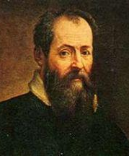
Giorgio Vasari was a Florentine historian and artist who is considered to be the “Father of Art History.” He lived from 1511 to 1574 and was the first to label the architecture of previous centuries as “Gothic.” The term “gothic” was in reference to the Germanic and Nordic tribes of barbarians that overran the Roman Empire in the sixth century CE. While often synonymous with the Medieval period, the Gothic style is actually only the last style of the Medieval period before the Renaissance. However, the Gothic style embodied what art critics, and people in general, hated in the Medieval period. The Medieval period lasted approximately from 400 CE to 1400 CE. It began with the advent of the downfall of the Western Roman empire and ended with the start of the Renaissance. Vasari believed that art and architecture from the Medieval period was degraded, especially in comparison to the Renaissance, which occurred during his own lifetime. The Renaissance is also known as the age of discovery because of its own breakthroughs in science, medicine, philosophy and thought. There was also a flourishing of artistic output during the Renaissance, further prompting Vasari to look with disgust upon the art and architecture of the Medieval period. Vasari said that the Renaissance liberated Italians from the debased and foreign styles of the Medieval period. Also according to Vasari, the first truly modern artist to break from the “crude manner of the Greeks” was Giotto di Bondone. By Greeks, Vasari means the Byzantines of the Byzantine style, which constituted the early part of the Medieval period. Giotto di Bondone, or simply Giotto, lived circa 1277 to 1337 and abandoned the conventions and stylizations of Medieval traditions.
Figure 1 Giorgio Vasari Self-Portrait “Giorgio Vasari 500 Years Old”

The Renaissance can be seen as a rejection of the Gothic or a reaction against it, as it came directly after the Gothic period style and did not use the same elements as what previously had been in the Gothic. The term “Renaissance” refers to a rebirth and revival of the Classical style. The Classical style consists of ancient Greek and Roman art and architecture. The Medieval style was born from the artistic style of the Roman Empire, as well as the iconography of the early Christian church. Most Medieval works of art do indeed contain religious subject matter. Along with these sources is the “barbarian” artistic influence of Northern Europe. The Medieval period is also known as the “Middle Ages.” It is referred to as the Middle Ages because it is the period of time between the Classical period and the Renaissance. Since the Renaissance was considered a time period that incorporated all things “Classical,” it becomes obvious that elements of the Classical period were preferred in regards to artistic and architectural styles of rendering artwork and buildings. For example, in a book entitled A Parallel of the Ancient Architecture with the Modern, authors Roland Freart Sieur De Chambray, John Evelyn and Leon Battista Alberti state:
Let it then suffice to take notice, that it is the ancient Greek and Roman Architecture only which is here intended, as most entirely answering all those perfections required in a faultless and accomplished building; such as for so many ages were so renowned and reputed by the universal suffrages of the civilized world, and would doubtless have still subsisted, and made good their claim, and what is recorded of them, had not the Goths, Vandals, and other barbarous Nations subverted and demolished them, together with that glorious Empire, where those stately and pompous Monuments flood; introducing in their stead a certain fantastical and licentious manner of building, which we have since called modern (or Gothic rather) congestions of heavy, dark, melancholy and monkish piles, without any just proportion, use or beauty, compared with the truly Ancient.

In essence, Alberti, De Chambray and Evelyn were stating that the “faultless and accomplished building” style of the Classical period was superior to the “piles” of modern or Medieval buildings. The building style of the Classical period utilized harmonious proportions and sought to envelop beauty in architecture through vertical elements such as columns and horizontality through the use of elements such as entablatures and friezes. Another commonly-used element was the triangular pediment. Greek buildings also made use of one of the three classical Greek orders of architecture: Doric, Ionic and Corinthian. This dislike of the art and architecture of the Medieval period or the Middle Ages led the majority of art critics to discount the “Dark Ages” as a time period of little artistic talent. Giorgio Vasari’s disdain for the Gothic style, and by extension, the Medieval period and its styles in general, displays a prejudice that was common in the time of the Renaissance, which lasted approximately from 1400 to 1600. The Renaissance was seen as mankind’s return to reason and rationality in the form of classicism after a thousand years of barbarism. Another Italian man named Antonio di Pietro Averlino, also known as Filarete, voiced his opinion of Medieval architecture. Filarete was an architect, sculptor and writer who lived circa 1400 to 1469 and said of imported styles: “Therefore, I advise everyone to abandon the modern style and not be advised by those masters who use this crude system. May he who found it be cursed! I believe that none other than barbarians brought it to Italy.” Filarete believed that architectural designs derived from forms of German and French styles were those of barbarians. The barbarians included the Goths, Gauls, Anglo-Saxons, Vandals, Vikings, and Lombards. This barbaric style was also known as maniera tedesca, or the “German manner”. Filarete and a small group of fellow practitioners converted what used to be an accepted imported style into a despised one. The derogatory connotations associated with Medieval art and architecture persisted into the twentieth century with art authorities such as Jacob Burckhardt and Bernard Berenson. The study of Medieval art began in earnest in the decades following the French Revolution. So it wasn’t until the late eighteenth century and particularly the nineteenth century that antiquaries became interested in the Medieval period.
The term “dark ages” was coined by Francesco Petrarca to describe the Medieval period of art and architecture. Francesco Petrarca, or Petrarch, lived from 1304 to 1374. Petrarch had a belief that Italy should be made new in the image of ancient Rome. He often read classical literature with a preference for the philosophy, poetry and history of antiquity. In fact, he had the largest collection of classical literature in existence in his day. He admired Rome’s ancient civilization, along with its monuments and marvels, and found inspiration in them for his own literary endeavors. While reading classical literature and incorporating it into his own work, he often alienated himself from a world that he saw as deteriorating. He is quoted as saying in his writings: “I am alive now yet I would rather have been born at some other time,” and “I never liked this present age.” Also in his works, he states his role as the reviver of classical studies in Italy and stresses the importance of not abandoning them. His curiosity for all things classical makes Petrarch one of the founders of the Renaissance. He systematically explored the literature and culture of ancient civilizations and what he found exercised a strong influence on every aspect of European culture from his day onwards. As a self-proclaimed wanderer and pilgrim, Petrarch travelled throughout Europe. He visited many Italian cities such as Verona, Genoa, Milan, Vicenza, Ferrara and Rome. He also visited Cologne in Germany, Basle in Switzerland, Paris in France and Prague in today’s Czech Republic. In his travels, Petrarch would have surely seen examples of Medieval architecture such as the examples that I will be discussing below. It seems miraculous that Petrarch could have seen such examples of Medieval architecture and still have thought that the Medieval period was a dark age in terms of architectural accomplishment. Interestingly, during his visit to Cologne in 1333 CE, he did have a compliment for one of the Medieval church buildings: “In the middle of the city I saw an uncommonly beautiful temple, which, though still incomplete, can be called with good reason the most significant.” It is unknown what specific building or structure in Cologne he was referring to, but he may have been talking about the Cologne, or Koln, Cathedral, as it is one of the most magnificent structures in the city and was in existence during Petrarch’s visit. Significantly, the cathedral was still under construction at the time of his visit, indeed, throughout his entire lifetime. This information would correspond to his claim that the “temple” was “still incomplete.”
Figure 2 Francesco Petrarca “Stirrings in Italy”

It is hard to know for sure what Petrarch, Vasari and their contemporary art critics were seeing in Medieval architecture that was viewed as dark. Perhaps it was the perceived loss of knowledge with the fall of the Roman Empire. It may have been the influence of “barbarians, as discussed earlier. It could be the diminution of Classical methods of construction. Likely, it is a combination of all of these reasons with the personal prejudices of art critics of the Renaissance, as well as art connoisseurs of the recent past. Whereas Classical architecture tended to utilize order, proportion, verticality and horizontality, Medieval architecture strayed from this uniformity and incorporated its own elements and innovations to produce new building designs.
While largely discredited today, individuals with ideas about the assumed inferiority of Medieval art and architecture should not have ignored the innovation, accomplishment and beauty of Medieval architectural styles. If one looks to examples of Medieval architecture, there is hardly evidence of a reversal of civilization, but of an advancement of civilization. The discourse to follow will explore why the Medieval period was not a “dark age” and in fact contributed extensively to the progress of architecture. In so doing it will prove that the Medieval period should not have been disregarded as a time of little artistic merit.
The Palatine Chapel at Aachen and the Carolingian Style
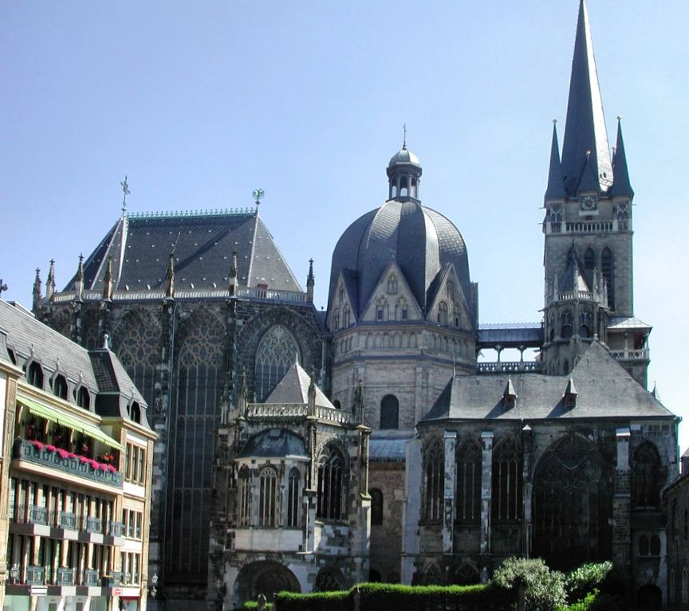
Figure 3 Aachen Cathedral (Palatine Chapel on the Left)
"Aachen- The Palatine Chapel"


The first of the styles to be discussed is the Carolingian style. The Carolingian style started in the late eighth century and lasted into the ninth century. The term “Carolingian” comes from Charlemagne’s name in Latin, Carolus, or Charles. This time period is also known as the Carolingian Renaissance. Whereas there are other time periods that wanted to imitate the ancient Greek and Roman model of art and architecture, the Carolingian revival had a different character. The Carolingian revival involved the use of politics and depended on Charlemagne’s cultural aspirations. He had a lot of respect for ancient Greek and Roman achievements and could see that if his court received classical educations, the court would have a higher standing in the eyes of others. As such, Charlemagne encouraged a revival of culture based on the ancient Greeks and Romans. This revival was considered to be an increase in intellectual standards compared to established standards of the time. Another item on Charlemagne’s agenda was to restore Rome to its former glory. He wanted to bring back the Roman model of having an emperor or an “Augustus” in charge of the Holy Roman Empire. The scholar Einhard, his biographer and friend, stated: “Throughout his whole reign the wish that he had nearest to heart was to re-establish the ancient authority of the city of Rome under his care and by his influence.” Charlemagne’s agenda and ambition to imitate art and architecture based on Roman antiquity produced a blooming of architecture in northern Europe that hadn’t previously been seen. Some of these Roman attributes can be seen in the Palatine Chapel and other Carolingian buildings. However, while the Carolingian style sought to emulate the Roman style as well as borrow from the early Christian and Byzantine styles, it also incorporated its own innovations into the new style. For example, a Carolingian innovation was the westwork, a monumental west-facing entrance that was common in Carolingian, and later, Romanesque churches.
Figure 4 Charlemagne
"100 Leaders"
Charles became king of the Franks in 768 CE and reigned until his death in 814 CE. In the 770s he became known as Carolus Magnus and finally, in 794 CE, he took on the moniker of Charles le Magne, or Charles the Great. This is how he gets his more well-known name of Charlemagne. Charlemagne is a significant figure of the Medieval period. Under his rule, Western Europe was reunited for the first time since the Roman Empire. He is often known as the father of modern-day France, Germany, and even Europe. Charlemagne installed the Frankish court at Aachen in Germany in 794 CE after beginning the construction of the Palatine Chapel in 792 CE. Up until this time, the Carolingian domain lacked a capital. Charlemagne was crowned the Holy Roman Emperor by Pope Leo III on Christmas day in 800 CE. In 805 CE, the Palatine Chapel was consecrated by Pope Leo III. Interestingly, the Palatine Chapel is the most famous building that is associated with Charlemagne. It is also regarded as the greatest example of Carolingian architecture. The Palatine Chapel functioned as Charlemagne’s personal and private chapel, as well as a chapel for the court. Additionally, it served as a coronation hall, an imperial mausoleum, and a reliquary.
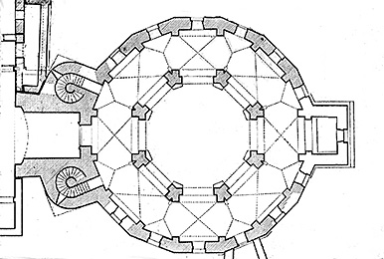
The Palatine Chapel has a two-story interior. The dome is sixteen-sided on the exterior and is eight-sided on the interior. An ambulatory surrounds the eight-sided core and there is no crossing or transept. From the central octagon, which supports the dome, there is a projecting apse and a two-towered entrance. The attached entrance has a deep exedra or niche carved from its front and a large “window of appearances,” which is an opening from which the emperor could view the atrium and be visible to the people that were in the atrium. The window of appearances is located on the entrance’s second level. The westwork constitutes the entrance and symbolizes the Palatine Chapel’s function as a fortress and an imperial foundation.
Figure 5 Palatine Chapel Plan
"Glossary of Medieval Art and Architecture"
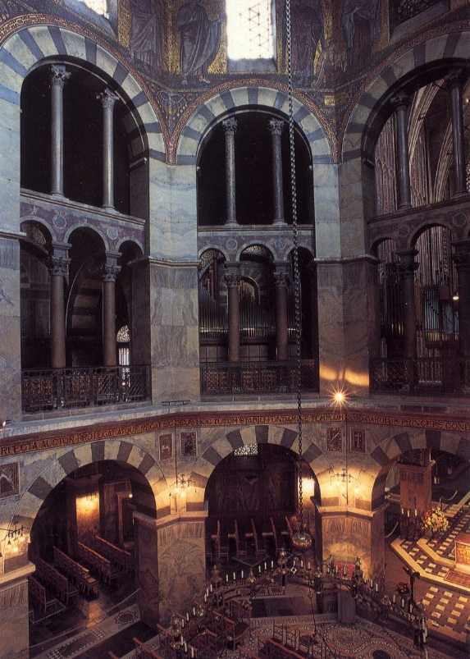
As previously mentioned, Charlemagne had great respect for the ancient Romans. As such, the Palatine Chapel was meant to hearken back to Roman building design. This idea was evident in the use of the groin vaulting of the ceiling form. Also, the Palatine Chapel utilizes columns and rounded arches, also very Roman in design. Apparently, Petrarch, Vasari, and their contemporaries did not notice or acknowledge these Roman elements within the Palatine Chapel. Perhaps they never visited Aachen or, if they did know of the Palatine Chapel, they refused to see that it was either a logical continuation of classical architecture or an early revival of it. Either way, they may have disregarded the Palatine Chapel because it was in Germany, a “barbarous nation.”
Figure 6 Octagon of the Palatine Chapel showing part of the Arcade with rounded Roman arches
"Aachen-The Palatine Chapel"
The Palatine Chapel at Aachen is considered one of the most influential buildings of the Medieval period. The Palatine Chapel influenced architecture around much of western Europe. The later Romanesque style was also influenced by the buildings constructed during Charlemagne’s reign. Additionally, the Palatine Chapel at Aachen was the burial place of Charlemagne. He was interred first in the chapel’s choir. In 1000 CE, Emperor Otto III had Charlemagne’s vault opened. Supposedly, Charlemagne’s body was in a perfect state of preservation. His body was seated on a marble throne, dressed in imperial clothes with a crown on his head. The gospels were laying open in his lap and he was holding a scepter. In 1165, Emperor Frederick Barbarossa opened the vault again and placed Charlemagne’s remains in a marble sarcophagus. At this time, at the request of Barbarossa, Charlemagne was canonized. In 1168, Barbarossa gave a bronze chandelier to the chapel to hang in the center of the octagon and over the shrine. The chandelier remains in the chapel today. In 1215, Frederick II had Charlemagne’s remains put in a golden shrine and placed directly under the chandelier. In 1349, there was a renewed interest in relics, especially Charlemagne’s. Charles IV commissioned the Reliquary of Charlemagne with his thigh bone and the Bust of Charlemagne with his skull. In 1481, King Louis XI of France commissioned the Arm Reliquary, which contained the radius bones and ulna Charlemagne’s right arm. All of these can still be seen in the Treasury of the Palatine Chapel. Charlemagne was seen as the progenitor of French kings since 1474. On the six-hundredth anniversary of Charlemagne’s death, his shrine was moved to the east end of the choir, where it still sits today. In 1978, the Palatine Chapel, as well as the rest of the added-on complex known as Aachen Cathedral, was one of the first twelve sites to be inducted into the UNESCO list of World Heritage Sites. In fact, it was the first German site and one of the first three European sites to be admitted onto the list. As such, the Palatine Chapel can be seen as Charlemagne’s legacy. The design at Aachen became an architectural icon that was associated with the notions of Christian power and the prestige of Charlemagne. The Palatine Chapel also influenced the architecture around much of western Europe. The Romanesque style was influenced by the buildings constructed during Charlemagne’s reign, such as the Palatine Chapel.
Adding to the magnificence of the Palatine Chapel at Aachen is the number of holy relics it holds. Charlemagne collected many relics during his life and kept them at Aachen, where they remain today. The Palatine Chapel purportedly contains the shroud that the Virgin Mary wore at the Crucifixion, the swaddling clothes of the baby Jesus, the loin-cloth worn by Jesus on the cross, and the cloth that St. John the Baptist’s head lay on after his beheading. These holy items are brought out only every seven years for people to see as per a custom that began in the mid-1300s. Significantly, the reliquary room of the Palatine Chapel was directly above Charlemagne’s throne room, signifying his power and the divine support of his rule.

Durham Cathedral and the Romanesque Style
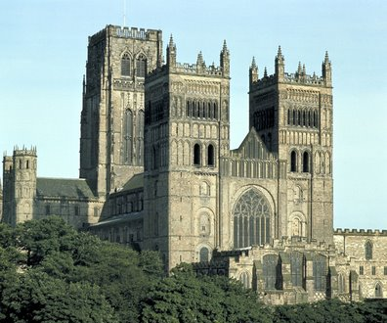
Figure 7 Durham Cathedral Exterior
"Durham Cathedral"

The English style of church architecture was different than that of the Palatine Chapel. Although the Palatine Chapel and other Carolingian buildings influenced the Romanesque style, the Romanesque had its own characteristics and innovations. Art historians in the early 1800s tried to categorize their profession and came up with the term “Romanesque.” The term encompassed ancient Roman architectural elements and aspects, as the name suggests. The word “Romanesque” itself means Roman-like or in the Roman manner. However, the term was meant to include western European art and architecture in the 1000s and 1100s CE. The driving force behind the Romanesque style was the expansion of monasticism. Monasticism is a religious way of life in which the participants renounce worldly endeavors in order to pursue a religious calling or devote themselves to spiritual work. As such, many monasteries, churches and cathedrals sprang up in the eleventh and twelfth centuries throughout Europe. As a part of this process, new monastic orders came into being such as the Carthusian, Cluniac, and Cistercian. The Romanesque style was also influenced by pilgrimages; that is, people who would travel or make a pilgrimage to a church or other sacred building to visit a saint’s relics or remains. The pilgrims would then pray to these remains or relics.
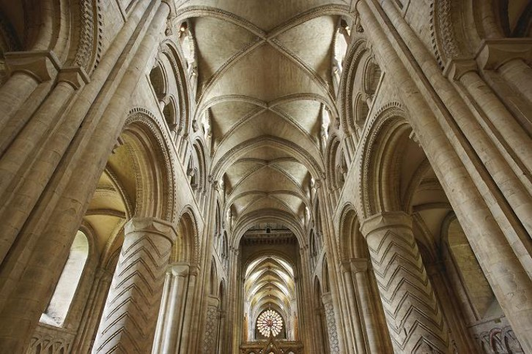
Romanesque churches now reached proportions that until this time had been unheard of in order to make room for larger numbers of monks and priests as well as bigger crowds of pilgrims coming to see and venerate saintly relics. This building zenith was also due to a somewhat stable political climate, economic abundance, and an increased population. The rise of architectural innovations and accomplishments for new buildings of the Romanesque style continued for the next two-hundred years. Romanesque architecture often adapted the plan of the Roman basilica with a nave, side aisles and apse. The Romanesque adaptation, though, was to include a transept that crossed the nave, ambulatories for faithful pilgrims and radiating chapels in which numerous priests could say mass concurrently. Large sculptures decorated church facades, doors, doorways and column capitals for the first time since the fall of the Roman Empire and frescoes were utilized on the vaulted ceilings and walls of churches. Romanesque art and architecture used many Roman elements and qualities, such as rounded arches. But, the Romanesque style also drew from Byzantine architecture as well as the northern European Insular style. The Insular style is also known as the Hiberno-Saxon style, or the style of art from post-Roman Britain, Scotland and Ireland. The Romanesque style also produced its own inventions, such as placing relief sculptures on tympanums. Early Medieval buildings and churches typically had wooden timber ceilings whereas Romanesque churches and buildings had barrel vaults or groin vaults made of stone. Romanesque buildings’ walls were thick out of necessity to work against the weight of the outward thrust of the vaulted ceilings. As such, only small windows were typically used in Romanesque structures. This will be in contrast to the later Gothic period, which will be discussed later.
Figure 8 Durham Cathedral's Vaulted Nave Ceiling
"Architectural Innovation: The Cathedral's Vaulted Ceiling"

The Romanesque period can be broken into four categories: French, which lasted from 1000 CE to 1160 CE; English or Norman, which ranged from 1066 CE to 1174 CE; Italian, lasting from 1013 CE to 1250 CE and German or Ottonian, which started in 962 CE and ended in 1250 CE. The Norman category is closely associated with William the Conqueror, as he is the individual who essentially brought the style to England. The style is known as Norman due to the fact that it was the Normans who came to England from Normandy in western France. Their leader was William II, Duke of Normandy, who became the king of England after the Battle of Hastings in 1066. He later became known as William the Conqueror.
Figure 9 William the Conqueror
"William the Conqueror"
Romanesque architecture is typically discernible due to its round arches and barrel or groin vaulting constituting the ceiling. Architecture from the Romanesque style also contains massive piers, thick interior and exterior walls, as well as buttresses on the exterior walls. This combination leads to a structure that has a sturdy and solid appearance. This style is also characterized by the transition from wooden churches to stone.
The construction of Durham Cathedral was ongoing from 1093 CE to 1133 CE. The project was begun under the direction the bishop William de Carilef, or William of Calais, to replace an earlier Saxon church. He was appointed by William the Conqueror in 1080 to design and build the cathedral. The Benedictine monks saw the new structure not only as a monastery and cathedral church, but also as a host for the shrine for their patron saint, St. Cuthbert. St. Cuthbert was bishop of the Diocese of Lindisfarne from 685 to 687 CE. He was famous for his healing abilities and even after his death, visitors would supposedly visit his shrine and be cured of various illnesses. Due to ninth century Viking raids, the monks of Lindisfarne fled further inland with the bones of St. Cuthert. In 995 CE, Lindisfarne monks found a peninsula on the River Wear that was defensible. They decided to stay there and build the first Saxon church of Durham. This church was likely made of wood. In 1018, this building 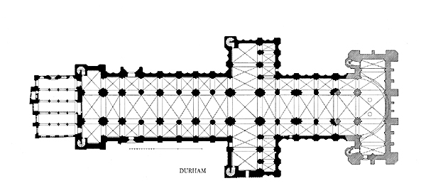
Figure 10 Plan of Durham Cathedral
"Images of Medieval Art and Architecture"

was replaced by a stone church. In 1104 CE, the remains of St. Cuthbert were moved into the recently completed choir. His shrine was the most important in England until the martyrdom of St. Thomas Becket. Today St. Cuthbert’s remains are behind the High Altar. The remains of St. Bede the Venerable are also housed at Durham Cathedral. St. Bede is a saint who lived in the seventh century and is known as the father of English history. However, he is most well-known for his literature about the history of the English church.
Durham Cathedral served as both a military headquarters and a seat of ecclesiastical authority. The two-towered façade has a Romanesque foundation, Gothic towers and eighteenth century battlements. On Durham’s interior, the nave consists of double bays with large columns alternating with piers. Huge transverse arches span the nave between the piers, dividing the nave space into three units. Ribs go diagonally from the piers and criss-cross the ceiling so that, with the transverse arches, the vaults display a strange, seven-part division in each unit. There are interlaced blind arcades on the lower walls of the side aisles that add decoration.
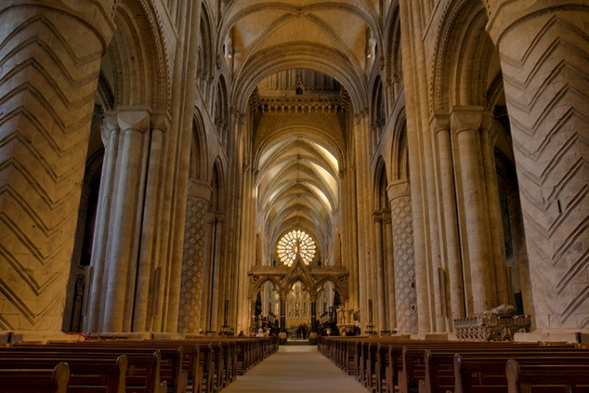
The decorated cylindrical piers of Durham Cathedral included incised lines, lozenges and zigzags. These features were carved in advanced so that when the blocks arrived at the cathedral, they could be assembled into different patterns. These are known as articulated piers. Durham had spectacular achievements in stone vaulting and as such, Durham Cathedral is considered an innovative building that helped establish new modes of design. This statement is also true of Durham’s cylindrical and incised piers. Durham’s importance in terms of architecture can be seen in the vaulted stone ceiling of the nave. It was the first in the world to be on such a large scale and it had a major influence on centuries of church buildings.
Figure 11 Nave of Durham Cathedral showing incised piers and columns "Durham Triumphs in English Tourism Week"
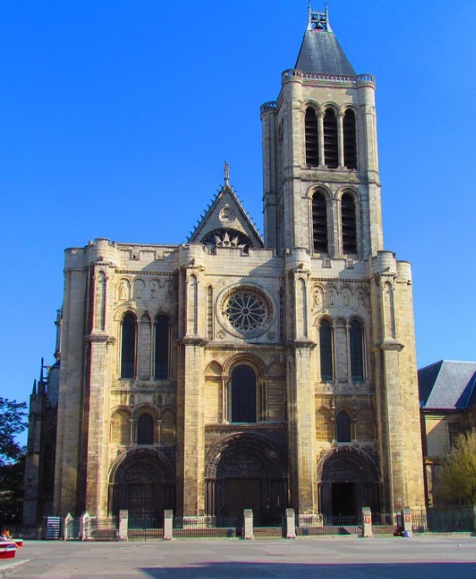
The Abbey Church of St. Denis and the Gothic Style
Figure 12 Exterior of St. Denis
"Travel to Eat"

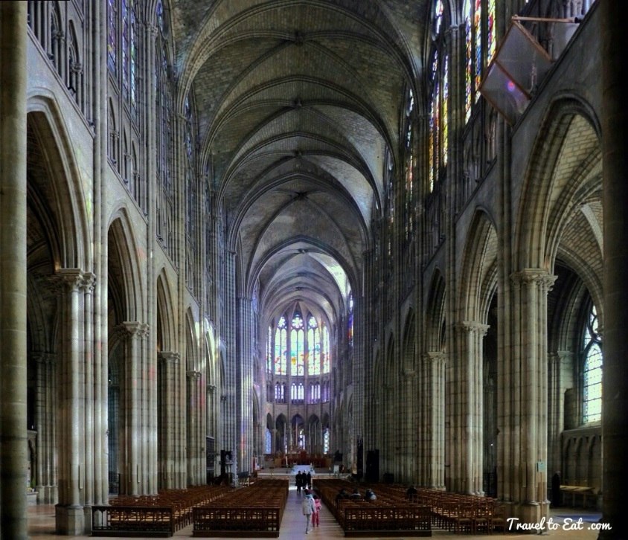
After the Romanesque period came the Gothic period. The originator of the Gothic style is the Abbey Church of St. Denis in France. The Gothic style lasted from circa 1140 CE until approximately 1400 CE. Architecture from the Gothic period style is the outcome of the engineering dilemma of how to use stone to span wider surfaces from taller heights. The Gothic style can be viewed as a reaction against the Romanesque style. From 1100 onwards, architects experimented with innovative new methods that allowed for walls to become disillusioned and spatial arrangement to be more fluid. Instead of round arches, the pointed arch in Gothic architecture was adopted due to it having a lesser lateral thrust than the round arch and was easily adaptable to openings of various lengths and widths. Also during the Gothic period, a new vaulting system was implemented that involved stone ribs combining into columns or piers all the way to the ground, thus distributing the weight of the vault. This new vaulting method was known as rib vaulting. As such, the vault could now be made of thinner and lighter stone and the walls could open up to accommodate larger windows. Flying buttresses began appearing in the 1170s and served to absorb the outward thrust of the vault at set intervals just under the roof, making it possible to reduce the building’s exterior masonry shell to a slight skeletal framework. Architects in northern France, and soon all over Europe, were competing in a race to conquer height. The vault height of each new cathedral tried to surpass its predecessors by a few meters. This elevation of a Gothic cathedral interior was meant to draw the viewer’s gaze to the highest point of the vault in an irresistible upward pull. This pull symbolized to the designers the Christian hope of leaving earth and entering Heaven. The transcendent experience of this architecture was reinforced by stained glass windows, sometimes spanning the entire height of the wall. Throughout the thirteenth century, an obligatory feature in most cathedrals was a monumental rose window.
Figure 13 Rib-vaulted Nave of St. Denis looking toward the apse
"Travel to Eat"
The Gothic style stands in contrast to the Romanesque style in that it strove for more space, height and light in its architecture. The Gothic period tried to incorporate lux nova, or new light and spatium nova, or new space. The purpose for the “new light” and “new space” was to allow more light inside the space and thus provide for a more spiritual experience within the cathedral or church. This spiritual experience was meant to encompass the notion of Heaven and the spiritual or religious awakening and enlightenment that came with entering Heaven. These elements were first executed in the chevet of the Abbey Church of St. Denis under the direction of Abbot Suger, which will be discussed later. Like the Romanesque, there are four periods that the Gothic style can be broken into. The first is the French, lasting from 1137 CE until 1500 CE. Then there is the English period that lasted from 1174 CE until 1485 CE. The Italian period lasted from 1200 CE to 1450 CE and the German period began in 1248 CE and ended in 1500 CE.
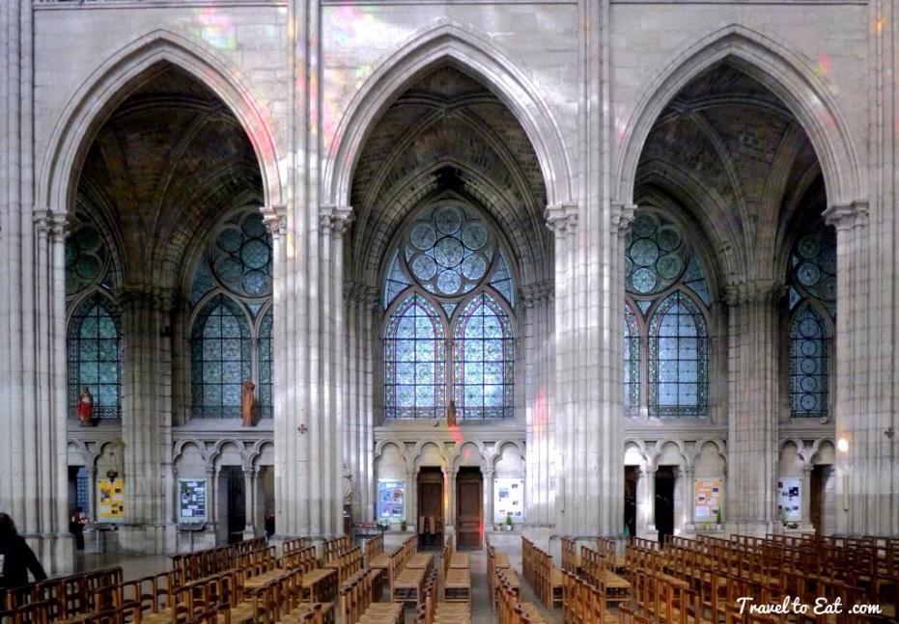
Whereas builders used to be craftsmen who used the learning and styles of the past and adapted them for contemporary use, builders by 1100 CE turned themselves into innovative members of the architect profession. The 1130s saw a rise in the level of intellectual sophistication that was needed of builders and architects, or master masons, in order to solve aesthetic problems with architecture. Masons and builders had to design small details while keeping in mind the effect that each decision would have on the whole structure. This method resulted in architectural works that contrasted and departed from prior standards while at the same time setting challenges that would grab and hold the attention of the next generations of builders until the end of the twelfth century.
Figure 14 Gothic Pointed Arches in Nave of St. Denis
"Travel to Eat"
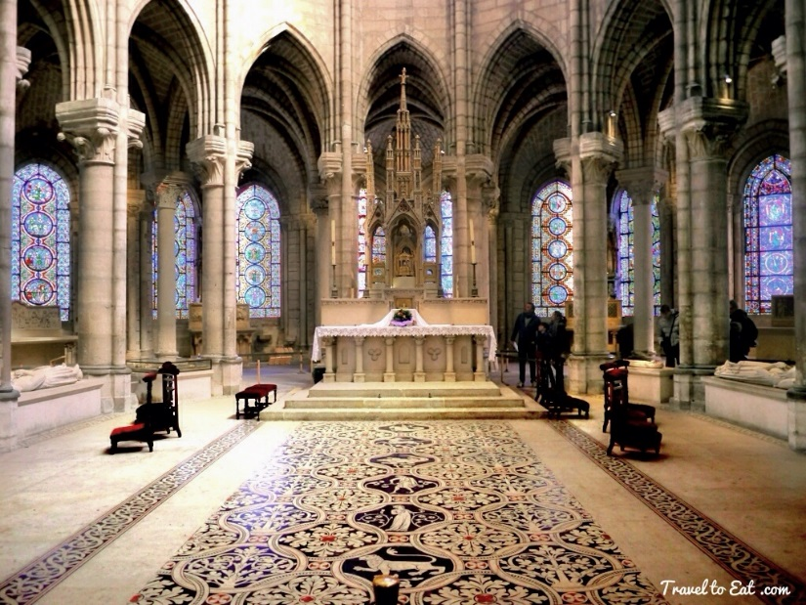
The Gothic style involved the use of pointed arches and rib vaults, as well as flying buttresses on the exteriors walls. The exterior walls were typically perforated with windows. During the Gothic period, there was a new emphasis put on verticality and height, especially on the interior of the building. There was also greater effort put into constructing thinner exterior and interior walls. Instead of the solidity and sturdiness of Romanesque, the Gothic was meant to have a sense of spaciousness created by a thin structure and visual coordination. The earliest attempts to place stone vaults safely over high and thin walls were made in Paris and the surrounding area in the 1130s. There would be even greater achievements of the Medieval period, but the decisive break with the past had been made in the aforementioned chevet at St. Denis. Gothic architecture was first articulated in the choir and ambulatory, or chevet, of the Abbey Church of St. Denis.
Figure 15 Chancel (choir, ambulatory, chevet) of St. Denis
"Travel to Eat"
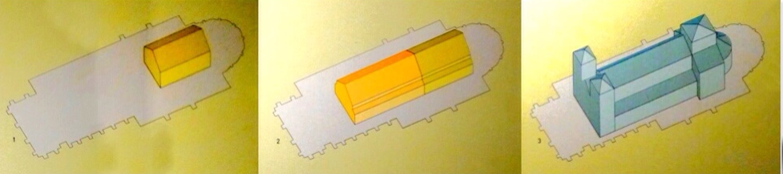
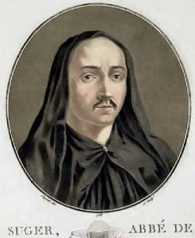
The core of St. Denis was the tomb of Dionysius, or St. Denis, a missionary that was supposedly martyred in 258 CE. St. Denis was thought to be the founder of Christianity in France and as such, the Abbey Church of St. Denis is considered the first Christian church in France. The church also held relics of St. Denis that transformed the church into a pilgrimage site. St. Denis began as a small funerary chapel in the fifth century. It was initially built by St. Genevieve in 475 CE to mark the burial place of St. Denis. The chapel was enlarged by the Merovingian king Dagobert in 638. Additions transformed it into a Carolingian basilica between 750 and 775. This basilica was extended on various occasions. St. Denis established itself as the royal abbey in France. Many princes received their education there and over the centuries, the church became a preferred burial place of many French kings, queens and nobles and has become known as the “royal necropolis of France.”
Figure 16 Growth of St. Denis (St. Genevieve's Chapel, King Dagobert's Addition, Carolingian Basilica)
"Travel to Eat"
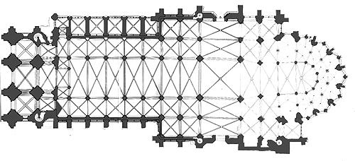
St. Denis reached the peak of its influence under the abbacy of Suger. Abbot Suger was born in 1081 CE and died in 1151 CE. He was the abbot of St. Denis from 1122 CE until his death. He replaced the Carolingian church of St. Denis starting in 1137 CE and finishing in 1144 CE. The original plan for expansion was to provide for two additions: a new west façade joined to the eighth-century nave and a new east end. The new east end would contain a larger crypt that would support a feretory, or raised relic platform, over the crypt with stairs on each side going up to the upper choir. This space was surrounded by a double ambulatory and seven chapels radiating from the apse. Both of these additions were completed under Suger’s abbacy and mostly still stand today. Initially, the original Carolingian transept, nave, and side-aisles between the two additions were going to be retained. However, when the success of the additions became apparent, Suger decided to replace the rest of the eighth century church as well. The narthex was begun in 1137 and was completed in 1140 and the chevet was started in 1140 and finished in 1144. Abbot Suger made it clear that he wanted light to be emphasized and maximized in the new church. He based this request on the theology attributed to him that stressed light as the link between the material and spiritual worlds. According to Suger, in reference to the light in St. Denis:
Figure 18 Plan of St. Denis
"Images of Medieval Art and Architecture"
Figure 17 Abbot Suger
"Abbot Suger: Gothic Architecture & Stained Glass"
Thus, when—out of my delight in the beauty of the house of God—the loveliness of the many-colored gems has called me away from external cares, and worthy meditation has induced me to reflect, transferring that which is material to that which is immaterial, on the diversity of the sacred virtues: then it seems to me that I see myself dwelling, as it were, in some strange region of the universe which neither exists entirely in the slime of the earth nor entirely in the purity of Heaven; and that, by the grace of God, I can be transported from this inferior to that higher world in an anagogical manner.

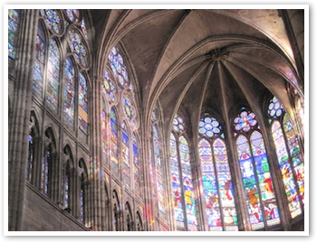
He also outlined what he wanted for the new choir of St. Denis. He wanted a spectacular setting for the shrine of the patron saint, enough space for pilgrims to circulate and the entire interior to be encircled by light reflected through large stained glass windows. Whereas Romanesque buildings had intervals between the chapels, St. Denis’ chapels were pulled in to form a constant rippling line. The walls were reduced down to buttresses and strips of dividing masonry. True to the Gothic style, the walls also contained many perforations. Each chapel had two windows and they seemed to give an appearance of a nearly unbroken circuit of glass. The chapels also enhanced the spaciousness that was achieved by the use of rib vaulting over the chapels and ambulatory as well as light, monolithic columns. Additionally, the rib vaulting created a sense of surfaces that were folded around complex spaces. Abbot Suger brought the shrine of St. Denis, as well as the remains of St. Denis’ and his martyred companions Saints Rusticus and Eleutherius, from the crypt to a site behind the high altar. The final remodeled church that is seen today was begun in 1231 CE and respected Suger’s additions, especially around the sanctuary.
Figure 19 St. Denis' Apse Windows
"Gothic's Genius: Abbot Suger"
According to the book Medieval Architecture, Medieval Learning: Builders and Masters in the Age of Romanesque and Gothic by Charles M. Radding and William W. Clark, instead of designing architectural elements such as windows, moldings, capitals and columns in order as they were needed, the builder of St. Denis designed all of these elements in advance of the actual building process. The builder decided to use this approach in order to see how the elements would interact to produce the effect he desired. In this way, St. Denis represented a departure not only in the effects it produced, but more importantly, the level of cognitive ability of the builders to keep in mind aesthetic objectives while planning each detail of the structure. Objectives such as this were meant to be a means of integrating the chapel, aisle and central nave of St. Denis into a space whose unity an observer could immediately see. One example is in the use of colonettes, or slim, vertical elements in the walls to correspond to and complement the lines of ribs and moldings. Another example is the use of arches flanking and framing the windows to reflect the multiple lines of the vaults. This spatial unity was a direct depart from the Romanesque style that incorporated space into distinct and separate modules. In essence, the Abbey Church of St. Denis is considered to be the most elegant building constructed for the display of relics in the twelfth century. In looking at St. Denis, it becomes obvious again that master masons, or architects, and builders expressed Medieval accomplishments in architecture and displayed artistic and intellectual abilities that set them apart from the rest of society, as well as each other.
Conclusion
While it seems obvious today to art historians, art critics and everyday tourists that these Medieval architectural examples are beautiful, majestic and awe-inspiring, these reactions and opinions weren’t always the case. Even as early as the Renaissance following the Gothic style of the Medieval period, art critics found no reason to accept the buildings and accomplishments of their predecessors. These new technological feats were revolutionary because the methods hadn’t been used before in architecture. This includes classical architecture that the Renaissance tried so hard to mimic and that art critics from the Renaissance saw as superior. These feats and innovations were important because they allowed different architectural styles to come into being and provided better architectural methods to reach the goals that buildings needed to achieve as times changed. These styles and inventions are also significant because the buildings that they were realized in continued to impact and influence architecture in later centuries. Not only are many of these buildings wonders of architectural achievement in and of themselves, a lot of them also contain important relics and remains of the individuals who helped give rise to the situations that made the building of these structures possible. They are also significant in their involvement and affiliation with historical events. Even though this paper has displayed the historical importance behind the Palatine Chapel, Durham Cathedral and St. Denis, as well as the architectural achievements and innovations that took place in building them, it seems as though significant individuals such as Petrarch and Vasari refused to see what was readily visible to them.

Bibliography:

Primary Sources:

Abbot Suger. Abbot Suger on the Abbey Church of St.-Denis and Its Art Treasures.
2nd ed. Princeton, N.J.: Princeton University Press, 1979.

This source informed me of Abbot Suger’s intentions in his own words. I was able to better understand why St. Denis was built the way it was.

Freart Sieur De Chambray, Roland, John Evelyn, and Leon Battista
Alberti. A Parallel of the Ancient Architecture with the Modern. London: Walthoe, 1733.

I obtained a quote from this source that shed light on why people in the past did not like Medieval architecture. I better understood the distinctions in their eyes between Classical and Renaissance architecture and Medieval architecture.

Vasari, Giorgio. Lives of the Most Eminent Painters, Sculptors and
Architects: Tr. from the Italian of Giorgio Vasari. Translated by Mrs. Jonathan Foster. Vol. 1. London: H.G. Bohn, 1850.

This book allowed me to better understand the bias of Vasari and his contemporaries towards Medieval art and architecture. The quote I obtained from this source helped illustrate the negative connotations I was discussing in my paper.

Secondary Sources:

Chapuis, Julien. "Gothic Art." Heilbrunn Timeline of Art History.
October 1, 2002. Accessed November 9, 2015. http://www.metmuseum.org/toah/hd/mgot/hd_mgot.htm.

This site was invaluable to me because it nicely summarized and outlined facts about the history behind each style. I trust this site because it is affiliated with the Metropolitan Museum of Art.

___________. "Romanesque Art." Heilbrunn Timeline of Art History.
October 1, 2002. Accessed November 9, 2015. http://www.metmuseum.org/toah/hd/rmsq/hd_rmsq.htm.

This site is also affiliated with the Metropolitan Museum of Art. It was immeasurably helpful in understanding the Romanesque period and the historical occurrences behind it.

Coldstream, Nicola. Medieval Architecture. Oxford: Oxford University
Press, 2002.

This book taught me more about Medieval construction technique. It also informed me as to the implications and influences that the Medieval era left on architecture.

Fazio, Michael W., Marian Moffett, and Lawrence Wodehouse. Buildings
Across Time: An Introduction to World Architecture. 3rd ed. Boston, Mass.: McGraw-Hill Higher Education, 2009.

This book was a textbook I used in a history of architecture class. It contained a lot of the background knowledge I needed to understand the terminology attached to Medieval architecture.

Hayes, Holly. "Sacred Destinations." Aachen Cathedral. May 12, 2014. Accessed April 16,
2016. http://www.sacred-destinations.com/germany/aachen-cathedral.

This site was invaluable because I learned more about the history and religious aspects of the Palatine Chapel. I was able to use this information in my paper to lend credibility to the Palatine Chapel’s significance.

Mann, Nicholas. Petrarch. Oxford: Oxford University Press, 1984.
With this book I was able to learn a lot about Petrarch. This information helped shed light on why he was so critical of Medieval architecture.

Radding, Charles M., and William W. Clark. Medieval Architecture,
Medieval Learning: Builders and Masters in the Age of Romanesque and Gothic. New Haven: Yale University Press, 1992.
This source was very valuable because it taught me more about the construction techniques in Gothic architecture. Specifically in the case of St. Denis.

Snyder, James. Medieval Art: Painting-Sculpture-Architecture, 4th-
14th Century. New York: H.N. Abrams, 1989.

This was a textbook I used in a directed studies class about Medieval art and architecture. It was the basis of my information when I was beginning my paper, as it summarized and evaluated many different Medieval buildings.

Sorabella, Jean. "Carolingian Art." Heilbrunn Timeline of Art History.
October 1, 2002. Accessed November 9, 2015. http://www.metmuseum.org/toah/hd/caro/hd_caro.htm.

This site is another that is affiliated with the Metropolitan Museum of Art. It shed a lot of light on the background and history of the Carolingian era.

Stalley, R. A. Early Medieval Architecture. Oxford: Oxford University
Press, 1999.

This book helped me better understand why Medieval architecture was inventive and innovative, as well as influential. I was better able to comprehend the difference between Medieval architecture and what came before and after.

"Romanesque Architecture." - Durham World Heritage Site. n.d. Accessed May 9, 2016.
https://www.durhamworldheritagesite.com/architecture/romanesque.

I was unable to find the author of this site, but it is an official site of Durham Cathedral. It illuminated the Romanesque era for me so that I could understand more of the history behind Durham Cathedral and the key figures in making its construction possible.

Image Sources:
“Aachen – The Palatine Chapel” http://earlymedieval.archeurope.info/index.php?page=aachen-the-palatine-chapel
“Abbot Suger: Gothic Architecture & Stained Glass” http://study.com/academy/lesson/abbot-suger-gothic-architecture-stained-glass.html
“Architectural Innovation: The Cathedral's Vaulted Ceiling” https://www.durhamworldheritagesite.com/heritage/significance/vaulted-ceiling
“Durham Cathedral”https://thefreelancehistorywriter.com/2012/08/07/durham-cathedral/
“Durham Triumphs in English Tourism Week” http://www.discoverbritainmag.com/winners-of-the-visitengland-awards-for-excellence-2016-revealed/
“Giorgio Vasari 500 Years Old” http://www.italianinsider.it/?q=node/486
“Glossary of Medieval Art and Architecture” http://www.pitt.edu/~medart/menuglossary/centplan.htm
“Gothic's Genius: Abbot Suger” http://www.catholiceducation.org/en/culture/art/gothic-s-genius-abbot-suger.html
“Images of Medieval Art and Architecture” http://www.medart.pitt.edu/image/France/sdenis/plans/sdenmap.html
“Stirrings in Italy” http://www.kingsacademy.com/mhodges/02_The-West-to-1900/07_The-High-Middle-Ages/07e_Stirrings-in-Italy_1200s-1300s.htm
“Travel to Eat” https://traveltoeat.com/saint-denis-basilica-paris/
"William the Conqueror” http://totallyhistory.com/william-the-conqueror/
“100 Leaders” http://100leaders.org/charlemagne

James Snyder, Medieval Art: Painting-Sculpture-Architecture, 4th- 14th Century (New York: H.N. Abrams, 1989), 343.
“Gothic Art.” Heilbrunn Timeline of Art History. Last modified 2000. Accessed November 9, 2015. http://www.metmuseum.org/toah/hd/mgot/hd_mgot.htm.
To historians, the Renaissance is the start of the modern period whereas to art historians, the modern period of art was in the twentieth century.
Snyder, 449.
Ibid., 460.
Roland Freart Sieur De Chambray, John Evelyn, and Leon Battista Alberti, A Parallel of the Ancient Architecture with the Modern (London: Walthoe, 1733), 9
Friezes are the flat middle level of an entablature and are often decorated with reliefs or sculptures. An entablature is the area above the capitals of columns and below the roof or upper level.
A pediment is a low gable that is typically triangular in shape and is over the entablature, colonnade or end wall of a building.
The Doric order is most easily distinguished by the simple circular capitals at the tops of columns. The Ionic order has the thinnest and smallest columns and uses scroll-shaped forms, or volutes, as capitals atop the columns. The Corinthian order is the most elaborate. It uses fluting, or vertical grooves along the columns and has acanthus leaves and scrolls as column capitals.
Nicola Coldstream, Medieval Architecture (Oxford: Oxford University Press, 2002), 213.
Coldstream, 221.
Heilbrunn Timeline of Art History, “Gothic Art.”
Snyder, 27.
“Romanesque Art.” Heilbrunn Timeline of Art History. Last modified October, 2002. Accessed November 9, 2015. http://www.metmuseum.org/toah/hd/rmsq/hd_rmsq.htm.
Coldstream, 26.
Nicholas Mann, Petrarch (Oxford: Oxford University Press, 1984), 6.
Mann, 12.
Ibid., 35.
Ibid., 9.
Ibid., 28.
Ibid., 27.
Ibid., 29.
Snyder, 422.
“Carolingian Art.” Heilbrunn Timeline of Art History. Last modified December, 2008. Accessed November 9, 2015. http://www.metmuseum.org/toah/hd/caro/hd_caro.htm.
Ibid.
Ibid.
Ibid.
Ibid.
Ibid.
Heilbrunn Timeline of Art History, “Carolingian Art.”
A westwork’s exterior usually consists of multiple stories that are between two towers. The interior includes an entrance vestibule, a chapel, and galleries that overlook the nave. It is sometimes synonymous with a narthex. A narthex is the vestibule that stretches across the front of a church.
Durham World heriotage Site
Snyder, 191.
Stalley, 39.
A reliquary is a container for holy relics and could sometimes be an entire room or building.
An ambulatory is a passage that leads around the apse and choir of a church. A transept is a cross arm that is placed at right angles to the nave of a church. A nave is a taller, central, longitudinal space of a church that extends from the entrance to the crossing and is flanked by aisles.
An apse is a semi-circular or polygonal recess that is typically at the east end of a church.
A vault is a ceiling that is constructed using a series of arches. A groin vault is a vault that is formed by the intersection of two perpendicular barrel vaults. A barrel vault is formed by placing arches in a row, creating a half-cylinder.
Stalley, 73.
A choir consists of the area of a church that is located between the crossing and the chevet. A chevet consists of the apse, choir and radiating chapels of a church.
Sacred Destinations, “Aachen Cathedral.”
Ibid.
Ibid.
Ibid.
A relic is the physical remains of a saint or other venerated individual. It can also be an item that belonged to the saint or individual.
Sacred Destinations, “Aachen Cathedral.”
Ibid.
Sacred Destinations, “Aachen Cathedral.”
Ibid.
Ibid.
Ibid.
Ibid.
Ibid.
Sacred Destinations, “Aachen Cathedral.”
Heilbrunn Timeline of Art History, “Romanesque Art.”
Heilbrunn Timeline of Art History, “Romanesque Art.”
Ibid.
Ibid.
Ibid.
Ibid.
A basilica is a large, oblong public building with an open interior space that usually includes a nave, aisles and an apse and is Roman in origin.
A façade is the front of a building or structure. A fresco is a technique of mural painting.
Heilbrunn Timeline of Art History, “Romanesque Art.”
A tympanum is a semi-circular space over a doorway.
A pier is a vertical, unattached masonry support that usually carries the heaviest architectural loads. It can also be the masonry structure between paired openings such as windows, doors and arches. A buttress is an architectural support that opposes the lateral thrust of a vault or arch within a building.
Stalley, 111.
Snyder, 294.
Durham World Heritage Site, “Romanesque Architecture.”
Ibid.
Ibid.
Durham World Heritage Site, “Romanesque Architecture.”
Stalley, 147.
Durham World Heritage Site, “Romanesque Architecture.”
A bay is a space between architectural elements. It is a recess or compartment.
A transverse arch is a supporting arch that crosses the vault.
A rib is an arch of masonry that forms part of the framework on which a vault rests.
A blind arcade, or a blind opening, is a series of arches with no actual openings that are applied against a wall for decoration.
Stalley., 107.
Ibid., 229.
Heilbrunn Timeline of Art History, “Gothic Art.”
Ibid.
A rib vault is formed when the joining of the curved sides of a groin vault are demarcated by a raised rib.
Heilbrunn Timeline of Art History, “Gothic Art.”
Heilbrunn Timeline of Art History, “Gothic Art.”
Charles M. Radding & William W. Clark, Medieval Architecture, Medieval Learning: Builders and Masters in the Age of Romanesque and Gothic (New Haven: Yale University Press, 1992), 57.
Radding and Clark., 57.
Coldstream, 27.
Radding and Clark, 54.
Ibid., 63.
Radding and Clark, 63.
Abbot Suger, Abbot Suger on the Abbey Church of St.-Denis and Its Art Treasures (Princeton, N.J: Princeton University Press, 1979), 63-65.
Coldstream, 31.
Coldstream, 195-196.
Ibid., 195.
Radding and Clark, 7.
Ibid., 76.

