UNIVERSITY OF WISCONSIN – EAU CLAIRE

Irish Assimilation in Fond du Lac County: 1850-1910

A Senior Thesis Submitted to the Department of History
At The University of Wisconsin – Eau Claire
Dr. Patricia Turner: Professor
Dr. Jane Pederson: Cooperating Professor

By Stephen E. O’Connell
Eau Claire, Wisconsin
December 2010

Copyright for this work is owned by the author. This digital version is published by McIntyre Library, University of Wisconsin Eau Claire with the consent of the author.

Abstract
The vast majority of studies of Irish immigration to the United States in the late nineteenth and early twentieth century have focused on urban centers. However, significant numbers of Irish immigrants in this period also settled in rural agricultural areas such as northern Wisconsin. The Irish immigrants who traveled to Wisconsin’s Fond du Lac County in the mid-nineteenth century and the early twentieth century offer a new perspective on Irish American history. This paper compares and measures the level of assimilation between the two migrant waves by utilizing sociological assimilation benchmark standards. Socioeconomic status, spatial concentration, literacy and intermarriage are the benchmarks applied to the Irish in Fond du Lac County. Established research of Irish assimilation rates in urban centers indicates that later generations of migrants assimilate faster than primary or secondary migrant waves. This paper confirms that, despite the rural location of these immigrants, assimilation occurred in a very similar pattern regardless of human population density. Evidence also indicates, however, that as assimilation among Irish immigrants in Fond de Lac increased, attachment to Ireland and expression of ethnic identity also increased. This conclusion provides a new perspective on the process of assimilation in that it suggests that assimilation and identity formation are not necessarily parallel processes. Further research is needed to confirm whether cultural expressions of Irish identity might have been encouraged by greater social integration of Irish immigrants into mainstream American culture.

Contents
ABSTRACT . . . . . . . . . . . . . . . . . . . . . . . . . . . . . . . . . . . . . . . . 2
INTRODUCTION. . . . . . . . . . . . . . . . . . . . . . . . . . . . . . . . . . . . . 1
FIRST WAVE . . . . . . . . . . . . . . . . . . . . . . . . . . . . . . . . . . . . . . 14
- SOCIOECONOMIC . . . . . . . . . . . . . . . . . . . . . . . . . . . 15
- SPATIAL CONCENTRATION . . . . . . . . . . . . . . . . . . . . . 19
- LAUNGUAGE . . . . . . . . . . . . . . . . . . . . . . . . . . . . . .21
- INTERMARRIAGE . . . . . . . . . . . . . . . . . . . . . . . . . . . 22

SECOND WAVE . . . . . . . . . . . . . . . . . . . . . . . . . . . . . . . . . . . . 24
- SOCIOECONOMIC . . . . . . . . . . . . . . . . . . . . . . . . . . .26
- SPATIAL CONCENTRATION . . . . . . . . . . . . . . . . . . . . .28
- LAUNGUAGE . . . . . . . . . . . . . . . . . . . . . . . . . . . . . .30
- INTERMARRIAGE . . . . . . . . . . . . . . . . . . . . . . . . . . . 31

CONCLUSION . . . . . . . . . . . . . . . . . . . . . . . . . . . . . . . . . . . . . 33

Introduction

Irish immigration to America can trace its roots to the early seventeenth century; however the largest migration occurred during the mid nineteenth century and continued through the early twentieth century. The majority of Irish traveling to North America found themselves in urban centers. This is a common trend throughout Irish migration to America for good reason. Urban centers and larger towns on the eastern seaboard offered a new beginning and greater opportunity for individuals leaving Ireland. However, significant numbers traveled to the Midwestern frontier states. The promise of cheap, abundant land attracted immigrants to continue their agriculturally based lifestyle. Wisconsin was an attractive destination; having gained statehood in 1848 and was largely rural and undeveloped. The Irish immigrants who traveled to Wisconsin in the mid nineteenth century and after did so for economic reasons. Economics is the common thread which links Irish migratory groups. This paper argues that, despite the rural location of these immigrants, assimilation occurred in a very similar pattern regardless of human population density. Evidence also indicates, however, that as assimilation among Irish immigrants in Fond de Lac increased, attachment to Ireland and expression of ethnic identity also increased.
The immigration of the Irish to America and subsequently Wisconsin has roots in economic, political and ecological events. The population in Ireland increased dramatically in the late eighteenth and early nineteenth centuries. This type of population growth was common in many other European countries primarily due to industrialization and urbanization. Ireland’s growth was not related to industrialization or urbanization. Ireland’s lack of industrialization is due to several factors, however, a lack of natural resources and an unfavorable climate are the most prominent explanations. Lack of urbanization also delegated 80 percent, about 6.4 million, of the total 8 million population to a rural and agricultural lifestyle. The massive population surge during the early nineteenth century is primarily due to the rural population. Because of landlord/tenant division of the land and the Napoleonic war blockade causing a shortage of grain in Europe, agricultural prices rose significantly when compared to industrial prices in Ireland. This led to an increase in the standard of living for a respectable portion of the rural families resulting in a population explosion which rivaled other European countries.
The potato in Irish history is both important and tragic. The potato became the single most important crop in Ireland in the early seventeenth century for several reasons. The crop required little maintenance to grow and cultivate. Potatoes were also extremely resilient to the turbulent Gulf Stream weather which often adversely affects Ireland’s climate. Additionally, it yielded incredibly high harvests while taking up very little acreage. By 1700 the potato had nearly displaced all other crops and assumed the role of primary consumption. However, the potato crop which had sustained Irish population and contributed to its growth was ultimately responsible for a mass starvation.
In 1845 a potato failure in Ireland caused by phytophthora infestans resulted in an untold amount of destruction and misery. Roughly 40 percent, about 3.2 million, of total Irish population was living in extreme poverty and were nearly entirely dependent on the potato for sustenance. Data regarding the specific numbers regarding death directly related to the potato failure are non-existent. However, given a 50 percent margin of error approximately 90 thousand died as a direct result of the potato failure. Many more died from subsequent epidemics and diseases. The most accurate estimates place a death toll from all causes between 500 thousand and 1 million between the years of 1841 and 1851. A certain irony resides in the fact that the potato which sustained the Irish population was ultimately the cause of so much death. Professor Salaman, a leader in the field of potato history sums up the situation eloquently: “Its greedy acceptance by the people, was no mere accident, for it satisfied their needs as efficiently as it symbolized their helpless degradation…. The fall of manna in the desert as not more opportune than the coming of the potato to Ireland.” Certainly a result of the rural poverty in Ireland was the near complete dependence on a single, cheap and available crop which greatly compounded starvation, disease and death.
Non-ecological events also played a part in the immigration of Irish to America. Long standing ideological differences with Britain combined with the potato blight forced many to emigrate. The Irish Poor Law of 1838 was a law enacted by the British Government that excised a tax from working Irish to assist the less fortunate. The tax money would specifically be used to establish and maintain “workhouses” for Irelands poor. Workhouses became increasingly overcrowded, especially after the famine and appalling conditions were common. The abysmal conditions and high death rate within workhouses along with social, political and religious oppression established an intense dislike of Great Britain. This massive amount of death and despair prompted the largest Irish migration in history. Census records indicate the majority of Irish arrivals in the United States were along the eastern seaboard. 1.1 million Irish arrived between 1847 and 1854. The migration of Irish between 1847 and 1854 is considered the first wave.
In 1855 immigration rates dropped to pre-famine levels for several reasons. Firstly a revival of anti-catholic sentiment appeared in America in the second half of the 1850s, of whom the Irish constituted a large percentage. Secondly, the 1857 panic in the United States reached Ireland describing low wages and unemployment. Thirdly, the conditions had improved tremendously in Ireland and Irish began to question the need to migrate. The blight was in recession, the Corn Laws (tariffs on grain imported to Britain) were repealed and private enterprises, mostly landlords, did everything in their power to mitigate the effects of the crop failure. Despite the lowered immigration rates after 1854, complications with a second famine and increasing hostilities between Ireland, Irish revolutionaries, and Britain facilitated increased emigration rates after 1875.
Ireland also experienced a secondary, albeit smaller potato famine in 1879. This famine was amplified by a greatly diminished harvest of other supplementary crops. This had a similar effect on migration as the first potato famine as many of the tenant farmers were familiar with the devastation just 30 years earlier. By the mid 1870s widespread knowledge in Ireland of America’s improved economy aroused additional motivation to migrate. Advertisements highlighted information regarding large areas of land for farming, high wages, low taxes, security and political and religious freedom in America. Additionally, the political situation in Ireland was becoming unstable. Settlement patterns imposed by Britain established a propertied protestant minority and a catholic unpropertied majority. The Protestants traditionally maintained an alliance with the British state and the Catholics were mostly lower paid Irish born tenant farmers. Differences over time organized religious backgrounds into a system of castes. Resentment ensued from the differences in castes which was often fueled by religious fervor. By 1890 Irish separatism was widespread, specifically with the Catholic majority. Political instability in Ireland in the late nineteenth century drained many of the discontented and unemployed young. The individuals who left Ireland in the years surrounding 1880 are part of a resurgence in American Irish immigration known as the second wave.
As the Irish departed the ships and first set foot on American soil they became increasingly aware of available rural farmland in the Midwestern frontier. Many Irish groups and individuals in both waves saw the fertile farm land in Wisconsin as a suitable area to continue an agricultural existence.
Fig. 1
*United States Census 1850-1910
Population

Figure 1 shows the Irish immigration rate to Wisconsin every decade. However the Irish resurgence in the 1880s is not represented in Wisconsin. The reasoning for this is beyond the scope of this examination but, as stated previously, the United States experienced a resurgence in Irish immigration in 1880. However, the Irish were not the largest group of foreign citizens in Wisconsin, but their actions and continuation provide a unique historical perspective. The vast majority of Irish congregated in urban centers around America. Milwaukee has long been the focal point of historians who focus on Irish immigration to Wisconsin. However, significant numbers also traveled rural areas such as the towns of Eden, Osceola and Taycheedah in Fond du Lac County. The Irish immigrants who traveled to Wisconsin’s Fond du Lac County offer a new perspective on rural Irish American History and assimilation trends in the rural sector. The involvement of the Irish in local economies, the proximity to other Irish groups, intermarriage, and language retention are basic units in which to measure the rate of Irish assimilation during the two migrations. Research regarding the reasoning behind the Irish settling into rural regions has been done before, but the interaction between assimilation and maintenance of an Irish ethnic identity in the Fond du Lac area has not
Research into Irish immigration to America is, quite simply, overwhelming. Additionally, the study of Irish immigration is virtually as old as Irish-American immigration itself. This is evidenced by many of the original documents displayed in “Empire City.” Philip Hone discusses his observations of the Irish in excerpts from his diary in 1847: “These Irishmen, however, insisted upon having their money, and when they received it were evidently disappointed and would fain have put it back again.” Whether it was personal observances or historical documentation, such as Theodore Roosevelt’s “New York History 1860-1890”; the Irish have been recorded and observed since the very beginning of their immigration. Historians primarily focus on early Irish immigration and immigration in general as being urban based; sources cited in this document such a Byron, McDonald, Jackson and many other are excellent examples of this urban focus. A highlight of many of these texts, including general histories of Ireland, focus on the potato blight in 1845 as a catalyst for migration to urban centers. The vast majority of Irish immigrants did settle in urban centers such as New York, Milwaukee, and Boston. Reginald Byron exemplifies this trend in “Irish America,” in which he argues that due to the very characteristics of surviving in America the Irish had to assimilate. He further states that contemporary Irish identity is unrealistic and artificial. After five or six generations of assimilation and intermarriage Irishness is a “virtual ethnicity, no longer a lived reality: a composed and constructed one consisting of a contrived categorical boundary containing idiosyncratic individual collections of bits and pieces.” Byron describes many factors contributing to his idea of the loss of Irish culture. Firstly he explains that American historians popularize and romanticize events and perceived views of what being Irish means. For example he explains that it is very popular in America to describe the Irish as having an intense hatred for the English. This idea is disputed by many historians who cite the Irish nationalist movement of the late nineteenth century; however Byron is consistent in his belief stating that England was, and has continued to be the primary destination of Irish migrants looking to create a better future for themselves and their families.
However, within recent years, there has been a growing interest in Irish ethnicity in Wisconsin. Serious research and information regarding the rural life of the Irish in Wisconsin was not produced until the 1950s. “History of the Irish in Wisconsin in the Nineteenth Century” is considered to be the definitive history of the Irish in Wisconsin. Additionally, it covers aspects of immigration ranging from the causes to the perceived assimilation of the Wisconsin Irishmen. Justille McDonald, the historian who produced this document, sums up her perception of assimilation; “Undue emphasis should not be placed upon the role of Irishmen in Wisconsin, but it is probably correct to maintain that among foreign immigrants to Wisconsin, Irishmen led the way in becoming Americanized.” Other early research regarding the Irish in Wisconsin include works by Fred Holmes. He postulates that the loss of ethnic ties due to diminishing social characteristics and customs over generations has led to the complete assimilation of Irish people in Wisconsin. “For the third generation, the customs brought to Wisconsin by the natives of Erin have dimmed yearly. The ways of their forbears – as in fiddling and jigging at weddings; the ghostly stories told at wakes for the dead… - are only haunting shadows in the minds of most descendants.” These views of assimilation are quite dated, but have been the standard view of Irish assimilation since the mid twentieth century.
Recently, there has been a notable shift in ideology among historians regarding Irish identity in Fond du Lac County and other rural areas in Wisconsin. David Holmes, a contemporary Irish historian, believes acculturation and assimilation was virtually required by Irish immigrants despite their feelings of exile and alienation in America. Holmes argues that the desire for prosperity and the great bounty of wealth within the land of Wisconsin was only accessible by merging some aspects of Irish culture with American culture. Holmes clearly agrees that Irish culture has diminished as the generations have continued, though he does cite several instances of continuing tradition. “Despite their gradual disappearance, these old customs still lasted a long time-longer than they survived in much of Ireland-and the old ways still resonate with todays Irish in Wisconsin who celebrate the life of a deceased friend or family member with an ‘Irish wake.’” Though David Holmes argues that the Irish were able to maintain ethnic separation abnormally long, he recognizes assimilation as an inevitable outcome.
This paper is not designed to trace Irish ethnicity over long periods of time, nor is it to assess the current status of Irish ethnicity; rather, it is designed to evaluate the levels of assimilation between two specific groups of immigrants in separate times and locations. This paper does not enter into any dispute regarding the validity of assimilation. The process of assimilation and its effects on the individuals in two specific time periods and locations are compared in an attempt to illuminate the process. The Osceola and Taycheedah townships in Fond Du Lac County are the two areas which will be examined due to the abnormally large Irish population starting in the mid 19th century. The two immigrant groups being examined are the Irish who left during the great potato famine between the years 1850 and 1870. The second group consists of Irish immigrants who formed the second migration in the years between 1900 and 1920. Through careful research certain conclusions can be drawn about the exact nature of Irish assimilation by comparing these immigrant groups in these two time periods and locations. This document will be separated primarily by location. Eden will first be discussed, then Taycheedah, then a direct comparison between the two areas. United States Census data provided the majority of statistical information for which to compare. Plat maps in conjunction with census information provided the means to map spatial distribution with the two time periods and locations.
Assessing immigrant assimilation is not an exact science, and the exact perception of assimilation has not only changed throughout the decades, but also changes based upon the sociologist analyzing assimilation. Traditionally the standard theory of assimilation consisted of a generational acquirement of the dominant culture. This was typically explained as a three generation process. The first generation retained the majority of their culture and assimilation was virtually non-existent. The second generation was thought to obtain the language of the dominant culture and possibly establish a family with a spouse of the dominant culture. The third generation was considered to be completely immersed in the larger culture and wholly adopt all practices and ideologies. The current status of determining assimilation consists of four measurable points of data; socioeconomic status, spatial concentration, language assimilation, and intermarriage. Assessing Immigrant Assimilation: New Empirical and Theoretical Challenges specifically outlines the standard procedure for determining an immigrant or immigrant groups level of assimilation. The first measurable statistic is socioeconomic status. This benchmark states that the closer an individual is to attaining a rate of pay similar to non-immigrants, than the closer that individual is to assimilation. Additionally, educational attainment and occupational specialization factor into the level of assimilation. The second measurable statistic is spatial concentration. This benchmark measures the physical distance between immigrants in their new area. It also states that the further immigrants are from each other, the higher their level of assimilation. The third measurable statistic is language assimilation. This benchmark has two components; literacy and loss of mother tongue. Quite simply, the acquirement of the dominant language and the loss of the native language directly associate to levels of higher assimilation. The final measurable statistic is intermarriage. Marriage outside of the immigrant’s ethnicity creates higher levels of assimilation. When these four benchmarks are combined over a given area, levels of assimilation can be assigned to the area of Eden and Taycheedah in both timeframes. This paper is broken into two major sections; The First Wave and The Second Wave. Within each section the four core benchmarks are applied to both areas in Fond du Lac County; Osceola and Taycheedah. Data and information is provided and analyzed in each subsection and any patterns or over-arching information is described in each sub conclusion. Additionally, the final conclusion discuses the differences between the two time frames in a much more comprehensive manner than is possible in each subsection.

The First Wave (1850-1870)
The first Irish migration occurred shortly after the great potato famine in Ireland in 1845. The amount of people who emigrated from Ireland during the years following the potato famine was much larger than any other Irish emigration to America and is described in the diary of three brothers. Bryan, Dennis and Terrence O’Loghlin left County Claire Ireland in 1849 in hopes of establishing a life that would be drastically different from the ravaged countryside of Ireland. The O’Loghlin brothers, who were County Claire natives, eventually found themselves just outside the city limits of Taycheedah, in Fond Du Lac County. They were Catholic and were able to communicate and write in the English language. Despite their previous occupations in Ireland the three brothers occupied and operated a working farm.
The story of these brothers parallels the typical migration pattern for the Irish in the first migration. The primary motivator for these groups was survival, their migration was necessitated out of desperation. Because of this migration of whole families or parts of families is much more common in this first wave. These groups were able to create support networks not only within their own migratory group, but also with other groups in the areas they settled. The initial migration created vast networks of Irish pockets around the nation, especially in small rural communities in Fond Du Lac County. The established Irish communities facilitated the arrival of second migration individuals who were able to rely on the support and initial help that the previous generation supplied. The four benchmarks will be applied to these immigrants who ended up in Fond du Lac between 1850 and 1870. The following information is derived from application of the benchmarks to U.S. Census data, genealogical databases, Plat maps, Wisconsin Blue Books, and personal accounts.

Economic Status of First Wave Irish:
Socioeconomic status is defined by educational attainment, occupational specialization, and earnings. The 1850 census of the United States includes some basic information about Fond du Lac county in general. Fond du Lac County contained 14,501 total individuals in 1850, 5,366 being of foreign soil (37.00 percent). Unfortunately the 1850 census does not breakdown nationality on a county level. Fond du Lac County housed 92 schools with 94 teachers serving 2,784 students. Interestingly 765 of these students were immigrants. This equates to 37.47 percent of the school population. 37 percent of the County’s population were immigrants yet only 27 percent of the students were immigrants. This has two possible explanations. Firstly, a large percentage of the immigrants were over the schooling age. Or secondly, immigrant children were simply not attending school. In either situation educational attainment in terms of school enrollment was not at the same level as non-immigrants.
Fig. 2
7372
2572
*United States Census: 1870

Fig. 3
*United States Census: 1870

Percent

The 1870 census shows Fond du Lac County containing 46,273 people, 14,796 (31.97 percent) of them being born in a foreign nation and 2,572 (5.55 percent of total and 17.38 percent of foreign born) people born in Ireland. However, 30,475 (65.85 percent) of these individuals had one or more parents who were foreign born 12,334 students attended school in Fond du Lac Count in 1850 yet only 954 (7.73 percent of total school children) of these students were foreign. This again has two explanations. Firstly, the parents of some of the students are immigrants, but their children are considered native born. Secondly, foreign families and children were not attending schools. Additionally 1661 (3.58 percent of total population) total people in Fond du Lac were illiterate, while 1467 (88.32 percent of illiterate) were illiterate and born in a foreign country. This is an astounding figure which correlates with the discrepancy of total foreign population and foreign school enrollment. This also clearly demonstrates the lack of educational achievement by immigrants throughout the period between 1850 and 1870.
The primary means of employment for the Irish in both Taycheedah and Osceola was that of a laborer. These individuals were contracted by established farms in the area to perform the basic tasks necessary to sustain the farm. Though a small amount of land was owned by many of the Irish families, the typical value of the real estate was rarely above $2000 with a personal estate being significantly lower. On average, American born individuals maintained a higher value of real estate with values reaching $4000 and beyond. Additionally, there were several Irish born people who listed their occupation as “farmer,” these individuals maintained a higher value of real estate, but in these cases the value of their personal estate was still well below $1000. Ironically, one of the richest men in Taycheedah was an Irish immigrant. B.B. Charles’ estate was valued at $20,000, which is an order of magnitude higher than any other Irish born person in both areas. Regardless of this outlier these statistics indicate a lack of upward mobility, and certainly most Irish laborers were surviving with lower incomes than their native counterparts.
Education and monetary statistics are also prevalent in the O’Loghlin primary source letters. The three O’Loghlin brothers settled in Taycheedah in the fall of 1849 and proceeded to establish a small farm. Contained within the letters is a description of their newly constructed house which consisted of a solid oak base and dimensions measuring 26’x20’x11’(tall). The house they built was valued at approximately $70 in 1850. However, the O’Loghlin brothers were well educated. Terrence, the oldest brother who was 39 in 1850 was a chemist. Dennis, 30 in 1850 was a civil engineer and classical scholar. Bryan, 23 in 1850, had no education beyond basic farming techniques. The O’Loghlin brothers along with the statistics indicate that educational attainment and by extension, earnings, were measurably lower than their non-immigrant counter parts.

Spatial Concentration of First Wave Irish:
Spatial concentration is defined by segregation away from other immigrants and dissimilarity and randomness in spatial concentration. In 1862, 104 individuals in Osceola were born in Ireland. The ages range drastically, but there is only one individual who is under the age of 20. Also in 1862, there are 51 people in Taycheedah who were born in Ireland. Osceola certainly contained a larger percentage of Irish born individuals, which is clearly shown on the plat map. The highest concentration or Irish immigrants is at the 10 and 11 marker. Certainly the Irish were heavily engaged in farming and almost every plot of land in these two markers were owned by Irish immigrants. There are also other pockets of Irish farmers near the 6, 14, and 16 markers. 90 percent of the land in the Osceola township is east of the number 20 markers and nearly all Irish land is connected to at least one other Irish plot.
A similar situation has occurred in the township of Taycheedah; however the amount of Irish born individuals is completely dwarfed by other nationalities. There are consistencies near the 26, 27, and 28 marker. The largest grouping appears to be approximately 8 plots of land owned by different Irish born individuals. However, there is also a more random placement of other Irish which seems to indicate a slightly greater degree of assimilation due to the overwhelming amount of non-Irish land owners.

Fig. 4
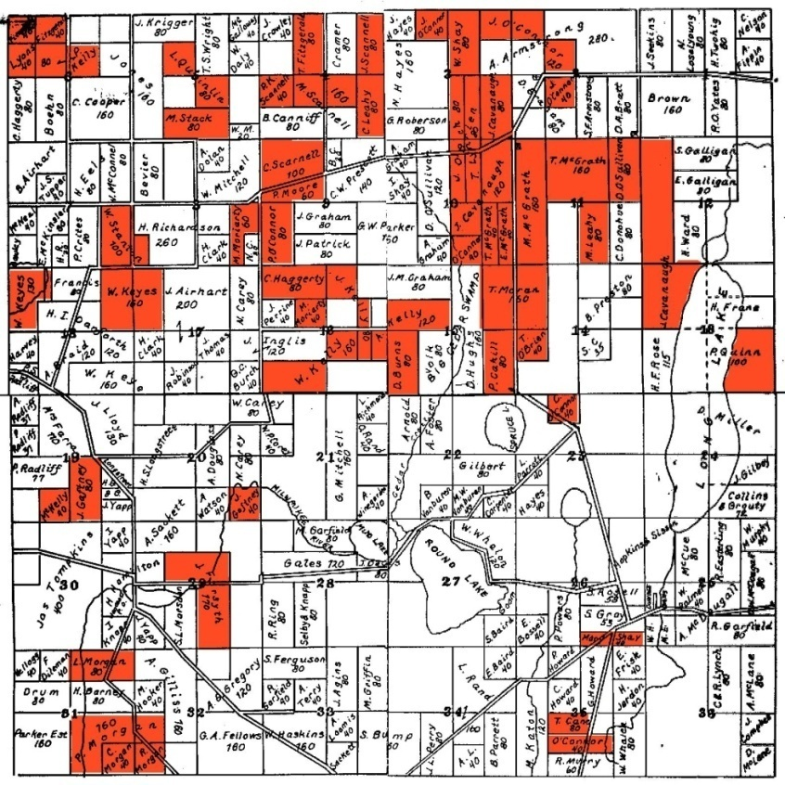
Osceola – 1862
Colored Areas are Irish
Fig. 5
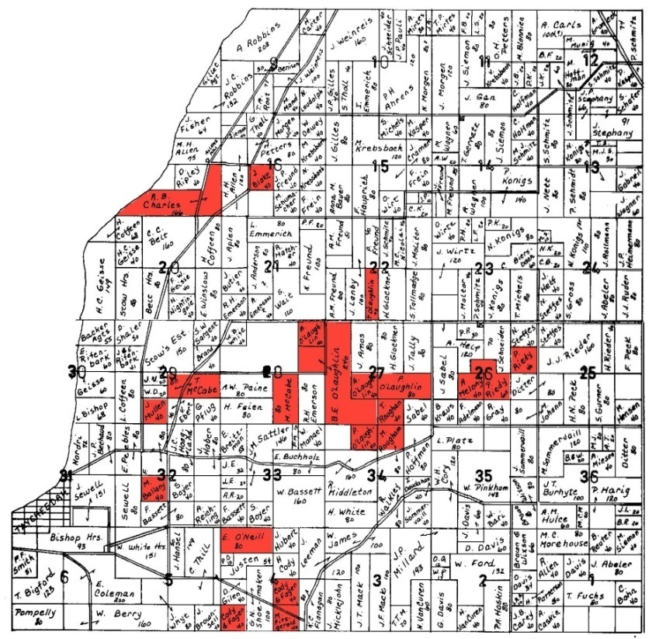
Taycheedah – 1862
Colored Areas are Irish
Clearly the Plat map of Osceola shows extreme Irish segregation. The Irish, whether by their own design or not, congregated in specific regions within the township and primarily established working farms. According to the guidelines of the assimilation model it appears that the majority of Irish immigrants (the total over both Osceola and Taycheedah) remained in closely knit areas. Though there were several outliers, this indicates a low degree of assimilation based upon the spatial concentration benchmark.

Language Assimilation of First Wave Irish:
Language assimilation is defined in terms of the ability to speak English and the loss of the mother tongue. The only statistical information regarding language is in regards to illiteracy rates. Of the Irish in Taycheedah and Osceola, approximately 50 percent of the Irish born population could not write in the English language. Additionally approximately 15 percent could not read English. These statistics do not directly transfer to the rate of speaking English, but they do indicate a certain level of comprehension. It is certainly clear that the vast majority of the Irish in these two areas were capable of communicating with English speakers, especially considering they were able to communicate with the census official and presumably other English speakers in the community.

Fig. 6
Percent
*United States Census: 1870

The loss of the mother tongue is not a statistic that was recorded by the census administrators, but there are references to it in the O’Loghlin brother’s letters. References to Glandine and other Irish words and phrases appear throughout the text. Certainly these men retained their mother tongue at the time the letters were written, which was just a year after their settlement. Unfortunately, little is known about the specifics of their lives regarding language after the final letter in 1850.

Intermarriage:
Intermarriage is defined, quite simply, as the marriage to non-immigrants. According to the data there were many instances of marriage to other immigrants outside of their nationality. For example, many Irish born people married Scottish born people. However, the rates at which the Irish married American born citizens were extremely low. Taycheedah only saw 2 (4.00 percent) Irish immigrants marry American born people. Osceola was nearly the same with only 4 (3.96 percent) people marrying American born citizens.
The typical pattern of movement of Irish immigrants is indicated by the Wisconsin census. The census indicates that over 90 percent of Irish immigrants were married to other Irish immigrants. The most plausible explanation for this is marriage before departure from Ireland. This theory is also supported by the fact that the vast majority of Irish families bore children in either east coast states, such as New York or Massachusetts, or their final home in Wisconsin. Of the small percentage who married American natives, all six married spouses who were born in East coast states; New York being the dominant state. This data implies that families migrated from Ireland together and stayed together after their arrival. Additionally this data shows there was very little assimilation based upon the intermarriage benchmark.
When the four benchmarks of assimilation are applied to the first migration, a very clear pattern of assimilation emerges. The first wave of Irish immigrants following the potato famine did not maintain very high levels of assimilation. Socioeconomic status indicates that a very large percentage of immigrants were laborers and received a much lower rate of pay than American born individuals. Even the Irish who were considered farmers maintained a level of pay which is lower than non immigrant farmers. Spatial concentration on a small scale is difficult, but clear patterns have also emerged. The Irish tended to purchase land next to other Irish immigrants. Language assimilation is slightly inconclusive because there is no hard data regarding the spoken word. Additionally, it is probable that many of these Irish were familiar with the English language before undertaking the journey across the Atlantic. Intermarriage shows, without a doubt, that the Irish maintained families within their ethnic group. This was achieved by migrating with their wives and children from Ireland to America.

The Second Wave (1900-1920)
When William Shea left his family in 1883 he was just 19 years old and searching for a better life. Shea, a native resident of County Kerry, Ireland, was among many Irish who migrated to various areas around the United States in search of prosperity. The decision for Shea to leave Ireland was not easy; his mother continually pleaded for him not to go, and his father undermined and used subversive tactics to delay his passage. Of particular interest is Shea’s father’s denial of passage. William Shea made several arrangements with his father during the two years prior to his departure; these arrangements typically involved Shea staying six more months to help with the harvesting of crops and continue his education. This cycle continued for 18 months until Shea’s father finally agreed to his passage. Though it took longer than Shea would have liked; he boarded a steamship in 1883 bound for the United States of America. His ultimate destination were the adjacent towns of Eden and Osceola. Shea chose Fond du Lac County because his uncle operated a small farm just outside the city limits of Eden. Upon arrival and introduction to his uncle, Joe Shea, he began many years of occupying a position of a farm hand. During his first year he worked for Joe and other nearby Irish farmers for a modest pay. In 1885 he acquired his first long time commitment to an Irish farmer named Scannell. His pay during these two years was $195 per year, of which he was paid at the end of each season. In 1891 Shea marries a women by the name of Hannah Hughes. Hughes was born in New York; just a few months after her parents had departed Ireland. In 1900 William Shea had amassed enough money to purchase a farm. Farming was the primary method of employment for the Irish in the second wave; this provided significant advantages over the farm hand occupation. By purchasing his own land Shea was able to gain equity and gain more capital and security much quicker than remaining a farm hand. In 1907 at the age of 43, Shea returns to Ireland to visit his parents. Nearly 25 years after leaving Ireland Shea discovers his parents have remained remarkably unchanged. Additionally, Shea is forced to act as a language intermediary between his father and Hannah. Shea’s father never learned English which, according to secondary literature is quite uncommon in the early twentieth century. Additionally, Shea never lost his ability to speak Irish. He returned to America in 1907 and lived the rest of his life with his wife on his farm till his death in 1964.
Shea’s departure of Ireland in 1883 is part of a second migration which has long standing roots. Though there has been steady immigration of Irish to America since the 1840s, Shea’s generation and the individuals who followed in the decades after left for slightly different reasons. Immigration slowed during the years of the Civil War and picked up in the decades following for several other reasons. Public knowledge about American life was well known in Ireland. Information regarding large areas of land for farming, high wages, low taxes, security and political and religious freedom were contrasted to almost the exact opposite in Ireland in the 1870s. In 1879 a second, though much smaller, potato crop failure occurred. The 1879 potato failure was amplified by a greatly diminished return of other, supplementary crops. This caused many tenant farmers to re-evaluate their precarious situation. Irish nationalism and sentiments of separation from Britain established a distinct chasm between the Irish population. The reasoning for Shea’s departure; oppression from Britain, economic hardship and a second crop failure; was no doubt linked to these events in Irish history and is the context of the second migration.

Economic Status of the Second Wave Irish:
Fig. 7

6551
882
*United States Census: 1900

As of 1900 the total population of Fond du Lac County has not grown significantly since 1850. However, the percentage of Irish born immigrants has dropped dramatically the percentage of German born citizens has risen. The primary means of employment for the Irish in both Taycheedah and Osceola in 1900 was that of a farmer. This occupation dwarfed other occupations, especially in Osceola. The only way to gauge economic status with the 1900 census is to look at home and land ownership. The data does not contain specific numerical values of real estate or personal estate, but does indicate ownership of land.
Fig. 8
*Census Data: 1870

Percent
Fig. 9
Percent
1900 Census Data (One person unaccounted for in Taycheedah)

Census records indicate that Irish immigrants who were farmers were by necessity, land owners. Though specific financial information is unavailable, immigrants of the farmer profession maintained a higher degree of wealth than laborer’s and unemployed individuals. The “Other” category includes one landlord and one blacksmith one store keeper and one unknown. These four individuals were also house and land owners which indicates their relative success compared to the laborer’s and unemployed. Combined the Irish in both of these communities maintained a 75 percent land ownership rate, which further solidifies higher levels of assimilation based upon the socioeconomic benchmark.
Spatial Concentration of Second Wave Irish:
In 1900, 29 individuals in Osceola were born in Ireland. Also in 1900, there were only 14 Irish born immigrants residing in Taycheedah. As with the 1862 data, Osceola retained a higher percentage of Irish immigrants. Additionally it is important to note that the census records only count the head of the household; often the spouse or children are omitted from such records. The higher percentage of Irish immigrants in Osceola is clearly represented on the plat map. The socioeconomic status of Osceola showed a higher percentage of farmers, clearly the Irish were heavily engaged in farming. The Osceola plat map shows a high concentration of Irish immigrants near the 1, 2 and especially 11 marker. William Shea’s land is almost completely surrounded by other Irish immigrants. Aside from this heavy concentration in the north-east corner of the town ship, the other immigrants appear to be randomly placed and not explicitly connected to other.
An even smaller pattern and concentration exists within the Taycheedah Township. The Irish in Taycheedah are a much smaller group and completely dwarfed by other nationalities. There is no pattern or connection between the Irish in Taycheedah, except for the children of the immigrants such as O’Loghlin and McCabe who retained plots near the 28 marker. The lack of immigrants and the abundance of other nationalities in Taycheedah indicates a higher level of assimilation than the immigrants in Osceola. However, a contributing factor to this is the small number of Irish farmers to begin with, and lack of available land due to an overwhelming amount of other individuals.

Fig. 10
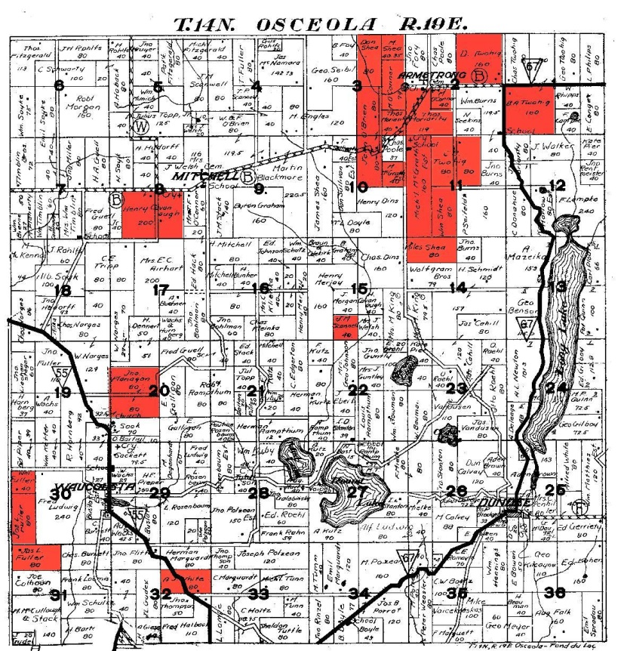
Fig. 11
Osceola - 1900
Colored Areas are Irish
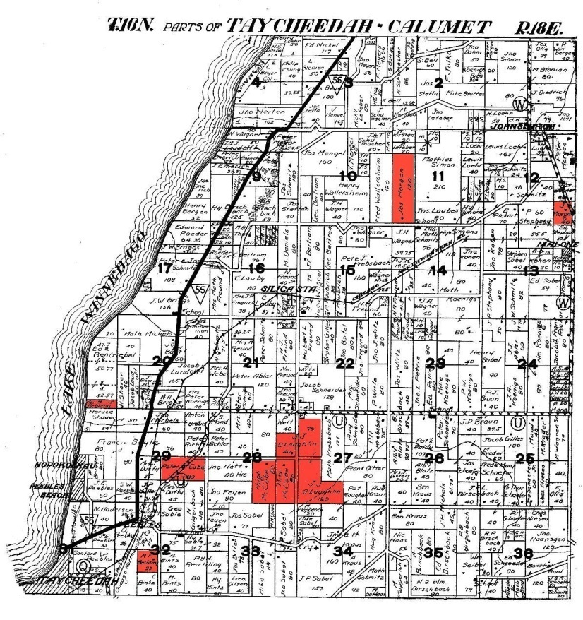
Taycheedah – 1900
Colored Areas are Irish

The plat map of Osceola shows a high level of distance between Irish plots of land. Though there was one exception in Osceola; clearly the Irish are assimilating more in terms of spatial concentration. The Irish in 1900 are not organizing into groupings and according to the guidelines of spatial concentration, are becoming more assimilated.

Language Assimilation of Second Wave Irish:
Fig. 12
1900 Census Data (One person unaccounted for in both Osceola and Taycheedah)
Percent

The 1900 census information shows that the majority of Irish in both townships can read and write. Therefore the vast majority, if not all, of Irish immigrants were capable of speaking English. This is not surprising considering 98 percent of citizens in Ireland could speak English or were bi-lingual. Because of this language assimilation based upon adoption of the foreign language is virtually meaningless. However, retention of the native Irish language is of concern. However, this statistic is not recorded in the census, but William Shea makes several references to his native Irish language. Shea returned to Ireland in 1907 to visit his parents, he brought his wife, Hannah Hughes. After 24 years away from Ireland, Shea had no issues communicating with his parents; who ironically could not or refused to speak English. Hannah Hughes could not communicate with her parents-in-law and required William to translate for her. Shea retained his language most likely because he was significantly older when he crossed the Atlantic. The use of the Irish language was not in wide practice in Wisconsin in 1900. The establishment of private clubs and the personal generosity of Irish immigrants to disseminate their culture and language is prevalent at and after 1900. A 1912 Fond du Lac County news paper describes Thomas Kelly, who traveled back to Ireland 4 times and paid for the voyages of seventeen people. During the turn of the 19th century there was an interest in Irish heritage primarily from the Irish immigrants themselves.

Intermarriage of Second Wave Irish:
Fig. 13
1900 Census Data (One person unaccounted for in Osceola)
Percent

The 1900 Census shows that the majority of Irish in both areas did not find Irish born spouses. The census data also reveals that of the immigrants who found Irish spouses did so before departure to America. The data also reveals that a large percentage of Irish either traveled to Fond du Lac County alone, suffered the loss of their spouse, or acquired a divorce. Additionally the vast majority of children born to all Irish in Fond du Lac were delivered in Wisconsin. This data implies several things. Firstly, assimilation rates for individuals during the 1900 census were high based upon the intermarriage benchmark. Secondly, a larger number of immigrants traveled alone, which is also depicted in Shea’s autobiography.
When the four benchmarks of assimilation are applied to the second migration assimilation rates appear quite high. Socioeconomic status data shows that many of the Irish immigrants established farms and owned property rather quickly, and maintained an economic lifestyle which was similar to other immigrant groups and even native Wisconsin residents. With such a small data set for the second smaller migration it is difficult to establish concrete assimilation theories regarding spatial concentration. However, it appears that Osceola maintained a dense pocket of Irish immigrants; while Taycheedah did not. This is most likely due to the larger amount of Irish born people in Osceola combined with the much larger German population in Taycheedah. Language assimilation confirms that most Irish could read and write English, which proves they could speak it. However, loss of the Irish language is not a statistic recorded by census takers, so Shea’s experience is the only reference we have to language retention. The intermarriage benchmark data clearly shows that the Irish are integrating and assimilating at a higher rate than the first wave migrants.

Conclusion
The first wave Irish immigrants responded to the potato blight in a logical and relatively consistent manner. When the first wave Irish data is applied to the assimilation benchmarks a clear pattern of unassimilation emerges. Socioeconomic status remained significantly lower than American born neighbors; spatial distribution shows a clear pattern of Irish enclaves; intermarriage rates are consistently Irish to Irish; language retention shows that far less people were fluent in the reading and writing of English when compared to the second wave. The result of the benchmark analysis on the first wave shows that this generation maintained an Irish identity which greatly surpasses the second wave.
Though the second wave Irish migrated from Ireland for similar economic reasons, the process of assimilation was different. Second wave Irish immigrants assimilated at a much higher rate as indicated by the benchmark analysis. Socioeconomic status was very similar to American born individuals; spatial distribution is more scattered; intermarriage rates even out between Irish to Irish and Irish to American; language retention shows that nearly all Irish migrants can both read and write English. Higher assimilation rates allude to other conclusions about Irish American and Irish Wisconsin history.
There are several points of discussion regarding the outcome of the data analysis. Firstly, Irish migration to rural areas, specifically Osceola and Taycheedah in Fond du Lac County, tends to mirror urban based assimilation trends. In a broad sense, first migrant peoples tend to have much lower rates of assimilation. New York City is a perfect example of an industrialized sprawling urban center in the nineteenth century. Migrants, regardless of their nationality, moved from their homeland to America and remained largely unassimilated. This is especially true when many migrants from a particular nationality move to an area with a low population density of that ethnic background. This is representative of the Italians, Chinese and especially the Irish in nineteenth century New York. Despite the much higher number of people per square mile, the process of assimilation with first wave migrants is similar regardless of a rural or urban setting. These first wave migrants typically worked at low-wage low-skilled jobs, married within their nationality, resided in close proximity, and retained their native language. The dissection of Fond du Lac’s second wave rural Irish mirrors urban assimilation. As the previous generations of immigrants becomes more numerous, assimilation rates of new immigrants increases. Second wave migrants are able to draw support from previously established immigrants and the transition to the majority culture is more easily lubricated with the help of previous generations.
There are also several factors which are not accounted for in the assimilation benchmark method which have a direct impact on assimilation rates. The primary factor is religion. As shown in Figure 1, the two largest immigrant groups in Fond du Lac County were the Germans and the Irish. The Irish were primarily Catholic and the Germans were primarily Protestant, or more specifically, Lutheran. Though this is a generalization, the concept of religious separation has a direct impact on assimilation. The desire for these first wave immigrants to remain close to their religion primarily affects intermarriage. In the early years of Irish immigration to Wisconsin it was very rare to marry outside your ethnic group and religion. Religion and ethnicity, at least in this instance, can been viewed synonymously, where religion is the determining factor regarding intermarriage assimilation. Second wave Irish migrants were also Catholic though they faced different challenges. The political and religious conflict in Ireland certainly left many feeling disconnected and alienated. These negative feelings were translated to the emigrating population who, quite clearly, were more open to marriage and association with Americans and other nationalities regardless of creed. The relative openness of second wave immigrants was also amplified by an increasing trend of globalization.
Globalization and the perceived feeling of interconnectedness introduced by nautical technological advancements also added to the second generation’s assimilation rate. As industrialization took hold of many nations, so did the desire to exchange goods and information with other portions of the world. On a micro scale, many second wave immigrants certainly felt like an alien in Wisconsin. However, many were also more aware of cultures which were different prior to departure. While this was certainly true of some of the first wave migrants; globalization, both in comprehension and practice, was not realized until the end of the 19th century. The concept of globalization eased the barriers for information and made the transition process easier.
The process of assimilation was quite different for the two groups discussed. The four benchmarks indicate as such. However, different circumstances during both time periods facilitated different assimilation rates which cannot be determined by the core benchmarks. Additionally, the process of assimilation affected each group in very different ways. The O’Loghlin brothers indicate a trend with first wave migrants which states that though they are aware of their heritage, they deeply admire and respect their new home. Given the disease and destruction in Ireland during the potato blight, this is easy to imagine. Second wave migrants experienced a more nostalgic prospective when discussing Ireland. According to the small amount of data available it also appears that there were many more return trips to Ireland within the second wave. The Daily Commonwealth Newspaper of Fond du Lac indicates that return trips to Ireland were quite common; one citizen even paid for many other less fortunate Irish who desired to see their homeland. This indicates that the second wave experienced a collective cultural practice which is still alive in many areas today. Another contributing factor to the phenomenon of retaining cultural nostalgia resides in the very demographics of rural areas in Wisconsin during the second wave. Rural areas such as Taycheedah and Osceola were heavily multicultural. Because of this there is a much higher percentage of individuals who do not give up their perceived cultural identity. Though the second wave does assimilate at much higher and faster rates, they still retain a sense of Irish dignity and are not forced to give it up. Ultimately, the process of assimilation is dependent on the many factors listed. However, the very fact that the Irish assimilated was inevitable and has no relation to urban or rural settings.

Bibliography
Primary Sources
1870-1900 Census data. Scanned copies of hand written documents. Heritage Quest Online. Proquest LLC.

Ancestry Online, “Fond du Lac Plat Maps,” http://www.rootsweb.ancestry.com/~wifonddu/resources/maps/1862-x.html; accessed 6/12/2010.

“Gave Help to Chapels Before,” The Daily Commonwealth, August 2, 1912.

Historical Census Browser. University of Virginia, Geospatial and Statistical Data Center; <http://fisher.lib.virginia.edu/collections/stats/histcensus/index.html>; accessed 9/20/2010.

O’Loghlin, Dennis to Laurence O’Loghlin 1850. O’Loghlin Papers. Special Collections Lib,. University of Wisconsin: Madison.

Shea, William, A Greenhorn comes to America, 1950.

United States Census Bureau Report: 1850-1910.

Secondary Sources
Byron , Reginald. Irish America: Oxford: Claredon Press; New York: Oxford University Press, 1999.

Costigan, Giovanni. A History of Modern Ireland: New York: Wester Publishing Company, Inc., 1969.

Garvin, Tom. Nationalist Revolutionaries in Ireland 1858-1928: Oxford: Clarendon Press, 1987.

Holmes ,David G.. Irish in Wisconsin: Madison, Wisconsin: The Wisconsin Historical Society Press, 2004.

Holmes , Fred L., Old World Wisconsin: Around Europe in the Badger State: Eau Claire, Wisconsin: E. M. Hale and Company, 1944.

Jackson, Kenneth T., and David S. Dunbar, eds. Empire City: New York Through the Centuries. New York: Columbia University Press, 2002.

Mary C. Waters and Tomas R. Jimenez, “Assessing Immigrant Assimilation: New Empirical and Theoretical Challenges,” Annual Review of Sociology 2005.

McDonald, Justille. History of the Irish in Wisconsin in the Nineteenth Century: Washington, D.C.: The Catholic University of America Press, 1954.

Ranelagh , John O’Beirne. A Short History of Ireland: Cambridge: Cambridge University Press, 1983.

Reginald Byron, Irish America, (Oxford: Claredon Press; New York: Oxford University Press, 1999), 38.
Ibid, 39.
John O’Beirne Ranelagh, A Short History of Ireland, (Cambridge: Cambridge University Press, 1983), 90.
Giovanni Costigan, A History of Modern Ireland, (New York: Wester Publish Company, Inc., 1969), 173.
Ibid.
Byron, Irish America, 47.
Costigan, A History of Modern Ireland, 173.
Byron, Irish America, 43.
Justille McDonald, History of the Irish in Wisconsin in the Nineteenth Century, (Washington, D.C.: The Catholic University of America Press, 1954), 3.
Ibid, 4.
Ranelagh, A Short History of Ireland, 115.
McDonald, History of the Irish in Wisconsin in the Nineteenth Century, 6.
Ibid.
Ibid, 5.
Garvin, Tom, Nationalist Revolutionaries in Ireland 1858-1928, (Oxford: Clarendon Press, 1987), 5.
Ibid, 1.
Jackson, Kenneth T., and David S. Dunbar, eds. Empire City: New York Through the Centuries. (New York: Columbia University Press, 2002), 167.
Byron, Irish America, 298-299.
Ibid, 299.
McDonald, History of the Irish in Wisconsin in the Nineteenth Century, 254.
Fred L. Holmes, Old World Wisconsin: Around Europe in the Badger State (Eau Claire, Wisconsin: E. M. Hale and Company, 1944), 190.
David G. Holmes, Irish in Wisconsin (Madison, Wisconsin: The Wisconsin Historical Society Press, 2004), 52-53.
Mary C. Waters and Tomas R. Jimenez, “Assessing Immigrant Assimilation: New Empirical and Theoretical Challenges,” Annual Review of Sociology 2005: 106.
O’Loghlin, Dennis to Laurence O’Loghlin 1850. O’Loghlin Papers. Special Collections Lib,. University of Wisconsin: Madison.
United States Census Bureau Report: 1850
United States Census Bureau Report: 1870.
“Irish Literacy” Historical Census Browser. University of Virginia, Geospatial and Statistical Data Center; <http://fisher.lib.virginia.edu/collections/stats/histcensus/index.html>; accessed 9/20/2010.
1870 Census data. Scanned copies of hand written documents. Heritage Quest Online. Proquest LLC.
Ibid.
O’Loghlin, Dennis to Laurence O’Loghlin 1850.
Ibid.
1870 Census data. Scanned copies of hand written documents. Heritage Quest Online. Proquest LLC.
Ibid.
Shea, William, A Greenhorn comes to America, 1950.
McDonald, History of the Irish in Wisconsin in the Nineteenth Century, 6.
Byron, Irish America, 62.
Shea, A Greenhorn comes to America, 1950.
“Gave Help to Chapels Before,” The Daily Commonwealth, August 2, 1912.

