“We are not making a Black Beer, but a Peoples Beer”:
“Black Capitalism” and the Struggles of Black Entrepreneurship

Brian H. Dombrowski
History 489: Research Methods
December 2018

Copyright for this work is owned by the author. The digital version is published in Macintyre Library, University of Wisconsin – Eau Claire with the consent of the author.

Contents
Figures iii
Abstract iv
Introduction 1
Richard Nixon’s “Black Capitalism” Initiative 5
Peoples Brewing Company 11
Problems for Peoples 15
What Happened to Black Capitalism? 21
Conclusion 23
Bibliography 25
Figures
Figure 1. Bar Graph showing Results of Black Voting 7
Figure 2. A Photo of Theodore Mack 11
Figure 3. A Peoples Beer Advertisement from 1971 13
Figure 4. A Chief Oshkosh Beer Bottle Label 14

Abstract

During Richard Nixon’s 1968 presidential campaign, he included a plank in his platform with the “Black Capitalism” Initiative. It was meant to promote black entrepreneurship and give the black community an opportunity for financial freedom. This paper will explore this initiative and why it failed, as well as a black-owned brewery and the adversity it had to face for its struggle to survive.
Introduction
The black population in America has struggled to receive their fair share of economic development and opportunity since the birth of the nation. There has been much confusion among Blacks about the meaning of the words on which the nation was conceived. The Declaration of Independence holds ideas that explain the ideal human condition. The beginning of the Declaration states that all men are created equal and they possess certain unalienable rights; life, liberty, and the pursuit of happiness. For Blacks in America, these words did not hold true and felt to be an unreachable reality, because of how they were exploited for labor so that white elites could be successful within the American economic structure. In his book, How Capitalism Underdeveloped Black America, Manning Marable brought forth the notion that capitalism is a sole reason that most black Americans never fully had a shot at economic success and slavery set the stage for full exploitation of Blacks in America.
Throughout America’s economic history, the exploitation of black people was central to its success. It created a long-lasting effect that didn’t bode well for the black community. Marable argued that the exploitation of black people caused an underdevelopment in the black community because it was convenient for white economic advancement. Chattel slavery was a leading consequence to underdevelopment and Marable specified that “the ordeal of slavery was responsible for accelerating the economic and political power of Europe and North America over the rest of the nonwhite world.” Chattel slavery is an institution that the slave is property and will be a slave until death or the owner, who has the right to decide everything for that person, grants the slave their freedom. White slave owners purposely withheld education from slaves to discourage personal advancement and stifle their awareness of their condition. To their masters, Blacks were simply tools in their capitalist machine. The more slave owners restricted their slaves’ abilities to just hard labor, the more ability they had to produce profit for the master. This created obvious hardship for enslaved Blacks and certainly made the ability to improve their condition seem impossible, especially when that condition was reduced to property with hardly any rights as a human. The end of the Civil War marked the end of an era and began a time of Reconstruction in the south. This marked the beginning of an economic struggle and black underdevelopment truly started to show.
During Reconstruction, black laborers set out to better their situation by obtaining land or finding factory work, overall, they primarily wanted to find a sense of security for themselves. However, many found themselves stuck as they faced many hardships such as Jim Crow laws and lack of economic ability. For most newly freed Blacks, “their only means of survival and economic development they possess was their ability to work, their labor power, which they sold in various forms to the agricultural capitalist.” Through a lifetime of raising crops, sharecropping was common among newly freemen, though it wasn’t the most ideal system because laborers were still being exploited for their work. White land owners used black sharecroppers to their advantage by taking most of the profits and utilizing the cheap labor. In response to the implications put on by the federal government, southern states implemented Jim Crow laws which combated opportunities for black advancement and economic success. Appeals were made to the government that “demanded universal education and ‘forty acres and a mule’; they received instead political leadership of an uneven quality, sharecropping, and convict-leasing.” Political and social support for the black community was basically nonexistent as they were still exploited for cheap labor after the abolition of slavery.
Black exploitation continued into the twentieth century as a large influx of Black laborers migrated to bigger northern cities in search of better economic opportunities and to escape Jim Crow in the south, but most found themselves facing the same racial discrimination from which they were trying to escape in the south. Many black laborers were still finding themselves working low-wage jobs and others were being turned away at the door, but those that did find jobs, received fewer wages than white workers eventhough they did the same amount of labor. They still didn’t receive political support from the federal government, in fact, America’s democratic government and the free enterprise system are structured deliberately to maximize black oppression. It continues to follow the model of black underdevelopment suggested by Marable. It is the goal of white capitalists to keep the black community at a level at which they will stay segregated and in lower classes to prevent Blacks from being equal business competitors. The exclusion of African Americans from the heart of American capitalism brought rise to prominent black political leaders such as W.E.B Du Bois, Booker T. Washington, and Marcus Garvey.
According to Marable, these political figures became the voice of their followers and were the most effective when it came to combat residual racism. Though they had different beliefs and schools of thought, they all believed in the power of education. They believed education to be the most important aspect of self-advancement. When it came to economics, Booker T. Washington believed that “blacks would be accepted as equals by whites only when they had acquired sufficient business acumen to successfully compete in the open market.” His political counterpart, however, felt the opposite about black capitalism. W.E.B Du Bois, who became one of the more prominent figures in the twentieth century, believed in the desegregation of American society. However, when it came to economics, Du Bois tended to be attracted to socialism over capitalism because he believed that racism and capitalism were tied together. The reason capitalism made Whites so successful, was because of racism because it allowed the exploitation of Blacks more socially and morally acceptable for their own gain. Socialism relies on a more shared economy which would essentially allow Blacks to receive a fairer share of income and benefits. Not only did Du Bois criticize American capitalism, but he criticized the American government claiming that it never really existed in America. He went as far as to declare that the great problem of American democracy was that “it had not yet been tried.” With this statement, he challenged the words written on the Declaration of Independence and that the unalienable freedoms an American has, wasn’t truly universal for every American, it excluded nonwhites.
In the 1950s and 60s, the civil rights movement polarized America on many different levels. Two prominent figures came out with separate schools of thought. The first, Malcom X, who believed in a more militant and religious reform to achieve his goals. On the opposite end of the spectrum was Martin Luther King, who strongly believed that a nonviolent approach was the answer to equality. The want for social and economic equality became stronger than ever. These turbulent times raised a bit of uncertainty in the nation and black voters were looking to Washington for answers as the violence increased. When the 1968 Presidential election came about, Richard Nixon was looking for a way to secure “much-needed black votes in his close contest with the late Sen. Hubert Humphry.” As a result, Nixon came up with his “Black Capitalism” Initiative. He advocated for black entrepreneurship and promised economic opportunity for the black community which previously had been swept under the rug for many decades throughout American history. Those such as Theodore Mack with his purchase of the Peoples Brewing Company would finally get the government support for a fair shot at economic success in America. Though Black Capitalism promised a government backing to fuel the development of black entrepreneurship, ultimately failed Theodore Mack because the promises of government support were broken and failed to help him when he appealed for help. Secondly, instilled Jim Crow racism resisted Black business owners and worked to limit their productive economic growth.

Richard Nixon’s “Black Capitalism” Initiative
Racial inequality in the business world remained the status quo in corporate America for decades and clashes about racial equality dramatically increased in the 1960s. So where exactly did Richard Nixon’s “Black Capitalism” initiative come from? As a Republican, Nixon was opposed the Johnson Administration’s “Great Society” antipoverty programs and Black Capitalism was to settle the opposition to its dismantling of the antipoverty programs. But Black Capitalism’s creation is also derived from a deeper racial inequality in America.
During the climax of the civil rights movement in the 1960s, there was much civil unrest throughout the country. In 1968, black America seemed to be in an ideological divide and the assassination of Martin Luther King on April 4, 1968, may have been a direct influence of Nixon declaring the initiative. The assassination of King instilled the feeling in the black community that the future freedoms for Blacks were clouded. Another argument about Nixon’s reason for Black Capitalism is that he felt that the Black Power Movement was a threat to the internal security of the US. He developed the initiative as a version of domestic détente. In other words, Nixon wanted to find a way to politically contain the Black Power threat as much as possible.
Above all, a politician’s main goal is to gain popularity in order to gain votes. He felt the pressure from civil rights groups after the assassinations of prominent group leaders. Therefore, Nixon had to figure out a way to calm a rising unrest and anger among the black community that was speaking out against white oppression in the US. Nixon wanted to create a Federal government program because Civil Rights Laws “had focused on the legal positions of these neglected African Americans but had done nothing toward improving their economic positions or living conditions.” Therefore, he announced the Black Capitalism Initiative in April of 1968 in a program titled “Bridges to Human Dignity.”
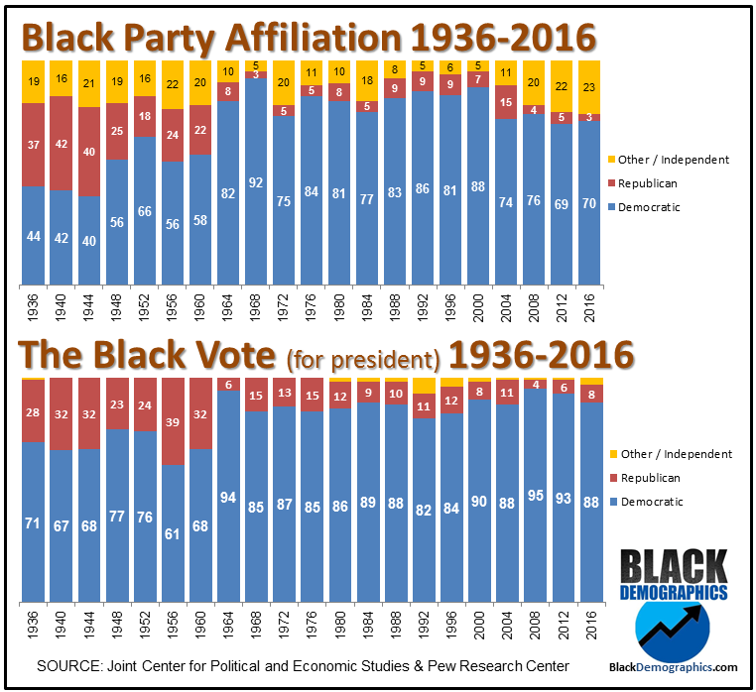
Figure 1: Voting results of black votes in percentage of the popular vote and political party affiliation, 1936-2016, Courtesy of Black Demographics.com
The Initiative’s primary reason was to give black entrepreneurs a hat to throw into the capitalism ring and attempt to create a stable black middle class. It was a government supported program that “created a climate among a number of commercial banks and lending institutions that made supplying money to minority entrepreneurs an acceptable practice.” It was a moral victory for blacks in America because it meant that corporate America would no longer be dominated by white men. Richard Nixon won the election in 1968, but despite his efforts with creating the Initiative, it was not with the help of Black voters. In reference to Figure 1, the Joint Center for Political and Economic Studies & Pew Research Center recorded that Black voters voted almost entirely democratic in the popular vote and Black political party affiliations lean primarily democratic in 1968. That evidence makes it clear that the Black community did not get won over to vote Republican and Nixon’s “Black Capitalism” idea did not win over the hearts and minds of his constituents enough to gain their vote.
The idea of Black Capitalism sounded ideal to many black entrepreneurs hungry for their chance, but with it, came those with doubts that the Initiative never had a chance. One of the arguments was that Black Capitalism would be nothing more than a small business program and that all promises made by the Nixon administration were nothing but embellished pipe dreams. An objection, as mentioned earlier, was that black small business owners would never be able to get outside of their segregated economy. This was a valid argument because many sources agreed upon the fact that black entrepreneurs lacked the education and the ins and outs of big business. It wasn’t an argument that they lacked determination but that they simply didn’t have access to the basic sources for success in capitalism. These sources are a huge personal wealth, the top 22 major corporations, the military complex, the federal and state apparatus, and the crime syndicate. This lack of resources derived from deep racial discrimination. The sum of all this inevitably tipped the scales against Blacks to merely have a stepping stone success, but Nixon pressed forward and implemented it upon being elected.
Once Richard Nixon was elected, he had to put Black Capitalism into practice. Therefore, Nixon signed Executive Order 11458 which directed the Secretary of Commerce to coordinate the Federal Government’s plans, programs, and operations, which contributed to the strengthening of minority businesses. The executive order also led to the creation of the Office of Minority Business Enterprise (OMBE) along with other minor organizations associated with the order. The OMBE was not particularly given any funds to help black entrepreneurs. Its task was to advise, encourage, mobilize, and evaluate minority businesses. The Secretary of commerce, Maurice Stans was the overseer of the OMBE and said that the Initiative was largely symbolic and there would be no real financial support given to minority businesses. This makes it evident that the Initiative was more propaganda than a fully working Federal program.
Over the next couple of years, black entrepreneurs tried to make their stake in business. Theodore Mack was one of these people. Mack was the president of the United Black Enterprises (UBE) and an ambitious black entrepreneur. The UBE was an organization from Milwaukee that consisted of black entrepreneurs who advocated for the black community and up and coming black businessmen trying to make their stake the business world. The UBE looked for potential business opportunities like failing businesses to buy, change and build to benefit the black community.
In 1969, the UBE attempted to purchase the Blatz division of the Pabst Brewing Co. but failed. The UBE submitted an offer of nine million dollars along with a six-week extension request to allow potential backers to view the business plans the UBE had for Blatz. The extension was denied by Federal Judge Robert E. Tehan. He said that UBE’s plan was “embryonic.” The leaders of the UBE claimed racism played a part in Tehan’s decision to reject the extension. A statement made by Ray A. Alexander, a chairman for the UBE claimed the racism of the white power structure. He said, “If it’s in their power to make us fall (and of course it is) just as a lesson, they will pull the rug out from under you without batting an eye. The lesson is, before you can succeed and be Black, the power structure must not be in a position to blow your game. Learn and remember it well.” After the failed attempt to buy Blatz, Theodore Mack, president of the UBE, set his sights on The Peoples Brewing company in Oshkosh, Wisconsin. Little did he know that the next two years would be fraught with adversity, opposition, criticism, racism, overwhelming competition, and a government initiative that failed him in the end.

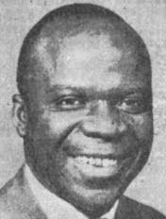
Peoples Brewing Company
Figure 2: A Photo of Theodore Mack, Courtesy of Oshkoshbeertimline.blogspot.com
In April of 1970, Theodore Mack purchased the Peoples Brewing Company located in Oshkosh, Wisconsin. It claimed to be the first black-owned brewery because it was said that “There are no other black breweries anywhere in the US.” This was a milestone for black business owners for the purchase of a larger production company was exactly what organizations such as the UBE strived for. Mack received a bank loan from the Marshall & Ilsley Bank in Milwaukee to purchase the brewing company. Though it was a milestone for the black community, the purchase produced weariness among the incumbent workers at the brewery because there were rumors that Mack was going to clean house and replace the white workers with Blacks, or at least be completely managed by Blacks. Mack firmly defused the rumor by mentioning that both Blacks and Whites would be put into management positions. The aim was to give black workers in Oshkosh opportunities to be in positions for which they were qualified.
Another worry among consumers was that Mack was going to completely change the face of the brewery. Peoples Beer was produced at the brewery was forty years in the making and prominent in the close vicinity of Oshkosh. There was fear that since the brewery was owned and run by blacks, the beer would not taste the same and consumers would lose the beer they knew. However, Mack, again, refuted this fear and assured consumers that “Peoples Beer and Peoples Brewing Company will remain unchanged as well as the beer formula to stay the same.” The importance of that statement showed that Mack did not want to erase the history of the brewery or antagonize the consumers who already enjoyed the beer. He also said that he wanted to retain the name of the brewery because it was “appropriate for the times.” Mack understood the gravity of the times and the name of the brewery may just have been a coincidence, but it may have added to the argument Mack and the UBE were trying to convey, that Blacks can be successful and competitive in the business world.
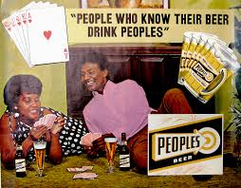
Mack purchased the brewery to give Blacks job opportunities, but he didn’t stop there. In order to raise the capital to fulfill the payment, he further opened opportunities by marketing stock shares of the company toward the black community. Peoples Brewing offered 65,000 shares at five dollars per share, Mack created an affordable means of financial advancement in a passive business role for normal citizens. Figure 3 shows that Peoples Beer was being marketed toward the black community in an effort to boost interest. Many Blacks bought up the available shares, but the shares weren’t restricted to just Blacks. Many white consumers also bought stocks in the company believing it to be a great opportunity. Mack wanted to emphasize that he certainly did not want to exclude white consumers because Whites were the ones primarily drinking it. He made that point to the public by stating, “We are not making a black beer, but a Peoples Beer.” He knew that if he turned away white consumers, the brewing company would never be able to survive, especially if he wanted to expand the company and reach out to more consumers. Nevertheless, the newspapers in Milwaukee and surrounding cities in southwestern Wisconsin remained tough on him as they kept on him about marketing primarily to the black community, to which he retorted, “There are 1,051 stock holders in Peoples Brewing company and they are of all races, creeds, and colors.” This statement further cemented his business intentions to naysayers.
Figure 3: A Peoples Beer Advertisement from 1971, Courtesy of Oshkoshbeertimeline.blogspot.com
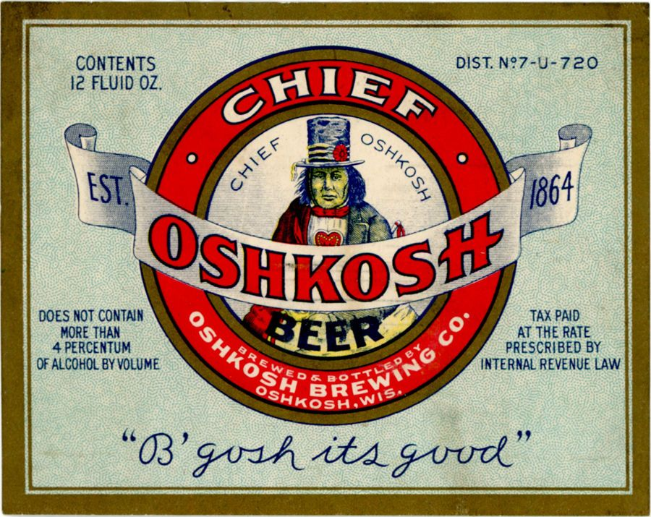
After the first year of production and distribution, the company saw a decline followed by a quick expansion. When Mack took over the brewery the year prior, Peoples Beer was sold primarily in Oshkosh and the small vicinity around the city. Mack expanded distribution of Peoples Beer to Milwaukee, Madison, Racine, Kenosha, Sheboygan, and the North side of Chicago. Mack, however, stated he felt the company was expanding too quickly and he blamed the unemployment rate in Oshkosh. He said, “I hate to say it but the unemployment rate in Oshkosh is eight percent or better. You know a person can’t buy beer when he needs to buy bread.” He stated that if the economy were better, then he wouldn’t have to expand his distribution area as quickly as he did. He had to expand the distribution area to get more consumers to ultimately increase sales. The expansion would have also created employment opportunities because drivers are needed for distribution. After the brewery expanded beer distribution southward. The brewery had an expansion of production when Mack purchased the Oshkosh Brewing Company along with its label and production rights which allowed them to start producing Chief Oshkosh and Rahrs beers in 1971. After Peoples started brewing the new beers, things started to go downhill for Mack and the company. Problems with expanding the distribution of Peoples and troubles with the Federal government came to cause financial problems for the brewery. The problems Mack faced outweighed the good that ultimately led the brewing company to its demise.
Figure 4: A Chief Oshkosh Beer Bottle Label, Courtesy of Pintrest

Problems for Peoples
The Peoples Brewing Company faced strong opposition the minute Mack assumed presidency over the company. A large problem for Mack was Jim Crow rhetoric and at the end of the existence of the brewery, the lack of government support and failure of Nixon’s Black Capitalism initiative. This didn’t weaken Mack’s spirits, however, wherever he went, he faced adversity that challenged his character and challenged his business wit. The Press may have unintentionally created a problem for Mack from the start. It followed Peoples Brewing very closely, which is not necessarily bad, but nearly every single news article about Mack or the Peoples Brewing Company made it a point to recognize that the company was a black-owned brewery all the way through to the day the company shut down. Though this was not bad for the Press to do, however, it could have unintentionally raised more objections against drinking Peoples Beer for those already prejudice against black business owners. There were many allegations made against Mack as the news came about the purchase of the brewery such as firing all the white workers and replacing them with all black workers, along with changing the recipes to only serve to black consumers. These rumors that were spread were all disputed and quickly put down by Mack as he was confronted about them. One of his stronger rebuttals was to a comment about the decline in sales. He made a strong statement about Oshkosh’s character when talking to the Press, he mentioned that the city is “regarded as one of the most bigoted cities in the country, north or south. If sales are down it will be a black eye on Oshkosh, not me.” This was a strong allegation, but Mack could have been referencing an event that happened at the University of Wisconsin-Oshkosh on November 21, 1968. It was a day remembered as “Black Thursday” where a group of ninety-four black students stormed the president’s office in protest. The students were arrested and later, expelled. It created a divide among people and surfaced racial issues in the community. Mack constantly had to defend his own character. He made a bold statement during a news media conference in Oshkosh:
I did not get this far by osmosis, but by hard work, by saving my capital and by getting along with all men. I grew up in Alabama…where they threw rocks at me and called me ‘nigger’…I don’t scare easily…I will not run, no sir. I believe in content of character, rather than in pigmentation of the skin. I wish there could be love between my white brothers and I…I’m coming here to stay, although I’ve been told by many people, whites and blacks, that this is not the town to come to.

This statement gave the people of Oshkosh a taste of Mack’s character and tenacity of a successful businessman. The underlining issue of the statement shows that Jim Crow rhetoric was still prevalent as far north in the nation as Oshkosh, Wisconsin. Blacks still struggled to better their position in society and raise their quality of life as a community. However, this thought wasn’t shared by the entire black community and the aspect of Peoples Brewing Company being owned by Blacks wasn’t completely well received within it.
Mack admitted to not knowing anything about the beer business and to his surprise, Peoples Beer did the best in college areas but wasn’t as well received by the black community as he had projected. The beer seemed to be more accepted by white consumers than Blacks. This perplexed and disappointed Mack as he didn’t quite understand why. His frustration showed in an interview when he urged black support of the beer. He said, “Unlike other breweries that only leave a few (economic) crumbs in the black community, black people in Milwaukee must come to understand that not only will Peoples provide jobs but most of the profits will come back to the community.” It can only be speculated that Mack was speaking about the stock shares that was mainly marketed toward the black community. He tried to make the point that the Blacks who aren’t buying and drinking the beer are only limiting themselves and it supports Mack’s argument that “If we don’t support ourselves, how can we expect anyone else to support us.” Not only did that support Mack’s argument, but it also reinforced the rhetoric of Jim Crow that black people are not naturally capable of supporting themselves and become a true participating asset to society. Mack would learn that Jim Crow rhetoric would only strengthen as he continued to expand south of Wisconsin’s border.
Problems for Peoples Brewing really started to increase as Mack attempted to expand distribution into Indiana. Three truck-loads of Peoples Beer with a worth of $15,000 left from Oshkosh bound for Gary, Indiana, but upon arrival, they were met by local police and Indiana state troopers. They impounded the trucks claiming that Peoples Brewing did not have the proper licensing to distribute in Indiana. The excuse was that Mack’s firm cannot be licensed as a distributor as long as it is a brewery. According to the Alcoholic Beverage Commission (ABC) That Peoples cannot sell directly to retailers. “That’s always been the law.” Mack was under the impression that he had obtained all the appropriate licensing necessary for beer distribution in Indiana. Though it was a setback, it was no surprise that it happened. Mack faced a lot of resistance from Indiana when he continued to try to distribute beer in there. Mack declared that “tremendous pressures have been brought to bear to prevent Peoples Beer from becoming a viable and competitive factor in Gary.” That statement leaves a clue that the powers that be in Indiana never intended on allowing Mack to distribute his beer in there and getting in there to distribute would pose a challenge. After the incident, Mack did get through all the legal red tape and was able to start distributing into Indiana and Ohio.
The troubles of distribution weren’t just centralized in Indiana, but it happened in Milwaukee as well. Peoples had “about a thousand outlets in the Milwaukee area, but many of the salesmen have been thrown out of taverns outside of the inner city.” Mack said, “Our salesmen, black and white, have been told in these places that they are not going to sell any nigger beer.” These venues did not want to sell the beer for fear they would lose business simply for serving a beer that was produced and distributed by a black-owned brewery. Time and time again, Mack faced bigotry and was challenged by out of date rhetoric, However, he pressed on and set his sights on an even bigger goal. He decided he wanted Peoples to be a distributor for the military.
Mack’s next move to appeal to the military didn’t turn out well for the company, though the fault shouldn’t be put on Mack. He corresponded with the military to obtain the proper regulations he needed to be cleared to distribute beer to servicemen, but to no avail. Mack felt he wasn’t receiving the proper support from the government and the lack of government support persuaded Mack to file a 100-million-dollar suit against the Small Business Administration (SBA) and the Department of Defense. The suit charges were that the brewery did not have a fair chance to obtain large government contracts for beer for the armed forces. As a result of the legal battle, Peoples Brewing halted production but remained to distribute remaining beer on hand. Mack did not take the lack of federal support lightly, in fact, he took it quite bitterly and did not hold back when he spoke about it. During a press conference, Mack mentioned that it seems that going through the courts is the only way a minority business can receive a fair share. He was bitter in his comments and called out the federal government including the president. In a direct quote, Mack stated, “We have seen the statutes we have listened to the President and we have seen the executive directives, but somewhere along the line someone is not doing what he’s supposed to…I have written to everyone from the President on down, but nothing has happened yet.” Mack’s frustration and confusion weren’t unwarranted. The Black Capitalism Initiative that Nixon promised four years prior, neither made any headway nor did the government officials selected to initiate it, make any effort to help Peoples Brewing, even when Mack appealed to them for help. Instead, they left Peoples out to dry and fend for itself financially and legally against the government as Mack mentioned that no government official reached out to him since the suit was filed. A few weeks after Peoples filed the suit, the IRS filed a tax lien against Peoples Brewing for $35,800 of unpaid taxes owed by Peoples. When asked about it, Mack quipped, “I guess they won’t get it until we get ours.” The lack of government support to a minority business proved too much for Mack and the Peoples Brewing Company was forced to shut its doors for good in 1973.
Though Mack and Peoples brewing company had to close its doors due to financial problems and lack of government support. There may be a final reason that contributed to Peoples having to close its doors. In the 1970s, giant beer barons such as Miller, Pabst, Budweiser, and Shlitz basically ruled the brewing industry in the Midwest. During this time, larger breweries, such as these, switched their focus from expanding their distribution borders to increasing their manufacturing power by increasing their size or buying and building new plants. The larger breweries were able to manufacture beer on a larger scale and much more efficiently that simply out-classed smaller breweries. Smaller breweries like Peoples Brewing couldn’t compete with these giant beer barons. The inability to match the manufacturing power caused many breweries to shut down in the 1970s. If Peoples followed this trend with the smaller breweries then it may have played a part in the closing of Peoples.

What Happened to Black Capitalism?
Whether or not the Initiative was merely a political tactic to attempt to strengthen support from the black communities and gain votes for the election in 1968, it doesn’t mean this was the primary reason it failed. It is evident Black Capitalism was not successful, especially if the Peoples Brewing Company is used as an example. Mack even made appeals to the president himself pleading for support on the account of his initiative. Maybe it failed because the program was simply in its infancy and was not handled as well as it could have, but the initiative only saw one term of Nixon’s presidency because of the scandals that caused the premature end to Nixon’s presidency and it never really took hold in the presidencies following Nixon’s. Nevertheless, when it came time to follow through, in Theodore Mack’s case, it ultimately fell short of its goals. If it was simply a political stunt to win over black voters, Blacks account for twelve to thirteen percent of the US population and merely ten to eleven percent of the voting constituents in most elections. Blacks are pressured to become dependent on white liberals and to articulate their agendas. Though Nixon is not a liberal, this states that Blacks in American politics didn’t have much to stand on and they relied on politians to do their political bidding for them much like Nixon’s Black Capitalism Initiative.
When Black Capitalism came to fruition, there was obvious opposition to it. The opposition was shrouded in racism and a long-standing rhetoric manifested from Jim Crow laws during Reconstruction, but it wasn’t only Jim Crow that set Black Capitalism for failure. It is rooted deeper and further back in American economics that planted failure. American Capitalism and politics systematically underdeveloped black people. The exploitation of Blacks from chattel slavery was central to American economics so politically, nothing was done to educate and develop Blacks during this time. “Blacks are unemployed, economically exploited and politically disenfranchised because they are excluded or segregated because of caste or racial discrimination.” Racial discrimination was deep-rooted into American society and resided in American rhetoric for decades, it remained as Nixon put for his Black Capitalism initiative. This instilled racism paired with the federal government’s failure to follow through spelled disaster for Black Capitalism from the beginning. Jim Crow rhetoric that caused underdevelopment in the black community withheld certain access to business levers that were needed for ultimate success. As mentioned above. these levers were necessary.
Nixon’s initiative did not fully provide the tools needed to run a business. The Initiative should have provided government supported business education programs. New business men that took advantage of the initiative lacked the education needed to have the ability to expand their business to be successful. Not only did racial uncertainty travel from white to black, but it also travelled the opposite way. The reason for the civil rights movements and black militancy served as a protection against a black mistrust of Whites, it seeps into business as black mistrust of white businessmen was one of the biggest reason Blacks never achieved economic reconstruction. Critics of the Initiative admitted that Nixon actively promoted it, but racial segregation “contributed to the growth of Black-owned service sector businesses (barber shops, beauty shops, hotels, and restaurants).” These small businesses generally only had black patrons which created a segregated economy and “the only really promising path to equal opportunity for Negroes in business as in other aspects of economic activity lies in full participation in an integrated, national economy. It cannot be found in a backwater of separatism and segregation.” Nixon’s Initiative was supposed to give minority business owners the support they needed to be able to compete in the national economy. The sum of all these aspects going against Black Capitalism caused it to fail. After the initial downfall of the initiative and after Nixon left office, the Executive order for Black Capitalism eventually phased out, leaving many new black businessmen without support.

Conclusion
Many black entrepreneurs throughout history struggled to succeed in America’s economy because of the racism and exploitation of black workers in the needlework of capitalism in America. These ideas remained through the decades and are still prominent today. In the 1960s, the nation was torn apart by polarizing ideas and the various civil rights movements. The idea of Black Capitalism sounds good to the ear and may look great on paper, but in practice was only doomed to fail because of these instilled racist ideas and the poor execution of the Federal Government. Eager black entrepreneurs fell victim to Nixon’s political creation to peak interest within the black community in America. As struggling companies appealed to him under his own initiative, he failed to give support and stand behind his constituents. When Theodore Mack purchased Peoples Brewing Company, he had plans to run a successful business, help build a stronger black middle class, and gain respect from his white business counterparts. When Mack attempted to get government contracts to sell to the military, the government should have held up their promise to a minority business owner and help him achieve those contracts. Lastly, other factors may have applied for the closing of the brewery like prices and taste. Maybe the beer the brewery produced did not taste good enough for the consumers to pay the cost. This is a plausible reason that could be explored, but overall, the Black Capitalism Initiative made promises to minority business owners that it did not keep, especially when it came to Theodore Mack and Peoples Brewing Company, that inevitably caused his failure.

Bibliography
Baradaran, Mehrsa. “A Bad Check for Black America.” November 9, 2017. Accessed December 13, 2018. bostonreview.net/class-inequality-race/mehrsa-baradaran-bad-check-black-america.
Dingle, Derek T. “Whatever Happened to Black Capitalism?” Black Enterprise 21, no. 1 (August 1990): 160-168.
Manning, Marable. How Capitalism Underdeveloped Black America. Boston: South End Press, 1983.
Moten, Crystal M. “Fighting Their Own Economic Battles: Saint Charles Lockett, Ethnic Enterprises, and the Challenges of Black Capitalism in 1970’s Milwaukee.” Souls 18, no.1 (March 2016): 106-125. Accessed October 25, 2018. http://jstor.org.
Schlosser, Laurie. “Black Thursday Remembered events spark emotion for Oshkosh 94, UWO community.” November 21, 2018. Accessed December 12, 2018. https://uwosh.edu/today/69003.
Stans, Maurice H. “Richard Nixon and His Bridges to Human Dignity.” Presidential Studies Quarterly 26, no. 1 (1996): 179-183. Accessed December 11, 2018, http://jstor.org.
Unknown. “Black Thursday.” 2010. Accessed December 12, 2018. www.blackthursday.uwosh.edu/index.html.
Walter, Lynn A., Linda F. Edelman, and Keneth J. Hatten. "The US Brewing Industry, Strategic Windows and Survival. "Journal of Management History 20, no. 4 (2014): 434-458, https://search.proquest.com/docview/2138083581?accountid=14790.
Weems, Robert E. and Randolf, Lewis A. “The Ideological Origins of Richard M. Nixon’s “Black Capitalism Initiative.” The Review of Black Political Economy 29, no. 1 (2001): 49-61. Accessed October 20, 2018. http://jstor.org.
Weems, Robert E. and Randolf, Lewis A. “The National Response to Richard M. Nixon’s Black Capitalism Initiative: The Success of Domestic Détente.” Journal of Black Studies 32, no. 1 (September 2001): 68-83. Accessed October 29, 2018. http://jstor.org.

Manning Marable, How Capitalism Underdeveloped Black America (Boston: South End Press, 1983), 7.
Marable, 7.
Marable, 136.
Marable, 2.
Wayne J. Villemez and John J. Beggs, “Black Capitalism and Black Inequality: Some Socialogical Considerations,” Social Forces 63, no.1 (1984): 119.
Marable, 15.
Ibid., 11.
Derek T. Dingle, “Whatever Happened to Black Capitalism,” Black Enterprise 21, no.1 (1990): 162.
Dingle, 162.
Robert E. Weems, Jr. and Lewis A. Randolf, “The Ideological Origins of Richard M. Nixon’s ‘Black Capitalism’ Initiative,” The Review of Black Political Economy 29, no. 1 (2001): 52.
Robert E. Weems Jr. and Lewis A. Randolf, “The National Response to Richard M. Nixon’s Black Capitalism Initiative,” Journal of Black Studies 32. No.1 (2001): 66.
Maurice H. Stans, “Richard Nixon and His Bridges to Human Dignity,” Presidential Studies Quarterly 26, no 1 (1996): 179.
Ibid.
Dingle, 162.
Dingle, 161.
Robert E. Weems Jr. and Lewis A. Randolf, “The National Response to Richard M. Nixon’s Black Capitalism Initiative,” 68.
Ibid., 69.
Dingle, 161.
Mehrsa Baradaran, “A Bad Check for Black America,” Boston Review, November 9, 2017, Accessed December 13, 2018. bostonreview.net/class-inequality-race/mehrsa-baradaran-bad-check-black-america.
Ibid.
“Black Enterprises, 2 Others Submit Offers to Buy Blatz,” Milwaukee Journal, July 14, 1969.
“UBE will fight Tehan decision,” Milwaukee Star, July 26, 1969.
“Judge Rejects UBE Request,” Milwaukee Sentinel, July 23,1969.
Ibid.
Milwaukee Courier, April 18, 1970.
La Crosse Tribune, May 10, 1971.
Milwaukee Courier, April 18, 1970.
Ibid.
Milwaukee Courier, April 18, 1970.
Milwaukee Star, April 18, 1970.
Milwaukee Courier, April 18, 1970.
“Brewing Firm Offers Public Sale of Stock,” Appleton Post Crescent, July 30, 1970.
“Black Beer Group Sets Table of Stock,” Milwaukee Journal, July 25, 1970.
Sheboygan Press, May 22, 1971.
“Expansion Planned by Peoples Brewery,” Milwaukee Journal, June 18, 1971.
Appleton Post Crescent, September 18, 1971.
Appleton Post Crescent, September 18, 1971.
Daily Northwestern, November 15, 1971.
Judy Russel, “’Falsehoods’ Rapped by Brewery President,” Oshkosh Daily Northwestern, April 27, 1970.
Laurie Schlosser, “Black Thursday Remembered Events Spark Emotion for Oshkosh 94, UWO Community,” Campus News, November 21, 2018, accessed December 12, 2018, https://uwosh.edu/today/69003.
“Black Thursday,” UW-Oshkosh, 2010, accessed December 12, 2018, www.blackthursday.uwosh.edu/index.html.
Ibid.
“Beer Business Different, Mack Finds,” Milwaukee Journal, September 17, 1971.
Sheboygan Press, May 22, 1971.
Ibid.
“Indiana Impounds Beer from Oshkosh,” Fond du lac Commonwealth Reporter, July 2, 1971.
“Brewery Venture Snarled in Indiana,” Milwaukee Journal, July 3, 1971.
“Indiana Impounds Beer from Oshkosh,” Fond du lac Commonwealth Reporter, July 2, 1971.
Ibid.
“Black Brewery to Begin Sales,” Eau Claire Leader-Telegram, February 17, 1971.
“Brewery Says It’ll Press On,” Appleton Post Crescent, November 15, 1972.
Ibid.
Ibid.
“Brewer Halts Production,” Fond du lac Reporter, November 14, 1972.
“Brewer Halts Production,” Fond du lac Reporter, November 14, 1972.
Lynn A. Walter, Linda F. Edleman, Keneth J. Hatten, “The US Brewing Industry, Strategic Windows and Survival,” Journal of Management History 20, no. 4, (2014): 437.
Ibid.
Walter, Edelman, and Hatten, 437.
Dingle, 162.
Marable, 8.
Marable, 1.
Ibid., 2.
Weems and Randolf, 62.
Ibid., 75.
Ibid., 76.

