Department of History
University of Wisconsin Eau Claire

Pure as a crystal, Sparkling as a Diamond:
The Development through Tourism of the City of Waukesha from 1870 - 1900
By: Alex Jelacic

History 489 Research Capstone
Professor: Dr. Oscar Chamberlain
Cooperating Professor: Dr. John Mann

05-16-16
In this paper I will be looking at tourism in Waukesha, Wisconsin. Waukesha was built on springs that were reportedly magical and could cure disease. The main time frame where tourism exploded in this area was between the late 1870’s until 1900. This is the time frame I will be analyzing. My goal will be to prove that through the expansion of the railroad, coupled with the vision of multiple entrepreneurs, this once small village transformed into a tourist attraction no one wanted to miss.

Since the dawn of ancient times, civilizations have believed that water has healing properties. From Roman bathhouses to Native American sweat lodges, cultures such as Egyptians, Greeks, Chinese and Japanese have long recognized the therapeutic uses of water to maximize physical and mental health. The English specifically, have been fascinated with springs dating back to the Middle Ages. The “taking of the water” was a spiritual pilgrimage for all that could make it to a spa of any type. There they would relax and take full advantage of mineral waters in which they would bathe as well as drink. These people (mainly elites) would leave soon after this experience due to how small scale the spas, and bath houses were. During the Protestant Reformation, these religious pilgrimages were brought to an end through the efforts of King Henry VIII and his trusted advisor Thomas Cromwell, 1st Earl of Essex. Thomas Cromwell was the leader of this movement, essentially shutting down anything that had to do with the Roman Catholic Church through the “Ten Articles” of 1536 and the Dissolution of the Monasteries. These articles ranged from changing the amount of sacraments there were in the English Church, to what would be allowed in and at churches. Most importantly, the articles gave the government the power to burn religious texts, shut down churches and stop pilgrimages for spiritual reasons. This meant that people were no longer allowed to travel to their formal holy springs for spiritual rejuvenation.
Looking at Bath as a case study of the springs in England we see a pattern that perpetuates throughout the story of most of the other springs. Bath was founded in 60 A.D. by Romans however archeologist have found that the springs throughout the city had been visited for thousands of years prior to this. The Celtic people believed that the waters were holy, connected to their goddess Sulis. They believed that the waters had healing effects due to her great power. When the Romans took over, they carried on this belief of cleansing and rejuvenation, even believing the waters had the power to heal leprosy. Bath would expand for thirty years after 90 A.D. until it was finished in 120 A.D. This large city was not dispelled when the Romans left in 410 A.D., however it fell into disarray until about 1500. At this time people tried to once again bring back the brilliance of this impressive city, but in 1536 the Dissolution of Monasteries was passed and the priory that headed the renewal process would be dissolved. This would not be the end of the springs however because. After cleaning out years’ worth of silt form the springs, once again the springs were praised for their healing powers. Nobles were enticed to travel away from their homes to once again “pilgrimage” to heal themselves. In fifty short years, Bath was given a royal charter to city status due to its rise in prominence by Queen Elizabeth. Within one hundred years and without the religious undertones coupled with the Enlightenment science, the process of “taking the water” also turned from a spiritual journey, to a journey of physical self-healing. Business men soon realized the building of hotels and spas lured visitors looking not only for hydrotherapy but, entertainment as well. In time, the elite would find it customary to travel to spas to "take the waters," even if it was partially a tribute to fashionable expediency. Between 1700 and 1750 Baths population went from 3,000 to 9,000 and peaked in the year of 1801 when the population had risen to around 40,000 making it one of the top ten largest city in all of England. By looking at Bath, we see in England how while visiting springs was a religious and spiritual visit originally, once the connotation of a spiritual pilgrimage was taken away from them, it turned into an event that attended for the purpose of physical rejuvenation and eventually recreation.
To help with explaining why Bath was able to grow so rapidly due to one resource we must look at the way that the springs were developed during this time. After Queen Elizabeth made Bath a city, it had a large surge of people move to it however fast-forward seventy-eight years and a young chemist by the name of Thomas Guidott wrote two massive articles about the healing abilities of the springs. The first “A discourse of Bathe and the waters there” and the second “Some enquiries into the nature of the water.” These two papers once again put Bath into the spotlight creating a niche for itself in hydrotherapy. This dedication to hydrotherapy and the health effects of water once again drew in large crowds. In 1742 Bath opened the Mineral Water Hospital to further demonstrate the healing properties of the mineral springs. In fact in 1790 there were 18 physicians, 13 surgeons, and 25 apothecaries. Finally, one of the most important inventions for the business of the springs was the creation of the “Bath Chair”. This simple device created in 1750 allowed for all people coming to the waters to partake in the ritual, whether old or young. This chair helped people in and out of the spas, thus making it worthwhile for older elites to continue to visit. Outside of the medical reasoning for this influx of visitors, the springs also had a large influx in entertainment. Theaters, art, parks, and restaurants sprang up left and right. With more job openings, there was a higher demand for workers. Thus, a major rise in population.
Though the history of Bath is a bit long, one must recognize a couple of key ideas in mind when thinking about springs in the mindset of someone from English decent. The first is the way that the springs developed. Starting of humble means, then turning into a place of healing, and finally into a place not only for healing but entertainment. Secondly is that the ability to go to a spring such as Bath was a treat that most of the English population did not have the monetary ability to do. This meant that from 1590 until the industrial revolution the spas were a place where only the rich and nobles were allowed to congregate. Finally, and most importantly, Bath proved that springs were not only a place to relax, but a place to get rich.
Taking notes from their mother country, entrepreneurs in the USA opened spas and hotels near springs creating oases for people to display their wealth at a grand scale. By the late 1800’s there were multiple famous springs scattered throughout the US. The most prominent of them all was Saratoga Springs in New York. This spring was based just outside of New York City, New York and was visited by Americans as early as 1783. The elite in New York City were interested and soon were visiting the springs, regularly by of the Saratoga and Schenectady Railroad. The entrepreneur Gideon Putnam would be the man that financed most of the developments around the Saratoga Springs over the next couple of decades. He was the original visionary of building the resorts and ended up building the finest hotel in America at the time, the Grand Union Hotel. Putnam and the men that worked alongside of him helped to create a city that dominated the US attraction to springs for one hundred years until the small town of Waukesha, Wisconsin’s would be discovered by Colonel Richard Dunbar.
When looking at the Waukesha Springs there are not very many historians who have taken the time to write about them. The first and most in-depth read that I was able to find was The Great Waukesha Springs Era by John Schoenknecht. John Schoenknecht is a teacher from Waukesha, Wisconsin who compiled a book that has a history of all 62 spring companies that appeared between 1868 and 1918. These histories are compiled one spring at a time and explain who was in charge as well as the products they were trying to sell. It is a massive work that incorporates all phases of a spring company’s business cycle. After Schoenknecht, the works done for The Wisconsin Magazine of History and other works similar to it. One of the most important authors for The Wisconsin Magazine of History in my research is Lillian Krueger. Her article “Waukesha, The Saratoga of the West” is an article that I routinely used to help me understand the Waukesha Springs in a context where she compares and contrasts the way that Waukesha and Saratoga were similar. Finally when looking at secondary sources, I ended up having to look at works that had to do with other springs. First Resorts: Pursuing Please at Saratoga Springs, Newport, and Coney Island by Jon Sterngass for example is a book having to do with the way that the first resorts in New York developed and prospered. He compared and contrasted their business models as well as the way that each different resort attracted people to it. The final secondary source that I used for information was newspapers. An example of this is Francis Stover’s analysis of the Waukesha Springs multiple decades after they were all shut down. Similarly to Lillian Krueger, Francis has some primary date in his paper because he was interviewing people that were alive and in their primes during the Waukesha spring period.
With a simple glance at these sources, one will find that there is a great foundation for looking at the Waukesha Springs in a historically significant context. In my analysis of Waukesha I will be looking at its development based on the tourism brought to it by natural springs from 1870 - 1900. In this analysis I will be exploring the five largest and most powerful springs. I will also be looking at the Fountain Spring Hotel which was debatably the grandest hotel in the Midwest during the time period. The reason I chose to use these units of analysis is because other businesses in the area followed what they did, however were normally insufficiently funded to perform at the level that they did. In the end I will show not only what each spring and entrepreneur did themselves, but the way that they worked together to create a tourism economy that would bring Waukesha from a small farming town to a city of beauty and glamour.
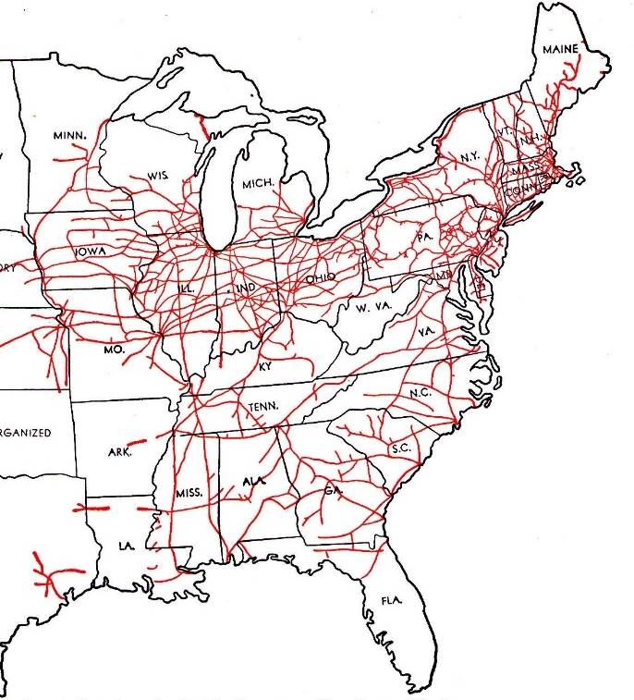
When looking at when Waukesha developed, we have to look into a different time than our own. We are looking at a time in history when the Civil War is very recent history and America was a growing industrial power due to the market revolution. Soon after the Civil War the use of railroads in the US pushed to new heights as you can see in the map of railroads in 1870. As you can see on the map, railroads were used extensively throughout the North. Though there were few connections into the North, once they had reached these connections, they would have the ability to quickly make it to Waukesha. Railroads were so important to the economy and the US that they grew from 30,600 miles in 1860 to almost 53,000 miles in only a decade. With this development, it was becoming cheaper for people to travel and relax. The USA was beginning to “see light and sound transmitted” across the nation, bridges were built, telegraph lines extended, and wealth was something that the “average man” could accumulate. These advance in technology as well as the railroad lines were the two most important additions to American daily life allowing for a tourist economy to develop.
Map of Railroads in 1880."Transcontinental Railroad History." First Transcontinental Railroad. Accessed May 08, 2016. http://cprr.org/.
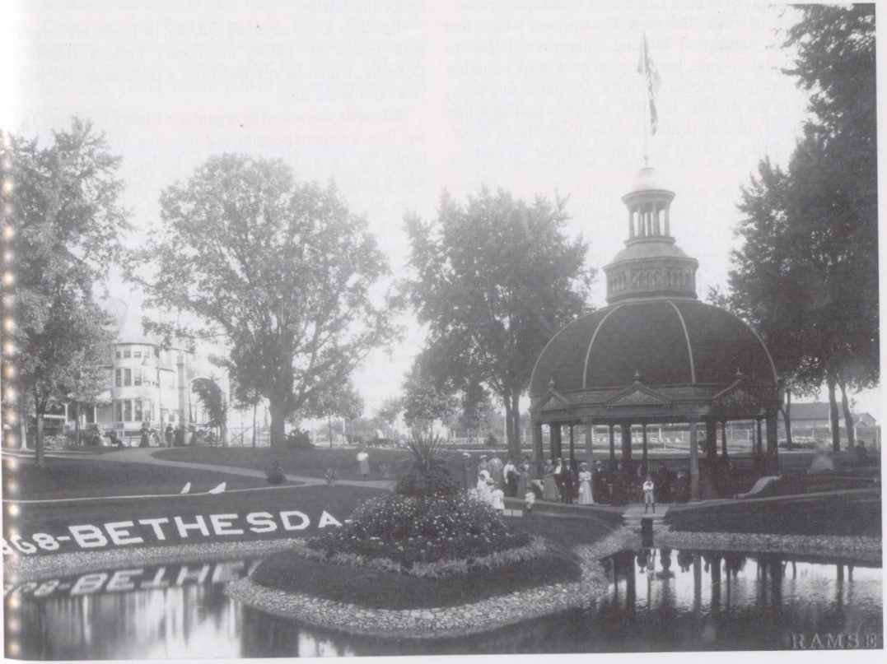
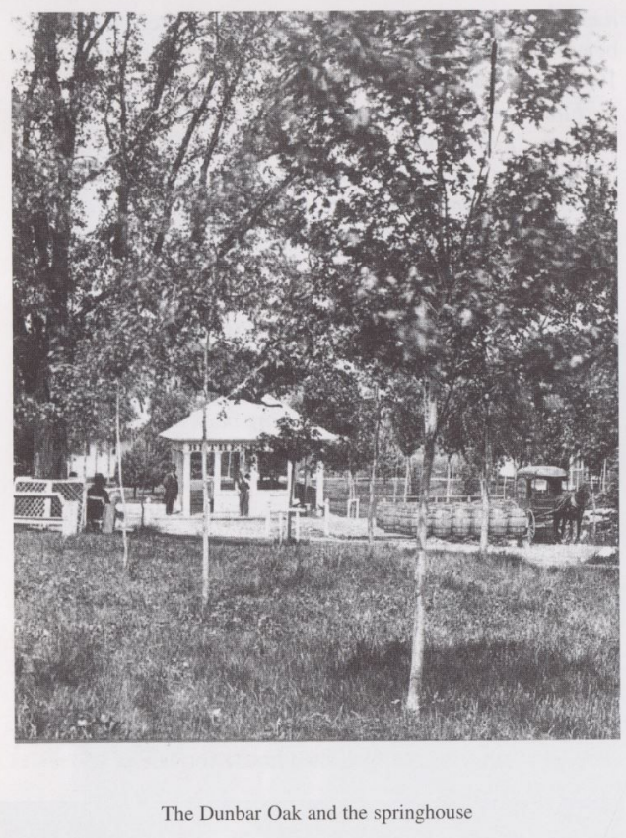
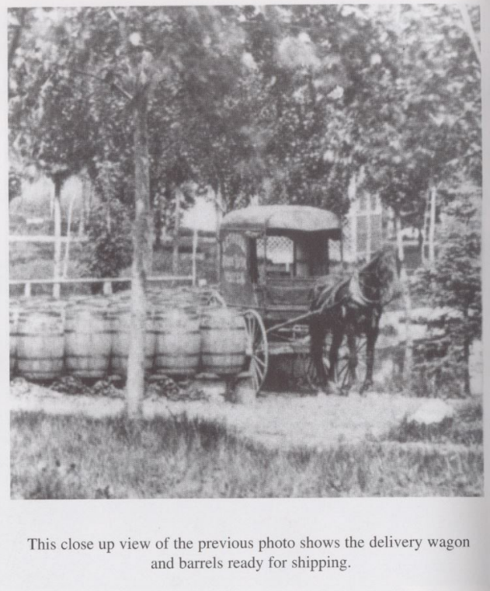
Through the mid 1860’s Waukesha was a small farming village about a twenty minute ride by train from the city of Milwaukee. Then, in the late 1870’s the city suddenly expanded to over triple the population. This sudden expansion into a thriving city can be traced back to a discovery made by Colonel Richard Dunbar. Dunbar was knocking at death’s door when he visited his sister-in-law knowing he was supposed to die within the next six weeks due to type two diabetes. In his journal he states that his doctor convinced him that “there was no use in resorting to any more remedies; that my case was beyond the reach of medical aid.” With this in mind, Dunbar decided that he would go with his Sister-in-law when she asked him to come for a ride around the land she owned. Halfway through this ride, Dunbar was overcome with thirst and was forced to stop to get a drink at a spring. After drinking the water, Dunbar miraculously felt energized and his polydipsia (excessive thirst) had been eradicated. That week Dunbar sent samples of the water to chemists and doctors, back in his home state of New York, and found that the water was extremely good for kidney as well as liver disease. Within the year he bought the land that he had drank the water from, and started commercially producing bottles of it to sell. This was the start of the Bethesda Mineral Spring. He named it this way due to the biblical connotation “House of Mercy,”. With an advertising campaign that said the water had healing effects, (this would later be debunked) and the leadership of Dunbar, within the next 10 years Waukesha was a bustling resort town covered in hotels as well as other spring bottling companies.
Picture of Bethesda Spring. Schoenknecht, The Great Waukesha Springs p.77
Schoenknecht, The Great Waukesha Spring Era p. 72
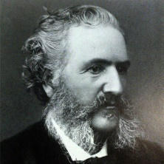
Colonel Richard Dunbar posing for a painting in Belfast Ireland. http://www.hellodrew.com/websites/spring_city/chapter01.html

When looking at the development of Waukesha, one important form of analysis that this paper will look at is how they exploited their dominant resource, water, to create wealth. At the height of the Waukesha Spring Era there were over forty springs that were being used by business men to attract tourists. Bethesda Spring was the first as well as most famous of all these springs. Richard Dunbar’s brainchild, the Bethesda Spring Company, was started in 1869. Early on the spring was a hit with locals as the water proved to be energizing and tasty (Dunbar also promised that the locals could take as much water as they wanted for free). This only helped to reinforce the conviction Dunbar’s desire to spread the waters of Waukesha to the world. Though business was slow for about a year, it did improve quite rapidly. On January 9, 1872, the Plaindealer reported that Dunbar was “shipping ten times the amount of water than he had in the past winter and that it was being shipped to every state in the Union and to Europe.” Later during the summer of 1872 it was reported that “business was so good, Dunbar had to use every barrel he could procure from area coopers.”
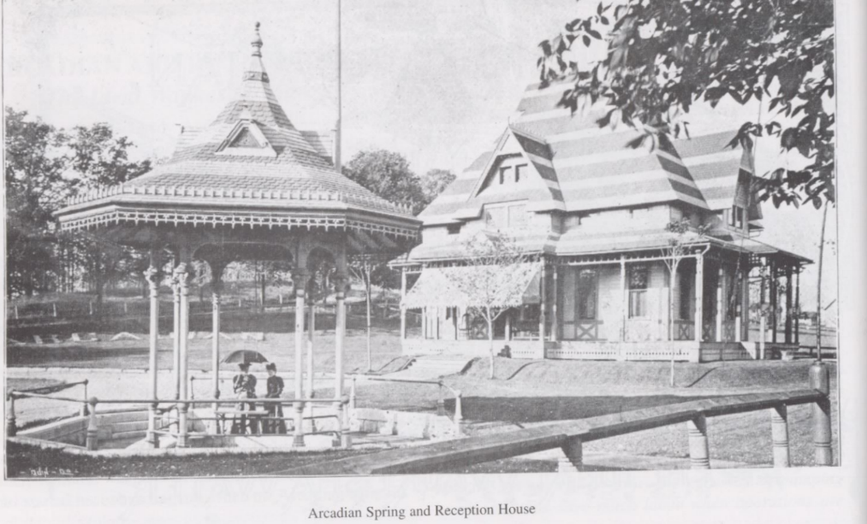
Seeing the popularity of Bethesda Spring, local entrepreneurs were soon looking to exploit the springs that were bubbling up throughout the area. After Dunbar’s Bethesda there are five springs that gave it competition between 1870 and 1910. The first spring to give competition to Bethesda was the Silurian which was opened in 1871 by Winchell D. Bacon. Though it was not developed into a tourist attraction for a couple years (by David Smeaton), it was located at the center of downtown Waukesha. This meant that when the elites that were visiting would tour the shops and attractions of downtown, they could always stop by a cool glass of healing water. After the Silurian was discovered, two more springs were discovered in succession. Mineral rock spring and Hygeia in 1872. Mineral Rock Spring was formed by Chauncey C. Olin (C. C. Olin) on what was formally known as Cutler Spring. After buying the land, he cleaned the spring, fashioned a new stone well, and built a beautiful pavilion over it. Hygeia Spring was founded soon after by Edward Flannery and was Bethesda’s top competitor when it came to the beauty of its park. On July 4, 1872 the Waukesha Freeman noted that “The Hygeia Spring…is rapidly increasing in popularity. Its crowds which throng to it almost rival those of its older neighbor (Bethesda).” The next year White Rock Spring popped up. Run by Hiram W. Colver, White Rock Spring would end up being the longest lasting spring as well as most profitable. Its bottling facility closed down in 1970 and still today there is a park where the spring once sat. Finally The Arcadian Spring was opened in 1885 by James Kennedy Anderson, a grocer from Waukesha. Within two years of being open, the Arcadian Spring was sending out over three hundred train car loads of product. The pump was being used so much that the water at the spring would dip below surface level creating rumors that demand was too great for supply. All five of these springs were known throughout the US and were fierce competitors with one another. In fact, though normally the spring owners would play nice, C. C. Olin was famous for his feud against the Fountain Spring Company. He was arrested multiple times when the Fountain Spring was built using the same reservoir as his spring. This Feud cost him and the Fountain Spring Company hundreds of thousands of dollars and tarnished Olin’s reputation.
Schoenknecht, The Great Waukesha Springs p.12
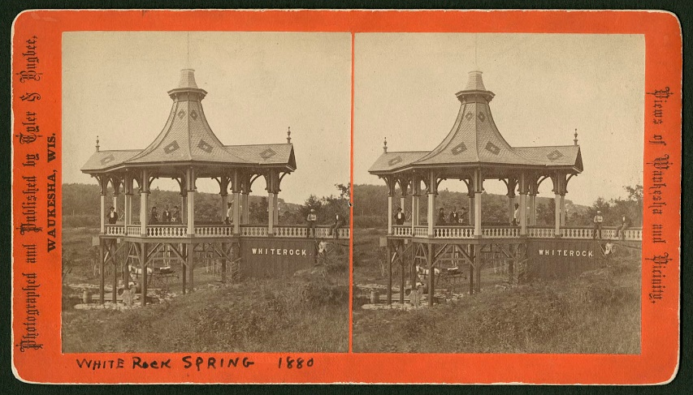
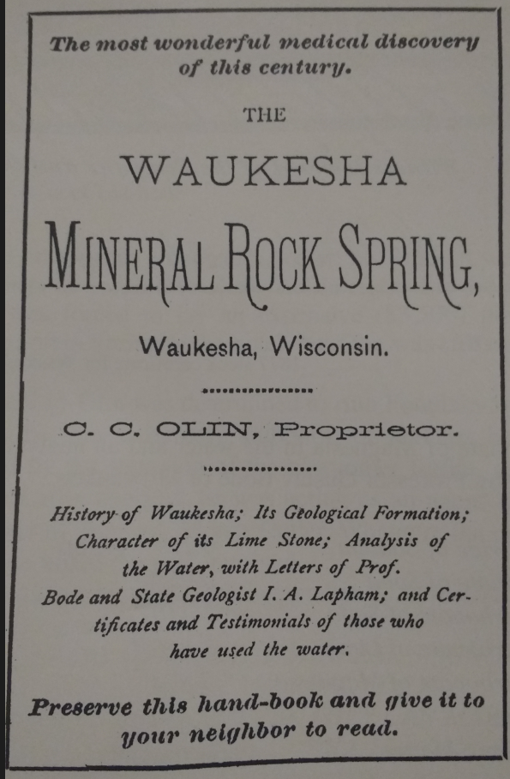
One of the most important reasons for the expansion of the Bethesda Spring was advertising. Dunbar was famous for allowing people to try his product before purchasing it to prove that there was no “humbug” in anything he had said about it. This led the other spring leaders to advertise about the healing effects of their springs in newspapers as well. One example would be the Mineral Rock Spring who quoted a woman names Mrs. James Sanders saying, “I had lost all hopes of recovering when I was introduced to use the Mineral Rock Spring water, and since then I have gradually regained the use of my limbs and also gained strength and flesh.” The next year C.C. Olin would revolutionize the way that springs could advertise when he created a booklet called “The Most Wonderful Medical Discovery of this Century - The Waukesha Mineral Rock Spring”. This book talked about the process of bottling and shipping his water, what disease it cured, what chemical properties it had, the proper way to drink the water, and a history of Waukesha, with press reviews from the Plaindealer, Freeman, Milwaukee Sentinel, and Chicago Advice. This booklet was passed out throughout the Waukesha, Milwaukee, and Chicago area. With an increase in scientific studies on the springs, coupled with most of the springs allowing for people to taste their water for free, soon even doubters were preaching about the effects that the water had on them physically. As more people testified on behalf of the Waukesha miracle water, and barrels of the water were delivered as far away as Western Europe, the wealthy elites from all over the nation made plans to visit this young, exciting new city.
White Rock Spring Pavilion. Waukesha County Historical Society. Accessed May 1, 2016. http://digicoll.library.wisc.edu/WebZ/FETCH?sessionid=01-49841-1973823538:recno.

Cover of the booklet passed around by C. C. Olin. Schoenknecht The Great Waukesha Springs Era p.183
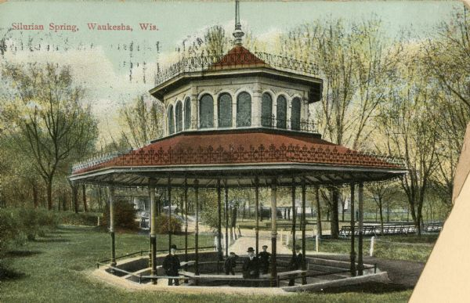
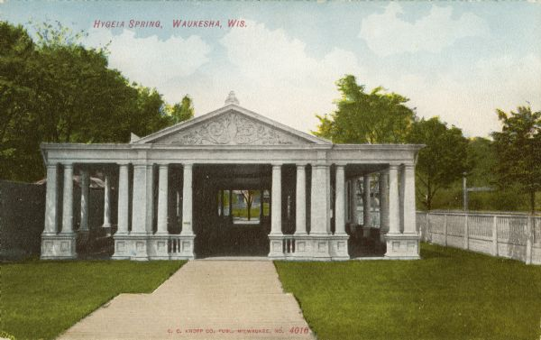
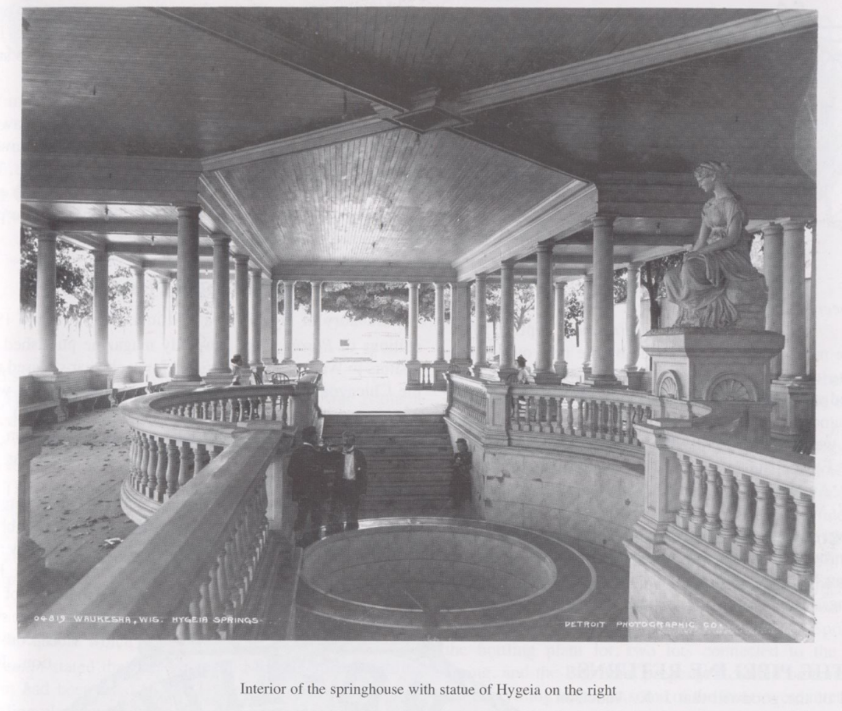
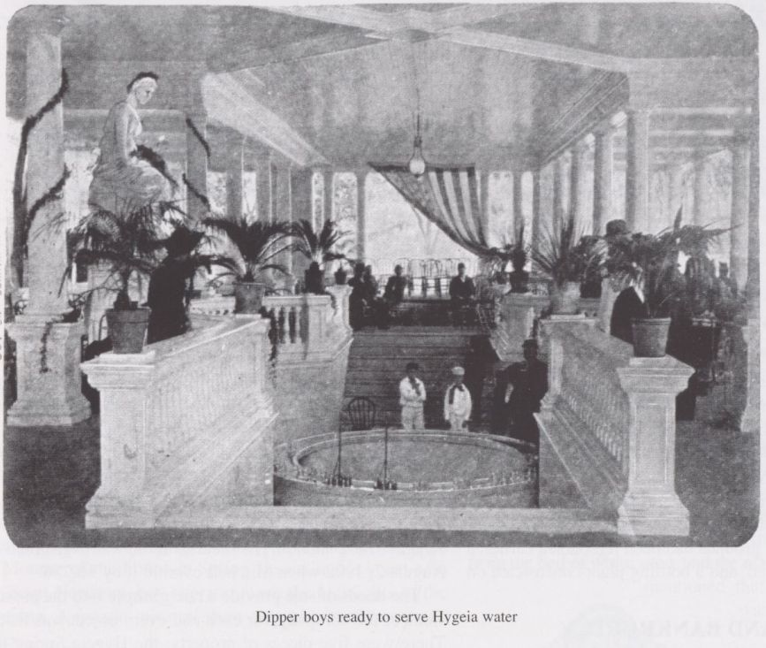
Richard Dunbar came from high society and since Bethesda Spring was starting to be visited by people at his socioeconomic level he decided that it was time to give his spring a makeover. Thus the second phase of analysis, tourism. Originally building a wooden structure shaped rectangle in shape with a walkway down to the pond, in 1872 he built a marble octagon shaped building and a park around it. He then built and maintained multiple paths, a handful of fountains, and dozens of gardens. With tons of open space, this park was perfect for a picnic and wasting away the day in the sun. After hiring two full time bands/orchestras, the Bethesda Spring’s park was no longer only a place for harvesting miracle water but was an attraction that was elegant enough to draw esteemed guests such as Mary Todd Lincoln. In fact, having a beautiful park as an attraction was so important to the Bethesda Spring company, fifteen years after the first remodel (Alfred Jones had taken over the company at this point) they renovated it, adding croquet and tennis courts to accommodate even more guests. Another park that acknowledged this demand for beauty from elite guests were the owners of the Silurian Spring. In summer of 1877, the Waukesha Freeman describes the Silurian Spring as “Mr. Smeaton (the owner), the proprietor, is a gentleman of taste and has laid the foundation for a fine park which will in due course of time form one of the most delightful resorts in this locality. The spring is high above the river and is never affected either by drought or flood while for purity it cannot be excelled.” After being sold in 1879 to William A. Haslage, the Silurian went under major improvements to the already beautiful park. In 1880 they installed a massive 200 barrel water tank that allowed for several fountains to be built as well as bathhouses on the premises for both male and females. They also built a two story pavilion over the spring where visitors could have a view over the Silurian grounds. In one season, it was reported that more than 4000 baths had been given at the Silurian Spring. To express the way that parks needed to be updated and beautified consistently we look to Hygeia Spring. In 1880, the most opulent park of all was normally considered to be Hygeia. It had the largest spring house in and in October of 1879 was complimented by the Waukesha Freeman who said that Hygeia had the most attractive pool of water. The competition to continue to be the best and beautiful was expensive and unfortunately in 1883 management changed and the Hygeia was not remodeled or updated again. The business of being the best and the most beautiful was something that had to be maintained every year however the Smith family who purchased the land for 3,500 dollars were not up to the challenge. The land was then sold four times before 1891 finally landing in the hands of James E. Mc Elroy. After instigating the largest scandal in Waukesha Springs history (the Great Water War of 1892), McElroy finally started to once again revamp the park around his spring. A great pavilion was erected in the form of a Grecian temple in reverence to the legend of Hygeia, a goddess of health. It had two entrances with the spring located in the center of the building. A statue of the goddess Hygeia was built over looking her pool of water and the visitors that would come to drink the cool waters. The most impressive part of this was that everything was made from pure marble costing hundreds of thousands of dollars. On its dedication day many bands played and orators spoke, even Governor of Wisconsin George W. Peak addressed the crowd.
Silurian Spring on a postcard Schoenknecht The Great Waukesha Springs p.225
Outside of the Hygeia Pavilion. http://www.wisconsinhistory.org/Content.aspx?dsNav=Ny:True,Ro:0,N:4294963828-4294955414&dsNavOnly=Ntk:All%7chygeia+spring%7c3%7c,Ny:True,Ro:0&dsRecordDetails=R:IM37166&dsDimensionSearch=D:hygeia+spring,Dxm:All,Dxp:3&dsCompoundDimensionSearch=D:hygeia+spring,Dxm:All,Dxp:3
Schoenknecht The Great Waukesha Springs p. 163-164
The springs of Waukesha not only renovated and improved their own land but also helped to upgrade infrastructure in the city of Waukesha. In the 80’s and 90’s bottling companies were the leaders in keeping and maintaining roads. They also added infrastructure that would not have been a good allocation of taxes for the county/city. An example of this would be the purchase of a public ferry by White Rock Spring that was used to bring tourists from downtown Waukesha up the Fox River to their park/gardens. The ferry was used by the county on multiple occasions for free to transport people, machines, and other types of cargo. Another good deed that was brought about by the springs were the use of electric lights on roads. The first to illuminate their park was the Arcadian Spring in 1888, however within a couple of years it was almost a necessity for all the springs, and the area to upgrade. There were also multiple festivals that were celebrated and produced by the springs. The largest and most known was “Bethesda Day”. A celebration of the founding of Bethesda Spring, this festival drew in thousands of people. Bands played all day and orators spoke of the miraculous properties of the waters. In 1895 “Bethesda Day” boasted attendance of over 8,000 persons. Millions of dollars in revenue would be brought to Waukesha citizens on this day alone.
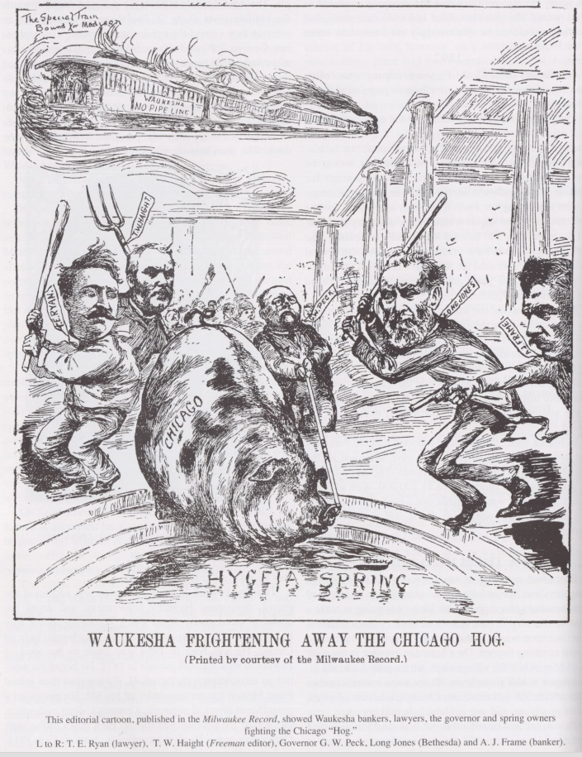
Another way to show the way that the springs effected the government as well as the local people would be to analyze the Great Water War of 1892 looking at the way that Waukesha citizen’s fought for what they felt was detrimental to the success of the city. As previously stated, Hygeia Spring was bought and sold multiple times until James E. Mc Elroy, an entrepreneur from Kansas City finally came to own it. McElroy was a smart man and was looking to the upcoming World’s Fair in 1893 which was to be held in Chicago, IL. He had the idea that he would build a pipeline from his spring in Waukesha down to the Columbian Exchange. In 1891 the board of trustees of Waukesha agreed to allow the pipeline to be laid in the following year, however they decided to wait to vote two for weeks’ time to get a more complete understanding of what would be needed to install the pipes. After the two weeks were up, the board had changed their mind, presumably due to the uproar that was heard from the residents of the county. McElroy was not pleased with this ruling so in February of 1892 the Hygeia Company went before the Waukesha village trustees again seeking permission to build the pipeline south through Waukesha. The Hygeia Company made a very strong case for itself, saying that Chicago would be sending “heaps of money” into Waukesha. It also had a step by step plan that would not interrupt daily life in Waukesha and would not affect any of the other springs in the city. The board of trustees still voted against allowing the pipeline to be built however McElroy was not done yet. With the pipeline costing an estimated $1,200,000 and parts of it already constructed, McElroy would be at a huge financial loss if he did not build the pipeline. While meeting early in March with his Chicago backers, the so-called "Hygeia Caper" was hatched. McElroy decided to employ 215 men from Chicago to construct a pipeline in the dead of night. In the evening of Saturday, May 7, 1892, a special train consisting of three passenger cars, two cars loaded with "highest quality" steel pipe, one car carrying provisions, and one stock car filled with horses, pulled into St. Paul depot. Fire bells were rang continuously throughout the night waking all citizens in town. Since rumors had been flying over the past few weeks that McElroy would still try and build his pipeline, most people went straight to Hygeia Spring, pistols and rifles in hand. Timothy Edward Ryan and Theron W. Haight, two local attorneys led the group denouncing Hygeia’s lawlessness, and urging the crowd to stay ready but calm. There was a wall of laborers and citizens facing off both waiting for the other to tire and to go home. At 3 A.M. the laborers were the ones to pack up and get back on their train south. This was a minor victory for the citizens of Waukesha because but an hour later the train pulled back up, once again the fire bell was rung and this time tempers started to flare up. Both groups of people yelled at one another and just before it seemed like something would happen that was more drastic than words, Bethesda Spring Company owner “Long” Jones stepped forward and asked to speak to the laborers foreman. Jones forcefully explained that the laborers were not welcome and that he would give the laborers an hour to leave before he would lose all control over the crowd. The foreman assessed the situation and boarded a train south with all his workers within the hour. That morning, McElroy was arrested and had to pay a large fee for “disturbing the peace”. This scandal did not end here though. McElroy went back to work trying to put a pipeline through Waukesha, this time going to the state legislature for help. With the help of machine politics, he was able to push two bills through the legislature that allowed for him to lay pipes the land of the State School for Boys. This land was long enough for him to get his pipes all the way through the county. Before the bills were enforced however the Waukesha representatives talked Governor Peak to hear from their constituents first. When a force of 800 men, women, and children showed up from Waukesha to protest the pipeline, the Governor would veto the bills thus giving the citizens of Waukesha their victory.
Schoenknecht, The Great Waukesha Springs Era p.156
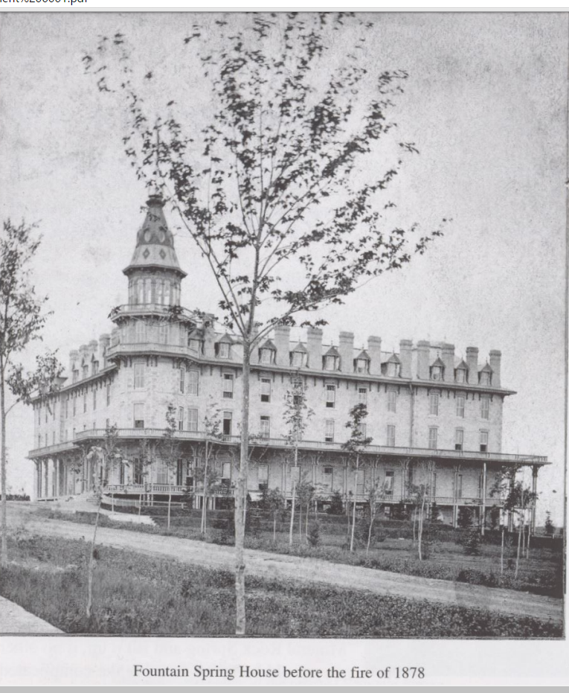
Though Waukesha had an attraction that would soon bring in thousands of visitors, the city was just not ready for them to come. In the early seventies, visitors all but overwhelmed the villagers. During the third summer of Colonel Dunbar's promotion of Bethesda water and Bethesda Park, there were but five hotels including the Exchange hotel, the Bruce house, the American house, the National hotel, and the Fox River house. The most spacious holding around fifty people. This meant that there was a large overflow of people who would stay at local residences. This void of space to live was waiting for an entrepreneur to step up and take. Matthew Laflin, a businessman from Chicago originally came to Waukesha with diabetes and was cured by the magical waters. He was in love with the small town, however he was appalled by his living quarters when he visited in 1870. He wanted to build a hotel that would do two things. The first would be to create a place where people would be able to stay in large scale. The second would be to build a hotel that could accommodate elites who desired finer things. Though he understand that the hotel was not the main attraction for most visitors, what was currently offered was not nearly luxurious enough for the type of society that would be coming to visit. With his good friend Thomas B. Bryan, another millionaire from Chicago, they purchased 144 acres of land in 1873 and quickly set to work building four story stone structure. Not sparing any expense, the price of the hotel skyrocketed spending over $160,000. It had a billiards room and a bowling alley in the basement, and “spacious park for outdoor exercise and amusements”. It also must be noted that the Fountain Spring house barn had been completed and would accommodate thirty-six horses and nearly fifty carriages. Before the 1874 season started, in a move that would make Colonel Dunbar smile, Laflin invited 250 journalists and editors to visit. Milwaukee Journal of Commerce, July 2, 1874 read:
Schoenknecht The Great Waukesha Springs p.100
“The entire company of two hundred and fifty sat down at once to a superb feast in the dining hall of the Fountain House.... The hotel - the largest and finest in the state - has been nearly completed since the 10th of March.... The enterprising gentlemen of Chicago who have added this material attraction to Waukesha at an outlay of $140,000, deserve the applause of the state.”
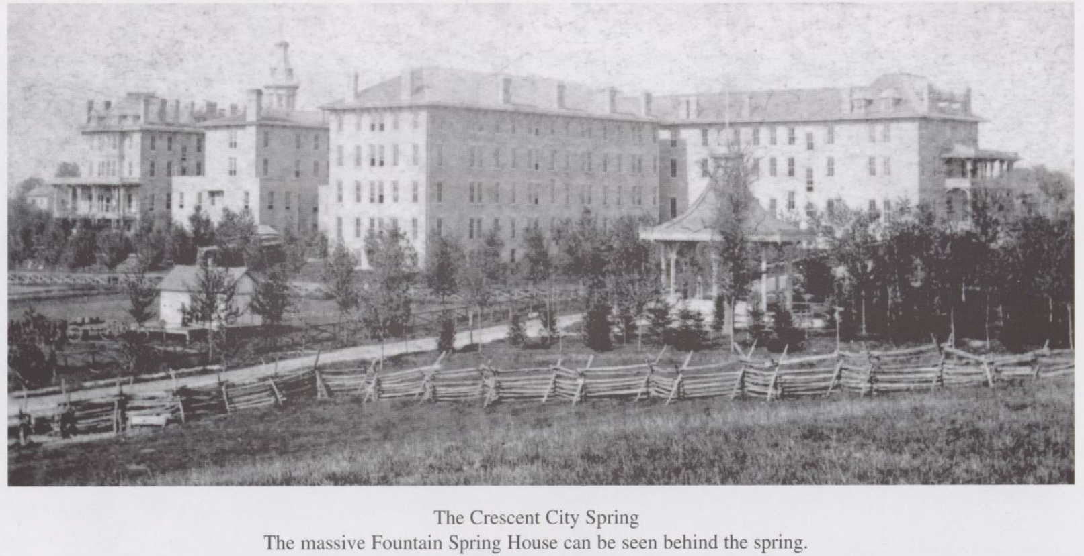
From this date, we see Waukesha being referenced as the Saratoga of the West. Though no one knows who said it first, it is believed that during this meeting that analogy was spoken and accepted by all who had visited both. Officially opened to the public on July 4, 1874, the Fountain Spring Hotel was an instant hit. With the free advertising done by the journalists who had visited, the first four years of service its rooms were sold out before the season could even start. At the tail end of the 1878 season disaster struck when there was a grease fire in the kitchen burning down three of its four walls and totally decimating the once great hotel. On Thursday, September 5, the headlines of the Freeman read: 'Fountain of Fire,' 'The "Pride of Waukesha” a Heap of Ruins,' the news to the citizens of the county. When the losses were totaled including the insurance that had been received, it was estimated that the building could be replaced for $50,000. This seems like a small price for a building that once cost $160,000 to build. Laflin thought so too so instead of rebuilding the same hotel he decided to upgrade. The result, the most glamorous hotel in the Midwest. Rebuilt of Milwaukee brick, the new building could accommodate upwards of 800 guests at one time. The grounds included a half-mile dirt track for harness and jockey racing, fields for croquet and tennis, plus an area designated for horse shows. Altogether, the property covered 120 acres. At the end of construction (the hotel was open for the 1879 season) Matthew Laflin and Thomas B. Bryan had spent over a quarter million. In today’s terms, that is over $5,000,000. This seems like a bit of overkill to build a hotel this extravagant in such a small city, however their investment soon paid off for them. In the May 17, 1879 edition of Hotel World it was reported that “dozens were turned away every week because of lack of accommodations”. It is almost ironic that when Matthew Laflin and Thomas Bryan built his first hotel his goal was to have a place that could accommodate for the people that were looking to spend their money at the Waukesha springs, just to create a situation where his massive hotel could not keep everyone happy. After the success that Laflin and Bryan had with their hotel, it was not long before hotels started to grow in size, however none would come close to the size and extravagance that this building had.
Schoenknecht, The Great Waukesha Spring Era p.103
Finally we come to the last important form of analysis. Who were the people that the springs were advertising to? Soon after Bethesda Spring’s “miraculous waters” were advertised nationally, summer travelers started to “flock to Waukesha instead of going to the famous Virginia Springs, or Saratoga”. The health and pleasure seekers listed on the guest books of most watering places were often those from the South, and these the Waukesha promoters found especially responsive to their newly discovered health springs. Wealthy southerners from Florida, Alabama, Louisiana, Mississippi, Texas, Tennessee, Kentucky, and Missouri, who wished to escape the heat, very often the malaria, and in some instances the recurring yellow fever, came North, so easily accessible due to the extensive railroad system in place. From here came the sick, reporters, and entire families with their coachmen and finest horses, African American “mammie” to attend the young, and maids for the mistresses remained the summers through. At this point one must define the word wealthy. In this case I am talking of men and woman who would be considered a part of the Southern elites. These are the people who had owned massive plantations or had worked in government. An example of this wealth was the nearly legendary Miss Bettie Brown from Galveston, Texas. She reportedly brought “16 trunks, her maid, her carriages, her grooms, her coachman and her horses”. It was also estimated that on any given Sunday night at Bethesda Park, one would be surrounded by at least “$200,000 worth of jewelry, silks, satins, ribbons, laces, hair bustles, ect...”. That being said, without the infrastructure to maintain and take care of these displays of wealth, Waukesha would not have been a travel destination for anyone of high class. One can see that Waukesha was drawing in wealthy guests from the South and they were doing their best to accommodate for them. In fact one can conclude that southerners were actually the group of people that was thought about the most. When the Fountain Spring House was rebuilt, it was fashioned with a fireplace in each of its rooms. This was done because “southerners were determined to have open fires on cool mornings”. The Hambitzer orchestra, Bethesda Springs standing band, always played “Dixie” to the applause of both the black and white southern members of the audience at Bethesda Park. In an excerpt from the Milwaukee Journal in 1953, historian Frances Stover interviewed a woman who, in her youth, visited the springs of Waukesha.
“Surely, you must know The Springs'”. The elderly lady in black with a white ruche who made the observation was in the drawing room of her Columbus (Miss.) home. All about were remembrances of her years as a southern belle. She could not understand that a Milwaukeean did not know all about “The Springs, the gayest summer society gathering place west of Saratoga” when she was a girl.”
When she mentioned Bethesda and Silurian, the Fountain House and the Park hotel, it was all plain. She was speaking of Waukesha. Wis., when it was the Saratoga of the west. She was recalling her happiest days, the summers when with her father and mother, the family servants, the family landau and the carriage and riding horses they entrained for “The Springs” to spend a delightful three months. “Taking the waters” was an excuse for enjoying a summer social season of prebreakfast quaffings of the water, mid-morning musicales, luncheons, tennis, croquet, drives, dips in the pool, formal dinners, balls and most of all, flirtation with the young dandies from Louisiana, Texas, Alabama, and Mississippi to say nothing of the Waukesha boys.
This woman was completely infatuated with the Waukesha springs and felt completely at home there. Through the efforts of the men who lead the springs, they were able to develop a city of splendor that attracted all of the finest guests.
The article’s from Frances Stover and Lillian Krueger also express how the extremely rich were not just there for a weekend then would return back home. They would be taking long term vacations, “taking the water” for months at a time. The Wisconsin Historical Co. even goes so far as to state that the “Fountain Spring Hotel was the home to some of the most brilliant representatives of the beauty and chivalry of Southern cities who lingered far beyond the ordinary limits of a watering place season dreading to return to their fever stricken homes as long as the specter of their dread hovered over them.” These elite guests did not buy land unless if the person was looking to be an entrepreneur and try to get into the hotel and spa business. Even though there had been great successes such as Laflin and Dunbar, there was always some hesitance for people who did not live in the Midwest to buy land. With the climate of Wisconsin, people from the South were not accustom to weather that would drop below 60 degrees Fahrenheit. Due to this fact, see that tourism decreased greatly from mid fall until early spring. This meant that prices were lower and there was cause for another group to visit the beautiful springs. When it was “out of season”, group of tourists that came to Waukesha were generally from Milwaukee or Chicago. As a suburb of the bustling port city, Waukesha was within a short horse and carriage ride away (or possibly a train ride of under twenty minutes). This meant that middle class citizens working in the Milwaukee area were able to come and treat themselves to the “high life” for a week or weekend. Including discounted rates, Milwaukeeans would flock to the springs on warm weekends. Chatting with the lingering Southerners who were still in the area. One of the main reasons that we see this major dip in tourism is that most of the hotels, following the lead of the Fountain Spring House, would close in late August when the summer season was over. This allowed for hotels to keep relatively normal pricing. When it came to the shops and theaters in the area, things became extremely manageable price wise.
When it came down to it, Waukesha’s greatest weakness was also its greatest strength. The fact that the springs were extremely spread out meant that either the springs had to supply transportation or the visitors would have to bring their own. This meant that guests would have to endure endless rides in their carriages not being able to spend their money at local businesses and at the springs. Thus at the turn of the century when the automobile started to show up at hotels, the springs and hotels were excited about this. It gave their guests less travel time and more time to participate in events set up by the springs. By 1905 the spring’s tourism was rapidly declining. What happened was that as people increased their ability to travel distances at a personal level, they started to want go out and drive to where they wanted to go instead of taking the train. There were many places that people could visit instead of traveling cross country to a spring. It was a revolution of tourism in America. Though the springs continued to sell their water, by 1910 almost all had closed down their parks and started to focus on selling their water. It was a slow painful way for a once beautiful area to slowly transform from tourism economy to industrial.
Rising from a village of 28,274 residents in 1870 to its peak population of 44,270 in 1890 (an increase of almost 64%), Waukesha went from being a no name county on the outskirts of Milwaukee, to being the gem of the Midwest. The development of Waukesha from 1869 until 1900 was a dramatic to say the least. When it comes down to it, the city would have never had this ride without the crazy entrepreneurs who dared to invest in it. Whether they were building beautiful parks or building hotels that revolutionized tourism west of the Alleghany’s. They created a city that was “Pure as a crystal, Sparkling as a Diamond”.

Appendix A

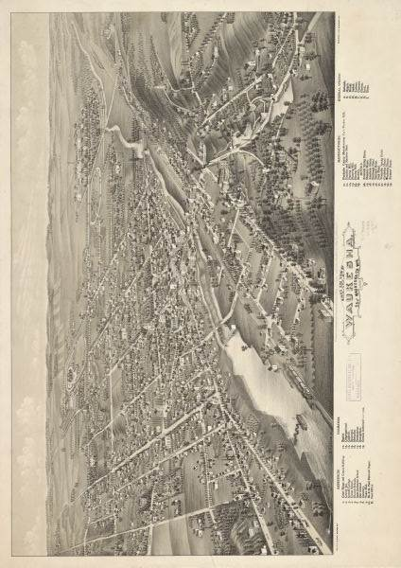

Historical Map of Waukesha as of 1880

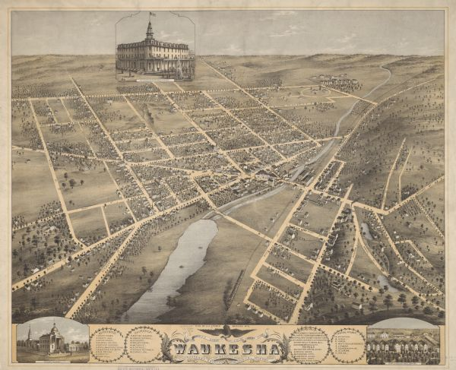
Map of Waukesha 1874, the year the Fountain Spring Hotel was opened. You can see it at the top of the image.
"Bird's Eye View of Waukesha, C.S. of Waukesha Co., Wis. 1880 :: Maps and Atlases in Our Collections." Bird's Eye View of Waukesha, C.S. of Waukesha Co., Wis. 1880 :: Maps and Atlases in Our Collections. Accessed May 15, 2016. http://content.wisconsinhistory.org/cdm/fullbrowser/collection/maps/id/560/rv/singleitem.

"Wisconsin Historical Society." Historical Image. Accessed May 11, 2016. http://www.wisconsinhistory.org/Content.aspx?dsNav=Ny:True,Ro:0,N:4294963828-4294955414.

Appendix B
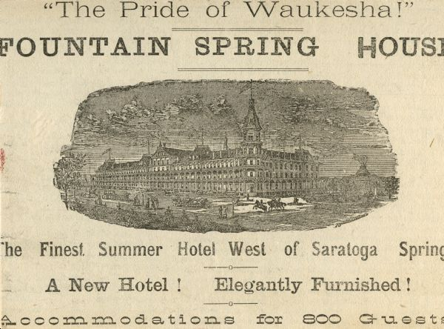

An ad for the Fountain Spring Hotel with a short synopsis from the Wisconsin Historical Society
"Wisconsin Historical Society." Historical Image. Accessed January 17, 2016. http://www.wisconsinhistory.org/Content.aspx?dsNav=N:4294963828-4294955414.
On July 4, 1874, the Fountain Spring House opened for business. Built of Waukesha limestone, the Fountain Spring House was eventually rebuilt to twice its original size and included a half-mile dirt track for harness and jockey racing along with fields for croquet, tennis and horse shows. Altogether, the property covered 120 acres.

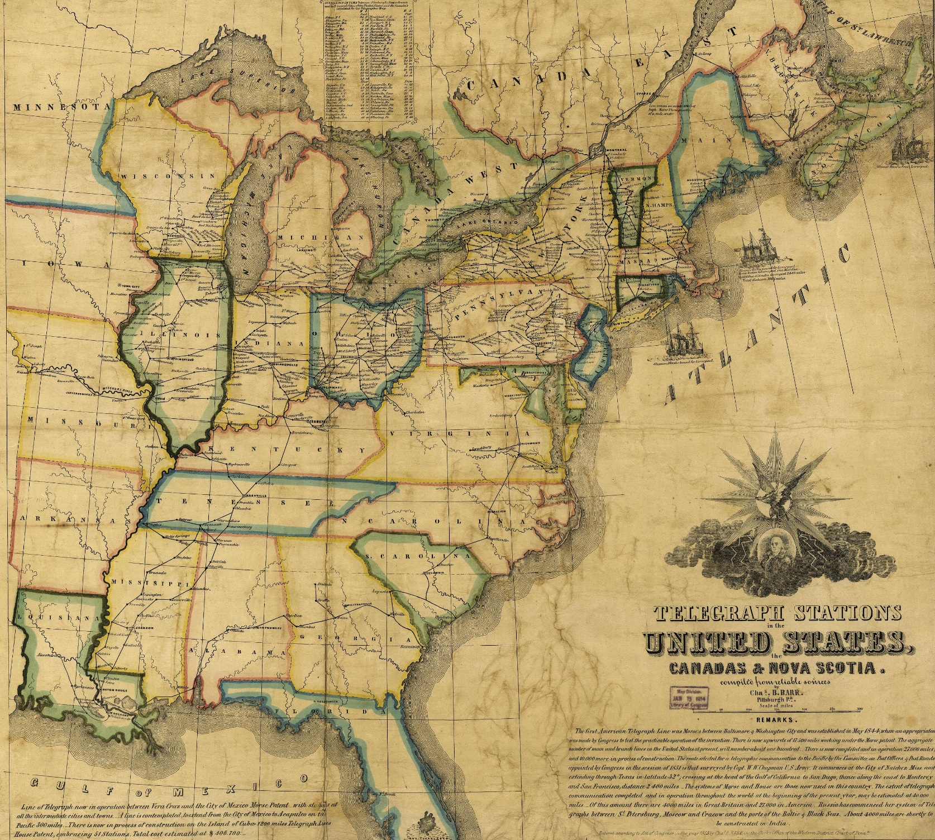
Appendix C

Map of telegraph stations in the US and Canada in 1853.
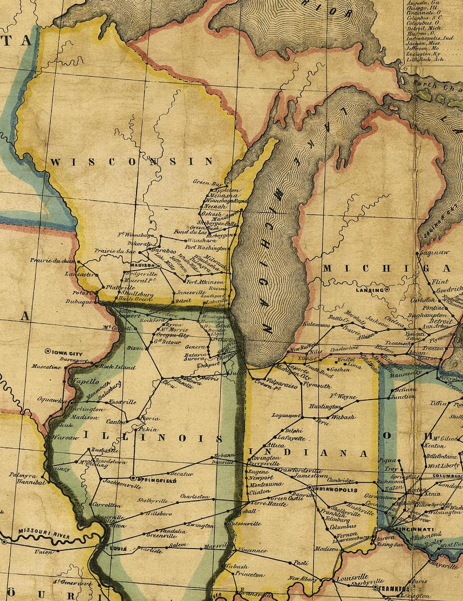

Telegraph stations in 1853, Notice Waukesha being the next stop to the left of Milwaukee.
"Distant Writing - The Rest of the World." Distant Writing - The Rest of the World. Accessed May 15, 2016. http://distantwriting.co.uk/Comparisons.html.
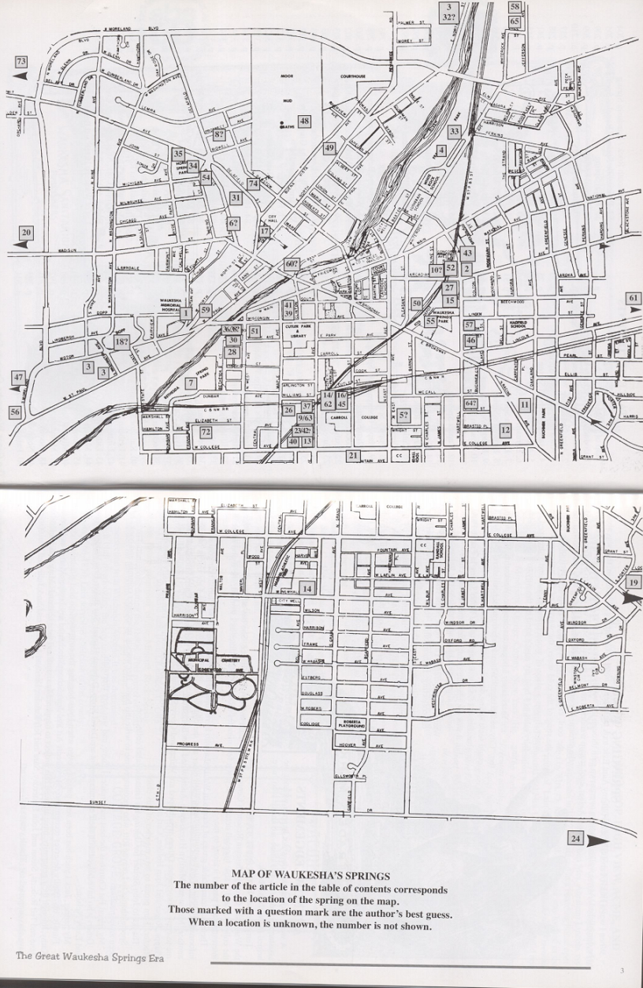
Appendix D
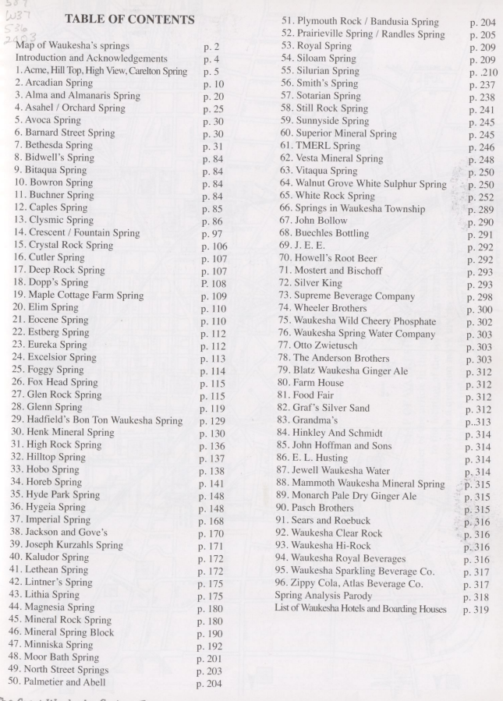
A map from The Great Waukesha Spring Era. Schoenknecht, The Great Waukesha Spring Era p.1-2
Primary Sources
“A Mineral Spring Discovered At Waukesha” Waukesha Freeman, March 11, 1869. Accessed January 30, 2016. http://access.newspaperarchive.com/us/wisconsin/waukesha/waukesha-plaindealer/1869/03-09/page-3?tag=bethesda+spring+waukesha&rtserp=tags/bethesda-spring-waukesha?&ndt=ex&py=1869&pm=3

First article about Dunbar’s spring. More just a statement that it happened.

“Bethesda Mineral Spring” Waukesha Plaindealer, June 11, 1872. Accessed January 13, 2016. http://access.newspaperarchive.com/us/wisconsin/waukesha/waukesha-plaindealer/1872/06-11/page-3?tag=dunbar&rtserp=tags/?pc=32060&psi=103&pci=7&pt=8223&ndt=ex&pd=11&py=1872&pm=6&pep=dunbar&psb=relavance

Article that talks about Dunbar and his need of more barrels to deliver his water throughout the country, and outside of the country.

"Col. Dunbar's Position." Waukesha Freeman, July 4, 1872. http://access.newspaperarchive.com/us/wisconsin/waukesha/waukesha-freeman/1872/07-04/page-5?

Article that speaks about how Hygeia is becoming a beautiful spring that people shouldn’t ignore.

David P. McDaniel. 2005. “Spring City and the Water War of 1892”. The Wisconsin Magazine of History 89 (1). Wisconsin Historical Society: 28–41. http://www.jstor.org/stable/4637158.

A synopsis of the Water War of 1892. Useful because it goes more in-depth than any other source I could find for this event.

“Hydrotherapy”. 1911. “Hydrotherapy”. The British Medical Journal 1 (2610). BMJ: 35–36. http://www.jstor.org/stable/25285011.

Another medical journal that talked about hydrotherapy and its upside and its downside. The main thing is that it really doesn’t have any true properties that are good for a person, it is all mental.

“Mineral Rock Spring." Waukesha Plaindealer, May 20, 1873. http://access.newspaperarchive.com/us/wisconsin/waukesha/waukesha-plaindealer/1873/05-20/page-3?

Woman’s testament to how well Mineral Rocks cured her of her ailments!

Murrell, William. 1881. “On Bethesda Water in the Treatment of Diabetes Mellitus”. The British Medical Journal 2 (1091). BMJ: 849–50. http://www.jstor.org/stable/25258265.

Scientific study on the waters from Bethesda Spring. Found it does nothing to aid people with diabetes.

Daily Milwaukee News, September 5, 1874.

Article about the Fountain Hotel and how amazing it is.

"The Silurian Spring." Waukesha Freeman, July 26, 1877. http://access.newspaperarchive.com/us/wisconsin/waukesha/waukesha-freeman/1877/07-26/page-3?

Article referencing how the Silurian is a beautiful park that has water that will never run out.

Waukesha Freeman August 6, 1888

Article that speaks about how the Arcadian was the first spring to have have electric lighting in its park.

Waukesha Freeman September 5, 1878

Announcement that the Fountain Spring had burned down.

Waukesha Journal, June 30, 1888.

Article that speaks about how due to the amount of water being pumped into bottles to be sold, people thought that there wouldn’t be enough water in the reserves for the amount of demand.

Western Historical Co., The History of Waukesha County, Wisconsin. Containing an account of its settlement, growth, development and resources; an extensive and minute sketch of its cities, towns and villages--their improvements, industries, manufactories, churches, schools and societies; its war record, biographical sketches, portraits of prominent men and early settlers; the whole preceded by a history of Wisconsin, statistics of the state, and an abstract of its laws and Constitution and of the Constitution of the United States, (Western Historical Co. 1880)

The synopsis in the title is the whole thing. I will be using this to reference Waukesha from a very factual base of information brought together by the Western Historical Co. It has a large amount of information about Wisconsin. All Facts.

Secondary Sources
“A History of the World: Bath Chair." BBC. http://www.bbc.co.uk/ahistoryoftheworld/objects/qcI7cMgiR0qmLnD_QPyIGQ.

Filler reference about the first Bath Chair and how it affected the ability for people to get in and out of the baths in Bath.
Bowman, Marion. 1998. “Belief, Legend and Perceptions of the Sacred in Contemporary Bath”. Folklore 109. [Folklore Enterprises, Ltd., Taylor & Francis, Ltd.]: 25–31. http://www.jstor.org/stable/1260567.

Talks about the history of Bath England. Has information starting with Celtic deities to present day beliefs about what the waters there are capable of.

Corbett, Theodore. The Making of American Resorts: Saratoga Springs, Ballston Spa, Lake George. New Brunswick, NJ: Rutgers UP, 2001. Print.

The early history of tourism in the USA. Talks about three different regions similar to the way that Jon Sterngass’ book does. It helps develop overall concept for what people were looking for from tourism.

“Historical Census Browser." University of Virginia Library. Accessed May 15, 2016. http://mapserver.lib.virginia.edu/.

Census for the US, I went through the population size of Waukesha for multiple decades.

Hobbs, John. "Britannia History: The Religious Policy of King Henry VIII." Britannia History: The Religious Policy of King Henry VIII. Accessed May 01, 2016. http://www.britannia.com/history/articles/relpolh8.html.

A short history of the reformation of England. Speaks about Thomas Cromwell and Henry the VIII.

Krueger, Lillian. "Mary Todd Lincoln Summers in Wisconsin." Journal of the Illinois State Historical Society (1908-1984) 34.2 (1941): 249-53. Web.

This article talks about how Mary Todd Lincoln visited Wisconsin including Waukesha after Abe’s Death. She visited in the mid 70’s.

Krueger, Lillian., and State Historical Society of Wisconsin. Waukesha, "the Saratoga of the West" / Lillian Krueger. 1941.

Just a synopsis of Waukesha and what was happening. This is similar to the first book mentioned because it gives more of an overall history of the area and time. Will be useful in the future as a source for possibly proving that Waukesha changed into a tourist town.

"Transcontinental Railroad History." First Transcontinental Railroad. Accessed May 08, 2016. http://cprr.org/.

Trains, railroads, and facts from 1830-1890

Schoenknecht, John. The Great Waukesha Springs Era, 1868-1918 / by John Martin Schoenknecht. Waukesha, Wis.: J.M. Schoenknecht, 2003. Print.

Awesome book that more or less does a chronology of the springs in Waukesha. Very good for learning bareminimum. Laying down a foundation of understanding. This book also has a ton of primary sources used in it that I will be able to look at in the future.

Spring City and the Water War of 1892. (2005). The Wisconsin Magazine of History, 89(1), 28-41.

This article is dedicated to the Water War of 1892. I think that this case is one of the most important in my analysis because it 100% proves that the Springs were affecting Waukesha. Before the industry had blown up I believe that they would not have cared if the people from Illinois would have taken the water.

Sterngass, Jon. First Resorts : Pursuing Pleasure at Saratoga Springs, Newport, & Coney Island / Jon Sterngass.Baltimore: Johns Hopkins UP, 2001. Print

A compare and contrast of Saratoga, Newport, and Coney Island. Has a large amount of information of the start of each. The development of Saratoga is the most important part, however the way that tourism was developing in the US was a key to this book as well.
Stover, Frances. "When Belles and Beaux Took Waukesha." Milwaukee Journal [Milwaukee] 6 June 1953: n. pag. Print.

Article that looks at the recent past and gives great incite into the way people acted as well as saw Waukesha during its peak spring era.

"Timeline of Roman Britain." Timeline of Roman Britain. Accessed May 07, 2016. http://www.britannia.com/history/romantime.html.

Just a quick timeline from Romans in Britain, Fact checker.

Waukesha . Landmarks Commission. Spring City's past : A Thematic History of
Waukesha. Rev. ed. Waukesha, Wis.]: City of Waukesha Landmarks Commission, 2002. Print.

Awesome book that more or less analyzes every facet of Waukesha life from the police force to agriculture. It does its analysis almost set up like a chronology of Waukesha. I like this book because it shows what the big issues were during this time period. It doesn’t specifically state anything however we can start to elude to the answers.

Hobbs, John. "Britannia History: The Religious Policy of King Henry VIII." Britannia History: The Religious Policy of King Henry VIII. Accessed May 01, 2016. http://www.britannia.com/history/articles/relpolh8.html.
Ibid
Bowman, Marion. 1998. “Belief, Legend and Perceptions of the Sacred in Contemporary Bath”. Folklore 109. [Folklore Enterprises, Ltd., Taylor & Francis, Ltd.]: 25–31. http://www.jstor.org/stable/1260567.
Timeline of Roman Britain." Timeline of Roman Britain. Accessed May 07, 2016. http://www.britannia.com/history/romantime.html.
Hobbs, “Britannia History: The Religious Policy of King Henry VIII."
“Hydrotherapy”. 1911. “Hydrotherapy”. The British Medical Journal 1 (2610). BMJ: 35–36. http://www.jstor.org/stable/25285011. P35
Bowman, “Belief, Legend and Perceptions of the Sacred in Contemporary Bath”. p.26
Ibid p.26
"A History of the World: Bath Chair." BBC. http://www.bbc.co.uk/ahistoryoftheworld/objects/qcI7cMgiR0qmLnD_QPyIGQ.
Sterngass, Jon. First Resorts : Pursuing Pleasure at Saratoga Springs, Newport, & Coney Island / Jon Sterngass.Baltimore: Johns Hopkins UP, 2001. Print p.9
Ibid p.9
Ibid p.7
Appendix A and D are maps for locations of the springs.
"Transcontinental Railroad History." First Transcontinental Railroad. Accessed May 08, 2016. http://cprr.org/.
Appendix C
Sterngass First Resorts
Schoenknecht, John. The Great Waukesha Springs Era, 1868-1918 / by John Martin Schoenknecht. Waukesha, Wis.: J.M. Schoenknecht, 2003. Print. 49-50
Krueger, Lillian., and State Historical Society of Wisconsin. Waukesha, "the Saratoga of the West" / Lillian Krueger. 1941. P.395
Schoenknecht, The Great Waukesha Springs Era p.67
Ibid p.54
“Bethesda Mineral Spring” Waukesha Plaindealer, June 11, 1872. Accessed January 13, 2016.
"Col. Dunbar's Position." Waukesha Freeman, July 4, 1872. http://access.newspaperarchive.com/us/wisconsin/waukesha/waukesha-freeman/1872/07-04/page-5?
Schoenknecht, The Great Waukesha Springs Era p.10
Waukesha Journal, June 30, 1888.
“A Mineral Spring Discovered At Waukesha” Waukesha Freeman, March 11, 1869. Accessed January 30, 2016
"Mineral Rock Spring." Waukesha Plaindealer, May 20, 1873. http://access.newspaperarchive.com/us/wisconsin/waukesha/waukesha-plaindealer/1873/05-20/page-3?
Schoenknecht, The Great Waukesha Springs Era p.184
Ibid p.183
Ibid p.54
Krueger, Lillian. "Mary Todd Lincoln Summers in Wisconsin." Journal of the Illinois State Historical Society (1908-1984) 34.2 (1941): 249-53. Web.
Schoenknecht, The Great Waukesha Springs Era p.67
"The Silurian Spring." Waukesha Freeman, July 26, 1877. http://access.newspaperarchive.com/us/wisconsin/waukesha/waukesha-freeman/1877/07-26/page-3?
Schoenknecht, The Great Waukesha Springs Era p.214
Ibid 216
Schoenknecht, The Great Waukesha Springs Era p.149
Ibid p.152
Schoenknecht, The Great Waukesha Springs Era p.161
Ibid p.161
Waukesha . Landmarks Commission. Spring City's past : A Thematic History of Waukesha. Rev. ed. Waukesha, Wis.]: City of Waukesha Landmarks Commission, 2002. Print.
Freeman August 6, 1888
Krueger, Waukesha, "the Saratoga of the West" 407-408
David P. McDaniel. 2005. “Spring City and the Water War of 1892”. The Wisconsin Magazine of History 89 (1). Wisconsin Historical Society: 28–41. http://www.jstor.org/stable/4637158.
Schoenknecht, The Great Waukesha Springs Era p.157
David P. McDaniel. 2005. “Spring City and the Water War of 1892”. p.34
Ibid p.34
David P. McDaniel. 2005. “Spring City and the Water War of 1892”. p.34-35
Schoenknecht The Great Waukesha Springs Era p. 158
David P. McDaniel. 2005. “Spring City and the Water War of 1892”. p.39
McElroy would eventually buy land north of Waukesha in Vernon where he would find another spring. From here he built a pipeline around Waukesha County south to Chicago. The real problem that people had with McElroy taking the water was that tourism was such a huge part of the economy in Waukesha, the Columbian Exchange was an attraction that would bring billions of dollars to the city.
Lillian, Waukesha, "the Saratoga of the West" p.399 “Upward of 70,000 strangers visited the spa annually, coming from all sections of the United States, Canada, Mexico, South America, the West Indies, and Europe.”
Ibid p.401
Ibid p.400-401
Western Historical Co., The History of Waukesha County, Wisconsin. Containing an account of its settlement, growth, development and resources; an extensive and minute sketch of its cities, towns and villages--their improvements, industries, manufactories, churches, schools and societies; its war record, biographical sketches, portraits of prominent men and early settlers; the whole preceded by a history of Wisconsin, statistics of the state, and an abstract of its laws and Constitution and of the Constitution of the United States, (Western Historical Co. 1880) p.667
Krueger, Waukesha, "the Saratoga of the West" p.402
Daily Milwaukee News, September 5, 1874.
This was significant because the hotel would have closed down within the next two weeks as it was only open during the watering season.
Waukesha Freeman September 5, 1878
Krueger, Waukesha, "the Saratoga of the West" p.405
Appendix B
Western Historical Co., The History of Waukesha County p.667
Ibid p.664
Stover, Frances. "When Belles and Beaux Took Waukesha." Milwaukee Journal [Milwaukee] 6 June 1953: n. pag. Print.
Krueger, Waukesha, "the Saratoga of the West" p.400
Stover, Frances. "When Belles and Beaux Took Waukesha."
Krueger, Waukesha, "the Saratoga of the West" p.395
Stover, Frances. "When Belles and Beaux Took Waukesha."
Schoenknecht, The Great Waukesha Springs Era p.61
Stover, Frances. "When Belles and Beaux Took Waukesha."
Western Historical Co., The History of Waukesha County p.664
“Historical Census Browser." University of Virginia Library. Accessed May 15, 2016. http://mapserver.lib.virginia.edu/.
Schoenknecht, The Great Waukesha Springs Era p.148

